SSC23-WVIII-02

Windform® XT 2.0 Use as 3U CubeSat Primary Structure

Amanda Stark, Andrew Paddock, Thuan Nguyen, Kurt Woodham
NASA Langley Research Center
1 NASA Drive, Hampton, VA 23666; 757-864-7909
Amanda.stark@nasa.gov

ABSTRACT
CubeSats provide a platform for small-scale space research and technology demonstration at reduced complexity, cost, and development time. These advantages drove the NASA Langley Research Center (LaRC) to develop and launch the GPX2 3U CubeSat to explore the viability of using Commercial Off-The-Shelf (COTS) differential Global Position System (dGPS) in low earth orbit. To reduce manufacturing costs and increase design flexibility, the project chose additive manufactured Windform® XT 2.0 as the primary bus material rather than traditional subtractive manufactured (milled) metal. The bus is a two-part, Selective Laser Sintered, 3D-print structure consisting of a single-piece, five-walled chassis and single-walled cover. The bus was specially designed to allow the project to accommodate the payload electronics stack as well as antennas, receivers, and deployable mechanisms. By using an additive manufactured solution, LaRC was able to design in features unrealizable through traditional milling, with a lead-time of roughly two weeks. In comparison, traditional subtractive manufacturing limits geometry options due to toolpath reach and bus construction would have required multiple components for each wall. This would have resulted in a more costly, longer lead-time article with more joints, fasteners, and complexity with a commensurate increase in overall mass. A number of lessons-learned were captured during the design, analysis, and testing of the GPX2 CubeSat covering thermal and structural analysis, vibration modeling, and geometric tolerancing. Additionally, a variety of material testing and verification were performed before and during spacecraft design and integration to assure the suitability of Windform® XT 2.0 for the launch and mission environments. This article provides the highlights of designing and testing the GPX2 bus.

Table 1: Nomenclature/Acronyms
Acronym/Variable | Definition
SV | Space Vehicle
dGPS | Digital Global Positioning System
ρ | Density
CTE | Coefficient of Thermal Expansion
LP | Launch Provider
AM | Additive Manufacturing
3DP | 3D Print
LEO | Low Earth Orbit (range)
CT | Computed Tomography
TML | Total Mass Loss
CVCM | Collected Volatile Condensable Material
RBF | Remove Before Flight
RT | Running Torque
WF | Windform
CRP | CRP Technology S.r.l.

Introduction
The GPX2 satellite was designed to test the accuracy of two dGPS receivers while flying in Low Earth Orbit (LEO). This mission was motivated by the OAAN [1] (On-Orbit Autonomous Assembly from Nanosatellites) project which required a specific accuracy for the distance between two dGPS sensors. This is of course valuable for any future autonomous space assembly mission. GPX2 is a three-unit (3U) CubeSat with dGPS communication and location capabilities. Besides acting as a test bed for the dGPS system, the satellite bus design and construction was of particular interest as it would be 3D-printed using CRP’s Windform® XT 2.0. Windform® was originally researched by the DiBar [2] (Differential Absorption Barometric Radar) project group in 2016. There have been reports that this material was used by SmallSat groups in the past for relatively non-structural components, but GPX2 is the first CubeSat flown by NASA Langley Research Center to utilize this material to manufacture the primary payload Bus structure.

Background
The “primary” structures of any vehicle are those which carry the significant loads during handling, testing, delivery and operational life. Industry has the most confidence using metals with traditional manufacturing approaches, but alternative materials and construction methods have been gaining traction for flight structures in the last decades. Composite materials and additive manufacturing (AM), as they pertain to the GPX2 spacecraft, are the focus of this paper. Composite materials are traditionally considered two or more materials combined as a single structure which take advantage of the individual strengths. An example of a common composite structure used around the world is steel reinforced concrete. A primary composite material used in aerospace is carbon fiber and epoxy, which, in the direction of the fibers, has a strength to weight ratio on the order of 4:1 as compared to structural steel.
Composite materials continue to gain usage in the aerospace industry as flight successes (and failures) increase the confidence within the engineering and manufacturing communities. Engineering characteristics for composites and AM that drive skepticism and hesitation for flight use include
- Mature material property databases based on standardized testing campaigns
- Material handling and storage controls
- Manufacturing process control
- Joint design
- Repair methods
All of these characteristics were encountered in some regard during the GPX2 project. The lessons learned presented here have the potential to encourage others to consider composite AM with enhanced confidence for their required products.
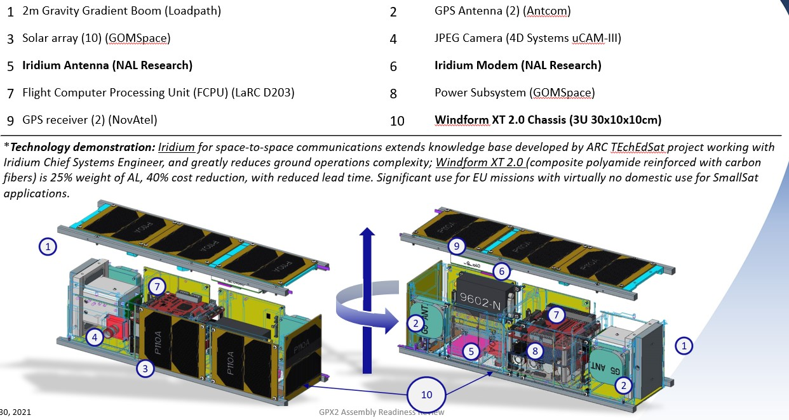
Figure 1: Primary GPX2 Structure & Component Identification
Figure 1 helps define the GPX2 SV structure for reference.

Windform® XT 2.0 Characteristics & Properties
Windform® is a matte black, composite polyamide reinforced with short carbon fibers that is typically processed by selective laser sintering (SLS). It is owned and trademarked by CRP Technology S.r.l. Due to the layered printing procedure, the final structure is anisotropic. Shown in Figure 2, the axes definitions have the sinter/print direction as “X”, the orthogonal in-plane direction as “Y” and the layer height direction as “Z”.
Important Windform® XT 2.0 physical properties, as reported by CRP, are presented in Table 2.

Thermal Considerations
Since 3D printing can result in a very complex design this becomes a disadvantage while building a thermal model. As previously mentioned, the 3D printing process results in anisotropic properties, including thermal conductivity. The directional values for thermal conductivity are found in Table 2 with the axial direction aligning with the CAD model’s Z-direction and the radial aligning with the X and Y-directions.
Windform® XT 2.0 is naturally a dark charcoal, almost black, color. The emissivity and solar absorptivity were measured from several 1 in2 samples at NASA Langley Research Center using an ET100 Emissometer manufactured by Surface Optics Corporation (Table 3). These values were used in the thermal model. CRP
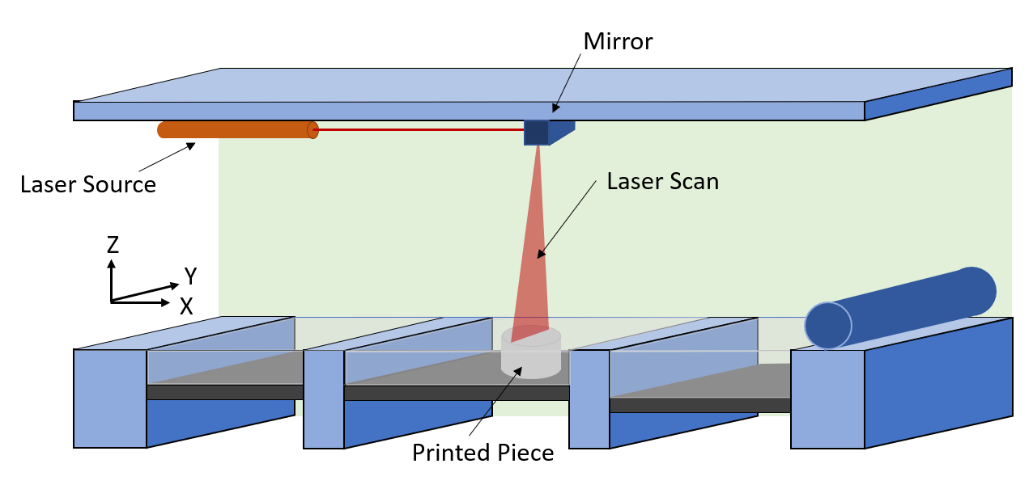
Figure 2: Schematic of Selective Laser Sintered Machine & As-Printed Material Direction Definition
presents a melting point of 179.3˚C for Windform® XT 2.0.

Table 2: Material Properties for Windform® XT 2.0 [3]
Property | Value | Units | Value | Units
Density | 1.1 | g/cm³ | 0.04 | lbs/in³
Specific Heat | 1741.60 | J/kg-K | 0.42 | btu/lbF
Strength, T (X-dir) | 81.4 | MPa | 11.8 | ksi
Strength, T (Y-dir) | 58.6 | MPa | 8.5 | ksi
Strength, T (Z-dir) | 41.2 | MPa | 5.6 | ksi
Young’s Modulus (X-dir) | 7.6 | Gpa | 1.1 | msi
Young’s Modulus (Y-dir) | 3.3 | Gpa | 0.4 | msi
Young’s Modulus (Z-dir) | 2.3 | Gpa | 0.3 | msi
Strain, break (X-dir) | 3.6 | %
Strain, break (Y-dir) | 5.3 | %
Strain, break (Z-dir) | 2.7 | %
Strength, Flex | 133.0 | MPa | 16.4 | ksi
Flex Modulus | 7.3 | Gpa | 1.1 | msi
CTE (X-dir) | 29.6 x 10⁻⁶ | E⁻⁶/°C
CTE (Y-dir) | 87.7 x 10⁻⁶ | E⁻⁶/°C
CTE (Z-dir) | 182.1 x 10⁻⁶ | E⁻⁶/°C
Thermal Conductivity - Axial | 0.45 | W/m-K
Thermal Conductivity - Radial | 0.76 | W/m-K
Table 3: Average Measured Emittance and Absorbance for Windform® XT 2.0 Material
Characteristic | Value
Emittance | 0.903
Absorbance | 0.898

Structural Design

GPX2 Requirements
Launch loads and on-orbit environments drive most of the mechanical and structural requirements of a spacecraft and the launch loads can vary between different launch vehicles/providers. During the GPX2 program, launch providers changed multiple times and therefore so did some of the requirements. On-orbit orientations and trajectories also altered with the changing LPs. High level requirement can be found in Table 4.
Table 4: GPX2 High-Level Mechanical Requirements Related to the Bus Structure
Requirement | Definition | GPX2 Status
Mass | Shall not exceed 6 kg | 3.16 kg
Outgassing | TML < 1.0%  CVCM < 0.1% | TML 0.53%  CVCM 0.0%
Space Debris Compliance | NASA-STD-8719.14 | Passed analysis

Design for Additive Manufacturing with Windform XT 2.0
The 30cm x 10cm x 10cm Windform® Bus consists of the Chassis and Cover, individually shown in Figure 3, and is responsible for containing all of the spacecraft components. The Chassis is the outer 5-walled structure where the Cover makes the final wall of the CubeSat. A CAD snapshot view of their exploded assembly relationship is shown in Figure 4. These two structures contain numerous features that are not possible to create with subtractive manufacturing for monolithic structures. This allowed GPX2 to minimize joints and
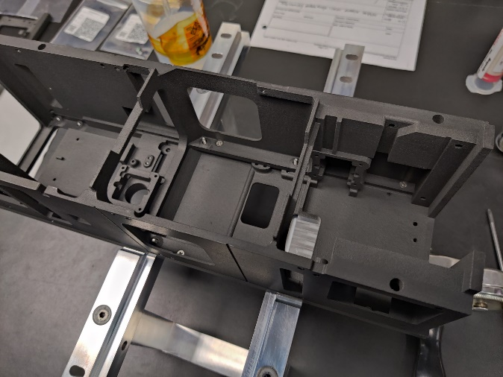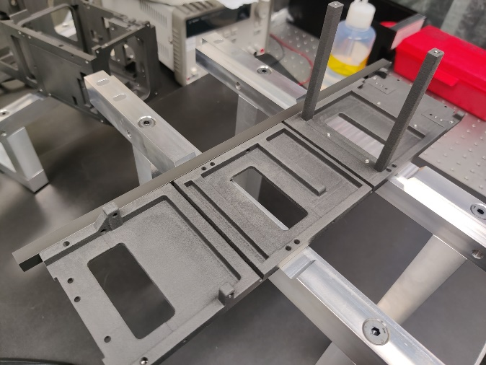
Figure 3: Windform® Chassis (Left) and Cover (Right)
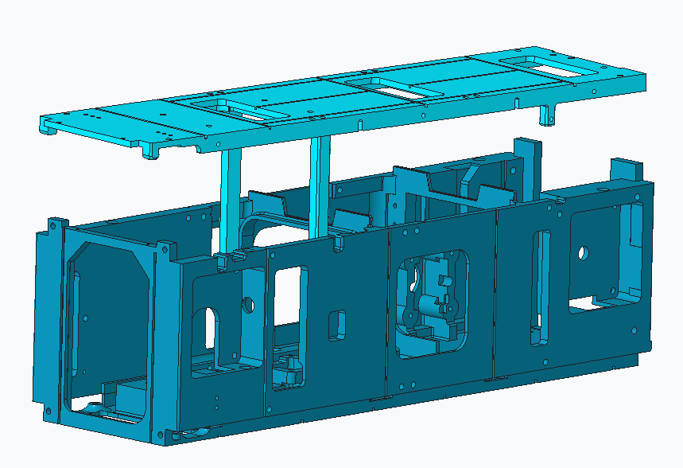
Figure 4: CAD Model of Bare WF Bus – Chassis (Lower) & Cover
fastening hardware as well as decrease assembly costs.
In the case of traditional metallic fabrication, a project specifies the tolerances and accuracies that they require. With AM, tolerances are typically “large” compared to those required for these types of space flight applications. Features that cannot be post-worked to achieve the desired tolerances must take the AM ranges into account during the design phase. Locations where the printed structure can have material removed after the fact, should be designed for such. This certainly is important for holes – considering their end roles.
- Windform® Tolerances
CRP’s general tolerances for Windform® are ±0.3mm (0.012”) for components up to 150mm (6.0”) and ±0.07mm per 25mm (0.003” per inch) for those greater. Their guidance includes wall thicknesses below 1.5mm (0.060”) not recommended and those over 10mm (0.4”) not recommended due to the high chance of warping during thermal stabilization mismatch. Another note for design consideration is that internal cavities should contain at least two holes for vacuum removal of un-sintered powder. A tapped hole’s threads may be directly printed if its diameter is larger than ½”.
- Holes
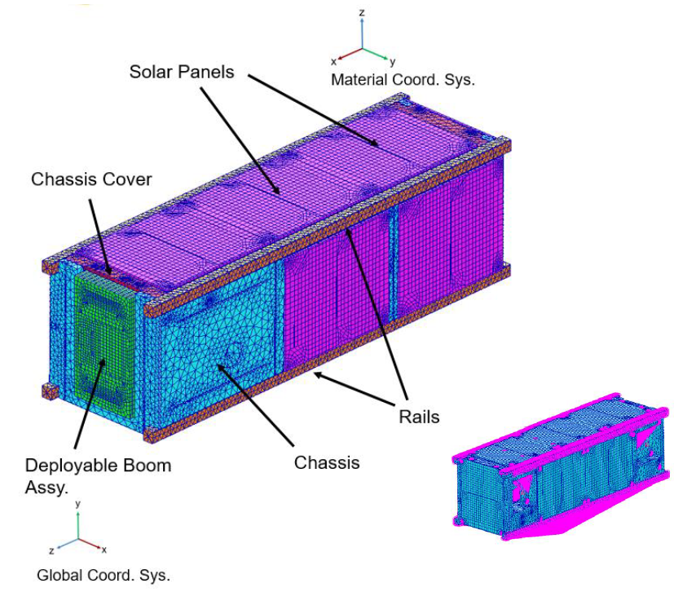
Figure 5: Finite Element Model
As mentioned above, holes that are required to have a high accuracy (to be tapped, fastener through-holes) should be designed slightly undersized with final sizing achieved after printing. The GPX2 Bus contains 60 holes that were designed to be post-print tapped to receive Nitronic 60 Helicoils. These small hole sizes ranged from #1 up to #4 and M3. Heat set threaded inserts were considered for this application and the experience of the mechanical design team, with Helicoils, was the primary motivation for their selection. It is recommended to conduct manufacturing and strength test trials with the different types of inserts.
- CTE Mismatch
When designing a joint that consists of different materials, one must consider the relative movement between the two (or more) components due to thermal expansion and contraction. This consideration was likely not considered ideally during this program, as some fastener preload post-TVAC testing loss was observed. See the Lessons Learned section at the end of this paper for more detail.

Structural Analysis
During the design phase a finite element model (FEM) was created so that five different structural analyses could be evaluated: modal, stress (quasi-static, random vibration, fastener pull-out, mechanical shock attenuation, and acoustic environmental), fastener, Steinberg, and thermal analysis. For the structural analysis work the worst direction average tensile strength for Windform® was chosen to be used for the allowable strength.
The GPX2 finite element model (FEM) was created using MSC Patran version 2017.0.2. The FEM was made from TET10, HEX8, and WEDGE6 solid elements. Auto mesh was used for the chassis and chassis cover due to their complex design. The chassis, chassis cover, and rails are made from TET10 solid elements, while the deployable boom assembly and solar panels are made from HEX8 and WEDGE6 solid elements. Fasteners are modeled using zero length CBUSH elements. The bolted connections in the FEM are represented with rigid multi-point constraints (MPC) or also known as rigid body elements (RBE2). The independent nodes of the MPCs are connected to the fastener elements and the dependent nodes are connected around the circumference of the fastener holes. This allowed loads extraction from analysis to be used for the hand calculation fastener analysis in accordance with NASA-STD-5020. All electronic components are modeled as lump masses to reduce the FEM size. A single drive node connected via the RBE2 to the rails’ surface represent the boundary condition between the GPX2 and the deployer. Figure 5 below shows the finite element model of GPX2.
The total mass of the FEM is 7.48 lbm, which is equivalent to 3.39 kg. Moreover, the total FEM mass does not include the fasteners mass. There are a total of 98 fasteners in GPX2. The type of fasteners included 1-64 UNC, 2-56 UNC, 4-40 UNC, and M3. In comparison to the total CAD mass (3.09 kg), the total FEM mass is slightly higher; hence, the FEM is conservative for analyses. A free-free modal analysis was conducted to confirm that all components are properly connected. MSC NASTRAN 2017.1 was used to run the analysis. The result showed six fundamental frequencies implying all components are connected. In addition, grounding check also showed pass in all six directions.

Stress Analysis
The analysis was done using the random vibration tool in MSC Patran and NASTRAN. Since 2% critical damping was chosen for random vibration analysis of previous 3U CubeSats, it was used for the GPX2 analysis as well. The 2% critical damping was applied for all modes and single drive nodes connected to the rails surface area via the RBE2 representing the boundary condition when GPX2 is placed inside the deployer. The analysis results showed a peak 3-sigma stress of 9820 psi which occurred at a fastener hole on the chassis. There are 2 types of bolted joints on GPX2. Type 1 joints involve securing the electronic components; there is a total of 86 type 1 joints. Type 2 joints secure the aluminum rail to the Bus and there is a total of 12. This is a bolted joint connection between the electronic stack and chassis where the threaded spacer from the electronic stack is threaded into the Helicoil bonded inside the Windform® chassis fastener hole. Hence, the failure mode for this joint is fastener pull-out. The highest tensile force extracted for this joint is 95 lbf.
Overall, the Chassis and Cover saw relatively low stress except at fastener hole locations. RBE2 were used to connect the fasteners and may have caused localize peak stresses, but since there are material/allowable uncertainties, the peak stresses cannot be ignored. In addition, finite element analysis has some limitations and cannot correctly model a fastener tear out failure mode. Hence, it is difficult to write a margin of safety. Risk reduction testing was conducted to have a better understanding of the Windform® XT 2.0 capability. In addition, fastener pull-out tests were conducted for a type 1 joint. This testing is discussed more in a later section of this document.
As part of the risk reduction, the joint connecting the electronic stack to the chassis was re-designed with the new failure mode being bearing stress. A breakout model of the re-designed joint was created and analyzed. The result showed the highest stress in the joint is 7454 psi on the Windform chassis. But due to material/allowable uncertainty, this stress cannot be ignored. As a result, an Engineering Design Unit (EDU) Random Vibration test was conducted as part of the risk reduction and material uncertainty effort.

Thermal Modeling
The primary thermal analysis tool used at NASA Langley Research Center is CRTech’s Thermal Desktop which is an add-on to AutoCAD. The practice is to build a simplified model of the spacecraft in Thermal Desktop (TD) so that the orbit predictions can be identified. TD allows the analyst to build heating rates for on orbit scenarios and run transient cases so that position on orbit can be used to calculate temperatures within the model. Within TD components of the spacecraft are built with either solid geometric shapes or flat thin surfaces that can have a defined thickness. When completed the thermal model often looks like a crude, simplified version of the CAD design.
This method of modeling works well when the spacecraft has components that can easily be simplified down to solid blocks or flat surfaces. If a 3D printed component is introduced and the mechanical designer is taking full advantage of the characteristics of 3D printing, the task of generating a simplified thermal model become troublesome.
The GPX2 thermal model was generated in Thermal Desktop v6.1 (Patch 30). Since the Bus components were designed with 3D printing in mind the two components contained details that could not easily be simplified in Thermal Destkop. Two major factors that the mechanical design engineer utilized were reducing the mass by varying the wall thickness and including extruded surfaces that were used to secure electronics components found in the system; these extrusions were specially designed for each electronic component and exhibited unique features.
The two categories for components found in GPX2 are the electronics and structure. The TD model was simplified to decrease analysis time. Figure 6 shows the interior with the electronic components indicated. The electronic components were built as blocks or were built with a combination of blocks and surfaces. In both cases density multipliers were included to adjust the overall mass.
Since the main structural components make up the Windform® 3D-printed Bus, SpaceClaim was used to import the CAD of the Bus components into the TD model. This also allowed the anisotropic material properties to be added to the SpaceClaim model with an articulator indicating directions for material properties. The aluminum rails are also considered structural components that are integral to the Chassis and Cover but were added as a block in the TD model after the Bus components were imported. The remaining components either have a mass that is negligible when compared to the full satellite or have no heat dissipation.

Modeling the Windform® Chassis and Cover for Thermal Analysis
SpaceClaim provides the capability to modify the CAD model so that a finite element mesh can be generated and used by TD. This process involves removing fine details that would cause issues when applying a mesh. The result is a simplified version of the CAD that contains the FEM, thermal properties, tag sets, and radiation groups that are needed by TD.

Modeling the Windform® Chassis and Cover for Thermal Analysis
SpaceClaim provides the capability to modify the CAD model so that a finite element mesh can be generated and
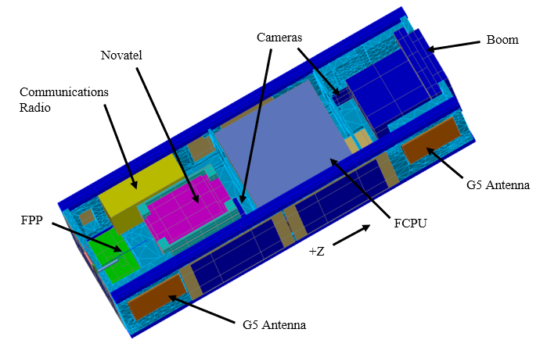
Figure 6: Location of Electronic Components with Hidden Cover and Solar Panels
used by TD. This process involves removing fine details that would cause issues when applying a mesh. The result is a simplifies version of the CAD that contains the FEM, thermal properties, tag sets, and radiation groups that are needed by TD.
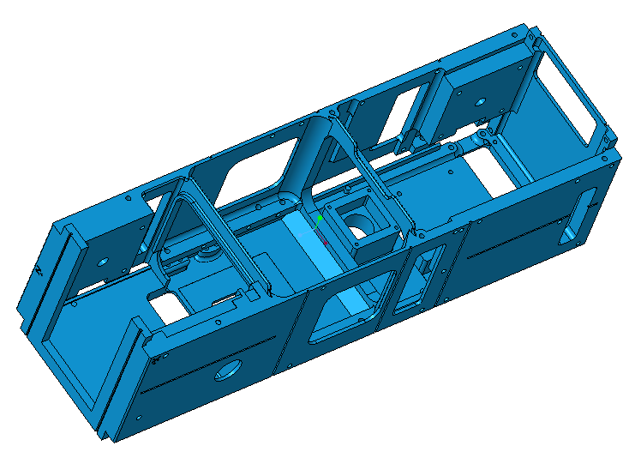(a) CREO CAD Model | 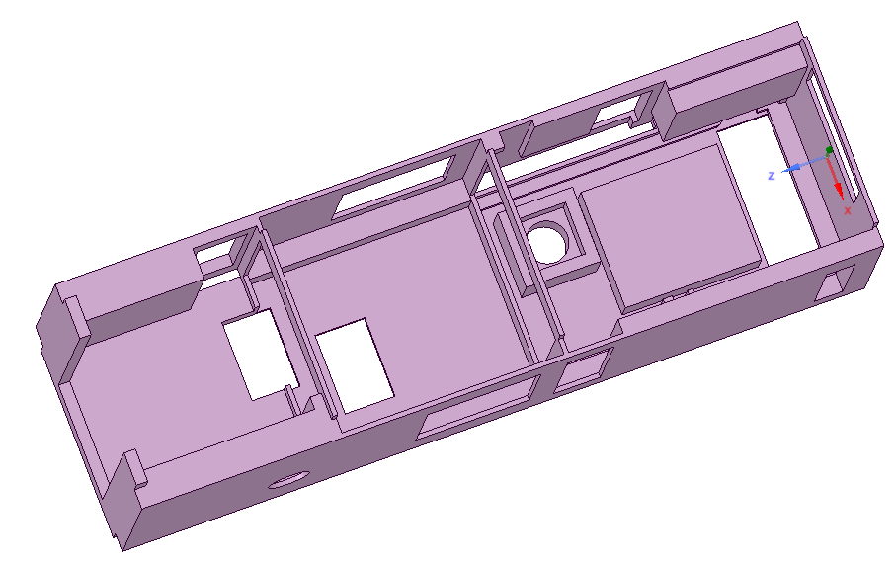  (b) SpaceClaim Model | 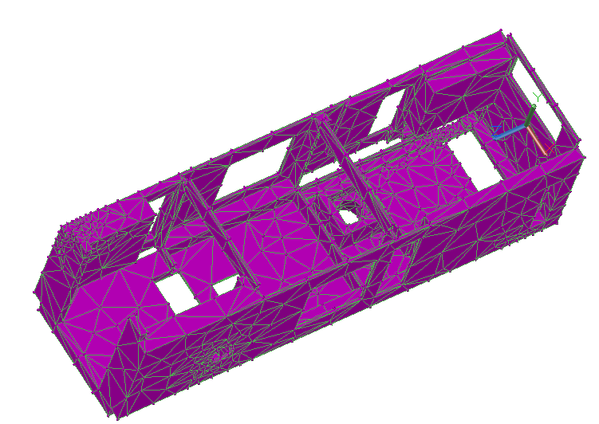  (c) Thermal Desktop Model
Figure 7: The Progression of the Chassis through SpaceClaim: (a) CREO CAD Model, (b) SpaceClaim Modified Model, (c) Imported Thermal Desktop Model
Figure 7 and Figure 8 show the progression of the Chassis and Cover, respectively, from CREO through SpaceClaim to Thermal Desktop. Small details were simplified, such as removal of fillets and holes. Small features, such as the hysteresis rod slots, were also removed or drastically simplified. All contacting surfaces were mapped so that they could be used in TD for contactors. Since 3D printed material has a distinct print orientation, the SpaceClaim model included a directional indicator for the non-isotropic material properties.

Manufacturing & Assembly
LaRC is a relatively large organization and engineering teams are generally most comfortable working with their own fabrication teams where personal relationships are in place and logistical practices well-known. Working with an outside vendor is a regular occurrence of course, but the teaming relationship on this project with CRP was a great experience.
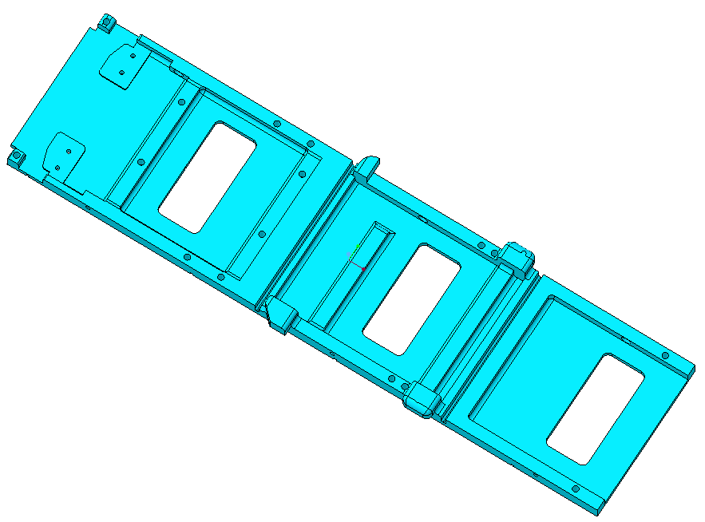(a) CREO CAD Model | 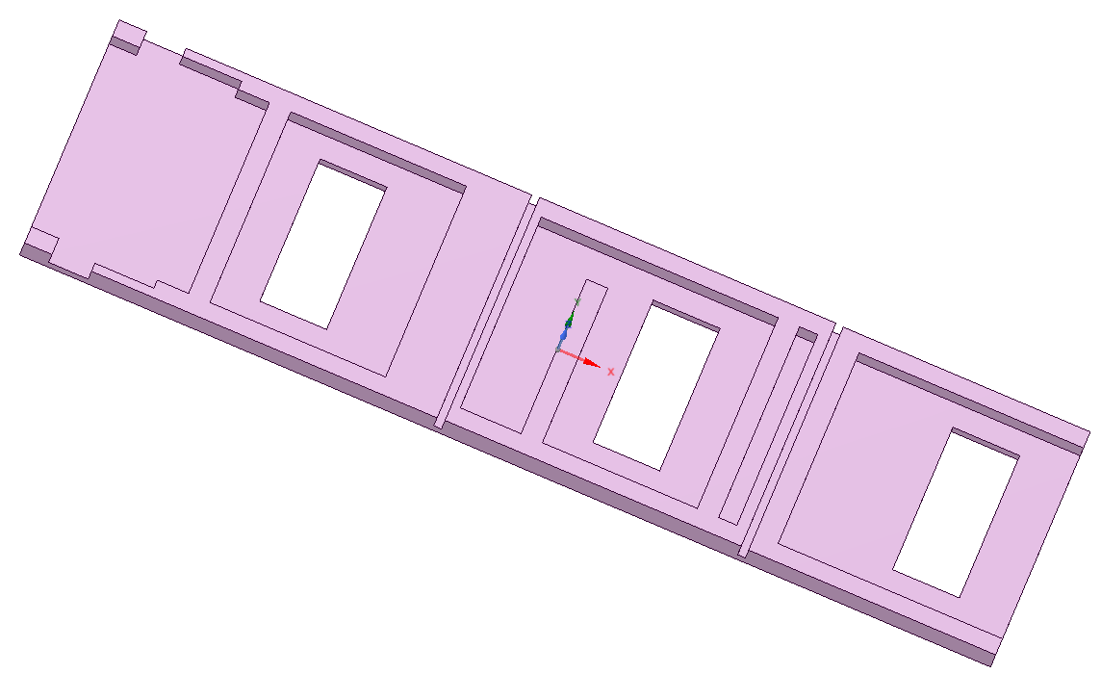  (b) SpaceClaim Model | 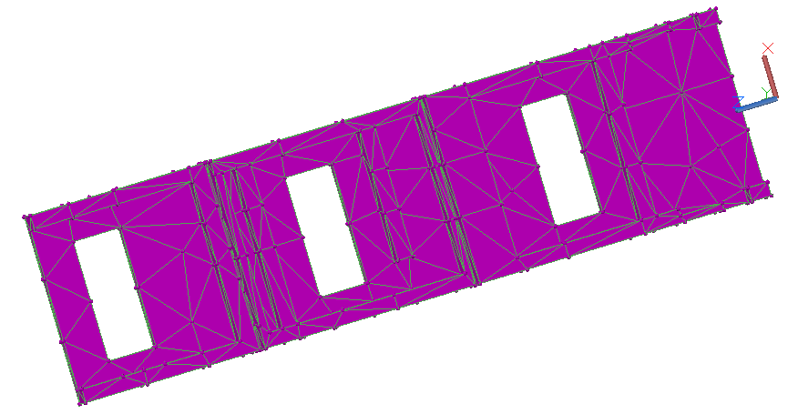  (c) Thermal Desktop Model
Figure 8: The Progression of the Cover Through SpaceClaim: (a) CREO CAD Model, (b) SpaceClaim Modified Model, (c) Imported Thermal Desktop Model

In-House Inspection, Manufacturing & Assembly
CRP delivered multiple prototypes for the Windform XT 2.0 Chassis, Cover, Switch Fingers and RBF pins. Upon receiving the protoflight and flight AM products from CRP, the LaRC NDE team conducted CT scans where some discrepancies, observed by visual inspection, were discovered that motivated action.

Discrepancies & Reworks
Upon inspection of both protoflight and flight Windform units, voids and mis-aligned inserts were discovered. Examples of CT scan shots are shown in Figure 9.
This supports the importance for performing CT scans of AM hardware. One of the voids was located in a critical load path area of the Cover Arm so another unit had to be produced and delivered to LaRC. Angled inserts (Figure 10) were also observed from the CT scans located in the ends of the two long Arms of the replacement Cover. The upper right image in Figure 9 is the worst of the two angled Helical inserts.

Testing

Testing Specific to Windform®
The GPX2 team conducted two sets of tests for the Windfrom® material, the pullout strength of the Helical inserts and the epoxy staking bonding strength to the WF. CRP installed the Helicoils per NASM 33537, class 3B, so the pull-out test articles were assembled and conducted by CRP.
- Helicoil Pullout
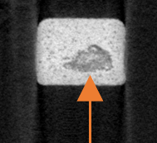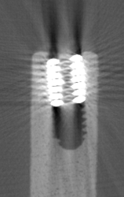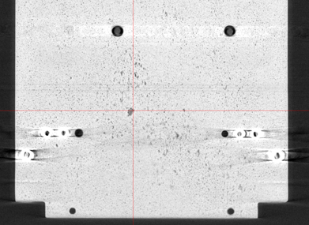
Figure 9: CT Scans Showing Examples of Voids and Angled Helicoils
Helical inserts are a standard practice in spacecraft assembly. Because the WF strength allowables are not confidently characterized and pull-out strength of inserts within WF XT 2.0 have not been tested, a test was designed to investigate the integrity of Windform XT 2.0 and Helicoils. CRP was slated to prepare the holes and perform all Helicoil installation for flight, so they did so for this test activity and conducted the strength testing. This test series consisted of using 24 printed coupons with each coupon having 2 different size Helicoil inserts. One of the test plates with 5 insert samples is pictured in Figure 11 alongside the plate situated in the tensile test fixture at CRP.
FEA work used the force results from these tests to evaluate safety margins for the fastened joints within the SV.
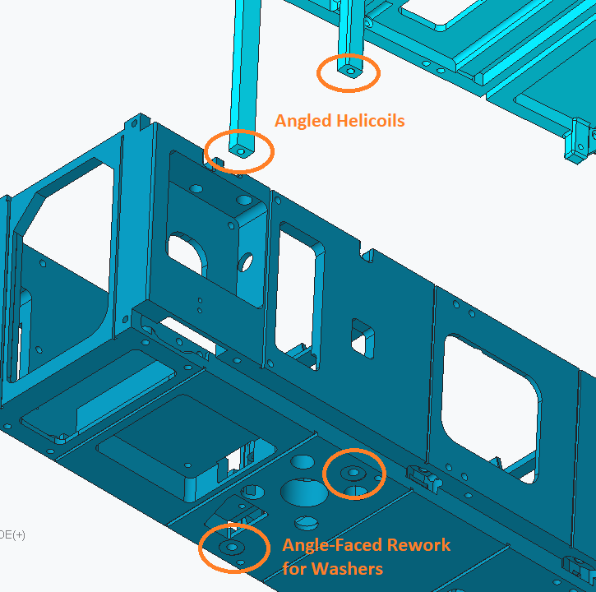
Figure 10: Location of Off-Angled Inserts and the Screw/Washer Faces Reworked to Ensure Even Area Preload

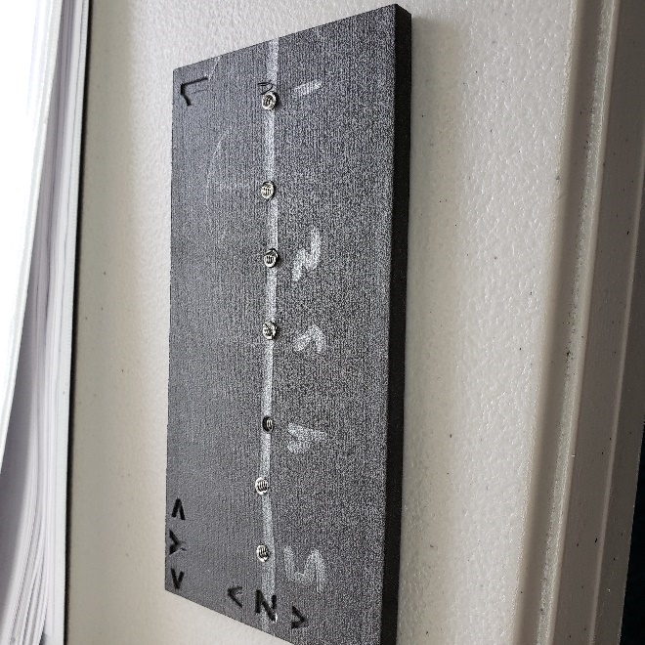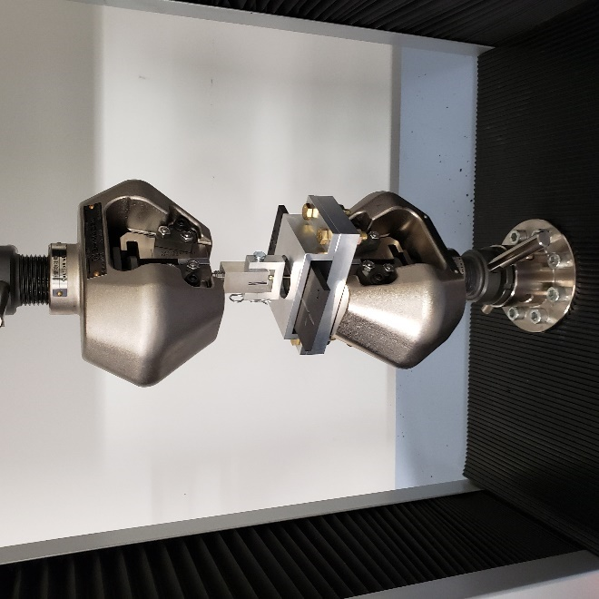
Figure 11: One of the Pull-Out Test Plates After Test (Left); Test Plate in CRP Test Fixture (Right)

- Adhesive Bonding
The goal of this activity was to determine which epoxy material adheres best to the Windform XT 2.0 when it is applied in the manner of staking – a small amount applied to a fastener head and the local surface of the WF member being joined, after surface preparation. Wiring would also be adhered to the interior of the Chassis and Cover with the same material. The launch vibration loading scheme that is of ultimate interest here includes a complex combination of tension, compression, shear, peel, cleavage, strain rate effects, CTE, etc. but since a test activity with a short schedule and low budget was required, a break-loose torque activity was chosen to validate the adhesion. The manner of failure that was deemed appropriate, easily measurable, was adhesive (most likely) or cohesive shear/peel through application of an untightening torque of a fastener that was also bonded with the epoxy to the WF.
With guidance from NASA-STD-5020A, section B.5.2 Process Validation, a number of comparison tests were performed with a prototype WF chassis, varying the epoxy products (Loctite EA 9394 and 3M Scotch Weld EC-2216 BA Gray) and two different fastener head types, flat and pan. Two epoxy geometries/shapes were applied based on NASA-STD-8739.1, torque stripe and dual sided. Figure 12 illustrates an example of both staking shapes.
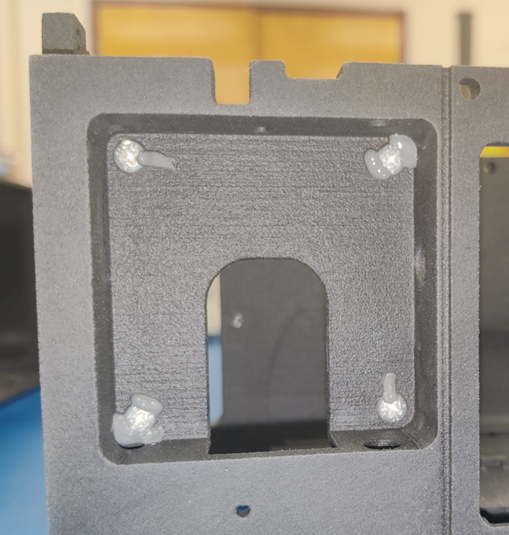
Figure 12: Four Pan-Head Screws Staked with EA 9394 Showing Both Torque Stripe and Dual Sided Geometries – Upper Left is Torque Stripe; Upper Right is Dual Sided
There were a number of existing, printed holes all through the Chassis and Cover which were directly tapped to provide free-running holes for the #4-40 fasteners. The process for the adhesive bonding was as follows: (1) the fastener running torques were measured going in, (2) final tightened torque (as little more than the running torques as possible once screw head has contacted the WF surface), (3) surface preparation (only isopropyl alcohol (IPA) wipe since the WF surface is already rough), (4) apply staking, (5) let the adhesives cure, and (6) measure the torque to break the staking. To reduce CTE effects, the cure was achieved quicker through a 60 min. soak at 90°C followed by 90 min. at -50°C.
As a minimum pass/fail criteria, the minimum break-loose torque was defined as just greater than the NASM 8846 minimum breaking torque of 10 in-oz for #4-40 screws.
The break-loose torques ranged from 12 to 108 in-oz. with an average of 50 in-oz. for 20 samples. The majority of the failure modes were adhesive from the screw head – the adhesive remained bonded to the Windform® XT 2.0. Since the EA 9394 is more viscous than the EC-2216, it was chosen over the EC-2216 so that staking could be applied to orthogonal surfaces during assembly because the EC-2216 would drip.
An addendum to this test was performed at the time of the activity that allowed the team to observe adhesion of Kapton tape to the Windform® after undergoing the aforementioned CTE environment. This was deemed beneficial as Kapton was potentially planned to be used within the SV to help with wire management. The Kapton seemed to increase adhesion after the hot/cold dwells, however this was a manual-feel observation of before/after peeling.

Structural Testing
A vibration test was conducted on a secondary non-flight unit. The goal for this test was to qualify the Bus system to protoflight levels. Low level sine sweeps were conducted pre and post random vibration and all test results had good correlation with the predicted modes. CT scanning was conducted before and after testing to verify that the 3D printed material found had no delamination during testing.
The full spacecraft also went through random vibration with levels aligning with the requirements provided by the launch provider. The spacecraft was tested inside the test pod provided by the CubeSat deployer manufacturer. Another difference for the full system test was that accelerometers could not be placed within the spacecraft and were instead placed at the same locations on the exterior of the testpod as the non-flight unit. Post-test visual inspection found no issues in the 3D printed structure; the full spacecraft did not go through the same CT scans as the non-flight unit.

Thermal Testing

The GPX2 spacecraft went through thermal vacuum (TVAC) testing to validate the workmanship of the system. The same thermal model was used to determine on-orbit predictions and design the TVAC test. This test was also used to thermally stress the components so that there would be increased confidence that the system will operate as intended in the anticipated thermal environment while under vacuum.
The test was conducted in a cylindrical test chamber that contains a platen and shroud system for thermal control. A unique test fixture was built so that the spacecraft could be tested without coming in contact with the test chamber platen due to each side having integrated solar panels. During the test, facility-controlled thermocouples were used to measure the temperatures of the electronic components. The system was built with eight flight thermistors that were set to measure both the Windform® and electronic components when the flight computer was powered. The location of the flight thermistors can be found in Table 5 and a list in Table 6.
Table 5: Flight Thermistor Placement
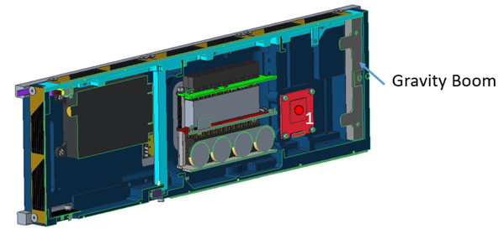
Thermistor 1: Camera
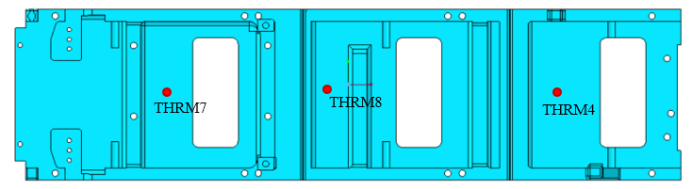
Thermistors 4, 8, and 7: Located on Inside of Cover
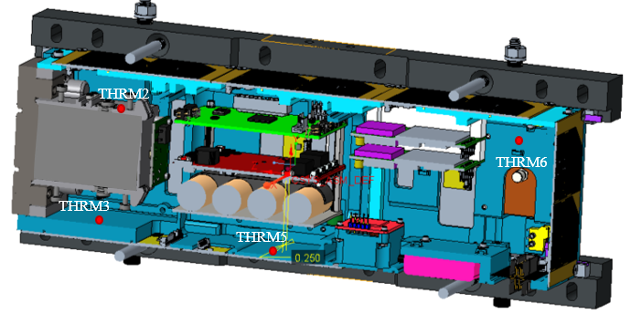
Thermistors 2, 3, 5, and 6: Located on Inside Components; Back Side of Image is “Up” During Testing
During this test the spacecraft had to undergo two thermal cycles with 4-hour dwells at hot and cold plateaus. Functional tests for the electronics were included at each hot/cold dwell.
While the system was powered on, telemetry data was collected from the flight thermistors and built-in temperature sensors on individual components. Of the eight flight thermistors six of them were potted directly to the Windform® Chassis or Cover on the interior of the spacecraft; the other two were located directly on components.
Table 6: Flight Thermistor Locations
Num. | Identifier | Location/Name
1 | T1 CAM | Camera, +X facing
2 | T2_BOOM_BODY | Boom_Body, Housing for the LP Boom, side closest to the Cover
3 | T3_CHASSIS_BOOM | Chassis_Boom, Chassis internal surface near boom
4 | AVG_T4_COVER_BOOM | Cover_Boom, Cover interior near boom
5 | T5_CHASSIS_AS | Chassis_AS, Chassis internal surface under AS
6 | T6_CHASSIS_COMM | Chassis_GPS, Chassis internal surface on GPS antenna, opposite end from boom
7 | T7_COVER_AS | Cover_GPS, Cover interior near Novatel GPSs
8 | AVG_T8_COVER_AS | Cover_AS, Cover interior near AS stack

The facility was set so that the rate of change for the test chamber was 4°C/min for most transitions. During the test the Windform® experienced a rate of temperature change greater than what the facility was set to. Since a test fixture was used it was expected that the temperature change experienced by the system would be different than the facility setting and achieving thermal equilibrium at each dwell took longer than predicted.

Data collection On-Orbit for Thermal response
The orbit that was achieved by GPX2 is approximately 100km above the International Space Station (ISS) (500km altitude). The flight thermistors collected data starting once the system was powered on after launch.
Table 7 contains the temperature values for temperatures on 1 August 2022, about a month after launch, and then for 22 December 2022, almost 6 months after launch. This captures the temperatures experienced by the spacecraft during a time of low solar flux and a time of high solar flux.
Following the launch, the thermal model was modified with temperature measurements placed in locations near the actual flight thermistors. This allowed for evaluating predictions from the thermal model that would match with the flight thermistors. Cases were run with orbital parameter matching ephemeris data collected form the NORAD database that tracks all satellites on the day that the on-orbit temperatures were collected for 1 August 2022. The temperatures that were collected from orbit are within the range predicted from the thermal model.

Lessons Learned

Joints for CTE Mismatch
Each aluminum rail was fastened (Figure 13) to the Chassis and Cover with three #4 or #2 screws, along their length, through countersunk thru-holes in the 3DP Windform where a significant CTE mismatch was present.
Figure 13: Locations of Aluminum Rail Fasteners to the Cover with Flat-Head Screws
Lesson: Consider a single fixed fastener with sliding attachments elsewhere for future designs. This will help to avoid CTE related joint stresses as well as ease the need for tight tolerances on hole locations. Additionally, sub-assembly joint thermal testing should be performed if analysis is not sufficient.

Fit-Check
The flight SV (Figure 14) initially failed the overall dimensional requirements and fit-check with the flight deployer. The flight unit fit in the test deployer (for vibe) which was assumed to be the same. Upon receipt from the supplier, the Windform® Chassis and Cover were not inspected for meeting critical dimensions.
Lesson: Fit-check all flight components as early as possible with strict attention to meet the structural requirements. Design additively manufactured components to be oversized, where critical, and then mill down to achieve the desired dimension/tolerance.

Polymer Loaded Joints
Where a plastic component was part of a preloaded joint, there were instances where some loss of torque/preload was observed after full torque was applied and some time passed.

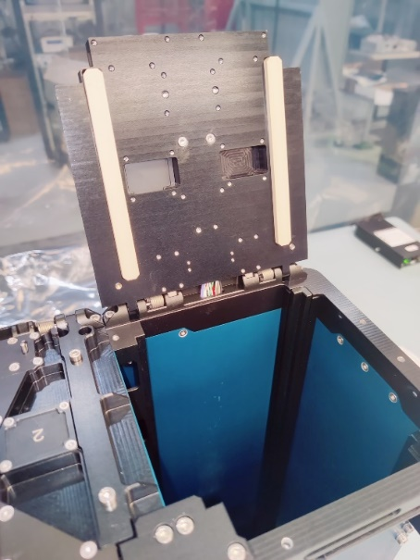
Figure 14: Flight SV Deployer, Showing the L-Shaped Rails that Interface with the Rails of the SV
Lesson: Conduct benchtop testing with joint materials to determine adequate torque schedule: ie, torque the fasteners – wait (24hrs) – retorque and measure the losses, if any. If a loss of torque is observed, continue the process.

Running Torque Measurement
Engineering called for the measurement of the running torque for all threaded holes at the start of the fabrication process. It was noted by other members of the team that it is not common practice to measure RT for machined threaded holes but only for those with locking Helical inserts. During the assembly of the flight hardware, there were some poorly tapped aluminum holes encountered and some hole misalignments between the joint members where the measurement of the running torque aided in realizing it.
The lesson is to indeed measure RT for small tapped holes.

Conclusion
Windform® XT 2.0 was found to be an excellent 3D printed material for a CubeSat bus. Great care was taken while design the GPX2 bus to minimize issues that can occur during the 3D printing process. The project collected well documented lessons learned for future use of 3D printed materials for space applications. Currently, the GPX2 satellite is still collecting data.

References

[1] | L. S. Murchison, A. Martinez and A. Petro, "On-Orbit Autonomous Assembly from Nanosatellites," NASA Ames Research Center, Moffett Field, 2015.
[2] | R. Lawrence, L. Bing, S. Harrah, Y. Hu, P. Hunt and C. Lipp, "Initial flight test resutls of differentail absorption barometric radar for remote sensing of sea surface air pressure," Journal of Quantitative Spectroscopy and Radiative Transfer, vol. 112, no. 2, pp. 247-253, 2011.
[3] | CRP Technologies, "Windform," 2022. [Online]. Available: https://www.windform.com/technical-data-quality/. [Accessed 2017].

