Millimeter Wave Doppler Radar Testing Using the Lunar Regolith Ejecta Simulator
Beverly W. Kemmerer
National Aeronautics and Space Administration, Kennedy Space Center, FL, 32899, US
Austin R. Atkins and Daniel P. Batcheldor
Engineering Research and Consulting LLC, Kennedy Space Center, FL, 32899, US
Austin G. Langton and James G. Mantovani
National Aeronautics and Space Administration, Kennedy Space Center, FL, 32899, US
A linear conveyor system has been devised to maintain lunar regolith simulant at a range of velocities, distances, angles, particle densities, and particle sizes. The Lunar Regolith Ejecta Simulator (LuRES) system shall test prototype and potential flight instrumentation for measuring the velocities of regolith particles accelerated by a plume-surface interaction (PSI) and determining effects of particle number densities and particle size distributions on return signals. Here we present the results of initial LuRES testing of the Millimeter Wave Doppler Radar (MWDR) instrument. The LuRES system held a single, ~900 µm BP-1 lunar regolith simulant particle at a continuous ~5 m/s velocity. The return signal of the MWDR from this LuRES configuration was analyzed to calibrate the MWDR instrument. Further testing is planned for the remaining of 2023 to calibrate the MWDR for various particle sizes and densities at a continuous velocity. These results will be presented in the final paper.
- Introduction
Descent and ascent engines from a lunar lander create exhaust plumes that interact with regolith. These plume surface interactions (PSI) may accelerate regolith particles to velocities that pose a risk to surrounding assets. Such risks were demonstrated by observed damage to Surveyor 3 due to the nearby landing of the Apollo 12 lunar module [1]. Estimates from the Apollo landing videos and simulations have shown that particle velocities could reach several kilometers per second [2][3]. However, direct in-situ measurements of these velocities have yet to be made leaving open the risks of PSI accelerated regolith particles. Consequently, instrumentation such as Millimeter Wave Doppler Radar (MWDR) is being developed to measure particle velocities.
The MWDR instrument provides a unique dataset based on direct measurements of ejecta particle velocities during PSI, which will help inform risk assessments associated with impacts by high-speed PSI ejecta particles. The PSI data obtained by the MWDR instrument will also inform the development of high-fidelity computational models of PSI effects and will help address NASA Strategic Knowledge Gaps related to characterizing entry, descent and landing effects, and the risks associated with high-speed PSI ejecta. As this instrumentation progresses through the technology readiness levels, it must be demonstrated in the laboratory environment, and beyond. The innovation reported here enables the laboratory demonstration of a MWDR using particles of known size distribution, density, distance, angle, and speed. This lunar regolith ejecta simulator supports the development of the MWDR instrument and other instrumentation.
- Method
The purpose of the Lunar Regolith Ejecta Simulator (LuRES) is to test the regolith velocity measurement capabilities of the MWDR instrument. Figure 1 is an image of our LuRES conveyor belt setup. The conveyor consists of a polyimide belt, drive motor, drive roller, secondary roller, radar absorption panels, a high-speed camera, and support structure. The drive and secondary rollers are horizontally spaced to span the belt enough to appropriately sample the radar cross section (RCS) as projected at the distance of the LuRES from the MWDR instrument. A laser pointer is used to check the alignment of the RCS onto the belt. The belt tension is adjusted by moving the relative positions of each roller. The drive motor contacts the drive roller which in turn rotates the belt. The belts linear velocity is controllable between 0 and approximately 5 m/s using a DC motor with a pulse width modulated controller. A radar zero-point on the belt is produced by the segment of tape that holds the belt together (green tape shown in Fig. 1). Regolith samples are adhered to the outer side of the belt and opposite from the site of the zero-point. The resulting radar data includes a strong signal for the zero point and an expected position in the time series for the regolith signal.

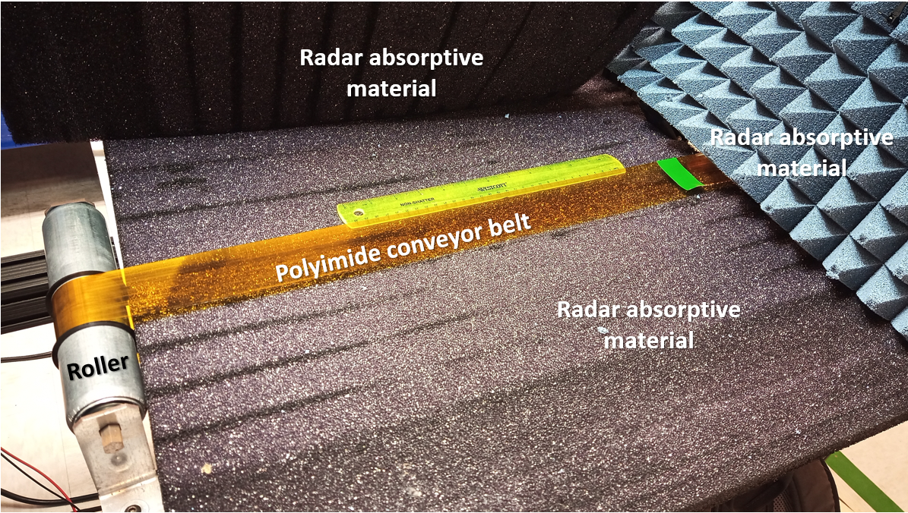
Fig. 1 LuRES polyimide conveyor belt setup

A high-speed camera is used to independently verify the belt velocity. Radar absorptive material is used to minimize radar reflections. LuRES is optimized for use with radar systems through the application of radar absorptive materials. LuRES was developed to allow a user to customize and fix the distribution of scattering targets on the belt so that a well-characterized target can be presented to an electromagnetic radiation source to calibrate a PSI measurement instrument such as the MWDR. This lunar regolith ejecta simulator could potentially be used to calibrate any doppler radar system designed to determine the velocity of particles similar in size to lunar regolith.
The MWDR instrument used for this work is a 94 GHz Continuous Wave (CW) radar with a Voltage Controlled Attenuator (VCA) that allows for a max transmit power of 24.5 dBm. Additionally, the BP-1 lunar regolith simulant particle size and surface area (to correlate to radar return signal) is determined by a high-powered microscope. Figure 2 shows the images of the analysis of the particle size and density using the microscope method.

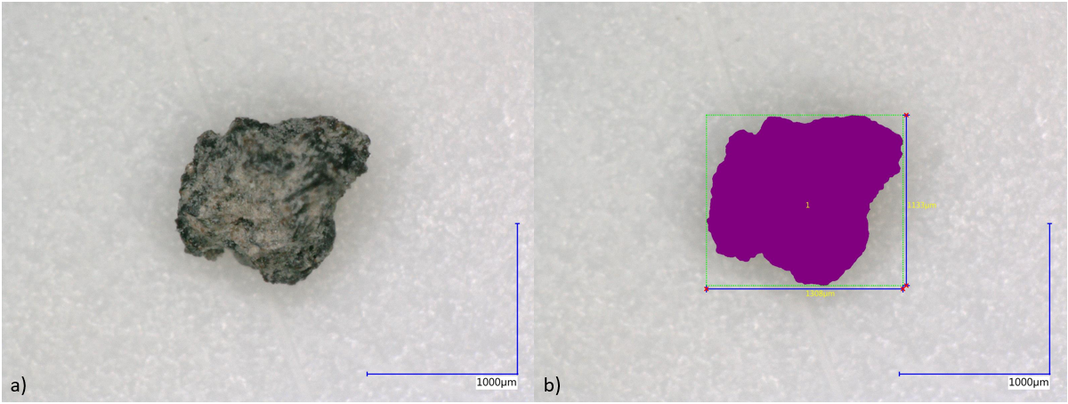
Fig. 2 Microscope analysis of BP-1 lunar regolith simulant particle size and projected cross-sectional area.
- Results
The MWDR instrument processed velocity signals using the LuRES setup has demonstrated the detection of a single particle of BP-1 lunar regolith simulant ~900 µm in diameter. Figure 3 shows the results of this initial testing. The tall peaks correspond to the zero-point tape segment used on the LuRES belt to act as a fiducial. The inter-fiducial peaks are the returned radar signals from the single ~900 µm BP-1 particle. Variations in the strength of the signal can be attributed to the aspect ratio of the fiducial marker due to belt wobble in the z-direction. Further testing is planned for the remaining of 2023 to calibrate the MWDR using the LuRES setup for various particle sizes and densities at a continuous velocity. These results will be presented in the final paper.

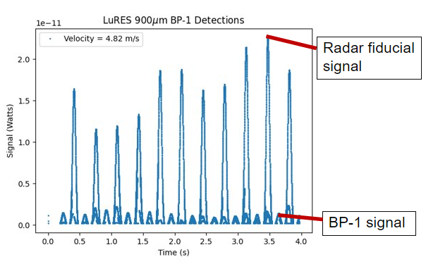
Fig. 3 MWDR initial testing results using the LuRES setup using a single BP-1 lunar regolith simulant particle ~900 µm in size. The return signal of the singular BP-1 particle is detectable with the MWDR instrument.

Acknowledgments
This work is supported by the National Aeronautics and Space Administration (NASA) Exploration Systems Development Mission Directorate (ESDMD) office and the Game Changing Development (GCD) program.

References
- Immer, C., Metzger, P., Hintze, P., Nick, A., Horan, R., 2011, “Apollo 12 Lunar Module exhaust plume impingement on Lunar Surveyor III”, Icarus, Volume 211, Issue 2, Pages 1089-1102, https://doi.org/10.1016/j.icarus.2010.11.013
- Immer, C., Lane, J., Metzger, P., Clements, S., 2011, “Apollo video photogrammetry estimation of plume impingement effects”, Icarus, Volume 214, Issue 1, Pages 46-52, https://doi.org/10.1016/j.icarus.2011.04.018
- Lane, J., & Metzger, P., 2015, “Estimation of Apollo Lunar dust transport using Optical Extinction Measurements”, Acta Geophysica, 63(2), 568-599, DOI: 10.1515/acgeo-2015-0005

Research Physicist, Exploration Systems and Development Office
Chemistry Support Scientist II, LASSO 6501.
Subject Matter Expert – Physics, LASSO 6520.
Automation and Robotics Systems, Exploration Systems and Development Office.
Research Physicist, Exploration Systems and Development Office.

