Backshell Radiative Heating and Shock Layer Kinetic Measurement in NASA’s Electric Arc Shock Tube Facility

Brett A. Cruden
AMA Inc., NASA Ames Research Center, MS 230-2, Moffett Field, CA 94035, USA
Augustin Tibere-Inglesse
ORAU, NASA Ames Research Center, MS 230-2, Moffett Field, 94035, USA
Christopher O. Johnston, Thomas K. West
NASA Langley Research Center, Hampton, USA
Aaron M. Brandis
NASA Ames Research Center, MS 230-2, Moffett Field, 94035, USA

Brett Cruden: Brett.A.Cruden@nasa.gov

Abstract A methodology for creating incident shocks with similarity to the backshell radiative heating environment on planetary probes is presented. Two test series were carried out in the Electric Arc Shock Tube (EAST) at NASA Ames to quantify the backshell environment for planned and executed missions entering the atmospheres of Mars and Titan. The comparison of measured radiance in the shock tube to simulated post shock radiation levels is used to quantify the uncertainty in the model. This model uncertainty may then be related back to the flight condition to assess the error in the flight heating prediction. Tests for Mars entry show the shock tube measurements to be bracketed between two kinetic models by 2-7%. This suggests an 8% error in predicting the measured heating cannot be attributed to radiation. Comparisons to planned Titan entry relevant conditions suggest a substantial overprediction of the backshell radiation, which suggests opportunity for future refinement of radiative heating models.

1 Introduction

For many planetary exploration destinations, the heating on the backshell of an entry capsule may be dominated by shock layer radiation. The shock layer radiation is dependent upon non-equilibrium kinetics in the shock heated gas. Johnston recently described the equations that produce similarity of streamlines around the back of the vehicle to incident shock waves [1]. By replicating the normal velocity at the shock origin of the streamline, similarity to an oblique shock is obtained. When evaluated in particle time, the oblique shock condition is replicated by an incident shock produced in the Electric Arc Shock Tube (EAST) facility at NASA Ames. Two test series have been conducted to demonstrate the methodology [2, 3]. In both cases the radiation as a function of wavelength and position behind the shock front is measured and compared to predictions for an axisymmetric flow. Tunable diode laser absorption spectroscopy (TDLAS) is employed to obtain temperature and number density data that corroborates the radiation measurement and model results [4, 5].
The first test has replicated the entry of the Mars2020 capsule [2]. Mars2020 entered the Martian atmosphere at a velocity of 5.3 km/s and was instrumented with backshell heat flux gauges that detected the radiative heating on the aftbody [6]. Shock tube tests were performed at velocities between 1.0-4.0 km/s to replicate the backshell conditions. The major emission bands originate from CO₂ vibrational transitions in the mid-infrared at 2.7 and 4.3 μm and were measured in separate tests. The second test pertains to candidate entry trajectories for the upcoming Dragonfly mission to Titan at ~7.3 km/s [3]. Conditions from 3.0 to 6.0 km/s were tested to replicate the regime of backshell heating. Emission spectra, primarily attributed to the CN radical, from the ultraviolet to near-infrared were measured. The measurements are used to assign an uncertainty to the predicted model, which will then be related to the backshell heating predictions using this Shock Tube Informed Bias (STIB) method.

2 Methodology

The shock tube informed bias method, developed by Johnston in 2019 [1], relates the condition of an oblique streamline behind a hypersonic vehicle to a normal incident shock as can be reproduced in a shock tube. A visual description of this process is detailed in Fig. 1 that depicts an entry vehicle and the corresponding bow shock. Any point in the flowfield can be traced back to its point of origin at the shock front, which can be described as an oblique shock. The conservation of mass, momentum and energy across an oblique shock require that the tangential velocity is constant across the shock, resulting in shock jump relations that are identical to the normal shock relations when written in terms of the normal component [7]. Therefore, an incident shock that is produced at an incident velocity $v_{1}$ may be claimed to have similarity to an oblique shock produced at a higher effective velocity, v_{eff},
 | $$v_{eff}=v_{1}/cosθ$$ | (1)
where θ is the angle of the oblique shock.

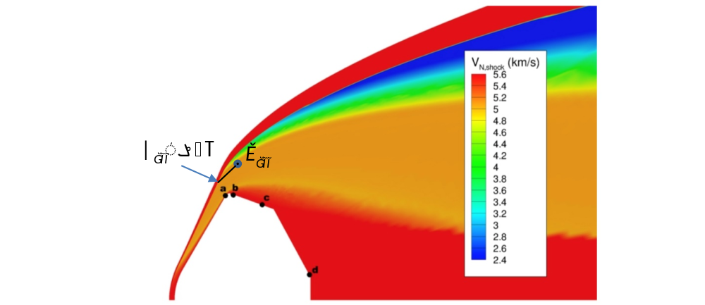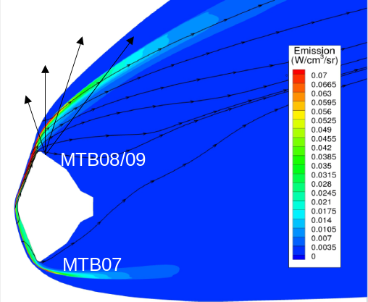
Fig. 1. Example flowfield geometric features for developing similarity relations. (left) Dragonfly, (right) Mars2020

The change in enthalpy and density ratio across the incident and equivalent oblique shock is identical, therefore the post shock gas will undergo the identical collisional, radiative and reactive relaxation processes. The post-shock behavior as a function of time is therefore the same for both cases. The results then have similarity if measured in particle, or Lagrangian, time. For an elapsed time t in the lab frame, a particle will have traveled a distance of $\left(v_{1}-v_{2}\right)t$ in the lab frame, where $v_{2}$ is the normal post shock velocity in the shock frame of reference. The particle is therefore a distance of $d=v_{2}t$ behind the normal shock, neglecting any deceleration effects. In the equivalent oblique shock frame of reference, the normal velocity is $v_{2}$ and the tangential velocity $v_{1}tanθ$, so the particle has traveled a distance given by $d_{eff}=\sqrt{{v_{2}}^{2}+{\left(v_{1}tanθ\right)}^{2}}t$. Equating these in terms of time and substituting in $ρ_{1}v_{1}=ρ_{2}v_{2}$ we obtain the following relationship between distance in flight and in the incident shock frame of reference
 | $$d_{eff}=d\sqrt{1+{\left(\frac{ρ_{2}}{ρ_{1}}\tan{θ}\right)}^{2}}$$ | (2)
Furthermore, binary scaling may be used to extend the length scale by comparing to normal shocks at higher incident pressure. The binary scaling relationship is valid for post-shock conditions controlled by second-order processes, which includes collisional relaxation and dissociation but not radiative decay or three-body recombination. The relationship may be written as $ρ_{eff}t_{eff}=ρ_{1}t$, so that by increasing $ρ_{1}$ a longer equivalent time scale is obtained in the flight condition given by $ρ_{eff}$. The normal velocities are unchanged in this transformation and since v₂/v₁ is a function of Ma and γ only (to first order), the post-shock velocities are also the same. Therefore, we may substitute the binary scaling relation between t and t_{eff} to obtain the new effective distance:
 | $$d_{eff}=d\frac{ρ_{1}}{ρ_{eff}}\sqrt{1+{\left(\frac{ρ_{2}}{ρ_{1}}\tan{θ}\right)}^{2}}$$ | (3)
Note that this could also be written as a binary scaling relationship in terms of the original and scaled effective distance, e.g. $ρ_{eff}d_{eff}=ρ_{1}d_{eff,1}$.
With these relationships established, it is possible to characterize each (x, y, z) point in the flowfield in terms of $(v_{eff},d_{eff})$ or $(v_{eff},t_{eff})$. Radiative heating is then calculated at vehicle body points of interest at a given point in the trajectory. For the radiation calculation, the relative contribution at each flowfield location (x, y, z) may be determined. These relative contributions are then translated to the $(v_{eff},t_{eff})$ mapping to obtain a histogram of contributors as will be discussed below. These histograms guide selection of test conditions in the incident shock tube that may be used to assess the error in prediction of radiative heat flux at selected trajectory points and vehicle locations. This approach, also developed by Johnston [8], is known as flowfield property binning.
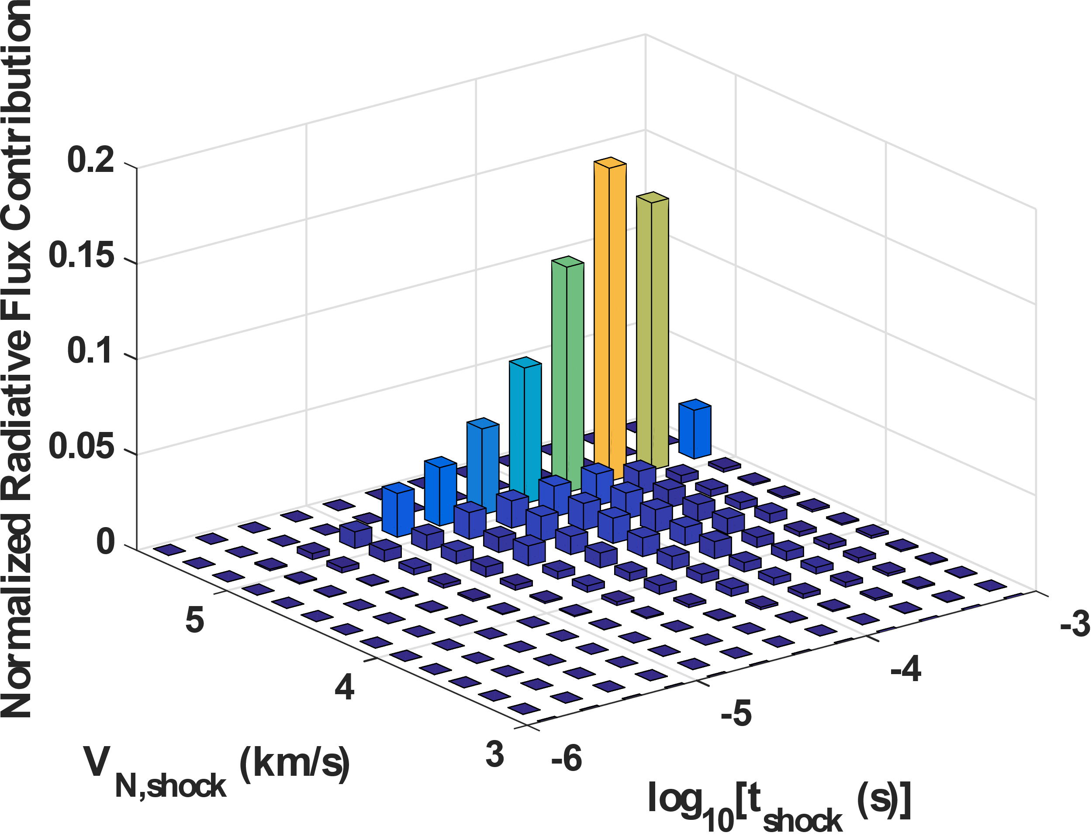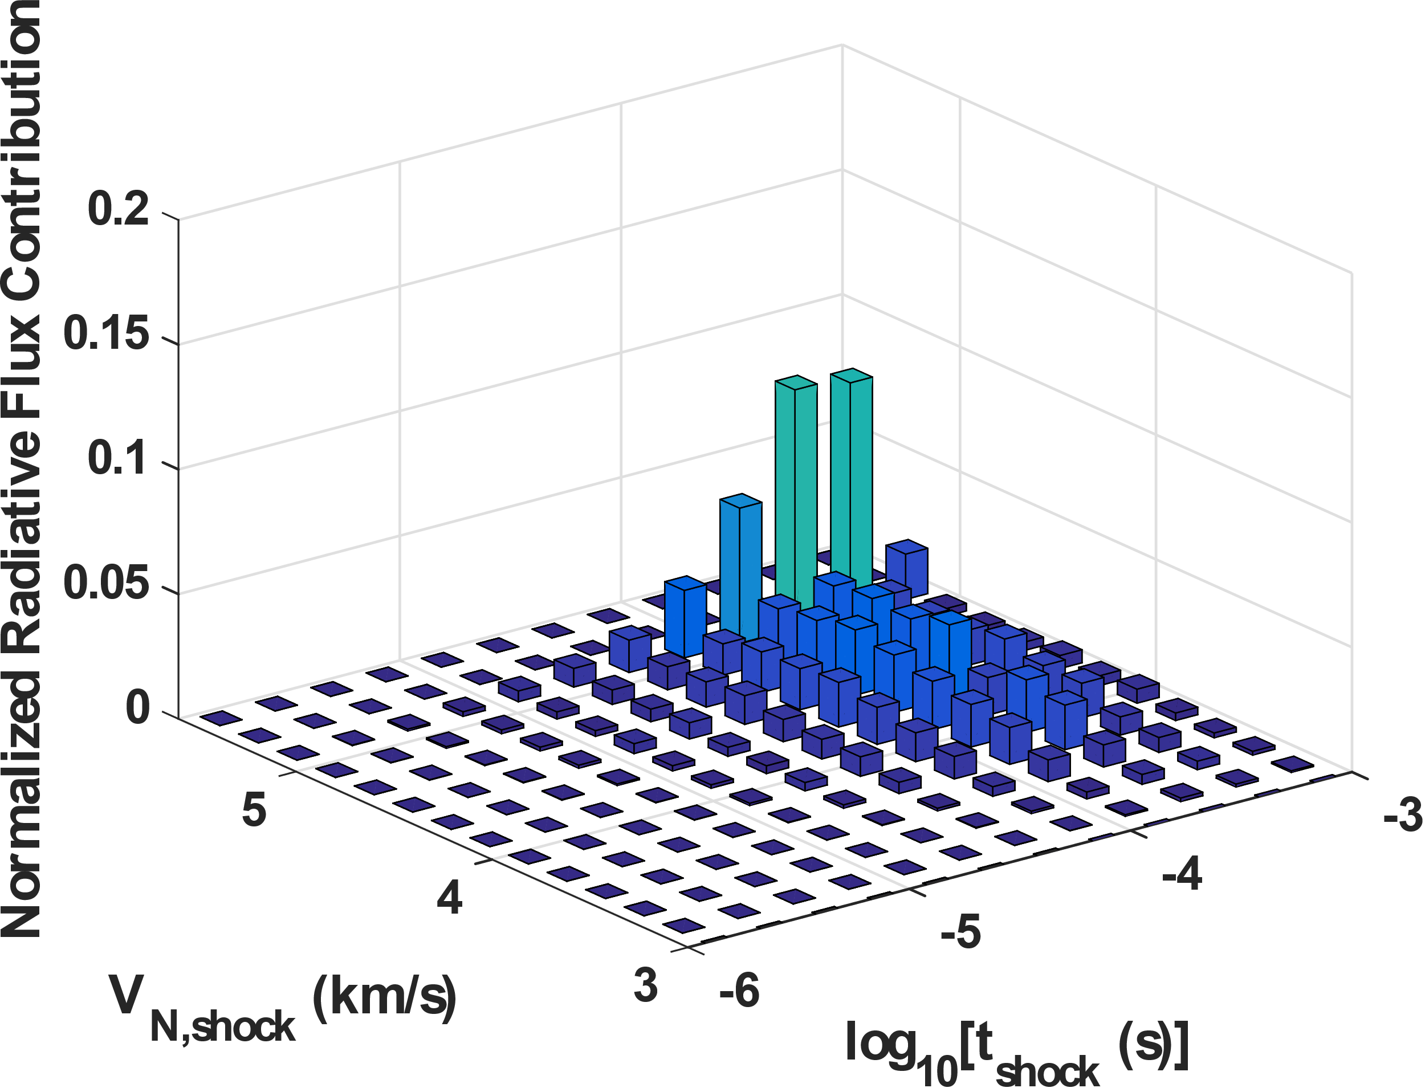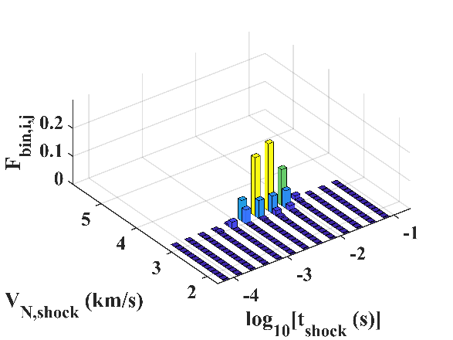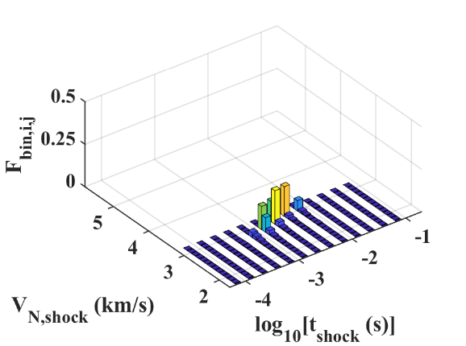

Fig. 2. Representative histograms showing the relative contributions to radiative heating in terms of normal shock velocity and Lagrangian time from the shock front. (top) Dragonfly point b (left) and c (right) at 0.4 Torr equivalent freestream pressure, (bottom) Mars2020 MTB08 (left) and MTB07 (right) at an equivalent pressure of 1.1 Torr.

Flowfield property binning was performed for two planetary probe missions – the first is Mars2020 which brought the Perseverance rover to the surface of Mars in 2021 and the second is the Dragonfly mission scheduled to arrive in Titan in the mid-2030s. Fig. 1 shows representative body points on each spacecraft. The Mars 2020 points correspond with the location of heat flux gauges on the vehicle backshell, known as MTB07 on the windside and MTB08 on the leeside. The points considered for Dragonfly are labeled a-d. Shock tube informed bias analysis was performed along the reconstructed Best Estimated Trajectory (BET) for Mars 2020 and for a candidate Dragonfly trajectory, yielding histograms such as shown in Fig. 2. Points on the trajectory are selected for validation – each point providing a value of $(v_{eff},ρ_{eff})$. For the majority of tests, $ρ_{1}$ is chosen as $ρ_{eff}$ and the range of $v_{1}$ to be tested is chosen to cover 90% of the histogram. This led to the test conditions shown in Fig. 3, overlaid with the trajectories studied. As of this work, 59 tests were performed for Mars entry and 58 for Titan. Additional tests at lower density (earlier times) in the trajectory are planned to be conducted in the EAST Low Density Shock Tube, a 54 cm diameter tube which is currently being installed in the facility.
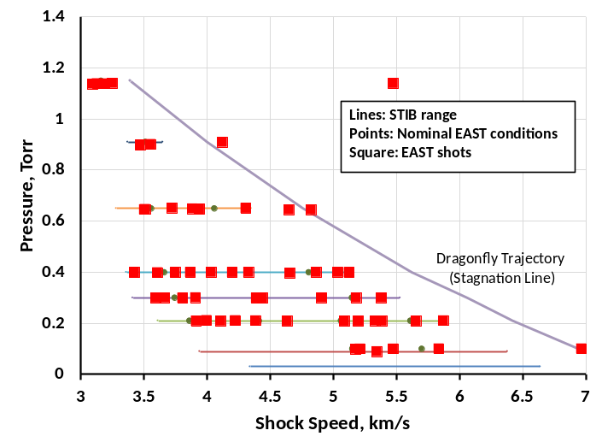
Fig. 3. Diagrams showing selected test points in velocity and density or pressure in the shock tube. The trajectory, which corresponds to stagnation line heating is also shown. (top) Dragonfly, (bottom) Mars2020.

3 Experiment
Representative results in the EAST facility are given in Fig. 4. Radiation from the shock is measured by four simultaneous spectrometers capable of spanning the Vacuum Ultraviolet through mid-Infrared (120-5500 nm). The spectrometers provide a 3D map of radiance (in absolute units) versus position in the tube (equivalently, distance or time behind the shock) and wavelength. Different spectral regions correspond to different transitions of the atoms and molecules in the shock. The examples shown in Fig. 4 display the CN Violet transition measured in Titan (2.2% CH₄ molar in N₂) gas and CO₂ ν₃ fundamental in Mars (1.9% Ar, 2.2% N₂ molar in CO₂) gas. These two features are the primary contributor of radiation (60-80%) in their respective entries. Additional contributors are measured and analyzed during the test series, but not shown in detail in this paper. The entirety of data measured in the test series is available through data.nasa.gov. A representative shock tube informed bias for each contributor is discussed below. More detailed future papers will examine the entirety of the datasets.
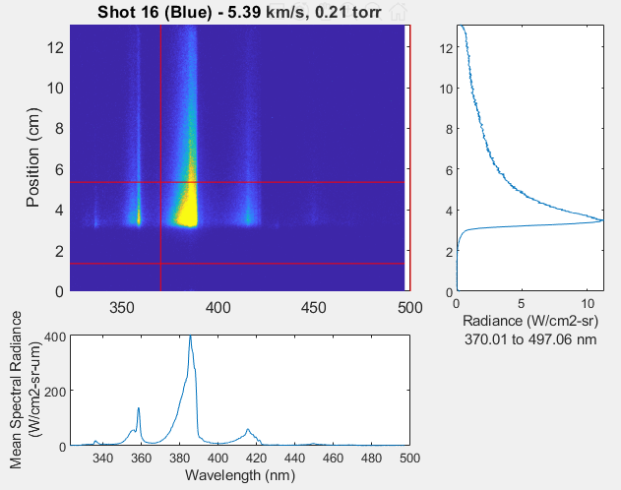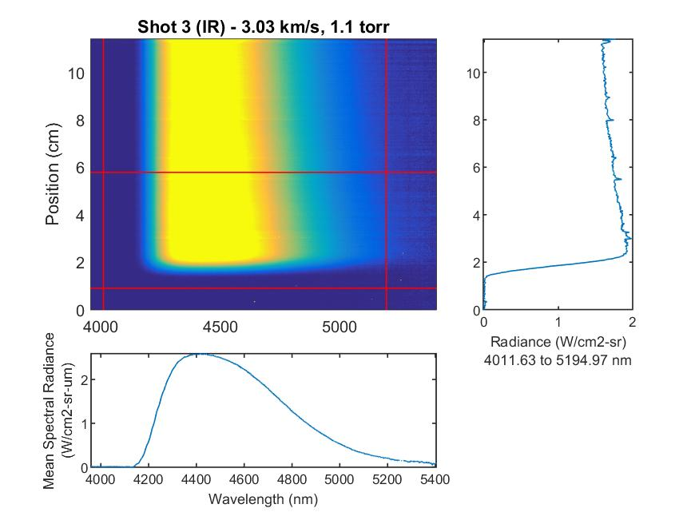
Fig. 4. Representative Radiation data obtained in the EAST facility. (left) CN Violet bands for Dragonfly entry, (right) CO₂ ν₃ fundamental for Mars2020 entry.

For Mars2020 entries, the effective length scales achieved in the test were somewhat less than those required by shock tube informed bias. Additional tests may be required at higher pressure to provide the missing validation data. At densities corresponding to later times in the trajectory, the shock chemistry is frozen on the timescale of the experiment, so it is not possible to assign an uncertainty at this time. A few tests performed at ~5x higher pressure are still pending analysis. However, at 3.2 km/s, which corresponds to peak radiative heating, chemistry is observed and is well described as an exponential decay toward equilibrium. The post shock radiance is fit with an exponential decay and extrapolated to 1-8 ms which corresponds to the timescales in Fig. 3. Similar fits are performed on model predictions using two different Mars atmosphere chemical kinetic models, referred to as Johnston [9] and Cruden [10]. The difference is evaluated across the two major bands responsible for Mars backshell radiation and used to assign an uncertainty to each prediction as shown in Fig. 5, corresponding to the MTB08 location. At the body point shown uncertainties are +2% for Cruden and -3% for Johnston model. Applying these uncertainties to the backshell heating predictions gives a consistent heating value of 4.3 W/cm² which can be considered to be the shock tube inferred radiative heat flux on the vehicle. This inferred value is lower than the measured value by about 0.3 W/cm² at both locations, which implies that the radiation models themselves are not responsible for the underprediction of the backshell heating. The total error in backshell prediction was about 8%, which is just outside the 5.2% uncertainty in the measurement, including radiative and convective components. The remaining error in prediction is believed to be a combination of inaccuracy in convective heating and uncertainty in the BET.
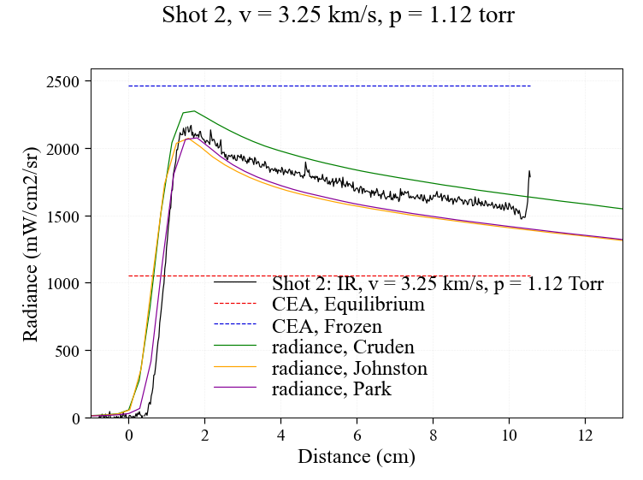
STIB Estimate
~0.4 ms
Fig. 5. (left) representative comparison of how EAST data compares to predictions with different kinetic models. (right) Applying the EAST uncertainty to predictions of backshell heating by the two models. Also shown is the flight data with convective heating contribution removed.

For Titan entry, Fig. 6 shows a comparison of predictions to measurements at high and low velocity. The high velocity case is overpredicted throughout and shows an exponential decay toward equilibrium. Hence, the same procedure of fitting the exponential decay is employed to assess the uncertainty. At lower velocity, the radiance is underpredicted and appears to plateau at values above equilibrium in both the predictions and experiment. The plateau is due to slower reactions involving primarily HCN that do not come to equilibrium in the measurement timescale. Therefore, the uncertainty is assumed to be constant outside of the measured time. This quantified uncertainty is shown in the contour plot of Fig. 6(c) for the selected time point. The 90% bounds of the four body points are overlaid on the figure, as well as the region over which measurement is performed. By integrating the product of the histogram and the uncertainty map, uncertainty values are derived after different locations behind the shock. Table 1 shows that this value decreases from 102 to 14% moving from the shoulder toward the back of the vehicle. This uncertainty is evaluated at only a single trajectory point. Future work will extend the study to additional times.
(a)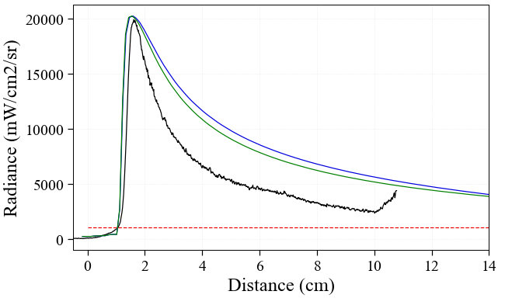(b)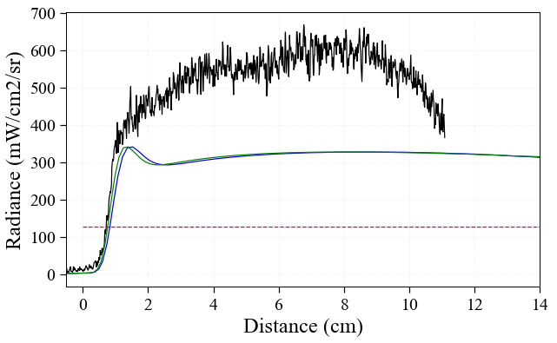

(c)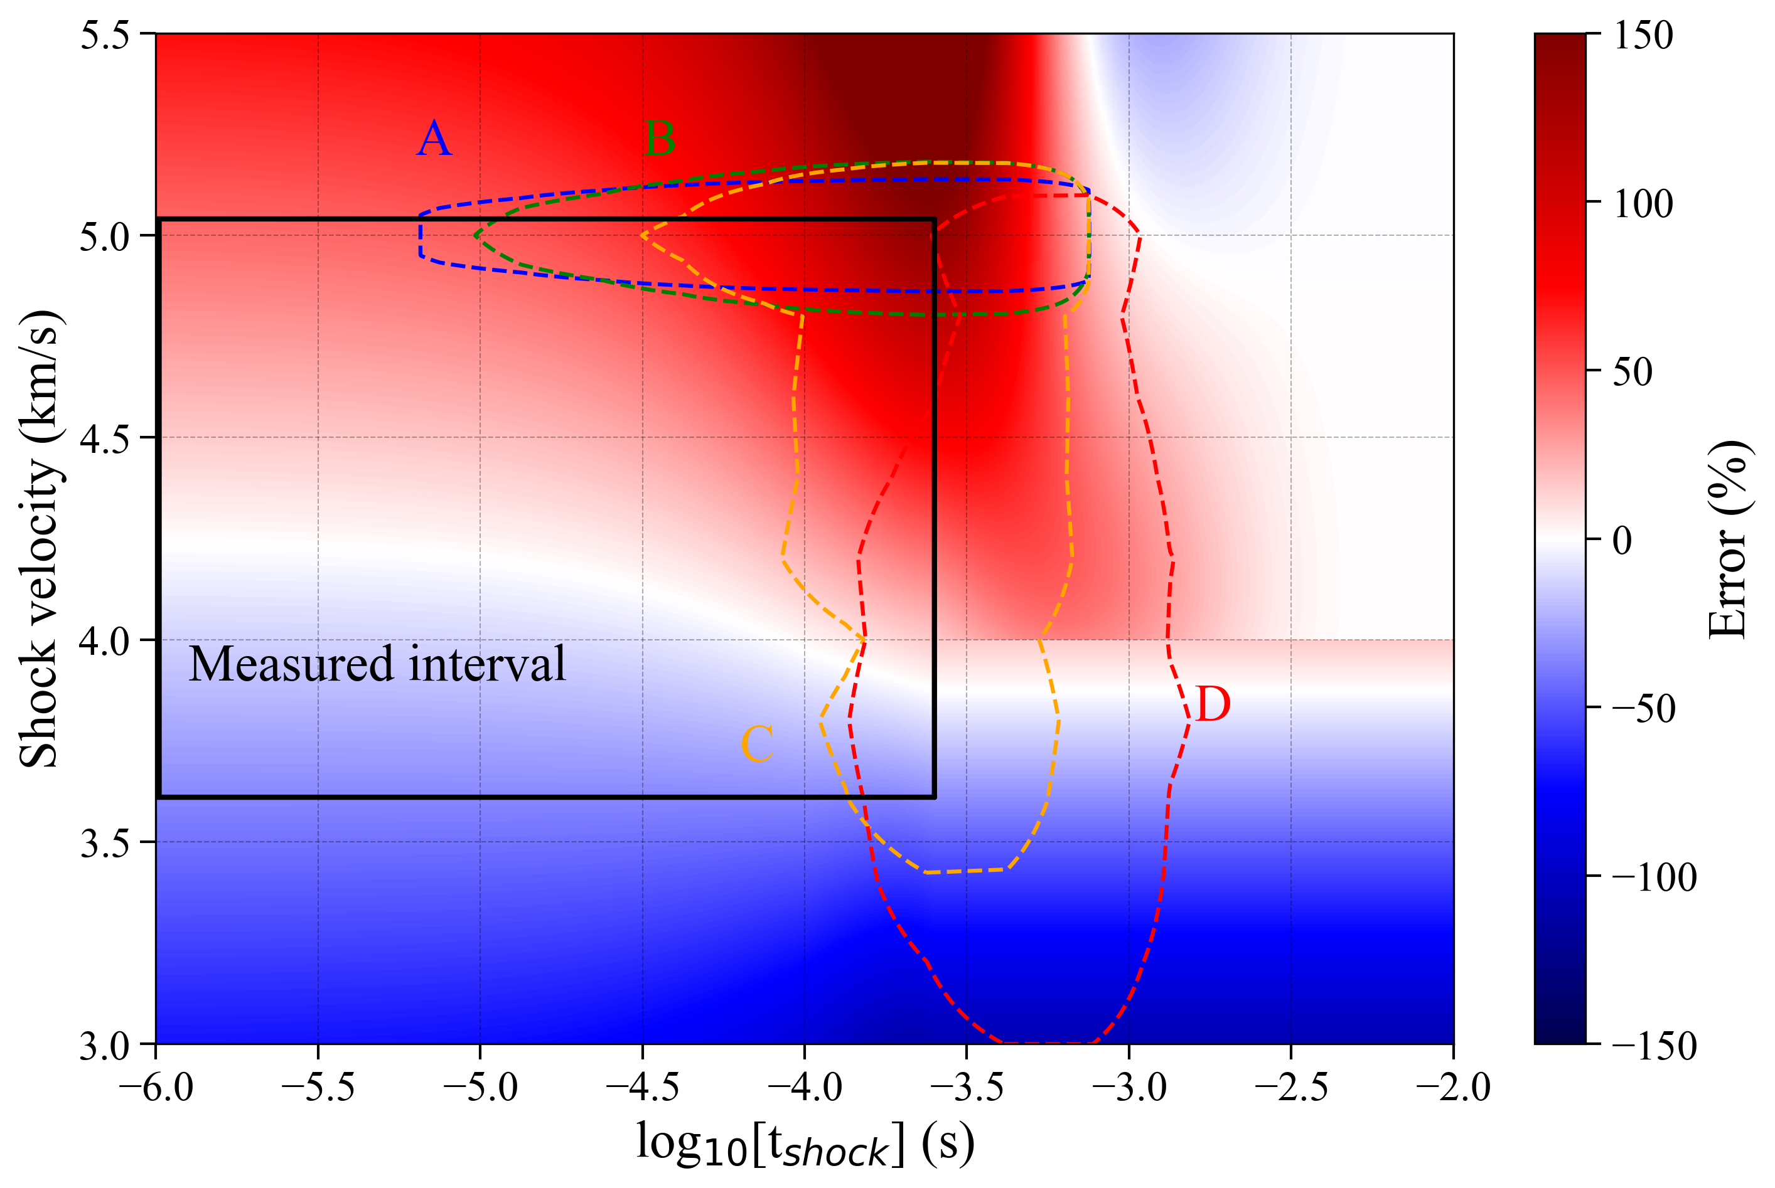
Fig. 6. Comparison of predicted to measured CN Violet radiation at (a) 3.61 km/s and (b) 5.04 km/s. (c) Map of prediction error versus shock velocity (v₁) and the post-shock Lagrangian time (p=0.4 Torr).

Table 1: Estimated error on the predicted wall radiative heat flux at the four surface points considered. Locations are as depicted on Fig. 1
Surface point | A | B | C | D
Estimated error | +102% | +92% | +65% | +14%

4 Conclusion

The method of shock tube informed bias has been presented here and shows a way to build similarity between spacecraft aftbody heating during planetary entry and incident shock measurements. The methodology is applied to two test series in the Electric Arc Shock Tube (EAST) facility at NASA Ames to inform the backshell environment for Mars 2020 and Dragonfly spacecraft.

The shock tube measurements themselves provide indications of where radiative heating model error may originate from. In the case of Mars entry, different in the CO₂ reaction rates bracket the data and may suggest opportunity to refine the model for increased accuracy. For Titan entry, further analysis of the data [3, 5] give indications of prediction errors in both CN reaction kinetics and the non-Boltzmann behavior modeling. These inaccuracies will be refined in the future and should allow reduced uncertainties to be obtained via STIB.

Applying STIB to quantify the differences of measurement to simulation at Mars, it is possible to infer the heating experienced by the spacecraft during entry. The result obtained is consistent when applied to two independent models. Comparing the result to the flight data suggests that remaining underpredictions are due to phenomena other than radiative heating. For Dragonfly entry, the shock tube informed bias suggests that predictions are conservative and quantifies an uncertainty that may be used by mission designers to construct heat shield margin policies. Backshell measurements with the DrEAM measurement suite [11] will provide additional verification in the distant future when Dragonfly entry occurs.

References

[1] C.O. Johnston, Evaluating Shock-Tube Informed Biases for Shock-Layer Radiative Heating Simulations, AIAA Aviation 2019 Forum. 2019-3259 (2019)
[2] A.C. Tibère-Inglesse et al., Examination of Mars2020 shock-layer conditions via infrared emission spectroscopy of CO2, AIAA SCITECH 2023 Forum. 2023-0960 (2023)
[3] A. Tibere-Inglesse et al., Backshell radiation measurements in the EAST facility for Titan entry, AIAA AVIATION. (2023)
[4] C. Jelloian et al., Examination of Mars2020 shock-layer conditions via infrared laser absorption spectroscopy of CO2 and CO, AIAA SCITECH 2023 Forum. (2023)
[5] E. Chang et al., Laser Absorption Spectroscopy Measurements of Post-Shock Non-Equilibrium Species in the NASA Ames Electric Arc Shock Tube, AIAA SCITECH 2023 Forum. (2023)
[6] R.A. Miller et al., MEDLI2: MISP Measured Aftbody Aerothermal Environments, AIAA SCITECH 2022 Forum. (2022)
[7] Ames Research Staff, Equations, Tables and Charts for Compressible Flow, NACA Report 1135. (1953)
[8] C.O. Johnston, Shock-Layer Radiation Insights Available Through Flowfield-Property Binning, AIAA SCITECH 2022 Forum. (2022)
[9] C.O. Johnston, A.M. Brandis, Journal of Quantitative Spectroscopy and Radiative Transfer 149, 303-317 (2014)
[10] B.A. Cruden et al., Characterization of CO Thermochemistry in Incident Shockwaves, 2018 Joint Thermophysics and Heat Transfer Conference. (2018)
[11] A. Brandis et al., Dragonfly Aerothermal Environment and Aerosciences Instrumentation, AIAA SCITECH. (2023)

https://data.nasa.gov/docs/datasets/aerothermodynamics/EAST/index.html, Tests 64 and 65

