PACE OCI Flight Unit Pre-launch Spectral Characterization

Samuel Kitchen-McKinley¹, Jeff McIntire¹, Hyeungu Choi², Gerhard Meister³, Julia Barsi¹, Brendan McAndrew³, Andrei Sushkov⁵, Barbara Zukowski⁴, William B. Cook³, Ulrik Gliese⁶, Kenneth Squire⁷, Joseph Knuble³

¹Science Systems and Applications, Inc., Lanham, MD 20706, USA
²Global Science & Technology, Greenbelt, MD 20707, USA
³NASA Goddard Space Flight Center, Greenbelt, MD 20771, USA
⁴Ball Aerospace, Lanham, MD 20706, USA
⁵Genesis Engineering Solutions, Inc., Lanham, MD 20706, USA
⁶KBR,
⁷Space Dynamics Laboratory, North Logan, UT, 84341, USA

Abstract

The Plankton, Aerosol, Cloud, ocean Ecosystem (PACE) mission [1] will extend and improve the data record of NASA’s satellite observations of global ocean biology, aerosols, and clouds. The Ocean Color Instrument (OCI) is the primary sensor on-board the PACE platform [2]. The OCI is a scanning radiometer with hyperspectral coverage from the ultraviolet (UV) to the near infrared (NIR) wavelength range and a fiber-coupled multiband filter spectrograph in the short-wave infrared (SWIR) spectral region. The OCI Flight Unit completed system level testing in November 2022 at the Goddard Space Flight Center (GSFC).
This paper presents the spectral characterization and performance of the OCI Flight Unit. The OCI Flight spectral performance was determined to be within design specifications and the characterization was measured within specified uncertainties.

Index Terms— PACE, OCI, Pre-Launch, RSR, Performance

1. Introduction

The OCI is a new type of sensor that builds on the design of heritage sensors MODIS [3], and VIIRS [4], as well as lessons learned from the prototype sensor ORCA [5]. The OCI is the primary sensor onboard the PACE platform scheduled to launch in January 2024. Unlike its heritage sensors, OCI has two slit grating hyperspectral spectrographs in addition to a fiber-coupled multiband filter spectrograph. The light is split into three spectral regions using dichroic filters: approximately 340nm – 605nm for the UV-VIS Focal Plane Assembly (FPA), 605nm – 905nm for the VIS-NIR FPA, and 905nm – 2400nm for the SWIR Detector Assembly (SDA). The two hyperspectral spectrographs use programmable CCD detectors that aggregate multiple CCD pixels which can aggregate one CCD pixel into 1, 2, 4, or 8 pixels in both the spatial and spectral direction independently. The maximum 8x8 aggregation represents a science pixel, a 1km square on the ground at nadir for each band with a 5nm bandwidth. The SDA provides nine separate bands from 940nm to 2260nm. Each SWIR band readout is a 1km square with various bandwidths. The OCI is scanning telescope utilizing a two-sided Half Angle Mirror (HAM) to de-rotate the light sent into the main optical sub bench. More details of the OCI design are described in Gorman et. al. [2].
The OCI Flight Unit was tested in thermal vacuum (TVAC) in September and October 2022 to assess characterization and performance compliance to design requirements. During the test campaign all OCI bands were tested in TVAC for their spectral characterization and performance compliance to design requirements. An overview of the OCI prelaunch test campaign is described in Meister et. al. [6].

2. TEST MEASUREMENTS

The OCI spectral characteristics were determined by sweeping a monochromatic source across the spectral range from 310nm to 2400nm. The test program used the Goddard Laser for Absolute Measurement of Radiance (GLAMR) as a tunable monochromatic source [7]. The laser source was fed into a 20 inch integrating sphere with three NIST traceable calibrated radiometers. The integrating sphere was placed 8 inches in front of the TVAC chamber window, with the center of the integrating sphere’s 8 inch aperture aligned to the Flight Unit’s nadir direction. The laser source was swept in 1nm steps for in-band regions. Four hyperspectral regions 10nm wide centered at 347nm, 555nm, 620nm, and 870nm, where swept in 0.2nm steps (two per CCD). Out-of-band regions in the SWIR, 900nm to 2400nm, where swept in 10nm steps. In-band radiance was set by GLAMR to 90% of L_{max} (maximum expected radiance expected on orbit) or L_{clip} (maximum radiance set for high gain bands). Out-of-band radiance in the SWIR region was set to output the maximum possible radiance by GLAMR.
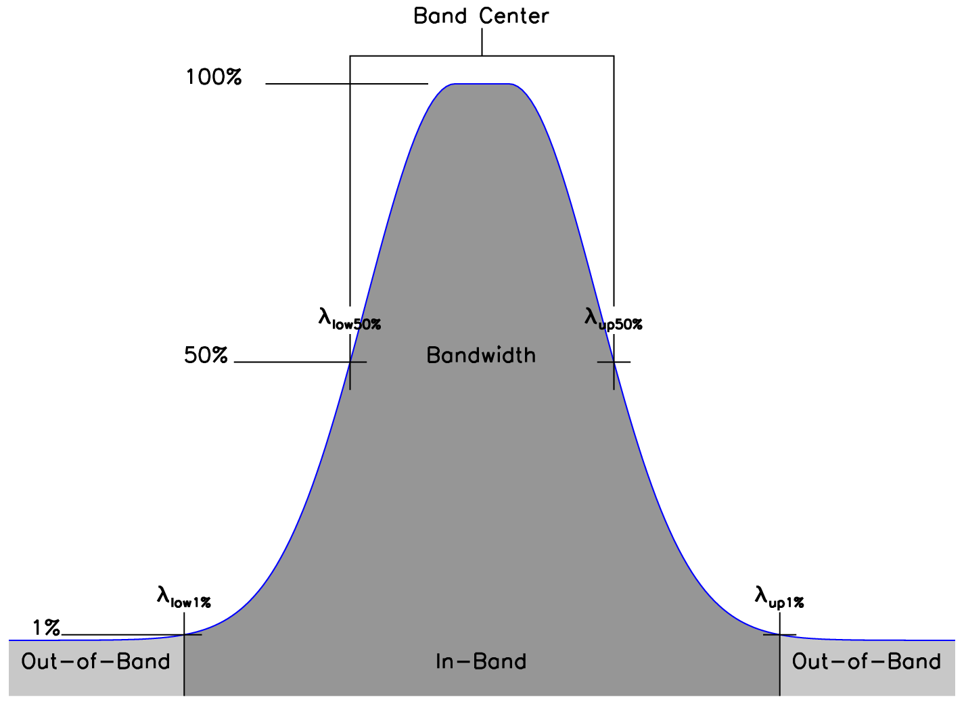
Figure 1. A general visual description of an RSR profile and its key values.
For each collect, the OCI was exposed to the GLAMR source held at a constant wavelength and radiance for a 35 second duration. The radiance and wavelength were measured by the GLAMR radiometers and a GLAMR wavemeter averaged over the collect period. The OCI response for each band was averaged over the collect period and uniform aperture of the integrating sphere, providing approximately 4000 samples per band, per HAM side, per collect. The results in this paper are based on 1386 collects.

3. DATA ANALYSIS

The OCI response is offset corrected for each scan by subtracting the average digital number count (DN) of the internal dark view pixels from the digital number count of the Earth view pixels.
dn = DN_{EV}-<DN_{DV}>
Absolute spectral response (ASR) of each band is a function of input GLAMR wavelength (λ) calculated with the OCI response and GLAMR input radiance, L, at that wavelength.
ASR(λ) = dn(λ)/L(λ)
From this we can get the relative spectral response (RSR), integrated out-of-band response ratio (IOOB), system gain, band centers, and bandwidths, per band, per HAM side. RSR is defined as,
RSR(λ) = ASR(λ)/max[ASR]
The system gain is defined for all measured λ as,
Gain = ΣASR(λ)Δλ
The integrated out-of-band response ratio is defined as,
IOOB = OOB/IB
where,
IB = ΣRSR(λ)Δλ, for all λ in-band
OOB = ΣRSR(λ)Δλ, for all λ out-of-band
The in-band (IB) spectral region is defined where the RSR is more than 1%, and the out-of-band (OOB) spectral region is defined where the RSR is less than 1%. The bandwidth is defined as the full width half max (FWHM) of the RSR, and the band center is defined as the center of the FWHM wavelengths. These definitions are described visually in Figure 1. Each collect was measured with the CCD aggregation set to 8 cross-track pixels by 1 spectral pixel. This was done so that analysis could be performed at the highest spectral resolution, while improving SNR. This paper will show the results in 8x1, for HAM side A. HAM side B showed similar results. The RSR in 8x1 can be aggregated as necessary to accommodate whichever spectral aggregation mode the OCI is set to. The 8x1 pixels were also aggregated offline to 8x8 science pixels to characterize the science level bands with 5 nm bandwidths. This was done to verify the OCI complied with design requirements defined at the science pixel level.

4. Results

The UV-VIS FPA provides 480 bands from 307.8125nm to 607.1875nm (nominal center wavelengths) and the VIS-NIR FPA provides 480 bands from 597.8125nm to 897.1875nm (nominal center wavelengths), each with 0.625nm spacing. Only bands from 340nm to 595nm on the UV-VIS FPA and bands from 615nm to 885nm on the VIS-NIR FPA were evaluated against design requirements. Hyperspectral bands less than 340nm and greater than 885nm have low sensitivity in the OCI and GLAMR has a low radiance output below 340nm. The OCI bands between 595nm and 615nm have low sensitivity and greater uncertainty because they are in the dichroic transition region.
Figure 2 shows the dispersion, bandwidth, gain, and integrated OOB response ratio for both hyperspectral FPAs. The nominal design center wavelengths and the measured center wavelengths agree to better than 1nm for both FPAs. The UV-VIS bands have a bandwidth of 4.1nm and the VIS-NIR bands have a bandwidth of 3.6nm. This is based on the bands measured in fine 0.2nm steps. The spread of bandwidths seen in the plot occur because most bands were measured in course 1nm steps. In a future analysis, this will be improved by using the fine stepped bands as a model to interpolate the course stepped bands. This is possible because the RSR profile is expected to be similar across all hyperspectral bands. This can be seen in Figure 3 which shows the in-band RSR for select hyperspectral bands. The RSR is currently linearly interpolated (lines) between the measured response points (circles). Bands with fine steps versus course steps can be seen clearly in the example bands shown in Figure 3.
Figure 2 also shows the integrated OOB response ratio is 2-4% for the UV-VIS FPA and less than 1% for the VIS-NIR FPA. The OOB RSR can be seen in Figure 4. The OOB regions beyond the wavelengths in each FPA show a noise floor of 10⁻⁶. This is limited based on the 4000 averaged samples. The wavelengths within each FPA show a base response at 10⁻⁵ with electronic crosstalk peaks at 10⁻⁴ every 20nm. There are some isolated optical crosstalk peaks up to 10⁻³. These peaks were expected from the optical and electronic models.
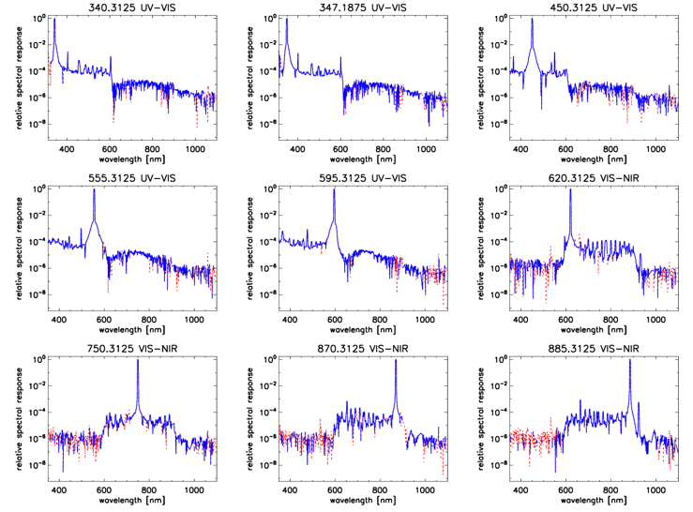
Figure 4. Out-of-band RSR for 9 select bands from the UV-VIS and VIS-NIR FPAs in log scale. The blue line is positive RSR values and the red dotted line is negative RSR values plotted as the absolute value. The nominal band center and FPA name is in the title for each plot.
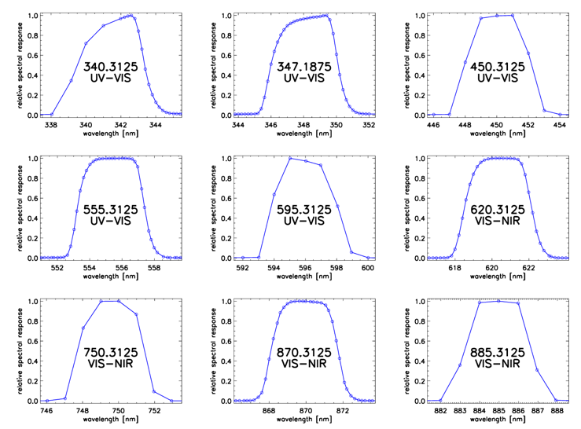
Figure 3. Measured in-band RSR for 9 select bands in the UV-VIS and VIS-NIR FPAs. Circles are individual measurements. The nominal band center and FPA name is displayed on each plot.
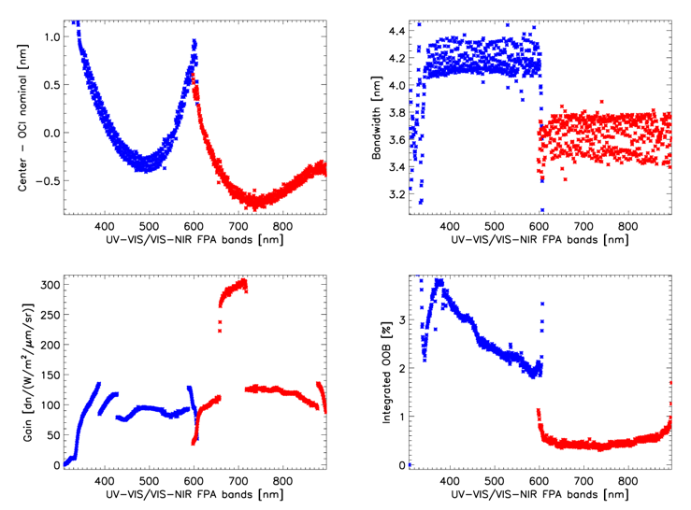
Figure 2. Results for all UV-VIS (blue) and VIS-NIR (red) FPA bands. Top left plot shows the spectral dispersion as the difference from the measured center wavelengths to the nominal center wavelengths of each band. Top right shows the bandwidth for each band. Bottom left shows the measured absolute system gain. Bottom right shows the integrated out-of-band response ratio.
The SWIR Detector Assembly provides nine bands as shown in Table 1. Figure 5 shows the in-band RSR profile for each SWIR band. Most bands show a clear “hump” on the upper edge of the band. This is thought to be due to the edge effects of the filters. Figure 6 shows a log plot of the OOB RSR for each SWIR band. Like the hyperspectral bands, the noise floor limited the RSR to a minimum of 10⁻⁶. There are clear OOB response features in each band with peaks up to 10⁻⁴. These features were expected based on component level testing of the SDA.
Table 1. SWIR measured center wavelength, bandwidth, and integrated OOB response ratio (SG: standard gain; HG: high gain).

Band Name | Center [nm] | FWHM [nm] | IOOB [%] | Gain [dn/(W/m2/  sr/um)]
940 SG | 939.7 | 44.3 | 0.20 | 448
1038 HG | 1038.3 | 74.4 | 0.13 | 2028
1250 SG | 1250.4 | 28.5 | 0.16 | 684
1250 HG | 1248.5 | 28.6 | 0.13 | 5494
1378 SG | 1378.2 | 14.4 | 0.19 | 763
1615 SG | 1619.6 | 73.7 | 0.11 | 1571
1615 HG | 1618.0 | 73.6 | 0.11 | 12186
2130 SG | 2130.6 | 49.3 | 0.12 | 4652
2260 SG | 2258.4 | 72.8 | 0.18 | 6440

5. conclusion

The Flight test campaign completed in November 2022. The OCI spectral characteristics were measured in TVAC using GLAMR as a monochromatic source. All tested OCI bands were found to be within requirements. Measuring the spectral characteristics is a large test that requires hundreds of measurements taken over many days in TVAC. Measurements were repeated if the GLAMR source was unstable. This required real time monitoring of the GLAMR source and OCI by test conductors as well as daily OCI analysis to ensure all required data points were recorded within stability requirements. Automatic flags and then manual data quality checks were made during post processing to ensure the best collects were used for each data point. The OCI Flight Unit performed as expected based on modeling and the OCI Engineering Test Unit (ETU) that was characterized in 2020 and 2021 [8,9]. The spectral characterization of the Flight Unit went very well based on lessons learned on the ETU. In particular, the SWIR in-band regions were covered better and the GLAMR performance was improved to output higher radiance in the UV region from 340nm to 550nm.

6. ACKNOWLEDGEMENTS

The authors would like to thank the OCI test team, the GLAMR team, and the XINA team for working to provide all the test data. The GLAMR team was especially helpful to properly understand and verify the test data used in this analysis.
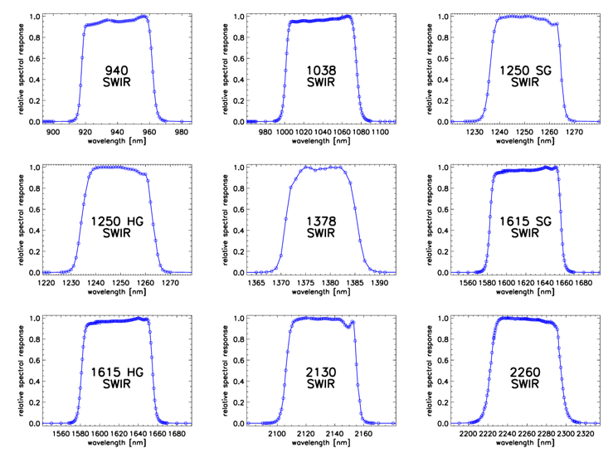
Figure 5. Measured in-band RSR for all 9 SWIR bands. Circles are individual measurements. The nominal band center is displayed on each plot.
7. References

[1] Werdell, P. J., et al. 2019. "The Plankton, Aerosol, Cloud, ocean Ecosystem (PACE) mission: Status, science, advances." Bulletin of the American Meteorological Society, 100 (9): 1775–1794 (2019)

[2] Eric T. Gorman, et al., "The NASA Plankton, Aerosol, Cloud, ocean Ecosystem (PACE) mission: an emerging era of global, hyperspectral Earth system remote sensing," Proc. SPIE 11151, Sensors, Systems, and Next-Generation Satellites XXIII, 111510G (10 October 2019)

[3] Barnes, W. L. and Salomonson, V. V., “Modis: A global imaging spectroradiometer for the earth observing system,” in [Optical Technologies for Aerospace Sensing: A Critical Review], 10269, 102690G, International Society for Optics and Photonics (1992).
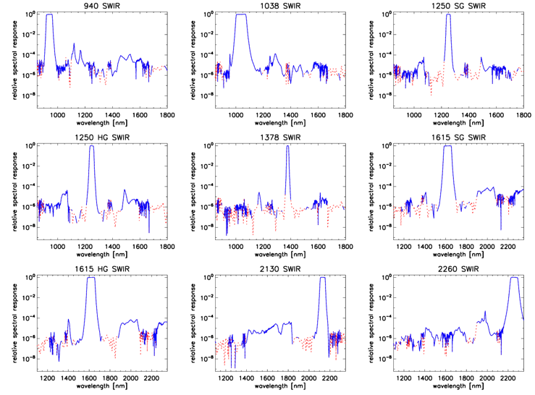
Figure 6. Out-of-band RSR for all 9 SWIR bands in log scale. The blue line is positive RSR values and the red dotted line is negative RSR values plotted as the absolute value. The band name is the title in each plot.
[4] Murphy, R., et al., “The visible infrared imaging radiometer suite,” in [Earth science satellite remote sensing], 199–223, Springer (2006).

[5] Wilson, M. E., et al., “Optical design of the ocean radiometer for carbon assessment,” in [Earth Observing Systems XVI], 8153, 81530S, International Society for Optics and Photonics (2011).

[6] Gerhard Meister, et al., “Initial Look at the Results from the Prelaunch Characterization Campaign of OCI on the PACE mission”, TH1.R6: NASA PACE Mission, IGARSS 2023, accepted.

[7] Julia A. Barsi, et al., "Spectral testing of the Landsat-9 OLI-2 instrument using the Goddard Laser Absolute Measurement of Radiance (GLAMR)," Proc. SPIE 10764, Earth Observing Systems XXIII, 1076405 (7 September 2018).

[8] Samuel Kitchen-McKinley, et al., "PACE OCI pre-launch ETU spectral characterization and performance," Proc. SPIE 11829, Earth Observing Systems XXVI, 118290Q (1 August 2021)

[9] Gerhard Meister, et al., “Test Results from the Prelaunch Characterization Campaign of the Engineering Test Unit of the Ocean Color Instrument of NASA’s Plankton, Aerosol, Cloud and Ocean Ecosystem Mission” Front. Remote Sens., Sec. Multi- and Hyper-Spectral Imaging, 23 June 2022.

