Evaluation of SWER(Ze) Relationships
by Precipitation Imaging Package (PIP)
during ICE-POP 2018

Ali Tokay*

Goddard Earth Sciences Technology and Research (GESTAR-II),
University of Maryland Baltimore County and
NASA Goddard Space Flight Center, Greenbelt, Maryland

Charles N. Helms
NASA Postdoctoral Program - Oak Ridge Associated Universities and
NASA Goddard Space Flight Center, Greenbelt, Maryland

Kwonil Kim
Kyungpook National University, South Korea

Patrick N. Gatlin
NASA Marshall Space Flight Center, Huntsville, Alabama

David B. Wolff
NASA Goddard Space Flight Center Wallops Flight Facility, Wallops Island, Virginia

Submitted to Journal of Hydrometeorology

June 20, 2022
Revised on November 30, 2022
Accepted on December 30, 2022

*Corresponding Author:
Mesoscale Processes Laboratory (Code 612.0),
NASA Goddard Space Flight Center, Greenbelt, MD 20771
tokay@umbc.edu

Abstract

Improving estimation of snow water equivalent rate (SWER) from radar reflectivity (Ze), known as a SWER(Ze) relationship, is a priority for NASA’s Global Precipitation Measurement (GPM) mission ground validation program as it is needed to comprehensively validate spaceborne precipitation retrievals. This study investigates the performance of eight operational and four research based SWER(Ze) relationships utilizing Precipitation Imaging Probe (PIP) observations from the International Collaborative Experiment – Pyeongchang Olympics and Paraolympics (ICE-POP 2018) field campaign. During ICE-POP 2018, there were 10 snow events that are classified by synoptic conditions as either cold low or warm low and a SWER(Ze) relationship is derived for each event. Additionally, a SWER(Ze) relationship is derived for each synoptic classification by merging all events within each class. Two new types of SWER(Ze) relationships are derived from PIP measurements of bulk density and habit classification. These two physically-based SWER(Ze) relationships provided superior estimates of SWER when compared to the operational, event-specific, and synoptic SWER(Ze) relationships. For estimates of the event snow water equivalent total, the event-specific, synoptic, and best-performing operational SWER(Ze) relationships outperformed the physically-based SWER(Ze) relationship, although the physically-based relationships still performed well. This study recommends using the density or habit based SWER(Ze) relationships for microphysical studies, whereas, the other SWER(Ze) relationships are better suited towards hydrologic application.

1.Introduction

The National Aeronautics and Space Administration’s (NASA’s) Global Precipitation Measurement (GPM) mission is designed to study the physics and space-time variability of global precipitation, which are key in tracing Earth’s water cycle across its weather, climate, and hydrological systems (Skofronick-Jackson et al. 2018). To accomplish this goal, the GPM program has identified the Level-I requirements which include the detection of falling snow and estimates of rainfall rate within prescribed uncertainty levels from the GPM core observatory’s active and passive sensors (Skofronick-Jackson 2017). This raises on a critical question: What is the reference for the validation of GPM precipitation products?

The GPM Ground Validation (GV) program selected the National Oceanic and Atmospheric Administration’s (NOAA’s) Multi-Radar Multi Sensor (MRMS) precipitation estimates as one of the validation products (Zhang et al. 2016, Kirstetter et al. 2020). The MRMS integrates the operational weather radar observations across the conterminous United States (CONUS) and southern Canada with the environmental and climatological data and rain gauge observations and constructs the quantitative precipitation estimate at 1 km resolution with a two-minute update. The environmental data is used to identify the snowy pixels and an empirical relationship is used to estimate the snow water equivalent rate (SWER) from radar reflectivity (Ze) measurements.

The GPM GV program also operates a Validation Network (VN), which constructs a 3-D mosaic of precipitation from several ground-based polarimetric radar networks, both operational and research, with coverage that expands beyond the United States (Petersen et al. 2020, Gatlin et al. 2020). The VN employs several precipitation retrieval algorithms, including empirical ones that relate the dual-polarization radar observables - horizontal reflectivity (ZH), differential reflectivity (ZDR), and differential phase (KDP) - to rainfall rate (R) given (e.g. Cifelli et al. (2011), but the VN does not currently include any SWER estimates. Accurately estimating snowfall from weather radar measurements can be more complicated than its liquid counterpart. SWER estimates can help in more than just validation of GPM snowfall estimates. For example, a comparison between the GPM core observatory and CloudSat radar snowfall products revealed the importance of the assumptions in deriving the SWER(Ze) relationship as well as in rain-snow delimitation algorithms (Skofronick-Jackson et al. 2019).

The search for a SWER(Ze) relationship is a seven decade-long problem. Based on filter paper measurements of melted snowflakes, Marshall and Gunn (1952) report that the SWER can be retrieved from Ze within a factor of 3.5. Rasmussen et al. (2003) presented a table of SWER(Ze) relationships in the form of

Ze = A SWER^{b} (1)

where the A-coefficient and b-exponent ranged between 160-3300, and 1.5-2.2, respectively. They point out that the wide range of A-coefficient and b-exponent depends on the crystal type, degree of riming and aggregation, density, and terminal velocity. A recent study by von Lerber et al. (2017) demonstrates the highly variable nature of the A-coefficient (> 16 times between the extremes) for the snow events measured by a Precipitation Imaging Package (PIP) in Finland. Bukovcic et al. (2020) derived empirical SWER(ZDR, KDP) and SWER(Ze, KDP) relationships from the two-dimensional video disdrometer (2DVD) measurements and applied them to dual-polarimetic radar measurements in Oklahoma. These two polarimetrically-based SWER estimates exhibit smaller bias than the traditional retrieval approach that uses only reflectivity, but their performance hinges on reliable estimates of KDP and ZDR, which can be relatively noisy where snowflake aggregates are present, especially near the ground (Bukovcic et al. 2020).

In addition to the inter- and intra-storm variability of the microphysical characteristics of falling snow (e.g. habit, density), the instrumentation and the derivation of the SWER(Ze) relationships play an important role in SWER estimates. Both Ze and SWER are functions of size, concentration, and the fall velocity of falling snowflakes. The PIP, which was developed by Dr. F. Larry Bliven of NASA Wallops Flight Facility over a decade of diligent work to measure individual precipitation-sized particles (Pettersen et al. 2020a), can measure these three attributes. Its cost effectiveness, ease of assembly, and low-maintenance operation in cold climate regimes (e.g. Souverijins et al. 2017, Shates et al. 2021, Schoger et al. 2021) makes the PIP a reliable device for measuring snowflakes.

This study evaluates the performance of operational- and research-based SWER(Ze) relationships utilizing PIP observations from the International Collaborative Experiment – PyeongChang Olympics and Paralympics (ICE-POP2018). The objective of this study is to evaluate several radar-based SWER(Ze) approaches for mapping precipitation during falling snow so that the VN can use them appropriately to validate spaceborne precipitation retrieval algorithms under the GPM program. Furthermore, more accurate quantitative precipitation estimates (QPE) is of great interest to the broader Earth Science community, and the results have important implications for hydrometeorological applications and cloud-microphysical model validation studies.

This study is organized as follows: the measurement site, the instrumentation, and the events are summarized under observations in Section 2. Section 3 presents the methodology under which the mathematical form of integral snowfall parameters, the derivation of SWER(Ze) relationship, and the evaluation statistics are defined. The operational and research-based SWER(Ze) relationships are given in Sections 4 and 5, respectively. The latter section also defines the density and habit based classification algorithms. Section 6 is dedicated to the two case studies where the time series of PIP-calculated and SWER(Ze) estimated snow water equivalent (SWE) and SWER are presented. The scatter diagrams of the calculated and estimated SWER are also given. The performance of SWER(Ze) relationships for all events is evaluated through two popular statistics in Section 7, followed by the conclusions in Section 8.

2. Observations

- Measurement Site

The ICE-POP 2018 field campaign was an international effort with contributions from 29 agencies from 12 counties led by the Korean Meteorological Administration. One of the main goals of the field campaign was to understand the microphysical characteristics of falling snow in complex terrain (Kim et al. 2021). The field study was conducted over the mid-eastern region of the Korean Peninsula during 2017-18 winter and included a wealth of ground sites both along the Pacific coast and inland in the mountainous regions. This study uses the in-situ and remote sensing observations from a number of instruments at the MayHills supersite (MHS; 789 m above the mean sea level, 37.6652˚N, 128.6996 ˚E). MHS was one of the inland sites and received abundant snowfall over a wide range of temperatures (0˚C ≥ T_{wet-bulb} ≥ -13˚C; T_{wet-bulb}: wet bulb temperature).

b. Instrumentation

The PIP was one of the primary instruments in this study (Figure 1a) and is used to calculate the particle mass, particle size distribution (PSD), and bulk descriptors of snowfall (e.g. SWER, Ze; Pettersen et al. 2020a, Tokay et al. 2022). The Vaisala WXT520 weather station (Figure 1b) outputs the temperature, relative humidity, atmospheric pressure, and wind direction and speed. The temperature and atmospheric pressure are employed to determine the density of air and dynamic viscosity, both of which are used in calculating the particle mass. The temperature, relative humidity, and atmospheric pressure are used to calculate the wet-bulb temperature which determines the snowing minutes (T_{wet-bulb} ≤ 0˚C). The wind rose is constructed based on the wind direction and speed for each event. A third key instrument in this study is the OTT PARSIVEL², a laser-optical disdrometer (Tokay et al. 2014). PARSIVEL² is a present weather sensor and is used here to verify the snowing minutes determined by the WXT520. It should be noted that PARSIVEL² sometimes reports drizzle in the presence of light snow but this limitation should have minimal impact on this study. The METEK Micro Rain Radar (MRR) is a vertically profiling 24 GHz frequency Doppler radar (Klugmann et al. 1996) and is used to determine the echo-top based classification. The MRR at the MHS site is configurated to profile the atmosphere to 4500 m above the ground with a vertical resolution of 150 m and temporal resolution of 30 seconds.

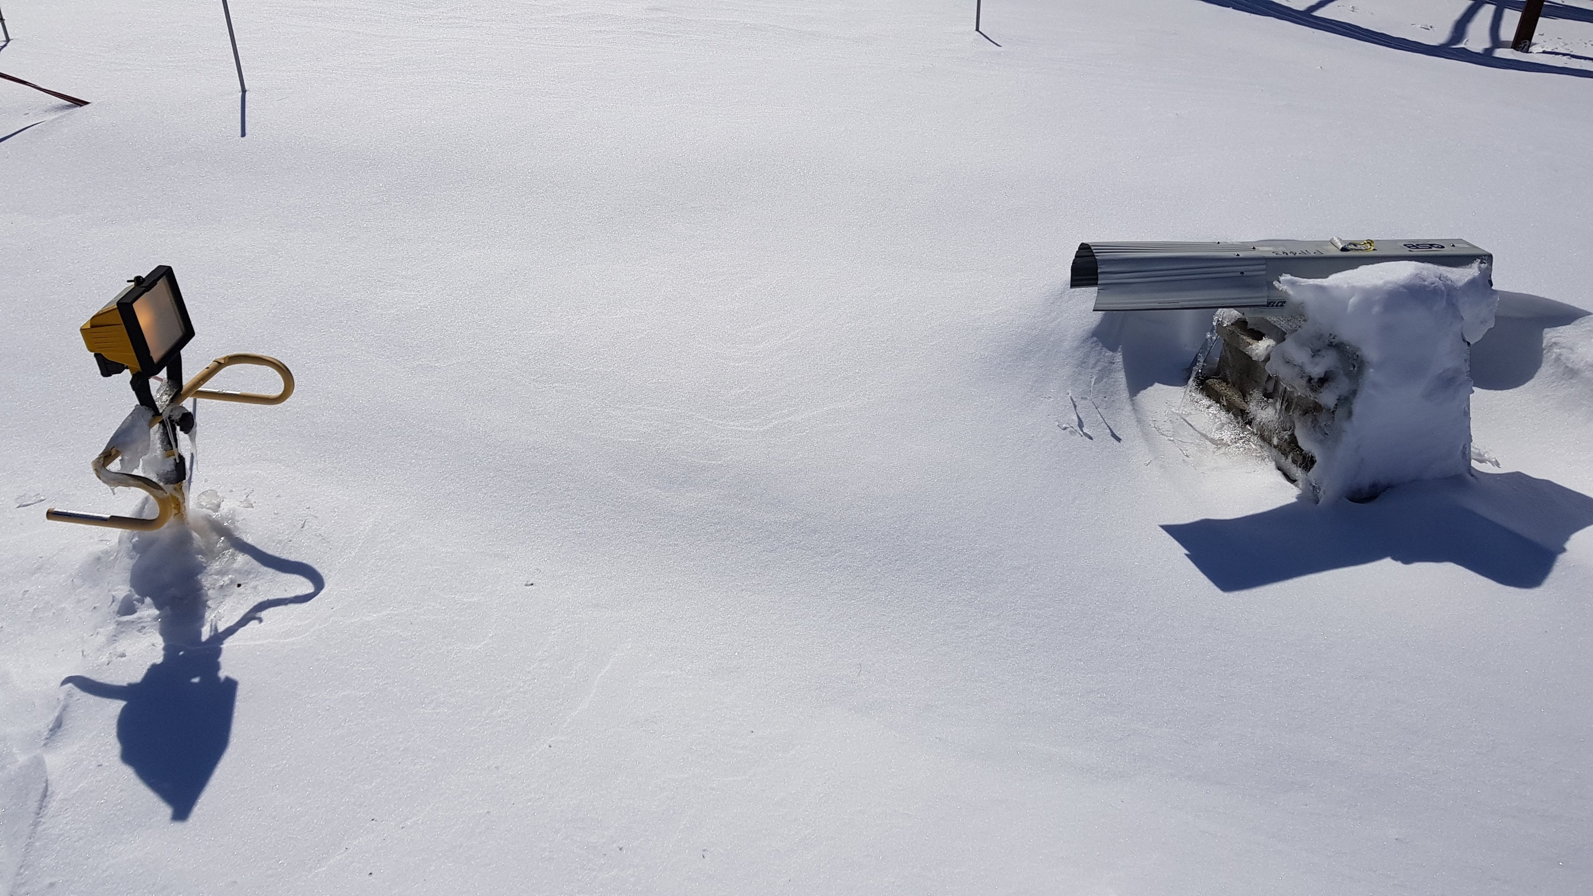
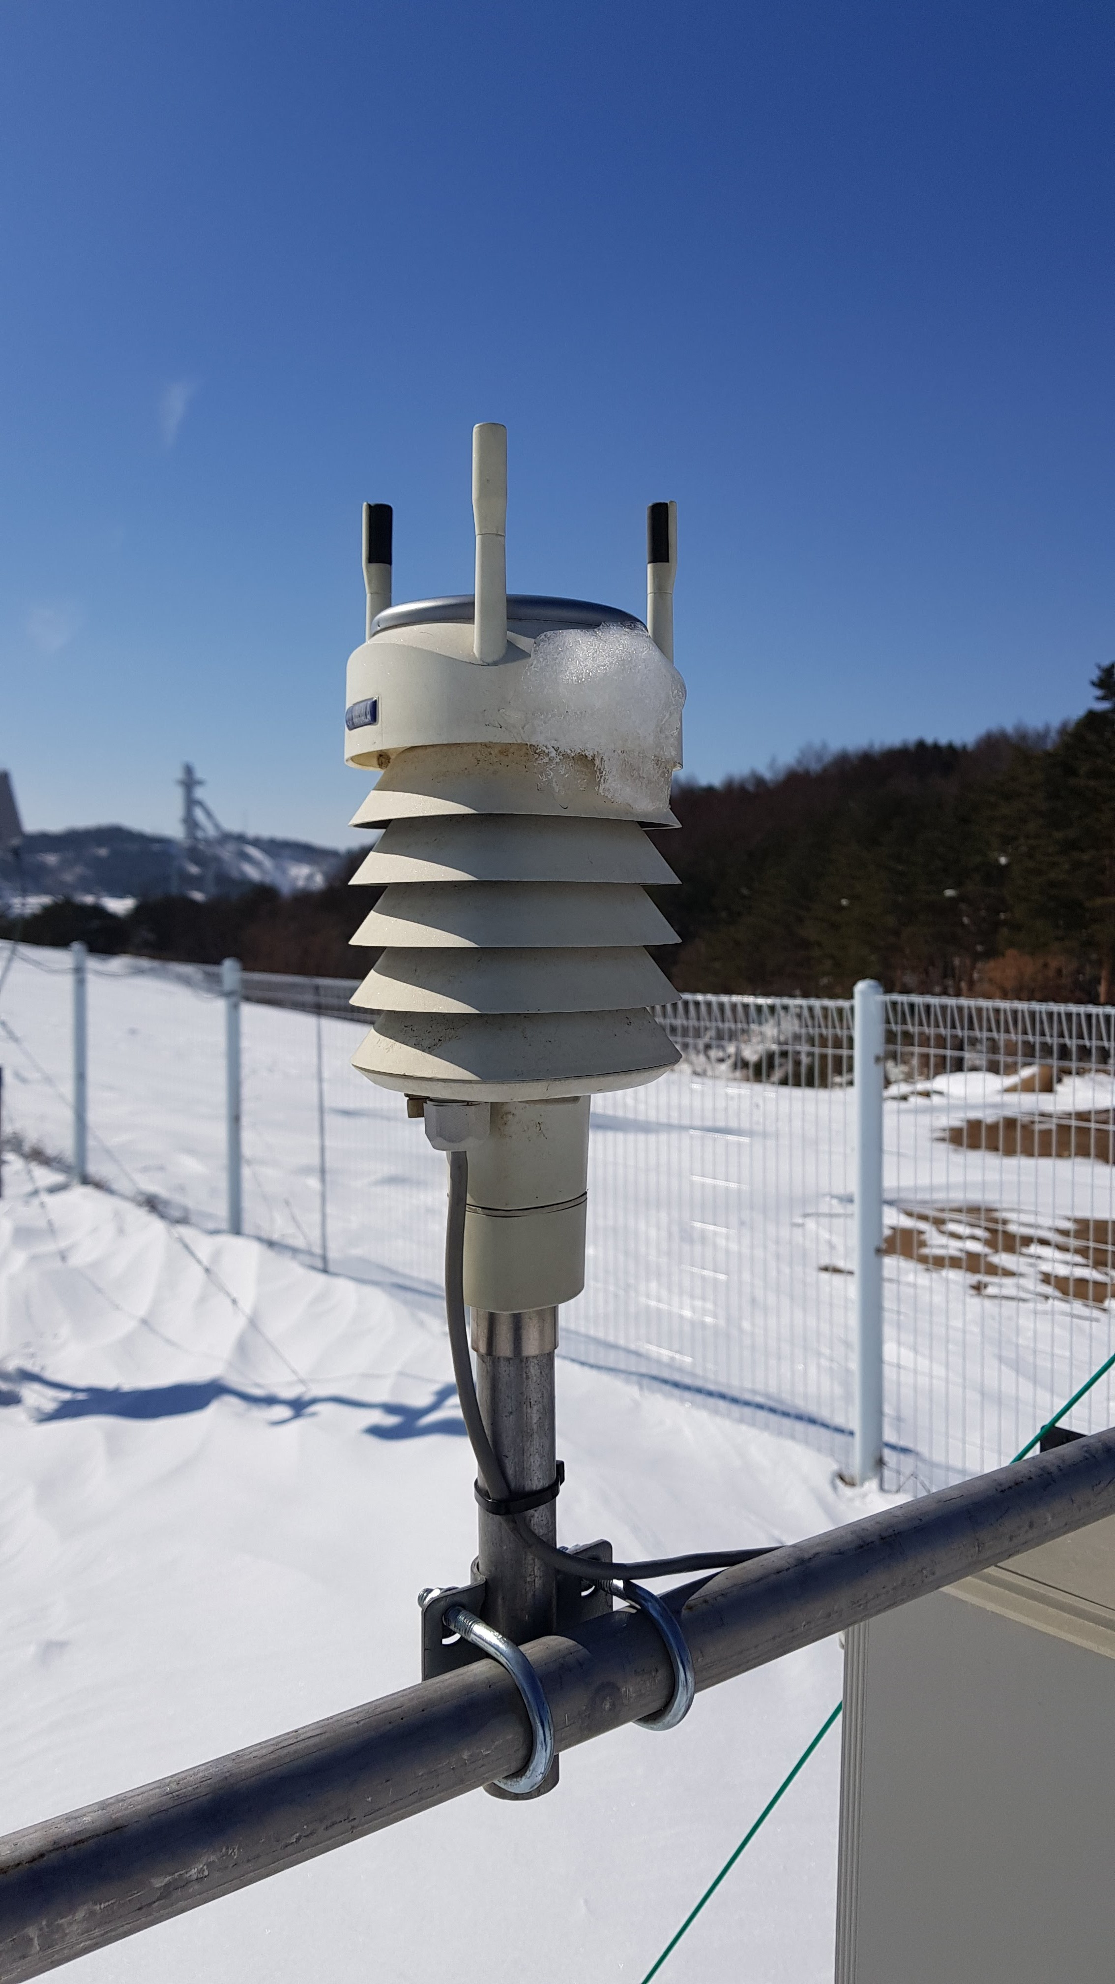
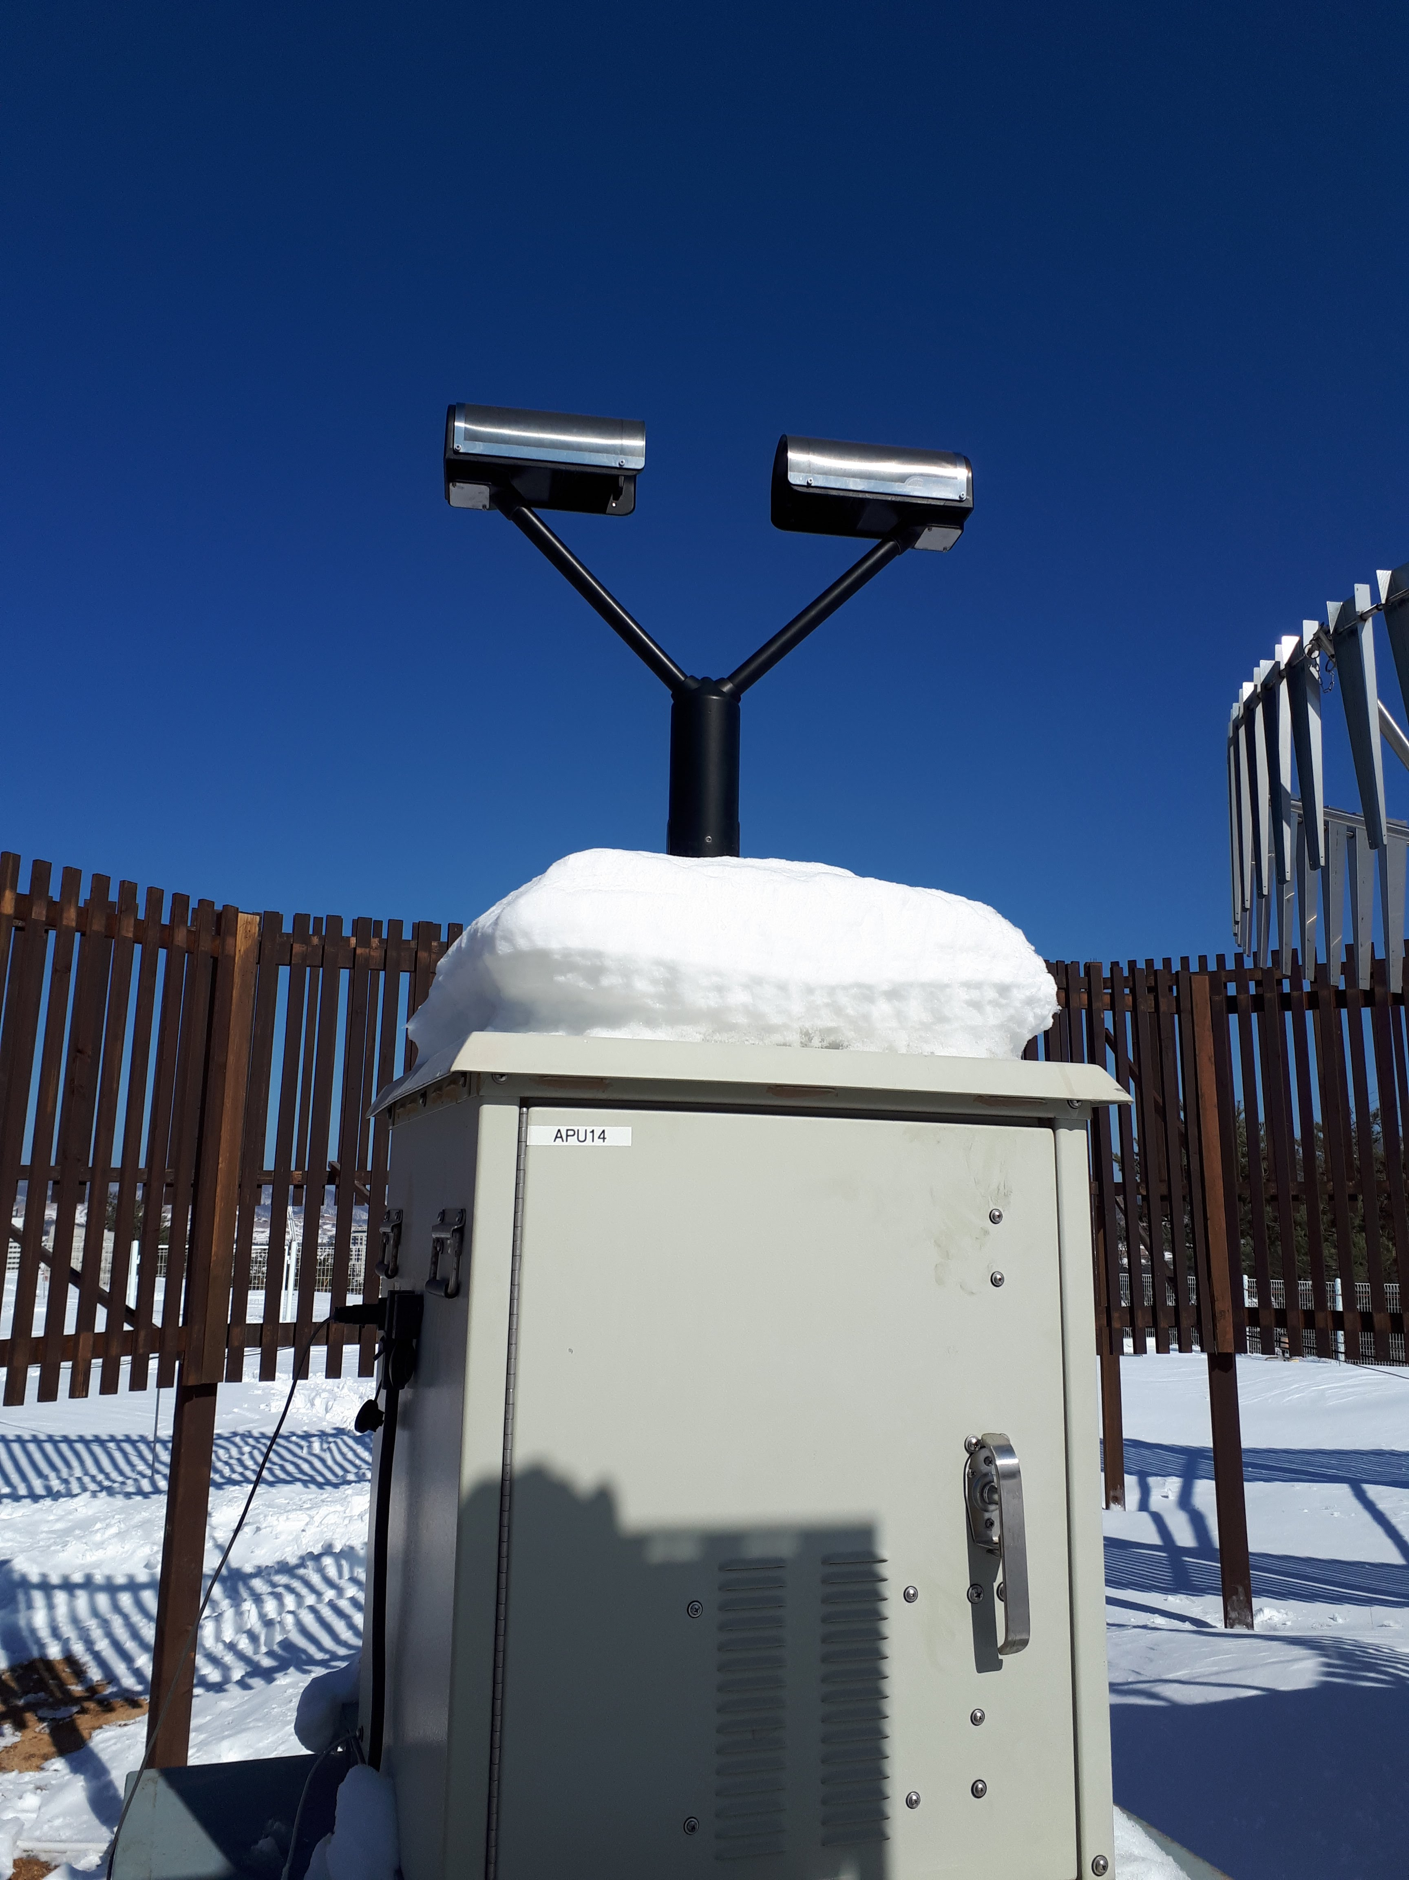
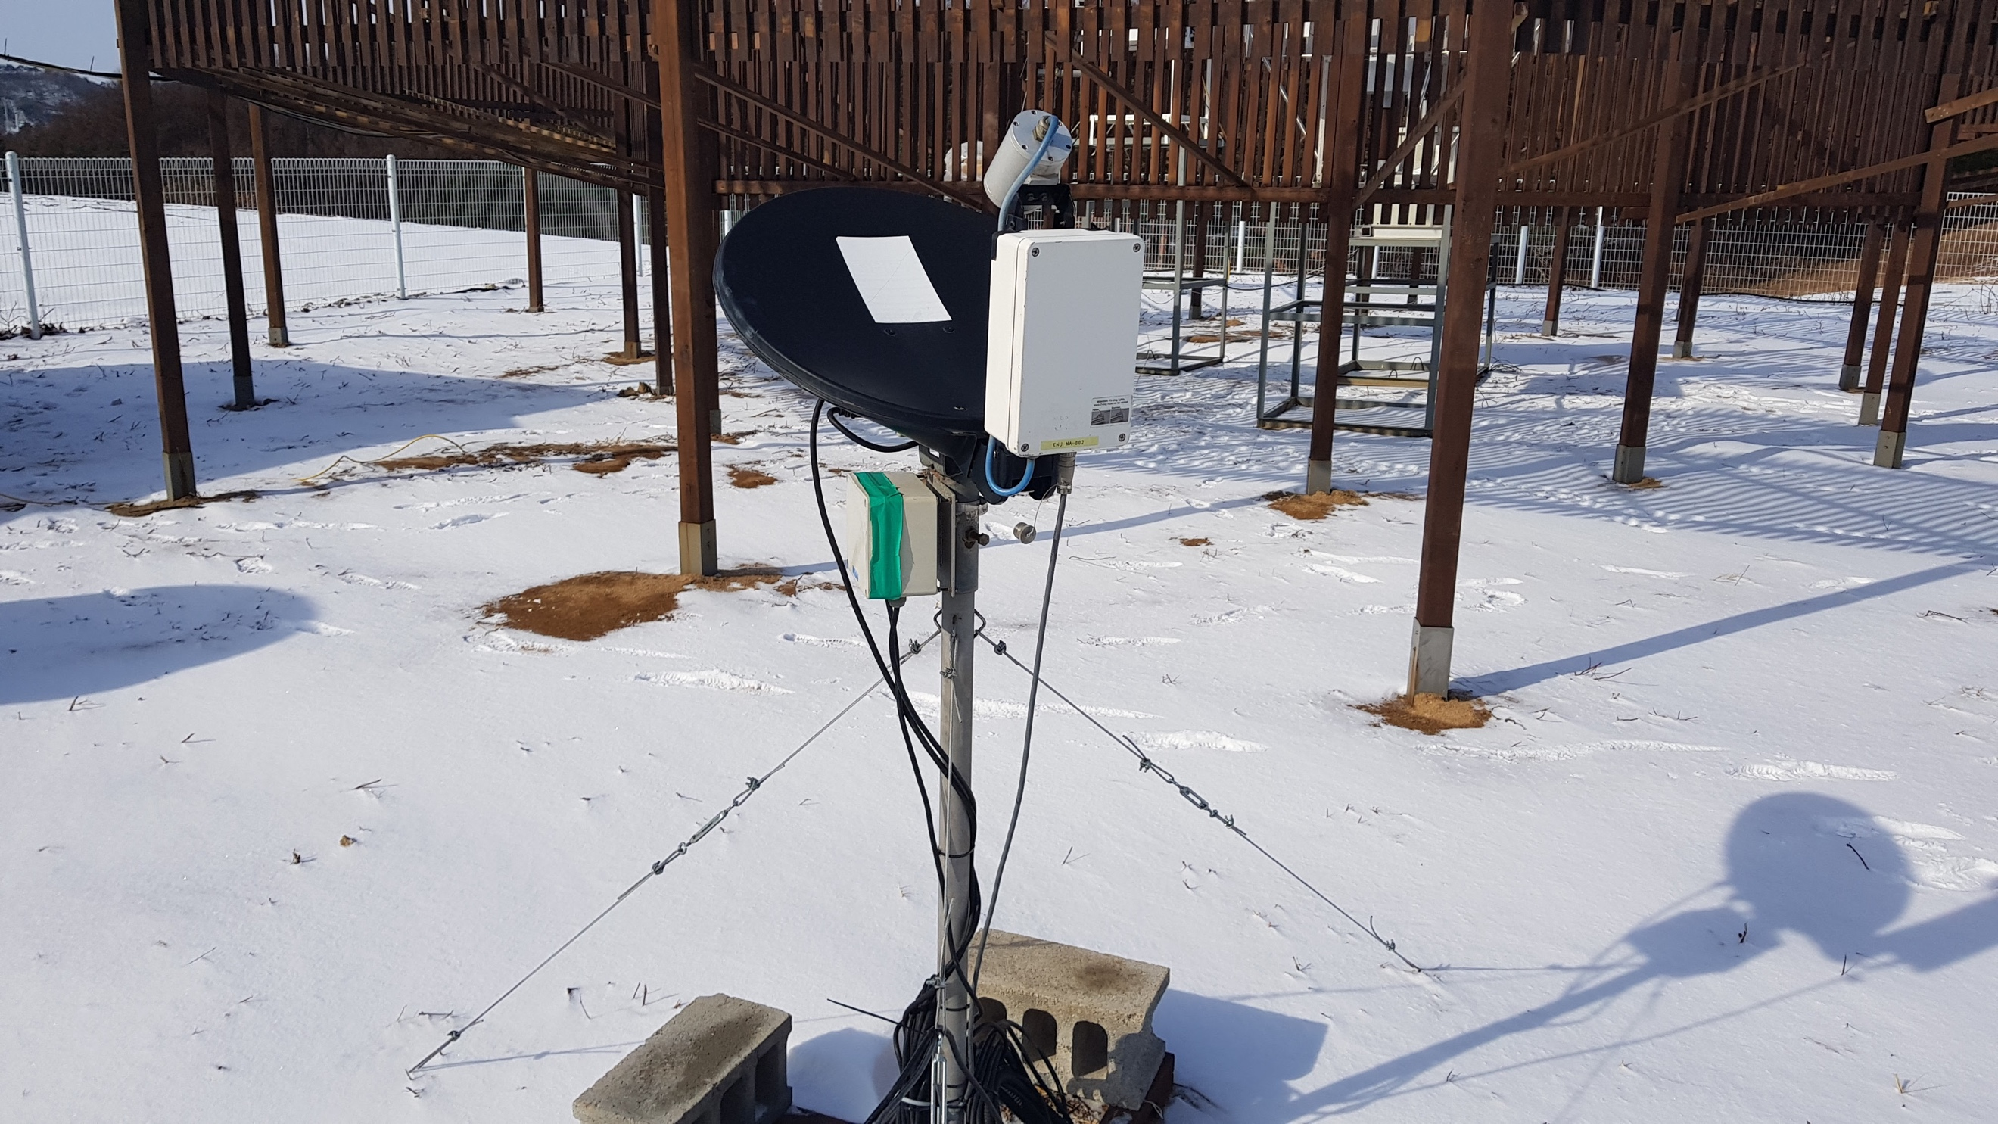
a
b
c
d

Figure 1. Picture of a) Precipitation Imaging Package (PIP), b) Vaisala WXT520 weather station, c) OTT PARSIVEL² disdrometer, and d) Micro Rain Radar (MRR) from MHS supersite (Courtesy of Kwonil Kim of Kyungpook National University).

The instrumentation used in this study was previously employed for numerous field campaigns. Among those, the PIP is a relatively newer instrument and became a desired instrument to measure the microphysical properties of falling snow since its original version, Snow Video Images (SVI, Newman et al. 2009) was deployed during the Canadian CloudSat CALIPSO Validation Project in 2006 (Wood et al. 2013). The components and working principles of PIP have been documented in Pettersen et al. (2020a, b). In brief, PIP records the two-dimensional grayscale video images of falling particles between a light source and a high-speed camera that are 2 m apart. The focal plane is about 1.3 m from the lenses. The depth of field (DOF) is size dependent and is formulated as 0.117/2 x D_{eq}, where D_{eq} is the equivalent diameter. The field of view (FOV) is 48 mm x 64 mm and is formulated as (64-D_{eq}) x (48-D_{eq}) including particles’ edge effects. The sampling volume is a multiplication of the FOV, DOF, and the number of frames (380 frames per second) over a given time period. The image pixel size is 0.1 x 0.1 mm and any particles with the equivalent diameter (D_{eq}) less than 0.2 mm are rejected to prevent camera resolution and image compression issues from contaminating the size distributions. The PIP’s measurement volume is not enclosed and therefore it is immune to both contamination by secondary particles associated with splashing as well as under-sampling in windy conditions (Newman et al. 2009). The PIP’s velocity measurements include particles’ upward motion with negative fall velocity. Only particles with a downward vertical velocity greater than 0 m s⁻¹ are included in the analysis.

c. Snow Events

The PIP recorded 10 major snow events during the first three months of ICE-POP 2018. The events were separated from each other with minimum one hour precipitation free periods based on PIP precipitation rate time series. The major events had at least 20 mm geometric snow depth and lasted 200 minutes or longer. Table 1 lists the event date, start and end hours in UTC, number of snowing minutes, maximum snowfall intensity (S_max), geometric depth of snow (S_total), and wet-bulb temperature statistics.

Table 1. Snow event layout including the type C: Cold low, W: warm low, and A: air-sea interaction, event date, start and end hour in UTC, number of snowing minutes, maximum snowfall intensity (S_max), geometric depth of snow (S_total), and median, maximum, and minimum wet-bulb temperature in degrees C.

Event # | Event type | Event Date  (MM/DD/YY) | Start and End period (DOY/HH) | #  minutes | S_max  (mm h⁻¹) | S_total  (mm) | Wet-bulb (˚C)  Median, Min, Max
01 | C | 01/09/18 | 009/13-21 | 403 | 19.5 | 25.13 | -11.5, -13.1, -11.2
02 | W | 01/16-17/18 | 016/20-017/01 | 228 | 16.0 | 22.66 | -0.6, -0.9, 0.0
03 | C | 01/22-23/18 | 022/07-023/00 | 788 | 47.8 | 109.67 | -6.9, -18.0, -3.0
04 | C | 01/30/18 | 030/08-21 | 713 | 25.6 | 64.68 | -8.1, -10.1, -7.6
05 | C | 02/22/18 | 053/07-21 | 280 | 59.2 | 32.82 | -5.6, -6.7, -4.4
06 | W | 02/28/18 | 059/03-22 | 792 | 99.9 | 650.40 | -1.2, -2.0, 0.7
07 | W | 03/04-05/18 | 063/14-064/07 | 900 | 66.8 | 222.05 | -3.2, -5.4, -0.3
08 | W | 03/07-08/18 | 066/09-067/19 | 1,841 | 24.1 | 173.78 | -2.7, -5.2, -1.1
09 | A | 03/15-16/18 | 074/11-075/09 | 919 | 42.1 | 98.98 | -5.5, -6.3, -0.8
10 | W | 03/20-21/18 | 079/09-080/14 | 1,366 | 35.5 | 123.84 | -5.8, -7.0, -4.6

The snowfall over the Pyeongchang area results from three different synoptic patterns. Jeoung et al. (2020) described these synoptic patters as cold low (C), warm low (W), and air-sea interaction (A). Kim et al. (2021) listed the 9 out of 10 major events that are used in this study as three cold low, five warm low, and one air-sea interaction. Kim et al. (2021) also presented the MRR based reflectivity distributions for five sites, including the MHS site. The reflectivity distributions were composited for cold low, warm low, and air-sea interaction events and the echo top heights were 3.0-3.5 km, ≥ 4.5 km, and 3.5-4.0 km for these three different synoptic patters, respectively. The expected echo top heights for the cold and warm low synoptic patterns were also present in the time series of MRR reflectivity at the MHS site during the cold low (e.g., Figure 2a) and warm low (e.g., Figure 2b) events. The echo top heights ranged from 1.0 km to 3.0 km in cold low events including event#01, which was not included in Kim et al. (2021) study. The echo started to appear from the highest MRR gate for warm low events, indicating that the echo tops ≥ 4. 5km. The MRR observations were not collected during the air-sea interaction event.

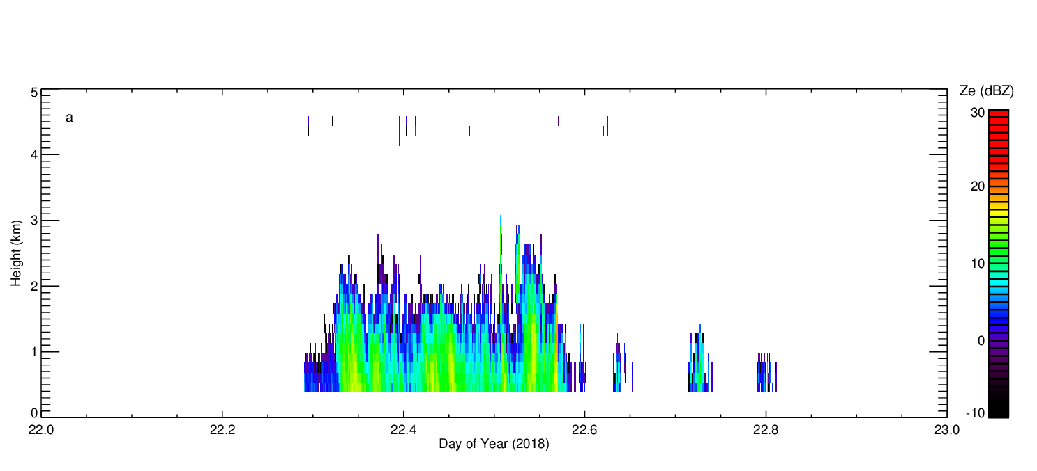
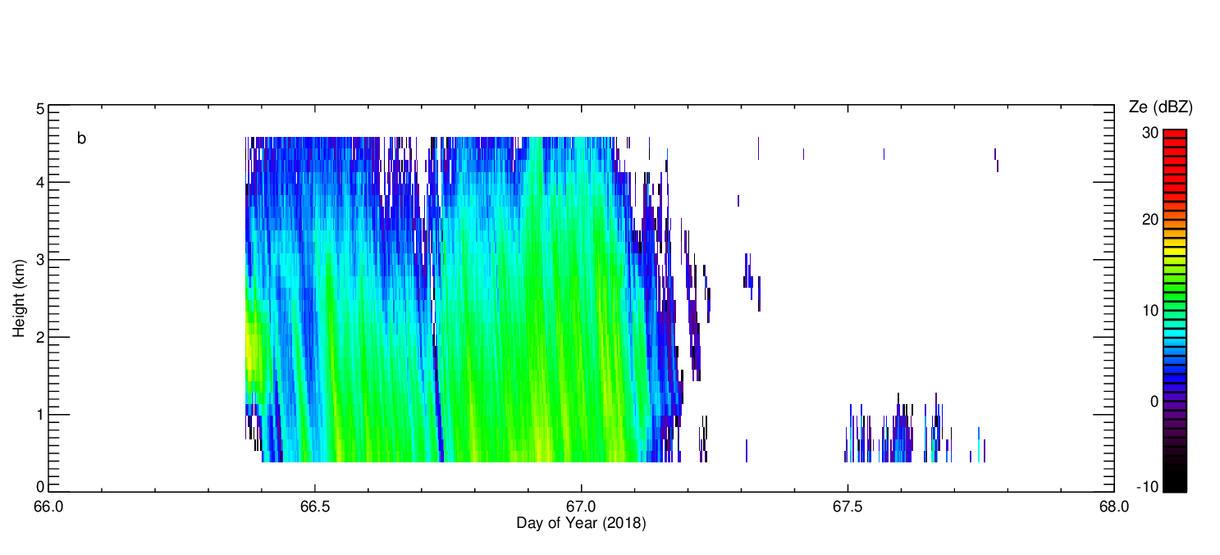
Figure 2. MRR Ze time series for events a) #03 and b) #08.

The distinction in echo top height between the cold low and warm low events was also evident in NASA’s dual wavelength (Ku- and Ka-band) dual polarization Doppler radar (D3R) observations. D3R was located at another ground supersite, Daegwallyeong (DGW), 2.16 km away from MHS site during ICE-POP (Munchak et al. 2022). Figure 1 of Munchak et al. showed the time-height plots of vertical profiles of Ku-band horizontal reflectivity, differential reflectivity, differential phase, co-polar correlation coefficient, and Ku- and Ka-band dual-wavelength ratio for events #01, #06 and #08 in Table 1. The cold low event (#01) was shallow, while two warm low events (#06, #08) were deep according to the D3R observations.

The wind was from the west southwest (WSW) in the cold low events including event #01, while the warm low events were dominated by east northeast (ENE) winds except event #02 where the wind speeds predominantly were weak (< 2 m s⁻¹), as depicted in Figure 3. The air-sea interaction event was also dominated by ENE winds. The wind direction was in a good agreement with Kim et al. (2021) study where selected soundings from warm low, and air-sea interaction events showed a transition of wind direction from northeast to southwest at around 700 millibars height and northwest at around 800 millibars height, respectively. The selected sounding from the cold low event had southwesterly flow near the surface, veering to westerly flow at around 600 millibars in their study. The wind speeds were relatively stronger in cold low events than in warm low events but the event median wind speed also had large variability within warm low event category, 0.5 to 4.4 m s⁻¹. Lim et al. (2020) attributed this difference to the position of the low pressure center. The synoptic low was closer to the Korean peninsula for event #07 than for event #09 resulting in stronger pressure gradients and stronger winds for the former event.

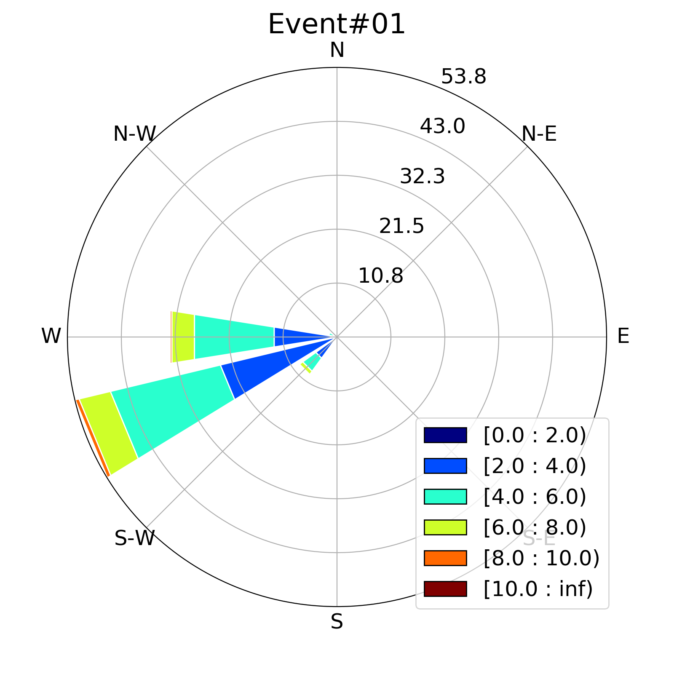
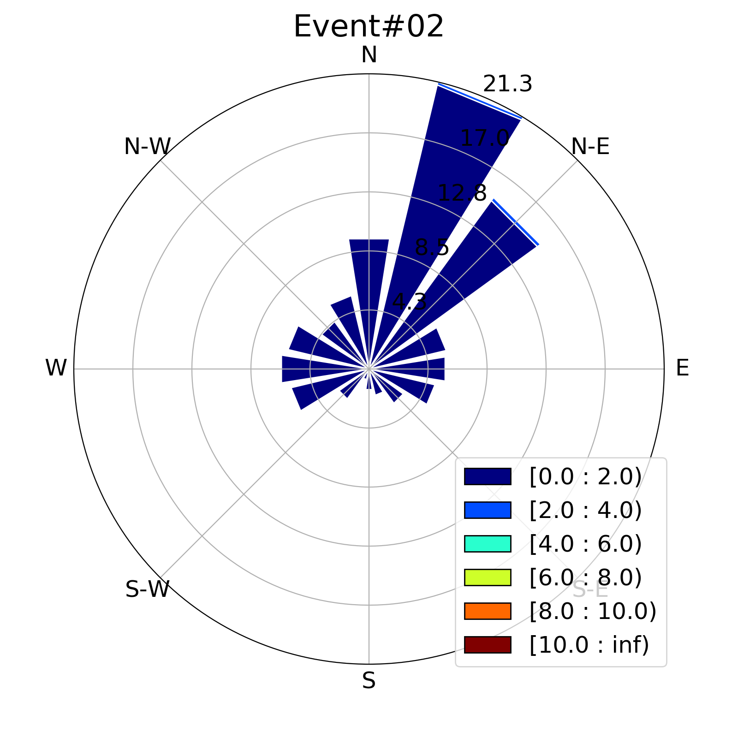
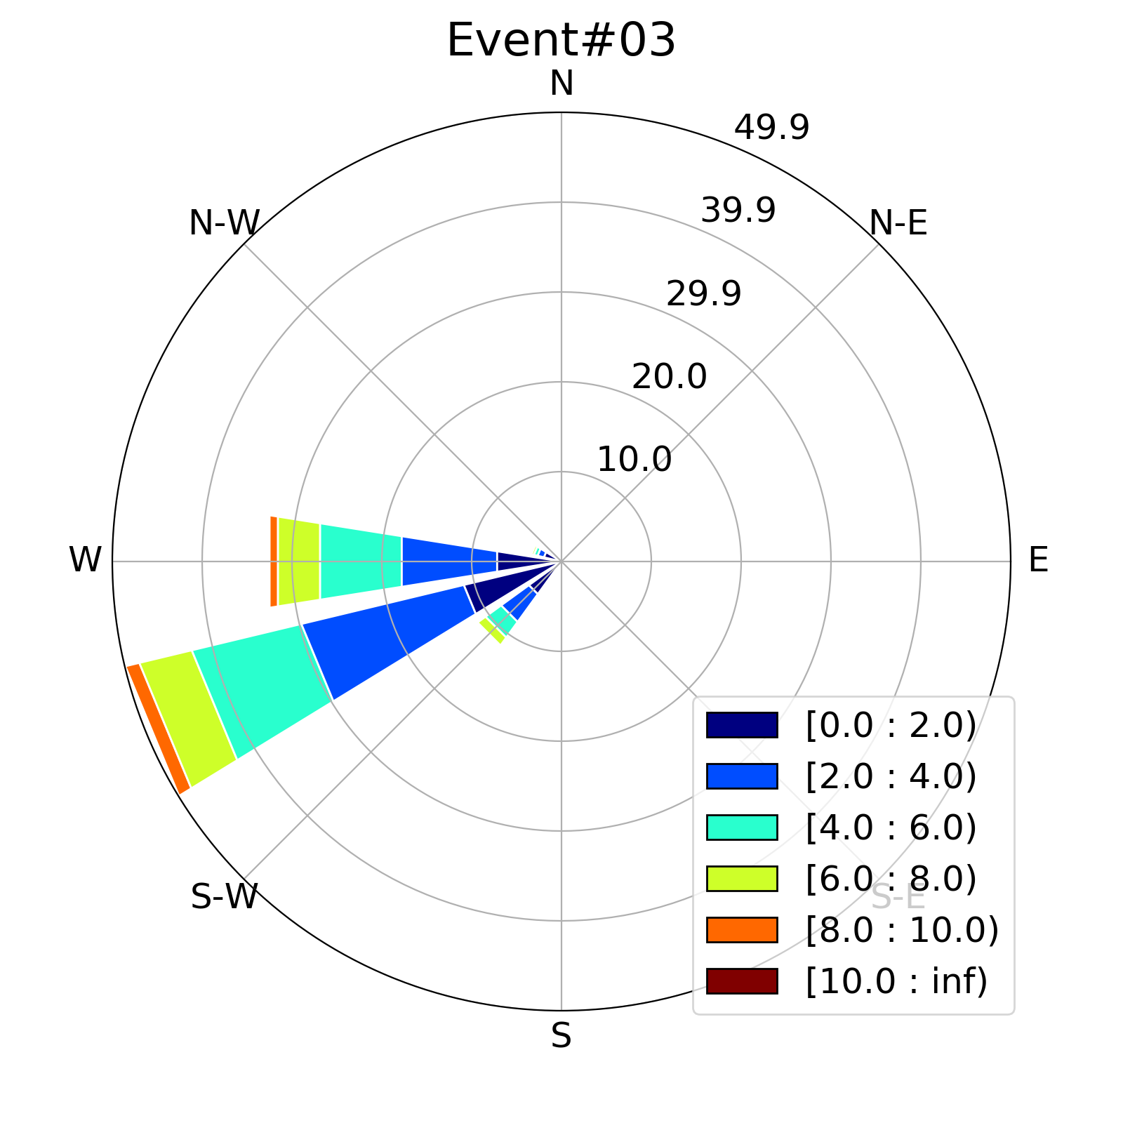
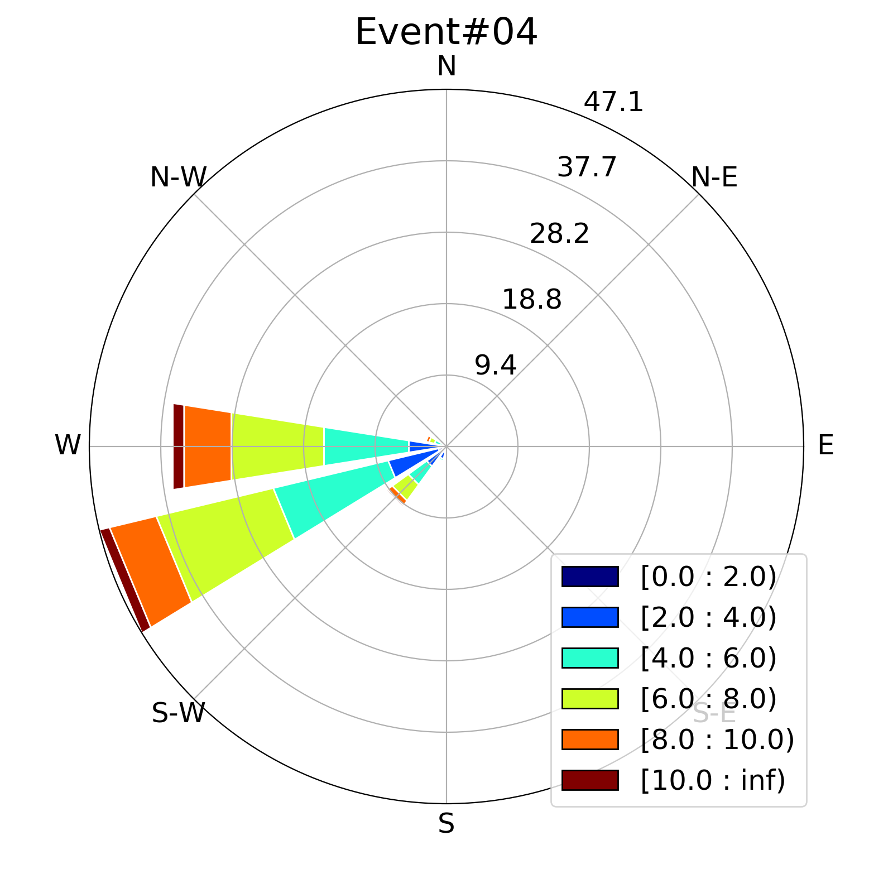
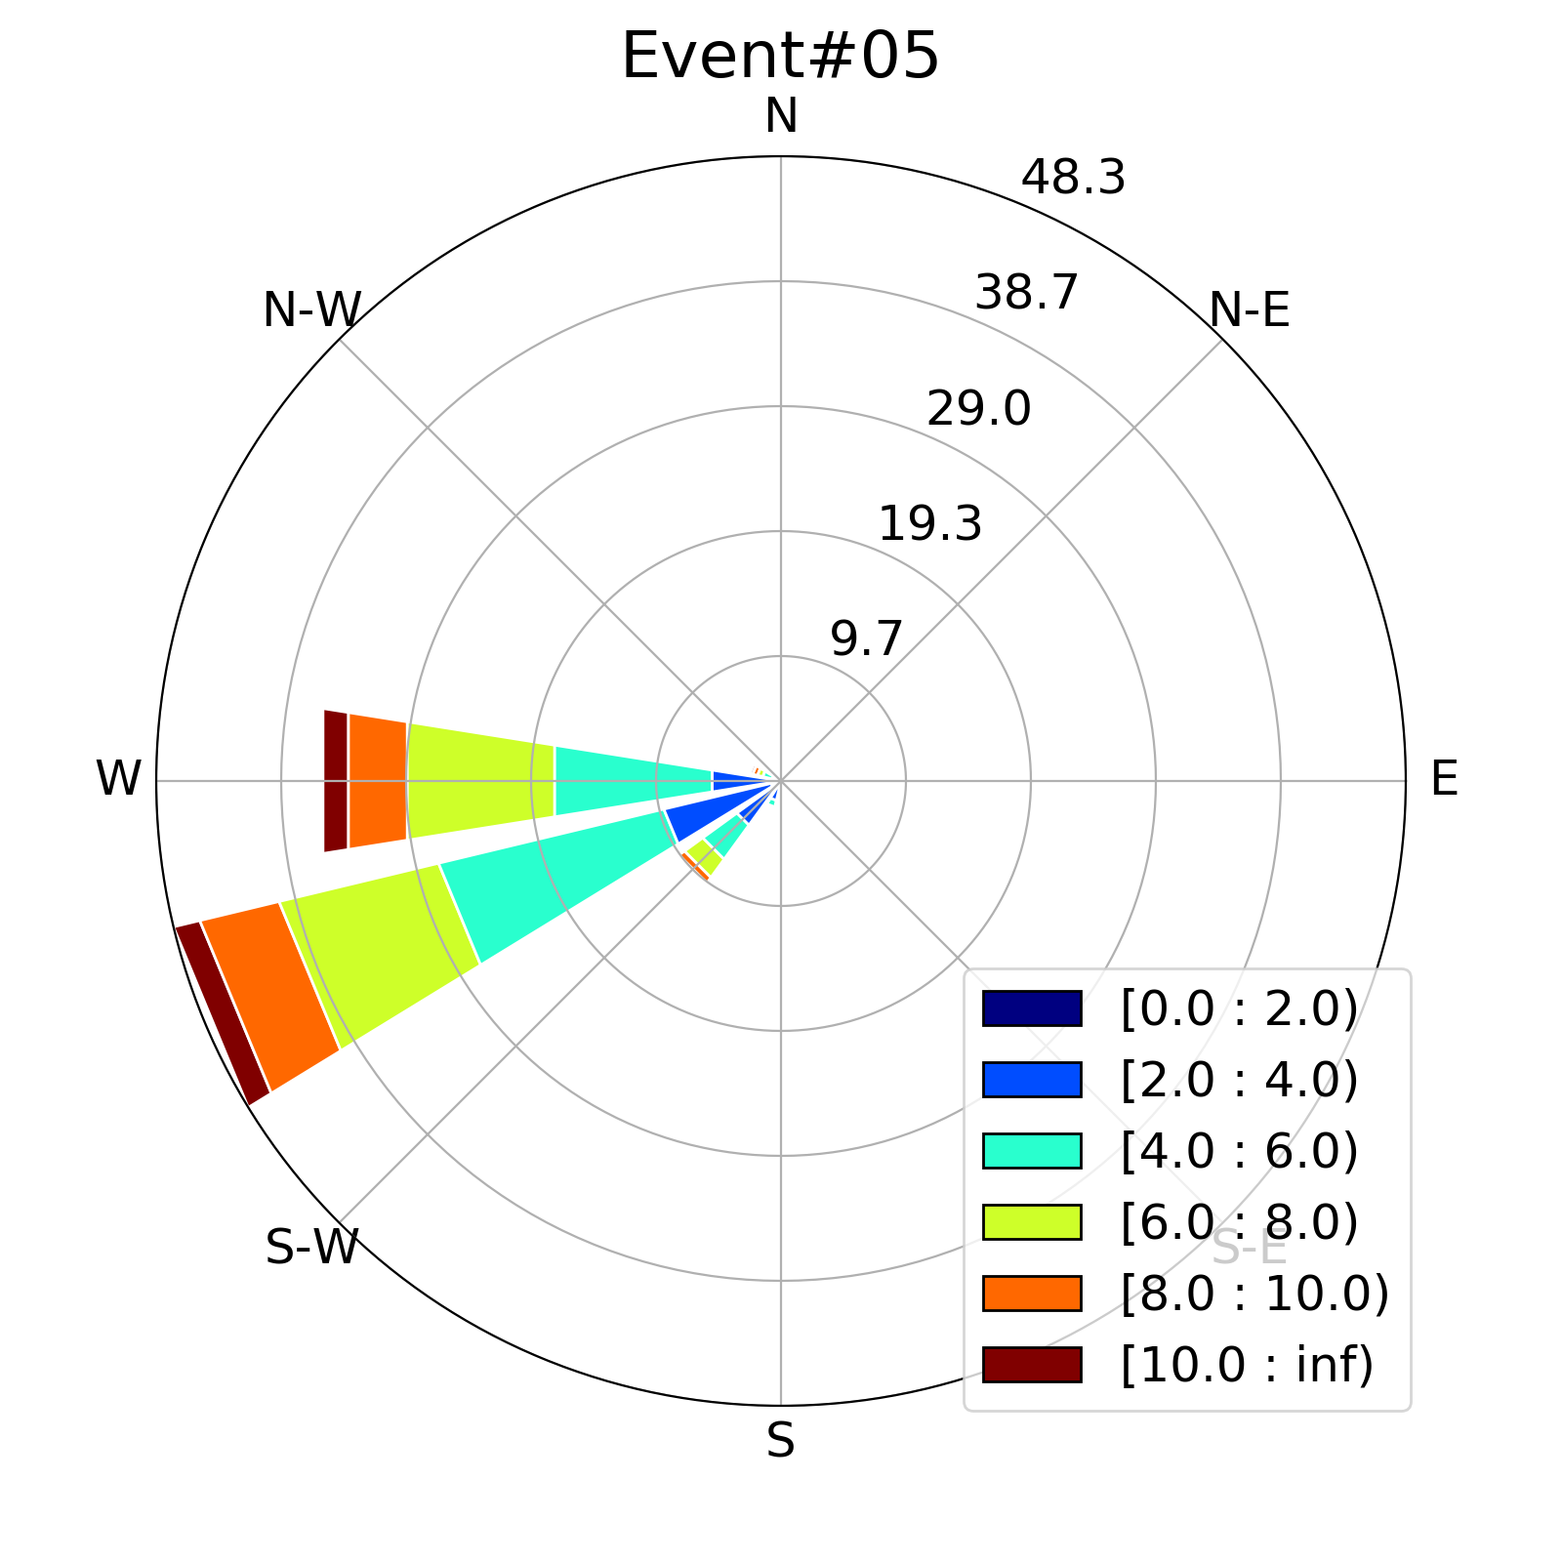
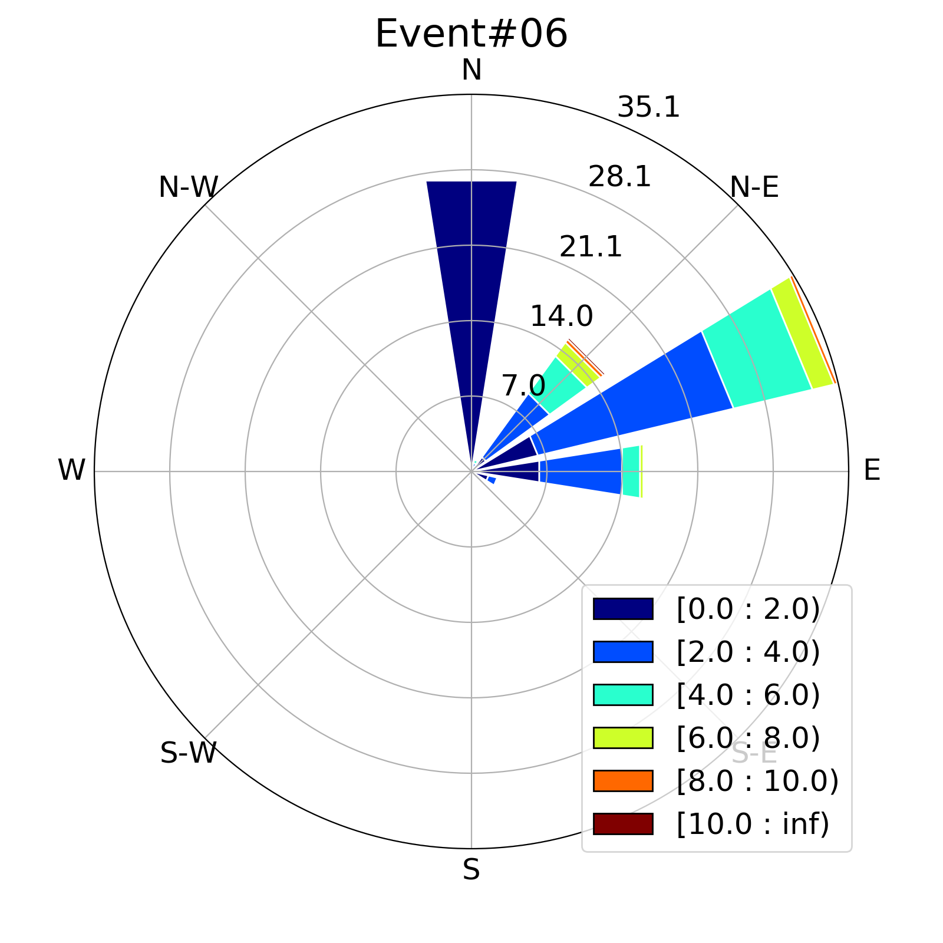
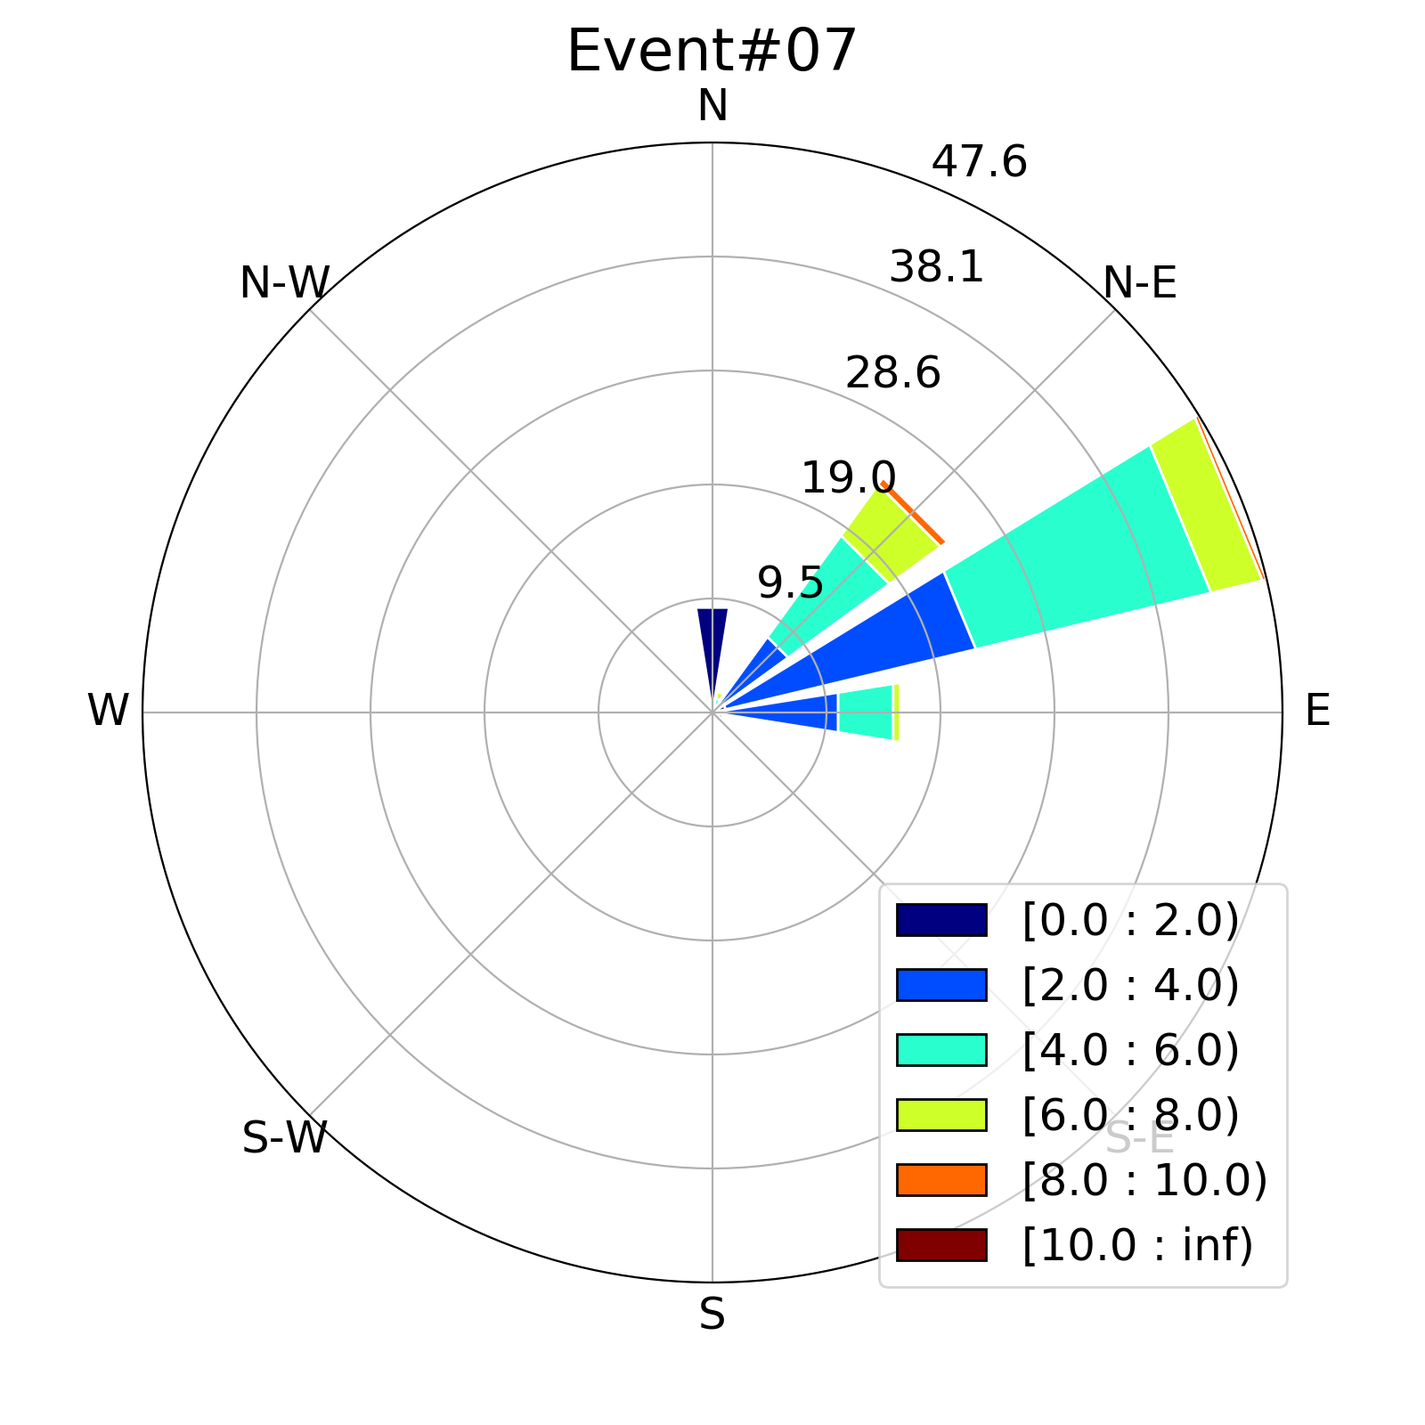
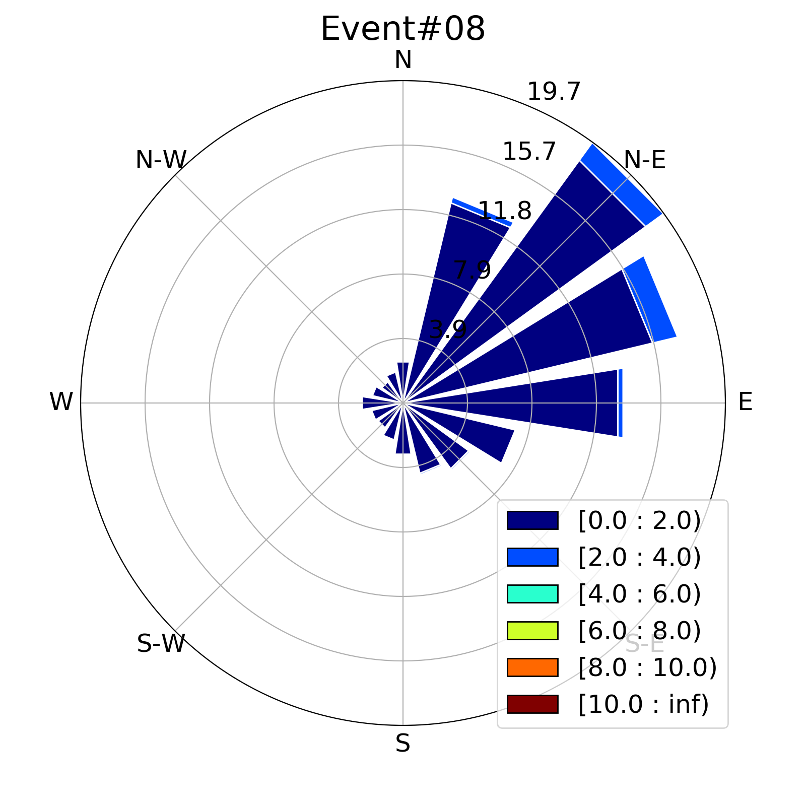
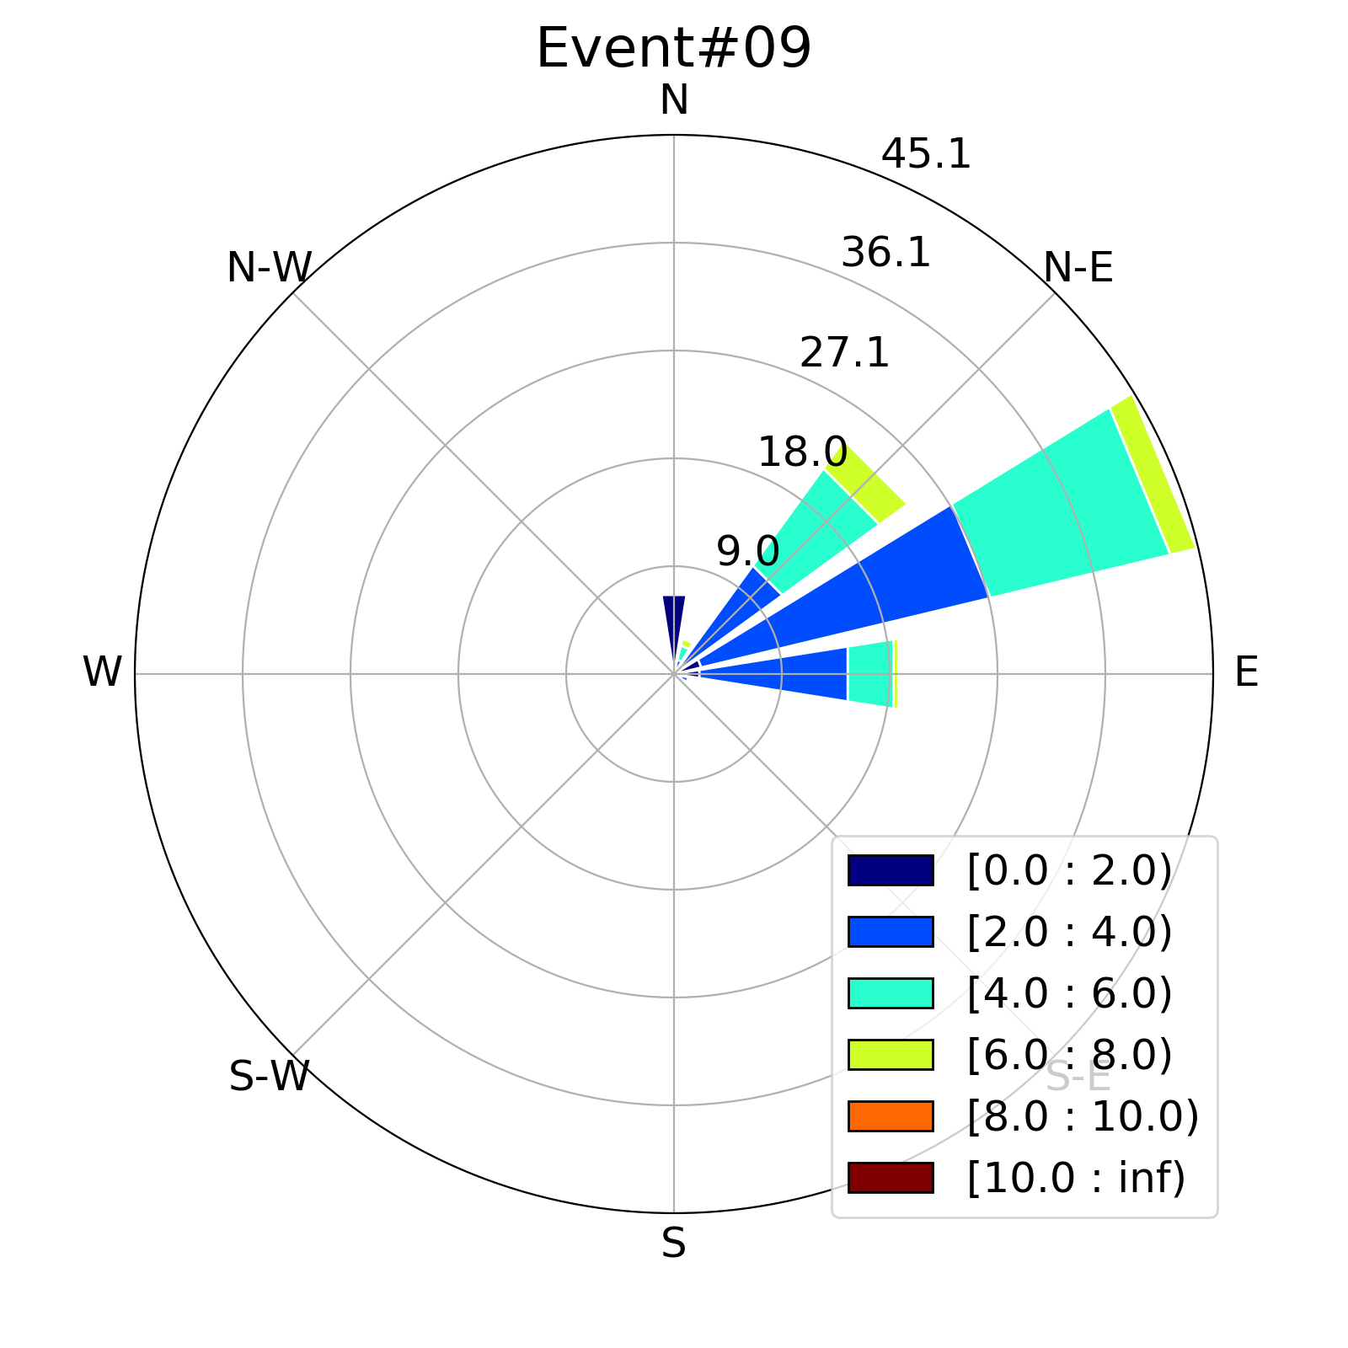
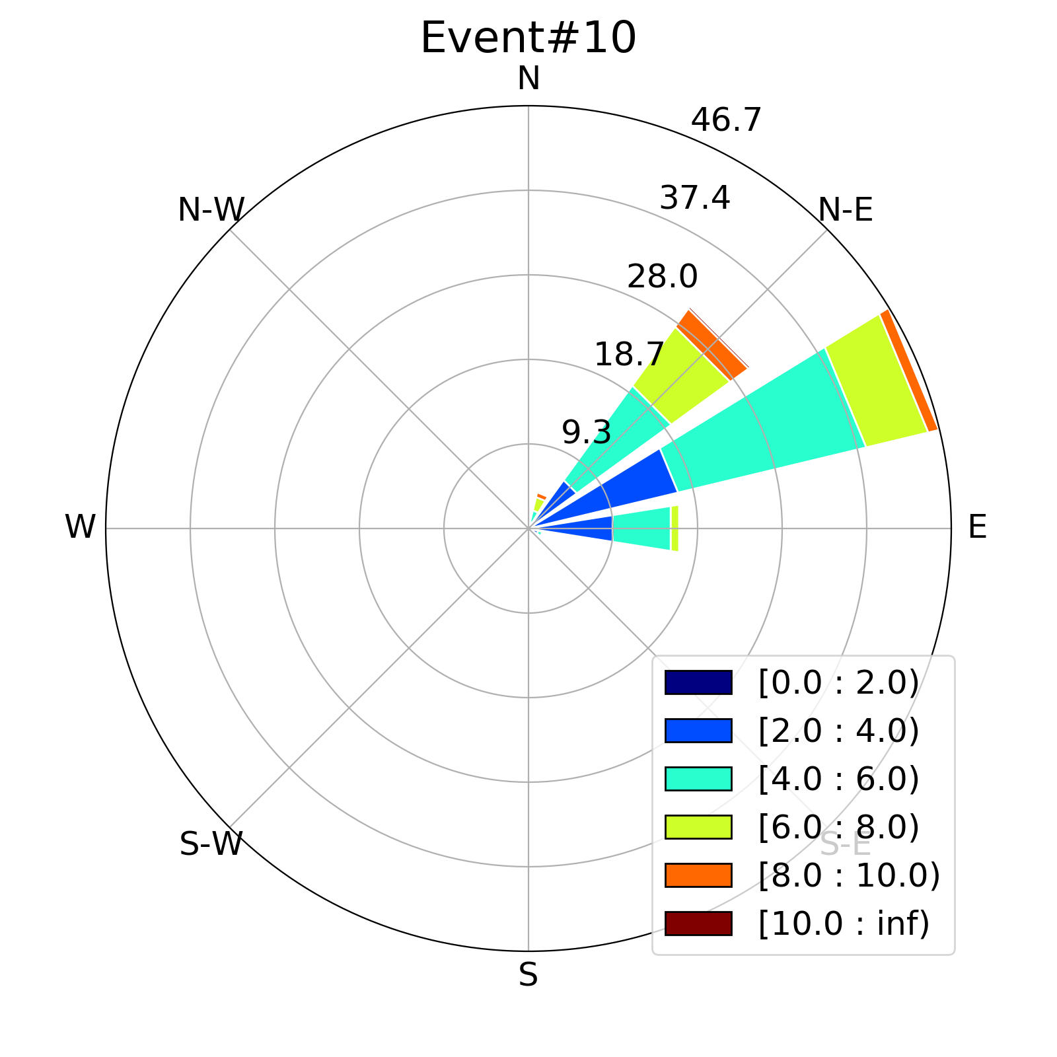

Figure 3. Windrose for the 10 major events During ICE-POP 2018.

The combination of the wet-bulb temperature and the low-level temperature profile is not only the key to separating snow and rain (Sims and Liu 2015) but is also an indicator for the wetness of the snow. The cold low events had mostly lower median T_{wet-bulb} than the warm low events but there were significant differences in median T_{wet-bulb} and the range between maximum and minimum T_{wet-bulb} among the warm low events (Table 1). A cold low event (event #05) and a warm low event (event #10) had similar T _{wet-bulb} trends while two warm low events (events #02, and #06) had the warmest T _{wet-bulb} among all events (not shown).

3.Methodology

This section introduces the formulation of the integral snowfall parameters, the data processing to derive the SWER(Ze) relationship, and the statistics to evaluate the SWE and SWER estimates.

- Integral Snowfall Parameters

Given the fact that the purpose of this study is to evaluate the accuracy of SWER(Ze) relationships, the SWER and Ze are the two main integral snowfall parameters. The SWER is the liquid equivalent rate of falling snow and is formulated as a function of mass (m), fall speed (v), and concentration (N) of the particles in a volume of air and is in units of mm h⁻¹ for a given minute:

$SWER= \frac{3.6}{ρ_{w}}\int_{D_{min}}^{D_{max}}{m\left(D_{mx}\right)v\left(D_{mx}\right)N\left(D_{eq}\right)dD_{eq}}$ (2)

where ρ_{w} is the density of water in g m⁻³, D_{min}, and D_{max} are the minimum and maximum particle diameters in millimeters, respectively. The particle mass is calculated following hydrometeor aerodynamics outlined by Böhm (1989) and documented in Tokay et al. (2022). The particle mass and fall velocity are expressed as a function of the maximum dimension of the particle (D_{mx}), which is set to 1.2 D_{eq} following the statistics of the particle refitting algorithm in Helms et al. (2022).

The Ze is the equivalent radar reflectivity factor and is formulated as a function of backscattering cross section (σ_{bscat}) and concentration of the particles in a volume of air. It is calculated for S-band radar wavelengths (λ = 10.7) using Mie Theory (Liao et al. 2013) and is expressed as

$Ze(λ)= \frac{{10}^{6}λ^{4}}{{|K_{w}|^{2}π}^{5}}\int_{D_{min}}^{D_{max}}{σ_{bscat}\left(D_{mx},λ\right)N\left(D_{eq}\right)dD_{eq}}$ (3)

where |K_{W}|² is the dielectric constant of water and is 0.934 at S-band. A cross check of the Ze calculation has been done by using Rayleigh approximation (Wood et al. 2013, von Lerber et al. 2017) and the reflectivity was almost identical between the two methods.

One of the two physical based classification algorithms relies on the bulk density which is given as,

$ρ_{snow}=ρ_{w}\frac{SWER}{SR}$ (4)

where SR is the intensity of falling snow and is formulated as functions of equivalent particle volume, concentration, and fall velocity and is given in units of mm h⁻¹ for a given minute as follows:

$SR=6 π {10}^{-4}\int_{D_{min}}^{D_{max}}{v\left(D_{mx}\right)D_{eq}^{3}N(D_{eq}})dD_{eq}$ (5)

The maximum SR and its geometric depth are given for a snow event in Table 1. Since SR is calculated for every minute, the geometric depth is calculated by summing SR and dividing by 60 for the event duration.

- SWER(Ze) relationship

There is no perfect method in deriving an empirical relationship between the Ze and SWER. This means that there will be a bias between the observed and estimated SWER for a given event. Tokay et al. (2001) showed noticeable difference for R(Ze) relationships when linear versus nonlinear least squares are used. They also demonstrated the differences in coefficients and exponents of the R(Ze) relationship when R is expressed as a function of Ze and vice versa. Although the literature is mostly written in the form of Eq. (1) for the SWER(Ze) relationship, the SWER is retrieved and Ze is the measured quantity. Thus, the empirical relationship should be formulated as

SWER = A’ Ze^{b’} (6)

The A-coefficient and b-exponent in Eq. (1) is then expressed as

A = (1/A’)^{(1/b’)} (7a)

b = 1/b’ (7b)

The method to determine A’-coefficient and b’-exponent is important to represent the observations which could be widely distributed in both SWER and Ze. This study uses the Sequential Intensity Filtering Technique (SIFT), which was introduced by Lee and Zawadski (2005) to effectively mitigate the variability of particle size distribution caused by observational noise. The Ze is a grouping parameter where the median SWER is calculated for 1 dBZ interval (ΔZe) as long as there are 10 or more samples within ΔZe. The orthogonal distance regression (Boggs et al. 1992) is then applied to paired Ze versus SWER observations as long as 8 or more samples are available.

Figure 4 depicts the two-dimensional (2-D) histograms of SWER versus Ze and the corresponding SIFT-based orthogonal regressions for event #03 and event #08. The performance of regression depends on the scatter of SWER at a given Ze in 2-D histogram. The paired SWER and Ze observations are relatively more distant from the best fit line in event #03 than in event #08 (Figure 4b, d). This hints that the error in SWER estimation would be higher in the former event than the latter event. The best line seems to overestimate the paired Ze and SWER observations at the high end in both events. Unless it has been compensated by the lower range of the spectrum, the event SWE totals would be overestimated in these events.
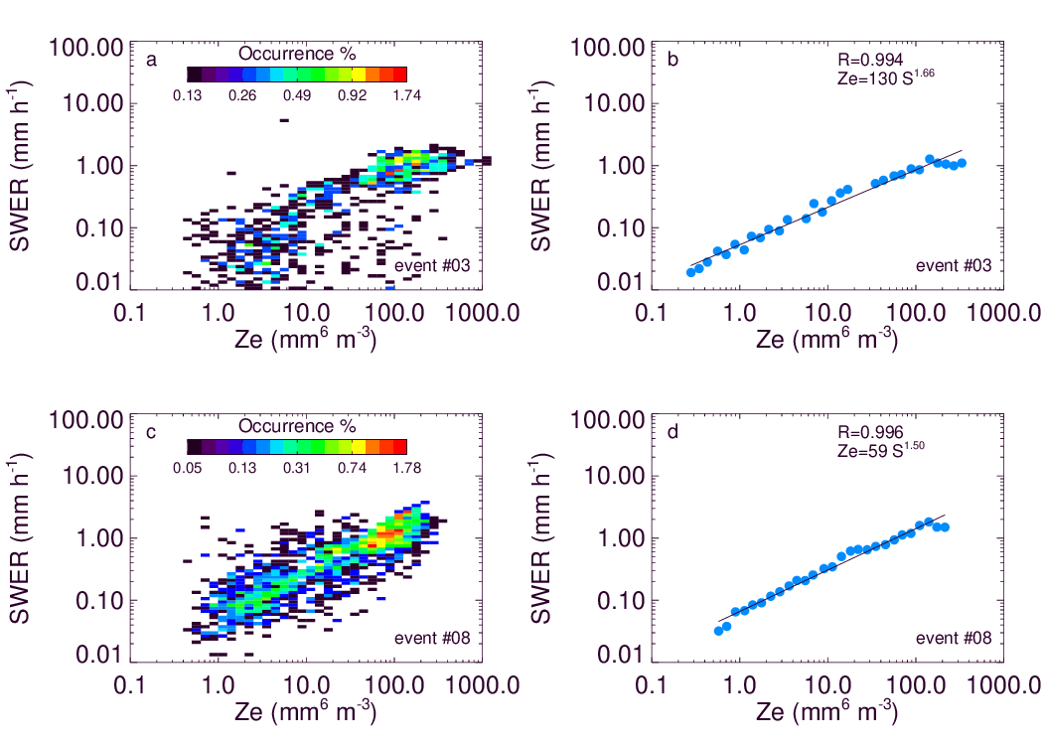
Figure 4: a, c) The two dimensional histograms of SWER versus Ze and b), d) the corresponding SIFT-based orthogonal regressions for event #03 and event #08.

The methodology of the retrieval of SWER from Ze described in this study is considered as a traditional method. Alternative statistical retrieval methods such as neural network (Chase et al. 2021) and random forest (Yu et al. 2022, King et al. 2022) have performed well in retrieving particle size distribution parameters (e.g. mass weighted mean diameter, D_{mass}) as well as integral parameters (e.g. SWER).

- Evaluation Statistics

This study uses two different statistics to evaluate the appropriateness of the SWER(Ze) relationship. First, relative bias (bias hereafter) between the observed and estimated snow water equivalent (SWE) is formulated as

$bias=\frac{{SWE}_{est}-{SWE}_{cal}}{{SWE}_{cal}}$ (8)

where SWE_{cal} is the summed PIP-calculated SWER following Eq. (2). The summation is done over snowy minutes of the event and then divided by 60 to express SWE in millimeter. SWE_{est} is the same as SWE_{cal} except SWER is determined from SWER(Ze) relationship where Ze is calculated from PIP observations following Eq. (3). The bias is widely used to evaluate the performance of a disdrometer where the reference instrument is typically a precipitation gauge (Tokay et al. 2014). The SWE bias using the PIP data was very low (≤ 0.10) in Tokay et al. (2022). There is a caveat in bias statistics, however. The low bias can result from the combination of over- and under-estimation of precipitation amounts at different segments of the integration period. The mean absolute error (MAE) between the estimated and calculated SWER is a more reliable statistic for the performance of SWER(Ze) relationship. The MAE is formulated as

$MAE=\frac{1}{NT}\sum_{i=1}^{NT}{\frac{\left|{SWER}_{est,i}-{SWER}_{cal,i}\right|}{{SWER}_{cal,i}}}$ (9)

where SWER_{cal,i} is the PIP-calculated SWER following Eq. (2) and SWER_{est,i} is the SWER(Ze) relationship based SWER for the i^{th} observation. NT is the number of observation in a given event.

4. Operational SWER(Ze) relationships

The US National Weather Service (NWS) employs five different SWER(Ze) depending on the region in CONUS (Bukovcic et al. 2018). The A-coefficient ranges from 40 to 222 and b-exponent is 2.0 in these relationships (Table 2). Assuming that the measured reflectivity is 20 dBZ, the estimated SWER ranges from 1.58 mm h⁻¹ to 0.67 mm h⁻¹ for an A-coefficient ranging from 40 to 222, respectively. If the intensity of the snowfall does not change in one hour, the estimated SWE is 42% higher for the former A-coefficient than the later A-coefficient. The Canadian radar network uses the relationship derived by Sekhon and Srivastava (1970). Boudala et al. (2006) reported that this expression underestimates the precipitation rate even at warm temperatures. Indeed, the Canadian SWER(Ze) relationship results in only 0.27 mm h⁻¹ SWER at 20 dBZ. The MRMS (Zhang et al. 2016) and Finnish Meteorological Institute (FMI) (Saltikoff et al. 2015) SWER(Ze) relationships use the same b-exponent as the US NWS but the A-coefficients are aligned with the dry snow. At 20 dBZ, the SWER estimates are 1.15 mm h⁻¹ and 1.00 mm h⁻¹ for the MRMS and FMI SWER(Ze) relationships, respectively.

Table 2. Operational SWER(Ze) relationships in the form of Ze = A S^{b}, Ze in mm⁶ m⁻³ and S in mm h⁻¹.

Site | A-coefficient | b-exponent
Northeast | 120 | 2.00
North-Plains&Upper-Midwest | 180 | 2.00
High-Plains | 130 | 2.00
Mountain-West | 40 | 2.00
Sierra-Nevada | 222 | 2.00
Canadian | 1780 | 2.21
MRMS | 75 | 2.00
FMI | 100 | 2.00

5. Research SWER(Ze) relationships

Four different approaches are taken to derive the SWER(Ze) relationships following the methodology presented in Section 3b. First, the event-specific SWER(Ze) relationships are derived. Table 3a lists the A-coefficients and b-exponents of the event-based SWER(Ze) relationships. A wide range in both A-coefficients and b-exponents is evident between the events. This reflects the inter-variability of the physical properties of the falling snow. Table 3a shows that the event #04 has an exceptionally high A-coefficient and b-exponent. At 20 dBZ, the derived SWER range from 0.30 mm h⁻¹ for event #04 to 1.43 mm h⁻¹ for event #08. This indicates that SWER in event #08 is 4.7 times the SWER in event #04 for the same reflectivity.

Table 3a. Event-specific SWER(Ze) relationships in the form of Ze = A S^{b}, Ze in mm⁶ m⁻³ and S in mm h⁻¹.

Event # | A-coefficient | b-exponent | Event # | A-coefficient | b-exponent
01 | 68 | 1.32 | 06 | 55 | 1.88
02 | 67 | 1.25 | 07 | 56 | 1.68
03 | 130 | 1.66 | 08 | 59 | 1.50
04 | 2275 | 2.57 | 09 | 57 | 1.71
05 | 274 | 1.60 | 10 | 78 | 1.47

Second, the warm and cold low events described in Section 2c are grouped into a single SWER(Ze) relationships. Events #01 and #09 are included in cold and warm low, respectively, following the similarities in environmental variables (e.g. wet-bulb temperature, wind direction and speed). Table 3b lists the A-coefficient and b-exponent of the synoptic setting-based SWER(Ze) relationships. Both the A-coefficient and b-exponent are higher in a cold low setting than in a warm low setting. This results in higher SWER in a warm low setting than in a cold low setting. For example, at 20 dBZ, SWER is 0.64 mm h⁻¹ and 1.19 mm h⁻¹ in cold and warm low settings, respectively.

Table 3b. Synoptic setting based SWER(Ze) relationships in the form of Ze = A S^{b}, Ze in mm⁶ m⁻³ and S in mm h⁻¹.

Synoptic setting | A-coefficient | b-exponent
cold low | 218 | 1.70
warm low | 73 | 1.58

Third, a three-tier density classification is constructed based on PIP bulk density following Eq. (6). The low density (ρ_{snow} < 0.1 g cm⁻³) class comprise 29% of the PIP observations, while 34% of the observations are classified as high density (ρ_{snow} ≥ 0.2 g cm⁻³) class. The mid density (0.1 ≤ ρ_{snow} < 0.2 g cm⁻³) class have the highest occurrence with 37%. The occurrence of each density class is distinctly different between the cold and warm low events. All four cold events are dominated by low density class (Figure 5). None of the density classes dominate the warm low events except in event #02 where the mid density class is dominant. The mid density class also has the highest occurrence in events #07 and #08 but the high density class has a relatively high occurrence (32-37%) in these events as well. The mid- and high density classes have nearly the same occurrence in event #10 and the latter class is noticeably higher in air-sea interaction event. The low and mid density classes are nearly the same in event #06.
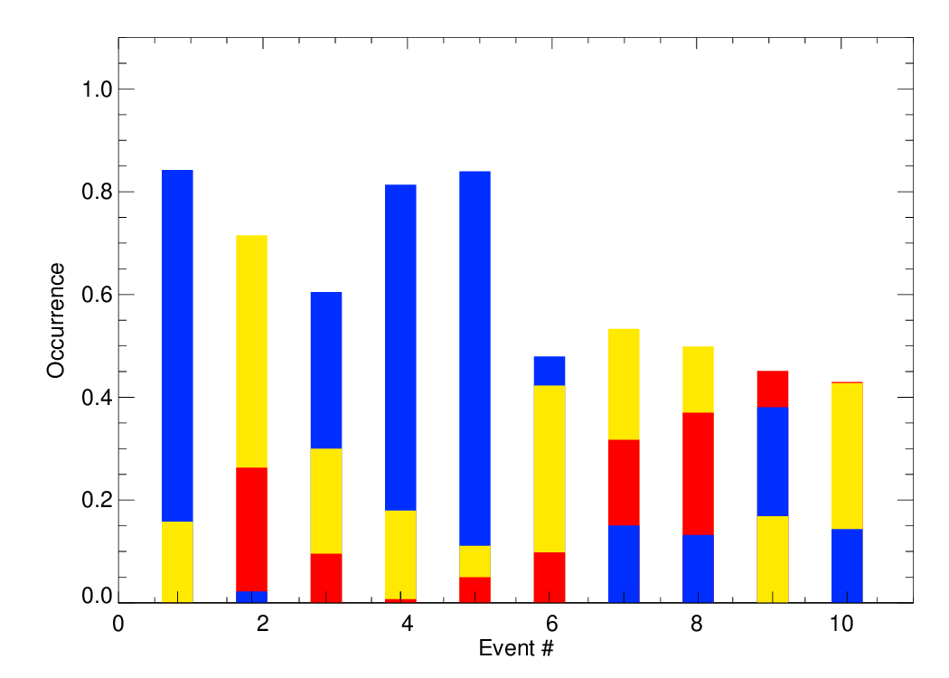
Figure 5. Percent occurrence of low density (blue), mid density (yellow), and high density (red) classes for 10 events. Each density class starts from zero. This means that the high density had the highest occurrence in events #09 and #10. The mid density had the highest occurrence in events #02, #07, and #08, while the remaining events (#01, #03, #04, #05, and #06) are received the highest contribution from low density.

Table 3c shows the derived SWER(Ze) relationships for the three bulk density classes. The low density class has the highest A-coefficient and b-exponent while vice versa is true for high density class. This results in higher SWER in high density than in low density. For example, at 20 dBZ, the SWER is 0.70 mm h⁻¹, 1.38 mm h⁻¹ and 2.26 mm h⁻¹ in low, mid, and high density classes, respectively.

Table 3c. Bulk density based SWER(Ze) relationships in the form of Ze = A S^{b}, Ze in mm⁶ m⁻³ and S in mm h⁻¹.

Bulk density class | A-coefficient | b-exponent
low | 176 | 1.48
mid | 63 | 1.42
high | 35 | 1.29

Fourth, a five-tier particle type (phase and habit) classification is constructed based on PIP particle size and fall velocity measurements. The habit classification follows on the Lee et al. (2015) algorithm which is based on coincident snowflake measurements by 2DVD and visual examination of snowflake photos during a winter experiment in northeast South Korea. The authors sampled approximately 40,000 snowflakes and proposed the empirical relationship between snowflake fall velocity and equivalent diameter (v-D_{eq}) for four different snowflake habits, graupel, dendrite, needle, and plate. The empirical relationship is given as,

v = α D_{eq}^{β} (10)

where α-coefficient values are 1.30, 0.82, 1.03, and 0.74, and β-exponent values are 0.94, 0.24, 0.71, and 0.35 for graupel, dendrite, needle, and plate, respectively. Figure 5 of Lee et al. (2015) shows that the observations are scattered around the best fitted curve especially in needle and graupel habits. Lee et al. 2015 also inherited the v-D_{eq} relationship (v = 9.65 -10.3 e^{-0.6Deq}) for raindrops following Atlas et al. (1973). The hydrometeor classification algorithm proposed by Lee et al. (2015) had six particle types: rain, wet snow/sleet, and four snowflakes habits. The algorithm calculates f factor for each particle type except wet snow/sleet for each minute. The f factor is formulated as

$f_{type}=\frac{1}{N_{p}}\sum_{i=1}^{N_{p}}{\left|v_{type}\left(D_{obs,i}\right)-v_{obs,i}\right|}$ (11)

where N_{P} is the number of particles in each minute. The particle type that corresponds to the minimum value of f factor (f_{min}) among the five particle types is assigned to the minute unless f_{min} > 0.6, assigned to wet snow/sleet. The main difference between Lee et al. (2015) and this study is the use of PIP rather than 2DVD. For insights into the differences in size and shape measurements made by PIP and 2DVD, readers are directed to Helms et al. (2022). More important to the present study, however, is that the fall velocity measurements of 2DVD and PIP also differ from each other: PIP uses object tracking to determine the fall speed while 2DVD measures the time required for a particle to move between two vertically-stacked observation planes. The particle matching between the two planes is key for 2DVD to produce accurate fall speeds. In the presence of snow, particles falling v > 4 m s⁻¹ were eliminated in 2DVD analysis as part of the quality control.

The PIP based particle type classification algorithm resulted in only 6% wet snow/sleet. Among the four different snowflake habits, dendrite and plate had the highest two occurrences with 46% and 23%, respectively while the graupel and needle had the lowest two occurrences with 12% and 13%, respectively. The plates dominated the cold low events, while the dendrites had the highest occurrence in warm low events and air-sea interaction event (Figure 6). The graupel had considerable contribution (25%) in the air-sea interaction event, while the needles occurred substantially (36-37%) in events #02 and #10.

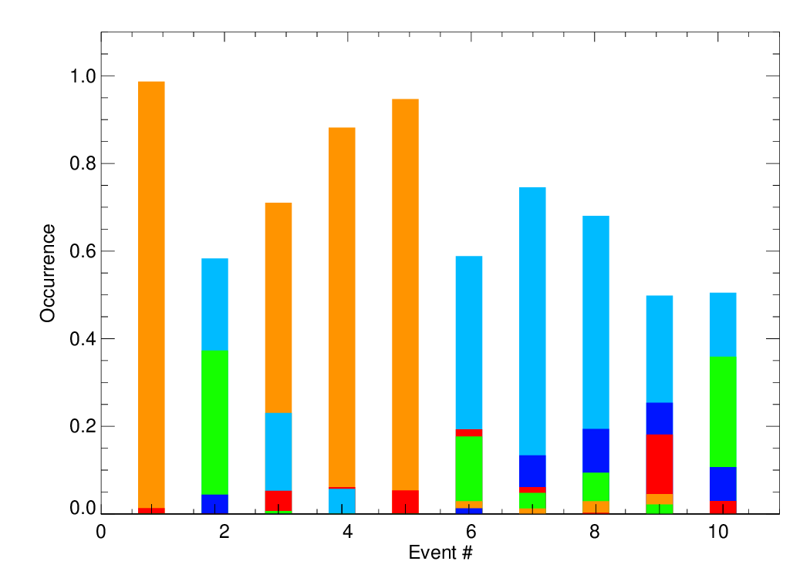
Figure 6. Percent occurrence of dendrite (light blue), plate (orange), needle (green), graupel (dark blue), and wet snow/sleet (red) classes for 10 events. Each habit class starts from zero. This means that the plates had the highest occurrence in events #01, #03, #04, and #05, while dendrites had the highest occurrent for the rest of the events (#02, #06, #07, #08, #09, and #10).

Table 3d shows the derived SWER(Ze) relationships for the five-tier particle type classes. The graupel class has the lowest A-coefficient and b-exponent while the opposite is true for the plate class. This results in higher SWER in graupel than in plate. For example, at 20 dBZ, the SWER is 0.59 mm h⁻¹ for the plate class and 2.52 mm h⁻¹ for the graupel class. The SWER is also relatively high for wet snow/sleet (2.03 mm h⁻¹) and is relatively low for dendrite (1.07 mm h⁻¹) and needle (1.74 mm h⁻¹) classes.

Table 3d. Particle type based SWER(Ze) relationships in the form of Ze = A S^{b}, Ze in mm⁶ m⁻³ and S in mm h⁻¹.

Particle type class | A-coefficient | b-exponent
graupel | 32 | 1.26
dendrite | 90 | 1.64
needle | 49 | 1.32
plate | 238 | 1.71
wet snow/sleet | 36 | 1.48

6. Case Studies

This section presents the time series and scatter diagrams of PIP-calculated and SWER(Ze) relationship-based SWER and SWE for events #03 and #08. These two events were the longest cold and warm low events, respectively (Table 1). The operational and research-based SWER(Ze) relationships, listed in Table 2 and Tables 3a,b,c,d, respectively, are evaluated for estimating the event SWE total and SWER utilizing bias and MAE presented in Section 3c.

Among the eight operational SWER(Ze) relationships, the NWS North-Plains & Upper-Midwest and MRMS SWER(Ze) relationships had the best performance for events #03 and #08, respectively. The best performance was determined by the minimum MAE. The SWE underestimated by 9.1% and 12.1% in events #03 and #08, respectively (Figure 7). This is mainly due to that fact that the estimated SWER could not match the peaks of PIP-calculated SWER in early segments of both events (Figures 7a-b). The scatter diagrams of estimated and PIP-calculated SWER shows the SWER regimes where the under- and over-estimation occurs (Figures 7c-d). The SWER was overestimated when SWER < 0.1 mm h⁻¹, while it was underestimated for SWER > 1 mm h⁻¹ in both events. The underestimation at heavier precipitation was the main reason for the negative bias in SWE.
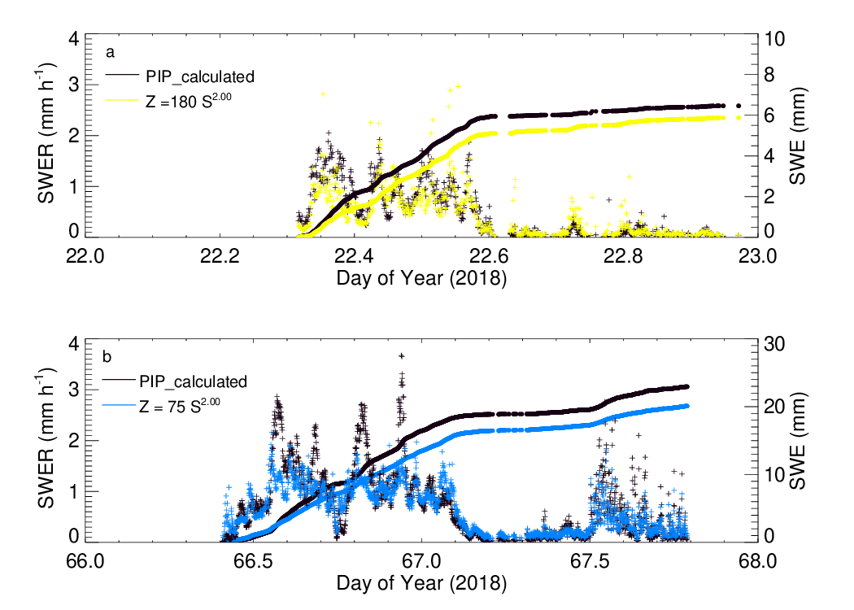

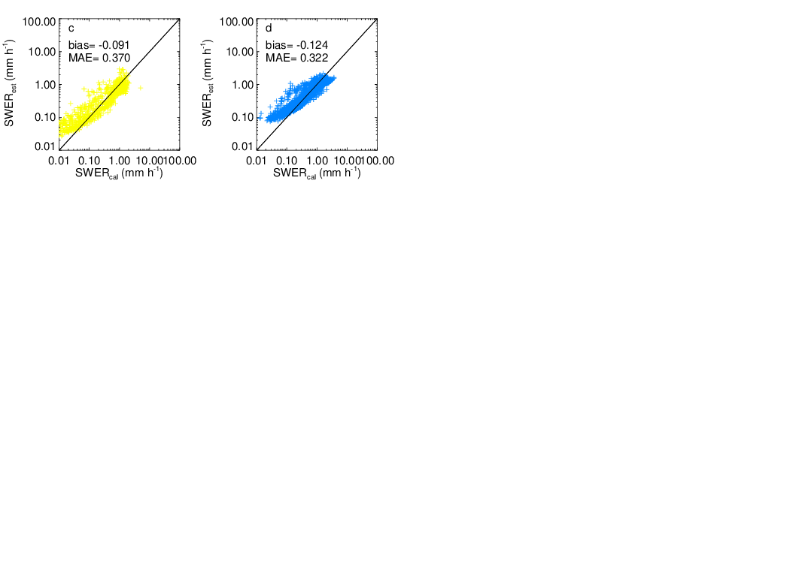
Figure 7. Time series of SWER and SWE for a) NWS North-Plains & Upper-Midwest SWER(Ze) relationship for event #03, and for b) MRMS SWER(Ze) relationship for event #08. The scatter diagrams of the estimated and PIP calculated SWER are given for c) event #03 and d) event #08.

Event-specific SWER(Ze) relationship had much lower A-coefficient and slightly lower b-exponent than the synoptic cold low SWER(Ze) relationship in event #03. This means that SWER is higher in event-specific SWER(Ze) relationship for a given reflectivity. Overall, the event-specific SWER(Ze) relationship overestimated the SWE total by only 2.7%. This might be interpreted as a very good performance for the event-specific SWER(Ze) relationship but this is not the case. The time series show multiple periods of over- and under-estimation of PIP-calculated SWER by both event-based and synoptic SWER(Ze) relationships (Figure 8a). A wide scatter on both side of the 1:1 line was evident in corresponding scatter diagrams (Figure 8e, f). The event-specific and synoptic SWER(Ze) relationship resulted in MAEs higher than that of the best operational SWER(Ze) relationship.

The low density observations occurred 61% of the time especially during the first half of event #03 where the precipitation was heavier (Figure 8b). The mid (30%) and high (9%) density observations were primarily present toward the end of the event when the precipitation was lighter. The density-based SWER(Ze) relationship underestimated the SWE total 1.6% and the MAE of SWER was the second lowest among the four research based SWER(Ze) relationships. This highlighted the advantage of physically-based multiple SWER(Ze) relationships over a single SWER(Ze) relationship for a given event. Misclassification is the main caveat of the physically-based SWER(Ze) relationships, however. In this event, the high density observations at the very early stage of the event may result from misclassification. A close look to the scatter diagram showed that the high density observations underestimated SWER, while the low density observations mostly overestimated SWER (Figure 8g).

Following Lee et al. (2015), plates dominated the event #03 with 73% occurrence (Figure 8h). The dendrites were observed to have 23% occurrence, mostly at the early stage of the event. Wet snow was scattered within plate observations and was attributed to a misclassification. The habit-based SWER(Ze) relationship underestimated the SWE total by 4.9% resulting in the lowest MAE among the four research SWER(Ze) relationships; the best performance for this event.

The wet-bulb temperature was steady at -3 C until 12:00 UTC and gradually dropped to -18 C with time (Figure 8d) in event #03. The heavier precipitation with dendrites and low density was observed during the period of steady wet-bulb temperatures early in the event. The lighter precipitation with plates and mid and high density occurred during the drop in wet-bulb temperature later in the event. It should be noted that the temperature where the hydrometeors form aloft plays more significant role than the surface wet-bulb temperature at the surface. Sims and Liu (2015) relied first on surface wet-bulb temperature but later added the temperature profile in the lower atmosphere to partition snow from rain.

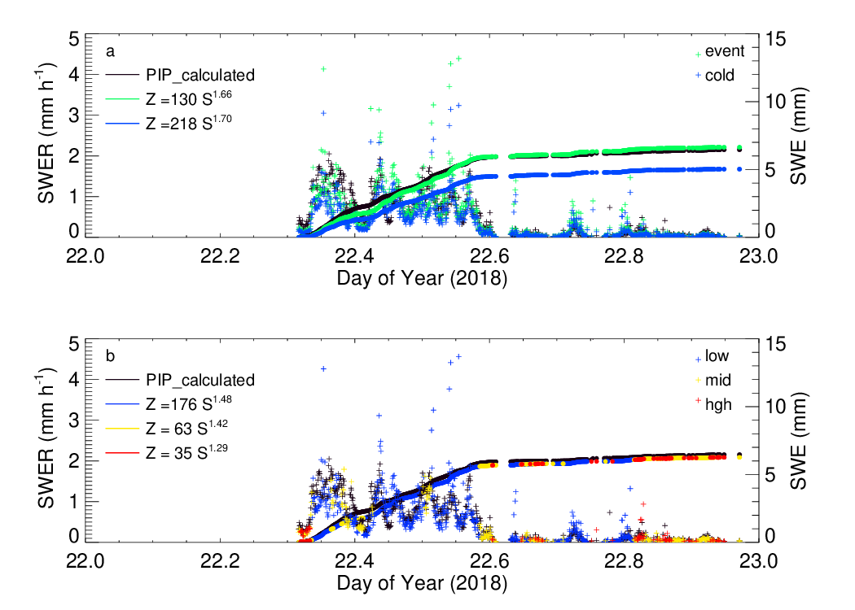
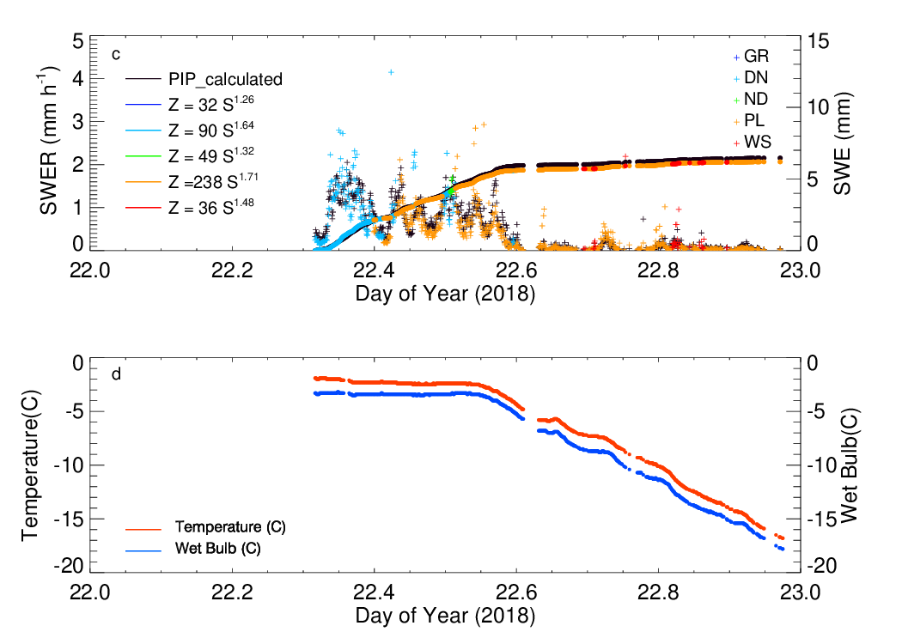
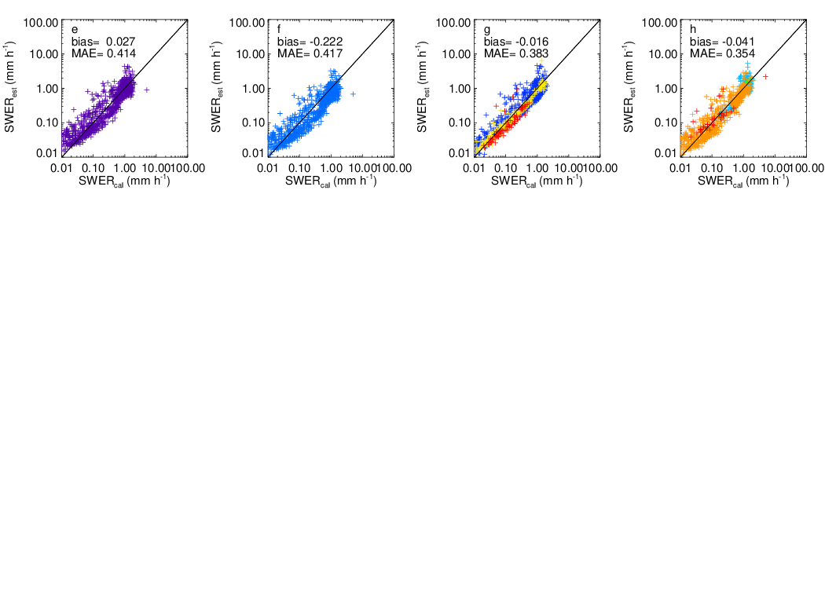
Figure 8. Time series of SWER and SWE for a) event-specific (purple) and synoptic cold low (blue), b) density-based, c) habit-based SWER(Ze) relationships for event # 03. d) Time series of temperature and wet-bulb temperature for the same event. The scatter diagrams of estimated and PIP calculated SWER are given for e) event-based, f) cold-low, g) density-based, and h) habit-based SWER(Ze) relationships.

There were similarities between the events #03 and #08 for the performance of research based SWER(Ze) relationships even though the events’ characteristics were drastically different. The event #08 was 2.3 times longer than the event #03 (Table 1). For the geometric depth of snow, the event #08 was 1.58 times deeper than the event #03, but the former event accumulated 3.54 times greater SWE than the latter event. This is a direct consequence of the difference in bulk density of snowflakes and was one of the key differences between cold and warm low events.

Event-specific SWER(Ze) relationships had lower A-coefficients and b-exponents than the synoptic warm low SWER(Ze) relationship. As a result, several peaks in the PIP-calculated SWER time series were underestimated to a lesser extent by the event-specific SWER(Ze) relationship than the synoptic warm low one (Figure 9a). The SWE totals were therefore underestimated only 1.3% and 16.2% by the event-specific and synoptic SWER(Ze) relationships, respectively. A wide but similar scatter on both sides of the 1:1 line reflected the under- and over-estimation of SWER at different segments of the time series (Figures 9e, f). The MAEs of the event-specific and synoptic SWER(Ze) relationships differed by less than 2% and about the same best operational SWER(Ze) relationship but noticeably higher than the physical based SWER(Ze) relationships.

The mid density observations dominated the first half of event #08 with 50% overall occurrence (Figure 9b). The high density observations mostly occurred during the second half the event with 30% overall occurrence. The low density observations at the beginning of the event could result from misclassification. Indeed, these low density observations overestimated SWER when SWER < 0.3 mm h⁻¹ and underestimated SWER when SWER ≥ 0.3 mm h⁻¹ (Figure 9g). The mid and high density observations followed the 1:1 line with a narrow scatter on both side of the line. The density-based SWER(Ze) relationship had higher SWE bias than the event-specific and synoptic SWER(Ze) relationships and this is mainly due to the overestimation of low density observations at high SWER. The MAE of the density-based SWER(Ze) relationship, on the other hand, was the lowest among the four research based SWER(Ze) relationships, highlighting the success of the physical-based SWER(Ze) relationships.

Following the Lee et al. (2015) classification, dendrites dominated the event #08 with 69% occurrence (Figure 8c). The graupel was observed during the second half of the event with 19% overall occurrence. The needles (9%) were present over brief periods, mostly during the early segment of the event. The plates at the beginning of the event were a results of misclassifications. Indeed, these plate observations overestimated SWER (Figure 9h). The graupel observations were on both sides of the 1:1 line when SWER < 0.5 mm h⁻¹ but SWER was underestimated above this threshold. The dendrites and needles were scattered on both sides of the 1:1 line with a slight underestimation of SWER. The SWE bias was 16%, higher than the best operational, event-specific, and density-based SWER(Ze) relationships but the habit-based SWER(Ze) has the second lowest MAE of SWER after the density-based SWER(Ze) relationship.

The wet-bulb temperature oscillated from -1 C during daytime hours to -5 C during nighttime hours (Figure 9d). A majority of the precipitation occurred during the colder nighttime hours. The peak wet-bulb temperature between 02:00–03:00 UTC (11:00-12:00 LST) coincided the transition from mid to high density. The graupel is observed after the mid event peak in wet-bulb temperature.

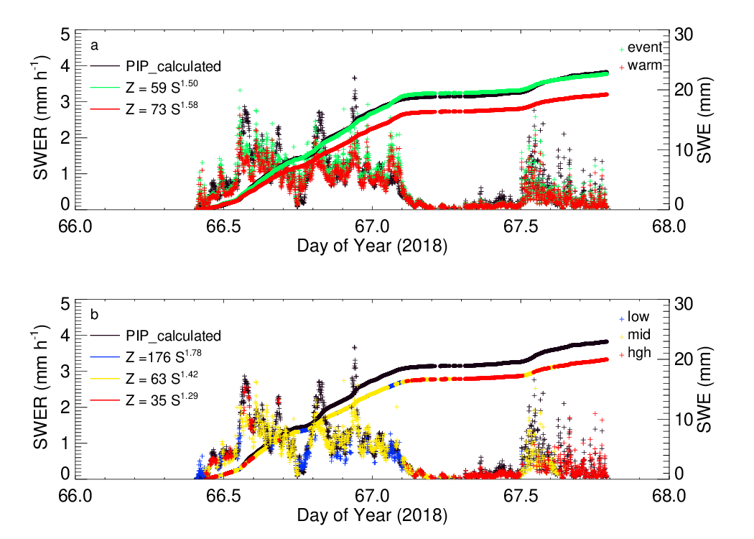
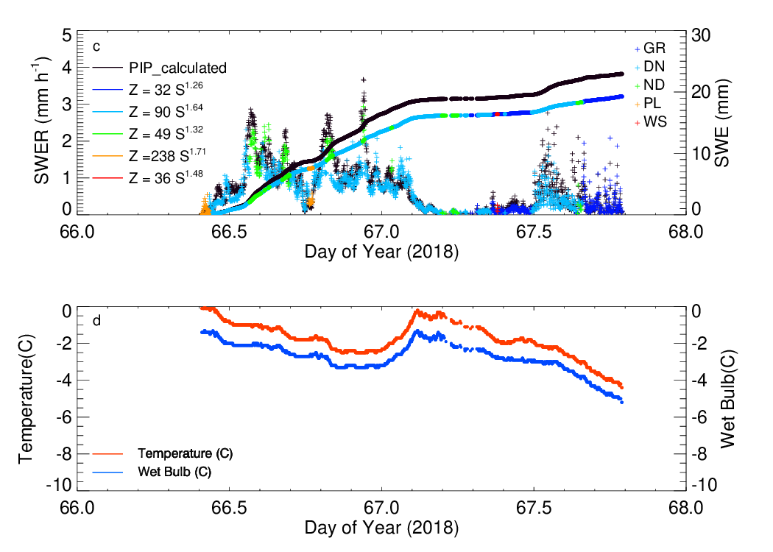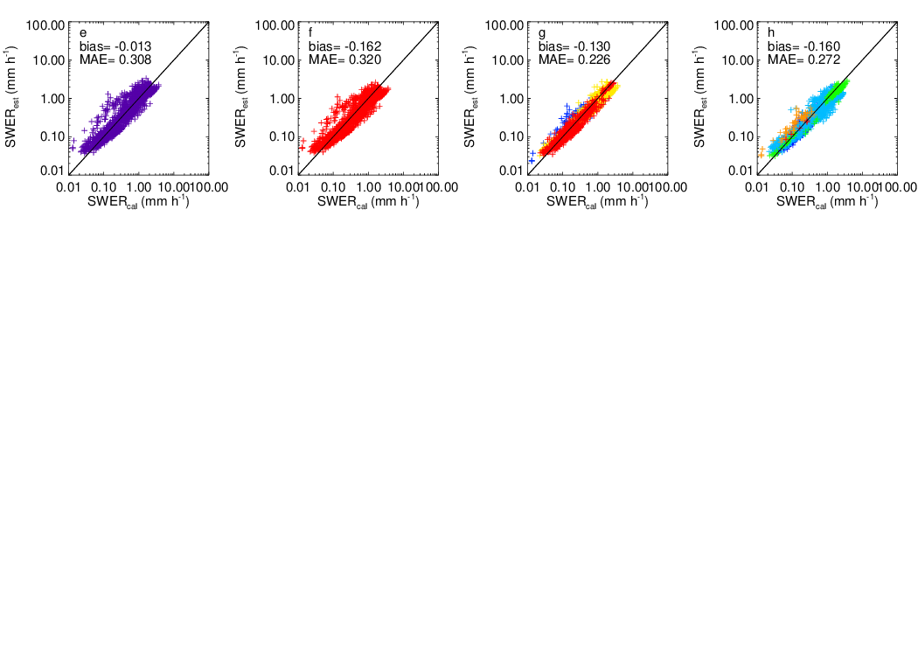
Figure 9. Time series of SWER and SWE for a) event-specific (purple) and synoptic warm low (blue), b) density-based, c) habit-based SWER(Ze) relationships for event # 08. d) Time series of temperature and wet-bulb temperature for the same event. The scatter diagrams of estimated and PIP calculated SWER are given for e) event-based, f) cold-low, g) density-based, and h) habit-based SWER(Ze) relationships.

7. Overall Statistics

This section presents the SWE bias and SWER MAE for i) eight operational SWER(Ze) relationships and for ii) four research and best operational SWER(Ze) relationships for 10 events. The performance of the operational SWER(Ze) relationships is drastically different between the cold and warm low events. For the warm low events including the air-sea interaction event, the operational SWER(Ze) relationships with the lowest two A-coefficients had the least SWE bias for three events each (Figure 10a). This is also true for the MAE except that the third lowest A-coefficient was the best performance in one of the warm low events (Figure 10b). For the cold low events including event #01, the operational SWER(Ze) relationships with higher A-coefficients had the least bias and minimum MAE. Among cold low events, events #04 and #05 had the highest bias and MAE among the best operational SWER(Ze) relationships. Recall from Table 3a, the event-based SWER(Ze) had exceptionally high A-coefficient and b-exponent for event #04. The operational SWER(Ze) relationship with the highest A-coefficient had the best performance, consequently.
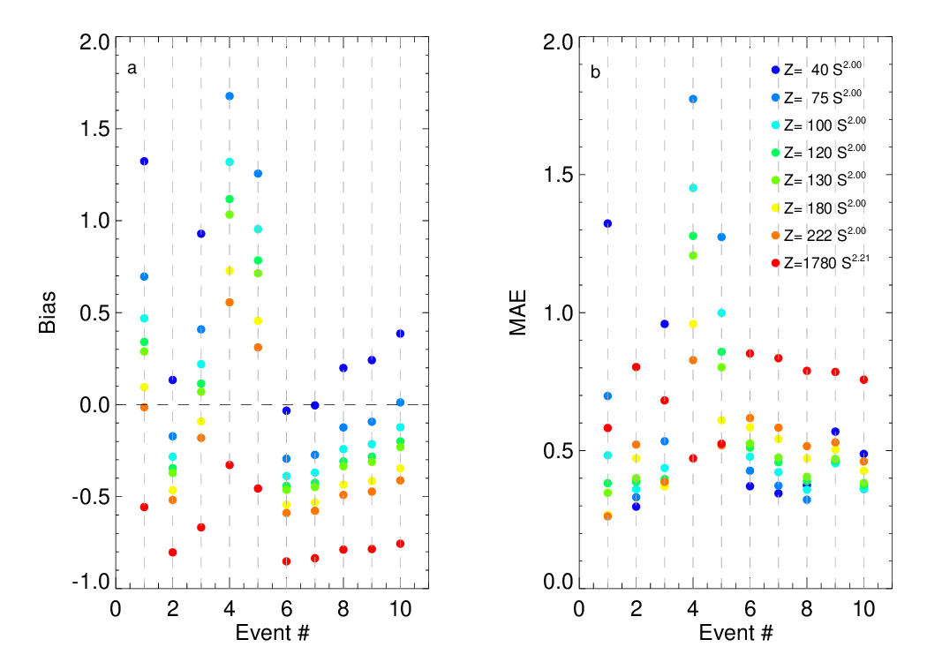
Figure 10. a) SWE Bias and b) SWER MAE for eight operational SWER(Ze) relationships for 10 events.

The performance of four research-based and best operational SWER(Ze) relationships varied from one event to another (Figure 11). The event-specific SWER(Ze) relationships had the lowest bias for four events, while synoptic warm/cold low SWER(Ze) relationships had the lowest bias for three events. Interestingly, the best operational SWER(Ze) relationships had lower bias than the research-based SWER(Ze) relationships for two events. The density-based based SWER(Ze) relationships had the lowest bias for the remaining one event. More importantly, the best performing SWER(Ze) relationships had bias < ±6% for all events except event #04. The second best performing SWER(Ze) relationships, on the other hand, had bias ≤ ±18% for 9 events. For MAE, the density-based SWER(Ze) had the best performance for all warm low events except event #02. The habit-based SWER(Ze) relationships had the lowest MAE for three events, while the best operational and event-specific SWER(Ze) relationships had the lowest MAE in one event each. The MAE was less than 30% for the best performed SWER(Ze) relationship in half of the events, while it exceeded 40% in events #04 and #05.
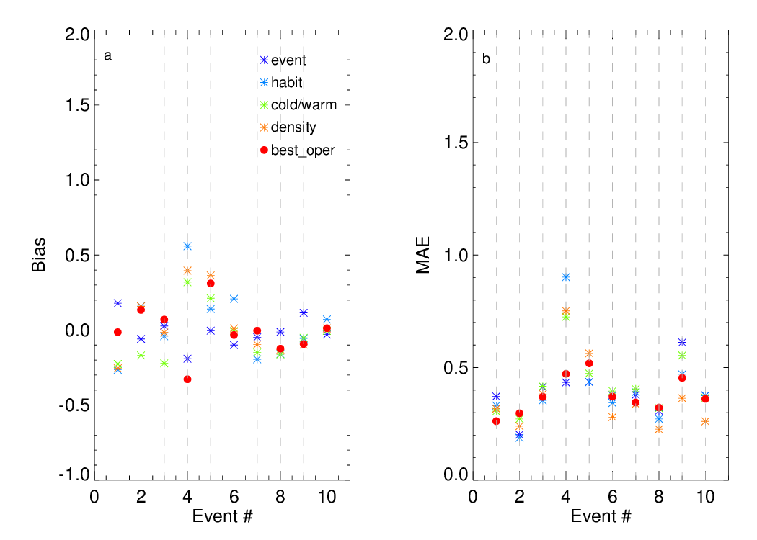
Figure 11. a) SWE Bias and b) SWER MAE for four research and best operational SWER(Ze) relationships for 10 events.

These statistics reveal two main conclusions: which classification method based SWER(Ze) relationships has the best performance for SWE and SWER estimates; and how well SWE and SWER can be estimated from SWER(Ze) relationships. For operational purposes, the radar based SWER estimate should be based on a handful of SWER(Ze) relationships. As noted earlier, there is a significant inter-variability for the physical properties between the events and the regional SWER(Ze) relationships listed in Table 2 and those used by the NWS are not adequate. This is also shown by the drastic differences in the performance of operational SWER(Ze) relationships in a given event.

The MRMS SWER(Ze) relationship is used in GPM ground validation program and is therefore of particular interest. It underestimated SWE by less than 30% in warm low events except a slight overestimation of 1.2% in event #10, and overestimated SWE 41-167% in cold low events. It also resulted in MAE of 32-46% in warm low events, and of 53-177% in cold low events. These findings conclude that the MRMS SWER(Ze) relationship should not be used for cold low events. For warm low events, its performance is compared to the performance of the synoptic SWER(Ze) relationship presented in Table 3b. Except event #08, the synoptic SWER(Ze) relationship performed better than the MRMS SWER(Ze) relationship for SWE total. The synoptic SWER(Ze) relationship resulted in higher MAE with respect to the MRMS SWER(Ze) relationship for two events only.

It seems that cold versus low events can easily be identified by a forecaster in the Korean Peninsula. If the precipitation is snow, it is practical to adopt the one of the two synoptic SWER(Ze) relationships presented in Table 3b. The synoptic warm low SWER(Ze) relationship results in bias within ±17% but MAE ranges from 26% to 55%. The synoptic cold low SWER(Ze) relationship, on the other hand, resulted in 21-22% bias and 31-47% MAE except for event #04.

The density-based SWER(Ze) relationships performed well for the majority of the events. Except for three events (#01, #04, and #05), the SWE bias was within ±16%. The MAE was under 40% except for events #04 and #05. The habit-based SWER(Ze) relationships also performed well. The bias was within ±21% except for the same three events listed for density-based SWER(Ze) relationships. The MAE was under 50% except for event #04. The main issue for the these two physically-based SWER(Ze) relationships is the misclassification due to subjectively defined bulk density boundaries and the effectiveness of the Lee et al. (2015) habit classification algorithm.

8. Conclusions

This study evaluated the performance of operational and research-based SWER(Ze) relationships utilizing the PIP-based observations from the ICE-POP 2018 field campaign. The PIP can accurately measure size, concentration, and fall velocity of the snowflakes from which Ze and SWER are calculated using hydrometeor aerodynamics outlined by Böhm (1989). This ICE-POP PIP dataset consists of 10 events, including four synoptically classified as cold low and six warm low events.

Prior to evaluation of SWER(Ze) relationships, two physically-based classification algorithms were developed. One of these physically-based classification SWER retrieval algorithms uses three-class bulk density of PIP observations, which reveal that low density class dominated cold low events, while mid and high density classes are largely observed in warm low events. The other physically-based classification algorithm adopted the Lee et al. (2015) habit algorithm, which showed dendrites and plates dominating the warm and cold low events, respectively. The event-specific and synoptic cold/warm low SWER(Ze) relationships are the other two research-based SWER(Ze) relationships evaluated in this study, resulting in four new estimates for SWE and SWER.

This study reveals that inter- and intra-variability of falling snow dominates the performance of SWER(Ze) relationships. It is clear that a single SWER(Ze) relationship is not the best solution for radar-based snowfall estimation in the Korean Peninsula. The inter-variability among the events is highlighted by the wide range of A-coefficients and b-exponents of the event-specific SWER(Ze) relationships derived from the large sample of PIP observations. The intra-variability of falling snow, which was observed mostly on relatively longer events revealed that a single SWER(Ze) relationship may not be appropriate for all the events.

Among 10 events, event #04, a cold low event, was exceptional. The event specific A-coefficient and b-exponent of the SWER(Ze) relationship were substantially higher than the other events and the vast majority of the literature (e.g. Table 3 of von Lerber et al. 2017). It is clear that the event-specific SWER(Ze) relationship performs relatively better than all other research and operational SWER(Ze) relationships but the bias and MAE are still high for the event-specific relationship. This indicates that there will be rare events where neither the operational nor the physical-based SWER(Ze) relationships will estimate SWE and SWER accurately.

The relatively poorer performance of the research-based SWER(Ze) relationships is particularly interesting in events #01 and #05, both cold low events. The best operational SWER(Ze) relationship had lower bias and MAE than the four research based SWER(Ze) relationships in event #01. If the bias of ±15% and MAE of 30% are considered as the thresholds for the reasonable performance of the SWER(Ze) relationships, all of the research-based SWER(Ze) relationships had poor performance for event #01. The event-specific SWER(Ze) also performed well in event #05. The SWE was underestimated by < 1% but MAE exceeded 40%, as being one of two least successful SWER(Ze) relationships for SWER. This emphasizes the importance of the purpose for which these relationships are being applied as this can differ between hydrologists and meteorologists. Hydrologists seek the best estimate of event SWE total, while the SWER estimate is more important for meteorologists.

The remaining cold low event (event #03) and all warm low events demonstrated that the physically-based SWER(Ze) relationships are superior to a single SWER(Ze) relationship for a given event. The density-based SWER(Ze) relationships yield a ≤ 15% bias in SWE and ≤ 30% MAE in SWER except for two events of the events in which they had higher MAE. The habit based SWER(Ze) relationships also performed reasonably well but misclassification is an issue for both physically-based algorithms. This suggests that physically-based SWER(Ze) relationships are favorable for a majority of the events but the classification algorithms are subject to improvement. During ICE-POP 2018, Multi-Angle Snowflake Camera (MASC), which provides very high resolution images of snowflakes that can be used to more precisely determine particle habit (Garrett et al. 2012), was collocated with the PIP, but did not operate continuously (Gehring et al. 2020). MASC images could provide refine the habit-based SWER relationship presented herein.

For operational purposes, there is an outstanding question: How can one apply the density or habit based SWER(Ze) relationships to the radar observations? It is suggested that the PIP based classification algorithms are first compared with collocated radar-based hydrometeor identification (HID) algorithms (e.g. Thompson et al. 2014). It is expected that this will lead to HID based SWER(Ze) relationships. A long record of falling snow with all the in-situ instrumentation used in this study as well as a MASC and a nearby scanning radar is perhaps the best suite for such a follow-up study.

Acknowledgments

First and foremost, acknowledgments go to Kwang Deuk Ahn of the Korean Meteorological Administration and GyuWon Lee of Kyungpook National University for their leadership during ICE-POP 2018. Specifically, the authors wish to thank their South Korean colleagues for operating the NASA’s PIP and PARSIVEL disdrometers and providing the Vaisala WXT520 weather station and MRR-2 database. Dr. Helms' contribution to this study was supported by an appointment to the NASA Postdoctoral Program at NASA Goddard Space Flight Center, administered by Universities Space Research Association and Oak Ridge Associated Universities under contract with NASA. This study is funded through NASA’s Internal Scientist Funding Model for Precipitation Measurement Mission via Grant # NNX16AE88G.

Data Availability

The data used in this study was extracted though a secure file transfer site where the IP address, username, and password were set by the ICE-POP 2018 field campaign organizers. To access the database, please contact to Kwonil Kim (kwonil.kim.0@gmail.com).

References

Atlas, D., R. C. Srivastava, and R. S. Sekhon, 1973: Doppler radar characteristics of precipitation at vertical incidence. Rev. Geophys. Space Phys., 11, 1–35.

Boggs, P. T., R. H. Byrd, J. E. Rogers, and R. B. Schnabel, 1992: User’s reference guide for ODRPACK version 2.01: Software for weighted orthogonal distance regression. https://docs.scipy.org/doc/external/odrpack_guide.pdf.

Boudala, F. S., G. A. Isaac, D. Hudak, 2006: Ice water content and precipitation rate as a function of equivalent radar reflectivity and temperature based on in situ observations. J. Geophys. Res., 111, D11202.

Böhm, H., 1989: A general equation for the terminal fall speed of solid hydrometeors. J. Atmos. Sci., 46, 2419–2427.

Bukovcic´, P., A. Ryzhkov, and D. Zrnic´, 2020: Polarimetric relations for snow estimation – radar verification. J. Appl. Meteor. Climatol., 59, 991–1009.

Chase, R. J., S. W. Nesbitt, and G. M. McFarquhar, 2021: A dual-frequency radar retrieval of two parameters of the snowfall particle size distribution using a neural network. J. Appl. Meteor. Climatol., 60, 341-359. https://doi.org/10.1175/JAMC-D-20-0177.1

Cifelli, R. V. Chandrasekar, S. Lim, P. C. Kennedy, Y. Wang, and S. A. Rutledge, 2011: A new dual-polarization radar rainfall algorithm: Application in Colorado precipitation events. J. Atmos. Oceanic Technol., 28, 352-364.

Garrett, T. J., C. Fallgatter, K. Shkurko, and D. Howlett , 2012: Fall speed measurement and high-resolution multi-angle photography of hydrometeors in free fall, Atmos. Meas. Tech., 5(11), 2625–2633, doi:10.5194/amt-5-2625-2012.

Gatlin, P. N., W. A. Petersen, J. L. Pippitt, T. A. Berendes, D. B. Wolff, and A. Tokay, 2020: The GPM validation network and evaluation of satellite-based retrievals of the rain drop size distribution. Atmosphere, 11(9), 010; https://doi.org/10.3390/atmos11091010.

Gehring, J. A. Ferrone, A-C. Billault-Roux, N. Besic, K. D. Ahn, G. Lee, and A. Berne, 2020: Radar and ground-level measurements of precipitation collected by EPFL during the ICE-POP 2018 campaign in South Korea. Earth System Science Data, https://doi.org/10.5194/essd-2020-134.

Helms, C. N., S. J. Munchak, A. Tokay, A., and C. Pettersen, 2022: A comparative evaluation of snowflake particle size and shape estimation rechniques used by the Precipitation Imaging Package (PIP), Multi-Angle Snowflake Camera (MASC), and Two-Dimensional Video Disdrometer (2DVD), Atmos. Meas. Tech. Discuss. [preprint], https://doi.org/10.5194/amt-2021-427, in review.

Jeoung, H., G. Liu, K. Kim, G. Lee, and E.-K. Seo, 2020: Microphysical properties of three types of snow clouds: implication for satellite snowfall retrievals, Atmos. Chem. Phys., 20, 14491–14507, https://doi.org/10.5194/acp-20-14491-2020.

Kim, K., W. Bang, E. C. Chang, F. J. Tapiador, C. L. Tsai, E. Jung, and G. W. Lee, 2021: Impact of wind pattern and complex topography on snow microphysics during ICE-POP 2018. Atmos. Chemistry Physics, https://doi.org/10.5194/acp-2021-128.

King, F., G. Duffy, and C. G. Fletcher, 2022: A centimeter wavelength snowfall retrieval algorithm using machine learning. J. Appl. Meteor. Climatol., 61, 1029-1039. https://doi.org/10.1175/JAMC-D-22-0036.1

Kirstetter, P. E., W. A. Petersen, C. Kummerow, and, D. B. Wolff, 2020: Integrated multi-satellite evaluation for the global precipitation measurement: Impact of precipitation types on spaceborne precipitation estimates. Satellite Precipitation Measurement; Levizzani, V., Kidd, C., Kirschbaum, D., Kummerow, C., Nakamura, K., Turk, F.J., Eds.; Springer Nature: Cham, Switzerland, pp. 583-608. ISBN 978-3-030-35798-6

Klugmann, D., K. Heinsohn, H. J. Kirtzel, 1996: A low cost 24 GHz FM-CW Doppler radar rain profiler. Contrib. Atmos. Phys., 61, 247–253.

Lee, G. W., and I. Zawadzki, 2005: Variability of drop size distributions: Timescale dependence of the variability and its effects on rain estimation. J. Appl. Meteor., 44, 241–255.

Lee, J-E., S-H. Jung, H-M. Park, S. Kwon, P-L. Lin, G. Lee, 2015: Classification of precipitation types using fall velocity-diameter relationships from 2D-video disdrometer measurements. Adv. Atmos. Sci., 32, 1277-1290.

Liao, L., R. Meneghini, H. K. Nowell, and G. Liu, 2013: Scattering computations of snow aggregates 1183 from simple geometrical particle models. IEEE J. Sel. Topics Appl. Earth Observ. Remote Sens., 6, 1184 1409-1417.

Lim, K.-S. S., E.-C. Chang, R. Sun, K. Kim, F. J. Tapiador, and G. Lee, 2020.: Evaluation of simulated winter precipitation using WRF-ARWduring the ICE-POP 2018 field campaign. Weather Forecasting, 35, 2199–2213, https://doi.org/10.1175/WAF-D-19-0236.1.

Marshall, J. S., and K. L. S. Gunn, 1952: Measurement of snow parameters by radar. J. Meteor., 9, 322-327.

Munchak, S. J., R. S. Schrom, C. N. Helms, and A. Tokay, 2022: Snow microphysical retrieval from the NASA D3R radar during ICE-POP 2018. Atmos. Meas. Tech., 15, 1439-1464.

Newman, A. J., P. A. Kucera, and L. F. Bliven, 2009: Presenting the Snowflake Video Imager (SVI). J. Atmos. Ocean. Tech., 26, 167–179.

Petersen, W. A., P. E. Kirstetter, J. Wang, D. B. Wolff, and A. Tokay, 2020: A. The GPM Ground Validation Program. Satellite Precipitation Measurement; Levizzani, V., Kidd, C., Kirschbaum, D., Kummerow, C., Nakamura, K., Turk, F.J., Eds.; Springer Nature: Cham, Switzerland, pp. 471–502. ISBN 978-3-030-35798-6.

Pettersen, C., F. L. Bliven, A. von Lerber, N. B. Wood, M. S. Kulie, M. E. Mateling, D. N. Moisseev, S. J. Munchak, W. A. Petersen, and D. B. Wolff, 2020a: The Precipitation Imaging Package: Assessment of Microphysical and Bulk Characteristics of Snow. Atmosphere, 11, 785.

Pettersen, C., M. S. Kulie, L. F. Bliven, A. J. Merrelli, W. A. Petersen, T. J. Wagner, D. B. Wolff, and N. B. Wood, 2020b: A composite analysis of snowfall modes from four winter seasons in Marquette, Michigan. J. Appl. Meteor. Climatol., 59, 103-124.

Rasmussen, R., M. Dixon, S. Vasiloff, F. Hage, S. Knight, J. Vivekanandan, and M. Xu, 2003: Snow nowcasting using a real-time correlation of radar reflectivity with snow gauge accumulation. J. Appl. Meteor., 42, 20–36.

Saltikoff, E., P. Lopez, A. Taskinen, and S. Pulkkinen, 2015: Comparison of quantitative snowfall estimates from weather radar, rain gauges, and numerical weather prediction model. Boreal Env. Resea., 20, 667-678.

Schoger, S. Y., D. Moisseev, A. von Lerber, S. Crewell, and K. Ebell, 2021: Snowfall-rate retrieval for K- and W-band radar measurements designed in Hyytiala, Finland, and tested at Ny-Alesund, Swlbard, Norway. J. Appl. Meteor. Climatol., 60, 273-289.

Sekhon, S. R., and R. C. Srivastava, 1970: Snow size spectra and radar reflectivity, J. Atmos. Sci., 27, 299–307.

Shates J. A., C. Pettersen, T. S. L’Ecuyer, S. J. Cooper, M. S. Kulie, and N. B. Wood, 2021: High-latitude precipitation: Snowfall regimes at two distinct sites in Scandianvia. J. Applied Meteor. Climatol., 60, 1127-1148.

Skofronick-Jackson, G., W. A. Petersen, W. Berg, C. Kidd, E. F. Stocker, D. B. Kirschbaum, R. Kakar, S. A. Braun, G. J. Huffman, T. Iguchi, P. E. Kirstetter, C. Kummerow, R. Meneghini, R. Oki, W. S. Olson, Y. N. Takayabu, K. Furukawa, and T. Wilheit, 2017: The Global Precipitation Measurement (GPM) Mission for Science and Society. Bull. Amer. Meteor. Soc., 98, 1679–1695.

Skofronick-Jackson, G., D. Kirschbaum, W. Petersen, G. Huffman, C. Kidd, E. Stocker, and R. Kakar, 2018: The Global Precipitation Measurement (GPM) mission’s scientific achievements and societal contributions: review in four years of advanced rain and snow observations. Q. J. R. Meteorol. Soc., 144, 27-48.

Skofronick-Jackson, G., M. Kulie, L. Milani, S. J. Munchak, N. B. Wood, and V. Levizzani, 2019: Satellite estimation of falling snow: A global precipitation measurement (GPM) core observatory perspective. J. Applied Meteor. Climatology, 58, 1429-1447.

Sims, E. M., and G. Liu, 2015: A parameterization of the probability of snow-rain transition. J. Hydrometeor., 16, 1466-1477.

Souverijns, N., A. Gossart, S. Lhermitte, I . V. Gorodetskaya, S. Kneifel, M. Maahn, F. L. Bliven, and N. P. M. van Lipzig, 2017: Estimating radar reflectivity – snowfall rate relationships and their uncertainties over by combining disdrometer and radar observations. Atmos. Resea., 196, 211-223.

Thompson, E. J., S. A. Rutledge, B. Dolan, V. Chandrasekar, and B. L. Cheong, 2014: A dual-polarization radar hydrometeor classification algorithm for winter precipitation. J. Atmos. Oceanic Technol., 31, 1457-1481.

Tokay, A., A. Kruger, and W. Krajewski, 2001: Comparison of drop-size distribution measurements by impact and optical disdrometers. J. Appl. Meteor., 40, 2083-2097.

Tokay, A., D. B. Wolff, W. A. Petersen, 2014: Evaluation of the new version of the laser-optical disdrometer, OTT PARSIVEL². J. Atmos. Ocean. Technol., 31, 1276–1288.,

Tokay, A., A. von Lerber, C. Pettersen, M. S. Kulie, D. N. Moisseev, and D. B. Wolff, 2022: Retrieval of snow water equivalent by the Precipitation Imaging Package (PIP) over Northern Great Lakes. J. Atmos. Oceanic Technol., 39, 37-54.

von Lerber, A., D. Moisseev, F. Bliven, W. Petersen, A.-M. Harri, and V. Chandrasekar, 2017: Microphysical properties of snow and their link to Ze–S relations during BAECC 2014. J. Appl. Meteor. Climatol., 56, 1561–1582.

Wood, N. B., T. S. L’Ecuyer, F. L. Bliven, and G. L. Stephens, 2013: Characterization of video disdrometer uncertainties and impacts on estimates of snowfall rate and radar reflectivity. Atmos. Meas. Tech., 6, 3635–3648, doi:10.5194/amt-6-3635-2013.

Yu, T., V. Chandrasekar, H. Xiao, L. Hang, L. Luo, and X. Li, 2022: Dual-frequency radar retrievals of snowfall using random forest. Remote Sensing, 14, 2685. https://doi.org/10.3390/rs14112685

Zhang, J., Howard, K., Langston, C., Kaney, B., Qi, Y., Tang, L., Grams, H., Wang, Y., Cocks, S., Martinaitis, S., Arthur, A., Cooper, K., Brogden, J., & Kitzmiller, D. (2016). Multi-Radar Multi-Sensor (MRMS) quantitative precipitation estimation: Initial operating capabilities. Bulletin of the American Meteorological Society, 97, 621–638. https://doi.org/10.1175/BAMS-D-14-00174.1.

