Managing the Lucy Mission

Donya Douglas-Bradshaw¹, Arlin Bartels¹, John Andrews², Vince Elliott¹, Chris Carson¹, Jim Rogers¹
¹National Aeronautics and Space Administration (NASA) Goddard Space Flight Center (GSFC), Code 434, Greenbelt, MD 20771
²Deptartment of Space Studies, Southwest Research Institute (SwRI), 1050 Walnut St., Suite 400, Boulder CO, 80302

Abstract
Lucy is NASA’s 13th Discovery-class mission. It will be the first mission to encounter seven Trojan asteroids in a series of five flybys. Lucy is led by Dr. Hal Levison of the Southwest Research Institute. As the Principal Investigator, Dr. Levison is accountable to NASA for the success of the investigation, with full responsibility for its scientific integrity and execution within committed cost and schedule. Day to day management of the Lucy project is delegated to Goddard Space Flight Center. During Lucy’s development, the project experienced a once-in-a-lifetime pandemic that threatened the team’s ability to meet the planetary launch window. Despite this challenge, Lucy launched on time and under budget. This chapter discusses key factors that enabled project success.

Keywords
Project Management, NASA, Discovery Mission, Announcement of Opportunity, PI Led Mission, NPR 7123.1, NPR 7120.5, Lucy, GSFC, Goddard, Trojan, Jupiter, Covid-19, Coronavirus, Lockheed Martin, SwRI, Arizona State University, Johns Hopkins University Applied Physics Lab, LORRI, L’Ralph, TES, Spacecraft, Instrument, Pandemic, Launch, KSC

Introduction
Lucy, a NASA Discovery Class mission, was selected via the 2014 Discovery Announcement of Opportunity and successfully launched at the opening of its planetary launched window on October 16, 2021. The Lucy mission name honors the influence that the Australopithecus afarensis hominin fossil named “Lucy” has had in advancing our understanding of the history of our species. Its name embodies the mission goal to similarly advance the understanding of the formation and evolution of our Solar System. The Jupiter Trojan Asteroids, which lead and follow Jupiter in its orbit by approximately 60 degrees°, have never been visited by a spacecraft. Lucy will investigate seven primitive asteroids near the Jupiter L₄ and L₅ Lagrange points where planetesimals from the outer planetary system have been preserved since early in Solar System history. This rich diversity of targets is enabled by fortuitous orbital alignments exploited by Lucy’s unique trajectory.

Management Approach
The aim of project management is to deliver a successful outcome that meets the needs of stakeholders while balancing constraints such as time, cost, and performance. Lucy’s management team developed an executable plan based on proven management practices. The plan involved clearly defined goals and objectives, unambiguous lines of authority, effective communication, results-driven design, a high performing team, project planning and control that kept the team on schedule and within cost, and a rigorous risk management strategy. These elements are discussed in the following sections.

Mission Implementation Team
Dr. Hal Levison, the Lucy PI, assembled a world-class team of institutions and highly experienced personnel to partner on this exciting mission of the first reconnaissance to Trojan bodies. The mission implementation team included team members from the Southwest Research Institute (SwRI), NASA Goddard Space Flight Center (GSFC), and Lockheed Martin (LM), all with demonstrated track records implementing PI-led missions. They had demonstrated experience executing within cost and schedule constraints while returning high value science to NASA and the planetary and space science communities. The team was further strengthened with the addition of John’s Hopkins University Applied Physics Laboratory (APL), Arizona State University (ASU), and GSFC as heritage instrument providers; all three recognized providers of planetary science instrumentation. KinetX, the lead for navigating to Pluto on New Horizons and Bennu on OSIRIS-Rex, rounded out the team.
The Lucy project development organization is shown in Figure 1. GSFC is responsible for project management, mission system engineering, safety and mission assurance, and mission operations. LM provided the spacecraft bus, spacecraft integration, and performs mission operations. GSFC led the navigation and mission design with support from KinetX. The Science Operations Center is provided by SwRI. APL provided the Lucy High-Resolution Visible Imager (L’LORRI), ASU provided the Lucy Thermal Emissions Spectrometer (L’TES), and GSFC provided the Lucy panchromatic and color visible imager and Infra-Red (IR) spectroscopic mapper panchromatic and color visible imager and IR spectroscopic mapper (L’Ralph).
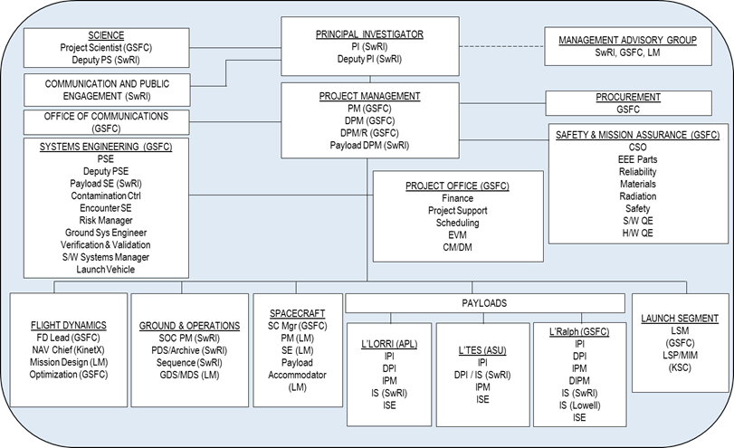
Figure 1. Lucy Project Organization Chart
The most important factor in Lucy’s success was the team itself. The team was fully staffed with high performers, a strong bond, and a sense of camaraderie that permeated every aspect of the team’s dynamic. All team members were fully dedicated and committed to both the mission and to each other. The high performing nature of the team enabled the project to absorb changes in key leadership positions with little to no impact and to overcome a myriad of technical challenges. They worked hard and celebrated their successes, demonstrating they were truly “Lucy Strong”.

Goals and Objectives
On any mission, clearly defined goals and objectives are paramount to ensuring that everyone involved has an understanding of what they are working towards. The team was deeply aware of the mission’s critical importance to NASA and the planetary community on a wide range of topics stemming from advanced understanding of the origin and evolution of the solar system. The objective of the Lucy mission is to provide crucial inputs to four of the ten Priority Questions for planetary science as expressed in the 2013 Decadal Study:
- Determine the compositional differences between the various classes of Trojans, measure the size-frequency distribution (SFD) of the craters at these targets, search for satellites and rings around the targets, and measure the physical and compositional differences between the two components of a near-equal mass binary to answer what were the initial stages, conditions and processes of Solar System formation.
- Determine the compositional makeup, geological features, physical surface properties (i.e., regolith characteristics like thermal inertia), and bulk density of Trojans and compare surface properties of a C-type family member to freshly exposed material on a D-type asteroid to answer how the giant planets and their satellites accrete, and is there evidence that they migrated to new orbital positions.
- Determine the compositional differences between the various classes of Trojans to answer what governed the accretion and what roles did bombardment by large projectiles play.
- Determine the compositional differences of known classes of Trojans to answer what were the sources of primordial organic matter.
Lucy’s science objectives are achieved using flight-heritage, highly capable instruments. The mission Level-1 requirements and success criteria are defined in the Planetary Missions Program Plan – Program Level Requirements Appendix for Lucy, and controlled within the Marshall’s Space Flight Center’s Planetary Missions Program Office. The Lucy level-2 requirements are defined in the Mission Requirements Document (Lucy-MGMT-REQ-0001) and controlled within GSFC’s Technical Data Management System.

Lines of Authority and Governance Structure
The Lucy project management processes and plans are aligned with the guidance provided by NASA Policy Directive (NPD) 1000.1, NASA Strategic Plan. NASA manages projects based on life cycles, Key Decision Points (KDPs), and evolving programmatic and technical products during each life-cycle phase, as described in NASA Procedural Requirements, NPR 7120.5, NASA Space Flight Program and Project Management Requirements and NPR 7123.1, NASA Systems Engineering Processes and Requirements.
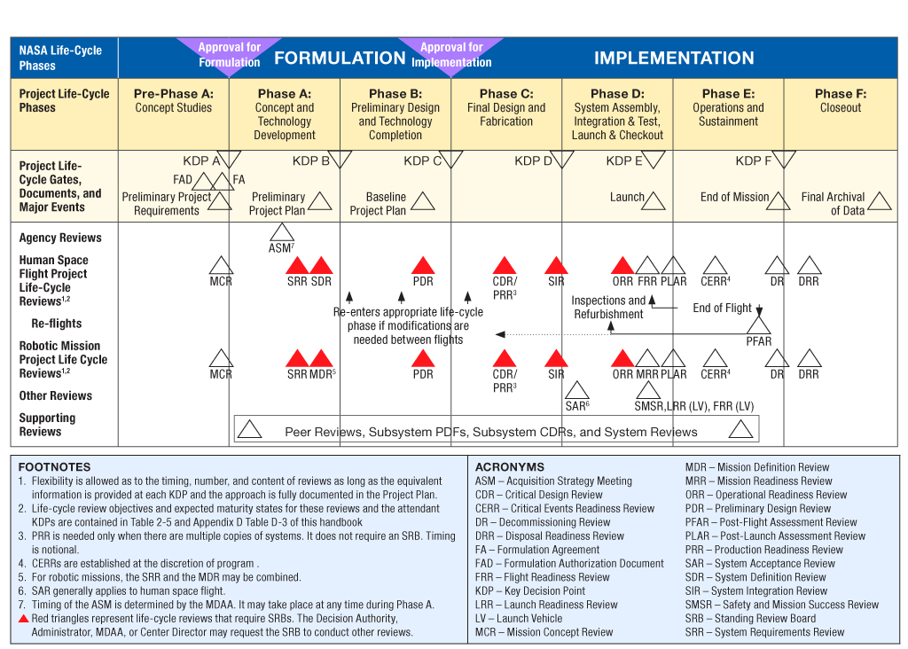
Figure 2. NASA Space Flight Project Life Cycle from NPR 7120.5E
Project authority is delegated from the Associate Administrator for the Science Mission Directorate through the Planetary Science Division (PSD), to the Planetary Mission Program Office (PMPO) at Marshall Space Flight Center (MSFC). The Science Mission Directorate Program Management Council governed the mission. The Lucy PI was responsible for formulation and maintains responsibility for implementing the mission. During Phases B/C/D, Dr. Levison delegated day-to-day decision-making authority to GSFC’s Lucy project manager (PM). During Phases E/F, Dr. Levison delegates day-to-day decision-making authority to GSFC’s Space Science Mission Operations (SSMO) PM. The SSMO project assumed responsibility for management of the Lucy mission in Phases E/F following the successful Post Launch Assessment Review.
Figure 3 shows how the Lucy project office relates to the PMPO, PSD, GSFC Center Management, and NASA Headquarters Management, while Figure 4 shows the governance structure for the Lucy project.
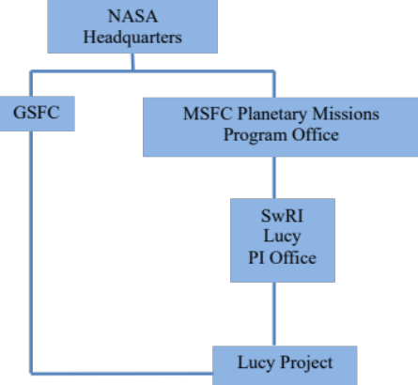
Figure 3. Project Office Relationship to GSFC Management and NASA Headquarters
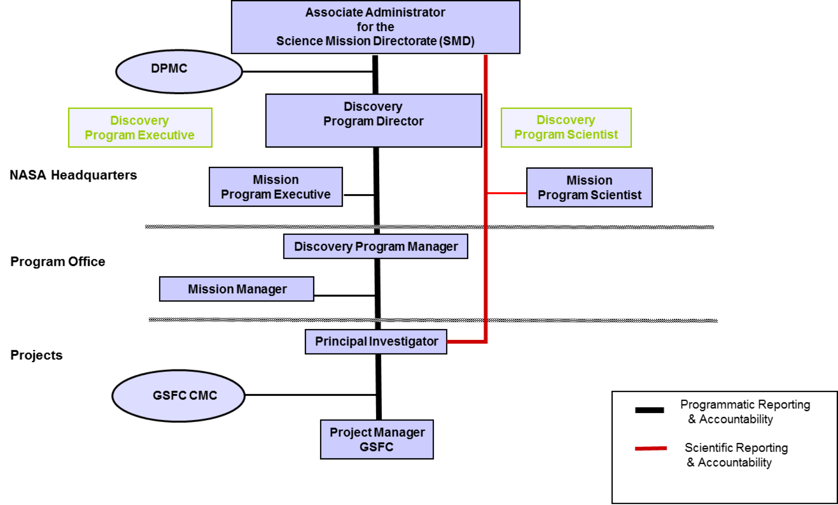
Figure 4. Lucy Governance Model

Planetary Missions Program Management
The PMPO provides the capability to integrate the programmatic resource requirements for all projects in the Discovery Program. The Discovery program manager is accountable to PSD Director for technical and programmatic progress of planetary missions, including Lucy. All Lucy project resources are budgeted and accounted for through PMPO from PSD.

Center Management
The Lucy development project office was located at GSFC and SSMO for mission operations is also located at GSFC. GSFC’s Center Director reports to NASA’s Administrator (through NASA’s Associate Administrator). GSFC’s Center Director is accountable for overall success of the Lucy project, via their acceptance of the delegated responsibility for managing project implementation and as the institutional authority for SSMO.

Principal Investigator
The Lucy mission is led by the PI. The PI has sole responsibility and accountability to the PMPO and PSD for the successful execution of the Lucy mission within cost and schedule. The PI is supported at SwRI by the deputy PI (DPI), the deputy project scientist, and the PI Support Office.
The PI served as the final decision authority on all matters related to maintaining the scientific integrity of the mission, staying within the PI-managed mission cost cap, and ensuring on-time delivery of the spacecraft to meet the fixed planetary launch window. The PI delegated day-to-day management and development decision-making authority to the PM within these guidelines and delegates day-to-day operations to the operations PM. The PMPO at MSFC holds the contract that funds the PI, his support office, and the science team.

Communication – Internal and External
Lines of authority help establish clear communication and decision-making, allowing for effective and efficient project execution. Good communication is essential for any project, but particularly for a NASA project where multiple teams and stakeholders may be involved. For the Lucy project, clear and consistent communication helped ensure everyone was informed and on track and connected partners regardless of home organization.
Lucy used partner institutions’ best practices to facilitate efficient and open communication internal to the team. Management tag up meetings were held on a weekly basis with all mission elements and partner institutions. In addition, the leadership team, including the PI, Deputy-PI, PM, Deputy-PM, and Project Scientist met on a weekly basis to facilitate communication among science, engineering, and business personnel. The team generated weekly status reports for distribution across the project. The leadership team also established multiple working groups that met weekly to work the design. In addition to standing meetings, the Lucy project held in person multi-day monthly status reviews (MSR) that alternated between the partner institutions.
Lucy’s communication plan also included routine status reporting to various stakeholders to ensure its project execution strategy managed stakeholder expectations. However, once Lucy entered the implementation phase, the team also implemented “First Stories” to quickly inform all levels of management at each of the partner institutions, as well as, members of the Standing Review Board of emerging technical issues that could substantially impact schedule. First Stories clearly conveyed a high level summary of the issue, the basis of decisions, progress, and critical milestones or decision points. Prior to any major review or key decision point, the development team briefed the independent review teams on current project issues and major risks. The open and honest communication fostered an air of trust.

Results-Driven Design
Lucy utilized a results-driven approach to the overall mission design, with an emphasis on successfully achieving the science objectives. The Lucy spacecraft and instruments were based on designs with extensive, successful flight history. There was no new technology development necessary for the mission. The majority of the hardware needed only minor design modifications to accommodate unique Lucy mission requirements. While some elements required a new design or were operating in different environments, none required technology development. It is worth noting that while the mission did not require technology development, there were lessons learned associated with manufacturability of the larger solar arrays.

Project Planning and Control
“Schedule is king” was an often-used phrase to emphasize the importance of prioritizing schedule adherence over other factors. Lucy’s constrained 21-day launch period induced a focus on schedule performance – this is an important distinction for planetary missions as compared to Earth-orbital missions. Since delaying launch would have had extreme mission impacts, a concerted effort was directed towards maintaining the schedule pace. This was achieved through active and balanced management of technical scope, schedule, and cost, i.e. the triple constraints, and healthy levels of cost reserves and funded schedule margin. Time became a precious commodity (“time is money, but no amount of money will help when you’re out of time”). Phase C/D had been well planned at healthy resource levels corresponding with previous analogous missions. The constrained launch period, by extension, constrained the development duration. Paying for risk mitigation activities was addressed as early as possible with an eye towards controlling scope creep.
Rigorous cost reserve management equated to lifecycle cost (LCC) control for the nearly $1 billion mission. The baseline was struck at selection (KDP-B). Every adjustment to the LCC baseline was justified, recorded, tracked, and reported monthly and at every lifecycle review. This provided the Lucy PI/PM with continuous awareness of available cost reserves. Strategically, the Lucy project utilized any and all available resources to get to the launch site on time with a qualified spacecraft and payload complement.

Schedule Management and Cost Control
The focus of schedule management was to develop and maintain a centralized Microsoft Project schedule database or Lucy Integrated Master Schedule (IMS). The IMS captured the time-phased required work scope of the Lucy project and was organized by the work breakdown structure (WBS). The IMS chronologically choreographed all of the milestones, major events, agency-level and project-level reviews, and logically related them to each other to identify the various critical path(s). It also tracked the total schedule slack at any given time throughout the project’s lifecycle. In addition, the IMS aligned task schedule dates with the time-phased budgets that existed in the various budgeting systems deployed on the project. The IMS was the system of record for schedule data for the project. The Lucy schedule management plan met or exceeded the requirements contained in NPR 7120.5E and any risks to meeting project schedules were communicated and tracked using the Lucy risk management process. KDP and launch readiness milestones were controlled by the PMPO at MSFC. Schedule risks, issues, and concerns were communicated to the PMPO, GSFC management, and NASA Headquarters program executive using pre-established status reporting process.
The Lucy IMS was fully constructed for every major lifecycle review. Schedule evaluation of the rolled up project schedule was performed through analysis and was reviewed biweekly providing visibility into the planning and scheduling milestones to help ensure project objectives were met. Due to the size of the Lucy flight system in comparison to the payloads and ground system development efforts, it was necessary to perform routine monthly assessments in a de-integrated form, all while verifying the overarching critical path and other interfaces through analysis. In this way, true schedule performance could be readily addressed with hardware providers or ground systems further off the critical path. Improved insight was gained using this approach to schedule control. The project implemented and maintained a schedule management system capable of facilitating the development, maintenance, analysis and control of the IMS.
All flight hardware and ground elements developed their schedules in coordination with the Lucy lead scheduler. Schedules from all hardware and ground elements were delivered monthly. Each partner institution was responsible for maintenance of their schedules and provided status for the schedule monthly at the PI Management Reviews (PIMRs). In addition, the Lucy lead scheduler performed monthly analysis (to include critical path, milestone burndown, observation of trends, etc.) of the Lucy master schedule and of the inputs from the partner institutions, reports to the project, and provided feedback to the institutions.
The Lucy lead scheduler developed performance metrics and reports to support all project reviews (e.g., MSRs, etc.) and meetings. Routine schedule assessments such as Top 3 Critical Paths, 12-Month “Rolling Wave”/Critical Milestone Schedule, Schedule Margin Tracking, and Goddard Schedule Assessment Tool Performance Metrics were reported on a monthly cadence. These assessments created a crosshatch of validation to schedule health and have been very effective on planetary missions where adherence to schedule is imperative to mission success. All schedule data was produced directly from the project master schedule and provided to project organizations via the project web-based Technical Data Management System. The IMS was baselined with project approval at KDP-C (Confirmation Review). Schedule data was combined with cost data for earned value management (EVM) reporting.
Through the 58 months of development, from mission selection to launch, Lucy met all of its major milestones and though challenges arose, the schedule replanning effort to mitigate disruptions was superior. Technical challenges are commonplace and expected; mitigating them in the COVID-19 environment was new. COVID-19 added an additional wrinkle to the mitigation efforts coupled with hardware and technical challenges alike. Mitigation creativity allowed for addressing development challenges in the new pandemic climate. Employing new or variations of existing mitigations such as early engagement of the long-lead acquisition process, smaller but separate floor and oversight teams, and the acquisition of the Defense Priorities & Allocations System rating to enable Lucy contractors to continue working during the domestic shutdowns allowed Lucy to stay on track.

Reserve Release Approach
On Lucy, the release of reserves was under the authority of and subject to review by the PM through PI-delegated authority (within certain pre-defined restrictions). Decisions that impacted schedule or requirements were addressed via the Configuration Control Board process. The process of change control, resource allocation, and release of reserves was essential to the success of Lucy. The PI was kept informed of the reserve releases through regular, weekly, and monthly project reporting. The Configuration Control Board process was used to control the mission baseline and track any technical changes. Technical changes that did not impact the mission baseline were managed by the Project Systems Engineer (PSE).
Projects carry three allotments of reserves or margins; Technical, Schedule, and Cost. Overall mission level technical resource reserves (mass, power, data rate, etc.) were held by the Lucy PSE. The Spacecraft Manager and Deputy Project Manager for Payloads (DPM-P/L) were allocated portions of the technical resource margins by the Lucy PSE, allocated as needed to support their respective technical teams. In the event more technical resources were required, the Lucy PSE further engaged, secured concurrence of the PM, and was able to approve release of mission-level technical reserves.
On a timeframe appropriate for the development phase, all technical resource current-best-estimates were updated so that the technical resources and technical reserves could be reallocated to reflect the progress of work and maturity of the design.
Overall mission-level schedule reserve or margin was held by the Lucy PM. The PM would allocate schedule margin for the three development teams (instrument, spacecraft, and ground system) as they developed their schedules. The DPM-P/L and Spacecraft Manager would request use of schedule margin from the PM to support their respective technical development efforts. In the event more schedule margin was needed, the Lucy PM was responsible for authorizing the release of these reserves.
The project schedule contained funded and unfunded (schedule slack) schedule margin. The project complied with GSFC requirements (GPR 7120.7) for minimum funded schedule margin (FSM) throughout development. FSM was incorporated into each project element’s cost and schedule estimates. Cost margin needed for utilizing unfunded schedule slack were also held by the PM. Schedule slack is defined as the unfunded duration between the nominal instrument, spacecraft or spacecraft subsystem, or element completion date and the delivery date to the next higher level of system integration. FSM is defined similarly but for the funded duration between the completion date and the delivery date to the next higher level of system integration. Both are measured in work days.
At the outset of development, Lucy carried 125 work days of FSM at the mission level against a policy requirement of 102 work days. This level of margin was allowed to slowly erode over time at a rate dependent upon the phase with an outcome of zero by launch. Lucy schedules were updated monthly at PIMRs and MSRs during Phase C, and more frequently during integration and test through launch. During this process, overall schedule accomplishment was evaluated per the baseline schedule, and FSM held by the development teams could be readjusted by the PM. Through Phase C/D and the tracking of the baseline schedule, mission-level FSM fell below the policy requirement only twice, in March 2020 due to the initial blow of COVID-19 and again in July 2020 due to the impact of a propulsion tank weld failure. Within one to two months of each episode, FSM levels were restored to be in compliance primarily due to the use of reordering/replanning the future schedule. This capability to adjust the future was enabled by two mission characteristics: (1) the experience and expertise of the spacecraft prime contractor, LM, and (2) the project strategy of procuring known hardware and materials early in Phase B to mitigate notorious supply chain challenges often experienced but commonly overlooked in planning.
Overall mission-level cost reserves were held by the Lucy PM for issues that might arise during development and operations. At mission selection, in January 2017, the project carried $122 million or 32 percent in cost reserves to conduct development. Cost reserve management utilized a process that documented and traced every entry from reserve request or cost threat, to lien, to encumbrance, and finally to baseline that is fully documented through the configuration management process. Through launch, more than 450 requests had been reviewed and evaluated for reserve release and over $128 million had been encumbered (cost reserves were augmented for the 2019 Government Shutdown and COVID-19 impacts). Cost reserves were requested formally by the respective WBS lead to the PM. If accepted, a lien was held against the project reserve budget. If the issue triggering the reserve request became a manifest, i.e., became a requirement to implement; the lien transitioned to an encumbrance and the project reserve budget was decremented by the lien amount. Only the Lucy PI and/or PM were able to approve the use of project cost reserves. Cost reserve management was so essential to Lucy programmatics that a dedicated member of the resources team was assigned the role of Cost Reserve Coordinator to assist requests through this process and bi-weekly Threats meetings were held without fail with project leadership to discuss and disposition requests.

Approach to Earned Value Management
Lucy’s approach to implementing EVM met the requirements imposed upon the project as a result of NPR 7120.5E, NASA’s Federal Acquisition Regulation, and as directed by the Discovery 2014 Announcement of Opportunity (AO). No waivers were requested for the Lucy EVM construct.
The LM spacecraft contract exceeded the $100 million threshold, requiring certified EVM System (EVMS) reporting of which LM already possessed. The L’LORRI (APL) and L’TES (ASU) instrument developments took place within the SwRI Payload Management contract as subcontracted efforts. The contract value did not exceed $100 million, but was more than the $20 million threshold requiring EVM reporting from SwRI. SwRI had experience in EVM from previous hardware developments. The L’Ralph instrument was built at GSFC and exceeded the $20 million threshold for EVM reporting. Lucy’s EVM approach was consistent with the best practices for implementing EVM at GSFC and was detailed in the Lucy EVM Plan released in July 2018. Since GSFC did not have a certified EVMS, Lucy implemented the guidelines of EVM as defined by Electronic Industries Alliance-748, EVM System, to the best of its ability. EVM training was made available to Lucy personnel prior to implementing the Lucy EVMS that was established for Phase C/D beginning in January 2019.
Lucy delivered earned value reports covering the full project – all WBS elements, including KinetX and level of effort management activities for which there were no separate earned value reporting requirements (because the value of these items fell below the dollar threshold for EVM requirements). Monthly schedule and cost reporting were utilized within the project to reconstruct the EVM performance for those efforts without EVM reporting requirements.
Over the 32 months of Phase C/D development and Earned Value monitoring, Lucy never fell below 0.90 in either the cumulative Schedule Performance Index or Cost Performance Index culminating in an on-time launch (1.0 Schedule Performance Index) and cost performance greater than 0.95 Cost Performance Index (despite the impact of COVID-19). With the initial pandemic impact of substance appearing in March 2020, the project began to baseline COVID-19 mitigation efforts by June 2020, only three months later, thereby neutralizing the prospect of long-term cost overruns and schedule delays.

Risk Management
All projects carry risk, and Lucy was no exception. The Lucy project managed risk through a continuous surveillance approach. The implemented Lucy Continuous Risk Management Plan operated consistently with the “B” risk classification, as defined in NPR 8705.4 Risk Classification for NASA Payloads. Lucy’s Risk Management Board (RMB), comprised of senior Lucy personnel, met regularly to facilitate and lead the Continuous Risk Management process. The RMB, chaired by the Lucy PM, met at least monthly to review, assess, and update mission risks and their mitigation plans. All Lucy staff, including the instrument, flight, ground, and science teams were responsible for identifying risk and commensurate mitigation schemes; this data was then presented to the RMB for review. Risks that were deemed yellow or red were managed at the RMB level, and risks that fell below that threshold were managed by the WBS element leads. The spacecraft, instrument, and ground system teams also implemented risk management and reported on all risks on a monthly basis for evaluation and potential escalation to the project RMB, or closed as mitigated.
Only the Lucy PI and PM were authorized to expend project-held resources for mitigation, assign responsibility for risk mitigation plans, and approve risk closure and/or acceptance. The PM reported the highest risk items to GSFC’s Center Management Council and NASA HQ as part of the MSR.

Leading Through a Once-in-a-Lifetime Pandemic
The nature of NASA projects often means that plans can change quickly. The project manager must be able to respond to these changes and adjust the project plan as needed. This became more evident during the pandemic.

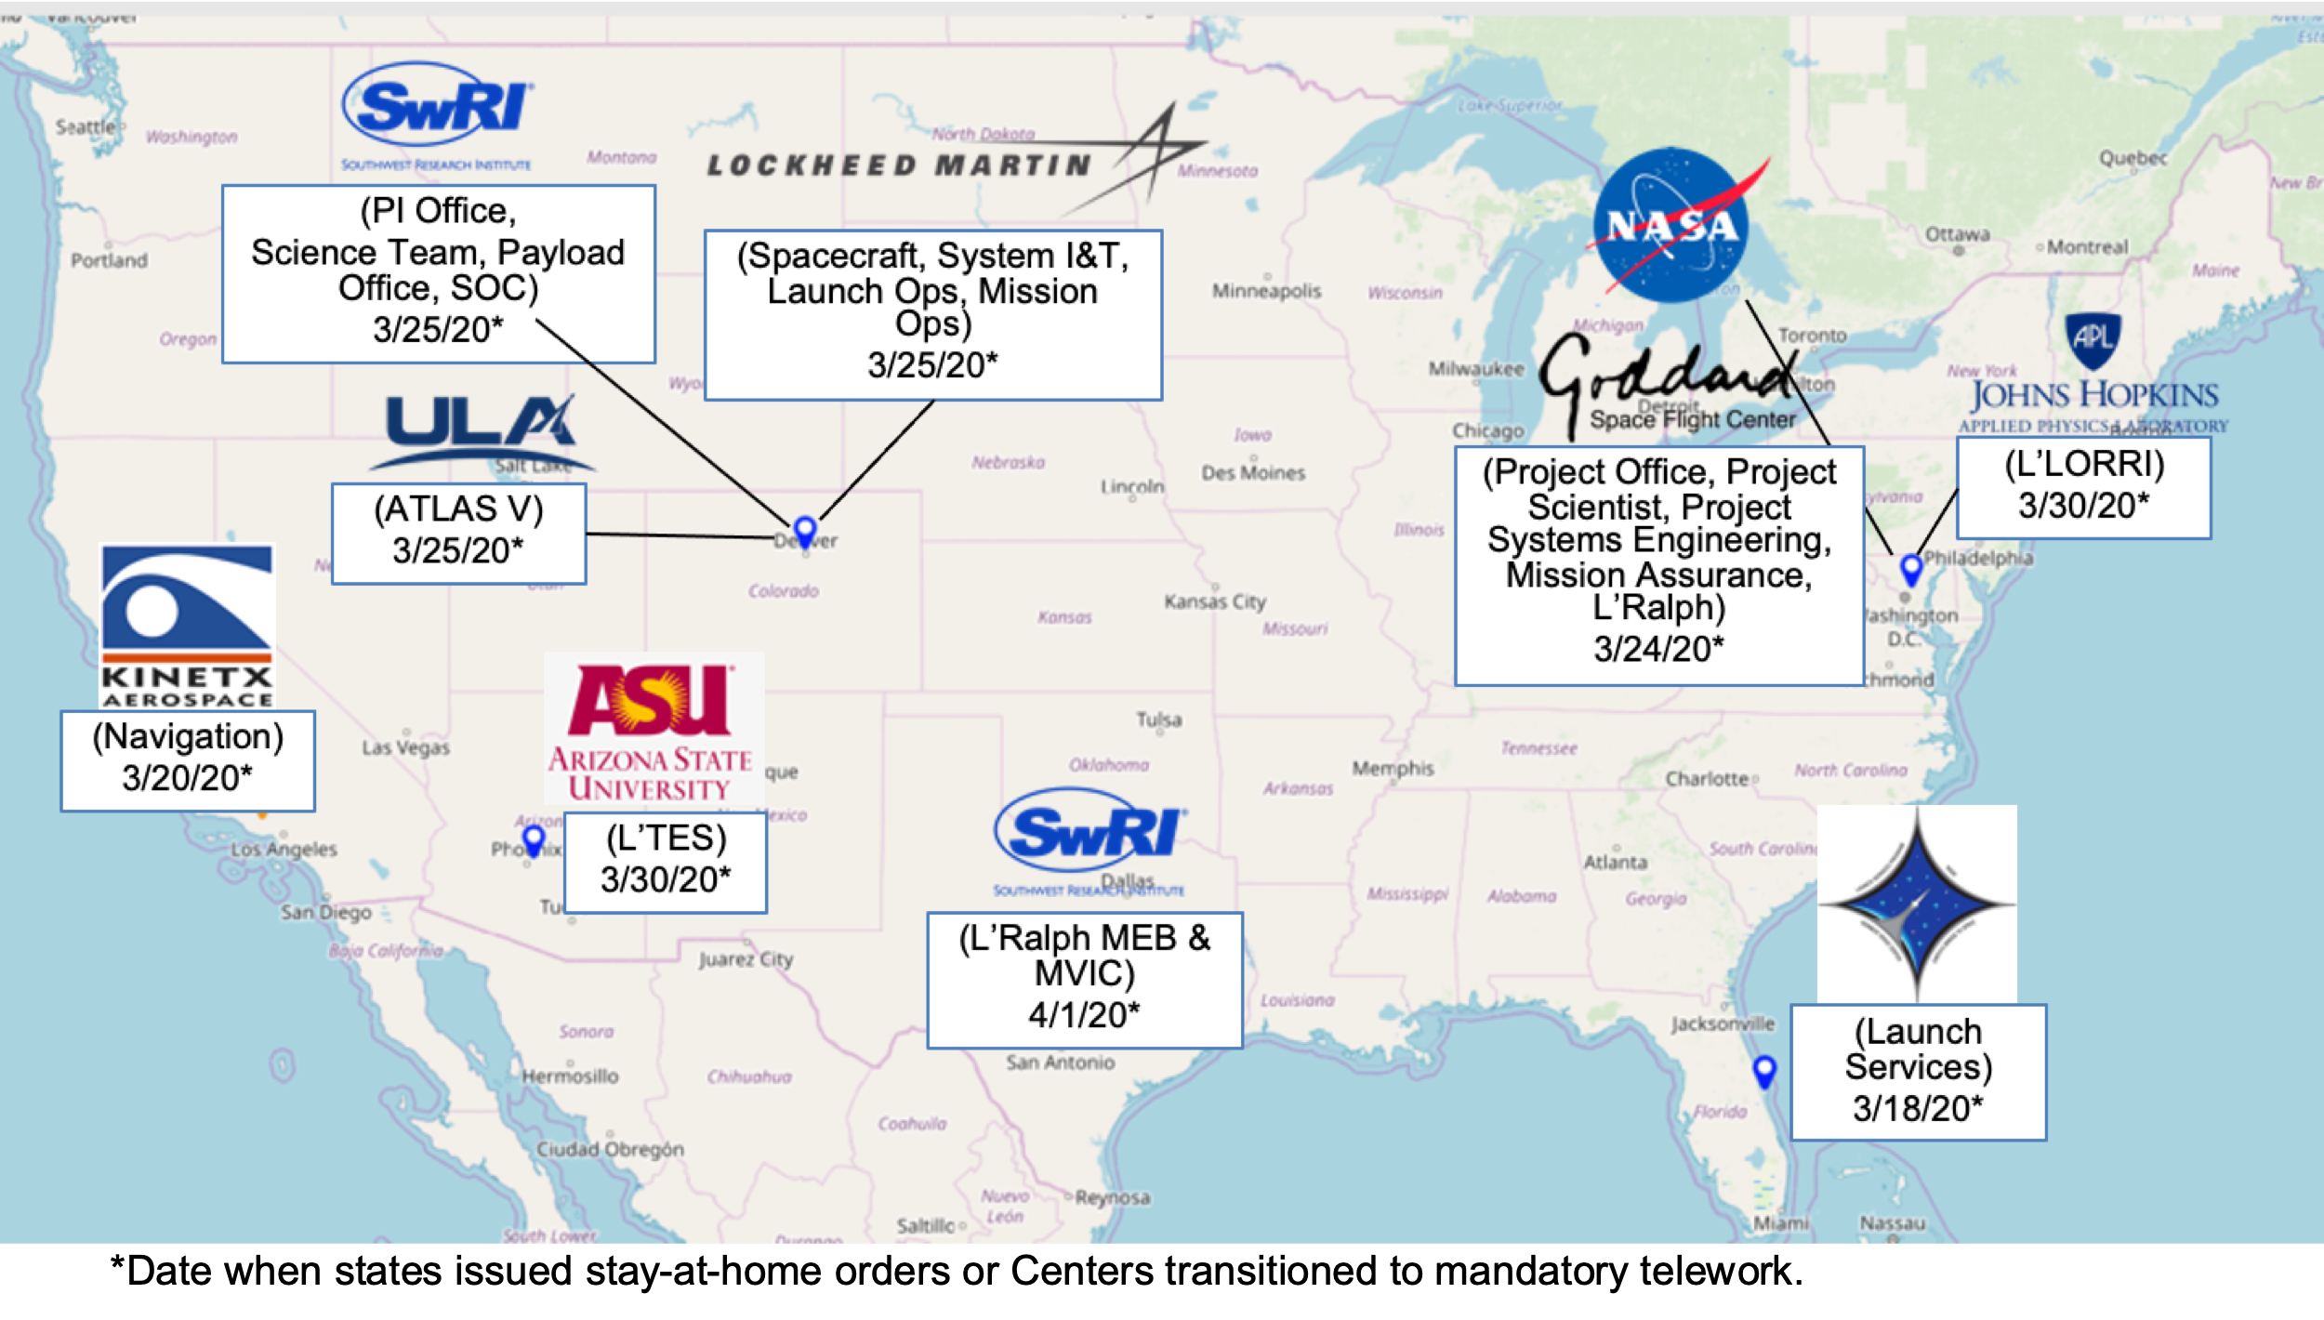
Figure 5 Initiation of COVID-19 Protocols Across All the Partner Institutions
In March 2020, five months before the planned start of spacecraft level assembly, test, launch, and operations (ATLO), the President declared a nationwide state of emergency as a result of the spread of the highly infectious novel coronavirus disease (COVID-19). By April 1, NASA transitioned to mandatory telework, and most states had issued mandatory stay-at-home orders. The Lucy spacecraft provider, as well as their supply chain, implemented changes to curb the spread of the virus. In some instances, these changes included closing facilities, affecting hardware development for varying lengths of time. Travel restrictions sharply reduced the amount of travel for typical integration support and minimized the number of personnel allowed on-site. The three Lucy instruments, propulsion subsystems, and solar arrays experienced significant schedule erosion jeopardizing the start of ATLO and ultimately our ability to meet the October 2021 launch readiness date. The team was challenged to maintain the health and safety of the Lucy team, remain within the Agency Management Agreement, and meet the planetary launch window.
First things, first. Lucy established project-wide COVID-19 protocols to keep the team safe: 1) Onsite support was reduced to essential personnel providing touch labor; 2) Teams were segregated, to the extent possible; 3) project travel was restricted; 4) the project provided protective equipment, and 5) institutions performed enhanced cleaning and disinfecting.
The project utilized a proactive “what-if” approach to assess “risk exposure”, identify trade space, and to develop work around plans for a number of scenarios, including work stoppages due to COVID, late hardware delivery, supply chain issues, inability to travel, etc. The team scrubbed the instruments and spacecraft test programs for optimization and to identify areas where the project could assume a higher risk posture to save schedule. For example, “testing as you fly” and “flying as you test” were critical considerations. New delivery dates were established for the instruments. The new dates included contingency, as well as schedule slack. The project provided additional oversight via daily tag-ups and weekly schedule reviews to give increased confidence that the instruments would meet the new dates.
The project aggressively spent reserves to mitigate COVID-19 impacts and meet the planetary launch window: 1) augmenting teleworking capabilities, including virtual inspections; 2) bringing on surge support for the spacecraft and instruments; 3) identifying opportunities to buy back schedule; and, 4) building instrument mass simulators.
In June 2020 the project implemented its Feasible ATLO Shortened Timeline (FAST) Plan, which:
- Accommodated late delivery of key hardware, restored the critical path funded schedule margin, and maintained the ATLO start date and Kennedy Space Center ship date.
- Maximized team resiliency to COVID-19, through both segregation of personnel, and utilization of weekend and alternate shift work where feasible.
- Utilized tools such as Zoom and Microsoft Teams to enable off-site personnel to monitor integration activities as well as test telemetry “over the shoulder” of onsite personnel.
Part way through ATLO, the project conducted a strengths, weaknesses, opportunities, and threats analysis to review the FAST plan. The project identified a total of twenty-three weaknesses/threats and twenty opportunities to mitigate schedule risks and further increase team resiliency for the remainder of ATLO and launch processing.
We could not lose site of the “human factor”. The project’s success thus far, had hinged on the social/relationship equity built up over the years. They continued to make a concerted effort to maintain the sense of team spirit with new creativity, including:
- Virtual parties/gatherings, a team peer award program, “accomplishments of note”, established peer “buddies” for support, virtual bingo, social distanced gatherings, etc.
- Project leadership traveling to work sites to show support to personnel required to work onsite.
- Adding more frequent team wide meetings to facilitate communication.
It worked! The project did not have to compromise the ground test campaign. The spacecraft shipped to the launch site and launch operations proceeded as planned. Lucy launched on time and under budget during a pandemic; compressing 9.5 months of work into 7 months, while keeping the team safe!
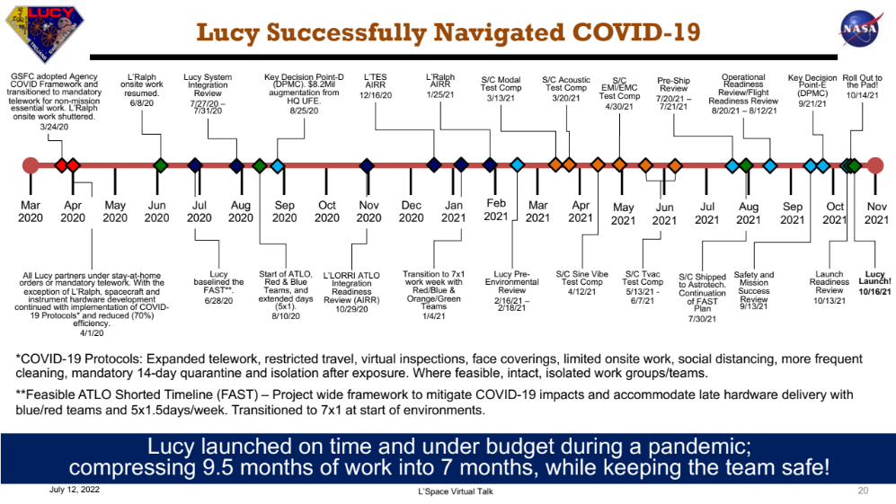
Figure 6 Lucy Successfully Navigated COVID-19

Lessons Learned
Lucy was successful in navigating COVID and launching on time for a number of reasons:
- They maintained a “people first, mission always” mindset.
- They balanced time, cost, and performance, with risk as the discriminator.
- They had healthy cost reserves, which were used to buy additional support and time.
- Risk management was continuous. They developed mitigation strategies with offramps.
- They embodied the characteristics of family…openness, grace, appreciation, interest in each other and their lives. They stepped in to help each other, filling in the gaps as needed.
- They worked hard and celebrated every success, big or small, together.
- Schedule was king. Every decision took the potential schedule impact into account.
- They were single-minded in their vision – to get to launch and have a successful mission.
Although the team was extremely successful, FAST came at a price – the project pushed hard for 10.5 months under very taxing circumstances. As time progressed, team brittleness because apparent. This would not have been sustainable under normal circumstances.

Acknowledgements
The authors would like to thank Mr. Michael Donnelly, Mr. John Loiacono, Mr. Robert Jenkins, Mr. Gary Davis, Mr. Mike Amato, and Mr. Charles Baker, and Mr. Matt Cox for their leadership and contributions to the Lucy mission.

Glossary

APL | John's Hopkins University Applied Physics Laboratory
ASU | Arizona State University
ATLO | Assembly, Launch, Test, and Operations
DPI | Deputy Principal Investigator
DPM | Deputy Project Manager
EVM | Earned Value Management
EVMS | Earned Value Management System
FAST | Feasible ATLO Shortened Timeline
FSM | Funded Schedule Margin
GPR | Goddard Procedural Requirement
GSFC | Goddard Space Flight Center
IMS | Integrated Master Schedule
IR | Infrared
KDP | Key Decision Point
LCC | Lifecycle Cost
L'LORRI | Lucy LOng Range Reconnaissance Imager
MSFC | Marshall Space Flight Center
MSR | Monthly Status Review
NASA | National Aeronautics and Space Administration
NPD | NASA Policy Directive
NPR | NASA Procedural Requirement
PI | Principal Investigator
PM | Project Manager
PMPO | Planetary Mission Program Office
PSD | Planetary Science Division
PSE | Project Systems Engineer
RMB | Risk Management Board
SSMO | Space Science Mission Operations
SwRI | Southwest Research Institute
L'TES | Lucy Thermal Emissions Spectrometer
WBS | Work Breakdown Structure

