SSC23-I-02

BioSentinel: Mission summary and lessons learned from the first deep space biology CubeSat mission

Matthew Napoli, Cheryle Kong, Jeffrey Homan, Jesse Fusco, Robert Nakamura, Mike Padgen, Shang Wu, Philip Shih, Mohammad Hejase
NASA Ames Research Center

Josh Benton, Dennis Heher, Terry Stevenson
KBR Wyle Services

Andres Dono Perez, Jose Alvarellos
Axient

NASA Ames Research Center
Moffett Field, CA 94035

ABSTRACT
Launched on Artemis-1, BioSentinel carries a biology experiment into deep space for the first time in 50 years. A 6U CubeSat form factor was utilized for the spacecraft which included technologies newly developed or adapted for operations beyond Earth orbit. The spacecraft carries onboard budding yeast, Saccharomyces cerevisiae, as an analog to human cells to test the biological response to deep space radiation. This was the maiden deep-space voyage for many of the subsystems, and the first time to evaluate their performance in flight operation.
Flying a CubeSat beyond LEO comes with unique challenges with respect to trajectory uncertainty and mission operations planning. The nominal plan was a lunar fly-by, followed by an insertion into Heliocentric orbit. However, some possible scenarios included lunar eclipses that could have severely impacted the power budget during that phase of the mission, while others could have resulted in a “retrograde” hyperbola at swing-by resulting in the spacecraft traveling inward toward Earth or even towards a collision with the lunar surface.
The commissioning phase of the mission was successful and completed a week ahead of schedule. It did not come without its exciting moments and challenges. First contact with the spacecraft uncovered that the vehicle was unexpectedly tumbling after deployment, a situation that needed to be corrected urgently. The mission operations team executed a contingency plan to stabilize the spacecraft, with just moments to spare before the battery ran out of power.
The BioSensor payload onboard the spacecraft is a complex instrument that includes microfluidics, fluid systems, sensor control electronics, as well as the living yeast cells. BioSentinel also included a TimePix radiation sensor implemented by JSC’s RadWorks group. Toral dose and Linear Energy Transfer (LET) spectrum data are compared to the rate of cell growth and metabolic activity measured in the S. cerevisiae cells.
BioSentinel mature nanosatellite technologies included: deep space communications and navigation, autonomous attitude control and momentum management, and micro-propulsion systems, to provide an adaptable nanosatellite platform for deep space uses. This paper discusses the performance of the BioSentinel spacecraft through the mission phase, and includes lessons learned from challenges and anomalies. BioSentinel had many successes and will be a pathfinder for future deep space CubeSats and biology missions.

bioSentinel Overview
BioSentinel is the first small satellite or CubeSat developed to carry biological organisms beyond low Earth orbit (LEO). It builds on the legacy of previous biological CubeSats developed at NASA Ames Research Center. The main objectives of BioSentinel are to develop the capability to support biological experiments beyond LEO, and to characterize the deep space radiation environment and its effects on biology. The main payload of the CubeSat is a 4U enclosure or BioSensor, which carries a series of microfluidic and optical components that allow the delivery of nutrients and monitoring of cell growth inside 18 independent fluidic cards^{1,2}. A second instrument attached to the BioSensor enclosure is a radiation detector or LET spectrometer to measure both absorbed dose and particle spectrum over the course of the 6-month nominal mission. The remaining volume inside the 6U CubeSat is occupied by the different spacecraft bus subsystems, including a 3D-printed propulsion system, solar panels, antennae, batteries, star tracker, radio transponder, etc.
After a series of delays, BioSentinel launched onboard NASA’s Artemis-1 rocket on November 16, 2022, and was deployed a few hours after launch. It was the sole biological payload among the ten free-flying CubeSats mounted between the interim cryogenic propulsion stage (ICPS) and the Orion crew vehicle. An identical BioSensor payload was launched to the International Space Station (ISS) in December 2021.

Science summary
The BioSentinel satellite contained two strains of the budding yeast, Saccharomyces cerevisiae, to assay the biological response to ionizing radiation and reduced gravity in both LEO (on the ISS) and in deep space. Budding yeast was selected for its known genetics, flight heritage, and because it can be kept in desiccated or dry state for long periods of time¹. A wild type strain served as a control for yeast health, while a mutant containing a deletion of the RAD51 gene – defective in the repair of DNA damage caused by ionizing radiation – served as a sensitized strain. The sensitivity of both strains to space-like ionizing radiation was tested and validated at the NASA Space Radiation Laboratory (NSRL) and other ground facilities¹. Growth and metabolic activity were measured on the ground and during flight by using absorbance measurements in fluidic cards^{1,2}.
After eight successful activations (16 fluidic cards total) on the ISS, we observed – as expected – no significant effects due to space radiation (unpublished results). The rad51 mutant strain showed slower growth and metabolic activity in both the ground and on ISS when compared to the wild type strain. This is to be expected since the mutant cells accumulate more damage when stored in desiccated form. Unfortunately, after a few card activations, no cell growth was observed in the free-flyer nor its ground control unit (see below). On the other hand, the LET detector continues to record data nominally. Radiation data from both ISS and free-flyer will be published via peer review and shared with the scientific community in the upcoming months.

Instruments

BioSensor Payload
During the checkout phase, the BioSensor payload performed nominally. On December 5, commands were sent to activate the first experiment. All the wells of both fluidic cards (16 wells per card) filled, but no yeast cell growth was observed over 12 days. Soon after, intermittent sensor signal failures were noticed, likely caused by condensation inside a cable connector. An attempt to fill the next set of cards on the other fluidic manifold was unsuccessful. We implemented a flow rate test but failed to identify the root cause of the fluidic issues. Back to the first manifold, we successfully filled another set of cards but again observed no growth. Signaling issues increased over time and now affected the optical data. We attempted one last experiment on the second bank, trying to fill the cards with just growth medium, but failed to fill the cards. When all temperature sensors failed, we could not start another experiment.
We observed no growth in the ground control payload, but fluidic cards loaded at the same time as flight, stored in desiccant chambers, showed growth as expected when filled. The nearly three-year stasis between payload assembly and flight, including periods in uncontrolled temperature environments, overwhelmed the payload environment mitigations (desiccant and activated carbon cloth) we had implemented to keep the cells alive².

LET Dosimeter Payload
The Linear Energy Transfer (LET) spectrometer instrument is mounted on the exterior of the BioSensor enclosure, and uses a Timepix sensor to measure patterns of energy deposition.
The detected patterns provide data on the cumulative ionizing radiation dose and energetic particle distribution experienced by the spacecraft and the internal biological samples. The purpose of the LET spectrometer is to characterize the deep space radiation environment, including the contributions from solar and galactic cosmic radiation particles as well as solar particle events. The LET spectrometer has functioned nominally throughout the BioSentinel mission, returning data consistently. The team has observed multiple solar radiation events; for example, two coronal mass ejections in February of 2023 which have been correlated with the GOES mission, as shown in Figure 1 below.
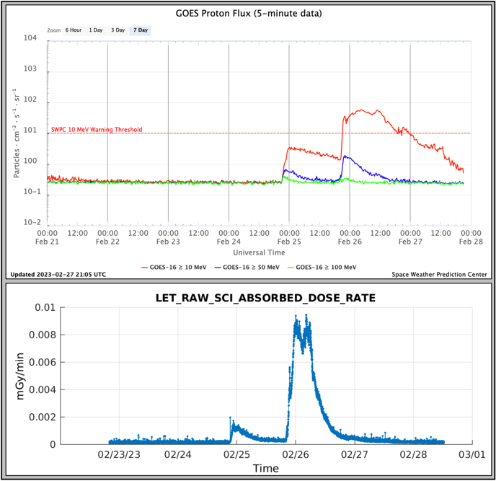
Figure 1: Flux measurements from the GOES satellite (top) and BioSentinel LET spectrometer (bottom) recorded for a pair of Coronal Mass Ejection events on Feb. 24 and 25, 2023

Spacecraft Performance
Flight Dynamics
Pre-launch activities included mission rehearsals and development of a tracking schedule in coordination with the Artemis-I payload office and the DSN for several potential launch dates. We computed the BioSentinel trajectories for the opening and the closing of the launch windows of the various SLS launch periods, theoretically bracketing its possible orbital behavior. An important influence on the trajectory of BioSentinel was the uncertainty associated with deployment from the OSA, which was rotating at a rate of 1 rpm; there was also uncertainty in its spin axis attitude, which implied an unknown clock angle of deployment. The unconstrained pre-launch clock angle value, and dispersions in the magnitude of deployment, plus the variable Moon-Earth-Sun topology for different SLS launch dates suggested a non-negligible risk of an impact with the lunar surface, which we evaluated using Monte Carlo techniques for various potential launch dates.
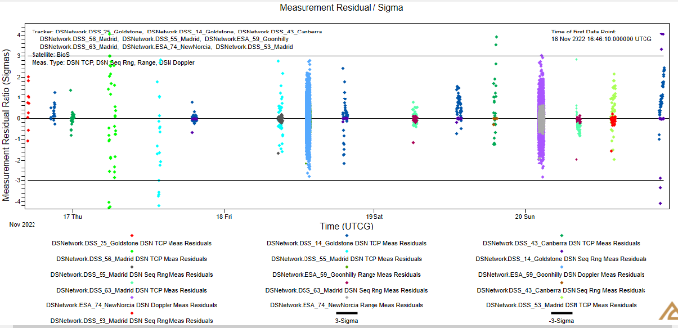
Figure 2: Last pre-flyby OD, showing residual ratios from a variety of tracking antennas from DSN as well as ESA

Figure 2 shows the result of our last pre-flyby OD; by then we had 16 passes of data, including two from ESA stations. The types of tracking data were very diverse, as we had DSN TCP and sequential ranging, as well as range and Doppler from the ESA stations. Our resulting post-deployment orbit is shown in Table 1; we were able to confirm not only that we would not hit the Moon, but more precisely we predicted a periselene altitude of 406 km at 5.215 days after deployment (21-Nov-2022, 15:40:51 UTC), as well as an eclipse duration of 36.5 minutes.
Table 1: J2000 post-deployment orbital elements at BioSentinel deployment time.

Epoch | 16-Nov-2022  10:30:42 UTC
a | 195,498.7 km
e | 0.964664
i | 30°.2527
Ω | 10°.9247
ω | 20°.4447
υ | 132°.984

Propulsion System
The BioSentinel propulsion system is seven-nozzle cold gas system using R-236fa as propellant. It operates in a burn-refill mode using two tanks: a saturated liquid-vapor main tank, and a vapor-only plenum³. An example of the propulsion system firing sequence is shown in Figure 3.
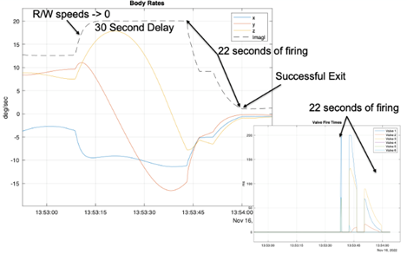
Figure 3: BioSentinel Propulsion System firing sequence
The propulsion system has experienced two performance issues during flight. One of the RCS thruster valves was failed closed during RCS checkout, and has been offline for the entire mission. A workaround was identified to perform momentum unloading with the remaining five thrusters (described below) and the failed valve was locked out. Rather than attempting to free the valve with repeated actuations, the failed thruster has not been commanded since the initial checkout.
The root cause of this failure is unknown, and if it is caused by mechanical damage or FOD, there is a possibility of the valve becoming stuck open if it is finally freed. A stuck open condition is far more serious than a stuck closed one, since the propulsion system would be constantly applying torque to the spacecraft when the plenum was filled. Future work is planned to troubleshoot the valve to determine root cause of the failure, but given the risk of a potentially mission-ending stuck open condition, this will not be performed until the science mission is completed.
The second propulsion system performance issue is related to the refilling logic. Nominally, the thrusters are fed from the vapor-only plenum, which gives more predictable performance than feeding from a liquid-vapor mixture. The plenum is then refilled from the main tank to maintain its pressure. In ground testing, the plenum was consistently warmer than the main tank, due to the location of the propulsion control electronics and the spacecraft comm system. This allowed relatively unsupervised filling of the plenum, since the propellant would not tend to condense in the warmer tank.
In flight, the thermal situation was reversed, with the main tank averaging 3-6 C warmer than the plenum. The consequences of this were not immediately noticed, and several overly-long plenum fills resulted in a significant amount of liquid building up in the plenum during the first three weeks of the mission. The plenum nominally contains 0.6 grams of propellant as vapor, but accumulated 2.4 grams total as a liquid/vapor mixture before the issue was noticed. This led to unpredictable performance as liquid droplets were ingested by the thrusters, causing increased mass flow and thus increased thrust. Four dedicated liquid-removal maneuvers were carried out, in which opposing pairs of thrusters were actuated to remove propellant without imparting momentum to the spacecraft. As of May 2023, the plenum was returned to its nominal vapor-only state, and the refilling logic has been reworked to reduce the amount of refilling based on expected consumption.
While the primary purpose of the propulsion system is attitude control and momentum unloading, one of the seven thrusters is oriented for delta-V along the body-X axis. This was implemented early in the design process to enable maneuvering away from the ICPS and other secondaries, and the thruster was not removed when that requirement was dropped. The delta-V thruster was later planned for use in avoiding a lunar impact, although the final deployment was in a favorable direction and such a maneuver was not required. This thruster has not yet been tested, such testing is planned for end-of-mission.
The remaining five RCS thrusters have behaved nominally throughout the mission, accumulating 408 firings as of May 2023, and are operating within their prelaunch performance range.

Momentum Management
During nominal operations the BioSentinel spacecraft is oriented with the solar arrays pointed at the sun except for during communication passes, when one of the two antennas is pointed at earth. The failed propulsion valve provided a torque in the -Z and -X axes, and therefore left the autonomous momentum management controller unable to provide full 3 axis momentum control. This proved to be particularly problematic because the attitude with the Medium Gain Antenna (MGA), our primary communication attitude, accumulated momentum in the +Z axis, and therefore needed the failed thruster for reaction wheel momentum desaturation. We implemented a solution which solves the challenge of being able to impart -Z and -X axes momentum. The solution uses the sun pointed attitude to bias these axes negatively, thus the momentum management system would only ever be required to apply torque in directions that utilized functioning thrusters. Several weeks of momentum accumulation with this solution are shown Figure 4, where the majority of time the spacecraft is sun pointed and all three axes are shown to be decreasing, with the communication attitudes marked by sharp rises in the Z axis momentum.
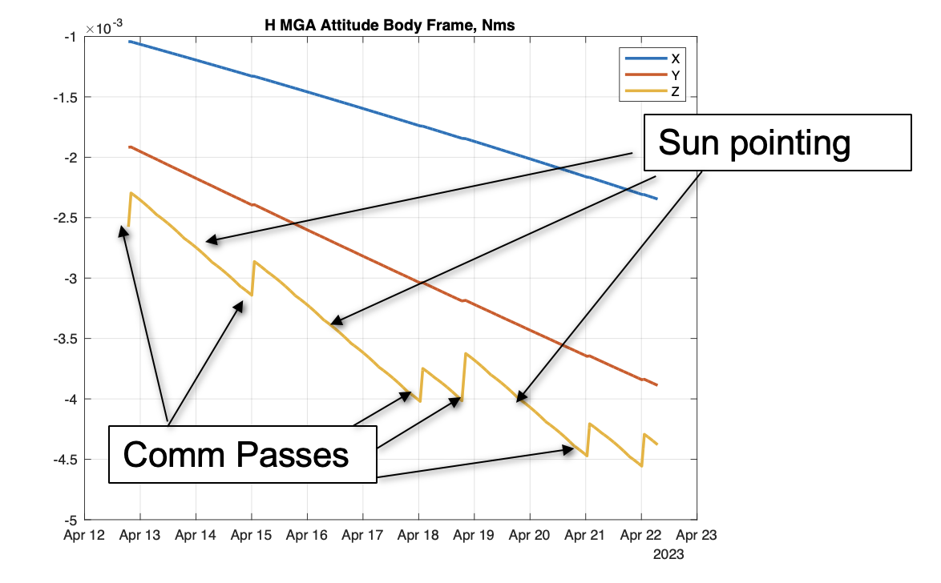
Figure 4: Sun Pointing Momentum Bias

Fault Management
The spacecraft’s autonomous fault management falls under three tiers. The first, is either a hardware fault or requires the quickest response and is handled at the hardware level (power cycle a latched processor, shut off a circuit overcurrent). The second, is a low-level software error with hard-coded responses (reject illegal app commands). The third is a configurable and possibly conditional anomaly with sometimes complex responses (mode change to decrease system high momentum with thrusters, and then return to nominal operations). After the autonomous responses, a fourth tier is simply a flag or event message that notifies the ground team, and the response is handled manually.
BioSentinel’s autonomous fault management has thus far worked well to prevent or resolve anomalies. One example was to manage the high rotation rates after deployment which required the thrusters to decrease momentum and allow sun-pointing with the reaction wheels. In a later situation, when the science payload began to draw too much current, the circuit was appropriately shut off as intended. In another example, a software bug in the FLASH driver would periodically cause the main processor to hang while attempting to interact with the memory. When the main processor hang-up occurred (a number of times, before we could implement the patch explained in the FSW/CDH section below), the external watchdog timer would appropriately reboot the system, preventing it from being stuck forever.
Closely related to fault management, has been the possible impact of radiation on the health and performance of the spacecraft. Our team’s primary indication has been telemetry reporting the number of correctable memory issues that have been fixed. To date, the system has reported approximately 150 error detection and correction (EDAC) instances in the SDRAM memory and approximately 550 triple mode redundancy (TMR) corrections in FLASH memory. No non-correctable instances have been reported to date. It should be noted that the FLASH memory is periodically scrubbed to detect errors, and as expected the error count has been steadily increasing throughout the mission. However, we have determined the SDRAM errors are only detected when memory is being read/written to, and the entire reported count occurred over a two-day span.
In addition to the memory errors that have been reported, the system has had a variety of device errors that could not be attributed to any known cause. For instance, twice (separated by a month) the RF radio has spontaneously stopped responding and required a reboot to resume operations. And similarly, the ADCS device has also stopped responding twice, and required a power cycle to resume nominal operations. We found that all these cases had no data indicating a cause and all may have been a result of radiation. However, these situations also demonstrated the appropriate and successful response by the fault management system. In each case, the anomaly was autonomously detected and responded to. And after the devices were rebooted, the mission continued without any interruption whatsoever. The operations team simply noted the event after the fact.

Comms and DSN Performance
BioSentinel uses the Iris CubeSat Deep Space Transponder, a coherent X-band transponder developed by the Jet Propulsion Lab (JPL) to provide the communication link⁴. It is a reconfigurable software defined radio (SDR) with the system architecture described in Reference 5. Table 2 summarizes the modulation and encoding schemes for downlink (DL) and uplink(UL) used in the mission.
Table 2: BioSentinel Modulation and Encoding Schemes
Modulation | BPSK (DL and UL)
Data Rate (DR) | DL: 8 kbps (nominal), 1kbps, or 62.5 bps (Safemode)  UL: 2 kbps (nominal), 1 kbps, or 62.5 bps (Safemode)
DL Encoding | Turbo-1/2 (DR < 1 kbps) -1/6 (DR>= 1 kbps)
UL Encoding | BCH

Downlink Performance
Table 3 summarizes the measured DL data of nominal operation (i.e. data rate = 8 kbps) for the passes in the first 150 days of mission from DSN, which were used to compare against the predicted data.
Table 3: Downlink Center Frequency Measured at DSN
Average (MHz) | 8409.54514
Min./Max (MHz) | 8409.50946/8409.60561
Range (MHz) | 0.09705
We measured the Average Data/Symbol Rate to be 8013.26/48076.78 bps.
We determined the data rates and symbol rates successfully used for safe mode and data transmission and those are summarized in Table 4.
Table 4: BioSentinel Safe Mode Data and Symbol Rates
BIT Rate (bps) | 1000, 500, 62.5
Symbol Rate (bps) | 6000, 1000, 125

Received Data Power Summary
We assessed the RMS difference between the measured and predicted received data power. This was shown to be 5.01 dB in Figure 5

Figure 5: RMS Data Power Difference
Due to the spacecraft detumbling at the beginning of the mission (right after deployment), we observed large differences between the measured and predicted values. There was not a good estimate on the angle between the antenna and the earth. We observed no patterns observed on the discrepancies.

BIT Signal-to-Noise Ratio (BSNR) and Symbol Signal-to-Noise Ratio (SSNR)
Measured and Predicted values of BSNR and SSNR were compared and are shown in Table 5.
Table 5: RMS Difference
 | RMS Difference
BSNR | 5.16 dB
SSNR | 4.77 dB

Figure 6: SSNR Differences
In general, the difference between measured and predicted value for SSNR were within 5 dB after the first day. Occasionally, we would observe a large discrepancy. As shown in Figure 6, we measured the SSNR to be several dB higher than the predicted value. This might be caused by the system noise temperature at DSN receiver being lower than the 35K value used in the predictions.
In both received data power difference and SSNR difference, we calculated:
Difference = Mean (Measured Values throughout the duration of the Pass) - Estimated Value of the Pass.

Uplink Performance
There was only one incident where the radio did not respond to the commands, which occurred just prior to one of the times the system autonomously reboot the radio. All other commands were successfully received.

Data Rate
Commands were successfully sent at bit rate of 1000 bps and 2000 bps. DSN Command success rate is at 99%.

Thermal
BioSentinel’s thermal configuration is quite complex for a spacecraft of its size. The active portion of the thermal subsystem is the BioSensor payload, which contains 23 separately-heated zones with individual control feedback for each, driven by a software control loop with optimized states for stasis vs. science ops. The remaining spacecraft – everything but the BioSensor payload – relies on passive thermal control, with the system carefully balanced around the heatloads of the spacecraft’s various subsystems and its sun-pointing nominal attitude.
The spacecraft was thermally designed to operate in three planned mission states: a lunar fly-by (eclipsing the spacecraft in full shadow), biology stasis, and biology science. The mission began with the lunar fly-by, and due to uncertainties in trajectory that existed until launch, a planned pre-heat of the entire spacecraft was performed immediately upon deployment from the launch vehicle. The pre-heat state utilized the BioSensor’s active heaters to raise the temperature of all 18 fluidics cards to approx. 24C, which also elevated the temperature of the overall spacecraft via heat soak into the remaining subsystems. The fly-by and eclipse period of approx. 35 minutes in lunar shadow was uneventful, with most portions of the spacecraft cooling less than 10C during the eclipse and remaining comfortably within temperature requirements. Figure 7 shows several key temperatures of the spacecraft during the eclipse period, which is indicated by the gray shading over the plot. Because the spacecraft’s thermal design employs a sun-pointing nominal attitude, only the solar arrays and their gimbal cover (located on the sun-pointing face of the spacecraft) sustained significant cooling during the eclipse, and rapidly returned to their prior temperatures when the spacecraft re-entered solar illumination.
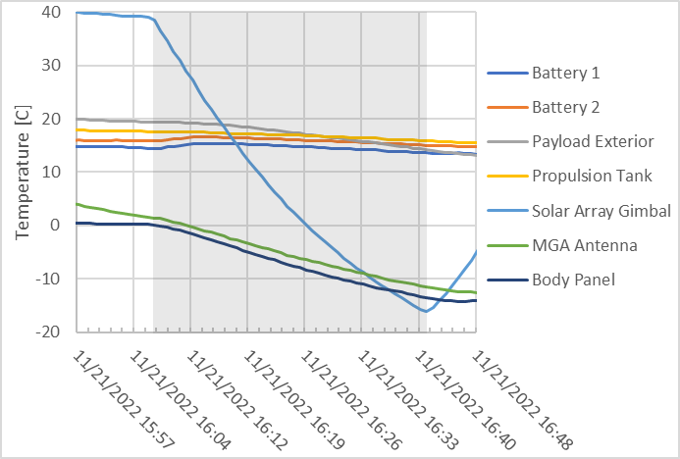
Figure 7: Spacecraft Temperatures During Eclipse
During science operations post-eclipse, the active heating elements of the BioSensor performed well, matching thermal model predictions for temperature stability and power consumption very closely. When heated for science operations, the BioSensor fluidics card pairs reached their assigned 23.0C setpoints and maintained these temperatures within +/- 0.1C, while stasis temperatures for all cards during non-science periods were stable at 4.0C.
Fault-management of the BioSensor’s thermal control software was also proven when partial loss of temperature feedback caused the thermal algorithm to revert to nearest-neighbor control, and finally to an open-loop freeze-prevention duty cycle when all temperature feedback dropped out. Because of the built-in thermal fault management, the BioSensor was maintained at bio-safe temperatures until all payload power was lost (see the payload section earlier for anomaly details).
Due to the isolated thermal-zone design of the BioSensor within the spacecraft, shutting down the BioSensor had little effect on the thermal state of the rest of the spacecraft. Without the bleed heat from the BioSensor, the battery pack steady-state temperatures dropped approx. 2C below their prior equilibrium point. This resulted in one of the battery packs falling 1C below its cold charging limit. All other spacecraft temperatures have remained comfortably within limits without the BioSensor powered.

CDH and Software
Prior to launch, flight software (FSW) and Mission Operations (MOS) testing revealed anomalies and flash drive performance issues. We determined that a FSW update would be required, but since the spacecraft was already integrated in the launch vehicle, the update would have to wait until flight operations started. To avoid having to upload an entire FSW image, we developed a way to patch the entire VxWorks image by using a patch file (containing only the differences) and a patch driver, which were only ~13% as large combined. After 2 months of operation, the patch files were successfully uploaded, verified via CRC checks, and then used to patch the original FSW image to the updated one with the resolved anomalies. The image was determined to be stable after one week of operation and validated after 1 month.
In the 4 months elapsed after the image update, FSW and C&DH operations have been nominal with very few reported issues. Two notable issues our team encountered were a bug resulting in Spacewire errors, and clock synchrony issues.
Our team discovered a bug in the IXC firmware during TVAC testing where the device ID was missing from the message when passed to the FSW bus. We observed that it occurs at a rate of approximately eight times per day. The bug leads to a failure in associating the message to the corresponding device that generated it, resulting in a dropped packet and a generated Spacewire error. We took no action in resolving the bug and decided on trending the error in the engineering subsystem.
During flight, we observed Spacecraft time and ground time drifting apart at a rate of 4.5 seconds/day. The initial solution was to periodically perform Spacecraft Time Correlation Factor updates to sync Earth time with the Spacecraft time. To minimize the clock drift, we then calculated the clock offset rate between the spacecraft and ground and transmitted a time drift adjustment command to the spacecraft to minimize the clock rate differences. This resulted in better synchrony between the two times and reduced the need for periodic clock jams.

Electrical Power System (EPS)

Solar Arrays. BioSentinel uses SpectroLab XTJ Prime triple junction solar cells with 30.7% efficiency. Panels 1-3 consist of three functional strings, while panel 4 has two. Each string consists of seven cells in series. From the pre-launch analysis we found that panels 1-3 could generate up to 1.48A each, and the maximum current expected for panel 4 is 0.99A. We determined the in-flight data shows 1.48A and 0.97A, respectively. This indicates that all the cells have been fully functional in space.

Battery. The Panasonic NCR18650B Li-Ion cells were manufactured in 2015 and have shown only small degradation. The effective capacity was 90% prior to delivery. However, due to launch delays, the cells were stored at full charge for 16 months. We estimated the remaining recoverable capacity to be 68% prior to launch.

Eclipse. Although we cannot verify the capacity with flight data, the battery’s performance during the eclipse indicated it to be healthy, as shown in Figure 8. Drawing an average of 1.5A, the battery voltage dropped 0.2V/minute during the eclipse. The battery and solar array performances remained consistent before and after the eclipse.
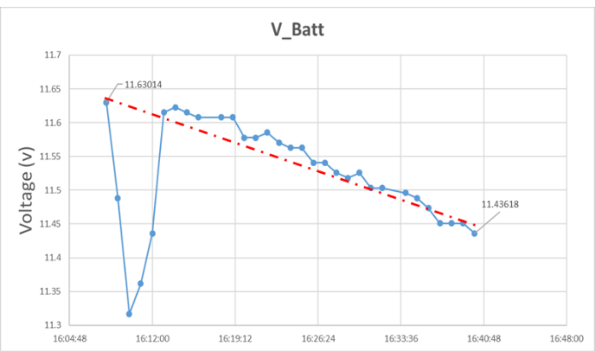
Figure 8: Battery performance during the eclipse. The initial voltage dip was due to transmitter enabling.

Other EPS Performance

Except for the gimbal, we have exercised all other EPS functions. We have observed no anomalies, upsets, or unexpected resets on the EPS. Since launch, we have found all EPS parameters are well within the ranges established prior to launch. With built-in margins, we expect EPS to be able to support the extended operations.

Mission operations

Mission Preparation

The pre-launch timeline was another area that was deeply affected by being a secondary on Artemis 1. Original preparations for a December 2021 launch began in June of 2021, with 3 operational simulations (SIMs) followed by 3 operational readiness tests (ORTs). As the ORT campaign came to a close, the operations team was ready to fly. However, a series of several month slips of the Artemis 1 mission led to the operations team conducting 4 more sims, one every few months, to maintain currency.
Additionally, during this time, several launch dates were prepared for as the slips occurred. Between the test campaign and launch date analysis, we uncovered several critical issues. The first was the bug in the flash memory driver that would render the memory unreliable. To address this, our team prepared a FSW patch to be competed as soon as possible after launch. The second was that the propulsion system initial configuration could prevent proper operation if internal pressure measurements were erroneous. Simply knowing the issue existed prepared our team to send the necessary reconfiguration commands at the first sign of trouble. And the third was that several Artemis 1 launch dates had over a 50% chance of impacting the moon (see flight dynamics section above). Our team prepared contingencies to perform a delta-V maneuver to avoid this impact when the system was not originally designed to support that functionality at all.
It is through the rigorous preparation of our MOS team that these issues were uncovered, and prepared for before the actual launch on Nov. 16, 2022, and ultimately allowing for a successful mission.

Flight Operations
The planned BioSentinel flight operations consisted of 5 mission phases: Launch/Host Ride, Initialization, Commissioning, Science, and Decommissioning.
Launch/Host Ride: (4 hours) The spacecraft was powered off during the entire launch, ascent, and ride to the release location. The Artemis 1 ICPS (Interim Cryogenic Propulsion Stage) released the spacecraft at Bus Stop #1, about four hours after launch.
Initialization: (~1 hour) After release, the spacecraft autonomously booted and executed an initialization sequence. The initialization sequence enabled payload thermal control, detumbled the spacecraft, deployed two sets of solar arrays, and enabled the telecom subsystem transmitter. The initialization sequence lasted about 30 minutes and ended with the spacecraft in safe mode.
In safe mode, the spacecraft rotates about the sun vector as shown in Figure 9. The solar arrays are directed at the Sun for battery charging and to keep a solar array shadow on the payload module area for thermal control.
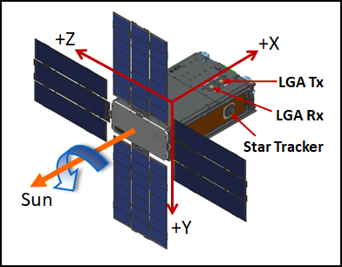
Figure 9: BioSentinel Spacecraft Safe Mode Attitude
The BioSentinel spacecraft has four patch-type antennas arranged in two transmit/receive (Tx/Rx) pairs as shown in Figure 10. The -Y face of the spacecraft has two Low Gain Antennas (LGAs) for the Tx/Rx pair. The +Y face of the spacecraft has a Medium Gain Antenna (MGA) for Tx and LGA for Rx. Each Tx/Rx antenna pair provides approximately hemi-spherical coverage. A telecom operation can only use the Tx/Rx antenna pair on one side of the spacecraft.
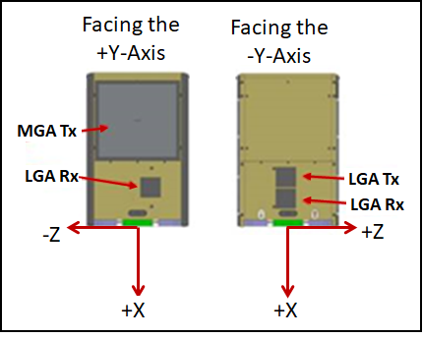
Figure 10: BioSentinel Spacecraft Antenna Placement
The safe mode design has the spacecraft rotating about the sun vector at 1 revolution per 30 minutes and the transmitter toggling in a repeating a pattern of ON for 20 minutes and OFF for 73.75 minutes. With the Earth contained in the transmitter antenna pattern about half of each spacecraft revolution.
The first two planned contacts with the spacecraft were downlink only passes, such that we could take advantage of the DSN MSPA (Multiple Spacecraft Per Aperture) capability, where the station was receiving from four of the Artemis secondaries simultaneously and the uplink was time shared between the four spacecraft. As expected DSN detected a signal from BioSentinel at 11:57 UTC on 11/16/2023. However, after locking telemetry we quickly determined that spacecraft had failed to properly detumble, was unable to point with reaction wheels due to the high momentum state and was power negative. The team determined that the battery would be unable to reach the first planned uplink with the spacecraft unless attitude control was restored. After declaring a spacecraft emergency with DSN, we were given a 30-minute pass where commands to reconfigure the propulsion system were sent without telemetry feedback, as the spacecraft transmitter was too hot to turn on at the time. The next time we communicated with the spacecraft was at 16:25 UTC, and the operations team was able to determine that the propulsion commands sent previously had enabled the spacecraft to successfully detumble and correctly point the solar arrays, solving the power problem.

De-tumbling
Due to high expected deployment rates, the propulsion system was used directly for initial detumble, with reaction wheels only used once total momentum was low enough to avoid saturation. The first detumble attempt failed due to a bug in the propulsion system initialization script that prevented the plenum from filling, and initial contact with the spacecraft was made while tumbling. Despite the highly off-nominal comm attitude, the spacecraft was successfully commanded into the correct filling mode and detumble was restarted. The second attempt was successful, and detumble completed without further incident. The initial and second detumble attempt are shown in Figure 11. The DSN supplied a 30 minute pass to allow these commands to be sent, and without this additional time the spacecraft would have spent hours longer tumbling in a power-negative condition.
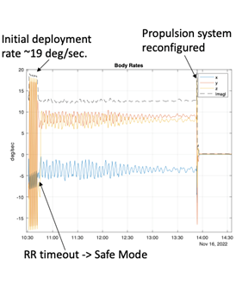
Figure 11: Initial Deployment Detumble Rates
This issue was first noted in one of the ops simulations, after spacecraft delivery and too late for a software update. The script bug and possible failure of detumble were identified, and the response planned out, so when the anomaly occurred, the operations team was already prepared to respond immediately.
Commissioning: (18 days) The commissioning phase of BioSentinel was comprised of 4x 1-hour DSN passes per day through the lunar flyby (approximately 5 days after launch), then dropping to two passes per day. The 4 pass/day schedule necessitated around the clock operations, but the operations team was able to drop down to a prime and downlink shift once the cadence dropped to 2 passes/day. During the first 2 days, and during prime shifts, passes were staffed with a Mission Manager, Flight Director, Command Controller, and various subsystem engineers. The downlink shifts were just staffed by a Command Controller and Flight Director to downlink data from onboard storage.
All subsystem checkouts were completed nominally. This included setting the clock, deploying two more solar arrays, validating the star tracker/estimator output, testing the comm system on both the LGA and MGA, updating on-board parameter tables, and starting nominal on-board command sequences.
During this period, our flight dynamics team continued their analysis on the deployment and happily projected that our trajectory missed lunar impact by greater than 400km, thus waiving off the possible delta-V maneuver. Additionally, the eclipse was short enough for our spacecraft to survive using nominal operations. The trajectory worked out to be quite favorable!
Finally, after the fly-by and eclipse, the FSW was patched, fixing the flash memory performance in preparation.
We presented the post-launch performance of the spacecraft and subsystems as part of readiness for science operations at the Post Launch Assessment Review (PLAR).
Science: The science phase of the mission began on December 4, 2022 with the start of the first BioSensor yeast experiment. During the science phase, only one pass per day (Mon-Fri) was used to downlink data from onboard storage and to perform housekeeping activities that included:
      - Once per week loading a 10-day stored command sequence and jamming the clock
- Manual momentum maneuvers
- Starting/stopping experiments
- Managing onboard data storage
A series of science experiments were conducted to varying success (summarized above). And additionally, there were several bus and BioSensor anomalies that the team worked through to keep the mission moving forward. Ultimately, the BioSensor was turned off on March 10, 2023. Radiation measurements will continue throughout the remainder of the mission using the LET dosimeter. Mission Operations will continue to monitor the Health and Status of the spacecraft and LET dosimeter, and will continue to downlink data from the spacecraft.
A summary of flight anomalies are shown in Tables 6-8, and a graphical representation of the Mission Operations Timeline is shown in Figure 12
Table 6: Summary of Notable Bus Anomalies
Bus Anomaly Number | Date | Description | Recovery
1 | 11/16/2022 | Rate Reduction did not exit Properly | Commands sent to enable Rate Reduction (x3) and set Propulsion to Dead Reckoning mode (x3).  Spacecraft was able to detumble.
2 | 11/17/2022 | Thruster 5 not working | Spacecraft is able to maintain controlled attitude without operation of Thruster 5
3 | 1/27/2023 | Flywheel of processor occurred while downlinking files | None taken, observation only.
4 | 1/31/2023 | Safe mode- C&DH reboot while downlinking files | Procedures in place to avoid reboot during downlinking of files.
5 | 2/1/2023 | Safe mode-Occurred during clock jam | Recovered from safe mode and flight rule implemented regarding clock jam
6 | 2/2/2023 | Safe mode-Star tracker was invalid | Safe mode recovery, observation only.
7 | 2/20/2023 | IRIS not responding and triggered fault management response to power cycle | None taken, observation only.
8 | 3/3/2023 | Safe Mode-C&DH reboot. | Added pass to recover from safe mode. No known cause.

Table 7: Summary of Notable Operations Anomalies
Operations Anomaly Number | Date | Description | Recovery
1 | 11/17/2022 | Quaternion for NP checkout was 180° off. Observed spacecraft was moving towards incorrect direction. | Recovered during same pass and completed activities.
2 | 11/23/2022 | Project scheduling error. Pass was moved and ATS was not changed. | Tried commanding in the blind, but the team was unable to acquire a signal.
3 | 11/24/2022 | Process Error: Command sent to go to nominal pointing instead of turn the transmitter on in the blind. | Team was able to recover in the same pass.

Table 8: Summary of Notable BioSensor Anomalies
BioSensor Anomaly Number | Date | Description | Recovery
1 | 12/12/2022 | Card 5 Resistance Temperature Detector (RTD) appeared off nominal | No action taken due to faulty RTD.
2 | 12/16/2022 | Pressure, Temperature, Humidity and Current Sensors readings appeared off nominal, with suspected moisture within the BioSensor. | Forced card heating gradient did not improve BioSensor behavior. Started recording optics data of select cards for subsequent activities.
3 | 12/19/2022 | Experiment 2 Cards fills incomplete. | Flow Rate Test conducted to assess pump/valve performance.
4 | 1/19/2023 | Pressure, Temperature, Humidity and Current Sensors readings appeared nominal | Inconclusive observations due to noisy optics data. No correlation to spacecraft behavior and BioSensor behavior that resulted in nominal readings.
5 | 2/6/2023 | Temperature readings for Experiment 3 RTDs off nominal | Reboot of BioSensor did not return readings to nominal.
6 | 2/10/2023 | RTD readings off nominal during Bank 2 flow rate test | No action taken, and observed no time correlation to spacecraft behavior and BioSensor behavior.
7 | 2/21/2023 | Temperature readings for Experiment 4 RTDs off nominal and current readings not correlating with predicted temperatures for the current draw. | No action taken; continued to observe optics readings

Extended Mission
After the BioSensor was turned off, ending the primary mission, our team pivoted to extended operations. This involved reducing the staffing profile and switching to a low effort conops. With the LET being the only payload, data downlink needs reduced, enabling our team to reduce the communication pass cadence to 1-2 passes/week. And without the additional heat generated by the BioSensor, the spacecraft is able to support 3 hour passes. These longer but less frequent passes are much easier for our part-time team to staff. In order to accommodate this new cadence, we generate longer stored command sequences (21 days) and updated the fault management to match. We are still able to downlink all detailed bus and radiation data at our highest data rates through April 2024 on 34m stations. After that time, our spacecraft’s distance to Earth will have increased so far that our link budget requires either 70m stations or we will have to selectively prioritize data at slower downlink rates.

Ground Stations
The BioSentinel project was configured to work with a total of 18 possible ground stations (14 DSN, 4 ESA). To complete with our pre-launch testing, we sent commands to, and received played back telemetry from, each station. In our testing we used all 4 of our possible bit/symbol rates on both of our primary and backup workstations.
DSN stations:
- Goldstone: DSS-14 (70m), DSS-24, DSS-25, DSS-26
- Canberra: DSS-34, DSS-35, DSS-36, DSS-43 (70m)
- Madrid: DSS-53, DSS-54, DSS-55, DSS-56, DSS-63 (70m), DSS-65
ESA stations:
- New Norcia: DSN-74
- Cerbreros: DSN-83
- Malargue: DSN-84
- Goonhilly: DSN-59

Table 9: Bit/Symbol Configurations
Bit-Rate | Symbol rate
62.5 | 125
500 | 1000
1000.17 | 6001
8012.82 | 48076.9

DSN Monitor Data
To verify station configuration (uplink rate, frequency, ranging, etc.) and status (carrier lock, measured bit rate, etc.) during each pass, we relied on Monitor Data. This important tool enabled our team to aid whenever the station operator was having trouble getting into 2-way lock with our spacecraft, which has occurred many times over the mission for various reasons. Pre-launch, randomly and unpredictably, we found that no Monitor Data was being received. Our colleagues at JPL were seeing it sent, but we couldn’t determine the cause of the issue. The closer we were to launch, the more anxious our team became. Since launch however, this problem has never materialized, thus appearing to be a test artifact.

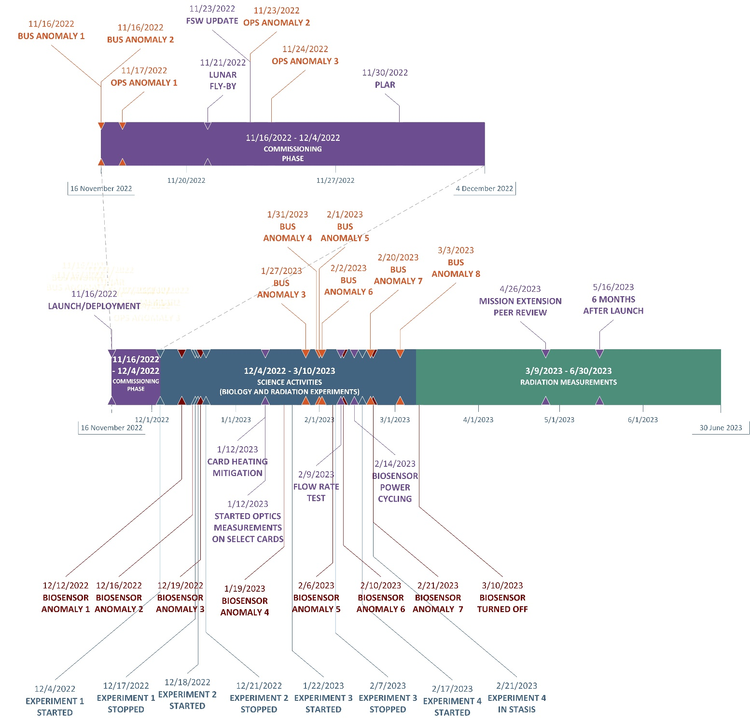
Figure 12: Mission Operations Summary Timeline

CONclusion

The BioSentinel spacecraft has demonstrated the capability of a deep space CubeSat to perform a novel science mission. The hardware has withstood launch on the world largest rocket, Artemis I, and traveled over 15 million kilometers from Earth during the first six months of the mission. Communication with the spacecraft thru DSN has met estimates along side the IRIS radio. The primary science mission was affected due to degradation of the yeast cells but the secondary payload has provide the science community valuable radiation measurements that can be analyzed in conjunction with LEO and ground test data. Successes and lessons learned from the BioSentinel mission will inform future deep space biology and deep space small spacecraft missions.

Acknowledgments
The BioSentinel team appreciates the support of the NASA’s Exploration Systems Development Mission Directorate – Mars Campaign Office through mission development, launch and operations. The NASA Ames Engineering Directorate and contractors for providing the team, resources, and facilities to execute the mission. Our sibling secondary payloads on Artemis I for collaborating before, during and after the mission. Special thanks to the NEAScout team who released the DSN pass we needed to detumble BioSentinel. And finally, the DSN for continuing to provide excellent service during mission operations.

References
- Liddell, L.C., Gentry, D.M., Gilbert, R., Marina, D., Massaro Tieze, S., Padgen, M.R., Akiyama, K., Kennan, K., Bhattacharya, S., and Santa Maria, S.R., “BioSentinel: Validating Sensitivity of Yeast Biosensors to Deep Space Relevant Radiation,” Astrobiology, April 2023.
- Padgen, M.R., Liddell, L.C., Bhardwaj, S.R., Gentry, D., Marina, D., Parra, M., Boone, T., Tan, M., Ellingson, L., Rademacher, A., Benton, J., Schooley, A., Mousavi, A., Friedericks, C., Hanel, R.P., Ricco, A.J., Bhattacharya A., and Santa Maria, S.R., “BioSentinel: A Biofluidic Nanosatellite Monitoring Microbial Growth and Activity in Deep Space,” Astrobiology, February 2021.
- Lightsey, E.G., Stevenson, T.S., and Sorgenfrei, M, “Development and Testing of a 3-D-Printed Cold Gas Thruster for an Interplanetary CubeSat”
- Antonio J. Ricco et al, “Biosentinel: A 6U Nanosatellite for Deep-Space Biological Science,” IEEE Aerospace and System Magazine, Volume:35, Issue:3, March 2020.
- M. Michael Kobayashi et al, “The Iris Deep-Space Transponder for the SLS EM-1 Secondary Payloads,” IEEE Aerospace and System Magazine, Volume:34, Issue:9, September, 2019.

