NASA Space Launch System Cubesats:
First Flight and Future Opportunities
Russell Lane, Courtney Ryals, Carole McLemore, David Hitt
NASA, MSFC: SLS Payload Integration Office
NASA, MSFC; 256.544.0847
william.r.lane@nasa.gov

ABSTRACT
On Artemis I, within the integrated SLS upper stage under the Orion spacecraft, there were 10 6U CubeSats. The spacecraft all had different mission objectives, ranging from studying the lunar surface for water and minerals, landing on the Moon, studying deep space radiation, studying the Sun, studying Earth-Moon LaGrange Point 2, and characterizing a near-Earth asteroid, to name a few. This paper discusses the conditions of the CubeSats’ flight on the Space Launch System (SLS) rocket and their deployments. Statistics concerning the 10 CubeSats will be provided relating to radio contact and mission performance. For those still in operation at the time of the paper/presentation submittal, latest status will be provided. Opportunities for future missions will be introduced, including an overview of the upgraded SLS Block 1B vehicle configuration with its new secondary payload accommodations. The updated deployment system for SLS Block 1B will have the capability of handling 6U, 12U, and 27U CubeSats. For potential CubeSat developers, a basic timetable will be provided for planning purposes.
Artemis I
On November 16, 2022, NASA’s first Space Launch System (SLS) rocket successfully launched, starting the Artemis I mission and the Artemis program of returning humans to the Moon (Figure 1). SLS is the most capable operational launch vehicle in the world, capable of sending humans onboard the Orion spacecraft and large cargos to the Moon and beyond in a single launch. The primary Artemis I mission objectives were testing the SLS vehicle and an uncrewed Orion spacecraft (with its new heat shield design), along with ground launch systems, in preparation for the crewed Artemis II mission. On Artemis I, 10 6U CubeSats launched in the Orion Stage Adapter (OSA) (Figure 2), which connects the SLS rocket to the Orion spacecraft. These CubeSats were deployed after the SLS upper stage had initiated its trans-lunar injection (TLI) burn, and Orion’s separation had been completed.
The CubeSats – developed by NASA, large business, small business, educational institutions, and international partners – all had different mission objectives that supported NASA’s future exploration goals. These ranged from studying the lunar surface for water and minerals, landing on the Moon, studying deep space radiation and the Sun, studying Earth-Moon LaGrange Point 2, and characterizing a near-Earth asteroid, to name a few. The mission was also the first use of the secondary payload deployment system developed for SLS.

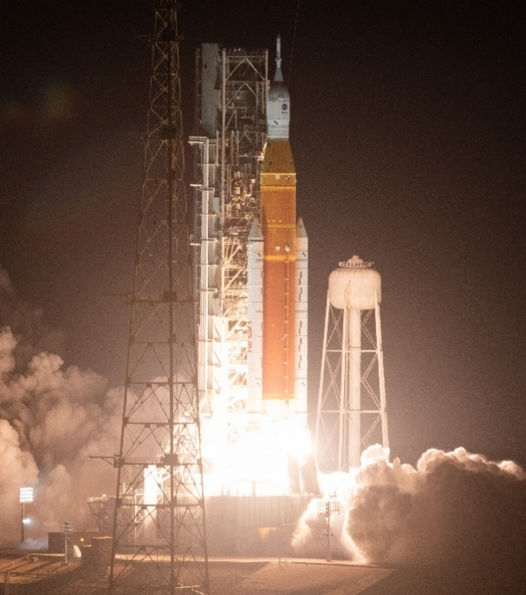
Figure 1: Artemis I launch
The secondary payload deployment system, with the CubeSats, is housed in the OSA, which connects the SLS upper stage, called the Interim Cryogenic Propulsion Stage (ICPS), and the Orion spacecraft. On Artemis I, after the ICPS and Orion separated from the SLS core stage, the ICPS made three propulsive burns, including the TLI burn. This placed the ICPS/Orion configuration on a trajectory toward the Moon. Shortly after TLI burn completion, the Orion spacecraft separated from the ICPS, leaving behind the OSA. After Orion left the vicinity of the stage via a series of small burns, the ICPS performed its disposal maneuver. The disposal maneuver was a process of inerting the ICPS propellant tanks and preparing the stage for a safe, permanent disposal in a heliocentric orbit. Once the disposal maneuver completed, it was safe to start deployment of the CubeSats.
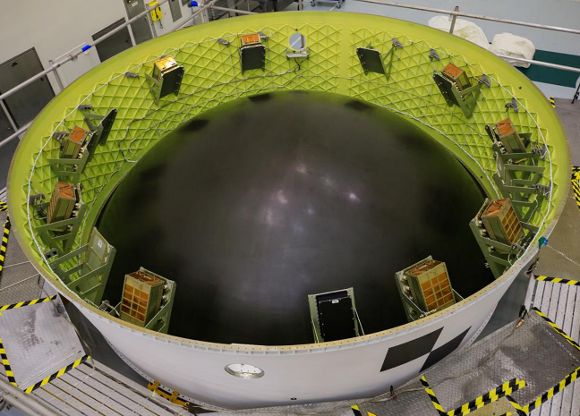
Figure 2: CubeSat loading at KSC in OSA
The forward opening of the ICPS was pointed at a 55-degree angle to the Sun and placed in a 1 rotation per minute (rpm) “barbecue roll” prior to completing its disposal maneuver. This configuration was selected to maintain an acceptable thermal environment for the secondary payloads. If the OSA remained in full shadow, the temperature would have decreased to a point where the deployment system and CubeSat batteries would have frozen, quickly ending the missions. Conversely, if a secondary payload in its dispenser would have experienced direct sunlight for a prolonged time, the CubeSat would have overheated before being deployed.
To better determine when secondary payloads would be deployed, payload integrators within the SLS Program created “bus stops” tied to conditions in space and trajectory milestones to aid the CubeSat developers in determining when to initiate deployment. Bus Stop #1 was the first opportunity to deploy a secondary payload once the ICPS disposal maneuver was complete. It was still within the outer Van Allen Belt, which contains electron radiation captured from the Sun. Bus Stop #2 was approximately 30 minutes beyond the outer Van Allen Belt. The reason for the 30-minute delay is the Van Allen Belt can fluctuate in size and shape due to solar activities; 30 minutes was a fair estimate to ensure being outside the outer belt while not causing a further delay in deployment. Bus Stop #3 was geometrically halfway between Earth and the Moon. This point in the trajectory was reached about 24 hours into the flight, even though it took roughly six days to reach the Moon. The Earth’s gravity was still pulling on the ICPS, slowing it down, until it reached the gravitational midpoint, which is much closer to the Moon. At this point, the ICPS started to accelerate due to the Moon’s gravitational pull. Bus Stop #4 was set at perilune, the closest approach of the ICPS to the lunar surface (roughly 230 km). The final bus stop, Bus Stop #5, was roughly 12 hours past the Moon – selected because it was the point where a CubeSat would gain the most benefit of the ICPS’s lunar gravitational assist (Figure 4). The bus stops were not the only times at which deployment was possible but provided an easy reference for planning purposes since absolute times and distances would vary based on the mission’s launch-date-derived flight profile.
With these bus stops identified, the CubeSat developers made deployment time selections, and the payload deployment system’s avionics unit was loaded with their selection for deployment. Each team weighed risks and benefits offered at each deployment location. Risk/benefit examples included but were not limited to: getting off early allowed one to make propulsive changes in trajectories while expending the least amount of propellant; being in or out of the Van Allen Belts and dealing with associated radiation effects; and possibly staying inside the OSA too long to where the ICPS loses its attitude toward the Sun and systems fail due to cold thermal environments. CubeSat developers could deploy between bus stops by simply adding time to the most recent stop, which several chose to do.
Even though the secondary payload system can accommodate up to 17 6U CubeSats, Artemis I had a 1,000-pound mass limit for the secondary payloads. Originally, 13 CubeSats were manifested for the Artemis I flight, but only 10 CubeSats were complete and delivered to Kennedy Space Center (KSC) in Florida prior to the deadline for integration onto SLS. The following are details about the CubeSats that flew on Artemis I (Table 1).

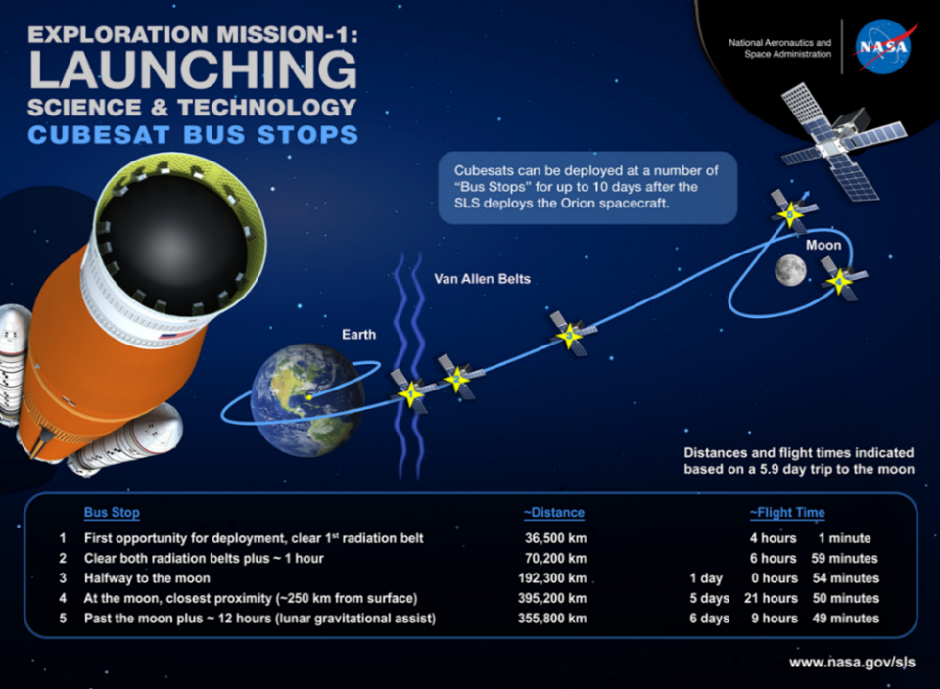
Figure 4: Bus Stop Approximations
Table 1: Artemis I Payload Developers, Affiliations, Destinations & Deployment Bus Stop
Artemis I Secondary Payloads – Deployed November 16, 2022
CubeSat | Developer / Location | Destination | Bus Stop
ArgoMoon | ASI; Turin, Italy | High Earth / Moon Orbit | 1
BioSentinel | Ames Research Center; Moffett Field, CA | Heliocentric Trajectory | 1
CuSP | Southwest Research Institute (SwRI); San Antonio, TX | Heliocentric Trajectory | 2 plus 2 hr
EQUULEUS | JAXA; Tsukuba, Japan | Earth-Moon L2 | 1
LunaH-Map | Arizona State University (ASU); Tempe, AZ | Lunar Orbit | 2 minus 30 min
Lunar IceCube | Morehead State University; Morehead, KY | Lunar Orbit | 1
LunIR | Lockheed Martin Space Systems; Denver, CO | GEO | 2
NEA Scout | Marshall Space Flight Center; Huntsville, AL | Near Earth Asteroid | 1 plus 90 min
OMOTENASHI | JAXA; Tsukuba, Japan | Lunar Surface (lander) | 1
Team Miles | Fluid & Reason, LLC; Tampa, FL | Deep Space | 2 plus 1hr
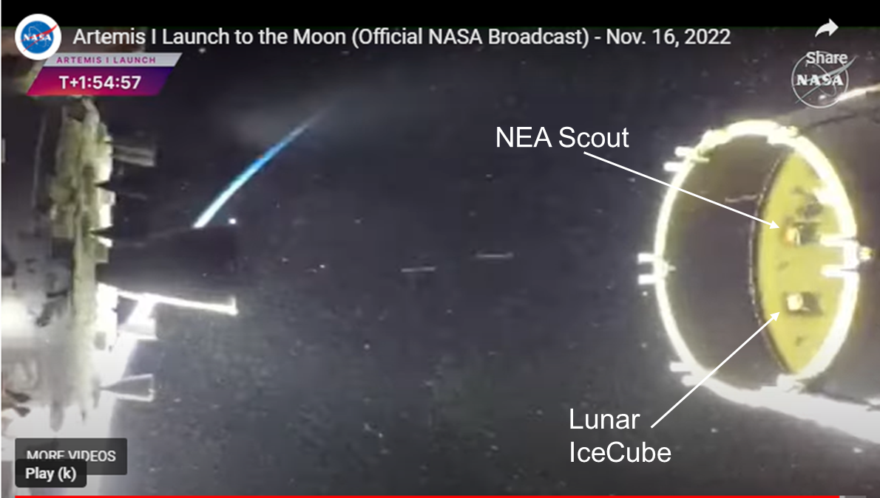
Figure 5: OSA w/ SPLs Taken by Orion Wing Camera

All CubeSats were deployed between approximately four to eight hours after launch. Figure 5 is an actual flight image showing two of the dispensers in the OSA shortly after the Orion separation from the SLS upper stage.
Post-flight assessments of the SLS vehicle data determined that the vehicle trajectory was nominal. Additionally, loads and environments experienced during the flight were nominal and within predictions. The SLS vehicle performed well within design and expectations.
Because the ICPS had ended its mission and was not capable of relaying CubeSat deployment status to Earth, teams on the ground relied on receiving a signal from CubeSats for confirmation of deployment. During the mission, ground teams received signals from eight of the 10 deployed CubeSats. Of those eight CubeSats, five achieved either partial or complete mission success.
The CubeSats had an 80-percent radio/comm contact success rate, with 50 percent achieving either partial or complete mission success as of the time of this writing. This maiden flight of SLS included the first mass deployment of CubeSats beyond LEO and the exercising of the Deep Space Network (DSN) and other ground networks, to support multiple simultaneous CubeSat missions.
While it was later established that some of the CubeSats were unsuccessful in meeting their performance objectives, the reasons are speculative in many cases despite extensive failure analyses by the CubeSat developers due to having limited data and no way to retrieve the CubeSat to perform more extensive forensics. However, in general, there are numerous reasons for not hearing from deployed CubeSats or losing communications from the CubeSats early on in their missions. Potential problems can be attributed to excessive tumbling, internal power failure, space thermal conditions experienced by CubeSat components (too cold or hot), radiation effects, and many more. Unlike low-Earth orbit (LEO) CubeSats, which have a known orbit and are easy to find, CubeSats flying to the Moon and beyond can be quickly lost if a communications link is not made with the ground soon after deployment. Additionally, since CubeSats are so small, visual or radar location finding has minimal potential for success. The SLS payload integration team and Artemis I CubeSat developers met frequently post-flight to discuss status, assist in troubleshooting problems, and identify potential lessons learned that can be implemented on future SLS missions.
Artemis II
Building from the Artemis I mission, preparations are underway for the Artemis II mission in late 2024. Artemis II will launch on a Block 1 crewed SLS configuration, and it will be the first crewed mission for SLS. While Artemis II’s main mission is for the four-astronaut crew to evaluate crewed system performance for SLS and Orion in the deep space environment, it will also have the capability to fly 6U and 12U CubeSats.
During the mission, Orion, the upper stage, and the secondary payloads will be in a high ballistic trajectory, which, if not corrected, would bring the items back into the Earth’s atmosphere for disposal. Orion will perform two burns – one to raise its orbit to fly around the Earth and a second to send itself to the Moon on a free return path to Earth. The SLS upper stage will stay on its ballistic trajectory, being disposed into the Pacific Ocean. Any CubeSats would have an approximate eight-hour window to alter their trajectories, or they will follow the SLS upper stage on a high-altitude return trajectory.
Artemis III
Artemis III is scheduled to return humans to the surface of the Moon. The SLS flight path will be similar to the Artemis I flight path. It is anticipated that SLS will have launch mass margin available to fly 6U and/or 12U CubeSats. Similar to Artemis I, the secondary payloads on Artemis III will have their first opportunity for deployment once Orion departs the upper stage vicinity and the ICPS has completed its disposal operations. When the flight path has been established, new bus stops will be identified so payload developers can determine a deployment point best suited for their mission(s). The announcement for Artemis III CubeSat launch opportunities is in development at the time of writing. Payload selection and notification is expected to be made in late summer/early fall of this year. Selection will be partly based on SLS mass allocation, payload suitability to the Artemis III flight path, NASA technology, science, and exploration goals, and other factors determined by NASA.
Future Flights
Following the Artemis III mission, NASA will begin flying the SLS Block 1B configuration. The vehicle features a new four-engine upper stage, called the Exploration Upper Stage (EUS), which will provide greater lifting capability and thus allow larger primary and co-manifested payloads. New secondary payload accommodations will be incorporated. The updated deployment system will have the capability of handling 6U, 12U, and 27U CubeSats in different combinations. The deployment system will also have feedback capability to identify that a CubeSat has been successfully deployed, as long as the EUS communications system is operational.
Unlike the SLS Block 1 configuration, where the payload dispensers are mounted to the inner wall of the OSA, the Block 1B secondary payloads will be mounted under the primary or co-manifested payload. The new structure holding the secondary payloads is called the Nest (Figure 7). The Nest sits inside the payload adapter, a conical shaped structure that attaches the primary or co-manifested payload to the EUS. In the Block 1B crew configuration, the payload adapter, Nest, co-manifested payload, and secondary payloads are stowed in a Universal Stage Adapter (USA) that provides as much volume for payloads as a 5-m commercial payload fairing. The Nest will be able to accommodate 6U, 12U, and 27U CubeSats. The 6U and 12U CubeSats will be housed inside commercially available dispensers for deployment and will deploy once the primary or co-manifested payload has departed. The 27U CubeSat accommodations and deployment system are still under consideration. Larger class satellites, like 27U CubeSats, typically use a separation ring or similar mechanism; this configuration is currently being considered in the Nest design.
The Nest will have 15 secondary payload mounting locations. Each location can deploy the CubeSat straight up (i.e., parallel to the vehicle’s center axis) or at a 20-degree angle from the vehicle’s center axis. The variable angle capability will provide options to future CubeSat developers looking to deploy constellations or swarms. The Nest will also have the structural capability to hold tandem 6U dispensers that are bolted together. Block 1B CubeSat opportunities represent a promising possibility for developers to explore swarm technology in deep space missions, such as deep space antenna arrays or swarm-style telescopes.

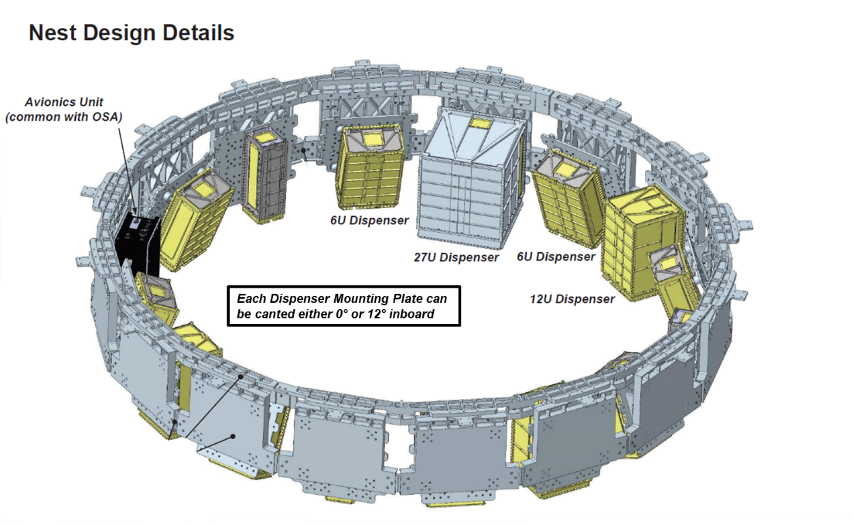
Figure 7: Nest Configuration

Conclusion
As the SLS configurations change and increase in capabilities, so will the accommodations potentially available to the payloads. NASA plans to continue to expand the uses and capabilities of the SLS launch vehicle to support science, technology development, and deep space exploration, including providing CubeSats with access to space beyond LEO, to the Moon, and destinations beyond the Earth-Moon system.

