COVER SHEET

Title: Interlaminar R-Curve Effects in Thermoplastic Composites: Experiments and Model Correlations

Authors: Prabhakar M. Rao ¹
Carlos G. Dávila ²
Ronald Krueger ³
William M. Johnston ²
James G. Ratcliffe ²
Cheryl A. Rose ²

Paper Number: 004499
FILE NAME: 004499_Rao.docx
(FIRST PAGE OF ARTICLE)

ABSTRACT

The interlaminar fracture behavior of thermoplastic composites under Mode-I and Mode-II static loading is investigated in this research. The material system under consideration is a carbon fiber reinforced low melt semi-crystalline resin TC1225 LMPAEK T700G (T700/LMPAEK)†. Characterization experiments were conducted to measure the load-displacement response, peak load, and propagation of delamination from a pre-implanted Kapton® insert. The Mode-I response was characterized using a double cantilever beam (DCB) test according to the ASTM D5528-22 standard. It was observed that the propagation exhibited significant resistance to delamination growth, i.e., an R-Curve effect. The test data indicated that the steady-state fracture toughness, $G_{I}^{SS}$, was approximately twice the mean initiation fracture toughness, $G_{Ic}$. The Mode-II response of an end notch flexure (ENF) specimen tested according to the ASTM D7905-19 standard exhibited an unexpected stable behavior upon attaining peak load. Prior to attaining peak load, the Mode-II response exhibited some non-linearity, which may be attributed to nonlinear bulk material response, e.g., hyper-elasticity, viscoelasticity, plasticity, etc., and potentially friction at the load/support rollers and R-Curve effects.
Finite element models based on the cohesive zone method (CZM) and the virtual crack closure technique (VCCT) were used to predict the DCB and ENF specimen responses. DCB analysis results obtained using $G_{I}^{SS}$ predicted propagation consistent with experimental data. However, results obtained with the as characterized $G_{Ic}$ were inaccurate in predicting delamination growth onset and peak load. ENF analysis results obtained with the as-characterized Mode-II fracture toughness, $G_{IIc}$, were inaccurate in predicting the peak load and propagation. Hence, R-Curve effects were included in both DCB and ENF simulations, which enabled improved predictions. The experimentally determined Mode-I R-Curve was used for the DCB simulations, whereas an R-Curve was derived for Mode-II assuming that the change in compliance of the specimen was associated with crack growth only.
The research in this paper endeavors to use detailed analyses to assist in the interpretation of experimental data for the characterization of interlaminar fracture properties in thermoplastic composites by evaluating the effects of the mentioned nonlinearities. Specifically, it will be shown that finite element models based on the CZM and the VCCT enable capturing the overall load-displacement response when R-Curve effects are properly included. In addition, the models exercised to explore the effects of friction on the Mode-II unloading curve and on the measured $G_{IIc}$.

INTRODUCTION

The work reported in this paper was performed as part of the NASA Hi-Rate Composite Aircraft Manufacturing (HiCAM) Project. The primary goal of the HiCAM Project is to demonstrate manufacturing approaches and associated technologies for large composite airframe structures that enable a 4X – 6X production rate increase without cost or weight penalty to meet the demand of next-generation, single-aisle commercial transport aircraft. The project aims to develop model-based engineering tools needed to rapidly mature and optimize both component design and the manufacturing processes. Achieving the overall project goal will require improvements across the seven major areas that drive high-rate composite aircraft manufacturing: materials, architectures, laydown, cure, assembly, inspection, and paint.
The methods being assessed and enhanced for structural sizing include current state-of-the-art rapid structural design and progressive damage analysis (PDA) tools, with the objective of understanding if they can support the materials, manufacturing and assembly technologies, and designs being proposed in the HiCAM Project. The overall methodology adopted in this study involved performing interlaminar Mode-I and Mode-II tests on a candidate thermoplastic composite material system (T700/LMPAEK) and correlating results obtained from corresponding PDA simulations with the test data.
Mode-I double cantilever beam (DCB) tests were performed in accordance with the ASTM D5528-22 standard, wherein it was observed that delamination propagation exhibited significant resistance to delamination growth, i.e., an R-Curve effect. In particular, the Mode-I tests indicated that the steady-state toughness significantly increased relative to the initiation toughness. When the R-Curve effect was properly included in the simulations, the results showed good correlations with test data regarding the initiation, peak load, propagation, and transition from initiation to propagation.
Mode-II end notch flexure (ENF) tests were performed in accordance with the ASTM D7905-19 standard, wherein a stable growth regime was observed upon attaining peak load, as opposed to the expected unstable growth onset. In Mode-II, an apparent R-Curve was derived assuming that all changes in compliance were associated with delamination growth only. Inclusion of the previously-mentioned effects, resulted in good correlations with test data, regarding initiation, peak load, and propagation.
The application of CZM and VCCT-based modeling approaches is described in this paper to predict the interlaminar fracture behavior of thermoplastic composites (TPCs) by considering the mechanisms mentioned herein. Correlations of predicted load-displacement response with test data serve to validate the methods.

INTERLAMINAR FRACTURE TESTS

Quasi-static Mode-I DCB and Mode-II ENF tests were performed on a carbon-fiber-reinforced low-melt semi-crystalline resin TC1225 LMPAEK T700G (T700/LMPAEK) material system, manufactured by Toray Composites, Inc. The fracture coupons fabricated, and the data obtained from the tests is summarized herein.

Materials and Specimen Geometry

The layup of the T700/LMPAEK test panels was: ${\left[0\right]}_{18}//{\left[0\right]}_{18}$, where ‘$//$’ indicates the mid-plane Kapton insert. The T700/LMPAEK panels were manufactured in a heated press.
The nominal dimensions of the DCB and ENF fracture coupons are shown in Figure 1. The nominal width of each specimen was 1.0 in. A pre-implanted mid-plane Kapton insert was incorporated into each specimen which acted as a delamination starter. These inserts nominally measured 3.0 in. from the specimen edge, Figure 1, and spanned the entire width of the specimen. The thickness of the inserts in the T700/LMPAEK coupons was 0.0005 in., consistent with the recommended value per the standards. The nominal initial delamination length, corresponding to the length of the Kapton insert from the loading point in DCB specimens, was $a_{0}=2.000$ in., Figure 1 (a). The nominal initial delamination length in the ENF specimens was $a_{0}=3.000$ in., Figure 1 (b).

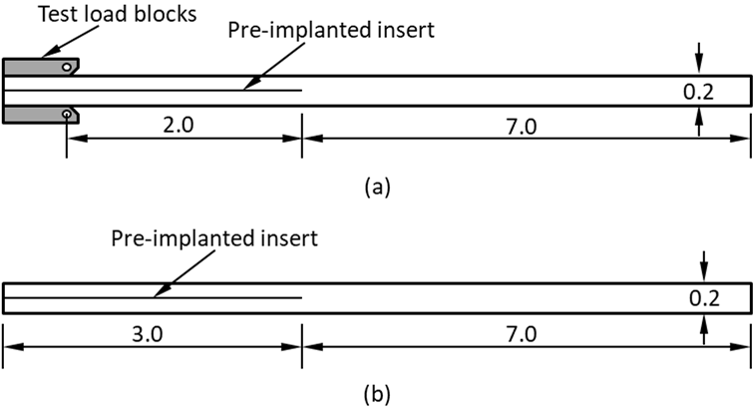

Figure 1: Schematics of interlaminar fracture test coupons. (a) DCB specimen geometry. (b) ENF specimen geometry. All dimensions are in inches.

The dimensions of the specimens tested are included in TABLE I.

TABLE I. FRACTURE SPECIMEN GEOMETRY. ALL DIMENSIONS IN INCHES.
 | Nominal |  |  | Minimum | Maximum
DCB Specimen
Thickness, $2h$ |  | 0.20 | 0.19883 |  |  | 0.20082
Width, $b$ |  | 1.00 | 0.9982 |  |  | 1.002
Initial crack length (Kapton insert) |  | 2.00 | 2.108 |  |  | 2.135
ENF Specimen
Thickness, $2h$ |  | 0.20 | 0.19751 |  |  | 0.19908
Width, $b$ |  | 1.00 | 0.99467 |  |  | 0.99983
Initial crack length (Kapton insert) |  | 3.00 | 3.420 |  |  | 3.812

The intralaminar properties of the T700/LMPAEK material system, sourced from the NCAMP database [1], are listed in TABLE II, whereas the interlaminar properties, TABLE III, were acquired via appropriate testing in the HiCAM Project.

TABLE II. ELASTIC MODULI OF THE T700/LMPAEK MATERIAL SYSTEM.
$$E_{11}^{T}$$ | $$E_{22}^{T}$$ | $$E_{33}$$ | $$ν_{12}$$ | $$ν_{13}$$ | $$ν_{23}$$ | $$G_{12}$$ | $$G_{13}$$ | $$G_{23}$$
(Msi) | (Msi) | (Msi) |  |  |  | (Msi) | (Msi) | (Msi)
18.10 | 1.32 | 1.32 | 0.337 | 0.337 | 0.487 | 0.674 | 0.674 | 0.443

TABLE III. INTERLAMINAR STRENGTH AND FRACTURE TOUGHNESS DATA FOR THE T700/LMPAEK MATERIAL SYSTEM.
$$X_{ILT}$$ | $$S_{ILS}$$ | $$G_{Ic}$$ | $$G_{I}^{SS}$$ | Mean NPC $G_{IIc}$ | Mean PC $G_{IIc}$
Ksi | Ksi | lbf/in. | lbf/in. | lbf/in. | lbf/in.
9.30 | 13.00 | 7.30 | 12.30 | 13.98 | 12.15

Test Configurations

The Mode-I interlaminar DCB test, Figure 2 (a), was performed according to ASTM D5528-22 standard, whereas the Mode-II interlaminar ENF test, Figure 2 (b), was performed according to the ASTM D7905-19 standard. The data acquired from these tests was used to quantify the Mode-I and Mode-II interlaminar fracture toughness and to characterize the R-Curve behavior. Post-test ultrasound scans were performed to characterize the shape of the delamination front, which demonstrated self-similar crack growth.

Mode-I Static Test Results

The DCB specimens exhibited linear response in the pre-peak load regime, Figure 3. The delamination growth phase of these specimens was mostly characterized by stable growth, Figure 3. However, specimens ‘P02B_DCS_08’ and ‘P02B_DCS_11’, Figure 3, exhibited discrete unstable growth increments. The mechanisms leading to unstable delamination growth were not ascertained. On the other hand, specimens ‘P02B_DCS_10’, ‘P02B_DCS_12’, and ‘P02B_DCS_13’ exhibited stable delamination growth, Figure 3 (a). The Mode-I fracture toughness of the T700/LMPAEK DCB specimens increases with delamination growth, Figure 3 (b), wherein it is evident that the steady-state fracture toughness increases significantly relative to the initiation toughness. This behavior, which manifests for $Δa≤0.75$ in., implies that increasingly greater energy is required at the crack-tip to overcome the resistance for fracture, and is known as the R-Curve effect. Also, it is evident from Figure 3 (b) that the T700/LMPAEK material attains steady-state propagation after delamination growth of $Δa>0.75$ in.

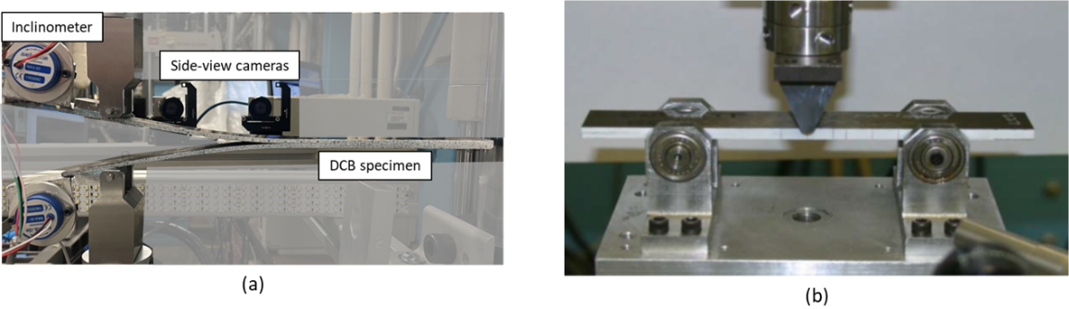

Figure 2: Interlaminar fracture test configurations. (a) DCB test configuration. (b) ENF test configuration.

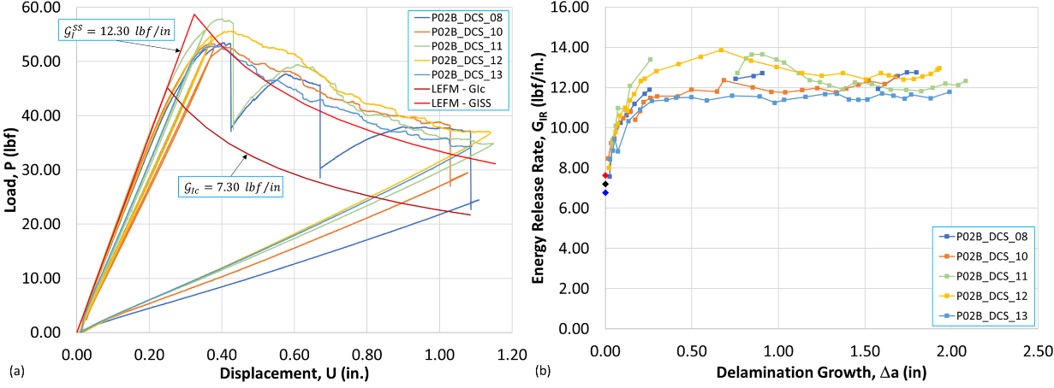

Figure 3: Experimentally acquired Mode-I data for the T700/LMPAEK material system. (a) Load-displacement response. (b) Delamination resistance curves. The mean initiation fracture toughness, $G_{Ic}$, (black diamond) is bounded by one standard deviation (blue and red diamonds).

Using $G_{Ic}$ and the mean Mode-I steady-state fracture toughness, $G_{I}^{SS}=12.30$ lbf/in, Linear elastic fracture mechanics (LEFM) solutions of the load-displacement response were obtained, Figure 3a. The LEFM solutions were obtained with $a_{0}=2.135$ in., TABLE I, using the following analytical expressions [2]:

 | $$P=\sqrt{\frac{b\left(E_{11}\frac{bh^{3}}{12}\right)}{{\left(a+χh\right)}^{2}}G_{I}},$$  $$δ=\frac{2{\left(a+χh\right)}^{3}}{3\left(E_{11}\frac{bh^{3}}{12}\right)}P$$ | (1)

In Equation (1), $χ=\sqrt{\frac{E_{11}}{11G_{13}}\left[3-2{\left(\frac{Γ}{1+Γ}\right)}^{2}\right]}$and $Γ=1.18\frac{\sqrt{E_{11}E_{22}}}{G_{13}}$. The input material used for these calculations are listed in TABLE II. The LEFM solution using $G_{Ic}$ underpredicts the peak load and propagation curve, whereas the LEFM solution using $G_{I}^{SS}$ overpredicts the peak load. These results indicate R-Curve effects are important and need to be considered in models.

Mode-II Static Test Results

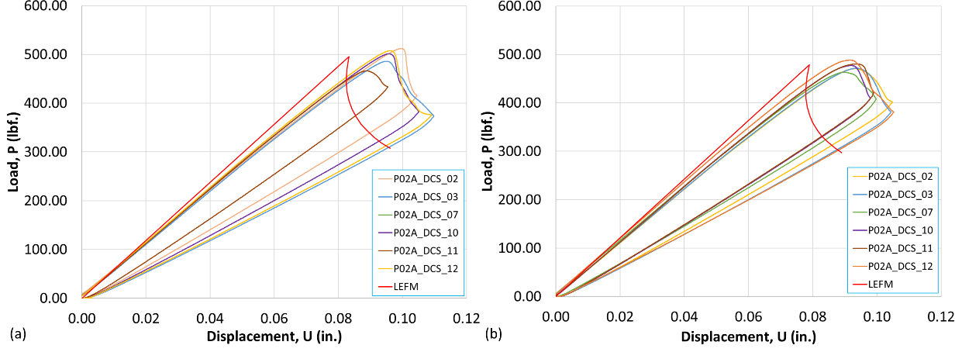

Figure 4: Experimentally measured Mode-II load-displacement response of the T700/LMPAEK material system. (a) NPC loading. (b) PC loading.

ENF specimens were tested under non-pre-cracked (NPC) and pre-cracked (PC) loading cycles. In each case, compliance measurements performed per ASTM D7905-19 were determined to be in family for all the specimens tested. The critical energy release rate (ERR) is obtained using the maximum load, $P_{max}$, as:
 | $$G_{Q}=\frac{3rP_{max}^{2}a_{0}^{2}}{2b}$$ | (2)
In Equation (2), $r$ is obtained via a least square fit of the specimen compliance, $C$, versus the cube of the crack length, $a_{0}^{3}$, dataset. If the delamination growth is found to be self-similar across the width of the specimen, then $G_{IIc}=G_{Q}$. The ENF specimens were loaded to half the expected failure at initial crack lengths $a_{0}=0.80$ in., $a_{0}=1.20$ in., and $a_{0}=1.60$ in. to determine the compliance calibration constants. The load-displacement responses were subsequently obtained with $a_{0}=1.20$ in., for total delamination growth of $Δa=0.50$ in. This procedure was followed for each specimen, and the computed critical ERRs were averaged to produce the mean Mode-II critical ERRs $G_{IIc}=13.98$ lbf/in for NPC loading and $G_{IIc}=12.15$ lbf/in for PC loading.
The Mode-II load-displacement response measured for the T700/LMPAEK material system under NPC loading is characterized by mostly linear behavior in the pre-peak regime, Figure 4 (a). However, specimen ‘P02A_DCS_11’, Figure 4 (a), seems to exhibit slight pre-peak nonlinearity. The load-displacement response measured for the T700/LMPAEK material system under PC loading is shown in Figure 4 (b). Under PC loading, the ENF specimens exhibit linear behavior until peak load, followed by stable unloading. In general, the response of the T700/LMPAEK material is similar under NPC and PC loading cases.
Using the average values of $G_{IIc}$ and $r$, under NPC and PC loading cases, corresponding LEFM solutions were calculated with Equation (2) and superimposed on the test data in Figure 4. The LEFM solutions underpredict the peak loads and the propagation curves. Further, the LEFM solutions are characterized by a sudden load-drop past the peak load, indicative of unstable delamination growth onset. In contrast, the test data include mild pre-peak non-linearity and gradual unloading past peak load, indicative of stable delamination growth onset. While the pre-peak non-linearity does not appear to be significant, these outcomes do not indicate whether the non-linearity is attributable to either the bulk material response, friction between the load/support rollers and the specimen, or potentially R-Curve effects.
In general, the observed stable delamination growth under Mode-II loading, Figure 4 (a) and (b), is unexpected. The stability of the response could potentially be a result of a process zone in which matrix cracking or other toughening mechanisms, such as fiber bridging, induce an R-Curve. Any direct evidence of these phenomena, however, has not been ascertained.

INTERLAMINAR FRACTURE ANALYSIS

Three-dimensional (3D) CZM and two-dimensional (2D) VCCT models of the DCB and ENF test coupons were developed in this work. Simulations were performed using the native capabilities of ABAQUS. The input material properties used in the simulations are listed in TABLE II and TABLE III.

Modeling the DCB Specimen

The Mode-I DCB CZM and VCCT models are shown in Figure 5. In the CZM model, Figure 5 (a) and Figure 5 (b), the bottom and top arms of the DCB specimen are discretized with 3D continuum eight-node incompatible mode (C3D8I) elements. The width of the model is chosen to be 0.125 in. since self-similar crack growth was achieved in the tests. Applied displacements on the bottom and top arms are introduced via multi-point constraints (MPCs). The length of the cohesive zone (CZ) elements, $l_{el}^{CZ}$, was chosen to be $0.008$ in. to adequately discretize the fracture process zone.
In the VCCT model, Figure 5 (c), the bottom and top arms of the DCB specimen are discretized with 2D continuum four-node plane strain incompatible (CPE4I) mode elements, and applied displacements are introduced as nodal boundary conditions. The element length at the delamination tip was $0.02$ in., and the plane of delamination was modeled as a discrete discontinuity in the center of the specimen. The models were composed of separate meshes for the top and bottom arms with identical nodal point coordinates in the plane of delamination, and contact interactions were defined to specify the contact area in the plane of delamination. The initial delamination front (red dot, Figure 5 (c)) defines the beginning of the intact region. Additionally, a node set, ‘bonded nodes’ in Figure 5 (c), was created to define the intact region.

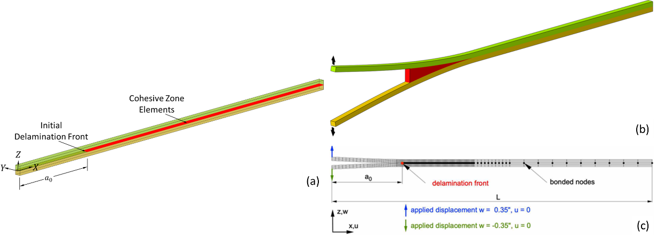

Figure 5: Mode-I DCB models. (a) 3D model showing requisite dimensions and location of the initial delamination front. (b) Deformed configuration showing cohesive zone (CZ) elements. (c) Deformed VCCT mesh.

Modeling the ENF Specimen

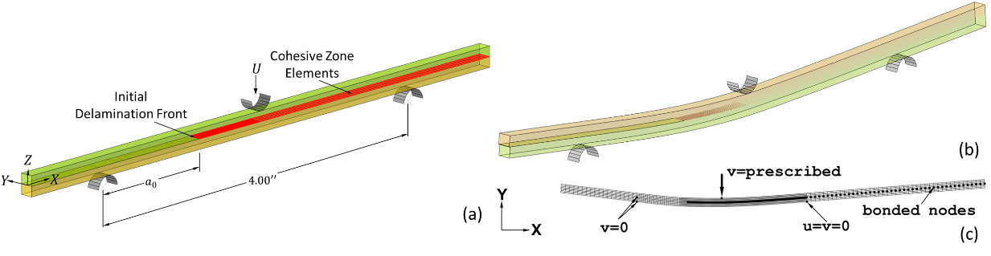

Figure 6: Mode-II ENF models. (a) 3D model showing requisite dimensions and location of the initial delamination front. (b) Deformed configuration showing CZ elements. (c) Deformed VCCT mesh.

Regardless of the noted variances in the initial crack length, TABLE I, models of the ENF specimens were developed with $a_{0}=1.20$ in., Figure 6, and nominal width and thickness, TABLE I. The meshing approach in the CZM ENF models was consistent with its DCB counterpart. Initially, the simulations considered frictionless contact between the load/support rollers and the specimen, which were subsequently augmented with frictional interactions. It should be noted that the long overhang regions, Figure 6 (a), are unnecessary, and can be either shortened significantly or eliminated without affecting the solution while reducing computing time.
The deformed mesh of the ENF VCCT model is shown in Figure 6 (c), wherein all the requisite dimensions are consistent with the CZM model. The meshing approach for the ENF VCCT model was consistent with its CZM counterpart, with $Δa=0.02$ in. at the crack tip. As opposed to the Mode-II CZM model, the interactions of the load and support rollers with the specimen were modeled via boundary conditions, as illustrated in Figure 6 (c).

Incorporating R-Curve Effects in CZM and VCCT Models

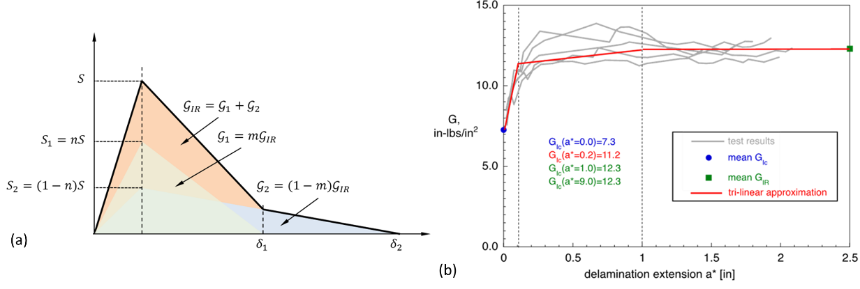

Figure 7: Techniques for including R-Curve effects. (a) CZM: Bi-linear softening law obtained by the superposition of two linear softening laws. (b) VCCT: Tri-linear approximation of Mode-I R-Curves shown in Figure 3.

As indicated by the data in Figure 3, Mode-I interlaminar fracture in the T700/LMPAEK material system is characterized by an increasing ERR with delamination growth. To accurately capture the mechanics of fracture in the presence of a rising R-Curve using CZM, the conventional bi-linear mixed-mode cohesive law must be modified to a tri-linear law [3]. On the other hand, to capture a rising R-Curve using VCCT, the interlaminar fracture toughness must be specified as a function of nodal position. Both approaches are discussed herein.
In the CZM approach, the fiber bridging model developed in [3] was adopted herein to incorporate the effects of rising R-Curve behavior. The fiber bridging model splits the steady-state toughness into an initiation part and a bridging or, more generally, a toughening part, resulting in a tri-linear cohesive traction-separation law characterized by bi-linear softening, Figure 7 (a). This tri-linear cohesive law is derived by considering the superposition of two linear softening laws which attain peak strength at the same displacement jump, Figure 7. It is evident that: $S_{1}+S_{2}=S$, and $G_{1}+G_{2}=G_{I}^{SS}$. As discussed in [3], the strength ratio, $n$, is given by:

 | $$n=1-\frac{2}{3}γ\frac{1-m}{l_{P}^{L}}\frac{EG_{I}^{SS}}{S^{2}}$$ | (3)

In Equation (3), $γ$ is a non-dimensional parameter which appears in various formulations for calculating the length of the process zone (LPZ) and is assumed equal to $0.884$ [3]. The parameter $l_{P}^{L}$ is the LPZ for the traditional linear softening cohesive law. Also in the Equation (3), the modulus, $E$, is the out-of-plane tensile modulus of the composite material ($E_{33}$, TABLE II), $S$ is the interlaminar tensile strength ($X_{ILT})$, and $G_{I}^{SS}$ is the steady-state fracture toughness, TABLE III.

For the T700/LMPAEK material system, $G_{1}=G_{Ic}=7.30$ lbf/in, and $G_{I}^{SS}=12.30$ lbf/in, resulting in $m=0.594$. The LPZ for the T700/LMPAEK material system is taken to be: $l_{P}^{L}=0.75$ in., which is the delamination growth required to attain steady-state propagation, Figure 3 (b). Using the previously-mentioned material properties in this section, the strength ratio for the T700/LMPAEK material system can be calculated as: $n=0.9401$. Since the calculations in this paragraph result in two peak strengths and fracture toughness values, two sets of coincident cohesive elements are required to incorporate the R-Curve effects. Within ABAQUS, duplication of the cohesive element set is easily accomplished by using the model input file *ELCOPY keyword line [4].
In the VCCT approach, the fracture toughness is specified as function of crack length, Figure 7 (b). This approach to modeling interlaminar fracture enables capturing the R-Curve effect. In ABAQUS, the crack length is defined in terms of node sets, and each node within such pre-defined node sets is associated with a fracture toughness, per the approximation determined using the test data. The approach to obtaining requisite input data is illustrated for Mode-I interlaminar fracture of the T700/LMPAEK material system in Figure 7 (b), wherein a tri-linear approximation to the R-Curve data is superimposed. After an increase in fracture toughness from initiation, a plateau or steady state is reached for longer delamination lengths. From the plateau, steady-state fracture toughness values were extracted (solid green squares). The averaged initiation fracture toughness values were added to the graphs for completeness (solid blue circles). The tri-linear approximations so obtained (solid red lines) were used to obtain the fracture toughness values used as input to the analysis. In this study, node sets were created at locations corresponding to: $a^{*}=0.00$ in., $a^{*}=0.20$ in., $a^{*}=1.00$ in., and $a^{*}=7.00$ in., and fracture toughness values were specified at the nodes within these node sets, per the tri-linear approximation, Figure 7 (b). The node set located at $a^{*}=0.00$ in. corresponds to the location of the initial crack/delamination front, $a_{0}=2.00$ in., Figure 1 (a), whereas the node set located at $a^{*}=7.00$ in. corresponds to the right end of the specimen, Figure 1 (a).

TEST/MODEL CORRELATIONS

The models and approaches discussed in the previous section were used to correlate Mode-I and Mode-II model predictions with corresponding test data. Both the Mode-I and Mode-II simulations predicted a slightly higher initial stiffness relative to the test data. This outcome may be attributed to differences in the properties of the materials tested in the NCAMP database, TABLE II, and those characterized in the HiCAM project.

Mode-I DCB Results

The predicted Mode-I load-displacement response for the T700/LMPAEK material system is correlated with test data as shown in Figure 8. The analytical LEFM solution, shown as a red line in Figure 8, was obtained using Equation (1), with the Mode-I steady-state fracture toughness, TABLE III. Since the LEFM solution does not consider any R-Curve effects, it is unable to predict the transition from initiation to propagation and predicts a somewhat higher maximum load than observed in the test. However, as expected, the LEFM solution predicts the propagation consistent with the test data, Figure 8.

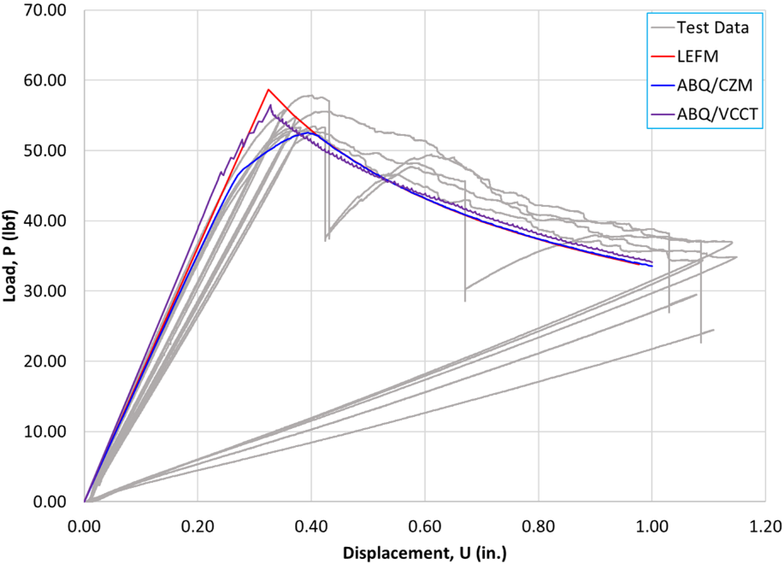

Figure 8: Comparison of predicted Mode-I load-displacement response with test data for the T700/LMPAEK material system – initial crack length, $a_{0}=2.135$ in.

The ‘ABQ/CZM’ solution, shown as the blue curve in Figure 8, models the R-Curve effects using the superimposed cohesive laws technique discussed earlier, and predicts the initial stiffness of the specimen consistent with the outer envelope of test data. Damage initiation corresponds to the onset of non-linearity, Figure 8, while damage propagation refers to the post-peak behavior. With the R-Curve effects properly considered, the ‘ABQ/CZM’ solution captures the initiation, the peak load, the transition from initiation to propagation, and the post-peak response consistent with the test data. Since the CZM approach addresses the rising R-Curve behavior accounting for the effects of the process zone and the bridging strength [3], the predicted peak load is more consistent with test data. However, additional studies to fully assess the effects of the bridging strength ($S_{2}$, Figure 7) and toughness ($G_{2}$, Figure 7) may be needed to achieve improved alignment with test data.
The ‘VCCT’ solution, shown as the purple curve in Figure 8, was obtained with fracture toughness specified as function of crack length, Figure 7 (b). The ‘VCCT’ solution predicts a slightly higher initial stiffness than observed by the other two analysis results, likely attributable to the 2D plane strain modeling approximation. Damage initiation is predicted to occur slightly early, likely because of the stiffer response. Similarly, the peak load is attained somewhat earlier in the loading history and is predicted to be higher than the ‘ABQ/CZM’ solution. The saw-tooth patterns in the ‘VCCT’ load-displacement response during the transition and propagation phases are caused by the node release in the automated growth analysis and are artifacts of the VCCT implementation in ABAQUS as of ABAQUS version 2022. The ABAQUS/VCCT implementation follows the principles of LEFM, and, therefore, the predicted load-displacement response closely aligns with the ‘LEFM’ solution, Figure 8. Although the R-Curve effects have been considered, the ‘VCCT’ solution does not show the pronounced non-linear transition from initiation to propagation, in close alignment with the CZM solutions and test data. The discrepancy may be caused by the inherently different formulation of VCCT and CZM and by the larger element size in the VCCT mesh, implying that a mesh refinement study may need to be conducted to fully investigate the disparities.

Mode-II ENF Results

For the sake of brevity, only the simulations performed with for the PC load case are correlated with corresponding test data, as shown in Figure 9. The ‘ABQ/CZM’ and ‘ABQ/VCCT’ solutions were obtained using the material properties listed in TABLE II, and interlaminar strength and fracture toughness, $G_{IIc}=G_{IIc}^{PC}=12.15$lbf/in, listed in TABLE III. In these simulations, Figure 9, R-Curve effects were not considered and hence neither superposed cohesive elements nor crack-length-dependent fracture toughness values were used. For comparison purposes, the LEFM solution obtained with Equation (2) using the mean Mode-II fracture toughness, $G_{IIc}=12.15$ lbf/in, is also included therein. Clearly, all the solutions underpredict the propagation curve, but predict average peak load consistent with test data even though the damage onset occurs early in the loading history.
The ‘ABQ/CZM’ and ‘ABQ/VCCT’ solutions, Figure 9, slightly overpredict the initial stiffness relative to average stiffness characterized by the test data, likely for the same reasons as in the DCB. As before, the saw-tooth patterns observed during stable propagation are caused by the node release during the automated growth analysis and are artifacts of the VCCT implementation in ABAQUS.
Regardless of the approach, the predictions are characterized by an initial sudden load-drop past the peak load, indicative of unstable delamination growth onset. However, the test dataset indicates a more stable delamination growth onset, as any sudden load-drop is not apparent, Figure 9. Other energy dissipating mechanisms such as matrix cracking, fiber bridging, viscoelasticity, hyper-elasticity, and friction may be active, causing stable growth. These effects were not considered in the simulations reported in Figure 9. Essentially, the listed energy-dissipating mechanisms present additional resistance to delamination growth under Mode-II, resulting in an R-Curve.

Mode-II ENF Results with Effects of R-Curve, Friction and Material Property Variances

Since the compliance is given by the displacement, $U$, per load, $P$, the crack extension, ERR, and instantaneous compliance can be calculated at every point of the load-displacement data using the computed fitting parameters. The resulting ERR as a function of crack extension is the resistance or apparent R-Curve, labeled $G_{IIR}$ in Figure 10 (a). Evidently, a crack extension of $Δa≈0.30$ in. needs to occur before steady-state propagation is established in Mode-II, Figure 10 (a). The calculation assumes that all changes in compliance are associated with crack extension only. It should be noted however that other sources of non-linearity, including hyper-elasticity, viscoelasticity, friction between the newly formed crack surfaces and the loading/support pins and the specimen, may be active, which could lead to the observed stable propagation.
The concave nature of the unloading curves, Figure 4, indicates that friction could be a more dominant parameter leading to the observed stable behavior. Furthermore, the non-linearity of the unloading curves under the PC loading case, Figure 4 (b), is more pronounced than under NPC loading, Figure 4 (a). This observation implies that friction between the newly formed crack surfaces may be more significant as opposed to the friction in the cracks induced by the Kapton insert.

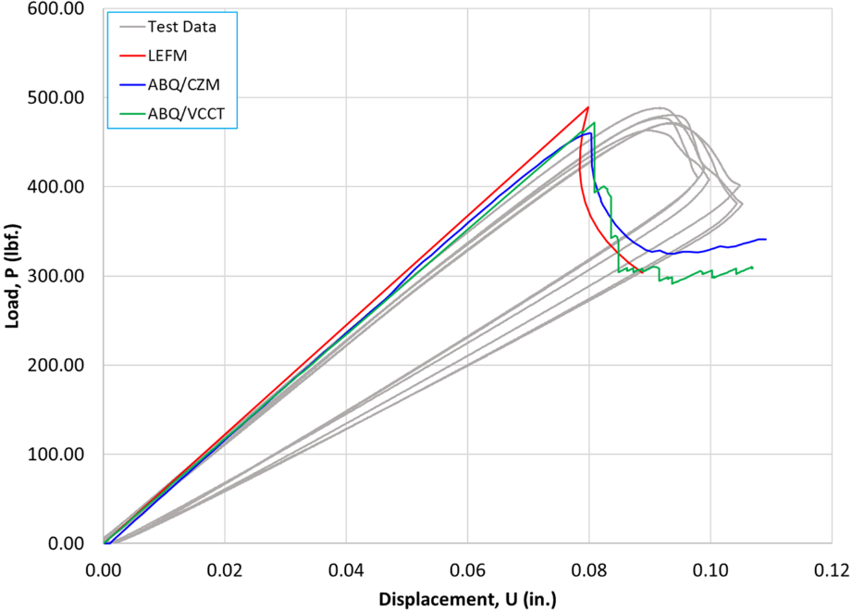

Figure 9: Comparison of predicted Mode-II load-displacement response with test data for the T700/LMPAEK material system under PC loading – initial crack length, $a_{0}=1.20$ in.

Using the outcomes reported in Figure 10 (a), several parametric studies were performed. The solution labeled ‘ABQ/CZM – GIISS’, Figure 10 (b), was obtained with the Mode-II steady-state toughness, $G_{II}^{SS}=17.66$ lbf/in, resulting in improved predictions of the propagation curve, but overprediction of the peak load. The curve labeled ‘ABQ/VCCT – GIISS’ was obtained using $G_{II}^{SS}=17.66$ lbf/in in the VCCT model. As the results shown in Figure 10 (b) indicate, the peak load is significantly overpredicted. Therefore, for comparison purposes, the VCCT model was executed by including the apparent R-Curve, Figure 10 (b). The curve labeled ‘ABQ/VCCT – R-Curve’, Figure 10 (b), shows the outcomes of including the apparent R-Curve in the VCCT model. The predicted peak load is closer to the ‘ABQ/CZM’ solution since the steady-state fracture toughness is the same in both solutions. As seen from Figure 10 (b), both VCCT solutions push out the propagation curve relative to the test data and the ‘ABQ/CZM’ solution. It may be argued that since $G_{II}^{SS}$ is the same in the CZM and VCCT models, the predicted propagation curves should be self-consistent. Hence the VCCT model outcomes may need further investigation, but the disparities in predictions relative to the CZM model and test data could be due to the larger element length ($Δa=0.02$ in.) at the crack-tip. As mentioned previously, the saw-tooth patterns in the ‘ABQ/VCCT’ solution result from the node release in automated delamination growth analysis and are characteristic of the implementation of the VCCT algorithm in ABAQUS.
Considering the observations discussed in this section, the interplay between the variances in material properties and friction is explored using the CZM model. The load-displacement response predicted by including the effect of friction between the newly formed crack surfaces is labeled as the curve ‘[1]’, Figure 10 (c). The coefficient of friction is assumed to be $μ=0.10$. For comparison, the solution obtained with $G_{II}^{SS}$ is included as the dotted curve therein. Both the solutions in Figure 10 (c) were obtained with $G_{II}^{SS}=17.66$ lbf/in. Evidently, modeling friction only between the newly formed crack surfaces slightly smooths out the peak load regime and unloading curve but does not quite capture the stable delamination growth onset manifest in the test data, and slightly pushes out the propagation curve. Therefore, friction was also modeled between the load/support pins. The resulting load-displacement response is labeled as the curve ‘[2]’ in Figure 10 (d). This additional friction only slightly increases the peak load and pushes out the propagation curve.
The next set of parametric studies explored the effects of the variances in material properties and friction. The propagation curve predicted by the solution labeled ‘[1]’, Figure 10 (c), appears to be closely aligned with the test data. Therefore, a simulation was performed with the frictional interactions included in ‘[1]’ and by knocking-down the elastic modulus, $E_{11}$, of the T700/LMPAEK material system by $5\%$ and the interlaminar shear strength, $S_{ILS}$, by $15\%$, relative to the baseline values listed in TABLE II and TABLE III, respectively. The resulting solution is labeled as the curve ‘[3]’ in Figure 10 (d). While the solution ‘[3]’, Figure 10 (d), predicts the peak load in closer alignment with the test data, it is still unable to capture the propagation curve as measured in the experiments. Finally, another simulation was performed which retained the parameters of ‘[3]’ and introduced friction between the load/support pins and the specimen. The resulting solution is labeled as the curve ‘[4]’ in Figure 10 (d). The solution ‘[4]’, Figure 10 (d), incorporates the characteristics of the test data but slightly overpredicts the peak load. However, this solution appears to be the most closely aligned with the test data.

Regardless of the approach, the models incorporating the effects of the rising R-Curve and variances in material properties and friction result in predictions that are in closer alignment with the test data. Therefore, further detailed analyses are required to help guide the experimental procedures and interpret resulting test data.

DISCUSSION

The results indicate that the approaches assessed herein, generally used for analyzing crack growth in thermoset composites, could also be used successfully for thermoplastic composites. Further, delamination growth behavior caused by the R-Curve effects can be captured adequately in simple characterization specimens if the appropriate input values can be chosen a priori.
Since the CZM and VCCT approaches address the rising R-Curve behavior in Mode I, they are both able to capture the transition from initiation to propagation. Once steady-state propagation prevails, after delamination growth of about 0.50 in. in the tested specimens, Figure 4, both the CZM and VCCT approaches closely capture the Mode-I propagation phase of the load-displacement response, Figure 7.
In the Mode-II tests conducted under the present effort, stable delamination growth was observed, implying a rising R-Curve. When the effects of such toughening mechanisms were incorporated along with the effects of friction and variances in material properties, the predictions closely aligned with test data. The reported results, therefore, allude to the critical role detailed analyses can play in guiding experiments and interpreting test data.

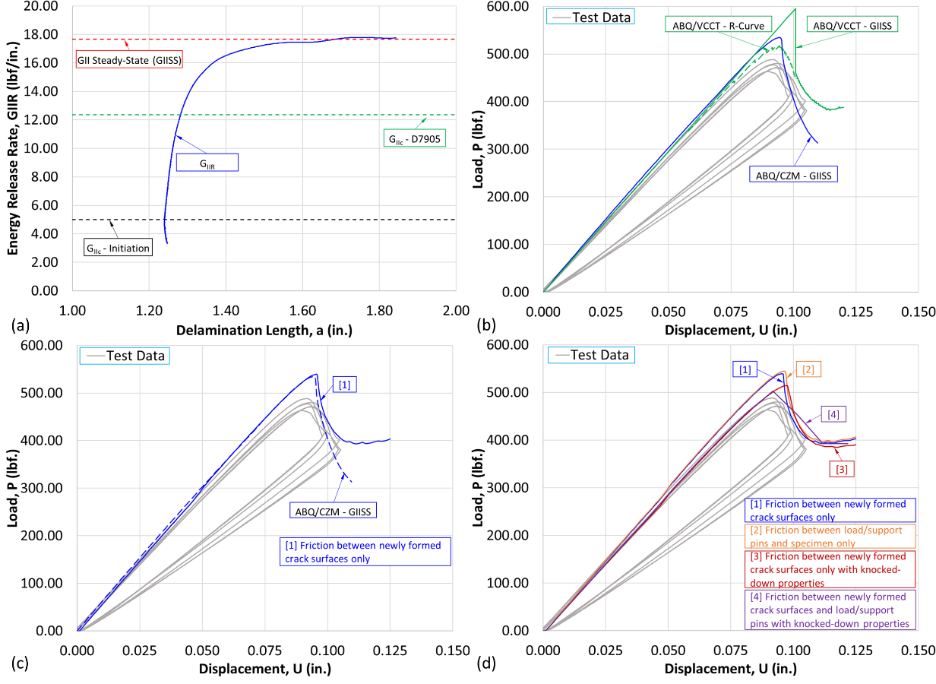
Figure 10: Outcomes of incorporating Mode-II R-Curve effects. (a) Apparent Mode-II R-Curve for the PC load-displacement dataset for specimen ‘P02A_DCS_12’, Figure 4. (b) Predicted load-displacement response using the CZM and VCCT approaches. (c) The load-displacement response predicted using the CZM approach with friction between newly formed crack surfaces. (d) The load-displacement predicted using the CZM approach with friction between newly formed crack surfaces and load/support pins and the specimen.

From a modeling standpoint, it may become difficult to implement the node-based interpolation scheme in structures with complex geometry, which may preclude the applicability of the VCCT approach. On other hand, superposing CZEs as discussed earlier, may be extended to structures with complex geometry, provided adequate care is taken in specifying requisite parameters appropriately. However, R-Curve behavior under mixed-mode loading would need to be characterized and addressed in the analytical formulations for bridging strength and fracture toughness. Alternatively, the inverse methodology proposed by Tijs et al. [5, 6], which minimizes the difference between the predicted and experimental load-displacement responses by adjusting the cohesive law parameters, could be used to determine an appropriate mixed-mode cohesive law. Clearly, further work is required to develop more general modeling methodologies applicable to geometrically complex structures.

CONCLUSIONS

The T700/LMPAEK thermoplastic Mode-I and Mode-II specimens were analyzed using the CZM and the VCCT approaches. Significant delamination growth resistance, i.e., an R-Curve behavior, was encountered in the Mode-I DCB specimens. The observed, but unexpected, stable delamination growth in Mode-II was also shown to be associated with an R-Curve. The R-Curve behavior under Mode-I was modeled using a fiber bridging model [3] as part of the CZM approach. Under Mode-II, it was shown that increasing the fracture toughness to the computed steady-state value was sufficient for approximating the propagation curve, without the need for superposed CZ elements. Upon including the effects of friction and variances in the material properties, it was shown that the CZM approach correlation with the Mode-II load-displacement response could be improved.
To model the Mode-I and Mode-II response of the T700/LMPAEK material with the VCCT approach, a node-based interpolation scheme to account for the crack-length-dependent fracture toughness was implemented to model the R-Curve behavior. While the predictions were in good agreement with test data, these load-displacement responses were characterized by saw-tooth patterns arising due to node release and typical of the VCCT implementation in ABAQUS.
Overall, it was shown that R-Curve effects in thermoplastic composites are important to capture propagation behavior, regardless of the damage mode. Therefore, detailed analyses of pure-mode and mixed-mode fracture, considering potential toughening mechanisms such as fiber bridging, material non-linearity, and friction are required to help guide experiments and develop confidence in predictive capabilities.

REFERENCES

[1] | NCAMP. 2019. "NCAMP Material Property Data Report," [Online]. Available: https://www.wichita.edu/industry_and_defense/NIAR/Documents/TorayTC1225UnitapeCAM-RP-2019-036RevA5.10.2021MPDRFinal.pdf.
[2] | J. R. Reeder, K. Demarco and K. S. Whitely. 2004. "The Use of Doubler Reinforcement in Toughness Testing," Composites Part A: Applied Science and Manufacturing, vol. 35, pp. 1337 - 1344.
[3] | C. G. Dávila, C. A. Rose and P. P. Camanho. 2009. "A Procedure for Superposing Lnear Cohesive Laws to Represent Multiple Damage Mechanisms in the Fracture of Composites," International Journal of Fracture, vol. 158, pp. 211-223.
[4] | C. G. Dávila, C. A. Rose and K. Song. 2008. "Superposition of Cohesive Elements to Account for R-Curve Toughening in the Facture of Composites," in ABAQUS Users' Conference.
[5] | B. Tijs, S. Abdel-Monsef, J. Renart, A. Turon and C. Bisagni. 2022. "Characterization and Analysis of the Interlaminar Behavior of Thermoplastic Composites Considering Fiber Bridging and R-Curve Effects," Composites Part A, vol. 162, pp. 1 - 17.
[6] | B. Tijs, M. Doldersum, A. Turon, J. Waleson and C. Bisagni. 2022. "Experimental and Numerical Evaluation of Conduction Welded Thermoplastic Composite Joints," Composite Structures, vol. 281.

