Long-Term Corrosivity at NASA Kennedy Space Center as a Function of Distance and Time from the Atlantic Ocean

Dr. Eliza L. Montgomery, Dr. Michelle S. Pierre, and Mya M. McMullen

NASA J. F. Kennedy Space Center, FL 32899

ABSTRACT

Long-term data to record both seasonal and notional bounding values for corrosivity at multiple sites at NASA Kennedy Space Center was needed to make better materials choices for NASA-based ground and spaceflight programs. The data was valuable for two key reasons, 1) to measure corrosion rate and chloride concentration as a function of time and distance from the Atlantic Ocean, and 2) compare the corrosivity at launchpad and site-specific areas to the more accelerated conditions at the KSC Beachside Atmospheric Corrosion Test Site for coating and materials performance prediction. Sites were chosen from 45 meter (150 feet) to 8 kilometers (5 miles) from the Atlantic Ocean and corrosion variables at each site were measured throughout each year from June 2017 to April 2023, except the Beachside site, which includes data from November 2010. The summary includes corrosion rate and chloride concentration values, which will be used as the updated NASA corrosivity standard for corrosion control requirements.

Key words: NASA, Corrosion Engineering Laboratory, corrosion rate, atmospheric exposure, remote atmospheric test site, chloride concentration, Atlantic Ocean, Kennedy Space Center, KSC.

INTRODUCTION

Historical studies have been completed measuring corrosion rate and chloride concentration as a function of distance from the Atlantic Ocean near the National Aeronautics and Space Agency (NASA) J.F. Kennedy Space Center (KSC),⁽⁾ ¹ which is located on the Merritt Island Wildlife Refuge in Florida. These studies measured a snapshot of conditions at one timeframe rather than considering seasonal changes as a function of time. Since single corrosion rate and chloride concentration values are mere snapshots in a particular time period, NASA KSC began higher fidelity measurements of corrosion rates and chloride concentration at the Beachside Atmospheric Corrosion Test Site in 2010 and seven other remote sites in 2017. The corrosion rate and chloride concentration of the test sites are monitored to determine the range of corrosion rates and chloride levels rather than depend on a single value for making critical lifetime predictions for ground support equipment and flight hardware. The data is then evaluated for weighted mean values and seasonal corrosion rates and chloride concentrations.

As has been previously reported for data at KSC’s Beachside Atmospheric Corrosion Test Site, corrosion rate and chloride concentrations are known to change seasonally as a function of time depending on initial deployment date.²⁻⁴ The corrosion rate and chloride concentration values tend to be the highest in the winter months due to the increased length of wetness events brought about by the condensation in the morning and lower overall temperatures that leave the samples wet for a longer time period. In the summer months, the temperatures are so high that the condensation and precipitation tend to evaporate much faster, causing an overall lower time of wetness and corresponding corrosion rate. These changes correspond to weather and ocean activity and can be cumulatively averaged over a year, but the data lends to the notion that corrosion testing should likely account for the seasonal changes depending on the intended length of test exposure.

Additionally, understanding how the corrosion rate and chloride concentration changes as a function of distance from the Atlantic Ocean is important when evaluating unexpected loss in purge events at a launchpad, for example, or how long KSC facility and launch infrastructure are expected to last in the marine environment. Most launch related components that are exposed to the marine environment must meet launchpad stay requirements⁸ so understanding the environment in remote areas where components will be stored and then later used is relevant for safety and the success of missions.

This paper provides corrosion rate and chloride concentration data that addresses the seasonal variability of different test sites across NASA KSC, uses that data to develop a realistic weighed average for each site as a function of time, and then compares the data as a function of distance from the Atlantic Ocean.

EXPERIMENTAL PROCEDURES

Preparation and Exposure of Wet Samples

Chloride deposition at the atmospheric test sites was monitored continuously during the exposure period using the wet candle method, ISO⁽⁾ 9225.⁵ Wet candles were exposed for a one-month period before replacement. Chloride concentration was measured using a chloride ion probe via method EPA⁽⁾ 9212.⁶ Figure 1 shows an example of wet candle exposure setup at the KSC Beachside Atmospheric Corrosion Test Site, which contains candles at two locations. All other locations contained one candle exposed per month. To ensure accuracy, the two sites closest to the Atlantic Ocean (KSC and ARL) used a higher calibration standard because of the higher range of chloride concentration values being measured.

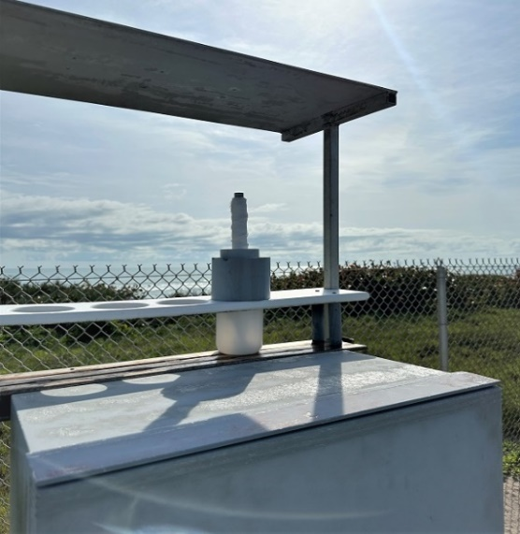
Atlantic Ocean
Wet Candle
Figure 1: Example of wet candles exposed to KSC atmospheric conditions and used to measure chloride concentration per month.

Preparation and Exposure of Corrosion Rate Samples

Corrosion rates at NASA KSC were measured using carbon steel panels as calibration coupons. 1010 steel (UNS 10100) panels, sized 10 x 15.25 x cm (4 x 6 in), were placed at 30-degree angles towards the Atlantic Ocean at varying locations across NASA KSC. The panels were placed out monthly or quarterly depending on location and exposed for one year. The corrosion products were removed using aluminum oxide blast media, as this method has been found to be sufficient to remove corrosion products while only removing a statistically insignificant amount of base metal. The data was normalized as corrosion rates per year per standard ASTM⁽⁾ G1⁷ as a function of time in which the month they were captured and measured for mass loss after total exposure to be compared to their initial weights. This difference in mass was then converted using each sample’s area, density and duration of exposure to determine yearly corrosion rates.

Atmospheric Test Sites

The various corrosion test sites across NASA KSC serve to record the general corrosivity of key locations for crucial ground and flight hardware and to provide an understanding of the seasonal atmospheric affects. The test sites each have at least one corrosion rate rack and one wet candle exposed to the environment. A map that shows the location of each test site and photograph examples of select sites are shown in Figures 2 and 3. The test sites are described in Table 1 by location, distance from the Atlantic Ocean, and general conditions tested. Some sites have corrosion rate samples that are exposed to the environment and also versions that are partially covered in an uncontrolled environment. The Vehicle Assembly Building (VAB) location is considered an uncontrolled environment and is periodically open to the environment.

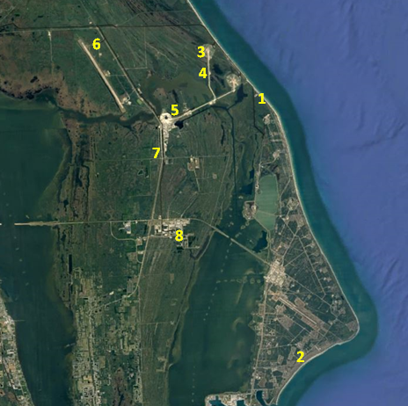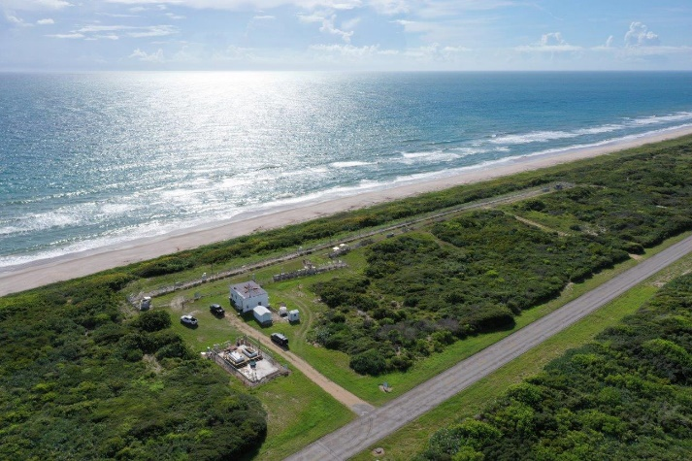
Location of corrosion rate panels and wet candles.
Figure 2: Overall map of NASA KSC Remote Atmospheric Test Site locations (left) and the Beachside Atmospheric Corrosion Test Site (right).

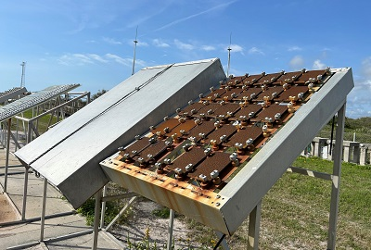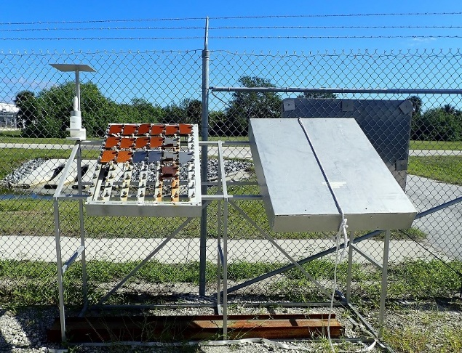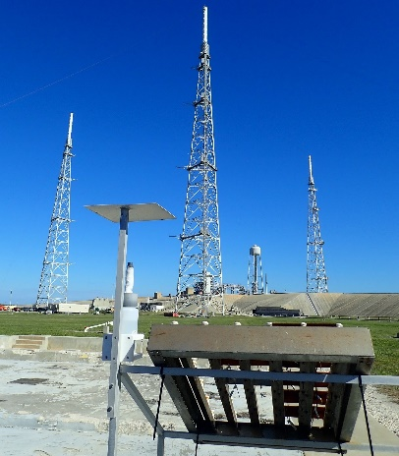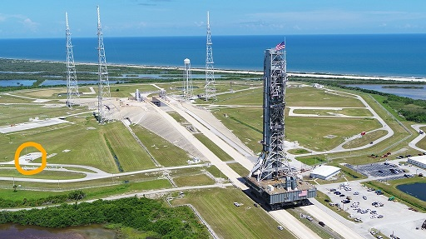
Figure 3: Examples of corrosion rate panels and wet candle set-ups at NASA KSC test sites, including the Beachside Atmospheric Corrosion Test Site (upper left), LEFT (upper right with covered and uncovered), and overview and close-up views of the LC-39B site (bottom).

Table 1
Test Sites Monitored for Corrosion Rate and Chloride Concentration by NASA KSC.
Site Designation | Location/Name | Distance from Atlantic Ocean | Conditions Tested
1 - KSC Beach | Beachside Atmospheric Corrosion Test Site | 45 meters (150 feet) | Marine, fully exposed and partially covered
2 - ARL CCSFS | Army Research Lab (ARL) site at Cape Canaveral Space Force Station (CCSFS) | 183 meters (602 feet) | Marine, fully exposed
3 - LC-39B | Launch Complex 39B, (LC-39B) | 1207 meters (0.75 miles) | Marine, fully exposed and partially covered
4 - Crawlerway | Crawlerway at LC-39B | 2012 meters (1.25 miles) | Coastal, fully exposed
5 - VAB | Vehicle Assembly Building (VAB) | 5632 meters (3.5 miles) | Uncontrolled interior, intermittently exposed to environment
6 - Doppler | Tropospheric Doppler Radar Wind Profiler (TDRWP) | 6920 meters (4.3 miles) | Coastal, fully exposed and partially covered
7 - Schwartz | Schwartz Rd, location not impeded by vegetation | 8046 meters (5.0 miles) | Coastal, fully exposed
8 - LETF | Launch Equipment Test Facility (LETF) | 8046 meters (5.0 miles) | Coastal, fully exposed and partially covered, industrial

RESULTS AND DISCUSSION

Chloride Concentration of All Test Sites

Beachside Atmospheric Corrosion Test Site.

The average monthly chloride concentration at the KSC beachside atmospheric site, shown in Figure 4, was measured during an exposure period from May 2010 through June 2022. Overall, the chloride deposition is considered high when rated using criteria from the ISO 9223⁹ standard, where the highest average level of chloride deposition is related to a deposition rate of between 300 and 1500mg/m²d. The overall range of chloride deposition rate at the KSC beachside atmospheric site was recorded with ranges between 50 and 7300mg/m²d, with a yearly weighted mean value of 982mg/m²d. The repeat pattern of seasonal changes with relation to dew point and time of wetness was observed throughout the duration of the exposure. Chloride data was consistently recorded to be much higher in the December-March timeframe correlating to the lower average ambient temperatures in the winter months that increase the daily time of wetness of the candle wicks during exposure. The sample locations, in relation to their distance from the Atlantic coast and KSC’s environmental location, follow typical coastal Florida weather patterns, where the average temperature is high and does not fluctuate significantly. Most months of the year having consistently high average temperatures that correlate to lower recorded chloride rates during those months.

As shown in Figure 4, chloride concentration values tend to be highest in the late fall and winter months, also coinciding to when wave heights are known to be higher.¹¹ The relationship between wave height and concentration of marine aerosols was compared to assess its correlation to chloride concentration. Increased wave height is generally related to an increase in chlorides in the air. Bubbles created from increased wave action are the main generator of marine aerosols and are generally directly related to wave height^{12,13}. Wave height values were measured from a weather buoy, buoy #41009, off the coast of Cape Canaveral that is funded by NASA and operated by the NOAA National Data Buoy Center.¹⁰ This buoy is approximately twenty-five miles from the wet candles located at the Beachside Atmospheric Corrosion Test Site. The average monthly wave height data over a period of ten years was extracted from the database website and compared to the seasonality of the measured chloride concentrations to verify their general relationship. The average monthly wave height recorded across 12 years through May 2010 - August 2022 and was plotted along with to the average monthly chloride rate. The comparison in Figure 5 shows that higher wave heights directly relate to a corresponding increase in chloride concentration values, assuming no major weather events. The similarity in distribution of data seen in the Figure 5 below correlates to a direct relationship between wave height and chloride concentration values.

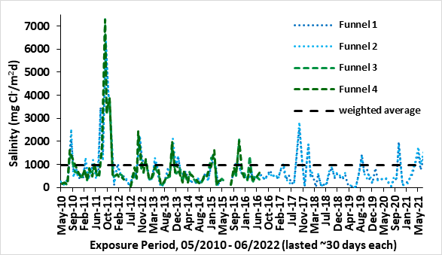
Figure 4: Chloride concentration as a function of exposure period, obtained using wet candles exposed at the NASA KSC Beachside Atmospheric Corrosion Test Site.

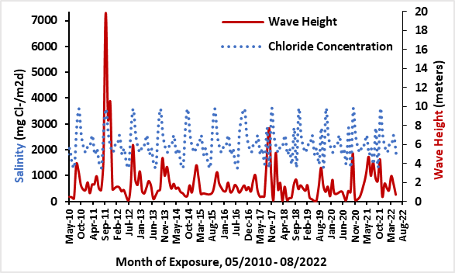
Figure 5: Wave Height recorded from NOAA Buoy Center Station 41009 in comparison to chloride concentration recorded at the KSC Beachside Atmospheric Corrosion Test Site.

KSC Remote Atmospheric Test Sites

Chloride concentration was measured as a function of distance from the Atlantic Ocean using data from the remote atmospheric test sites at KSC, Figure 6. The sites were selected due to their distance from the Atlantic Ocean and proximity to critical flight hardware when exposed in the environment for long periods of time before launch. Sites closer to the Atlantic Ocean produced higher readings in comparison to sites located farther from the ocean, which is an expected result. Each site’s overall weighted average is included on the graph to represent the representative average recorded throughout the duration of the study. The overall seasonality trends relating to chloride concentrations were also consistent at the supplemental sites.

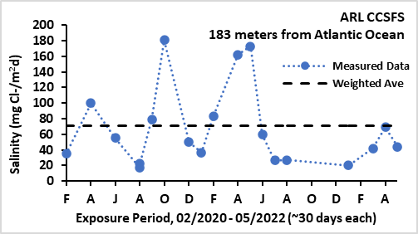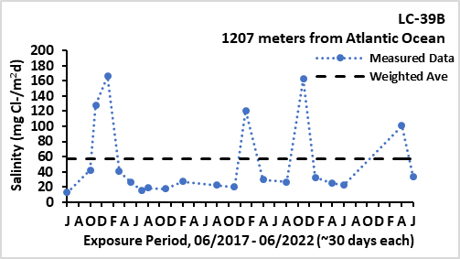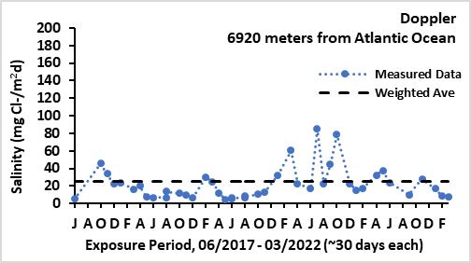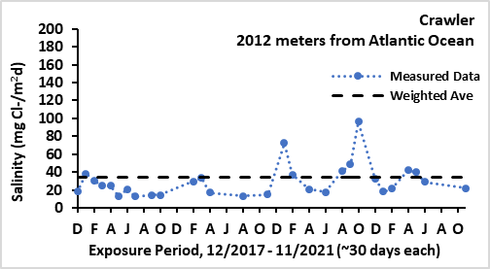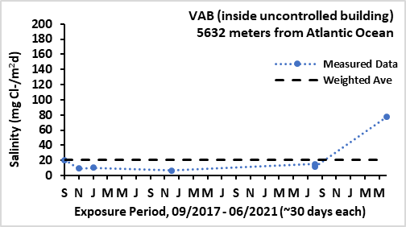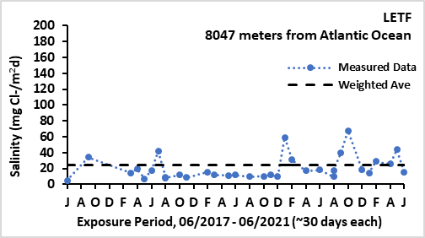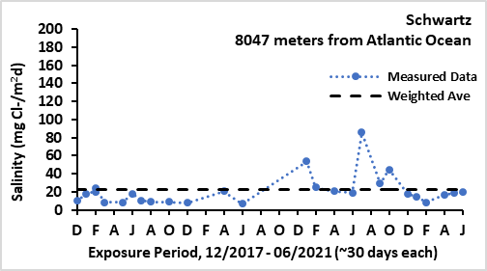
Figure 6: Chloride concentration as a function of exposure period, obtained using wet candles exposed at NASA KSC’s Remote Atmospheric Test Sites.

Chloride Concentration as a Function of Distance from the Atlantic Ocean

Figure 7 demonstrates the relationship between chloride concentration and distance from the Atlantic Ocean. The weighted averages for chloride concentrations at each site, calculated over the entirety of their exposure duration, were used to represent the average lifetime chloride concentration values for each site. These measurements were then correlated to each sites’ distance from the Atlantic Ocean. Though this data is the weighted average of the measured chloride concentration distributions that can be expected in relation to the distance from the Atlantic Ocean, the values may differ based on the time of year due to seasonality changes. Overall, the measurements shown in Figure 7 can be used to predict long term salinity exposure rates when assessing risk factors impacted by environmental exposure. The highest chloride concentrations were recorded at the Beachside Atmospheric Corrosion Test Site, located only 45 meters from the Atlantic Ocean, whereas the lowest values recorded were recorded at sites farthest away from Atlantic Ocean. There is a dramatic drop in average salinity noted between the Beachside (45 meters from ocean) and ARL (186 meters from ocean) sites. This large decrease in chloride concentration due to both the distance from the ocean and also likely due, in part, to the environmental factors between the two sites. The KSC Beachside site has a relatively direct proximity to the ocean with only sea grape bushes intermittently blocking some exposure, whereas the ARL site location is set farther back from the shore and impacted by shielding vegetation. The corresponding transportation of marine aerosol salt deposits that can reach the ARL location is likely much lower.

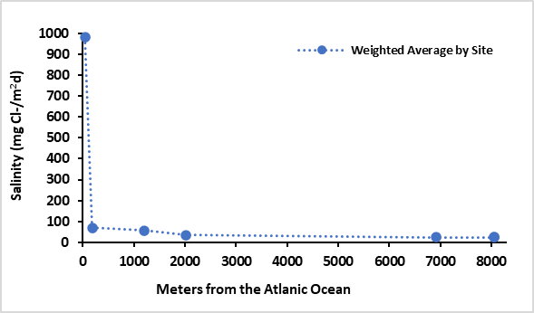
Figure 7: Chloride concentration as a function of distance from the Atlantic Ocean based on all NASA KSC site locations.

Corrosion Rate of All Test Sites

Beachside Atmospheric Corrosion Test Site

The corrosion rates of panels exposed at the KSC Beachside Atmospheric Corrosion Test Site are somewhat variable and dependent on seasonal weather conditions. Figure 8 shows corrosion rate data for panels from initial exposure dates of April 1975 through February 1977 and then from November 2010 through April 2022. Panels were exposed each month for one year, and seasonal changes that influence corrosion rate are evident. The most notable influence is that panels initially exposed from April through July tend to have an overall lower corrosion rate when compared to those exposed during the rest of the year, with exceptions for years during when major storms occurred. Corrosion rates tend to be highest in the winter months due to the longer time of wetness. The panels remain wetter longer due to relatively lower temperatures causing moisture from condensation to remain on the samples before it is evaporated by the rise in temperatures throughout the day¹⁰⁻¹⁶ . Winter months also tend to have higher winds and wave action and therefore transfer more aerosol salts that collect on the surfaces of the samples in those months. During typical weather patterns, winter is also a dryer season, thus resulting in less salts that are rinsed off by precipitation compared to summer months. Typically, average seasonal variations remain similar, but the intensity and duration of certain weather events vary because, for example, inclement weather storms and their corresponding rain and wind patterns can be similar or can differ from one year to the next. An average corrosion rate for 1010 steel panels at the Beachside Atmospheric Corrosion Test Site is difficult to define by one value without considering other seasonal characteristics of the exposure site, therefore a range is more realistic. The corrosion rates measured at the site during the study vary from 0.127 mm/y to 0.51 mm/y (5.0 to 20.0 mpy), with a weighted average of 0.28 mm/y (11.0 mpy).

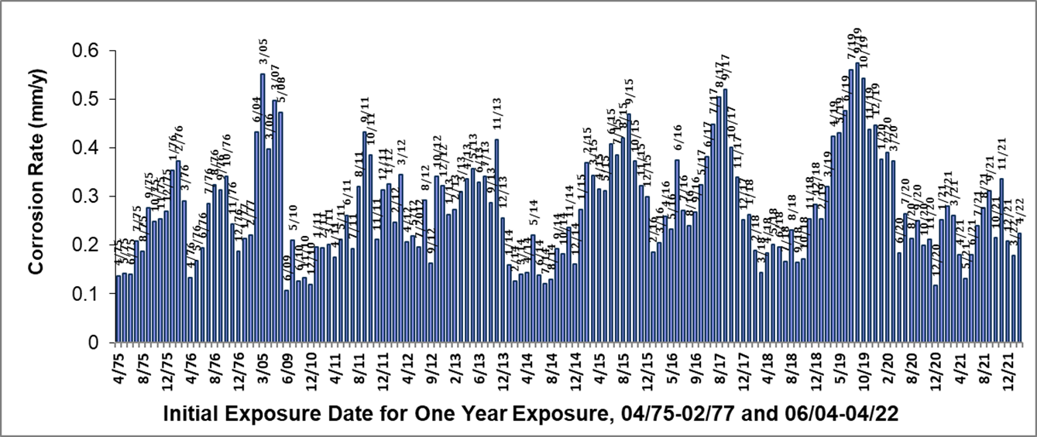
Figure 8: Corrosion rate as a function of exposure period, obtained using steel panels exposed at the NASA KSC Beachside Atmospheric Corrosion Test Site.

KSC Remote Atmospheric Test Sites

Corrosion rates were measured across a function of distance from the Atlantic Ocean in parallel to the locations of chloride candle sites, as outlined in Table 1 and Figure 2. Several sites deployed both covered and uncovered sets of samples, and these two groupings of measurements are separated below with Figure 9 representing the uncovered sample set and Figure 10 representing the covered sample set. The covered samples had an expected lower average corrosion rate as compared to the uncovered samples because the samples are shielded on three sides from precipitation and wind. The way the metal shield lying over the samples possibility could have influenced the overall surface and internal temperature of the samples throughout the day because the samples were protected from direct contact with UV from the sun.

This data set, shown in Figure 9 and 10, shows the measured corrosion rate distributions that can be expected in relation to the distance from the ocean. The data varies seasonally, as expected, with values decreasing as distance from the ocean increases. The largest noticeable difference in corrosion rate observed between the covered and uncovered samples was shown between the test sets exposed at the KSC Beach site located 45 meters from the Atlantic Ocean. In comparison, the other remote atmospheric test sites located more inland did not have nearly as much of a mentionable difference between the covered and uncovered samples. Noted, the Doppler site, located almost 7000 meters from the ocean, consistently had slightly higher corrosion rates than its sister sites located at 186 meters (ARL) and 2012 meters (LC-39B). This is likely due in part to its environmental location being very exposed with low vegetation and little to no impedance. Overall, there is statistically insignificant differences between the corrosion rates at the remote atmospheric test sites.

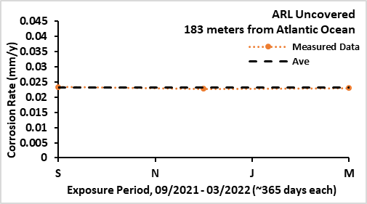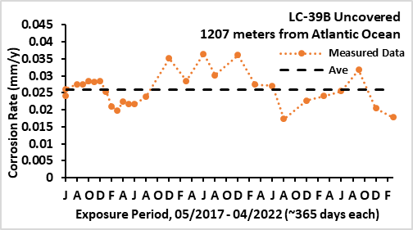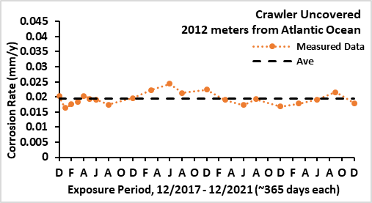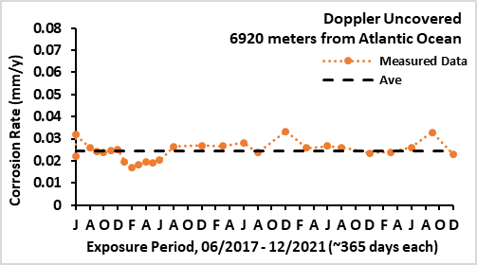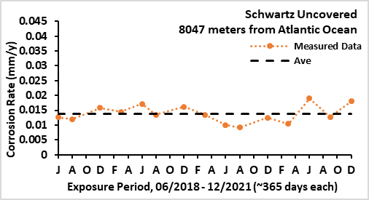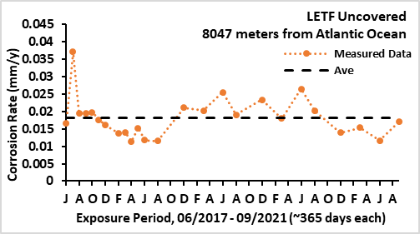
Figure 9: Corrosion rate as a function of exposure period, obtained using steel panels uncovered and exposed at NASA KSC’s Remote Atmospheric Test Sites.

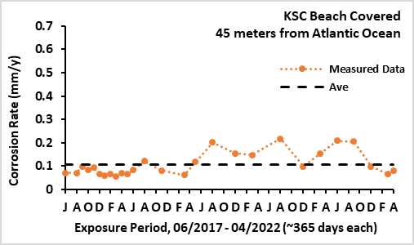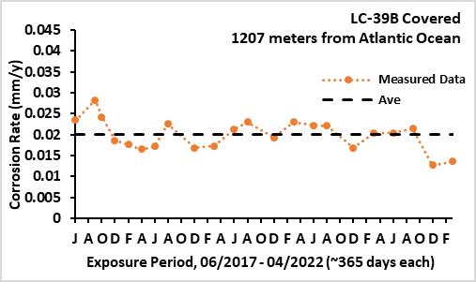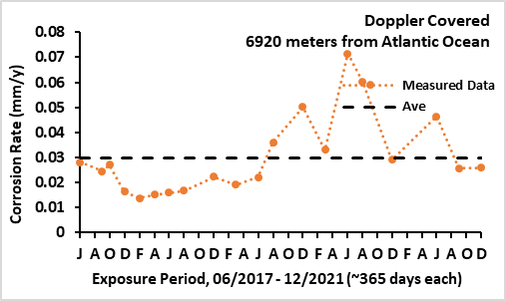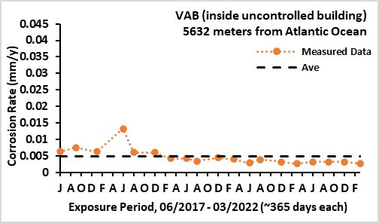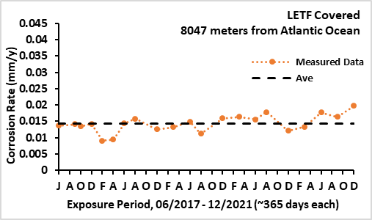
Figure 10: Corrosion Rate as a function of exposure period, obtained using steel panels covered and exposed at NASA KSC’s Remote Atmospheric Test Sites.

Corrosion Rate as a Function of Distance from the Atlantic Ocean

The graphs in Figures 11 and 12 show the relationship between the average corrosion rate at each site over their lifetime of exposure and the resulting effect from distance from the Atlantic Ocean for each of the uncovered and covered conditions. As expected, the highest corrosion rate was recorded at the KSC Beachside Atmospheric Corrosion Test Site and then corrosion rates decrease drastically for the remote sites. The differences between the corrosion rates for the remote atmospheric test sites are nominal. The corrosion rate values for the covered sample sets were typically reduced by a factor of three at the Beachside site and only slightly decreased at the remote atmospheric test sites.

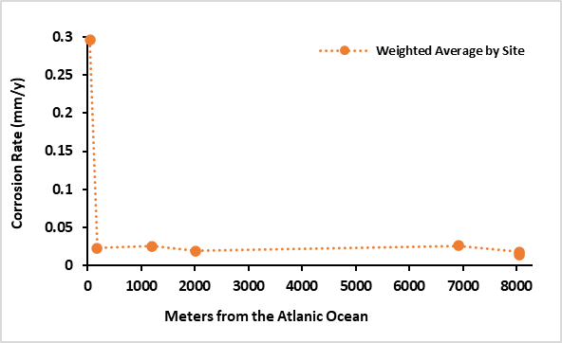
Figure 11: Corrosion rate as a function of distance from the Atlantic Ocean for the uncovered site locations.

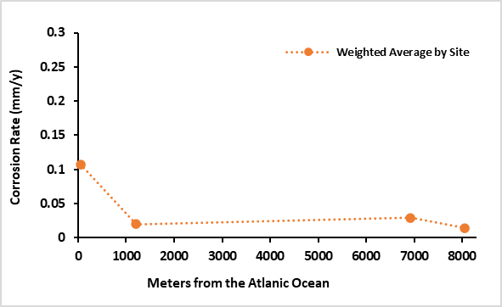
Figure 12: Corrosion rate as a function of distance from the Atlantic Ocean for the covered site locations.

Comparing Chloride Concentration and Corrosion Rate

Data comparing the chloride concentration and corrosion rate values at the KSC Atmospheric Corrosion Test Site are shown, Figure 13, where the seasonal changes demonstrated the same overall trend of increased values in the winter months. This correlation of data demonstrates a direct relationship between corrosion rate and chloride concentration. When considering seasonal changes, if salinity recordings at a given location are found to be high, it could be inferred that corresponding corrosion rates found at the site will be high as well, and vice versa. This conclusion is generally accepted in the corrosion community but also restated in this paper to reinforce the seasonal relationship.

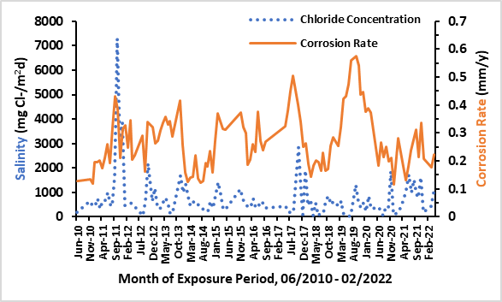
Figure 13: Comparison of chloride concentration and corrosion rate values at the KSC Beachside Atmospheric Corrosion Test Site as a function of time.

The overall relationship between the three parameters, salinity, corrosion rate, and distance from the Atlantic Ocean follow the same trends, Figure 14. Tables 2 and 3 provide numerical values for salinity and corrosion rate for uncovered and covered corrosion rate panels correspondingly. The values for salinity and corrosion rate are significantly higher at the Beachside site compared to the remaining sites. The remote atmospheric test sites have nearly the same values as a function of distance from the Atlantic Ocean, though differences may become relevant depending on operations occurring at each location. The intent of this data is to provide users with useful metrics for materials and systems performance for expected and unexpected exposures to the direct marine environment.

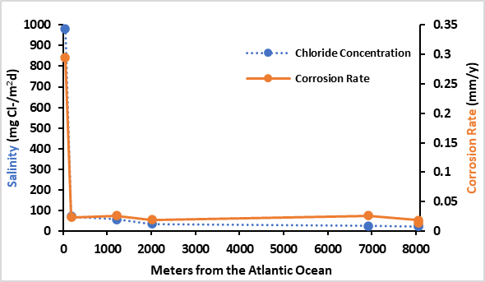
Figure 14: Combined chloride concentration and corrosion rate values as a function of distance from the Atlantic Ocean.

Table 2
Numerical Data for Corrosion Rate and Chloride Concentration as a Function of Distance from the Atlantic Ocean, Uncovered Exposure for Corrosion Rates.
Site | Distance from the Atlantic Ocean, meters (feet or miles) | Corrosion Rate for Uncovered Samples  mm/y (mpy) | Chloride Concentration (mg Cl-/m²d)
KSC Beach | 45 (150 feet) | 0.295 (11.6) | 982
ARL CCSFS | 183 (602 feet) | 0.023 (0.91) | 70.6
LC-39B | 1207 (0.75 miles) | 0.026 (1.02) | 57.1
Crawler | 2012 (1.25 miles) | 0.019 (0.76) | 34.5
Doppler | 6920 (4.3 miles) | 0.026 (1.04) | 24.9
Schwartz | 8047 (5 miles) | 0.014 (0.54) | 23.1
LETF | 8047 (5 miles) | 0.018 (0.72) | 23.9

Table 3
Numerical Data for Corrosion Rate and Chloride Concentration as a Function of Distance from the Atlantic Ocean, Covered Exposure for Corrosion Rates.
Site | Distance from the Atlantic Ocean, meters (feet or miles) | Corrosion Rate for Covered Samples  mm/y (mpy) | Chloride Concentration (mg Cl-/m²d)
KSC Beach | 45 (150 feet) | 0.295 (11.6) | 982
LC-39B | 1207 (0.75 miles) | 0.026 (1.02) | 57.1
VAB | 5632 meters (3.5 miles) | 0.005 (0.02) | 20.7
Doppler | 6920 (4.3 miles) | 0.026 (1.04) | 24.9
LETF | 8047 (5 miles) | 0.018 (0.72) | 23.9

CONCLUSIONS

The distance from the ocean and seasonal effects influence corrosion and chloride concentration values. The values should be considered for planning risk assessments for launch and other spaceport operations. Salinity and mass loss levels have a direct relationship to one another and may be used to predict the other once numerical values are understood. This paper provides the numerical values for corrosion rate and salinity and their corresponding seasonal ranges as a function of distance from the Atlantic Ocean to be used as a standard data set in the future.

ACKNOWLEDGEMENTS

Special thanks to the NASA KSC Corrosion Engineering Laboratory team for their technical support: Jerome Curran, Mark Kolody, Teddy Back, and Melanie Speaks.

REFERENCES

- Report MTB 099-74, “Report on the Relative Corrosivity of Atmospheres at Various Distances from the Seacoast” (NASA-Kennedy Space Center, 1980)
- E.L. Montgomery, L.M. Calle, J.P Curran, and M.R. Kolody, “Timescale Correlation between Marine Atmospheric Exposure and Accelerated Corrosion Testing – an Update,” Department of Defense Corrosion Conference 2011, (La Quinta, CA, July 31- August 5, 2011), paper and presentation.
- E.L. Montgomery, J.P. Curran, M.R. Kolody, and L.M. Calle, “Timescale Correlation between Marine Atmospheric Exposure and Accelerated Corrosion Testing,” NACE International Corrosion 2011, (Houston, TX, March 13-17, 2011), paper and presentation.
- E.L. Montgomery, J.P. Curran, M.R. Kolody, and L.M. Calle, “Timescale Correlation between Marine Atmospheric Exposure and Accelerated Corrosion Testing – Part 2,” NACE International Corrosion 2011, (Houston, TX, March 13-17, 2011), paper and presentation.
- ASTM G1 (latest revision), "Standard Practice for Preparing, Cleaning, and Evaluating Corrosion Test Specimens" (West Conshohocken, PA, ASTM).
- ISO-9225 (latest revision), “Corrosion of Metals and Alloys - Corrosivity of Atmospheres - Measurement of Pollution” (Geneve, Switzerland ISO).
- EPA Method 9212 (latest revision), “Potentiometric Determination of Chloride in Aqueous Samples with Ion-Selective Electrode” (Washington, DC, Environmental Protection Agency)
- NASA-STD-6012 (latest revison), “Corrosion Protection for Space Flight Hardware” (Washington, DC, NASA Headquarters).
- ISO-9223 (latest revision), “Corrosion of Metal and Alloys, Corrosivity of Atmospheres – Classification”, (Geneve, Switzerland, ISO).
- Station 41009 – Climatic Summary plots for significant wave height, National Oceanic and Atmospheric Administration, National Data Buoy Center, http://www.ndbc.noaa.gov/view_climplot.php?station=41009&meas=wh
- A. Clarke, V. Kapustin, S. Howell, K. Moore, B. Lienert, S. masonis, T. Anderson, D. Covert, “Sea-Salt Size Distributions from Breaking Waves: Implications for Marine Aerosol Production and Optical Extinction Measurements during SEAS”, Journal of Atmospheric and Oceanic Technology 20 (2003): pp. 1362-1374.
- M.E.R. Gustafsson and L.G. Franzen, “Inland Transport of Marine Aerosols in Southern Sweden,” Atmospheric Environments 34 (2000): pp. 313–325.
- S.R. Massel, “Ocean Waves Breaking and Marine Aerosol Fluxes,” Atmospheric and Oceanographic Sciences Library Volume 38 (2007): pp. 207-228.
- Y. Ma, Y. Li , F. Wang, “The Atmospheric Corrosion Kinetics of Low Carbon Steel in a Tropical Marine Environment”, Corrosion Science Vol. 52 (2007): pp. 1796.
- Y. Ma, Y. Li, F. Wang, “Corrosion of Low Carbon Steel in Atmospheric Environments of Different Chloride Content”, Corrosion Science Vol. 51 (2009): pp. 997.
- J.G. Castaño, C.A. Botero, A.H. Restrepo, E.A. Agudelo, E. Correa, F. Echeverría, “Atmospheric Corrosion of Carbon Steel in Colombia”, Corrosion Science Vol. 52 (2010): pp. 216.
- S. Feliu, M. Morcillo, B. Chico, “Effect of Distance from Sea on Atmospheric Corrosion Rate”, Corrosion Vol. 55, 9 (1999): pp. 883.
- J. Morales, S. Martı´n-Krijer, F. Dı´az, “Atmospheric Corrosion in Subtropical Areas: Influences of Time of Wetness and Deficiency of the ISO 9223 Norm”, Corrosion Science Vol. 47 (2005): pp. 2005.
- S. Coburn, “Atmospheric Corrosion Properties and Selection, Carbon Steels”, Metals Handbook, Metals Park, American Society for Metals (1978): pp. 720.
- T.E. Graedel, R.P. Frankenthal, “Corrosion Mechanisms for Iron and Low Alloy Steels Exposed to the Atmosphere”, Journal of the Electrochemical Society Vol. 137, 8 (1990): pp. 2385.

⁽⁾ National Aeronautics and Space Agency J.F Kennedy Space Center, Kennedy Space Center, FL 32899.
⁽⁾ International Organization for Standardization, Geneva, Switzerland.
⁽⁾ Environmental Protection Agency, Pennsylvania Avenue NW, Washington, DC 20004.
⁽⁾ ASTM International, West Conshohocken, PA
⁽⁾ International Organization for Standardization, Geneva, Switzerland.
⁽⁾ National Oceanic and Atmospheric Administration

