FRONT MATTER

Title
Invasion in the Niger Delta: Remote sensing of mangrove conversion to invasive Nypa fruticans from 2015-2020

Authors
Abigail Barenblitt^{1,2*}; Lola Fatoyinbo²; Nathan Thomas^{1,2}; Atticus Stovall^{2,3}; Celio de Sousa^{2,4}; Chukwuebuka Nwobi⁵, Laura Duncanson⁶
Affiliations
¹ ﻿Earth System Science Interdisciplinary Center, University of Maryland, College Park, MD, United States
² ﻿Biospheric Sciences Laboratory, NASA Goddard Space Flight Center, Greenbelt, MD, United States
³ Geographical Sciences Department, University of Maryland, College Park, MD, United States
⁴ University of Maryland, Baltimore County, Baltimore, MD, United States
⁵ ﻿School of GeoSciences, University of Edinburgh, Edinburgh EH9 3FF, UK
⁶ Geographical Sciences Department, University of Maryland, College Park, MD, United States
*Corresponding author. Email: abarenbl@umd.edu
Abstract

Invasive species are a leading threat to biodiversity worldwide. Nypa palm (Nypa fruticans) has emerged as the predominant invasive species in the Niger Delta region of Nigeria. While endemic mangroves have high rates of carbon sequestration, stabilize coastlines, and protect biodiversity, Nypa does not provide these services outside its native region of Southeast Asia. Oil exploration and urbanization in this region also exacerbates mangrove loss and Nypa spread. As Nypa is difficult to distinguish from endemic mangrove species in remotely sensed data, estimates of mangrove and ecosystem services losses in Nigeria are highly uncertain. Here, we analyze multisensor satellite data with machine learning to quantify the rapid expansion of Nypa from 2015-2020 in Nigeria. Using Landsat imagery and random forest classification, we quantify total potential Nypa extent in Nigeria in 2019. We then produced a Nypa extent map using iterative combinations of Sentinel-1 SAR, Sentinel-2 MSI, and ALOS PALSAR. Random forest classifications using SAR data from ALOS and Sentinel-1 were best suited for mapping Nypa extent with similar accuracies (78% and 75% respectively). Based on data availability and accuracy, we focused our change analysis on Sentinel-1 SAR. Our results show ~28,000 ha of mangroves were converted to Nypa in Nigeria by 2020 and covered a larger extent than endemic mangroves, compounding the effect of the existing degradation and deforestation in the region. We also compared forest height and complexity estimates from GEDI (Global Ecosystem Dynamics Investigation) LiDAR to further distinguish between endemic mangroves and Nypa in three dimensions. Nypa structural variability, measured by top-of-canopy height, vegetation cover, plant area index, and foliage height diversity, was lower than that of mangroves. At current rates of Nypa expansion, the entire area of study would be invaded by Nypa by 2028, with potentially detrimental consequences to the ecosystem services provided by mangroves.

MAIN TEXT

- Introduction

1.1 Nigeria's Mangroves
In 2015, the United Nations established a set of 17 Sustainable Development Goals (SDGs), including the Protection of Life on Land (SDG 15) and Climate Action (SDG 13) [1]. The protection and monitoring of mangrove habitats is critical to meeting these goals, as well as other metrics for reduction of deforestation and climate change (eg. the UN Framework Convention on Climate Change (UNFCCC) Conference of the Parties (COP26)). Globally, half of all mangrove forests have been lost since the mid-20th century [2]. Mangroves support a wide number of ecosystem services, as well as several of the indicators needed to achieve the SDGs. They are critical for the storage of blue carbon, or coastal-related carbon, and are among the most carbon-rich tropical forests of the world [3]. Indeed, mangrove forests have been shown to store more carbon than any other terrestrial ecosystem and therefore their loss releases more carbon into the atmosphere when deforested [3,4]. Mangroves also serve as natural nurseries, providing habitat for over 3000 terrestrial and aquatic species, and are the center of sensitive, complex ecosystems vital for fishing industries and income [5,6]. Additionally, mangroves stabilize coastlines against erosion and support local economies [5].
Nigeria is home to the largest continuous mangrove system in the world in the Niger Delta [7,8]. This ecosystem is considered one of the richest wetlands in terms of biodiversity worldwide [9,10], providing habitat for endangered species like red colobus monkeys (Procolobus badius), Sclaters' geunon (Cercopithecus sclateri) and Heslop's pygmy hippotamus (Choeropsis liberiensis) [7]. However, Nigeria’s mangroves are considered to be the most exploited in the world [10]; indeed, Nigeria’s mangroves have been heavily degraded by oil pollution, aquaculture conversion, road construction, and cutting [7]. This has led to the conversion of high-density patches to low-density patches for the last 20 years [11,12]. The mangroves of Nigeria are considered to be critically endangered by the World Wide Fund for Nature [5]. Along with the impact to biodiversity and carbon storage as a result of mangrove loss, it is estimated that climate change impacts will be more severe in this region as ecological, socio-economic, and adaptive ecosystem services of mangroves are lost [13].
While some mangrove loss is attributable to urban development and oil exploration, which is common in the region [14], a major threat to this ecosystem is the spread of invasive Nypa Palm (Nypa fruticans, hereafter Nypa). The introduction of invasive species is one the biggest threats to biodiversity globally, and are exacerbated by anthropogenic activities, such as urbanization [15,16]. In Nigeria, Nypa has been replacing mangroves [17] since their introduction as a crop to Calabar, Nigeria, in 1906 from Singapore [18]. These mangrove associates were initially planted as a cheap source of thatching and as a method for curbing coastal erosion [19,20]. However, this plant not only spreads rapidly— out-pacing mangrove growth rates over the last 30 years [21]—but is not used by local populations, and has been shown to lead to greater erosion than replaced mangrove stands [22].
Nypa now occurs along the coasts of Bayelsa, Akwa Ibom and Cross Rivers states [23,24] and has been linked to mangrove loss in the Niger Delta and Calabar Estuary [25]. Its growth pattern, which suppresses the growth of native mangroves, allows it to occupy space left behind by native mangrove species, such as Rhizophora sp [21,26] after degradation or cutting for timber. Its buoyant seeds also invade the same territory in which mangroves are found, outcompete mangroves with their rapid growth patterns, and disperse without competition in degraded ecosystems due to their ability to survive where mangroves cannot [21]. Nypa can alter soil nutrient composition, hydrology and landscape architecture [21], and does not provide the same ecological services as mangroves [27]. For example, unlike native mangroves, Nypa is branchless and has low litterfall, which reduces nesting sites for coastal bird species and impedes nutrient cycling [21].
Not only does Nypa encroachment degrade natural ecosystems, but it can also impact local economies and livelihoods. Invasions of Nypa remove economically important mangrove species, which provide poles, fuelwood and tannins [28]. Mangroves support important fisheries, which yield both fish and crustaceans like shrimp for human consumption, as well as wood production [29]. Once Nypa invades a mangrove forest, fishes that would normally breed in those areas disappear [30]. In areas of Nypa, studies have identified few incidences of native shellfish like burrowing crabs [29]. Additionally, floating masses of Nypa can destroy and reduce the economic viability of fisheries by destroying nets and obstructing waterways [21,29]. Due to these blockages, areas invaded by Nypa are sometimes filled with sand, leading to more habitat loss [21].
Exacerbating this pattern is the vulnerability of disturbed ecosystems. The high volume of oil and gas exploration and spillage in the Niger Delta leads to declining mangroves and increased dispersal of Nypa [31]. Additionally, rapid urban expansion has occurred around the city of Port Harcourt, an urbanized area in the southeastern region of the Nigeria’s mangrove forests [32]. Urbanization is a major threat to biodiversity in the region and is one of the largest contributors to the spread of invasives, as it degrades an already fragile ecosystem and creates room for invasive Nypa [33]. Previous studies have shown that Nypa seedlings survive longer than mangrove seedlings when planted on polluted mangrove soil [34]. Therefore, as degradation from oil exploration and urbanization increase, habitat becomes more viable for Nypa and less viable for important, native mangrove species.
Monitoring the extent of invasive plants like Nypa can be a key technique for controlling them [35]. Satellite observations have already been used for a number of studies regarding the monitoring of SDGs [36], mangrove extent and loss [37], and invasive species [24,38,39]. While the remote sensing of specific mangrove species and their associates can prove difficult, previous work has demonstrated the capability of satellite imagery for mapping invasive species [40]. For example, previous studies have successfully utilized Sentinel-2 MSI (Multi Spectral Instrument) and Sentinel-1 SAR (Synthetic Aperture Radar) data to map the extent of other invasive species like American Bramble [38,39].
Nypa is spectrally similar to mangrove forests, but occurs as thin fringes, growing in patches with uniform height and composition when compared to mangroves alongside different structural components, and may therefore be discernible using a combination of optical and SAR data [24,41]. Previous work on Nypa extent used ALOS-2 PALSAR-2 (Advanced Land Observing Satellite-2 Phased-Array L-band Synthetic Aperture Radar-2), Landsat, and SRTM (Shuttle Radar Topography Mission) to quantify Nypa expansion [24]. This previous work had a high accuracy overall, but a lower accuracy for Nypa identification. Here we aim to improve the detection of Nypa in Nigeria using combinations of multiple spaceborne sensors–especially combinations of active SAR (ALOS, Sentinel 1) and LiDAR (GEDI) data, as well as passive optical data (S2 and Landsat).

- Materials and Methods

2.1 Experimental Design
Here, we explore the use of four satellite sensors—Landsat 8 OLI, Sentinel-1 SAR, Sentinel-2 MSI, and ALOS-2 PALSAR-2—to determine their efficacy in measuring the extent of Nypa in Nigeria in 2020. We build on previous work ([24]) to analyze multiple datasets as well as timesteps (2015-2020) to explore the rate of Nypa expansion in the region. Finally, we evaluate the use of lidar canopy height metrics from GEDI (Global Ecosystem Dynamics Investigation) data to contrast the structural complexity of endemic mangroves and invasive Nypa, and infer how the spread of Nypa affects structural aspects of biodiversity. Details for the workflow of analysis can be found in Figure 1.

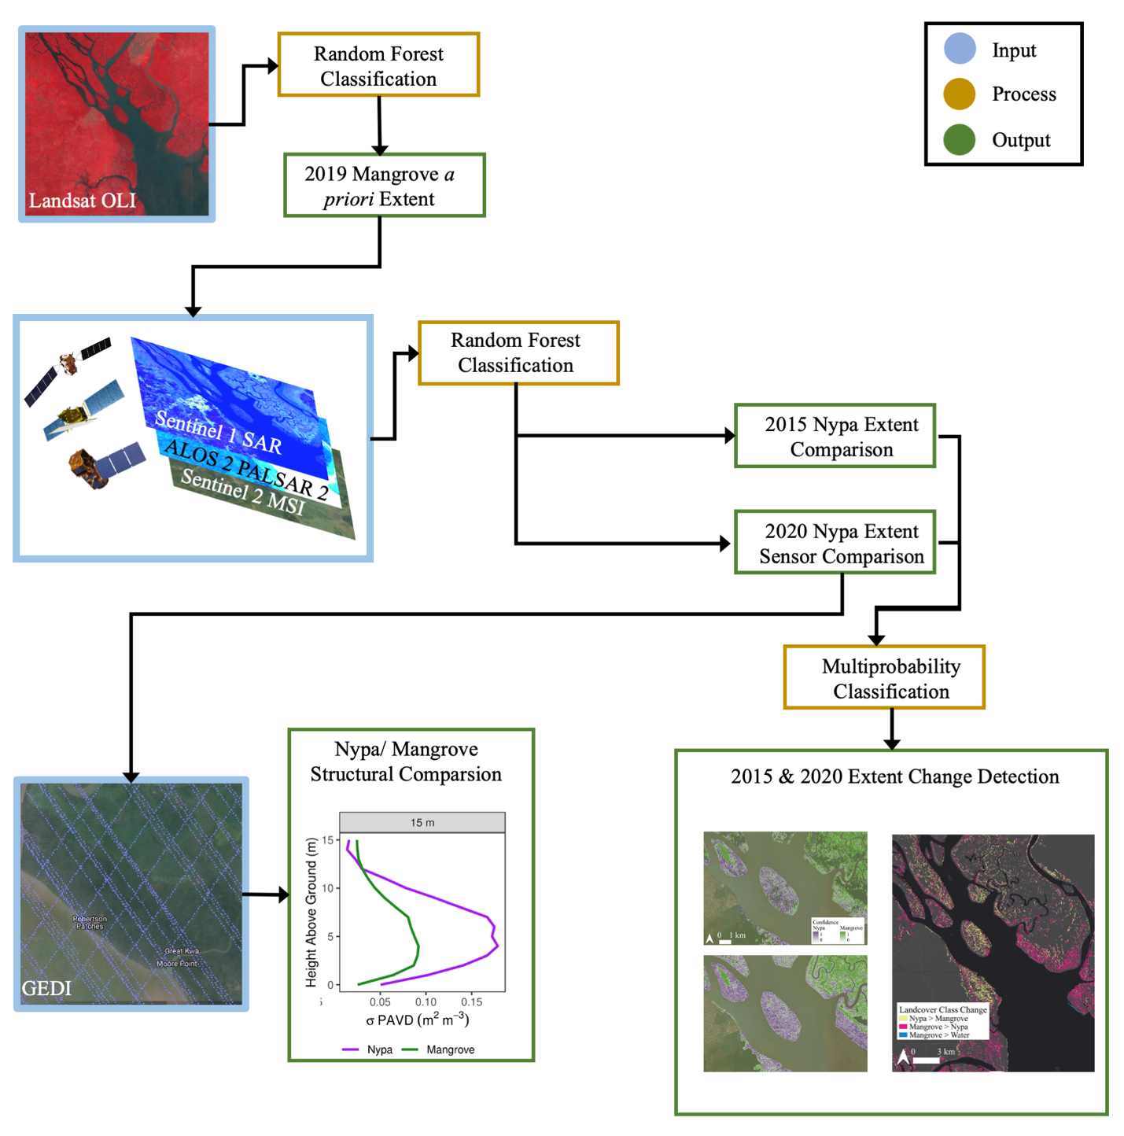
Figure 1. Workflow of experiment design. Blue boxes indicate inputs, gold indicates process, green indicates output. Iterative random forest classifications were used to map Nypa potential, and then change in Nypa extent. Finally, GEDI observations over the study area were used to compare structural diversity in mangroves and Nypa.
Nigeria's coast is largely characterized by wetlands and mangroves. Urbanization and oil exploration has increased the human footprint in recent years, leading to extensive losses of mangroves, other forests and wetlands [7,8]. Ecological zones within this region include seasonal rainforests, sandy coastal ridge, freshwater swamp forests and saline mangroves [42,43]. The study area was restricted to the southeastern region of the Niger Delta, within the states of Cross River, Akwa Ibom, and Rivers, as well as the Calabar Estuary following previous work by Nwobi et al., 2020 [24], which identified 90% of Nypa occurring in this area (Figure 2).
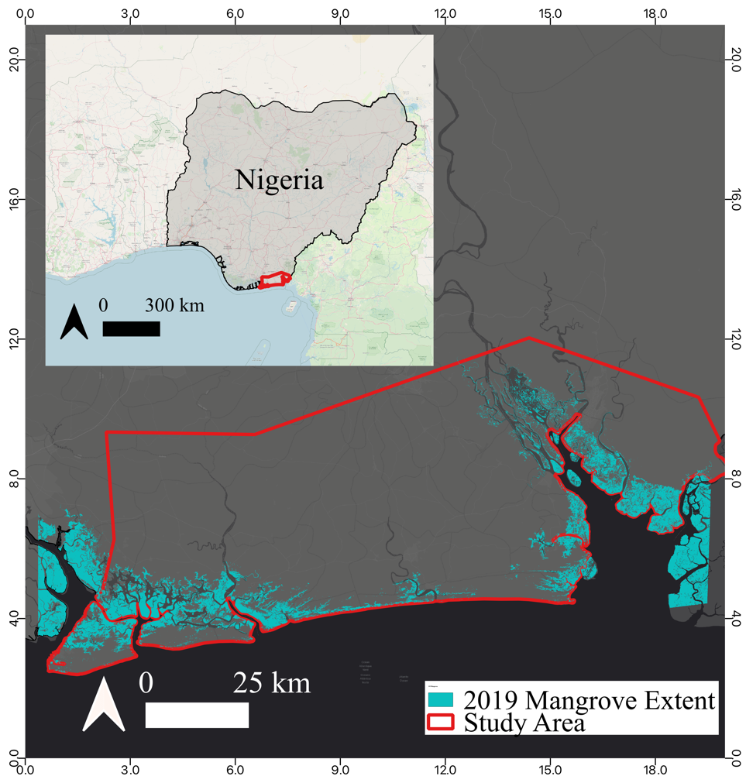
Figure 2. Study area (red outline) of the Southeastern portion of the Niger Delta and the Calabar Estuary.

2.3 Mangrove a priori Extent
Following the methods used by De Sousa et al., 2020 [44] we generated an a priori Nypa potential map for Nigeria, including all primary and associate (Nypa) mangrove species, using the Landsat 8 Operational Land Imager (OLI) Surface Reflectance (SR Collection Tier 1) imagery archive available on Google Earth Engine (GEE). Due to high cloud coverage in the region, a cloud-free median composite of the stacked Landsat imagery was created on a per-band, per-pixel basis using Landsat data spanning 2018-2020 to ensure that at least one cloud-free pixel was included for the median composite. We chose a Random Forest Classification (RFC) [45] to run the machine learning model based on previous work that has demonstrated its efficacy and high overall accuracy compared to other approaches [44,46,47]. The RFC was used to classify the median composite into a binary Mangrove/ Non-Mangrove output using training polygons acquired by visually inspecting freely available high spatial resolution imagery in Google Earth Pro and the Global Mangrove Watch dataset [48]. Areas of intact and homogenous areas of mangroves detected through visual inspection of very high-resolution imagery served as areas for selecting training polygons. Areas of high vegetation— demonstrated by Normalized Difference Vegetation Index (NDVI) values >0.25—occurring at low elevations near the coastline were included as training polygons for Mangrove, while areas of low vegetation—demonstrated by NDVI values < 0.25—were included as training polygons for Non-Mangrove. We avoided selecting fringe mangroves to avoid using mixed pixels as training data. We selected sample polygons covering a geographic swath from Lagos (west) to Uyo (far east). In total, 20,665 sample pixels were collected for Mangrove and 30,391 pixels for Non-Mangrove. We ran the model using the following predictor variables: Red, Green, Blue NDVI, Normalized Burn Ration (NBR), Normalized Difference Mangrove Index (NDMI), Modified Normalized Difference Water Index (MNDWI), Simple Ratio (SR), Green Chlorophyll Vegetation Index (GCVI), Bare Soild Index (BI), elevation, and slope (derived from the Shuttle Radar Topography Missions’ Digital Elevation Model). We chose predictor variables based on previous work by De Sousa et al., 2020 [44], which used the above predictor variables to classify mangroves and other landcover classes in Liberia and Gabon. The model was run using 100 trees and 5 predictor variables. A 100 m buffer was applied to the a priori map to allow for potential additional undetected mangrove to be included in the study area. We masked the study area with the resulting extent map to identify regions where mangrove forests and Nypa may occur (Figure 2).

2.4 2020 Nypa fruticans Classification
Classification of Nypa was accomplished by creating four new RFCs using data from Sentinel-1 SAR, Sentinel-2 MSI (Multispectral Instrument), and ALOS-2 PALSAR-2 sensors. The four RFC models included the following: S1 RFC (Sentinel-1 SAR), S2 RFC (Sentinel-2 MSI), S1_S2 RFC (Sentinel-1 SAR and Sentinel-2 MSI), PALSAR RFC (ALOS-2 PALSAR-2). Table 1 demonstrates each sensor used for the four random forest models constructed, as well as the bands used from each sensor. We ran a grid search of random forest parameter combinations to explore combinations of trees (1-1000) and number of parameters (1-4) used in the RFC model, and after finding no difference in model precision with a lower or higher number of trees, we ran a model using 500 trees and 4 predictor variables. A table with variable importance, using GEE’s .explain() function, which returns a decrease in Gini impurity index [49], is available in Supplemental (S1). The code associated with this methodology is available through Barenblitt & Thomas 2022 [50].

For each of the Sentinel models we composited all available data from 01-01-20 to 12-31-20 for the individual sensor by concatenating the mean of available bands. While median is the preferred compositing technique for Landsat imagery and the creation of cloud-free composites, SAR is not inhibited by clouds, which allows a mean composite to be used in constructing a data stack [44,51,52]. This composite was then masked to areas defined as mangrove in section 2.2. Due to lower available quantities of stripmap level 2.1 ALOS-2 PALSAR-2 data, seasonal images from the wet and dry seasons were averaged between seasons and subset to the mangrove extent. As Nypa and mangrove do not exhibit leaf-on/leaf-off seasonality, other phenological data was not considered in the present study. Three ALOS images were required to cover the spatial extent of the study region. To maintain native pixel resolution (6.25 m) two scenes were averaged per path and row. Averaging minimized the impacts of speckle and local environmental conditions (moisture), reducing the need for spatial filtering. This resulted in 6 images, composed of 3 pairs with both HH (HH polarization backscattering coefficient) and HV (HV polarization backscattering coefficient) backscatter. Each pair of images were averaged in 𝞂° backscatter and converted to decibel (dB) for analysis. The dates of the imagery spanned 2019-06-24 to 2019-08-28.
Radar data from Sentinel-1 SAR and ALOS were ingested in linear power, averaged and then converted to decibel (dB) for use in the models. We created a mean composite of Sentinel-1 SAR dual polarization data from VV (Single co-polarization, vertical transmit/vertical receive) and VH (Dual-band cross-polarization, vertical transmit/horizontal receive) backscatter to create all predictor variables used in the model (see Table 1). These radar backscatter coefficients were used as predictor variables since they are indicative of structural components of vegetation [53].
For the Sentinel-2 MSI model, clouds were masked using Sentinel-2’s ‘QA60’ (cloud presence) band, to eliminate imagery with clouds prior to mosaicking. NDVI (Normalized Difference Vegetation Index) was calculated across all pixels and added as a band to the available imagery [54]. While more vegetation indices are available for Sentinel-2, a number of these are used in the a-priori classification, and as NDVI has been used in prior studies to distinguish invasive species, it was the only index reintegrated into this phase of the model construction [55]. To create a data mosaic for the S1_S2 RFC model, we combined the Sentinel-1 SAR and Sentinel-2 MSI composites into one image layer stack. For the PALSAR RFC, we created a mean composite of dual polarization data from HH and HV, following a similar method as was used to process the Sentinel-1 SAR data.
We trained each model using three cover classes: Nypa (Nypa fruticans), Water (rivers and stranding water), and Mangrove (native mangrove stands). Training polygons were created by visual inspection of high-resolution satellite imagery from WorldView, following a similar methodology to Barenblitt et al 2021 [46] and section 2.2, and through the use of locations collected through ground-surveys. Training polygons for Nypa were restricted to areas of lower heights (<15m) as measured by 12 m TanDEM-X (​​TerraSAR-X add-on for Digital Elevation Measurement). TDX data was transformed from ellipsoid height to orthometric height (EGM08) prior to analysis. A table of all training pixels used for each model can be found in Supplemental (S2).

2.5 Accuracy Assessment
To validate the land cover classification, we generated randomly stratified points for each cover type within the study area. After eliminating points where high-resolution imagery was unavailable, this resulted in 168 points for Nypa, 125 points for Water, and 211 points for Mangrove in 2020. A 15m radius circle was centered on each validation point. This circle was then used to separate points into 3 land cover classes (Nypa, Water, or Mangrove) based on high resolution imagery in Google Earth Pro and Worldview Imagery from 2020.
We assessed the accuracy of the land cover classification using a confusion matrix. This matrix was used to visualize the algorithm’s performance by comparing actual and predicted values. Metrics calculated using this included overall accuracy, Producer’s and User’s Accuracy, and Commission and Omission Error. The population matrix was estimated using the sample matrix, based on the best accuracy assessment methods of Oloffsson et al. [56] and these results were used to revise unbiased estimates of each landcover class. Following the accuracy assessment, we used a Multiprobability Random Forest Classification of 500 trees to generate a map of the spatial confidence of the Sentinel-1 SAR landcover classification.

Model Comparison
After interpretation of initial results, the S1 RFC model was elected as the model to use for the 2015 comparison analysis, due to both the overall accuracy and the availability and ease of data access in comparison to PALSAR-2, which did not have the required data available across the entire study area. In addition, the S1 RFC model produced the highest User’s Accuracy for Nypa specifically. The methodology described in sections 2.3 was repeated using a Sentinel-1 SAR mean composite from 01-01-2015 to 12-31-2015. While fewer images were available, in 2015, S1 imagery was still consistently available from April to December. New training data was created using visual interpretation of available WorldView and Google Earth Pro high-resolution imagery. The accuracy assessment of the 2015 model used 147 randomly sampled points for Nypa, 191 points for Water and 164 points for Mangrove in 2015 and followed the methodology described in section 2.4.
We compared resulting classification maps from 2015 and 2020 on a pixel-by-pixel level using a map-to-map approach to determine which pixels demonstrated a change in landcover classes. The raster layers were overlaid and pixels demonstrating a classification change were totaled and separated into the following categories: Nypa to Water, Nypa to Mangrove, Water to Nypa, Water to Mangrove, Mangrove to Nypa, and Mangrove to Water.

2.7 GEDI Comparison of Nypa vs Mangrove
To compare the structural complexity and variability of Nypa to that of endemic mangroves, all available GEDI02_B Canopy Cover and Vertical Profile Metrics Data Global Footprint Level data from March 2019 to February 2021 were collected across the study area. In total, 93 GEDI orbits were available. We limited our footprint data to quality flag = 1, which indicates the cover and vertical profile metrics represent land and meet the quality of extended Gaussian fitting to the lowest mode [57]. Though coverage beam footprints were not explicitly excluded, the quality filter retained far more power beam footprints than coverage beam footprints (82% of footprints vs 18%). After limiting to the extent of our study area, 108,713 GEDI samples remained. At each GEDI footprint location, we extracted all overlapping classified pixels from the 2020 Sentinel-1 SAR landcover map. 100,889 GEDI footprints were classified as water and excluded from the analysis. To reduce ambiguity in the structural characterization of each cover class we excluded mixed classification GEDI footprints such that a single GEDI sample required more than 80% of the same pixel class to be included in further analysis. This exclusion step removed 1441 footprints (18.4% of vegetation classified footprints) from analysis. Nypa accounted for 1,682 GEDI footprints and mangrove accounted for 4,701 GEDI footprints.
The classified GEDI data allowed us to then compare Nypa and mangrove footprint-level metrics and foliage profiles. Of the available metrics, we evaluated GEDI RH100 (canopy height at the top of the canopy), FHD (Foliage Height Diversity, unitless), PAI (Plant Area Index) and cover, (canopy cover) with density distributions. The GEDI02_B product provides an estimate of the density of foliage or Plant Area Vegetation Density (PAVD using RH100) for each individual GEDI footprint (~25 m diameter circle) in the forest in the vertical dimension. The default vertical resolution of foliage profiles (5 m) was insufficient for us to clearly compare the two vegetation types. With R code, we adapted publicly available python code on github for “remapping” the PAVD profile at 1 m resolution by recalculating the gap fraction to the desired resolution [58]. Though the 1 m resolution is considered less accurate in terms of representing the magnitude of foliage at a given layer, the additional resolution improved our capacity to compare the two vegetation types. Profiles were aggregated into 5, 10, 15, 20, and 30 m height classes based on RH100 estimates and we derived the mean and standard deviation of PAVD at each 1 m height bin, allowing us to visualize the structural differences between Nypa and mangrove stands at different heights. Note, we chose the RH100 height estimate since this was the only canopy height metric available in the GEDI02_B dataset. Finally, we compared the GEDI RH98 values to TanDEM-X height values to determine how comparable height estimates from each sensor are in the Niger Delta. For this comparison, we chose to compare to the RH98 since other work has found this to be a more stable parameter for estimating canopy height [59].

- Results

3.1 Landcover Classification
Results of the Landsat classification of mangroves indicate that the potential zone of Nypa and the 100m buffer totaled 144,152.29 ha in 2020 in our area of interest. For 2020, of the four models investigated here, the PALSAR RFC and the S1_S2 RFC had the highest accuracy, each with an overall accuracy of 78%. The S1 RFC had an overall accuracy of 75% and the S2 RFC had an overall accuracy of 68%. The S1 model also had the highest User’s Accuracy for Nypa (74%) followed by the S1_S2 model (69%) and the PALSAR model (60%). The S2 model had the lowest User’s Accuracy for Nypa (37%). Radar is therefore a strong and useful determinant for the classification of vegetation types, outperforming optical sensors in using reflectance alone to classify mangrove and Nypa. This indicates that structure is a useful parameter for discriminating mangrove from Nypa which is not possible with optical reflectance alone. All accuracy results are indicated in Table 2 and extent maps for each model are demonstrated in Figure 3. A full table of error matrices can be found in Supplemental (S3). When we compared spatial outputs for each model, 64.8% of the S2 RFC, 82.5% of the S1_S2 RFC combination model, and 70.0% of the PALSAR RFC demonstrated agreement with the S1 RFC. Between all four models, 59.5% of the total study area was in agreement (Figure 3). For the 2015 S1 RFC, the overall model accuracy was 85% (Table 2).

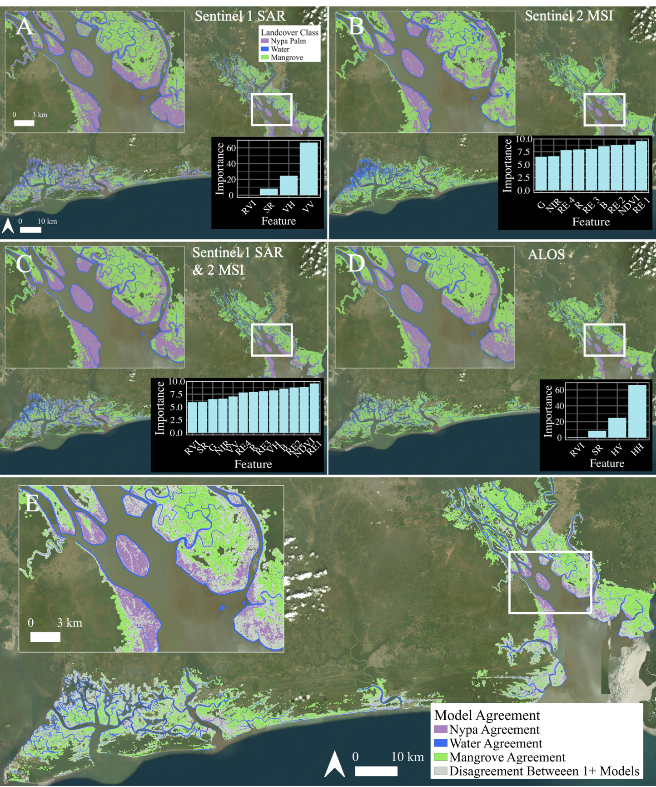
Figure 3. Landcover classification results from Random Forest model, including importance (%) of each model variable using A) Sentinel 1 SAR; B) Sentinel 2 MSI; C) Sentinel 1 SAR and Sentinel 2 MSI combined; D) ALOS E) Areas of agreement between all 4 models. Purple, blue, and green indicate areas where all models classified pixels as Nypa, Water, and Mangrove respectively. Gray indicates areas where >1 model disagreed.

3.2 2015-2020 Comparison
Results from the RFC models for 2015 and 2020 can be found in Table 3. The total area classified as Nypa increased by 57.3% since 2015 at an average rate of 11.5% yr⁻¹ (Figure 4). Resulting landcover classifications are available through Barenblitt et al. 2022 [60].
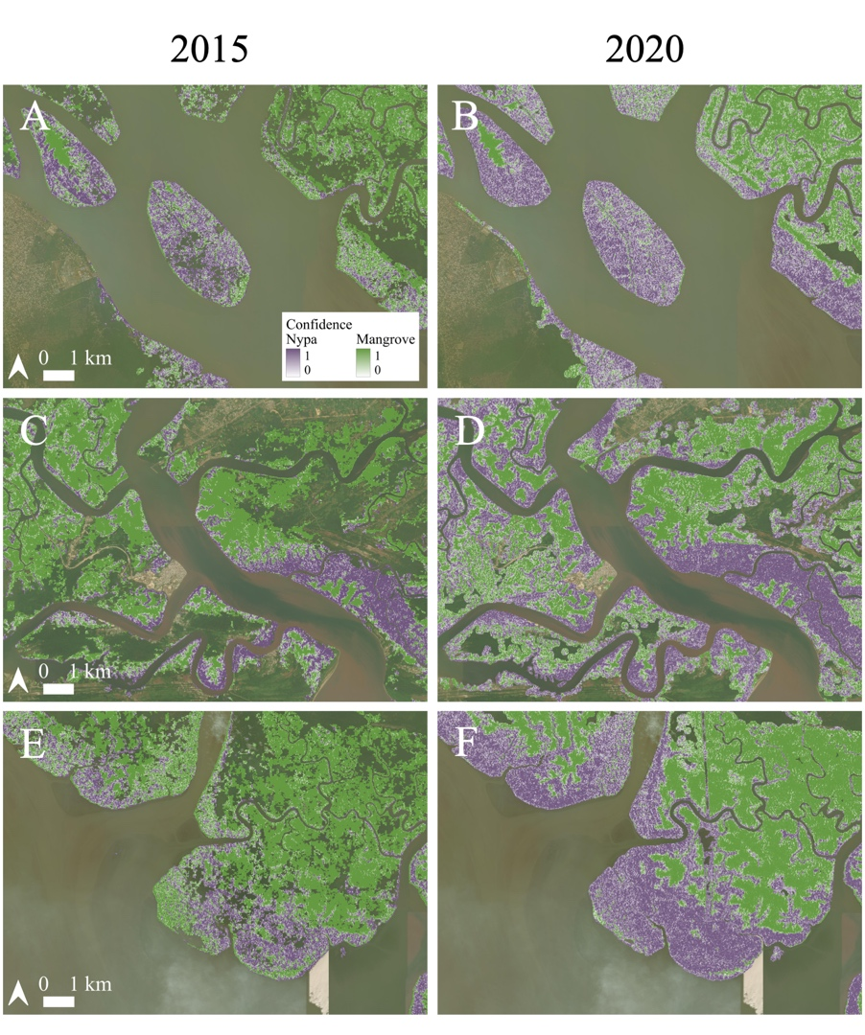
Figure 4. Comparison of Nypa extent with confidence values from 0-1 in 2015 and 2020 near A-B) Parrot Island; C-D) Opobo; E-F) South of Ekpene Esuk

Within the study area, a total of 36,880.03 ha experienced a change in landcover class (Figure 5). Of that change, 28,075.07 ha of Mangrove changed to Nypa, accounting for 76.1% of the total area of change. Of the remaining area of change, 3,803.67 ha (10.3%) of Nypa were converted to Water, 2,542.4 ha (6.9%) of Nypa converted to Mangrove, 463.1 ha (1.3%) of Water converted to Nypa, 102.5 ha (0.3%) of Water to Mangrove, and 1893.2 (5.1%) of Mangrove to Water (Figure 5).

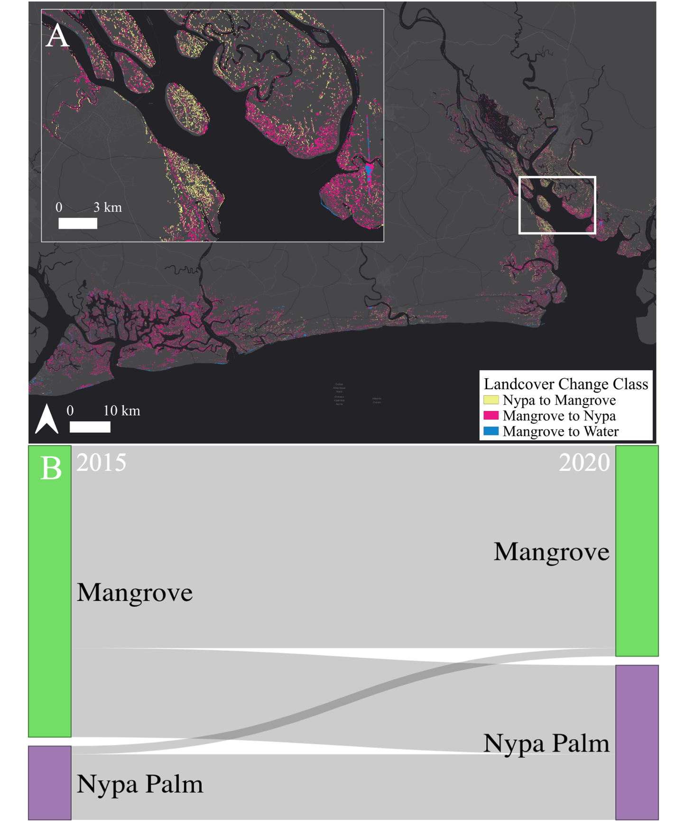Figure 5. A) Mapped landcover changes between 2015-2020; B) Visualization of total landcover change detection for Mangrove (green) and Nypa Palm (purple).

3.3 GEDI Comparison
In comparison to mangroves, Nypa structural metrics were skewed to lower estimates for top-of-canopy height (RH100), cover, PAI and FHD (Figure S1, Table S4). For instance, mean RH100 in mangroves was 8.8 m (sd=4.6 m), compared to Nypa RH100 of 8.2 m (sd= 4.6 m). Though these values overlap, the structural profiles of Nypa and mangrove differ. The height distributions differed most dramatically in low stature stands (Figure 6).
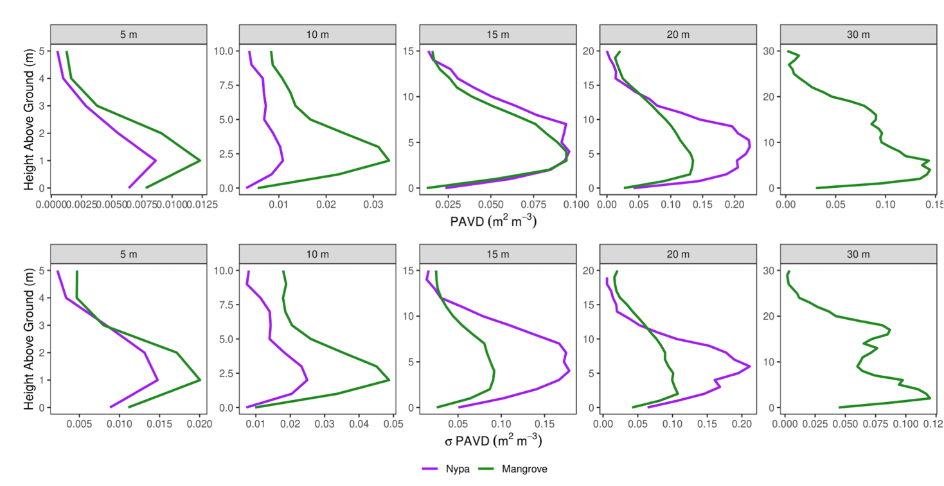
Figure 6: GEDI-based internal forest foliage profiles (plant area vegetation density or PAVD at 1 m vertical resolution) and standard deviation of PAVD of Nypa palm (purple) and Mangrove forests (green) by RH100 height bin. Below 15 m Mangroves have a higher density of PAVD and a higher standard deviation of PAVD than Nypa. At 15 m Nypa and Mangroves have similar structural profiles, but Nypa has much higher variation in foliage density. In the tallest stands, Nypa has higher understory density and much higher variability in the PAVD profile than mangroves. In the 30 m height class, Nypa did not exist in our classification map, so a PAVD profile was unable to be created. Note: the y axis is scaled by the maximum height in the height class and x axis was scaled by the maximum PAVD in each height class.

Nypa below 10 m were observed more frequently, while tall stands of mangroves were more frequent, shown clearly with both GEDI and TanDEM-X by differencing the density distributions of height for both classes (Figure 7C and Figure 7D). Mangroves also had a higher proportion of more structurally complex stands than Nypa. Mean Cover and PAI differed very little between the two classes (Cover = 17% in Nypa and Mangrove, PAI = 0.57 m²/m² in Nypa and 0.5 m²/m² in Mangrove). GEDI revealed clear differences in internal structure of Nypa and mangrove stands (Figure 6). GEDI-based foliage profiles (PAVD using RH100) and standard deviation of PAVD of Nypa palm (purple) and Mangrove forests (green) differed by GEDI height bin: below 15 m, Mangroves have a higher PAVD and a higher standard deviation of PAVD than Nypa. This is most likely due to the complex aboveground root structure of the red mangrove (Rhizophora), which overlaps with the canopy in short stands. At 15 m, Nypa and Mangroves have similar PAVD profiles, but Nypa has much higher variation in foliage density (Figure 6). This can be explained by the long palm leaves of Nypa which start at the base of the tree and create a singular distinct structural layer, whereas mangroves will have two distinct layers structural layers– the canopy and roots (Figure 7C and Figure 7D). In the tallest stands, Nypa PAVD is higher in the 0-15 m layer, and has much higher variability in the PAVD profile than mangroves. Only mangroves were found in the 30 m height class. The comparison between TanDEM-X and GEDI RH98 highlighted the main differences in how each sensor detects canopy height (Figure 7). In low stature stands, both sensors tend to agree in height estimates, on average. As stature increases, TanDEM-X becomes less sensitive to forest height than GEDI – a trend consistent with SAR instrument characteristics. Overall, the height distributions from each sensor appear quite different. TanDEM-X captures fewer small stature forests than GEDI. The major characteristic shapes of each forest type are consistent across sensors – Nypa displays an approximate bimodal distribution, while Mangrove forests have a more log-normal distribution.

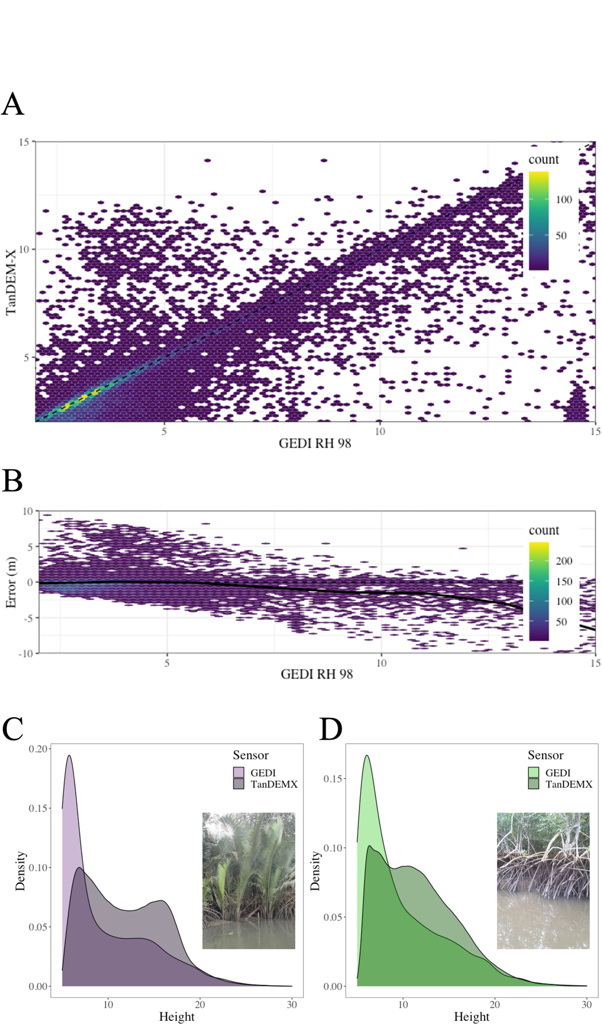
Figure 7. Structural differences between Nypa palm (purple) and Mangrove forests (green). A) One-to-one comparison of TanDEM-X and GEDI RH98 height estimates (higher density values in yellow and lower density in purple). B) Residual error estimate (TanDEM-X minus GEDI RH98, with horizontal dashed line indicating 0 bias) showing a tendency for TanDEM-X to overestimate low stature forests and underestimate in higher stature forests. C) Comparison of height values measured by GEDI and values measured by TanDEMX adjusted by a 5 meter increase. Density of height (m) data over Nypa Palm using TanDEMX (light purple) and GEDI (dark purple). D) Density of height (m) data over Mangrove using TanDEMX (light green) and GEDI (dark green).

- Discussion

Our findings demonstrate not only the efficacy of combinations of Landsat and Sentinel-1 SAR data for monitoring invasive species encroachment into mangroves, but also the rapid expansion of Nypa in Nigeria's mangroves, as well as the potential impact such expansion will have on structural diversity in the region.

4.1 Landcover Classification and Nypa fruticans Extent
While other studies demonstrate the efficacy of using remote sensing to monitor the expansion of invasive species, few monitor the expansion of Nypa [38,61]. Additionally, the high accuracy of the final model demonstrates that Sentinel SAR data is a reliable method for monitoring the rapid spread of this plant over a large region and provides an additional methodology for the remote sensing of invasive mangrove-associated species.

The results from comparisons of the four combinations of optical and radar data in the classification yielded the highest accuracy when PALSAR-2 or Sentinel-1 SAR was the only sensor used. While Landsat was useful in delineating mangrove areas, the reflectance of Nypa and native mangroves is likely too similar to be distinguishable using optical sensors alone. Whereas other studies have avoided this obstacle by using imagery from seasons where invasive vegetation is readily distinguished from native vegetation, this is not possible for tropical regions like the Nigerian coast [40]. However, harnessing SAR’s ability to distinguish structural differences within designated areas of mangrove appears to be an effective method for monitoring Nypa expansion. The use of 10 m SAR also provides higher resolution mapping capabilities, while bypassing challenges emerging from the cloudy nature of the region, which is a challenge for optical studies of vegetation [44,48,62,63].

Additionally, while PALSAR-2 has a finer resolution than GEE Sentinel-1 SAR (6.25 m and 10 m respectively), these sensors use different wavelengths. ALOS relies on L-Band, which has a wavelength of 23.5 cm while Sentinel SAR relies on C-Band, which uses a wavelength of 5.6 cm. As incident radar energy is backscattered from targets at the same size or larger than the wavelength, this is indictive of the size of the structural components of the vegetation types [64]. As palms, Nypa stems have less woody biomass than the mangrove and form smaller components than mangrove trunks and branches. This may explain why the PALSAR-2 model performed strongly, as its larger wavelength (L-band) was able to better separate these structural types by using the sensitivity of the L-band to the woody components of the mangroves, which were not detected within Nypa. This is in contrast to the C-band wavelength which is sensitive to the smaller stems of Nypa, thus increasing saturation and its ability to discriminate the two vegetation types. While the accuracy of the PALSAR-2 model slightly exceeded that of the Sentinel-1 model, the ease of availability of Sentinel-1 SAR via GEE at the time of this study contributed to our decision to use it.

The relatively high accuracy of this model demonstrates that remote sensing data from Sentinel SAR alone is reliable in identifying and understanding patterns of Nypa expansion in this study region. Invasive species are one of the leading threats to biodiversity worldwide [15,16]. Mapping invasive species in West African countries like Nigeria can be especially challenging for optical sensors due to not only the cloudy nature of this region, but also the similar optical reflectance of Nypa and mangrove [24,44]. These results compliment other studies that have used SAR to map other invasives, including Mimosa (Acacia dealbata) in Chile and American Bramble (Rubus cuneifolius) in South Africa [65,66]. As in our study, SAR was used in these studies to compliment optical imagery. However, our results differ in that the SAR model proved to be more accurate than the optical S2 model, whereas the abovementioned studies demonstrated higher accuracy using S2 [65,66]. This difference is likely due to the use of an a priori map created using Landsat, which reduced the potential Nypa area to regions where the spectral signature of Nypa and mangrove were less distinguishable. Therefore, the secondary step of reanalyzing the same wetland region using SAR alone distinguished between structural signatures Landsat was unable to detect, thereby overcoming limitations of remote sensing to distinguish between associated species in tropical regions. The methodology used in this study has the potential to be applied to other regions where invasive species are not easily distinguished from native vegetation, for example to distinguish palm from broadleaf tree species, as in the case of oil palm in previous studies [53,67,68]. The use of SAR to classify invasive species also indicates more potential for invasive plant monitoring where cloudiness makes optical classification more difficult. Whereas long periods of data must be mosaiced to create cloud-free composite in countries like Nigeria, SAR is not limited by clouds and could therefore also be used to provide more multi-temporal data to monitor invasive encroachment within shorter time periods. Developing methodologies to understand the extent and rate of Nypa spread could therefore help monitor not only the spread of this species, but other species that invade and disrupt tropical ecosystems.

4.2 Nypa fruticans Extent Change Over Time and Implications
Within the study area, Nypa was already heavily prevalent at the beginning of the study period in 2015, accounting for nearly the same amount of area as Mangrove. By 2020, Nypa grew by 57% and accounted for more area than native mangrove. Excluding the influence of external environmental variables, the current growth rate projects that Nypa could cover the entire extent of the study area by the year 2028. These results support a previous study of the region by Nwobi et al 2020, which noticed an increase of Nypa from 1,441 ha in 2007 to 11,444 ha 2017, about half the increase in extent (22, 000 ha) we measured during our study period [24]. This suggests that while Nypa was already prominent in 2015, much of its growth likely occurred during our five-year study period, rather than earlier, and most of this growth occurred within our study region. When comparing the 2020 Nypa classifcation in this study to the 2017 map in the Nwobi et al 2020 study, most of this new Nypa extent is found further inland, but still adjacent to waterways. This supports previous studies of mangrove invasions, which demonstrated hydrologic flow as a major component in invasion patterns in mangrove regions [69]

Additionally, since our study covers only a period where Sentinel-1 data was available (2015 onward), we show that Nypa expanded rapidly over a relatively short time frame. The rapid expansion of a singular invasive species is especially concerning as 57 species of invasive plants have been found in mangroves worldwide, compared to the ~60 species of native mangroves [70]. The combination of impacts of Nypa on native habitats, carbon storage, and economic opportunities could be devastating if this invasive continues to encroach on native mangroves at the current rate of spread. These implications also reflect on Nigeria's neighboring country, Cameroon, where it is currently and will continue to impact mangrove habitats in West Africa [32]. Finally, in other regions like the Sundarbans, other invasive plants like Giant Reed (Arundo donax) modify coastal geomorphology and reduce faunal diversity, similar to Nypa in Nigeria [70]. Therefore the implications of increased capabilities of remote sensing to monitor invasive plants through the use of SAR could improve monitoring beyond the region of West Africa.

4.3 Implications of Structural Comparison of Mangroves and Nypa
In comparison to mangroves, Nypa skewed lower for height (RH100) and complexity (FHD). This is concerning as structural variability in terrestrial ecosystems is often associated with higher biodiversity [71–73]. GEDI provides a first-of-a-kind look at the internal structure of mangrove and Nypa forests at large scales. We anticipate some uncertainty in the GEDI statistics due to potential geolocation errors in the version 1 GEDI release and uncertainty in ground finding under the extremely high cover in the study area. GEDI provides the best estimates of the ground surface when the sensitivity parameter is equal to or greater than the cover of the vegetation being measured, so, in some high-cover areas, heights may not be accurate. However, the density of height values collected by GEDI appears to agree with those collected by TanDEM-X, though GEDI values appear to be consistently ~5 m higher than TanDEM-X values collected at the same locations. These results are in agreement with previous work to calibrate GEDI RH100 values using TanDEM-X heights, which found that TanDEM-X products generally underestimate heights [74]. Even under these constraints GEDI has clearly shown the differing internal structure of the Nypa and mangrove forests in the Niger Delta and Calabar Estuary. While the resolution of GEDI (25 m) is lower than that of the final S1 landcover classification (10 m), moving from a higher resolution classification to the lower resolution GEDI analysis allowed us to exclude regions of mixed cover. Therefore, the differences detected between the structure of Nypa and mangrove likely describe regions that are more uniform in cover type. This leaves room for further analysis of transition zones as Nypa continues to invade.

The most striking difference between the two forest types – supported by on-the-ground observations – is that the tallest stands of Nypa have high understory density, while mangroves remain more open in the understory. This difference in structural characteristics could also affect how wildlife use the Niger Delta ecosystem, as species like waterbirds and primates rely on mangrove canopies [75,76]. While mangroves are structurally homogenous compared to other forest types, the structural variation found due to stem density and mangrove species zonation support fauna like birds, as bird species composition is closely associated with plant species composition and the configuration of vegetation structure [77]. Additionally, the high density of canopy cover has been determined to be predictive of bird species richness [77]. Therefore, changes to the structural characteristics of Nigeria’s mangroves ecosystem could reduce habitat available for canopy-dwellers and reduce heterogeneity of faunal species in mangroves. This supports previous work demonstrating increasing homogeneity of mangroves worldwide, with implications on flora and fauna beyond Nigeria [78].

The evidence provided by comparing GEDI across Nypa and Mangrove areas suggests this invasive species can directly affect the forest structure, with implications for impacts on ecosystem function for supporting biodiversity. These results demonstrate how SAR and other sensors used for landcover classification would be aided by the inclusion of GEDI LiDAR, and points to possibilities for the inclusion of structural data in Random Forest model construction. The use of structural data as a predictor variable in model construction could lead to more accurate and specific models in the future. Additionally, a wealth of data is available for directly mapping forest structural features within each landcover class. The differences detected within the structural components of each individual landcover type—including canopy height and PAVD profiles—not only allow us to compare structural components of each vegetation type, but would also allow direct mapping of structural changes within each class over time. This utility could prove especially relevant for better understanding transition zones and monitoring where Nypa is invading mangroves. Finally, at the time of the current study, GEDI data was available from 2019-2021. In March, 2023, GEDI was powered down and stored on the International Space Station, but will resume operations in 2024 [79]. The future availability of GEDI will allow for monitoring of structural changes within Nypa and mangrove over time, as well as between landcover types, allowing for further support of landcover mapping with SAR and GEDI data.

4.4 Model Limitations
As we used an a priori map to determine areas of Nypa potential within the study area, the models generated using the Sentinel series and PALSAR are not independent of the Landsat-generated map. Therefore, errors in the a priori map could be propagated into the final S1 map. However, as new training data was created independently from that used for the a priori map, we believe this error is reduced, especially in light of the use of the a priori map to limit the study area of interest, rather than generate predictor variables for the final classification. An initial grid search of the random forest classifications primarily indicated that the accuracy of the model did not vary widely, regardless of number of trees used and number of predictor variables. This suggests there is little sensitivity in the model's parameters and predictors, despite the high precision of the model, which could reflect on the model's overall accuracy. We have attempted to account for this by providing the detailed accuracy assessment described in the methods. Additionally, imagery was used from 01/01/20 - 12/31/20 across all sensors. For Sentinel-2 optical imagery, this meant data was lost due to the necessity of cloud masking. Even when the collection period was expanded, significant cloud coverage was identified in the data. This makes the direct comparison between the SAR and optical data less exact. However, it does demonstrate another case for the use of SAR data in this study as SAR is unaffected by cloud cover.

Conclusions
This study used remote sensing techniques to quantify the extent of Nypa fruticans in the Niger Delta and Calabar Estuary, as well as the extent of invasive expansion from 2015-2020. Our findings support the use of remote sensing, particularly SAR data, to monitor an invasive species in a region where cloudiness and similarity of vegetation reflectance are obstacles to remote sensing techniques. The expansion of Nypa during the five-year time period of this study suggests that the negative impact of Nypa could continue to increase, affecting both livelihoods and biodiversity in the region. Future iterations of this work could apply this technique to similar tropical areas where invasives threaten biodiversity and ecosystem functions. As more L-band SAR data becomes available, including from the upcoming NISAR mission (NASA – ISRO Synthetic Aperture Radar mission) we anticipate further applications of this data for Nypa and other palm species monitoring. Additionally, future monitoring of Nypa should explore the use of LiDAR from sensors like GEDI to improve the classification of Nypa compared to areas of native mangrove. Nypa is often associated with degradation caused by other human activity, such as oil exploration and spills. Therefore, further work investigating patterns in the root cause of the spread of Nypa are critical for addressing these invasions.

Acknowledgments

We would like to thank Paulo Jose Murillo for providing feedback on the change detection aspect of this paper, the Japanese Aerospace Exploration Agency (JAXA) Kyoto and Carbon (K&C) initiative for the provision of ALOS-2 PALSAR-2 data, and the German Aerospace Agency (DLR) for the provision of TanDEM-X data. ﻿This project was funded by the NASA Applied Sciences Program grant number 80NSSC19K0205 within NASA's Earth Science Division.

Author contributions:
AB: Writing - original draft, Investigation, Visualization, Methodology, Validation
LF: Conceptualization, Supervision, Writing - review & editing, Funding Acquisition, Project Administration
NT: Methodology, Data Acquisition, Writing - review & editing
AS: Methodology, Data Acquisition, Writing - review & editing
CS: Methodology, Data Acquisition, Writing - review & editing
CN: Ground Data Acquisition, Writing - review & editing, Resources
LD: Writing - review & editing

Competing interests: The authors declare that there is no conflict of interest regarding the publication of this article.

Data Availability: Data has been made available through Barenblitt & Thomas 2022 [49] and Barenblitt et all 2022 [51].

References
[1] U.N.G. Assembly, Transforming our world: the 2030 Agenda for Sustainable Development, (2015). https://doi.org/10.1163/15718093-12341375.
[2] D.A. Friess, K. Rogers, C.E. Lovelock, K.W. Krauss, S.E. Hamilton, S.Y. Lee, R. Lucas, J. Primavera, A. Rajkaran, S. Shi, The State of the World’s Mangrove Forests: Past, Present, and Future, Annu Rev Environ Resour. 44 (2019) 89–115. https://doi.org/10.1146/ANNUREV-ENVIRON-101718-033302.
[3] D.C. Donato, J.B. Kauffman, D. Murdiyarso, S. Kurnianto, M. Stidham, M. Kanninen, Mangroves among the most carbon-rich forests in the tropics, Nat Geosci. 4 (2011) 293–297. https://doi.org/10.1038/ngeo1123.
[4] E. McLeod, G.L. Chmura, S. Bouillon, R. Salm, M. Björk, C.M. Duarte, C.E. Lovelock, W.H. Schlesinger, B.R. Silliman, A blueprint for blue carbon: Toward an improved understanding of the role of vegetated coastal habitats in sequestering CO2, Front Ecol Environ. 9 (2011) 552–560. https://doi.org/10.1890/110004.
[5] World Bank, Defining an Environmental Development Strategy for the Niger Delta Volume Ii Annexes Contents, 2 (1995) 1–153.
[6] D. Yeo, A. Srivathsan, J. Puniamoorthy, F. Maosheng, P. Grootaert, L. Chan, B. Guénard, C. Damken, R.A. Wahab, A. Yuchen, R. Meier, Mangroves are an overlooked hotspot of insect diversity despite low plant diversity, BMC Biol. 19 (2021) 1–17. https://doi.org/10.1186/s12915-021-01088-z.
[7] N.P.O. Chidumeje, K. Lalit, T. Subhashni, The Niger Delta wetland ecosystem: What threatens it and why should we protect it?, Afr J Environ Sci Tech. 9 (2015) 451–463. https://doi.org/10.5897/ajest2014.1841.
[8] T.A. Worthington, P.S.E. zu Ermgassen, D.A. Friess, K.W. Krauss, C.E. Lovelock, J. Thorley, R. Tingey, C.D. Woodroffe, P. Bunting, N. Cormier, D. Lagomasino, R. Lucas, N.J. Murray, W.J. Sutherland, M. Spalding, A global biophysical typology of mangroves and its relevance for ecosystem structure and deforestation, Sci Rep. 10 (2020) 1–11. https://doi.org/10.1038/s41598-020-71194-5.
[9] N.D.E.S. (NDES), Environmental and Socio-economic Characteristics , second phase of field report. Report published by the Energy Information Administration (EIA), USA Government Department of Energy., 2005.
[10] F. and A.O. of the U.N. (FAO), Review of the State of the World Fishery Resource: Marine Resource, FAO Fisheries Circular No. 920 Firm/C920, Rome. (1997) 173.
[11] C. Kuenzer, A. Bluemel, S. Gebhardt, T.V. Quoc, S. Dech, Remote sensing of mangrove ecosystems: A review, 2011. https://doi.org/10.3390/rs3050878.
[12] P. Wang, A.O. Numbere, G.R. Camilo, Long-term changes in mangrove landscape of the niger river delta, nigeria, Am J Environ Sci. 12 (2016) 248–259. https://doi.org/10.3844/ajessp.2016.248.259.
[13] U.D. Chima, S.L. Larinde, Deforestation and degradation of mangroves in the Niger Delta Region of Nigeria : Implications in a changing climate DEFORESTATION AND DEGRADATION OF MANGROVES IN THE NIGER DELTA REGION OF NIGERIA : IMPLICATIONS IN A, (2016).
[14] N.P.O. Chidumeje, K. Lalit, T. Subhashni, The Niger Delta wetland ecosystem: What threatens it and why should we protect it?, Afr J Environ Sci Tech. 9 (2015) 451–463. https://doi.org/10.5897/ajest2014.1841.
[15] S.R. Biswas, P.L. Biswas, S.H. Limon, E.R. Yan, M.S. Xu, M.S.I. Khan, Plant invasion in mangrove forests worldwide, For Ecol Manage. 429 (2018) 480–492. https://doi.org/10.1016/j.foreco.2018.07.046.
[16] J. Gurevitch, D.K. Padilla, Are invasive species a major cause of extinctions?, Trends Ecol Evol. 19 (2004) 470–474. https://doi.org/10.1016/j.tree.2004.07.005.
[17] J.W.A. Langeveld, S. Delany, The impact of oil exploration, extraction and transport on mangrove vegetation and carbon stocks in nigeria, (2014) 56.
[18] T. Holland, The Useful Plants of Nigeria, Kew Bull. Misc. Inform. 9 (1922) 712–753.
[19] R. Keay, C. Onochie, D. Standfield, Nigerian trees, 1964.
[20] A.C. Zeven, The introduction of the Nipa Palm to West Africa, Journal of the Institute of Oil Palm Research. 5 (1971) 35–36.
[21] A.O. Numbere, M. Mason, Mapping of Nypa Palm Invasion of Mangrove Forest Using Low-Cost and High Resolution UAV Digital Imagery in The Niger Delta, Nigeria, Current Trends in Forest Research. 6 (2019) 1–8. https://doi.org/10.29011/2638-0013.101031.
[22] P. Widodo, Sukarsa, W. Herawati, H.A. Hidayah, T. Chasanah, E. Proklamasiningsih, Distribution and Characteristics of Nypa Palm (Nypa fruticans Wurmb.) in Southern Part of Cilacap Regency, IOP Conf Ser Earth Environ Sci. 550 (2020). https://doi.org/10.1088/1755-1315/550/1/012010.
[23] T.C.H. Sunderland, T. Morakinyo, Nypa fruticans, a weed in West Africa, PALMS. 46 (2002) 154–155.
[24] C. Nwobi, M. Williams, E.T. Mitchard, Rapid Mangrove forest loss and Nipa Palm (Nypa fruticans) expansion in the Niger Delta, 2007-2017, Remote Sens (Basel). 12 (2020). https://doi.org/10.3390/rs12142344.
[25] C.J. Nwobi, M. Williams, Natural and Anthropogenic Variation of Stand Structure and Aboveground Biomass in Niger Delta Mangrove Forests, Frontiers in Forests and Global Change. 4 (2021) 1–14. https://doi.org/10.3389/ffgc.2021.746671.
[26] E. Okon, D. Bown, A. Isichei, Plant Invasions in Nigeria, Nigerian Forests: Protection and Sustainable Development. (2013) 320.
[27] U. Nigeria, Nigeria Biodiversity and Tropical Forestry Assessment: Maximizing Agricultural Revenue in Key Enterprises (Markets), in: Chemonics International Inc, 2008.
[28] I. Etukudo, Potential of forest resources development in Akwa Ibom State Economy, Forestry and Sustainable Environment, Forestry Association of Nigeria, Akwa Ibom State. (2001) 56–69.
[29] C.E. Isebor, T.O. Ajayi, A. Anyanwu, The incidence of Nypa fruticans (Wurmb) and its impact on fisheries production in the Niger Delta mangrove ecosystem, 16th Annual Conference of the Fisheries Society of Nigeria (FISON). (2003) 13–16.
[30] O. Aburto-Oropeza, E. Ezcurra, G. Danemann, V. Valdez, J. Murray, E. Sala, Mangroves in the Gulf of California increase fishery yields, Proceedings of the National Academy of Sciences. 105 (2008) 10456–10459. https://doi.org/10.1073/pnas.0804601105.
[31] E.O. Enakireru, I. Airen Aigbe, The environmental impact of crude oil theft in nigeria: challenges, Maintianing Environmental Integrity. (2014).
[32] N.Z. Feka, G.N. Ajonina, Drivers causing decline of mangrove in West-Central Africa: A review, Int J Biodivers Sci Ecosyst Serv Manag. 7 (2011) 217–230. https://doi.org/10.1080/21513732.2011.634436.
[33] A.E. Obayelu, Assessment of Land Use Dynamics and the Status of Biodiversity Exploitation and Preservation in Nigeria, Journal for the Advancement of Developing Economies. (2018). https://doi.org/10.13014/k25x273x.
[34] A.O. Numbere, G.R. Camilo, Reciprocal Transplant of Mangrove (Rhizophora racemosa) and Nypa Palm (Nypa fruticans) Seedlings in Soils with Different Levels of Pollution in the Niger River Delta, Nigeria, Global Journal of Environmental Research. 10 (2016) 14–21. https://doi.org/10.5829/idosi.gjer.2016.10.01.10342.
[35] S.W. Myint, C.P. Giri, L. Wang, Z. Zhu, S.C. Gillete, Identifying mangrove species and their surrounding land use and land cover classes using object-oriented approach with a lacunarity spatial measure, GIsci Remote Sens. 45 (2008) 188–208. https://doi.org/10.2747/1548-1603.45.2.188.
[36] R. Hakimdavar, A. Hubbard, F. Policelli, A. Pickens, M. Hansen, T. Fatoyinbo, D. Lagomasino, N. Pahlevan, S. Unninayar, A. Kavvada, M. Carroll, B. Smith, M. Hurwitz, D. Wood, S.S. Uz, Monitoring water-related ecosystems with earth observation data in support of Sustainable Development Goal (SDG) 6 reporting, Remote Sens (Basel). 12 (2020). https://doi.org/10.3390/rs12101634.
[37] L. Goldberg, D. Lagomasino, N. Thomas, T. Fatoyinbo, Global declines in human-driven mangrove loss, Glob Chang Biol. 26 (2020) 5844–5855. https://doi.org/10.1111/gcb.15275.
[38] P. Rajah, J. Odindi, O. Mutanga, Z. Kiala, The utility of Sentinel-2 Vegetation Indices (VIs) and Sentinel-1 Synthetic Aperture Radar (SAR) for invasive alien species detection and mapping, Nat Conserv. 35 (2019) 41–61. https://doi.org/10.3897/natureconservation.35.29588.
[39] P. Rajah, J. Odindi, O. Mutanga, Feature level image fusion of optical imagery and Synthetic Aperture Radar (SAR) for invasive alien plant species detection and mapping, Remote Sens Appl. 10 (2018) 198–208. https://doi.org/10.1016/j.rsase.2018.04.007.
[40] C. ying Huang, G.P. Asner, Applications of remote sensing to alien invasive plant studies, Sensors (Switzerland). 9 (2009) 4869–4889. https://doi.org/10.3390/s90604869.
[41] D. Lu, S. Hetrick, E. Moran, Shadow Lu, Photogramm Eng Remote Sensing. 76 (2010) 1159–1168.
[42] M. Ogbe, Biological resource conservation: a major tool for poverty reduction in Delta State. A key note address delivered at the Delta State maiden Council meeting on Environment with all stakeholders held at Nelrose Hotel, Delta State, Nigeria between 28th and 2, in: 2005: p. 16.
[43] Olomukoro, Environmental pollution and its implication in Nigeria. A paper presented at the Delta State maiden council meeting on Environment with all stakeholders held at Nelrose Hotel, Delta State, Nigeria Between 28th and 29th September, 2005, (2005) 23.
[44] C. De Sousa, L. Fatoyinbo, C. Neigh, F. Boucka, V. Angoue, T. Larsen, Cloud-computing and machine learning in support of country-level land cover and ecosystem extent mapping in Liberia and Gabon, PLoS One. 15 (2020) 1–24. https://doi.org/10.1371/journal.pone.0227438.
[45] L. Breiman, Bagging predictors, Machinge Learning. 24 (n.d.) 123–140.
[46] A. Barenblitt, A. Payton, D. Lagomasino, L. Fatoyinbo, K. Asare, K. Aidoo, H. Pigott, C.K. Som, L. Smeets, O. Seidu, D. Wood, The large footprint of small-scale artisanal gold mining in Ghana, Science of The Total Environment. 781 (2021) 146644. https://doi.org/10.1016/j.scitotenv.2021.146644.
[47] P. Mondal, X. Liu, T.E. Fatoyinbo, D. Lagomasino, Evaluating combinations of sentinel-2 data and machine-learning algorithms for mangrove mapping in West Africa, Remote Sens (Basel). 11 (2019). https://doi.org/10.3390/rs11242928.
[48] P. Bunting, A. Rosenqvist, R.M. Lucas, L.M. Rebelo, L. Hilarides, N. Thomas, A. Hardy, T. Itoh, M. Shimada, C.M. Finlayson, The global mangrove watch - A new 2010 global baseline of mangrove extent, Remote Sens (Basel). 10 (2018). https://doi.org/10.3390/rs10101669.
[49] S. Shetty, M. Prasun, K. Gupta, M. Belgiu, S.K. Srivastav, Analysis of Machine Learning Classifiers for LULC Classification on Google Earth Engine, 2019.
[50] A. Barenblitt, N.M. Thomas, NypaPalmExtent, (2022). https://doi.org/10.5281/zenodo.6773611.
[51] J. Xiong, P.S. Thenkabail, J.C. Tilton, M.K. Gumma, P. Teluguntla, A. Oliphant, R.G. Congalton, K. Yadav, N. Gorelick, Nominal 30-m cropland extent map of continental Africa by integrating pixel-based and object-based algorithms using Sentinel-2 and Landsat-8 data on google earth engine, Remote Sens (Basel). 9 (2017). https://doi.org/10.3390/rs9101065.
[52] A. Midekisa, F. Holl, D.J. Savory, R. Andrade-Pacheco, P.W. Gething, A. Bennett, H.J.W. Sturrock, Mapping land cover change over continental Africa using Landsat and Google Earth Engine cloud computing, PLoS One. 12 (2017). https://doi.org/10.1371/journal.pone.0184926.
[53] Y.W. Kee, A.R.M. Shariff, A.M. Sood, L. Nordin, Application of SAR data for oil palm tree discrimination, IOP Conf Ser Earth Environ Sci. 169 (2018). https://doi.org/10.1088/1755-1315/169/1/012065.
[54] C.J. Tucker, Red and photographic infrared linear combinations for monitoring vegetation, Remote Sens Environ. 8 (1979) 127–150. https://doi.org/https://doi.org/10.1016/0034-4257(79)90013-0.
[55] D. Dong, C. Wang, J. Yan, Q. He, J. Zeng, Z. Wei, Combing Sentinel-1 and Sentinel-2 image time series for invasive Spartina alterniflora mapping on Google Earth Engine: a case study in Zhangjiang Estuary, (n.d.). https://doi.org/10.1117/1.JRS.14.044504.
[56] P. Olofson, G.M. Foody, M. Herold, Good practices for estimating area and assessing accuracy of land change, Remote Sens Environ. 148 (2014) 42–57. https://doi.org/10.1016/j.rse.2014.02.015.
[57] R. Dubayah, J.B. Blair, J. Beck, B. Wirt, J. Armston, M. Hofton, S. Luthcke, H. Tang, GLOBAL Ecosystem Dynamics Investigation (GEDI) Level 2 User Guide For SDPS PGEVersion 3 (P003) of GEDI L2A Data and SDPS PGEVersion 3 (P003) of GEDI L2B Data, 3 (2021) 1–25.
[58] J. Armston, GEDI Level 2B Vertical Plant Profiles, (2020).
[59] L. Duncanson, J.R. Kellner, J. Armston, R. Dubayah, D.M. Minor, S. Hancock, S.P. Healey, P.L. Patterson, S. Saarela, S. Marselis, C.E. Silva, J. Bruening, S.J. Goetz, H. Tang, M. Hofton, B. Blair, S. Luthcke, L. Fatoyinbo, K. Abernethy, A. Alonso, H.E. Andersen, P. Aplin, T.R. Baker, N. Barbier, J.F. Bastin, P. Biber, P. Boeckx, J. Bogaert, L. Boschetti, P.B. Boucher, D.S. Boyd, D.F.R.P. Burslem, S. Calvo-Rodriguez, J. Chave, R.L. Chazdon, D.B. Clark, D.A. Clark, W.B. Cohen, D.A. Coomes, P. Corona, K.C. Cushman, M.E.J. Cutler, J.W. Dalling, M. Dalponte, J. Dash, S. de-Miguel, S. Deng, P.W. Ellis, B. Erasmus, P.A. Fekety, A. Fernandez-Landa, A. Ferraz, R. Fischer, A.G. Fisher, A. García-Abril, T. Gobakken, J.M. Hacker, M. Heurich, R.A. Hill, C. Hopkinson, H. Huang, S.P. Hubbell, A.T. Hudak, A. Huth, B. Imbach, K.J. Jeffery, M. Katoh, E. Kearsley, D. Kenfack, N. Kljun, N. Knapp, K. Král, M. Krůček, N. Labrière, S.L. Lewis, M. Longo, R.M. Lucas, R. Main, J.A. Manzanera, R.V. Martínez, R. Mathieu, H. Memiaghe, V. Meyer, A.M. Mendoza, A. Monerris, P. Montesano, F. Morsdorf, E. Næsset, L. Naidoo, R. Nilus, M. O’Brien, D.A. Orwig, K. Papathanassiou, G. Parker, C. Philipson, O.L. Phillips, J. Pisek, J.R. Poulsen, H. Pretzsch, C. Rüdiger, S. Saatchi, A. Sanchez-Azofeifa, N. Sanchez-Lopez, R. Scholes, C.A. Silva, M. Simard, A. Skidmore, K. Stereńczak, M. Tanase, C. Torresan, R. Valbuena, H. Verbeeck, T. Vrska, K. Wessels, J.C. White, L.J.T. White, E. Zahabu, C. Zgraggen, Aboveground biomass density models for NASA’s Global Ecosystem Dynamics Investigation (GEDI) lidar mission, Remote Sens Environ. 270 (2022). https://doi.org/10.1016/j.rse.2021.112845.
[60] A. Barenblitt, L. Fatoyinbo, N. Thomas, A. Stovall, C. de Sousa, C. Nwobi, Niger Delta Nypa Palm Extent 2015-2020, (2022). https://doi.org/10.17632/n5x9dnhyby.1.
[61] T.L. Hawthorne, V. Elmore, A. Strong, P. Bennett-Martin, J. Finnie, J. Parkman, T. Harris, J. Singh, L. Edwards, J. Reed, Mapping non-native invasive species and accessibility in an urban forest: A case study of participatory mapping and citizen science in Atlanta, Georgia, Applied Geography. 56 (2015) 187–198. https://doi.org/10.1016/j.apgeog.2014.10.005.
[62] S. Banks, L. White, A. Behnamian, Z. Chen, B. Montpetit, B. Brisco, J. Pasher, J. Duffe, Wetland Classification with Multi-Angle/Temporal SAR Using Random Forests, Remote Sens (Basel). 11 (2019). https://doi.org/10.3390/rs11060670.
[63] B.A. Barnieh, L. Jia, M. Menenti, J. Zhou, Y. Zeng, Mapping land use land cover transitions at different spatiotemporal scales in West Africa, Sustainability (Switzerland). 12 (2020) 1–52. https://doi.org/10.3390/su12208565.
[64] I.H. Woodhouse, E.T.A. Mitchard, M. Brolly, D. Maniatis, C.M. Ryan, Radar backscatter is not a “direct measure” of forest biomass, Nat Clim Chang. 2 (2012) 556–557. https://doi.org/10.1038/nclimate1601.
[65] T. Kattenborn, J. Lopatin, M. Förster, A.C. Braun, F.E. Fassnacht, UAV data as alternative to field sampling to map woody invasive species based on combined Sentinel-1 and Sentinel-2 data, Remote Sens Environ. 227 (2019) 61–73. https://doi.org/10.1016/j.rse.2019.03.025.
[66] P. Rajah, J. Odindi, O. Mutanga, Z. Kiala, The utility of Sentinel-2 Vegetation Indices (VIs) and Sentinel-1 Synthetic Aperture Radar (SAR) for invasive alien species detection and mapping, Nat Conserv. 35 (2019) 41–61. https://doi.org/10.3897/natureconservation.35.29588.
[67] C. Pohl, Mapping palm oil expansion using SAR to study the impact on the CO 2 cycle, IOP Conf Ser Earth Environ Sci. 20 (2014). https://doi.org/10.1088/1755-1315/20/1/012012.
[68] I. Carolita, S. Darmawan, R. Permana, D. Dirgahayu, D. Wiratmoko, T. Kartika, S. Arifin, Comparison of Optic Landsat-8 and SAR Sentinel-1 in Oil Palm Monitoring, Case Study : Asahan, North Sumatera, Indonesia, IOP Conf Ser Earth Environ Sci. 280 (2019). https://doi.org/10.1088/1755-1315/280/1/012015.
[69] S.R. Biswas, J.K. Choudhury, A. Nishat, M.M. Rahman, Do invasive plants threaten the Sundarbans mangrove forest of Bangladesh?, For Ecol Manage. 245 (2007) 1–9. https://doi.org/10.1016/j.foreco.2007.02.011.
[70] S.R. Biswas, P.L. Biswas, S.H. Limon, E.R. Yan, M.S. Xu, M.S.I. Khan, Plant invasion in mangrove forests worldwide, For Ecol Manage. 429 (2018) 480–492. https://doi.org/10.1016/j.foreco.2018.07.046.
[71] A. Lenière, G. Houle, Response of herbaceous plant diversity to reduced structural diversity in maple-dominated (Acer saccharum Marsh.) forests managed for sap extraction, For Ecol Manage. 231 (2006) 94–104. https://doi.org/10.1016/j.foreco.2006.05.024.
[72] R. MacArthur, J. MacArhtur, On Bird Species Diversity, Ecology. 42 (1961) 594–598.
[73] J. Tews, U. Brose, V. Grimm, K. Tielbörger, M.C. Wichmann, M. Schwager, F. Jeltsch, Animal species diversity driven by habitat heterogeneity/diversity: The importance of keystone structures, J Biogeogr. 31 (2004) 79–92. https://doi.org/10.1046/j.0305-0270.2003.00994.x.
[74] A.E.L. Stovall, T. Fatoyinbo, N.M. Thomas, J. Armston, O. Ebanega, M. Simard, C. Trettin, R. Vancelas, O. Zogo, A. Aken, M. Debina, A. Mekui, M. Kemoe, E. Ondo, J.S. Kim, D. Lagomasino, S. Lee, J.C. Ndong, G.D. Voubou, C.Z. Essono, Comprehensive comparison of airborne and spaceborne SAR and LiDAR estimates of forest structure in the tallest mangrove forest on earth, Science of Remote Sensing. (2021) 100034. https://doi.org/10.1016/j.srs.2021.100034.
[75] P.L. Mancini, A.S. Reis-Neto, L.G. Fischer, L.F. Silveira, Y. Schaeffer-Novelli, Differences in diversity and habitat use of avifauna in distinct mangrove areas in São Sebastião, São Paulo, Brazil, Ocean Coast Manag. 164 (2018) 79–91. https://doi.org/10.1016/j.ocecoaman.2018.02.002.
[76] S.A. Abere, B.A. Ekeke, The Nigerian Mangrove and Wildlife Development, Mediterr J Soc Sci. 2 (2011) 824–834.
[77] J. Mohd-Azlan, R.A. Noske, M.J. Lawes, The role of habitat heterogeneity in structuring mangrove bird assemblages, Diversity (Basel). 7 (2015) 118–136. https://doi.org/10.3390/d7020118.
[78] S.K. Sarker, J. Matthiopoulos, S.N. Mitchell, Z.U. Ahmed, M.B. Al Mamun, R. Reeve, 1980s–2010s: The world’s largest mangrove ecosystem is becoming homogenous, Biol Conserv. 236 (2019) 79–91. https://doi.org/10.1016/j.biocon.2019.05.011.
[79] J. Smith, NASA Announces Pause in GEDI Mission, Earthdata.Nasa.Gov. (2023).

Table 1. Sensors used in Random Forest Classifications and variables used to create individual models
Instrument | Source | Sensor Type | Bands/ Indices Used | Resolution | Available Scenes | Models Created
Sentinel-1 SAR | Copernicus, European Space Agency | C-band Synthetic Aperture Radar | VV, VH, RVI (Radar Vegetation Index), SR (Simple Ratio) | 10 m | 91 (2020)  18 (2015) | S1 RFC, S1_S2 RFC
Sentinel-2 MSI, Multispectral Instrument, Level 2 A | Copernicus, European Space Agency | Multispectral imager | Blue, Green, Red, Red Edge 1, Red Edge 2, Red Edge 3 , Near-infrared (NIR), Red Edge 4, Normalized Difference Vegetation Index (NDVI) | 10 m | 52 (2020) | S2 RFC, S1_S2 RFC
PALSAR-2 | ALOS-2, Japanese Aerospace Exploration Agency (JAXA) Kyoto and Carbon (K&C) initiative | L-band Synthetic Aperture Radar | HH, HV, RVI (Radar Vegetation Index), SR (Simple Ratio) | 6.25 m | 3 (2020) | PALSAR RFC

Model | Year | Producer's Accuracy | User's Accuracy | Nypa Producer’s Accuracy | Nypa User's Accuracy | Total Accuracy
S1 RFC | 2020 | 67% | 75% | 67% | 74% | 75%
S2 RFC | 2020 | 37% | 80% | 80% | 37% | 68%
S1_S2 RFC | 2020 | 75% | 69% | 75% | 69% | 78%
PALSAR RFC | 2020 | 81% | 60% | 81% | 60% | 78%
S1 RFC | 2015 | 78% | 81% | 78% | 81% | 85%
Table 2. Output of model accuracies from error matrices. Models are labeled in the “Model” column by sensor(s) used to conduct the Random Forest Classification (RFC). The “Year” column depicts which year data was collected from for running the model. Remaining columns demonstrate the values of accuracy calculated using a confusion matrix.

Table 3. Proportion of Landcover Classes in 2015 and 2020
Landcover Class | 2015 Area (ha) | SE (+/-) | 2020 Area (ha) | SE (+/-) | 2015 Area (%) | 2020 Area (%) | Change 2015-2020 (%)
Nypa | 38107.85 | 6140.33 | 59937.75 | 5657.9 | 26.4 | 41.6 | 57.3
Water | 24867.73 | 3363.74 | 36841.15 | 3567.3 | 17.2 | 25.5 | 48.1
Mangrove | 81595.11 | 6561.3 | 47373.40 | 5334.8 | 56.4 | 32.9 | -42.0

Supplemental

Table S1: Variable Importance By Model
Model | Band | Importance (%)
S1 | RVI | 0.34
S1 | SR | 8.36
S1 | VH | 24.7
S1 | VV | 66.6
S2 | B2 | 10.8
S2 | B3 | 9.9
S2 | B4 | 11
S2 | B5 | 12.3
S2 | B6 | 11.7
S2 | B7 | 11.4
S2 | B8 | 9.8
S2 | B8A | 11.4
S2 | NDVI | 11.8
S1S2 | RVI | 5.6
S1S2 | SR | 6
S1S2 | VH | 8.2
S1S2 | VV | 7.1
S1S2 | B2 | 8.6
S1S2 | B3 | 6.5
S1S2 | B4 | 7.9
S1S2 | B5 | 9.6
S1S2 | B6 | 8.8
S1S2 | B7 | 8
S1S2 | B8 | 6.6
S1S2 | B8A | 7.8
S1S2 | NDVI | 8.9
PALSAR-2 | RVI | 0.5
PALSAR-2 | SR | 8.5
PALSAR-2 | HH | 66.2
PALSAR-2 | HV | 24.9

Table S2: Training Pixels for RFC Models
Model | Nypa | Water | Mangrove | Total
S1 (2020) | 3601 | 2679 | 10046 | 16326
S2 | 3601 | 2679 | 10046 | 16326
S1S2 | 3601 | 2679 | 10046 | 16326
PALSAR-2 | 5646 | 2373 | 14785 | 22814
S1 (2015) | 2071 | 4318 | 10675 | 17064

Table S3: Random Forest Model Error Matrices
Model |  | Nypa | Water | Mangrove
S1 | Nypa | 126 | 22 | 20
S1 | Water | 3 | 114 | 1
S1 | Mangrove | 59 | 11 | 113
S2 | Nypa | 61 | 19 | 86
S2 | Water | 2 | 113 | 4
S2 | Mangrove | 13 | 24 | 150
S1S2 | Nypa | 114 | 26 | 26
S1S2 | Water | 1 | 115 | 2
S1S2 | Mangrove | 37 | 12 | 137
PALSAR-2 | Nypa | 89 | 6 | 54
PALSAR-2 | Water | 3 | 89 | 9
PALSAR-2 | Mangrove | 18 | 2 | 147

Table S4. Output of GEDI comparison over areas of invasive Nypa and native mangrove and TanDEM-X values. Excludes values below 0 m.
Structural Variable | Cover Type | Mean | SD | 0% Quantile | 25% Quantile | 50% Quantile | 75% Quantile | 98% Quantile
RH100 (m) | Nypa Palm | 8.2 | 4.6 | 3.0 | 5.0 | 6.0 | 10.5 | 20.3
RH100 (m) | Mangrove | 8.8 | 4.6 | 3.0 | 5.4 | 7.1 | 11.2 | 20.7
Cover (%) | Nypa Palm | 17.0 | 25.6 | 0.03 | 0.9 | 4.6 | 18.9 | 89.0
Cover (%) | Mangrove | 17.0 | 23 | 0.03 | 1.0 | 6.1 | 23.2 | 84.5
PAI (m²/m²) | Nypa Palm | 0.57 | 1.1 | 0.0006 | 0.02 | 0.09 | 0.4 | 4.4
PAI (m²/m²) | Mangrove | 0.5 | 0.9 | 0.0006 | 0.02 | 0.1 | 0.5 | 3.7
FHD | Nypa Palm | 1.6 | 0.7 | 0.6 | 1.0 | 1.6 | 2.2 | 2.9
FHD | Mangrove | 1.7 | 0.7 | 0.6 | 1.2 | 1.8 | 2.2 | 2.9
TDX Height (m) | Nypa Palm | 6.9 | 4.3 | 0.0 | 3.1 | 6.5 | 10.2 | 16.1
TDX Height (m) | Mangrove | 6.6 | 4.3 | 0.0 | 3.1 | 6.0 | 9.3 | 16.7

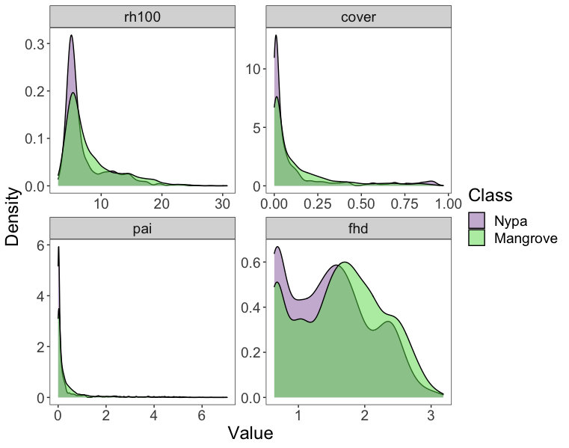
Figure S 1: Structural differences between Nypa palm (purple) and Mangrove forests (green). A) Distribution of structural variables analyzed from GEDI measurements, including top-of-canopy height (rh100), vegetation cover (cover), plant area index (pai), and foliage height diversity (fhd) - a measure of structural complexity.

