TITLE: NASA Team Develops a Test Article to Demonstrate “Zero Boil-Off” Storage of Liquid Hydrogen via Cryocoolers and a Two-Stage Cooling Approach
AUTHOR: Jonathan R. Stephens, NASA Marshall Space Flight Center
Funded by NASA’s Technology Demonstration Mission Program and managed by the Cryogenic Fluid Management Portfolio Project, a NASA team is developing a test article to demonstrate the “zero boil-off” storage of liquid hydrogen using active cooling (cryocoolers) and a two-stage cooling approach. The current state of the art for storage of liquid hydrogen on-orbit is on the order of hours while future missions may require storage for months or even years. To enable such extended storage durations, “near zero” propellant loss, or “zero boil-off”, must be achieved. This may be accomplished with the implementation of “near zero” leakage components, a high performing suite of passive technologies to minimize the environmental heat loads, and active cooling via cryocoolers to intercept and remove heat from the propellant tanks and associated structure. Of course, with any cryogenic vehicle and mission, a mass and power trade should be conducted to determine if it is indeed feasible to carry the additional dry mass associated with active cooling, or if one could simply carry additional propellants to accommodate propellant loss which is typically not an option for a long duration mission.
Cryocoolers operating at 20 Kelvin are needed for “zero boil-off” storage of liquid hydrogen, while their 90 Kelvin counterparts are used for soft cryogens such as liquid oxygen, liquid methane, or liquid natural gas. Since cryocoolers are a source of dry mass and require electrical power, it is desirable to minimize the refrigeration required to achieve “zero boil-off” conditions which can be done by including technologies such as low conductivity structures and high performing insulation. Less refrigeration requirements lead to fewer or smaller cryocoolers, hence mass and power savings. With active cooling and minimal environmental heat loads, “zero boil-off” conditions for liquid hydrogen storage can be achieved with 20 Kelvin units alone, however they have a significantly larger specific mass (kg/W) and specific power (W/W) relative to their 90 Kelvin counterparts, meaning larger mass and greater electrical power required per watt of refrigeration.
This effort focuses on the development of a ground test article to investigate a two-stage active cooling approach which can potentially lead to mass and power savings when active cooling is implemented for long duration liquid hydrogen storage. Since the specific mass and specific power associated with the 20 Kelvin cryocoolers are high relative to 90 Kelvin cryocoolers, the objective is to intercept and reject as much heat as possible with a 90K cryocooler, then use the 20 Kelvin unit for tank heat removal and pressure control. Previous efforts ([1], [2], and [3]) have shown via analysis and testing, that this two-stage approach trades well against a single-stage approach in terms of mass and power savings.
Leveraging demonstrations and lessons learned from the NASA’s Cryogenic Propellant Storage and Transfer program, the test article will include a fully integrated suite of required technologies which includes a propellant tank equipped with a tube-on-tank heat exchanger, a load bearing multi-layer insulation inner blanket, a thin foil tube-on-shield broad area cooling heat exchanger located within the insulation and thermally strapped to the support struts, and an outer multi-layer insulation blanket. The thin foil tube-on-shield broad area cooling heat exchanger will be connected to the 1st-stage cooling loop of an industrial cryogenerator (Fig. 1) and will be operating at temperatures of 80 Kelvin and below, while the 2nd-stage loop will be connected to the tube-on-tank heat exchanger and operating at approximately 20 Kelvin.
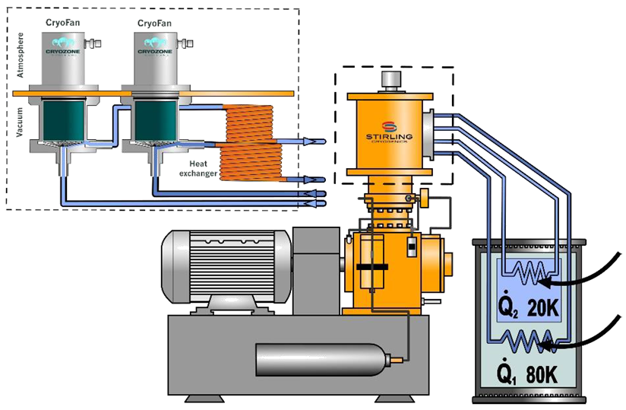
Fig. 1: Two-Stage Cryogenerator, Courtesy of Stirling Cryogenics
Propellant Tank
The team procured a propellant tank outfitted with a tube-on-tank heat exchanger specifically for this test article. It is a “non-flight” ASME rated tank constructed of Al 5083 and the tube-on-tank heat exchanger made from Al 1100 which has an extremely high thermal conductivity at liquid hydrogen temperatures. There are a total of nine tubes, each having a flow diameter of 0.18”. However, the tubing is D-shaped, thick-walled tubing which is desirable to minimize the risk associated with welding and maximize the contact area between the tube and the tank surface. The tube-on-tank heat exchanger has a supply/return manifold on both the forward and aft ends to enable the refrigeration loops to be configured for flow in either direction. An image of the 2-SC propellant tank is shown below in Fig. 2.
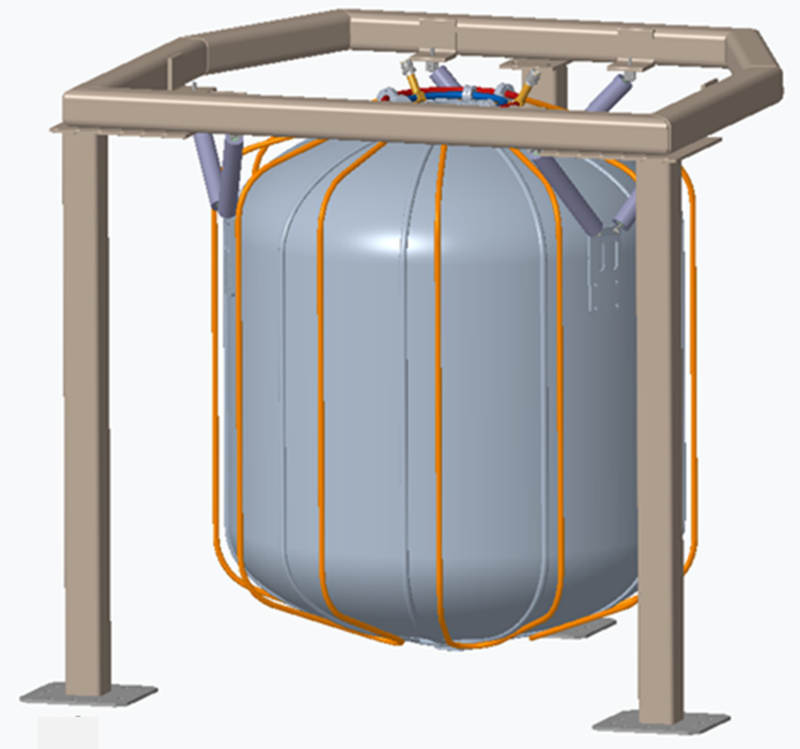
Fig. 2: Tank with Tube-On-Tank Heat Exchanger with Tube-On-Shield Coolant Loops Shown, Tank Model Courtesy of PHPK
Cryocoolers
The first phase of testing is planned to be conducted with a two-stage industrial cryocooler, or cryogenerator, with the 1st stage and 2nd stages operating at 80 Kelvin and 20 Kelvin, respectively. This team recently procured such a unit with two separate heat exchangers and gas flow loops that would meet the requirements with extra margin to spare for future test programs: the Stirling Cryogenics SPC-1T (see Fig. 1 and Reference 4). Initially, this system will simulate the operation of the Reverse Turbo-Brayton Cycle cryocoolers which are currently being developed for flight applications and planned to be used on a follow-on test series.
Insulation
The eventual use of the flight cryocoolers imposes constraints on the insulation system design. To enable a “zero boil-off” demonstration with the 20 Kelvin flight cryocooler, not only did the allowable pressure drop and helium flow capacity drive the sizing of the tube-on-tank heat exchanger, but there are limitations on heat lift which drives the design of the insulation system as well. A heat load budget was created assuming 20 Watts as the cryocooler cooling limit. Allowing for parasitic heat loads associated with cryocooler integration and including some conservative margin, the result is 11 Watts limit to the total propellant tank heat load, of which 3 Watts is through the tank acreage while the remaining is associated with support structure, penetrations, and instrumentation. To achieve this low heat flux (~0.52 W/m2), a high performing insulation system must be implemented.
A private company was contracted via NASA’s Small Business Innovation Research program for the design, build and installation of the test article insulation system which includes both insulation blankets, the thin foil tube-on-shield broad area cooling heat exchanger and a wrapped multi-layer insulation system to be applied to the struts, refrigeration lines, as well as penetrations for filling, draining, pressurizing, and venting the test article. The inner blanket will be required to have the load bearing capability needed to support the weigh associated with the thin foil tube-on-shield broad area cooling heat exchanger and the outer blanket. Based on the most recent analysis, the inner blanket configuration is 10 reflective layers, while the outer blanket is 24 layers.
Planned Testing
Once the build of the test article and cryogenerator characterization testing is complete, these components will be integrated into the Test Stand 300 20’ vacuum chamber facility at NASA Marshall Space Flight Center and undergo approximately sixteen weeks of continuous testing with liquid hydrogen. A detailed test plan will first determine the steady-state heat load associated with the environment followed by active cooling using both a single-stage and two-stage cooling approach.
Summary
Analysis to date and previous test programs indicate that the implementation of the two-stage cooling approach can potentially lead to significant mass and power savings when active cooling is used to enable the long duration storage of liquid hydrogen. The team plans to conduct a detailed test series which includes demonstrating “zero boil-off” utilizing a single stage cooling approach (baseline with the 20 Kelvin stage only), and the two-stage cooling approach at different thin foil tube-on-shield broad area cooling heat exchanger temperatures. When the effort concludes, this approach and integrated suite of Cryogenic Fluid Management technologies will advance to a Technology Readiness Level of 6 for surface applications. However, due to the gravitational sensitivity associated with the tube-on-tank heat exchanger in a micro-gravity environment, the application will remain at Technology Readiness Level of 5 until a flight demonstration can be achieved. Testing is currently planned for late 2024.
Acknowledgement: The author would like to acknowledge the Two-Stage Cooling Activity Team which without their hard work, this effort would not be possible: Travis W. Belcher, Patrick A. Giddens, Ryan J. Grotenrath, Brian D. Hamill, Sarah Nguyen, Kevin W. Pedersen, James W. Smith, Juan G. Valenzuela, and Robert M. Witbrodt.
References:
[1] D.W. Plachta, W.L. Johnson, and J.R. Feller, “Cryogenic Boil-Off Reduction System Testing”, AIAA/ASME/SAE/ASEE Join Propulsion Conference, July 28th, 2014, Cleveland, OH. https://ntrs.nasa.gov/api/citations/20150000134/downloads/20150000134.pdf
[2] D.W. Plachta, W.L. Johnson, and J.R. Feller, “Zero Boil-Off System Testing”, Cryogenics, Volume 74, 2016, Pages 88-94, ISSN 0011-2275, https://www.sciencedirect.com/science/article/abs/pii/S0011227515001265
[3] “Vibro-Acoustic Test Article (VATA) Test Series”, Noah o. Rhys, Lee W. Foster, Jessica J. Wood, Juan G. Valenzuela, and Jim J. Martin, NASA Marshall Space Flight Center, Huntsville, AL. https://ntrs.nasa.gov/citations/20190031823
[4] Stirling Cryogenics, “SPC-1T Cryogenerator”, https://stirlingcryogenics.eu/wp-content/uploads/2022/09/Stirling-Cryogenics_DS-SPC-1T-ENG-13-09-2022.pdf

