Using mylar-insulated cryopumping panels to improve vacuum level during warm temperature testing at JSC’s large thermal vacuum facilities
B Gasior¹, J Owen¹, K Cui¹, H Song¹, and J Homan¹

¹Johnson Space Center, Houston, TX, 77058, United States of America

E-mail: brett.t.gasior@nasa.gov, julianne.owen@nasa.gov, kaixin.cui@nasa.gov, hee.j.song@nasa.gov, jonathan.l.homan@nasa.gov
Abstract. Johnson Space Center’s Space Environment Simulation Lab (SESL) has both Chamber A, the world’s largest purpose-built thermal vacuum chamber capable of creating deep space conditions, and Chamber B, the largest human rated thermal vacuum chamber. A unique design feature of these chambers is the gaseous helium cryopumping panels within the liquid nitrogen shroud. This shroud is used to bring the chamber to cryogenic temperatures while the cryopumping panels trap gasses on its surface area to create a high vacuum environment of 5*10⁻⁶ Torr. In preparation for the James Webb Space Telescope (JWST) flight test, a series of functionals required the chamber to run at higher temperatures, and therefore did not need active cooling from the liquid nitrogen shroud. During testing, cryopumping panels were used to mitigate contamination during this main shroud warm-up. One of the cryopumping panels in Chamber A was covered with several layers of aluminized mylar to thermally protect the zone from the warmed shroud. This strategy was effective and became part of operations during JWST testing. Currently, Chamber B has requests for both commercial and NASA space suit tests at both high and low temperatures to validate thermal models. High temperature tests could benefit from reduced heater demand with an insulated shroud while still sustaining the high vacuum environment provided by the cryopumping panels. This paper will quantitatively define the thermal loads on the panels used in previous Chamber A warm up sequences. Additionally, this report will perform thermal analyses to assess the feasibility of adding layers of aluminized mylar to the cryopumping panels of Chamber B.
- Background
The Johnson Space Center’s Space Environment Simulation Lab (SESL) houses two specialized chambers. Chamber A, seen in Figure 1, is the world’s largest purpose-built thermal vacuum chamber capable of creating deep space conditions. Chamber B, seen in Figure 2, is the largest thermal vacuum chamber designed for human-rated operations. Chambers A and B were built in 1964 to support testing of the Apollo vehicle and command module to train astronauts in a simulated space environment [1]. For the James Webb Space Telescope (JWST) thermal vacuum test in 2017, Chamber A was upgraded to simulate a deep space environment with temperatures as low as 13.5 Kelvin [2].
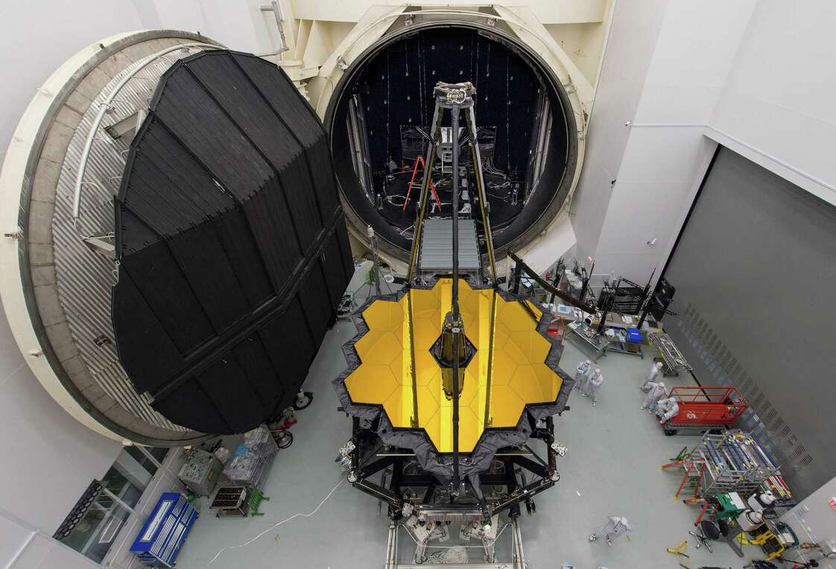
Figure 1. James Webb Space Telescope & Chamber A

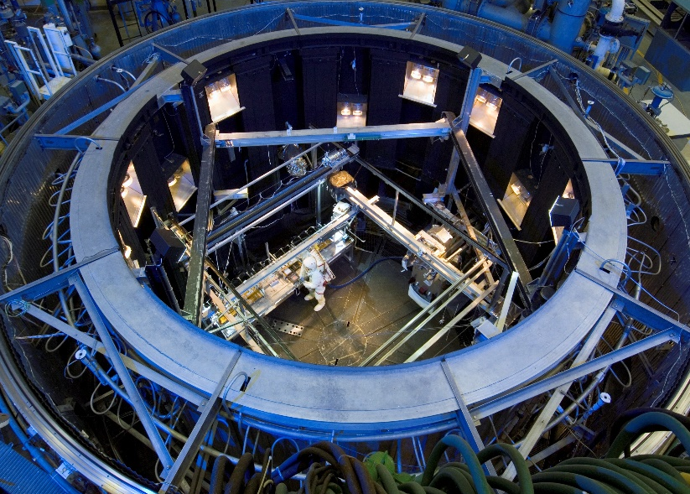
Figure 2. Top down view of Chamber B

- Helium Cryopumping Panel Background
A unique design feature of these chambers is the presence of gaseous helium cryopumping panels within the chamber’s liquid nitrogen shroud. This shroud is used to bring the chamber to cryogenic temperatures while the cryopumping panels utilize their extensive surface area to trap gases, creating a high vacuum environment with pressures lower than 5*10⁻⁶ Torr.
In preparation for the JWST flight test, a series of functionals required Chamber A to operate at higher temperatures. Active cooling from the liquid nitrogen shroud was not necessary, since the cryopumping panels could still effectively mitigate contamination at these higher temperatures. During the main shroud warm-up, one of these cryopumping panels was covered with several layers of aluminized mylar. The mylar insulation was added to reduce heat transfer and thermally protect the zone from the warmed shroud. This strategy proved effective in improving efficiency and mitigating contamination and became part of operations during JWST testing.

Proposed Insulation on Cryopumping Panels
Currently, Chamber B has requests from both commercial and NASA space suit tests to accurately generate thermal models at both high and low temperatures. High temperature tests would benefit from a warmer shroud while sustaining the high vacuum environment provided by the cryopumping panels. To enhance the efficiency of operations during these tests, it has been proposed that thermal insulation be added to Chamber B’s cryopumping panels.
- Building the Thermal Model of Chamber B
A feasibility study using a thermal model of the chamber was conducted. Within Chamber B, there are four different LN₂ shroud zones (labeled as N2, M2, L2, and P2) and an LN₂ shroud covering the outer walls of the chamber (labeled with an A prefix); depicted in Figure 3. Fifteen cryopumping panels (labeled with a B prefix) are located behind each inner LN₂ panel. Neither these zones nor the inner and outer shrouds of the LN₂ panels can be controlled individually. Since there is no individual control of the LN₂ panels, the analysis model assumed all of the helium cryopumping panels were insulated with mylar. The surface emissivity of the shrouds and panels was measured using an emissometer/reflectometer. The front of the LN₂ panels, which are coated in black paint, have a measured emissivity of 0.90, and the back of the LN₂ panels, with no paint, have a measured emissivity of 0.16. The helium cryopumping panels, which are uncoated, have an emissivity of 0.13.

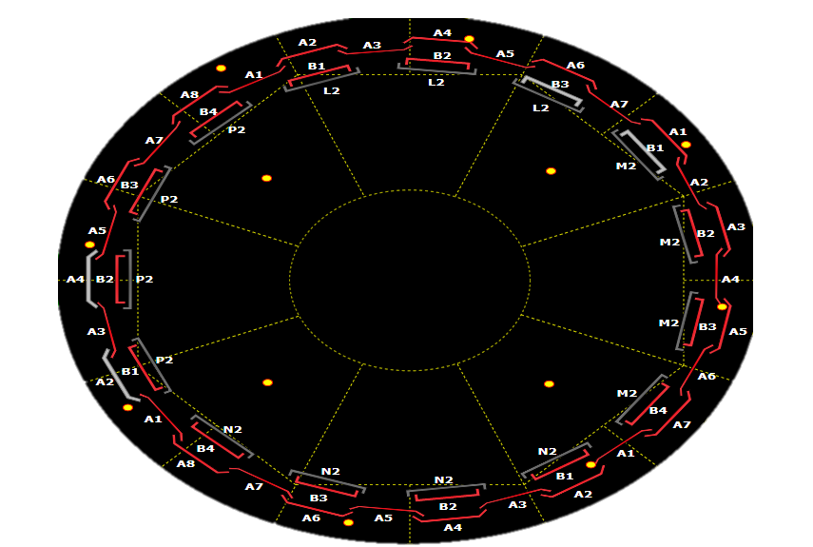
Figure 3. Representation of the LN₂ shrouds and helium panels on the facility data screens

Data Collected from Chamber B Functionals
In March of 2023, a full thermal vacuum functional was run on Chamber B in preparation for future testing. Temperatures of the LN₂ zones and the helium cryopumping panels were used as boundary conditions for the analysis model. The time that the cryopumping panels took to go from their initial (room temperature) steady state condition to their final cold steady state condition (~20 and 90K for helium and LN2 respectively) was used to make the Thermal Desktop model as accurate as possible. Figure 4 above shows the helium cryopumping panel temperature, and Figure 5 shows the LN2 shroud temperature in Zone N of Chamber B throughout the functional. Finally, data from a Type T thermocouple attached to the wall of the chamber was used as boundary conditions for the outer LN2 panels.
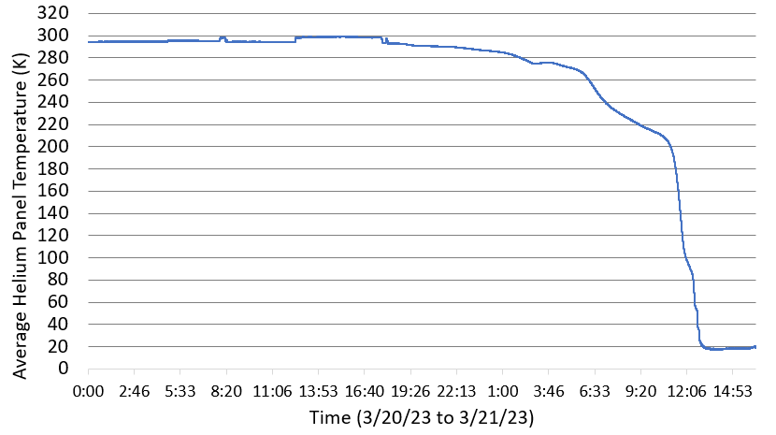
Figure 4. Helium cryopumping panel temperature

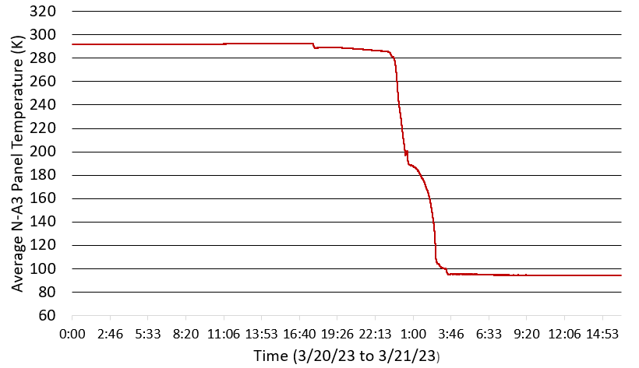
Figure 5. Zone N LN₂ shroud temperature

Thermal Desktop Model
Measurements of the cryopumping and shroud panels in Zone N of Chamber was used to create a CAD model in Creo Parametric 8 and subsequently imported into Thermal Desktop. The thermal model was constructed with three-dimensional elements with a unit height thus is effectively a two-dimensional model. For these type elements, the insulation feature can be used and parameterized for insulation studies. Thermal elements included the specific dimensions of pipes. Convection nodes for helium and LN₂ were tied to the inside of these pipes and provided temperatures of 20K and 90K to the cryopumping panels and shrouds respectively, as shown in Figure 6.

Thermophysical and optical properties were comprised of Aluminum 1100-H14 for the panels and previously measured emissivity for the black paint coating. Radiation sink temperature of the walls beyond the shroud was 225 K as provided from the functional. Two blackbody circles above and below the thermal elements were added to ensure no heat flux outside the unit height. Insulation was added to the model using the effective emittance (E-star) values of varied MLI (multi-layer insulation) layers [3]. The result of the model can be seen in Figure 7, displaying the temperature outputs for a test case with insulation.

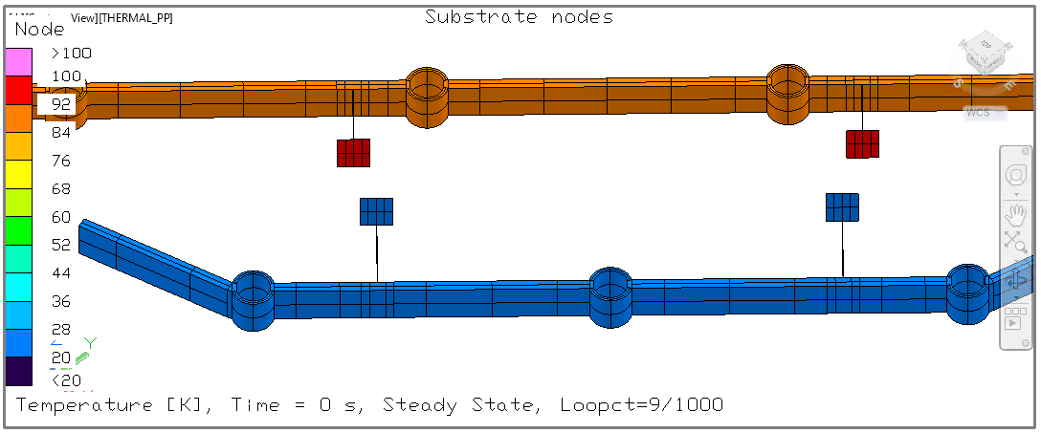
Figure 6. Thermal model with provided temperatures of 20K and 90K to the cryopumping panels and shrouds

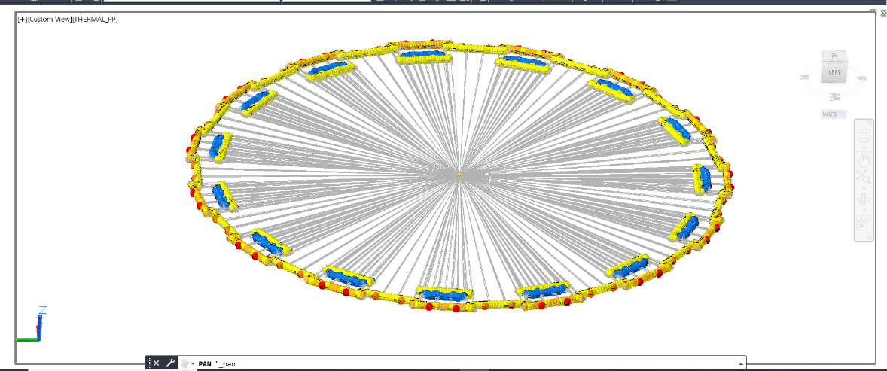
Figure 7. Back insulation case thermal model result
- Conclusion
Three insulation configurations of the cryopumping panel were analyzed. These cases modeled insulation on the front of the cryopumping panel, pointing towards the center of the chamber, on the back of the panel, and a final case with both sides insulated. These cases were run parametrically, with layers modeled from five to fifty MLI layers, in increments of five. Additionally, a control case with no insulation was run. The heat flux from the cryopumping panels for each of the 3 MLI configurations were compared with the heat flux of the control (uninsulated) configuration, as a percent reduction.
Figure 8 displays the percentage of the original heat flux per layer insulation for all three cases. The results of these graphs all have similar large initial reductions of heat flux near the first five to ten layers, and then stabilize around 88% for the front case, 17% for the back case, and 3.5% for the case with both.

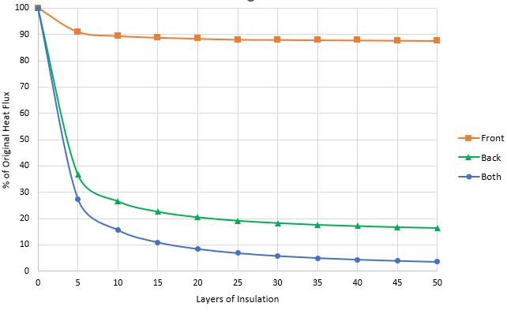
Figure 8. Percent of heat flux per layer of insulation

- Future Work
Following this study, further experimental validation is necessary. As seen from Figure 8, slight temperature differences between the inner and outer LN2 shroud temperatures can greatly impact the results and implied MLI configuration. Analysis results indicate the influence of warmer chamber wall temperature on outer LN2 shroud thus increased heat flux from the outer LN2 shroud to the cryopumping panels. Silicone diodes will be installed to provide a temperature of the gaseous helium in the pipes. This additional data will ground the thermal model with more accurate boundary conditions.
Tests need to be conducted to validate the results of the thermal analysis and to assess the impact of adding 5 layers of MLI around the cryopumping panels. Additional functionals will be run with the installed MLI to ensure how test results compare with the thermal model. There are various types of MLI that can be used such as perforated mylar. As part of this feasibility study, the reliability, ease of integration, and economic costs must also be considered.
- References
- Gutro R 2013 James Webb Space Telescope Chamber A NASA https://www.nasa.gov/mission_pages/webb/news/chamber-a.html
- Historic American Engineering Record - TX-1124 Library of Congress https://www.loc.gov/resource/hhh.tx1124.sheet/?sp=1
- Gilmore D G 2002 Spacecraft Thermal Control Handbook The Aerospace Press and American Institute of Aeronautics and Astronautics, Inc.
Acknowledgments
We would like to thank John Tatum, Cody Schaefer, Gerardo Barrios, Steven Del Papa, Shakira Morera-Felix, Ian Graham, Rumualdo Gonzalez, Darren Nelson, Tayera Ellis, Sam Vengerik, Miria Finckenor, Meghan Carrico, and Jesse Macias. In addition, we would like to thank everyone in the Systems Test Branch of the Crew and Thermal Systems Division at NASA JSC.

