EVOLUTION OF ASTRODYNAMICS FOR MULTIBODY ENVIRONMENTS, NUMERICAL PRECISION AND DYNAMICAL UNDERSTANDING

David C. Folta* and Kathleen C. Howell†

The innovative nature of dynamical systems theory and its applications in trajectory design enabled many recent missions by opening up new transfer and capture opportunities to meet mission requirements, reduce fuel costs, and address various launch constraints and contingencies. With a combination of proven numerical methods and an advanced understanding of the dynamics, an ‘experienced’ user can rapidly design multibody and cislunar missions such as Lunar IceCube and Artemis/Themis and relatively quickly conceive trajectory concepts for Sun-Earth mission orbits, such as the Space Weather Follow On-L1 Lissajous orbit—one that can be achieved and maintained.

INTRODUCTION

A synopsis of the astrodynamics evolution of dynamical systems methodologies as practical approaches to Sun-Earth, Earth-moon and cislunar designs, combined with established numerical applications, is presented along with a brief description of specific missions that have seen benefits. While the early use of dynamical systems theory for applications arose from the desire to understand the interactions and basic principles of these unique regions, it was not anticipated that such insights would provide the essential capability to design trajectories for advanced observatories such as the James Webb Space Telescope or the Artemis Gateway mission. Such mathematical approaches provide the mission designer with a significantly enhanced understanding of the entirety of the space environment during a transit. It was not completely understood that the practicality would permit innovative methods to achieve and maintain these challenging orbits by utilizing all or parts of the foundational dynamical systems theory within a numerical and high-fidelity construct.

To clarify the overall evolution of astrodynamics for multibody environments and the related numerical precision and dynamical understanding, our discussion begins with a review of the methods and the model fidelity to support early lunar and cislunar missions. Looking back at these missions of the 1960s and 1970s, we review the types of the perturbation models and the numerical targeting schemes available. These are not vastly different from models and methods used in the early 2000 timeframe and, in most cases, current applications. With respect to a dynamical systems context, early on, most of the systematic approaches focused on the Circular Restricted Three Body Problem (CR3BP), or applied expanded Taylor series to approximate such
__________________
* Senior Fellow, Aerospace Engineer, NASA Goddard Space Flight Center, Greenbelt, MD. 20771, david.c.folta@nasa.gov
† Hsu Lo Distinguished Professor of Aeronautics and Astronautics, School of Aeronautics and Astronautics, Purdue University, West Lafayette, IN 47907; howell@purdue.edu

regions, as was accomplished with the Richardson-Carey constructions to estimate the underlying behaviors for the International Sun Earth Explorer-3 (ISEE-3) Sun-Earth L1 (SEL₁) orbit.[1,2,3] Given that level of approximation, an improved CR3BP estimation was developed; however, it would be years before these basic concepts included the higher-fidelity perturbations of Earth and Moon ephemeris models. Once this level of accuracy was achieved, the collaboration with numerical designs flourished.

Original Numerical and Dynamical Cislunar Designs

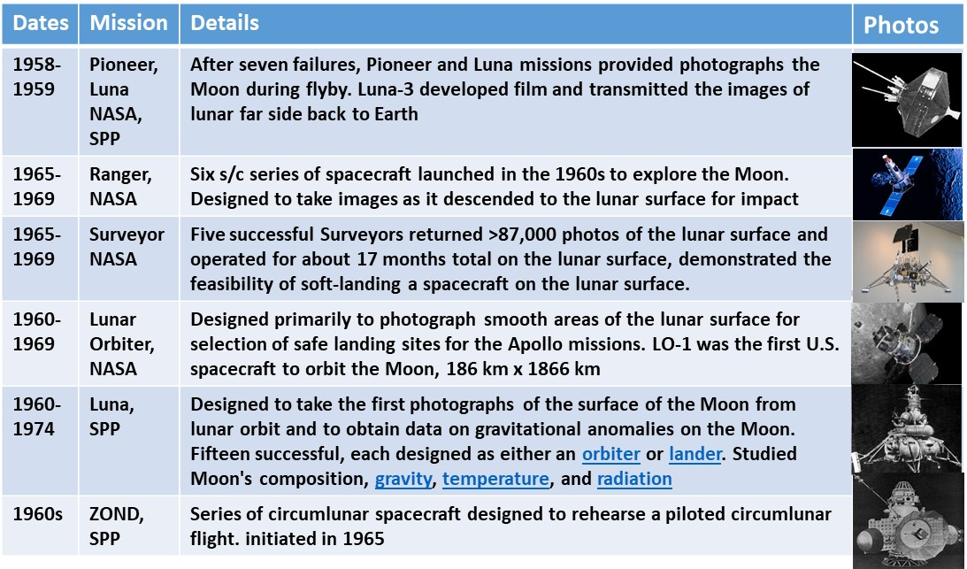
From the early NASA and international cislunar and lunar mission programs, only three of the first 27 lunar missions were successful. Given that success rate, a reasonable concern is the level of fidelity expected in simulations and the environmental models for trajectory design and operations. [4] The early design approaches for trajectories in cislunar space originated differently from the more dynamically-informed strategies now employed, but first consider the requirements. A straightforward design example is the Ranger-7 mission that required very precise targets and objectives, and encountered the lunar surface in direct motion along a hyperbolic trajectory, with an incoming asymptotic direction at an angle of -5.57 degrees from the lunar equator. The orbit plane was inclined 26.84 degrees to the lunar equator. After 68.6 hours of flight, Ranger 7 impacted in an area between Mare Nubium and Oceanus Procellarum at 13:25:48.82 UT at a velocity of 2.62 km/s. Several other lunar missions were successful and led to the mapping of the lunar surface as well as establishing a basic understanding of lunar orbits and lunar gravity perturbations, although very limited since the main objectives in these missions involved a survey of locations for Apollo landing sites. Table 1 provides examples of missions from the 1950s to the mid-1970s. The SPP acronym is for the Soviet Space Program, prior to Roscosmos.
Table 1. Early Lunar Mission Examples

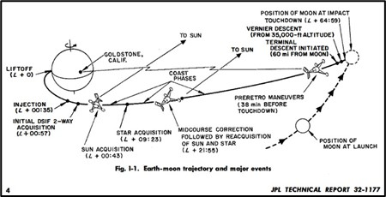
Surveyor III launched on April 17, 1967, from Cape Kennedy with the Atlas/Centaur AC-12 vehicle. The Centaur burn injected the spacecraft into a temporary parking orbit with an altitude close to the nominal 167 km. After a 22-min coast period, the Centaur was reignited and injected the spacecraft into a very accurate lunar transfer trajectory as shown in Figure 1. The uncorrected lunar impact point was approximately 466 km from the prelaunch target point. Even in the early days of lunar trajectory design there was an understanding that gravitational perturbations of the Sun and planets could alter the reference trajectory. As noted in Table 2, simulations were already at a level to permit reasonable (realistic) lunar designs. Note that the coordinate frames, that is, inertial, equinox, Local Vertical Local Horizontal, and others, were originally established for aerodynamics and ballistic missile/rocket applications. As the need for improved models became more urgent, by the mid-1980s, rotating, velocity-normal-binormal, and fixed frames were recognized with numerous others added to address specific mission requirements. Such mission-specific frameworks included primary-secondary rotating frames. Thus, trajectory design and maneuver model resolution increased with the improvement in computational power; most modeling and integration types emerged very similar to today’s versions.
Figure 1. Surveyor Mission Concept

Table 2. Examples of Simulation and Modeling Progress
 | Apollo Era | 1980s operation  (GSFC Ref for Libration, flybys) | Current Operations  (GSFC ref; Cis-lunar, flybys, lunar, libration orbiters)
Coordinate frame | Mean Celestial Equator and Vernal Equinox, IMU, LVLH, | Inertial, Rotating, Fixed, IMU, LVLH, VBN, | Inertial, Rotating, Fixed, IMU, LVLH, VBN, Body, numerous others constructed
Perturbations | Simplified Earth model, third body (Sun, Moon, Earth) | Earth, Moon, point mass third body (all planets and sun), Solar radiation pressure, spherical harmonics models | Earth, Moon, Point mass third body, Spherical harmonics models, Solar radiation pressure, flat plate and coefficients, tides
Integration | Encke, Runge-Kutta, Cowell | Cowell 12th Order, Adams-Bashforth Predictor Corrector, fixed step and time regularized, Runga Kutta, Others… | Runga Kutta versions, Cowell, Others…
Lunar Gravity  Models | 4 x 2 Deg and Order | 20 x 20 (Bills and Ferrari) | LP 165 x 165, LRO and Grail (1200 x 1200)
Maneuvers | Impulsive and Finite, some attitude profiles | Attitude dependent frames for Impulsive and Finite | Attitude dependent frames for Impulsive and Finite
Computer Systems | Mainframes and simplified calculators | Mainframe IBM 360-90 and 360-75, Moved to PC in early 90’s. Start of real-time visualization. | Laptops, Servers, Unix, PC, multi-core systems,  high end 3-D Visualization
Analytical Models | Needed for speed, lambert targeting | Speed not required for mission types, Differential Correctors and Optimization | Increase CPU capabilities, e.g. GPU, Differential Correctors, Collocation, Optimization (multiple methods, e.g. SNOPT)
Atmospheric | Basic drag models | Drag models based on Harris Priester (HP) | HP, MJ70, MSIS, many others, etc.

Influence Of Multi-Body Dynamics

No lunar missions were launched in the 1980s. Lunar exploration ended with the last of the Apollo and Luna missions, and the next program was the Space Shuttle / Hubble Space Telescope (HST) and several planetary missions. The last lunar missions included Apollo 17 (1974), Luna 21 (Lunokhod 2 (rover)), Luna 22-24 (1976) with Luna 24 delivering a sample to Earth on August 23, 1976.

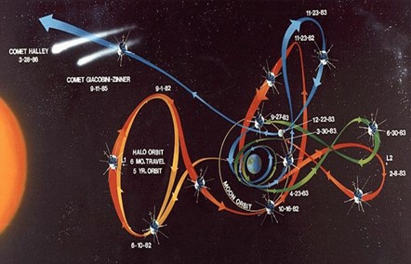
The International Sun Earth Explorer-3 (ISEE-3) / International Comet Explorer (ICE) mission, formulated and led by Dr. Farquhar while at Goddard, began the next stage with the first Sun-Earth libration point mission that demonstrated multi-body dynamics and the realism of circular restricted three body approaches to designs. [2,3] ISEE-3 achieved the first libration point orbit about SEL₁ in 1978 and remained on station for several years using a fundamental stationkeeping strategy based on numerically integrating the full state until a close approach to the reference torus was achieved, then executed a maneuver to adjust the velocity to follow a nearby halo orbit torus trajectory. This approach resulted in larger than necessary stationkeeping maneuvers, e.g., 1 m/s per month; but the viability of such design approaches was verified. With the addition of multiple lunar flybys to transfer between SEL₁ and SEL₂, and a cislunar entry into heliocentric space, ISEE-3/ICE intercepted Comet Giacobini-Zinner in 1985. A summary of the ISEE-3 trajectory is shown in Figure 2. After a 25-year heliocentric cruise, ICE returned to fly by Earth in 2014. The development and applications of CR3BP approaches and its various extensions began in earnest and initiated the dynamical systems evolution in support of astrodynamics applications. Dynamical systems research originating from the first steps by Archie Roy, Victor Szebehely, Roger Broucke, David Dunham, and Bob Farquhar, and others, then expanded significantly from work by Carlos Simo, Josep Masdemont, Gerard Gomez, Angel Jorba, Jerry Marsden, John Blackwell, Kathleen Howell, Martin Lo, Dan Scheeres, Jim Miller, Edward Belbruno, and many others that continues to this day with the next generation of researchers moving forward at a rapid pace.
Figure 2. The ISEE-3/ICE Mission Design

Multibody Transport Network Building Blocks

The first missions to these multibody regions were primarily based on numerical methods to achieve a specified orbital condition, and their applications were somewhat new for their time, with evolving levels of perturbation theory, optimization, and various unproven integration techniques that were being formulated to support Earth orbiters. To-wit, trying to utilize a time regularized 12th order predictor corrector integrator that was originally based on supporting low Earth orbits with a periapsis to design maneuvers for control of the ISEE-3 spacecraft in a SEL₁ halo orbit. Also, several differential targeting methods were used in combination with the anticipated evolution predicted by CR3BP motion.

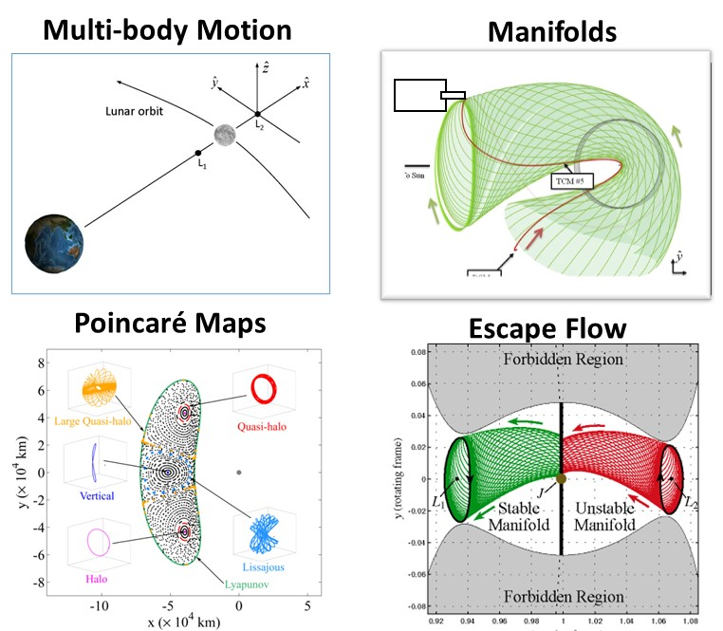
With respect to dynamical systems, in the beginning of this “application period”, we used raw data computation of state transition matrices and their monodromy matrices to determine simple intuitive concepts, e.g., visualizing and defining the stability for such libration point orbits such that the numerical targeting strategy was fully understood from a dynamical perspective. Then, a maneuver could be designed without the brute-force construction of direction and magnitude via differential corrections. This strategy allowed for correction to avoid an escaping trajectory, but also to meet target conditions that satisfy the dynamics, resulting in longer duration maintenance capabilities. Figure 3 presents several developments that provided guidance regarding manifolds, heteroclinic and homoclinic designs and Poincaré maps. These innovations allow descriptions of various libration point orbit conditions that are now routine.
Figure 3. Visualized Dynamical Systems for Design Guidance [5-7]

With the increased general knowledge, improved perturbation models, additional coordinate frames, integration method enhancements, along with new computational capabilities, the multibody transport network evolution began. There was now a basic understanding of the multibody environment that could be exploited for Sun-Earth and Earth-Moon libration point orbit design. Even the original SEL₁ orbiter, ISEE-3, relied on the application of series expansions for perturbations to aid in the explanation of the oscillatory behavior, with similar revolutions. Numerical use of an ‘high-precision’ Cowell-Moulton 12th order predictor/corrector with the addition of a time-regularized application was employed to ‘follow’ a reference pattern established using the CR3BP along with a reference generated via the series expansion by Richardson-Carey.

CIRCULAR RESTRICTED THREE BODY PROBLEM ADVANCES TO SUPPORT ASTRODYNAMICS APPLICATIONS

As understanding of the multibody environment became common, the CR3BP was examined rigorously to prepare for other mission applications. The three-body problem as an analytical solution does not exist, but became a ‘rule’ for evolution in terms of an appropriate set of nondimentional nonlinear differential equations summarized as in Figure 4. Deterministic for one particular initial state, only one set of future states will evolve. We know the particular equilibrium solutions (e.g., the SEL₁and SEL₂ are equilibrium points, with two center components) and we have successfully determined – and learned to compute – some of the infinite number of periodic solutions. The Hamiltonian structure of the system gives rise to a wide variety of different families of periodic orbits that are available for mission design. Approximate solutions can be delivered numerically and linearized relative to a libration point, and/or formulated as linear variational equations to yield information on the stable and unstable directions, with respect to the equilibrium points, that give rise to the stable and unstable manifolds. Of course, exploiting the variational differential equations relative to the periodic orbits serves as the basis for much of the innovative design options the emerge from the focus on numerical methods.
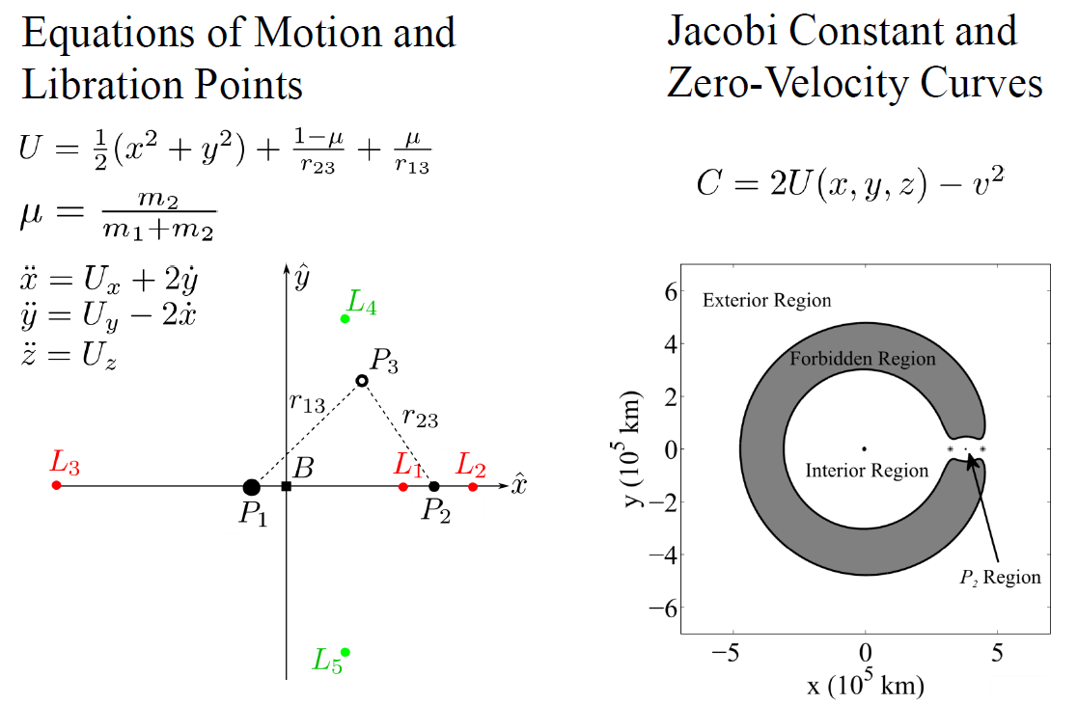
Figure 4. Familiar equations of motion
in the CR3BP

The development of design techniques originated from basic concepts in the vicinity of the equilibrium points in the CR3BP. The local region near an equilibrium point appears in Figure 5(a) with the bounding zero-velocity curves in black. In the local region near an equilibrium point, the stable/unstable manifolds appear in blue (ξ,η) in the figure. The manifolds serve as separatrices, and flow can transit past the equilibrium points (a sample transit in green) or denied the opportunity to pass through the equilibrium point region (non-transits in red) Similar motion emerges as the motion becomes more complex with a focus on periodic orbits in the vicinity of a libration point. As a Hamiltonian system, a periodic orbit in the CR3BP yields a monodromy matrix with eigenvalues in reciprocal pairs. A unity pair reflects the periodic orbits in families. For the other two pairs, denote λ₁ as the eigenvalue that is real with magnitude >1, then in the variational space, the unstable mode is directed along the associated eigenvector. The reciprocal eigenvalue, i.e., λ₂ = 1/λ₁ is the eigenvalue that is real but clearly <1 and, thus, yields the stable mode. Any complex pairs are also reciprocal and represent a center subspace. In Figure 5(b), a planar periodic orbit exists in the linear center subspace of a libration point orbit; again, the bounding zero-velocity curves at this energy level are plotted in black. The orbit and its associated stable and instable manifold trajectories appear in blue. The manifolds still act as separatrices and bound the flow. The sample transit paths are green; non-transits are red.

Beyond the equilibrium points and the periodic orbits, transfers remain a critical component for trajectory design to support actual missions. Although there are now a wide variety of concepts, some of the most basic transfer designs have been based on another type of fundamental behavior, i.e., homoclinic and heteroclinic connections that link periodic orbits. An example if each appears in Figure 6. The heteroclinic connection in Figure 6(a) links an unstable manifold trajectory departing an L₁ planar Lyapunov orbit (red) and evolve into the stable manifold trajectory arriving at an L₂ planar Lyapunov orbit (blue) at the same energy level, i.e., same JC value. In Figure 6(b), a homoclinic orbit departs and returns to the same L₁ Lyapunov orbit. [8]

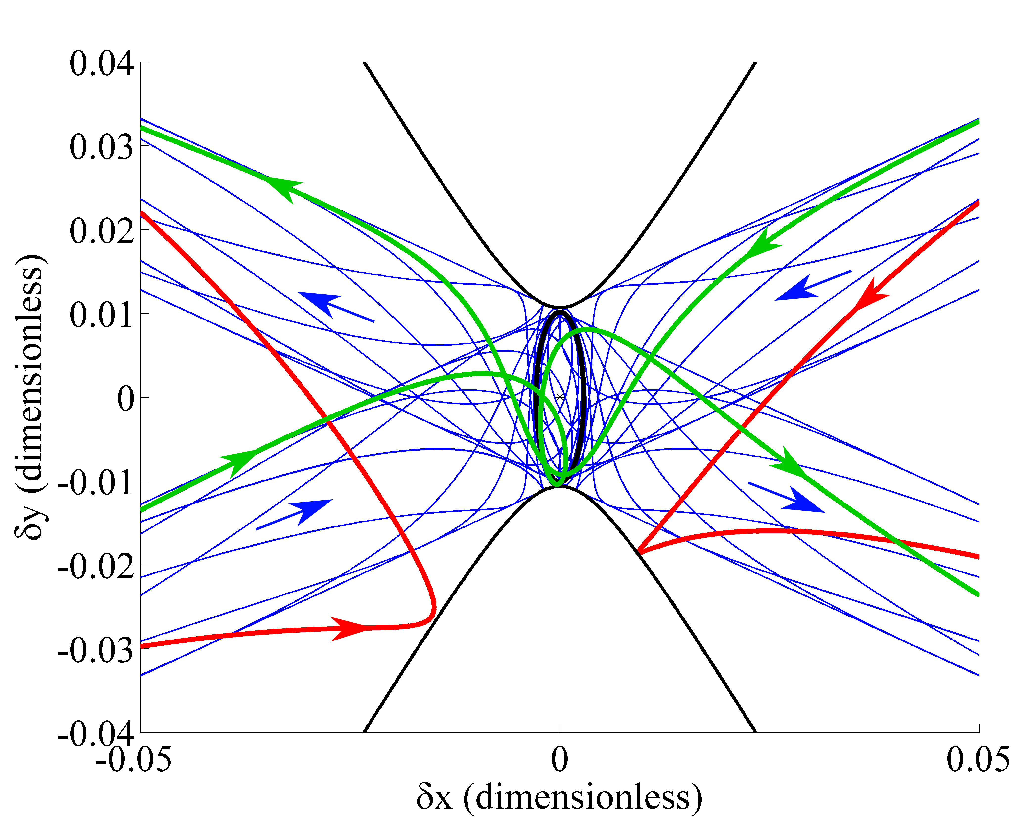
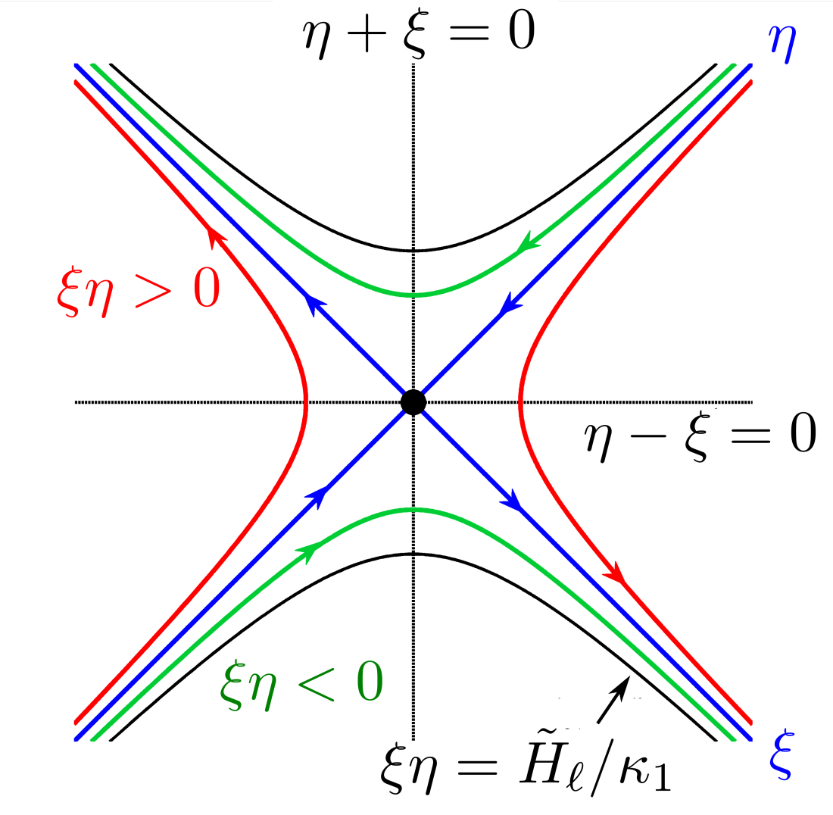

(a) Equilibrium Point
Figure 5. Flow through the local region near a libration point. [8]
(b) Planar Periodic Orbit
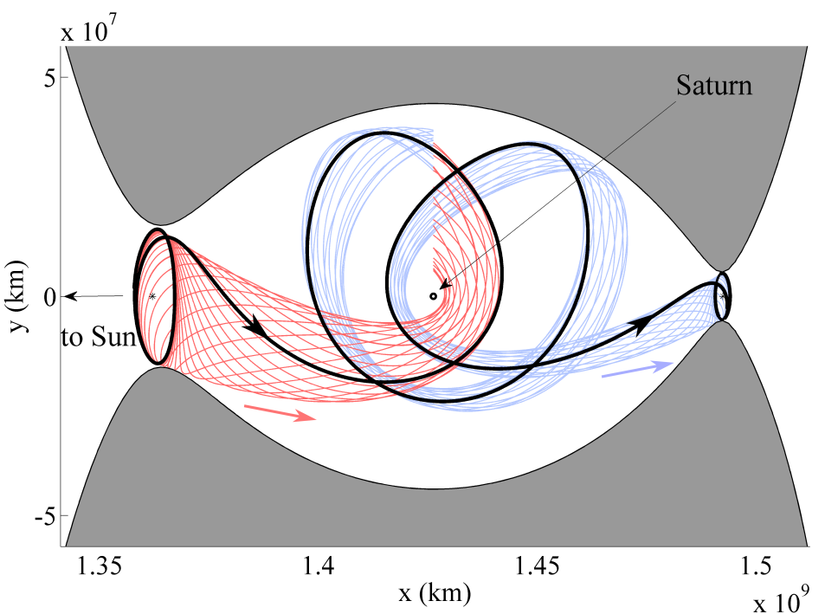
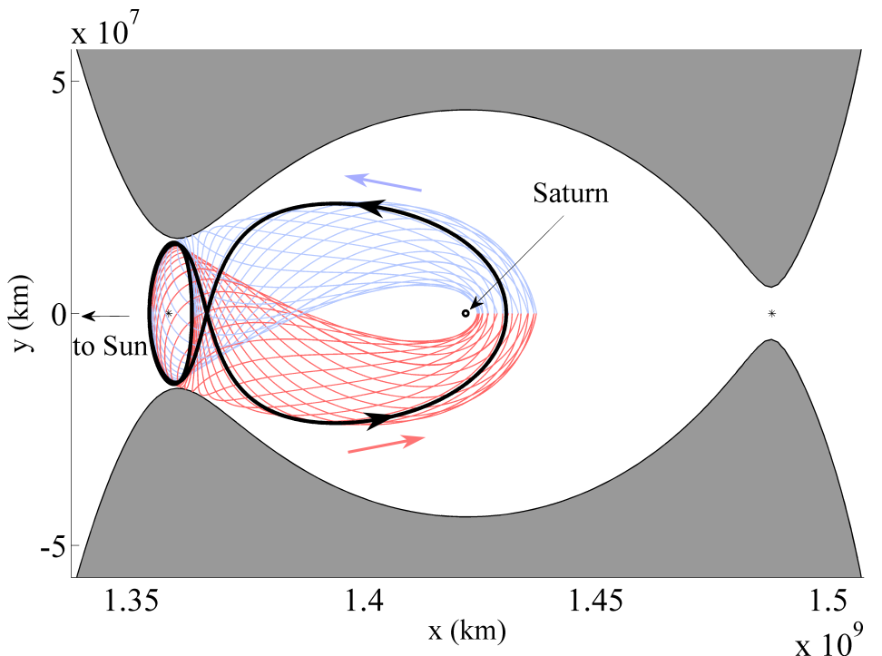

(a) (b)
Figure 6. in the CR3BP, sample planar (a) heteroclinic and (b) homoclinic orbits (plotted in black) . [8]

The dynamical systems approach provided a wealth of new options for cislunar and Sun Earth orbit design. At a minimum, CRTB approximations can be used to define types of orbits available for cislunar mission and to define initial conditions for lunar transfer as illustrated in Figure 7. [9-10] Planar as well as spatial resonant orbits in the CR3BP also appeared during these background development times that continue to deliver viable and beneficial characteristics for mission applications.
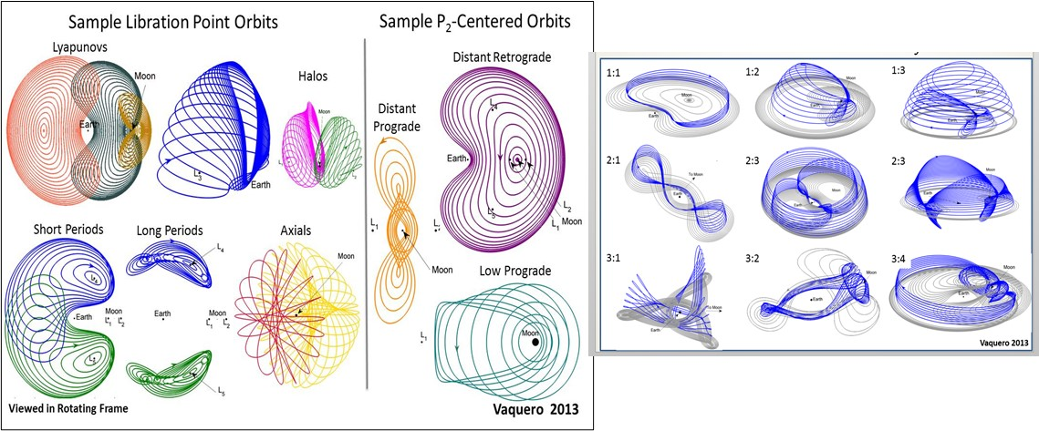
Figure 7. Sample Earth-moon Libration orbits using a CTRB approach. [9,10]
A Revisit to Lunar and Cislunar Mission Design Influenced by Dynamical Systems

The 1990’s provided continued improvements in techniques and intriguing new mission scenarios for multibody dynamics and a return to the Moon. During this time, NASA demonstrated new methods to reach the Moon and to design cislunar missions and improved the operational accuracies and navigation requirements.

The Clementine Mission (1994), a joint mission with the Ballistic Missile Defense Organization (BMDO) and NASA, entered into a lunar orbit sized as 430 km x 2950 km in 1994 and then it transferred to a trajectory to study an asteroid encounter with Geographos. The spacecraft obtained multi-spectral imaging of the entire lunar surface, assessed the surface mineralogy of the Moon, obtaining altimetry from +/- 60 deg latitude and obtained gravity data for the near side. The Lunar Prospector mission (1997), NASA’s first long duration low circular polar orbit of 100 km, achieved an orbit altitude of ~15 km x ~40 km (above the mean lunar radius), and discovered a frozen lunar orbit condition. The LP spacecraft had a controlled impact at end-of-mission. One of the purposes of the mission was to increase the fidelity of the gravity model degree and order. Lunar Prospector inserted into orbit using a 20 x 20 deg and order and delivered on this goal as evidenced by Bills and Ferrari. [11] A post mission opportunity produced a 165 deg and order gravity model based on Doppler measurements. [12] Previous research on the interaction of perturbations that permit lunar frozen orbits included Lidov, M.L., (1963), Ely and Lieb (2005), Ramanan and V. Adimurthy (2005), Park S.Y. and Junkins (1995), Elipe and Lara, (2003), Folta and Quinn (1998, 1999 (post LP mission results)). [13-19] Several missions as seen in Table 3 including Artemis (Themis), GRAIL, and Chang’e-4 fully exploited the multibody foundations. These missions attain lunar orbits using the aforementioned manifold trajectory generation techniques and the understanding of the stability in these regions.

The WIND (1994) and Geotail (1992) missions did not enter into lunar orbit, but used multiple lunar gravitational assist to attain their respective cislunar and Sun-Earth libration mission orbits. WIND required the use of multiple lunar flybys to rotate the line of apsides to ensure that apoapsis was along the Earth-Sun line, before/after entering into the SEL₁ orbit for its transfer to other near-Earth regions that relied on dynamical systems and multibody applications. Genesis (2001) demonstrated the interactions of the dynamically sensitive regions for transfer to Earth entry. [20,21] The Hiten mission (1990) was the first that employed a ballistic transfer starting with a spacecraft in a large elliptical Earth orbit and using lunar flybys with the intent to achieve a lunar orbit. These missions are illustrated in Figure 8. Each of these missions employed dynamical systems to various degrees along with improved targeting, optimization, and perturbation models developed by preceding missions. With a combination of these improvements and understanding of the multibody regions, a successful design was a certainty. It is notable that trajectory planning for Genesis in the late 1990’s was accomplished initially with the original concept from a dynamical systems perspective. With a successful planning outcome for Genesis and other mission in the timeframe, these approaches gained a permanent place in a trajectory analyst’s toolbox. Later missions appearing in Table 3 are beneficiaries of earlier developments.

Table 3. Lunar Missions 2000-2023
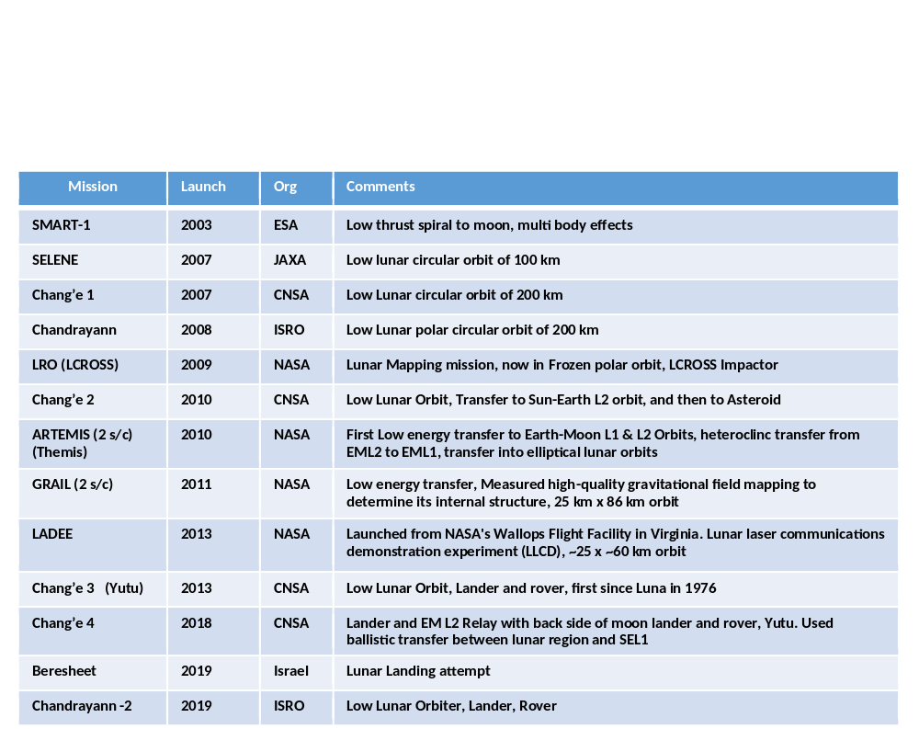
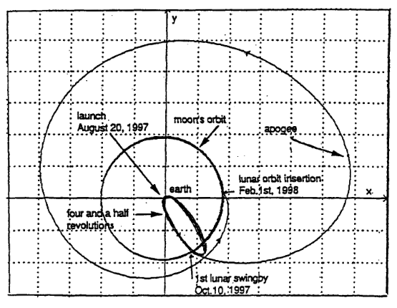
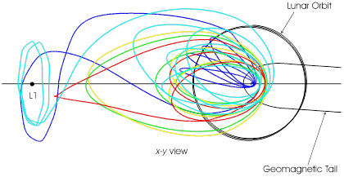
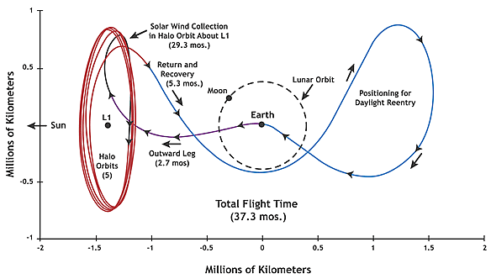

Figure 8. Hiten(left), Wind, and Genesis (right) Trajectories in Solar Rotating Coordinate Frame.

Recent Applications of Multibody Dynamics

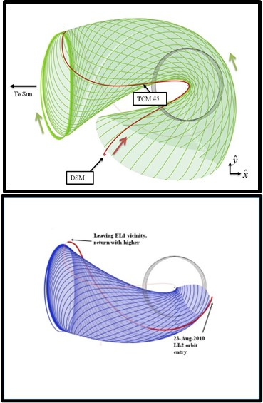
Examples of dynamical systems, or multibody dynamics, within the context of actual flight have become more plentiful in the past decade (2010-2023) with several missions based on this intuitive design approach. In this example, we focus on its use for the first applications to achieve Earth-Moon L₂ and L₁ quasi-halo orbits and on transfers to the SEL₁ and SEL₂ regions. A unique application to the Artemis/Themis Mission trajectory design achieved lunar orbit from an initial Earth elliptical orbit, in Figure 9. [5,6,22] Two lunar gravity assists separated by 13 days flipped the apoapsis direction and attained a ballistic Sun-Earth trajectory along with a deterministic Deep Space Maneuver (DSM1). All maneuvers targeted an Earth-Moon libration point orbit insertion state based on improved CR3BP fidelity for both a Sun-Earth and Earth-Moon environment. This mission used unstable manifolds to confirm and target the Earth-moon L₂ Lissajous as shown in Figure 10. Additionally, heteroclinic approaches were useful in determining the connection from the Earth-moon L₂ to L₁ desired libration point orbits for Artemis/Themis as shown in Figure 10. There are two Artemis/Themis spacecraft designated P1 and P2, each flown separately using a combined dynamical systems and targeting/optimization architecture.
Figure 9. Examples of Stable and Unstable Sun-Earth Manifolds

The DSM1 set up the stable manifold trajectory while other correction maneuvers established and controlled the unstable manifold path towards the Earth-Moon system. An insertion orbit maneuver of 2.56 m/s was required to attain the Earth-Moon L₂ quasi-halo orbit. Note that due to the spacecraft configuration that limited Delta-V (DV) directions to the ecliptic plane or to a southern hemisphere direction, the final insertion state did not allow the targeting of the Earth-moon L₂ Z position component. Thus, the insertion state and DV was customized to insert onto the available quasi-orbit rather than a desired orbit. Figure 11 illustrates the transfer trajectory for the ”P1” spacecraft, with Figure 12 representing the transfer for the “P2” spacecraft. Yes, there were two spacecraft transferred simultaneously into Earth-Moon quasi-halo orbits that where subsequently transferred into elliptical lunar orbits with inclination near 10 deg to align the orbit plane to meet instrument observations. For the P2 design, the multi-body environment raised periapsis to lunar orbit with a single lunar gravity assist. There were three deterministic Deep Space Maneuvers (DSMs) performed to fly the manifold trajectories. All maneuvers targeted the Earth-Moon libration point orbit insertion state and followed the unstable Lissajous manifold trajectories towards the Earth-Moon system. An L₁ Lissajous insertion orbit maneuver of 0.25 m/s was required.

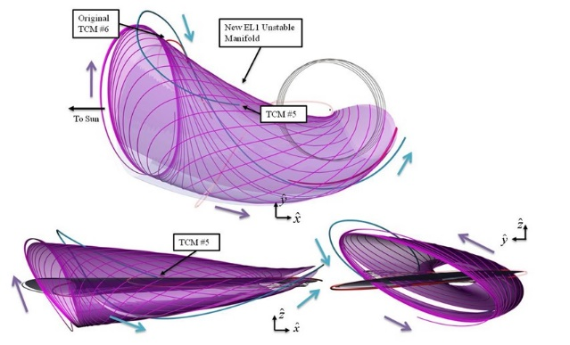
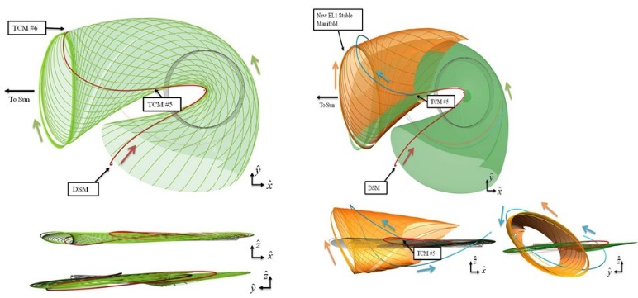
Figure 10. ARTEMIS-P1 Stable (right) and Unstable (right) Manifolds used to Design the Artemis/Themis Transfer

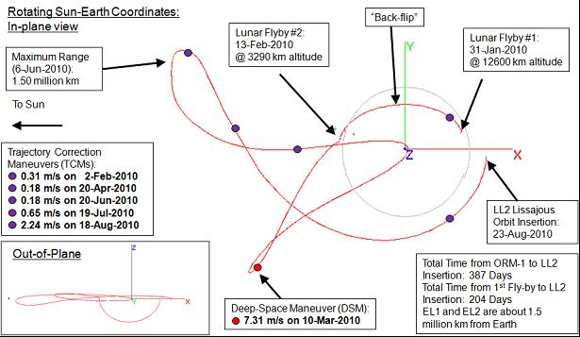

Figure 11. ARTEMIS-P1 Transfer Trajectory in Solar Rotating Coordinate Frame

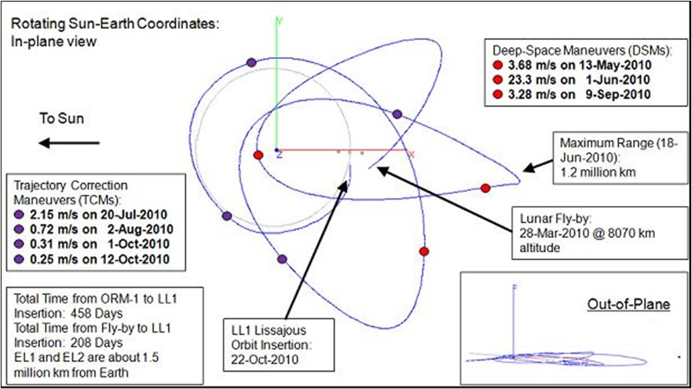

Figure 12. ARTEMIS-P2 Transfer Trajectory in Solar Rotating Coordinate Frame

Once the P1 and P2 spacecraft were in their proper quasi-halo orbits, then a transfer from the P1 spacecraft in the Earth-Moon L₂ (EML₂) orbit was to transfer to the Earth-Moon L₁ (EML₁) side to coordinate observations with the P2 spacecraft and to permit similar transfers from EML₁ to a lunar elliptical orbit. Therefore, the next logical step was to determine if the natural flow in the system exposes any useful structures, i.e., see Figures 13 and 14. If the system did not originate (initial conditions) on one of the known particular solutions, was the evolution at all predictable for numerical use? Since the orbits are unstable, there is flow toward and away from these structures (manifolds) and it is natural to seek a foundational understanding of the natural flow throughout the system and pursue a parsing of the information into a numerical setting. The community continues to gain insights concerning the connections / links between various structures and the methodologies for exploiting this knowledge in the full models necessary for cislunar and lunar missions. [21]. Following methods introduced by W.S. Koon, M. Lo, J.E. Marsden, and S. D Ross, a heteroclinic connection served as a basis for design to produce a transfer between “nearly” periodic orbits.

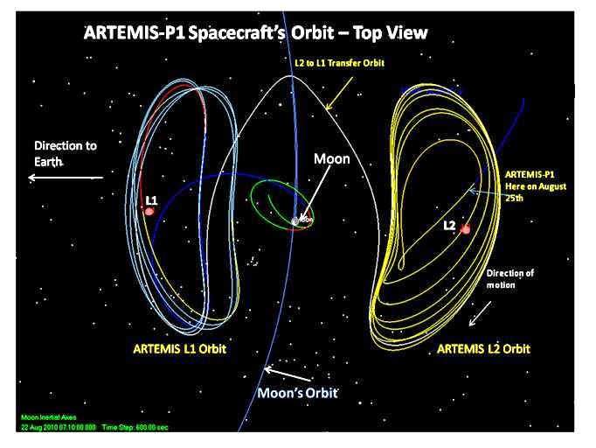
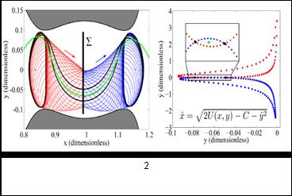
Figure 13. Theorized Heteroclinic Transfers [23]
Figure 14. Artemis/Themis Operational Heteroclinic Transfer

Dynamical Systems Improvements to Sun-Earth L₁ and L₂ Mission Design

Over the next three years NASA is planning several missions to SEL₁ and SEL₂, such as the Space Weather Follow On-L1 (SWFO-L1) at SEL₁ and the Nancy Grace Roman Space Telescope (RST) at SEL₂. These two specific missions are employing dynamical systems approaches in different ways to meet requirements and to develop innovations that can minimize fuel use or serve to design the baseline trajectory. SWFO-L1 is a space weather mission that, among other science objectives, will monitor the Sun for signs of solar storms that may impair the Earth’s telecommunication network. The RST spacecraft is an observatory designed to answer questions about dark energy, exoplanets, and astrophysics and, thus, needs the SEL₂ environment. These upcoming missions rely on a combination of proven dynamical systems applications and the numerical targeting and optimization schemes to satisfy mission requirements and to permit the use of operational perturbation models. Such approaches allow a rapid design process, one that enables the designer to leverage a comprehensive understanding of the region’s stability, trajectory pathways, and predictable orbit evolution, to guide them to a design that meets challenging constraints, such as fuel use and limitations on Lissajous amplitudes, to meet observation and communication requirements.

Sun-Earth L₁ Applications: Space Weather Follow On-L1

Periodic and quasi-periodic motion in the vicinity of SEL₁ / SEL₂ is generally unstable, hence, stationkeeping (Stkp) strategies are required to offset this instability and overcome the effect of perturbations and uncertainties. Some of the perturbations come from: orbit determination errors where the uncertainties on the position and velocity of the spacecraft affect the size of the planned Stkp maneuvers; maneuver execution errors that deviate the trajectory from the desired nominal path; solar radiation pressure (SRP) uncertainties due to attitude changes that influence the trajectory between maneuvers; and momentum unloads (MUs), i.e., small maneuvers performed to desaturate the spacecraft reaction wheels and used for attitude control. These small maneuvers can be very frequent and deviate the spacecraft from the nominal path, impacting the magnitude of Stkp maneuvers. Here we will focus on the impact of MUs on the Stkp delta-v budget and provide study results on a process to mitigate their effect based on a dynamical systems approach. This capability is of special relevance for the SWFO-L1 mission, that will experience frequent (~ weekly) large momentum unload maneuvers that result in a ~6 cm/s residual in the sunward direction, thus, significantly perturbing the orbit.

A SWFO-L1 study was undertaken to explore applied dynamics and its use to determine an improved attitude that simultaneously meets both the MU design and the Stkp needs. The SWFO-L1 mission support team employs the CR3BP as a base model to describe the dynamics of a spacecraft relative to libration point orbits as it is a representative model of the true dynamics around SEL₁/ SEL₂. The CR3BP also allows us to derive analytical expressions for the directions to perform SK maneuvers and derive alternatives for the MUs directions. Note that, when performing analyses to evaluate the impact of the different strategies proposed here, we use a higher-fidelity force model including the gravitational attraction of all the planets in the solar system, the Moon and SRP.

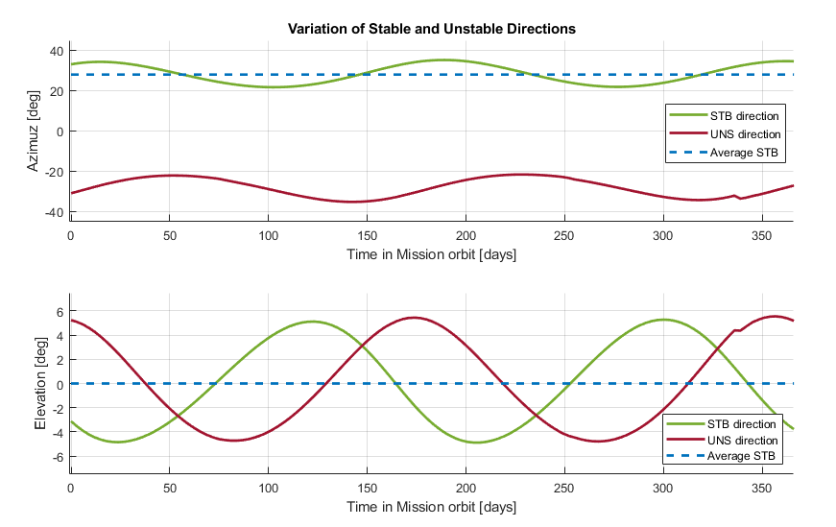
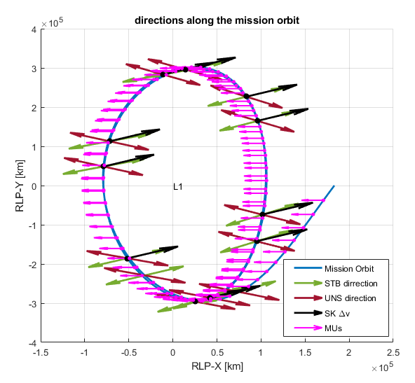
While the directions of the stable and unstable eigenvectors associated with a libration point orbit varies along the orbit, they remain close to the stable and unstable eigenvectors associated with the libration point SEL₁. The left hand side of Figure 15 illustrates the variation for two orbital periods of the azimuth and elevation of the stable (green) and unstable (red) directions in the RLP frame. The blue dashed line corresponds to the azimuth and elevation which are 28.25◦ and 0◦ respectively.

Figure 15. Left: Variation of the Azimuth and Elevation of the stable and unstable
eigenvector for one orbital period. Right: Variation of the stable and unstable directions.
along the mission orbit

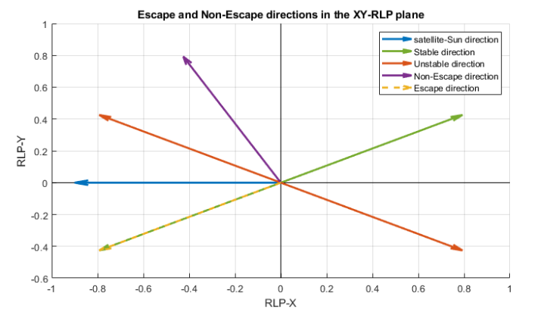
A proposed strategy to mitigate the impact of the momentum unloads on the Stkp delta-V budget uses the non-escape direction for MU, as these are frequent maneuvers to avoid deviating from the Lissajous pattern. We want to maximize the change along the unstable manifold to return to the Lissajous orbit with minimum delta-V. Figure 16 offers a schematic representation of these two MU and dV sequences along the mission orbit. While moving along the Lissajous orbit, the stable and unstable directions vary (see Fig. 3), and so do the escape and non-escape directions. To account for this direction variation, one can approximate the non-escape direction by a direction perpendicular the stable eigenvector and contained in the ecliptic plane. Monte Carlo simulations have been performed comparing SWFO’s nominal momentum unloading (MU) strategy (where MU are along the spacecraft-Sun direction) , with a new MU/dV strategy (where MU are along the non-escape direction). In both cases MU are applied every 3 days with the same residual delta-V and station-keeping maneuvers every 30 days. We have seen that this new MU/dV can reduce the delta-v budget for station-keeping up to 90%, being a strategy to be considered for future mission applications.[24]
Figure 16. Escape and Non-Escape Directions in the
Sun-Earth XY-Plane Rotating Frame.

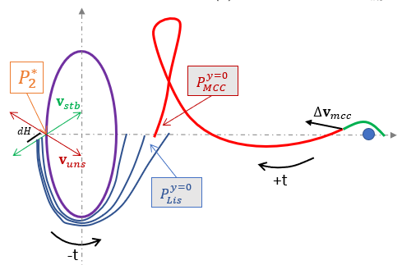
In addition to the Stkp approach, a dynamical systems understanding is also used to attain the required Lissajous orbit, a small orbit that remains within bounds of 4 deg minimum and 13 deg maximum angle as measured off the Earth to Sun vector. A simple diagram in Figure 17 illustrates the representation of the Lissajous orbit and that of the transfer orbit. Since SWFO-L1 is a rideshare, its initial transfer trajectory will not achieve the insertion location to enter into the Lissajous. The use of a manifold generated from the required Lissajous orbit parameters that meets the angle constraint is used in a ‘traditional’ manner to compute the stable and unstable directions that provide a backward integration and provides an LOI location that is located on the Sun-Earth line. This method is not different from other design applications other that it is used on a Lissajous orbit rather than on a periodic (or quasi-periodic) larger orbit, such as JWST or RST.
Figure 17. SWFO Lissajous Orbit and Transfer Design.

Sun-Earth L₂ Dynamical System Applications: Roman Space Telescope

To identify feasible transfer trajectories, the underlying structures associated with a representative, autonomous dynamical model are used and recover a solution in a higher-fidelity numerical model. First, the equations of motion in the CR3BP are introduced along with the definition of the rotating frame. In this model, particular solutions are leveraged to construct an initial guess for a mission trajectory. Once corrected, these solutions are transitioned to a point mass ephemeris model.[8] Accordingly, the equations of motion for a multi-body point mass ephemeris model are used, along with an approximate model of solar radiation pressure. Following the definitions of these dynamical models, Poincaré mapping strategies are used as a means for clear visualization of trajectories within the chaotic regime of the Sun-Earth-Moon system. This technique is used to identify and select arcs to construct an initial guess trajectory. Given an initial guess, a corrections scheme for recovering continuous trajectories is then implemented. Together, these dynamical representations and associated computational techniques are useful in designing a feasible trajectory for the RST spacecraft.

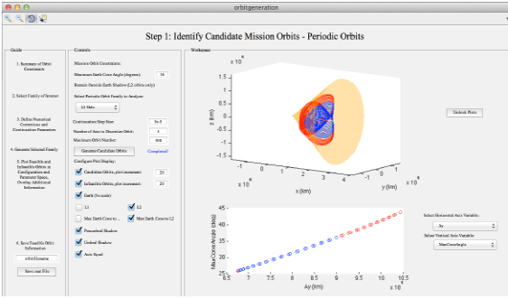
The application of dynamical systems theory enables the development of a systematic and well-informed trajectory design procedure for the RST mission. [25] This procedure consists of the following steps:

1. Families of periodic orbits that exist in the CR3BP near the SEL₂ point are constructed as shown in Figure 18. Orbits, discretely sampled along each family, that satisfy the Earth shadow and 36 degree angle constraints are retained and saved as candidate mission orbits in a .mat file. Note that quasi-periodic orbits are not included in the candidate orbit set to reduce the complexity of visualization and computation. However, periodic orbits offer a sufficient starting point for recovering quasi-periodic mission orbits during the corrections process.
Figure 18. Graphical user interface implementing, in Matlab, Step 1 in the RST trajectory design procedure: the identification of candidate mission orbits.
2. Stable manifolds that reach the Earth vicinity in negative time are generated for a user-specified range of candidate mission orbits along a selected L2 libration point orbit family to support identification of transfers that potentially require a small DV maneuver. Trajectories that lie on the manifolds are integrated backwards in time in the Sun-Earth CR3BP until they pierce a hyperplane defined by an x-coordinate between the Earth and L₂. Manifolds arcs that intersect this hyperplane, along with information identifying their generating periodic orbit, are stored.
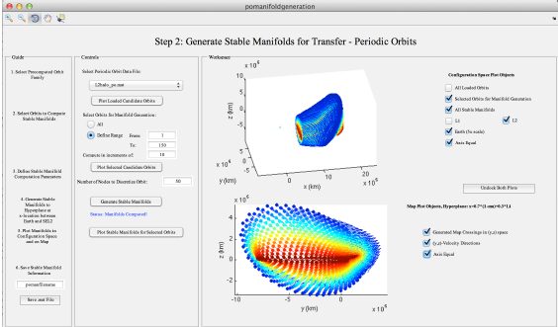
3. Paths that depart the initial LEO are generated, see Figure 19. A set of states, sampled to lie along a LEO and that occur between 10 and 60 minutes beyond a specified initial condition, i.e., state vector and epoch, is constructed. Then, a range of tangential DV-LEO maneuvers, defined by a range of magnitudes, are applied to each state within this set. After application of a DV-LEO, each state is then integrated forward in time in the Sun-Earth CR3BP until piercing a hyperplane defined by an x-coordinate between the Earth and L₂. This hyperplane is defined to be consistent with the previous step. Paths that depart the specified LEO and pierce the hyperplane, along with the maneuver direction and epoch, are stored.
Figure 19. Graphical user interface implementing, in Matlab, Step 2 of the RST trajectory design procedure: the generation of stable manifolds associated with selected candidate mission orbits.
4. An initial guess is constructed using Poincaré mapping as seen in Figure 20. An interactive graphical environment enables the selection of a LEO departure path along with multiple revolutions of the mission orbit and an associated stable manifold arc. Arcs along each segment of the trajectory itinerary are assembled and discretized into a series of nodes, thereby forming an initial guess.

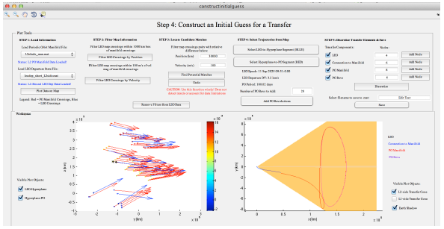
Figure 20. Graphical user interface implementing, in Matlab, Step 4 of the RST trajectory design procedure: constructing an initial guess via Poincaré mapping.
5. The constructed initial guess is corrected in the Sun-Earth CR3BP to ensure full state continuity, while also incorporating the two maneuvers. The initial condition is constrained to equal the specified state as provided in Earth-fixed coordinates, and the epoch is allowed to vary. During this step, the magnitude of the maneuver, as well as the maximum SEL₂ angle along the transfer, are gradually reduced until satisfying the mission constraints. Note that the midcourse correction maneuver is not incorporated into the design of the reference trajectory but, rather, reserved for mitigating the impact of any errors in the large maneuver.
6. The entire trajectory is corrected within a point-mass ephemeris model. In this step, the initial state is constrained in Earth-fixed coordinates, while the magnitude of the maneuver and the maximum SEL₂ angle along the transfer is gradually reduced. Furthermore, SRP can be incorporated into the dynamical model during the corrections process.
7. The corrected trajectory is used to generate similar solutions at various epochs across a user-defined launch window. The resulting trajectories are stored and GMAT scripts are automatically generated as shown in Figure 21.

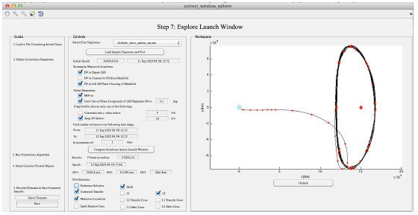
8. A trajectory, designed using dynamical systems techniques and later corrected in a point mass ephemeris model, is exported to GMAT and then STK. The GMAT script writes to a text file including the epoch and the state corresponding to waypoints along the reference trajectory. Then, this text file is read into Matlab and input into STK via Matlab’s Component Object Model (COM) connection. The designed trajectory is recovered via targeting in a higher-fidelity model within STK with the application of regular station-keeping maneuvers. The procedure, as summarized above, is implemented via a graphical user interface within Matlab as an additional module to Purdue University’s ATD trajectory design environment. Each step is accessed in separate windows, with the computed data saved as a .mat file for use in subsequent steps. Using this module, the general procedure is leveraged to design trajectories to either SEL₂ orbits or, with some modifications, SEL₁ orbits.
Figure 21. Graphical user interface implementing, in Matlab, Step 7 of the RST.

As illustrated in the above steps, employing dynamical systems techniques along with early incorporation of the mission constraints, a well-informed trajectory design procedure is constructed and implemented as an additional model to Goddard’s and Purdue University’s Adaptive Trajectory Tool (ATD). In this approach, the natural underlying dynamical structures that exist within an approximate and autonomous CR3BP model of the Sun-Earth are analyzed. Candidate arcs that may satisfy the mission constraints, while also following the general itinerary of a transfer between LEO and a mission orbit near SEL₂, are then identified and assembled to construct an initial guess. This initial guess is corrected first in the CR3BP and then in a point mass ephemeris model that captures the perturbative effect of SRP. During this corrections procedure, mission constraints on the geometry of the transfer and associated maneuvers are enforced. The resulting feasible transfer is then exported to GMAT and/or STK for subsequent analysis. Using Matlab and Ansys’s Satellite ToolKit, in combination with further use of dynamical systems theory, a preliminary station-keeping analysis within a high-fidelity ephemeris model that also incorporates regular momentum unloads is performed. This procedure, demonstrated for the RST mission, enables rapid and well-informed recovery of feasible transfers within the chaotic dynamical regime of the Earth, Sun and Moon.

Application of Dynamical Systems for General Lunar Exploration

Another dynamical systems and numerical application consideration is to use natural and low thrust lunar ballistic capture scenarios, see Figure 22. One common visualization strategy is to use maps to color the initial apse states by the behavior of the resulting trajectory arc. The initial state of a trajectory that impacts the Moon within the return to the second periapsis (p = 2) map is colored red. The initial states for trajectories that depart through the Earth-Moon L₁ and L₂ gateways are colored purple and green. Trajectories that remain in the lunar region (r < 115,500 km) are termed “captured,” and the associated initial states are depicted in orange. These visualizations provide a quick assessment of possible cislunar or Earth-Moon designs using a CR3BP approach and perturbation theory. The applications were used to assist in the low-thrust ballistic transfer for the Lunar IceCube mission that utilized a 1.2 mN thrust. [26]
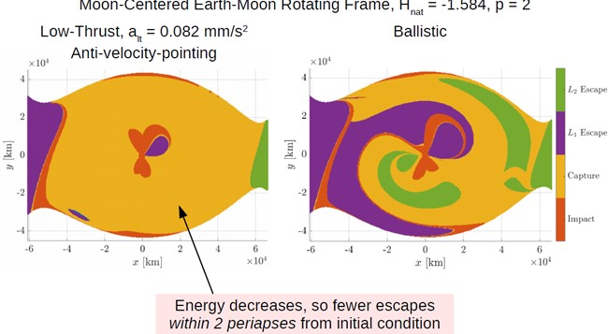
As has been in the forefront for the Artemis lunar mission, is the design of an orbit that meets Gateway mission and lunar south pole coverage requirements. Various lunar orbits can be implemented using these dynamics as described in this paper, including the aforementioned Earth-Moon libration point orbits at EML₁ and EML₂. Near Rectilinear Halo Orbits (NRHO), Butterfly, and Vertical orbits are useful for lunar communication and observation coverage, with the NRHO being selected to support the Gateway mission. The development of the NRHO exists due to the bifurcations of the same dynamics that provide the other EML₁ and EML₂ orbit used by the Artemis/Themis mission. [14] In Figure 23, examples of NRHO, Butterfly and Vertical orbits in an Earth-Moon system.
Figure 22. Low Thrust Periaspe Map.

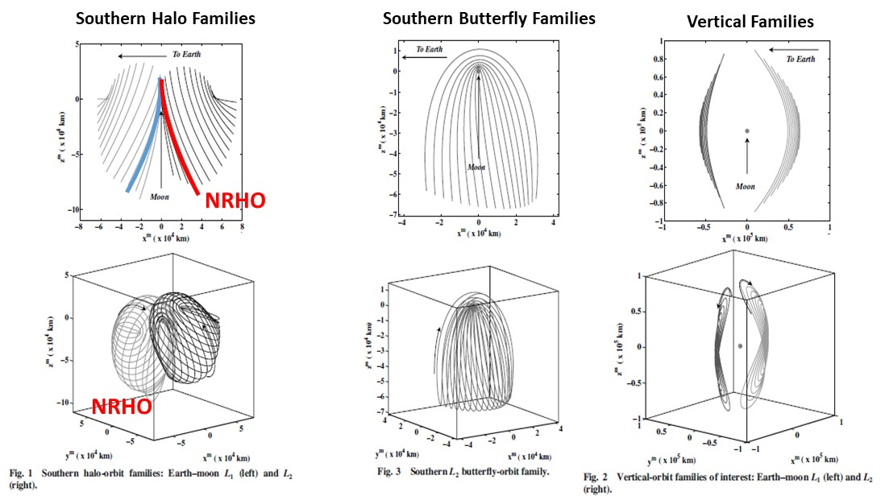
Figure 23. Near Rectilinear Halo Orbits, Butterfly orbits and
Vertical Orbit in the Earth-Moon System.

CONCLUSION

As the aspiration for missions to these Sun-Earth and Earth-Moon regions became achievable, the need for improvements in the understanding of astrodynamics became a key driver. Over the past 50 years, a number of astrodynamicsts and engineers, at NASA centers and universities, strived to determine innovative methods to not only achieve specialized Sun-Earth or Earth-Moon libration point orbits, but to also provide access from these unstable regions to distinctive orbits about the Moon and in its neighboring environment. The development of orbit designs that permitted multibody missions, which in turn provided new data to improve upon those innovations, was a constant cycle of gratifying effort. The background of the trajectory formulation of these early missions and the ensuing astrodynamics expansion which followed was deliberate. From a reliance on numerical and analytical modeling and targeting techniques to achieve specific conditions to the applications of dynamical systems and advanced optimal formulations, a distinct progress was established. The continuous innovations required to meet future mission challenges are essential and astounding. Thoughts on the how recent improvements can aid in the design of future mission are discussed with the hope that a spark of invention will be a result, regardless of how fanciful it may seem.

REFERENCES
[1] K. Howell, H. Pernicka, Numerical Determination Of Lissajous Trajectories In The Restricted Three-Body Problem, Celest. Mech. 41 Vol, 1–4, 1988, pp. 107–124.
[2] D. Richardson, N. Carey, A Uniformly Valid Solution For Motion About The Interior Libration Point Of The Perturbed Elliptic-Restricted Problem, in: Proceedings of the Astrodynamics Specialist Conference, AAS Paper No.75-021, Nassau, Bahamas, July,1975.
[3] R. W. Farquhar, D. Muhonen, and D. Richardson, Mission Design for a Halo Orbiter of the
Earth, Journal of Spacecraft and Rockets, Vol 14, No. 3, 1977, pp. 170-177.
[4] Lunar Flight Handbook NASA SP-34 Part 2, Space Flight Handbook, Vol. 2. NASA, 1963.
[5] D. Folta, M. Woodard, K. Howell, C. Patterson, W. Schlei, Applications Of Multi-Body Dynamical Environments: The ARTEMIS Transfer Trajectory Design, Acta Astronautica, Vol. 73, 2012, pp. 237–249.
[6] D.C. Folta, T.A. Pavlak, A.F. Haapala, K.C. Howell, M.A. Woodard, Earth–Moon libration point orbit stationkeeping: Theory, modeling, and operations, Acta Astronautica, Vol. 94, No. 1, pp. 421-433, (2013).
[7] W. Koon, M. Lo, J. Marsden, S. Ross, Dynamical Systems, the Three-Body Problem, and Space Mission Design, April 25, 2011, Available online, http://www.cds.caltech.edu/~marsden/books/ Mission_Design.html
[8] A. Haapala, Trajectory Design Using Periapse Poincaré Maps and Invariant Manifolds, M.S. Thesis, Purdue University, School of Aeronautics and Astronautics, December 2010.
[9] M. Vaquero, K. Howell, Design of Transfer Trajectories Between Resonant Orbits in the Restricted Three-Body Problem with Application to the Earth-Moon System, Acta Astronautica, Vol, 94, No. 1, January-February 2014, pp. 302-317.
[10] M. Vaquero, K. Howell, Leveraging Resonant Orbit Manifolds to Design Transfers between Libration Point Orbits, Journal of Guidance, Control and Dynamics, Vol. 37, No. 4, July 2014, pp. 1143-1157.
[11] B. Bills and A. Ferrari, A Harmonic Analysis of Lunar Gravity, Journal of Geophysical Research, Vol. 85, No. B2, February 1980, pp. 1013-1025.
[12] A.S. Konopliv, S.W. Asmar, E. Carranza, W.L. Sjogren, and D.N. Yuan, Recent Gravity Models as a Result of the Lunar Prospector Mission, Icarus, 150, 1–18, 2001.
[13] M.L. Lidov, Evolution of the Orbits of Artificial Satellites of Planets as Affected by Gravitational Perturbation from External Bodies, AIAA Journal (Russian Supplement) Vol 1, no 8, August, 1963.
[14] Ely and Lieb, Constellations of Elliptical Inclined Lunar Orbits Providing Polar and Global Coverage, AAS/AIAA Astrodynamics Specialist Conference, Lake Tahoe, CA, August, 2005.
[15] R.V. Ramanan and V. Adimurthy, An Analysis of Near-Circular Lunar Mapping Orbits, Journal of Earth Syst. Sciences, Dec. 2005, pp. 619-626.
[16] S.Y. Park and J.L. Junkins, Orbital Mission Analysis for a Lunar Mapping Satellite, Journal of the Astronautical Sciences, Vol 43, No.2 1995 pp. 207-217.
[17] A. Elipe and M. Lara, Frozen Orbits About the Moon, Journal of Guidance, Control, and Dynamics, Vol 26, No. 2, March-April 2003
[18] D. Folta and D. Quinn, Lunar Frozen Orbits, AAS/AIAA Astrodynamics Specialist Conference, Girdwood, Alaska, AAS 99-397, August 16-19, 1999.
[19] D.C. Folta, The Lunar Prospector Mission, AAS/AIAA Astrodynamics Specialist Conference, Keystone, Colorado, AIAA-2006-6749, August 21-24, 2006.
[20] K.C. Howell, B.T. Barden, M.W. Lo, Application of dynamical systems theory to trajectory design for a libration point mission. Journal of the Astronautical Science, Vol. 45, No. 2, 1997, pp. 161–178.
[21] W. Koon, M. Lo, J. Marsden, S. Ross, Heteroclinic Connections Between Periodic Orbits and Resonance Transitions In Celestial Mechanics, Chaos Vol. 10, No. 2, 2000, pp. 427–469.
[22] T.H. Sweetser, S.B. Broschart, V. Angelopoulos, G.J. Whiffen, D.C. Folta, M.-K. Chung, S.J. Hatch, M.A. Woodard, ARTEMIS Mission Design, Space Sci. Rev. 165 (1-4) (2011) 27–57.
[23] A.F. Haapala. and K.C. Howell, Representations of Higher-Dimensional Poincaré Maps with Application to Spacecraft Trajectory Design, Acta Astronautica, Vol. 96, March-April 2014, pp. 23-41.
[24] A. Farres, D.C. Folta, C.M. Webster, .Z. Michaels, Mitigating the Impact Of Momentum Unloads On Station-Keeping Around Libration Point Orbits, AAS 22-688.
[25] N. Bosanac, C.M. Webster, K.C. Howell, D.C. Folta, Trajectory Design for the Wide Field Infrared Survey Telescope Mission, Journal of Guidance, Control and Dynamics, Vol. 42, No. 9, September 2019, pp. 1899-1911.
[26] A. Cox, K. Howell, D. Folta, Dynamical Structures in a Low-Thrust, Multi-Body Model with Applications to Trajectory Design, Celestial Mechanics and Dynamical Astronomy, Vol. 131, Issue 3, March 2019.

