Roman Optical Telescope Integration Status and Preparation for Test

Tony L. Whitmanª, Peter Millerª, Joshua Abel^{b}, Bente Eegholm^{b}, Matthew Bolcar^{b}, J. Scott Smith^{b},

Brian Martensª, Pete McCarthyª, Joel Proebstle^{b}, Erin Schieleª

ªL3Harris Technologies, Rochester, NY; ^{b}NASA Goddard Space Flight Center, Greenbelt, MD

abstract
The OTA for the Nancy Grace Roman Space Telescope includes the primary mirror, secondary mirror, and aft optics for guiding light into the Wide Field Instrument and the Coronagraph Instrument. The telescope is taking shape as the tested optical mirror assemblies are integrated. The assemblies have been thermal cycled to the cold temperatures for infrared operation, load tested to launch loads, vibration tested, and optically tested. Testing included launch-level vibration testing of the 2.4-meter light-weighted primary mirror assembly. In addition, the telescope control electronics (TCE) box has been fully assembled and the environmental testing of the TCE is progressing. Pictures and descriptions of the integration and test progress are provided, along with performance results measured at these levels of assemblies. Planning and test equipment preparation for the telescope thermal vacuum testing continues including plans to take advantage of the large dynamic range available with focus diversity phase retrieval and a Shack-Hartmann wavefront sensor for the gravity-sagged primary mirror.

Optical Telescope integration
With the completion of testing all the optical and structural assemblies, the telescope is about midway through the integration process. First the Forward Optical Assembly was stacked with the Secondary Mirror Assembly supported with the six strut assemblies onto the Primary Mirror Assembly as shown in Figure 1.
Completed in this assembly includes installation of the following:
- redundant actuators for fine focus adjustment of the secondary mirror position,
- an actuator under each secondary mirror support tube for full six degree of freedom adjustment,
- light scrapers near the mirrors and on the support tubes for stray light control,
- complete coverage of heaters and temperature sensors with associated wiring,
- strategically placed accelerometers for later testing while installation access was available,
- cables and wires along the secondary mirror support tubes to reach the tubes and secondary mirror assembly,
- blankets along the secondary mirror support tubes
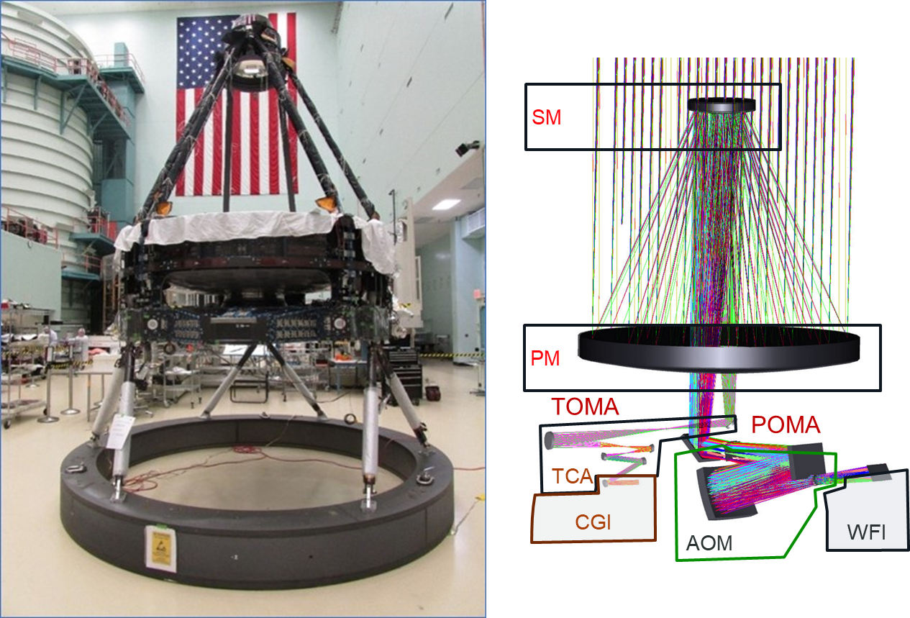
Figure 1. The secondary mirror (SM) stacked on the primary mirror (PM) (covered by protective sheets).

Then the Pick-Off Mirror Assembly (POMA) was installed onto the large Aft Metering Structure (AMS) under the primary mirror as shown in Figure 2. This mirror picks the portion of the light field from the secondary mirror for the Coronagraph Instrument and includes a thermal cover for a more uniform temperature profile throughout the mirror.

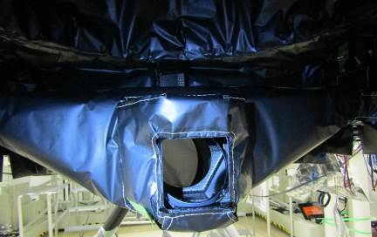
From SM
To TOMA
Figure 2. Pick off mirror assembly integrated and blanketed.
Meanwhile the remaining 4 mirror assemblies, including tip/tilt actuators, used to generate the collimated beam for the Coronagraph Instrument were integrated into a composite structure to complete the Tertiary Optical Mirror Assembly (TOMA) shown in Figure 3. Upon completion of the blanket installation above the TOMA location, the TOMA will be integrated to the Aft Metering Structure using 6 struts with adjustable lengths.
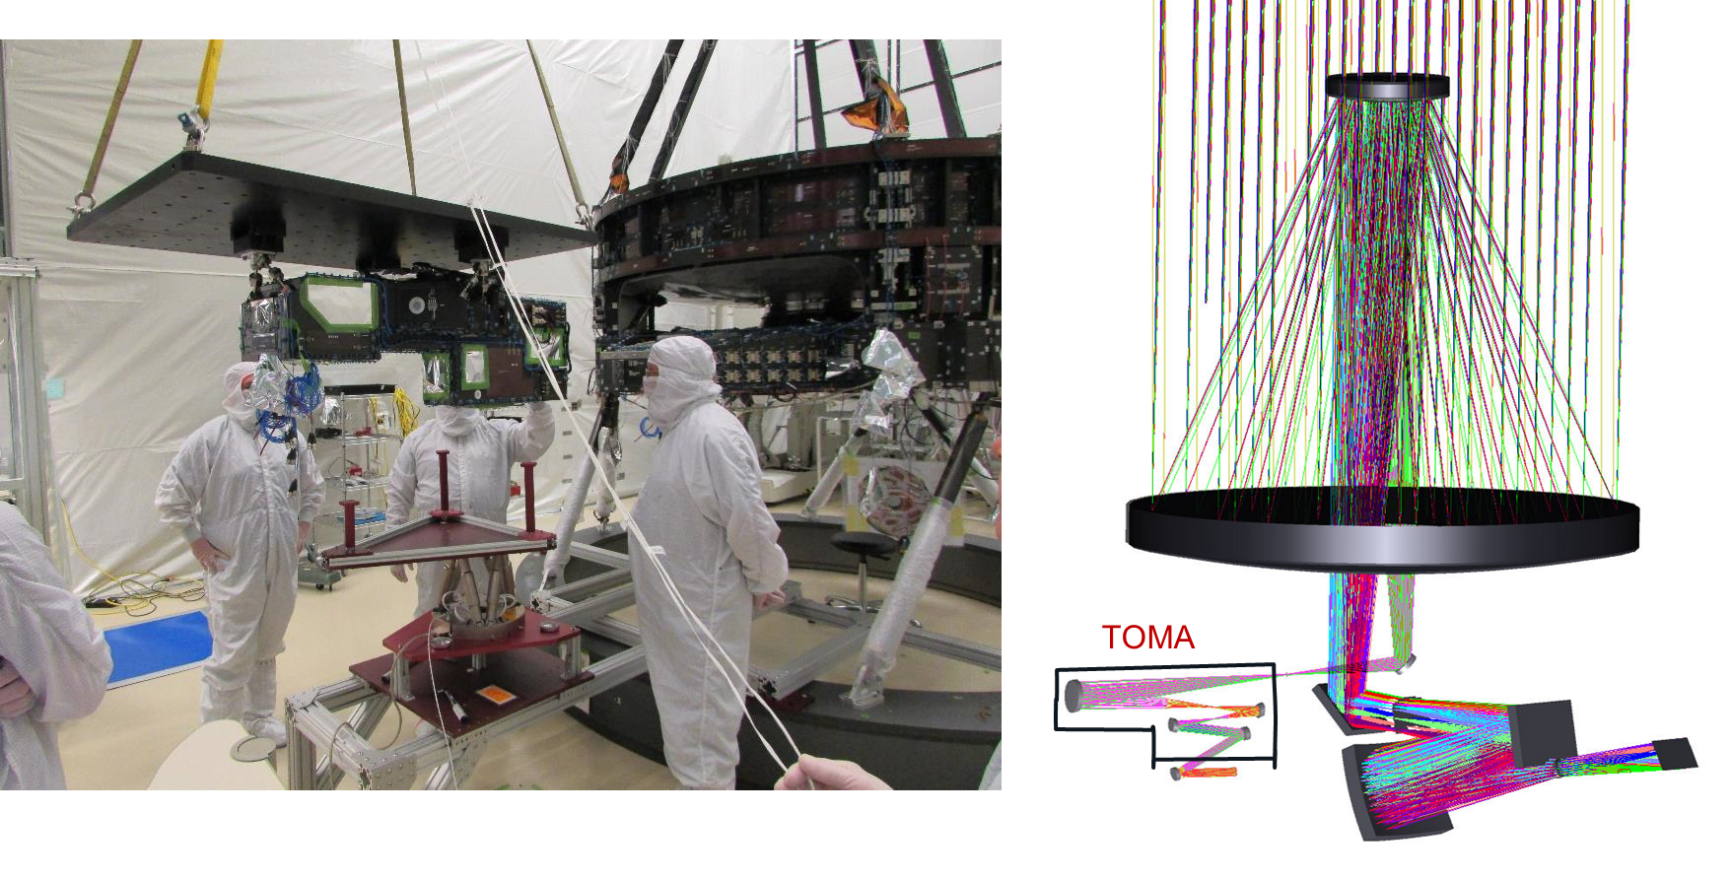Figure 3. Staging Tertiary Optical Mirror Assembly for integration under the Primary Mirror Assembly.
The Aft Optics Module (AOM) will contain 3 mirror assemblies including one with 3 actuators for tip, tilt, and piston adjustment. The long light path and large mirrors were designed to squeeze into the space available within the Wide Field Instrument and the Instrument Carrier structures. The tightly-packaged design adds access challenge to the integration of the mirror assemblies into the structure. A mockup of the AOM was constructed and integration steps were practiced with improvements of installation tools and visualization access in progress. The structure with one installed mirror assembly will be integrated to the Aft Metering Structure using 6 struts. Then the remaining two mirror assemblies are integrated to the Aft Optics Structure as part of the OTA optical alignment.
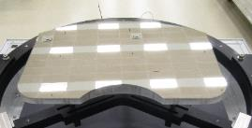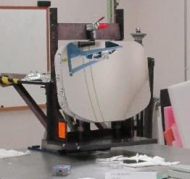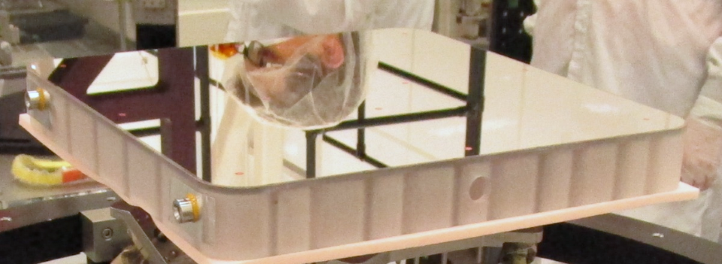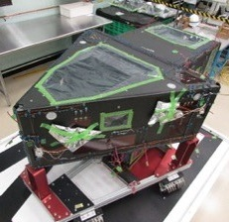Figure 4. Aft Optics Structure and 3 mirror assemblies staged for integration.

Optical telescope verification plan
As part of the integration process, the Secondary Mirror, the Tertiary Optics Module Assembly, and the 3 mirror assemblies, are adjusted to meet wavefront error, exit pupil alignment, and image plane position requirements¹ before locking in place using a combination of optical metrology, optical references, mechanical references, an interferometer, and a decades-old legacy full aperture auto-collimating flat mirror above the primary mirror (Figure 5). During these measurements the light-weighted primary mirror is supported to offload sag due to gravity. See reference [1] for more background and details on the optical verification plan.
Upon completion of the integration, the telescope progresses to environmental testing:
- Structure modal testing
- Sample vibration transmission testing
- Sine vibration testing
- Acoustic testing
- Optical performance at operating temperature
- Thermal control performance at operating, survival, and transition temperatures
- Structural performance through thermal cycling
- Sample thermal elastic sensitivities on optical performance

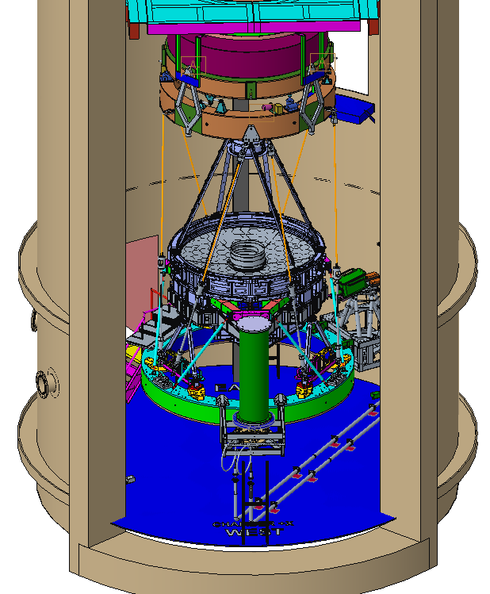
Figure 5. Telescope hanging from legacy auto-collimating flat mirror and vibration isolation with image plane optical test equipment underneath inside low-pressure chamber.

Vibration Test preparation

The vibration facility has been enlarged to accommodate the size of the optical telescope as shown in Figure 6. A large weldment with support bearings was constructed for lateral motion and a head expander was installed for the vertical motion. Characterization and capacity tests are in process.
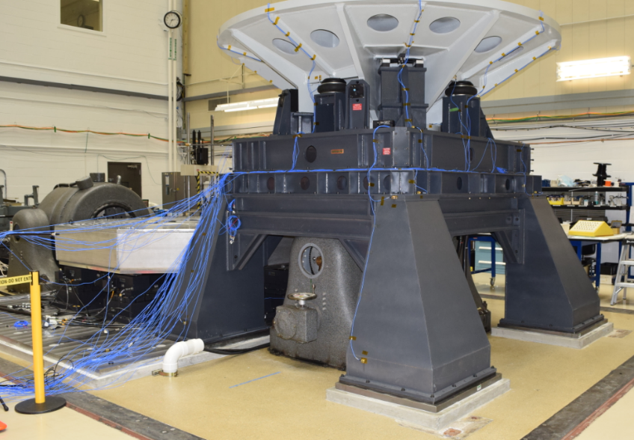
Figure 6. Weldment and bearings sized for the Roman optical telescope attached to lateral shaker (left). Likewise, the head expander for Roman over vertical shaker (right).

Optical test equipment preparation
The legacy equipment used to offload the primary mirror sag caused by gravity can only be used in a low-pressure, non-vacuum environment. During the thermal vacuum optical test of the telescope, optical metrology methods with appropriate dynamic range will measure the wavefront error in the presence of the large gravity sag of the light-weighted primary mirror.
For the coronagraph field, a commercial Shack Hartmann wavefront sensor (SHWFS) measures the optical performance. The sensor has been characterized in the laboratory and inserted into a large optical wavefront error testbed at NASA’s Goddard Space Flight Center. Inside a pressure tight enclosure (Figure 7), the SHWFS and an interferometer are used simultaneously in the offloaded configuration to cross calibrate their relative measurements. In the full-sag state, the interferometer continues to be used to set the image location and measure the pupil alignment.
The wide field portion will use fiber sources and detectors from the Goddard Space Flight Center that are translated across several field points and through focus with an actuated hexapod (Figure 7) for wavefront sensing similar to techniques used by the James Webb Space Telescope [2]. The sources and detector for testing the Roman Space Telescope were characterized by Goddard. L3Harris created an as-built (so far) optical model for the Roman optical telescope, adapted existing wavefront sensing algorithms to the Roman test configuration, and started wavefront sensing simulations. In the offloaded configuration, an interferometer is used to cross calibrate the relative measurements with the wavefront sensor and check the wavefront sensing algorithm. In both configurations, the interferometer sets the image location and measures the pupil alignment.
The full aperture auto-collimating flat mirror for the double-pass optical testing is complete and ready for integration into the thermal vacuum chamber (Figure 8). Like the configuration above, the telescope will hang from this auto-collimator assembly and vibration isolators with the same image plane optical test equipment underneath used in the optical alignment in section 2 above, as shown in Figure 9. This chamber includes an existing liquid nitrogen shroud with heater panels currently in fabrication.
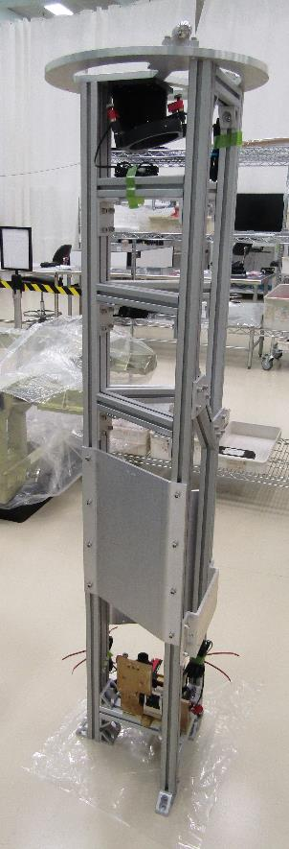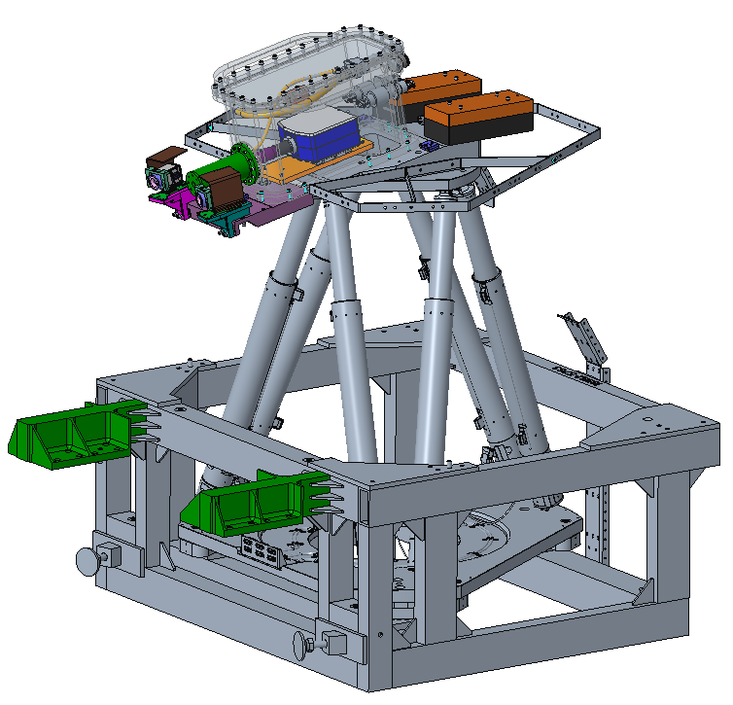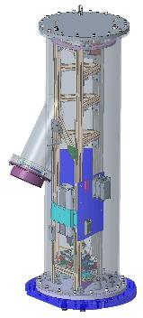Figure 7. Telescope image optical bench for narrow coronagraph field under construction (left) to be inserted in pressure tight enclosure (middle). For the wide field, optical instruments are moved around the field using an actuated hexapod (right).
Figure 8. Thermal vacuum auto-collimating flat mirror.
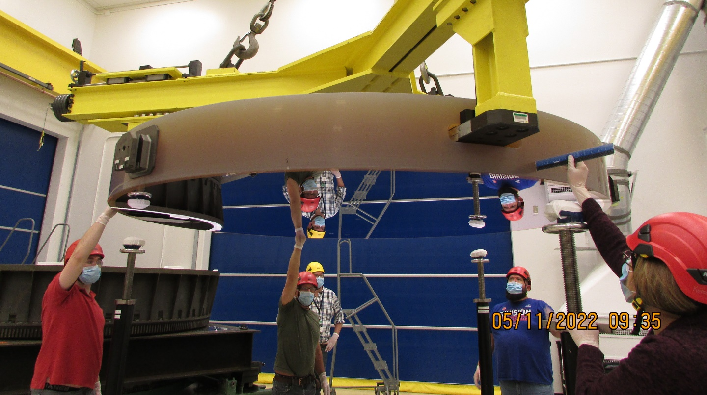

Figure 9. Test configuration in thermal vacuum chamber with thermal blankets removed for illustrative purposes.
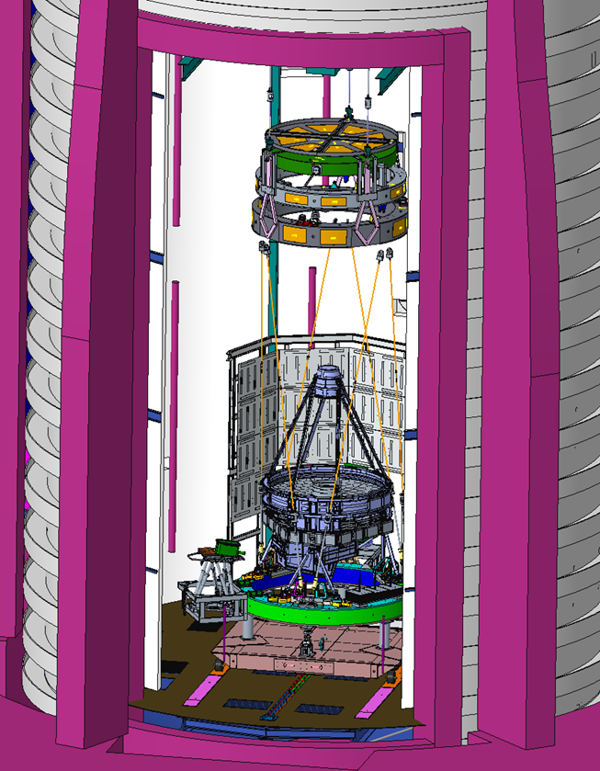

predicted optical performance
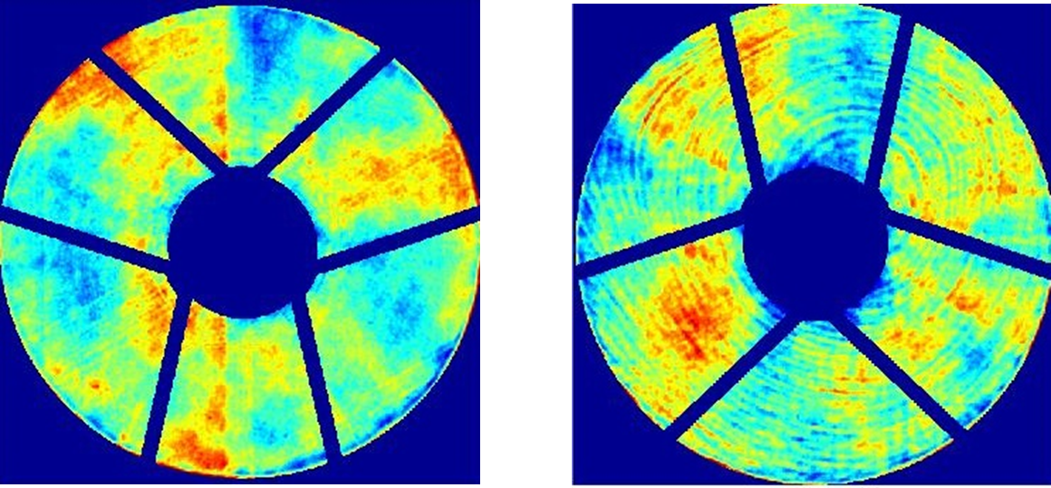The optical model has been updated with the mirror figures, reference [3], and with the wavefront error (WFE) measured through the completed Tertiary Optical Mirror Assembly resulting in the image maps in Figure 10. The on-orbit WFE prediction is ~ 70 nm RMS WFE.

Figure 10. Predicted wavefront error maps from the wide field side (left) and the coronagraph side (right).

Telescope Control Electronics (TCE)

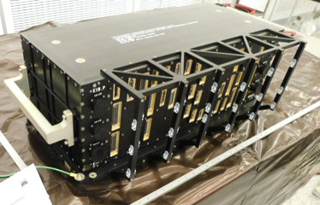
Figure 11. Completed Telescope Control Electronics box.
The TCE includes proportional-integral control of 96 heater channels and position control of 13 actuators for tip, tilt, and/or piston of the secondary mirror, a flat mirror in the TOMA, and a flat mirror in the AOM. Figure 11 shows the TCE ready for performance and environmental testing. The initial room temperature performance test is complete and the box is currently in test for electromagnetic compatibility and electromagnetic interference. Then the box will go through a thermal cycle before experiencing vibration testing while powered in the launch configuration. Finally, the performance of the box is tested through the full temperature range.

Summary
The optical telescope assembly for the Roman Space Telescope is more than halfway through integration. The control electronics box is complete and stepping through environment testing. The system test configurations have started integrations and characterizations in preparation for the completed optical telescope assembly.

Acknowledgements
The design, build, assembly, and testing of the Optical Telescope Assembly was supported by the National Aeronautics and Space Administration under Contract Number 80GSFC19C0021.

references
- Bolcar, M.R., “The Roman Space Telescope optical system: status, test, and verification,” Proc. SPIE 12676 (2023).
- Acton, D.S., “Phasing the Webb Telescope,” Proc. SPIE 12180 (2022)
- Whitman, T.L., et. al., “Roman Optical Telescope Assembly (OTA) Build and Integration Progress,” Proc. SPIE 12180 (2022)

