Oregon Coast Range Ecological Conservation
Mapping Recent Logging within Drinking Watersheds of Oregon’s Coastal Range to Support Future Resource Management Policies

Technical Report
August 11th, 2023

Emily French (Project Lead)
Uma Edulbehram
Sarah Hughes
Madison Arndt

Advisors:
Dr. Cédric Fichot, Boston University (Science Advisor)
Joseph Spruce, Science Systems and Applications, Inc. (Science Advisor)

Fellow:
Tyler Pantle (Massachusetts – Boston)

1. Abstract
Logging operations are widespread across the Oregon Coast Range and conventional logging practices pose a risk of contamination to surface water quality. The NASA DEVELOP Oregon Coast Ecological Conservation team partnered with nonprofit Oregon Wild to quantify the extent of clearcutting and commercial thinning in 80 Coast Range drinking watersheds between 2000 and 2022. This project used all available Landsat data from 1997 through June 2023 in Google Earth Engine. Sensors used include Landsat 5 Thematic Mapper, Landsat 7 Enhanced Thematic Mapper Plus, Landsat 8 Operational Land Imager, and Landsat 9 Operational Land Imager-2. The Continuous Change Detection and Classification (CCDC) algorithm was used with Landsat observations to identify clearcutting patches. Percent change in summer median Landsat Normalized Difference Vegetation Index (NDVI) images were used to identify areas of forest disturbance including commercial thinning. The team concluded that logging, including both clearcutting and commercial thinning, impacted 31% of forested area in drinking watersheds and the intensity of logging remained consistent from year to year. Clearcutting occurred primarily on private land while commercial thinning occurred primarily on state and federal lands. This study showed that CCDC effectively identifies clearcutting, and percent change in NDVI successfully identifies disturbances including commercial thinning. Key constraints included the lack of field validation data and the inability to attribute disturbances to logging with certainty. Ultimately, this study identified the drinking watersheds and communities most likely to be impacted by logging activity. These results can inform legislation aimed at balancing the commercial and environmental benefits of forestlands.

Key Terms
Logging, Watershed, Drinking Water Quality, Landsat, Continuous Change Detection and Classification, Google Earth Engine, Oregon Coast Range, NDVI

2. Introduction

2.1 Background Information
In Oregon, surface water accounts for approximately 70% of all water use and nearly 3.5 million Oregonians in both rural and more densely populated municipalities like Portland, Salem, Eugene, Medford, and Bend rely on surface water for some or all of their supply (Souder, 2021; Oregon Department of Environmental Quality, 2018). As surface water flows across the landscape, it is vulnerable to contamination from both natural and anthropogenic sources. According to the Oregon Department of Environmental Quality, natural causes of drinking water impairment in Oregon include landslides, streambank erosion, and riparian or upland disturbance due to fire and extreme weather (2018). Common sources of anthropogenic pollution include urban stormwater runoff, municipal and industrial wastewater, mining sites, animal management areas, wastewater systems, agricultural practices, construction sites, and forestry operations (Oregon Department of Environmental Quality, 2018).

In Oregon, forests play an important role in protecting surface waters from contamination by preventing erosion and filtering rain and snowfall before delivering it to streams. Although forestry practices designed to minimize impact to water quality have improved significantly in recent decades, conventional logging practices like clearcutting, particularly in riparian zones, and short logging cycles pose a significant threat to water quality across the state (Souder, 2021). In 1996, Congress expanded the Safe Drinking Water Act to include drinking water source protection. Since then, community drinking water systems have moved from a framework focused on treatment to one that recognizes the importance of prevention. Studies show that prevention activities, particularly water source protection, effectively lower treatment and maintenance costs and reduce the risk associated with contaminants where regulatory standards and monitoring capacity may be limited (Freeman et al., 2008; U.S. Environmental Protection Agency, 2023).

In this context, the goal of this study was to use Earth observations to understand the extent of clearcutting and commercial thinning in Oregon’s coastal drinking watersheds from 2000 to 2022. Ultimately, the results of this study will help inform decision-making related to water source protection and logging. This study defines clearcutting as the removal of all trees in an area exceeding two acres. Commercial thinning practices vary widely, ranging from partial thinning of forest cover to small patch removal. This analysis focused on 80 drinking watersheds in the Oregon Coast Range ranging from 0.04 to 924 square miles in size (Figure 1). The Oregon Coast Range is a mountainous region west of the Willamette Valley and is characterized by a mild climate with a very wet winter season and relatively dry summers, with an average yearly precipitation of over 100 inches (Oregon Department of Environmental Quality, 2018). The land cover in this region is dominated by temperate coniferous forests, with common tree species including Douglas fir, western hemlock, western redcedar, and Sitka spruce. Industrial private companies—primarily timber companies—are the largest landowners in this region, followed by the US Forest Service and Bureau of Land Management. Most of the remaining area is managed by private non-industrial owners or the State Department of Forestry (U.S. Bureau of Land Management, 2023). In recent decades, logging regulations have restricted clearcutting on national forestlands. In contrast, conventional logging practices like clearcutting have become more prevalent on privately owned land (Kennedy & Spies, 2004).

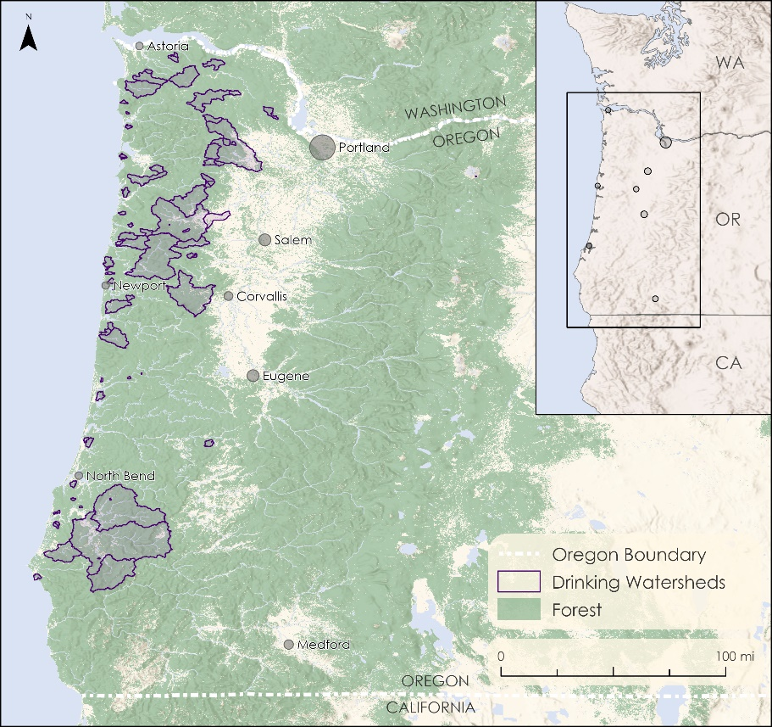
Figure 1. Locations of drinking watersheds within the Oregon Coast Range (modified from Oregon Wild). The Willamette Valley contains the cities of Portland, Salem, Corvallis, and Eugene, and is otherwise comprised mostly of agricultural land.

Given the clear link between forest management and drinking water quality (Shah et al., 2022), there is a need to map and monitor logging activity on the Oregon Coast, particularly in drinking watersheds. Temporal segmentation approaches like the Continuous Change Detection and Classification algorithm (CCDC) and LandTrendr have been widely used to monitor forest disturbances and degradation across a range of forest types (Chen et al., 2021; Kennedy et al., 2010; Pasquarella et al., 2018; Sulla-Menashe et al., 2014). CCDC incorporates all available Landsat data to generate pixel-level timeseries that account for seasonality and interannual trends in surface reflectance and brightness temperature (Zhu & Woodcock, 2014). One of the primary optical remote sensing challenges for the Oregon Coast Range is frequent cloud cover, particularly in the winter months. A pixel-based approach like CCDC effectively addresses this challenge of obtaining cloud-free imagery by using any cloud-free pixel regardless of the overall scene cloud cover instead of relying on a limited number of entirely clear scenes like many other satellite-based approaches (Zhu & Woodcock, 2014). In temperate regions, like the Oregon Coast Range, satellite-based forest monitoring is also complicated by seasonality including both phenology and changes in precipitation. Recent research publications show how CCDC incorporates seasonality and subtle degradation trends, making it an appropriate method for monitoring logging in temperate forests (Chen et al., 2012; Pasquarella et al., 2018). Following these applications, the DEVELOP team implemented CCDC from 2000 to 2022 across the Oregon coast to map, quantify, and assess the extent of clearcutting in 80 drinking watersheds.

Note that fires, like clearcutting, also remove the majority of trees over large areas. As a result, fires cannot be distinguished from logging using a method like CCDC that relies on changes in surface reflectance alone.
To be able to identify clearcutting with a high degree of certainty, the project team confirmed that there were no major fires in the study watersheds. Another form of logging that occurs along the Oregon Coast Range is commercial thinning. This logging treatment is characterized by the partial removal of trees in an area of 2 acres or more, as opposed to the full removal of vegetation associated with clearcutting (Wilson and Sader, 2002). Since the Normalized Difference Vegetation Index (NDVI) is a common measure of vegetation presence and often used to monitor forest change, the team chose this index to be the foundation for the thinning analysis (Lunetta et al., 2002; Mancino, et al., 2014; Sader, Bertrand and Wilson, 2003).

2.2 Project Partners & Objectives
The Oregon Coast Range Ecological Conservation team partnered with Oregon Wild, a non-profit organization founded in 1974, whose mission is to protect Oregon’s wildlife, rivers, and forests. They are a vocal advocate for sustainable forest management practices and engage with the community through public education, lobbying, volunteer opportunities, and activism (Oregon Wild, n.d.). In recent years, one of their primary focuses has been to counter erosion and improve drinking water quality by promoting legislation that establishes riparian buffer zones around water bodies that feed into community drinking water sources. While there is some public awareness of logging activity and its impact on water quality, the magnitude of the problem is not wholly understood (Oregon Wild, n.d.). In this context, the team’s main objective is to provide spatiotemporal information on the extent of clearcutting and commercial thinning on the Oregon coast through the creation of watershed level logging maps and summary statistics to help Oregon Wild educate the public and assist upcoming forest management legislation.

3. Methodology

3.1 Data Acquisition
To run CCDC, the team accessed all available Tier 1 top-of-atmosphere reflectance Landsat data for the study region from 1997 to June 2023 in Google Earth Engine (US Geological Survey, 2013). Landsat data has a 30-meter spatial resolution and a 16-day temporal resolution. To create a forest mask for the study region, the team downloaded National Land Cover Database (NLCD) tree canopy cover data for 2001 from the USGS ScienceBase Catalog and 2011, 2016, and 2021 NLCD tree canopy cover data from the USFS FSGeodata Clearinghouse (U.S. Geological Survey, 2003; U.S. Forest Service, 2014, 2019, 2023). The team also downloaded NLCD 2006 land cover data from the USGS ScienceBase Catalog when tree canopy cover data were not available as a separate layer (U.S. Geological Survey, 2011). NLCD data are currently produced as a raster layer with a 30-meter resolution based on Landsat and Sentinel-2 data and are commonly used for land cover change analysis. To help validate results and set thresholds, the team used National Agriculture Imagery Program (NAIP) images from 2020 and 2022 (USGS EROS Archive, 2023). Oregon Wild also provided the team with a shapefile of drinking watersheds which was used for reporting forest cover and logging activity statistics by watershed ownership type based on the Oregon Department of Forestry public land management layer (Oregon Department of Forestry, 2016).

Table 1. Earth observations used for analysis
Platform and Sensor | Data Product | Dates | Acquisition Method
Landsat 5 Thematic Mapper | Level 2, Collection 2, Tier 1 Top of Atmosphere Reflectance | January 1997 to June 2013 | Earth Engine Data Catalog/USGS
Landsat 7 Enhanced Thematic Mapper + | Level 2, Collection 2, Tier 1 Top of Atmosphere Reflectance | January 2000 to present | Earth Engine Data Catalog/USGS
Landsat 8 Operational Land Imager | Level 2, Collection 2, Tier 1 Top of Atmosphere Reflectance | February 2013 to present | Earth Engine Data Catalog/USGS
Landsat 9 Operational Land Imager – 2 | Level 2, Collection 2, Tier 1 Top of Atmosphere Reflectance | September 2021 to present | Earth Engine Data Catalog/USGS

3.2 Data Processing
3.2.1 CCDC
Before running CCDC, the team retrieved all available Landsat images and corresponding surface reflectance values for the specified study region and period (Table 1). To facilitate working with an algorithm as data intensive as CCDC, the project team took advantage of a suite of CCDC visualization and pre-processing tools developed by Paulo Arévalo and Eric Bullock on Google Earth Engine (Arévalo et al., 2020). One of the tools in this suite allowed the team to filter images for clouds, shadows, and haze and merge them into a single Image Collection. Using this suite of tools not only greatly simplified preprocessing but also allowed the team to quickly visualize CCDC timeseries and outputs before running the algorithm over the full study area (Arévalo et al, 2020).

After pre-processing, the team ran the CCDC algorithm over the entire filtered image collection from 1997 to June 2023. Observations from before 2000 and after 2022 were included so that CCDC could fit more accurate regression models at the edges of the study period of 2000-2022. To avoid processing errors, the team divided the study area into 36 units and processed CCDC in sections before creating an aggregated mosaic. As CCDC detects model breaks based on multiple bands, the team used all Landsat bands aside from blue, which can be affected by aerosols, and thermal bands, which are not commonly used to detect forest degradation, to identify breaks (Arévalo et al., 2020). Breaks are inserted when six or more consecutive observations deviate from the predicted value. After a break is inserted, the algorithm generates a new harmonic regression model (Figure 2). While CCDC parameters can be adjusted to make the model more or less sensitive to change, the team followed the default parameters outlined in Arévalo et al. (2020). The resulting CCDC product is a 23-band image of outputs including the model slope, amplitude, largest break magnitude for each band, and date of largest break, which can then be used to distinguish land cover change from natural variability. At this stage, the team took advantage of the tools developed by Arévalo et al. (2020) to explore the results and extract meaningful information on forest loss from the CCDC image.

Figure 2. A CCDC time series showing shortwave infrared measurements (blue) and resulting harmonic regression models (red, yellow) for a study area pixel that was clearcut in 2004.

3.2.2 Forest Mask
After running CCDC for the study area, the team applied a forest mask to the 23-band image to remove non-forested areas from further examination. The team created the forest mask using NLCD land cover layers in 5-year increments over the study period (U.S. Geological Survey, 2003, 2011; U.S. Forest Service, 2014, 2019, 2023). For the tree canopy cover raster layers, pixel values represent the percent of pixel area forested. To convert this to a binary layer, the team labeled pixels that were at least 40% forested as forest and considered those below this threshold non-forest. For the NLCD 2006 land cover layer, where a tree canopy raster was not available, the team aggregated pixels labeled as “deciduous forest,” “coniferous forest,” and “mixed forest” to forest, and labeled all others non-forest. The team merged all resulting binary forest rasters to create the forest mask, which represents the maximum forested extent over the study period (“Forest” in Figure 1).

3.2.3 Extracting CCDC Model Break Information
After applying the forest mask to the CCDC image, team members extracted single-band images, visualizing the date and magnitude of the largest model break for the shortwave infrared band (SWIR1). The team selected model breaks based on the SWIR1 band as it captures changes in dense vegetation and is frequently used when analyzing forest change with CCDC (Chen et al., 2021). The pixel values for the magnitude image ranged from -0.15 to 0.15, where negative values represent forest growth and positive values represent forest loss or degradation. The accuracy of CCDC results in identifying patches of clearcutting by year is visualized in Appendix A1.

3.2.4 CCDC Post-Processing
To isolate areas of clearcutting within the study region and period, the team implemented several masking techniques. First, the team removed areas where the year of the largest model break was either before 2000 or after 2022. Next, the team masked pixels where the largest break magnitude was less than 0.075, indicating no change or forest regrowth. This threshold was selected based on visual comparison of pixel magnitude with annual Landsat median images. To reduce noise, the team then applied another mask to remove groups of less than 9 connected pixels, representing a 2-acre area. This threshold was set based on partner knowledge that commercial clearcutting events are almost always larger than 2-acres. Finally, the team filled small gaps of 1 or 2 pixels within larger clearcut patches since these small areas were functionally part of the clearcut event.

3.2.5 Landsat Summer Median NDVI Images
To identify commercial thinning, the team used NDVI. To do this, the team obtained cloud-free Landsat images over the study period, then created median NDVI images with a composite period including the summer months of June, July, and August for each year in Google Earth Engine. NDVI is a vegetation index frequently used to assess forest change calculated with the near infrared and red bands (Equation 1; Rouse et al., 1974). The team only included summer months in these composite images to reduce the effect of seasonality.

$$NDVI =\frac{NIR-RED}{NIR+RED}$$
(1)
3.2.6 NDVI Percent Change and Post-Processing
Next, the team created images showing the percent change in NDVI year-to-year (Equation 2). The team applied several masks to identify disturbance areas likely to be commercial thinning. Based on visual comparison with Landsat and NAIP true color imagery, the team defined substantial forest loss as less than -8% change in NDVI. Pixels that did not meet this threshold were removed. Second, the team removed any patches under 2-acres since, like clearcutting, commercial thinning is unlikely to be applied to areas below this threshold. Given that clearcut areas also have significant NDVI loss, initial thinning and clearcutting results overlapped considerably. To avoid double counting logging activity as both commercial thinning and clearcutting, the team removed areas the CCDC analysis identified as clearcutting from the thinning layer. As thinning can span over two years but is unlikely to happen more than once during the study period, the team removed pixels that had been flagged as potential thinning in more than two years. Visual interpretation confirmed that these areas are frequently non-forest landcover like shrublands or floodplains which experience frequent NDVI fluctuation. In instances where thinning was detected in two years, the team attributed thinning to the year with the greatest NDVI loss. The team’s methodology in identifying areas of commercial thinning is demonstrated in Appendix A2.

$$Percent Change=\frac{NDVI Year 2 - NDVI Year 1}{NDVI Year 1}×100$$
(2)

3.3 Data Analysis
The team calculated zonal statistics for each drinking watershed in the study area, including total area, forest area, percent forested area, area clearcut each year from 2000-2022, and percent of forested area clearcut each year. Additionally, team members calculated the same zonal statistics for the following land ownership types within the drinking watersheds: private, federal, state, local, and tribal. Next, the team calculated the area thinned each year and the percent of forested area thinned each year for each drinking watershed and land ownership type. Yearly totals for watershed and ownership type clearcutting and thinning estimates were then summed to find the total area clearcut or thinned over the 22-year study period.

In discussion with partner organization Oregon Wild, the team determined that commercial thinning operations do not typically occur on privately managed lands. Functionally, the primary logging activity on private land is clearcutting, and little to no commercial thinning. However, this analysis identified thinning around the edges of clearcuts within private land. Given the 30-meter spatial resolution of a Landsat pixel, these thinning pixels represented the area at the edge of a clearcut where the forest was partially removed. While these edge areas experienced a substantial decrease in NDVI, this decrease is not attributable to commercial thinning. Therefore, the team also calculated zonal statistics by watershed and land ownership type with thinning on private land removed.

To estimate total area impacted by clearcutting and thinning, the team dissolved the watershed layer to create a new layer of the maximum extent of all watersheds and then calculated global zonal statistics. This was necessary as some watersheds were nested or overlapping, therefore summing the logging area of all watersheds would overestimate the total effected area. Finally, the team summed the area clearcut with area thinned to estimate total area logged, and summed percent of forest area clearcut and thinned to estimate the total percent of forest area logged.

4. Results & Discussion
4.1 Analysis of Results
4.1.1 Clearcut Results
The team’s analysis on clearcutting found that 26% of the forested area within the 80 selected watersheds experienced clearcutting between 2000 and 2022. This is equivalent to approximately 584 square miles of land. The team found that the amount of clearcutting that occurred year to year remained relatively stable at around 1% of forested area, or 25 square miles, per year. As shown in Table 2, the majority of the study area’s watersheds had less than 50% of their area clearcut over the study period. 35 of the 80 watersheds had 25 - 50% of their forest area clearcut. Meanwhile, only 4 of the observed watersheds had more than 50% of their forest area clearcut. The watershed with the most clearcutting was Rockaway Beach where 78% of the forest area was clearcut over the study period.

Table 2. Results identifying the number of watersheds characterized by different percentages of clearcutting.
% of Watershed Clearcut | Number of Watersheds
0 - 10% | 23
10 – 25% | 18
25 – 50% | 35
50 – 75% | 2
75 – 100% | 2

Oregon Wild gave the team a list of seven focus watersheds (Appendix B), including the watershed that supplies Seaside, a coastal city located in the northern region of the project’s study area with a population of around 7,000 (U.S. Census Bureau). Here the team found that 56% of the watershed, or 30 square miles, was clearcut between 2000 and 2022 (Figure 3). Approximately 2.5% of the watershed’s forest area was clearcut each year over the study period. This watershed is a good example of the long-term rotational logging common within drinking watersheds.

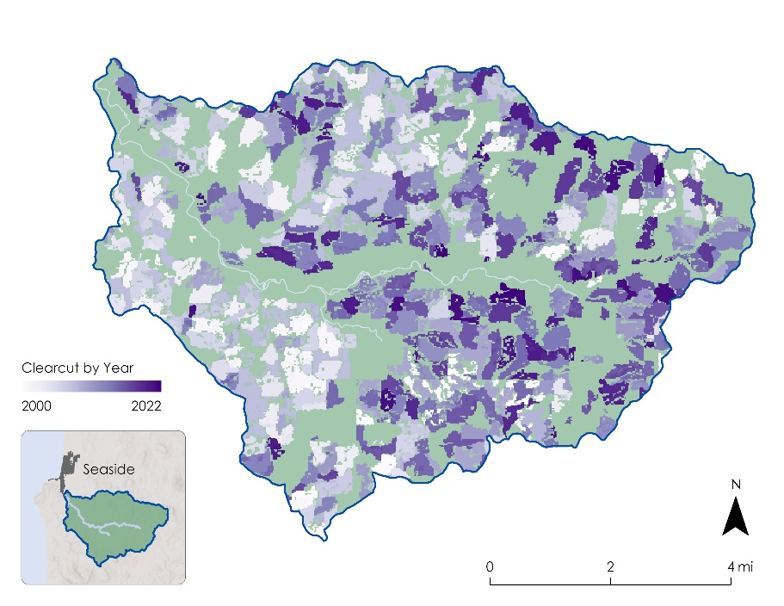
Figure 3. 2000 – 2022 clearcut forest clearcut date map for the watershed supplying the city of Seaside, OR.

4.1.2 Commercial Thinning Results
The team found that 5.6%, about 352 square miles, of forested area in the 80 drinking watersheds was thinned. One of the primary disturbances in the Oregon Coast Range is commercial thinning, which happens mainly on federal and state land. The rate of forest thinning remained relatively consistent from 2000-2022 at a rate of 0.7%, or 5 square miles, yearly across the total study area. As evident in Table 3 thinning impacted less than 10% of forest area in 33 watersheds, 10-25% in 41 watersheds, and over 25% in the remaining 5 watersheds.

As previously mentioned, the team performed additional zonal statistics after removing the thinning areas from private lands. These results more accurately reflect the reality of logging in the Coast Range. Commercial thinning results excluding thinning on private land found that 5%, 113 square miles, of the study area was thinned. Of the 80 watersheds, 65 experienced under 10% commercial thinning, 12 experienced 10-25% thinning, and the remaining 3 watersheds experienced 25-50% thinning (Table 3).

Table 3. Results identifying the number of watersheds characterized by different percentages of commercial thinning.
% of Watershed Thinned | Number of Watersheds | Number of Watersheds (Excluding thinning on private land)
0 — 10% | 33 | 65
10 — 25% | 41 | 12
25 — 50% | 5 | 3
50 — 75% | 1 | 0
75 —100% | 0 | 0

After discussion with the partner organization and reviewing watershed level statistics across the study area, the team elected to highlight the four contiguous drinking watersheds serving Lincoln City, OR (Figure 4). Lincoln City is a small coastal community with a population just under 10,000 (U.S. Census Bureau). The team found that of the 60 square miles of forested area in Lincoln City, 5%, or 3.2 square miles, had been commercially thinned over the study period.

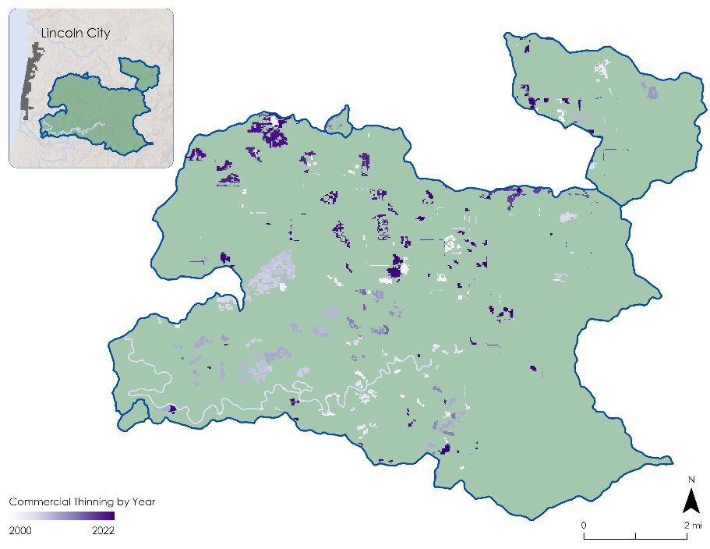
Figure 4. Areas of commercial thinning by year in Lincoln City drinking watershed.

4.1.3 Total Results & Ownership
After running zonal statistics on the 80 watersheds, the team found that 31% of the study area was impacted by logging, including both clearcutting and commercial thinning. Of this total, 26% of forested areas were clearcut and 5% were identified as commercial thinning. Overall, 58% of forest area in Seaside’s drinking watershed was logged and 34% of forest area in Lincoln City’s drinking watersheds was logged (Figure 5). See Appendix B for logging estimates for all seven focus watersheds including Seaside, Lincoln City, Yamhill, Yachats, Willamina, Rockaway Beach, and Hillsboro.

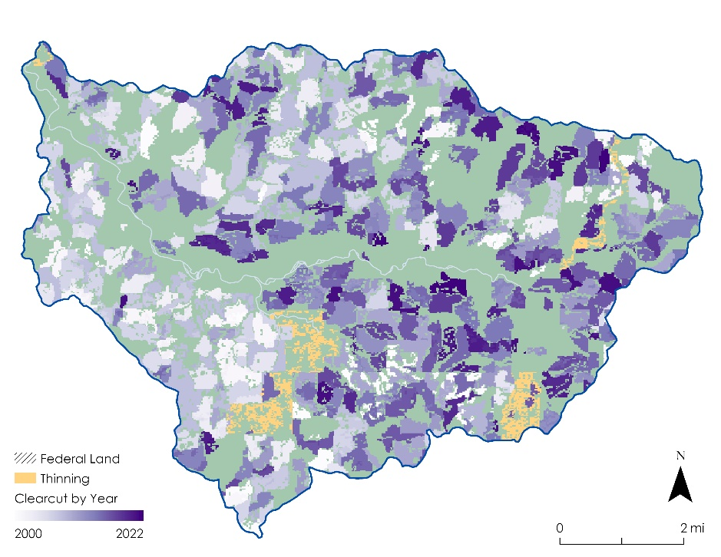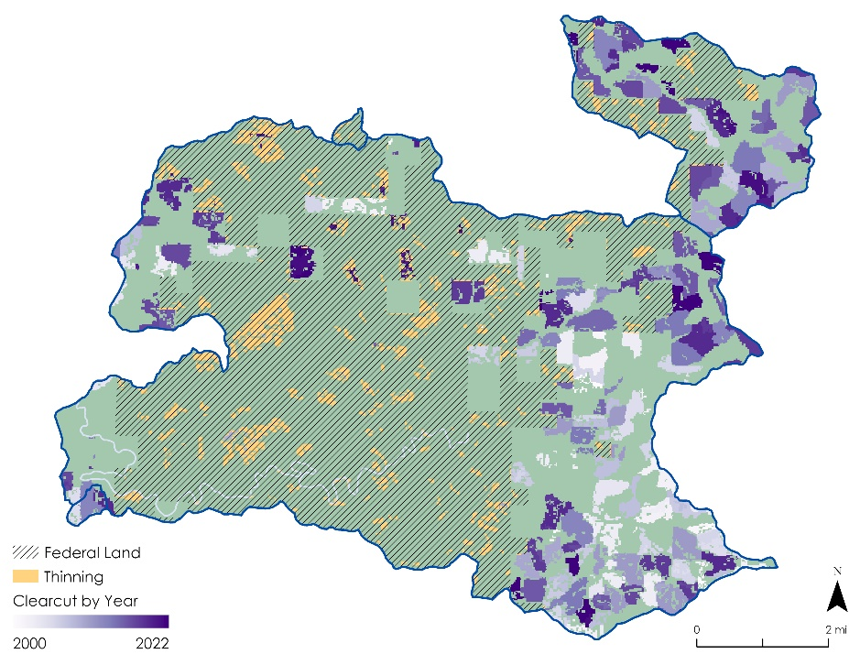
Figure 5. Areas of clearcutting and thinning in Seaside and Lincoln City drinking watersheds.

In addition to quantifying logging by watershed, the team considered five land ownership types within the maximum extent of the 80 study drinking watersheds including private, federal, state, local, and tribal lands (Figure 6). These results show that clearcutting is more common on private land than land owned by federal or state agencies, while commercial thinning is more prevalent on Oregon state land (Table 4). While a large percentage of locally owned and tribal land experienced logging activity, these classifications account for a very small proportion of the study area, respectively 2% and 0.2%, and so results for these ownership types should be taken with a degree of caution.

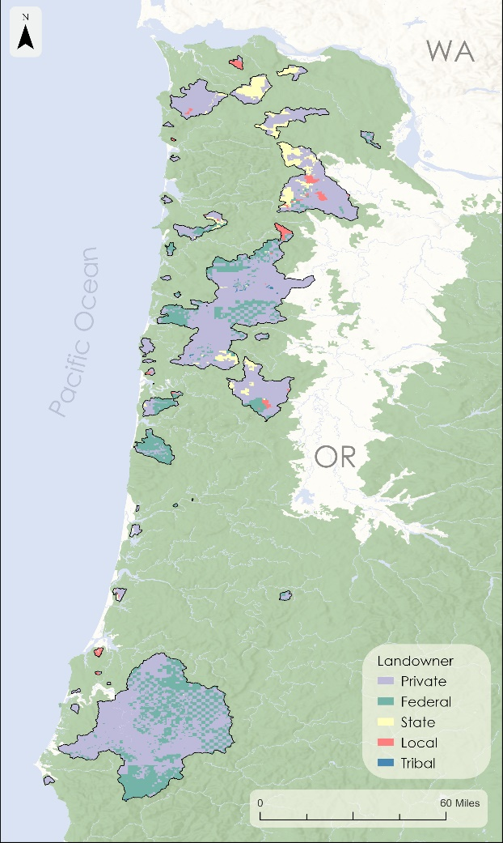
Figure 6. Land ownership in each of the observed watersheds.

Table 4. Results identifying the percentage of different logging practices for each land ownership type.
Land Ownership | % Clearcut | % Thinned | Total % Logged
Federal | 3% | 12% | 15%
State | 18% | 24% | 42%
Private | 42% | 0% * | 42%
Local** | 13% | 18% | 31%
Tribal** | 18% | 27% | 45%
*As previously explained, results identifying thinning on private land can mostly be attributed to clearcutting and so the team did not count thinning in these areas.
**Percentages based on very small areas.

4.1.4 Errors and Uncertainties
While performing analysis and exploring results, the team encountered several points of uncertainty and potential error. To set thresholds and mask the initial CCDC and NDVI outputs, the team relied on visual comparison of Landsat and high-resolution NAIP imagery as well as qualitative information from Oregon Wild. For instance, as part of the clearcutting analysis, the team set a threshold of 0.075 SWIR1 reflectance to mask out pixels where the magnitude of the largest CCDC model break was not large enough to be classified as a clearcut. While this threshold looked appropriate based on a visual assessment, the threshold may have been set more accurately using field validation points.

It’s also important to note that results cannot be attributed to logging with certainty given that the methodology relies on changes in surface reflectance which may be prompted by a range of disturbances like fires, landslides, and windstorms. This uncertainty is especially relevant to commercial thinning analysis, as the change in landcover related to thinning events, and thus reflectance, is subtle. The forest mask introduced an additional source of uncertainty. The team identified forested areas by creating a mask that combined NLCD tree canopy cover data over the study period. This data had a spatial resolution coarser than Landsat data and some non-forest areas were included. Additionally, as the forest mask combined tree canopy layers over a 20-year period, the mask includes some areas that were only forested for a short period. These areas may introduce error for years where they are not forested. This was particularly visible in the commercial thinning analysis for places with substantial NDVI fluctuation like shrublands or riverbeds.

Additional uncertainties include the underestimation of clearcut areas in 2022. Despite using all available Landsat data from 2023, the CCDC algorithm did not have enough observation points to accurately detect model breaks at the end of the study period. Lastly, the Landsat 7 ETM+ scan line error was visible in the results of the commercial thinning analysis. This is a common problem in remote sensing analysis. There were thus limited observations across the study period resulting in banding and likely overestimation of commercial thinning for years that rely on Landsat 7 data alone. A common solution to this error after 2015 would be to supplement the analysis with Sentinel-2 observations.

4.2 Feasibility Assessment
This project successfully used Landsat satellite data to quantify and map logging across two decades. The team found that the CCDC algorithm is an effective method to identify clearcut areas in the Oregon Coast Range, and that using Landsat provides CCDC with sufficient observations to accurately map the date of occurrence for clearcut events. Although running CCDC is computationally intensive, the visualization suite created by Arévalo et al. (2020) allows users to create time series showing land cover change on-the-fly for any area in the world, as well as map the magnitude and timing of change. While this tool is beneficial for exploratory analysis, the maps, animations, and summary statistics produced by the team can aid Oregon Wild in informing legislation and heightening public awareness of logging in drinking watersheds.

In addition, the team found that percent change in NDVI is an effective metric for identifying subtle forest disturbances in the Coast Range, including commercial thinning. However, without appropriate validation or additional data and analysis, it is not possible to attribute these disturbances to a commercial thinning event with certainty.

By focusing on drinking watersheds in the Oregon Coast Range, the team was able to identify watersheds most impacted by logging. This will allow Oregon Wild to focus public education campaigns on communities whose drinking water may be at risk of contamination due to logging activity in their drinking watersheds. Logging estimates by ownership type will also benefit Oregon Wild. For instance, the team found that a relatively high percentage of thinning occurred on state land, which could help the partner inform legislation that regulates logging on state land.

4.3 Future Work
The most important next step would be to validate the results of this study using field data in conjunction with high resolution imagery. Although the methods consistently and accurately identified clearcutting and commercial thinning patches, the degree to which forest loss resulting from natural disturbances was misidentified as logging is unknown. Field validation sites, particularly in areas affected by disturbances such as floods and landslides, would help to refine the methodology.

Oregon Wild could additionally apply the team’s analysis to other forested regions in Oregon, with the caveat that this method may be less appropriate for areas where severe wildfires are common. This study’s methodology could also be used to quantify and map logging before 2000 or update results as more recent data becomes available. To further build off these results, water quality should be monitored in heavily logged watersheds. This could provide insight into the relationship between water quality and logging on the Oregon coast. In addition, future studies could estimate the carbon impacts associated with logging using remotely sensed space-borne data such as aboveground biomass density data from Sentinel-1 and the Global Ecosystem Dynamics Investigation (GEDI).

5. Conclusions
This project also quantifies the extent of logging by land ownership type. The team found that clearcutting occurred predominantly on private land, 42% of forest area on private land was impacted by logging activity, and that commercial thinning mainly took place on areas owned by the state or federal government. CCDC proved to be an effective method for identifying areas of clearcutting in the Oregon Coast Range. While percent change in NDVI was a suitable tool to identify commercial thinning, the team concluded that it was hard to attribute changes in NDVI to commercial thinning as opposed to other disturbances. This led to likely overestimation in the commercial thinning results that would require future field validation to amend errors.
Ultimately, this research will increase transparency regarding the extent of logging on public and private land—information that is often difficult or impossible for the public to access. Oregon Wild can use the results of this study to increase community awareness and help forest stakeholders make informed decisions about where and how logging occurs, particularly in drinking watersheds.

6. Acknowledgements
The project team would like to thank Erik Fernandez from partner organization Oregon Wild for his guidance throughout this project and for sharing his extensive field knowledge. The team would also like to thank our science advisors, Dr. Cédric Fichot at Boston University and Joseph Spruce at Science Systems and Applications for all their help, as well as our NASA DEVELOP fellow, Tyler Pantle. Finally, the team thanks Boston University Research Scientist Dr. Paulo Arévalo for sharing his CCDC and Google Earth Engine expertise.

Any opinions, findings, and conclusions or recommendations expressed in this material are those of the author(s) and do not necessarily reflect the views of the National Aeronautics and Space Administration.

This material is based upon work supported by NASA through contract NNL16AA05C.

7. Glossary
CCDC – Continuous Change Detection and Classification
Clearcutting –the removal of all trees in an area of 2 acres or more
Commercial thinning – partial removal of trees in an area of 2 acres or more
Drinking watershed – Area over which surface water flows to reach a single outlet point used to source drinking water, such as a reservoir
Earth observations – Satellites and sensors that collect information about the Earth’s physical, chemical, and biological systems over space and time
ETM+ – Enhanced Thematic Mapper Plus; sensor on Landsat 7 satellite capturing 8 spectral bands
MODIS – Moderate Resolution Imaging Spectroradiometer
NDVI – Normalized Difference Vegetation Index
NIR – near infrared spectral band
OLI – Operational Land Imager; sensor on Landsat 8 satellite capturing 9 spectral bands
OLI-2 – Operational Land Imager 2; sensor on Landsat 9 satellite capturing 9 spectral bands, replica of OLI
NIR – near infrared spectral band
Riparian – adjacent to a river
SWIR – shortwave infrared spectral band
TM – Thematic Mapper; sensor on Landsat 5 satellite capturing 7 spectral bands

8. References
Abell, R., et al. (2017). Beyond the Source: The Environmental, Economic and Community Benefits of Source Water Protection. The Nature Conservancy, Arlington, VA, USA.
https://www.nature.org/en-us/what-we-do/our-insights/perspectives/a-natural-solution-to-water- security/?src=r.global.beyondthesource

Arévalo, P., Bullock, E. L., Woodcock, C. E., & Olofsson, P. (2020). A Suite of Tools for Continuous Land Change Monitoring in Google Earth Engine. Frontiers in Climate, 2.
https://doi.org/10.3389/fclim.2020.576740

Chen, S., Woodcock, C. E., Bullock, E. L., Arévalo, P., Torchinava, P., Peng, S., & Olofsson, P. (2021). Monitoring temperate forest degradation on Google Earth Engine using Landsat time series
analysis. Remote Sensing of Environment, 265, 112648.
https://doi.org/10.1016/j.rse.2021.112648

Freeman, J., Madsen, R., & Hart, K. 2008. Statistical Analysis of Drinking Water Treatment Plant Costs, Source Water Quality, and Land Cover Characteristics. Trust for Public Land. https://www.sciencebase.gov/catalog/item/52fe6b7fe4b0354fef6de496

Kennedy, R. S. H., & Spies, T. A. (2004). Forest cover changes in the Oregon Coast Range from 1939 to 1993. Forest Ecology and Management, 200(1–3), 129–147. https://doi.org/10.1016/j.foreco.2003.12.022

Kennedy, R. E., Yang, Z., & Cohen, W. B. (2010). Detecting trends in forest disturbance and recovery using yearly Landsat time series: 1. LandTrendr — Temporal segmentation algorithms. Remote Sensing of Environment, 114(12), 2897–2910.
https://doi.org/10.1016/j.rse.2010.07.008

Lunetta, R., et al. (2002). Impacts of vegetation dynamics on the identification of land-cover change in a biologically complex community in North Carolina, USA. Remote Sensing of Environment, 82, 258– 270. https://doi.org/10.1016/S0034-4257(02)00042-1.

Mancino, G., Nolè, A., Ripullone, F., & Ferrara, A. (2014). Landsat TM imagery and NDVI differencing to detect vegetation change: assessing natural forest expansion in Basilicata, southern Italy. iForest 7, 75-84. https://doi.org/10.3832/ifor0909-007

Oregon Department of Environmental Quality Watershed Management Section. (2018). Oregon Public Water Systems Surface Water Resource Guide.
https://www.oregon.gov/deq/FilterDocs/SurfaceWaterResourceGuide.pdf

Oregon Department of Forestry (2016). Public land management. https://www.oregon.gov/odf/aboutodf/pages/mapsdata.aspx

Oregon Wild. (n.d.). About Us. Oregon Wild. Retrieved June 14, 2023, from https://oregonwild.org/about

Oregon Wild. (n.d.). Forests - Keeping Our Water Clean. Oregon Wild. Retrieved June 14, 2023, from https://www.oregonwild.org/waters/forests-keeping-our-water-clean

Pasquarella, V.J., Holden, C.E., & Woodcock. (2018). Improved mapping of forest type using spectral- temporal Landsat features, Remote Sensing of Environment, (210), 193-207. https://doi.org/10.1016/j.rse.2018.02.064

Rouse, J. W., Haas, R. H., Scheel, J. A., and Deering, D. W. (1974). Monitoring vegetation systems in the Great Plains with ERTS. Third Earth Resources Technology Satellite-1 (ERTS-1) Symposium, 1, Paper A 20, 309–317. https://ntrs.nasa.gov/citations/19740022614
Sader, S., Bertrand, M. & Wilson, E. (2003). Satellite Change Detection of Forest Harvest Patterns on an Industrial Forest Landscape. Forest Science. 49. 341-353.
https://doi.org/10.1093/forestscience/49.3.341

Shah, N., Baillie, B., Bishop, K.., Ferraz, S., Högbom, L., & Nettles, J. (2022). The effects of forest management on water quality. Forest Ecology and Management, 522.
https://doi.org/10.1016/j.foreco.2022.120397.

Souder, J. A. (2021). Trees to Tap: How Forest Practices Affect Oregon's Municipal Water. Oregon State
University Extension Service. https://catalog.extension.oregonstate.edu/em9295-0

Sulla-Menashe, D., Kennedy, R. E., Yang, Z., Braaten, J., Krankina, O. N., & Friedl, M. A. (2014). Detecting forest disturbance in the Pacific Northwest from MODIS time series using temporal
segmentation. Remote Sensing of Environment, 151, 114–123.
https://doi.org/10.1016/J.RSE.2013.07.042

U.S. Bureau of Land Management (2023). BLM OR Management Ownership Dissolve Polygon Hub. Oregon State Office. https://gbp-blm-egis.hub.arcgis.com/datasets/BLM-EGIS::blm-or-management- ownership-dissolve-polygon-hub/about
U.S. Census Bureau. (2022). US. Census Bureau Quick Facts: Lincoln City, Oregon. United States Census Bureau https://www.census.gov/quickfacts/fact/table/US/PST045222
U.S. Census Bureau (2022). U.S. Census Bureau Quick Facts: Seaside City, Oregon. United States Census Bureau. https://www.census.gov/quickfacts/fact/table/seasidecityoregon/PST045222
U.S. Environmental Protection Agency. (2023, March 14). Basic Information about Source Water Protection. https://www.epa.gov/sourcewaterprotection/basic-information-about-source-water- protection

U.S. Forest Service (2023). National Land Cover Database (NCLD) 2021 Tree Canopy Cover Conterminous
United States: U.S. Forest Service data release,
https://data.fs.usda.gov/geodata/rastergateway/treecanopycover/

U.S. Forest Service (2019). National Land Cover Database (NCLD) 2016 Tree Canopy Cover Conterminous
United States: U.S. Forest Service data release,
https://data.fs.usda.gov/geodata/rastergateway/treecanopycover/

U.S. Forest Service (2014). National Land Cover Database (NCLD) 2011 Tree Canopy Cover Conterminous
United States: U.S. Forest Service data release,
https://data.fs.usda.gov/geodata/rastergateway/treecanopycover/

U.S. Geological Survey (2003). National Land Cover Database (NLCD) 2001 Land Cover Conterminous
United States: U.S. Geological Survey data release, https://doi.org/10.5066/P9MZGHLF.

U.S. Geological Survey (2011). National Land Cover Database (NLCD) 2006 Land Cover Conterminous
United States: U.S. Geological Survey data release, https://doi.org/10.5066/P9HBR9V3.

US Geological Survey (2013). Landsat 5 Thematic Mapper (TM) Level 2, Collection 2, Tier 1 Top of
Atmosphere Reflectance [Dataset]. Earth Engine Data Catalog/USGS. Retrieved June 2023, from doi.org/10.5066/P9IAXOVV

US Geological Survey (2013). Landsat 7 Enhanced Thematic Mapper Plus (ETM+) Level 2, Collection 2,
Tier 1 Top of Atmosphere Reflectance [Dataset]. Earth Engine Data Catalog/USGS. Retrieved June 2023, from doi.org/10.5066/F7WH2P8G

US Geological Survey (2013). Landsat 8 Operational Land Imager (OLI) Level 2, Collection 2, Tier 1 Top of Atmosphere Reflectance [Dataset]. Earth Engine Data Catalog/USGS. Retrieved June 2023, from doi.org/10.5066/P9OGBGM6

US Geological Survey (2013). Landsat 9 Operational Land Imager (OLI-2) Level 2, Collection 2, Tier 1 Top of Atmosphere Reflectance [Dataset]. Earth Engine Data Catalog/USGS. Retrieved July 2023, from https://doi.org/10.3133/fs20193008

U.S. Geological Survey EROS Archive (2023). Aerial Photography – National Agricultural Imagery Program. Retrieved July 2023, from https://doi.org/10.5066/F7QN651G

Wilson, E. H., & Sader, S. (2002). Detection of forest harvest type using multiple dates of Landsat TM imagery. Remote Sensing of Environment, 80, 385–396. https://doi.org/10.1016/S0034-4257(01)00318-2.

Zhu, Z., & Woodcock, C. E. (2014). Continuous change detection and classification of land cover using all available Landsat data. Remote Sensing of Environment, 144, 152–171.
https://doi.org/10.1016/j.rse.2014.01.011

9. Appendices

Appendix A: Examples of Logging on the Oregon Coast Range
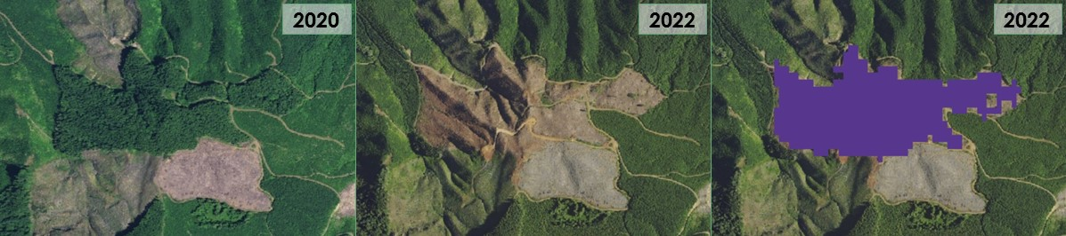Figure A1: True color images of an example of clearcutting and identified using CCDC in purple.

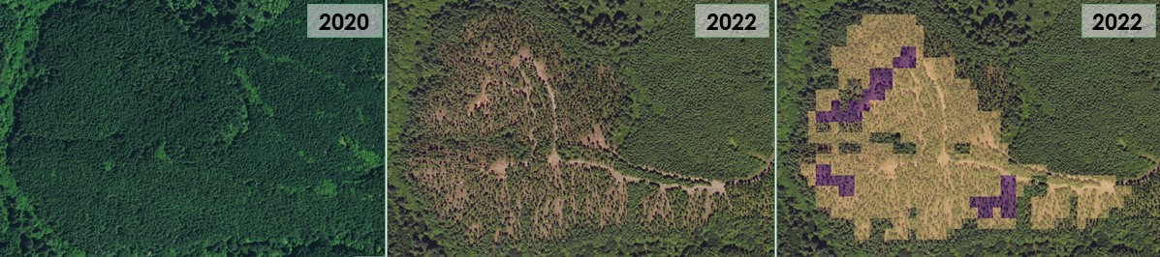Figure A2: True color images of an area, seen in yellow, identified as commercial thinning using percent change in NDVI as derived from NAIP. Heavily thinned patches are counted as clearcutting, visualized in purple.

Appendix B: Total Logging Results for Highlighted Watersheds

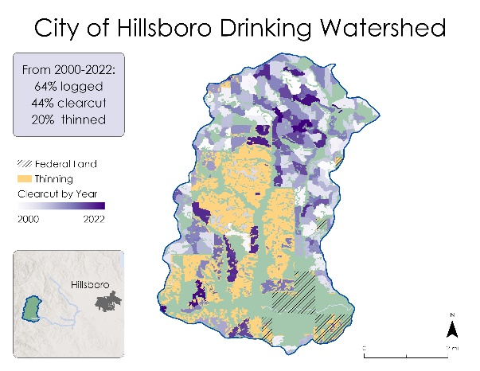 | 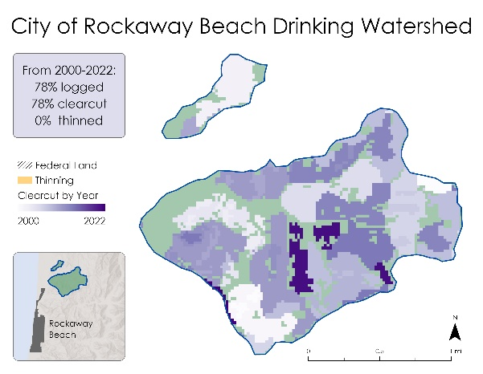
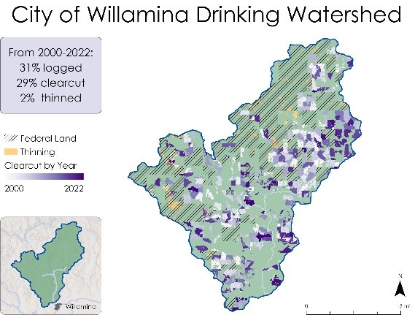 | 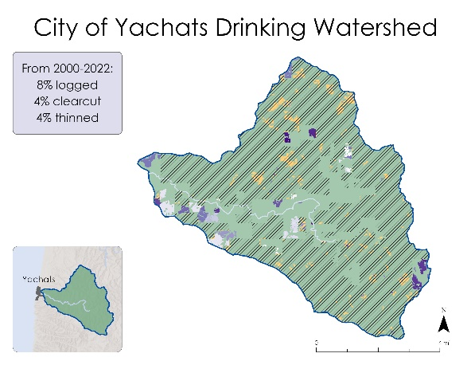
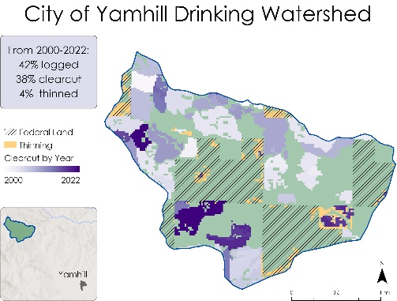 | 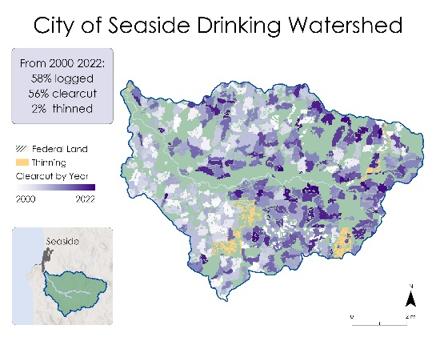
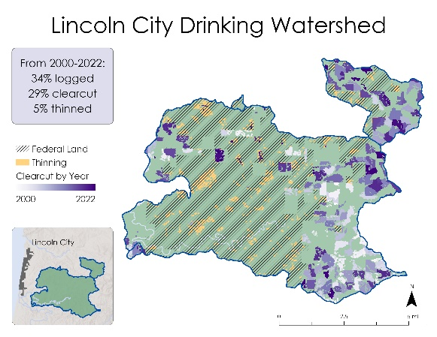 | Figure B1: Maps of highlighted watersheds chosen by Oregon Wild displaying CCDC clearcutting results by year and total commercial logging for the following watersheds: Hillsboro, Rockaway Beach, Willamina, Yachats, and Yamhill, Seaside, and Lincoln City.

Appendix C: Total Logging on the Oregon Coast Range

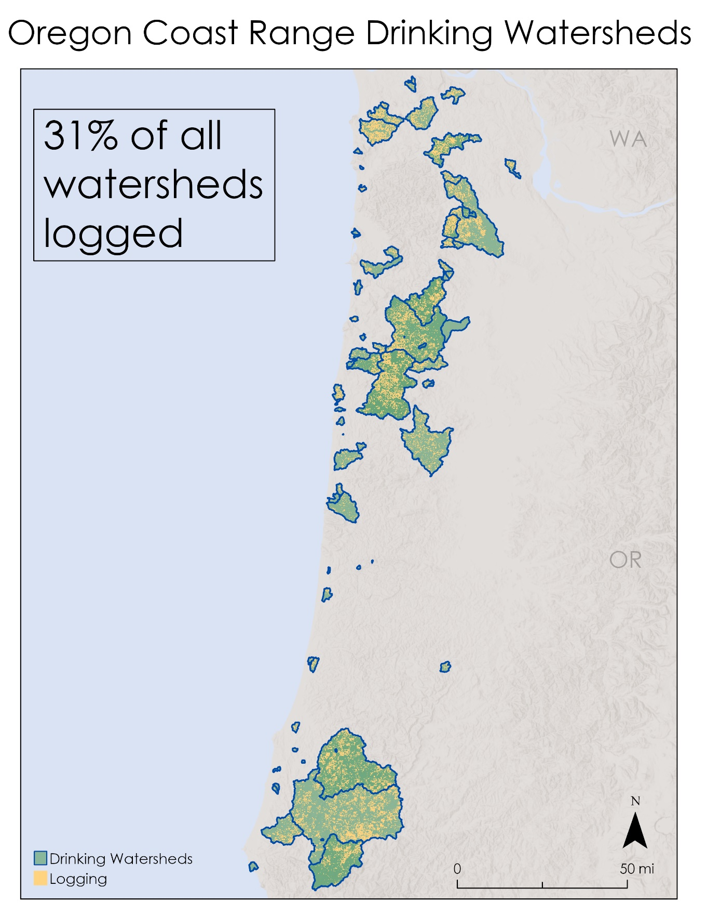
Figure C1: Map of total logging, including clearcutting and commercial thinning, within the 80 watersheds in the team’s study area.

