Early Artemis Surface Navigation: Challenges, Approaches, and Opportunities

Evan Anzalone, NASA/MSFC
Lemuel Carpenter, NASA/LARC
Cheryl Gramling, NASA/GSFC
Laurie Mann, NASA/GSFC
Thomas Moody, NASA/JSC

Biographies

Evan Anzalone is a navigation engineer at NASA’s Marshall Space Flight Center supporting Artemis Campaign Development Systems Engineering and Integration as its Navigation Lead.
Lemuel Carpenter is the Integrated Performance & Systems Management Deputy Lead within the Systems Engineering & Integration Office of NASA's Extravehicular Activity and Human Surface Mobility Program .
Cheryl Gramling is the Space Communications and Navigation (SCaN) Lunar PNT Lead at NASA’s Goddard Space Flight Center.
Laurie Mann is a flight dynamics engineer at NASA’s Goddard Space Flight Center supporting the Extravehicular Activity and Human Surface Mobility Program.
Thomas Moody is the Integrated Performance & Systems Management Lead within the Systems Engineering & Integration Office of NASA's Extravehicular Activity and Human Surface Mobility Program.

Abstract

The early Artemis missions represent the return of humanity to the surface of the Moon and provide opportunities for meeting early science and exploration goals. Position, Navigation, and Timing (PNT) capabilities are a fundamental element and inform operational design, flight rules, and the ability to meet these. This paper provides an overview of the needs, potential implementations, challenges, and concepts of operations in the initial human surface missions, Artemis III and IV. These early excursions are a crucial learning opportunity to gain more experience in the actual operational environment for Artemis V and beyond where exploration objectives and complexity increases. As part of the study, the team defined a threshold performance navigation requirement (including position and orientation) to meet crew safe return and assessed a breadth of navigation approaches that could be deployed to augment the crew’s baseline navigation capability. Data was collected in terms of size, mass, power, operational constraints, environment constraints, interface, and performance to define the technical metrics. Given these, the trade team conducted polling among the various Artemis Campaign elements to capture preference, integration challenges, and operational impacts. These were used to develop weightings and inform a ranked order of solutions across each of the early missions. The results of the study recommended augmenting the initial orientation capability with additional navigation sensors to provide coarse position and heading information to the crew to enable a safe contingency walk-back when out of video range. The team identified opportunities for embedding this hardware in future scenarios to provide an integrated solution. With the deployment of the LunaNet’s Lunar Augmented Navigation System, the crew will be able to maintain accurate real-time navigation knowledge with minimal physical impacts. Discussion of future testing and continued analysis is included in this paper. These forward plans and long-term architecture systems will enable a powerful navigation approach for orbiting and surface users, enabling a high level of scientific return and crew safety.

introduction

In April of 2023 NASA released the "Moon to Mars Architecture" which described the envisioned goals and objectives as well as architectural segments for human exploration of the Moon and Mars. One of these goals is to create an interoperable global lunar utilization infrastructure [1]. This goal led to the derivation of a critical objective to "develop a lunar position, navigation and timing architecture capable of scaling to support long term science, exploration, and industrial needs”. This drives us to not only consider the near term crew safety needs but also the long term infrastructure and utilization needs for the lunar surface.

We are currently in the first segment, the Human Lunar Return (HLR) segment, which includes a limited amount of orbital and surface-based elements, leaving the crew to maximize the utility they can get from Gateway, Human Landing System (HLS), Lunar Communications Relay and Navigation System (LCRNS), and the Extra Vehicular Activity (EVA) system. During this phase lunar infrastructure will have limited coverage and availability so astronauts will be highly reliant on technologies familiar to GPS denied regions. Crew will rely on orienteering and simple passive aids for initial missions following preplanned traverses. As we move forward from the HLR segment to the Foundational Exploration (FE) segment, traverses will get longer and farther from HLS driving the need for more precise absolute and relative PNT knowledge. This PNT knowledge will be critical to coordinate the activity of multiple rovers and crew during, as well as in between, lunar crewed missions. In this FE segment we can no longer rely on simple solutions seen during Apollo and the HLR segment and will have to utilize more computationally heavy solutions such as onboard optical navigation and greater utilization of the LCRNS system as additional relays become available. Lastly, navigation systems used on the lunar surface and lessons learned while using them will be evolved into capabilities needed for the initial Mars exploration segment. Although the needs are less clear at this time it is likely that Mars will face similar challenges where low power or passive technologies that enhance crew orienteering capability may be critical for the first astronauts to operate on Mars. Additionally, there is a needed ability for mobility systems to determine and share positioning data with crew and other surface or orbital assets.

During the Apollo missions, crew members used basic orienteering to navigate on the Moon’s surface. Even with the easier terrain and lighting conditions as compared to the South Pole, there are multiple examples of the crew members being unsure of their actual location on the surface and whether they had reached a specific targeted location [2]. Starting with Apollo 15, the crew was provided a sun compass as a navigation aid as the distance traversed away from the lander was expected to increase [3]. The deployment of a navigation system on Apollo Lunar Terrain Vehicle greatly enhanced the efficiency and capability for surface navigation, utilizing a mix of gyroscope, odometry, and solar alignment. Limited navigation technology or navigation infrastructure was developed after the Apollo years for human lunar surface exploration, though advancements have been made in surface robotic navigation capabilities, such as for the Volatiles Investigating Polar Exploration Rover and Mars exploration rovers. Similarly, with the advent of Global Navigation Satellite Systems (GNSS) combined with low-cost optical sensors and inertial measurement units, pedestrian navigation for terrestrial users has grown by leaps and bounds. These all provide potential solutions in hardware and software that can be used to early Artemis missions.

This paper will focus on the early Artemis navigation needs and challenges, associated performance requirements and how they were derived, available navigation methods, and the associated trade methodology and initial recommendations. In addition, the planned verification activities spanning analyses and testing is briefly covered, as well as the navigation architecture evolution into the sustaining phase of Artemis (or FE).

Navigation Needs and ChallengeS

As part of its basic goal for exploration and surface mobility, the lunar surface crew needs to know in real-time their location and what direction to head out to reach a certain target or return to safety. The very first Artemis missions will not have a supporting navigation infrastructure in place like what we are accustomed to on Earth such as GNSS. To ensure the least amount of interference with crew walking and performing exploration and science tasks, the navigation component needs to be low mass, power, and volume, which may limit the performance of the solution. The challenge for crew navigation will be to achieve both a low Size Weight and Power (SWaP) implementation while meeting performance and reliability requirements.

The South Pole environment is very challenging in terms of lighting and terrain, which will make it difficult for crew to use orienteering or solely rely on camera-based approaches. Orbital and surface Radio-Frequency based navigation elements will also be affected by terrain blocking line-of-sight or creating multipath effects. Consequently, Navigation Systems will need to implement navigation algorithms capable of sensor fusion to ensure a resilient and reliable solution can be derived near-real time.

At its core navigation performance relies on accurate reference systems and time definition. While on Earth, such standards are well developed and agreed upon, this remains to be done for the lunar environment. Consistency across the various elements of the navigation architecture is required to minimize service and user errors due to time difference, or reference frames/maps discrepancies. Various cross-governments efforts are currently undergoing to define and capture these standards [4].

For Artemis III, navigation will support traverse planning and execution functions dispersed across multiple elements, including the lander, the astronaut in the spacesuit, and ground mission support. The baseline navigation method will be orienteering as was used for the Apollo missions. Orienteering is defined as wayfinding by correlating map information to real-world physiological information (primarily visual). The crew will have pre-planned traverses provided for each EVA based on science activities and safety criteria such as terrain slope, line of sight to the lander and illumination conditions. The crew will use the pre-planned traverse on detailed maps along with orienteering techniques (e.g., identifying handrails, attack points, and back stops and establishing pace counts) to estimate their current position and their walking direction.

The crew will communicate this information to the mission control center (MCC) via audio during the traverse. In addition, when possible, the crew will also send video and still images of their surroundings to the ground team. MCC will use the crew estimate of position/heading along with any available video information to confirm/refine the crew position/heading and track the full traverse as executed. The science team will confirm/refine the estimated crew position during sampling/science operations and track sampling locations and provide updated instruction for the traverse to MCC. MCC will replan traverses based on science inputs or in case an emergency return is needed. The crew will execute the updated traverse based on their best estimate of their position/heading, which may be an aggregate of what they are seeing with respect to the available maps and MCC/Science inputs. The entire operation relies on the crew being in communication with the ground team through the majority of the traverse period, which means that line-of-sight with the lander needs to be possible.

This approach is not ideal for many reasons: loss of communication (occurring across multiple links) will reduce crew’s ability to replan the traverse, multiple elements are involved in position/heading estimation and will create latency and delays during traverse which will use precious and limited EVA time resources. Ultimately, the traverse planning function needs to also be available to the crew so they can determine their traverse independently from the ground especially in the event of an emergency in real-time. In this scenario, the crew may need to rapidly return to the lander under contingency supplies. Additionally, a reliable surface-based navigation system is needed to remove latency and shorten times needed to make decisions.

The effectiveness of using orienteering depends on the illumination conditions and the number of natural features available to the crew. Figure 1 shows two examples of lighting conditions at the south pole [5] for notional landing sight and dates. These can be compared with surface imagery from Apollo 14 in Figure 2 that show the impact of low sun at a surface user perspective. To mitigate any risk to the crew not being able to locate themselves on surface and getting disoriented, additional navigation capabilities beyond orienteering are investigated which would be standalone for Artemis 3 with the goal of integrating them into the EVA suit by Artemis 4, if deemed beneficial.

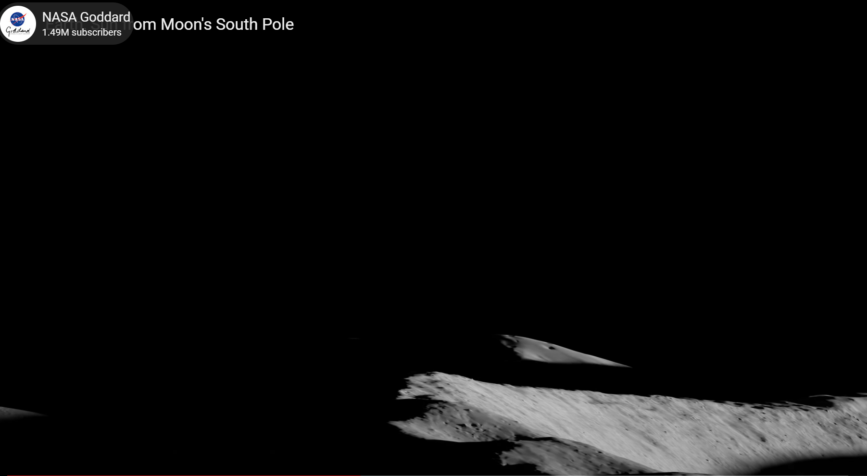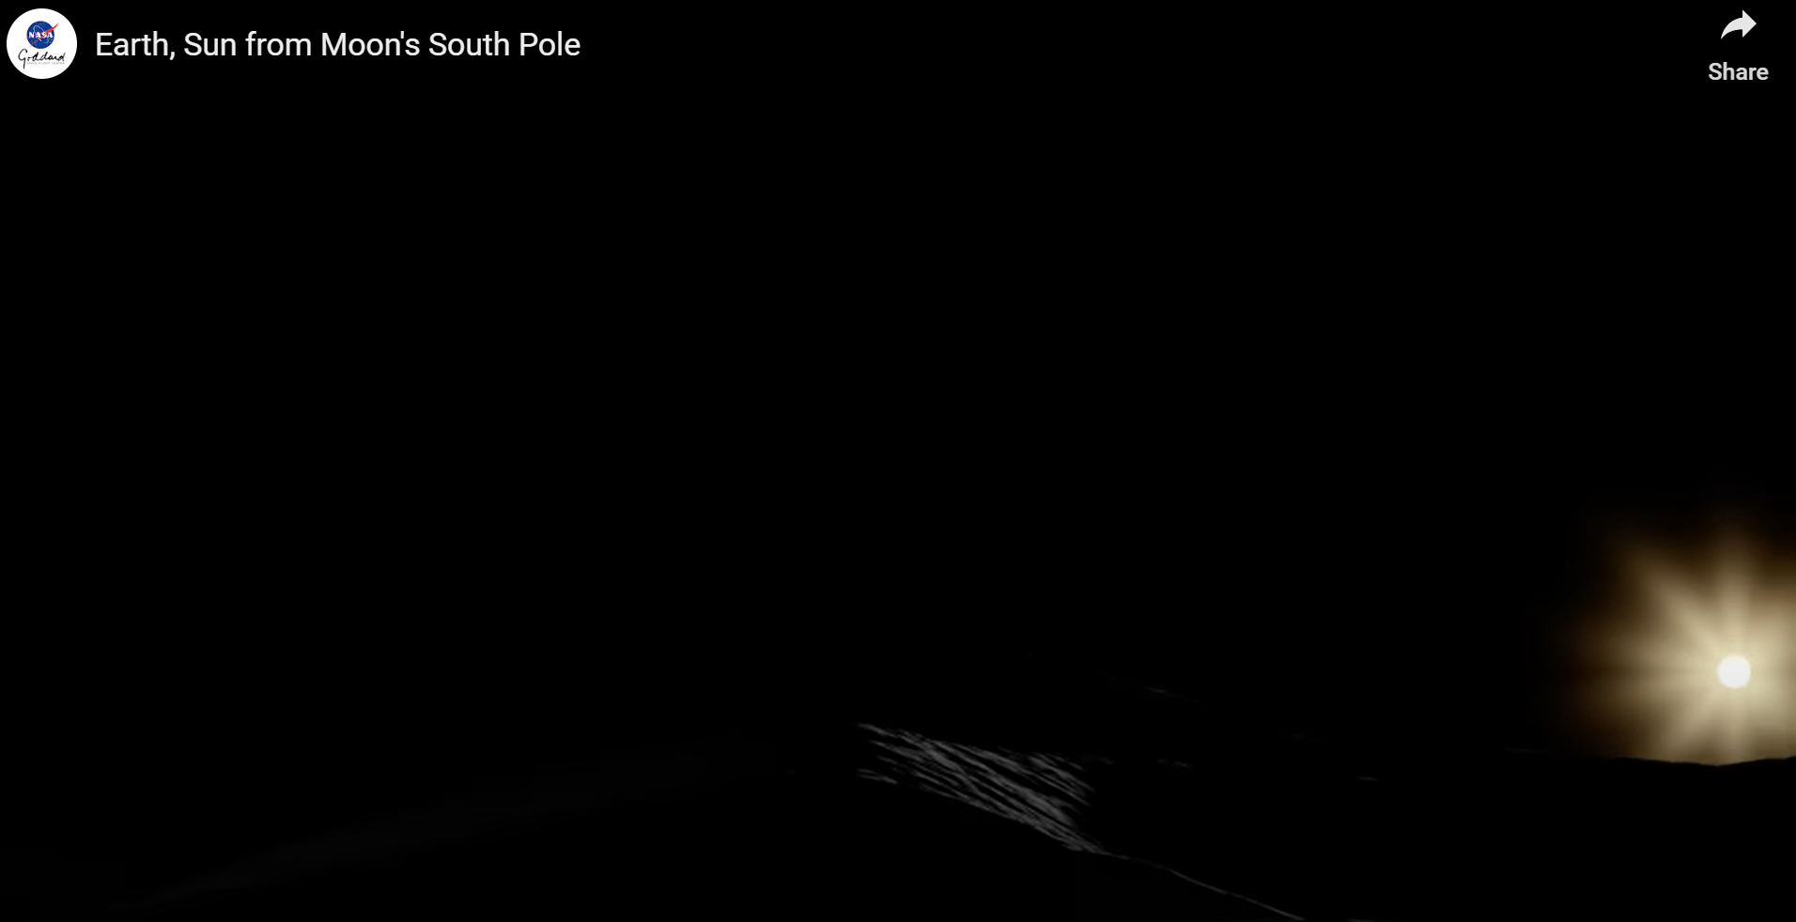
Figure 1. Example of South Pole Illumination Conditions
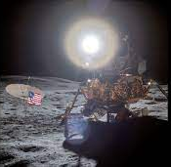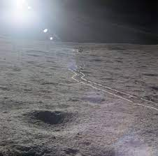
Figure 2. Apollo 14 Low Sun Examples

RequirementS Development Approach

For the Artemis 3 and 4 timeframes, the navigation system performance prime function is ensuring the safety of the crew with a goal of supporting science activities. A general navigation knowledge of 10 meters (root sum squared 3-sigma) was defined as a goal for overall spatial awareness and science sampling/return to a sample location. This value has informed the long-term objectives and developments. However, the minimum performance required to ensure the return of the crew in the event of a major suit anomaly was unknown. Some initial analysis was performed to quantify the navigation knowledge (both position and heading) to ensure the return to safe haven. For this analysis, a first-order MATLAB simulation was developed with the following assumptions:

- Distances from the lander are modeled as a straight line
- Maximum radial distance from lander is 2-km due to desired communication capability
- Constant walking speed is assumed to be 2 km/hr
- 10 min are required to ingress to lander
- When the lander is in sight, crew has a true heading knowledge
- Total contingency reserve is 1 hour
- Maximum duration of 8 hours (nominal)

At each navigation estimation point, the crew will use their position estimation (true position + position knowledge error) and the lander position to derive a targeted heading. The crew will correct its current heading (true + heading knowledge error) to align to the targeted heading and will walk in that direction at the average speed until the next planned navigation update (defined as a simulation variable). The simulation varies the navigation update interval and the time spent deriving the navigation update. Once the crew true position is in view of the lander (HLS Viewing Distance), the crew can walk along the targeted heading without any knowledge errors. This does not include the additional need to avoid hazardous areas, where a straight-line return may not be possible. In the simulation, both the position and heading errors are modeled as Gaussian, with the ability to change distributions to uniform, max/min within the input parameters. Figure 3 provides a flow diagram summarizing the process.

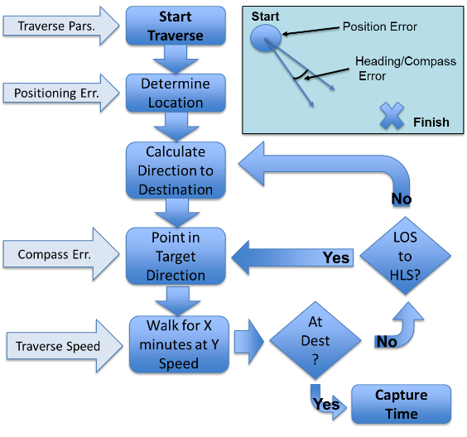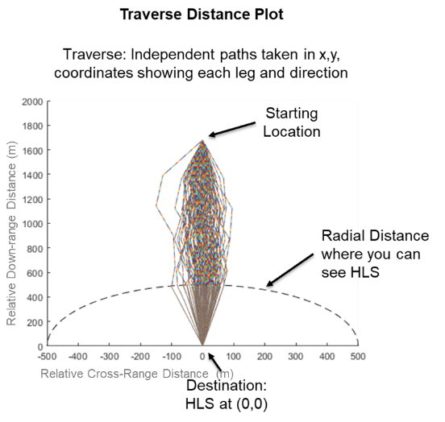
Figure 3. Modeling Process and Set of Monte Carlo Ground Paths
Given this analysis framework, a variety of situations can be assessed to gain insight into the interplay between the multiple parameters of navigation error, time spent navigating, margin on return, etc. The first set of results looks to understand the impact of being able to see HLS from a distance (and its usage as a notional “lighthouse”). Figure 4 shows a contour plot of time margin in minutes to get back to the lander as a function of walk back distance and distance at which the lander is visible for a fixed navigation update frequency and time to determine the navigation solution. Each image shows a unique set of navigation update frequency and time spent during that update. For the diagrams, the color scale is capped with white being all cases with greater than or equal to 0 minutes margin. As such, these white areas can be safe traverses. A negative margin indicates more time is needed than available for a safe return. It is beneficial to have quick frequent updates of the navigation state to better navigate to a target which may not be visible until the crew gets within very close proximity to target. However, if the navigation update takes too much time, the improved knowledge may not outweigh the time spent getting the new solution. As expected, when the lander is visible from a further distance, the navigation solution is not as important as the lander provides a true direction for return. The navigation solution time to derive a solution and its overall knowledge accuracy can be adjusted based on the maximum expected walk-back distance and the ability to see the lander. Two situational constraints will constrain this: the ability to see HLS may also be limited by the lighting environment and seeing HLS does not guarantee a safe path back to the lander, the astronaut will need to continue to be cognizant of and avoid surface hazards, which may extend the time needed to achieve safe return.

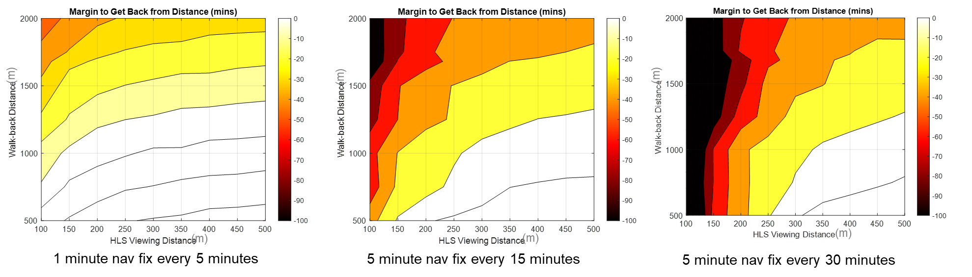
Figure 4. Margin to Contingency Return versus Walk-Back Distance and Lander Viewing Distance: (a) 1-min Navigation Update Every 5 min, (b) 5-min Navigation Update Every 15 min, (c) 5-min Navigation Update Every 30 min.
This analysis shows the interplay between the various design metrics, and shows that the navigation performance requirement in terms of “time to fix” and “accuracy” must both be accounted for. In order to provide a more robust set of requirements, an alternate approach is needed. Figure 5 shows how the navigation performance for three different navigation update frequency and walk-back scenarios affect the time margin to get back to safety. For these results the viewing distance from the lander is assumed to be 300 meters. The range of navigation estimation duration, as well as frequency of navigation update, envelops what the crew may experience using orienteering during a traverse. They may perform a quick look of their surrounding and continue evaluating their location and heading while walking; and at times they may decide to stop, consult map products, and use navigation aids. The analysis shows viable design trace for a variety of update intervals. This overlapping area of position and heading error with positive margin provides a baseline capability that can meet the mission needs. Based on these preliminary results, if the crew can determine their position within 150 meters and their heading to within 10 deg, they can return to the lander in time from walk-back distance between 1.4 to 1.2 km.

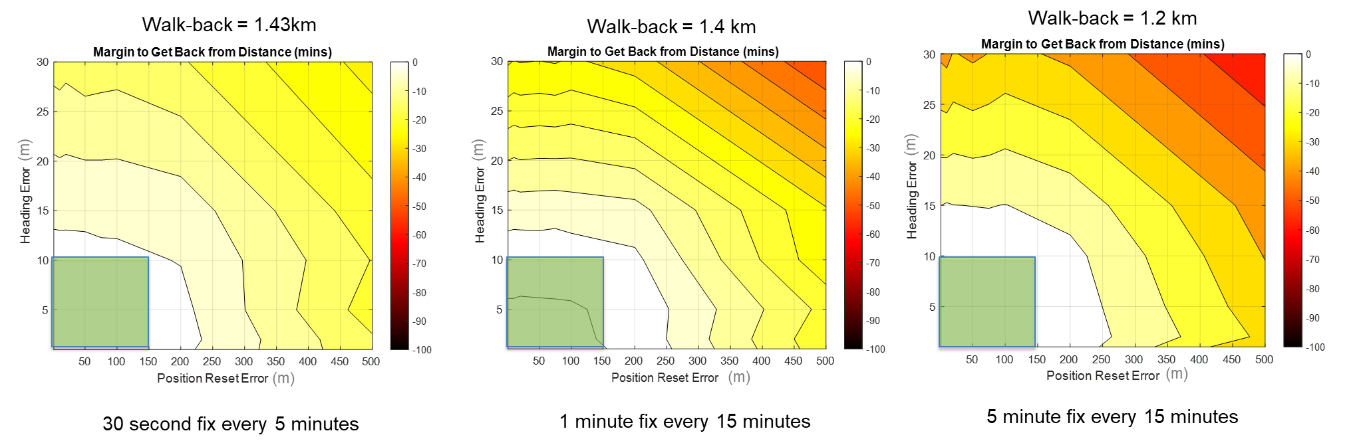
Figure 5. Margin to Contingency Return versus Heading Knowledge and Position Knowledge : (a) 0.5-min Navigation Update Every 5 min, (b) 1-min Navigation Update Every 15 min, (c) 5-min Navigation Update Every 15 min
This analysis was intended to be a first order analysis to provide insight to navigation sensitivities to walk-back distances to help derive a set of requirements to develop to. As noted, a straight-line walkback is assumed over a flat area. This does not bring into account other environment features or impacts such as craters or slopes that may be inaccessible to the crew on a surface traverse. As such, there is a noted difference in describing distances as either “as the crow flies” vs “as the crow walks.” For this analysis, the walking distance can be assumed to be a “as walks” type of scenario. Similarly, other environmental cues may provide additional insight to the crew that was not included here. For example, the use of Earth as a local Northing reference or other elements of the terrain may further aid in the navigation capability. Similarly, the time spent navigating needs further refinement to capture the assumption that the crew may not stand in place, but rather is continuing this mental process during the entire walk-back and continuing to make observations during the entire traverse rather than a fixed process. This analysis assumed a steady speed over flat terrain; additional time will be needed when the astronaut walk avoid a hazard or walk up slopes that may reduce the speed. Similarly, the astronaut may perform navigation while walking. This is difficult to capture numerically, but provides insight that time spent navigating at a stop is a conservative assumption.

While this requirement assumes a fixed capability, further analysis is needed to better characterize expected error models and their sensitivity to local conditions. This is needed to help inform error statistics and modeling, and areas that may be impacted by the traverse itself. As more detailed and proposed traverses are released, this initial performance requirement will be re-evaluated with inclusion of surface terrain and implementing constraints on maximum slope or illumination conditions. Refinement of the suit contingency timeline may affect the duration allocated to the walk-back and may further limit the allowed exploration range, e.g. additional time may be needed to account for the initial detection of a contingency event. As such, while this analysis was initially intended for use in requirements verification, it will continue to be used in a validation role to capture operational impacts of the design solutions and verify adequate margin from a navigation perspective, supporting continuing traverse analysis and simulations across Artemis.

Technical Solution Space and Recommendations

With the above understanding of the needs and requirements for surface navigation for the early missions, the team then transitioned to identifying the potential options for implementation. To do this, the team relied on the initial data collected from the Artemis navigation trade [6] to provide a basis for understanding technical solution options. Given this input, more information was gathered to refine their characteristics with a focus on integration impacts. Similarly, the individual elements were polled to understand design and implementation preferences to capture their expertise and prior experience with similar missions. This section provides an overview of the solutions considered, their comparisons, ranking process, and primary conclusions.

Potential Solutions

The first step in the trade study was to understand the potential solutions that currently exist in the field with application to navigation on the lunar surface. The primary implementations are discussed briefly in the following sections. More detail is available on each, but this is intended to provide an overview of the types of solutions considered.

Orienteering and Enhanced Orienteering

Before the deployment of the satellite navigation, people navigated on Earth using maps and simple and readily available landmarks or natural features such stars, magnetic pole, or the Sun. These method are still applicable on the Moon (except for the magnetic pole) and provide a baseline capability for navigation. Though it lacks a magnetic field, celestial references such as the Earth and Sun can be used as directional references. An example image of the Earth from a South Polar Region Location is shown in Figure 6.

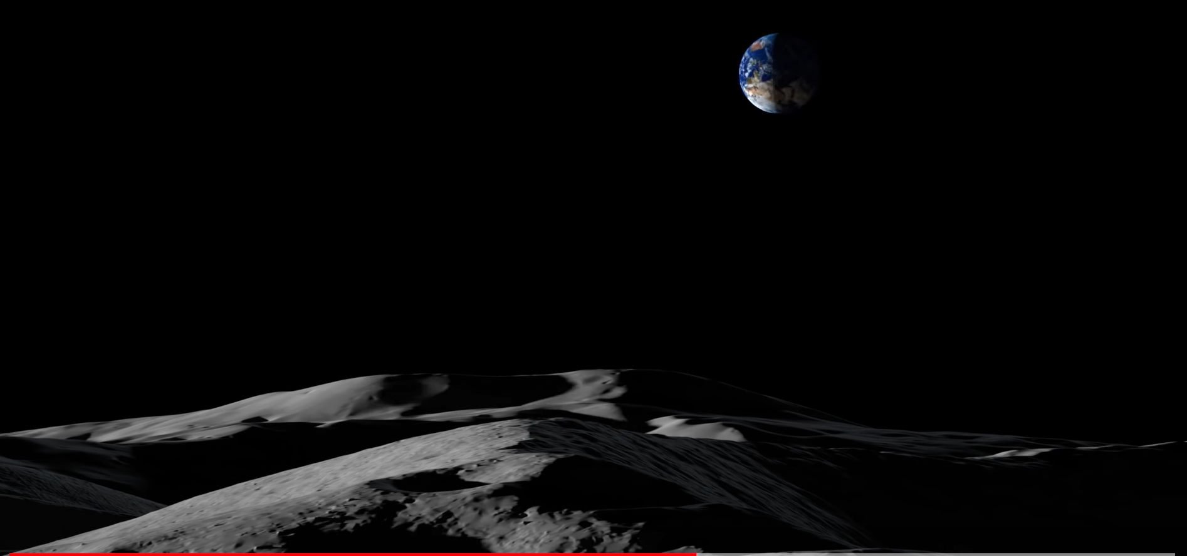
Figure 6. Earth over the South Pole Region under Low Lighting Angles

Using the Earth and/or Sun to provide a general heading knowledge and using a motion integration capability, one can derive a coarse position and heading on a map. The heading can be determined using the following sensors/methods: Aligning of a map with Sun, Earth or surface assets such as the lunar lander, Sun compass, Coarse or Fine Sun Sensors, or Star Trackers. The position can be determined relative to a starting point using the following sensors/methods: Counting steps, Pedometers, Accelerometers, or Inertial Measurement Units. The position can also be determined relative to a map based on natural features such as nearby unique craters or hills if illumination allows. Each one of these sensors/methods comes with pros/cons and different solution accuracy and time to determine the solution.

Optical Navigation
This navigation method uses a camera or lidar type sensors to generate the observables used in deriving a state estimation. There are two major types of camera-based navigation which are germane to Moon surface navigation: 1. Using stars/planets as the reference (also known as clean), an asset can derive its state by looking at the difference between the observed object compared to the known catalog. 2. Using natural terrain features such as craters or horizon line such as Terrain Relative Navigation [7], an asset can derive its state based on an a priori model of these features or in-situ mapping of the terrain via methods such as Simultaneous Localization And Mapping (SLAM [8]). Because these methods use a camera as its main sensor, its performance is sensitive to lighting conditions. In addition, processing images to identify features or performing in-situ mapping requires sizable on-board memory and processing power.

A LIDAR-type sensor can also be used to perform TRN (either via an a priori model or using SLAM). Using a Lidar sensor allows the navigation performance to not be affected by lighting conditions. However, Lidar sensors generally are larger SWaP units compared to cameras. Processing Lidar point clouds also requires large on-board memory and processing power.

Radio Frequency-based
Multiple approaches to RF-based positioning can be utilized to aid in navigation. Prior studies [9] utilized radio direction finding techniques to provide a relative bearing (and potential coarse range) between elements. Similarly, the use of multi-antenna systems in a communication surface architecture can also be used to generate a relative bearing between elements. The use of multiple bearing observations can enable the use of triangulation to estimate a surface position. Alternate methods to measure angles or ranges can be employed through systems such as Ultra WideBand Ranging [10] that can enable high precision inter-element measurements. Lastly, fixed elements can generate signals analogous to, but on a non-interference basis with, planned orbital navigation implementations. This can help provide a common standard for surface and orbital-sourced radiometric signals, enabling greater diversity in geometry of observations. The primary constraint to their implementation is the need for additional surface architecture, either as deployed payloads or as part of the host lander vehicle. Similarly, their range may be limited due to either power constraints and/or line of sight.

Operational Constraints and Integration Challenges
In parallel with understanding the technical solutions and options, it is important to understand how they could be utilized. This is needed both in terms of any operational constraints based on the environment, and how the additional navigation hardware would integrate with existing solutions, e.g. the spacesuits. From an operational perspective, it is important to understand the limitations associated with each solution. For example, some solutions may require line of sight to the sun, appropriate lighting levels, and/or line of sight to another assets. These were used to understand the robustness of each solution to potential operational scenarios, such as operating within a permanently shadowed region and being able to maintain a navigation solution.

The other aspect is understanding how the hardware would integrate with the existing elements that are currently in design. This is a broad trade space and helps to identify all of the interfaces that will be touched by the deployment of the navigation solution. A short summary of the considered options is given in Table 1, below. Separate from the technical solutions, these were reviewed by the stakeholders in the trade study to assess their preference to help capture subject matter expertise on issues like difficulty of integration, interface challenges, and operational perspectives. From these studies, the team strongly leaned towards suit-embedded solutions as the longer term goal, while understanding that for near-term solutions, flexibility is needed to decouple development efforts and ensure capability could be delivered on-time. While external solutions do hold promise, these will require tighter integration across multiple elements and also limit when they could be used, i.e. within range of the other elements. For contingency scenarios, there is a strong need for an onboard autonomous solution to enable safe return.

Table 1. Integration Options
Integration Option | Description
EVA-Integrated – Artemis 3 | Physically and electrically connected to suit as host platform for Artemis 3 vendor
EVA-Integrated – Artemis 4+ | Physically and electrically connected to suit as host platform for Artemis 4 vendor (differentiated from Artemis 3 due to increased time for implementation)
EVA-Attached | Attached externally to source with potential use of external connectors for power and data
Pallet-installed | Installed to potential cart being considered to carry tools for astronauts, self-sufficient power and data
Temporary Infrastructure | Deployed via tripod or onto surface, fully self-sufficient, with a known fixed in location on surface
Autonomous Rover | Development and utilization of a small robotic platform to follow crew and perform navigation and other mapping or science functions
HLS-installed – Artemis 3 | Installed into HLS vehicle utilizing its power, comm, and structure
HLS-Installed – Artemis 4+ | Installed into HLS vehicle utilizing its power, comm, and structure (differentiated from Artemis 3 due to increased time for integration)
Mobile Vehicle (LTV or PR) Integrated | Operates as part of and hosted by mobile vehicle
Mobile Vehicle (LTV or PR) Attached | Independent payload with its own comm and power attached to a payload port on mobile vehicle

Qualitive Performance and Constraints
The next step in the trade study was to evaluate the potential solutions across the operational constraints and performance. Figure 7 below provides a summary of the team’s qualitative rankings. The team used a 1-5-9 scale to represent good/positive (green), medium (yellow), and poor/constrained (red). This was primarily applied to operational constraints or other qualitative data. For quantitative data, such as range or performance, numerical results were grouped based on levels of performance to define clusters of capability. These were then used to provide inputs for the applicability of each technique to the operational need. In the table below, the types of solutions are grouped into three sections: the top being absolute navigation (light blue in left-most column), the middle are relative navigation solutions (darker blue), and the bottom (darkest blue) are coarse navigation aids that can help return a user to a path or starting location, only. The distinction is in terms of the accuracy and fidelity of the navigation information. For example, relative solutions will be dependent on understanding of initialization of user attitude to local baselines in order to transform the relative solution to an absolute knowledge.

The left side of Fig 7 provides a comparative notional performance assessment. These capabilities are the results of a mix of iterative review and first order analysis to capture an initial estimate of the capability performance. This table also includes assessments of how the solutions can scale or support areas of operation to capture aspects such as error drift over distance or how observation geometry may change over longer traverses. This level of fidelity was adequate to inform the initial trade study, and additional analysis is underway to study the top-ranking solutions in more detail along planned trajectories.

The right side of the table provides inputs into what kinds of data each solution can provide, i.e. whether it is only a position and/or a heading, as well as what operational constraints impact its performance. These provide insight to the operational scenarios that each can support. For example, if a solution requires line of sight to surface infrastructure, it may not be applicable for far-field traverses; or if line of sight to the sun is required, that will limit exploration into shadowed regions. Together, this information on operation constraints helps to provide insight into ranking the solutions based on user feedback in terms of desires and operational conditions that evolve over each Artemis mission.

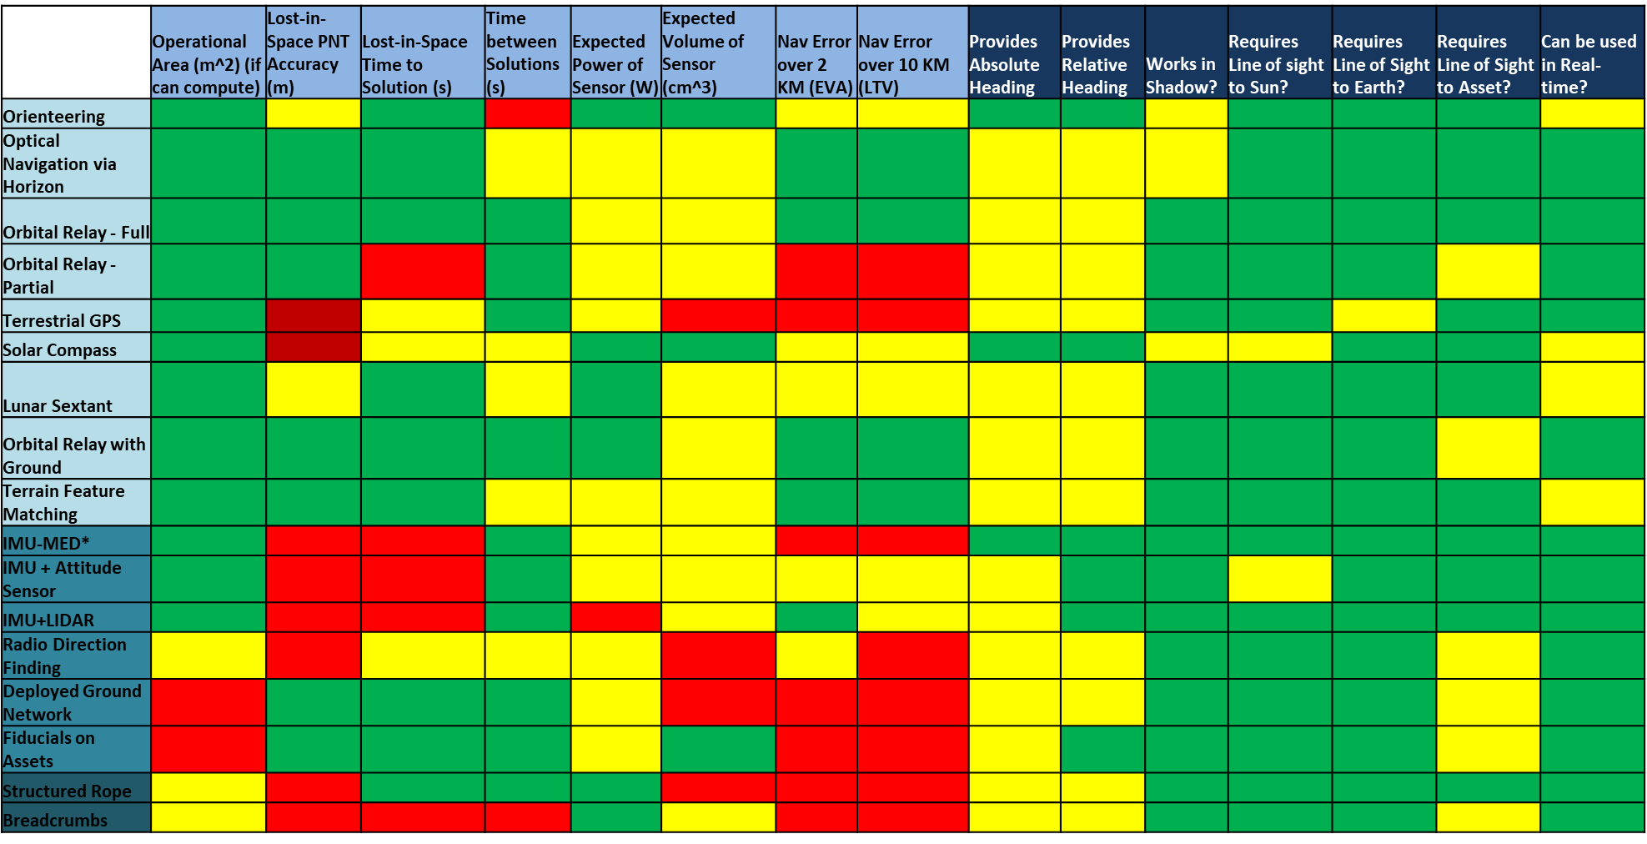
Figure 7. Solution Qualitative Rankings(X-Axis is Metric, and Y-Axis is Individual Solution)

Ranking and Prioritization Approach
To capture the relative ranks and weights of each metric, the trade study team was polled to capture their understanding of and preferences for implementation of navigation solutions across both their element and the evolution of Artemis missions. The design team includes subject matter experts in navigation supporting each element to capture their insights and experience regarding such aspects as integration challenges, operational plans, and desired performance. A summary of these metrics is given in Table 2. These values were also documented in terms of each Artemis mission to allow for an understanding of the desired evolution of capability over time. This helps to provides insight to what capabilities are needed when, and when certain constraints need to be relaxed.

Table 2. Solution Scoring Approach
Metric | Description and Scoring
Technical Integration Difficulty | 1,4,6, or 9 ranking from team capturing ease of integration into hardware and operations (1 represents easiest; 9 represents hardest)
Technical Integration Preference | Weighting scheme letting each element identify preference for implementation of PNT Solution
Applicability To Con-ops | Yes/No scoring to show ability of technique to meet specific functional needs
Operational Constraints | Yes/No grading on elements such as operational conditions (i.e. line of sight, operates in shadows) and data generation

These scores were all consolidated into an excel worksheet and combined to capture an integrated scoring for each solution. As identified above, the scores capture a complex set of desires from technical performance to element preference and constraints. In order to provide a broad understanding of the design options, the equation in Figure 8 was used to capture an integrated view. This scoring function normalized each unique set of criteria to capture a value for each. The total points value captures the maximum number of points or score that was possible based on the qualitative ranking for each, essentially normalizing each to a scale between zero and one. To combine the independent scores, a separate weighting is included, represented by the letters A, B, C, and D. This allows for capturing a score based on the relative ranking of each criterion. With this approach, a variety of scenarios can be assessed to understand the robustness of the various solutions. An example scenario may be focusing all points on performance or operational constraints and others may be focused on con-ops and integration. This scoring process was used to inform an overall ranking of solutions for each Artemis mission.

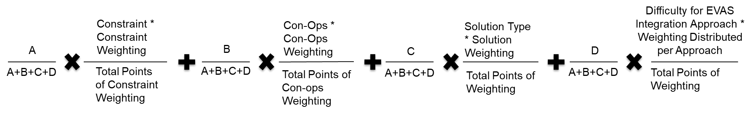
Figure 8. Scoring Function

Results of Initial Ranking
For initial analysis, equal ranking was assumed between each scoring parameter. Given the qualitative nature of the scoring and ranking approach, the ordering of solutions is primarily intended to provide insight into the relative preference between them and guide the analyst in conducting more detailed trades and analysis before coming to a final solution decision. The results for each mission are provided herein.

Review of the Artemis III rankings provides several useful insights to the approach to navigation across the elements and the balance being pursued between accepting operational constraints and enabling successful exploration. Based on the scoring, the teams were willing to accept conditions such as staying in sunlit areas and line of sight to ensure a safe traverse, while being very hesitant to accept integration challenges that could cause risk in terms of mission readiness. Additionally, given the operational constraints, it was identified that a relative navigation solution was adequate for the early missions for real-time operation. While the crew may have a map to orient to the local terrain, the navigation aids would be focused on providing local information relative to the start of a traverse that could be transformed back into an absolute navigation either through initialization or post-processing. As such, the solutions heavily leaned towards orienteering as a baseline solution for the initial missions. The study did show a second clear preference for hardware that could provide a heading solution, with IMU (Inertial Measurement Unit), IMU with Attitude Sensors, and IMU+LIDAR, scoring equally well. This highlights the need for providing the crew with an augmented capability to understand current heading while conducting a traverse. The terrestrial analog is equivalent to having a magnetic compass with the additional capabilities it enables. Similarly, based on integration preferences, the optimal implementation would be in terms of a handheld or independent unit that could provide information to the crew or to ground operations.

The Artemis IV rankings provided very similar of observations as Artemis III. The key difference was that for the Artemis IV mission there is an opportunity to update requirements and enable a more tightly integrated solution to meet the navigation needs. Similarly, as the missions continue, the importance of the operational constraints increases, with a focus on more robust solutions that can provide real-time information. For the Artemis IV mission, inertial navigation aids scored very strongly as well, but the use of optical navigation via horizon imagery scored very high. For optical navigation testing, Artemis III will provide invaluable testing data to support post-processing and traverse reconstruction using asset such as any handheld camera. These solutions are important in order to give the crew a way to determine their absolute location with coarse accuracy. This presents the next level of capability from being able to measure direction to also being able to measure position. The recommendation from this scoring was to pursue tightly integrated solutions of IMU and attitude measurements into the suit itself and refine the optical navigation approaches to enable additional capability.

For both sets of scoring, solutions utilizing elements such as a LIDAR scored very high even though they had significant initial issues with integration and operations. While not a viable option for each mission due to the integration challenges, it helps to guide future development and clearly shows its value. The team found it of high importance to continue pursuing this due to the great level of capability in terms of both localization and mapping.

Another area of promising development is in the use of optical markers, or fiducials, to aid in relative navigation. These could be deployed to multiple surface elements, for example, and when in view of a user camera (either in-flight or post-processing) allow for high precision relative pose estimation. The trade study showed values in the ease of integration and usage of existing hardware (such as a potential handheld camera and suit-mounted cameras) to capture the imagery needed for pose estimation. This effort has led to current work to assess the use of this technique across the entire architecture.

Plans and Approach to Testing and Validation

The Artemis III and IV navigation solution requirement verification and validation plan will include both simulation and analysis, as well as human in the loop testing using both virtual realities and Earth field test analogs. The analyses will focus on quantitative assessment of navigation systems performance and their effect on the executed traverses using various tools such as Goddard Enhanced Onboard Navigation System (GEONS), Mission Analysis, Operations, and Navigation Toolkit Environment (MONTE), and Pextant. These analyses will focus on the two main use cases for the early missions: return to lander and science sampling traverse.

In addition to the analyses, more qualitative testing is taking place to understand how well the crew will be able to navigate using orienteering in two different environments. The first environment is the Prototype Immersive Technologies Lab (PIT) where the Integrated Testing Facility (ITF) at NASA JSC developed a virtual reality where a test subject can simulate walking on the Moon’s surface. The simulation uses detailed terrain models based on digital elevation maps with rendered lighting and various surface components such as the Human Landing System, and associated tools such as the handheld camera. In this environment the test subject can estimate where they are based on what they see (lander, sun, Earth and various terrain landmarks) and make a decision on direction of travel based on a provided map. The testing allows for more qualitative and subjective evaluation of the crew’s ability to navigate.

While a great tool to simulate what the crew will see/experience once at the South Pole, the virtual reality testing has limitation in that the subject does not feel any load or restriction from wearing a suit. In addition, they do not experience any tripping on large rocks or consequences from stepping in steep craters or heading into shadow areas. In a real situation, the crew may decide to walk around areas with many boulders or avoid shadow areas where vision is limited. To evaluate the traverse and navigation operations concept with more realistic human loading conditions and terrain, field testing is being planned in Arizona at a location with terrain similar to what the crew may see for the early Artemis missions. In these analog testing scenarios, the test subjects wear mockup suits and can evaluate tools or other hardware planned for the mission. They can test for fatigue, overall situational awareness, and amount of communication required between the different elements of the Artemis team in various traverse scenarios. There are also limitations associated with the field testing as for example, it is very difficult to recreate the right South pole lighting condition and the terrain will have vegetations which is not present on the Moon. However, this testing brings another qualitative set of data which when combined with the other information collected via analyses or virtual reality simulations builds our understanding on how well we will navigate at the South pole without a precise navigation system in place.

Architecture Evolution and Challenges

With the arrival of the Lunar Terrain Vehicle (LTV), the expected surface mobility and associated functionality will increase. The exploration range expands from 2-km to 10-km, which means that the walking crew may have to walk back 10-km in the event of an LTV issue. There is also a significant shift in navigation performance which will require methods, hardware, and software beyond what will be deployed for Artemis III and IV.

To meet this need, higher performance, lower TRL (Technology Readiness Level) and higher SWaP technologies are required. Local relative autonomous navigation, hazard detection and avoidance will leverage optical sensor such as a stereo camera, while absolute navigation and path planning may take advantage of the planned deployment of overhead broadcast Position, Navigation, and Timing (PNT) signals from LunaNet assets combined with accelerometer data.

The current Lunar Communications Relay and Navigation System (LCRNS) is planning a phased deployment and demonstration of overhead assets with a single Augmented Forward Signal (AFS) available in Artemis III, up to three AFS signals by Artemis IV, and up to four simultaneous signals forming the Lunar Augmented Navigation Service (LANS) that is similar in concept to the terrestrial Global Positioning System, by Artemis V[11]. The LANS service’s availability might not be continuous which means that the navigation system will need use many different types of observables and cannot solely rely on LANS for its navigation solution. However, development and leverage of an AFS/LANS receiver in the early Artemis III-IV timeframe will be a critical step in verifying and validating the navigation capability. Longer term efforts within Space Communications and Navigation (SCaN) are investigating development of a global lunar PNT system composed of LunaNet compliant orbital AFS providers with Moon-based monitor and control stations to serve the Moon Sustaining Phase needs. In addition, the deployment of Moon surface clocks and various instrument/sensors to survey the Moon and provide an accurate Lunar Geodetic System and Local Lunar Time is also being scoped as part of an essential Moon navigation infrastructure.

Other challenges and opportunities will also impact the development and deployment of navigation capabilities. To enable long-term high-bandwidth surface communication, systems such as Third Generation Partnership Program (3GPP) [12] are being considered to support a robust network of users, payloads, and vehicles on the surface. Based on their implementation, these assets could also act as surface navigation references, providing local measurements via additional reference signals or antenna array-based direction finding. The integration of these various assets into a coherent interoperable architecture is a key focus of current architecture planning and development.

Conclusion

This paper presented a first study aimed at defining the navigation needs, operations concepts, and potential implementations for early Artemis missions. While there exists many navigation methods, the South Pole environment will ultimately require a navigation system using multiple types of sensors with an algorithm capable of sensor fusion to ensure a reliable and resilient navigation solution. The early Artemis missions will favor simple, low size and weight solutions at the expense of performance as they will focus on ensuring crew mobility and return to safety by the Artemis III timeframe. Additional post-processing of video and images may be performed to further refine the location of the taken samples during the mission and enable return to the exact sample locations. Later Artemis missions will leverage some of the planned navigation infrastructure which will allow for better performance and increased surface mobility. Further analyses and testing of the navigation operation concept and navigation solution candidates is planned to inform feasibility and the path forward for Artemis 3 and beyond.

Acknowledgment

The authors would like to acknowledge the support of the Artemis Campaign Development Systems Engineering and Integration and Space Communications and Navigation (SCaN) organizations for supporing this work. Particularly thanks go to Mark Kirasich, Steve Creech, Erika Alvarez, Brian McDonald, and Greg Heckler. Additionally, the authors would like to express their thanks to the leadership within the Artemis elements for their support, specifically Larry Jones and Chris Nelson. Lastly, this work would not be possible without the inputs and time of all of those who participated in the study, providing rankings and data on the proposed solutions.

References

- NASA’S MOON TO MARS STRATEGY AND OBJECTIVES DEVELOPMENT: a blue print for sustained human presence and exploration throughout the Solar system. https://www.nasa.gov/sites/default/files/atoms/files/m2m_strategy_and_objectives_development.pdf
- Climbing Cone Ridge - Where Are We? (nasa.gov)
- Apollo Sun Compass (spacecentre.co.uk)
- Gramling C., Crenshaw J., Mann L., (2022). Interoperable Services to Mitigate Lunar Position, Navigation, and Timing Challenges. 73rd International Astronautical Congress, Paris.
- NASA GSFC, Earth, Sun from Moon's South Pole - YouTube, https://www.youtube.com/watch?v=aD1OQ9UBwuU
- Anzalone, E, Gramling, C. Artemis Navigation Architecture: Early Capabilities and Long Term Evolvability and Evolution, ESA GNC Conference, 2023, Sopot, Poland.
- Johnson, Andrew E., and James F. Montgomery. "Overview of terrain relative navigation approaches for precise lunar landing." 2008 IEEE Aerospace Conference. IEEE, 2008.SLAM
- Miller, Kyle, et al. “KNaCK-SLAM: Kinematic Navigation and Cartography Knapsack Velocity-aided LiDAR Inertial Simultaneous Localization and Mapping (SLAM)”. 53rd Lunar and Planetary Science Conference, 2022. https://www.hou.usra.edu/meetings/lpsc2022/pdf/2808.pdf
- Moreau, Michael C. "Navigation Concepts for NASA's Constellation Program and Human Missions to the Moon." ION National Technical Meeting 2008. 2008.
- Anzalone, Evan, Anand Iyer, and Tamara Statham. "Use of navigation beacons to support lunar vehicle operations." 2020 IEEE Aerospace Conference. IEEE, 2020.
- Speciale et al, (2022) Lunar Relay Services Requirements Document (SRD) Baseline Release Date: 12/05/2022 Revision B w/DCN 001, ESC-LCRNS-REQ-0090 Rev_B 12-05-2022 DCN001.pdf (nasa.gov)
- Edwards, Bernard, et al. "3GPP Mobile Telecommunications Technology on the Moon." 2023 IEEE Aerospace Conference. IEEE, 2023.

https://software.nasa.gov/software/GSC-14687-1
https://montepy.jpl.nasa.gov/
https://github.com/norheim/pextant

