Chile Wildland Fires
Augmenting Wildfire Risk Assessment Efforts with Satellite-based Measurements of Soil Moisture and Vegetation Health in Central and South-Central Chile

Technical Report
August 11th, 2023

Benjamin D. Goffin (Project Lead)
Aashutosh Aryal
Quinton Deppert

Advisors:
Dr. Venkataraman Lakshmi, University of Virginia (Science Advisor)
Lauren Childs-Gleason, NASA Langley Research Center (Science Advisor)
Dr. Kenton Ross, NASA Langley Research Center (Science Advisor)

Fellow:
Olivia Landry (NASA Langley Research Center)

1. Abstract
Since 2010, Central and South-Central Chile have recorded abnormally low annual precipitation, resulting in over a decade-long megadrought. This water deficit has driven more severe wildfires, which begin earlier in the year, last longer, and burn over significantly larger areas. Past studies indicated wildland fires propagate following vegetation stress and under certain soil moisture conditions. Our work further investigated the drivers of the unprecedented wildfire that devastated Central and South-Central Chile in 2017 and 2023. To that end, we leveraged NASA Earth observations from space to explore the link between terrestrial variables and wildland fires. We first delineated the burnt extent using data from Landsat 9 Operational Land Imager 2 (OLI-2), along with the combined information from Terra + Aqua Moderate Resolution Imaging Spectroradiometer (MODIS). Next, we analyzed vegetation health based on the Normalized Difference Vegetation Index (NDVI) and evapotranspiration (ET) products of Terra MODIS. Furthermore, we examined soil moisture data from the Soil Moisture Active Passive (SMAP) mission. As the megadrought continues, we found greater anomalies and stress in vegetation indices across the region. We also identified certain pre-fire conditions in soil moisture and evapotranspiration in the days and months leading to the recent wildfires. We compared these findings against control areas that were not impacted by wildfires. Using satellite-based NASA Earth observations, we were able to provide insights into potential indicators of wildfire risk, which can augment future risk assessment and management efforts.

Key Terms
wildfire risk, soil moisture, evapotranspiration, NDVI, SMAP, Terra MODIS, Chilean megadrought

2. Introduction
2.1 Background Information
Since 2010, Central and South-Central Chile have recorded abnormally low annual precipitation, resulting in a more than decade-long drought (Garreaud et al., 2020). This megadrought has severely affected water availability over a large region stretching from 32 to 39°S. In addition, Central and South-Central Chile have also experienced their warmest decade on record. These two conditions have driven more severe wildfires, which tended to begin earlier in the year, last longer, and burn over significantly larger areas (González et al., 2018). During the extreme Chilean fires of 2017, tree plantations made up nearly half of the burned land, causing substantial economic losses. In addition, more than 9.5 million people were exposed to smoke from the fires and increased air pollution (Bowman et al., 2019). Overall, about one-quarter of the urban population in Chile inhabits the wildland-urban interface where wildfire problems are most pronounced, showing the necessity for accurate wildfire risk assessment (Sarricolea et al., 2020).

In the spring of 2022, a NASA DEVELOP team leveraged data from the Global Forecast System along with Earth observation (EO) data from Landsat 8 Operational Land Imager (OLI) and the Shuttle Radar Topography Mission (SRTM) to assist with wildfire management (Hietpas et al., 2021). Their model was able to automate the mapping of wildfire risk, but it left some actual points of ignition outside of the predicted risk areas. Other studies indicated that wildfires occur following certain soil moisture conditions, suggesting that soil moisture information could improve forecasts of fire occurrence and size (Krueger et al., 2016, 2022). Alternatively, satellite-based measurements were also used to capture plant stress and capture dry vegetation prone to feed wildfires (Ehsani et al., 2020; Pascolini-Campbell et al., 2022).

These recent findings give ground for improved wildfire risk assessment considering actual soil moisture and plant conditions. Our study area encompasses the seven administrative regions of Central and South-Central Chile shown in Figure 1 below, including Valparaíso, Santiago, Libertador General Bernardo O'Higgins, Maule, Ñuble, Biobío, and Araucanía. For this project, we used EO from April 1, 2015, to March 31, 2023, with an emphasis on the two extreme wildfire events that occurred from January 18 to February 5, 2017, and January 30 to February 20, 2023.
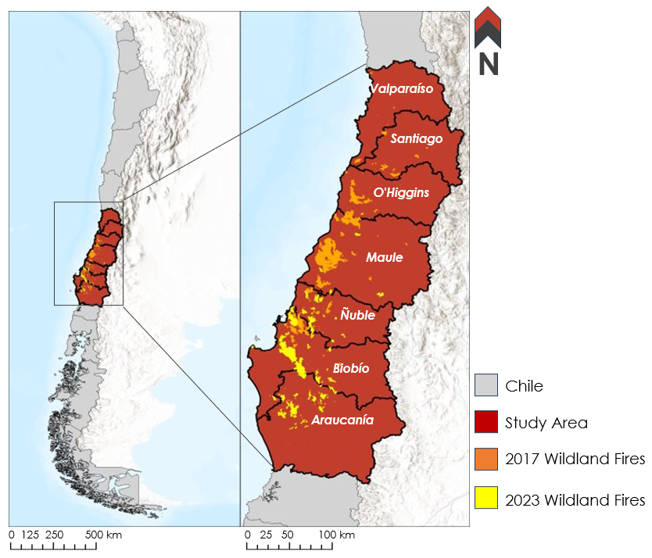Figure 1. Regions of South-Central Chile concerned with major wildfires in 2017 and 2023. [Base map credits: Esri, FAO, NOAA, USGS, Garmin]

2.2 Project Partners & Objectives
The Corporación Nacional Forestal (CONAF) is a private non-profit organization (state-owned) that administers forest policies and contributes to the development of sustainable forestry resources in Chile. CONAF comprises programs that monitor, prevent, and respond to wildfires. CONAF currently uses NASA EOs to calculate anomalies in terrestrial processes and track fire occurrences. However, their fire delineation and risk assessment both require months of data preparation. The Embassy of Chile Agricultural Office in Washington, D.C. works to promote international partnerships between governments, scientists, and forest stakeholders.

We collaborated with CONAF and the Embassy of Chile Agricultural Office to enhance near-real-time wildfire risk assessment capabilities. Specifically, we incorporated satellite-based measurements of evapotranspiration and soil moisture to better capture conditions on the ground. Furthermore, we compared the extent of burnt areas with fire risk maps to validate our risk assessment approach. Ultimately, this work has the potential to inform resource allocation and increase wildfire resiliency in the region.

3. Methodology
3.1 Data Acquisition
Our team acquired EO from various satellites including Landsat 9 Operational Land Imager 2 (OLI-2), Terra Moderate Resolution Imaging Spectroradiometer (MODIS), Terra + Aqua combined MODIS, and Soil Moisture Active Passive (SMAP) Radiometer (Table 1). We utilized level-2 surface reflectance data from Landsat 9 OLI-2 for pre-and post-wildland fire, false-color composite burned areas delineation (Masek et al., 2006; Vermote et al., 2016). We also obtained wildfire extents from the Terra + Aqua combined MODIS burned area product (Giglio et al., 2021). In addition, we obtained Normalized Difference Vegetation Indices (NDVI) and evapotranspiration (ET) information from Terra MODIS (Didan, 2021; Running et al., 2017 & 2021). We also relied on modeled data from NASA Short-term Prediction Research and Transition Center (SPoRT) for evaporative stress index (Anderson et al., 2007 & 2011; Hain & Anderson, 2017). We utilized daily precipitation data (final run) from the Integrated Multi-satellitE Retrievals for Global Precipitation Measurement (IMERG). Furthermore, soil moisture data were used from the SMAP Level 3 and Level 4 products (O'Neill et al., 2021; Reichle et al., 2022). Finally, we used a Rothermel Model from CONAF to determine the types of landcover that were affected by recent wildfires.

Table 1.
Acquired Data and Data Sources
Platform & Sensor | Data Source | Parameter | Time Period
Landsat 9 OLI-2 (LaSRC v1.5.0) | USGS via  Google Earth Engine | Surface reflectance  (false-color composite) | December 2022 –  March 2023
Terra + Aqua (combined) MODIS (MCD64A1 v061) | NASA AppEEARS | Burned area | December 2016 –  March 2023
Terra MODIS (MOD13A2 v061) | NASA AppEEARS | NDVI | January 2001 –  May 2023
Terra MODIS (MOD16A2 v061 & MOD16A2GF v061) | NASA AppEEARS | ET | January 2001 –  March 2023
GPM IMERG (GPM_3IMERGDF v006) | NASA Earthdata | Precipitation | June 2000 –  September 2021
SMAP L3 & L4 (SPL3SMP_E v005 & SPL4SMGP v007) | NASA Earthdata | Soil moisture | April 2015 –  May 2023

In addition, several ancillary datasets were used to support our project’s objectives. We obtained a digital elevation map (DEM) of our study area from the NASA DEM (NASA JPL, 2020). We also received a land surface model specific to our area of study from our partners at CONAF. This layer of information (shown in Figure A1) is based on the Kitral system and broken down into 34 categories of combustible cover and wildfire fuel (Julio et al., 1995).

3.2 Data Processing
Our team retrieved Landsat-9 OLI-2 surface reflectance satellite imagery using the Google Earth Engine (GEE) portal and performed additional processing through the JavaScript Application Programming Interface (API). We compiled observations in the month before and after the fire events. We proceeded to filter out images with more than 10 percent cloud cover and took the median value at each pixel for the month pre- and post-fire. Next, we assigned Band 7 (shortwave infrared 2), Band 5 (near-infrared), and Band 3 (green) to Red, Green, and Blue (RGB), respectively, resulting in a false-color composite of burned scars in the study area as shown in Figure 2 below. Using ArcGIS Pro (v3.1.0), we also performed raster calculations to data from Terra MODIS and removed pixel values outside of the valid range from –32767 to 32700. In addition, we applied a scale factor of 0.1 to display ET data in terms of mm per 8 days.

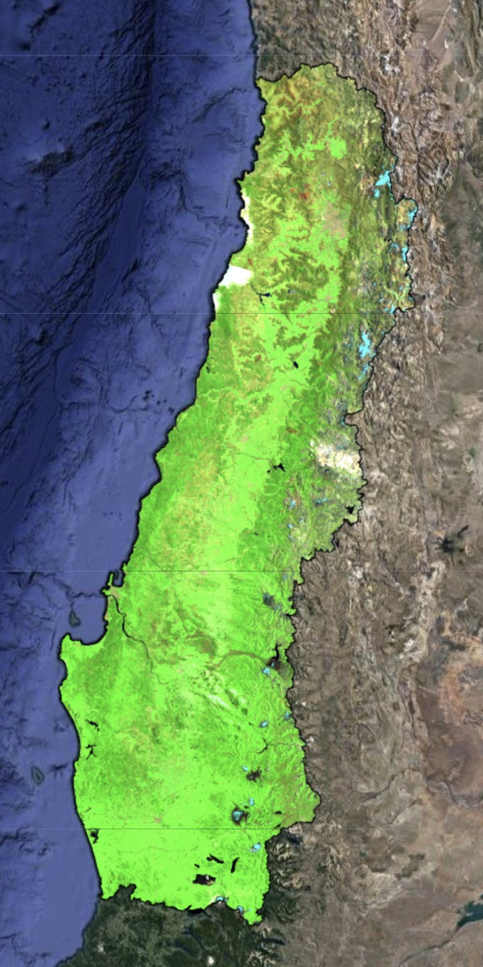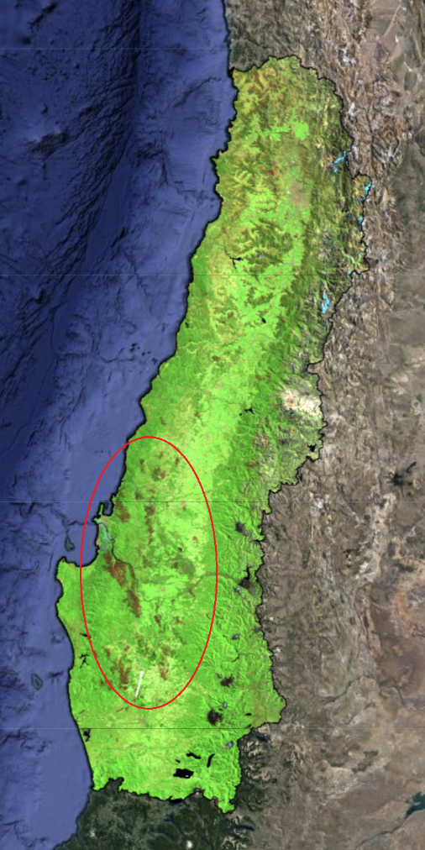
Figure 2. False-color composite of pre- (left) and post-fire (right) images of 2023 wildland fires clipped to the study area. The burned scars from the wildfire are shown as reddish-brown spots and circled in red.

3.3 Data Analysis
Our analyses were performed using Python (v.3.10.11) in Visual Studio Code. The various input files were in a NetCDF format and read as xarray data frames. First, to assess the severity of the megadrought conditions We first explored precipitation and NDVI data using GPM IMERG and Terra MODIS satellite products, respectively. We analyzed precipitation amounts for the years from 2002 to 2020. Similarly, we explored monthly NDVI from January 2001 to May 2023. Given that the megadrought started in 2010 (Garreaud et al., 2020), we established a baseline period from 2001 to 2009 to calculate long-term average values of NDVI and precipitation (not impacted by drought conditions). Then, we differentiated the monthly NDVI and annual-accumulated precipitation after 2010 from their long-term average to obtain anomaly values and capture deficits in these variables.

In addition, we delineated the extents of the wildfire using two methods relying on different satellite observations. We utilized the Burn Area product from combined MODIS to determine where and when the recent wildfires took place in 2017 and 2023. We also compared these areas with the extent of the burned scars from our false-color composite (described in Section 3.2). We focused the next steps of our analyses on the three southernmost regions of our study area (i.e., Ñuble, Biobío, Araucanía), which were most impacted by the 2023 wildfires. Then, we wanted to explore ground conditions across locations with homogeneous characteristics in time and space. So, we then concentrated on the burned areas from February 1st to 6th, when the wildfires spread substantially in less than a week and roughly 70% of ignitions occurred as shown in Figure A2-a. Using the fuel surface model provided by our partners at CONAF, we then extracted specific burned areas. Like previous studies by Bowman et al. (2019), timber plantations appeared to be severely affected by the recent wildfire as shown in Figure A2-b. Therefore, we narrowed down our selection further to consider conifer and eucalyptus plantations, which made up more than 140,000 hectares of the affected land covers. Next, we used the Digital Elevation Model (DEM) to include areas with relatively homogeneous landscapes. As such, we refined the elevation range of interest to encompass 100 to 300 meters above sea level, where approximately 60% of the aforementioned wildfires were observed as shown in Figure A2-c). Using the same criteria in land cover and elevation, we also identified locations that were not devastated by recent wildfires. We used these areas (shown in Figure 3 below) as control in our analyses.

We proceeded to compare ground conditions across burned and control areas. We investigated evapotranspiration patterns in the eight-day composites and months preceding the recent wildfires. We also analyzed the surface and root zone soil moisture data in the dekads (10-day intervals) and months from May 2015 to June 2023. We made spatial and time series plots for evapotranspiration and soil moisture data. We also examined in more detail the distribution of soil moisture and evapotranspiration across burned and control areas.

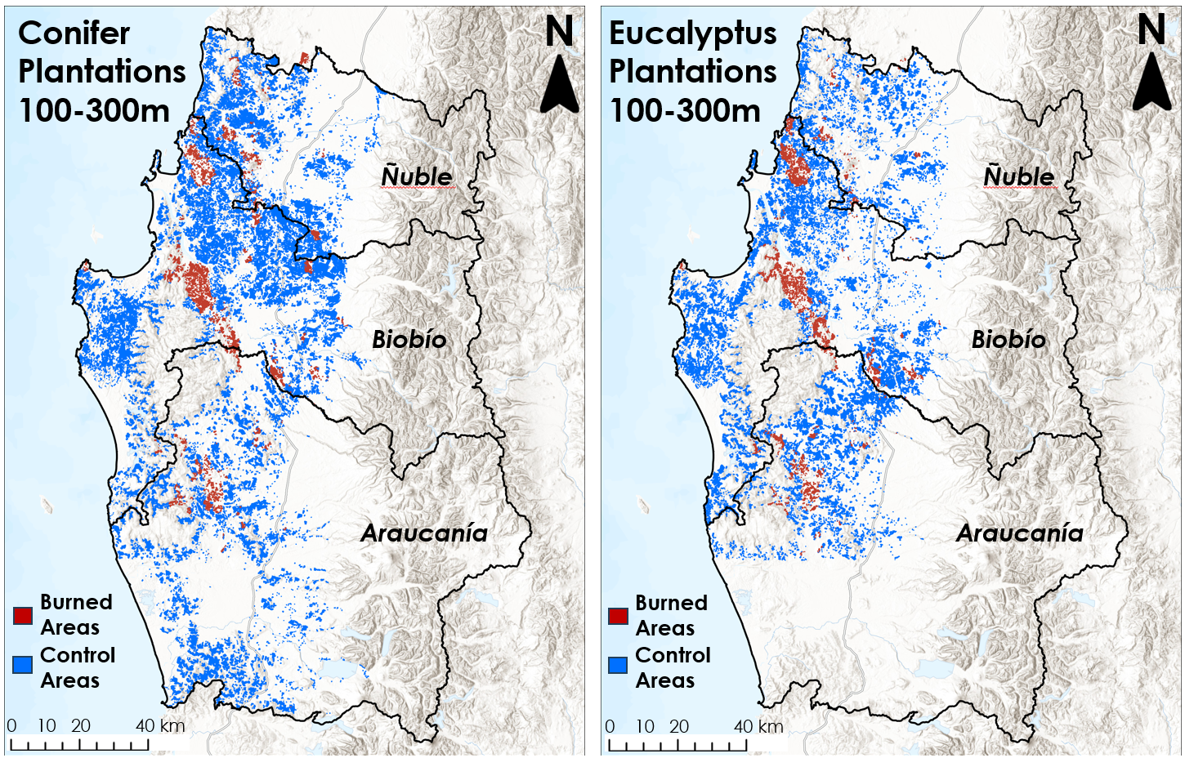Figure 3. Burned and control areas for conifer plantations (left) and eucalyptus plantations (right) selected using homogenous characteristics. [Base map credits: Esri, CGIAR, HERE, Garmin, FAO, NOAA, USGS]

4. Results & Discussion
4.1 Analysis of Results
4.1.1 Precipitation Deficits
We first investigated the satellite precipitation data within our study area. Precipitation across our study area varies drastically across the seven regions of interest, from around 200 mm to more than 1200 mm annually, as shown in Figure 4 below. In addition, we observed substantial variations in accumulated precipitation values from year to year. Looking more closely at three southernmost regions in our study area (i.e., Ñuble, Biobío, and Araucanía), we found precipitation deficits repeatedly on the order of 250 mm beginning in 2010, as seen in Figure 5 below. This amount represents roughly 20% of the annual precipitation in the region prior to 2010, showing the severity of the megadrought. This persistent rainfall deficit in the study area leads us to believe this region is under water stress and vegetation is likely impacted.
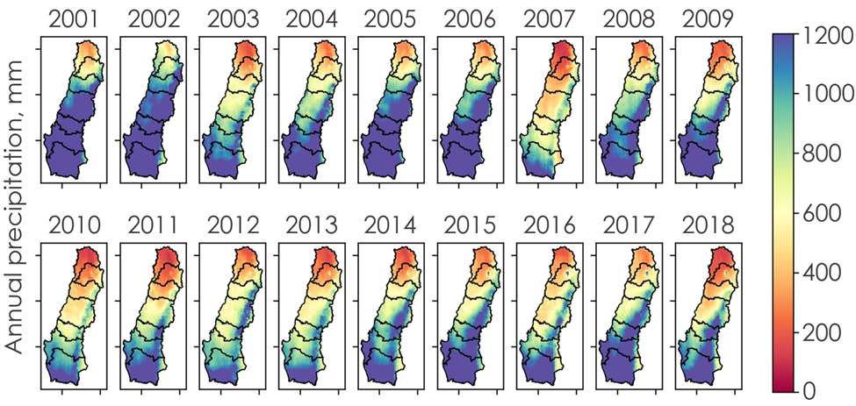Figure 4. Total accumulated annual precipitation variability over the years within the study area

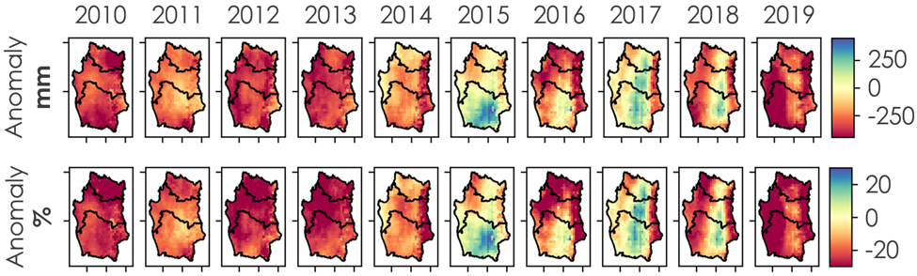Figure 5. Precipitation anomaly in terms of accumulated precipitation and percentage difference in precipitation deficit

4.1.2 NDVI Anomalies
Similarly, we investigated the impact of the megadrought on vegetation in the region and used NDVI as an indicator of plant greenness and health. Figure 6 shows the NDVI anomalies through the years during the earlier months of the fire season (i.e., December, January, and February). From these plots, we found that the vegetation in the study area is under stress, and the vegetation health has deteriorated over the years as the drought is prolonged in the region. It is also noticeable from the plots that there is an increase in negative NDVI anomalies during the megadrought period, which could be one of the driving factors to cause an increase in wildfire activities in the region during this period. From the plots, we can also see a shift from positive NDVI anomaly to negative NDVI anomaly in most areas as time progresses, providing good evidence for a demonstrable increase in vegetation stress.
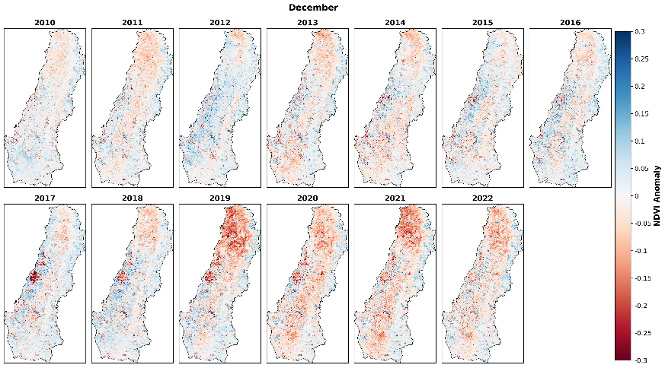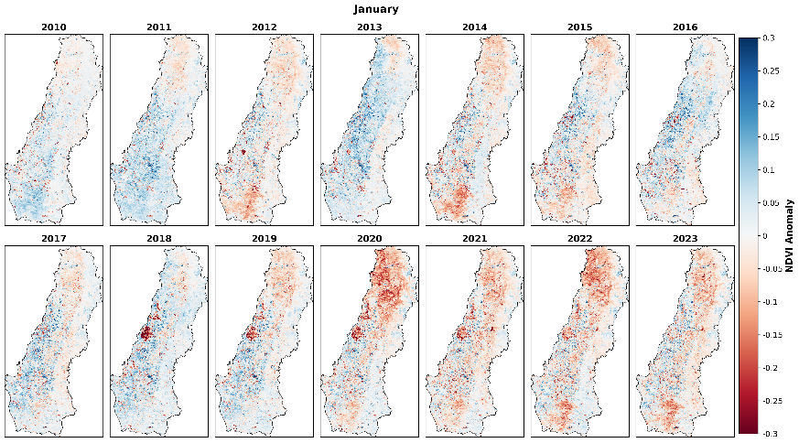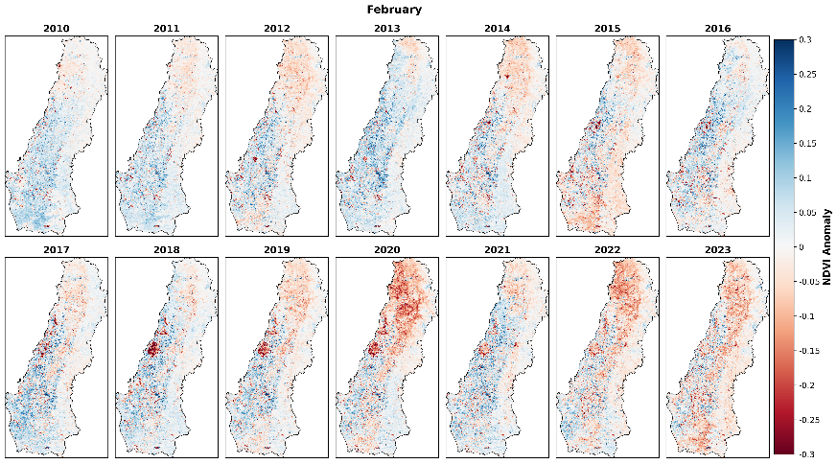
Figure 6. NDVI Anomalies of the megadrought period (2010-2023) for the fire season months from December to February
4.1.3 Evapotranspiration as an Indicator for Wildfire Risks
Next, we explored evapotranspiration data to see if fluctuations in ET may help understand wildfire patterns. When looking at the eight-day composites of January 2022 and January 2023 shown in Figure 7 below, we found that ET values were substantially higher in 2023 prior to the fire than they were in 2022. This suggests a potential threshold for ET above 170 mm in the month leading to fire.

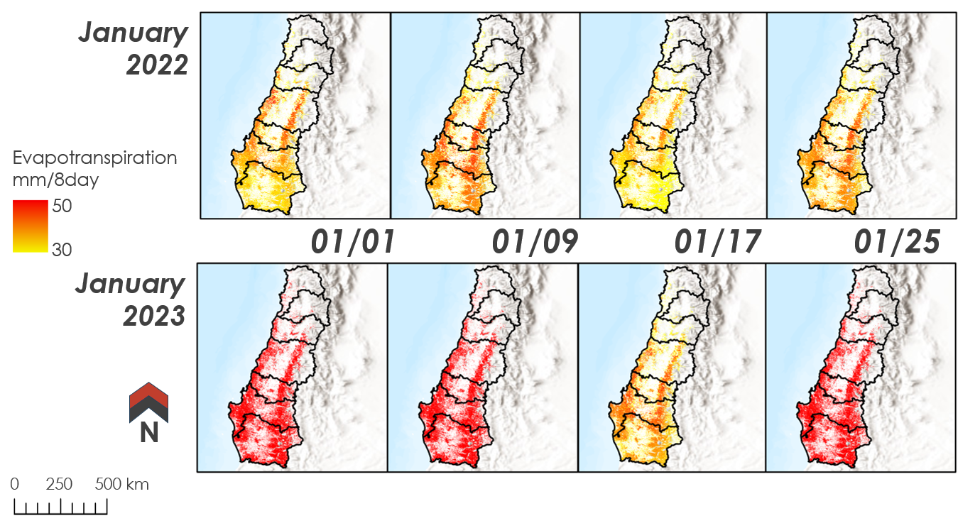Figure 7. Variations in evapotranspiration throughout the months of January 2022 and 2023. Higher ET values were found in the month leading to the 2023 wildfires.

4.1.4 Surface Soil Moisture as an Indicator for Wildfire Risks
Following a deeper analysis of the surface soil moisture (from SMAP level 4) in the aggregated ten-days before the wildfire, we found that about half of the burned conifer plantation (i.e., roughly 28,000 hectares) exhibited extremely low values below 0.075 m³/ m³ as shown in Figure 8 below. This pattern was also found when examining the soil moisture distribution across eucalyptus plantations. In addition, the distribution of soil moistures values is generally the same for both dekad and month. This led us to believe that both lead times are indicative of persistent conditions leading to wildfire. Overall, the substantial skewness we observed below 0.075 m³/ m³ appeared robust across a range of parameters and could serve as a critical threshold value when assessing risks leading to the 2023 wildfire in the region.

We also investigated the soil moisture conditions ahead of the 2017 fire event and found no particular patterns as shown in Figure 9 below. This suggests that the 2017 and 2023 wildfires can be treated as separate case studies with potential varying patterns in pre-fire conditions.

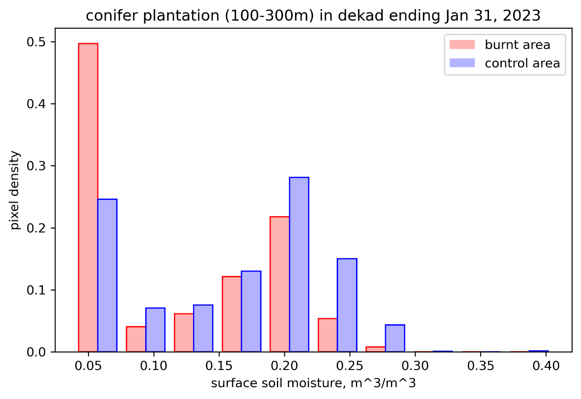
Figure 8. Distribution of soil moisture across conifer plantations (100-300 masl) in dekad ending January 31, 2023. Very low values of soil moisture were more likely to be found within burned extents than in the control areas.

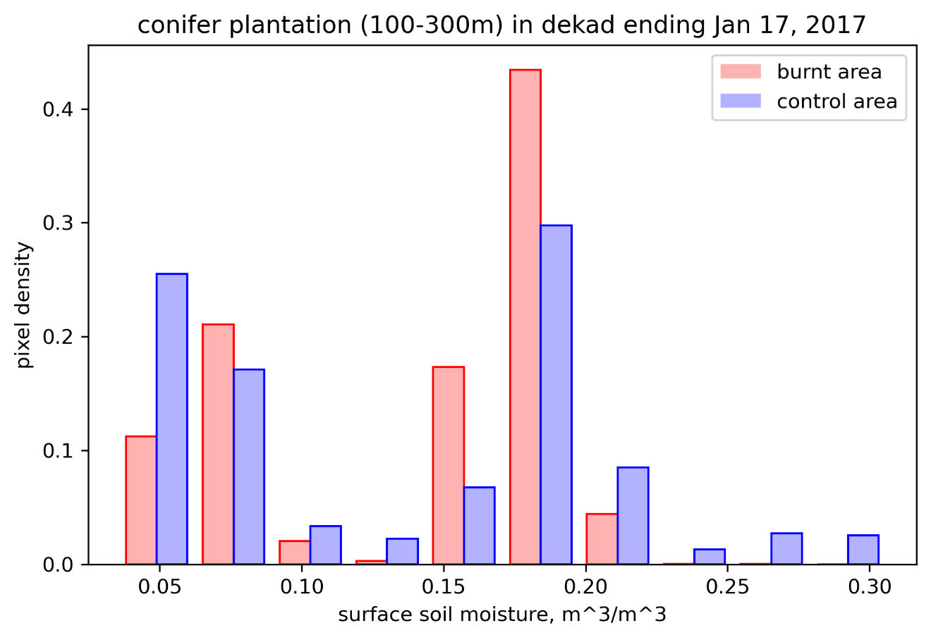
Figure 9. Distribution of soil moisture across conifer plantations (100-300 masl) in dekad ending January 17, 2017. Locations within burned extents did not exhibit particular pre-fire conditions.

4.2 Limitations
Our methods relied primarily on remotely sensed data and lacked in-situ measurements to corroborate our findings. As with all satellite products, our methods are constrained by limited return periods, at times impacted by cloud cover. In addition, space-based measurements of vegetation greenness and ET might not characterize dry conditions near the ground level, but rather capture fuel in the upper canopy. Our partners at CONAF also indicated that wildfires often have an underground component burning within the organic matter, which could not be investigated in our approach. Furthermore, it should be noted that the spatial resolution from SMAP is coarse (i.e., on the order of 3 kilometers with the level 4). As such, a single SMAP pixel typically encompasses various cover types and potentially different information on the ground. Last, our study did not explore the localized effect of fast and dry, easterly wind reported by our partners at CONAF.

4.3 Feasibility Assessment
The approach we tested provides partners with a methodology to leverage measurements from space and capture fire spread and impacts. In addition, it can help evaluate pre-fire conditions. The developed methodologies are replicable and will provide CONAF with novel ways to monitor wildfire and assess fire risk based on remote sensing information. It is a basis to assist CONAF in assessing wildfire spread and monitor pre-fire conditions in the administrative regions of Central and South-Central Chile. CONAF will reportedly incorporate our findings in their wildfire management efforts. Improvements to future fire risk forecast could help allocate resources to prevent and suppress wildland fires.

4.4 Future Work
Moving forward, further investigation is needed to better understand and confirm the results we obtained. It would be beneficial to zoom in and further investigate what extreme measurements in soil moisture and evapotranspiration correspond to on the ground. One could make our control areas more robust by taking into account soil types and observed meteorological conditions. There would also be added value in further validating certain critical thresholds in soil moisture and evapotranspiration against actual burn areas and ignition points. Taking this further, one could compare the new risk forecast against previous red-flags.

5. Conclusions
Since 2010, Central and South-Central Chile has recorded abnormally low annual precipitation, resulting in a more than decade-long megadrought. This water deficit across the region has been fueling some of the most devastating wildfires in Chile’s modern history, both in December 2017 and February of 2023. These extreme wildfire events driven by new climate extremes pose a greater threat to forested resources and the communities living at the wildland-urban interface. Previous wildfire risk assessment efforts in the region have primarily relied on climatic variables. This project utilized space-based measurements of terrestrial variables to understand conditions on the ground better before ignition occurred. Leveraging NASA Earth observations from space, we captured the severity and impact of the ongoing megadrought. We found a substantial, and persistent deficit in precipitation starting in 2010. As a result, we also observed a marked decline in vegetation health over the last decade. We also delineated the spread of wildfires and identified land covers most impacted in 2017 and 2023. Based on remotely sensed measurements of soil moisture and evapotranspiration, we had hypothesized that conditions in the days and months preceding wildfires would differ within the burned extent than in the control areas with the same land cover type and elevation. When comparing the two, we found that the burned timber plantations were more likely to have high ET and/or low soil moisture values than the controls. Our data suggests a critical threshold for surface soil moisture (SMAP L4) below 0.075 m³/m³ and above 170 mm/month for ET (Terra MODIS). The methods developed and findings obtained can provide partner organizations with novel, satellite-based measures to monitor wildfires and assess fire risk based on remote sensing information.

6. Acknowledgements
We want to acknowledge our project partner CONAF, Chile, and the Agricultural Office, Embassy of Chile, Washington, for entrusting us with this project. We are incredibly grateful to Gonzalo Esteban Tapia Koch (CONAF) and Jorge Andrés Saavedra Saldías (CONAF) for their technical guidance and constructive feedback on our methodology, results, and findings. We are also grateful to Fernando Vásquez and Andrés Rodríguez from the Embassy of Chile, who have been excellent liaison between CONAF and NASA DEVELOP to ensure seamless collaboration. Our special thanks go to our science advisors, Dr. Kenton Ross (NASA Langley Research Center) and Dr. Venkataraman Lakshmi (University of Virginia), whose expertise and feedback helped shape and implement our project. Lastly, we would like to extend our sincere gratitude to our Node Fellow, Olivia Landry, whose constant and endearing support towards our team helped make our project successful and to our Project Coordination Fellow, Cecil Byles.

Any opinions, findings, and conclusions or recommendations expressed in this material are those of the author(s) and do not necessarily reflect the views of the National Aeronautics and Space Administration.

This material is based upon work supported by NASA through contract NNL16AA05C.

7. Glossary
Burned Area - Areas where fires have been determined to have burned using a wildfire delineation methodology
Central and South-Central Chile - Our regions of interest, including Valparaiso, Santiago, O’Higgins, Maule, Ñuble, Biobío, and Araucanía
CONAF - In Spanish: Corporación Nacional Forestal, or in English: National Forest Corporation
Control Areas - Areas with the same landcover type and elevation as burned areas, used for comparison
Dekad - A period of ten days
Digital Elevation Model - A model representing elevation in meters above sea level
Earth observations - Satellites and sensors that collect information about Earth’s physical, chemical, and biological systems over space and time
Evaporative Stress Index - An index used to estimate vegetation stress based on temperature measurements
Evapotranspiration - Measurement of combined water loss via evaporation and transpiration, often measured in millimeters per 8 days
Google Earth Engine - A platform for acquiring and processing Earth observations
IMERG - Integrated Multi-satellite Retrievals for Global Precipitation Measurement
JavaScript Application Programming Interface - An interface for acquiring and processing Earth observations
Megadrought - The substantial and prolonged deficit in precipitation experienced in Chile over the past decade
MODIS - Moderate Resolution Imaging Spectroradiometer
NDVI - Normalized Difference Vegetation Index
Precipitation - Rainfall measured in millimeters
Rothermel Model – Surface cover and fire spread model used by CONAF
Soil Moisture Active Passive - A satellite that measures soil moisture in the upper 5 centimeters below the ground surface, processed at Level 3 (L3) or Level 4 (L4)
Vegetation Health - Refers to the health of vegetation and may be indicated by evapotranspiration or NDVI values

8. References
Anderson, M.C., Norman, J.M., Mecikalski, J.R., Otkin, J.A., & Kustas, W.P. (2007). A climatological study of evapotranspiration and moisture stress across the continental United States based on thermal remote sensing: 1. Model formulation. Journal of Geophysical Research: Atmospheres, 112. https://doi.org/
10.1029/2006JD007506
Anderson, M.C., Hain, C., Wardlow, B., Pimstein, A., Mecikalski, J.R., & Kustas, W.P. (2011). Evaluation of drought indices based on thermal remote sensing of evapotranspiration over the continental United States. Journal of Climate, 24(8), 2025-2044. https://doi.org/10.1175/2010JCLI3812.1
Bowman, D.M., Moreira-Muñoz, A., Kolden, C.A., Chávez, R.O., Muñoz, A.A., Salinas, F., González-Reyes, Á., Rocco, R., De la Barrera, F., Williamson, G.J., & Borchers, N. (2019). Human–environmental drivers and impacts of the globally extreme 2017 Chilean fires. Ambio, 48, 350-362. https://doi.org/
10.1007/s13280-018-1084-1
Didan, K. (2021). MODIS/Terra Vegetation Indices 16-Day L3 Global 250m SIN Grid V061 [Data set]. NASA EOSDIS Land Processes DAAC. Retrieved June 21, 2023, from https://doi.org/10.5067/MODIS/
MOD13Q1.061
Huffman, G.J., Stocker, E.F., Bolvin, D.T., Nelkin, E.J., & Tan, J. (2019). GPM IMERG Final Precipitation L3 1 day 0.1 degree x 0.1 degree V06 [Data set]. NASA Goddard Earth Sciences Data and Information Services Center (GES DISC). Retrieved July 8, 2023, from https://doi.org/10.5067/
GPM/IMERGDF/DAY/06
Ehsani, M.R., Arevalo, J., Risanto, C.B., Javadian, M., Devine, C.J., Arabzadeh, A., Venegas-Quiñones, H.L., Dell’Oro, A.P., & Behrangi, A. (2020). 2019–2020 Australia fire and its relationship to hydroclimatological and vegetation variabilities. Water, 12(11), 3067. https://doi.org/10.3390/
w12113067
Garreaud, R. D., Boisier, J. P., Rondanelli, R., Montecinos, A., Sepúlveda, H. H., & Veloso-Aguila, D. (2020). The central Chile mega drought (2010–2018): A climate dynamics perspective. International Journal of Climatology, 40(1), 421-439. https://doi.org/10.1002/joc.6219
González, M. E., Gómez-González, S., Lara, A., Garreaud, R., & Díaz-Hormazábal, I. (2018). The 2010–2015 Megadrought and its influence on the fire regime in central and south-central Chile. Ecosphere, 9(8), e02300. https://doi.org/10.1002/ecs2.2300
Giglio, L., Justice, C., Boschetti, L., & Roy, D. (2021). MODIS/Terra+Aqua Burned Area Monthly L3 Global 500m SIN Grid V061 [Data set]. NASA EOSDIS Land Processes DAAC. Retrieved June 15, 2023, from https://doi.org/10.5067/MODIS/MCD64A1.061
Hain, C.R., & Anderson, M.C. (2017). Estimating Morning Change in Land Surface Temperature from MODIS Day/Night Land Surface Temperature: Applications for Surface Energy Balance Modeling. Geophys. Res. Lett., 44(19), 9723-9733. https://doi.org/10.1002/2017GL074952.
Hietpas, K., Ochoa-Madrid, E., Williams, E., & Spencer, O. (2021). Fairfax Water Resources: Estimating urban flood susceptibility, historical flooding extent, and land cover change in Fairfax County, Virginia to aid in flood mitigation planning [Unpublished manuscript]. NASA DEVELOP National Program, California – JPL. https://ntrs.nasa.gov/api/citations/20220005936/downloads/
2022Spring_JPL_ChileDisasters_TechPaper_FD_v3.docx.pdf
Julio, G.H., Castillo, M.E., & Pedernera, P. (1995). Modelación de Combustibles, in: Actas Taller Internacional sobre Prognosis y Gestión en Incendios Forestales. Proyecto FONDEF FI13, Santiago, 111-128.
Krueger, E. S., Ochsner, T. E., Carlson, J. D., Engle, D. M., Twidwell, D., & Fuhlendorf, S. D. (2016). Concurrent and antecedent soil moisture relate positively or negatively to probability of large wildfires depending on season. International Journal of Wildland Fire, 25(6), 657-668. https://
doi.org/10.1071/WF15104
Krueger, E.S., Levi, M.R., Achieng, K.O., Bolten, J.D., Carlson, J.D., Coops, N.C., Holden, Z.A., Magi, B.I., Rigden, A.J., & Ochsner, T.E. (2022). Using soil moisture information to better understand and predict wildfire danger: A review of recent developments and outstanding questions. International Journal of Wildland Fire, 32, 111-132. https://doi.org/10.1071/WF22056
Masek, J.G., Vermote, E.F., Saleous N.E., Wolfe, R., Hall, F.G., Huemmrich, K.F., Gao, F., Kutler, J., & Lim, T-K. (2006). A Landsat surface reflectance dataset for North America, 1990–2000. IEEE Geoscience and Remote Sensing Letters, 3(1), 68-72. http://dx.doi.org/10.1109/LGRS.2005.857030
NASA JPL (2020). NASADEM Merged DEM Global 1 arc second V001 [Data set]. NASA EOSDIS Land Processes DAAC. Retrieved June 27, 2023, from https://doi.org/10.5067/MEaSUREs/
NASADEM/NASADEM_HGT.001
O'Neill, P. E., S. Chan, E. G. Njoku, T. Jackson, R. Bindlish, J. Chaubell, & Colliander, A. (2021). SMAP Enhanced L3 Radiometer Global and Polar Grid Daily 9 km EASE-Grid Soil Moisture, Version 5 [Data Set]. NASA National Snow and Ice Data Center Distributed Active Archive Center. Retrieved June 15, 2023, from https://doi.org/10.5067/4DQ54OUIJ9DL
Pascolini-Campbell, M., Lee, C., Stavros, N., & Fisher, J. B. (2022). ECOSTRESS reveals pre-fire vegetation controls on burn severity for Southern California wildfires of 2020. Global Ecology and Biogeography, 31(10), 1976-1989. https://doi.org/10.1111/geb.13526
Reichle, R., G. De Lannoy, R. D. Koster, W. T. Crow, J. S. Kimball, Q. Liu, & Bechtold, M. (2022). SMAP L4 Global 3-hourly 9 km EASE-Grid Surface and Root Zone Soil Moisture Geophysical Data, Version 7 [Data Set]. NASA National Snow and Ice Data Center Distributed Active Archive Center. Retrieved June 28, 2023, from https://doi.org/10.5067/EVKPQZ4AFC4D
Running, S., Mu, Q., & Zhao, M. (2017). MOD16A2 MODIS/Terra Net Evapotranspiration 8-Day L4 Global 500m SIN Grid V006 [Data set]. NASA EOSDIS Land Processes DAAC. Retrieved June 21, 2023, from https://doi.org/10.5067/MODIS/MOD16A2.006
Running, S., Mu, Q., & Zhao, M. (2021). MODIS/Terra Net Evapotranspiration 8-Day L4 Global 500m SIN Grid V061 [Data set]. NASA EOSDIS Land Processes DAAC. Retrieved June 21, 2023, from https://
doi.org/10.5067/MODIS/MOD16A2.061
Sarricolea, P., Serrano-Notivoli, R., Fuentealba, M., Hernández-Mora, M., De la Barrera, F., Smith, P., & Meseguer-Ruiz, Ó. (2020). Recent wildfires in Central Chile: Detecting links between burned areas and population exposure in the wildland urban interface. Science of the Total Environment, 706, 135894. https://doi.org/10.1016/j.scitotenv.2019.135894
Vermote, E., Justice, C., Claverie, M., & Franch, B. (2016). Preliminary analysis of the performance of the Landsat 8/OLI land surface reflectance product. Remote Sensing of Environment, 185(2), 46-56. http://dx.doi.org/10.1016/j.rse.2016.04.008

9. Appendices
Appendix A
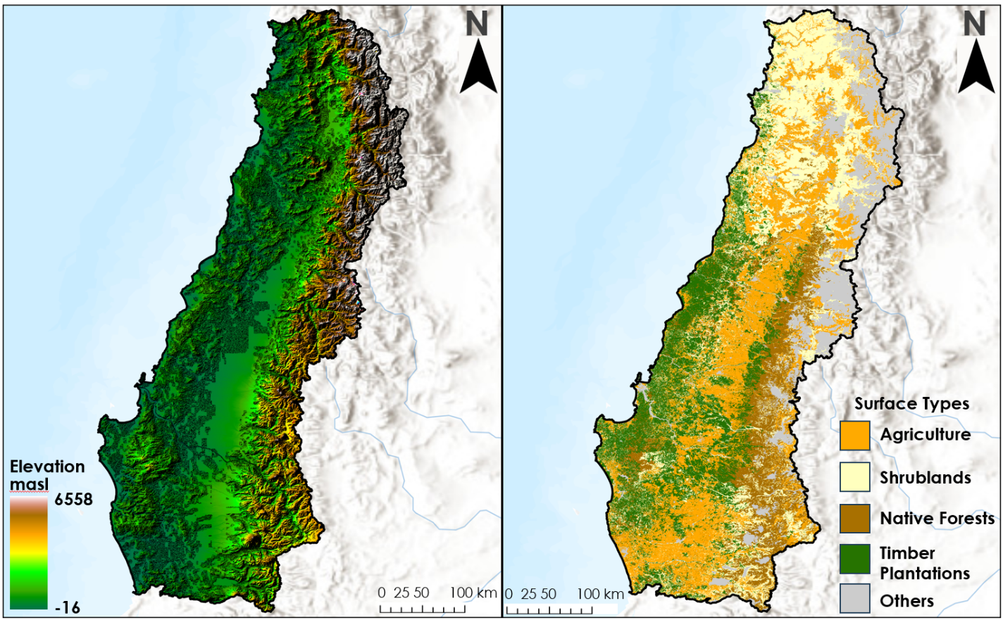Figure A1. Ancillary data used for the analysis – Digital Elevation Map (left) and Fuel Surface Model /Land cover Types (right) [Base map credits: Esri, CGIAR, HERE, Garmin, FAO, NOAA, USGS]

a)
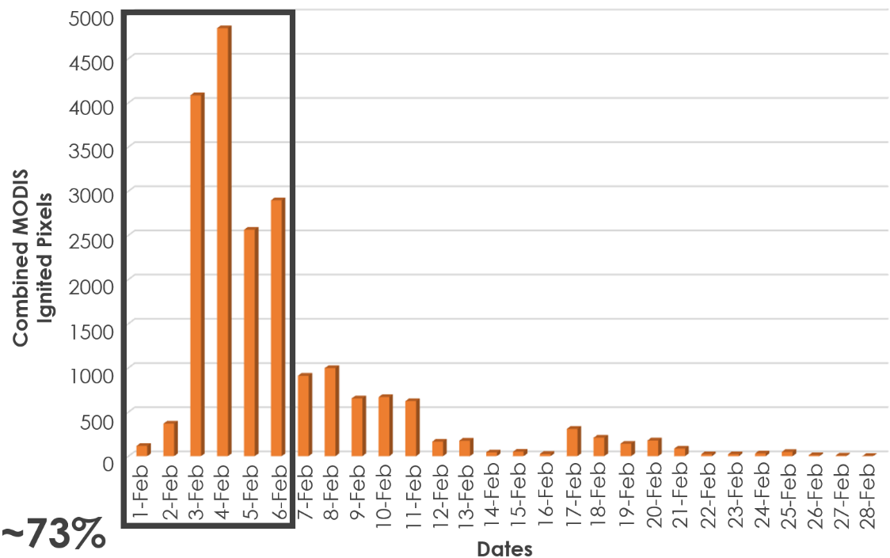
b)
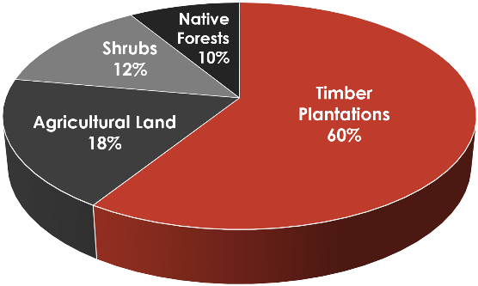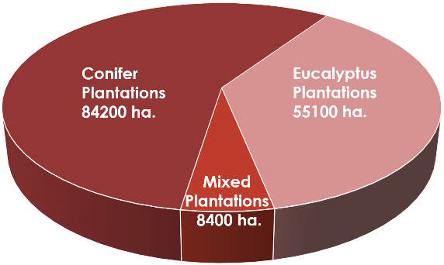

c)
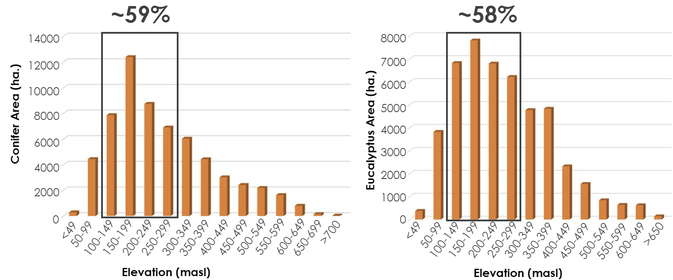
Figure A2. a) Timeline of wildfires indicating daily burned pixels from wildfires in February 2023 at the region of interest; b) Pie-charts showing the categorization of fuel surface model and the types of timber plantations affected in February 1-6, 2023; c) Histograms showing the elevation distribution of different types of timber plantations, mainly conifer and eucalyptus plantations, affected in February 1-6, 2023.

