New York Ecological Conservation
Evaluating Agricultural Conservation Easement Impact Using Earth Observations to Examine Avoided Soil Carbon Loss to Development


Technical Report
August 11th, 2023

Samantha Schulteis (Project Lead)
Samuel Haas
Oliver Wilson
Stephanie Willsey

Advisors:
Charlie Bettigole, Skidmore College (Science Advisor)
Joe Spruce, Science Systems and Applications, Inc. (Science Advisor)

Fellow:
Caroline Williams (Pop-Up Project)

1. Abstract
Farmland provides ecosystems and communities with services ranging from habitat conservation to food security. As total U.S. farmland continues to decline, agricultural lands near urban areas are especially vulnerable. Our project partners—Finger Lakes Land Trust, Genesee Land Trust, and Saratoga Preserving Land and Nature (PLAN)—can use study results to better profile farmland vulnerability, issuing conservation easements to protect maximum acreage in Saratoga County and the Finger Lakes Region of New York. Multiple existing studies effectively use remote sensing imagery to analyze historical land cover and forecast future change. This study examined soil carbon stocks and land cover change to estimate avoided soil carbon loss. We also predicted farmland vulnerability. We completed these analyses using European Space Agency (ESA) and NASA Earth observations that include Landsat 5 Thematic Mapper (TM), Landsat 8 Operational Land Imager (OLI), Landsat 9 OLI-2, Sentinel-2 Multispectral Instrument (MSI), and Suomi National Polar-Orbiting Partnership (NPP) Visible Infrared Imaging Radiometer Suite (VIIRS) for nighttime lights data that aided in the land change model analysis. We determined that the conversion of agriculture to development from 1990 to 2022 occurred at rates of 0.91% (Finger Lakes) and 7% (Saratoga). Urban development is predicted to increase surrounding urban centers through 2030 and 2050. We also estimate that between 26.5 and 348,101 kilotons (Finger Lakes) and 3.7 and 58,006 kilotons (Saratoga) of soil carbon losses have been avoided through agricultural easements. Findings from this study will support our partners in determining agricultural conservation easement benefits and prioritizing the acquisition of future easement sites.

Key Terms
Agriculture, conversion, soil carbon, Sentinel-2, Landsat, Suomi NPP VIIRS, conservation easements

2. Introduction
Total farmland in the United States decreased by 1.3 million acres between 2010 and 2021, with properties near urban areas proving especially vulnerable (National Agricultural Statistics Service, 2022). Farmland conservation is of special interest to many non-profit organizations, as it provides ecosystems and local communities with services ranging from habitat conservation to food security (Batary et al., 2011; Tscharntke et al., 2012). Land trust organizations incentivize the protection of farmlands through conservation easements, whereby landowners can sell or donate development rights to their farmland in perpetuity. While permitting ongoing agricultural usage.
2.1 Background Information
Farmland provides many benefits to surrounding communities, offering employment opportunities, supplying fresh and nutritious produce, and fostering relationships between people and their environment (Lobley et al., 2009; Slavin & Lloyd, 2012; Brodt et al., 2006). Additionally, farmland conservation protects preferred habitats for many vulnerable species and contributes to landscape resilience, or the ability of habitat to sustain ecological function in a changing environment (Bollinger, 1995 Abson et al., 2013). The development and disturbance of agricultural soils can also turn responsibly managed farmland from a carbon sink into a source, ultimately increasing carbon dioxide levels in our atmosphere (Lal, 2001). Given current public concerns regarding climate change adaptability, farmland conservation is of utmost importance for protecting planet Earth and meeting our immediate needs (Hoffmann et al., 2022).

Urban sprawl poses significant challenges to farmland conservation, especially in the northeastern United States (Peiser & Hugel, 2022). Demand for land continues to increase as urban areas expand and the energy sector transitions toward land-intensive forms of renewable power (Lamhamedi & de Vries, 2022). Many characteristics that make the land suitable for agriculture are also ideal for development, including available water sources, already cleared land, property fragmentation, and flat slopes (Carrión-Flores & Irwin, 2004; Levia & Page, 2000). Thus, these attributes – all of which are available from free, public datasets – can indicate where farmland loss will likely occur. If land trusts can identify vulnerable farmland, they can target conservation easement acquisition to protect maximum acreage.

Many existing studies effectively use remote sensing imagery to examine historical land cover and forecast future change. Urban areas generally display lower values of the Normalized Difference Vegetation Index (NDVI) compared to less developed study regions in Europe. NDVI can thus also help to estimate fractional vegetation cover (Kaspersen et al., 2015). Another index, the Normalized Difference Impervious Surface Index (NDISI) can distinguish impervious surfaces from bare soil (Su et al., 2022). Further, population growth is a valuable indicator in estimating areas of farmland at risk of development (Xie et al., 2023). We pulled from these various methods to predict future trends in farmland conservation to development.

2.2 Project Partners & Objectives
Land cover change and landscape data can help predict development and identify ideal locations for agricultural conservation easements in the Northeastern United States (Malakoff & Nolte, 2021). Our study area encompassed Saratoga County and the Finger Lakes Region of New York State (Figure 1), which are heavily characterized by agricultural lands. We created historical impervious surface maps for every fifth year using data from May-October 1985-2022 to inform a localized soil carbon analysis. We also made predictive land cover maps for 2030 and 2050 based on the observed change between 2001 and 2019. These forecasting maps can be used to identify agricultural lands vulnerable to development. We compared the differences in remotely sensed vegetation and soil health between agricultural lands both in and out of easements to confirm the efficacy of these legally binding agreements.

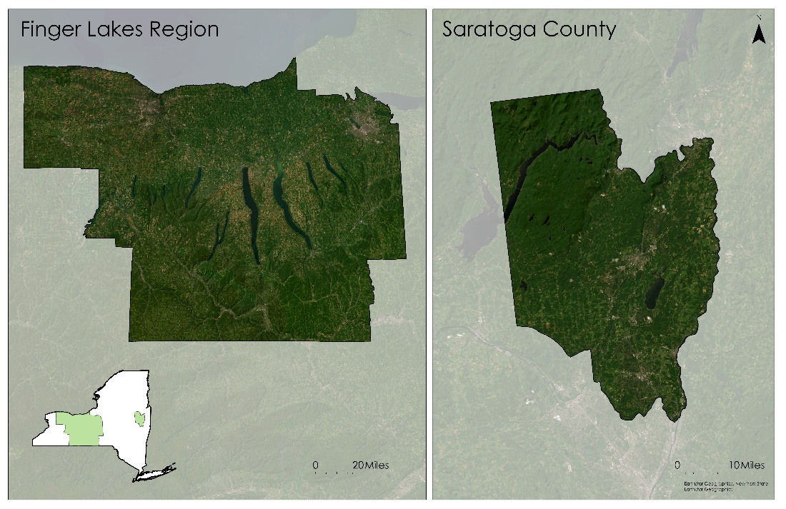
Figure 1. Study Area. Our area of interest for this study encompasses the Finger Lakes Region and Saratoga County in New York State, USA.

We partnered with three New York-based land trust organizations (Table 1) that focus on issuing agricultural conservation easements to local farmers. All three groups help landowners preserve their property in perpetuity while emphasizing farmland benefits. With limited experience in remote sensing, our partners expressed most interest in land change prediction maps to aid easement acquisition decision-making.

Demand for agricultural conservation easements is rising within Saratoga County and the Finger Lakes Region in New York State. In each grant cycle, land trusts assess their pool of landowner applications based on selection criteria unique to each organization, which may include soil quality, landscape connectivity, or wildlife habitat. From there, each organization selects 2-6 easement projects to fund with their allocated budget, often supplemented by federal, state, or county grant funding. In our study area, landowners compete for this small pool of conservation easements. Using our predictions to identify which agricultural areas are most at risk of urbanization, these land trusts can enhance their existing strategic planning process for easements to fulfill.

Table 1
Partner Organizations
Partner Organization | Working Area | Missions
Finger Lakes Land Trust | Finger Lakes Region | - Conserve contiguous lands and waters  - Ensure clean water and local foods
Genesee Land Trust | Finger Lakes Region | - Connect families to nature  - Protect unique natural habitats  - Conserve family farms
Saratoga PLAN | Saratoga County | - Help farm owners preserve land in perpetuity  - Educate the public on farmland benefits

3. Methodology
3.1 Data Acquisition
3.1.1 Historical Impervious Maps & Agriculture Conservation Easement Land Conversion Analysis
We acquired surface reflectance data from Landsat 5 TM, Landsat 8 OLI, Landsat 9 OLI-2, and Sentinel-2 MSI data through Google Earth Engine (GEE) for 1985, 1990, 1995, 2000, 2005, 2010, 2015, 2020, and 2022 (Table 2). We avoided using Landsat 7 due to scanline correction errors that cause uncertainties in acquired data. All Landsat data were from surface reflectance collection 2, tier 1, and level 2. Harmonized Sentinel-2 data were from surface reflectance and in collection and level 2A. We used these data to create a supervised classification for our area of interest for the dates when existing land cover layers were unavailable, including the Coastal Change Analysis Program (C-CAP) and the National Land Cover Database (NLCD; Table 3). A full list of software used for this study is found in Table A1 in the appendix.

Table 2
Data Sources. List of sensors used with corresponding temporal and spatial resolution as well as bands or variables for analysis.
Sensor | Year(s) | Spatial Resolution | Bands or Variables
Landsat 5 TM | 1985, 1990, 1995, 2000, 2005, 2010 | 30m | B1, B2, B3
Landsat 8 OLI | 2015, 2020 | 30m | B2, B3, B4
Landsat 9 OLI-2 | 2022 | 30m | B2, B3, B4, B5
Sentinel-2 | 2020, 2022 | 10m | B02, B03, B04, B08
Suomi NPP VIIRS | 2019 | 15 arc seconds (~500 m at the equator) | Nighttime Lights

3.1.2 Prediction Maps
We acquired ancillary data from the 2001 and 2019 National Land Cover Data and the 2019 3-Dimensional Elevation Program (3DEP) from the United States Geological Survey (USGS). We also gathered Suomi NPP VIIRS Nighttime Lights data from the National Oceanic and Atmospheric Administration (NOAA; Elvidge et al., 2021) and Global Aboveground Biomass Carbon Density Data from NASA’s Oak Ridge National Laboratory Distributed Active Archive Center (NASA ORNL DAAC). We calculated distances to Transmission Lines from a United States Department of Homeland Security dataset. Finally, we downloaded population (2020 Decennial Census Redistricting Data) and census block data for New York State from the United States Census Bureau to measure population density. We used all the ancillary data collected as predictor variables for the TerrSet Land Change Modeler (LCM) (Table 2, 3).

Table 3
Ancillary data
Source | Data Acquired | Predictor Variable (for Terr Sett)
C-CAP | Landcover (1996) | N/a
NASA ORNL DAAC | Aboveground Biomass (2010) | Biomass
NLCD | Landcover (2001, 2004, 2006, 2008, 2011, 2013, 2016, 2019) | N/a
U.S. Census Bureau | Population and Census Tracts (2020) | Population density
U.S. Department of Homeland Security | Transmission Lines (2021) | Distance to transmission lines
USGS | National Land Cover Database (2001, 2019) | Classified land images, distance to water, development
USGS | 3DEP Digital Elevation Model (2019) | Slope, Northness, Eastness

3.1.3 Soil Carbon Analysis
Our soil carbon analysis was designed to measure the amount of soil carbon that would have been lost to the atmosphere if easements had not been conserved and had instead been converted to development. We ran this calculation by combining two methods: a) we estimated how much soil carbon would be lost from the physical act of converting a farm into low-density development (i.e., disturbing and paving over soil will send carbon into the atmosphere) and b) the loss of annual soil carbon sequestration that naturally occurs in farmland but would not occur if the land were converted to development. For a), we acquired soil carbon bulk stock data (tons/ha) from the International Soil Reference and Information Centre (ISRIC) at 250-meter resolution to calculate soil carbon stocks in each easement. We estimated a 61% decrease in near-surface soil carbon stocks at the time of development to provide us with a figure of how much carbon loss would have occurred had the land been developed (Majidzadeh et al., 2017). For b), we estimated annual carbon accrual in temperate croplands at 0.825 tons/ha per year to find the amount of carbon the easements would have failed to sequester had they been developed (Smith, 2007).

3.1.4 Ecosystem Service Analysis
As with our impervious surface analysis, we collected Landsat 5 TM, 8 OLI, 9 OLI-2, and Sentinel-2 MSI imagery and associated indices for our ecosystem service analysis. All Landsat and Sentinel imagery remained in their native resolutions of 30 and 10 meters, respectively. We also used shapefiles provided by our partners for the protected agricultural lands.

3.2 Data Processing
3.2.1 Historical Impervious Maps & Agriculture Conservation Easement Land Conversion Analysis
We collected and processed Landsat and Sentinel-2 data in GEE. We also applied a cloud mask to all data, removing cloudy images over 40% and all images outside the growing season of May 1st to October 15th. We created a composite median image for each year of interest from years before and after to account for cloud visibility challenges (e.g., our 1995 estimates included imagery from growing seasons 1994-1996). Since Landsat and Sentinel-2 have different native resolutions (30 meters and 10 meters, respectively), we resampled Sentinel-2 data to 30 meters. We then created five categories of training data from visual inspection of historical imagery: forest, water, impervious surfaces, agriculture, and tilled agriculture (Figure B.1.). We placed between 50 and 300 data points per class depending on the region assessed. For years after 1995 (Finger Lakes) or 1990 (Saratoga), we used NLCD or C-CAP data to extract agriculture and impervious information rather than classified Landsat imagery. Across our study area, we estimated conversion rates from agricultural lands to impervious surfaces between 1985 and 2022. We then made easement buffers and clipped them to classified and NLCD data.

3.2.2 Prediction Maps
Our land cover change predictions relied upon training variables, including elevation, land cover, nighttime lights, biomass, population density, and transmission lines. We reclassified land cover data into six categories (developed, agriculture, forest, wetland, other, and water) to suit the goals of our projects. Next, we filtered NLCD data into four classes of development intensity, using a focal statistics tool with the sum function to create a dynamically weighted distance-to-development raster in ArcGIS Pro. We also used the raster calculator tool in QGIS to create a binary layer for water presence, later used with the distance tool in TerrSet to measure the distance to water for an input variable. Within TerrSet, we used the distance tool to measure the distance to transmission lines as an additional input variable. We converted the elevation layer into northness and eastness layers to be used as additional variables. We then mosaiced all data as needed and clipped it to our study areas with a matching 30 m x 30 m resolution. Per the requirements of TerrSet, we merged each file as a band into a single raster containing the final nine variables in QGIS. We then extracted each file in a byte data format using a raster calculator and moved to TerrSet, with each 30 m x30 m cell aligned and in the same projection (EPSG: 26918).

3.2.3 Soil Carbon Analysis
We processed the carbon stock data in GEE and RStudio to find carbon stock measurements in each of the easements. The data were projected to Universal Transverse Mercator (UTM) Zone 18N and clipped by the New York State boundary using GEE. Once in R, we extracted the soil data by easement boundaries to find the mean carbon stock in tons/acre for each easement, and along with easement area, total tons of carbon per easement.

3.2.4 Ecosystem Service Analysis
We calculated vegetation indices from Landsat 5, 8, and 9 and Sentinel-2 images, including NDVI, the Enhanced Vegetation Index (EVI), the Soil Adjusted Vegetation Index (SAVI), the Green Leaf Index (GLI), and the Chlorophyll Vegetation Index (CVI). We used ArcGIS Pro to calculate, clip, and project these data to UTM Zone 18N over our study areas. Before exporting the data, we resampled the rasters for the second half of the analysis to work. For the Finger Lakes Region, we resampled the data to 1-kilometer; in Saratoga County, we resampled the data to 500-meters. We resampled each area of interest to ensure the analysis would not fail before the results were populated. We accomplished the second half of the analysis in RStudio.

3.3 Data Analysis
3.3.1 Historical Impervious Maps & Agriculture Conservation Easement Land Conversion Analysis
The statistical analyses for the supervised classifications consisted of a random forest to predict the land classes and error matrices. We split our dataset into two groups: 70% was used as the training dataset, and 30% was set aside for validation.

From the validation outputs, we computed error matrices from which area- and pixel-based accuracies could be estimated for 1985, 1990, and 1995. We also calculated the Kappa coefficient for each of these years to gain a further understanding of our results’ accuracy. The kappa coefficient (Equation 1) evaluates the performance of the classification compared to a random assignment of values.
(1)
k = (P_{o} – P_{e})/ (1 - P_{e})
Where:
P_{o} = observed accuracy
P_{e} = chance agreement

We completed land cover change statistical analysis around the easements in RStudio. This analysis took place in 1,250-meter (Saratoga) and 4,000-meter (Finger Lakes) buffers surrounding current conservation easements. We based buffer size on the average distance between easements and urban pixels. With the raster stack described in section 3.2.1, we assessed landcover pixels for change within the buffered areas. We assigned each landcover raster a value of 1, allowing simple addition to determine any change (Table 4). Then we added two rasters together to calculate the land change within the buffer. First, we acquired the landcover raster closest in age to when a conservation easement was created (THEN). We also utilized the most recent (2019) landcover raster (NOW) for this step. By extracting two raster values for each pixel, we determined which pixels experienced change. We explored three metrics; percent change of urban land, total lost agricultural land, and percent of agricultural land converted to urban land, all within buffered areas. We made all calculations based on easement age.

Table 4
Conversion Rate Equations
Output/Metric | Equation
Total urban land conversion percent change within buffer | (Urban “NOW” - Urban “THEN”)/Urban “THEN”
Total area m of agricultural land converted within buffer | (Urban “NOW” - Ag “THEN”) * 900
Total percent of agricultural land converting to urban within the buffer | (Urban “NOW” - Ag “THEN”)/Ag “THEN”

3.3.2 Prediction Maps
We used LCM to create land change prediction maps, testing nine variables (Tables 2, 3). For each of our study areas, the LCM trained results on nine predictor variables and our two classified land covers from 2001 and 2019 (Figure C.1). The LCM then produced a map of land change vulnerability and a hard land cover transition prediction for 2030 and 2050. The Saratoga model accuracy was 84.13%, while the Finger Lakes model accuracy was 83.54%. TerrSet used 5,000 random points to train each model, then added 5,000 random points to check the accuracy of each given model. The Saratoga model had a skill measure of 0.68, and the Finger Lakes model measured 0.67, where a skill measure of 0 equals random chance, and a measure of 1 is a perfect prediction. We deemed these accuracy values suitable for our project goals and further validated our results by predicting a known land cover (2019) from an older (2011) land cover layer.

In Saratoga County, we found that development, distance to transmission lines, nighttime lights, and population density variables achieved a similar accuracy to using all nine original variables (Table 5). In the Finger Lakes Region, we found nighttime lights to be a more accurate predictor variable than any of the other eight, yielding a similar accuracy value to when all nine were combined (Table 5).

Table 5
Variable Accuracy. A measure of model accuracy if each variable were independently excluded from the model.
Variable | Saratoga Accuracy | Variable use in Saratoga Model | Finger Lakes Accuracy | Variable use in Finger Lakes Model
Biomass | 76.43% | No | 83.53% | No
Development | 76.01% | Yes | 83.56% | No
Distance to Transmission Lines | 77.24% | Yes | 83.47% | No
Distance to Water | 84.43% | No | 83.38% | No
Eastness | 77.56% | No | 83.50% | No
Nighttime Lights | 73.64% | Yes | 50.40% | Yes
Northness | 77.42% | No | 83.57% | No
Population Density | 74.41% | Yes | 83.45% | No
Slope | 77.07% | No | 83.38% | No

3.3.3 Soil Carbon Analysis
Our soil carbon calculations quantified two pieces of avoided carbon loss: a) the initial loss of soil carbon resulting from the conversion of farmland to impervious developed surfaces; and b) the avoided annual soil carbon sequestration of agricultural land, which would not occur if farmland were converted. We scaled both quantifications by the likelihood of development, calculated using the model described in section 3.3.2. To do this, we multiplied the carbon density on each easement by 0.39 (percent loss in development) (Majidzadeh et al., 2017). We then multiplied the age and area of an easement by 0.845 tCO₂ /ha, determined to be the average of agronomy and grazing rates (Smith et al., 2017). We then multiplied the resulting number by a mean development probability per easement obtained from the probability maps in LCM to get a final measure of avoided soil carbon loss summarized in the equation below (Equation 2).
(2)
C = ((S*X*0.39) + (0.845*A*X))*P
Where:
C = Avoided soil carbon losses
A = Age of easement
X = Area of easement in hectares
S = Carbon stock from Soil Grids
P = Potential risk of development

3.3.4 Ecosystem Service Analysis
The ecosystem service analysis compared vegetation indices within agricultural conservation easements to unprotected lands in our areas of interest. We calculated vegetation indices at 500-meter resolution for Saratoga and 1-kilometer resolution for the Finger Lakes Region, which we stacked in R Studio after processing in ArcGIS Pro. Resampling ensured that the analysis would be completed in a timely manner and that it would return results rather than failing. Next, we read in the partner’s easement shapefile and created a separate shapefile of buffered easements in R, excluding the easements themselves. We then clipped the vegetation indices to the easement and buffered shapefiles, and restacked. We then completed a trend analysis using a Mann-Kendall Trend test (for easements older than 2015) and a pixel-by-pixel linear regression on a stack (for easements newer than 2015, given constraints on the Mann-Kendall Trend test). Our outputs for this analysis took on the form of a map (Figure D1).

4. Results & Discussion
4.1 Analysis of Results
4.1.1 Historical Impervious Maps & Agriculture Conservation Easement Land Conversion Analysis
Our supervised classifications for both study areas returned acceptable accuracies and Kappa coefficients, all within acceptable ranges, making us confident in our resulting estimates (Tables 6 and 7). The conversion rate methodology provided multiple metrics to help describe land change and development pressure placed upon current easements. In the Finger Lakes Region, we found the average urban land increase across all the easements to be 5.54%, while the average percentage of agricultural land converted to urban was 0.91%. In the Finger Lakes Region, the average amount of agricultural land converted to urban was 150 acres. In Saratoga County, we found the average urban land increase across all the easements to be 16%, while the average percentage and amount of agricultural land converted to urban was 7% and 19 acres, respectively.

Table 6
Accuracies and Kappa Coefficients, Finger Lakes
Years | Area-Based Accuracy (%) | Pixel-Based Accuracy (%) | Kappa Coefficient
1985 | 87.5 | 90.8 | 0.855
1990 | 87.1 | 88.5 | 0.852
1995 | 85.1 | 90.5 | 0.784

Table 7
Accuracies and Kappa Coefficients, Saratoga Springs
Years | Area-Based Accuracy (%) | Pixel-Based Accuracy (%) | Kappa Coefficient
1985  1990 | 90.8  91.1 | 90  92.3 | 0.865  0.901

4.1.2 Prediction Maps
The Saratoga model accuracy was 84.13%, while the Finger Lakes model accuracy was 83.54%. TerrSet used 5,000 random points to train each model, then added 5,000 random points to check the accuracy of each given model. The Saratoga model had a skill measure of 0.68, and the Finger Lakes model measured 0.67, where a skill measure of 0 equals random chance, and a measure of 1 is a perfect prediction. We deemed these accuracy values suitable for our project goals and further validated our results by predicting a known land cover (2019) from an older (2011) land cover layer.

In Saratoga County, we found that development, distance to transmission lines, nighttime lights, and population density variables achieved a similar accuracy to using all nine original variables (Table 5). In the Finger Lakes Region, we found nighttime lights to be a more accurate predictor variable than any of the other eight, yielding a similar accuracy value to when all nine were combined (Table 5).

Variables that gave the highest accuracy in the model all related to previous development or served as a proxy for development (i.e., VIIRS NPP Nighttime Lights data). We found historic urban development trends to be the most accurate predictor of future development for 2030 and 2050 within our study area (Figure C2). Between 2019 and 2050, our model predicted that 6,643 (1.23% of total land) and 38,516 (0.64% of total land) acres of agricultural land will be developed in Saratoga County and the Finger Lakes Region, respectively. Within Saratoga County, development increased along Interstate 87 through the center of the county, as demonstrated in our vulnerability mapping (Figure C3). In the Finger Lakes Region, future development is predicted to sprawl from that of the past (Figure C3). Given these patterns, we suggest our land trust partners focus their easement placement on the areas we identified as vulnerable to prevent likely agricultural conversion.

Table 5
Variable Accuracy. A measure of model accuracy if each variable were independently excluded from the model.
Variable | Saratoga Accuracy | Variable Use in Saratoga Model | Finger Lakes Accuracy | Variable Use in Finger Lakes Model
Biomass | 76.43% | No | 83.53% | No
Development | 76.01% | Yes | 83.56% | No
Distance to Transmission Lines | 77.24% | Yes | 83.47% | No
Distance to Water | 84.43% | No | 83.38% | No
Eastness | 77.56% | No | 83.50% | No
Nighttime Lights | 73.64% | Yes | 50.40% | Yes
Northness | 77.42% | No | 83.57% | No
Population Density | 74.41% | Yes | 83.45% | No
Slope | 77.07% | No | 83.38% | No

4.1.3 Soil Carbon Analysis
We estimated avoided soil carbon losses scaled by development probability by using soil carbon analysis of our partners' agricultural easements. This metric quantifies previously unaccounted climate benefits of land conservation. Using development probability as a variable, we determined a range of avoided soil carbon loss values depending on the changing development probability. When accounting for development probability across our study areas, we calculated that 30.2 kilotons of CO₂ emissions are likely avoided by current agricultural easements held by our project partners. We also calculated a maximum avoided carbon potential for our study area for the scenario where the probability of development is 1.00 for every easement (Table 8). In this scenario, the total avoided soil carbon emissions would be 406.1 kilotons for all agricultural easements in our study areas.

Table 8
Soil Carbon Loss Estimates. Results reported in metric tonnes.
 | Likely Avoided Carbon Loss (tons) | Maximum Avoided Carbon Loss (tons)
Saratoga County | 3,679 | 58,006
Finger Lakes Region | 26,519 | 348,101
Total Study Area | 30,198 | 406,107
Average per acre | 0.96 | 12.98

4.1.4 Ecosystem Service Analysis
Our analysis of the vegetation indices for the ecosystem service analysis returned no significant differences between protected agricultural land and other lands. Our results from this analysis show that our methods cannot detect the effects agricultural conservation easements have on ecosystem services in this region. However, further analysis using a finer resolution dataset should be completed to verify the results.

4.2 Feasibility Assessment
Our partners can feasibly replicate some, but not all, of the methods described in this paper. The land change methods require the use of the software TerrSet, which requires purchase and may limit useability. The impervious surface, soil carbon analysis, and ecosystem service analysis can be conducted using free software (R Studio, Google Earth Engine, QGIS). However, a moderate to significant amount of geospatial analysis is required to prepare the data for use and carry out additional analysis. The soil carbon analysis is easily replicable for our partners. However, an up-to-date land use vulnerability map (i.e., our TerrSet-generate layers) is required to produce the most accurate results. A list of software and alternative sources can be found below (Table 9).

Table 9
Project Software and Alternatives
Analysis | Software Used | Alternative Software
Impervious Surfaces Mapping | GEE | ArcGIS Pro, Global Mapper, GRASS GIS, QGIS
Land Change Modelling | TerrSet | Land Use and Cover Change Modeling Framework by the National Institute for Space Research
Soil Carbon Analysis | R Studio | ArcGIS Pro, Global Mapper, GRASS GIS, QGIS
Ecosystem Service Analysis | GEE and R Studio | ArcGIS Pro, Global Mapper, GRASS GIS, QGIS

While the methods of our project are not easily reproducible for partners, our end products have the potential to hold great value. Our findings will benefit our partners' conservation easement selection process and success measure. Land trust organizations can use agricultural development transition potential data as an additional selection criterion when determining easement placement. Conversion rates can also be a baseline for easement issuance, as our partner organizations have never accessed this calculation form. Additionally, partners can use avoided soil loss measures to demonstrate the climate benefit of their conservation efforts and seek climate-related funding for future campaigns.

4.3 Future Work
This project delivers multiple products that will be immediately valuable while also inspiring future research. We made maps of land change vulnerability and future predictions that may be valuable forecasting tools for landowners and the public. We also calculated land use conservation rates and soil accrual capabilities for each easement our partners maintain. Our partners can use these measures, alongside prediction and vulnerability maps, to identify focus locations for their conservation efforts.

We applied our project methods to a small (Saratoga County) and large (Finger Lakes Region) study area. Result accuracy can likely be improved with optimized methods for each study area. Our impervious surface maps, and therefore conversion rates, could be improved by using alternative impervious surface mapping methods optimized for agricultural landscapes. Further, we trained our predictive maps on data ending in 2019, before renewable energy development gained popularity in upstate New York. Our partners identified energy sector land use as a likely source of future agricultural land conversion, and we believe our model can better account for this concern if a more recent NLCD is used. Additionally, adding in-situ measurements to complement our remotely sensed data can likely improve our soil carbon accuracies. Like our soil carbon results, the findings from each project component could benefit from validation, requiring in-situ data collection.

5. Conclusions
Agricultural lands provide numerous benefits to surrounding human and natural communities, providing healthy food in rural areas, serving as a source of income to millions of families, and creating habitat for countless endangered species. Urban development trends in Saratoga County and the Finger Lakes Region of New York State threaten farmland and its benefits to surrounding ecosystems. Our land change models predicted almost all future development close to previously urbanized areas. This result is on par with what our project partners expected to find, given their expertise in our study areas.

We also found high agriculture-to-development conversion rates in Saratoga County and certain parts of the Finger Lakes Region. As with the land cover prediction results, these findings are not surprising, given that our study area contains many of the fastest developing counties in the state. Our work comes at a crucial time in conservation management that allows land trusts to selectively protect agricultural land surrounding urban centers, retaining many of the ecosystem and community benefits that accompany agricultural presence.

The easements we studied have already likely avoided a large amount of carbon losses over their lifetimes, which will only continue increasing with easement age and expanding development pressures. Our avoided soil carbon loss findings serve as another reminder that preserving farmland has quantifiable benefits in a world of development and population growth.

Our partners will receive additional shapefiles showing the spatial extents of current farmland forecasted for development. Land trusts can use this data to inform landowner visits, ground truthing, and easement placement. As the high conversion rates surrounding present conserved areas prove to make current easements effective, we hope that any easements resulting from our work will be situated in these vulnerable places and protect the ecosystems and identity representative of upstate New York.

6. Acknowledgements
First and foremost, we would like to thank our Fellow, Caroline Williams, for their continuous dedication to project development and execution. We would also like to extend our gratitude toward our science advisors, Charlie Bettigole and Joe Spruce, for sharing their technical expertise during methodology development and results analysis. We also share our appreciation with NASA DEVELOP’s Project Coordination team, specifically Cecil Byles, for their assistance with revision.

We would also like to express gratitude toward our project partners, in no particular order, for their local expertise and cooperation related to easement data acquisition.
- Amanda Grisa, Farmland Protection Manager, Genesee Land Trust
- Max Heitner, Director of Conservation, Finger Lakes Land Trust
- Tori Roberts, Conservation Project Manager, Saratoga PLAN

This material contains modified Copernicus Sentinel data (2020, 2022), processed by the European Space Agency (ESA).

Any opinions, findings, and conclusions or recommendations expressed in this material are those of the author(s) and do not necessarily reflect the views of NASA.

This material is based upon work supported by NASA through contract NNL16AA05C.

7. Glossary
3DEP – 3-Dimensional Elevation Program
Avoided Soil Carbon Losses – the difference of soil carbon accrued over time in a scenario where land is placed into conservation easements rather than being developed
C-CAP – Coastal Change Analysis Program
CVI – Chlorophyll Vegetation Index, this index calculates the amount of chlorophyll content in leafy vegetation based on green and near infrared wavelengths
Conservation easement – a voluntary and legally-binding agreement that protects the land(s) enrolled by restricting future land use/change and development of the land(s) in perpetuity
Earth observations – satellites and sensors that collect information about the Earth’s physical, chemical, and biological systems over space and time
Ecosystem services – the many benefits that wildlife and ecosystems provide to people such as nutrient cycling, clean water, and lumber resources
EVI – Enhanced Vegetation Index, used to quantify greenness in vegetation
ESA – European Space Agency
Finger Lakes Land Trust – project partner
GEE – Google Earth Engine
Genesee Land Trust – project partner
GLI – Green Leaf Index, represents the relationship between the green and blue/red wavelengths
Impervious surfaces – artificial structures, like roads, that cover the soil in water impenetrable materials such as brick, asphalt, or concrete
IPCC – Intergovernmental Panel on Climate Change
ISRIC – International Soil Reference and Information Centre
Kappa coefficient – a statistic used to measure inter-rater reliability
Landsat 5 TM – Landsat 5 Thematic Mapper, Earth observation satellite in orbit from March 1984 - June 2013
Landsat 8 OLI – Landsat 8 Operational Land Imager, Earth observation satellite in orbit from February 2013 – present
Landsat 9 OLI-2 – Landsat 9 Operational Land Imager-2, Earth observation satellite in orbit from September 2021 - present
LCM – Land Change Modeler in TerrSet
NDISI – Normalized Difference Impervious Surface Index
NDVI – Normalized Difference Vegetation Index
NLCD – National Land Cover Database
NOAA – National Oceanic & Atmospheric Administration
NPP – National Polar-Orbiting Partnership
Remote sensing – acquiring information about an object of phenomenon without direct contact to the object or phenomenon such as with satellites and aircrafts
Saratoga PLAN – Saratoga Preserving Land and Nature, project partner
SAVI – Soil Adjusted Vegetation Index
Sentinel-2 MSI – Sentinel-2 Multispectral Instrument, Earth observation satellite in orbit from June 2015 – present
Soil Carbon – a solid form of carbon stored in soil as organic matter or inorganic minerals
SSURGO – Soil Survey Geographic Database
Suomi NPP VIIRS – Suomi National Polar-Orbiting Partnership Visible Infrared Imaging Radiometer Suite, Nighttime lights sensor in orbit from October2011 - present
TerrSet – a geographic information system used to make land cover predictions and model sustainable development
USGS – United States Geological Survey
Urban Sprawl – the rapid expansion of cities and towns’ geographic extents
VIIRS – Visible Infrared Imaging Radiometer Suite

8. References
Abson, D. J., Fraser, E. D., & Benton, T. G. (2013). Landscape diversity and the resilience of agricultural returns: A portfolio analysis of land-use patterns and economic returns from lowland agriculture. Agriculture & Food Security, 2(1), 2. https://doi.org/10.1186/2048-7010-2-2

Batary, P., Baldi, A., Kleijn, D., & Tscharntke, T. (2011). Landscape-moderated biodiversity effects of agri-environmental management: A meta-analysis. Proceedings of The Royal Society B: Biological Sciences, 278(1713), 1894–1902. https://doi.org/10.1098/rspb.2010.1923

Bollinger, E. K. (1995). Successional changes and habitat selection in hayfield bird communities. The Auk, 112(3), 720-730.

Brodt, S., Feenstra, G., Kozloff, R., Klonsky, K., & Tourte, L. (2006). Farmer-community connections and the future of ecological agriculture in California. Agriculture and Human Values, 23(1), 75–88. https://doi.org/10.1007/s10460-004-5870-y

Carrión-Flores, C., & Irwin, E. G. (2004). Determinants of residential land-use conversion and sprawl at the rural-urban fringe. American Journal of Agricultural Economics, 86(4), 889–904. https://doi.org/10.1111/j.0002-9092.2004.00641.x

de Sousa, L., Poggio, L., Batjes, N.H., Heuvelink, G.B.M., Kempen, B., Ribeiro, E., Rossiter, D. (2020) SoilGrids 2.0: producing quality-assessed soil information for the globe. Under submission to SOIL. https://doi.org/10.17027/isric-soilgrids.713396f4-1687-11ea-a7c0-a0481ca9e724

Dewitz. J., and U.S Geological Survey, 2021, National Land Cover Database (NLCD) 2019 Products (ver. 2.0, June 2021): U.S Geological Survey data release, https://doi.org/10.5066/P9KZCM54

Elvidge, C.D, Zhizhin, M., Ghosh T., Hsu FC, Taneja J. (2021). Annual time series of global VIIRS nighttime lights derived from monthly averages:2012 to 2019. Remote Sensing, 13(5), 922, https://doi.org/10.3390/rs13050922

Hoffmann, R., Muttarak, R., Peisker, J., & Stanig, P. (2022). Climate change experiences raise environmental concerns and promote green voting. Nature Climate Change, 12(2), 2. https://doi.org/10.1038/s41558-021-01263-8

Kaspersen, P. S., Fensholt, R., & Drews, M. (2015). Using landsat vegetation indices to estimate impervious surface fractions for European cities. Remote Sensing, 7(6), Article 6. https://doi.org/10.3390/rs70608224

Lal, R. (2001). World cropland soils as a source or sink for atmospheric carbon. In Advances in Agronomy (Vol. 71, pp. 145–191). Academic Press. https://doi.org/10.1016/S0065-2113(01)71014-0

Lamhamedi, B. E. H., & de Vries, W. T. (2022). An exploration of the land–(renewable) energy nexus. Land, 11(6), 6. https://doi.org/10.3390/land11060767

Levia, Jr., Delphis F., & Page, D. R. (2000). The use of cluster analysis in distinguishing farmland prone to residential development: A case study of Sterling, Massachusetts. Environmental Management, 25(5), 541–548. https://doi.org/10.1007/s002679910042

Lobley, M., Butler, A., & Reed, M. (2009). The contribution of organic farming to rural development: An exploration of the socio-economic linkages of organic and non-organic farms in England. Land Use Policy, 26(3), 723–735. https://doi.org/10.1016/j.landusepol.2008.09.007

Majidzadeh, H., Lockaby, B.G., Governo, R. (2017). Effect of home construction on soil carbon storage – A chronosequence case study. Environmental Pollution, Volume 226, Pages 317-323. https://doi.org/10.1016/j.envpol.2017.04.005

Malakoff, K. L., & Nolte, C. (2021). The heterogeneous effects of agricultural conservation easements on the loss of farmland to development in New England (SSRN Scholarly Paper No. 3944928). https://doi.org/10.2139/ssrn.3944928

Morris, L. (2017). Textural Classes Used in the Soils Family. University of Georgia. https://bugwoodcloud.org/bugwood/productivity/pdfs/Textural_Classes_Used_in_the_Family2017-8-30.pdf

National Agricultural Statistics Service. (2022). Farms and Land in Farms (No. 1995–2004; Agriculture Counts). United States Department of Agriculture. https://www.nass.usda.gov/Publications/Todays_Reports/reports/fnlo0222.pdf

National Oceanic and Atmospheric Administration, Office for Coastal Management. (1996). Coastal Change Analysis Program (C-CAP) Regional Land Cover. [Data Set]. Charleston, SC: NO. https://coast.noaa.gov/htdata/raster1/landcover/bulkdownload/30m_lc/

Oak Ridge National Laboratory. (2020). Aboveground Biomass (version 1). Oak Ridge National Laboratory. https://daac.ornl.gov/VEGETATION/guides/Global_Maps_C_Density_2010.html

Peiser, R., & Hugel, M. (2022). Is the pandemic causing a return to urban sprawl? Journal of Comparative Urban Law and Policy, 5(1), 26–41.

Slavin, J. L., & Lloyd, B. (2012). Health benefits of fruits and vegetables. Advances in Nutrition, 3(4), 506–516. https://doi.org/10.3945/an.112.002154

Smith, P., D. Martino, Z. Cai, D. Gwary, H. Janzen, P. Kumar, B. McCarl, S. Ogle, F. O’Mara, C. Rice, B. Scholes, O. Sirotenko, 2007: Agriculture. In Climate Change 2007: Mitigation. Contribution of Working Group III to the Fourth Assessment Report of the Intergovernmental Panel on Climate Change [B. Metz, O.R. Davidson, P.R. Bosch, R. Dave, L.A. Meyer (eds)], Cambridge University Press, Cambridge, United Kingdom and New York, NY, USA

Su, S., Tian, J., Dong, X., Tian, Q., Wang, N., & Xi, Y. (2022). An impervious surface spectral index on multispectral imagery using visible and near-infrared bands. Remote Sensing, 14(14), Article 14. https://doi.org/10.3390/rs14143391

Tscharntke, T., Clough, Y., Wanger, T. C., Jackson, L., Motzke, I., Perfecto, I., Vandermeer, J., & Whitbread, A. (2012). Global food security, biodiversity conservation and the future of agricultural intensification. Biological Conservation, 151(1), 53–59. https://doi.org/10.1016/j.biocon.2012.01.068

U.S. Census Bureau. (2020). Race. U.S Census Bureau. https://data.census.gov/

U.S. Geological Survey Earth Resources Observation and Science Center. (2018). Landsat 4-5 TM [Data set]. US Geological Survey. https://doi.org/10.5066/F7KD1VZ9

U.S. Geological Survey Earth Resources Observation and Science Center. (2018). Sentinel-2 [Data set]. US Geological Survey. https://doi.org/10.5066/F76W992G

U.S. Geological Survey Earth Resources Observation and Science Center. (2020). Landsat 8 OLI/TIRS [Data set]. US Geological Survey. https://doi.org/10.5066/f78s4mzj

U.S. Geological Survey Earth Resources Observation and Science Center. (2020). Landsat 8-9 OLI/TIRS [Data set]. US Geological Survey. https://doi.org/10.5066/P9OGBGM6

U.S. Geological Survey. (2023). Elevation Products (3DEP). U.S Geological Survey. https://apps.nationalmap.gov/downloader/

U.S. Homeland Security (2022). Transmission Lines. ESRI ArcGIS Online. https://hifld-geoplatform.opendata.arcgis.com/datasets/geoplatform::transmission-lines/about

Xie, Y., Hunter, M., Sorensen, A., Nogeire-McRae, T., Murphy, R., Suraci, J. P., Lischka, S., & Lark, T. J. (2023). U.S. farmland under threat of urbanization: Future development scenarios to 2040. Land, 12(3), Article 3. https://doi.org/10.3390/land12030574

9. Appendix

Appendix A
DATA PROCESSING SOFTWARE TABLE

Table A1.
Data Processing Software. This table includes a full list of software used for this project.
Software | Description | Analysis
GEE | Cloud-based geospatial analysis platform used for easy data acquisition and analysis | Impervious Surface Analysis and Ecosystem Service Analysis
TerrSet | Integrated geospatial software for monitoring and modeling land cover change from raster inputs | Prediction Maps
QGIS | Open-source geographic information system software for analyzing and editing spatial information | Prediction Maps
R Studio | An integrated development environment for R, supporting direct code execution and workspace management | Soil Carbon Analysis and Ecosystem Service Analysis
ArcGIS Pro | Private geographic information system software for analyzing and editing spatial information | Impervious Surface Analysis, Prediction Maps, Soil Carbon Analysis, and Ecosystem Service Analysis

Appendix B
IMPERVIOUS SURFACE FIGURES
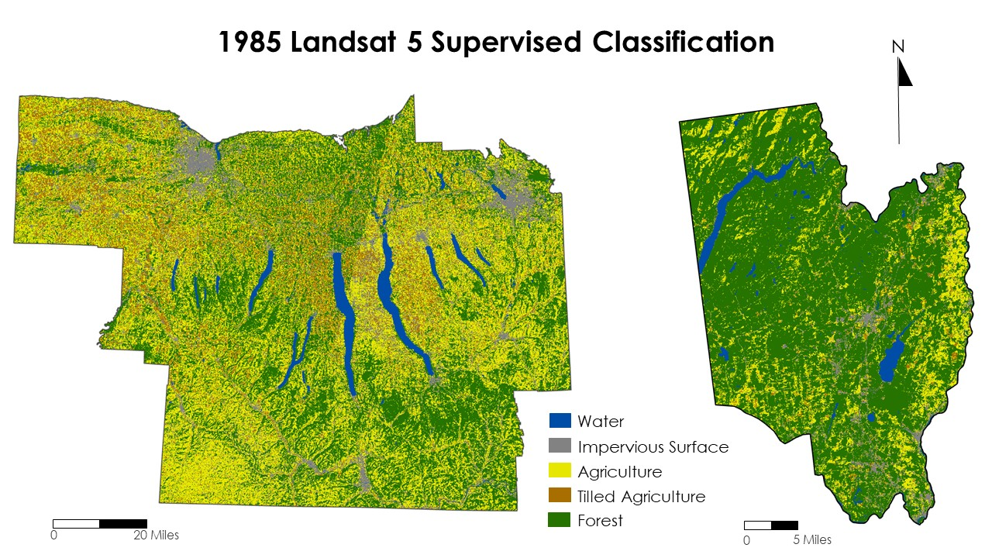
Figure B1. Supervised Classification Maps. A supervised classification was created for the Finger Lakes Region and Saratoga County using Landsat 5 imagery for the year 1985. Five classifications were used to create this data which consisted of: water, impervious surfaces, agriculture, tilled agriculture, and forest.

Appendix C
LAND COVER CHANGE SUPPLEMENTARY FIGURES
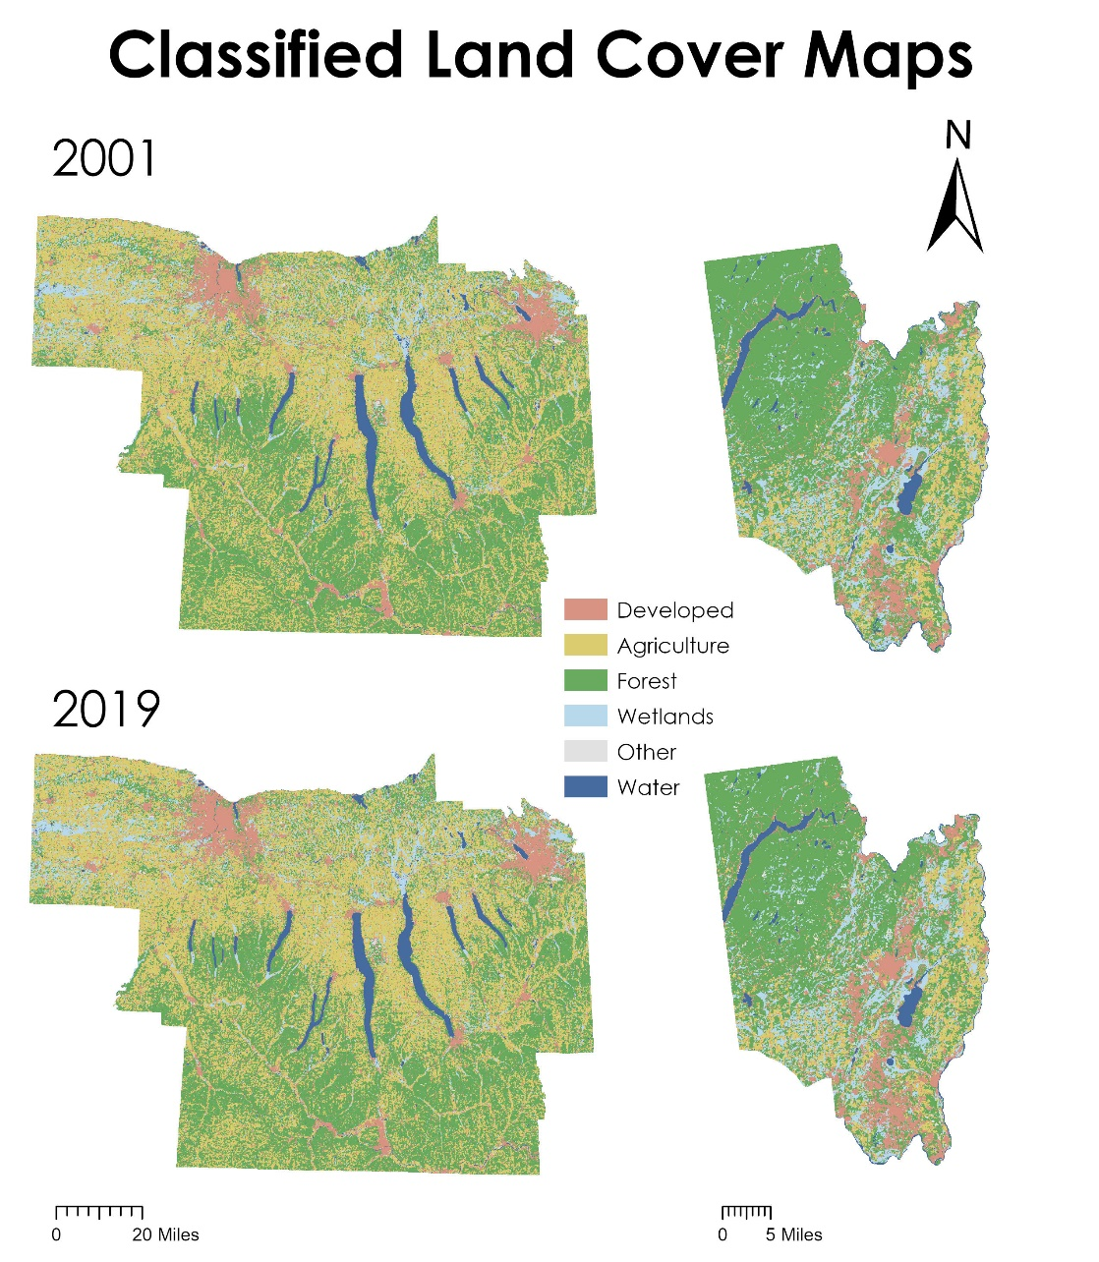
Figure C1. Land Cover Maps. We used Classified Land Cover Maps from 2001 and 2019 to train the TerrSet LCM.

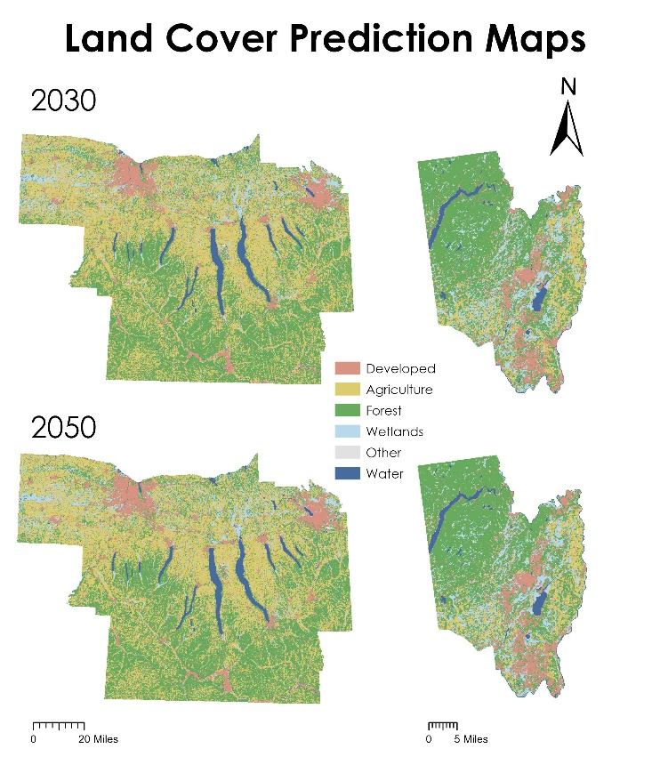
Figure C2. Prediction Maps. Land cover maps of projected land change for the years 2030 and 2050.

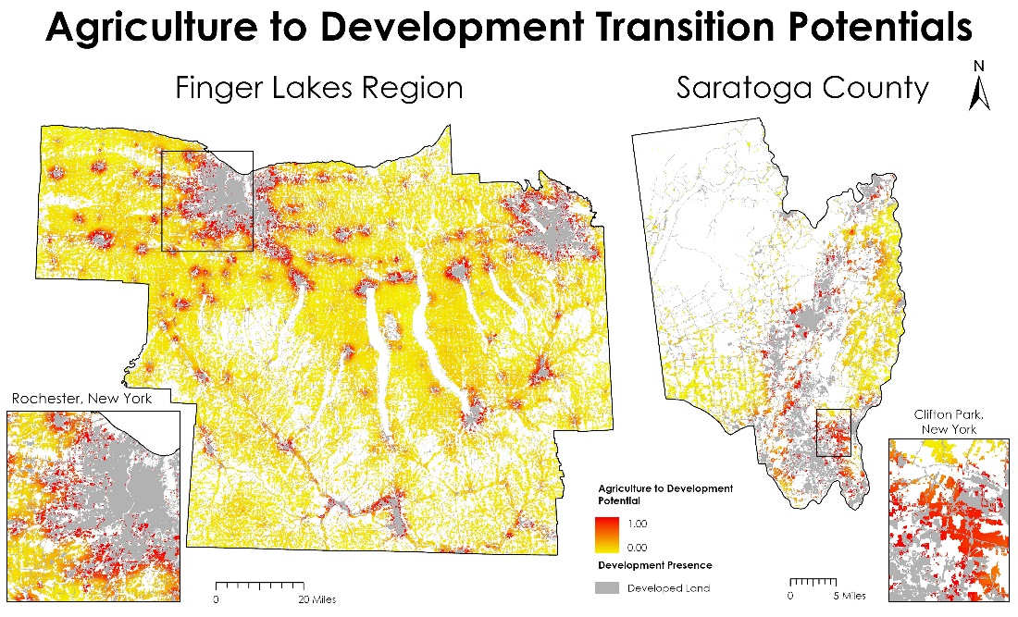
Figure C3. Transition Potentials. TerrSet assigned a vulnerability value to all areas classified as agriculture in 2019. Areas of low development potential received values near to zero (yellow), while TerrSet gave more vulnerable agricultural lands a higher value (red).

Appendix D
ECOSYSTEM SERVICE ANALYSIS SUPPLEMENTARY FIGURES
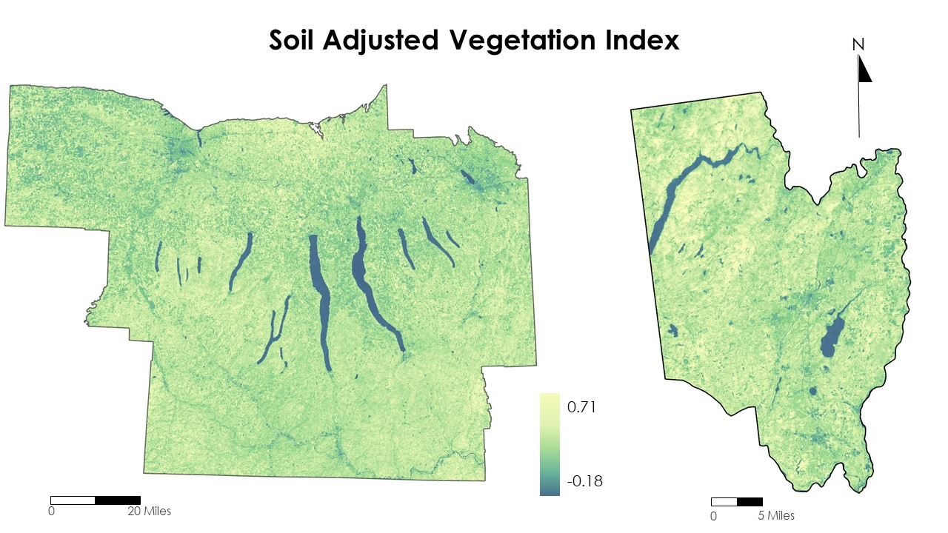Figure D1. Trends in SAVI. The SAVI was calculated using Landsat 5, 8, 9, and Sentinel-2 every five years starting in 1985 and ending in 2022 in the Finger Lakes Region and Saratoga County. These datasets were then stacked, and trends were extracted to create the figure above.

