Aconcagua Basin Agriculture
Analyzing Hydrological Norms, Evapotranspiration, and Soil Moisture to Assess Crop Water Demand and Water Usage in Chile’s Aconcagua River Basin


Technical Report
August 11th, 2023

Javiera Canales Valenzuela (Project Lead)
Carmen Martha Petras
Daniela Quintero Garcia

Advisors:
Dr. Kenton W. Ross, NASA Langley Research Center (Science Advisor)
Dr. Venkat Lakshmi, University of Virginia (Science Advisor)
Lauren Childs-Gleason, NASA Langley Research Center (Science Advisor)

Fellow:
Olivia Landry (NASA Langley Research Center)

1. Abstract
The Aconcagua basin has experienced a prolonged drought since 2010, posing a significant concern to the agricultural sector, which contributes to 12% of the national agriculture output. Reduced precipitation and warmer conditions have led to water constraints for agricultural activities. As the agriculture sector relies more on irrigation, there has been a decline in surface water availability and a shrinking groundwater supply, both primarily sourced from snow and glacial melt. This study focuses on evaluating crop water demand and water usage in the Aconcagua Basin, leveraging in-situ and available satellite data from Aqua and Terra Moderate Resolution Imaging Spectroradiometer (MODIS), 1-km downscaled Soil Moisture Active Passive (SMAP), Global Precipitation Measurement Mission IMERG (GPM), and Landsat 8 Operational Land Imager (OLI). Remote sensing hydrologic norms from pre- and intra-drought conditions provided a baseline for our water use analysis. We have identified areas of the basin where water usage is exaggerated compared to other regions by analyzing soil moisture, evapotranspiration, and vegetation index trends across agricultural lands. The study highlights the presence of irrigation and exaggerated water usage categorized by crop type while normalizing the data by the quantity of water allocation (m³/s) to each subregion. The findings have the potential to assist our partners, the Centro de Información de Recursos Naturales (CIREN) and the Ministry of Agriculture, in refining water allocation approaches; showcasing the feasibility of leveraging remote sensing and earth observation datasets to monitor agricultural practices within the context of water scarcity.

Key Terms
Remote sensing, soil moisture, evapotranspiration, drought, agriculture, crop demand, Chile, water allocation

2. Introduction
2.1 Background Information
As both the effects of climate change intensify and climate extremes are understood and experienced by local communities around the world, Earth scientists grapple to explain how climate change will impact everyday life. One of the main impacts of climate change on communities around the world is drought. Droughts are multi-factored; with increased global temperatures that enhance evapotranspiration (ET) leading to lower Soil Moisture (SM) in periods of low precipitation being the main factor. Long-term droughts cause a multitude of environmental and anthropogenic issues such as decreasing water availability and increasing uncertainty in crop yields. Remote sensing (RS) as a scientific tool may support individuals, community governance, and federal decisions regarding water conservation and allocation. Satellite-based products provide better observation compared to in-situ measurements in terms of spatial and temporal resolution (Tran et al., 2023a, 2023b, 2023c). This study analyzes the feasibility of RS to assess climatology and crop yields in the megadrought conditions of Central Chile. Chile further struggles with water management since the privatization of water resources in the National Water Code updated in 1980 (Webb et al., 2021). The Aconcagua River Basin (ARB; Figure 1) in Central Chile, has experienced drought since 2010, and is heavily farmed (Garreaud et al., 2017). The use of RS data in the ARB may caution the Chilean government on possible crop yields based on drought variables and inform how to best allocate water resources.

Chile comprises six macro zones defined by hydrological, climatological, and topographic features by the Chilean Water Directorate (DGA) (Alvarez-Garreton et al., 2018). The ARB is in the central macro zone, (Macrozona Centro, 32.3°S, 70°W; Webb et al., 2021). With a drainage area spanning approximately 7,200 km² (Fierro et al., 2021), the climate of this area is predominantly Mediterranean, characterized by warm, dry summers and mild, wet winters, with a prolonged dry season from October to March (DGA, 2016a). Moreover, the ARB serves as a vital agricultural resource, accounting for approximately 12% of Chile's national agriculture, livestock, and forestry production (Webb et al., 2021). The effect of snowmelt on recharging groundwater is critical to sustaining agriculture during the growing season (Webb et al., 2021; Bown et al., 2008). This study focuses on SM and vegetative index data from the start of the current drought until the present and analyzes hydrological norms for pre-drought years to indicate climatological baselines. We focus most analyses on a comuna scale. A comuna is a political entity smaller than a municipality.
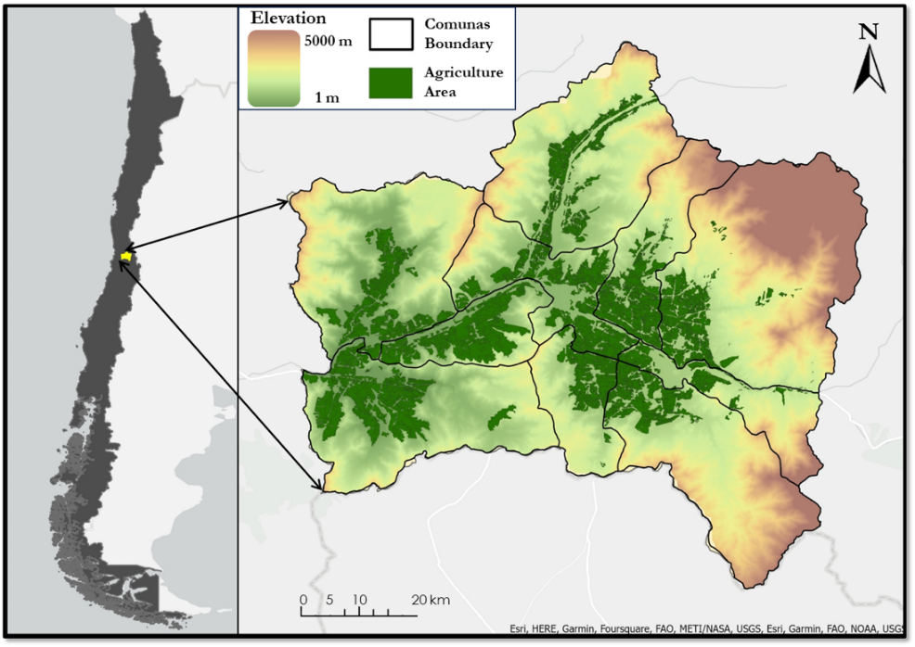
Figure 1. Aconcagua River Basin map with agriculture area extent shown in dark green overlayed on a Digital Elevation Model
Several studies have been conducted in the ARB addressing the megadrought using precipitation, river discharge analysis, and glacier inventory (Janke et al., 2017; Bown et al., 2008). One study assesses the utility of large-scale datasets in predicting crop yield and understanding the relation of yield-index correlations during the growing season of soybean and corn crops. This study incorporated SM, ET, and vegetation indices (NDVI, EVI), concluding that over the United States, ET and SM indices are better predictors of corn and soybean yields than vegetation indices. Moreover, this result shows that globally available coarse resolutions of SM and ET products agree with field data estimates of crop yield (Mladenova et al., 2017).

Other studies have focused more on the performance of satellite soil moisture products to understand the variables that affect SM retrievals. In Iowa, a study over the corn belt used satellite data (SMAP) to indicate performance in a seasonal analysis and concluded that seasonal biases (cyclical influences on data) related to the parametrization of the algorithm were hidden (Walker et al., 2019). Another study concluded that SM from SMAP tends to be underestimated when compared to field and hydrological model data, showing more spatial bias when row-crop agriculture is extensive (Jadidoleslam et al., 2022). Soil moisture from Earth Observations is a crucial source of information for monitoring vegetation development and SM in agriculture when ground-based data is limited (Jadidoleslam et al., 2022; Walker et al., 2019; Mladenova et al., 2017).

When looking at agricultural drought, a deficit in available soil moisture causes a reduction in plant water content, impeding metabolic activity among crops (Kapoor et al., 2020). Reduction in crop yields result from crops altering their resource economics; reducing their metabolic and transpiration rates by reducing their stomatal aperture to conserve water (Mladenova et al., 2017). This reduction in plant transpiration can be identified from satellite SM and ET measurements.

2.2 Project Partners & Objectives
This project aimed to include satellite soil moisture and evapotranspiration data to assess crop yields and water usage in conjunction with hydrological norms and vegetation indices in the ARB during the megadrought period, 2010-present. The partners facilitating this project in Chile were the Centro de Información de Recursos Naturales (CIREN), and the Embassy of Chile, Agricultural Office. CIREN interacts with various end users including agricultural producers, public institutions, and consulting firms that could all benefit from more accurate SM assessments as well as crop yield analyses using RS. This project builds CIREN’s capacity for consulting by providing downscaled SM analyses and frameworks using ET that indicate locations of heavy irrigation. This information allows for strategic crop species selection and climate change resilient decision-making practices in the agricultural sector and could potentially influence future decisions regarding water rights.

3. Methodology
3.1 Data Acquisition
To generate a hydrological norm analysis (short-term climatology) during the drought period of 2010-present and the pre-drought period of 2000 to 2010, we gathered Land Surface Temperature (LST), precipitation and evapotranspiration (ET). We used MODIS/Aqua Land Surface Temperature/Emissivity Daily L3 Global 1 km SIN Grid (Wan et al. 2021) to directly derive average LST during the daytime and generate monthly temperature data in Celsius on Google Earth Engine (GEE). Precipitation data, obtained from GPM IMERG Final Precipitation L3 1 month 0.1 degree x 0.1 degree V06 (Huffman et al., 2019), is critical for indicating irrigated zones and regions of higher drought impact. We acquired ET data from MODIS/Terra Net Evapotranspiration Gap-Filled 8-Day L4 Global 500 m SIN Grid (Running et al., 2021) to compare crop yields and climatology to water use in the ARB.

The basin delineations and subbasin sections of the central zone were provided by the Dirección General de Aguas - Chile through CIREN. The agricultural land was extracted in the ARB central zone from a land use dataset (provided by our CIREN partners) that separated the basin into agriculture zones, forests, artificial areas, bodies of water, wetlands, snow and glacier cover, and forest plantations. This data was collected during the 2020-2021 agriculture season by the Instituto Nacional de Estadisticas from Chile census data. This agriculture ARB central zone mask was applied to each hydrological norm variable, soil moisture, and Normalized Difference Vegetation Index (NDVI), as well as used to place crop yield census data in a spatial orientation.
The SMAP-Derived 1-km Downscaled Surface Soil Moisture Product, Version 1 (Lakshmi et al. 2023), is a combination of MODIS land surface temperature and SMAP Enhanced L2 Radiometer Half-Orbit 9 km. This dataset was downloaded directly from the National Snow and Ice Data Center (NSIDC) webpage. Soil moisture in the top 5 cm of soil was measured in m³/m³ volumetric units. We used the downscaled soil moisture product to monitor agricultural water use and indicate drought-stressed zones of the ARB during the growing season.

Table 1.
Acquired data and data sources
Variable | Source | Resolution | Time Period
Land Surface Temperature (LST) | MOD11A1 v061 MODIS/Aqua Land Surface Temperature/Emissivity Daily L3 Global 1km SIN Grid | 1000m | 2000-06-01 to 2023-06-01
Normalized Difference Vegetation Index (NDVI) | USGS Landsat 8 Collection 2 Tier 1 and Real-Time data TOA Reflectance | 30m | 2013-03-18 to 2023-06-01
Precipitation | GPM IMERG Final Precipitation L3 1 day 0.1 degree x 0.1 degree V06 | 10000m | 2000-06-01 to 2021-09-30
Soil Moisture | SMAP- Derived 1km Downscaled Surface Soil Moisture Product | 1000m | 2015-05-01 to 2022-09-29
Evapotranspiration (ET) | MOD16A2GF v061 MODIS/Terra Net Evapotranspiration Gap-Filled 8-Day L4 Global SIN Grid | 500m | 2001-01-01 to 2023-06-01
Land Use Type | CIREN Partners - Field and census data | N/A | 2020-2021
Crop Yield | CIREN Partners | N/A | 2020-2021 growing season
Aconcagua River Basin (ARB) | Dirección General de Aguas - Chile | N/A | N/A

3.2 Data Processing
To undertake analysis, we first aggregated the study variables (Precipitation, ET, PAR, SM, NDVI, LST) on a monthly basis. This was done in the process of importing each variable into GEE. We estimated the monthly precipitation within ARB as the daily accumulated rainfall in each month. For ET, because the data product is an accumulated 8-day and 5-day composite for ET, we summed all the images present in each month to obtain the monthly accumulated ET. Photosynthetically Active Radiation (PAR) on a pixel level was processed by selecting the bands measured only during sunlight hours in Chile Standard Time (GMT-4), from 8:00 to 20:00. Subsequently, we averaged these bands daily to compute the monthly average.

Python was used to process all previous steps for soil moisture, evapotranspiration, and precipitation data. For SM, we removed daily values equal to zero, then averaged the daily value within each month and converted the volumetric units of (m3/m3) to mm. Once monthly data was processed, either average or accumulated for each variable, we compiled a short-term climatology for each hydrology variable (excluding SM) within the ARB. We visualized climatology in 12 images, one for each month averaged across all drought years that data is available. The short-term climatology initial processing served as a baseline for us to compare agricultural water usage seasonally in later processing.

To determine the “greenness” of agricultural areas within our study area, we calculated NDVI as the normalized difference between Near InfraRed (NIR) and Red reflectances from Landsat 8 imagery, band B5 and B4 respectively, as outlined in equation 1 (Figure 2b; Huang et al., 2020):
$NDVI = \frac{NIR-RED}{NIR+RED}$ (eq. 1)
Ascertaining the seasonal averages of NDVI required the use of GEE to aggregate months from October to April and average them. We then exported the images as TIF files for further analysis in Python.

Along with the temporal filter, we created a spatial mask for the agriculture region within the central zone of the ARB (a composite of eight sub-basins in the Aconcagua central valley). We segregated the fruit census layer of the agriculture region obtained from CIREN into four separate masks of the most prevalent fruits in the central region, grapes, walnuts, avocados, and fruit trees (peaches for fresh consumption, peaches for canning, and mandarin orange) using Excel. We then applied each variable to the crop masks for every growing season.
To estimate total water allocation by comuna, we averaged the values of point data within each comuna monthly and aggregated seasonally.

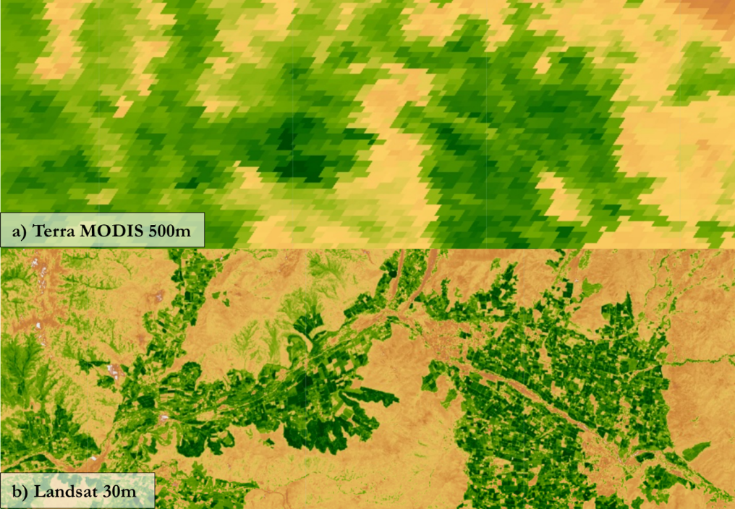
Figure 2. a) Terra MODIS NDVI cover from GEE b) Landsat 8 OLI NDVI cover from GEE. This is an example of determining if pre-processed data, such as NDVI, is clearer than self-calculated data using bands

3.3 Data Analysis
With the crop masked variables, we produced a time series analysis to visualize the yearly-seasonal trends during the megadrought. Furthermore, for SM and ET, we applied a second land use type mask, natural forests, to determine if SM and ET are changing only in agricultural lands or in other land use types in the region. This comparative analysis allows our CIREN partners to visualize and validate irrigation changes in the drought period while controlling for SM and ET variations in the ARB.

Delving into water usage, we analyzed the average water allocation by comuna and compared to the average soil moisture and accumulated evapotranspiration as well. The comuna label that was embedded in the point metadata for each water extraction location was overlaid with the comuna polygons to achieve a water usage average per comuna. This water extraction in cubic meters per second layer was applied to the agriculture masked SM and ET polygon layers. These analyses were displayed in a ratio format as hydrologic variable (e.g., SM or ET) per comuna water allocation. With this ratio analysis, it is possible to determine which comunas are using more water than allocated compared to others.

4. Results & Discussion
4.1 Analysis of Results
The data presented in Figure 3 shed light on the hydrological patterns of the studied region before and during drought periods. The findings suggest that precipitation levels decrease during intra-drought periods, indicating a prolonged drought in the ARB. Furthermore, there is a drop in ET, which implies that the soil and vegetation are experiencing moisture loss, likely due to the limited water availability. In addition, Figure 3 shows an increase in Land Surface Temperature (LST) during intra-drought periods. This rise in LST is a sign of higher surface heating and reduced moisture content, both of which are common traits of drought conditions.

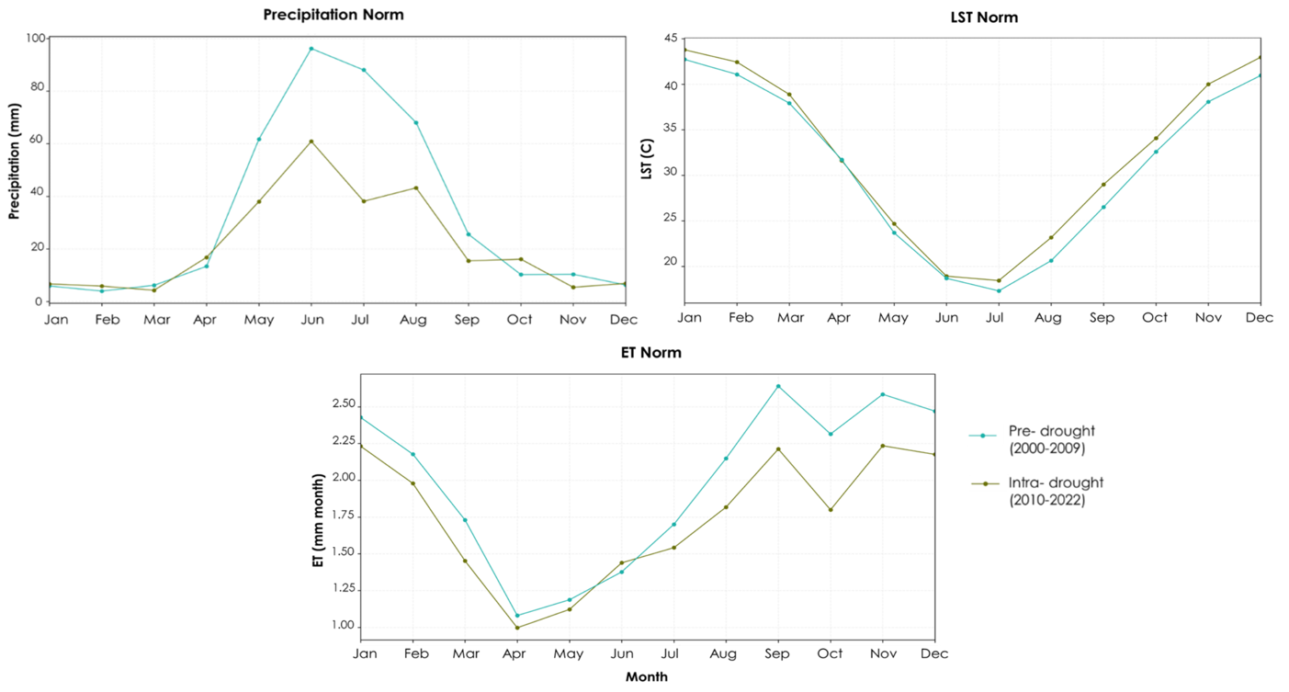

Figure 3. Hydrology Norms of precipitation, land surface temperature, and evapotranspiration for 2000-2023

The information shown in Figure 4 is only a small part of a larger analysis of seven seasons. Figure A1 from Appendix A contains the complete seasonal analysis. The figure gives a brief summary of certain observed trends. Crop area soil moisture levels have consistently increased, which may be due to better irrigation practices, increased use of irrigation, or changes in land management techniques. It is important to investigate the factors behind this trend to gain a better understanding of regional hydrological processes and to make informed decisions related to agriculture and the environment.

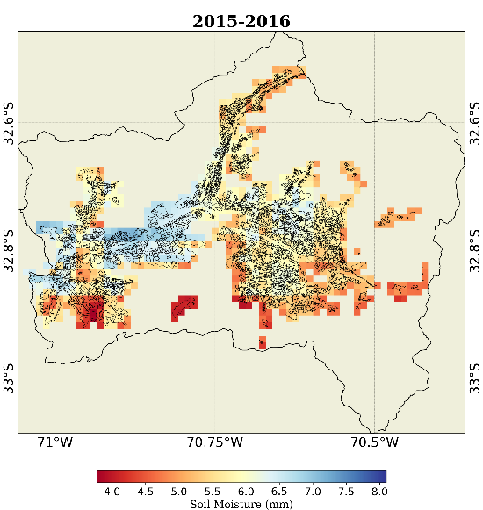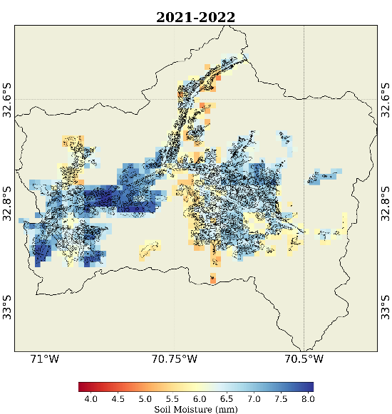

Figure 4. Seasonal soil moisture in 2015-2016 (left image) and 2021-2022 (right image).

Figure 5 represents only two seasons out of the twelve analyzed in the complete seasonal analysis, which can be found in Figure A2 from Appendix A. The analysis of ET shows a negative trend in seasonal variations over crop areas, indicating a consistent decrease over time. This intriguing finding suggests that a persistent drought is impacting the region's overall water balance, despite the observed increase in soil moisture levels. The declining trend in ET signifies that crops and vegetation are experiencing reduced water loss rates through evaporation and transpiration, likely due to the limited water availability in the soil and the atmosphere. This scenario could lead to water stress for plants, restricting their growth and overall productivity.

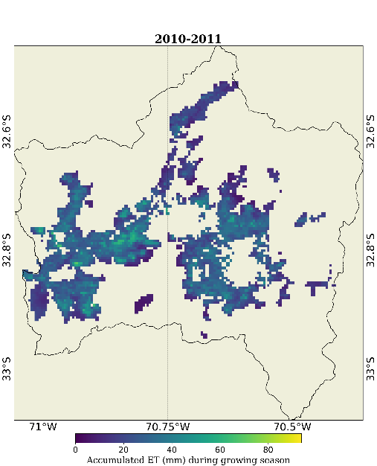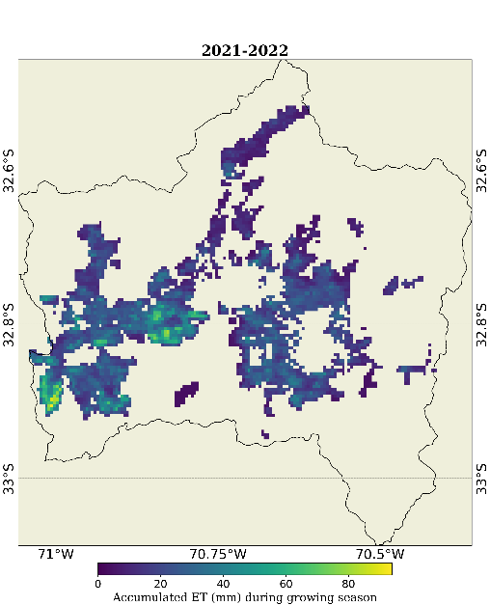
Figure 5. Seasonal evapotranspiration in 2010-2011 (left image) and 2021-2022 (right image)

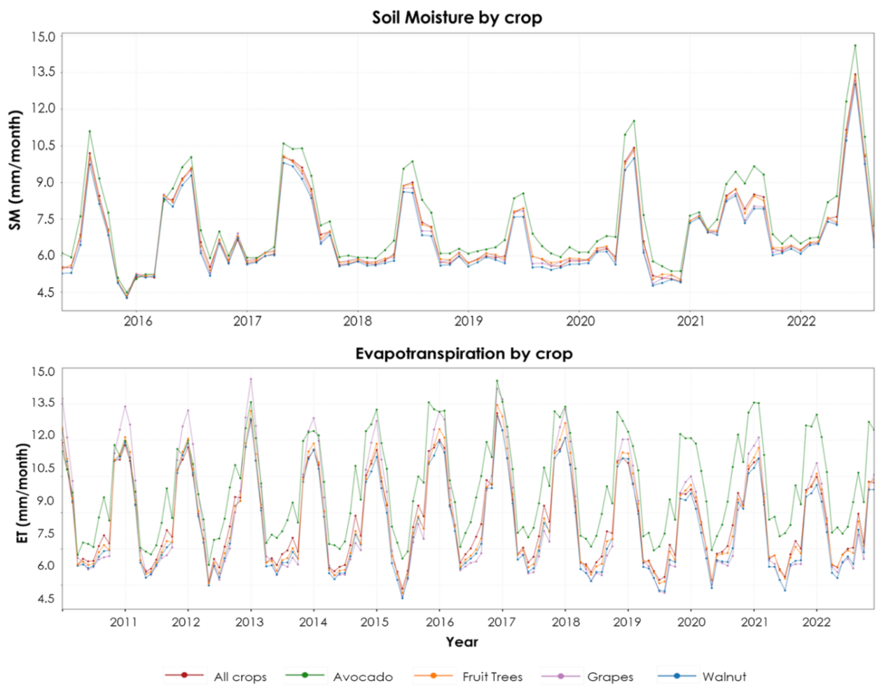

Figure 6. Spatial average time series of soil moisture and evapotranspiration by different crops.

Figure 6 shows the water demand for walnuts, fruit trees, grapes, and avocados in the study area. The results provide important insights, especially regarding avocados. They consistently require higher soil moisture levels, indicating a significant need for higher irrigation than other crops. When analyzing the evapotranspiration rates of the same crops, avocados also exhibit consistently higher values. However, there is an interesting observation when comparing the peak evapotranspiration periods between crops. Grapes have higher ET values and dominated the peak periods from 2010 to 2014, while avocados became the most water-demanding crop from 2014 onwards. These findings collectively highlight avocados as the crop with the highest water demand among the four studied and agree with the information from CIREN about avocados increasing over time in the region.

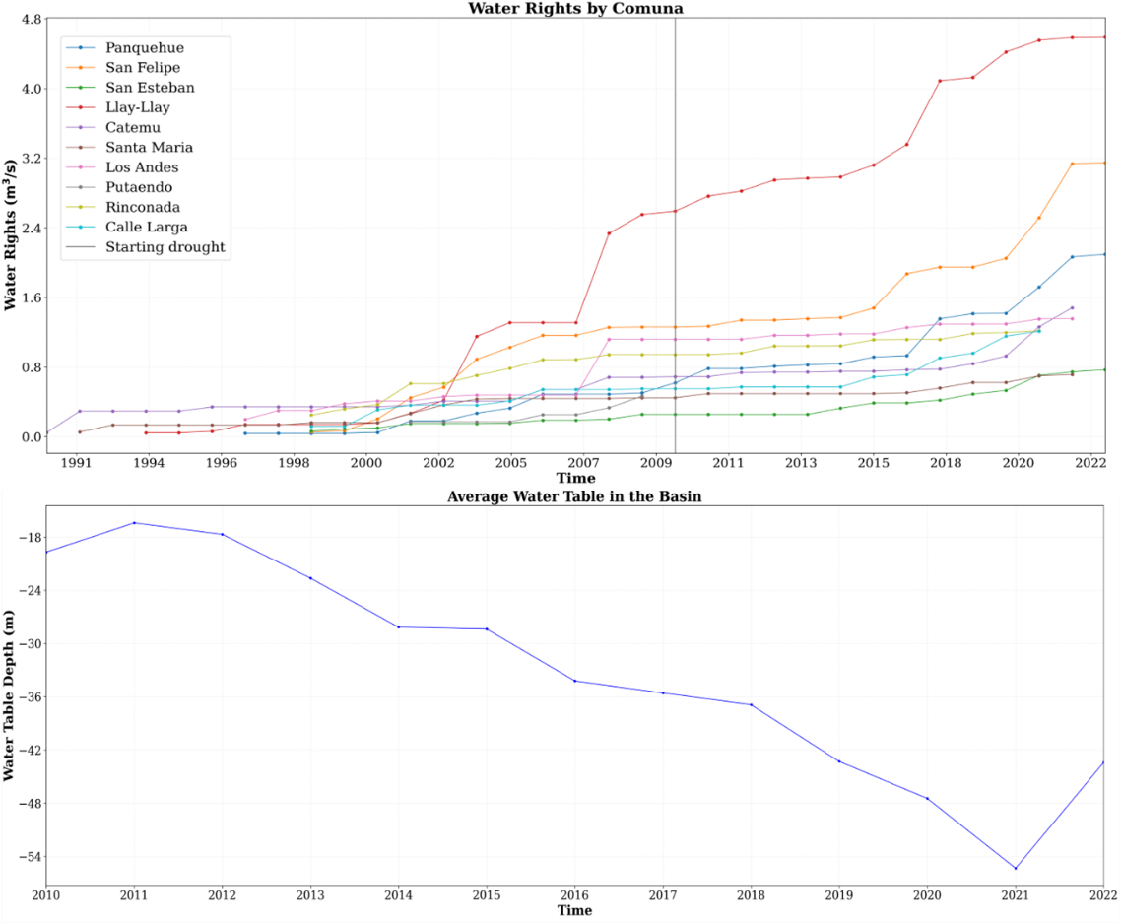

Figure 7. (Upper image) Accumulated water rights allocated by comuna in time, and (lower image) average water table condition in the central region on the ARB

Figure 7 illustrates the water rights allocated by ten different comunas in the central region of the ARB. While most comunas have seen an increase in water rights, it is noteworthy that the comuna 'Llay-llay' has experienced the greatest increase since 2007. Additionally, a vertical gray line indicated the beginning of the time series plot for the water table in 2010. However, due to inconsistent data from many wells with groundwater observations, we calculated the average groundwater level in the central regions to gain a general understanding of how the ongoing megadrought affects groundwater. As expected, the average water table has been steadily decreasing since 2010, and this alarming declining trend raises concerns within the community.

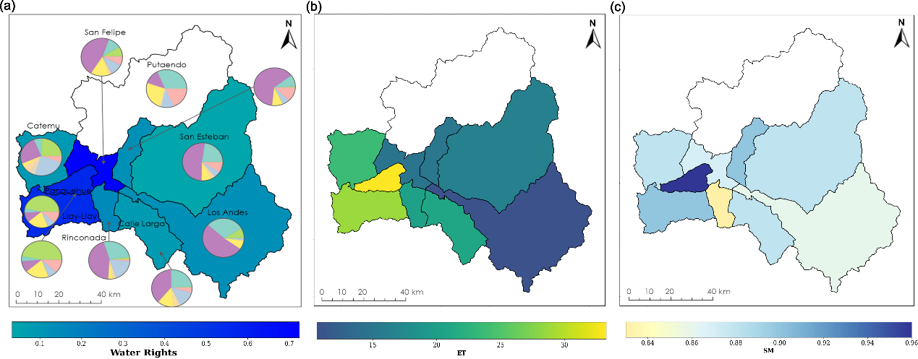

Figure 8. a) Water allocation (m³/s, WA) and dominant crop type per comuna within central ARB in the 2020-2021 growing season. WA is normalized by agriculture area in each comuna. b) ET by comuna. c) SM by comuna.

Figure 8a provides an overview of water allocation in the central ARB region. The accompanying pie charts depict the proportional area occupied by major crops within individual comunas. Predominantly, the central ARB region cultivates table grapes, avocados, and walnuts as its primary crops. In the eastern regions the major crop is table grapes, which are characterized by a low water allocation in meters cubed per second to the agriculture areas. Notably, in the eastern regions, table grapes stand out as the primary crop, marked by a relatively low water allocation in cubic meters per second for the agricultural area. Conversely, in the western regions, avocado crops are more prevalent. It is evident that avocados dominate areas with substantial water allocations, particularly on the hillslopes towards the western part of the region.

Table 2.
Ratio of water allocation to evapotranspiration and soil moisture for the 2020-2021 growing season
Comuna | WA (m³/s) | ET/WA | SM/WA
San Felipe | 0.72 | 20.40 | 1.21
Panquehue | 0.56 | 59.83 | 1.72
Llaillay | 0.54 | 52.92 | 1.67
Rinconada | 0.15 | 135.03 | 5.53
Santa Maria | 0.13 | 120.01 | 7.15
Los Andes | 0.12 | 85.19 | 6.86
Catemu | 0.09 | 267.07 | 9.95
Calle Larga | 0.08 | 264.64 | 11.14
San Esteban | 0.03 | 486.12 | 26.66

The normalized ratio table (Table 2) compares the water allocated to the agricultural area in each comuna to the agro-hydrological variables studied. Darker blue shades indicate an intensification of water use with disproportionately high ET and SM values compared to the water allocated to the comuna. San Esteban is the comuna with the highest water intensification and perhaps the greatest irrigation present with the lowest water allocated for irrigation use. On the other hand, San Felipe, Panquehue, and Llaillay have more water allocated and lower ET and SM values. The table demonstrates that, while there is likely water overuse in all comunas, some have exaggerated that use compared to others.

As this study is to assess the feasibility of a further scientific undertaking, there are many unquantified errors that would need to be accounted for in future conclusions. Water allocation data availability varies by comuna, as such, Putaendo has not recorded water allocation in the past 34 years. Beginning in 2021, Rinconada and Calle Larga also have no water allocation data. From 2022, six of the ten comunas in the central ARB no longer record water allocation. Whatever the reason for this, water allocation research in this region may not continue past 2021. For this study, we used values from 2020 for the 2020-2021 water allocation season in the two aforementioned comunas, which may have resulted in a lower water allocation than the actual values.

There is some uncertainty surrounding the in-situ data, particularly when it comes to measuring the water table. In this region, not all observations of the water table are consistent, as some observation wells have only been measured once in the past decade. As a solution, we decided to calculate the average depth of the water table using data from the four wells in the ARB that have the most complete set of measurements. It is important to note that the observation wells’ locations have differing elevations, which may also contribute to uncertainty because the depth of an unconfined aquifer can vary significantly based on the land's elevation. The water table trend presented in this study is only an approximation for the area. Unfortunately, the specific method and precision of the water table measurements were not documented. Consequently, this omission causes extra uncertainty.

Another source of uncertainty arises from the use of agriculture areas and crop-type masks to determine crop water demand. These masks were obtained from a land cover census conducted in 2020. While most of the crops under study are perennials that remain planted in the same region for a decade or more, there may be changes in the crop area of these perennials and significant variations in crop cover for the annuals studied. For this study, only the 2020 census data was available, but crop masks were used to compare evapotranspiration and soil moisture across different years.

When utilizing earth observations, inherent uncertainties relate to the instrument, known as instrument error, where the sensors and instruments used to collect Earth observation data can introduce uncertainty due to their design, calibration, and maintenance. Other uncertainties come from data processing, where raw earth observation data often undergo various processing steps to correct for distortions, remove noise, and convert measurements into usable formats. Hence, errors in data processing algorithms or assumptions can introduce uncertainties that affect the final results.

To ensure accurate Earth observation data, it is essential to compare it with established sources of information, such as ground-based measurements. When validation processes are inadequate or flawed, it can introduce uncertainties into the collected data. For this reason, we cannot determine the accuracy of the seasonal analysis of ET and SM over crop areas due to the absence of this validating in-situ data. Uncertainties in evapotranspiration values also arise from the Terra MODIS model, which assumes a constant biome (Mediterranean in this study area) in the region without accounting for seasonal or yearly variations. The model also pulls meteorological data that is of a coarser resolution than the 500m ET byproduct.

Based on an elevated soil moisture and decreased evapotranspiration in the month of April, we conclude, after reviewing our results, that the growing season should end in March and not include April. April is included in the soil moisture and evapotranspiration seasonal estimates, which may skew the results positively for soil moisture and negatively for evapotranspiration.

4.2 Feasibility Assessment
We used soil moisture, evapotranspiration, NDVI, and other climatology variables to estimate water usage and irrigation in the central region of the Aconcagua River Basin in Chile. The complicated method is feasible for our CIREN partners to apply to other agriculture-intensive areas in Chile as the partners are adept at coding, using GEE, and mapping Earth observation variables with GIS. The Dirección General de Aguas (DGA) can feasibly use the information provided in this study to inform water allocation decisions based on an increase in irrigation, crop area (especially avocados), and a rapidly lowering water table. It is possible for the project methods to be adapted for any drought-threatened region of the country that has groundwater gauges and water allocation records.

Monitoring irrigation and extraction on a farmer level is a sensitive topic within the water rights political discussion in Chile. As soil moisture and evapotranspiration data processing and analyzing methods developed in this study are new to our partners, they may provide additional supporting data to reallocate water usage or restrict planting in acutely drought-stressed areas with the ARB.

4.3 Future Work
For better integration into CIREN’s decision-making process, it would be beneficial to create a clear tutorial on how to process downscaled SM data and compare SM, ET, and NDVI to water allocation and water table data in Google Earth Engine and Python. The CIREN partners suggested a further analysis to regrid SM, ET, and NDVI on one grid scale to compare values more directly with water usage data. Furthermore, it was suggested that an updated hydrological model including soil moisture and water table comparisons be made for the region. We further advise the inclusion of Snow Water Equivalent (SWE) and glacier melt variables in the analysis and prediction of hydrological norms in the area to update a model. These additional variables, along with the parameters analyzed in this study, and using CMIP6 model outputs (Coupled Model Intercomparison Project Phase 6) can be used to predict crop yield. Predictions of snowmelt, precipitation, evapotranspiration, land surface temperature, and several more may allow a comprehensive view of the fragility of water resources in the agriculture region.

Taking the study one step further, a future team could use satellite imagery to collect crop specifics in the region, (which crops are grown in each farmland) and feed into a climate modeling machine learning program to estimate crop yields based on the discussed hydrologic variables. To do this, we would need to acquire previous crop yield census data to train the prediction model.

Moving away from agriculture in the project type, it would be useful to measure soil subsidence in the region. The ARB biome, prolonged drought effects, and agricultural production are similar to the valley region of California. As such, the region is envisioned to have experienced clear soil subsidence from the depletion of the aquifer by agriculturalists. This compression of the Earth’s surface may be viewed with Synthetic Aperture Radar (SAR) data. The results from this extended study may urge communities, agriculturalists, and the government to take additional water resource preservation measures.

5. Conclusions
As hypothesized in previous studies in the region and around the globe, the precipitation and ET are lower in the drought period than the decade previous while land surface temperature is higher during the drought when compared to the pre-decadal average. Furthermore, the water table time series shows a decrease in the water table level since the start of the drought in 2010. As there is less surface water available, extraction of groundwater has increased to a point where the rate of withdrawal is higher than the rate of recharge from precipitation, snowmelt, and glacial melt.

The spatial seasonal analysis of soil moisture (Appendix A) in the agricultural area indicates a clear increase in soil moisture from 2015 through the 2021-2022 growing season. We attribute this increase to a necessary intensification of irrigation, especially in the regions with the most water-demanding crops, grapes, and avocados. Since soil moisture from SMAP measures only the top 5 cm of the soil, we may not be sure if the increased irrigation has caused agriculture to maintain production during the drought. Veritably, evapotranspiration had indicated that crops have suffered during the drought even if surface irrigation has increased. The slight diminution of ET over the same agricultural area from 2010 to 2022 indicates that crops have transpired less in recent years. The community concern that crops are dying and cannot be supported with the amount of water allocated may have evidential roots from ET analysis. Water storage and water capture are crucial in irrigated agriculture. Poor water penetration leads to inadequate irrigation and is also associated with too much water for a temporary period of time (Prichard et al., n.d.). Similar to the seasonal analysis of soil moisture by crop type, avocadoes show the highest water demand in the region. CIREN indicated that, while there is no formal record of the increase in avocado production on the hillslopes of the central ARB, it is well known in the community that planting has accelerated in the drought-stressed region with the knowledge that the crop is very water-demanding.

Table 1 comparing the water allocated to the agricultural area of each comuna to SM and ET normalized values represents a large disparity between comunas in the region. This table could be extremely beneficial for our partners to indicate the comunas that show the greatest intensification of water use (San Esteban, Calle Larga, and Catemu) compared to the other comunas in the central ARB. From this analysis, we expect decision-makers to be better equipped to tackle water allocation in the ever-greater water-stressed region. Also, the dramatic highlighting of water intensification and a depleting water table during a megadrought may urge greater policy action to protect the region’s water resources.

Water use monitoring and allocation is a sensitive topic in the region, especially since 2010 and urgent water constraints on farmers. This study was cautious to not point blame at specific farmers or farmlands and chose to take a comuna approach instead. However, results indicate that the current method of water use is unsuitable for the changing climate. The water crisis in the Aconcagua River Basin of central Chile is worsening; and scientific studies such as this one may be invaluable to decision-makers in mitigating the human impact of drought.

6. Acknowledgements
The Aconcagua Basin Agriculture Team thanks our project partners from El Centro de Información de Recursos Naturales (CIREN), specifically our point of contact, Felipe Antonio Arróspide Alarcón. We would like to thank our partner Fernando Vasquez in the Embassy of Chile, Agricultural Office. We are grateful to Dr. Venkat Lakshmi and Dr. Kenton Ross for advising the study and aiding in project finalization, and Olivia Landry and Cecil Byles for offering support, guidance, and feedback during the session.

Any opinions, findings, and conclusions or recommendations expressed in this material are those of the authors and do not necessarily reflect the views of the National Aeronautics and Space Administration.

This material is based upon work supported by NASA through contract NNL16AA05C.

7. Glossary
ARB – The Aconcagua River Basin. The basin that contains the study area of this project. The Aconcagua River Basin is within the larger region of Valparaíso, approximately 50 km North of Santiago.
Comuna – A subsection of a county smaller than a municipality. There is no English equivalent word that represents this level of political entity in Chile.
CIREN – The partners El Centro de información de Recursos Naturales.
DGA - Dirección General de Aguas. Governmental sector that allocates terrestrial water sources ensuring an upholding of constitutional water rights and equity.
Earth observations – Satellites and sensors that collect information about the Earth’s physical, chemical, and biological systems over space and time.
ET – Evapotranspiration. The loss of water from the Earth’s surface through evaporation from soil and transpiration through the stomata of plants.
GEE – Google Earth Engine. This is a cloud-based geospatial analysis platform that allows users to acquire, process, and visualize geospatial data of our planet.
LST – Land Surface Temperature. The temperature at the surface of the Earth, as seen from satellite imagery.
Megadrought – A persistent drought period normally lasting at least one decade.
MODIS – Moderate Resolution Imaging Spectroradiometer.
NDVI – Normalized Difference Vegetation Index. From –1 to 1 where 1 indicates maximum greenness, values around 0 represent bare soil, and values near –1 are areas covered by water or clouds.
NIR – Near Infrared Radiation. Radiation in wavelengths from 700 to 1,300 nm.
PAR – Photosynthetically Active Radiation. The solar radiation that is available for plant photosynthesis, between 400 and 700 nm.
RS – Remote Sensing. Monitoring physical characteristics by measuring reflected and emitted radiation.
SM – Soil moisture. The volumetric (m3/m3) water per unit of soil in the top 5 cm of the soil.
SMAP – Soil Moisture Active Passive. A NASA satellite that measures and maps soil moisture on Earth.
Stomatal aperture – Pores on the surface of plants located mostly on the bottom of leaves.

8. References
Alvarez-Garreton, C., Mendoza, P. A., Boisier, J. P., Addor, N., Galleguillos, M., Zambrano-Bigiarini, M., Lara, A., Puelma, C., Cortes, G., Garreaud, R., McPhee, J., & Ayala, A. (2018). The CAMELS-CL dataset: Catchment attributes and meteorology for large sample studies – Chile dataset. Hydrology and Earth System Sciences, 22(11), 5817–5846. https://doi.org/10.5194/hess-22-5817-2018

Bown, F., Rivera Ibáñez, S., & Acuña, C. (2008). Recent glacier variations at the Aconcagua basin, central Chilean Andes. Annals of Glaciology, Volume 48, Number 1, pp. 43-48(6), 2008 https://repositorio.uchile.cl/handle/2250/117815

Drought and Climate Change. (n.d.). Center for Climate and Energy Solutions. Retrieved June 21, 2023, from https://www.c2es.org/content/drought-and-climate-change/

Garreaud, R. D., Alvarez-Garreton, C., Barichivich, J., Boisier, J. P., Christie, D., Galleguillos, M., LeQuesne, C., McPhee, J., & Zambrano-Bigiarini, M. (2017). The 2010–2015 megadrought in central Chile: Impacts on regional hydroclimate and vegetation. Hydrology and Earth System Sciences, 21(12), 6307–6327. https://doi.org/10.5194/hess-21-6307-2017

Huang, S., Hupy, J. P., Shao, G., Tang, L., Wang, Y. (2020). A commentary review on the use of normalized difference vegetation index (NDVI) in the era of popular remote sensing. Journal of Forestry Research, 32, 1-6. https://doi.org/10.1007/s11676-020-01155-1

Huffman, G.J., Stocker, E.F., Bolvin, D.T., Nelkin, E.J., & Tan, J. (2019). GPM IMERG Final Precipitation L3 1 month 0.1 degree x 0.1 degree V06 [Data set]. Goddard Earth Sciences Data and Information Services Center (GES DISC). https://doi.org/10.5067/GPM/IMERG/3B-MONTH/06

Jadidoleslam, N., Hornbuckle, B. K., Krajewski, W. F., Mantilla, R., & Cosh, M. H. (2022). Analyzing Effects of Crops on SMAP Satellite-Based Soil Moisture Using a Rainfall–Runoff Model in the U.S. Corn Belt. IEEE Journal of Selected Topics in Applied Earth Observations and Remote Sensing, 15, 247–260. https://doi.org/10.1109/JSTARS.2021.3131133

Janke, J. R., Ng, S., & Bellisario, A. (2017). An inventory and estimate of water stored in firn fields, glaciers, debris-covered glaciers, and rock glaciers in the Aconcagua River Basin, Chile. Geomorphology, 296, 142–152. https://doi.org/10.1016/j.geomorph.2017.09.002

Kapoor, D., Bhardwaj, S., Landi, M., Sharma, A., Ramakrishnan, M., & Sharma, A. (2020). The Impact of Drought in Plant Metabolism: How to Exploit Tolerance Mechanisms to Increase Crop Production. Applied Sciences, 10(16), Article 16. https://doi.org/10.3390/app10165692

Lakshmi, V. and B. Fang. (2023). SMAP-Derived 1-km Downscaled Surface Soil Moisture Product, Version 1 [Data Set]. Boulder, Colorado USA. NASA National Snow and Ice Data Center Distributed Active Archive Center. https://doi.org/10.5067/U8QZ2AXE5V7B. Date Accessed 08-10-2023

Mladenova, I. E., Bolten, J. D., Crow, W. T., Anderson, M. C., Hain, C. R., Johnson, D. M., & Mueller, R. (2017). Intercomparison of Soil Moisture, Evaporative Stress, and Vegetation Indices for Estimating Corn and Soybean Yields Over the U.S. IEEE Journal of Selected Topics in Applied Earth Observations and Remote Sensing, 10(4), 1328–1343. https://doi.org/10.1109/JSTARS.2016.2639338

Running, S., Mu, Q., Zhao, M., Moreno, A. (2021). MODIS/Terra Net Evapotranspiration Gap-Filled 8-Day L4 Global 500m SIN Grid V061 [Data set]. NASA EOSDIS Land Processes Distributed Active Archive Center. Accessed 2023-08-10 from https://doi.org/10.5067/MODIS/MOD16A2GF.061

Tran, T.-N.-D., Le, M.-H., Zhang, R., Nguyen, B. Q., Bolten, J. D., & Lakshmi, V. (2023). Robustness of gridded precipitation products for vietnam basins using the comprehensive assessment framework of rainfall. Atmospheric Research, 293(15), 106923. https://doi.org/https://doi.org/10.1016/j.atmosres.2023.106923
Tran, T.-N.-D., Nguyen, Q. B., Zhang, R., Aryal, A., Łukaszewska, M.-G., Sinicyn, G., & Lakshmi, V. (2023b). Quantification of Gridded Precipitation Products for the Streamflow Simulation on the Mekong River Basin Using Rainfall Assessment Framework: A Case Study for the Srepok River Subbasin, Central Highland Vietnam. Remote Sensing, 15(4), 1–27. https://doi.org/10.3390/rs15041030

Tran, T. N. D., Nguyen, Q. B., Vo, N. D., Le, M. H., Nguyen, Q. D., Lakshmi, V., & Bolten, J. (2023c). Quantification of global Digital Elevation Model (DEM) – A case study of the newly released NASADEM for a river basin in Central Vietnam. Journal of Hydrology: Regional Studies, 45(October 2022), 101282. https://doi.org/10.1016/j.ejrh.2022.101282

Walker, V. A., Hornbuckle, B. K., Cosh, M. H., & Prueger, J. H. (2019). Seasonal Evaluation of SMAP Soil Moisture in the U.S. Corn Belt. Remote Sensing, 11(21), Article 21. https://doi.org/10.3390/rs11212488

Wan, Z., Hook, S., Hulley, G. (2021). <i>MODIS/Aqua Land Surface Temperature/Emissivity Daily L3 Global 1km SIN Grid V061</i> [Data set]. NASA EOSDIS Land Processes Distributed Active Archive Center. Accessed 2023-08-10 from https://doi.org/10.5067/MODIS/MYD11A1.061

Webb, M. J., Winter, J. M., Spera, S. A., Chipman, J. W., & Osterberg, E. C. (2021). Water, agriculture, and climate dynamics in central Chile’s Aconcagua River Basin. Physical Geography, 42(5), 395–415. https://doi.org/10.1080/02723646.2020.1790719

9. Appendix A

Appendix A contains the complete season analysis of soil moisture (Figure A1), evapotranspiration (Figure A2), and NDVI (Figure A3) over crop areas.

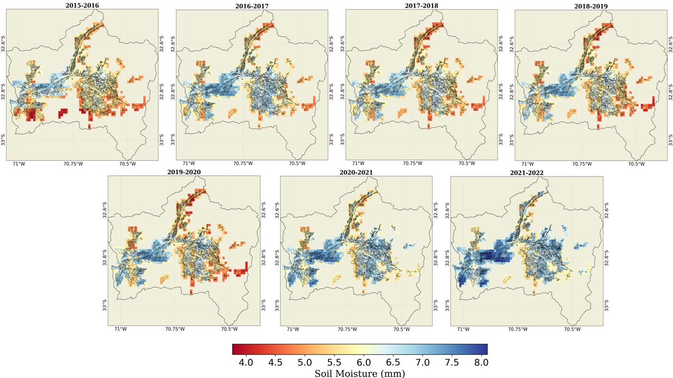
Figure A1 Seasonal average soil moisture from 2015-2022

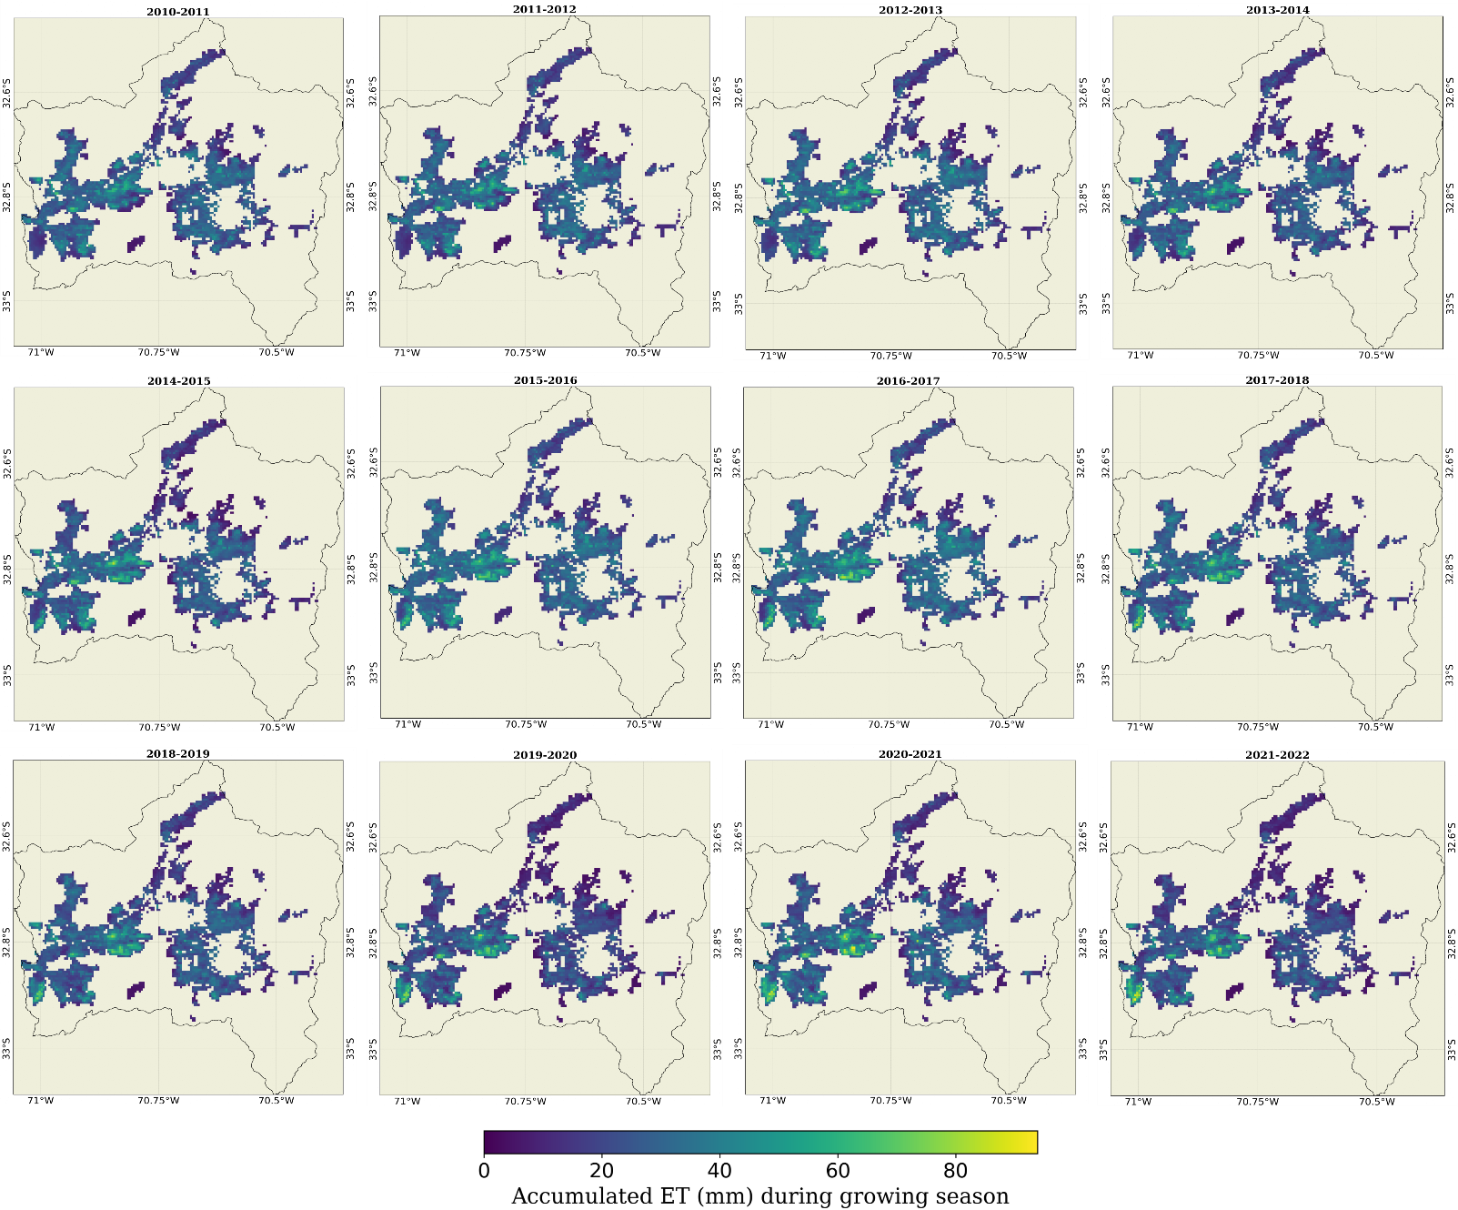

Figure A2. Seasonal accumulated evapotranspiration from 2010-2022

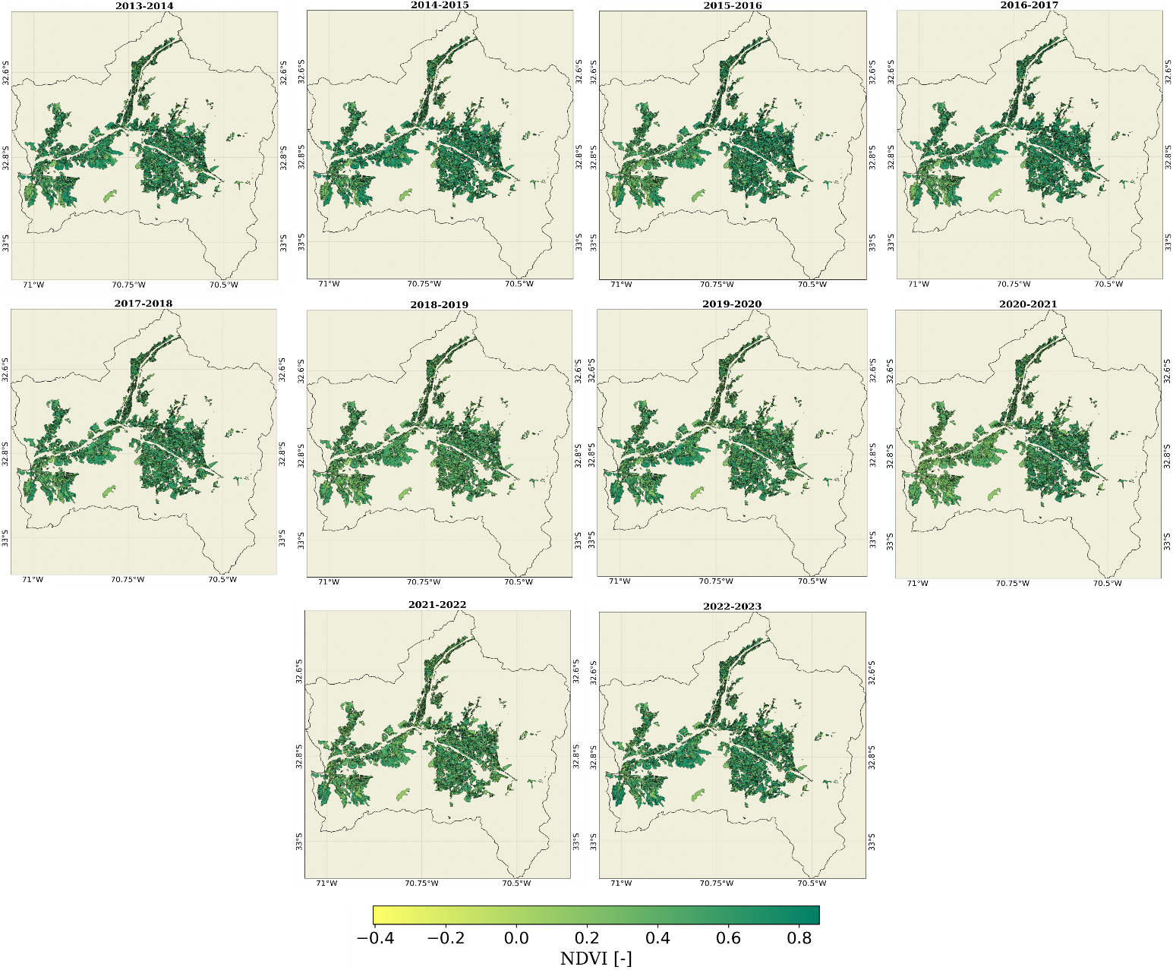
Figure A3. Seasonal average NDVI from 2013-2022

