PACE OCI crosstalk characterization based on pre-launch testing

Shihyan Lee^{1,2}, Gerhard Meister¹, Samuel Kitchen-McKinley³, Joseph Knuble⁴, Ulrik Gliese⁵, and Robert Bousquet⁶

¹NASA Code 616, Ocean Ecology Lab, Goddard Space Flight Center, Greenbelt, Greenbelt Rd., Maryland, MD 20771, USA
²Science Applications International Corporation, 12010 Sunset Hills Rd., Reston, VA 20190, USA

³Science Systems and Applications Inc., 10210 Greenbelt Road, Lanham, Maryland 20706, USA
⁴NASA Goddard Space Flight Center, Greenbelt, Greenbelt Rd., Maryland, MD 20771, USA
⁵KBR, 7701 Greenbelt Rd., Greenbelt, MD 20770, USA
⁶Genesis Engineering Solutions, Inc., 4501 Boston Way, Lanham, MD 20706, USA

ABSTRACT

Scheduled to launch in 2024, the Ocean Color Instrument (OCI) onboard the Plankton, Aerosol, Cloud, ocean Ecosystem (PACE) mission will collect hyperspectral data from 315 nm – 895 nm via two grating spectrometers (in both the blue and red spectral regions) and 9 multi-spectral bands in the short-wave infrared (940 nm – 2260 nm). The increased spectral resolution and radiometric accuracy is expected to improve upon data collected by heritage sensors such as SeaWiFs, MODIS, and VIIRS, allowing new applications in ocean color, aerosol, and cloud science. During ground testing, higher than expected spatial-spectral crosstalk was measured for the hyperspectral bands in the blue spectrograph. Using a monochromatic-collimated light source, light from a single science pixel (1km x 1km) was found to produce crosstalk signals over 31 pixels in the cross-track direction. This spatial augmentation is caused by the spectral crosstalk’s asynchronous spatial movement during Time Delay Integration (TDI).
To fully characterized the magnitude and spectral dependency from this, a crosstalk model was developed by synthesizing data collected from monochromatic-collimated light and monochromatic light that filled the OCI optical aperture. The model was validated by showing good agreement between predicted values and other relevant test data collected using both monochromatic and white light sources.

1. INTRODUCTION
NASA’s next generation Ocean Color Instrument onboard PACE mission will be the first satellite sensor to provide moderate spatial resolution (1km), hyper-spectral resolution (5nm) from UV to Near Infrared Red (NIR) at daily global coverage [1]. This engineering challenge is achieved by 2 extremely fast running CCDs recording signals in a blue (315-610nm) and a red (600-895 nm) spectrograph [2]. A 16 science pixel time-delay-integration (TDI) is used to increase the signal-to-noise ratio (SNR) to meet stringent ocean science requirements. The CCD detector is much smaller than the science pixel, and 8 CCD pixels form 1 science pixel (or simply refer to as pixel in this paper).
The OCI field stop is about 1 by 16 pixels in track and scan direction. The grating disperses the light to fill the focal plane assembly (FPA), which is 128 CCD pixels (16 science pixels) wide and 512 CCD pixels tall (corresponding to ~320nm; see Figure 1). In each spectral band, the signals are carried through the consecutive 128 pixels, synchronized to the scanning speed of the OCI telescope. For each spectral band, the signals from all 128 CCD pixels are integrated as a single TDI pixel.

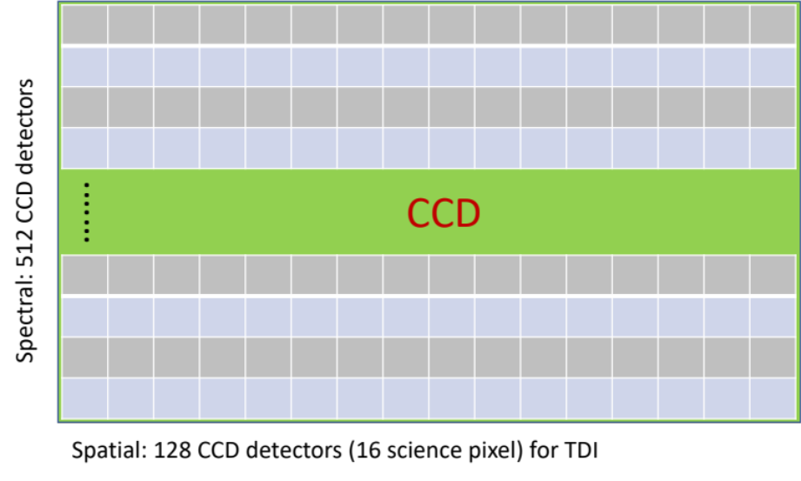

Figure 1. OCI hyperspectral band Charge-Coupled Device (CCD) sensor. For each spectral band, all 128 CCD detectors are simultaneously illuminated. The signals are digitized and aggregated in the onboard electronics via TDI. The 128 CCD detectors produce data in 128 physical pixels, which can be further aggregated into 16 science pixels (1 science pixel = 8 physical pixels).

The prelaunch radiometric characterization of OCI was completed in 2022 [3]. In the stray light measurements of that test campaign, using a collimated-monochromatic light source with a size of 1x1 pixel [3], a crosstalk feature was detected that is much wider than the source. In Figure 2, OCI blue bands show a 31-pixel wide crosstalk feature at 382.8nm from a 1-pixel wide source of monochromatic light at 583nm. In this paper, we define this unique crosstalk feature as a “ghost”. As expected, the OCI response near the peak at 583nm follows the typical exponential decay in both spatial and spectral direction.

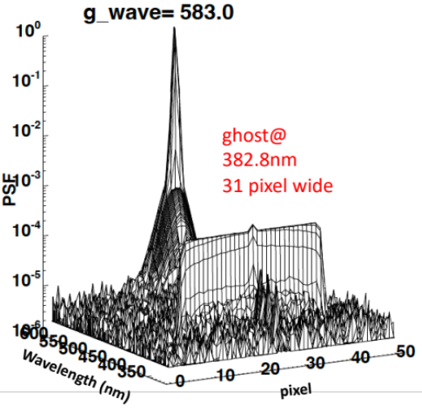
Figure 2: Normalized OCI blue CCD band response (PSF) from a 1x1 pixel collimated-monochromatic light at 583 nm. PSF = dn/max(dn), where dn is the background subtracted digital count

The 31-pixel wide ghost feature is caused by asynchronous spatial movement during Time Delay Integration (TDI). This can be visualized using snapshot simulations from the OCI optical model without TDI integration. Figure 3 shows the modeled OCI response from 1x1 pixel monochromatic light at 583nm at various TDI pixel locations. Each of the snapshot images is the instantaneous view of the OCI response at that TDI pixel before integration. The snapshot images show the ghost feature starts out at the opposite side of the source within the focal plane, then moving in the opposite direction as the OCI scan motion (Figure 3 a-d). The ghost’s asynchronous spatial movement results in a crosstalk feature extending 15 pixels beyond the source after TDI. Since the ghost can be sent to a pixel that is up to 15 pixels away to the left (Figure 3d) or to the right (Figure 3d) side of the signal, resulting a 31-pixel (center pixel + 15 pixel at each side of the peak) wide ghost feature from an 1-pixel wide source (Figure 2).

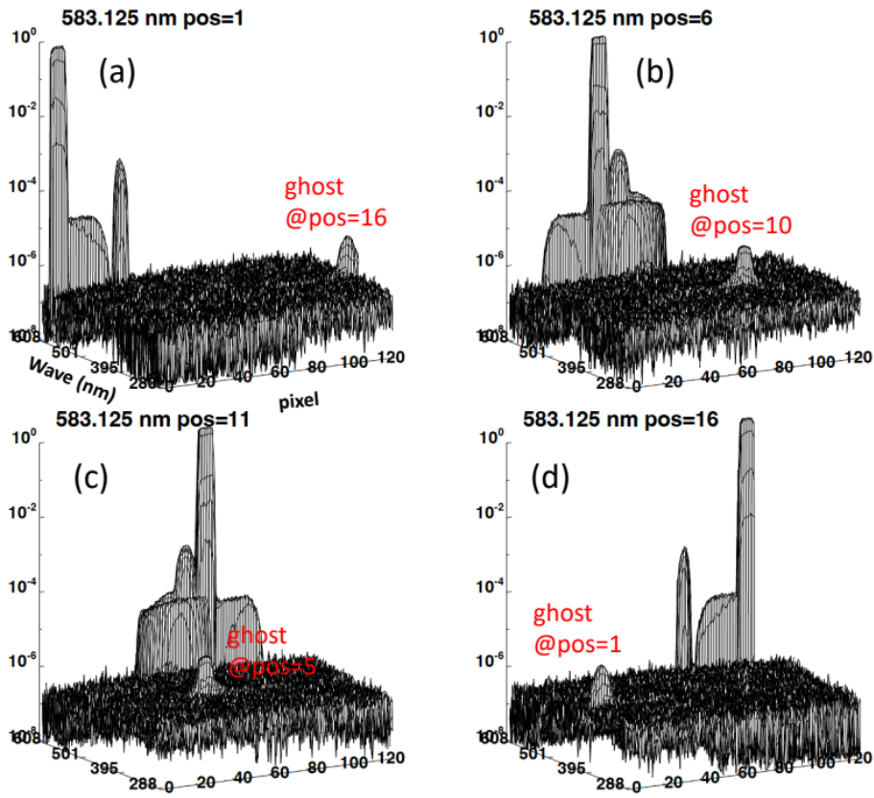
Figure 3: OCI snapshot PSF illustrated by OCI optical model when source in pixel location (a) 1 (pos=1), (2) pos=6 (3) pos=11 and (4) pos=16. Note: model performed at CCD pixel resolution. 1 science pixel = 8 CCD pixel

To further examine this ghost feature, we compared measured OCI response between 1 and 7 pixels wide monochromatic-collimated sources. In Figure 4, the ghost feature from 583nm monochromatic light is wider in the 7 pixel mask data. The broadening of the ghost can be better observed from the spatial profile of the ghost features, when we slice the OCI data cube at the ghost wavelength (Figure 5). Compared to the ghost feature in the 1-pixel mask data (Figure 5a), the 7-pixel mask ghost (Figure 5b) is roughly 7 times stronger and 6 pixel wider. The 7-pixel mask ghost has a more gradual drop off at the edge than the 1-pixel mask ghost. The comparison results shows the 7-pixel ghost is the convolution of 1-pixel mask ghost with a 7 pixel wide kernel. The results indicate the total ghost contamination can be estimated by the convolution of the source and the 1-pixel mask ghost.
Another notable feature in Figure 5 is that the out of band (OOB) response in 7-pixel mask data is 7 times wider than the 1-pixel mask data but has the same magnitude. This is consistent with typical OOB behavior as it is the simple ratio of the source intensity and sizes.

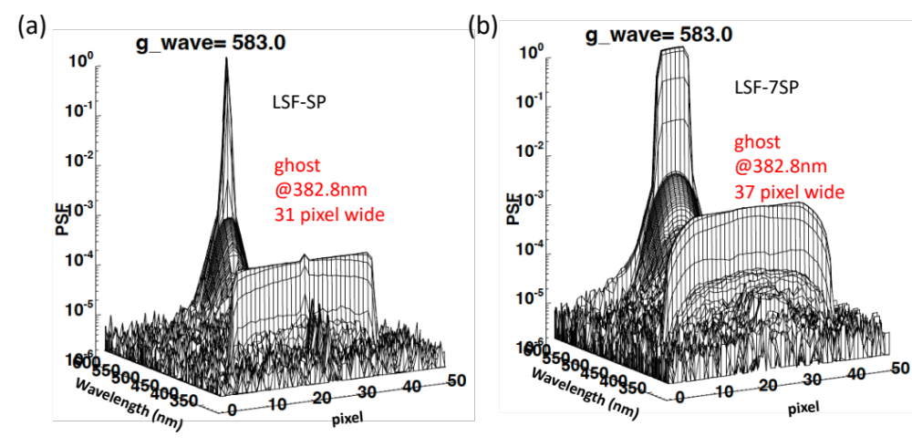
Figure 4: Normalized OCI blue CCD band response (PSF) from 583 nm monochromatic light collimated with a (a) 1 science pixel mask, and (2) 7-science pixel mask.

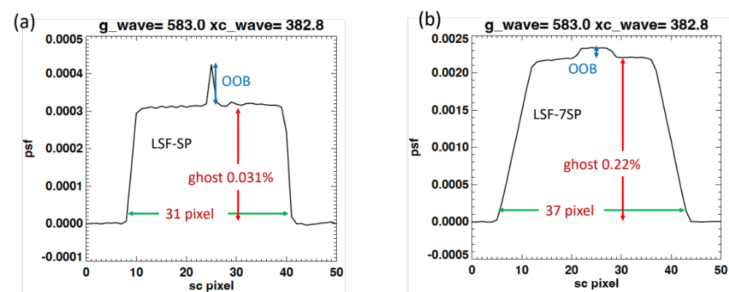

Figure 5: OCI spatial profile at the ghost wavelength (382.8 nm) for LSF test performed using (a) 1 science pixel mask (2) 7-science pixel mask. Ghost in 1-pixel mask data is ~0.031 % and 31 pixels wide; ghost in 7-pixel mask data is ~0.22 % and 37 pixel wide. The out of band (OOB) for both 1 and 7-pixel masks are about the same, ~0.01 % in each case.

2. Crosstalk Characterization
Ideally, we would use the optical model to characterize OCI crosstalk. However, the OCI optical model predicted crosstalk does not always agree with measurements. As shown in Figure 3, the optical model was useful in showing the asynchronous ghost feature within the Blue FPA; however, it failed to predict the correct crosstalk wavelength and magnitude from 583nm monochromatic light.
To characterize the OCI crosstalk, we need to first understand the spectral variability of the ghosts. To do that, we used the high contrast scene data collected from monochromatic-collimated light with the 1-pixel mask to compute the baseline crosstalk map. Unfortunately, the high contrast scene data was only collected at 11 discrete wavelengths (see Figure 6). Therefore, we used OCI spectral calibration data [5] to fill the data gaps in the high contrast scene data. OCI spectral calibration data is monochromatic and completely fills the OCI aperture, and it is available in 1nm steps for the blue and red FPA wavelength range. The OCI spectral calibration data are less accurate than the high contrast scene data in estimating the ghost because it fills the OCI aperture.

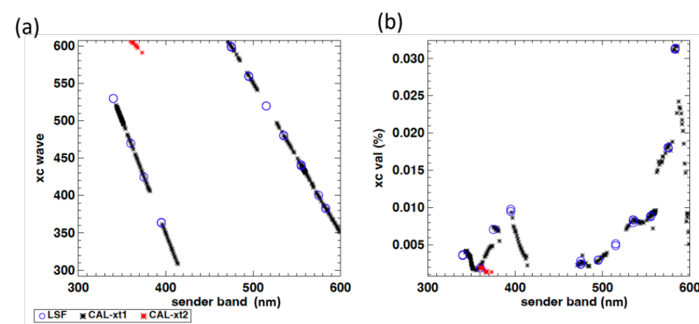
Figure 6: Estimated ghost wavelength (xc wave) in (a) and magnitude (xc val) in (b) vs. source wavelength (sender band). The symbols indicate the test data type used to calculate the results. LSF = high contrast scene data, CAL = spectral calibration data. 2 ghost features are estimated in spectral dataset: primary (CAL-xt1) and secondary (CAL-xt2).

Figure 6 shows the OCI ghost wavelengths and ghost magnitudes estimated from high contrast scene and spectral calibration data. In Figure 6a, the ghost wavelength (xc wave) originated from a source wavelength (sender band) is separated into 2 different wavelength regions. For sender bands (source) greater than 450 nm, the ghost wavelength is moving about twice as fast as sender band wavelengths. For sender bands less than 450 nm, the ghost is moving ~3 times as fast as the sender band wavelengths (compare the slopes in Figure 6a). For sender bands around 365 nm, there is a secondary ghost feature with ghost wavelengths around 600 nm.
Figure 6b shows the ghost magnitude vs. sender wavelength. In each of the 2 ghost regions, the magnitude increases toward longer wavelengths before dropping back down. There is a dip in the ghost magnitude around 370 nm, where a secondary ghost was detected (Figure 6a). The source at 365 nm contaminates 2 wavelengths (xc wave=456nm and xc wave=601.6nm), which reduces each ghost’s magnitude. Figure 6b shows that the magnitude of the secondary ghost is very small compared to the larger features of the primary ghost. To simplify the crosstalk modeling and correction, we decided to ignore the secondary ghost feature when characterizing OCI crosstalk.
In Figure 6, there are 2 spectral gaps (383 nm to 395 nm and 506 nm to 526 nm) in the ghost features identified by the OCI spectral calibration data. The gaps are the result of the threshold in the ghost detection algorithm to reduce uncertainty due to the cross contamination between near peak crosstalk and ghost features when the ghost wavelength is very close to the source wavelength. This is not an issue in the OCI high contrast scene data as the ghost feature is better defined in the narrow collimated source. To complete the ghost mapping for the entire FPA, the ghost wavelength and magnitude are interpolated to fill the 2 spectral gaps.

3. Crosstalk Model
As described above, to fully characterize OCI crosstalk, we need to map out the normalized OCI response from monochromatic light collimated with 1-pixel mask for all bands within the FPA. Since such data were only taken at some selected wavelengths during the high contrast scene tests, the OCI crosstalk was modelled as:
- Compute the nominal PSF by removing the ghost feature in the measured high contract scene data. This ghost-free nominal PSF is used as the baseline crosstalk map which contains the near peak crosstalk responses (Figure 7). The nominal PSF is computed for each of the 11 wavelengths measured during the high contrast scene tests.
- For source wavelengths at each OCI band, compute the modeled nominal PSF by interpolating the measured nominal PSF from the 2 nearest wavelengths. Figure 8a shows an example of the modeled 540nm nominal PSF computed from interpolating nominal PSF measured at 535 nm and 555 nm. Note that 540 nm is not a wavelength measured during OCI high contrast scene tests.
- For source wavelengths at each OCI band, compute the modeled PSF by adding the predicted ghost to the modeled nominal PSF. This is demonstrated in Figure 8b, where the modeled PSF is constructed by adding the predicted ghost to the nominal PSF.
- For each OCI band, compute the modeled crosstalk by aggregating the modeled PSF response going into that band from all source wavelengths. Eq. 1 describes the relationship between crosstalk influence coefficient (IC) and modeled PSF. Note that the sending band is the wavelength of the light source.

${IC}_{w_{r}}\left(w_{s},x\right)={PSF}_{w_{s}}\left(w_{r},x\right)$ [eq. 1]

$w_{r}$ $, w_{s}:receiving and sending band$
${IC}_{w_{r}}\left(w_{s},x\right)$: IC of receiving band w_{r} at location x from sending band w_{s}
${PSF}_{w_{s}}\left(w_{r},x\right):$ PSF of sending band w_{s} to receiving band w_{r} at location x. PSF is the modeled PSF described in step 3).

.

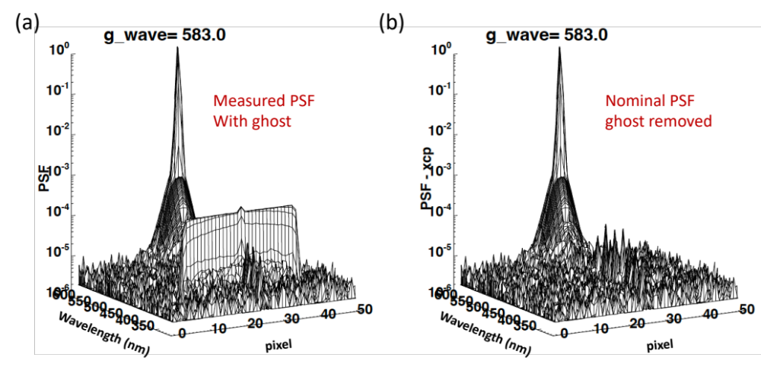
Figure 7: (a) Normalized OCI response from high contract scene measurement with monochromatic source at 583 nm. (b) nominal PSF for 583 nm source with ghost feature removed.

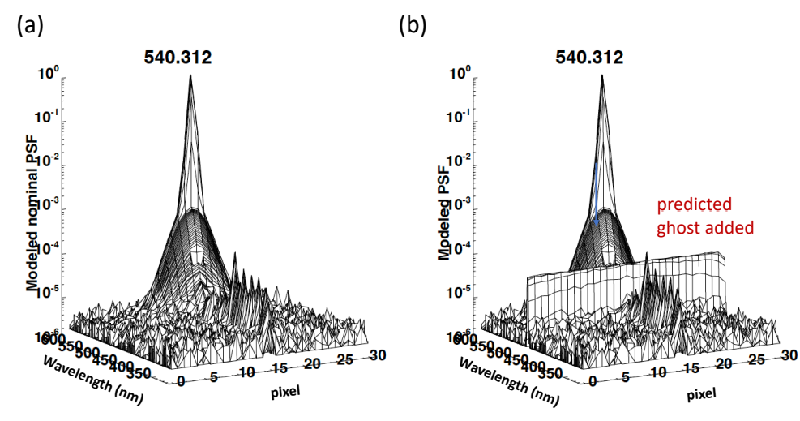
Figure 8: (a) Modeled nominal PSF by interpolating nominal PSF from 2 nearest measured wavelengths; (b) Modeled PSF: modeled nominal PSF + predicted ghost.

The OCI crosstalk map is computed with a spectral resolution of 0.625 nm and spatial resolution of 1 science pixel (~1km) to accommodate all possible OCI spectral aggregation schemes [2] during on-orbit science data collection. This results in a dimension of 480 by 31 in spectral band and spatial pixel per FPA. Note that 32 out of the total 512 spectral pixels are not used for on-orbit operation, resulting in 480 spectral bands with 0.625 nm bandpass.
Figure 9 shows the modeled crosstalk influence coefficients for the 540 nm band with a 5nm bandpass. This crosstalk map has the spectral resolution reduced by 8x, resulting in a map with a dimension of 60 (spectral bands) by 31 (spatial pixels). The crosstalk map in Figure 9 shows 2 ghost wavelengths compared to the single ghost in PSF (Figure 8b). This is explained by the Figure 6a (crosstalk sender vs. receiving band), where two different source wavelengths (sender bands) often produce a ghost at the same wavelength (receiving band).

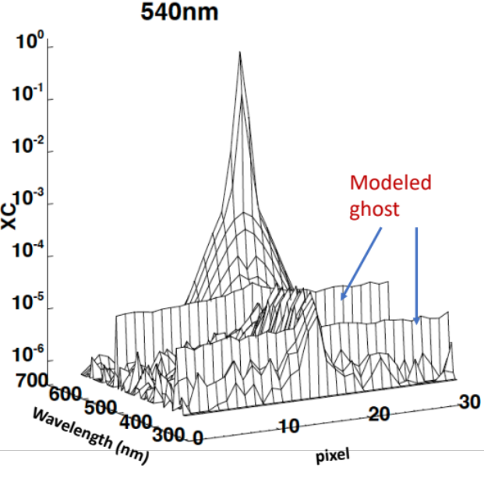
Figure 9: Modeled crosstalk influence coefficients (XC) for 540 nm band with a 5 nm band width.

Based on the crosstalk influence coefficients (IC in eq. 1) we can compute the measured OCI radiance (L_{xc}) from a “true” scene radiance (L_{m}) by summing the crosstalk contribution from all wavelengths ($w_{s})$ and locations (i) [eq. 2];

$L\text{xc(x,}w_{r}\text{)}=\sum_{i, w_{s}}{L\text{m}{(w}_{s},i)⋅{IC}_{w_{r}}\left(w_{s},i\right)}$ [eq. 2]

L_{xc}(x,w_{r}): OCI measured radiance at pixel x, and band w_{r}
L_{m}(w_{s},i): “true” scene radiance at location i, and wavelength w_{s};
i is from x-15 to x+15
w_{s} is from the lowest to the highest wavelength in the same FPA

To evaluate the accuracy of the modeled crosstalk maps, we compute the modeled white light PSF and compare that with the measured white light PSF from the 1-science pixel high contrast scene data. To compute the modeled radiance, we convolve the crosstalk IC with an ideal 1-pixel high contrast scene with the peak radiance equal to the radiance measured in the white light data. By normalizing the modeled white light radiance, we can compare the modeled white light PSF with the measurements.

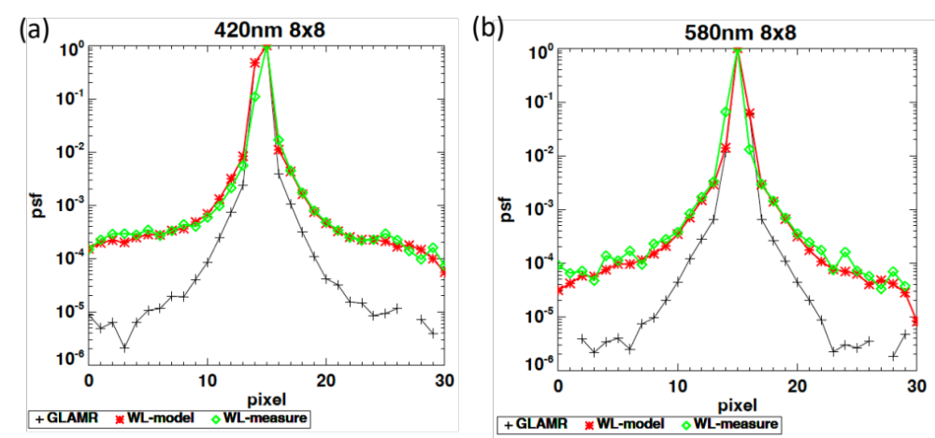
Figure 10: Comparison of modeled and measured OCI PSF from 1-science pixel high contrast scene. WL-model = modeled white light PSF, WL-measure = measured white light PSF, GLAMR = monochromatic light PSF.

Figure 10 shows the comparison of modeled vs. measured normalized OCI response (PSF) from a 1-science pixel mask, high contrast scene. Figure 10 shows the model and measured white light PSF agree fairly well except the pixel adjacent to the peak. The higher uncertainty near the peak is partially caused by the small band-to-band registration error where the centroid moves slightly among the OCI bands [6]. Since the modeled crosstalk is based on the relatively few measured wavelengths, the modeled bands further away from the measured wavelength will have larger spatial uncertainty. The impact of the small spatial uncertainty is magnified near the peak due to the steep drop in PSF. The effect of this spatial uncertainty is shown in Figure 10, where the modeled-vs-measured white-light PSF near the peak has better agreement in 580 nm than 420 nm. The closest measured wavelength from 580 nm is 583 nm, which is closer than the 420 nm from the measured 395 nm.
Another notable feature in Figure 10 is the large differences between white light and monochromatic light. The large increase is the result of the accumulated crosstalk from all of blue band wavelengths and the 31 adjacent pixels. Comparing the measured OCI response (Figure 2) and Figure 10, it can be seen that the crosstalk contribution is dominated by the nearby wavelengths close to the peak (i.e. <=5 pixels), likely due to scattering off the grating. Away from the peak (> 5 pixels), the dominant contribution gradually shifts to the ghost features. The ghost contributes equally from all 31 adjacent pixels, which forms the floor of crosstalk out to the edge of the PSF profile.

4. Conclusion and Discussion
In this paper, we described the methodology to characterize the OCI optical crosstalk. The OCI optical crosstalk feature is more complex than heritage multi-spectral ocean color sensors, i.e. SeaWiFS, MODIS and VIIRS, due to its grating providing hyper-spectral bands and due to TDI, which enables the crosstalk signal to accumulate from 1-15 spatial pixels away. Compared to the filter band design in the heritage sensors, there is increased crosstalk coming from the nearby wavelengths and a ghost feature in the OCI blue CCD bands.
The ghost’s unique spectral/spatial characteristics could potentially result in significant impacts to ocean science products. Because the crosstalk can be sent from a distant wavelength and a distant location, the sender wavelength could have a much higher radiance than the receiving band. This is especially true for ocean color data, where the signal is decreasing rapidly from blue to the red. Since the ghost contribution is spatially continuous for up to 15 pixels away, it cannot be removed by the current straylight masking, which usually only excludes 1-2 pixels from the cloud edge. For ocean data near to clouds, the crosstalk can be sent from the cloud pixel into the ocean pixel up to 15 pixels away. This would results in significant contamination as the brightness of the cloud is much higher than the ocean.
At the time of this writing, a new ghost feature was discovered in red FPA. This ghost feature was over-looked previously as it is coming from wavelengths outside of the red FPA bands. The crosstalk characterization method presented here should also apply to red FPA bands. Work is underway to include this new found ghost in the red FPA crosstalk map. Concurrently, an OCI crosstalk correction based on the modeled crosstalk maps presented in this paper is also under development. Both the red FPA crosstalk map update and operational implementation of crosstalk correction should be ready before the PACE launch in early 2024.

[1] Werdell, P. J., M. J. Behrenfeld, P. S. Bontempi, et al. 2019. "The Plankton, Aerosol, Cloud, ocean Ecosystem (PACE) mission: Status, science, advances." Bulletin of the American Meteorological Society, 100 (9): 1775–1794, 2019.

[2] Eric T. Gorman, David A Kubalak, Deepak Patel, Andre' Dress, David B. Mott, Gerhard Meister, P. Jeremy Werdell, "The NASA Plankton, Aerosol, Cloud, ocean Ecosystem (PACE) mission: an emerging era of global, hyperspectral Earth system remote sensing," Proc. SPIE 11151, Sensors, Systems, and Next-Generation Satellites XXIII, 111510G, 10 October 2019.

[3] Gerhard Meister, Joseph Knuble, Julia Barsi, et al., “Initial Look at the Results from the Prelaunch Characterization Campaign of OCI on the PACE mission”, TH1.R6: NASA PACE Mission, IGARSS 2023.

[4] Joseph J. Knuble, Gerhard Meister, Colby Jurgenson, Hyeungu Choi, Nicholas R. Collins, Eric T. Gorman, Kim Jepsen, Shihyan Lee, Robert Bousquet, Bill Cook, Ulrik Gliese, “Measurement techniques for the high-contract and in-field stray light performance of OCI”, SPIE San Diego 2023.

[5] Samuel Kitchen-McKinley, Jeff McIntire, Hyeungu Choi, Gerhard Meister, Julia Barsi, Brendan McAndrew, Andrei Sushkov, Barbara Zukowski, William B. Cook, Ulrik Gliese, Kenneth Squire, Joseph Knuble. “PACE OCI Flight Unit Pre-launch Spectral Characterization”, 1502: NASA PACE Mission, IGARSS 2023.

[6] Hyeungu Choi, Jeff McIntire, Samuel Kitchen-McKinley, Gerhard Meister, Leland Chemerys, Shihyan Lee, "Spatial characterization of PACE OCI ETU using time-delay mode," Proc. SPIE 12232, Earth Observing Systems XXVII, 1223211 (30 September 2022); https://doi.org/10.1117/12.2632640

