Lake Anna Water Resources
Using NASA Earth Observations to Identify Algal Event Risk Factors in Lake Anna and Help Inform Future Management Practices

Technical Report
August 11th, 2023

Olivia Etherton (Project Lead)
Caroline Bahun
Alexander Krest
Justin Wilder

Advisors:
Dr. Kenton Ross, NASA Langley Research Center (Science Advisor)
Lauren Childs-Gleason, NASA Langley Research Center (Science Advisor)

Fellow:
Olivia Landry (NASA Langley Research Center)

1. Abstract
Lake Anna is a man-made reservoir and popular recreation destination that spans over 13,000 acres—9,600 public and 3,400 private—in the Piedmont region of Virginia. The Lake has recently seen a rise in documented harmful algal blooms (HABs), which pose a variety of community and ecological concerns and are often exacerbated by anthropogenic factors, such as excess nutrient loads from agricultural runoff. NASA DEVELOP has partnered with the Virginia Department of Environmental Quality (DEQ) to help monitor cyanobacteria and nutrient pollution indicators across Lake Anna. The team utilized Earth observations (EO) and in situ ancillary data to identify and monitor algal bloom trends. The team used Landsat 8 Operational Land Imager (OLI), Landsat 9 OLI-2, Sentinel-2 Multispectral Instrument (MSI), and Sentinel-3 Ocean and Land Color Instrument (OLCI) to analyze water quality variables such as chlorophyll-a, turbidity, surface temperature, and cyanobacteria. Due to the lack of comprehensive in situ data and historic HAB event records, our ability to compare and validate EOs was limited. Additionally, deficient spatial resolutions, along with a geographically complicated shoreline, accentuated the spatial constraints we faced in our analysis. After examining EOs, our results indicated conditions conducive to the formation of HABs within the upper reaches of Lake Anna. Yet, spatially dependent limiting factors may have also influenced where these phenomena developed. When used in concert with existing in situ datasets, NASA EOs provide relevant stakeholders with more comprehensive analyses with which to engage in enhanced monitoring and watershed management.

Key Terms
cyanobacteria, harmful algal blooms, phycocyanin, NDCI, NDTI, Sentinel, Landsat, Google Earth Engine

2. Introduction
2.1 Background Information
Harmful algal blooms (HABs), often associated with coastal waters, are becoming an increasingly urgent issue for inland waterbodies across the country. As photosynthetic aquatic organisms, algae are important oxygen-producers in a balanced aquatic ecosystem. Instances of algal overgrowth, called blooms, may occur within relatively unspoiled, nutrient-limited ecosystems, however, anthropogenic stressors often exacerbate their frequency and intensity. Excess nutrients in waterways, particularly phosphorous and nitrogen, are often carried by runoff from agricultural fields, sewage, and industrial activities and can cause eutrophication—a process by which rapid algal growth and die-off can drastically deplete dissolved oxygen critical to sustaining aquatic life (Misra et al., 2011). When present in sufficient concentrations, HABs composed of toxigenic cyanobacteria, such as those of the genus Microcystis, may create water quality conditions detrimental to the well-being of wildlife and humans alike (Refsnider et al., 2021). Cyanobacteria (blue-green algae) species are the most common sources of toxins in freshwater blooms, including neuro- and hepatotoxins, which can cause a range of health complications for the human respiratory, gastrointestinal, and nervous systems (Virginia Department of Health, 2021). The ecological and public health impacts of persistent HAB events can also contribute to loss of recreation and subsistence opportunities, impaired landscape aesthetics, property devaluation of adjoining sites, and the contamination of drinking water supplies (Wolf and Klaiber, 2017; Heil and Muni-Morgan, 2021).

This project studied Lake Anna, an existing area of need identified by the state for its increasing susceptibility to HABs. Spanning 13,000 acres of Virginia’s Orange, Spotsylvania, and Louisa counties, this man-made reservoir was constructed in 1972 to act as a stable cooling supply for the North Anna Power Station. With roughly 3,400 acres of the lake privately managed as a Waste Heat Treatment Facility (WHTF) for resulting outflow from the Power Station, the importance of this legacy use cannot be understated. For example, the North Anna Power Station currently generates 17% of Virginia’s total electricity, including power for 450,000 homes across the region (Thrasher, 2023). However, since Lake Anna’s creation its uses have expanded far beyond this singular goal, the most pertinent being the waterway’s role as a recreational site. Not only important for local residents' quality of life, but visitors also come to enjoy the recreational opportunities at Lake Anna State Park and have contributed $10 million annually to the local economy (Magnini, 2020). Unfortunately, the prospect of worsening and more frequent HABs, particularly within popular multi-use reservoirs such as this, threaten the very direct and in-direct services provided by the lake today. The use of novel management approaches such as the incorporation of remotely sensed data will be required to abate such eventualities.

This study explored the use of NASA and European Space Agency (ESA)-derived Earth observations to monitor cyanobacteria and nutrient pollution indicators for enhanced management of the Lake Anna watershed. Our team used several parameters as proxies for algae and cyanobacteria presence: phycocyanin, chlorophyll-a, and turbidity. Water surface temperature and nutrient levels served as indicators of environmental conditions favorable for algal bloom development. We employed Sentinel-2's Multi-Spectral Instrument (MSI) to examine chlorophyll-a and turbidity. Chlorophyll-a, a predominant pigment in algae, can serve as a generalized indicator of algal growth. Turbidity, a measure of light penetration into water, can serve as a proxy for algal presence because suspended algae at the water’s surface blocks sunlight (Ministry of Environment, 2022). Using Sentinel-3 Ocean and Land Color Instrument (OLCI), we also examined phycocyanin, a photosynthetic pigment which can be used to distinguish cyanobacteria from algae in a bloom. From Landsat 8’s Thermal Infrared Sensor (TIRS) and Landsat 9’s TIRS-2, we acquired lake surface temperature readings. A water temperature range between 25 – 35°C is optimal for freshwater cyanobacteria; in fact, upwards of 25°C cyanobacteria have a competitive advantage over algae, which typically have lower temperature optima (Berg, 2015; Ministry of Environment, 2022). In situ and ancillary datasets augmented these Earth observations (EO) with data on phosphorous, nitrogen, and other water quality parameters. While not a substitute for in situ monitoring efforts, leveraging EO data using GIS can provide a wealth of supplementary information that may enable decision-makers to decipher key contributors to macro-level processes and inform more holistic management (Mahrad et al., 2020; Weng, 2001).

For the purposes of this project, we considered the WHTF to be part of the Lake Anna system due to the interconnected hydrology of these two waterbodies. However, we also emphasize that only the publicly regulated reservoir, and not the privately-owned and managed WHTF, fall under the regulatory oversight of the Virginia Department of Environmental Quality (DEQ). Additionally, any reference to a northern (upper) or southern (lower) portion of the lake, refers to those areas located to the north or south of Rt. 208. Our team examined dates between 2016 and 2022, a period which coincides with enhanced monitoring efforts by the Commonwealth of Virginia and that saw a near continuous rise in HAB advisories within the lake (Gibala-Smith, 2018). We primarily conducted our analyses on the recreation season, which the Virginia Department of Health (VDH) defines as May 1st to Oct 31st.
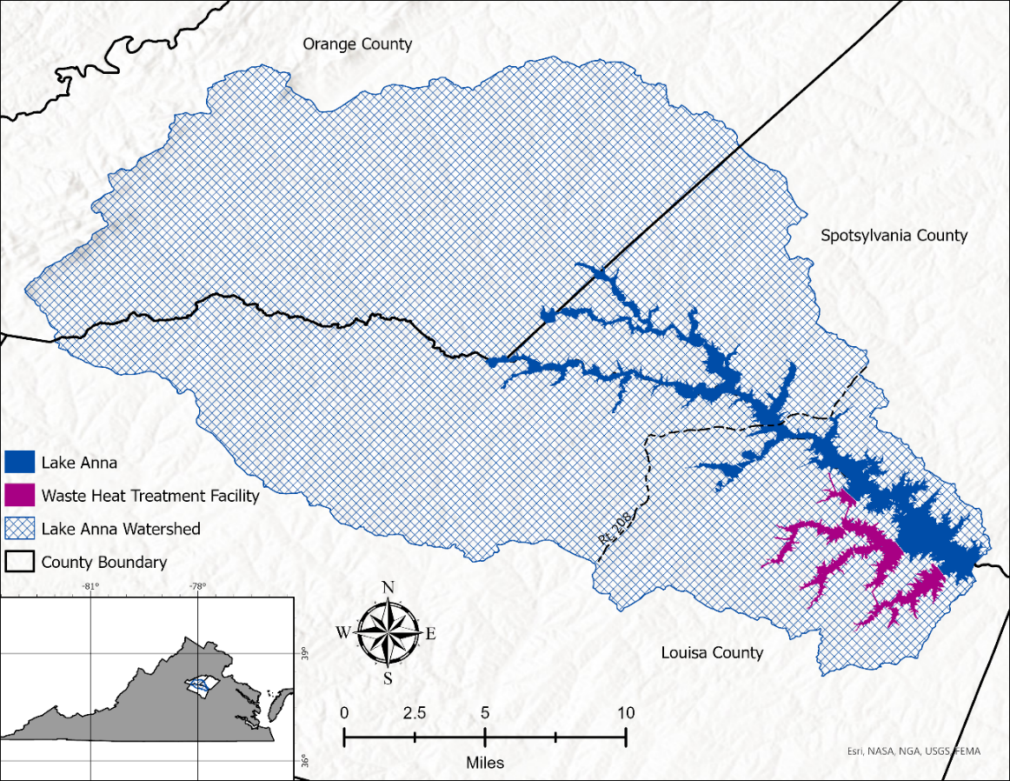
Figure 1. Our study area, including Lake Anna proper and its primary watershed based on a combined HUC 12 classification, as well as the Waste Heat Treatment Facility operated by Dominion Energy.

2.2 Project Partners & Objectives
The Virginia Department of Environmental Quality (DEQ) is responsible for administering laws and regulations on a variety of environmental initiatives, including setting water quality standards and facilitating HABs monitoring statewide (DEQ, 2022a). While the Virginia Department of Health (VDH) is responsible for issuing HAB advisories, the DEQ plays a major role in researching the phenomenon. Therefore, this study should be made easily transferable between relevant agencies including the Virginia Department of Agriculture and Consumer Services (DACS) as this agency along with the DEQ and VDH comprise the state’s HAB workgroup (DEQ 2021).

Due in part to heightened public engagement with HABs, which recently prompted appropriations from the State’s General Assembly, the DEQ has renewed interest in addressing HABs across the state (DEQ, 2022b). The agency has been directed to pay particular attention to Lake Anna due to its recreational value and also likely because of the North Anna Power Station for which the Lake was constructed (DEQ, 2022b). Therefore, through a combination of processed NASA and ESA-derived Earth observing data, along with managed GIS outputs, this study aimed to monitor cyanobacteria and nutrient pollution indicators across Lake Anna and its primary watershed. Prior to this project, the agency relied upon in-house hotspot maps produced using GIS and in situ HAB data collection and did not utilize NASA EO data due to a lack of expertise and capacity. Our team developed map products capturing algal distribution trends, cyanobacteria concentrations and associated timeseries, bloom proxies, and risk factors to enhance the DEQ’s capacity to mobilize in situ monitoring resources and inform decision-making regarding watershed management.

3. Methodology
3.1 Data Acquisition
3.1.1 Cyanobacteria
This project utilized 300m resolution imagery from Sentinel-3's Ocean and Land Colour Instrument (OLCI) Level-2 Water Full Resolution collection to investigate cyanobacterial presence through the detection of associated phycocyanin pigmentation (Table 1). We accessed this dataset through the European Organisation for the Exploitation of Meteorological Satellites (EUMETSAT) Data Store. We selected candidate images based on a visual inspection that looked to provide the clearest skies over our study area. Our group then downloaded one image from every 7-day period beginning July 1st and ending November 3rd from 2016–2022.

3.1.2 Chlorophyll-a, Turbidity, & Surface Temperature
Our team used Google Earth Engine (GEE) to acquire data on chlorophyll, turbidity, and surface temperature. We retrieved ESA’s Sentinel-2 MultiSpectral Instrument (MSI), Level-2A data for a Normalized Difference Chlorophyll Index (NDCI) and Normalized Difference Turbidity Index (NDTI). We used spectral bands ranging from 10m to 20m resolution, in order to better view chlorophyll concentrations and turbidity. Our team acquired Level 2, Collection 2, Tier 1 Surface Temperature (ST) products from Landsat 8’s Thermal Infrared Sensor (TIRS) and Landsat 9 TIRS-2 to examine lake surface temperature at a 30m resolution (Table 1).

3.1.3 In Situ & Ancillary Data
We retrieved three ancillary datasets from the Virginia Open Data Portal: the 2019 Virginia Census Counties & County Equivalents (VCCCE), Lakes/Reservoirs Water Quality Standards (L&R WQS), and 6th Order National Watershed Boundary Dataset (NWBD) HUC 12 Watersheds (HUC12) shapefiles. Additionally, our team acquired the USDA annual Cropland Data Layer for each available year of our study (2016–2022) using the USDA’s CroplandCROS web app. Through these datasets our team was able establish a basic visualization of our study area as well as account for surrounding land use types that may be influencing water quality conditions in Lake Anna. Our team also obtained tabular in situ water quality data directly from the DEQ. This dataset compiled existing sampling records from monitoring sites on Lake Anna and included parameters such as chlorophyll-a, total nitrogen, total phosphorus, pH, temperature, and dissolved oxygen. Additionally, our team gathered historical advisory data from the VDH’s archived press releases regarding HABs within Lake Anna.

Table 1.
Earth observation datasets acquired:
Sensor/Dataset | Parameter | Processing Level | Date(s) | Acquisition Method | Product ID
Sentinel-3 OLCI | Phycocyanin | Level 2 / WFR / Reprocessed | 2016–2020 | EUMETSAT | COPERNICUS / S3 / OLCI / (version BC003)
Sentinel-3 OLCI | Phycocyanin | Level 2 / WFR | 2021–2022 | EUMETSAT | COPERNICUS / S3 / OLCI /
Sentinel-2 MSI | NDCI / NDTI | Level-2A | 2016–2023 | GEE | COPERNICUS/S2_SR_HARMONIZED
Landsat 8 / 9 TIRS / TIRS-2 | Surface Temperature | Tier 1, Level 2 ST | 2016–2023 | GEE | LANDSAT/LC08/CO2/T1_L2 &  LANDSAT/LC09/CO2/T1_L2

Table 2.
Ancillary & in situ datasets acquired:
Dataset | Parameter | Dates | Acquisition Method
2019 VCCCE* /  L&R WQS* /  HUC* | County Boundaries /  Waterbodies /  Watersheds | 2019 /  2020 /  2020 | Virginia Open Data Portal
In situ Sampling | Chlorophyll-a, Phosphorus, Nitrogen | 2016–2022 | Virginia DEQ
USDA Cropland Data Layer | Agricultural Land Use | 2016–2022 | USDA CroplandCROS
* 2019 VCCCE – 2019 Virginia Census Counties & County Equivalents
* L&R WQS – Lakes/Reservoirs WQS
* HUC – 6th Order NWBD HUC 12 Watersheds

3.2 Data Processing
3.2.1 Cyanobacteria
The images we used for cyanobacteria monitoring from Sentinel-3 OLCI, Level-2 Water Full Resolution (WFR) collection and Version BC003 reprocessed collection, had undergone significant third-party pre-processing by EUMETSAT prior to acquisition for this project. As a Level-2 dataset, band data within the images we retrieved had already been converted from their initial radiance values to those of water-leaving reflectance, which had been corrected for atmospheric and sun specular interference (ESA, 2023). We further processed these files in the Sentinel Application Platform (SNAP; version 9.0.0), a software package developed by ESA for the purpose of Earth observation processing and analysis. Within SNAP, we spatially and spectrally subset images to reduce their resulting file size, with the final image containing reflectance bands 7, 8, and 10.

Upon importing processed Sentinel-3 OLCI WFR images from SNAP into GEE, we merged the selected images into monthly groupings (July – October). Our team then aggregated these image collections using a 95th percentile reducer to produce a monthly composite image. Our members processed each reduced monthly composite image, through the CIcyano algorithm as described by Lunetta et al. (2015). Within this equation, the Rayleigh-corrected reflectance (R) values of Sentinel-3 bands 7, 8, and 10 (centered at 620nm, 665nm, and 681nm respectively) were manipulated in a manner that produces an output conditioned to detect spectral signatures synonymous with the absorption peak of phycocyanin.

With these readings, we then differentiated between areas of cyanobacterial presence and advisory level conditions based on the (CIcyano > 0.0001) detection threshold as described by Schaeffer et al., 2022 and (CIcyano > 0.001) representing approximately 100,000 potentially toxigenic (PTOX) cyanobacteria cells/mL as well as the state regulated swimming advisory threshold (VDH, 2021). We processed resulting outputs through a 300m inward buffer from the shoreline of Lake Anna to avoid any land-based contamination associated with Sentinel-3's 300x300m spatial resolution. Considering these contamination constraints, the team decided to only include whole pixels found within the 300m buffer for the final analysis. We then exported the refined rasters into ArcGIS Pro, where a series of final adjustments were made. We converted cell values to integers and reprojected the layers to WGS 1984 Universal Transverse Mercator (UTM) Zone 18N to ensure proper display and aid in area calculation, thus transforming area unit data from degrees to meters. Following this step, we then performed a raster to polygon conversion while retaining multi-part features. Our members separately processed the data associated with areas (km²) of CIcyano values greater than 0.001 and the total area in which cyanobacteria concentrations were detected by utilizing the select by attributes tool to manually separate and export these desired range of values.

3.2.2 Chlorophyll-a
We used Sentinel-2 MSI, Level 2A to conduct a chlorophyll-a analysis of Lake Anna using NDCI (Equation 1). Before we ran this index, our team applied a series of masks in GEE on top of the image collection. First, we applied a cloud mask to improve the quality and clarity of the satellite images by removing pixels impacted by clouds. This was done by using Sentinel-2 MSI metadata property called Cloud Pixel Percentage to keep pixels that contain less than one percent cloud coverage. Lastly, we applied a water index on the images to enhance open water presence. After our team processed the Sentinel-2 MSI image collection, we ran the NDCI by pulling the Red Edge 1 and Red spectral bands from the satellite images and inserted in the formula provided by NASA 2000, as shown below. These bands were used to identify chlorophyll-a concentrations throughout Lake Anna’s parameters. After the NDCI was run, our team merged each recreation season into one dataset.

$NDCI=\frac{\left(Red Edge 1 - Red\right)}{(Red Edge 1 + Red)}$ (1)

3.2.3 Turbidity
Sentinel-2, Level 2A data were also used to calculate turbidity in Lake Anna via NDTI (Equation 2). Turbidity demonstrates areas with potential algal blooms since algal blooms cause higher turbidity in water. To run the NDTI analysis, the same formula used to calculate the NDCI was used to calculate the turbidity levels. However, we pulled Green and Red spectral reflectance bands from the satellite images to measure the turbidity levels. Once the index was run, we merged each of the recreation seasons data layers in GEE to compose one dataset.

$NDTI=\frac{\left(Red - Green\right)}{(Red + Green)}$ (2)

3.2.4 Surface Temperature
The Landsat 8 & 9 ST data products are preprocessed collections created using the single channel algorithm (version 1.3.0) developed jointly by the Rochester Institute of Technology (RIT) and NASA’s Jet Propulsion Laboratory. Our team used GEE to import the Landsat 8-9 ST datasets, filter by the geographic and temporal bounds of our study, apply scaling and temperature conversion factors, cloud-mask, isolate our band of interest (ST_B10), buffer, and clip the imagery to our study area shapefile of the Lake Anna watershed. We retrieved ST data for our full study period, first using Landsat 8 but opting for Landsat 9 once it became available from October 31, 2021, onward. We applied a 100-meter inward buffer to minimize the contamination of retrievals by land pixels. To cloud mask, we developed a bitmask using bits 8-9 (cloud confidence) and 10-11 (cloud shadow confidence) of the QAPIXEL band.

3.2.5 In Situ & Ancillary Data
Our team reformatted and filtered Excel files of in situ data as needed to prepare them for import into ArcGIS Pro and for various statistical analyses. Dependent upon our needs, filters may have focused on a variety of spatial, temporal and or variable based scales. Additionally, we created a suite of shapefiles for which to set data for investigation and to aid in the visualization of such data.

3.3 Data Analysis
3.3.1 Cyanobacteria
Our team assessed cyanobacterial metrics through a variety of visual and statistical approaches. We created time-series maps and associated bar and box-whisker plots of cyanobacteria coverage within ArcGIS Pro and Microsoft Excel, respectively. Following the creation and conglomeration of these monthly composite images, our team overlayed those layers containing values (CIcyano > 0.001) within ArcGIS Pro and, using the count overlapping features tool, created a heat map that spanned the associated 28-month study period. Through this approach we were able to visually assess regions of the Lake that suffered from recurrent bouts of advisory level HAB events. The team employed a Kruskal-Wallis test to compare the change in area occupied by the advisory level and total detected cyanobacterial concentrations over monthly and yearly timespans. We utilized the Kruskal-Wallis test instead of a traditional ANOVA as our data failed to meet the assumption of normality. Following this non-parametric approach, our team also employed a post-hoc Dunn’s test to elucidate multiple comparisons among sample means. Additionally, although our analysis did not ostensibly delve into the statistical analysis of PTOX cell concentrations, resulting values were used as reference and verification points when able.

In an aside, our team briefly tested Wynne’s Cyanobacteria Index against Lunetta’s CIcyano algorithm to compare detection rates among these similar indices. As described in Wynne et al. (2008), the Cyanobacteria Index utilizes Rayleigh-corrected reflectance (R) values of Sentinel-3 bands 8, 10, and 11 (centered at 665nm, 681nm, and 709nm respectively; Equation 3).

$CI=-\left[R\left(681\right)-R\left(665\right)+\left[R\left(709\right)-R\left(665\right)\right]⋅\frac{\left(\left(681-665\right)\right)}{\left(\left(709-665\right)\right)}\right]$ (3)

Our team ran this comparison during the month of October 2017, for which a relatively low amount of cyanobacteria was detected by the CIcyano algorithm. We chose this month to test the efficacy of the Cyanobacteria Index, an equation that has been shown to be vulnerable to generating false positives, thus expanding the number of detections due to the presence of various green algae species (Wynne et al., 2021).

3.3.2 Chlorophyll-a
The mean of the NDCI was taken from the recreation season of the entire study period. Our team looked into the standard deviation of the index values, specifically the 25th, 50th, 75th, and 90th percentiles. The 100th percentile was not included as it was not a good representation of the dispersion of chlorophyll-a concentrations. This is because the 100th percentile is most likely skewed by outside factors, such as land contamination. We lastly exported these layers to ArcGIS Pro to be configured into algal bloom trend maps.

3.3.3 Turbidity
Similar to the chlorophyll-a concentration, the mean of the NDTI was taken from the recreation season of the entire study period. Our team examined the standard deviation of the index values, specifically the 25th, 50th, 75th, and 90th percentiles. Like the NDCI we did not include the 100th percentile as outside factors such as land contamination may skew with the dispersion of turbidity levels. We lastly exported these layers to ArcGIS Pro to be configured into turbidity trend maps.

3.3.4 Surface Temperature
Our team generated several maps using seasonal statistics to visually assess spatiotemporal lake surface temperature trends. We scripted GEE code to derive median and 95th percentile ST values for two sub-annual periods: the recreation season and an abbreviated period from Jun. 1st – Sept. 30th designed to encompass the months during which temperature is likely to have the greatest influence on algal proliferation. We also calculated mean ST, but due to skewing caused by cool temperature outliers, we chose to exclude the output from further analysis. We exported this data from GEE to create ST trends maps for each year of our study in ArcGIS Pro. To conduct a rudimentary validation, we then compared available in situ temperature measurements, taken at no greater than 1m depth, side-by-side with pixel-level ST retrievals for corresponding dates and sample locations.

3.3.5 In situ & Ancillary Data
Our team used in situ data to perform a Kriging analysis in ArcGIS Pro to interpolate the concentration spread of chlorophyll-a, total nitrogen, total phosphorus, and total dissolved oxygen throughout the lake in the 2016–2022 timeframe (Appendix B1). We clipped the interpolated data to the lake boundary shapefile and layered it on top of the USDA Cropland Data Layer to determine primary sources of agriculture feeding excess nutrients into the lake. Additionally, we overlayed a stream map from the Virginia Base Mapping Program (VBMP) to gain a better perspective on which sources were directly and indirectly feeding the lake through runoff.

We investigated the relationship between water quality parameters and localized HAB advisories by using principal component analysis (PCA) to visualize similarity, or lack thereof, between the Middle North Anna and Upper Pamunkey branches of the Lake (Fig. B2). We derived the nomenclature and boundaries of these sections from the VDH’s Algal Bloom Surveillance Map dashboard. During this analysis we used water quality data from two DEQ monitoring stations, recorded at a depth of 0.3 meters from the months of June to October of 2019–2022. Components investigated included total nitrogen (mg/L), total phosphorous (mg/L), temperature (°C), pH and the presence or absence of an advisory. To overcome the incorporation of binary advisory data within the PCA, presence was coded as 1 and absence coded as –1. This operation was performed in RStudio Desktop (version 2023.06.1+524) using the FactoMineR and Factoextra packages (Husson et al., 2008; Kassambara & Mundt, 2020).

Additionally, our team also combined in situ and geospatial data by launching cursory explorations into nutrient contributions from across the Lake Anna watershed and trophic conditions within the Lake itself. Incorporating row crop export coefficients adapted from Lin (2004), our team detailed nitrogen and phosphorous loading amounts across the 10 individual sub-watersheds (Hydrologic Unit Code 12) that flow into Lake Anna. For these purposes we included corn, soybeans, cotton, and tobacco as row crops, as described by Klopfer (2001). We then visualized the resulting phosphorous loading dataset using ArcGIS Pro to gain a quick understanding of which watersheds are the greatest contributors to what is considered to be one of the Lakes’ primary limiting factors (Schnieder, 2020). It’s important to note that when we performed this analysis, it only incorporated cropland data from 2021, as to align with portions of this project which proceeded this investigation. Near the conclusion of this project, we also performed a brief scoping into the trophic state of the more lacustrine, southern half of the Lake. Due to severe data restrictions, this investigation consisted of readings from two sensors located in the southern basin during the months of June to October of 2018. Lacking secchi disk readings, we could not perform a traditional Trophic State Index (TSI) and instead followed a modified TSI as defined by the Florida Department of Environmental Protection (Paulic et al., 1996; Equation 4). The TSI acts as a rapid water quality classification assessment in which researchers gauge the potential biological productivity of a lake or reservoir by measuring its total nitrogen, phosphorous, and chlorophyll-a amounts (Paulic et al., 1996). It is important to note that the values inserted into the following equations were the averages of recordings during the June–October 2018 time period. The final TSI equation is formatted by first running three formulas related to component parameters (Table D1). Our team calculated the TSI value associated with phosphorous concentration for a phosphorous-limited waterbody. We used the phosphorous limited equation as the total nitrogen to total phosphorous ratio was greater than 30, a threshold described by Paulic et al. (1996). The final comprehensive TSI formula we employed was also specific to phosphorous-limited lakes and was formatted as follows, utilizing the previously produced component values.

$TSI=\left[TSI\left(chla\right)+TSI2\left(TP\right)\right]/2$ (4)

Producing a singular and rather temporally limited output, we decided that the primary purpose of this examination was to act as an additional verification technique to supplement our Sentinel-3 cyanobacteria analysis.

3.3.6 ACOLITE
Our team used ACOLITE, a software which processes raw satellite imagery, to derive a Floating Algal Index in turbid waters for October 18, 2018. The team processed Sentinel-2 data to emphasize algal mats floating on the lake. First, we inserted the directory file for Sentinel-2 data downloaded from ESA’s website and configured the polygon to a GeoJSON file of the Lake Anna shapefile (Appendix A1). We then set the L2W parameters to fit the floating algal index in turbid waters (FAIT) algorithm, which gives a clear picture of what areas in the lake are populated with algal blooms. The processor makes use of the strong NIR signal to avoid the misclassification of green pixels (Dogliotti, 2018).

$$FAIT=FAI>0, R_{rc}\left(Red\right)<0.08 and a* <threshold$$

4. Results & Discussion
4.1 Analysis of Results
4.1.1 Cyanobacteria
Our analysis revealed that the average area (km²) did not differ for advisory level detections between years, (H₍₆₎ = 2.78, p = 0.84). Similarly, the average area (km²) for total cyanobacteria detection also did not significantly differ between years (H₍₆₎ = 2.47, p = 0.87). However, our analysis did find that there was a significant difference between the average area occupied by advisory level detections between months (H₍₃₎ = 11.99, p = 0.01). This significant difference between months also applied to the total detection area (H₍₃₎ = 9.01, p = 0.03). Under both conditions, advisory and total area, we discovered the months of August and September harbored significantly higher mean values than October (p < 0.05; Figures D2 & D3). This latest finding allowed us to reveal a significant drop in cyanobacterial presence during the month of October compared to its two predecessors. The hot-spot analysis we performed on the advisory level data indicated that approximately 1.20 km² out of our 1.95 km² study region fell within the ‘high occurrence’ category, meaning that cyanobacteria concentrations in this zone were at or above the 100,000 PTOX cells/mL for 8–12 months out of the 28-month study period (Figure 2). We found that an additional 0.67 (km²) fell within the ‘medium occurrence' category, indicating that advisory level concentrations were present for 5–7 months of the study period. Finally, we found that only a single pixel measuring roughly 0.08 km² fell into the ‘low occurrence’ category, meaning that advisory level conditions were found for only 4 months during the study period. Additionally, we found that the greatest spatial coverage of cyanobacterial presence occurred during August of 2018, when the entire 1.95 km² study area was shown to be impacted (Figure C1). The highest recorded cell density we recorded during this study was roughly 900,000 PTOX cells/mL in October of 2018. We noted that this finding coincided temporally with the lake’s highest ever directly recorded PTOX value of about 10,800,000 cells/mL in nearby Fisherman’s Cove during the same month (Bonk, 2018).

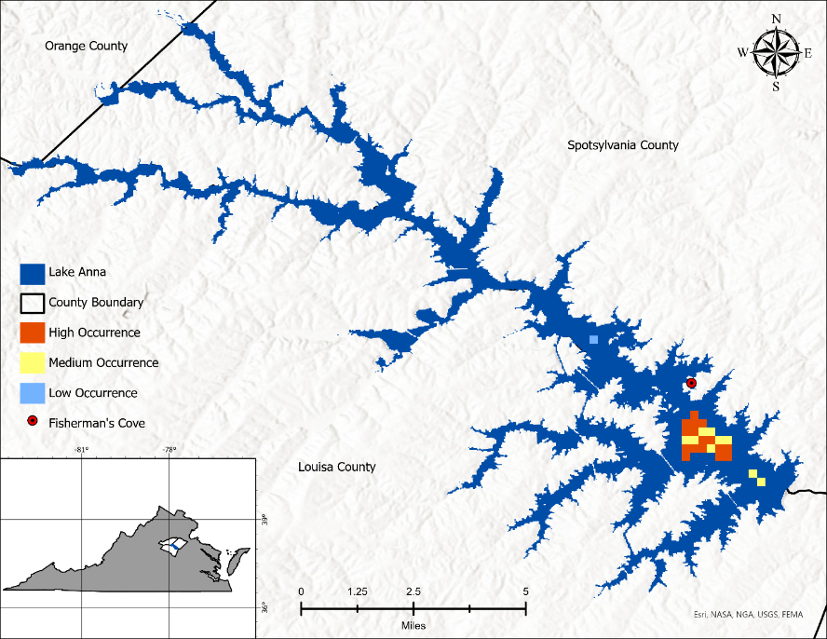
Figure 2. CIcyano heat-map featuring those full pixels within the 300m shoreline buffer. Identifying those areas experiencing over 100,000 PTOX cells/mL during the 28-month study period. High Occurrence = 8–12 months / Medium Occurrence = 5–7 months / Low Occurrence = 4 months

Regarding our brief comparison of the Cyanobacteria Index and CIcyano algorithm, it was found that the two mechanisms respond quite differently to the same conditions. In the case of CIcyano we found that in October of 2017 approximately 0.15 km² were found to be above the 100,000 PTOX cells/mL advisory threshold and an additional 0.08 km² fell within the detection limit of 10,000 PTOX cells/mL. However, we found that the Cyanobacteria Index returned an approximate area of 0.30 km² for which supposed cyanobacteria exceeded the state advisory limit and an additional 1.35 km² for which the detection threshold was reached. We attributed this discrepancy to past documentation of the Cyanobacteria Index's tendency to produce false positives when detecting mixed masses eukaryotic algae, not necessarily indicative of cyanobacterial presence (Wynne et al. 2021). We briefly attempted to verify our belief on this matter by applying these indices to NOAA reported HABs that occurred within the western basin of Lake Erie and visually comparing the outputs to those created as part of external research efforts. Although limited, we found that the indices appeared to be performing correctly within these verification events.

4.1.2 Chlorophyll-a & Turbidity
As mentioned in the data analysis section, our team used the ratio of two spectral bands to calculate the NDCI and NDTI of Lake Anna. Because both indices are a ratio, the quotient values are unitless and fall within the 1 to –1 range. As shown in Figure A2, the tips of the more northern tributaries have high chlorophyll-a concentrations as well as increased turbidity. Increased turbidity was seen in the southern half of Lake Anna, but lower turbidity was detected in the middle to upper tributaries. Increased chlorophyll-a concentrations were also seen along the edges of the entire lake. Comparing the NDCI in (Fig. A2) to the kriging analysis of the DEQ in situ data in (Fig. B1), show relatively the same concentration patterns. Our team expected to see the chlorophyll-a concentrations to have a positive correlation with the turbidity of the water. However, we noticed that they were instead opposite of one another. This result was unexpected because of the increased HAB advisories that have been issued in the upper tributaries.

After our team completed the NDCI and NDTI analyses in GEE, we discovered that there were various factors that were interfering with the validity of our results. Objects such as boats, docks, bridges, or even wakes can obstruct satellite imaging. Docks appeared as the highest chlorophyll concentrations as well as the most turbid. Light colored bridges appeared at lower chlorophyll concentrations, but high turbidity. In the more shallow, clear areas along the edges of Lake Anna, bottom reflectance could potentially play a factor contributing to the high concentration readings.

4.1.3 Surface Temperature
Visual inspection of spatiotemporal trends in surface temperature throughout Lake Anna appeared to show consistently higher temperatures in two regions year-to-year: the lake’s southern basin and northern (Pamunkey and North Anna) branches. Median temperatures for June through September throughout the waterbody consistently mapped above 25°C, but especially so in these regions. This temperature range indicates an overall lake environment which would give cyanobacteria a competitive edge over green algae (Ministry of Environment, 2022). Higher temperatures in the northern branches are consistent with the area’s known susceptibility to HABs, as confirmed by the issuance of HAB advisories there. It is noteworthy that this region of Lake Anna is generally shallower and easily warmed by solar radiation. It is also a region where our study saw high indications of other HABs indicators and risk factors. In the southern region of the waterbody, the WHTF was frequently visually distinct from the rest of the reservoir (Fig. E1); median surface temperatures in the cooling lagoons regularly reached into the upper 30s and 40s Celsius. The reservoir waters adjacent to the WHTF, especially at the water discharge location, reached more moderate yet still elevated values (upper 20s, low 30s Celsius). Sparse in situ and HAB event records for this region limited our ability to compare temperature trends with algal growth or bloom risk factors across this region. Similar to Sentinel-3's chlorophyll-a and turbidity retrievals, several anomalous high temperature readings were returned over locations on the lake where boat docks, bridges, and other man-made structures were present. Future work would benefit from masking or otherwise removing values retrieved at these locations from the analysis as a whole.

4.1.4 In situ & Ancillary Data
The principal component analysis we completed revealed that the Middle North Anna Branch and Upper Pamunkey Branch of Lake Anna did not operate as a cohesive unit. For example, we noted that advisories were most closely correlated to pH in the Middle North Anna branch (Figure D4) while advisories were more traditionally correlated with levels of nitrogen and phosphorous in the Upper Pamunkey branch (Figure D5). It is believed that these results may indicate the possibility of variable limiting factors impacting the formation of HABs across the Lake. Within both branches of the lake, we found that the first two principal components accounted for over 60% of the variability in the data. We believe it likely that pH may be representing one of the first two axis at both locations, with temperature accounting for the second in Pamunkey and either nitrogen or phosphorous accounting for the second in North Anna. We also noted considerable data range overlap during all 4 of our sample years, at both locations individually (Figure D6 & D7).

Through our team’s estimation of annual nutrient loads per hectare of row crops per HUC 12, we identified the Clear Creek and Terry’s Run sub-watersheds as being the leading nutrient contributors. Based on Lin’s 2004 export coefficient for row crops, we estimated that these two sub-watersheds contributed a combined 7,003 kg of phosphorus and 25,261 kg of nitrogen annually to the Lake (Fig. B3). We found that these two sub-watersheds harbored roughly 15.27 km² of row crop farmland, and loaded nutrients into what are generally the most HAB afflicted portions of the Lake. While these results were most pertinent to the upper reaches of Lake Anna, our TSI analysis focused on the southern half of the Lake, more closely aligning with our CIcyano area of interest. For the TSI sampling season of 2018 we recorded a value of 47.96, thus placing the southern basin within a range that is described as accommodating sufficient nutrients, fairly high productivity, and the ability to support an abundance of algae (Paulic et al., 1996). We believe that this apt description of the southern half of the lake lends further credence to the EO outputs discussed earlier in this report.

4.2 Feasibility Assessment
While we were able to detect cyanobacterial presence within Lake Anna, the spatial resolution afforded by Sentinel-3's OLCI was incompatible with much of the waterways’ relatively narrow surface area. We feel that the issue of spatial resolution is particularly pressing when one considers the importance of detecting cyanobacteria in nearshore areas that are frequently used for recreation. Regardless, data retrieved from this platform may still prove useful in those areas lacking adequate monitoring programs. While confident in our detections, the shortage of verifiable HAB reports across the southern half of Lake Anna leaves room for uncertainty. Most of the analyses we performed in this study were highly dependent upon the availability of data for any given waterway. For our purposes, many of the datasets we utilized often lacked comprehensive recordings in terms of spatial, temporal, or variable coverage. Despite these possible shortcomings, our explorations into the geospatial relationships among in situ datasets proved to be an opportunity for verification of EO data. By visually linking these findings we are able to highlight the importance of incorporating both in situ and remotely sensed data for water resource management.

4.3 Future Work
4.3.1 Cyanobacteria
Following our team's research, we believe there are further resolution, modeling, validation, and EO methods to integrate into the Virginia DEQs HAB monitoring procedures. Developing a cyanobacteria detection workflow that affords improved spatial resolution, one limiting factor in our work, would be a major step toward fully implementing these procedures within inland lakes and other coastal areas. As we touched upon earlier, a combined EO and in situ approach toward water resource management is likely to lead to more comprehensive outcomes than a singular metric. To accomplish this, however, a battery of verification will be required across various settings to fully flush out any inadequacies and or inconsistencies present in any given index. Another important aspect of future work is the transformation of unitless metrics into standardized measures that can be applied equally across multiple waterbodies.

4.3.2 In situ
The DEQ provided sufficient data on a variety of nutrients and other parameters contaminating the lake such as nitrogen, phosphorus, and pH. Additional in situ water quality parameters that would be beneficial in developing a more well-rounded interpretation of Lake Anna’s water quality and HABs are total suspended solids (TSS) and alkalinity. TSS could tell us more about the water’s clarity and can be compared to the NDTI analysis run in GEE to see if the EO maps align with in situ data. Looking further into geochemistry, like alkalinity, could reveal where some sources of runoff are coming from and whether it affects the risk factors of HABs.

4.3.3 Modeling
Our study provided a cursory look at the relative row crop contribution of each HUC 12 watershed to Lake Anna’s nutrient load. Watershed model-building, using software such as the Soil and Water Assessment Tool (SWAT), would provide the DEQ with more nuanced insight into best watershed management practices moving forward. Sophisticated modeling tools incorporating various land use and crop types, precipitation data, and hydrologic soil data at the sub-watershed level could provide valuable insight into possible sources of nutrient loading and contamination and how these variables may impact HABs in Lake Anna.

4.3.4 Validation: USGS Continuous Monitoring
Future use of EOs in HABs monitoring at Lake Anna would benefit from more robust validation with in situ data. For example, the DEQ could choose to coordinate future sampling efforts with EO-derived monitoring efforts. Additionally, the USGS has begun installing continuous monitoring stations in four sites throughout Lake Anna. These stations are collecting a wide range of water quality parameters, including fluorescence, conductivity, pH, nitrate, and phosphorous, every 15 minutes—data which could be invaluable for comparison with EOs for HAB indicators and risk factors.

4.3.5 PACE
As early as January of 2024, NASA will be launching their Plankton, Aerosol, Cloud, ocean Ecosystem Ocean Color Instrument (PACE OCI) satellite. PACE OCI will be an advanced hyperspectral instrument, meaning it will retrieve data over a broad spectral range: 350 to 885nm wavelengths at 5nm intervals. This means PACE OCI will have the ability to differentiate between various types of phytoplankton as well as characterizing it as either harmful or helpful (NASA, 2023). These satellite images could be used to better detect water bodies impacted by HABs.

5. Conclusions
Our results demonstrated that EOs may be more suited to detecting risk factors associated with HABs than cyanobacteria itself, especially within spatially restricted waterbodies. While the procedures for directly sensing cyanobacteria that we used in this paper proved capable, their resolution is not at the level required to account for the more critical regions along the Lake Anna shoreline. We noted that where EO are successful is in their long-standing ability to detect ecological phenomenon in regions that are otherwise subject to a lack of direct monitoring. Additionally, with continued refinement, the use of EO will only serve to further our understanding of the complex natural environment and humanity's role in shaping it. Through these possibilities our partners and the community as a whole will be able to gain a greater understanding of the issues facing them and thus how to best combat these issues. When used in concert with existing in situ datasets, NASA Earth observations enable water resource managers to incorporate data that may otherwise have gone overlooked, citizens a chance to visualize conditions manifesting in their local community, public health officials the ability to steer these citizens away from harm, and decision makers the opportunity to communicate objective findings to their constituents.

6. Acknowledgements
Virginia Department of Environmental Quality (DEQ)
- Dr. Tish Robertson (Monitoring and Assessment Scientist)
- Amanda Shaver (Water Quality Assessment Team Leader)
- Bryant Thomas (Office of Ecology Manager)
NASA DEVELOP
- Dr. Kenton Ross (Science Advisor)
- Olivia Landry (Fellow)
- Robert Cecil Byles (Senior Fellow)
- Laramie Plott (Fellow)

This material contains modified Copernicus Sentinel data (2016-2023), processed by ESA.
Any opinions, findings, and conclusions or recommendations expressed in this material are those of the author(s) and do not necessarily reflect the views of the National Aeronautics and Space Administration.
This material is based upon work supported by NASA through contract NNL16AA05C.

7. Glossary
ACOLITE – A software used for atmospheric correction and processing for coastal and inland water applications.
API – Application programming interface: a way for two or more computer programs to communicate with each other
CIcyano – A spectral index developed by Lunetta et al. (2015), to aid in the remote detection of harmful algal blooms, conditioned to detect spectral signatures synonymous with the absorption peak of phycocyanin.
DEQ – Department of Environmental Quality: a department that administers both state and federal laws and regulations in regard to air quality, water quality, water and land protection.
Earth observations – Satellites and sensors that collect information about the Earth’s physical, chemical, and biological systems over space and time.
Export Coefficient – A prediction model for the total annual load of nutrients (N/P) that may be delivered to a given waterway from its catchment. Generally applied to a specific land use within a region.
FAIT – Floating Algal Index in Turbid waters. An algorithm that measures algal mats on the surface of water.
GEE – Google Earth Engine is a cloud-based geospatial analysis platform that allows users to analyze satellite images.
Harmful Algal Blooms (HABs) – The rapid growth of algae or cyanobacteria that could harm animals, people, and local ecology.
In situ (sampling / data) – Data recorded in location, generally using hand-held or structural apparatus, requiring direct contact with the subject of study.
Kriging Analysis – A geostatistical technique used for spatial interpolation and prediction. It considers the spatial correlation between data points and provides an accurate prediction of its spread.
Landsat – A series of artificial satellites that use different wavelengths to monitor the Earth’s resources.
NDCI – Normalized Difference Chlorophyll Index. An algorithm used to calculate chlorophyll concentrations by finding the ratio between red and red-edge bands.
NDTI – Normalized Difference Turbidity Index. An algorithm used to estimate spectral reflectance values of water pixels to estimate turbidity.
OLI / OLI-2 – Operational Land Imager. A pushbroom sensor, or along-track, sensor that operates in the visible and short wave infrared spectral regions. Housed on NASA’s Landsat 8 & 9 satellites.
PACE – Plankton, Aerosols, Cloud, ocean Ecosystem. A NASA satellite mission providing hyperspectral data on global ocean color, ecology, biogeochemistry, clouds, and aerosols. Launch date anticipated as soon as Jan. 2024.
Phycocyanin – The blue-green pigment associated with many freshwater cyanobacteria species. Plays an important role in photosynthesis and subsequent detection by Earth observing platforms.
Rayleigh-corrected reflectance – A common method of atmospheric correction that attempts to transform initial radiance values by accounting for various forms of light scattering, absorption, and reflection.
SNAP – Sentinel Application Platform. An interface that allows for the viewing and processing of different remote sensing applications.
Turbidity – Water clarity, as measured in the amount of light scattered by suspended material.
VDH – Virginia Department of Health: a department that oversees public health throughout the Commonwealth of Virginia.
WHTF – Waste Heat Treatment Facility. A 3,400-acre region, representing the southwestern portion of Lake Anna, which acts as a set of cooling lagoons for water discharged from the North Anna Power Station.

8. References
Berg, M. & Sutula, M. (2015). Factors affecting the growth of cyanobacteria with special emphasis on the Sacramento-San Joaquin Delta. Southern California Coastal Water Research Project Technical Report 869. https://www.waterboards.ca.gov/waterrights/water_issues/programs/bay_delta/california_waterfix/exhibits/docs/RestoretheDelta/RTD_236.pdf

Bonk, V. (2018). Harmful algae bloom prompts ‘no swimming advisories’ for Virginia’s Lake Anna. WTOP News, Virginia News, Chevy Chase, MD. https://wtop.com/virginia/2018/10/harmful-algae-bloom-prompts-no-swimming-advisories-for-virginias-lake-anna/

DEQ. (2021). Harmful Algal Blooms in Virginia (RD 411). Department of Environmental Quality, Appropriation Act - Item 377 P. (Special Session I, 2021).

DEQ. (2022a). About Us. https://www.deq.virginia.gov/get-involved/about-us

DEQ. (2022b). Harmful Algal Blooms. https://www.deq.virginia.gov/topics-of-interest/harmful-algal-blooms/

Dogliotti, A., Gossn, J., Vanhellemont, Q., & Ruddick, K. (2018). Detecting and quantifying a massive invasion of floating aquatic plants in the Río de la Plata turbid waters using high spatial resolution ocean color imagery. Remote Sensing, 10(7), 1140. https://doi.org/10.3390/rs10071140

European Space Agency (ESA). (2016). Sentinel-2 MSI: Multispectral Instrument [Dataset]. Earth Engine Data Catalog/USGS. Retrieved June 2023, from https://doi.org/10.5270/S2_-6eb6imz

ESA. (2023). Level-2 Water WRR and WFR. The European Space Agency, Sentinel Online, User Guides. Retrieved July 2023 from https://sentinels.copernicus.eu/web/sentinel/user-guides/sentinel-3-olci/product-types/level-2-water

ESA. (2023). Sentinel-3 OLCI User Guide. European Space Agency, Sentinel Online. Retrieved June 2023 from https://sentinel.esa.int/web/sentinel/user-guides/sentinel-3-olci

EUMETSAT (2022). Sentinel-3, OLCI Level 2 Ocean Colour Full Resolution, European Organisation for the Exploitation of Meteorological Satellites [Dataset]. EUMETSAT Data Store. Retrieved June 2023 from http://www.eumetsat.int

EUMETSAT (2022). Sentinel-3, OLCI Level 2 Ocean Colour Full Resolution (Version BC003)-Reprocessed, European Organisation for the Exploitation of Meteorological Satellites [Dataset]. EUMETSAT Data Store. Retrieved June 2023 from http://doi.org/10.15770/EUM_SEC_CLM_0061

Gibala-Smith, L.A. (2018). 2018 Virginia Freshwater Bloom Overview. Old Dominion University, Phytoplankton Analysis Laboratory, Norfolk, VA.

Heil, C. & Muni-Morgan, A. (2021). Florida’s harmful algal bloom (HAB) problem: Escalating risks to human, environmental and economic health with climate change. Frontiers in Ecology and Evolution, 9, 646080. https://doi.org/10.3389/fevo.2021.646080

Husson, F., Lê, S. & Josse, J. (2008). FactoMineR: An R package for multivariate analysis. Journal of Statistical Software, 25(1), 1–18. https://doi.org/10.18637/jss.v025.i01.2023

Kassambara, A. & Mundt, F. (2020). factoextra: Extract and Visualize the Results of Multivariate Data Analyses. General Public License, http://www.sthda.com/english/rpkgs/factoextra

Klopfer, S. (2001). Virginia Gap Analysis Project. Virginia Department of Game and Inland Fisheries, Virginia Tech Conservation Management Institute, GIS Division, Blacksburg, VA. https://services.dwr.virginia.gov/fwis/help/gap/mapkey.htm

Lin, J. (2004). Review of Published Export Coefficient and Event Mean Concentration (EMC) Data. US Army Corps of Engineers, Wetlands Regulatory Assistance Program, Technical Report ERDC TN-WRAP-04-3.

Lunetta, R.., Schaeffer, B., Stumpf, R., Keith, D., Jacobs, S., & Murphy, M. (2015). Evaluation of cyanobacteria cell count detection derived from MERIS imagery across the eastern USA. Remote Sensing of Environment, 157, 24-34. https://doi.org/10.1016/j.rse.2014.06.008

Magnini, V. (2020). Virginia State Parks Economic Impact Report 2019. Virginia Tech, Pamplin College of Business, Blacksburg, VA. https://www.dcr.virginia.gov/state-parks/document/virginia-state-parks-2019-economic-impact-study.pdf

Mahrad, B. E., Newton, A., Icely, J. D., Kacimi, I., Abalansa, S., & Snoussi, M. (2020). Contribution of remote sensing technologies to a holistic coastal and marine environmental management framework: a review. Remote Sensing, 12(14), 2313 https://doi.org/10.3390/rs12142313

Ministry of Environment and Climate Change Strategy. (2022a, June 13). What causes an algae bloom?. Province of British Columbia. https://www2.gov.bc.ca/gov/content/environment/air-land-water/water/water-quality/algae-watch/what-are-algae/causes-of-an-algae-bloom

Misra, A., Chandra, P., & Raghavendra, V. (2011). Modeling the depletion of dissolved oxygen in a lake due to algal bloom: Effect of time delay. Advances in Water Resources, 34, 1232-1238. https://doi.org/10.1016/j.advwatres.2011.05.010

NASA. (2000). Measuring vegetation (NDVI & EVI). NASA Earth Observatory, Goddard Space Flight Center. https://earthobservatory.nasa.gov/features/MeasuringVegetation/measuring_vegetation_2.php

NASA. (2023). Get to know PACE. NASA, Ocean Science Division. https://pace.oceansciences.org/about.htm

Paulic, M., Hand, J., & Lord, L. (1996). 1996 Water-Quality Assessment for the State of Florida (Section 305 (B) Main Report). Florida Department of Environmental Protection, Bureau of Water Resources Protection, Division of Water Facilites. http://www.hillsborough.wateratlas.usf.edu/upload/documents/1996%20Water-Quality%20Assessment%20for%20the%20State%20of%20Florida%20Section%20305(b)%20Main%20Report.pdf

Refsnider, J., Garcia, J., Holliker, B., Hulbert, A., Nunez, A., & Streby, H. (2021). Effects of harmful algal blooms on stress levels and immune functioning in wetland-associated songbirds and reptiles. Science of the Total Environment, 788, 147790.

Schaeffer, B. A., Urquhart, E., Coffer, M., Salls, W., Stumpf, R. P., Loftin, K. A., & Werdell, P. J. (2022). Satellites quantify the spatial extent of cyanobacterial blooms across the United States at multiple scales. Ecological Indicators, 140, 108990. https://doi.org/10.1016/j.ecolind.2022.108990

Schnieder, J. (2020). Guidance Memo No. 09-2005: Monitoring of Lakes and Reservoirs. Virginia Department of Environmental Quality, Water Planning Division. https://townhall.virginia.gov/l/GetFile.cfm?File=C:%5CTownHall%5Cdocroot%5CGuidanceDocs%5C440%5CGDoc_DEQ_3959_v3.pdf

Thrasher, T. (2023). Emergency sirens to be replaced by cell phone alerts for ‘unlikely’ events at North Anna Power Station in Louisa County. ABC 8 News, Richmond, Va. https://www.wric.com/news/virginia-news/emergency-sirens-to-be-replaced-by-cell-phone-alerts-for-unlikely-events-at-north-anna-power-station-in-louisa-county/

US Census Bureau (2019). TIGER/Line Shapefiles 2019. Virginia Open Data Portal, 2019 Virginia Census Counties & County Equivalents [Dataset]. Retrieved June 2023, from https://data.virginia.gov/Government/2019-Virginia-Census-Counties-County-Equivalents/rgvv-r79s

US Geological Survey (USGS) (2016). Landsat 8 Operational Land Imager (OLI) Level 2, Collection 2, Tier 1 Surface Reflectance [Dataset]. Earth Engine Data Catalog/USGS. Retrieved June 2023. https://doi.org/10.5066/P9OGBGM6

US Geological Survey (USGS) (2021). Landsat 8 Operational Land Imager (OLI) Level 2, Collection 2, Tier 1 Surface Temperature [Dataset]. Earth Engine Data Catalog/USGS. Retrieved June 2023. https://doi.org/10.5066/P9OGBGM6

Virginia Department of Health. (2021, Aug. 5). Guidance for Cyanobacteria Bloom Recreational Advisory Management. Virginia Department of Health, Office of Environmental Health Services, Richmond, VA. https://www.vdh.virginia.gov/content/uploads/sites/178/2022/01/FINAL_SIGNED_ Guidance_for_Cyanobacteria_Recreational_Advisory_Mgt.5Aug2021-1.pdf

Virginia Department of Conservation and Recreation (2020). 6th Order NWBD HUC 12 Watersheds [Dataset]. Virginia Open Data Portal. Retrieved June 2023, from https://data.virginia.gov/Government/6th-Order-NWBD-HUC-12-Watersheds/s9fk-xwfb

Virginia Department of Environmental Quality (2020). Lakes/Reservoirs WQS [Dataset]. Virginia Open Data Portal. Retrieved June 2023, from https://data.virginia.gov/Environment-Natural-Resources/Lakes-Reservoirs-WQS/jkr5-zz47

Weng, Q. (2001). Modeling urban growth effects on surface runoff with the integration of remote sensing and GIS. Environmental Management, 28, 737-748. https://doi.org/10.1007/s002670010258

Wolf, D. and Klaiber, H. (2017). Bloom and bust: Toxic algae's impact on nearby property values. Ecological Economics, 135, 209-221. https://doi.org/10.1016/j.ecolecon.2016.12.007

Wynne, T., Stumpf, R., Tomlinson, M., R. A. Warner, Tester, Dyble, P. & Fahnenstiel, G. (2008). Relating spectral shape to cyanobacterial blooms in the Laurentian Great Lakes. International Journal of Remote Sensing, 29, 3665-3672. https://doi.org/10.1080/01431160802007640

Wynne, T., Meredith, A., Briggs, T., and Litaker, W. (2021). Harmful Algal Bloom Forecasting Branch Ocean Color Satellite Imagery Processing Guidelines. NOAA Technical Memorandum NOS NCCOS 296 48 pp. https://doi.org/10.25923/606t-m243

9. Appendices
Appendix A – Lake Anna Normalized Difference Indices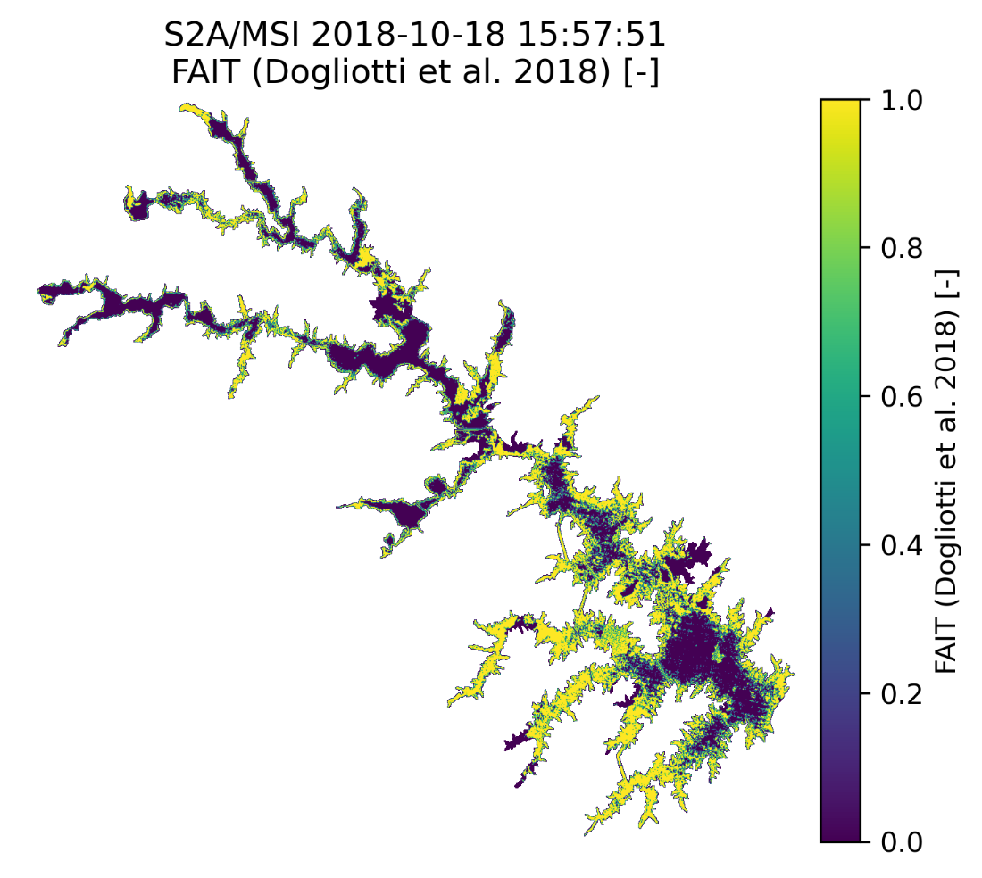
Figure A1. Floating Algal Index in Turbid Waters (FAIT) on Lake Anna
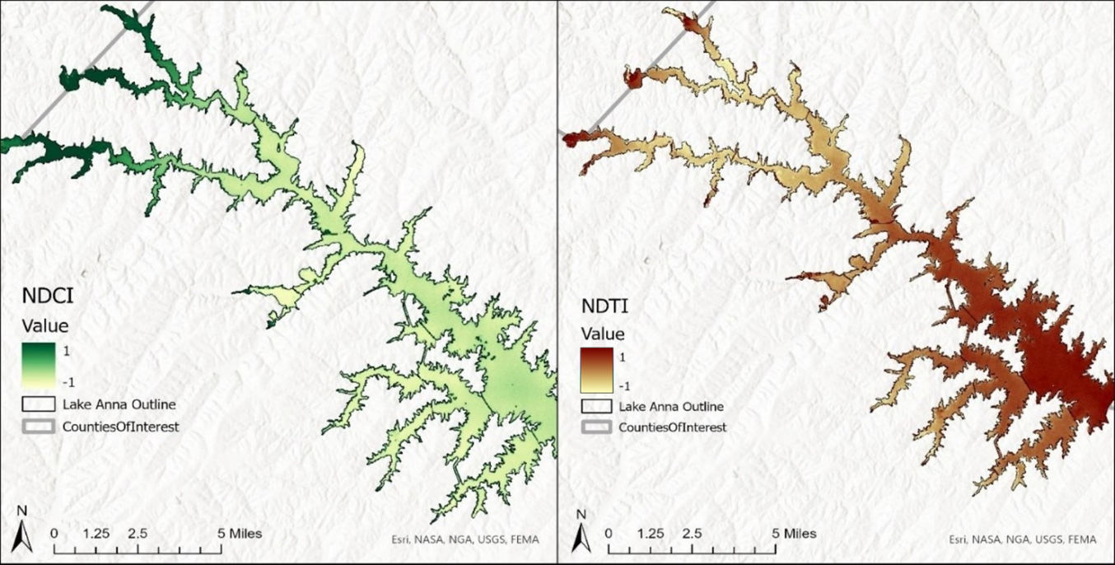
Figure A2. NDCI (left) and NDTI (right) analyses of Lake Anna from 2016–2022 produced using GEE to identify chlorophyll concentration and turbidity levels.
Appendix B – In situ & Ancillary data
Figure B1. Kriging analysis of Lake Anna for 2016–2022 average using in situ data collected by DEQ, showing the spatial spread of chlorophyll-a (μg/L).

Figure B2. Locations of localized PCA analysis colored in orange. The Upper Pamunkey branch being directly to the north of the Middle North Anna branch.

Figure B3. HUC 12 nutrient loading analysis, colorized based on relative annual phosphorous contributions to Lake Anna. Clear Creek and Terry’s Run sub-watersheds highlighted in red, Clear Creek located directly west of Terry’s Run.

Appendix C – Cyanobacteria
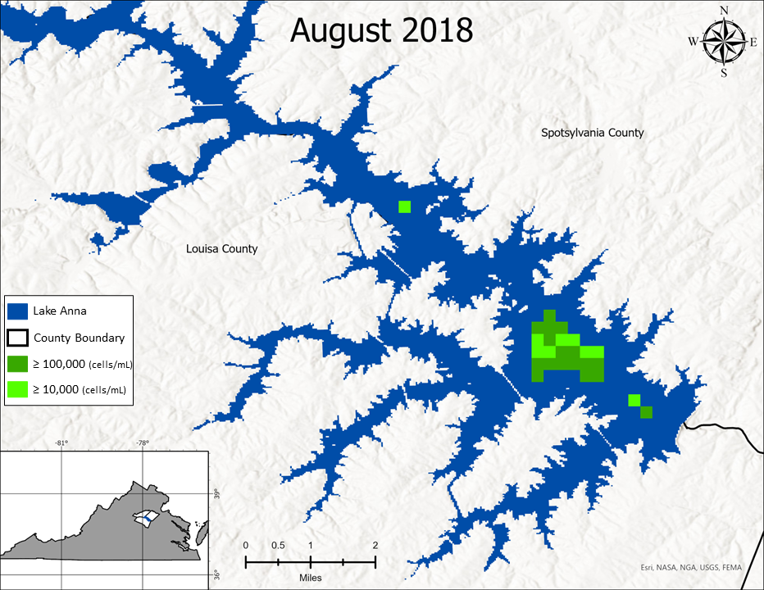
Figure C1. Cyanobacteria concentration map, for the composite image of August 2018, representing the peak spatial detection period during our study.

Appendix D – Tables, Charts, & Graphs

Table D1. Component TSI equations
TSI Component | Component Equation
Chlorophyll-a | $$TSI\left(chla\right)=16.8+\left[14.4×\ln\left(chla\right)\right]$$
Nitrogen | $$TSI\left(TN\right)=56+19.8×\ln\left(TN\right)$$
Phosphorous (for phosphorous limited lakes) | $$TSI2\left(TP\right)=10×\left[2.36×\ln\left(TP×1000\right)-2.38\right]$$
Table D1. Component TSI equations

Figure D2. Box and whisker plot associated with the average area (km²) occupied by advisory level cyanobacteria concentrations, by month, during our 28-month study period.

Figure D3. Box and whisker plot associated with the average area (km²) occupied by total (advisory and detection level) cyanobacteria concentrations, by month, during our 28-month study period.

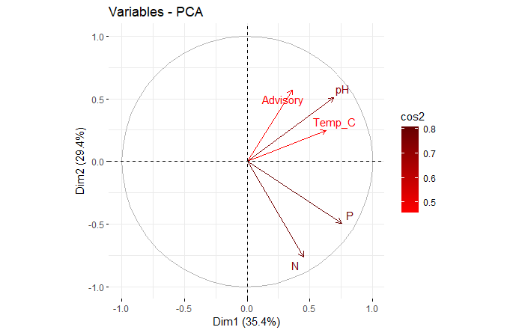
Figure D4. PCA loading plot for the Middle North Anna branch, representing total nitrogen (N), total phosphorous (P), temperature (Temp_C), pH (pH), and HAB swimming advisory data (Advisory).
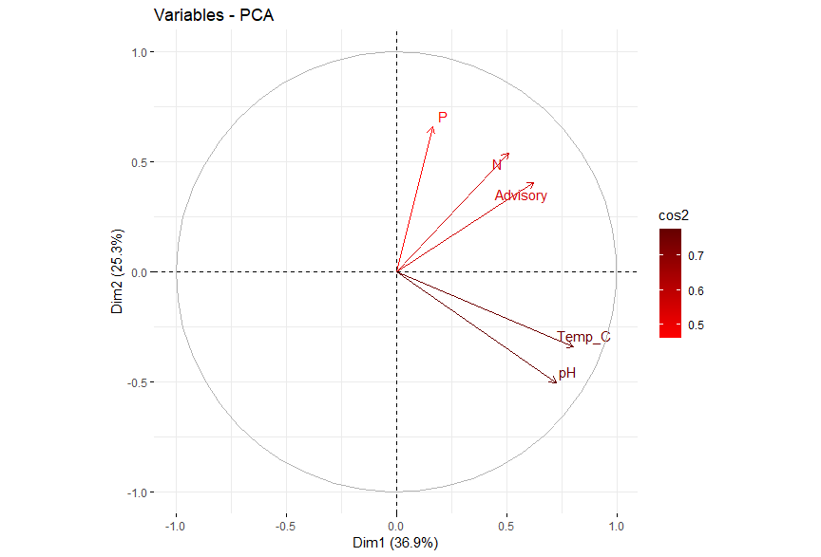
Figure D5. PCA loading plot for the Upper Pamunkey branch, representing total nitrogen (N), total phosphorous (P), temperature (Temp_C), pH (pH), and HAB swimming advisory data (Advisory).

Figure D6. Principal Component Analysis with representative ellipses for the Middle North Anna branch during the study period (2019–2022). PCA variables included swim advisory occurrence, total nitrogen, total phosphorous, pH, and temperature.

Figure D7. Principal Component Analysis with representative ellipses for the Upper Pamunkey branch during the study period (2019–2022). PCA variables included swim advisory occurrence, total nitrogen, total phosphorous, pH, and temperature.

Appendix E – Surface Water Temperature
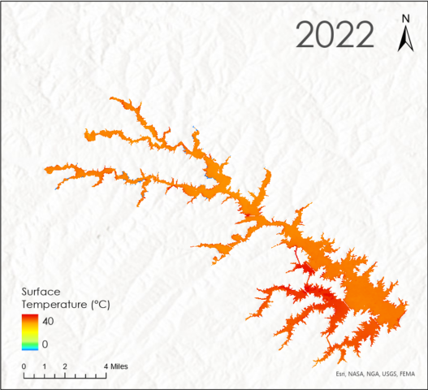
Figure E1. Median surface water temperature ℃ for Lake Anna, June 1st – September 30th, 2022. Note high temperatures recorded in the Waste Heat Treatment Facility, in the southwestern portion of the reservoir.

