NASA Support for Commercial Crew Launch Capabilities
September 15, 2023
Authors (ordered): Lisa McCollum; Rajiv Doreswamy, Ph.D.; Maggie Freeman

Since the earliest days of U.S. human spaceflight, NASA’s Marshall Space Flight Center (MSFC) in Huntsville, Alabama, has played a key role in American crew launch capability, from engineering support for the first Mercury-Redstone launches, to the Saturn launches to the Moon, through Shuttle and now Artemis. Today, MSFC brings that expertise gained through decades of crewed space launches to NASA’s Commercial Crew Program (CCP), providing launch vehicle engineering and programmatic support. Launch vehicle support for Commercial Crew has come as a paradigm shift for the MSFC team, inspiring new approaches that leverage expertise and best practices from past NASA-developed launch vehicle missions, while at the same time providing new synergies from work with commercial partners on CCP. This paper will explore the role that the MSFC launch vehicle services team plays in CCP, as well as lessons learned from the program that will continue to benefit a new era of spaceflight partnerships.
In the past NASA’s way of doing business meant that agency personnel were deeply integrated in the design, qualification, processing, and operation of a crew transportation system. The space agency owned the vehicle design and its operating infrastructure. In Commercial Crew's approach, NASA partners with private industry, defining the safety, performance and mission requirements while leveraging a new shared assurance model for insight and oversight. This approach allows for both a public purpose and agency purpose to be pursued and achieved. The public purpose facilitates U.S. private industry development of safe, reliable and cost-effective human space transportation to and from low Earth orbit. The agency purpose enables NASA to become one of many customers purchasing commercial services to meet its International Space Station (ISS) crew transportation needs at a lower cost. CCP established an acquisition approach that permitted logical evolution and maturity of multiple systems. As shown in Figure 1, multiple rounds of Space Act Agreements (SAAs) were awarded and refined over the course of four years for the design and development of private-sector human spaceflight concepts and technologies.

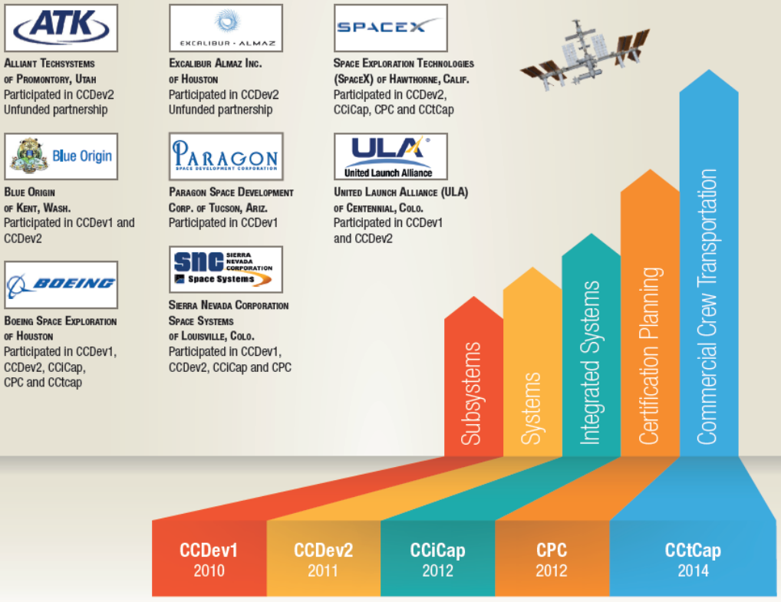
Figure 1. Phased Progression of Commercial Crew Program Partnership Agreements and Contracts

Initiated in 2010, Commercial Crew Development Round 1 (CCDev1) utilized SAAs that stimulated efforts within the private sector to aid in the development of crew transportation capabilities. These SAAs were awarded to five partners: Blue Origin, Boeing, Paragon, Sierra Nevada and United Launch Alliance. Round 2 (CCDev2) utilized SAAs that aided in further development, with four partners: Blue Origin, Boeing, Sierra Nevada and SpaceX. In 2012, transition to the Commercial Crew Integrated Capability (CCiCap) SAA occurred which continued the development of three fully integrated systems, including tests to verify, validate and mature the integrated designs. The final SAAs were awarded to three partners: Boeing, Sierra Nevada and SpaceX. These SAAs overlapped into the next phase, Certification Products Contracts (CPC) which were awarded to enable the development of data products to implement NASA’s flight safety and performance requirements. CPC enabled NASA and commercial partners to engage in dialog about the requirements for certification and promote the delivery, technical interchange and NASA disposition of early lifecycle certification products. Both CCiCap and CPC occurred from 2012 to 2014, with NASA providing over 10,000 comments on approximately 800 deliverables from the commercial partners.
In 2014, the Commercial Crew Transportation Capability (CCtCap) Contracts were awarded, which is currently the operating phase today. These contracts were awarded to two commercial partners: SpaceX and Boeing, for the final development and certification of a crew transportation system, including design, manufacturing, testing, qualification, production and operation for flights to the ISS. Since the CCtCap selection eight years ago, CCP has successfully completed an uncrewed orbital test flight (Demo-1), a crewed orbital test flight (Demo-2) and six crewed post-certification missions with partner SpaceX (Crew-1 through Crew-6). The seventh crew rotation mission with SpaceX (Crew-7) is currently in orbit, safely docked to ISS and expected to complete in early 2024. CCP has also completed two uncrewed test flights with partner Boeing (Orbital Flight Test (OFT) and OFT-2) with their first crewed test flight (Crew Flight Test) tentatively scheduled to occur in 2024. All of these missions are launched from either NASA’s Kennedy Space Center (KSC) or Cape Canaveral Space Force Station in Florida. KSC is also considered the Headquarters for CCP. However, CCP is co-led by Johnson Space Center (JSC) in Houston, Texas and as previously mentioned, CCP employs critical support and expertise from MSFC in Huntsville, AL.
Supporting as a strong partner in that multi-center collaboration, MSFC’s role in CCP spans across programmatic and management support for the Launch Vehicle Systems Office (LVSO), safety and mission assurance, cost account management, as well as engineering expertise for both commercial partners’ launch vehicles and spacecraft propulsion. MSFC’s CCP team provides expertise in nearly all aspects of launch vehicle design and performance with a significant emphasis in propulsion, including liquid engines and solid motors, stage propulsion, thrust vector control, structures and dynamics, and safety and mission assurance. While the primary focus is on the Launch Vehicle, a smaller subset of the team supports Integrated Vehicle Performance as well as Spacecraft Propulsion. The team’s responsibilities have included human certification of commercial launch systems for the CCP missions, including the Atlas V and Falcon 9 vehicles shown in Figure 2, and verifying each launch vehicle and mission complies with certification requirements and policies.

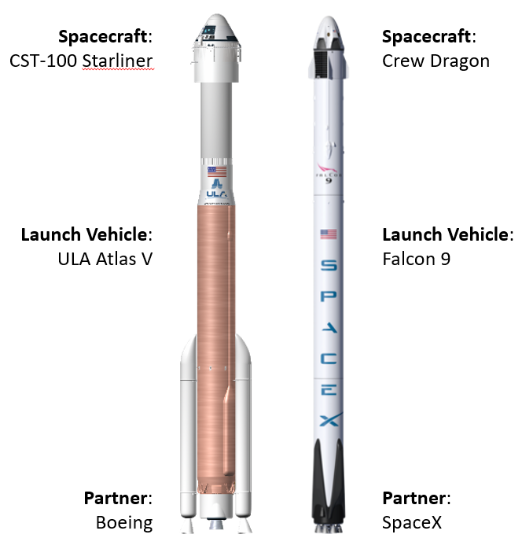
Figure 2. Atlas V and Falcon 9 Vehicle Configurations

In order for MSFC to assess flight readiness, the MSFC CCP team works closely with KSC and JSC as well as the commercial partner to perform focused evaluation of the partner’s flight system readiness assessment. The MSFC team also assures that Center and Agency leadership has been provided adequate evidence of meeting NASA’s technical management processes and requirements. Any residual technical risks due to hazards, waivers, or non-compliance are also reviewed, appropriately characterized, assessed and documented in support of CCP’s risk acceptance decision. Once the MSFC CCP team completes their assessment, a MSFC-internal Pre-Flight Readiness Review (FRR) is held for each mission to provide the MSFC Center Director and Senior Leaders an executive summary of the work performed by the MSFC CCP team, along with any potential risks or technical issues. This review provides further preparation for the Center Director leading up to the CCP Program FRR and NASA Agency FRR (assuming that the MSFC CCP team does endorse the certification of flight readiness for the applicable mission). Figure 3 illustrates the levels and rigor of reviews leading to the Agency FRR and subsequent launch. Note that both CCP and ISS Program have roles leading to the Agency FRR in addition to the preparations completed by each specific NASA center.

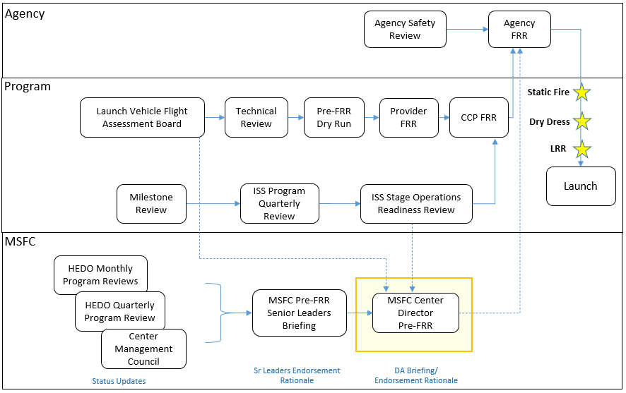
Figure 3. Certification of Flight Readiness Preparations

In addition to endorsing flight readiness, MSFC continues to provide support for launch operations and post-flight data reviews. Prior to 2020, most launch operations required the MSFC CCP team to travel to the launch site for console support. However, with the COVID-19 global pandemic, MSFC was faced with new challenges for continuing mission operations. To provide real-time launch support, a collaboration between the MSFC CCP team and MSFC’s Huntsville Operations Support Center (HOSC) was established. The HOSC has provided launch operations support since Apollo, providing real-time oversight to safety standards for the vehicle and verifying data. CCP’s usage of the HOSC allowed for operational flexibility for a small team during the height of COVID, without sacrificing any mission support capabilities. During each Commercial Crew launch, an operational engineering support team is on console at MSFC’s HOSC facility supporting the CCP Chief Engineer and NASA Operations Manager for launch readiness decisions as shown by Figure 4 for the recent SpaceX Crew-7 mission on August 26, 2023. The team is equipped with wall-to-wall monitors for situational awareness, commercial partner-provided laptops for primary operators, and NASA provided laptops with remote access to KSC’s vehicle data telemetry for all other operators. Both NASA and commercial partner laptops are equipped with Graphical User Interface capabilities, which allow the operators to view the real-time data and plotting scripts used to monitor the health of the vehicle during the launch countdown and operation.

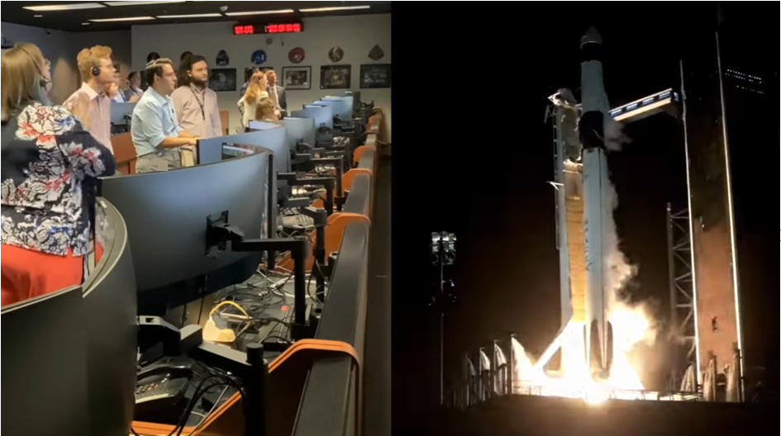
Figure 4. A Portion of CCP’s Mission Support Team shown at MSFC’s HOSC supporting Crew-7 Launch Operations.

This joint NASA-commercial partner collaboration for launch support is also the foundation for how CCP operates on the programmatic level. The public private partnership (PPP) between CCP and commercial providers utilize a “Shared Assurance” model which strives to achieve a balance of insight and oversight appropriate for shared government and commercial industry accountability in establishing a safe, reliable and cost-effective Crew Transportation System. CCP is accountable for ensuring compliance of the transportation vehicle to CCP’s human spaceflight requirements through evaluation and approval of the commercial provider’s evidence in accordance with a risk-based insight approach. The commercial provider is responsible for the design, development, test and evaluation, and operation of the vehicle. By design, the CCP model allocates greater accountability to commercial providers as compared to a traditional NASA human spaceflight program. It is through the combined and integrated effort that the CCP PPP achieves consistent safety, reliability, and cost-effective transportation systems proving that the public private approach is viable.
Through the progression to CCtCap, lessons learned have been continually documented including focus on hardware/software design and operations for NASA’s human spaceflight programs to benefit from CCP’s experience. MSFC’s workforce has also evolved along with the progression of CCP and has demonstrated its ability to work alongside commercial partnerships in a shared assurance model. Although NASA does not own the vehicle design, MSFC is able to offer specialized expertise or capabilities such as testing services, deep dive technical reviews, and hardware evaluations for our commercial partners when needed. This flexibility to engage NASA’s expertise both supports the safety and reliability of the Commercial Crew transportation capabilities, as well as progresses the capabilities of the commercial space transportation industry. CCP also demonstrates an extremely effective collaboration between multiple NASA field centers. By leveraging capabilities at KSC, JSC and MSFC, CCP gains the benefit of a wide range of expertise and skills to execute the program’s mission. MSFC’s long history of propulsion and launch vehicle expertise is well utilized in this collaboration.
As new programs have begun to utilize PPP models, they have looked to CCP for guidance stemming from lessons learned. For example, Human Lander Systems (HLS), managed by MSFC, is the mode of transportation that will take astronauts to the lunar surface and will serve as a research platform both on the surface and in lunar orbit. HLS is utilizing a PPP approach and MSFC is working closely with its commercial partners throughout the development process. In addition to HLS the Agency has recently announced the Commercial Low Earth Orbit (LEO) Destination Program (CLDP). The goal of CLDP is to use a PPP model to provide a LEO destination, for research and development, after the retirement of ISS. CCP can share many lessons learned for data sharing, depth of insight, shared assurance, and NASA support of vehicle operations. However, it is crucial to note that each program has a significantly different mission. Although they share commonality with the PPP model of operation, the objectives and mission architecture may necessitate variations in how the PPP and Shared Assurance model is executed for best success of the mission. Although CCP’s success with PPP provides a wealth of knowledge for other programs leveraging similar models, the lessons learned must be applied and tailored appropriately.

Partner | Mission | Key Accomplishments | Mission Duration
SpaceX | Demo-1 | - Met all test flight objectives  - First dock to ISS for the Crew Dragon spacecraft | March, 2019
Boeing | OFT | - Met ascent and descent, entry, and landing flight test objectives  - First American-made orbital crew capsule to land on land | December, 2019
SpaceX | Demo-2 | - Met crewed test flight objectives  - Docked to ISS for 63 days | May, 2020 – August, 2020
SpaceX | Crew-1 | - Broke the record for longest spaceflight by a U.S. crewed vehicle previously set at 84 days by an Apollo capsule  - Docked to ISS for 167 days | November, 2020 – May, 2021
SpaceX | Crew-2 | - First crewed flight of a reused Crew Dragon and Falcon 9 booster  - Broke the previous on-orbit record by Crew-1 and first ISS fly-around since Space Shuttle  - Docked to ISS for 199 days | April, 2021 – November, 2021
SpaceX | Crew-3 | - First reuse of Crew Dragon nose cone  - First indirect crew handover following post flight assessment  - Docked to ISS for 174 days | November, 2021 – May, 2022
SpaceX | Crew-4 | - First four-time flight Falcon 9 First Stage Booster  - New Spacecraft Freedom with reuse of Dragon composite components  - Docked to ISS for 169 days | April, 2022 – October, 2022
Boeing | OFT-2 | - Met all test flight objectives  - First dock to ISS for the Starliner spacecraft | May, 2022
SpaceX | Crew-5 | - First female commander of a CCP mission  - First NASA flight of an indigenous woman  - First flight of a Russian cosmonaut on a U.S. commercial spacecraft  - Docked to ISS for 156 days | October, 2022 – March, 2023
SpaceX | Crew-6 | - First four-time reuse of a Crew Dragon capsule  - First flight of a United Arab Emirates astronaut  - Docked to ISS for 185 days | March, 2023 – September, 2023
SpaceX | Crew-7 | - First fully international crew: NASA astronaut, European Space Agency astronaut, Japan Aerospace Exploration Agency astronaut, and Roscosmos cosmonaut  - Currently docked to ISS | August, 2023 - Present
Table 1. Accomplishments resulting from Commercial Crew Partnered Missions

Through the nearly fifteen years of growth from the beginning of the Commercial Crew Program to today, MSFC has been and will continue to be a strong supporter of collaboration, launch vehicle development and partnered spaceflight. The team has now supported eleven successful flights as shown by Table 1 to the ISS between two commercial providers and continues to show tremendous engineering and programmatic support for future missions. As we reflect on these successes we must remember to continue gathering and implementing lessons learned along the way, and to remain adaptable as the future of human spaceflight evolves towards more partnerships between the public and private sectors.

