San Joaquin Valley Health & Air Quality
Evaluating the Overlap of Social Vulnerabilities and Air Quality in the San Joaquin Valley Air Pollution Control District


Technical Report
August 11th, 2023

Jonathan Szeto (Project Lead)
Jasper Beardslee
Piper Christian
Bethany MacCarter
Alma Quintero

Advisors:
Dr. Kenton Ross, NASA Langley Research Center (Science Advisor)
Dr. Travis Toth, NASA Langley Research Center (Science Advisor)
Dr. Liz Wiggins, NASA Langley Research Center (Science Advisor)
Lauren Childs-Gleason, NASA Langley Research Center (Science Advisor)

Fellow:
Julianne Liu (Virtual Environmental Justice)

1. Abstract
Little Manila Rising (LMR) is a nonprofit in Stockton, California that has been increasingly concerned by the air pollution in their city and the neighboring San Joaquin Valley (SJV). Geographical factors, climate conditions, and anthropogenic activities, such as agriculture burning and vehicle emissions, contribute to the high levels of air pollution in this region. To visualize the distribution of air pollution and social disparities across the SJV, LMR partnered with NASA DEVELOP. The DEVELOP team used Terra and Aqua MODIS, Sentinel-5P TROPOMI, and CALIPSO CALIOP to observe Aerosol Optical Depth (AOD), Nitrogen Dioxide (NO₂), and the vertical distribution of pollutants at varying pollution levels, respectively. Additionally, Suomi-NPP VIIRS provided active fire data. By leveraging NASA Earth observations along with sociodemographic and public health data, the DEVELOP team created maps identifying the areas experiencing the highest vulnerabilities and disparities in pollution exposure. The team found that AOD was slightly higher in agricultural regions, while NO₂ was consistently higher along transportation corridors and urban areas. Wildfires dominated the type of detected active fires, and there was high correlation (R² = 0.6924) between active fires and burn permits in agricultural tracts. Furthermore, the team identified both high AOD vulnerability and high NO₂ vulnerability in census tracts in South Stockton, an area that has been historically redlined and disinvested in, and where LMR resides. There was also a moderate correlation between air quality reported from the satellites and in-situ ground monitors. These results will support LMR’s organizing strategies for stricter enforcement of air pollution regulations and increased public health equity for community members.

Key Terms
Agricultural Fires, Air Quality, CALIPSO, Environmental Justice, MODIS, San Joaquin Valley, Sentinel-2, VIIRS, Aerosol Optical Depth, Nitrogen Dioxide

2. Introduction
2.1 Background Information
San Joaquin Valley (SJV) sits within the Central Valley of California and is home to roughly 800,000 residents (US Census Bureau, 2022). Agriculture dominates the region, employing almost 20% of the population and accounting for over $24 billion in annual revenue (Public Policy Institute of California, 2023). SJV experiences some of the worst air quality in the nation and, for the past 25 years, has annually failed to meet federally established standards for both particulate matter (PM) 2.5 and ozone (Rodriguez-Delgado, 2022). Major sources contributing to the poor air quality are wood combustion (including agricultural burning), vehicle emissions, dust, and agricultural ammonia. Furthermore, wildfires have increased from land-use and climate change and are an additional source of pollution (Hixson et al., 2012; Chen et al., 2014; Enayati Ahangar et al., 2022). Moreover, the mountains surrounding SJV trap air pollution and winter temperature inversions confine pollutants near the surface (Chen et al., 2014).

PM_{2.5} refers to any atmospheric solid or liquid particle with a diameter less than 2.5 microns. Such particulates can enter the cardiovascular system through the lungs and cross the blood-brain and placental barriers (US Environmental Protection Agency [EPA], 2016; Xing et al., 2016; Calderón-Garcidueñas & Ayala, 2022). PM_{2.5} has been linked to a range of health impacts including chronic respiratory diseases, lung cancer, asthma, ischemic heart disease, stroke, and pre-term births (Sharma et al., 2020; Li et al., 2017). Nitrogen dioxide (NO₂), a pollutant commonly formed through the combustion of fuel in vehicles, can react with solar radiation to form ozone. Exposure to ozone is associated with respiratory and cardiovascular diseases and asthma-related emergency room visits (Zhang et al., 2019). Scientific research suggests adverse health impacts to nearly all systems of the body can stem from both PM_{2.5} and ozone exposure, even at levels well below U.S. federal standards (Hoffmann et al., 2021).

Residents in SJV have increased health burdens derived from high levels of air pollution within the valley. A 2014 health survey found that 34.3% of adolescents aged 1–17 and 20.8% of adults in SJV were diagnosed with asthma, compared to the state rate of 14.5% and 13.8%, respectively (Harder+Company Community Research, 2016). Furthermore, exposure to PM_{2.5} is linked to roughly 1,200 cases of premature death in the SJV each year (California Air Resources Board, 2019).

The disproportionate impact of air pollution on the residents of SJV has led to the creation of multiple Environmental Justice (EJ) initiatives designed to understand and address the lived experiences of those affected. From 1920 to 1960, the Little Manila community in Stockton, California was home to the largest population of Filipinos outside of the Philippines. The labor of Filipino immigrants helped to establish agriculture as the largest industry in California. Under the leadership of labor organizer Larry Itliong, Filipino farmworkers fought for better working conditions for decades. Their efforts culminated in a 1965 strike which prompted an international boycott of table grapes (Little Manila Rising, n.d.). The Mexican farm labor union led by Cesar Chavez and Dolores Huerta joined the Filipino union in the strike. Their collaboration led to the creation of the United Farm Workers, a major force in the Civil Rights Movement (Morehouse, 2015). EJ in SJV remains strong today. Skywatch, run by Little Manila Rising (LMR), distributes PurpleAir sensors to residents of San Joaquin County to help quantify air quality conditions in areas not covered by San Joaquin Valley Air Pollution Control District’s (APCD) 24 air monitoring sites (Little Manila Rising, n.d.). SJV Air Collaborative, another program, is a network of low-cost air quality monitoring instrumentation that provides real-time PM_{2.5} data to disadvantaged communities within SJV (SJVAir, n.d.).

Past studies have used remote sensing to examine NO₂ in SJV, as a proxy for combustion engine pollution (Lee et al., 2023). Previous researchers have utilized remote sensing, specifically MODIS and CALIPSO, to track overall air quality and suspended atmospheric aerosols (Gupta et al., 2006, Liu et al., 2018). Our research will differ in two ways. First, in the utilization of demographic data to center our research on those impacted by the pollution. Second, in the examination of how air pollution levels in SJV fluctuated over previous years.

Our study area, SJV, consists of eight counties: San Joaquin, Stanislaus, Merced, Madera, Fresno, Kings, Tulare, and Kern. For portions of our project, we will provide a more detailed examination of San Joaquin County given that it contains the city of Stockton, where LMR resides (Fig. 1). Our study period is from 2012 to 2023, which allowed us to establish seasonal and annual trends for air pollutants and agricultural burning. This period captures droughts that lasted from 2012 to 2016. These droughts lead to large crop die-offs, a subsequent increase in agricultural burns, and policies passed in 2017 and 2021 which aimed to phase out agricultural burning (Bertoldi et. al., 2022).

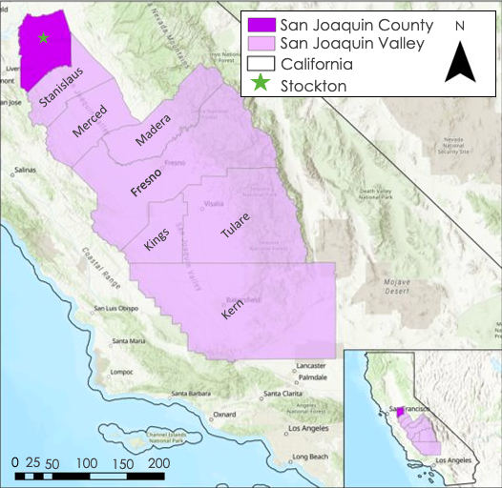
Figure 1. Study Area of the San Joaquin Valley and its counties. Our study area primarily focused on San Joaquin County, where our partners Little Manila Rising reside.

2.2 Project Partners & Objectives
Founded in 2000, Little Manila Rising (LMR) serves the South Stockton community by developing and advocating for equitable solutions to historical marginalization, institutionalized discrimination, and harmful public policies. With a strong emphasis on EJ and health equity, LMR strives to reduce exposure to environmental hazards, such as air and water pollution, to promote health and wellness throughout the South Stockton community (Little Manila Rising, n.d.). LMR partnered with NASA DEVELOP to use Earth observation tools to better understand the distribution of air pollution across SJV and visualize the resulting health disparities to support their advocacy and community organizing, especially with regards to policies for agricultural burning and transportation construction initiatives. Our project’s objectives included modeling air pollution distributions across SJV, visualizing impact disparities based on social vulnerability data, validating remotely sensed air quality data with ground-based sensors, and identifying overlap between poor air quality and regional burning.

3. Methodology
3.1 Data Acquisition
3.1.1 Earth Observation Datasets for Air Pollutants and Active Fires
Satellites examine the interaction between radiation and particles to analyze aerosols such as smoke, NO₂, and PM_{2.5}. Aerosol optical depth (AOD) is one form of measurement, where high AOD values indicate there is a high aerosol concentration (NASA Earth Observatory, 2010). We downloaded cloud-masked Multi-Angle Implementation Atmospheric Correction (MAIAC) data from the Moderate Resolution Imaging Spectroradiometer (MODIS) sensor on the Terra and Aqua satellites to calculate the monthly median and 95th percentile AOD on an annual basis from 2012–2023 through Google Earth Engine (GEE). We replicated this process to calculate the monthly median and 95th percentile for NO₂ using cloud-masked data from Sentinel-5P TROPOMI but were limited to the timeframe of 2018–2023 based on data availability.

The Cloud-Aerosol Lidar with Orthogonal Polarization (CALIOP) sensor on the Cloud-Aerosol Lidar and Infrared Pathfinder Satellite Observations (CALIPSO) satellite provided aerosol thickness, height, and classification. We used the Vertical Feature Mask (VFM) and Extinction Coefficient products specifically. We obtained CALIPSO data by filtering the orbit track by coordinates, using the NASA Atmospheric Science Data Center subsetter and extracting three samples from CALIPSO VFM profile and Aerosol Extinction Coefficient for three given dates.

The VIIRS sensor on the Suomi NPP satellite provided active fire data for the project. We downloaded 375m annual Active Fire data from the Fire Information for Resource Management System (FIRMS) over the 2012–2021 time period into a separate CSV text file for each year. The data indicates the geographic locations of fires detected by the VIIRS sensor during overpass of SJV through latitude and longitude coordinates.

Table 1. List of Sensors and Data Products
Satellite | Sensor | Product Dataset | Date Ranges | Source
Air Pollution Time Series and Pollution Exposure Map
Terra/Aqua* | MODIS | AOD pollution map and timeseries | 2012–2023 | GEE
Sentinel-5P | TROPOMI | NO₂ pollution map and time series | 2018–2023 | GEE
Point-in-Time Case Study
CALIPSO | CALIOP | VFM | 8/30/2019,  10/1/2020, 9/16/2021 | GEE
Active Fire Maps
Suomi NPP | VIIRS | 375m Active Fire | 2012–2021 | Fire Information Management Product (FIRMS)

3.1.2 Ancillary Data
In addition to satellite data, the team acquired various datasets from 2012 to 2022 to validate air pollutant data and create a social vulnerability index (Table 2). To compare data from MODIS and TROPOMI with in-situ data, we acquired 2019 to 2022 PM_{2.5} and NO₂ concentrations from the Ground Sensor Air Quality System of the U.S. Environmental Protection Agency (EPA). We also acquired ground-based 2019 to 2022 AOD measurements from AERONET. We then downloaded data regarding the location and times of agriculture permitting within SJV from the University of California Berkeley’s Eat Crops Don’t Breathe Crops initiative (Bertoldi et al., 2022). On the U.S. Department of Agriculture’s (USDA) Cropland Collaborative Research Outcome Service website, we downloaded cropland data of central California. Lastly, we obtained census tract shapefiles from the U.S. Census Bureau.

Our team sourced sociodemographic data for vulnerability indicators from EJScreen, the EPA’s Environmental Justice Screening and Mapping Tool, and the Centers for Disease Control and Prevention’s PLACES initiative. We chose the following variables from the EPA’s EJScreen to use as vulnerability indicators based on feedback from LMR: Total Population, Percent Minority, Percent Low Income, Percent Unemployed, Percent Less than High School Education, Percent Under Age 5, Percent Over Age 64, and Life Expectancy. From the CDC’s PLACES initiative, we used Chronic Obstructive Pulmonary Disease Rates, Coronary Heart Disease, Current Rates, Current Asthma Rates, and Percent No Health Insurance. We downloaded these data into two separate CSV text files.

Table 2. Social, Environmental, and Validation Datasets
Data Source | Data Name | Data Type | Year(s)
Environmental Protection Agency (EPA) | Environmental Justice Screening Tool (EJScreen) | CSV text file of community vulnerability | 2016–2020
Centers for Disease Control and Prevention (CDC) | Community Health Measures (Places) | CSV text file of community health vulnerability | 2015–2020
EPA | Ground Sensor Air Quality System (AQS) | CSV text file of daily air quality records of NO₂ and PM_{2.5} | 2019–2022
NASA/PHOTONS | AERONET AOD Level 2 (Aerosol Robotic Network) | AOD Daily Average | 2019–2022
Eat Crops Don’t Breathe Crops. U.C. Berkeley | San Joaquin Valley Burn Permitting Location | Excel file of burn permit locations and dates | 2012–2021
U.S. Department of Agriculture | Cropland Data | Cropland data shapefile | 2022
U.S. Census Bureau | California Census Tracts 2020 | California census tract shapefile | 2020

3.2 Data Processing
3.2.1 Processing for Air Quality Indicator Map and Time Series
To initially process air quality data, we created a shapefile in ArcGIS for the counties composing SJV. We then uploaded the shapefile to GEE. Next, we imported AOD data from Terra and Aqua’s MODIS sensor (MAIAC), and NO₂ data from Sentinel-5 Precursor’s TROPOMI. For AOD, we selected a Quality Assurance (QA) value of 0 from the “cloud mask” bit to filter for clear skies and a QA value of 1 from the “QA for AOD” bit to filter for best quality data. For NO₂, we applied a cloud mask to the data following the cloud fraction parameters within the GEE catalog, selecting a cloud fraction of 0 (indicating clear skies). Following the cloud mask, we selected the MODIS Green band (0.55 μm) for AOD and the Sentinel-5 Tropospheric Vertical Column Band for NO₂. Data were bound to the shapefile and the yearly dates. The years 2012 to 2022 were selected for AOD, and 2018 to 2022 for NO₂.

We used two different methods to represent yearly median AOD and NO₂ levels in addition to when AOD and NO₂ were at their most prevalent (95th percentile). To understand where pollution was distributed during a normal year, we took the median of AOD to reduce the skew of the data and aid in representation over longer time periods. We then clipped the data to the shapefile and created a palette. AOD used a scale min of 0 and a scale max of 1100, and we applied a reducer of 0.001. NO₂ used a scale min of 0 and a scale max of 0.0002, and no reducer was applied since the scale of the data was already correct. The maps were then exported as GeoTIFF files to use in ArcGIS Pro alongside census tract data.

To visualize pollution levels at their most prevalent, we filtered the AOD and NO₂ data to their respective 95th percentiles during each year visualized. We then used the “reduce" method to cut out the lower concentration data and visualized it using the parameters described above. The map was exported as a GeoTIFF to be used in ArcGIS Pro alongside census tract data.

To obtain monthly time series data for AOD and NO₂, the same steps listed above were performed, except the output was set to create a chart, instead of a GeoTIFF. For NO₂, a reducer of 10,000 was applied to ensure numerical differences could be detected within the data in Excel. These charts were downloaded as CSVs so data could be analyzed within Excel. From our CALIPSO VFM profile, we extracted 532 nm Extinction Coefficient plot using a Python script during the Determined Event Dates (DED) of 8/30/19, 10/1/20, and 9/16/21 (AOD levels > 95th percentile). The resulting plot displayed only the layer of aerosols classified by subtype and determined aerosol height and thickness.

3.2.2 Processing for Active Fire and Burn Permitting Data
Our team uploaded annual CSV text file datasets of burn permitting and active fires into Microsoft Excel and modified the datasets to only include the date and the longitude and latitude coordinates of each burn permit and active fire for each year from 2012 to 2021. The active fire datafiles for these years were then uploaded to ArcGIS Pro and clipped to only include fires detected in our study area. Next, we downloaded the location of active fires in our study area as CSV text files and reuploaded them to Excel. We then calculated and recorded the number of burn permits and active fires on a monthly and yearly basis, from 2012 to 2021, both in SJV and San Joaquin County. After, our team uploaded the most recent year of complete burn permitting and active fire data, 2021, into ArcGIS Pro alongside our census tract shapefile. We joined the burn permits and active fires point features to the census tract shapefile and calculated the number of burn permits and active fires in each census tract.

3.2.3 Cropland Data
Our team clipped the USDA cropland raster of central California in ArcGIS Pro to our study area. The cropland raster delineates the predominate land use of each pixel. For example, pixels that contain carrot farms are classified as “carrots” while those that contain grasslands are described as “grasslands.” In ArcGIS Pro, our team used supervised classification to classify all pixels with land use pertaining to agriculture as “agricultural” and all others as “non-agriculture.” Grasslands, the various forest biomes, and water pixels were classified as “non-agriculture”, while idle cropland was classified as “agriculture.” A new raster was created from these classifications to delineate all the “agriculture” and “non-agriculture” pixels. Our team then classified each census tract in our study areas as an “agriculture” or “non-agriculture” tract depending on the majority of the pixels in the census tract, depicted in Appendix C. Lastly, we exported a final table of all the census tracts where each row contained the respective tracts’ 11-digit FIPS code, the number of burn permits and active fires in the tract, and whether the tract was classified as “agriculture” or “non-agriculture.”

3.2.4 Processing for Vulnerability Map
Our team modified the CDC PLACES and EPA EJScreen datasets using Python to remove unwanted data points and only include the numerical data of the chosen sociodemographic indicators and their 11-digit Census Tract FIPS code. We then uploaded the two datasets into ArcGIS Pro and used the “Join” analysis tool to combine them based on their Census Tract FIPS code. Lastly, the team clipped the dataset to only the relevant census tracts in our study area before downloading the conglomerated dataset as a single CSV text file.

3.3 Data Analysis
3.3.1 Air Quality Indicator Map and Timeseries Analysis
We validated our AOD and NO₂ data from Terra and Aqua MODIS with in-situ EPA air quality monitor readings. To do this, we selected three EPA air quality monitors in SJV: Fresno (sensor # 06-019-2016), Madera (sensor # 06-039-2010), and Kern (sensor # 06-029-0014). From these sensors, we downloaded daily data from 2019 to 2022, which reflects the most recent available data at the highest possible granularity. We then created a 2-km buffer around these monitors and gathered the daily MODIS values for AOD and NO₂ within the buffer region for 2019–2022. Using R, we calculated a daily mean for both satellite and sensor values, if multiple values were provided, and performed an inner join on the data. We also filtered data by years, seasons, and pollution thresholds and then calculated linear regressions between the EPA PM_{2.5} and MODIS AOD measurements, as well as the EPA NO₂ and Sentinel-5 NO₂ measurements. We performed a second validation of our MODIS AOD data with the in-situ AERONET (Aerosol Robotic Network) AOD Level 2 data from their Fresno_2 sensor, using daily mean values of AOD from 2019 to 2021, to assess MODIS AOD reliability.

For our DED case study, we analyzed the VFM plot and determined the subtypes of extracted aerosol layer, such as polluted dust, polluted continental, smoke, and dust. Lastly, we analyzed the aerosol extinction coefficient plot and defined the aerosol mixing layer distance from the surface and its thickness in kilometers. We compared the calculated AOD from CALIPSO with MODIS AOD.

3.3.2 Active Fires and Burn Permitting Analysis
Our team first created a map of active fires and the number of burn permits for each census tract in our study area in 2021 to visualize the number of each. We then overlayed these maps with a 2021 average AOD by census tract map. We created bivariate maps which show how AOD concentrations, active fires, and burn permits overlap in our study area.

The number of fires, the number of burn permits, and the average AOD and NO₂ concentration by census tract in the whole SJV were then graphed on both a monthly and yearly time-series to compare the temporal changes among all three variables from 2012 to 2021. Our team then plotted the number of burn permits vs. the number of active fires, the number of active fires vs. AOD concentration in all census tracts, and number of burn permits vs AOD concentration using 2021 data to calculate an R² linear regression to determine the correlation between these variables. Our team then plotted the same three graphs again for only census tracts that were classified as “agriculture” for the whole SJV. Lastly, the team conducted t-tests to determine if there was a significant difference in the number of active fires and AOD concentrations. This comparison was done between agriculture and non-agriculture census tracts. Additionally, the team compared agricultural tracts with the number of burn permits above the median number administered, and they also compared these with non-agricultural census tracts in SJV. This statistical analysis was then repeated with average NO₂ concentrations.

3.3.3 Vulnerability Analysis
We conducted a comprehensive analysis of vulnerability by combining relevant social indicators from EJ Screen and CDC PLACES with a shapefile of our census tracts. This allowed us to visualize and understand the distribution of vulnerability within our study area, and based on this analysis, we developed a social vulnerability index that encompassed all the indicators. To produce this index, we followed the CDC’s method as presented in Flanagan et al. (2011) and further validated our social vulnerability index by conducting a Principal Component Analysis of the selected vulnerability indicators in R. Using this index, we derived a map of social vulnerability by census track in our study area.

We created multiple bivariate choropleth maps to illustrate the overlap of AOD and NO₂ with social vulnerability and the individual sociodemographic factors. These maps provide a comprehensive visualization of the valley’s overall air pollution vulnerability. Additionally, we compared each census tract’s social vulnerability index with its average AOD concentration and average NO₂ concentration in 2019, calculating the R² value to determine the correlation between social vulnerability and the two air quality values.

In summary, for both AOD and NO2, we produced maps of the pure air pollution for 2022. Using the GeoTIFFs exported from GEE, we created pollution maps for median and 95th percentile data for both AOD and NO₂ in the entire SJV. These visuals allowed us to see the "regular" distribution of AOD and NO₂ (median) alongside the distribution when the pollution was at its worst (95th percentile). We then used the zonal statistics "mean" feature of QGIS and ArcPro to map the average air quality values within each census tract in SJV.

4. Results & Discussion
4.1.1 Air Quality Trends
4.1.1.1 Air Quality Visualizations
We had two major takeaways from our air pollution maps. First, the highest levels of pure AOD were located predominantly in non-urban/agricultural areas of SJV, with the southern half of SJV seeing worse pollution than the north. While some points of higher concentration were near cities, highest levels of AOD were in rural areas (Figures 2A and 2B). These findings were confirmed using the zonal statistics maps, with census tracts in agricultural areas showing a higher level of average AOD than census tracts closer to metropolitan areas (see Appendix B). Second, the highest levels of NO₂ were seen around urban areas and major highways. Non-agricultural regions, such as cities and metropolitan areas, saw the highest concentrations of NO₂, while rural areas saw the lowest. NO₂ was also concentrated around major highways and transportation corridors, although in amounts less than that of metropolitan areas. When overlaying roadways onto our maps, the major highways that linked cities together could be traced by the vein-like NO₂ values that surround them (Figures 2C and 2D). These findings were corroborated by our zonal statistics maps for NO₂ with urban census tracts showing the highest average values of NO₂ in SJV, followed by census tracts near major roads. Simultaneously, non-agricultural census tracts had higher concentrations of NO₂ than agricultural census tracts.

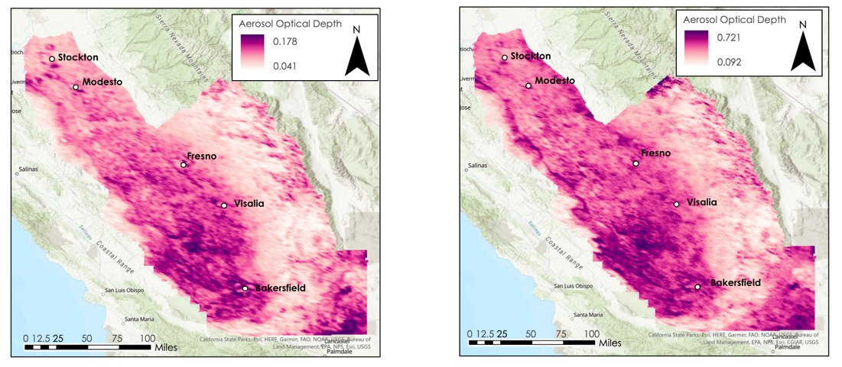
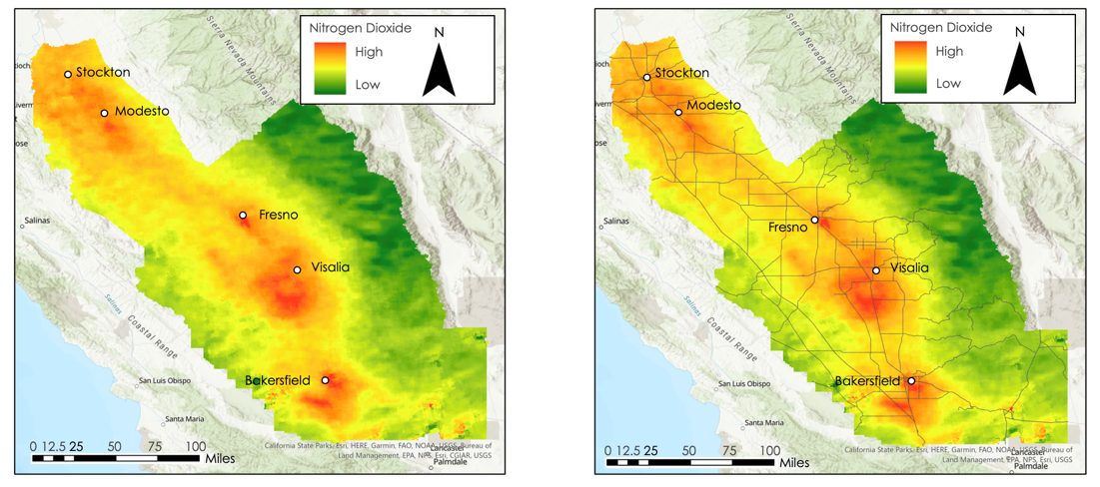
Figure 2. A. (Top left map) 2022 Median AOD in SJV. B. (Top right map) 2022 95th Percentile AOD in SJV. C. (Bottom left map) 2022 95th Percentile NO₂ in SJV. D. (Bottom right map) 2022 95th Percentile NO₂ in SJV with Roads

Alongside maps of the entire SJV, we also created maps of pollution for San Joaquin County. These enabled us to better understand pollution levels near urban areas, like Stockton, and at a smaller scale. The same series of maps created for the SJV entirety were also produced with the San Joaquin County as the focal point. We found that AOD levels were higher around the southern side of Stockton, and the interior of the city saw noticeably lower levels of AOD than the areas directly to the south. Notably, South Stockton is the region of the city that historically received poor redlining grades and underinvestment (Galvin, 2020). This was confirmed by our zonal statistics maps. Census tracts to the north of Stockton had average AOD levels lower than census tracts to the south. Interestingly, this pattern was also seen in Modesto, a city just to the south of Stockton, within San Joaquin County. The northern census tracts in Modesto saw noticeably lower levels of average AOD during the year when compared to census tracts on the southern side of the city. We also found that the highest NO₂ levels were located around the urban centers of San Joaquin County, with the NO₂ pollution sitting predominately in the area just outside the city of Stockton. When examining the results by census tract, the tracts nearest to the cities and major roads saw higher levels of average NO₂.

4.1.1.2 AOD and NO₂ Trends in Agricultural and Non-Agricultural Tracts
The team ran t-tests to determine whether there was a significant difference in air pollution levels between non-agricultural and agricultural census tracts in SJV. Mean values of median AOD, 95th percentile AOD were slightly higher in agricultural tracts than non-agricultural tracts, and this difference was statistically significant (Table 1 in Appendix C). Contrastingly, non-agricultural tracts had statistically higher levels of NO₂ values than agricultural tracts.

4.1.1.3 AOD and NO₂ Time Series Trends
To understand how AOD and NO₂ levels fluctuated throughout the year, we created time series plotting the median and 95th percentile values for both. For AOD, we plotted the average values for the whole SJV by month for 2012 to 2022 and included the years 2020 and 2021 as outliers. For NO₂, we plotted the average NO₂, by month, for 2018 to 2022 and included 2020 and 2022 as outliers. Standard error shading was also created for each line plot. These plots were created for SJV and San Joaquin County to help us analyze fluctuations from different scopes.

Plotting air quality data this way allowed us to analyze how concentrations of AOD and NO₂ varied month to month. We saw two key takeaways. First, AOD peaked consistently in July to October both in SJV as a whole and in San Joaquin County. 2020 was an anomaly year for AOD, with 95th percentile values being over 2 times higher than the average values from 2012 to 2022 (Figure 2F). This outlier was likely due to a severe wildfire (The Creek Fire) that began in early September. During this time period, 95th percentile AOD values were nearly 3.5 times higher than the monthly average (Cal Fire, 2022 ). Second, NO₂ values within SJV and San Joaquin County consistently increase in the fall of each year before peaking in November. Interestingly, 2022 NO₂ values were consistently higher for most months when compared to the average from 2012 to 2022 and previous individual years. NO₂ values for 2020, a year when COVID lockdowns were enforced, were noticeably lower than average (Figure 2E).
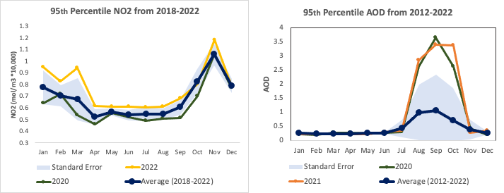
(2E) (2F)

Air Pollution Time Series Across San Joaquin Valley: (2E) Mean 95th percentile NO₂ time series from 2018 to 2022. 2020 and 2022 were outlier years (2F) Mean 95th percentile AOD time series from 2012 to 2022. Note that 2020 and 2021 were outlier years.

4.1.1.4 AOD and NO₂ Validation
The linear regression of the AOD and PM_{2.5} data for 2019 to 2022 had an R² value and residual error of 0.42 (±0.25) and 0.56 (±0.21) for Fresno and Madera, respectively. The highest correlations between AOD and PM_{2.5} were found in spring/summer, fire season. Fire season spans from May 1st through October 31st. These correlations were particularly strong when the PM2.5 values exceeded 15µg/m3. This value of 15µg/m3 is the recommended threshold for daily exposure according to the World Health Organization (Appendix A: Table 1). NO₂ satellite and sensor data for 2019–2022 displayed R² values with residual errors of 0.39 (+/- 0.17) and 0.40 (+/- 0.22) for Fresno and Bakersfield sensors, respectively. No clear correlations were revealed for NO₂ through filtering the data by season, years, or concentration thresholds. The linear regression of MODIS AOD with AERONET AOD resulted in R² value and residual error of 0.88 (±0.14; Figure 3), demonstrating a strong correlation, and therefore confirmed that our MODIS data was valid.
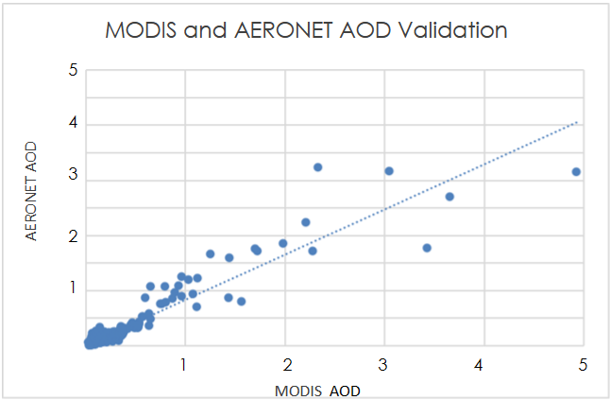
Figure 3. MODIS AOD vs. AERONET AOD Linear Regression Validation
4.1.2 Case Studies
We selected three dates for the DED. First, October 1, 2020, was selected when AOD levels were high. Next, September 16, 2021, was selected due to moderate AOD levels. Lastly, August 30, 2019, was selected for its low AOD levels. MODIS and CALIPSO data were available for these dates over San Joaquin County (Appendix F). We generated an Extinction Coefficient Plot to illustrate the Aerosol Height and thickness for our selected DED (Appendix F). This analysis provided valuable insights into the altitudes where most aerosols were distributed and their concentrations during three distinct air quality levels over San Joaquin County. The extinction coefficient plots reveal significant findings regarding aerosol distribution at different altitudes and concentrations under varying AOD levels. On days with higher AOD concentrations, aerosols exhibit higher concentrations at lower altitudes while also being present at higher altitudes.

Additionally, we created VFM plots on the same DED to identify the aerosol types present during varying pollution levels above San Joaquin County (Appendix F). The analysis indicates that on days with lower pollution, dust and polluted dust were the predominant aerosol subtypes. However, on days with higher pollution, polluted continental and smoke became prominent components in the vertical features.

4.1.3 Active Fire and Burn Permitting Analysis
We plotted the number of active fires detected in each census tract within SJV for 2021 with the VIIRS Active Fire dataset (Figure 4). This was done to better visualize the spatial distribution of fires across the valley. We utilized the plots to analyze where the distribution overlaps with areas of high pollution and social vulnerability.

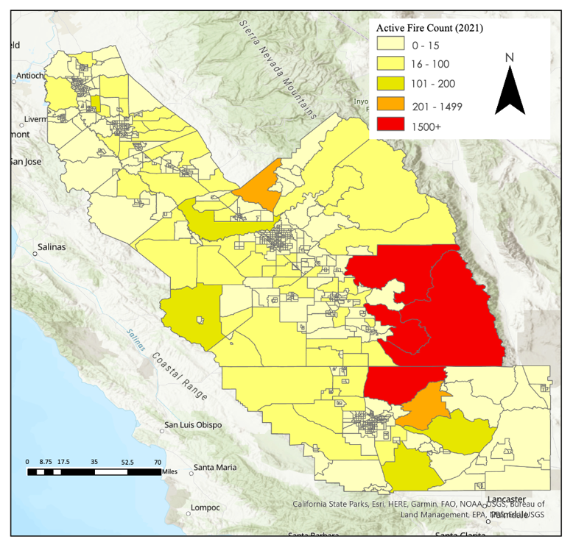

Figure 4. Active Fire Distribution Map.

To understand burn permit usage, we plotted the number of burn permits and active fires, by month, from 2012 to 2021 (Figure 5). This helped us visualize the temporal variation and scale of burn permits and active fires throughout the study period. From these graphs, we observed that the highest number of burn permits administered and the highest number of active fires detected occurred in differing months. The number of burn permits administered reaches a peak during the off-season whereas the number of fires detected peaks during the fire season.

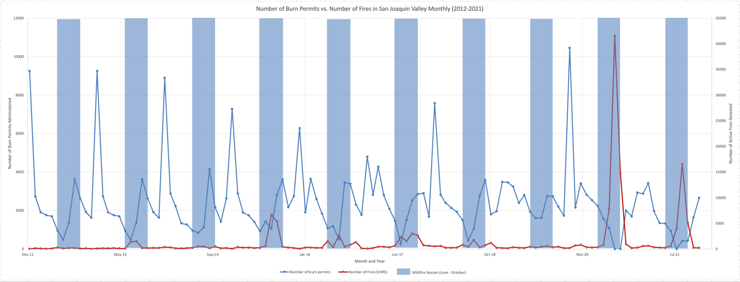
Figure 5. Burn Permitting and Active Fire Time series

We also produced regression models to determine the correlation between our air quality indexes and either burn permits administered or active fires detected in census tracts. Figure 1 in Appendix D contains these plots which illustrate weak correlation between the number of active fires detected, burn permits adminsitered in a census tract, and the detected values of the four main air quality metrics (median AOD, 95th percentile AOD, median NO₂, 95th percentile NO₂). However, the team also produced regression models to determine if there was a correlation between months of high AOD and high number of fires detected and found a moderately-strong correlation (Appendix D). The team also ran a t-test to determine if there was a significant difference in burn permitting and the number of actives detected in agricultural vs non-agricutlural census tracts. Table 1 in Appendix E demonstrates that agricultural tracts got a statistically significant higher number of burn permits, however there is no statistical difference in the number of active fires detected between agricultural vs non-agricultural tracts. After removing the three census tracts that were involved in the two massive wildfires in Tulare County, which produced more than half of the detected fires, agricultural tracts show a statistically significant increase in the number of active fires compared to non-agricultural tracts. We also created one bivariate map showing the overlap between social vulnerability and active fires detected by the VIIRS satellite sensor (Figure 6). If we overlap the same data with the highest AOD values in 2021, we can see that many areas with high fire counts also had higher max values of AOD. However, we found no significant correlation between fire counts and AOD values. It is worth noting that due to wildfires, a map of this analysis could change from year to year based on the presence and location of wildfires.

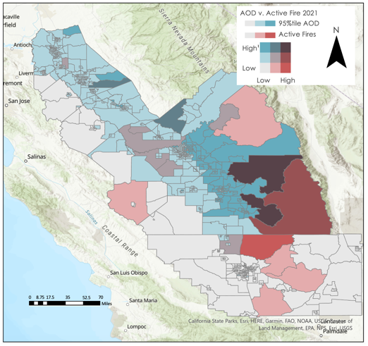
Figure 6. Active Fire Vulnerability Maps:

4.1.4 Vulnerability Maps
We created a social vulnerability index for each census tract in our study area by both conducting a PCA and using the CDC method as described in 3.3.3 with the demographic data acquired in 3.2.4. Comparing the indices created by both, the team found that the CDC and PCA approach had moderate agreement in identifying which census tracts were more socially vulnerable relative to the others in the SJV. The top three indicators of a high social vulnerability score for each census tract were poverty level, minority population, and income, according to the PCA. The team used these values to produce our vulnerability index for the bivariate maps.

Our team produced six bivariate maps displaying the spatial overlap of social vulnerability and air quality in SJV. We created these bivariate maps to determine which census tracts are disproportionately impacted by poor air pollution, or active fires, given their vulnerability. All bivariate maps visualized social vulnerability in conjunction with either AOD, NO₂, or active fire count. By census tract, we plotted the mean of median and 95th percentile AOD and NO₂ data to demonstrate how social vulnerability interacts with air pollution on both normal and high pollution concentration days (Figure 7A, 7B, 7C, 7D).

AOD was higher in agricultural regions of the SJV (Figure 6A, Appendix C), while NO₂ was higher along transportation corridors and within urban areas (Figure 6B, Appendix C). When examining San Joaquin County, where Stockton is located, census tracts within South Stockton, a region that has historically been redlined and disinvested in and where LMR resides, has both the highest AOD vulnerability and NO₂ vulnerability (Figure 7C, 7D).

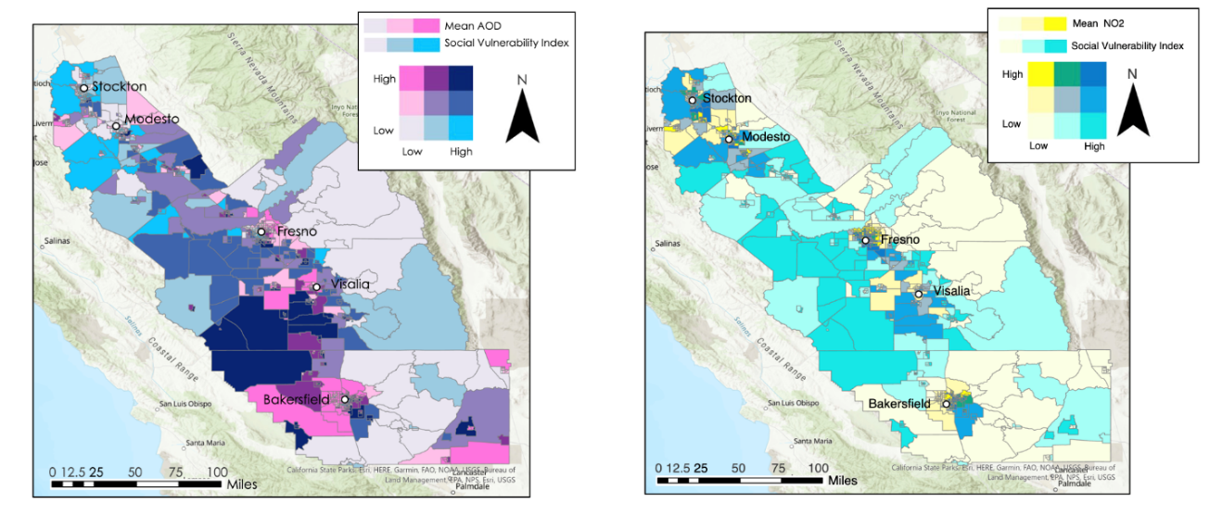
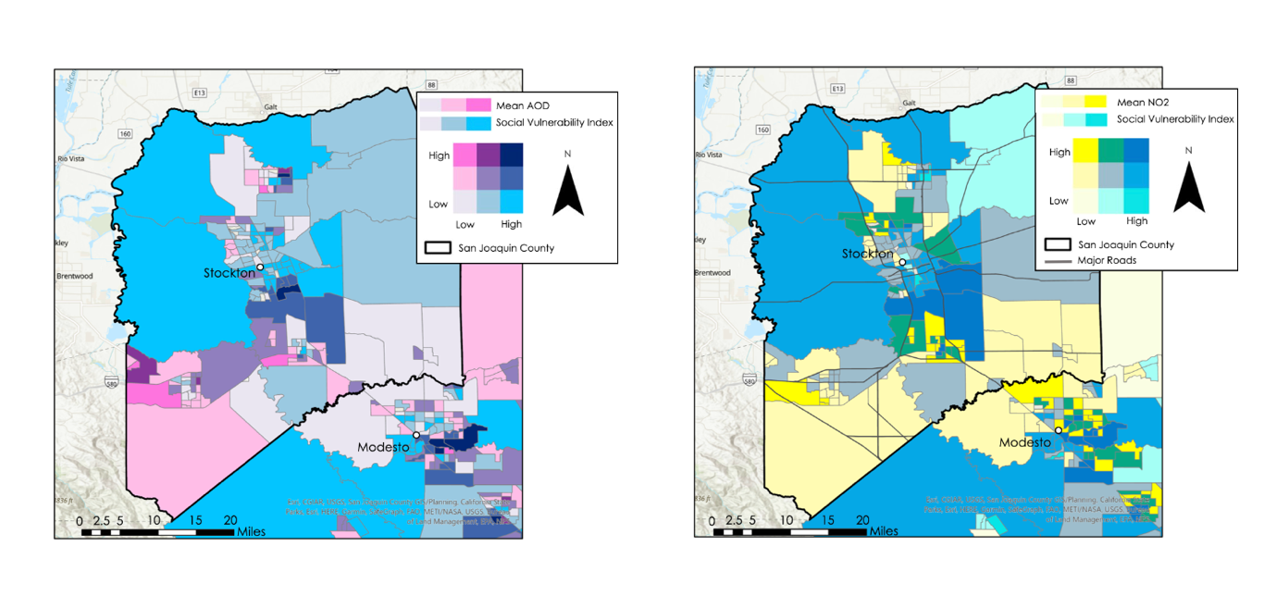
Figure 7. Pollution Vulnerability Maps. A. (Top left map) 95th Percentile AOD Vulnerability Map. B. (Top right map) 95th Percentile NO₂ Vulnerability Map. C. (Bottom left map) 95th Percentile AOD in San Joaquin Count. D. (Bottom right map) 95th Percentile NO2 in San Joaquin County.

We also produced regression models to determine the correlation between our air quality indexes and social vulnerability in census tracts. Figure 1 in Appendix D contains these plots which illustrate weak correlation between social vulnerability and the four main air quality metrics (median AOD, 95th percentile AOD, median NO₂, 95th percentile NO₂). We also ran t-tests to see if census tracts with social vulnerability scores above the median experienced higher levels of AOD and NO₂ than those with scores below the median. There was no statistical difference in AOD values between census tracts above and below the median in terms of social vulnerability, but census tracts with social vulnerability scores above the median do experience statistically higher NO₂ concentration. (Appendix D, Table 1)

4.1.5 Discussion
The team found that AOD was higher in agricultural regions, while NO₂ was higher along transportation corridors and urban areas. The team identified both high vulnerability for AOD and NO₂ in census tracts in the South Stockton community. This area has been historically redlined and is where LMR resides. Across SJV, AOD values peak from August to November which overlaps with the latter months of the wildfire season. NO₂ values peak in late fall and early winter from November to January which could either be explained by times of high travel and commercial activity, or thermal inversions.

For our case studies, the extinction coefficient plots illustrate that on days of high pollution, aerosols occurred at greater concentration in lower elevation regions and extended into higher altitudes. Furthermore, the VFM illustrates that the aerosol subtype was mainly polluted dust. During days of high pollution, polluted continental dust and smoke became major components of the air mixtures. Since many of these pollutants exist below 500 meters, they can all have an adverse effect on human health.

During wildfire season, the number of active fires detected tends to spike. Wildfire season occurs at a different time period than when the greatest number of burn permits are administered. There is little correlation between burn permits administered and active fires detected by census tract for the entire SJV (Figure 1 Appendix E). The team reasons that wildfires are the predominant source of active fires in the valley. This is further supported by Table 1 in Appendix E which demonstrates that there are more wildfires in non-agricultural tracts than agricultural tracts on average, though this is not statistically significant. These wildfires are also skewed to three specific census tracts in Tulare County, which overlap with Sequoia National Park, where a massive wildfire occurred in 2021 in August through October. Removing these census tracts from the t-test leads to agricultural tracts having a statistically significant greater number of active fires than non-agricultural tracts (Table 1, Appendix E). Given that burn permitting correlates highly with active fire detection in agricultural tracts (Appendix E, Figure 1), reducing burn permits administered in these areas could lead to overall less non-wildfire fires detected.

In our AOD bivariate choropleth maps, census tracts that were darker purple had higher AOD pollution vulnerability. In our NO₂ bivariate choropleth maps, census tracts that were darker blue had higher NO₂ pollution vulnerability. In both cases, this indicates an overlap of both high pollution levels and high social vulnerability. For AOD, pollution vulnerability was highest in inner city areas and in certain rural, agricultural census tracts. For NO₂, pollution vulnerability was highest in urban areas, especially tracts along major roads and highways. While there was no direct correlation between social vulnerability and any of the air quality indexes, census tracts with social vulnerability scores above the median do experience statistically higher levels of NO₂ concentrations. This further highlights the disparate impacts that highway planning near disenfranchised and historically redlined communities have had on pollution exposure throughout SJV.

4.2 Feasibility Assessment
The methodology that our team created was effective at accessing and representing information pertaining to air quality distribution in the area of interest. By using Earth observation satellite tools, the team could visualize air quality in all areas within the valley. This is an improvement over past strategies that relied on using in-situ ground sensors, which only can show accurate air quality measures at the exact coordinates in which the sensors are located. Furthermore, by averaging the air quality values in the census tracts, the team also gave LMR a method of easily identifying small areas of interest based on air pollution distribution. With this, LMR can easily identify areas of high pollution vulnerability and focus advocacy efforts on local municipal governments that have jurisdiction over these areas.

By leveraging data from both the EPA EJScreen and the CDC PLACES initiative, the team was able to improve on prior social vulnerability indexes by directly incorporating health-related data. This approach gives the partners a more holistic view on the vulnerabilities in each census track within the study area by considering the direct health risks when creating the indexes. This is especially relevant given the project’s focus on environmental health, which led the team to specifically incorporate health indicators that are directly related to the risks associated with air pollution. With this information, LMR can use our bivariate maps with confidence that the overall pollution vulnerability best reflects both the air quality and sociodemographic risk distribution.

Similar to our air quality maps, the implementation of active fire maps also provides a visualization of potential air pollution sources across the valley. With this information, LMR can also cross-examine active fire locations with burn permitting locations to determine the legality of these fires and whether to pursue legal action or advocate for stronger enforcement. Though active fire data does not discriminate between agricultural fires, which is what our partner is most concerned about, and wildfires. The active fire map provides a valuable and powerful visualization of where potential fire management needs to be increased, especially since air pollution from these sources is harmful regardless of its origin. Lastly, the discernment between agriculture and non-agricultural census tracts provided by the USDA adds greater contextual data to our findings that can also help our partners focus their advocacy efforts for both air quality and fire management.

4.3 Future Work
Future scientific work of this project should further aerosol-altitude analysis with CALIPSO and expand upon the case study portion of our project for a better understanding of aerosol distribution at different vertical heights at different levels of pollution across the entire SJV. Our case study focused primarily on San Joaquin County, which is not representative of all portions and parts of the valley. Completing more case studies at differing locations, notably different high population cities, would give a better understanding of the vertical distribution of aerosol in all these high priority locations and thus better inform advocacy in these areas. Furthermore, TROPOMI can also measure carbon monoxide (CO), and formaldehyde (HCHO), which are other pollutants of concern that can directly affect human health. Future studies should attempt to look at the distribution of these pollutants across the valley. The investigation of CO also opens a new possibility to distinguish sources of AOD, since CO is an aerosol that indicates the presence of fires.

Moreover, further work could be expanded upon by looking at other environmental hazards that pose health and wellbeing risk to SJV residents, such as wildfires, water scarcity or quality, and urban heat. Exploring these other environmental hazards in conjunction with air pollution would provide a more comprehensive view of environmental risks and their disproportionate impact on certain populations. This understanding of environmental vulnerability can also be expanded upon by creating a more comprehensive social vulnerability index. Currently, the social vulnerability index does not incorporate variables that indicate the population is attempting to adapt to current risks, such as ventilation installation rate or HVAC system prevalence. Incorporating more of these variables into the social vulnerability index would increase vulnerability map accuracy.

5. Conclusions
Through our results, air pollution is not equitably distributed throughout SJV. There are many areas of high social vulnerability that also experience high levels of air pollution. Specifically, NO₂ is more inequitably distributed than AOD as seen in our bivariate maps. This is most likely because NO₂ is an aerosol associated with commerce and transportation. Some research suggests industries build near lower-income communities and that NO2 pollution is higher in historically red-lined communities (Mohai & Saha, 2015 and Lane et al., 2022). This is further confirmed by our statistical analysis that found that NO₂ concentrations were greater in non-agriculture census tract, which tend to be more urban. AOD concentrations were greater in agriculture areas, which may be due to the high levels of dust, pesticides, and chemicals associated with these regions.

Throughout the SJV, active fires and air pollution concentration was temporally correlated but not spatially correlated. Air pollution concentrations in the SJV were higher in months with more active fires, however census tracts with more active fires did not see any significant difference in air quality than those with less. This is most likely due to the transboundary nature of air pollution, which makes it more difficult to find any spatial correlation since aerosols can easily move away from their census tract sources. Our regressions attempting to model the correlation between air pollution, social vulnerability, and burn permits further confirms this as there was no significant correlation between a census tract’s social vulnerability index or burn permit count and its air quality. However, the team did find that census tracts with greater social vulnerability were exposed to statistically higher concentrations of NO₂, further confirming our finding about the inequitable distribution of this aerosol across the valley.

Overall, the team found that satellite remote sensing can be used to estimate air quality in the SJV with moderate accuracy. Our validation modelling found good correlation between satellite derived data and data taken from in-situ ground monitors. This provided more confidence to the validity of our bivariate maps, which only further underscores that inequitable distribution of air pollution across the SJV.

6. Acknowledgements
The team would like to thank our partner, Little Manila Rising, for their collaboration and input on the project. We also would like to give a special thank you to our science advisors Dr. Kenton Ross, Dr. Travis Toth, Dr. Liz Wiggins, Lance Watkins, and our Node Fellow Julianne Liu for their continued support throughout this term.

This material contains modified Copernicus Sentinel data (2018-2022), processed by ESA.

Maps throughout this work were created using ArcGIS® software by Esri. ArcGIS® and ArcMap™ are the intellectual property of Esri and are used herein under license. All rights reserved.

This work utilized data made available through the NASA Commercial Smallsat Data Acquisition (CSDA) program.

Any opinions, findings, and conclusions or recommendations expressed in this material are those of the author(s) and do not necessarily reflect the views of the National Aeronautics and Space Administration.

This material is based upon work supported by NASA through contract NNL16AA05C.

7. Glossary
AERONET – Ground-based remote sensing Aerosol Robotic Network.
Aerosol Optical Depth (AOD) – A measure of aerosols distributed within a column of air from the measuring instrument to either the ground or top of the atmosphere.
Agriculture Fire/Burning – A technique used by farmers to burn excess crops and clear waste and weeds.
ArcGIS Pro – Geographic Information System (GIS) Software.
CALIOP – Cloud-Aerosol Lidar and Infrared with Orthogonal Polarization, source/sensor onboard of CALIPSO satellite.
Earth observations – Satellites and sensors that collect information about the Earth’s physical, chemical, and biological systems over space and time
Extinction coefficient – High extinction coefficient indicates high absorption and scattering of light and high associated aerosols present in the atmosphere, which can be comparable with ground sources.
GEE – Google Earth Engine, Earth observations processing software.
Lidar – Light Detection and Ranging, also known as laser imager.
MAIAC – Multi-Angle Implementation of Atmospheric Correction, combines AOD measurements from Terra and Aqua Satellites.
MODIS – Moderate Resolution Imaging Spectroradiometer.
NO₂ – Nitrogen Dioxide used as a proxy for ozone and transportation emissions
Particulate Matter (PM) – A mixture of solid particles and liquid droplets found in the air.
TROPOMI – Tropospheric Monitoring Instrument on Sentinel-5P.
Vertical Feature Mask (VFM) – Describes vertical and horizontal distribution of aerosol layers only, displaying the aerosol type for all the layers.
VIIRS – Visible Infrared Imaging Radiometer Suite on the Suomi-NPP
Wildfire – A large, destructive fire that spreads quickly.

8. References
Atkinson, R. W., Kang, S., Anderson, H. R., Mills, I. C., & Walton, H. A. (2014). Epidemiological
time series studies of PM2.5 and daily mortality and hospital admissions: A systematic review and meta-analysis. Thorax, 69(7), 660–665. https://doi.org/10.1136/thoraxjnl-2013-204492

Bertoldi, R., Zhang, E., Khan, M., & Lopez-Velazquez. (2022, May 20). Eat Crops Don’t Breathe Crops! ArcGIS StoryMaps. https://storymaps.arcgis.com/stories/065ec8d88bdf441aa56914e037cb7909

Calderón-Garcidueñas, L., & Ayala, A. (2022). Air Pollution, Ultrafine Particles, and Your Brain: Are Combustion Nanoparticle Emissions and Engineered Nanoparticles Causing Preventable Fatal Neurodegenerative Diseases and Common Neuropsychiatric Outcomes? Environmental Science & Technology, 56(11), 6847–6856. https://doi.org/10.1021/acs.est.1c04706

California Air Resources Board. (2019, January 24). Clean-air plan for San Joaquin Valley first to meet all federal standards for fine particle pollution | California Air Resources Board. https://ww2.arb.ca.gov/news/clean-air-plan-san-joaquin-valley-first-meet-all-federal-standards-fine-particle-pollution

Cal Fire. (2022, October 21). Creek Fire. https://www.fire.ca.gov/incidents/2020/9/4/creek-fire/

Chen, J., Lu, J., Avise, J. C., DaMassa, J. A., Kleeman, M. J., & Kaduwela, A. P. (2014). Seasonal modeling of PM2.5 in California’s San Joaquin Valley. Atmospheric Environment, 92, 182–190. https://doi.org/10.1016/j.atmosenv.2014.04.030

Christian, P., Summers, F., Vargas Magana, Y., & Delgado, A. (2023). Great Salt Lake Health and Air Quality: Monitoring Lakebed Exposure and its Impact on Air Quality and Environmental Hazards in the Great Salt Lake Watershed. NASA DEVELOP.

Copernicus Sentinel data processed by ESA, Koninklijk Nederlands Meteorologisch Instituut (KNMI). (2021). Sentinel-5P TROPOMI Tropospheric NO2 1-Orbit L2 5.5km x 3.5km, Version 2. Greenbelt, MD, USA, Goddard Earth Sciences Data and Information Services Center (GES DISC), accessed 3 July 2023. https://doi.org/10.5270/S5P-9bnp8q8

Enayati Ahangar, F., Cobian-Iñiguez, J., & Cisneros, R. (2022). Combining Regulatory Instruments and Low-Cost Sensors to Quantify the Effects of 2020 California Wildfires on PM2.5 in San Joaquin Valley. Fire, 5(3), Article 3. https://doi.org/10.3390/fire5030064

Flanagan, B. E., Gregory, E. W., Hallisey, E. J., Heitgerd, J. L., & Lewis, B. (2011). A Social Vulnerability Index for Disaster Management. Journal of Homeland Security and Emergency Management, 8(1). https://doi.org/10.2202/1547-7355.1792

Galvin, G. (2020, January 22). Stockton, California: America’s Most Diverse City Is Still Scarred by Its Past. US News & World Report. https://www.usnews.com/news/cities/articles/2020-01-22/stockton-california-americas-most-diverse-city-is-still-scarred-by-its-past

Gangwar, R. S., Bevan, G. H., Palanivel, R., Das, L., & Rajagopalan, S. (2020). Oxidative stress pathways of air pollution mediated toxicity: Recent insights. Redox Biology, 34, 101545.
https://doi.org/10.1016/j.redox.2020.101545

Gupta, P., Lind, E. (2023). AERONET.NASA [Level 2.0 AOD daily values] Accessed: [2023-03-01], https://aeronet.gsfc.nasa.gov/cgi-bin/data_display_aod_v3site=Dugway_Utah&nachal=2&level=3&place_code=10
Gupta, P., Christopher, S. A., Wang, J., Gehrig, R., Lee, Y., & Kumar, N. (2006). Satellite remote sensing of particulate matter and air quality assessment over global cities. Atmospheric Environment, 40(30), 5880–5892. https://doi.org/10.1016/j.atmosenv.2006.03.016
Harder+Company Community Research. (2016). San Joaquin County 2016 Community Health Needs Assessment. https://www.sjcog.org/DocumentCenter/View/3489/2016-CHNA-full-document---narrative-and-health-profiles
Hixson, M., Mahmud, A., Hu, J., & Kleeman, M. J. (2012). Resolving the interactions between population density and air pollution emissions controls in the San Joaquin Valley, USA. Journal of the Air & Waste Management Association, 62(5), 566–575. https://doi.org/10.1080/10962247.2012.663325
Hoffmann, B., Boogaard, H., de Nazelle, A., Andersen, Z. J., Abramson, M., Brauer, M., Brunekreef, B., Forastiere, F., Huang, W., Kan, H., Kaufman, J. D., Katsouyanni, K., Krzyzanowski, M., Kuenzli, N., Laden, F., Nieuwenhuijsen, M., Mustapha, A., Powell, P., Rice, M., … Thurston, G. (2021). WHO Air Quality Guidelines 2021–Aiming for Healthier Air for all: A Joint Statement by Medical, Public Health, Scientific Societies and Patient Representative Organisations. International Journal of Public Health, 0. https://doi.org/10.3389/ijph.2021.1604465

Lane, H. M., Morello-Frosch, R., Marshall, J. D., & Apte, J. S. (2022). Historical Redlining Is Associated with Present-Day Air Pollution Disparities in U.S. Cities. Environmental Science & Technology Letters, 9(4), 345–350. https://doi.org/10.1021/acs.estlett.1c01012

Lattanzio, R. K. (2022). Clean Air Act: A Summary of the Act and Its Major Requirements (No. RL30853). Congressional Research Service.

Lee, H. J., Kuwayama, T., & FitzGibbon, M. (2023). Trends of ambient O3 levels associated with O3 precursor gases and meteorology in California: Synergies from ground and satellite observations. Remote Sensing of Environment, 284, 113358. https://doi.org/10.1016/j.rse.2022.113358

Lelieveld, J., Evans, J. S., Fnais, M., Giannadaki, D., & Pozzer, A. (2015). The contribution of outdoor air pollution sources to premature mortality on a global scale. Nature, 525(7569), Article 7569. https://doi.org/10.1038/nature15371

Li, X., Huang, S., Jiao, A., Yang, X., Yun, J., Wang, Y., Xue, X., Chu, Y., Liu, F., Liu, Y., Ren, M., Chen, X., Li, N., Lu, Y., Mao, Z., Tian, L., & Xiang, H. (2017). Association between ambient fine particulate matter and preterm birth or term low birth weight: An updated systematic review and meta-analysis. Environmental Pollution, 227, 596–605. https://doi.org/10.1016/j.envpol.2017.03.055

Liu, B., Ma, Y., Gong, W., Zhang, M., Wang, W., & Shi, Y. (2018). Comparison of AOD from CALIPSO, MODIS, and Sun Photometer under Different Conditions over Central China. Scientific Reports, 8(1), Article 1. https://doi.org/10.1038/s41598-018-28417-7
Lyapustin, A., Wang, Y. (2018). MCD19A2 MODIS/Terra+Aqua Land Aerosol Optical Depth Daily L2G Global 1km SIN Grid V006 [MCD19A2 V006]. NASA EOSDIS Land Processes DAAC. Accessed 2023-07-03 from https://doi.org/10.5067/MODIS/MCD19A2.006
Mohai, P., & Saha, R. (2015). Which came first, people or pollution? Assessing the disparate siting and post-siting demographic change hypotheses of environmental injustice. Environmental Research Letters, 10(11), 115008. https://doi.org/10.1088/1748-9326/10/11/115008
Morehouse, L. (2015, September 19). Grapes Of Wrath: The Forgotten Filipinos Who Led A Farmworker Revolution. https://www.wbur.org/npr/440861458/grapes-of-wrath-the-forgotten-filipinos-who-led-a-farmworker-revolution
NASA/LARC/SD/ASDC. (2018). CALIPSO Lidar Level 2 Aerosol Profile, V4-20 [CAL_LID_L2_05kmAPro-Standard-V4]. NASA Langley Atmospheric Science Data Center DAAC. Retrieved from https://doi.org/10.5067/CALIOP/CALIPSO/LID_L2_05KMAPRO-STANDARD-V4-20
NASA Earth Observatory. (2010, November 2). Aerosols: Tiny Particles, Big Impact [Text.Article]. NASA Earth Observatory. https://earthobservatory.nasa.gov/features/Aerosols/page5.php
NRT VIIRS 375 m Active Fire product VNP14IMGT distributed from NASA FIRMS. Available on-line https://earthdata.nasa.gov/firms. https://doi.org/10.5067/FIRMS/VIIRS/VNP14IMGT_NRT.002
PLACES. Centers for Disease Control and Prevention. Accessed [July 1, 2023]. https://www.cdc.gov/places

Planet Labs PBC. (2018). Planet Application Program Interface: In Space for Life on Earth. https://api.planet.com

Public Policy Institute of California. (2023). Policy Brief: The Future of Agriculture in the San Joaquin Valley. https://www.ppic.org/publication/policy-brief-the-future-of-agriculture-in-the-san-joaquin-valley/

RStudio Team (2020). RStudio: Integrated Development for R. RStudio, PBC, Boston, MA http://www.rstudio.com/
Rodriguez-Delgado, C. (2022, June 16). California has some of the worst air quality in the country. The problem is rooted in the San Joaquin Valley. PBS NewsHour. https://www.pbs.org/newshour/nation/california-has-some-of-the-worst-air-quality-in-the-country-the-problem-is-rooted-in-the-san-joaquin-valley
Sharma, S., Chandra, M., & Kota, S. H. (2020). Health Effects Associated with PM2.5: A Systematic Review. Current Pollution Reports, 6(4), 345–367. https://doi.org/10.1007/s40726-020-00155-3

USDA National Agricultural Statistics Service Cropland Data Layer. (2022). Published crop-specific data layer [Online]. Available at https://nassgeodata.gmu.edu/CropScape/ (accessed {July 2023}). USDA-NASS, Washington, DC.
US Census Bureau. (2020). Quick Facts San Joaquin County, California. https://www.census.gov/quickfacts/fact/table/sanjoaquincountycalifornia/PST045222
US Environmental Protection Agency. Air Quality System Data Mart [internet database] available via https://www.epa.gov/outdoor-air-quality-data. Accessed July 13, 2023.
US Environmental Protection Agency. 2020 EJScreen. www.epa.gov/ejscreen/download-ejscreen-data
US Environmental Protection Agency. (2023, May 31). Current Nonattainment Counties for All Criteria Pollutants. Green Book.
https://www3.epa.gov/airquality/greenbook/ancl.html
US Environmental Protection Agency. (2016, April 19). Particulate Matter (PM) Basics. https://www.epa.gov/pm-pollution/particulate-matter-pm-basics
Xing, Y.-F., Xu, Y.-H., Shi, M.-H., & Lian, Y.-X. (2016). The impact of PM2.5 on the human respiratory system. Journal of Thoracic Disease, 8(1). https://doi.org/10.3978/j.issn.2072-1439.2016.01.19

Zhang, J. (Jim), Wei, Y., & Fang, Z. (2019). Ozone Pollution: A Major Health Hazard Worldwide. Frontiers in Immunology, 10. https://www.frontiersin.org/articles/10.3389/fimmu.2019.02518
2020 TIGER/Line Shapefiles (machinereadable data files) / prepared by the U.S. Census Bureau. (2019). https://www.census.gov/cgi-bin/geo/shapefiles/index.php?year=2020&layergroup=Census+Tracts

9. Appendices

Appendix A: Satellite Data Validation

Table A1. R² and Residual Error results for two EPA sensors used to validate AOD and PM_{2.5} data
Filtered Data | Fresno R² | Residual Error | Madera R² | Residual Error
All Data (2019–2022) | 0.4219 | 0.2489 | 0.5589 | 0.2092
2019 Only | 0.0214 | 0.04597 | 0.0567 | 0.04487
2020–2022 | 0.4423 | 0.2769 | 0.5689 | 0.2311
Fall | 0.2717 | 0.2625 | 0.3851 | 0.2395
Winter | 0.2804 | 0.2802 | 0.3955 | 0.2664
Spring | 0.4700 | 0.2656 | 0.5820 | 0.2268
Summer | 0.5946 | 0.2987 | 0.6867 | 0.2485
Fire Season | 0.5711 | 0.2669 | 0.6373 | 0.237
Not Fire Season | 0.1050 | 0.06021 | 0.0948 | 0.05352
PM 2.5 < 15µg/m³ | 0.0265 | 0.06927 | 0.0095 | 0.06882
PM 2.5 >= 15µg/m³ | 0.4033 | 0.4216 | 0.5650 | 0.3874

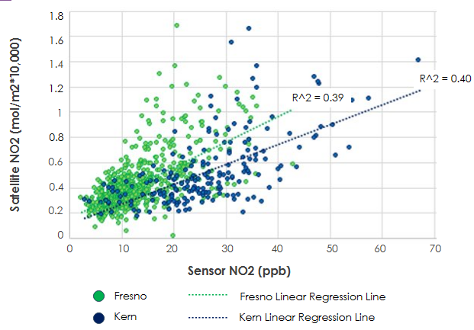
Figure A1. Scatterplot showing the correlation between satellite collected NO2 data from Sentinel-5 and EPA ground-sensor data from Fresno and Kern counties.

Table A2. R² and Residual Error results for two EPA sensors used to validate NO₂ data
Filtered Data | Fresno R² | Residual Error | Kern R² | Residual Error
All Data (2019–2022) | 0.3892 | 0.1656 | 0.3958 | 0.2158
2019 Only | 0.3853 | 0.1507 | 0.6666 | 0.1852
2020–2022 | 0.3961 | 0.1693 | 0.271 | 0.2225
Fall | 0.3446 | 0.1895 | 0.3098 | 0.2451
Winter | 0.4308 | 0.1859 | 0.2829 | 0.2541
Spring | 0.4423 | 0.1498 | 0.3039 | 0.2299
Summer | 0.1089 | 0.09087 | 0.1365 | 0.1009
Fire Season | 0.2104 | 0.1051 | 0.3518 | 0.1419
Not Fire Season | 0.4031 | 0.2165 | 0.3185 | 0.2954
NO2 < 13.3ppb | 0.1221 | 0.09681 | 0.0007184 | 0.08102
NO2 >= 13.3ppb | 0.1228 | 0.2422 | 0.3615 | 0.226

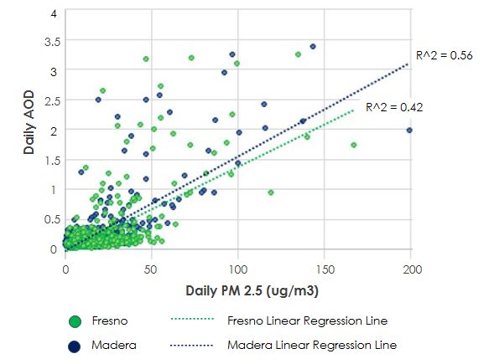
Figure A2. Scatterplot showing the correlation between satellite collected AOD data from MODIS and EPA ground-sensor data from Fresno and Madera counties.

Appendix B: Maps

Figure B1. (Top Left) This map shows the median AOD across the SJV. (Top Right) This map shows the 95th percentile AOD across the SJV. (Bottom Left) This map showcases the distribution of 95th percentile nitrogen dioxide across the SJV. (Bottom Right) This map is the Bottom Left Map overlaid by the major roads of the area.

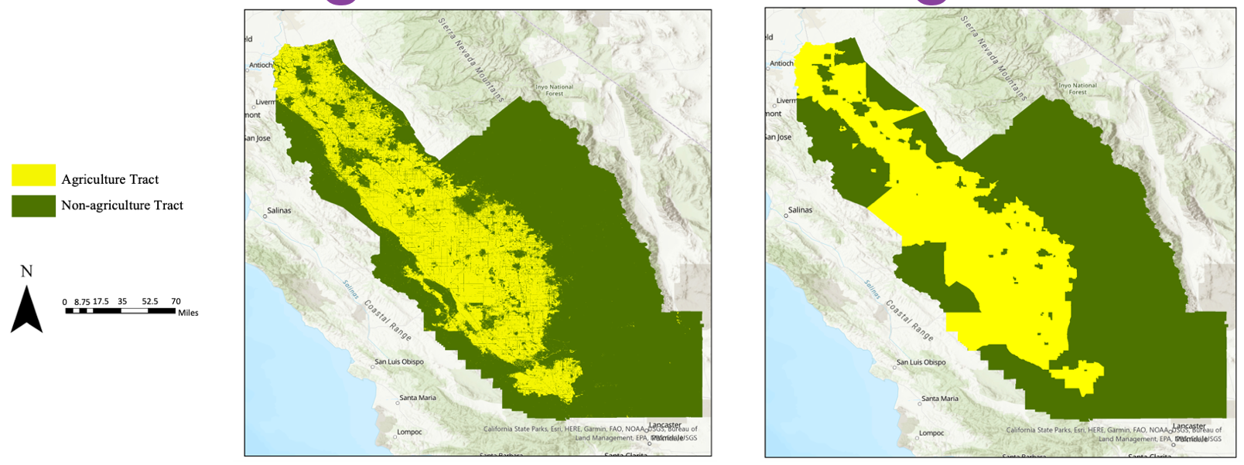
Appendix C: Agriculture Classification Graphs
- (B)
Figure C1. Agriculture Census Tract Classification using USDA Cropland Data. Pixels in the study area classified as agriculture (yellow) or non-agriculture (red) pixels depending on the USDA Cropland land use classification, (B) Census tracts in the study area classified as agriculture (yellow) or non-agriculture (red) based on the predominant pixel classification within the zonal area.

Table C1. Air quality statistics for agriculture vs. non-agriculture census tracts from 2019-2021.
 | Median AOD mean | 95%tile AOD mean | Median NO₂ mean | 95%tile NO₂ mean | Median CO mean | 95%tile CO mean
Agriculture tract mean value | 0.107 | 0.354 | 0.0000367 | 0.0000661 | 0.0335 | 0.0452
Non-agriculture tract mean value | 0.104 | 0.327 | 0.0000396 | 0.0000836 | 0.0333 | 0.0447
T-test p-value | 0.00619 | 4.18 x 10⁻⁶ | 4.66 x 10⁻¹¹ | 8.32 x 10⁻⁴⁰ | 0.0111 | 0.00158

Appendix D: Air Quality Regression Models and Statistical Tests
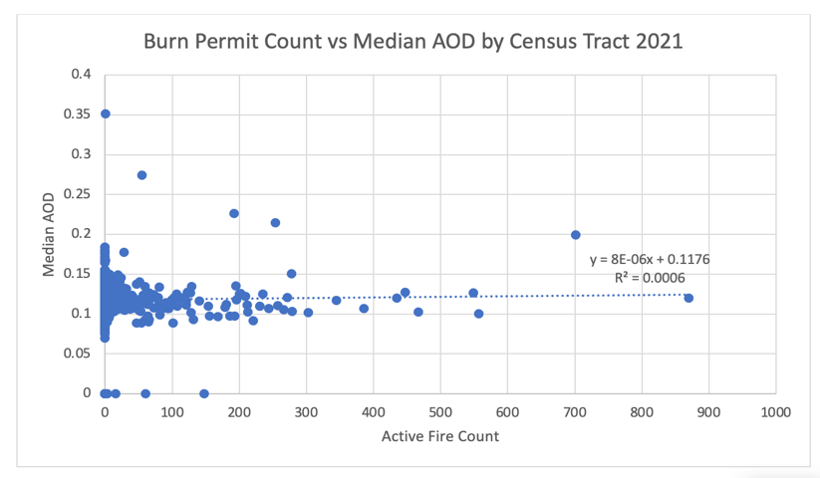
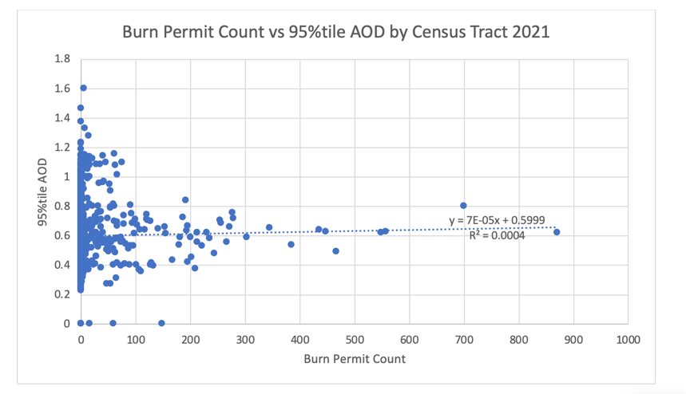
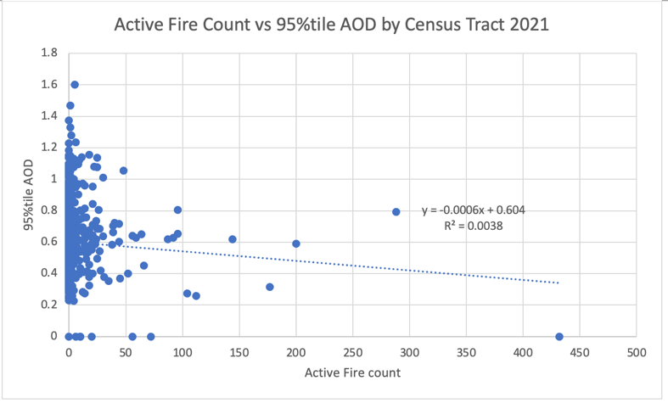
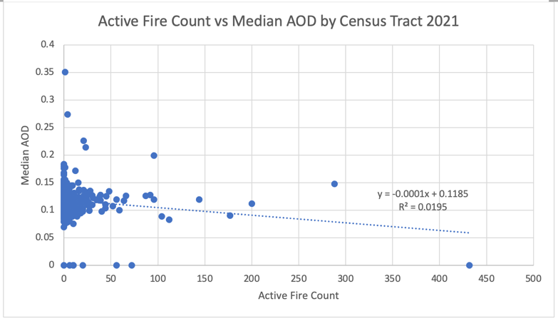
Figure D1. Active Fire and Burn Permit Count vs. Aerosol Optical Depth value by census tract in 2021 regression models.

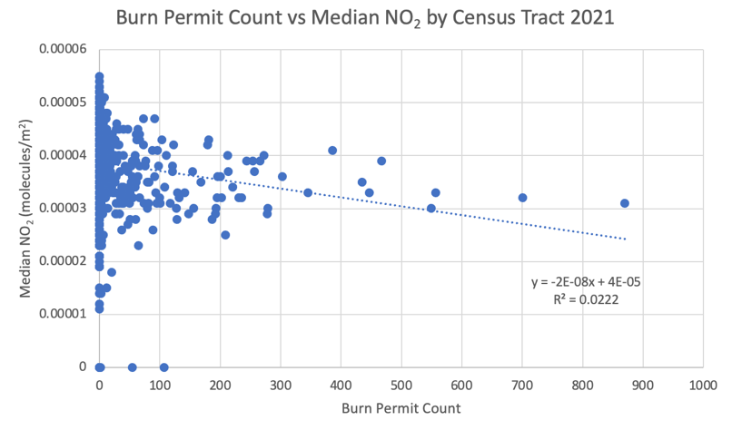
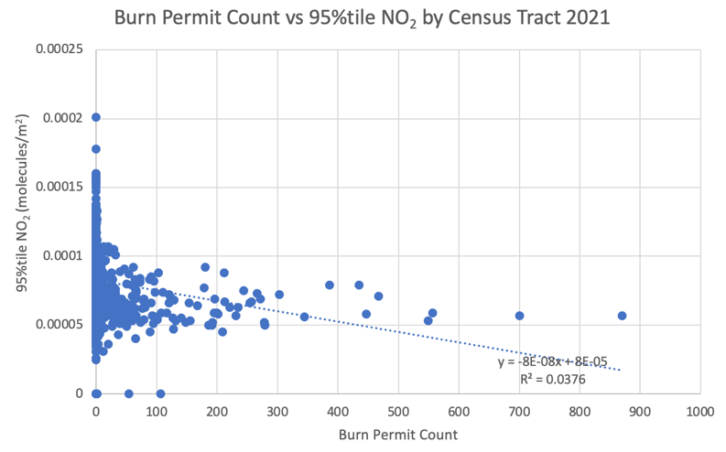
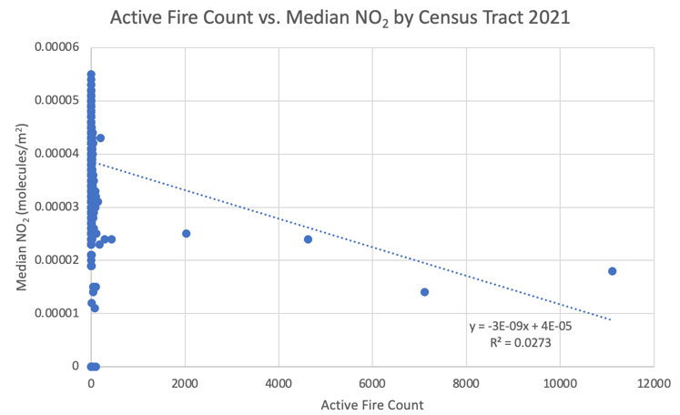
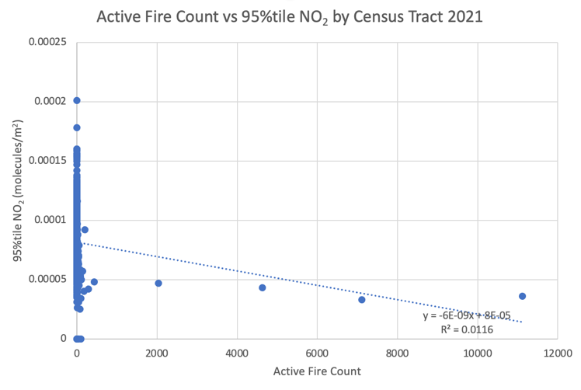
Figure D2. Active Fire and Burn Permit Count vs. Nitrogen Dioxide value by census tract in 2021 regression models.

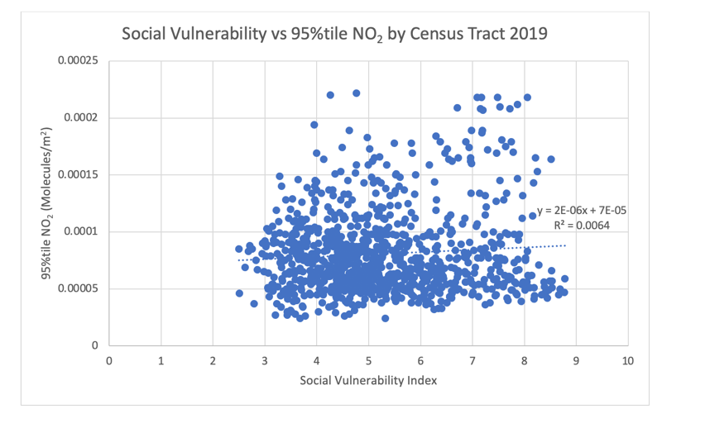
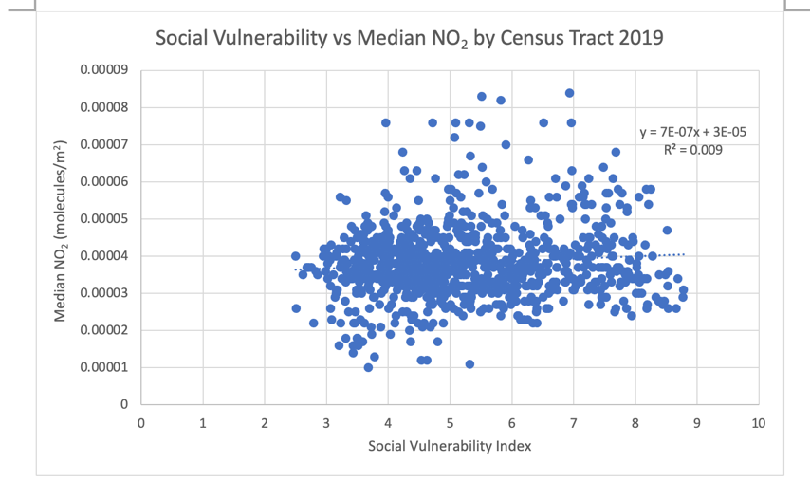
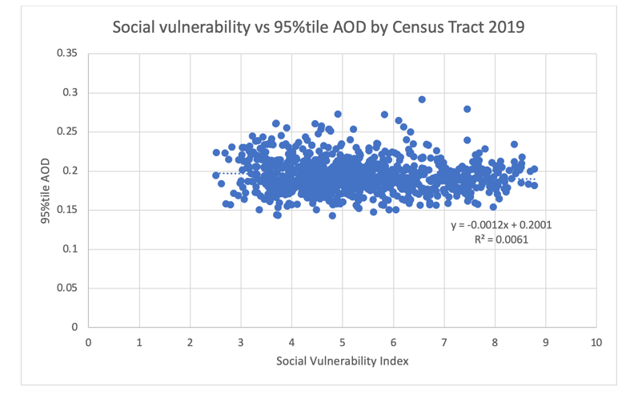
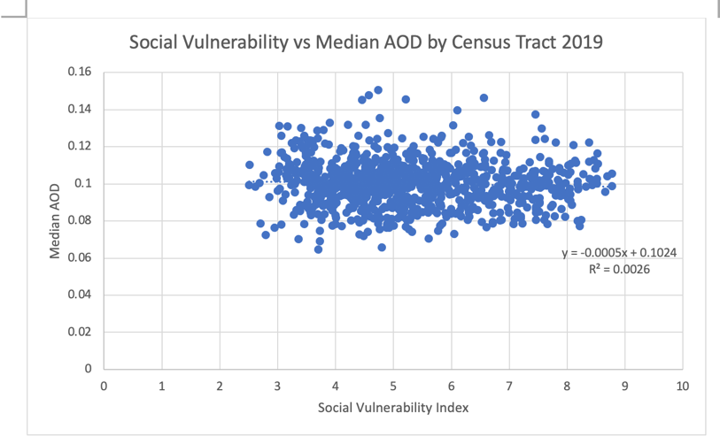
Figure D3. Social Vulnerability Index vs. Nitrogen Dioxide and Aerosol Optical Depth value by census tract in 2019 regression models.

Table D1. Air quality t-test statistics as a function of a census tract’s social vulnerability index in 2019
Social Vulnerability Index Value | Median AOD mean | 95%tile AOD mean | Median NO₂ mean | 95%tile NO₂ mean
Above median | 0.995 | 0.193 | 0.0000393 | 0.0000831
Below median | 0.101 | 0.195 | 0.0000372 | 0.0000784
t-test p-value | 0.175 | 0.0818 | 0.000427 | 0.0454

Appendix E: Active Fire Regression Models and Statistical Tests
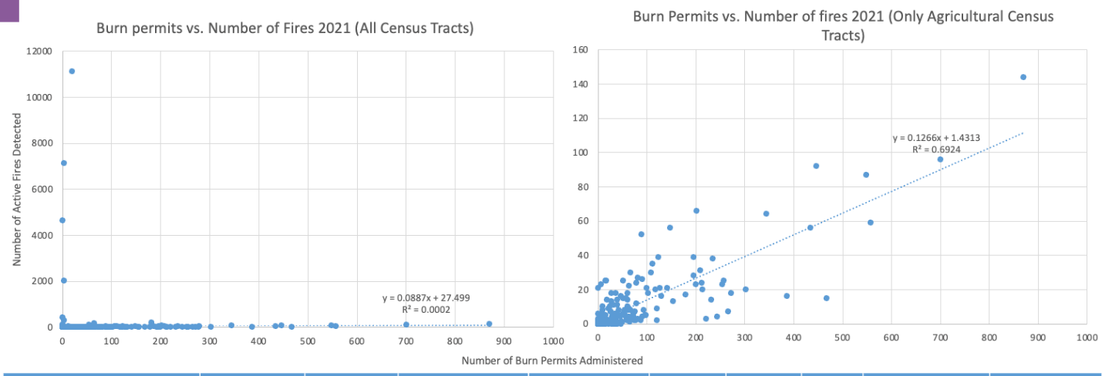
(A) (B)
Figure E1. Burn Permit vs. Number of Active Fires Regression Model:
- Burn permits vs number of detected fires for all census tracts in the study area (B) Burn permits vs number of detected fires only in census tracts classified as agriculture.

Table E1. Burn permit and active fire statistics in agriculture and non-agriculture census tracts in 2021:
Test | Mean Ag | Mean Non-Ag | N Ag | N Non-Ag | T-Stat | Critical Point | P-value
(A) Ag vs. Non-Ag tracts: # Burn Permits | 68.65 | 3.75 | 218 | 772 | 7.99 | 1.97 | 3.71 x 10⁻¹⁴
(B) Ag vs. Non-Ag tracts: # Active Fires | 10.93 | 34.73 | 218 | 772 | 1.30 | 1.96 | 0.20
(C) Ag vs. Non-Ag tracts: # Active Fires (No wildfire dates) | 10.93 | 2.50 | 218 | 768 | 4.99 | 1.97 | 9.66 x 10⁻⁷
- Burn permits in agriculture vs non-agriculture census tracts, (B) Number of active fires detected in agriculture vs non-agriculture census tracts, (C) Number of active fires detected in agriculture vs. non-agriculture census tracts but data from dates of significant wildlife as recorded by Calfire in 2021 were removed from affected census tracts.

Appendix F: CALIPSO Case study and Vertical Feature Data
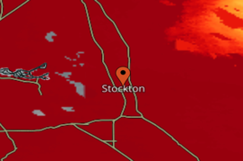
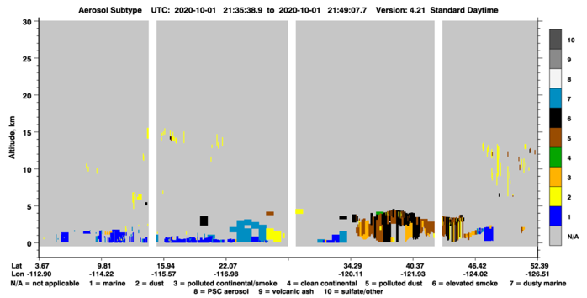
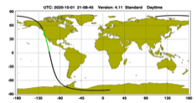

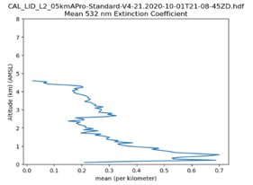

(A)
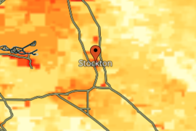
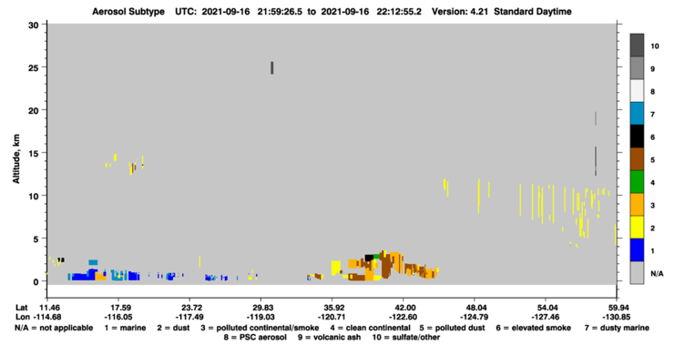
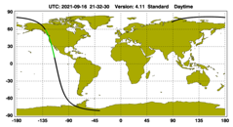

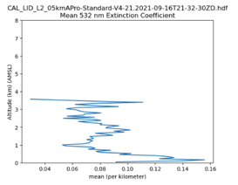

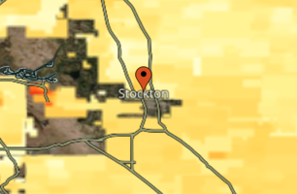
(B)
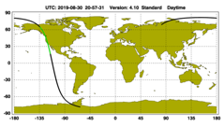
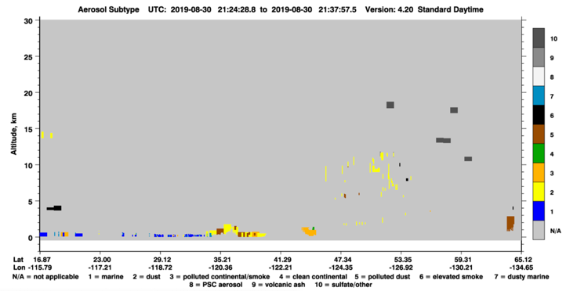

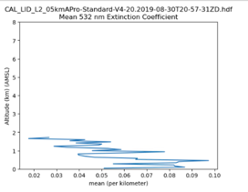

(C)

Figure F1. Burn Permit vs. Number of Active Fires Regression Model:
- High pollution date (10/01/2020) Aerosol Subtype VFM with CALIPSO Aerosol Height and Thickness Extinction Coefficient Plot and MODIS NASA Worldview Photo. (B) Moderate pollution date (09/16/2021) Aerosol Subtype VFM with CALIPSO Aerosol Height and Thickness Extinction Coefficient Plot and MODIS NASA Worldview Photo. (C) Low pollution date (08/30/2019) Aerosol Subtype VFM with CALIPSO Aerosol Height and Thickness Extinction Coefficient Plot and MODIS NASA Worldview Photo.

