Supporting Information for
Land Surfaces at the Tipping-Point for Water and Energy Balance Coupling
Jianzhi Dong^{1,2}, Ruzbeh Akbar², Andrew F. Feldman^{3,4}, Daniel Short Gianotti², Dara Entekhabi²
- Institute of Surface-Earth System Science, Tianjin University, Tianjin, China
- Department of Civil and Environmental Engineering, MIT, Cambridge, Massachusetts 02139, USA
- Biospheric Sciences Laboratory, NASA Goddard Space Flight Center, Greenbelt, Maryland, USA
- NASA Postdoctoral Program, NASA Goddard Space Flight Center, Greenbelt, Maryland, USA

Contents of this file:
Sections S1 to S5

Introduction:
This supporting information provides synthetic test results for the applied soil moisture drydown identification approach (Section S1) and demonstrates the robustness of $П$ to soil moisture retrieval biases (Section S2). In addition, the spatial distribution of flux tower observations used for validating $П$ is shown in Section S3. Finally, the estimated soil moisture thresholds as a function of microclimate and vegetation are shown in Section S4.

S1. Synthetic tests of SMCS performance
S1.1 Statistics of synthetic errors
The determination coefficient (R²) between estimated L(θ) and SMAP-based dθ/dt are globally estimated for four seasons (not shown). The estimated L(θ) explains more than 50% of the variability in dθ/dt. Regions with more water-limitation have more variance explained when compared to regions with energy-limitation as the dominant evaporation regime.
As such, we can provide a realistic estimate of the noises of SMAP-observed ${dθ}/{dt}$ (denoted as $γ$ for brevity). Note that R² is approximately the portion of true signal variance within the variance of $γ_{t}$ (denoted as $σ_{γ_{t}}^{2}$). Therefore, the variance of the error (denoted as $σ_{e_{t}}^{2}$) can be estimated as:
 | $$σ_{e_{t}}^{2}=σ_{γ_{t}}^{2}(1-R^{2})$$ | (S1)
We find that $σ_{e_{t}}$ typically has a strong $γ$ dependency (not shown). To capture such $γ$-dependency, the “observation errors” in the synthetic experiments is generated using a zero-mean unit-variance Gaussian noises (denoted as $η_{t}$) as:
 | $$v_{t}=η_{t}γ_{t}$$ | (S2)
 | $$e_{t}=\frac{v_{t}}{σ_{v_{t}}}σ_{e_{t}}$$ | (S3)
where σ denotes the standard deviation of the subscript variable.

S1.2 Design of synthetic experiments
Based on (S1) to (S3), a series of synthetic experiments are used for testing the performance of SMCS under different observation error levels and configurations. The robustness of SMCS is evaluated using a 500-member synthetic test, and the synthetic “truth” for each member is generated based on randomly selected $L(θ)$ form (Figure 1), with slope and soil moisture thresholds randomly drawn from 20 to 30 mm/day and 0.05 to 0.37 m³/m³, respectively. The synthetic truths are then perturbed by adding random noises to produce synthetic observations – capturing the RS retrieval error impacts on L(θ) determination. The above 500-member synthetic experiment is performed with 50, 100, 300 and 500 particles, respectively, to investigate the optimal configurations of SMCS. We also include cases with ${σ_{e}^{2}}/{σ_{T}^{2}}$ of 0.1, 0.5, 1.0 and 1.5 to investigate the performances of SMCS under different error assumptions. As mentioned above, globally averaged ${σ_{e}^{2}}/{σ_{T}^{2}}$ for SMAP retrievals is approximately 1 and hence, ${σ_{e}^{2}}/{σ_{T}^{2}}=1.5$ represents error levels that approximately 50% higher than the SMAP observations.
Results show that SMCS can robustly identify the forms of L(θ) – with classification accuracy above 94% for all cases. For the error levels comparable to the SMAP observations (${σ_{e}^{2}}/{σ_{T}^{2}=1}$), R² of the parameter estimates is above 0.8 when more than 100 particles are used. On average, the R² of parameter estimation with 300 is similar as that with 500 particles, but has significantly reduced computational cost – see Figure S1.
We repeated our analysis with the traditional strategy that estimates all the five parameters at once. This traditional approach constantly underperforms our two-stage approach for all scenarios. The all-case-averaged classification accuracy and parameter estimation accuracy for the traditional approach is 95% and 0.78, respectively, comparing with the accuracies of 97% and 0.87 for our two-stage approach.
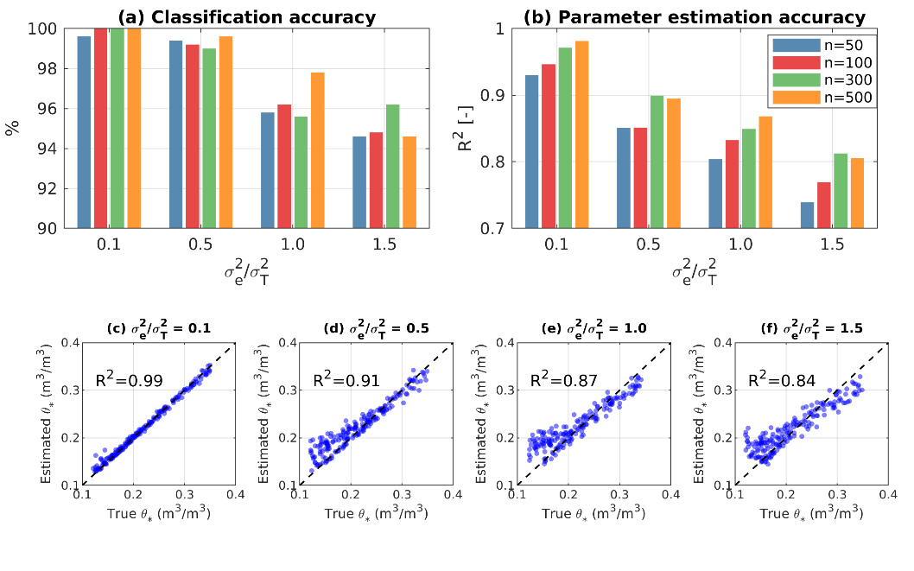
Figure S1. The performance of the soil moisture drydown identification framework under different assumptions of observation error and the number of particles. Part a: classification accuracy; part b: parameter estimation accuracy, averaged across all soil moisture thresholds (i.e., $θ_{w}$, $θ_{*}$ and $θ_{fc}$); parts c to f: comparison of true and estimated $θ_{*}$ with 300 particles under different synthetic observation error levels.
In addition, we also compared estimates based on the recent DREAM_zs algorithm (https://sticsrpacks.github.io/CroptimizR/articles/Parameter_estimation_DREAM.html), which is an advanced Monte Carlo based global optimization algorithm. The DREAM_zs- and SMCS-based estimates are highly consistent.
The impact of information criteria/metric is also compared. Results based on the same experiment settings as Figure S1, but $L(θ)$ is classified using AIC and RMSE, yield nearly identical results as that with AICc.

S2. SMAP retrieval bias impacts on П
To investigate the impact of observation biases on $П$, we can approximate the biased θ time series (denoted as $θ_{b}$) as $θ_{b}=\left(1+a\right)θ+b$, where a and b are multiplicative and additive biases of θ observations, respectively. Clearly, $θ_{b}$ is a linear transformation of $θ$ and hence, the multiplicative and additive biases do not change the functional form of L(θ). Likewise, the optimal L(θ) parameter base on $θ_{b}$ (denoted as $θ_{b*}$ and $θ_{bw}$) is also a linear transformation of $θ_{*}$ and $θ_{w}$, which can be written as $θ_{b*}=\left(1+a\right)θ_{*}+b$ and $θ_{bw}=\left(1+a\right)θ_{w}+b$, respectively.
Combining the mathematical expressions of $θ_{b*}$ and $θ_{bw}$ and (11), it is clear that all the biasing impacts (i.e., a and b) are cancelled out in $П$ estimation.

S3. Number of data pairs in drydown analysis

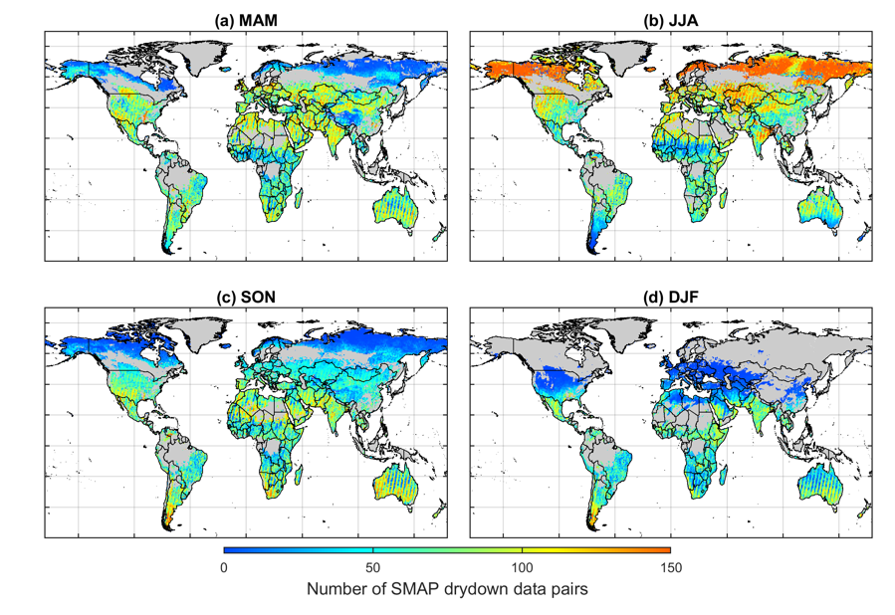
Figure S2. The number of valid SMAP soil moisture drydown data pairs across different seasons.

S4. Spatial distribution of flux tower observations
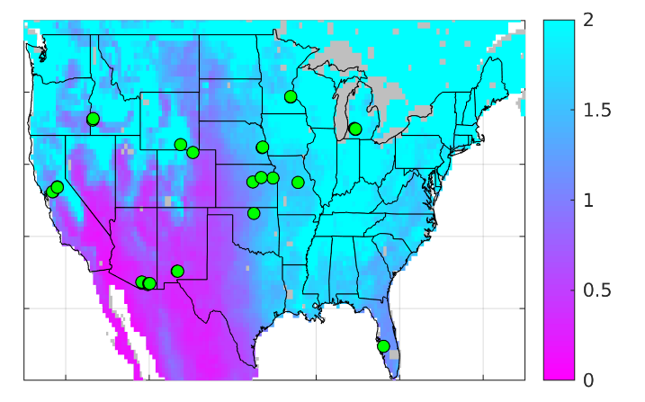
Figure S3. The spatial distribution of AmeriFlux sites that has at least 5 years of data during April 2015 to April 2021. Background color represents the spatial distribution of AI values.

S5. Seasonal variations of hydrological regime

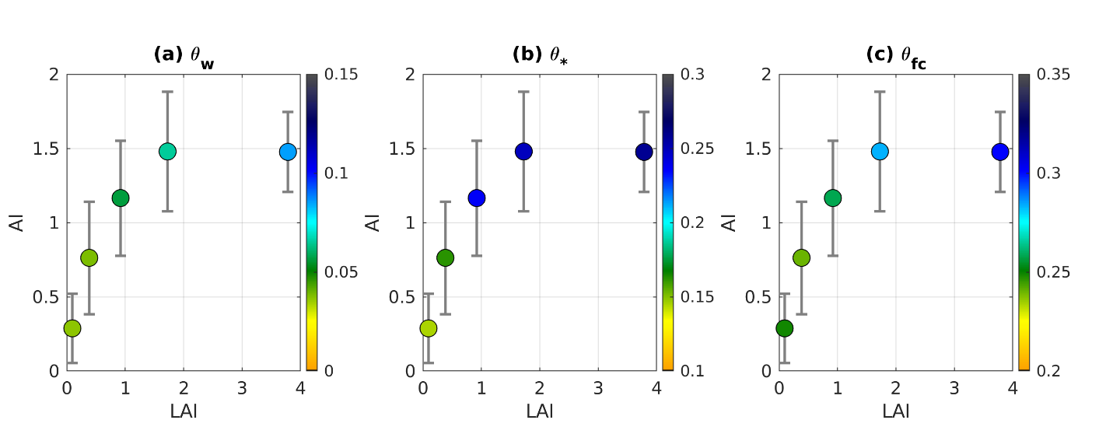
Figure S4. $θ_{w}$ (a), $θ_{*}$ (b) and $θ_{fc}$ (c) as a function of LAI and AI. The irregular LAI bins are determined according to different percentiles of global LAI distribution. The error bars denote the variability of AI within each LAI bin. Color shadings of the circles are median soil moisture thresholds for each LAI bin.

