Mars Surface Habitat Concept Design

Ryan Hughes1, David McGraw III2,

Paul Kessler3, and Andrew Choate4

*NASA Marshall Space Flight Center, Huntsville, AL, 35808, USA*

**Abstract**

## An initial Mars Surface Habitat (MSH) concept design study was conducted as part of the National Aeronautics and Space Administration (NASA) Habitation Systems Development Office’s effort to inform NASA crewed Mars architecture decisions. The study assessed the unique challenges, risks, and benefits of a surface habitation element within the Mars architecture trade space. The goal of the study was to identify unique functional capabilities necessary to support a crewed mission on the Martian surface, the unique challenges and risks associated with such an architecture, and the areas of further analysis required to make such a mission possible. Continuing NASA’s development and execution of the Moon to Mars lunar surface missions, attention will continue progressing toward the initial crewed Mars mission. To prepare for this, NASA’s Exploration Systems Development Mission Directorate (ESDMD) has established a strategic analysis cycle (SAC) where an architectural trade space is identified and evaluated. Given that the Mars architecture and mission profile are still in this trade space, the architecture and mission considered for this study is SAC21 [1]. In addition, reference conceptual designs are being refined for the Mars Transit Habitat (TH) [2] and MSH systems which will enable crew to safely travel to and inhabit the surface of Mars. The NASA Mars architectures trade space includes the use of a Pressurized Rover (PR) to address both crew habitation and mobility needs. This study assesses the use of a dedicated habitat via the MSH and an unpressurized terrain vehicle for crew mobility and exploration in lieu of the PR. Determining the optimum mission architecture will require continued analysis by ESDMD teams and this study is intended to support of such a study. The MSH concept design team aims to explore this area of the Mars habitation trade space, and in doing so, inform and highlight the considerations associated with a MSH in the surface architecture. It is not the intention of this study to make specific habitation or architecture decisions, but instead to provide a habitation element concept compatible with the Mars architecture trade space.

1. **Introduction**

NASA’s Moon to Mars (M2M) strategy is being used to develop and document its objectives-based approach for future human deep space exploration efforts. This objectives-based approach allows NASA to ensure that a comprehensive framework can be put in place to support future exploration goals, ultimately resulting in the first successful crewed missions to Mars while being resilient to changing priorities. “Architect from the Right” is a M2M principle which allows NASA to work from a defined objective to determine the complete set of technologies and systems required for success. As a part of this strategy, there is a strong consideration for “Mars Forward” thinking that aims to minimize the required number of new technology developments and apply operational lessons learned required from prior missions to enable future Mars exploration. NASA’s Architecture Definition Document (ADD) [3] outlines the Mars architecture trade space and highlights the many considerations and decisions needed to finalize the architecture and mission scope. Systems developed for the lunar surface exploration missions can be made extensible for use on the Martian surface [4]. The lunar surface will therefore be used as a testbed for demonstrating system capabilities, improving current designs, and gathering operational data. This will help mitigate risk for the initial crewed Mars mission.

This study focused on the initial development of a Mars Surface Habitat (MSH) within Mars architecture trade space outlined in the ADD. The use of an MSH is evaluated in place of a Pressurized Rover (PR) within the Strategic Analysis Cycle ‘21 (SAC21) [1] as a means of grounding a design and implications to a surface habitat. Ground Rules and Assumptions (GR&As) and Functional Allocations (FAs) from the previous architectural concept lunar Surface Habitat (SH) [5] were leveraged as a starting point and approaching the design using the NASA Moon to Mars (M2M) Objectives [6] and “Architecting from the Right”. Using the lunar SH reference design as a departure point for the SH allows for sensitivity analysis of habitation across planetary environments. A Master Equipment List (MEL) for the MSH and all its subsystems was developed using the same approach. Each GR&A, FA, and MEL element was considered on a case-by-case basis to determine applicability to the Mars environment, and modifications or additions were made as necessary.

A notional Concept of Operations (ConOps) was derived from the SAC21 [1] and used as the primary method to identify operational risks and opportunities. The ConOps details MSH operations during all phases of the mission including staging in cislunar space, transit from Earth-orbit to the Martian surface, and Mars surface operations. Many key assumptions such as Mars Descent System (MDS) payload mass envelopes, Earth-Mars-Earth transit times, and Mars surface stay duration were leveraged from SAC21 and used in this study to align the MSH concept design with existing and future NASA Mars architecture trade space.

The initial MSH concept study concluded in May 2023. It is the authors’ intent that the identified advantages, disadvantages, knowledge gaps, risks, and challenges will help inform the continued efforts of ESDMD and broader NASA community in assessing crew Mars mission science, technology, and engineering development efforts within the current Mars architecture trade space.

1. **Mission Overview**

The study explored the use of the MSH concept in lieu of the PR during the 30-sol Mars surface mission as referenced in SAC21 [1] and “*Reference Surface Activities for Crewed Mars Mission Systems and Utilization”* [7]. The short-stay, opposition class trajectory was used to achieve the shortest overall mission duration possible (~2 years) [1]. The study leveraged Artemis-derived lunar surface systems as much as possible for Mars to decrease the development requirements for the mission and reducing Mars surface infrastructure while placing the minimal number of new technology developments along the mission critical path.

In the SAC21 mission profile, there are separate cargo and crew transit vehicles, which are sent on independent opportunities with the cargo variant departing first. Cargo and elements packaged across three MDSs will depart from Earth’s sphere of influence (SOI) between three to five years prior to the crew’s departure during a 2039 opportunity [1]. Two of the three MDSs would carry surface elements and equipment required for the mission and would descend to the Martian surface following their transit to and arrival in Mars orbit. For the purposes of this study, the third MDS would carry the MSH rather than the PR and would loiter in a 5-sol Mars orbit following transit until the crew arrive in the crewed-DST. It is expected that the MSH would fully inflate and deploy systems while still in Earth orbit. The systems would be checked out before heading to Mars.

Crew would launch in an Orion capsule with a co-manifested logistics module (LM) and rendezvous with the TH as part of the crewed deep space transport (crewed-DST). The Orion and LM would undock from the DST before DST initiates the burn into an opposition-class trajectory and an approximately 10-month Earth-Mars transit duration. The MSH would dock with crewed-DST to facilitate crew transfer in conjunction with MSH staging activities prior to descending to the surface. The crew would descend to the Mars surface in the MSH.

Three MDSs are planned to deliver all required surface equipment for the first crewed Mars mission. As part of the MSH concept study, a notional breakdown was needed to distribute the proposed surface element manifest. MDS-1 would be cargo rated and carry the 10 kWe FSP, Mars Terrain Vehicle (MTV), Surface Propellant Transfer Package (SPTP) [8], Nitrogen Tetroxide Oxidizer (NTO), Mars Surface Manipulator System (MSMS), and a complement of required logistics and spares. MDS-2 would also be cargo rated and carry the Mars Ascent Vehicle (MAV), crew transfer adapter, spare FSP equipment, and necessary consumable resources and logistics items. MDS-3 would be crew rated and carry the MSH, an additional 10 kWe FSP, science utilization equipment, and crew-related systems and logistics. Further it would be necessary to determine if these systems could on fit within the volumetric envelope of the lander and is therefore included in the future work section.

The launches required for the three MDSs could be distributed across departure windows best identified by the propulsion system and mission profile. A notional lander manifest with associated masses is provided in Table 1.

Table : MDS Manifest Mass Properties

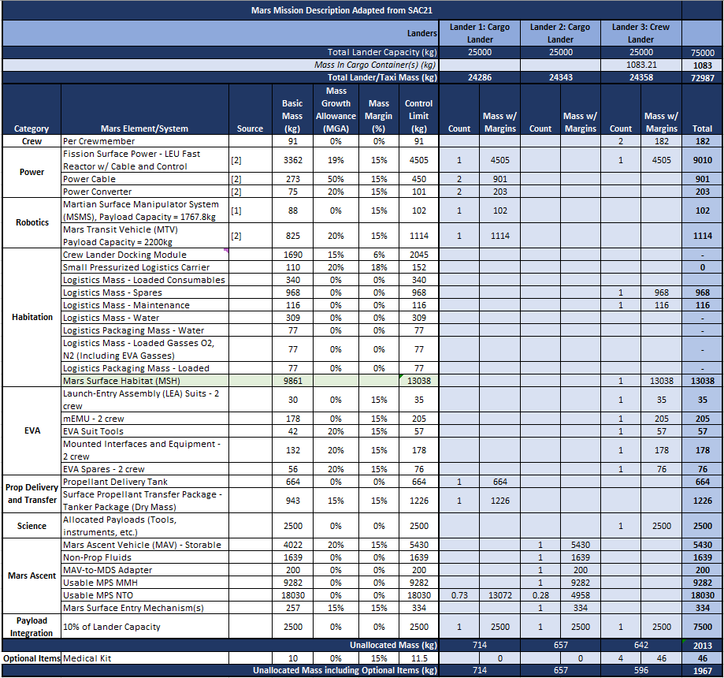

1. **MSH Subsystem Overview**
2. **Structure**

The assumed MSH structural design is almost identical to that of the lunar SH. A basic model of the lunar SH structure is provided in Figure 1 for reference. The primary structure consists of two primary segments: a metallic and an inflatable softgoods compartment. The MSH utilizes a vertically orientated, three-floor layout, two of which are housed within the large inflatable softgoods volume. The metallic compartment contains the crewed descent system and associated systems, as well as a logistics port and crewed extravehicular activity (EVA) airlock. It could also be used for logistics storage. The inflatable portion contains primary habitation functional volumes and systems such as crew quarters and environmental control and life support systems (ECLSS).

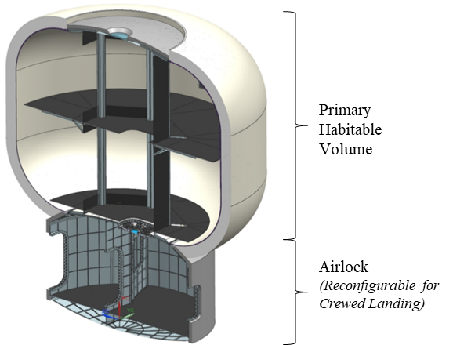

Figure : Notional MSH Primary Structure

The lunar SH structural design is primarily driven by internal pressure and the MSH is expected to also operate at 8.2 psia. While the increased gravity on Mars was not assumed to impact the MSH structural design, landing loads will be evaluated as forward work within the Mars Entry, Descent, and Landing (EDL) space. The MSH could also operate at an increased internal pressure of 10.2 psia to accommodate docking with the TH which is capable of operating at both 10.2 psia and 14.7 psia [2]. Unique to the MSH is the addition of a passive NASA docking system (NDS) and supporting vestibule on the inflatable upper bulkhead to support crew transfer operation. The supporting vestibule is accompanied by separation hardware which would allow the crewed DST-to-MDS transfer system to be discarded prior to descent in order to limit landed mass. The metallic portion of the MSH would consist primarily of 2050 Al-Li due to its high strength to weight ratio. The inflatable softgoods section would be made up of several layers, each with a dedicated purpose from an atmosphere retaining bladder to MMOD protective Kevlar and thermal insulation [2].

Translating the lunar SH concept to the Martian surface environment resulted in various changes to many of the subsystem masses. A summary of these mass deltas is provided in Table 2. Lunar SH and MSH predicted landed masses for each subsystem were used for the comparison.

The most significant mass deltas occurred in the ECLSS, power, Extravehicular Activity (EVA) Support, thermal control, and landing support systems. A large portion of the ECLSS mass increase can be attributed to the MSH carrying four Small Pressurized Logistics Containers (SPLCs). The MSH relies on FSP for power generation while on the surface of Mars and thus carries no solar array, resulting in significantly less onboard power system mass. The increase in EVA support system mass can be explained by the manifesting of crew Exploration Extra-Vehicular Mobility Unit (xEMU) suits, and the addition of a modern air save pump to reduce airlock depressurization venting. The surface of Mars has a drastically different thermal environment than that of the Moon, requiring unique thermal insulation solutions to be employed by MSH. The insulation strategy as well as radiators were sized for the Mars environment and were predicted to decrease overall Thermal Control System (TCS) mass. Finally, much of the additional landing support mass appears in the form of mounted seating which restrain crew during descent. Additional small changes are present throughout each system and represented in the MSH MEL. The largest of these are discussed in the paragraphs below.

Table : Lunar SH Mass Delta to MSH

| **Subsystem** | **LSH Mass (kg)** | **MSH Mass (kg)** | **Change (kg)** |
| --- | --- | --- | --- |
| Body Structures | 2423 | 2560 | +137 |
| Connection & Separation | 150 | 389 | +239 |
| Landing Support | 0 | 303 | +303 |
| Environmental Protection | 928 | 1110 | +182 |
| Power | 1963 | 1273 | -690 |
| Command & Data Handling | 271 | 271 | 0 |
| Communications & Tracking | 434 | 439 | +5 |
| Crew Display & Controls | 59 | 59 | 0 |
| Thermal Control System | 1475 | 1163 | -312 |
| ECLSS | 1090 | 1899 | +809 |
| Crew Habitation & Support | 781 | 810 | +29 |
| EVA Support | 103 | 520 | +417 |
| Manipulation & Maintenance | 81 | 250 | +169 |
| Operational Items | 292 | 292 | 0 |
| **Overall Mass** | **10050** | **11338** | **+1288** |

1. **Power Systems**

The MSH concept in this study assumes regenerative fuel cells (RFC) as carried over from the lunar SH. During transit, the MSH would rely on DST to provide the required power for uncrewed dormancy operation that is expected to be ~4kW. After docking with crewed-DST in the 5-sol Martian parking orbit, the MSH could receive power from the crewed-DST until descending to the surface of Mars. After landing on the surface, the MSH would eventually connect to, and nominally rely on power provided by the 10 kWe FSP. Onboard energy storage would be utilized when MSH does not have access to external power generation or storage systems. The assumed RFCs are sized to supplement power supplied by the MDS and support crew for the duration of the gravity acclimation period [7] while the MTV connects the MSH to FSP. This connection operation is assumed to be accomplished robotically to prevent the need for crew to conduct an EVA early in the mission. RFC performance and reliability in the Mars environment are topics of future work. Decreased RFC performance could significantly increase the required volume allocated on MSH and is part of the broader Mars architecture trade space.

Power distribution systems onboard MSH would be used to allocate power to the various electrical components onboard, from both external sources and onboard storage. Power received from FSP would be independent of solar and weather conditions, thus the MSH does not have the same “Survive the Night” scenario as the lunar SH. The power conditioning and distribution systems utilized by the lunar SH are assumed to be very similar in mass to those used by the MSH, and so the same estimated values were used to create the MSH Power Systems MEL. Power conversion is assumed to be handled by FSP as it is manifested with a converter on the MDS.

1. **ECLSS**

Habitation ECLSS design is dependent on several factors which makes ECLSS design complex [9]. Habitat lifetime, reusability, mission duration, crew size, mass requirements, and energy requirements were considered to define the notional MSH ECLSS discussed below.

The assumed mission architecture calls for MSH to be a single-use habitat which influenced many ECLSS decisions. If the MSH is reconsidered as a reusable habitat, then some of these decisions could change. The MSH has a total lifetime of 10 years and is expected to support one Mars surface mission lasting 30 sols.

Preliminary ECLSS trades have suggested that a fully open system is preferable in the proposed architecture [9]. All CTBs required for the mission are manifested onboard MSH at launch due to its large, pressurized volume. Open ECLSS is estimated to be 250 kg lighter than a partially open system that does water processing [7]. Preliminary analysis across NASA suggests the mass breakeven point for a closed ECLSS would not occur until after approximately three 30-day missions with 4 crew utilizing a PR and SH [10], further supporting the fully open design. In addition to mass savings, an open ECLSS is less complex, with a smaller spare parts catalog compared to a closed-loop, regenerative ECLSS. Increased ECLSS simplicity would be beneficial for the anticipated uncrewed dormancy and surface exploration periods, as the mass impact of delivering spares to Mars is comparatively greater than to the Moon.

The only aspect of the MSH ECLSS which is regenerable is the 4BCO2 system [11]. The 4-Bed Carbon Dioxide (4BCO2) scrubber would periodically vent CO2 into the Mars atmosphere and a combination of HEPA, charcoal, or UV filters could be used to mitigate contamination concerns related to Planetary Protection Protocol (PPP). Analysis suggests the Zeolite-based 4BCO2 would provide mass savings over a Lithium Hydroxide (LiOH)-based system if used for the duration of the 30-sol surface stay [10].

1. **Habitation Support Systems**

The transit period to Mars will require crew to be in microgravity for long durations. The Mars TH will accommodate the crew’s exercise and related health counter-measure requirements through a series of systems during the Mars transit portion of the mission [2]. Gravity acclimation upon arrival on the Martian surface is thus a major consideration and imposes a significant for crew health and safety. MSH will need to provide the appropriate countermeasures to ensure optimal crew health and performance is to carry out surface missions safely, successfully, and sustainably.

The activities required to maintain crew physiological health for the duration of the transit to Mars are still being studied and may necessitate new exercise regimens and equipment technologies. As more research is done to identify the measures needed to maintain long term crew health in microgravity, the required habitation support systems will become more well defined. The European Enhanced Exploration Exercise Device (E4D) is a potential candidate system for a crewed Mars mission and plans to fly to the International Space Station (ISS) in the coming years [12]. The E4D can function as a row machine, resistance exercise machine, rope pull machine, and a cycling machine. A multi-functionality system such as this may be required for Mars missions. The MSH can accommodate this as well as additional exercise and countermeasure systems as deemed necessary to preserve crew health and accelerate gravity readaptation, and this flexibility is seen as a major strength of the MSH.

1. **EVA Support Structures**

The MSH is assumed to both utilize an airlock, and suitports to provide ingress and egress. The airlock provides a volume separate from the primary habitable volume to mitigate dust transfer and provide a space for EVA equipment maintenance operations. The airlock would be used in conjunction with a modern high-performance air-save pump to recover gas during airlock depress/repress cycles. The MSH would feature suitports in the internal airlock wall and a logistics suitport on the external wall leading between the primary habitable volume and the environment. Suitports mitigate dust transfer into the primary habitable volume associated with crew EVA operations. This is of primary concern as Martian dust contains perchlorates harmful to human health. Therefore, suitports would serve as the primary method for crew egress/ingress from the MSH during surface exploration operations. The logistics suitport allows for smaller items to be transported in and out of the MSH habitable volume without the need for an airlock depress/repress cycle and provides a means for convenient waste disposal.

During EVA, the exterior airlock hatch would be left open and covered with a dust fly to minimize dust transfer into the airlock volume. This space would be left unpressurized during EVA allowing direct access to the inner hatch and suitports. This would ensure that crew on EVA have two methods of ingress to the pressurized habitat. The internal hatch could be used to transfer incapacitated crewmembers or other bulky items without the use of a suitport.

1. **Thermal Systems**

The unique thermal environment of Mars will likely require the MSH to feature an insulation system approach different from the lunar SH. Conditions on the surface of Mars are defined by extremely low pressures on the order of 700 Pa (less than 1% of an Earth atmosphere) and temperatures averaging –100 C in the winter and –60 C during the summer. The MSH was assumed to experience these conditions, which were detected at the Viking 2 landing site [13], [14]. The Martian atmosphere is approximately 95% CO2 by volume, and for the purposes of this analysis the atmosphere was assumed to be pure CO2 [14]. Following discussions with Subject Matter Experts (SMEs), these conditions are predicted to be detrimental to the performance of Multi-layer Insulation (MLI), which is currently planned for use on the lunar SH. The ideal material for MSH insulation on the Martian surface is currently unknown, however a potential candidate is Cryogel A197 [15].

The MSH will reject heat through multiple techniques, including passively through body structures and insulation, as well as actively with external radiators and evaporative cooling systems. The radiators and body insulation on MSH have been sized according to their respective heat rejection requirements. This was achieved using a custom MATLAB tool. Figure 2 and Figure 2 show body heat transfer rates and TCS masses for a range of Cryogel A197 insulation thicknesses. Insulation mass was determined using computed volume as well as the physical properties of Cryogel A197 in a Mars analogous environment [16]. A Cryogel A197 insulation thickness of 25mm was assumed for the purpose of assigning TCS masses within the notional MSH MEL.

Figure : TCS Performance in Nominal Conditions

Figure : TCS Performance in Dust Storm

1. **Communication Systems**

The MSH could share many similarities in onboard communication technologies with the lunar SH. The MSH could utilize the same S-band, ultra-high frequency (UHF), and Wi-Fi proximity communications used by the lunar SH while in operation on the surface. These would be leveraged to communicate with surface assets such as xEMU suits during EVAs as well as the MTV. The MSH would be capable of streaming and relaying video feeds to the crewed-DST and to Earth. The MSH could utilize the Ka band for long distance communications with the crewed-DST and mission control on Earth. This communications equipment must be protected from re-entry damage, and the subject of MSH communications external outfitting is a topic of future work.

It is expected that any Mars surface assets would experience communications blackout periods at certain points in the mission. The TH could relay communication signals between the MSH and Earth during a portion of these blackout periods, which would occur when Earth and the MSH are no longer in Line of Sight (LOS). A network of communications satellites could provide the required coverage to eliminate blackout periods between the MSH, crewed DST, and Earth [17]. The subject of such a satellite network and the effectiveness of minimizing or eliminating blackout periods is a topic of future work.

1. **Planetary Protection Protocol**

The PPP for a crewed Mars surface exploration mission is still being defined. However, two main goals are clear: minimize the probability of contaminating Mars during surface exploration and prevent back-contamination of Earth by the systems and astronauts returning. Of these two high level goals, the latter is deemed to be of greater importance [18]. The approach to back-contamination from Mars may be very similar to the approach taken during the Apollo era. It is likely that after the first crewed Mars mission it will be confirmed that there are in fact no threats on the surface of Mars and protective measures such as mitigating dust transfer back to Earth and quarantining upon return could be relaxed.

Minimizing the probability of Mars contamination by the MSH could be achieved through various methods. The MSH presents two primary concerns relating to PPP and crewed operations. These are the venting of atmospheric gasses, and safing requirements for trash and waste on the surface. One of the primary modes through which onboard gasses will enter the Martian atmosphere will be through airlock depressurization venting. PPP techniques to mitigate this risk include using an advanced air save pump to minimize vented gas, as well as a sterilization and filtration system to scrub the remaining atmosphere of any contaminants that could be vented. This system could be attached to the off-gas vent and could consist of charcoal and small grain HEPA filters to filter out any microbes and other harmful particles. The MSH ECLSS concept utilizes a 4BCO2 scrubber [9] and would need to vent carbon dioxide (CO2) to the atmosphere of Mars. Contamination resulting from this process could be further mitigated by venting CO2 through HEPA and charcoal filters. Sterilizing vented gas with UV light may also be a viable means of minimizing contamination caused by airborne microbes making their way to the Martian surface. All of these options require forward work of integration and overall technical development and tactical implementation plan for an MSH.

1. **Trash and Waste Disposal**

Trash and waste disposal is certainly a concern from the aspect of PPP, with wet trash and human metabolic waste disposal presenting complications for a short stay mission. The trade between leaving on the surface or transporting off-planet via the MAV is a difficult trade based on the SAC21 framework. Therefore, MSH plans to utilize SPLCs to transport and store trash and waste on the surface. When an SPLC is filled with trash, it would be sealed, pressurized, and detached from the logistics suitport before being placed on the Martian surface. Empty SPLCs could be manifested at launch and mounted on the logistics suitport or housed within the MSH airlock. The MSH concept design assumed four SPLCs were manifested within the habitat mass, with one SPLC being used every seven sols. Volumetric concerns relating to SPLC manifesting and transport operations leave this topic as a subject of future work. Alternative solutions such as pressurized softgoods storage containers may also be viable.

1. **Surface Exploration Concept of Operations**

Similar to the lunar SH and other lunar surface elements, the MSH internal atmosphere would be maintained at 8.2 psia and 34% O2 during crewed periods. This O2 rich and lower pressure atmosphere is driven to facilitate high-rate surface EVAs, with suits planned to operate at 4.3 psia. Such a pressure difference could result in EVA pre-breathe periods significantly shorter than those on the ISS and similar to lunar surface operations. Mars surface operations would revolve around frequent and long-duration EVAs to conduct science and explore the surface. MSH would accommodate the increased egress/ingress cadence which results from the primary objective of the crewed Mars mission: conduct science and exploration activity.

The surface exploration ConOps provided in SAC21 has been adapted for MSH compatibility and is provided below.

Sols 1-3 make up the Martian gravity adjustment period [7]. During this period the crew would be exercising, reconfiguring the MSH cabin, and telerobotically inspecting surface equipment. On sol 4 the first crew EVA could be conducted. The purpose of this EVA is to test EVA equipment such as the suits and ports, as well as establish crew performance levels after the gravity readaptation period. The crew could conduct an additional EVA in the afternoon if time permits. Surface-based utilization payloads housed in the MSH during transit could be offloaded during an EVA on sol 5. The MTV may be used to assist with this offloading if necessary. The MTV could also be staged during this period in preparation for use as a crew mobility system during excursions later in the mission. Sol 6 is a scheduled rest day for the crew.

On sol 7 the crew might begin the first excursion away from the landing site, driving to exploration site 1 on the MTV. EVA surface exploration activities could be conducted, with crew returning to the MSH within 6 to 8 hours from MSH egress. Without some mobility, the limitation of exploration range would be significant and limited to walk back distances. For sols 8-10, the crew could travel back to exploration site 1 using the MTV and conduct scientific experiments and EVA activities before returning to the MSH each sol. On sol 11, the crew could remain at MSH and perform MTV and EVA equipment maintenance as needed. Sol 12 could be spent performing housekeeping operations, trash removal, and logistics restocking. For an MSH-based architecture, logistics restocking implies restocking point-of-use items from cargo storage within the habitat. Sol 13 is a scheduled rest day for the crew.

Beginning on sol 14, the crew may travel to a second exploration site. The same pattern of activity and EVA use for the first exploration site from sols 7-11 would be repeated. Similarly, sol 18 could be spent performing equipment maintenance at the MSH as needed, and on sol 19 the crew could perform housekeeping operations, trash removal, and logistics restocking. Sol 20 is a scheduled crew rest day.

On sol 21 crew would begin traversing to the third exploration site. The pattern of activity for the first and second exploration sites during sols 7-11 and 14-18 would be repeated. The crew could make their final journey back to the MSH on sol 25, and sol 26 could be spent conducting final unfinished science utilization or other tasks. Sol 27 would be the final scheduled crew rest day of the surface stay.

On sol 28 the crew would transit to the MAV via the MTV, taking approximately 100kg of return cargo with them. Upon arriving the crew would perform staging activities on the exterior of the MAV and ingress through the radially mounted hatch. Minimizing dust transfer into the MAV during this process is a major concern and is a topic of future work. Sols 29-30 may be spent performing MAV staging activities. After this period the MTV would remotely or autonomously relocate to a safe distance from the MAV to prevent damage caused ascent burn and resulting dust-plume. Finally, on sol 31 the MAV ascends from the Martian surface and rendezvous occurs with the crewed-DST three to five days later. Six and a half days are allocated to DST staging for the roughly 17-month return transit to Earth [7].

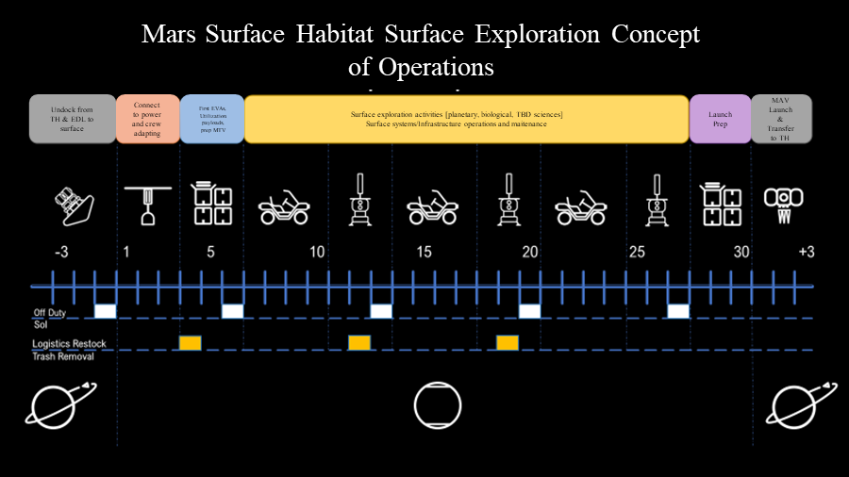

Figure : SAC21-based MSH Surface ConOps

1. **Architectural Considerations**
2. **Large Pressurized Volume**

Given the large, pressurized volume of the MSH falls within the same delivered mass envelope as the notional Mars PR [1], there are several potential functional advantages to consider across the architecture. First, there is an opportunity to support the entire mission logistics stowage within the volume while maintaining the functional space for other activities. Second, more IVA science capability can be included. This could allow science equipment for curating and analyzing samples. In some cases, it is not practical to return science samples back to Earth, especially considering the impact mass impact on the Mars transportation architecture. Identifying and returning a smaller subset to Earth may become necessary as a result. Third, the inclusion of additional exercise and medical equipment would be possible. This allows the crew a greater degree of countermeasures to recondition the body for Mars exploration and to better mitigate any health anomalies in-situ. Finally, the ability to support a change in crew size and duration would exist within one system. If there were a desire to increase the crew size for safety reasons or increase duration, the larger volume would be capable of supporting with additional outfitting. This means that the MSH is more flexible to changing architectures.

There are some disadvantages to MSH when compared to the PR. First, the PR offers the ability to explore a greater degree of the Mars surface. With the additional exploration however, there is less capability to analyze samples found provided that this is a desire of the science community. Second, the PR concept offers the ability to dock with the MAV for crew transfer which reduces PPP risk whereas the MSH would still remain on its lander 1 km away and require the MTV and an EVA. Ingress with EVA suits to the MAV featured in SAC21 would pose significant challenges, if not a significant redesign to accommodate the large suits and necessary don/doff volume. Since the MSH does not include inherent mobility capability, there is a risk that crew may not be capable of getting to the MAV for a contingency related abort. Finally, The MSH ConOps duration for docking to the DST is increased in order to perform necessary outfitting activities to prepare for landing. For the notional Mars PR, this would be minimal. While autonomous options may be able to be deployed the entire docked configuration is challenging given the placement of the systems on the exterior and would need to be addressed as part of forward concept and architecture refinement.

1. **MSH Concept Study Conclusion and Future Work**

This MSH concept study offers a first look at a dedicated Mars surface habitation element and the architectural implications. As a result, many questions were left unanswered following the study’s completion. Future concept studies and definition of the Mars habitation trade space will be required to address the open trade space. Many of these topics are included as part of proposed future work in Table 3.

Table : Future MSH Concept Studies and Refinement with Mars Architecture Trade Space

|  | |
| --- | --- |
| **Title** | **Description** |
| **Quantifying EVA Losses** | The MSH is a stationary element and therefore crew would need to utilize a separate mobility element for excursions to distant surface exploration sites. Overnight exploration would likely be impossible, and the crew would need to return to the MSH before xEMU life support is depleted. The amount of time required for this process has not been finalized and is dependent on several factors including distance to the site, xEMU don/doff time, EVA pre-breathe duration, and mobility element speed. It is unknown if the time crew spend returning to the MSH would represent a significant portion of their EVAs reducing overall science potential. Quantifying this loss in useful crew time has been identified as an area of future work to support a trade study between alternative habitation and mobility solutions. |
| **MSH EDL Integration and Dynamics** | Entry, Descent, and Landing integration and dynamic was not addressed as part of this analysis, nor in its reference materials. It is assumed that the MSH would land in the inflated state, but the viability of this operation is unclear. Future work is required to determine whether the MSH primary structure, can withstand the rigors of atmospheric entry, descent, and landing. Primary areas of concern are dynamic structural loading, extreme thermal conditions, and lander constraints such as center of gravity and moment of inertia. |
| **Crewed Landing** | This study assumes that crew will land inside the MSH. This implies that the MSH will provide crew habitation in space, in atmospheric flight, and on the surface. It is an area of future work to determine what kinds of systems must be included or adapted to allow the MSH to perform under such a wide range of environments. Crewed landing does not depend on inflated landing, as the crew can land inside the metallic section of the habitat with the inflatable portion depressurized and the common hatch sealed. |
| **RFC Performance on Mars** | The MSH concept design relies on RFCs for energy storage. RFC technology is still in development and if they do not achieve the assumed energy density, the MSH concept design could become infeasible. The effects of the Martian environment on the performance and reliability of RFCs are also currently unknown. If the Mars environment is detrimental to the performance of the RFCs, then more mass and volume would need to be allocated to energy storage. At this time, lithium-ion batteries are not considered a feasible energy storage due to the mission profile. |
| **Communications Outfitting** | The precise equipment, external mounting requirements and considerations, in addition to specific methods of communication for the Mars surface elements is currently undecided, but was assumed to be the same mass as those used on the lunar SH. |
| **Elimination of Blackout Periods** | Communication blackout periods between the MSH, TH, and Earth are anticipated during a 30-sol surface stay and should be mitigated in the interest of crew safety. A network of one or more communications satellites could be deployed to mitigate or eliminate these blackout periods. The feasibility and characteristics of this network are the subject of future work. |
| **MAV Ingress Dust Mitigation** | Crew ingress was assumed to occur through the primary hatch while the MAV was depressurized. Mitigating dust transfer into the MAV and removing dust from the habitable volume during this process is a subject of future work. |
| **Benefits of Additional Exercise Equipment** | The large PV of the MSH allows for extensive exercise equipment to be manifested if desired. The benefits of such equipment are still under evaluation. The necessity of manifesting comprehensive exercise equipment on-board the MSH is also unknown. |
| **Duplicate Spare FSP Concerns** | The necessity of a duplicate/spare FSP in an architecture which features a dedicated habitation element is part of the trade space. If the duplicate spare is deemed necessary, it is future work to determine how best to integrate FSP and MSH into the mission architecture without risk to crew. It may be necessary to relocate either FSP or MSH. There is also a challenge of fitting it within the volumetric envelope of the lander. If decided to be unnecessary, the landed mass of the second FSP could be utilized for a dedicated MAV crew transfer/docking system and allow for a short sleave, dust free transfer. |
| **Multiple Operating Pressures** | MSH would operate at 8.2 psi while in transit and loiter, and while on the surface of Mars. However, it must raise to 10.2 psi when docking with TH. The structural implications of increasing the pressure gradient are not explored in this study and is a subject of future work. It may be that the structural mass increases by a significant amount, but this consideration is not unique to the MSH concept design. |
| **Hot & Cold Case Analysis** | The thermal analysis conducted for the MSH concept design was limited in scope and served only to estimate insulation and radiator mass for the concept MEL. The anticipated thermal environments vary dramatically from deep space dormancy to atmospheric reentry. Dust storms present a thermal challenge unique to Mars surface systems and were considered in this analysis. They usually occur once per year, with a global storm every 5 years lasting for up to 6 months. A more in-depth thermal analysis which incorporates a wider range of expected environments must be conducted to form a better understanding of the MSH Thermal Systems and is a subject of future work. |
| **Gravitationally Induced Structural Changes** | The MSH is assumed to retain the primary and secondary structures of the lunar Surface Habitat. This is in part because the primary structure of the SH was sized to retain the pressure differential, while gravity was not a significant sizing factor. The pressure needs of MPH are largely the same as those of SH, but the gravitational acceleration is roughly doubled. For this analysis, it was assumed that the structure of the SH would be able to handle the increased gravitational loading, but future work must be done to confirm or refute this. |

**Acknowledgments**

The authors would like to thank the Mars Architecture Team (MAT) in addition to the many subject matter experts who contributed to this study, including – David Howard, Richard (Greg) Schunk, Brian Evans, Jim Meehan, Zach Bryant, Hernando Gauto, James Johnson, and Tracie Prater.

# 

# **References**

|  |  |
| --- | --- |
| [1] | M. A. Rucker, D. A. Craig and L. M. Burke, "NASA’s Strategic Analysis Cycle 2021 (SAC21) Human Mars Architecture," in *IEEE*, Big Sky, 2022. |
| [2] | A. Choate, P. Kessler, T. Nickens, M. Simon and D. Harris, "NASA’s Moon to Mars (M2M) Transit Habitat Refinement Point of Departure Design," in *IEEE Aerospace*, Big Sky, 2023. |
| [3] | NASA, "Moon-to-Mars Architecture Definition Document (ESDMD-001)," April 2023. [Online]. Available: https://ntrs.nasa.gov/citations/20230002706. |
| [4] | National Aeronautics and Space Administration, "HEOMD Strategic Campaign Operations Plan for Exploration," 2021. [Online]. Available: https://ntrs.nasa.gov/citations/20210022080. |
| [5] | D. Harris, P. Kessler, T. Nickens, A. Choate, B. Horvath, M. Simon and C. Stromgren, "Moon to Mars (M2M) Habitation Considerations: A Snap Shot as of January 2022," 2022. |
| [6] | National Aeronautics and Space Administration, "Moon to Mars Objectives," NASA, 2022. |
| [7] | S. Hoffman, M. Rucker, A. Andrews and K. Watts, "Reference Surface Activities for Crewed Mars Mission Systems and Utilization," in *44th COSPAR Scientific Assembly*, 2022. |
| [8] | A. Krenn, D. Trent, G. Sanders, S. Hoffman and E. Hinterman, "Architectural impacts of in-situ resource utilization production of oxygen for use as propellant in a Mars ascent vehicle," in *IOP Conferences Series: Materials Science and Engineering*, 2022. |
| [9] | Z. Bryant, A. Choate and D. Howard, "Environmental Control and Life Support (ECLS) System Options for Mars Transit and Mars Surface Missions," in *ICES*, Calgary, 2023. |
| [10] | C. Stromgren, C. Burke, J. Cho, W. Cirillo, A. Owens and D. Howard, "Regenerative ECLSS and Logistics Analysis for Sustained Lunar Surface Missions," in *IEEE Aerospace Conference*, Big Sky, 2022. |
| [11] | G. E. Cmarik, W. T. Peters and J. C. Knox, "4-Bed CO2 Scrubber – From Design to Build," in *ICES*, Lisbon, 2020. |
| [12] | Danish Aerospace Company, "E4D," 2021. [Online]. Available: https://www.danishaerospace.com/da/work/products/e4d. |
| [13] | R. Osczevski, "Martian Windchill in Terrestrial Terms," *American Meteorological Society,* vol. 95, no. 4, pp. 533-541, 2014. |
| [14] | J. E. Tillman, "Mars: Temperature overview," University of Washington, [Online]. Available: https://www-k12.atmos.washington.edu/k12/resources/mars_data-information/temperature_overview.html. [Accessed 2023]. |
| [15] | J. Appelbaum and D. Flood, "Solar Radiation on Mars," NASA, Cleveland, 1989. |
| [16] | J. E. Fesmire, J. B. Ancipink and A. M. Swanger, "Thermal Conductivity of Aerogel Blanket Insulation Under Cryogenic-Vacuum Conditions in Different Gas Environments," in *CEC*, Madison, 2017. |
| [17] | K. Bhasin, J. Hayden and J. R. Agre, "Advanced Communication and Networking Technologies for Mars Exploration," in *International Communications Satellite Systems Conference and Exhibit*, Toulouse, 2001. |
| [18] | Committee on Space Research, "COSPAR Policy on Planetary Protection," 3 June 2021. [Online]. Available: https://cosparhq.cnes.fr/assets/uploads/2021/07/PPPolicy_2021_3-June.pdf. |