A Hybrid CFD/Engineering Model Tool for Lunar Lander Surface Erosion Prediction

Andrew Weaver,¹ Thomas Shurtz,² Peter Liever,³ Tim Dawson,³ Jason Howison,³
Jeffrey West,⁴

¹Jacobs Space Exploration Group, NASA Marshall Space Flight Center, Sev1Tech, Huntsville, AL; andrew.b.weaver@nasa.gov
²Jacobs Space Exploration Group, NASA Marshall Space Flight Center, Jacobs, Huntsville, AL; t.p.shurtz@nasa.gov
³Jacobs Space Exploration Group, NASA Marshall Space Flight Center, CFD Research Corporation, Huntsville, AL; peter.a.liever@nasa.gov
⁴NASA Marshall Space Flight Center, Huntsville, AL; jeffrey.s.west@nasa.gov

ABSTRACT

Plume-Surface Interaction (PSI) between lander engine plumes and landing area regolith poses risks to the landers and space exploration missions through view obscuration and high-energy ejecta impacts from eroded particle clouds and vehicle tilting from plume-induced craters. To address these risks, NASA MSFC Fluid Dynamics Branch (ER42) has developed a cascade of predictive simulation capabilities for PSI, including the recent development of a hybrid CFD/engineering model tool that allows for rapid PSI simulations with a descending/ascending vehicle and an eroding surface. The development of this fully-coupled, moving body/eroding surface simulation capability is detailed along with a demonstration of the tool’s capabilities on the Apollo 12 Lunar Module landing. Predictions of eroded mass flow rates as a function of time are verified against Apollo 12 flight data, from which the developed, viscous erosion model has been calibrated.

INTRODUCTION

Plume-Surface Interactions (PSI) occur as rocket plumes from a spacecraft’s propulsive landing system impinge on a surface below. This plume-surface interaction with unprepared, regolith surfaces poses multiple risks to the lander, the crew, and the mission due to plume driven ejecta and surface cratering. Eroded regolith particles may obstruct the view and/or impact the spacecraft and surrounding assets, resulting in damages. If a sufficiently large crater is formed due to PSI effects, then the spacecraft could tilt excessively. These PSI effects and the risks they pose to spacecraft landings have been observed and reported dating back to the Apollo era. For example, refer to Fig. 1 for images from Apollo 15 showing ejecta sheets obstructing the view of the Lunar surface below the lander.

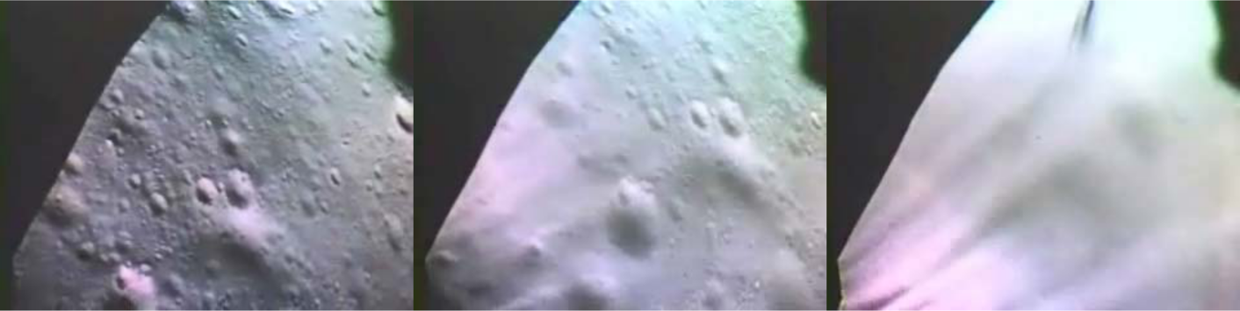
Figure 1. Camera images of Lunar surface from Apollo 15 LM landing as it descends (Credit: Metzger et al. 2010)

The Fluid Dynamics Branch at NASA Marshall Space Flight Center has developed a cascade of predictive simulation capabilities for PSI in order to address and mitigate PSI risks to landers and landing missions in a timely manner. This includes the development of the multi-phase, multi-physics Gas Granular Flow Solver (GGFS) simulation tool (Gale 2017, Liever 2020) at the higher-fidelty end of the predictive simulation capability spectrum. Hybrid Computational Fluid Dynamics (CFD)/engineering model tools have also been developed (Shurtz 2022) in support of multiple NASA Flight Programs such as Human Lander System (HLS), Commercial Lunar Payload Services (CLPS), and Lunar Site Planning and Design. A hybrid CFD/engineering model approach decreases the turnaround time for metrics such as crater depth through the assumption of viscous shear erosion regime and a corresponding viscous shear erosion model.

This paper focuses on the development of a hybrid CFD/engineering model tool that is fully coupled between the predicted plume flow and surface cratering in the viscous shear erosion regime. The coupled effects between plume impingement and surface erosion can now be captured by coupling the CFD tool, Loci/CHEM (Luke 1999), with the Descent Interpolated Gas Granular Erosion Model (DIGGEM) (Shurtz 2022) during simulation runtime. An entire vehicle descent trajectory on the order of tens of seconds can now be modeled with the fully-coupled, Loci/CHEM-DIGGEM tool through the use of time compression. Details of the Loci/CHEM-DIGGEM tool and the time compression modeling approach based on a separation of time scales of key dynamical processes will be presented in the next section. A demonstration of the newly developed CFD/engineering model tool will also be presented for the Apollo 12 landing.

LOCI/CHEM-DIGGEM MODEL DETAILS
The Descent Interpolated Gas Granular Erosion Model (DIGGEM) was originally developed as a one-way coupled post-processing application to predict time-varying crater depth on the Lunar surface beneath a propulsively descending vehicle. The model is based on the following functional relationship between plume induced shear stress on the ground and eroded regolith mass flux: $\dot{m}\left(x,y,t\right)=C{\left(τ\left(x,y,t\right)-τ_{threshold}\right)}^{n}$, where $\dot{m}$ is the locally eroded mass flux, $τ$ is the local shear stress on the ground, and $C$, $n$, and $τ_{threshold}$ are model parameters which must be calibrated using available data. The model parameters were determined by comparing CFD predicted shear stress for the Apollo 12 LM at several fixed altitudes to observationally calculated erosion mass flow rates from an analysis of Apollo 12 landing footage by Lane and Metzger (Lane 2015).
While use of this engineering model allowed relatively quick turnaround for predicting crater growth beneath a vehicle, it suffered from some notable limitations. The CFD solutions could not account for the changing terrain shape due to crater growth, thereby limiting application to cases which are loosely coupled (very shallow craters). Also, the process requires separate pseudo-steady CFD solutions of the vehicle at several fixed altitudes as inputs. The shear stress for altitudes between those which are simulated must be interpolated, and it is not always clear a priori which altitudes will need to be simulated to capture important plume impingement features. To overcome these limitations, the DIGGEM model has been directly integrated into the Loci/CHEM tool to allow fully two-way coupled simulations of a moving vehicle through the final portion of descent where significant erosion occurs.
Loci/CHEM includes two capabilities which allow this implementation of the DIGGEM model. The first is a moving body overset mesh capability (componentMotion) which allows one mesh for the background and the Lunar surface, and a separate mesh surrounding the vehicle. Relative motion between the vehicle mesh and the background mesh can be prescribed such that the vehicle position in time throughout the simulation can be made to match an expected/known trajectory. The second capability is a module (gridMotion) which allows the mesh to be deformed by altering the location of surface nodes, and then smoothly displacing volume elements in the region surrounding the deformed surface. The DIGGEM model was implemented by creating an additional module (surfaceErosionFlux), which uses the instantaneous shear stress on the surface mesh to enforce a local displacement of the surface. This displacement is calculated using the relationship from the DIGGEM model: $d=-\left[C{\left(τ-τ_{threshold}\right)}^{n}/ρ\right]dt$, where $d$ is how far the surface at that location should be displaced in the normal direction and dt is the simulation timestep size. Note the negative sign in the equation for displacement, since the displacement is in the direction into the solid surface to represent a loss of surface material at that location. The calculation of the surface motion and flow field (and shear stress) calculation happens at each timestep allowing tight coupling of the simulation.

TIME COMPRESSION MODELING APPROACH TO MODEL VEHICLE DESCENT
The timescales involved in simulating the flow of rocket engine exhaust plumes are quite different from those involved in the descent of a landing vehicle, or the regression of the Lunar surface under viscous erosion effects. Fluctuations in plume flow take place in microseconds, and gas velocities are in kilometers per second. The vehicle final descent takes several seconds at speeds around 1 meter per second, and Lunar surface regression velocity is on the order of centimeters per second at maximum. This presents a difficulty for the fully coupled simulations. Maintaining a time step of 1 or 10 microseconds to accurately model the plume flow, for a duration of 10s of seconds to capture a landing sequence, would require millions of simulation timesteps. This would require computational time in years even when using thousands of processors simultaneously. Because the timescales are separated by several orders of magnitude, it is possible to compress some of the timescales without drastically altering the nature of the interactions in the simulation. The Lunar surface does not need to respond to each and every short term fluctuation in the plume, because it is the average effect over longer durations that matters. Similarly, in the time that it takes the vehicle to move considerably closer to the ground, the plume has undergone thousands of fluctuations and can be seen to respond almost instantaneously to changes in the vehicle position.

A very good approximation to the solution to the problem of viscous erosion crater formation may be obtained by compressing many fluid field solution steps into a single vehicle motion or ground deformation step. In the coupled Loci/CHEM-DIGGEM tool, this is done by artificially increasing the rates of vehicle motion and eroding surface regression by a factor of 100. This allows an entire descent trajectory to be simulated using only tens of thousands of fluid solver timesteps. Exact implementation is achieved by multiplying the constant C in the erosion/ shear stress calculation by 100, and multiplying the times at which vehicle location is specified in the component motion file by 100. An additional step is made to correct some of the error introduced when using this method. When the vehicle speed is increased to hundreds of meters per second, an accompanying error in the applied engine exhaust velocity occurs. When the engine exhaust velocity is 3000 m/s and the actual vehicle velocity is 3 m/s (increased to 300 m/s for time compression), the error in exhaust velocity is 10% because the apparent velocity of the gas in the simulation is the sum of the 3000 m/s applied at the engine outlet and the 300 m/s motion of the engine outlet itself. The correction is made by subtracting the excess vehicle velocity (in this case 297 m/s) from the gas velocity applied at the engine outlet boundary.

A sensitivity study of the effects of various degrees of time compression was carried out to verify the appropriateness of this approximation on the prediction of crater depth over time. Factors of 1 (no compression), 10, 100, and 1000 were used in a simplified axisymmetric case for 5 s of simulated physical time (to allow the no time compression simulation to complete in a reasonable amount of computational wall-time). The results are shown in Fig. 2. The solutions for compression factors up to 100 are very close to the solution for the uncompressed approach. At a factor of 1000, the differences become noticeable, and qualitative features are no longer captured correctly.

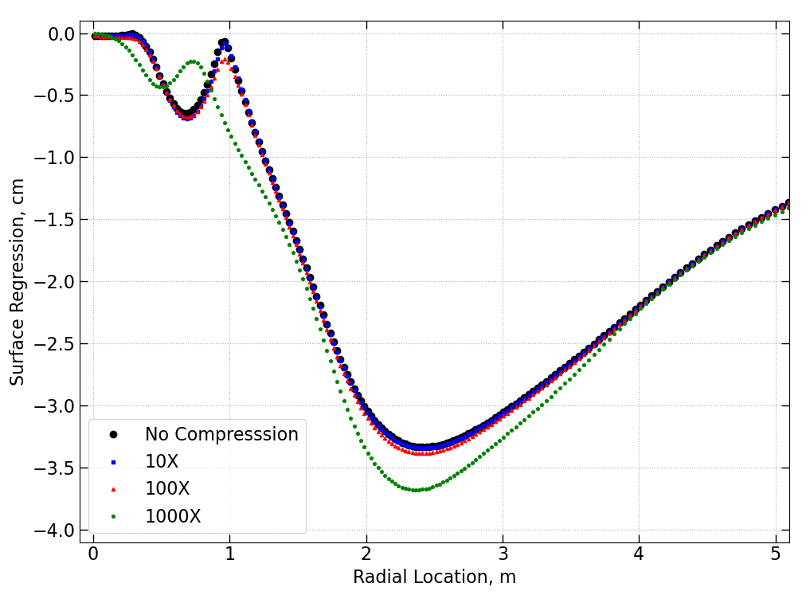
Figure 2. Effects of time compression on surface regression from 1x to 1000x

HYBRID CFD/ENGINEERING MODEL SIMULATION OF APOLLO 12 LANDING
The fully coupled, Loci/CHEM-DIGGEM model described in the previous section is applied to the Apollo 12 landing and detailed here. During the simulation, the modeled Apollo 12 vehicle is descending towards the Lunar surface. The Lunar surface is continuously deforming throughout the simulated vehicle descent due to the modeled surface erosion from the DIGGEM model. The time compression methodology detailed earlier allows for this coupled simulation to be completed in a practical amount of time, with the vehicle descending 100 times faster in the computational model relative to the actual flight descent velocity. This equates to a little over a week of wall clock time compared with over a year that would be necessary without the use of time compression. Combining the coupled CFD/engineering model with the time compression methodology allows for higher fidelity viscous shear erosion predictions of a naturally coupled plume/surface environment in a practical amount of time.

Transient effects of vehicle motion on the plume and surface erosion can now be captured, as evidenced from the time progression of plume Mach number and crater depth in Fig. 3. First, observe the evolving plume shape from Mach number contours in Fig. 3 at multiple instances in time. The plume expands wide in the low-pressure, Lunar environment, but it decreases in size as the vehicle descends since there is less space for the plume to expand before impinging on the Lunar surface. Also, ripples in the plume contours are visible from Fig. 3. These ripples arise from the unsteady nature of the plume/surface interaction, with the plume gases recirculating in a region directly beneath the vehicle. This recirculation zone can be observed from the streamlines shown in Fig. 4, and it is a known phenomenon in PSI (Mehta 2013).

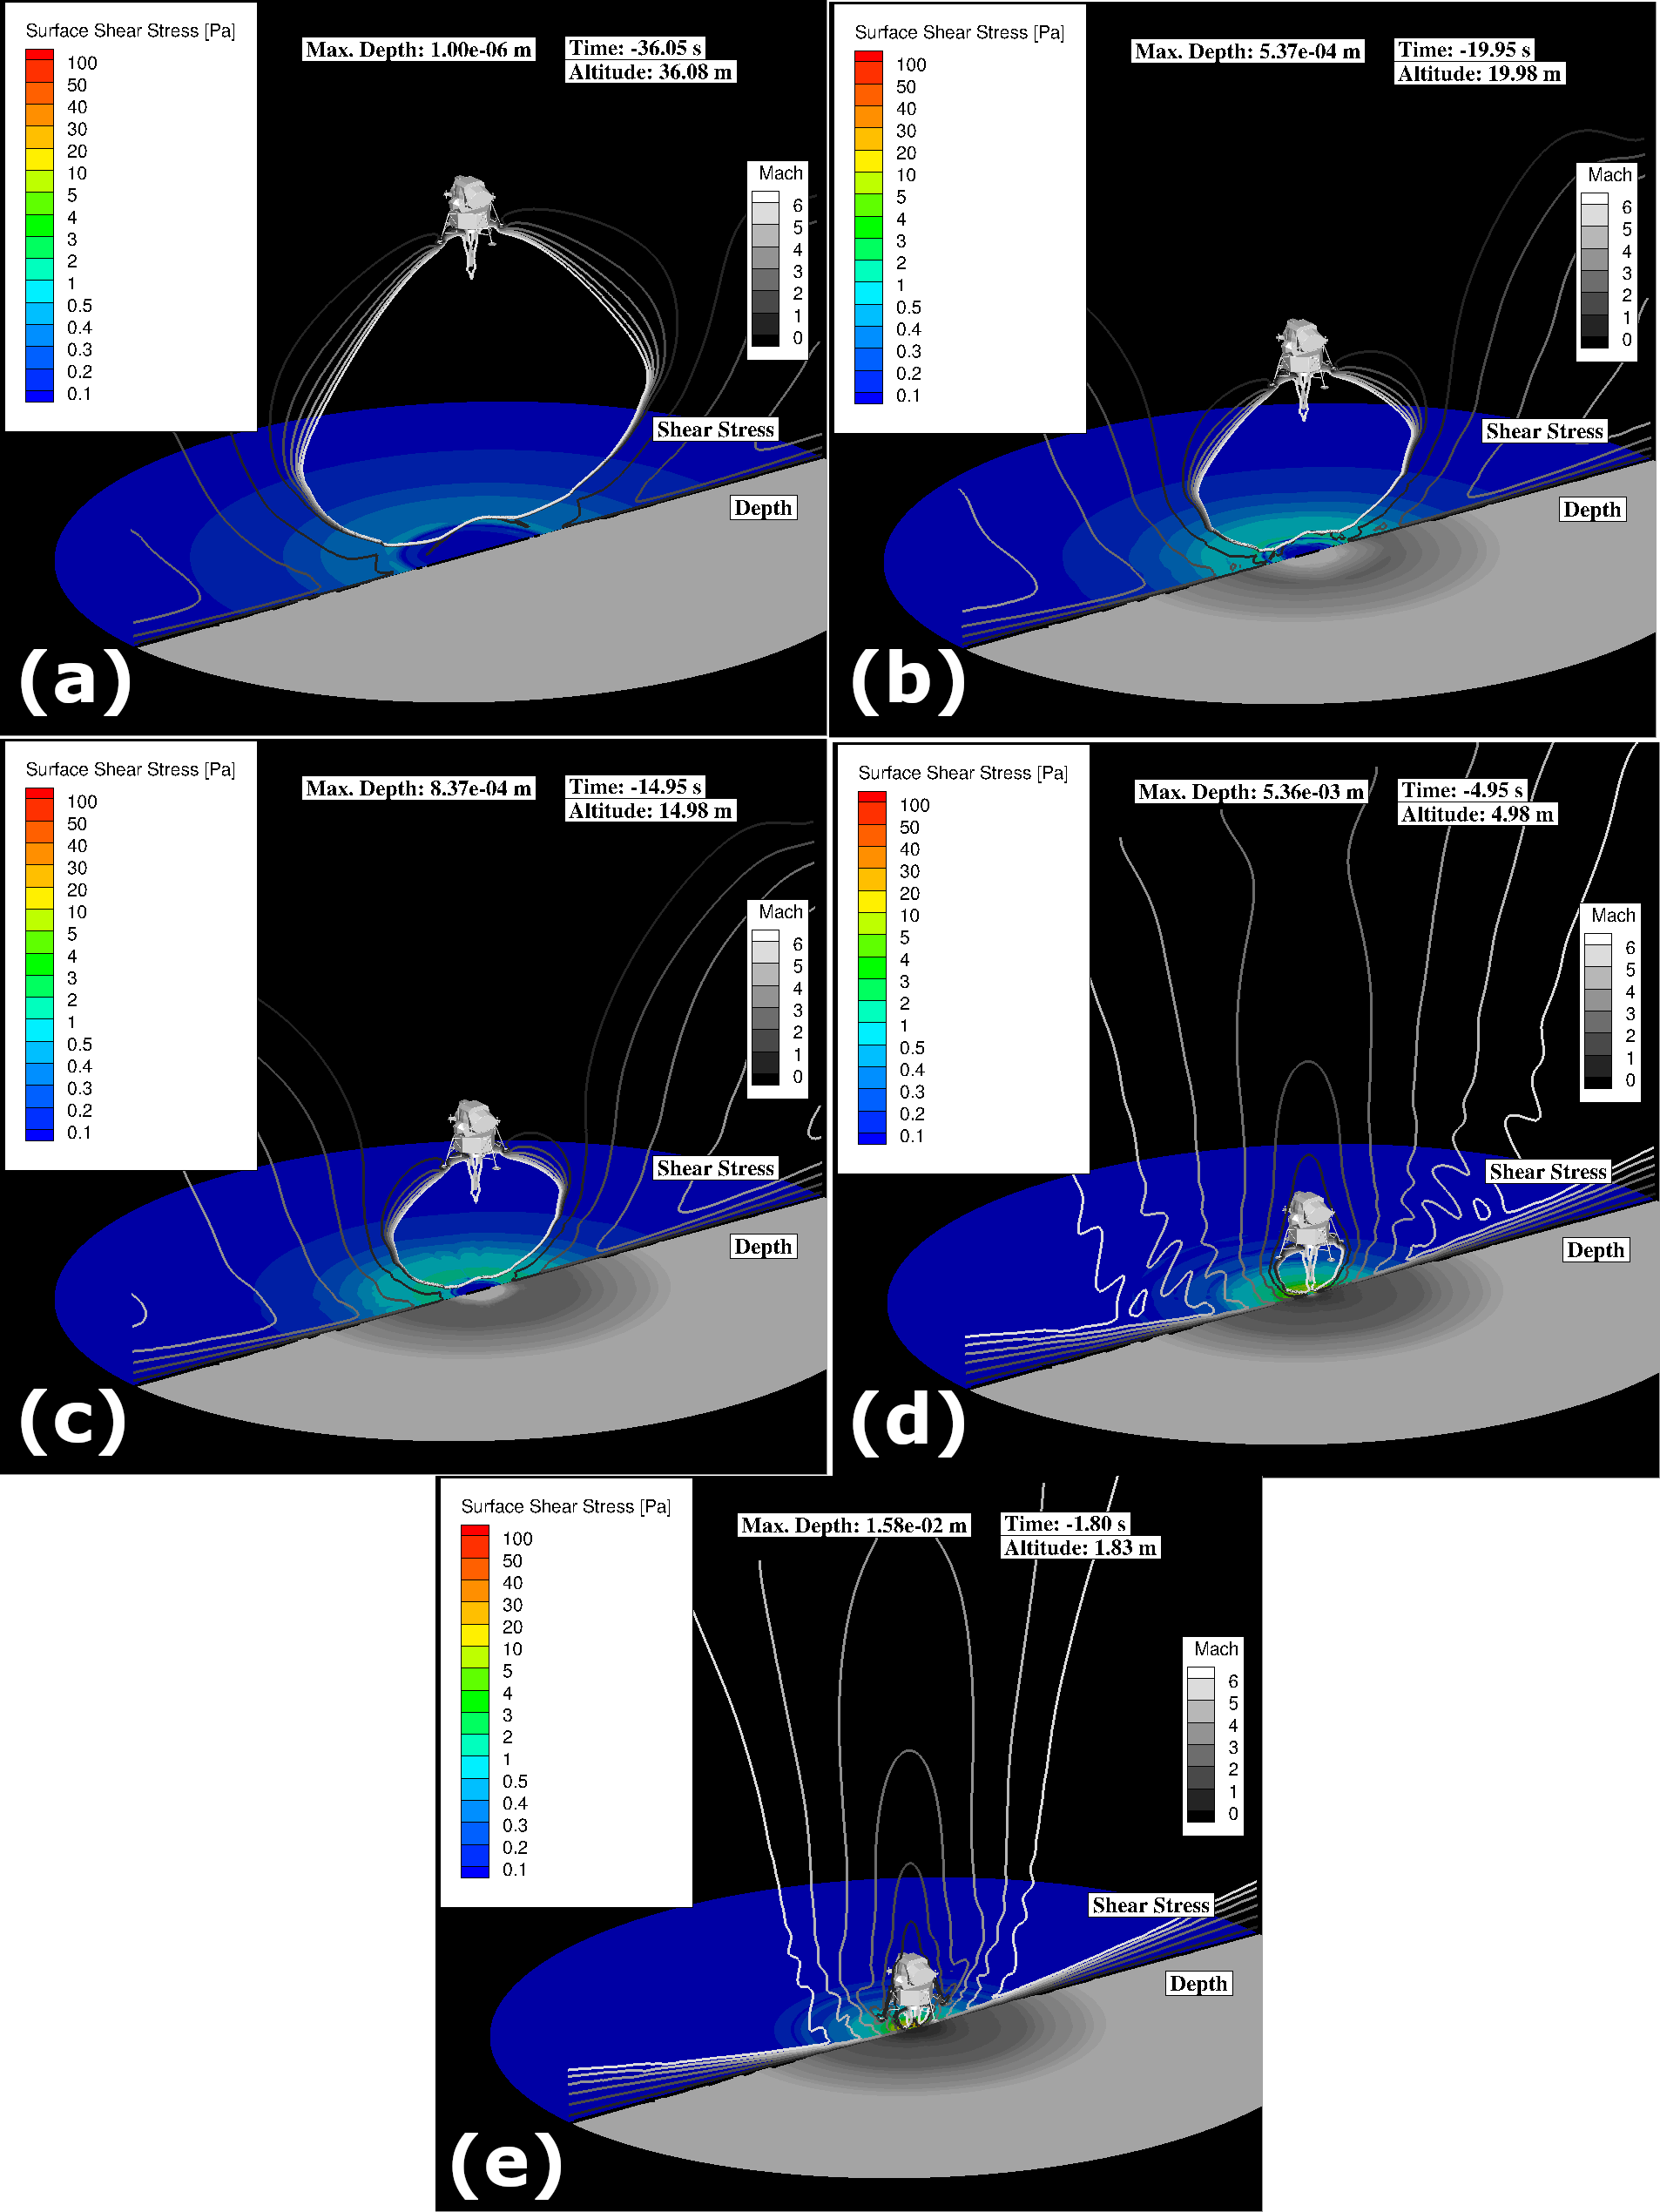
Figure 3. Time evolution of plume Mach number, surface shear stress, and crater depth from coupled Loci/CHEM-DIGGEM simulation of Apollo 12 landing: (a) time=-36.05 s, (b) time= -19.95 s, (c) time=-14.95 s, (d) time= -4.95 s, (e) time=-1.8 s

Changes to the Lunar surface also contribute to unsteady plume behavior with plume gases impinging deeper into the growing crater and exiting at greater angles along crater walls. With the fully-coupled approach, there is a continuous feedback between the plume and Lunar surface conditions. Consider the effects of the transient plume impingement effects on crater evolution.

The decreased available space for plume expansion as the vehicle descends results in decreased plume footprints. Simultaneously, the impingement pressures and surface shear stresses are increasing. These combined effects result in smaller regions of more intense surface erosion nearer to the plume stagnation region as the vehicle descends. The decreasing plume footprint size and increasing shear stresses during vehicle descent can be observed from Fig. 3.

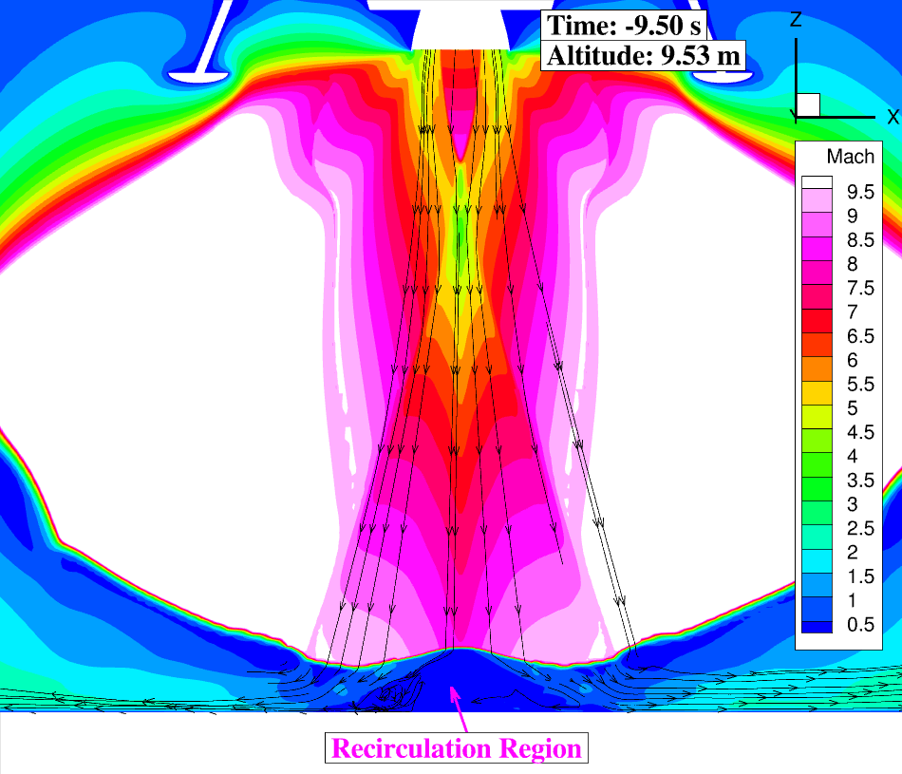
Figure 4. Mach contours and plume flow streamlines from coupled Loci/CHEM-DIGGEM simulation of Apollo 12 landing at an altitude of 9.53 m

Cratering metrics such as eroded mass flux and crater depth metrics are obtained from the Loci/CHEM-DIGGEM simulations of Apollo 12 landing. The eroded mass flux is obtained directly from the DIGGEM model described previously, while the crater depth is a time-integrated property of the eroded mass flux. Crater depth may be observed from Fig. X to be increasing as the vehicle descends, and at time t= -1.8 s from touchdown, the maximum crater depth reaches approximately 1.5 cm. This crater depth is consistent with optical extinction based estimates from Lane and Metzger (Lane 2015), which also reports a maximum crater depth of 1.5 cm. Since the DIGGEM model is calibrated to Apollo 12 flight data from Lane and Metzger (Lane 2015), the resulting eroded mass flow rate using the fully coupled, Loci/CHEM-DIGGEM tool can be compared with the original flight data to verify that the calibrated DIGGEM model parameters remain valid.

The eroded mass flow rate is an area-integrated property of eroded mass flux that may be evaluated at any instant in time (or altitude given the descent trajectory). Thus, the eroded mass flow rate is computed for the entire, simulated Apollo 12 descent and compared with flight data (Lane 2015) in Fig. 5 below.

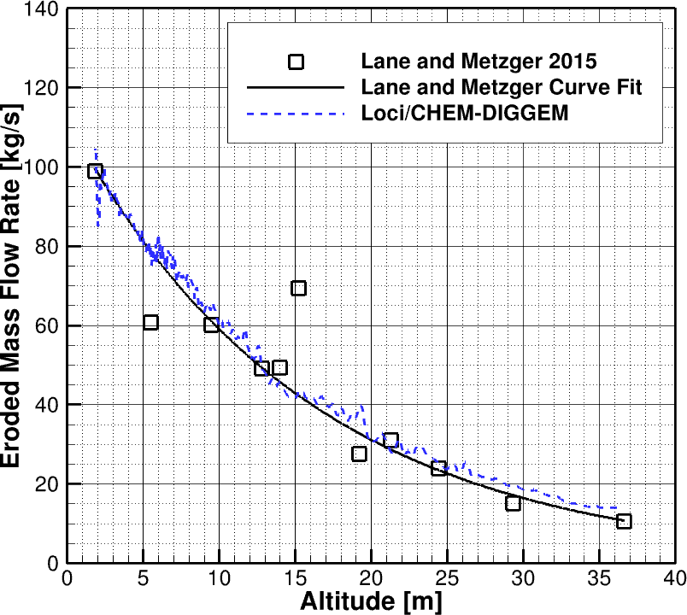
Figure 5. Comparison of eroded mass flow rate from Loci/CHEM-DIGGEM simulation to calibration data from Lane and Metzger 2015

The eroded mass flow rate from the fully-coupled Loci/CHEM-DIGGEM simulation follows the trend from Lane and Metzger (Lane 2015). Overall, the eroded mass flow rates from Loci/CHEM-DIGGEM are within 30% of the curve fit, but it is within 12% of the curve fit below 15 m vehicle altitude where most of the erosion occurs. This level of agreement with flight data verifies that the DIGGEM model parameters remain valid with the newly developed, fully-coupled modeling approach.

CONCLUSION

Plume surface interactions (PSI) continue to pose risks to landers during propulsive landings. The recently developed, hybrid Computational Fluid Dynamics (CFD)/engineering model tool couples high-fidelity, CFD simulations of plume flow with engineering models for viscous shear erosion. This modeling approach fits into the cascade of predictive simulation capabilities for PSI developed within the Fluid Dynamics Branch at NASA Marshall Space Flight Center by replacing some of the higher-fidelity modeling approaches for granular physics with engineering models. Simulations of entire vehicle descent trajectories on the order of tens of seconds are now possible with the fully-coupled approach, as long as modeling assumptions for time compression and viscous shear erosion remain valid.

The hybrid CFD/engineering model tool has been demonstrated for the landing of Apollo 12 Lunar Module (LM). Effects of the vehicle descent on the plume and surface erosion are evident, and eroded mass flow rates and maximum crater depths obtained from the simulation compare well with estimates from flight data. This verifies that the DIGGEM model parameters remain well calibrated, and validation of the hybrid CFD/engineering model tool’s prediction of crater depth is currently underway.

REFERENCES

Gale, M. P., Mehta, R. S., Liever, P. A., Buettner, K. E., and Curtis, J. S. (2017). “Gas-Granular Flow Solver for Plume Surface Interaction and Cratering Simulations.” 23rd AIAA Computational Fluid Dynamics Conference, June 2017. AIAA Paper 2017-4503. 10.2514/6.2017-4503.
Lane, J. E. and Metzger, P. T. (2015). “Estimation of Apollo Lunar Dust Transport using Optical Extinction Measurements.” Acta Geophysica, 63(2), 568-599, 10.1515/acgeo-2015-0005.
Liever, P. A., Gale, M. P., Mehta, R. S., Weaver, A. B., West, J. S., and Westra, D. G. (2020). “Gas-Particle Flow Simulations for Martian and Lunar Lander Plume-Surface Interaction Prediction.” ASCE Earth and Space 2020, Seattle, WA.
Luke, E. (1999). “A Rule-Based Specification System for Compuational Fluid Dynamics.” Ph.D. Dissertation, Mississippi State University, Mississippi.
Mehta, M., Sengupta, A., Renno, N. O., Van Norman, J. W., Huseman, P. G., Gulick, D. S., and Pokora, M. (2013). “Thruster Plume Surface Interactions: Applications for Spacecraft Landings on Planetary Bodies.” AIAA J., 51(12), 2800-2818, 10.2514/1.J052408.
Metzger, P. T., Lane, J. E., Immer, C. D., Gamsky, J. N., Hauslein, W., Li, X., Latta III, R. C., and Donaue, C. M. (2010). “Scaling of Erosion Rate in Subsonic Jet Experiments and Apollo Luanr Module Landings.” ASCE Earth and Space 2010, 191-207, 10.1061/41096(366)21.
Shurtz, T., Krolick, W., Weaver, A., Liever, P., and West, J. (2022). “A Hybrid CFD/Engineering Model for Predicting Plume Induced Erosion and Cratering.” IPPW 2022, Abstract #102, Santa Clara, CA.

