TSIS-1 Pointing System Performance after 5 Years on ISS
Patrick Brown  Laboratory for Atmospheric and Space Physics  University of Colorado Boulder  1234 Innovation Drive  Boulder, CO 80303  pat.brown@lasp.colorado.edu | David Gathright  Laboratory for Atmospheric and Space Physics  University of Colorado Boulder  1234 Innovation Drive  Boulder, CO 80303  david.gathright@lasp.colorado.edu

Abstract— The Total and Spectral Solar Irradiance Sensor-1 (TSIS-1) was installed on the ISS in December 2017, completed its prime 5-year mission in 2023, and is now in extended operations. Within the first year of operations, the paper titled, “Challenges and Solutions for Precision Solar Pointing on the ISS for the TSIS Instrument” was presented at the 2019 IEEE Aerospace Conference. This paper described challenges associated with ISS jitter and structural obscuration along with on-orbit measurements of these phenomenon and how TSIS-1 initially performed in their presence.
Since the paper was presented in 2019, TSIS-1 has continued to operate with much success. This paper will provide a 5-year update on the performance of the TSIS-1 pointing system, including additional measurements of ISS base motion jitter, updated ISS obscuration information, data trends that showed slight increases in azimuth motor torque and pointing errors, and a pointing anomaly due to contamination on one of the pointing system sun sensors. These results may help other payload developers better understand the ISS environment and long-term mechanism performance.
Table of Contents
1. Introduction 1
2. ISS Base Motion Jitter 2
3. ISS Obscuration 3
4. TPS Pointing Trends 5
5. HFSS-B Contamination 7
6. Conclusions 8
Acknowledgements 9
References 9
Biography 9

1. Introduction
In March 2018, the Total and Spectral Solar Irradiance Sensor-1 (TSIS-1) instrument completed commissioning and began science operations on external Site 5 of Express Logistics Carrier-3 (ELC-3) on the International Space Station (ISS). In 2023, TSIS-1 completed its prime 5-year mission (and is now in extended operations) having contributed to the multi-decades-long records of total and spectral solar irradiance. To collect the science, the Thermal Pointing System (TPS) accurately pointed the Total Irradiance Monitor (TIM) and the Spectral Irradiance Monitor (SIM) sensors at the Sun at every available opportunity.
Shortly after commissioning, the initial TPS performance results were documented along with a description of the challenges, and their solutions, to operating the TPS on the ISS [1]. Since then, the TPS has performed well and additional data has been collected that adds to those initial results. This paper continues with the themes of the original paper and, as such, refers the reader to the original paper for background and details of TSIS-1 and the ISS challenges of jitter and obscuration.
This paper begins by providing updates to the original topics of ISS base motion jitter and obscuration. Next, it discusses TPS pointing trends, particularly slight increases in azimuth pointing errors and motor currents. Finally, it describes a contamination anomaly on High-rate Fine Sun Sensor-B (HFSS-B).
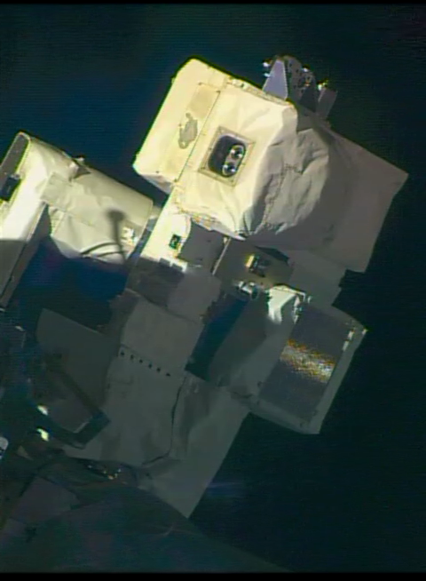
Figure 1: TSIS-1 at Sunrise on the ISS (Credit: NASA)

2. ISS Base Motion Jitter
Background
Prior to TSIS-1 commissioning in early 2018, there was very little measured data of ISS base motion jitter at external mounting sites (e.g., ELCs). So when TSIS-1 measured the ISS jitter using the HFSS and found it to be small magnitude (<4 arcseconds 1σ) and low frequency (<0.5 Hz), it was very encouraging. However, as previously cautioned in our 2019 paper, those measurements were taken over a very short time window, which may or may not have been indicative of long term performance. Therefore, to help better characterize the ISS jitter environment and its potential impact to pointing performance, TSIS-1 took several additional jitter measurements during its first five years on orbit.
TSIS-1 was able to measure ISS base motion jitter by parking the TPS gimbal in a location that would allow the sun to pass through its field of view (FOV)(i.e., a “transit”). Because the TPS was stationary during transits, the apparent motion of the sun across the HFSS FOV was indicative of the ISS motion that consisted of the orbit-related rigid-body angular motion plus the base motion jitter. The rigid body motion was removed by simply applying a linear fit on the azimuth axis and a quadratic fit on the elevation axis to produce residuals that represented the ISS jitter at 200 Hz HFSS sample rate. A quadratic fit was used on the elevation axis to account for slow, sinusoidally varying yaw motion of the ISS.
New Jitter Measurements
In addition to the six jitter measurements from commissioning, an additional fourteen jitter measurements were performed during the first five years of on-orbit operations. No jitter measurements were performed in 2019 and 2020 as TSIS-1 settled into routine operations, but measurements resumed in 2021, 2022, and 2023 to provide regular trending of the ISS jitter environment and its potential impact on TPS pointing performance (discussed further in Section 4: Pointing Trends). Figure 2 shows a summary of all the TSIS-1 measurements of ISS base motion jitter, which includes measurements by both HFSS-A, which was a cold spare until 2022, and HFSS-B, which was the primary, operable HFSS until 2022 (discussed further in Section 5: HFSS-B Contamination). There are two important observations about this plot. First, the elevation jitter values are consistently in the 2 to 4 arcseconds 1σ range over the five year period and as measured by each HFSS. Second, the azimuth jitter values vary from 4 to 12 arcseconds 1σ range, which is a much larger distribution than observed during commissioning. Although not shown in this plot, the frequency content of the ISS jitter was consistent with the commissioning measurements that showed <0.5 Hz motion.
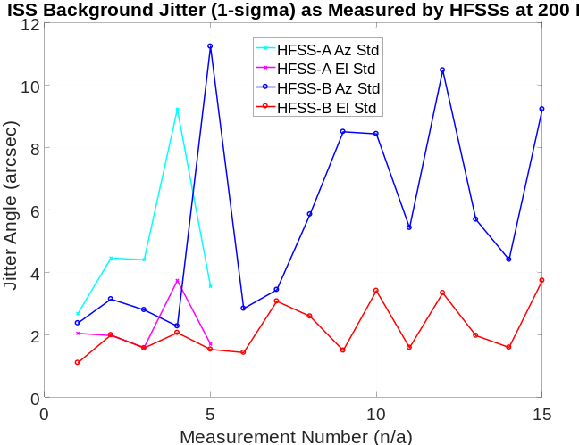

Figure 2: Summary of ISS Background Jitter Measurements by TSIS-1
To better understand the variability in the azimuth jitter magnitudes, it is helpful to examine time series plots of individual measurements. A recent measurement by HFSS-A in Figure 3 shows performance similar to commissioning but with a slight addition of a low frequency component on the azimuth axis. Over this time period, the ISS jitter values are 3.5 arcseconds 1σ in azimuth and 1.7 arcseconds 1σ in elevation, both of which are very close to the values observed during commissioning.
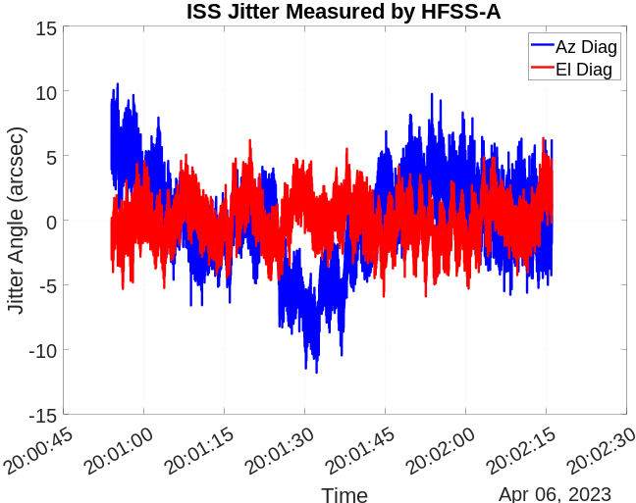
Figure 3: HFSS-A Measurement of ISS Jitter in 2023
Figure 4 shows a measurement by HFSS-B in 2021 with ISS jitter values of 5.7 arcseconds 1σ in azimuth and 1.9 arcseconds 1σ in elevation. It is clear from this plot that the primary difference in the larger azimuth jitter is due to a low-frequency component that is intermittently present in the measurements. This low-frequency component was seen in measurements with the TPS actuator brakes both engaged and disengaged, so it is not a case of free body motion of the TPS gimbal. Additionally, the intermittent nature of it implies that it is not systematic nonlinearity in the HFSS measurements. Therefore, it is reasonable to conclude at this time that ISS base motion jitter can vary in magnitude and frequency content as indicated by the TSIS-1 measurements in Figure 2 above. This conclusion is quite reasonable given the highly complex, time-varying nature of the ISS. Nonetheless, the TSIS-1 measurements of ISS base motion jitter still suggest that the ISS is a relatively benign and stable jitter environment that is suitable for a large variety of external payloads. In particular, this information has been extremely valuable to the CLARREO Pathfinder (CPF) payload team, another LASP instrument that will fly on an ISS ELC [2].

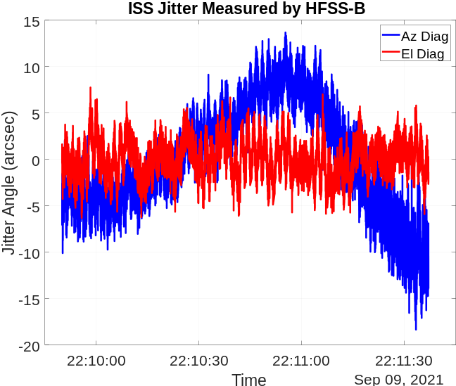
Figure 4: HFSS-B Measurement of ISS Jitter in 2021

3. ISS Obscuration
Background
The effect of ISS structural obscuration near sunrise and sunset was a concern for TSIS-1 because of how it could affect operational robustness and the available duration of solar tracking per orbit. During commissioning, a technique was developed to use sun sensor magnitude data across the TPS gimbal field of regard (FOR) to slowly generate a solar field of regard (aka, an obscuration) map. This technique helped to provide real-world understanding of the complex ISS viewing environment and to tailor TPS commanding to provide robust tracking in the presence of variable solar signal.
When the initial solar FOR map was published in 2019, it was hoped this approach and awareness of ISS obscuration complexity could be applied by other ISS payloads. Since then, the Stratospheric Aerosol Gas Experiment III (SAGE III) team applied this technique to better visualize and understand their unexpected structural blockages, which helped to minimize the effect of obscuration on their science availability [3]. This experience was also applied to the design-phase work of the pointing system for the CPF payload to help create better predictive obscuration tools [2].
Since commissioning, the ISS has experienced several significant configuration changes that could have affected obscuration, including removal of the SCaN (Space Communications and Navigation) Testbed payload from ELC-3 Site 3 (forward-zenith-starboard location on ELC-3; removed June 2019), several dockings of the Crew Dragon capsule on the forward and zenith ports of the Harmony module (starting in May 2022), installation of the ISS Roll Out Solar Array (iROSA)(port arrays 2B/4B installed in June 2021, 4A installed in December 2022), and installation of the Russian Multipurpose Laboratory Module (MLM; aka Nauka; installed July 29, 2021).
Solar Field of Regard Map
To help evaluate the potential impacts of these configuration changes to obscuration, solar FOR maps were generated for different time periods throughout the mission. To help capture the variable aspects of obscuration, the percent obscuration was calculated for binned gimbal locations, which provided a color gradation indicative of how often the location was obscured. Therefore, objects that are only present some of the time appear as “ghosts” in the map. The color map was also updated to a more intuitive scheme that shows yellow at locations with solar availability and black at locations that are shadowed.
Figure 5 shows the solar FOR map for the first five years on-orbit. Generally, this figure looks the same as the original solar FOR map that TSIS-1 documented in 2019 in Figure 10 of [1], which suggests that none of the aforementioned ISS configuration changes had a significant impact on the ability of the TPS to track the Sun. For example, the iROSA did not change the port solar array obscuration at all, SCaN Testbed’s removal was barely noticeable as a change, and the Dragon (including Crew) only appeared as ghosted rectangular shapes (forward, zenith ports) near existing ELC structure due to its intermittent visiting status. On the aft side of the ISS, the intermittent status of the Soyuz was also apparent as ghosting, along with the newly installed MLM. Perhaps the largest change in the solar FOR map is the location of the limb of the Earth. The addition of the MLM required a change in ISS pitch attitude, which manifested on the ram (sunrise) side as a band of ghosting along the limb and on the wake (sunset) side as additional solar visibility (lack of ghosting when compared to the 2019 FOR image is an analytical artifact) at the limb.
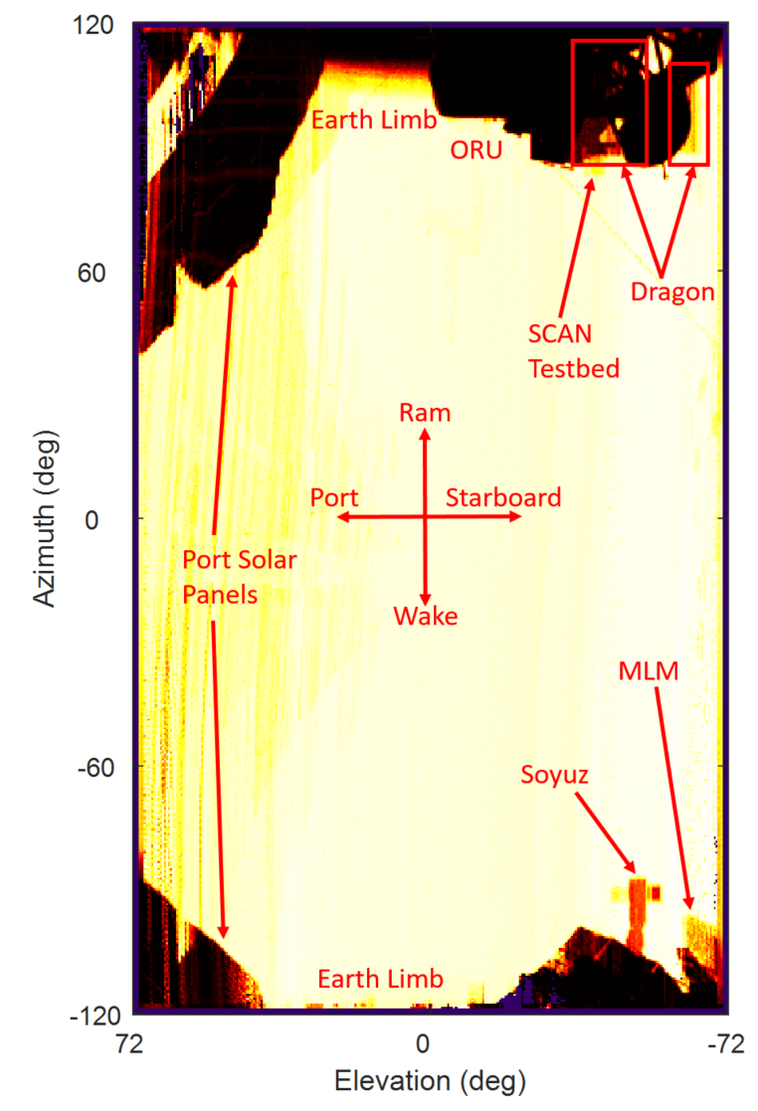
Figure 5: TSIS-1 Solar Field of Regard Map
Solar Tracking Durations
The primary concern with ISS structural obscuration was its potential to limit the available time for solar tracking, which would thereby limit the available time to collect solar irradiance measurements. The solar FOR map (Figure 5) shows that there was clear view of the sky over a large angular space, which implies that there would be long, continuous solar tracking periods for TSIS-1 at ELC-3, Site 5. As another means of evaluating solar availability, the solar tracking period per orbit was plotted versus solar beta angle as seen in Figure 6, which was previously presented in the 2019 paper in Figure 13 [1]. The trends in solar tracking durations per orbit that were originally observed in 2019 continued through the next five years, with 45+ minutes of continuous solar viewing time per orbit over most solar beta angles. Additionally, there were many situations (e.g., visiting vehicles) that resulted in shorter than nominal solar tracking durations. Overall, the TPS has been able to provide sufficient solar tracking time for the TSIS-1 instruments to collect solar irradiance measurements.
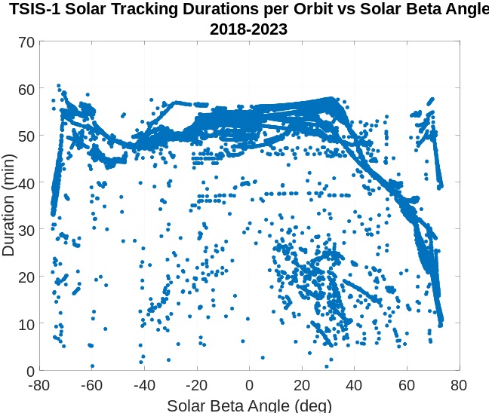
Figure 6: TSIS-1 Solar Tracking Durations per Orbit
Glint Measurements
It is also worth including a closely related analysis to the solar FOR maps that might also be useful to other ISS payload developers. Similar to looking for decreases in the solar signal over the FOR to locate obscuration sources, it was also possible to look for glint sources by identifying times when the solar signal increased above its baseline magnitude. It is well known that white beta cloth and other ISS surfaces are responsible for specular reflection of the Sun, which can negatively impact optical sensors.
By examining the TSIS-1 sun sensor magnitudes over the course of the mission, it was found that there were frequent transient increases in solar signal throughout each year, and three large increases over the five year period are seen in Figure 7. The small, frequent glint events that appear as “hair” on the sinusoidally-varying solar signal were ~2% larger than the nominal solar signal, whereas the three larger glint events were 17%, 9%, and 29% larger than the nominal solar signals. The odd characteristic of the three large events was that they occurred near zenith, where there is no ISS structure. However, based on the record of visiting vehicles, the three large glint events were found to correlate to the Soyuz Expedition 57S docking, the SpaceX Crew 4 docking, and the Progress 82 docking respectively. For this reason, it appears that the three large glint events were caused by the visiting vehicles transiting above TSIS-1, and/or the robotic arm being parked within the TSIS-1 FOV. A possible extension of this analysis would include plotting the glint events spatially similar to the solar FOR maps. But even in time series format, this information was helpful in the evaluation of potential impacts of ISS glint on the CPF HFSS, and it may be of use to other payload developers as well.
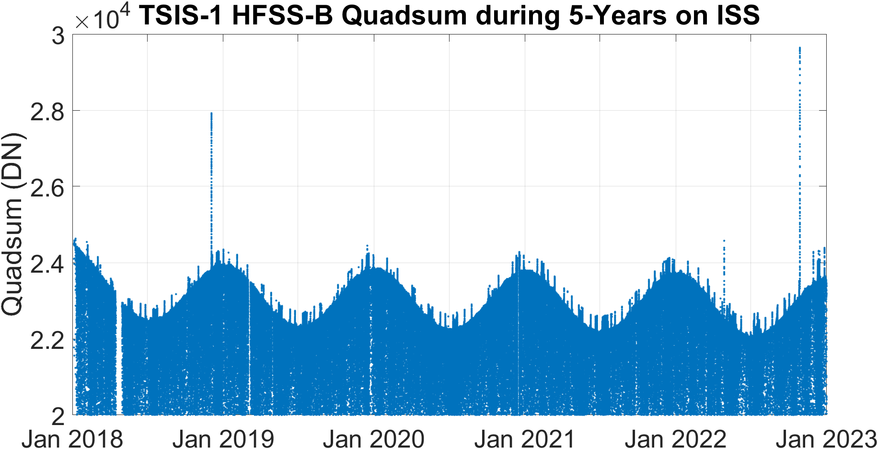
Figure 7: Glint Signatures on HFSS Solar Signal (Quadsum) including “2% Hair” and Three Large Glint Events

4. TPS Pointing Trends
Data Trending Methods
To help track performance over the course of the mission, the TSIS-1 engineering team trended TPS data that was beyond the scope of typical data monitoring by the instrument operations team and the science data systems team. TPS data monitoring and trending began immediately following commissioning with generation of automated, emailed daily PDF reports that showed gimbal angles, HFSS angles, and motor currents. These reports were useful in providing rapid assessments of performance changes and also provided quick inferences of the current operating regime (e.g., solar beta angle, ISS flight attitude, etc.).
Automated weekly PDF reports were also generated, saved, and emailed to provide longer term trending of a larger number of telemetry items. To help detect meaningful trends, several key metrics were calculated over each solar tracking period when the weekly report was generated: the standard deviation of the HFSS angles (i.e., the variability or jitter of the pointing errors), the mean of the HFSS angles, the standard deviation of the motor currents, and the mean of the motor currents. These metrics each condensed down an entire orbit’s worth of measurements (i.e., ~5400 values) to a single metric that could shed light on pointing performance trends. To aid in subsequent data analysis, these metrics were saved in standardized data files that were compatible with existing LASP data retrieval tools that usually query a relational database of telemetry data. This method of generating higher level data products is similar to processing of science data products, so these items were colloquially called Level-2 (L2) engineering data. Because the automated weekly report generation handled the heavy lifting of calculating the pointing metrics, subsequent long-term plotting the L2 TPS data was accomplished efficiently, which encouraged regular data trending.
Pointing Trends
Figure 8 shows a plot of the TPS pointing errors, as reported by HFSS-B, during each solar tracking period over the first five years on orbit. The y-axes of these plots are scaled to 60 arcseconds, which is the 1σ requirement for TPS pointing jitter. Both axes show performance that is roughly an order of magnitude better than requirements, with the elevation axis showing steady performance of 2-3 arcseconds 1σ over the entire time period. The azimuth axis shows a slight upward trend in pointing error from 4 arcseconds 1σ at beginning of mission to 9 arcseconds 1σ in 2023, and there also appears to be more variability over the course of each year. Although well within requirements, this performance degradation was significant enough to warrant additional investigation as will be described in the remainder of this section.
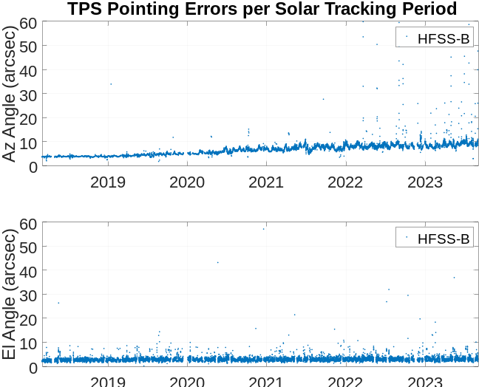
Figure 8: TPS 1σ Pointing Errors during Each Solar Tracking Period for the First Five Years on Orbit
Figure 9 shows a plot of the mean TPS motor currents during each solar tracking period over the first five years on orbit. There is no requirement per se on the motor currents, but the maximum available (aka, stall) current is slightly larger than 3 Amps, so both axes are operating at only 10% of their dynamic range and therefore have more than adequate margin. Similar to the pointing errors, the elevation axis exhibits steady behavior over the five year time period, whereas the azimuth axis shows a slight increase in current magnitude from -0.22 Amps to -0.32 Amps. Interestingly, the current seemed to steady out at its maximum magnitude in the 2021 to 2023 time period and then slightly decreased toward -0.3 Amps in 2023. The increase in azimuth motor current throughout the mission was also significant enough to warrant further investigation, which is described further in this section.
The TPS BLDC actuators were life tested to twice their expected life for a total of 67,000 cycles and showed no appreciable degradation, whereas after 3 years or ~16,000 cycles on-orbit, the azimuth axes showed noticeable increases in both pointing error and motor current. Therefore, these increases were not explainable as obvious run-in degradation.

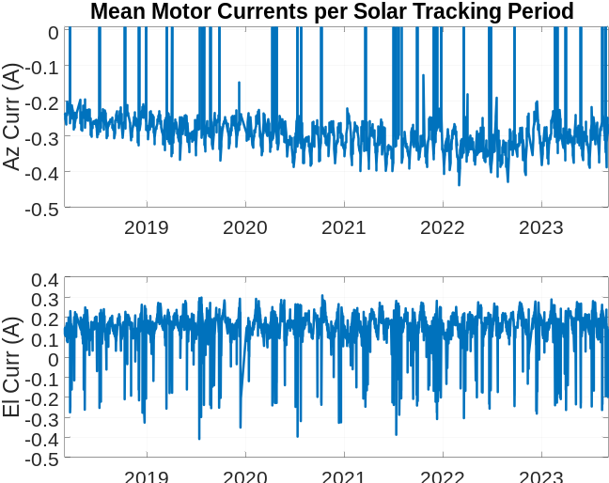
Figure 9: Mean TPS Motor Currents per Solar Tracking Period for the First Five Years on Orbit
-XVV Trend Reversals
Examining the TPS metrics further, it was observed that when the ISS reversed its attitude for dockings of Russian visiting vehicles (i.e., flying “backwards” in the –XVV orientation), the azimuth motor current, and to a lesser degree the azimuth pointing error, experienced noticeable reductions in magnitude as seen in Figure 10. In this plot, the first yaw reversal to –XVV occurred July 1 and was immediately accompanied by a large reduction in azimuth motor current from 0.35 Amps to 0.24 Amps and an associated gradual reduction in azimuth pointing error from 9 arcseconds 1σ to 6 arcseconds 1σ. On July 2, the ISS yawed back to its nominal +XVV orientation, and the motor current experienced an immediate increase (but did not return to its previous level) followed by a slow, steady increase. Pointing errors also showed a slow, steady increase after the ISS returned to +XVV.
Next on July 11, the ISS reversed yaw to –XVV orientation again, which was immediately followed by similar decreases in motor current and pointing errors. However by July 16, these values began to increase ever so slightly until the ISS switched back to its nominal +XVV orientation on July 18, which also showed increases in current and pointing errors.
Finally on July 22, the ISS reversed yaw to –XVV yet again, which caused an immediate reduction in motor current, but this time the current did not remain low. Instead, it began to increase back toward 0.3 Amps before increasing further on July 30 when the ISS switched back to +XVV orientation again.
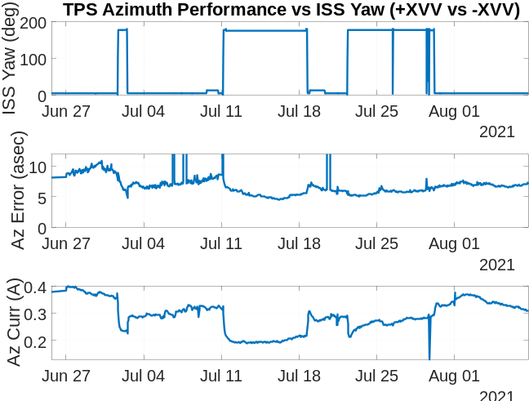
Figure 10: TPS Azimuth Pointing Errors and Motor Currents as a Function of ISS Yaw Orientation (+XVV vs -XVV)
After observing the correlation between ISS yaw orientation and azimuth performance, the team sought to find an underlying mechanism that could explain the behavior. The first aspect of the TPS to consider was its motion tracking profile. During each period of sunlight, the azimuth axis slowly tracks the sun at ~4 degrees per minute. Then upon reaching eclipse, it moves quickly toward the zenith position to support dark sky measurements. Finally, it moves quickly toward its maximum angular range to begin solar tracking at sunrise. I.e., the speed of motion of the azimuth axis is not symmetric in each half of its orbit cycle. An additional difference with –XVV observations is that the TPS continues to operate on its nominal, +XVV command sequence, which adds an additional, quick slew across the azimuth range of motion just prior to starting solar tracking. This seemed to suggest that there was a speed/directionality effect on the motors, possibly related to redistribution of bearing lubricant. A review of space mechanism literature did not reveal any obvious causes or other examples of this phenomenon. Although possibly related to the long-term increase in azimuth motor current and pointing errors, the direction reversal behavior was not pursued further as a method of understanding the azimuth degradation.

On-Orbit Special TPS Activities
Continuing to investigate the azimuth degradation, two types of special on-orbit TPS activities were performed periodically. The first type of activity was the ISS jitter measurement that is described in Section 2. Because the TPS closed-loop motor control provides active attenuation of base motion, it stands to reason that if the base motion jitter increased, the required motor current to attenuate the jitter would also increase, and there would be associated residual increases in pointing errors. However, as previously shown in Figure 2, there was no slow, steady increase in ISS base motion jitter that correlated to the increases in azimuth motor current and pointing errors. In fact, many of the jitter measurements were at beginning of TSIS-1 life levels even years later, yet there were no associated improvements in azimuth performance. Therefore, ISS base motion jitter does not appear to be the cause of the increases in azimuth motor currents and pointing errors.
The second type of special on-orbit activity sought to investigate if the azimuth actuator itself had experienced degradation. To monitor actuator health, the TPS test program performed regular range of motion (ROM) scans at constant speed. When operating at constant speed and without any external forces or torques (a reasonable assumption given the TPS design and environment), the required motor torque is equal to the torque due to internal losses (e.g., bearing friction/drag torque, twist capsule torques, etc.). Because motor current is directly proportional to the motor torque, it was therefore possible to use measured motor current during ROM scans to characterize and trend motor health.
During system-level testing, the TPS performed nine ROM scans (excluding those during thermal vacuum testing to be discussed further below). After reaching orbit, one more ROM scan was performed during commissioning to confirm functionality and performance post-launch. Therefore, a baseline set of ROM data existed to help detect possible on-orbit trends in motor currents. Four additional ROM scans were performed as special activities (two in 2021 and two in 2023), and they have been added as an annual special activity for the future. Figure 11 shows the mean motor currents in each direction for both axes during TSIS-1’s integration and test (I&T) phase (the first 9 data points) and on-orbit (the last 5 data points).
Several observations can be made about this plot. First, the data is generally all consistent and there are no significant outliers or trends. Second, the elevation currents are usually larger than azimuth currents, although there is no known special significance to this. Finally, and most significant, the on-orbit azimuth currents showed a noticeable increase in magnitude in both directions compared to the relatively steady currents from I&T (i.e., measurements 10 through 14). However it is also worth stating that even with these increases, the azimuth currents are still in family with elevation currents.
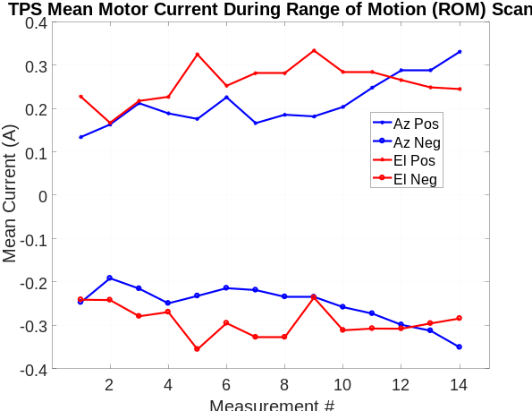
Figure 11: TPS Mean Currents for ROM Scans
To help try to explain the increase in azimuth motor currents, the TPS motor currents were also examined as a function of temperature, including thermal vacuum (TVAC) testing. The temperature sensitivity data showed that motor currents were insensitive to temperature from 0° C through 70° C, but as expected, increased significantly at colder temperatures (e.g., near the cold dwell temperature of -30° C) due to increase in bearing lubricant viscosity. The on-orbit motor temperatures during ROM scans were all in the 0 to 20° C range and showed little variation as a function of temperature. Therefore, the increase in on-orbit azimuth motor currents in Figure 9 are not attributable to temperature sensitivity.

At this time, it is reasonable to conclude that because the external jitter environment remained relatively stable and the motors were in a stable thermal regime, the cause of the increase in on-orbit azimuth motor currents and pointing errors was due to internal degradation of the azimuth actuator. A specific cause of the degradation (e.g., lubricant breakdown) has not been identified at this time. However, the change in performance is small relative to the allowable motor current and pointing error, so the TPS still maintains an order of magnitude margin in both of these performance metrics. Therefore, no operational changes are needed for the TPS, but data trending of these quantities will continue for the remainder of the TSIS-1 mission.
Finally, it is unclear whether the azimuth degradation would be considered normal under the given circumstances, but it is hoped that by sharing these results, TSIS-1 will be contributing to overall body of knowledge within the aerospace community. Hopefully, this information can spur conversations and additional information sharing.
5. HFSS-B Contamination
While reviewing the TPS weekly report in March 2022, it became obvious that Fine Sun Sensor-A (FSS-A) and Fine Sun Sensor-B (FSS-B), experienced instantaneous shifts of 46 arcseconds in their reported azimuth angles and 43 arcseconds in their reported elevation angles on March 19. HFSS-B, the active sun sensor used for TPS closed-loop pointing control, showed no change, and HFSS-A, the cold spare, was powered off. The change in FSS angles was identical, which would be highly unlikely to occur in both sensors at the same time. Therefore, it appeared that HFSS-B experienced a rapid change, which was immediately compensated for in the closed-loop pointing control. To investigate this hypothesis, HFSS-A was powered on and it showed changes that agreed with the FSSs, which implied that HFSS-B had experienced an instantaneous change in performance. This anomaly had an immediate, negative impact on TSIS-1 science, so action was taken to investigate and correct the issue.
A cornerstone to this investigation lay in the performance stability of HFSS-A which was powered off at the time of the anomaly. However, HFSS-A was powered on annually to verify its health and performance. Each year, its performance was quantitatively compared to HFSS-B in several ways included mean values per solar tracking period, standard deviation per solar tracking period, and the standard deviation of their difference. Each year prior to the anomaly, there were small (<4 arcseconds), static differences between the two sun sensors that remained constant from year to year, but otherwise performance was comparable between the two.
The annual trending created high confidence in the stability and performance of HFSS-A, so the TPS switched to HFSS-A as the controlling HFSS for closed-loop pointing control. After making this switch, a TPS calibration scan was performed across the Sun in each axis (i.e., a “cruciform scan”), which allowed for a spatial comparison to be made between the HFSS units. Analysis of the cruciform scan showed that HFSS-B had significant linear and nonlinear errors compared to HFSS-A that were not present prior to launch. Based on this information and that HFSS-B exhibited a large angular offset compared to the other three sun sensors, it was surmised that it suffered a contamination event to its optics. The day prior to the anomaly, the Soyuz MS-21 crew vehicle docked at the ISS, so it is possible that it was the source of the HFSS-B contamination.
After verifying HFSS-A performance, switching closed-loop pointing control to HFSS-A, and confirming that HFSS-B had suffered degradation, it was decided to use HFSS-A as the primary, controlling HFSS for the remainder of the mission. The final step in making the permanent transition to HFSS-A was to calculate and load appropriate offsets (bias terms) to HFSS-B to compensate for the contamination and correct its reported sun angles to the extent possible. However, this process was complicated by another contamination event that happened to HFSS-A on August 18, 2022. This event had a much smaller effect, with 4 arcseconds of shift in the azimuth axis and 3 arcseconds of shift to the elevation axis. With this new information, careful bookkeeping ensued to calculate HFSS-A pointing offsets that would point the TPS and the instruments in the original direction prior to the HFSS-B contamination anomaly. These changes were loaded to the HFSS and the TPS has been accurately pointing the SIM and TIM sensors at the Sun since then without any additional HFSS contamination anomalies. These anomalies highlighted the benefit of pointing system sensor redundancy in a challenging environment like the ISS.
6. Conclusions
TSIS-1 completed its 5-year prime mission in 2023 and is now in extended operations on the ISS. During that time, the TPS has pointed the TIM and SIM instruments at the Sun nearly every orbit to support their critical measurements of total and spectral solar irradiance.
Over five years, the TPS has performed twenty measurements of ISS base motion jitter to help characterize this poorly understood environment. During that time, the measurements show that ISS base motion jitter is relatively stable, low magnitude (<12 arcseconds 1σ), and low frequency (<0.5 Hz), but lower frequency motion has been observed that was not present during the initial 2018 measurements.
The ISS configuration is highly dynamic and several large changes occurred during TSIS-1’s first five years. But analysis of ISS obscuration over the TPS field of regard and solar tracking time across solar beta angles both showed that the ISS configuration changes had minimal impact on the TPS’s ability to provide sufficient solar viewing time to collect solar irradiance measurements.
Long-term TPS data trending revealed a slight degradation in azimuth pointing performance and motor currents. Interestingly though, it was also observed that –XVV flight attitude led to temporary reversals of these trends, although the underlying reason for the reversal is unknown. Examination of the measured ISS jitter showed that it was uncorrelated with, and therefore an unlikely cause of, the azimuth degradation trends. However, long-term trending of range-of-motion scans from ground testing through the five year prime mission showed a clear increase in azimuth motor currents. Therefore, it appears that actuator degradation (e.g., lubricant breakdown) is the cause of the azimuth performance degradation. In spite of the slight azimuth degradation, the TPS still maintains an order of magnitude margin in both pointing performance and motor current compared to allowable values, so it should be able to continue supporting TSIS-1 science for the foreseeable future.
In 2022, HFSS-B suffered optical surface contamination that degraded its accuracy. Fortunately, TSIS-1 has sun sensors on the TIM (FSS-A) and SIM (FSS-B) instruments, and a cold-spare HFSS (HFSS-A), which allowed the TSIS-1 team to reconfigure the TPS to operate with HFSS-A with the same pointing accuracy that HFSS-B provided prior to the anomaly.
The ISS has provided an excellent but somewhat challenging accommodation for TSIS-1 to perform its critical role of measuring solar irradiance. It is hoped that other payloads might learn from the experiences of the TPS during its first five years on-orbit. We look forward to continued operations in the coming years on the ISS.
Acknowledgements
This work was authored by employees of the Laboratory for Atmospheric and Space Physics under Contract No.80GSFC23CA062 with the National Aeronautics and Space Administration. The United States Government retains and the publisher, by accepting the article for publication, acknowledges that the United States Government retains a non-exclusive, paid-up, irrevocable, worldwide license to reproduce, prepare derivative works, distribute copies to the public, and perform publicly and display publicly, or allow others to do so, for United States Government purposes. All other rights are reserved by the copyright owner.
The authors would like to thank our partners at the NASA Goddard Space Flight Center for their unwavering support, direction, and sponsorship of TSIS-1. We are also deeply indebted to everyone on the ISS program for accommodating TSIS-1 for so many years.
At LASP, we wish to thank the TSIS-1 instrument operations team, particularly Robby Mendoza and Charlie LaBonde, who not only keep TSIS-1 operating successfully, but who have also accommodated our TPS requests. Thank you to Steven Penton on the science data team for his input to the HFSS-B contamination anomaly and resolution. Finally, we would like to thank Tom Patton, the LASP project manager for TSIS-1, for his ongoing support.
References
[1] Brown, P., “Challenges and Solutions for Precision Solar Pointing on the ISS for the TSIS Instrument”, IEEE Aerospace Conference, 2019.
[2] Brown, P., Holden, T., “The HySICS Pointing System: Precision Pointing of CLARREO Pathfinder from the ISS”, IEEE Aerospace Conference, 2024.
[3] Peterson, A., Porter, S., Nehrir, J., “Operations Challenges in a Dynamic Environment: A Three-Year Perspective of SAGE III”, IEEE Aerospace Conference, 2021.
Biography

Patrick D. Brown is a systems engineer at the Laboratory for Atmospherics and Space Physics (LASP) at the University of Colorado Boulder. He received a B.S. in Mechanical Engineering from Rutgers University in 1997 and a M.S. in Aeronautics and Astronautics from MIT in 1999. He has been with LASP for 22 years. He has been the lead engineer for the TSIS pointing system throughout its lifecycle over the past 19 years and was previously the pointing lead for the TIM instrument on the Glory mission. He is currently the pointing lead for the CLARREO Pathfinder payload that will fly to the ISS in the 2025 timeframe.

David Gathright is a project manager at the Laboratory for Atmospheric and Space Physics (LASP) at the University of Colorado Boulder. David graduated from the University of Oklahoma with a B.S. in Aerospace Engineering in 1999 and from the University of Colorado Boulder with an M.S. in Aerospace Engineering in 2001. He started working at LASP as a graduate student writing flight software for the SORCE instruments in 2000 and has since worked at LASP as a professional flight software engineer, an integration and test engineer and a systems engineer. David served in all of those roles on the very long lasting TSIS-1 project, finally ending up as the chief systems engineer on the project. He is currently the project manager for the TSIS-2 payload, which will be hosted on a free-flying spacecraft.

