A Scenario-Based Approach to Assess Continuity Gaps in Earth Observations

|  |  |
| --- | --- |
| **Marie Ivanco**  **Elizabeth Ford**  **Katharine Burn**  **Bailey Ethridge**  **Lindsey Jacobson**  **Christopher Jones**  **NASA Langley Research Center**  **1 North Dryden Street**  **Hampton, VA 23681**  **marie.l.ivanco@nasa.gov**  **elizabeth.a.wusk@nasa.gov**  **katharine.z.burn@.nasa.gov**  **bailey.e.ethridge@nasa.gov**  **lindsey.t.jacobson@nasa.gov**  **christopher.a.jones-2@nasa.gov** | **Nicole Herrmann**  **Mary W. Jackson NASA Headquarters**  **300 Hidden Figures Way**  **Washington, DC 20024**  **nicole.b.herrmann@nasa.gov** |

***Abstract*—** **Decision analysis processes outlined in systems engineering references, such as the Systems Engineering Body of Knowledge [1]or the NASA Systems Engineering Handbook[2], recommend following a series of steps to support decision-making for engineering applications. These steps are consistent across the literature and typically involve defining objectives, defining relevant criteria against which candidate alternatives can be assessed, selecting an evaluation method, assessing alternatives, and making a recommendation based on this assessment. These approaches are well-suited to assess systems for which sets of common objectives and constraints can be identified. A vast body of literature describes their application to numerous engineering problems, and many methods have been developed since the middle of the 20th century to support the assessment of candidate alternatives for such systems [3, 4, 5, 6]. These approaches, however, show some limitations when decisions pertain to systems of systems. These collections of individual systems typically do not share a common set of objectives and constraints, tend to be highly complex, and the definition of assessable, high-value candidate alternatives poses a challenge due to interdependencies.**

**The formulation, development, operation, and funding of Earth observing missions are such that gaps may occur between missions, therefore impacting the continuity of measurements. These Earth observing mission architectures constitute systems of systems for which a common set of objectives and constraints can be challenging to define. When tasked with assessing gaps that may occur for a series of spaceborne missions that address similar science parameters, the authors therefore proposed to depart from the traditional objective- and criteria-based approach and instead adopted a scenario-based approach. This approach does not require a prioritized set of common objectives; rather, it assesses the impact of possible decisions on the system-of-systems and characterizes its possible future states. It also offers the flexibility to adjust assumptions, update inputs, and refine supporting models over time, while enabling the rapid, early identification of challenges and key decision points. By simulating the impact of potential decisions on the entirety of the system-of-systems, the approach enables the synchronization of multiple decisions that typically occur at the level of the individual system.**

**This paper provides an overview of the approach that was developed to assess continuity gaps for a series of operational and planned spaceborne Earth observing missions, a description of its application to the problem at hand, and a discussion of currently known limitations.**

Table of Contents

1. Introduction 1

2. Motivation 2

3. Methodology and its Application to the Assessment of Continuity Gaps in Earth Observations 5

4. Other Work 11

5. Limitations and Future Work 11

6. Conclusion 12

References 12

Biographies 13

1. Introduction

The complexity associated with formulating and developing Earth observing missions, compounded with operational and funding uncertainty, is such that gaps may occur between missions. Characterizing these potential gaps and assessing their likelihood to occur are essential to support strategic decision-making. Earlier this year, the authors were tasked with assessing the likelihood of gaps to occur for a series of spaceborne missions, either in operation or in formulation, that address similar science parameters in order to inform decision-making at the portfolio level. Gaps can result from a variety of causes, which can be technical or programmatic in nature. The assessment therefore needed to account for the current and forecasted programmatic environment, existing technical capabilities, and anticipated technology developments. Interdependencies between causes of potential gaps also needed to be considered in the assessment.

Engineering and programmatic decisions for aerospace systems at NASA are often informed using processes outlined in systems engineering references, such as the Systems Engineering Body of Knowledge [1], the NASA Systems Engineering Handbook [2], or the Risk-Informed Decision-Making Handbook [7]. These references recommend following a series of steps that are consistent across the literature. These typically involve defining objectives, defining relevant criteria against which candidate alternatives can be assessed, selecting an evaluation method, assessing alternatives, and making a recommendation based on this assessment. This approach is well-suited to inform decisions for systems for which a set of common objectives and constraints can be identified, such as the design of a sub-system, a single mission, or a constellation of CubeSats. A vast body of literature describes the application of the approach to numerous engineering problems, and many methods have been developed since the middle of the 20th century to support the assessment of candidate alternatives for such systems [3,4,5,6].

This approach, however, shows some limitations when decisions pertain to systems of systems, such as multi-mission architectures. These collections of individual systems typically do not share a common set of objectives and constraints, tend to be highly complex, and the definition of assessable, high-value candidate alternatives poses a challenge due to interdependencies. Traditional systems engineering decision-making approaches are less suited to support the identification of desirable configurations for systems that have been optimized independently.

The authors therefore adopted a different approach to inform decisions related to a multi-mission Earth observing architecture. The chosen approach was inspired by selected components of the Military Decision-Making Process [8], as well as wargaming methods [9], from which a set of initial ideas and concepts was leveraged to develop a scenario-based approach for civilian space-based applications. The assessment of the likelihood of continuity gaps to occur was first performed for the initial set of mission assumptions, such as mission launch year and mission nominal lifetime. The likelihood of gaps was then assessed within the context of multiple scenarios – compilation of alterations to the baseline assumptions – that represent possible future states of the system-of-systems (SoS).

This paper first provides the motivation for the development of an approach that departs from those recommended in references typically leveraged by NASA systems analysts and systems engineers to inform design and programmatic decisions for aerospace systems. The following section describes the methodology and how it was applied to inform decisions pertaining to the continuity of a set of Earth observations. The authors conclude with a discussion of other scenario-based approaches utilized for civilian applications, currently known limitations of the employed methodology, and plans for future work.

2. Motivation

*Inapplicability of traditional Structured Decision-Making to assess the continuity of Earth observations*

NASA has been working to better understand our home planet from the unique vantage point of space since the first TIROS satellites launched in the 1960s. Today, measurements obtained from more than two dozen NASA-supported Earth observing satellites and instruments aboard the International Space Station make it clearer than ever that our planet is a rapidly changing complex system. Our society has become increasingly reliant on this data as the information obtained from space is critical to support decision-makers and society in mitigating and adapting to changing environmental conditions.

Maintaining the ability to provide this critical data requires continuous data collection from Earth observing satellites for several years and sometimes decades to observe large-scale climate trends and changes over time. With operational mission lifetimes varying from one year to extended operations of 10 years or more, the likelihood of data continuity gaps needs to be assessed well in advance of their occurrence to support strategic decision-making. Decision-makers at NASA Headquarters face significant uncertainty in this process and must consider a variety of factors and potential outcomes, which are often difficult to predict but greatly impact the ability to maintain continuity of critical data sets. For instance, several missions rely on international partnerships to advance key technologies or provide significant hardware contributions. With minimal insight into partners’ bureaucratic processes, NASA leadership relies on assurances and relationships with these partners to make strategic decisions on development timelines for missions.

For continuity missions – series of missions that are launched sequentially to provide data continuity over multiple years or decades – architectures typically consist of one on-orbit operational mission, one mission in formulation or development, and one mission in pre-formulation to maintain long-term data continuity. For the mission in formulation or development, understanding the likelihood of a continuity gap is important to inform decisions related to launch timelines. For example, the launch readiness date (LRD) of the mission is adjusted based on estimates for the current operational mission’s end-of-life in order to minimize possible continuity gaps. Assessments are also required to inform the strategic planning of a potential LRD for the follow-on future mission. This decision cannot be made in isolation and impacts decisions made for the LRD of the mission in formulation or development. If the follow-on future mission is delayed, trades must be considered between delaying the mission in formulation or development to minimize the likelihood of a possible future gap and maintaining the initial LRD for that mission in order to minimize the likelihood of a possible near-term gap with the operational mission.

While historical performance of vendors or partners can be leveraged as indicators of future performance, insights related to technology development, international partner environments, domestic policy fluctuations, and other unknown unknowns must be accounted for in a structured approach to inform the strategic decision-making process.

The Decision Analysis Process presented in the NASA Systems Engineering Handbook (Fig. 1) provides a clear framework to inform many engineering and programmatic decisions [2]. This process is routinely used in the Agency to make structured and traceable decisions.

As mentioned, this process shows some limitations when decisions pertain to an SoS, for which the identification of common evaluation criteria, alternative solutions, and generalizable assessment methods is challenging. ISO/IEC/IEEE define an SoS as a “set of systems or system elements that interact to provide a unique capability that none of the constituent systems can accomplish on its own” [10]. A portfolio of Earth observing missions can be thought of as an SoS. Missions provide unique observing capabilities, while also providing additional collective value. Maier identified two distinguishing characteristics of an SoS: operational and managerial independence of component systems [11]. An SoS has operational independence if its component systems can usefully operate independently when they are disassembled from the SoS. An SoS has managerial independence if component systems not only can operate independently, but they do operate independently and maintain operations independent of the SoS. The independence of component systems implies that central authorities have limited control over an SoS and will never have perfect knowledge of the actions of component systems. It is also possible that there is no central authority for an SoS [12].

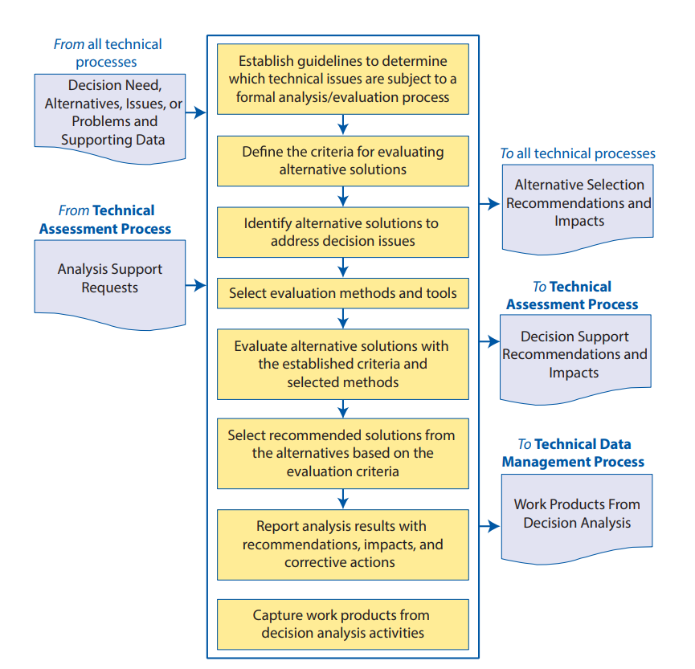

**Figure 1. Decision Analysis Process, NASA Systems Engineering Handbook [1]**

SoS constantly evolve based on the decisions made at the level of the component systems [12]. The behavior of an SoS is defined by the actions of many decision-makers, each with independent objectives, unique constraints, and limited spheres of influence, as in the case of a portfolio of Earth observing missions. Many decisions are made at the mission-level, from the concept formulation phase through operations. Reliably predicting the behavior of an SoS is impossible due to the complexity of divided autonomy.

To inform decision-making at the level of the SoS, analysts may attempt to model how an SoS could evolve. Fang identified three classes of methods for modeling the behavior of SoS given their divided autonomy, including individual priority guaranteed, game theory, and negotiation [13]. The individual priority guaranteed method assumes that component systems have the priority to satisfy their own requirements [13]. Game theoretical methods study how rational agents interact in a given context. Negotiation involves modeling how incentive mechanisms can influence agent behavior [13]. However, it has been acknowledged that there is a lack of scientific laws that can be applied to effectively model the behavior of SoS [13]. Given these challenges associated with rule-based modeling, analysts may depart from attempting to model the SoS and may instead simulate possible SoS behavior to inform decision-making.

*The Military Decision-Making Process and wargaming: scenario-based approaches for military applications*

To develop an approach that simulates the behavior of a multi-mission Earth observing satellite architecture, the authors consulted methods employed by other agencies of the United States government. The U.S. Army employs a methodology termed the Military Decision-Making Process (MDMP) to analyze complex cross-domain missions and to inform decisions made by senior commanders. The MDMP consists of a seven-step process to understand the situation and mission, develop courses of action (COAs), wargame solutions, and produce an operation plan or order [14]. Employment of the MDMP is best leveraged for problem sets requiring the integration of multi-domain assets such as aviation, artillery, infantry, joint forces, and so forth, where each domain is operationally and managerially independent. This methodology is extensively used across the U.S. Army and similar methods are employed across the joint force (Joint Operational Planning Process) and across NATO allied nations (Military Operational Planning Process). Although NASA has a strictly civilian mandate, parallels can be drawn at a theoretical level between the integration of multi-domain military assets and the management of a cohesive portfolio of space missions that provide a breadth of science measurements. Both military assets and Earth observing space missions operate with managerial and operational independence. Component systems are designed and optimized to satisfy their individual functional objectives. Yet, these component systems should be deployed optimally with respect to the SoS. Some aspects of the MDMP can therefore be employed in an approach to inform decisions for civilian aerospace applications.

A core component of the MDMP is the development, analysis, and comparison of COAs. A COA is a series of potential actions that could be employed to accomplish a mission. The MDMP Handbook proposes screening criteria to establish the validity of a COA: COAs must be feasible, acceptable, suitable, distinguishable, and complete [9]. Definitions of these criteria are listed in the handbook and replicated in Table 1.

**Table 1. Screening criteria used to establish the validity of a COA, Military Decision-Making Process Handbook [9]**

|  |  |
| --- | --- |
| Feasible | The COA can accomplish the mission within the established time, space, and resource limitations |
| Acceptable | The COA must balance cost and risk with the advantage gained |
| Suitable | The COA can accomplish the mission within the commander’s intent and planning guidance. |
| Distinguishable | Each COA must differ significantly from the others (such as scheme of maneuver, lines of effort, phasing, use of reserve forces, and task organization). |
| Complete | A COA must incorporate the following information:   * How the decisive operation leads to mission accomplishment. * How shaping operations create and preserve conditions for success of the decisive operation or effort. * How sustaining operations enable shaping and decisive operations or efforts. * How to account for offensive, defensive, and stability or civil support tasks. * Tasks to be performed and conditions to be achieved. |

COA analysis is often performed through wargaming. In military applications, wargames are conducted by role-playing an action-reaction-counteraction cycle between opposing forces. These wargames often utilize a table-top or virtual arena to visualize factors such as terrain, magnitude of forces, and locations of forces. A single COA is evaluated in the context of a potential desired end state, considering factors such as the physical environment and timing of operations. As simulated enemy forces respond to actions taken, the team assesses the effectiveness and adaptability of the COA, key decision points, driving factors, and critical assumptions. Multiple COAs are explored in the wargame and compared, leading to the selection of the most preferrable COA.

Although the action-reaction-counteraction cycle used in wargaming and the simulation of adversarial forces are not suitable for the civilian application at hand, defining a series of potential decisions and analyzing their impact on a collection of Earth observation missions is highly relevant. The concept of COAs, as well as the associated guidelines to define them and the screening criteria to ensure their validity, were used to formulate the methodology described in this paper. The analysis of individual COAs and their subsequent comparative analysis were also inspired by wargaming and employed to discover key decision points and decision drivers for Earth observation mission planning.

3. Methodology and its Application to the Assessment of Continuity Gaps in Earth Observations

The methodology adopted by the authors to assess multi-mission Earth observing architectures consists of seven steps, shown in Fig. 2. Steps 1-3 consist of identifying and modeling possible events that would impact the likelihood of a continuity gap, as well as potential causes of those events. Monte Carlo simulation techniques are then applied to estimate the probability of a gap to occur in a given year for a set of baseline assumptions across the multi-mission architecture. A series of scenarios and corresponding assumptions are then defined to simulate the effects of potential decisions on the overall architecture. The likelihood of continuity gaps is assessed in the context of these scenarios and a comparative analysis is performed to characterize driving factors and key decision points. A detailed explanation of each step follows.

*Identification of adverse events*

The first step consists of the identification of possible adverse events, which are undesired events that could cause continuity gaps between missions. Here, a continuity gap is defined as a length of time during which there are no operational missions collecting a particular type of data. This analysis does not assess the degree to which there is continuity between missions with respect to sensor specifications, calibration uncertainty, or temporal and spatial sampling; rather, it offers a mechanism to quickly assess the impact of decisions in terms of operational availability for the multi-mission architecture.

For spaceborne missions, three types of adverse events can introduce continuity gaps: the mission launch is delayed, the mission does not succeed, and the mission ends prematurely. A launch is considered delayed when the launch occurs on a different calendar day than the day nominally scheduled. A mission is considered unsuccessful post-launch if there is a loss of vehicle at launch, unsuccessful orbit insertion, or failure of the satellite or sub-systems to retrieve measurements that satisfy science requirements. A mission is considered to end prematurely if the mission’s actual lifetime is less than the expected design lifetime. This could be caused by technical failures, accelerated orbital decay, or damaged caused by space debris.

An architecture of four notional missions is used in this paper to illustrate the methodology and its application. Figure 3 shows a notional timeline for these missions. This timeline illustrates three cases of mission sequencing: missions with a one-year overlap, missions with a multi-year overlap, and missions with a pre-existing gap. The example also combines operational missions and missions in formulation. Adverse events are shown on the figure. For operational missions, only one of type of adverse event is applicable: the mission ends prematurely. For missions in formulations, all three types of events are applicable.

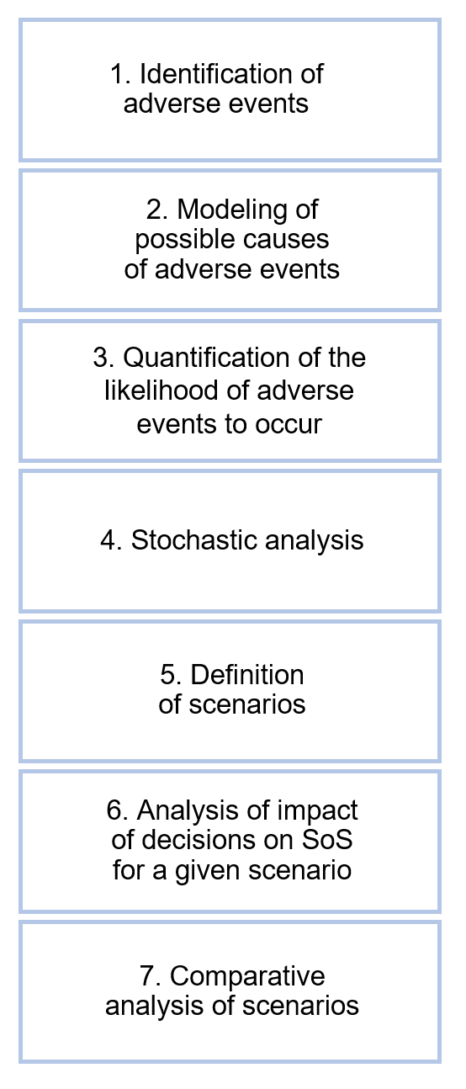

**Figure 2. Overview of the methodology**

*Modeling of possible causes of adverse events*

The Probabilistic Risk Assessment Procedures Guide for NASA Managers and Practitioners provides approaches to identify and model the causes of adverse events. These “initiating events” are events that “perturb the system (i.e., cause it to change its operating state or configuration), representing a deviation in the desired system operation” [15]. The guide recommends developing Master Logic Diagrams (MLDs) to identify these initiating events and group them by topic area. An MLD is a “hierarchical, top-down display of [initiating events], showing general types of undesired events at the top, proceeding to increasingly detailed event descriptions at lower tiers, and displaying initiating events at the bottom.” [15]

An MLD is produced for each identified adverse event for each mission in the architecture. A four-mission architecture comprised of one operational mission and three missions in formulation requires the generation of ten MLDs. An example MLD for the case of a launch delay is shown in Fig. 4.

In each MLD, potential causes for the adverse event are documented as nodes and grouped by failure type. These can be decomposed as needed to provide more detailed descriptions of these failure causes. Initiating events are identified and linked to nodes in the lowest tier of the diagram. While failure types and their decomposition are generalizable across spaceborne missions with only minor adjustments, initiating events are mission-specific. Multiple initiating events can be linked to a single failure cause, and if no initiating event is linked to a failure cause, that failure cause is not used in the model.

A thorough review of project documents, to include analysis results obtained by the various mission teams, supports the definition of the potential adverse events and their associated initiating events, including the assignment of probabilities to these events.

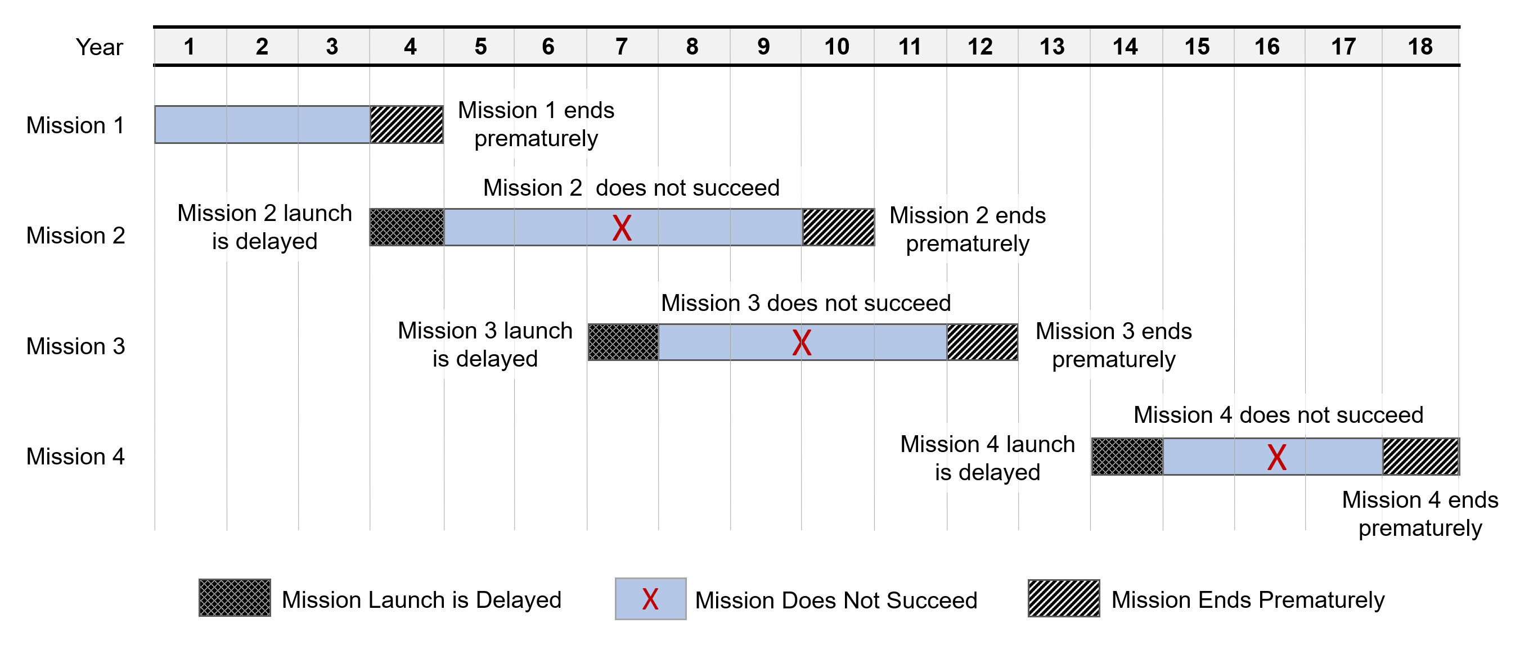

Figure 3. Notional timeline for a multi-mission architecture and associated potential adverse events

*Quantification of the likelihood of adverse events to occur*

Initiating events nodes within the MLDs are modeled as either discrete or continuous events. Nodes contributing to a launch delay or early mission termination are modeled as continuous events and are represented by a continuous distribution of potential event durations. Nodes associated with the mission not succeeding are modeled as discrete events in that they represent a binary outcome which has a probability of occurrence.

Historical data are used to parameterize initiating event nodes by deriving an empirical cumulative distribution function (CDF) for continuous events and estimating the probability of occurrence for discrete events. These data include, among others, failure rates, mean times to failure, orbital debris collision estimates, schedule and cost growth estimates, and launch delays due to random weather events. These are acquired from both commercial and internal sources.

Development of the proposed approach was prompted by a time-sensitive request for analysis to support scheduled discussions. Due to the compressed timeline, data were at times insufficient to accurately parameterize a node. The authors elected to omit these nodes from the analysis rather than to model them poorly to avoid compromising the quality of the analysis. Non-modeled nodes were documented.

*Stochastic analysis with Monte Carlo simulation*

Monte Carlo simulation techniques are applied to estimate the probability of a gap to occur given the aleatoric uncertainty of initiating events in the MLDs. For each simulation run, discrete event nodes are evaluated by sampling a uniform distribution to generate a random number between 0 and 1, then comparing it to the event probability to determine whether or not the event occurs. Continuous event nodes are evaluated by using the Inverse Transform method to sample the node’s distribution: again, a random number is generated between 0 and 1, and the value of the inverse CDF at that number gives a randomly sampled number from that distribution. This process is repeated for each mission considered in the analysis; the outcomes are applied to mission timelines and result in either excluding the mission altogether, delaying launch dates, and/or terminating the mission earlier than planned. An updated hypothetical mission manifest is then produced from the combination of these outcomes.

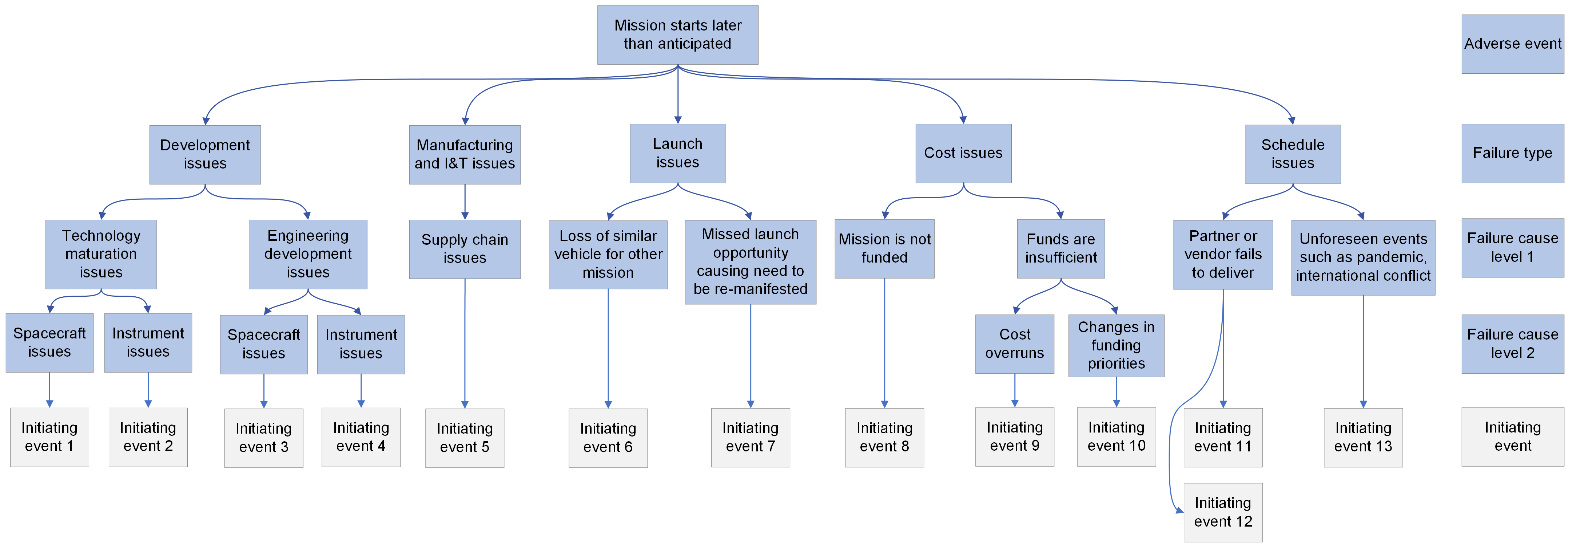

Figure 4. Master Logic Diagram (MLD) for a launch delay

Performing *N* Monte Carlo runs results in *N* such manifests, from which the probability of a gap in a given year, *j*, can be calculated as

(1)

where is the number of active missions in year *j* and is an indicator variable which is equal to one when is zero and zero otherwise.

Example results from applying the described approach to the set of four notional missions are shown in Figs. 5, 6, and 7. The figures are screenshots of outputs from a tool created by the authors to perform the analysis. The outcomes from each run of the Monte Carlo simulation are aggregated to find the most probable timeline, presented in Fig. 5. Probabilistic estimates of mission lifetime, delays at launch, and lifetime deficits in case of early termination are shown for each mission in the notional manifest. Figures 6 and 7 show the expected probability of a gap in continuity and the expected mission count, respectively, in each year.

As compared with the nominal mission manifest, the stochastic analysis predicts lower expected mission counts between years 4 and 10, with the greatest decrease in mission count in year 5. Referencing the timeline in Fig. 5, high probabilities of gaps estimated in year 5 (72%) and year 6 (37%) are due to the average launch delay expected for Mission B. Further analysis can then be done to identify driving factors in delay likelihood and duration for that mission. Initiating events could not be modeled accurately for Mission D resulting in no delay or early termination estimates for the mission in this round of analysis. Additionally, the timeline estimated by the stochastic analysis suggests an improved outlook for years 11 through 17, with the delayed launch date causing Mission C to fill a previously expected gap. Insights such as these derived from probabilistic gap analysis enable more informed portfolio planning than under deterministic mission timeline assumptions alone.

*Scenario definition and modeling*

Researchers have acknowledged that when approaching decision problems for an SoS, decision-makers should not strive to predict the future, but rather should strive to develop improved maps of the real world and learn how to effectively navigate them [16]. While causes of adverse events can be identified, modeled, and probabilistically quantified for each individual mission, plausible future states of the portfolio of missions cannot be predicted with confidence. Rather, a scenario-based approach enables decision-makers to investigate a wide range of possible future portfolio configurations to better understand the impact of potential decisions.

In this work, scenarios consist of alterations to baseline assumptions. Examples of these alterations are: a change to the mission launch date, a change in expected mission lifetime, a change in design lifetime, or a mission cancellation. A scenario can consist of a single alteration to a baseline assumption or a series of alterations across multiple missions. Scenarios are defined to be representative of potential decisions. These decisions can be internal decisions, for which NASA has full decision authority, but can also be external decisions, for which other mission stakeholders have decision authority.

Once scenarios are defined and documented, inputs to the Monte Carlo analysis tool are modified accordingly and the stochastic analysis described in the previous section is performed for each scenario. The tool outputs a new mission timeline with updated estimates of mission lifetime, delays at launch, and early termination. As previously described, delay and lifetime deficit durations for each mission are averaged across simulation runs to calculate expected mission lifetimes, similar to what is shown in Fig. 5. Because these durations are randomly sampled from distributions specific to each initiating event, the resulting timelines will vary between analyses unless the number of runs completed are sufficient for convergence.

The probability of a gap for a given year and the yearly mission count are also updated. For ease of comparison, outputs based on updated scenario assumptions are overlaid with outputs based on baseline assumptions. Figures 8, 9, and 10 show example plots of tool outputs for a notional scenario. Baseline assumptions are represented in white, while scenario assumptions are represented in orange.

In the notional scenario considered, Mission C begins three years later than its nominal launch date; baseline assumptions are preserved for Missions A, B, and D. Delaying Mission C's start does not impact the expected mission lifetime, but rather shifts the occurrence of launch delays and mission terminations (note: in the current implementation of the tool, the relationship between launch year and expected delays is not modeled). Figures 9 and 10 enable direct comparison of the probability of a gap in each year between the notional scenario and the baseline assumptions, in light of estimated delay and deficit durations. Both sets of assumptions result in the same probability of gaps until year 8, when the notional scenario's probability begins to exceed that of the baseline. This trend continues until year 14, with the probability of a gap in continuity peaking at 32% in year 12 under the notional scenario (6.4x greater than the baseline). However, because Mission C is shifted to the right, the notional scenario improves the expected mission count later in the timeline. The risk of continuity loss in year 14 is significantly mitigated, with a 64.5% reduction in gap probability and a 30.9% increase in expected mission count. While there is no probability of a gap after year 14 under the baseline assumptions, delaying Mission C by three years yields a higher expected mission count throughout the last seven years of the portfolio creating potential redundancy in measurements.

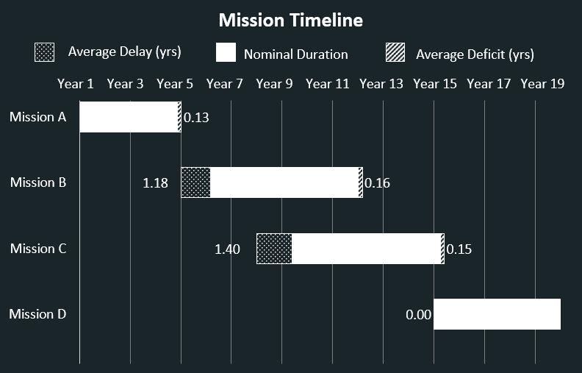

Figure 5. Tool output of the stochastic analysis for mission timelines

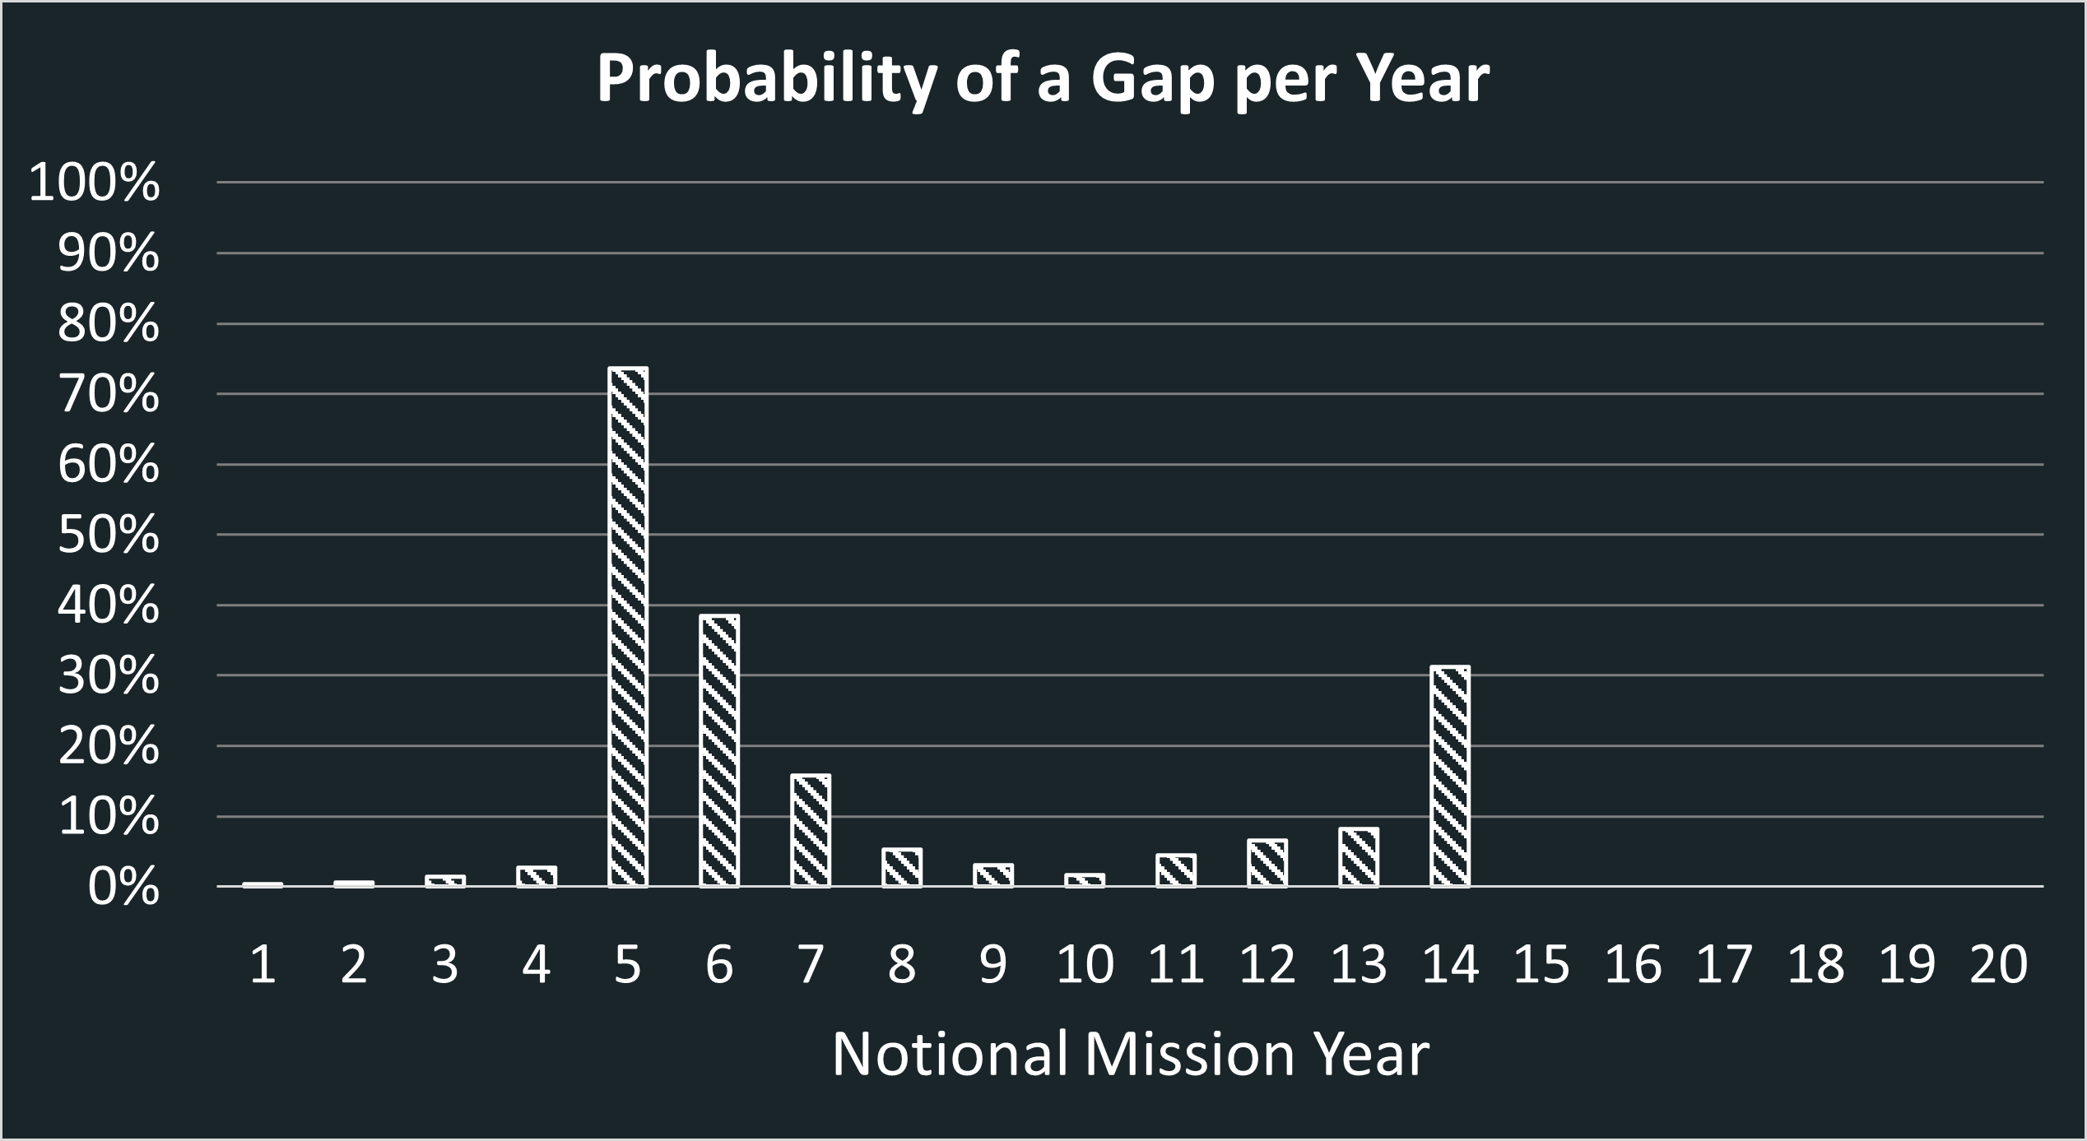

Figure 6. Tool output of the probability of a gap in a given year

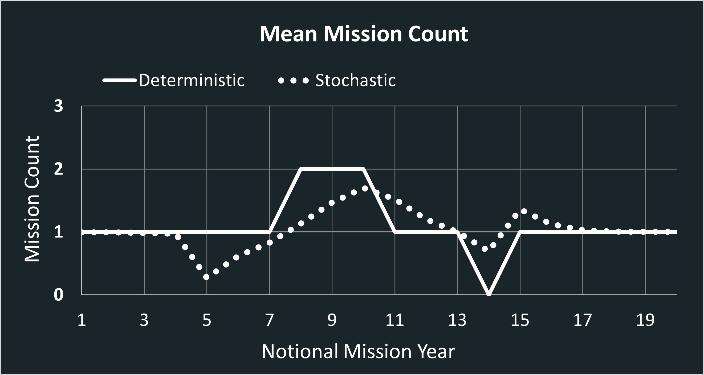

Figure 7. Tool output for deterministic and stochastic mission counts in a given year

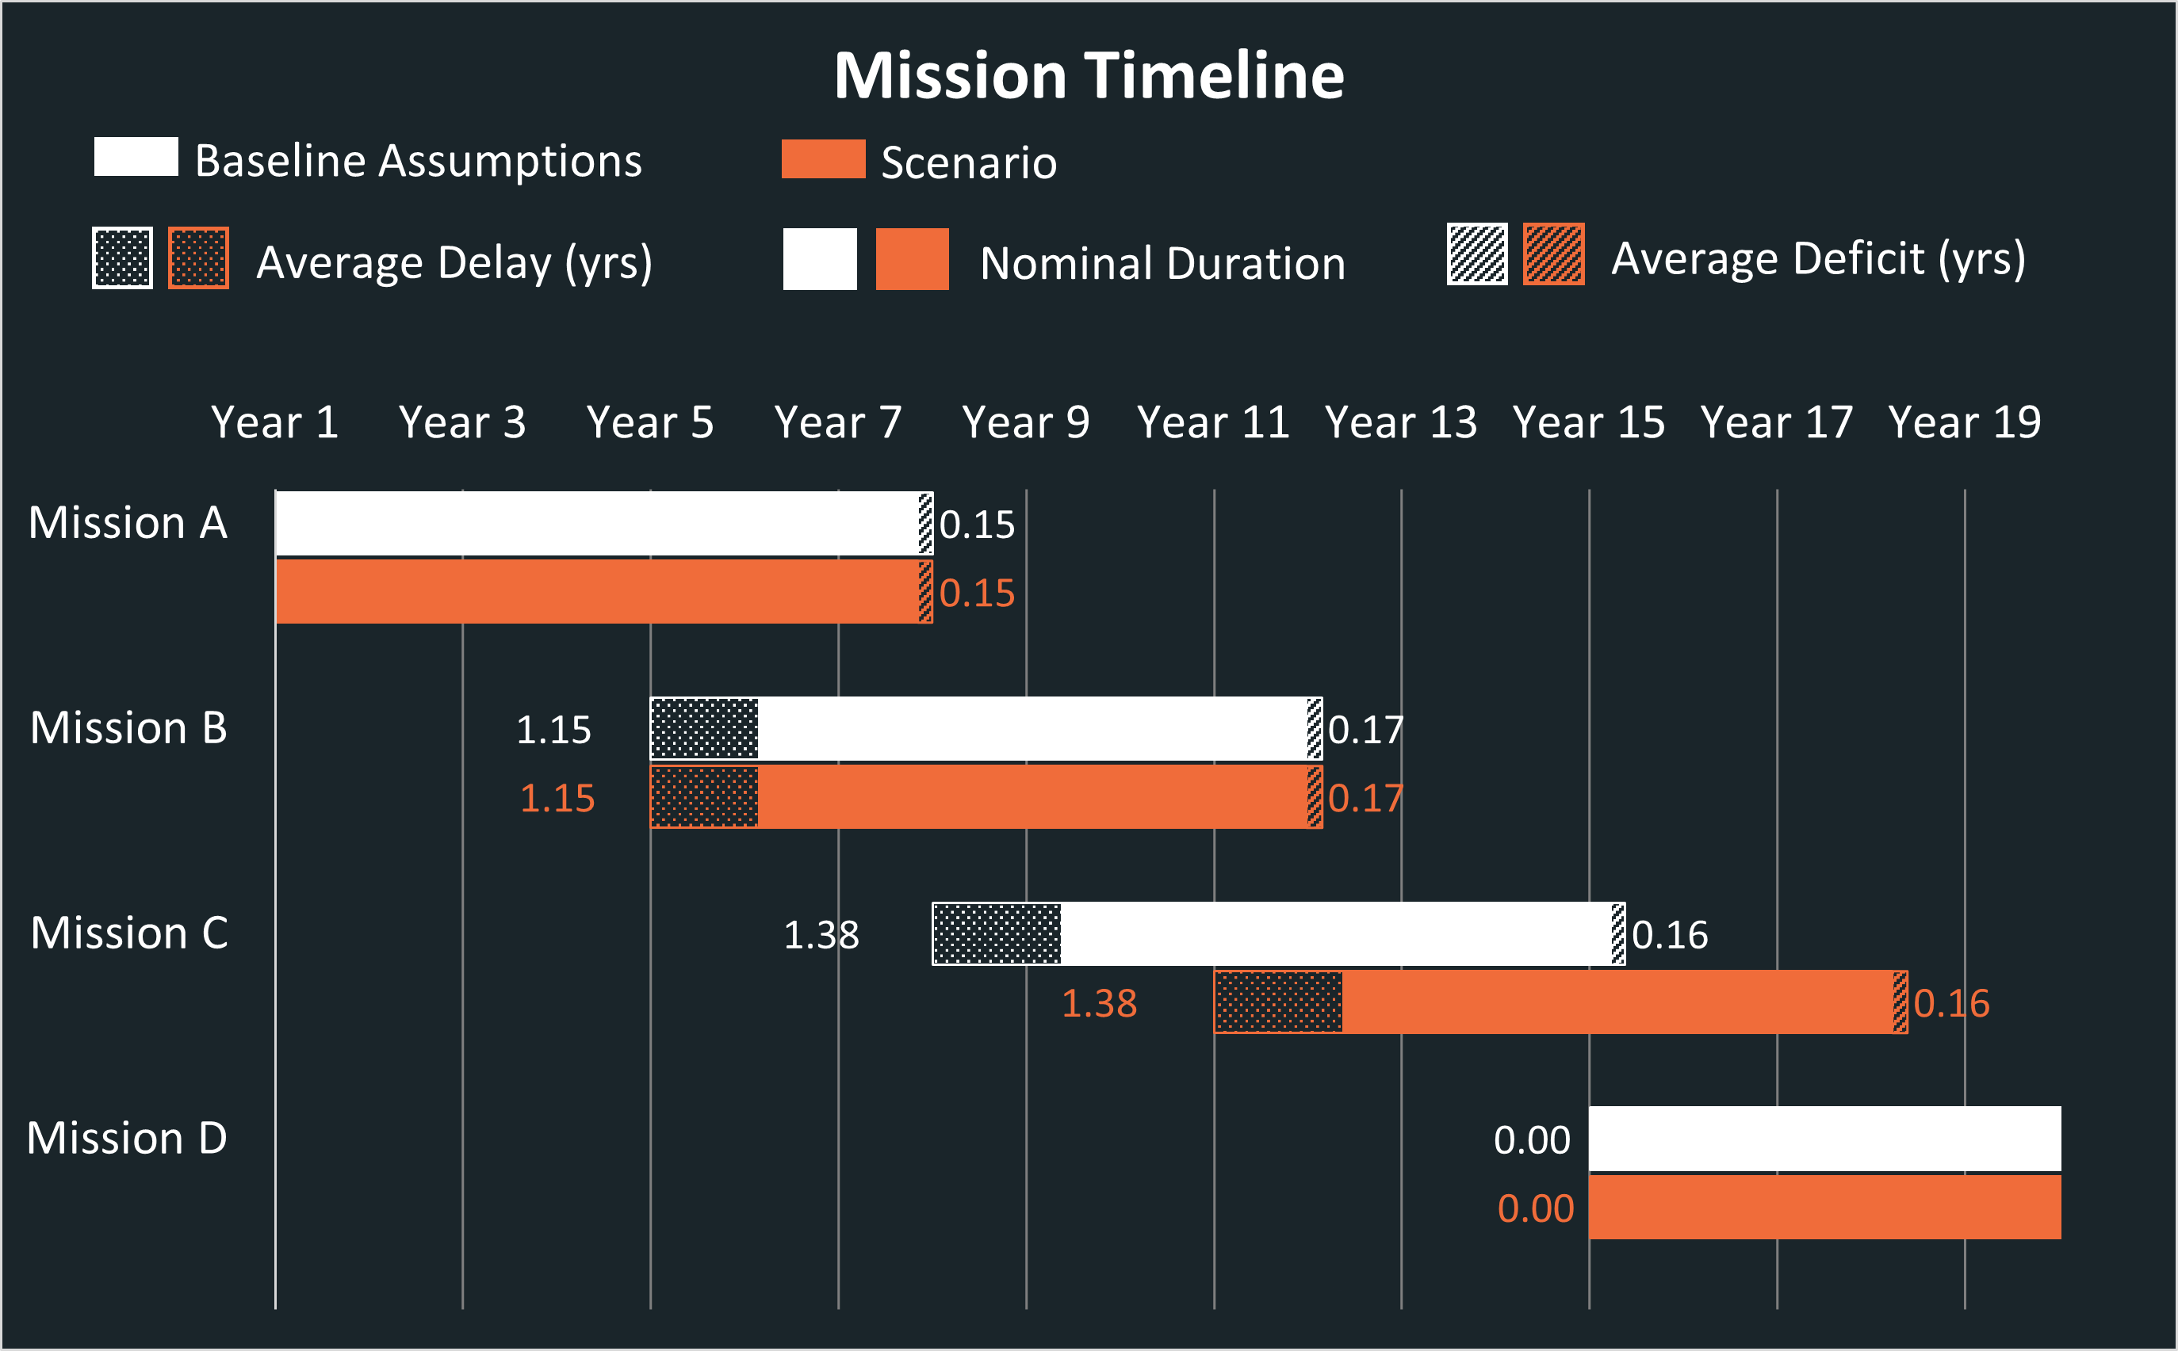

Figure 8. Tool output of mission timelines for one scenario

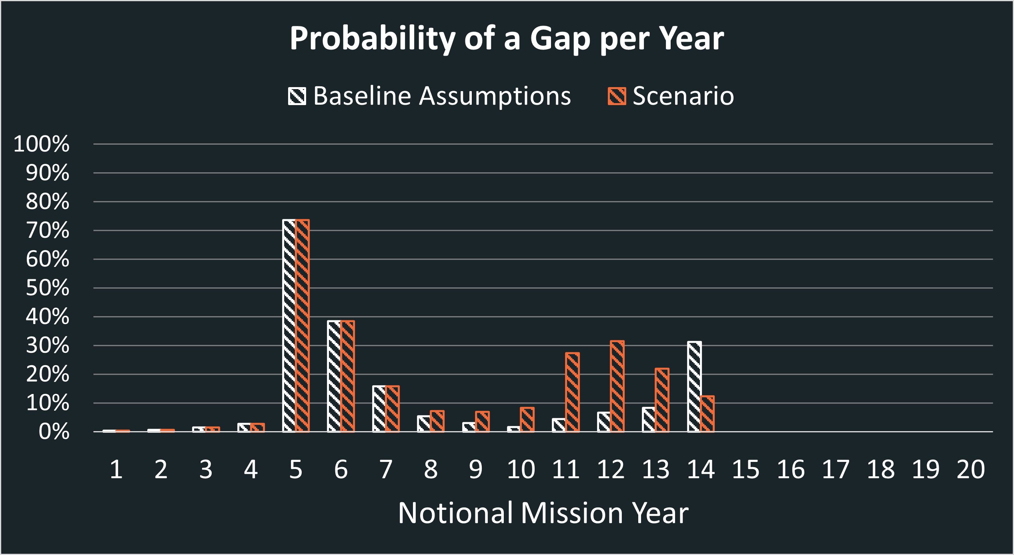

Figure 9. Tool output of the probability of a gap in a given year for one scenario

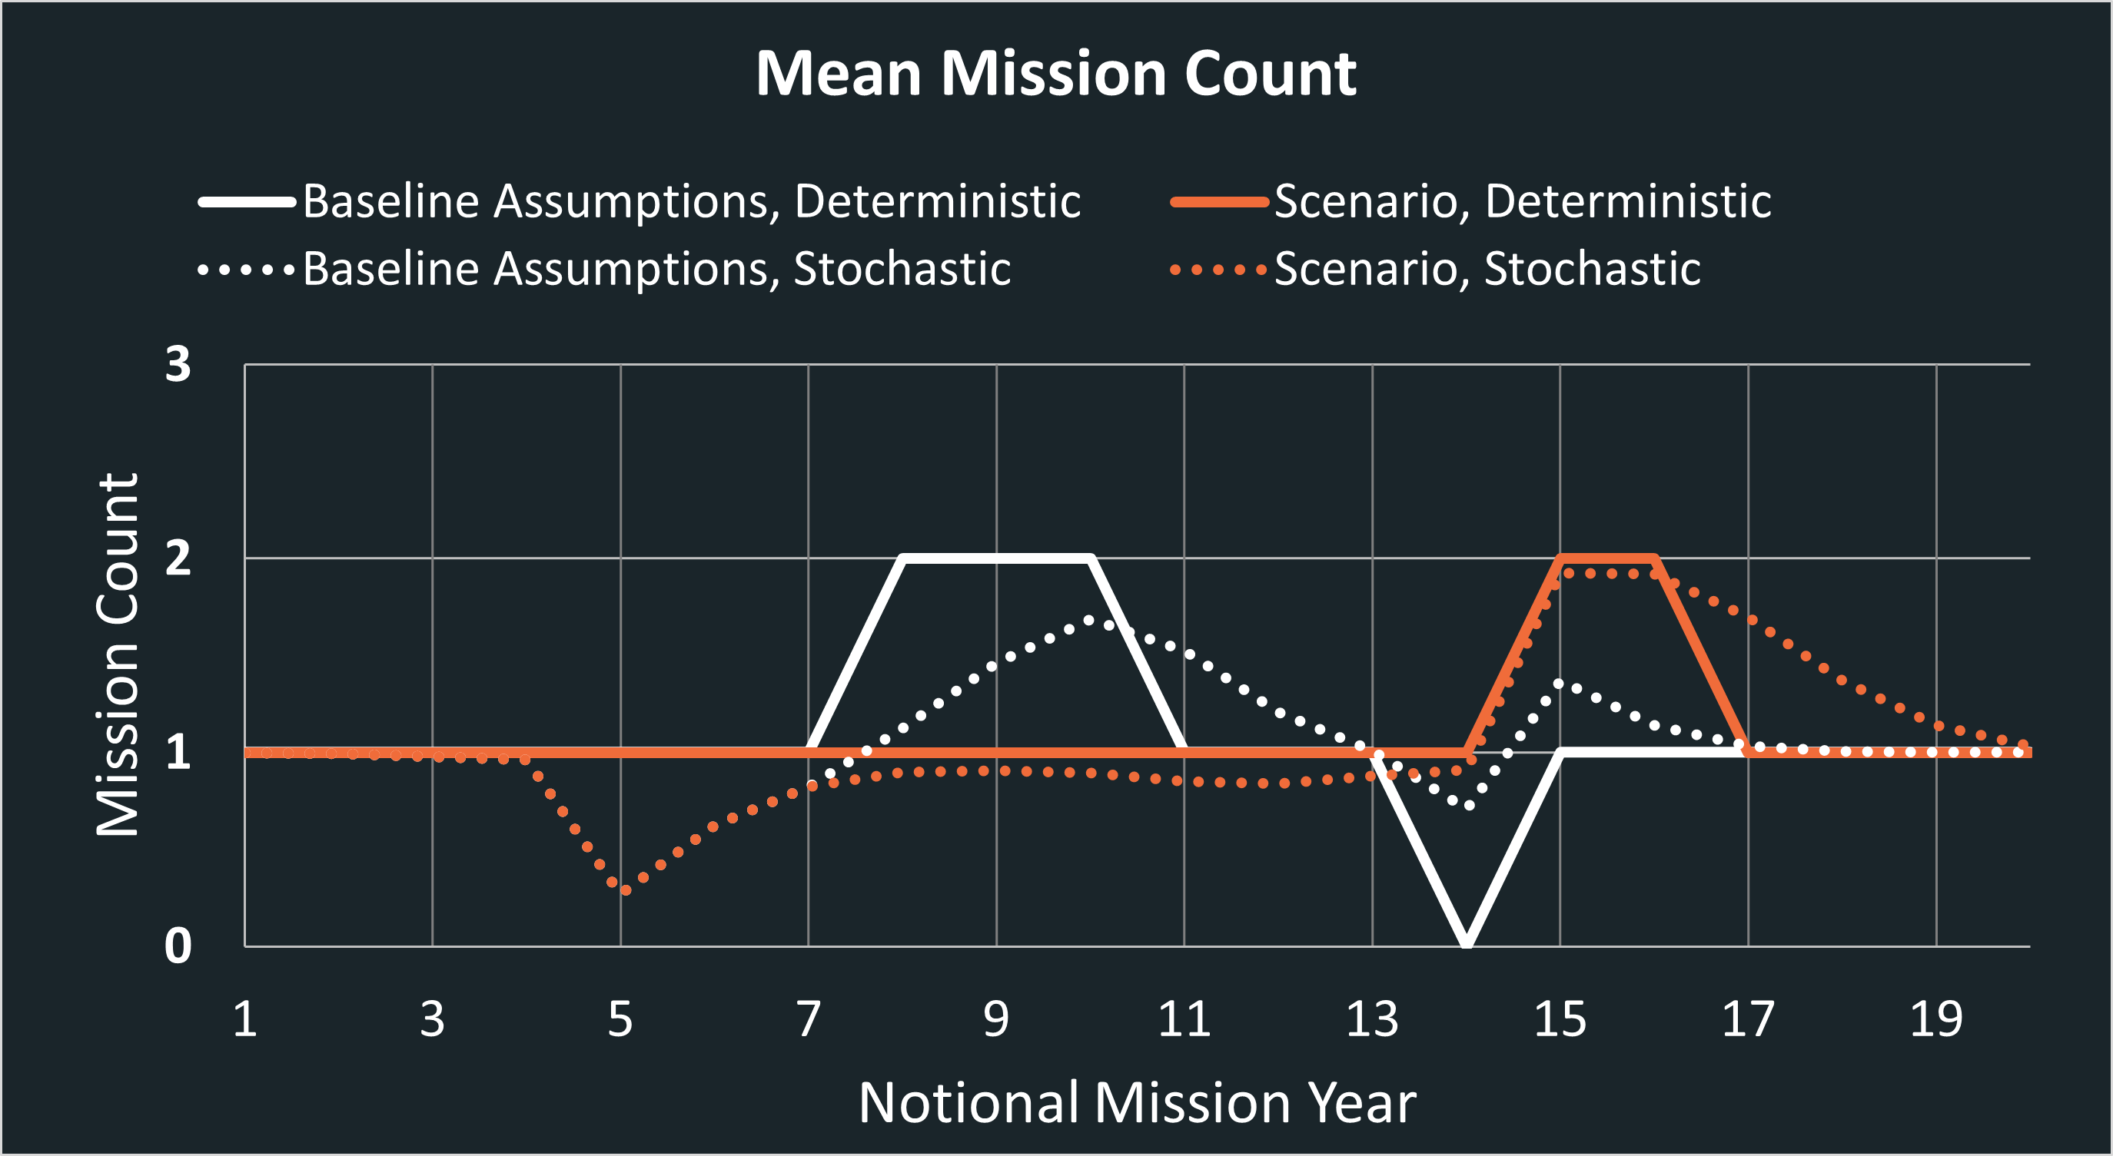

Figure 10. Tool output for deterministic and stochastic mission counts in a given year for one scenario

Following wargaming best practices, one scenario is considered and documented at a time. Assumptions, scenario descriptions, tool outputs, and analysis takeaways are systematically documented in a consistent format to enable the comparative analysis of scenarios. This comparative analysis helps characterize the impact of decisions relative to other decisions that could potentially be made. It also helps facilitate discussions around preference trades earlier or later in the mission timeline, as well as potential mitigation options. As a corollary to the identification of continuity gaps, the comparative analysis provides insights into opportunities for overlapping missions and increasing operational resilience.

The seven-step approach combines probabilistic assessments of adverse events that might impact the launch, success, or duration of an individual mission, with scenario analysis to simulate a range of possible future states of the multi-mission architecture. The approach offers the flexibility to update assumptions, adjust inputs, and refine supporting models over time. The inherent imperfect knowledge of component systems can be addressed by these adjustments as knowledge is gained.

4. Other Work

As previously mentioned, the development of the proposed approach was prompted by a time-sensitive request for analysis to support scheduled discussions. As a result of the compressed timeline, the approach was primarily informed by the initial research into wargaming methods. Once the requested analysis was delivered, the authors conducted an extensive literature review on additional scenario-based decision-making methods for civilian applications, in order to support the refinement of the employed methodology for future analyses. Many approaches have been proposed to inform decisions when there are uncertainties that prevent analysts from using traditional methods based on predictions. Some of these are grouped under the umbrella of Decision Making under Deep Uncertainty (DMDU) and include Robust Decision Making (RDM), Dynamic Adaptive Planning (DAP), Dynamic Adaptive Policy Pathways (DAPP), Info-Gap (IG) Theory, and Engineering Options Analysis (EOA). These approaches can be decomposed in three generic steps: framing the analysis, performing exploratory uncertainty analysis, and choosing initial actions and contingent actions [17]. Marchau [17] and Stanton [18] provide detailed descriptions of these DMDU approaches and some of their applications.

In addition to these approaches employed for civilian DMDU applications, Army Design Methodology (ADM) is a process used to conceptualize operations in the planning process, which “helps commanders and staffs with understanding, visualizing, and describing operations” [19]. ADM is used in conjunction with the MDMP to frame the operational environment, define a desired future end state, frame problems hindering the ability to achieve the desired future state, develop an operational approach, and reframe both operational environment and problem as necessary during execution.

DMDU methods and ADM require the definition of a set of desired objectives or a desired end state. For example, RDM aims to “seek robust, rather than optimal strategies (…) [that] perform well, compared to the alternatives, over a wide range of plausible futures.” [17] The first step of the process is to define the objectives and criteria of the decision-makers, against which strategy robustness is assessed. DAP develops “a ‘basic’ plan along with monitoring (to determine whether the plan is on-course) and correction actions (to implement if the plan is not on-course)” [18]. The DAP process also starts with the definition of objectives against which alternatives are assessed in terms of vulnerabilities and for which contingency plans are formed. ADM frames the problems that hinder the ability to achieve the desired end state given the conditions of the operational environment [19].

Defining a desired end state and its associated objectives is challenging for an SoS. In the example of a multi-mission architecture of Earth observing missions, it can be a challenge to integrate objectives defined at the mission level with SoS-level objectives. There are also many stakeholders who have a vested interest in the future state of the SoS and whose input would be required to define this desired end state. In addition, there is an inherent complexity associated with the characterization of the continuity of measurements and the many factors that would need to be adequately defined to formulate such a desired end state. While many concepts in these approaches can be leveraged to further inform the methodology presented in this paper, further research is required to determine how to address uncertainties when a desired end state is not easily definable. Additional literature review will also be conducted on scenario planning methods and how they contrast with DMDU approaches.

5. Limitations and Future Work

The proposed methodology enables the assessment of the likelihood of continuity gaps to occur for a multi-mission architecture and provides a framework to assess this likelihood in the context of multiple scenarios that represent possible future states of the system-of-systems. Given the compressed timeline to develop the methodology, collect data, develop analytical tools, and perform the analysis, there are inherent limitations to the approach developed.

Some of these limitations pertain to the ability to model initiating events and estimate probabilities for their occurrence. For example, the impact of congressional budget decisions and the risk for decreased or cancelled funding are currently not taken into account in the analysis due to the lack of an adequate model. The authors are collecting historical NASA budget requests as well as enacted budgets to analyze trends and quantify risks of related initiating events in future modeling efforts. Similarly, modeling of hardware redundancy and mission risk class needs to be refined in order to better characterize the likelihood of hardware failure during operations. Possible interdependencies between MLD nodes will be further investigated to ensure that initiating events can be assessed and combined as statistically independent nodes.

Continuity gaps are defined in the current methodology as a length of time during which there are no operational missions. This coarse definition of continuity offers the benefit of highlighting potential operational gaps and the impact decisions might have at a portfolio level in terms of operation availability. However, the continuity of measurements is much more complex than achieving operational continuity. A thorough definition of continuity is provided in the 2015 National Academies of Sciences report on the continuity of NASA Earth observations from space: "Continuity of an Earth measurement exists when the quality of the measurement for a specific quantified science objective is maintained over the required temporal and spatial domain set by the objective. The quality of a measurement is characterized by its combined standard uncertainty, which includes instrument calibration uncertainty, repeatability, time and space sampling, and data systems and delivery for climate variables (algorithms, reprocessing, and availability) -- each of which depends on the scientific objective” [20]. The authors will continue working to incorporate these key considerations in the assessment of continuity, whether in the methodology itself or in a complementary approach that could be used in conjunction with the current methodology.

Finally, future work will revolve around defining additional steps beyond the comparative analysis of scenarios. The current methodology helps highlight decisions that have a significant impact on the mission portfolio, as well as initiating events that are drivers in the likelihood of gaps to occur. This current capability is, however, a linear process and needs to include iterative loops with decision-makers. Upon review of the results of the first round of analysis, additional scenarios should be defined based on knowledge gained from the analysis and decision-maker preferences. Doing so would allow for more complete scenario generation and additional insights into the impact of potential decisions.

6. Conclusion

Gaps between operational Earth observing missions can result from a variety of causes, which can be programmatic and/or technical in nature. Characterizing these potential gaps and assessing their likelihood to occur are essential to support strategic decision-making for missions in pre-formulation, formulation, and development.

Insights related to technology development, international partner environments, domestic policy fluctuations, and other sources of uncertainty must be accounted for in these assessments, which require the use of a structured and traceable approach. While the Decision Analysis Process provided in the NASA Systems Engineering Handbook provides a clear framework to inform many engineering and programmatic decisions, it shows some limitations when decisions pertain to SoS, such as multi-mission architectures. A scenario-based approach is better suited to address uncertainties associated with the behavior of the SoS, which can be studied by analyzing a series of scenarios that simulate a range of possible future states. The use of a scenario-based approach does not require a prioritized set of common objectives, constraints, or a set of criteria that are used to compare and assess alternative options, which are challenging to obtain for SoS. The approach alsooffers the flexibility to update assumptions, adjust inputs, and refine supporting models over time; and the inherent imperfect knowledge of component systems can be addressed by these adjustments as knowledge is gained over time. By simulating the impact of potential decisions on the overall architecture, analysts can report on driving factors and key decision points, which in turn inform strategic decisions to accept, minimize, or mitigate potential gaps.

References

[1] R. Madachy, G. Roedler, G. Parnell, S. Jackson, “*Guide to the Systems Engineering Body of Knowledge (SEBoK), Decision Management*” v. 2.8, SEBoKwiki. Available: https://sebokwiki.org/wiki/Decision_Management

[2] *NASA Systems Engineering Handbook*, National Aeronautics and Space Administration, Washington, DC, USA, 2020. Available: https://www.nasa.gov/sites/default/files/atoms/files/nasa_systems_engineering_handbook_0.pdf

[3] R. L. Keeney, H. Raiffa, *Decisions with Multiple Objectives - Preferences and Value Tradeoffs*. New York, NY: Wiley, 1976.

[4] T. Saaty, “How to Make a Decision: The Analytic Hierarchy Process,” *Interfaces* vol. 24, nu. 6, pp. 19-43, 1994.

[5] J. Lafleur, J. Sharma, J. Apa, “From Mission Objectives to Design: An Efficient Framework for Downselection in Robotic Space Exploration,” in *AIAA SPACE 2007 Conference & Exposition*, 2007, pp. 6258.

[6] G. H. Cho, et. al., “A logical approach for evaluating preliminary shape design of a very light jet,” in *The 26th Congress of ICAS and 8th AIAA ATIO,* 2008,pp. 8948.

[7] *NASA Risk Informed Decision Making Handbook*, Vol. 1.0, National Aeronautics and Space Administration, Washington, DC, USA, 2010. Available: https://ntrs.nasa.gov/api/citations/20100021361/downloads/20100021361.pdf

[8] *Military Decision-Making Process*, Center for Army Lessons Learned, Handbook No. 15-06. Available: <https://usacac.army.mil/sites/default/files/publications/15-06_0.pdf>

[9] *Strategic Wargaming Series Handbook*, United States Army War College, 2015. Available: <https://csl.armywarcollege.edu/DSE/StrategicWargamingDivision/publications/USAWC%20Wargame%20Handbook%201%20July%2015.pdf>

[10] *Systems and software engineering — System of systems (SoS) considerations in life cycle stages of a system*, International Standard 21839, 2019-07: ﻿ISO/IEC/IEEE 21839:2019.

[11] M. W. Maier, “Architecting principles for systems‐of‐systems,” in *Systems Engineering*, 1998, vol. 1 nu. 4, pp. 267–284.

[12] D. A. DeLaurentis, K. Moolchandani, C. Guariniello, *System of Systems Modeling and Analysis*, 1st ed. Boca Raton, FL: CRC Press, 2022.

[13] Z. Fang, “System-of-Systems Architecture Selection: A Survey of Issues, Methods, and Opportunities,” in *IEEE Systems Journal*, 2022, vol. 16, no. 3. Available: https://doi.org/10.1109/JSYST.2021.3119294.

[14] *Army Design Methodology*, ATP 5-0.1, Department of the Army, USA, 2015.

[15] M. Stamatelatos, et. al. “Probabilistic Risk Assessment Procedures Guide for NASA Managers and Practitioners,” 2011, *NASA/SP-2011-3421*.

[16] D. DeLaurentis, R. K. “CAB” Callaway, “A System-of-Systems Perspective for Public Policy Decisions,” in *Review of Policy Research*,2004, vol. 21, no. 6, pp. 829–836.

[17] V. A. W. J. Marchau, W. E. Walker, P. J. T. M. Bloemen, S. W. Popper, “Decision Making under Deep Uncertainty,” 2019, doi: 10.1007/978-3-030-05252-2.

[18] M. C. B. Stanton, K. Roelich, “Decision Making Under Deep Uncertainties: A Review of the Applicability of Methods in Practice,” in *Technological Forecasting and Social Change*, 2021, vol. 171, doi: 10.1016/j.techfore.2021.120939.

[19] *ADP 5-0 The Operations Process*, Department of the Army, USA, 2019. Available: <https://armypubs.army.mil/>.

[20] *Continuity of NASA Earth Observations from Space: A Value Framework*, The National Academies of Sciences, Engineering, and Medicine, Washington, DC, 2015. Available: htpps://doi.org/10.17226/21789.

Biographies

|  |
| --- |
|  |
| ***Katharine Burn*** *joined the Systems Analysis and Concepts Directorate at NASA Langley Research Center in August 2022 following the completion of her master’s degree in aerospace engineering from Purdue University. She has experience modeling and analyzing systems of systems (SoS) architectures for aerospace systems with a current focus on analyzing Earth science mission portfolios. Katharine also holds a bachelor’s degree in mechanical engineering from Utah State University.*  ***Bailey Ethridge*** *serves as a mission analyst within NASA Langley Research Center’s Systems Analysis and Concepts Directorate, where she develops analytical tools and methodologies for both Earth science and human spaceflight mission applications. Bailey received B.A.s in cultural anthropology and applied mathematics from the University of North Carolina at Asheville and is currently pursuing her M.S. in computational modeling and simulation engineering at Old Dominion University.*  ***Elizabeth Ford*** *is a Decision Analyst in the Systems Analysis and Concepts Directorate of NASA Langley Research Center. Her work focuses on the analysis of Earth science missions. Mrs. Ford received her B.S. in Mechanical Engineering from Virginia Polytechnic Institute and State University and a Master of Engineering Management from the University of Nebraska Lincoln. Prior to joining NASA, she served as an Occupant Safety Engineer for General Motors.*  ***Nicole Herrmann*** *serves as a Program Executive in the Earth Science Division of the Science Mission Directorate at NASA Headquarters.  In this role, Nicole supports technical and programmatic integration of Earth Science missions in the Flight Programs office as well as providing insight and oversight to Headquarters leadership and external stakeholders for those missions.  She began her career at NASA as an intern*  *in the History Division and has had various roles supporting future human exploration over the last 16 years at Headquarters and Marshall Space Flight Center.  Nicole graduated from the University of Maryland in College Park receiving a Bachelor of Arts in History and a minor in Astronomy.  She completed graduate studies at the George Washington University receiving a Master of Arts in International Science and Technology Policy with a focus on Space Policy as well as a Master of Science in Systems Engineering, also from the George Washington University.* |
| ***Marie Ivanco*** *is an Aerospace Engineer working in the Systems Analysis and Concepts Directorate of NASA Langley Research Center. Her work encompasses many aspects of space mission design and analysis, with a special focus on Decision Science applied to complex aeronautics projects. Mrs. Ivanco received her B.S. and M.S. degrees in Mechanical Engineering from Old Dominion University. Mrs. Ivanco also holds a B.A. in Political Science from Institut d’Etudes Politiques, Lyon, France and a M.A. from La Sorbonne Law School, Paris, France.*  *A person smiling in front of a flag  Description automatically generated with medium confidence*  ***Lindsey Jacobson*** *is a Pathways Intern working in the Systems Analysis and Concepts Directorate of NASA Langley Research Center. Ms. Jacobson is also an NSF Graduate Research Fellow and PhD student studying Mechanical Engineering at North Carolina State University. Her research focuses on the design for flexibility and adaptability, and she is specifically interested in how margins help establish these “ilities” in complex systems. Ms. Jacobson holds a B.S. in Aerospace Engineering from North Carolina State University.*  ***Christopher Jones*** *works in the Systems Analysis and Concepts Directorate of NASA Langley Research Center, where he is currently serving as Chief Technologist for the Directorate. He obtained his Master’s and Ph.D. in aerospace engineering from Georgia Tech in 2009 and 2016, respectively, and his Bachelors in mechanical engineering from the University of South Carolina in 2007.* |