On The Incorporation of Both Function-Driven Requirements and Topology Optimization in The Development of Lunar Launch & Landing Pads

Luke L. Scharber, NASA/Marshall Space Flight Center, Huntsville, AL
&
Michael R. Fiske, Jacobs Space Exploration Group, Huntsville, AL

Abstract
In the design of additively manufactured structures, there can be a constant battle between focusing on function-driven design and topology optimization in an attempt to improve a products ability to meet all requirements.
Function-driven optimization is defined as the process of identifying the best design parameters that satisfy project functionality requirements. Function-driven optimization is typically implemented by a designer(s) who, instead of computational limitations, has human bias for the input or inputs determined. On the other hand, topology optimization is defined as a mathematical method that optimizes material layout within a given design space, for a given set of loads, boundary conditions, and constraints with the goal of maximizing the performance of the system. In topology optimization, the work is defined by the limited mathematical inputs and computationally available goals/restraints. If not evaluated simultaneously, these two approaches can result in fundamentally different design concepts meant to address the same requirements.
NASA’s Artemis program includes the development of a base camp near the lunar South Pole. After site selection is made, one of the first infrastructure elements needed will be a launch and landing pad (LLP). The construction of such a pad will prevent damage to nearby structures from plume-surface interaction (PSI) while also providing a stable platform for the lander. These benefits reduce the required distance between the established landing zones and other settlement infrastructure.
In this paper, the authors evaluate the requirements associated with lunar LLP development, application of both functional and topological optimization techniques, methodologies to combine the two techniques, and potential impacts on final design of such a pad.
- Introduction
Since the late 1980’s, additive manufacturing (3D printing) has increased exponentially in various industrial domains, including aerospace, automobile and medical. Research, development and implementation continues to grow with new technologies, processes, and applications [1]. The advent of accessible additive manufacturing (AM) has been a boon to the field of optimization. Previously impossible or impractical to manufacture designs have now become not only feasible but also cost effective with the proliferation of this new manufacturing capability.

One field experiencing rapid development is the 3D printing of structural construction materials, also known as additive construction. The use of additive construction is growing rapidly due to the flexibility, speed, safety, and logistics benefits offered when compared to standard construction techniques. It is a disruptive technology that employs the principles of additive manufacturing on a human habitat structure scale. Developed initially for emergency management and disaster relief operations, additive construction has now grown into military infrastructure and planetary (Moon & Mars) surface infrastructure applications as well [2]. The Moon-to-Mars Planetary Autonomous Construction Technology (MMPACT) project at NASA’s Marshall Space Flight Center (MSFC) has been evaluating applications of additive construction for lunar surface infrastructure since 2005. Because of the exorbitant costs associated with placing material on the lunar surface, the MMPACT project has focused on processes/technologies that maximize the use of In-Situ Resource Utilization (ISRU)-based materials. A first demonstration mission is scheduled for 2027 and Table 1 describes the materials/processes that were evaluated for possible demonstration on this mission.
Material | Process/Technology
Calcium Sulfo-Aluminate binder-based concrete | Extrusion
Sulfur binder-based concrete | Extrusion
Sodium Silicate/Sodium Hydroxide (Geopolymer) binder-based concrete | Extrusion
Sintered regolith | Microwave sintering
Molten regolith | Vitreous Material Transformation (VMX) (laser-based powder bed fusion)
Molten regolith | Extrusion

Table 1 – Materials/Processes Evaluated for First MMPACT Demonstration Mission
It is anticipated that one of the first infrastructure elements to be fabricated on the lunar surface will be a landing/launch pad. Since the Apollo missions, it has been known that debris-generating interactions between a rocket and extra-terrestrial surfaces represent known risks to local surface infrastructure (habitats, shelters, towers, etc.) and possibly even infrastructure elements in low lunar orbit (Gateway, for example) [3]. To realize the successful construction of a lunar landing/launch pad for Artemis Base Camp, current proposals intend to use in-situ resources (regolith) to construct these critical structures. This unique material choice, completed via a novel approach to additive manufacturing in the harsh lunar environment, presents challenges that are best addressed by a combination of topology optimized design and traditional functional optimization.

Structural optimization refers to the process of designing and assessing structures that are iterated or otherwise modified to better suit their intended function and performance while meeting any established constraints. A popular method to accomplish this is via topology optimization. Topology optimization typically involves finding the most efficient distribution of material within a given space to achieve desired mechanical properties while simultaneously minimizing weight, compliance, etc. These designs may not always be naturally intuitive but the rise of tools available to develop these geometries have seemed to mirror the rise and adoption of AM. However, as a counterpoint to this process and an area of focus for this paper, the software used to achieve this will typically fail to consider functional aspects of the design. Allowed control inputs are limited and a compromise is needed in order to attempt to reap the maximum benefit of topology optimization while considering design features that need to be optimized separately.

Significant risks exist for larger landers proposed for the Artemis Program due to higher thrust levels leading to increased ejecta and cratering, presence of co-located assets in the ejecta path, and potential strict surface levelness requirements for tall vehicles. ISRU-based additive construction provides an opportunity to build infrastructure on the lunar surface to address these issues and potentially many more.

- Definition/Examples of Functional Requirements-Driven Design Optimization
Since the advent of the Industrial Revolution, design of hardware systems has been performed by defining a set of specific requirements and/or functionalities and then making a series of design decisions/solutions aimed at addressing each of those requirements. Then, these individual design solutions are brought together in what is hopefully an elegant design solution. This has been a largely successful approach. These functional requirements can be thought of as a requirement that, by itself, or in conjunction with other requirements, may drive a specific design solution. The design solution could be aimed at a specific set of material mechanical and thermal properties, for example. Another example could be a specific type of valve that might be selected for use with a required viscous material. As new technologies (i.e., additive manufacturing/additive construction) and new approaches (i.e., systems engineering-based and topology optimization processes) have entered the mainstream, now is the time to revisit some of these approaches in an attempt to fully integrate the latest and greatest materials, manufacturing processes, and design approaches.

- Enabling Topology Optimization
Topology optimization is a mathematical principle that uses algorithmic models to optimize a component or system’s shape/design while remaining within a user-defined requirements space. This is done by removing redundant material areas in a way to minimize mass or address other goals such as optimizing a structures modal response. Given an appropriate set of environmental conditions, loads, constraints, and manufacturing limitations, the software tools employing the topology optimization can rapidly optimize a design.

This process, in concept, has existed for many years, with some predictions for the technological capability occurring well over 100 years ago [4]. Despite the sound concept having existed for decades, widespread application of this technology in industry had not become truly practical until the last dozen or so years. Over this time period the increased proliferation and maturation of AM can be tied to the increased adoption of topologically optimized designs in the aerospace industry.

Topology optimization is of course useful across multiple fields of engineering for various applications, but the technology, which is particularly well suited for weight reduction, has clear and significant benefits for the aerospace sector. NASA has recognized this and is actively working to codify the use of this methodology within the aerospace industry. The administration has taken an encompassing approach and funded efforts for both the required manufacturing processes and the design aspects of topological optimization.

For instance, AM mechanical material properties are essential for effective topological optimization, however, these properties can be inconsistent with their wrought counterparts [5]. In a way each AM machine can act as if was its own mill, producing slightly different quality materials. That, in addition to other factors, like controls for the feedstock (composition, size, etc.) or subsequent post processing of the part, results in the material variation that invalidates the direct adoption of wrought capabilities. Without the well-established statistically determined material databases for similar wrought materials certifying these AM processes for use in space flight often requires extensive testing.

NASA has made significant steps to organize processes intended to create effective qualified space hardware. This has been accomplished both via hardware development and policy. Marshall Space Flight Center (MSFC) has designed, built, and tested multiple complex propulsion system components and the recently published NASA Standard 6030 - Additive Manufacturing Requirements for Spaceflight Systems has leveraged the success of these tests to lay a groundwork for AM use in spaceflight as shown in Figure 1.

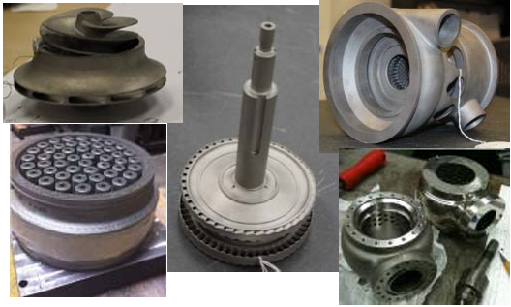
Figure 1 Additively manufactured propulsion system components. Credit: NASA

This progress has enabled NASA to confidently employ topology optimization, a process which as noted earlier is typically reliant on these manufacturing techniques. Within Marshall Space Flight Center topology optimization has been implemented on a plethora of tasks and trade studies, including the thermal optimization of a cryogenic propellant tank strut or the mass reduction of a NASA developed bracket for the Mars Ascent Vehicle (MAV) reaction control systems (RCS) (Figure 2). Several software packages capable of this are used on center, though the focus for this paper will be the ANSYS Workbench™ optimization module.

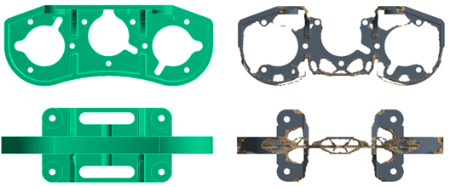
Figure 2 Optimization results of a NASA developed structural bracket, resulting in approximately 50% mass savings from the traditional design. Credit: NASA

There still exist barriers to the adoption of topology optimized structures for spaceflight structures. complexities in the manufacturing validation, the expense of AM material characterization, and the unique challenges presented for the non-destructive evaluation of such parts, pose some difficulties. These, however, are not insurmountable and NASA has flown multiple structural AM hardware components in space applications, like those aboard the Lunar Flashlight mission.
Adapting this experience and technical background to an AM lunar regolith structure will not be direct in nature, though, the framework for achieving the qualification of the structure (for in-space application), can be leveraged. Some of the key identified differences and what similarities exist are addressed in more detail in the section regarding the application of topology optimization to pad design.

Achieving the same success as that attained for Earth-based AM construction, will be essential to executing America’s vision for permanent settlement on the lunar surface.

- Definition of Artemis Program
Led by NASA, the Artemis program is a robotic and human Moon exploration effort that includes five major partner agencies; the European Space Agency (ESA), the Japan Aerospace Exploration Agency (JAXA), the Canadian Space Agency (CSA), the Israel Space Agency (ISA) and the Australian Space Agency (ASA). The program’s long-term goal is to establish a permanent base on the Moon to facilitate the feasibility of human missions to Mars.
The Artemis program has defined a series of five unmanned and manned missions in two phases between 2022 and 2029, including the first manned mission to the Moon in late 2024. Phase I is shown graphically in Figure 3. In addition, a series of support missions will be executed to include robotic landers, delivery of Gateway modules to Near-Rectilinear Halo Orbit (NRHO), Gateway logistics, delivery of the Human Lander system (HLS) as well as habitat modules and rovers, and delivery of other elements to the lunar surface. Many of these landings will utilize the Commercial Lunar Payload Services (CLPS) program, and all of these landings will be directly on the lunar surface. With direct surface landings come the known issues associated with plume-surface interaction, cratering, potential damage to adjacent infrastructure, and potential acceleration of regolith particles into low lunar orbit. Resolution of these issues can only be achieved through the placement of landing/launch pads with associated blast protection.
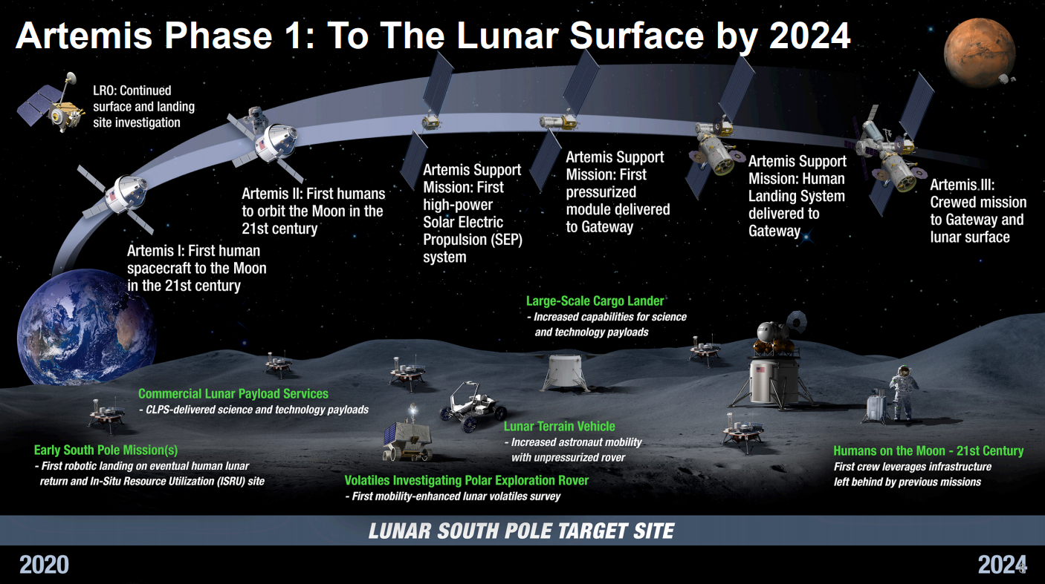
Figure 3 Phase I of the NASA Artemis Program through the Artemis III mission
With this understanding, it is reasonable to assume that a landing/launch pad will be the first element of lunar infrastructure to be constructed on the lunar surface in support of the Artemis program. NASA/MSFC’s MMPACT project has been focusing on ISRU-based LLP development and is planning a series of development and qualification missions using CLPS landers over the next several years.
- Summary of Key LLP Requirements
As mentioned, significant risks exist for larger landers proposed for the Artemis Program due to higher thrust levels leading to increased ejecta and cratering, presence of co-located assets in the ejecta path, and potential strict surface levelness requirements for tall vehicles. These risks can drive some significant requirements, especially when coupled with the lunar South pole environmental requirements. Other variables that drive design requirements include lander weight (structural loading), descent/ascent engine location and plume profile (thermal loading), and others. Maximization of ISRU-materials for pad construction is another high priority. Other design requirements may include, but are not limited to, those shown in Table 2.
Requirement | Discussion Notes | Reference
Life Expectancy | Design should have potential for unlimited use without damage | [3]
Ease of Repairability | If needed, repairs should be minimal, maximize use of ISRU materials, minimize crew time and not be intrusive (easy to access) | [3]
Maintenance Upmass | Use of ISRU materials for repair or maintenance activities should be maximized. | [3]
Reliance on Crew for Maintenance | Use of crew for pad maintenance should be minimized | [3]
Life Cycle Cost | Total life cycle cost should be minmized | [3]
Ingress/Egress | Design should provide a safe and accessible route for crew and equipment to and from the lander | [3]
Pad/Apron Diameter | TBD, a function of lander positional accuracy | [6]
Blast Shield Height | TBD, a function of pad diameter, apron diameter, plume profile and effectiveness of blast wall/landing pad at mitigating dust generation | [6]
Required Distance From Habitat (or other surface infrastructure) | TBD, depending on effectiveness of blast wall/landing pad at mitigating dust generation | [3]
Cleanability | Ability to remove residual dust/debris after a launch or landing | [3]
Load capability | Given a known lander, pad material and pad construction technique, the pad can withstand large static and dynamic loads without causing significant or permanent structural damage | [3]
Plume-Surface Interactions | The design should contain features that redirect the engine plume underneath a lander such that stagnation does not occur in both centered and off-center landings. | [3]
Flow Dissipation Capability | The design should contain open space or only smooth flow redirection features | [3]
Landing Accuracy Tolerance | The landing area shall be large enough to support landing accuracy tolerances such that landing can occur with equal effectiveness. | [3]
Supporting Infrastructure to Service Vehicles | The design shall include service vehicle support such as repair or refueling capability, and ingress/egress roads/ramps. | [3]
Other Supporting Infrastructure | The design shall include components or landing aids such as beacons, visual landing targets, or lighting. | [3]
Table 2 Possible Lunar LLP Design/Performance Requirements
The current ability to land or launch from the lunar surface requires you to land or launch on/from unprepared regolith surfaces. While this has been moderately successful in the past, the intended goals of the Artemis Base Camp will require a more permanent and certain solution for the repeated use of our astronauts. Lunar launch and landing pads will be necessary infrastructure if we are to mitigate the risks of ejected regolith at nearby facilities or to provide a safe and proven touchdown location for America’s next generation of lunar landers.

At present many of the fine details for the loads that the lunar landing pads will experience remains to be defined. This is to be expected as lander development, and details relating to the approach characteristics, are still in work. However, while the exact definitions for these loads may not be available, reasonable first estimates for many of the driving loads can be made given mission requirements and self-apparent environmental loading.

Of consideration in the conceptual design studies conducted within NASA has been, dynamic touchdown loading, max bearing loads, solar heating, lunar regolith settlement, applicable loads from plume surface interaction, and the cyclic impacts of the afore listed.

In order to assess the appropriate failure modes, the brittle nature typically experienced by AM regolith materials [7, 8], and the importance of preventing the liberation of debris that could cause damage to the lander or nearby structure, must be considered. While they share similarities, the sintered lunar regolith considered for this study and a typical structural concrete, do not exhibit equivalent material behaviors and it is unclear if similar failure modes will exist. Per existing test data, the lunar regolith samples seem closer to a brittle fracture behavior model, like is seen in some stone. Normal concrete, in comparison, shows a shifting compressive modulus prior to reaching peak compressive stress (Mohammed 2018). These constraints, and how they impact the model are integral to defining optimization constraints.

- Application of Functional Optimization to Pad Design
As an example, in this paper, we will study the case of a lunar landing/launch pad, for which one proposed design solution incorporates a unique, 3D vented pad configuration. This includes surface openings meant to capture exhaust plume, internal channels designed to redirect the plume from a vertical to outwardly radial horizontal orientation, and side vents meant to reduce thermal and kinetic energy from the plume prior to venting into the lunar environment [9]. As shown in Figure 4, the pad consists of four main segments; 1) an outer wall, 2) a bottom plate, 3) a series of “petals” to guide plume flow radially and provide support to the roof (all shown in Figure 4.A), and 4) a roof plate (shown in Figure 4.B).
Note that water soluble foam was used in the channels to provide overhang roof support in this design which was subsequently removed using a pressure washer after the roof plate concrete had cured. A subsequent successful hot fire test on this pad [10] demonstrated the ability to capture and redirect some exhaust plume inside the pad (as identified via camera, and flow and pressure sensors) and reflect the remainder of the plume. So, from a purely functional standpoint, the requirements of guiding and redirecting exhaust plume were met via the use of a hollow, vented pad that could really only be fabricated using large-scale 3D printing.

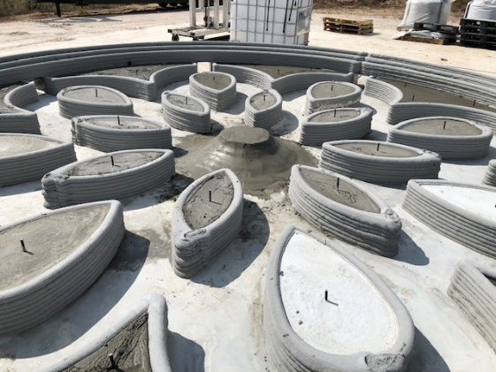
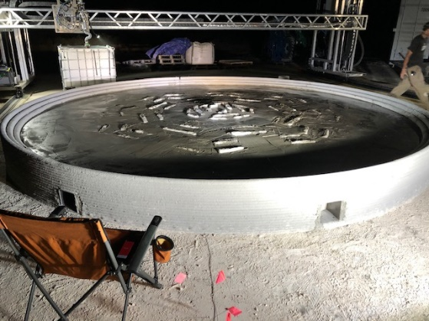
- (B)
Figure 4 – Major Elements of the LunarPAD 3D Printed Lunar Landing/Launch Pad Prototype
- Internal Features and Outer Wall B) Roof Plate

As the MMPACT project was contemplating the design of a representative landing pad element for demonstration on the CT-1 mission in 2027, a number of design solutions were evaluated. These included a monolithic plate, bonded tiles, a design such as the one shown above, or a topologically optimized design. These evaluations have resulted in question such as:

- Would or could a functional requirement-based design be as efficient in terms of material usage (for example) as a topologically optimized design?
- Would or could a topologically optimized design be able to meet all key functional requirements?
- Is there a way to integrate results of both approaches without sacrificing performance?

- Application of Topology Optimization to LLP Design
Considering the information required for topology optimization of a lunar pad design
The design of the Artemis Base Camp’s landing pads, by nature of NASA’s currently selected manufacturing technique (AM), will be capable of employing the less traditional designs typically created as a result of topology optimization. NASA has awarded ICON a contract to develop construction technologies that will help build lunar infrastructure like habitats, roads, and landing pads. The current method of construction, shown by graphic from ICON, utilizes a laser mounted rover to fabricate the hypothetical pad. The scale of this printing project is beyond anything currently attempted.

Unlike the many factors that may be considered when approaching an optimized functional design, the topology optimization goal for the lunar landing pad is focused on a singular primary goal, with established constraints that must be met. That being a reduction in printed volume, while remaining within the structural capability of the material at extreme loading conditions. Typical aerospace components benefit from reduced mass, or improved modal response, and while a lunar pad may see no direct benefit from a reduced mass, by minimizing the printed volume, the manufacturing system realizes the benefits of minimized power consumption and a reduced time for construction. Both critical metrics for the successful operation of this technology on the Moon, resulting in design possibilities as shown in Figures 5 and 6.

To effectively optimize this structure, the inputs: material properties, initial bounding geometry, manufacturing constraints, structural requirements, loads, and unique environmental impacts, must all be defined. Given the novelty of this task, it must be considered that additional unknowns may exist, and uncertainties are large. However, by involving analysis early in the process of mission planning we can begin addressing or identifying these issues so we can vector future research efforts to meet the unique challenges presented by the lunar environment. Challenges that are necessary to overcome if we are to build a lunar launch/landing pad.
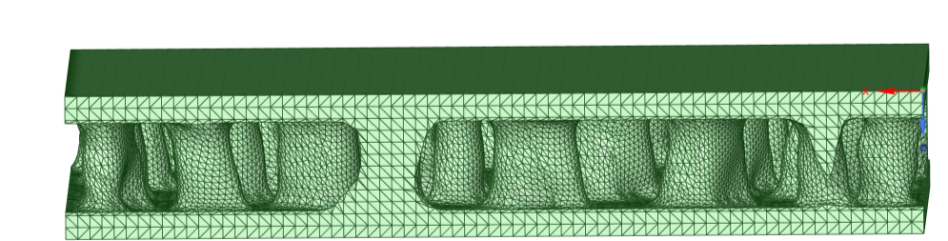
Figure 5 A representative section of an optimized landing pad section accounting for a lunar surface stiffness, landing load, and solar thermal heating

The material properties for a sintered lunar regolith can vary due to a multitude of factors. Long term considerations should factor for material composition at site, initial thermal state, and variation in laser power over time. Ground testing has been completed for a variety of samples [8], and some progress is being made in identifying what shifts in material trends can be anticipated between the Earth construction samples and those constructed on the Moon. Future planned testing with NASA and its commercial partners includes tests in a vacuum which will address the disparities some of these environmental differences create.

These material uncertainties need to be considered but do not preclude initial assessment of a hypothetical structure. One approach is to capture the impact of these variations through bounding assessments, determining worst case combinations of material factors, and applying higher factors of safety based on initial data.

The initial bounding geometry for a launch/landing pad will be defined by the capability of the landers accuracy when touching down as well as the footprint of that lander. Secondary features, like a solar shade or blast wall may also be considered as part of the structure. The primary requirements for the feature are to prevent debris generation from plume surface interaction and to provide a stable, defined, landing zone for the vehicle. This requires that the geometry maintain a uniform surface, a factor relevant to defining topology exclusion zones. These are further defined by manufacturing limitations. For instance, surface roughness will impact local stress risers for any design as post processing is unlikely to be initially available on the lunar surface. The impact of these can be captured in post-processing of a model but ascertaining the impact of this feature and if it changes with respect to geometry is important. Additional constraints such as, layer thickness and overhang constraints, can be captured in the optimization set up. Other constraints, such as limitations to the fine control of the laser, can be addressed with human aided design changes to the selected optimized model.
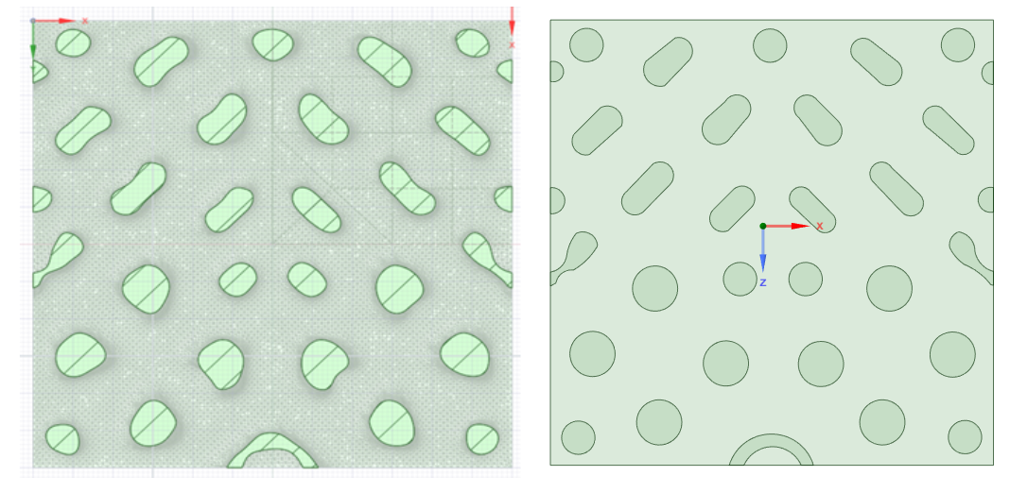
Figure 6 A representation of modifying a topology optimized structure (right) to a less organic, simpler functional design (left)

To account for uncertainties and unknowns, including material variations, analysis uncertainties, etc., a structural member must be designed to carry a load considerably larger than the maximum expected applied load. To determine the appropriate design load, the maximum expected applied load is multiplied by a factor of safety (FOS). When pursuing optimization FOS becomes an important but indirectly defined constraint. To the analyst’s knowledge there is no established requirement document for AM lunar regolith structures that defines a FOS applicable to this effort. For current efforts, a best effort at a reasonable factor was determined using rationale from NASA/TM‒2009-215723/REV1 (White Paper on FOS), JSC 65828, and NASA STD 5005. As the manufacturing technology matures, mission risk tolerances are established, load fidelity improves, and material understanding grows a more accurate FOS can be determined.

Given the above considerations initial studies have shown significant volumetric savings are possible using topology optimization. A level-set topology optimization method produced an optimized model with an approximately 45% reduction in mass while maintaining positive factors of safety under predicted worst-case loading. A similar trade run with more traditional parameter driven optimization was run as a comparator and yielded only 39% savings with a hex grid pattern. While this was still a significant improvement over a monolithic segment, it was not improved compared to the fine level of control for material reduction that is achievable via topology optimization.

It is anticipated that as the resolution of the loads and fidelity of the material data improves the accuracy of this prediction can be refined, additionally as more test specimens and demonstration articles are developed additional factors, not traditionally tracked in an optimization model, like material sag, varying density, and shape cooling behavior. Both layer resolution and shape cooling behavior can impact the local stresses of the pad. Some of the disadvantage incurred by these manufacturing by-products can be alleviated by targeted design. However, an understanding of the behavior of the constructed material is necessary to accomplish this feat. Early testing of the technology will allow for these factors to be considered in future design iterations.

- Integration of Optimized Design Elements
“Humans in the loop” is a good way to ensure optimized designs are still considering functional aspects outside of the optimization focus, as well as a way for identified areas of improvement to be manually implemented. A focused effort during topology optimization to ensure that functional requirements are considered when evaluating topological optimization constraints will help ensure that adequate functional design features, some of which may only be available through advanced manufacturing techniques like AM, are incorporated.

- Conclusions

Topology optimization is well suited for lunar construction. The manufacturing methods are theoretically able to implement complex designs, meaning greater potential for optimization. And as NASA is in the early stages of implementation the requirements for construction remain malleable and able to account for the eccentricities for this kind of design as the design matures. It should be noted however, that while the process of topology optimization is useful, we’re not about to be replaced by machines just yet. A human in the loop is still beneficial to further refine designs and needed to implement other functional design changes not accounted for in the topology optimization process. Ultimately, by understanding the constraints that come with using the computer driven optimization software we can take full advantage of AM and recognize significant mass/volume savings, while still achieving the functionally driven requirements.

- Acknowledgments
The authors would like to thank the management of the NASA MSFC Moon to Mars Planetary Autonomous Construction Technology (MMPACT) project for their funding and support to this effort.
- References
[1] Yi Wei Daniel Tay, Biranchi Panda, Suvash Chandra Pauly, Nisar Ahamed Noor Mohamed, Ming Jen Tan & Kah Fai Leong (2017), “3D Printing Trends in Building and Construction Industry: A Review”, Virtual and Physical Prototyping, http://doi.org/10.1080/17452759.2017.1326724.
[2] Michael R. Fiske, Jennifer E. Edmunson, Edward G. Weite III, Mallory M. Johnston, John C. Fikes, Rob P. Mueller, William R. Robertson and Behrokh Khoshnevis, “The Disruptive Technology That is Additive Construction: System Development Lessons Learned for Terrestrial and Planetary Applications”, AIAA SPACE Forum, 17-19 September 2018, Orlando FL, http://doi.org/10.2514/6.2018-5127.
[3] A.I. Campbell, H.C. Carson, M. DeSoto, M.R. Fiske, L.E. Martin, V.R.T. Murai, F.S. Ramirez, E.M. Romo, K.E. Schang, and K.C. Smith, “An Analysis of Lunar Landing Pad Designs and Construction Methods”, in Progress in Additive Manufacturing 2021, ed. N. Shamsaei, N. Hrabe, and M. Seifi, (West Conshohocken, PA: ASTM International, 2022), 225-247. http://doi.org/10.1520/STP164420210128.
[4] LÓGÓ, János; ISMAIL, Hussein. Milestones in the 150-Year History of Topology Optimization: A Review. Computer Assisted Methods in Engineering and Science, [S.l.], v. 27, n. 2–3, p. 97–132, Sep. 2020. ISSN 2956-5839
[5] Gradl, Paul: Mireles, Omar: Protz, Christopher: Garcia, Chance. Metal Additive Manufacturing for Propulsion Applications. AIAA, ISBN (print): 978-1-62410-626-2eISBN: 978-1-62410-627-9. Jul 2022

[6] Morris, A.B., et al., Plume Impingement on a Dusty Lunar Surface, AIP Conference Proceedings, Vol. 1333. No. 1. American Institute of Physics, 2011.

[7] Stephen J. Indyk, Haym Benaroya. A structural assessment of unrefined sintered lunar regolith simulant. Acta Astronautica, Volume 140, 2017, p. 517-536, ISSN 0094-5765

[8] Goulas, Athanasios & Binner, Jon & Engstrom, Daniel & Harris, Russell & Friel, Ross. (2018). Mechanical behaviour of additively manufactured lunar regolith simulant components. Proceedings of the Institution of Mechanical Engineers Part L Journal of Materials Design and Applications. 233. 10.1177/1464420718777932.

[9] Campbell, A., Carson, H., De Soto, M., English, K., Fiske, M., Martin, L., Murai, V., et al, “LunarPAD – On the Development of a Unique ISRU-based Planetary Landing Pad for Cratering and Dust Mitigation,” in AIAA Scitech 2021 Forum (Reston, VA: American Institute of Aeronautics & Astronautics, 2021), AIAA-2021-0356, https://doi.org/10.2514/6.2021-0356
[10] Campbell, A., Carson, H., De Soto, M., English, K., Fiske, M., Martin, L., Murai, V., et al, “LunarPAD Post-Hot Fire Test Performance Evaluation,” in AIAA Scitech 2022 Forum (Reston, VA: American Institute of Aeronautics & Astronautics, 2022), DOI: 10.2514/6.2022-2422

