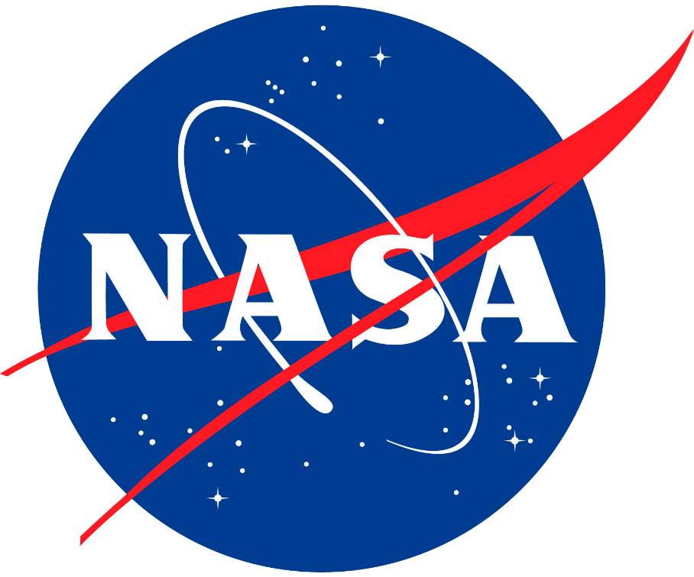

ECS Artemis II Upgrades

Monique Toon
NASA Kennedy Space Center
Academic Level: Senior
Academic Major: Mechanical Engineering
OSTEM-NASA Internship Fall 2023
11/13/2023

Mentor: Stephen W. Camick
Org Code/Division: NE-XF/Environmental Control and Life Support Systems

Abstract
The National Aeronautics and Space Administration (NASA) actively works to further the expectations of space exploration and research. NASA has been able to develop innovative technology and methods that has allowed for continued discovery and innovation. NASA is in the midst of work for the Artemis mission, which is to return to the moon in an effort to prepare for future Mars exploration. After the successful launch of Artemis I last November, our sights have shifted to Artemis II, which is set to launch next year and bring humans into the lunar orbit for the first time in over fifty years. Artemis II will be the first crewed mission for the program and will represent another step forward in our mission to advance our knowledge of the universe around us. From there, the Artemis program will move onto building a permanent site on the moon that will allow us to eventually reach Mars.
During my time at NASA, I was able to work with the NE-XF Branch, also known as the Environmental and Life Support Systems Branch. I specifically worked with the Environmental Control Systems (ECS) team. During my time here, construction on the system in the Vehicle Assembly Building (VAB) and at Launchpad 39B have been progressing at full force. ECS is used to provide processed and purged air at specific temperatures, pressures, and humidity’s to fulfill requirements necessary to support Orion and the SLS. While the Pad has been undergoing upgrades from the original Artemis I configuration, the VAB has a completely new ECS very similar to it. While both systems have been undergoing upgrades, we have been able to transition into testing the systems as we prepare for stacking in the VAB early next year.
My role has allowed me to learn about how the systems work and function through walkdowns and visits out to both the Pad and the VAB. I’ve been able to see firsthand how the system operates and have learned how the system affects the vehicle. I’ve been able to shadow my mentor, my coworkers, and COMET operators to oversee the construction efforts of the system along with the testing of the software and the system itself. I even was able to aid in testing at the console myself at Pad 39B. Additionally, I am also revising and reviewing displays for Artemis IV that will be used to remotely control parts of the system. Eventually these displays will be used to support the future of Artemis.

Acknowledgements
I would like to thank my entire team at NE-XF for the kindness and support they have given me during my time here. Additionally, I want to thank my mentor Stephen Camick for his passion and commend him for being an incredible guide and teacher. Being able to learn alongside everyone will be an experience I will never forget. I’d also like to thank Miles Lynch for giving me guidance on my work and aiding me throughout this semester and all the people who kindly gave their time during guided informational walkdowns of various facilities. Lastly, I would like to thank KSC Education for this internship opportunity.

