Application of Stuffed Whipple Shield to Robotic Spacecraft

Ivonne M. Rodriguez ⁽¹⁾
⁽¹⁾ NASA Goddard Space Flight Center, Code 592, 8800 Greenbelt Road, Greenbelt, MD 20771, USA, Ivonne.M.Rodriguez@nasa.gov

ABSTRACT
Protection of human life onboard the International Space Station (ISS) requires reinforced shielding of crewed modules to prevent penetration of micro-meteoroid and orbital debris (MMOD), while optimizing the necessary mass for that application. An efficient way to achieve that protection consists in combining metal plates with ceramic and Kevlar fabrics in critical areas, a configuration known as the “Stuffed Whipple Shield”. In robotic spacecraft, fuel tanks are particularly vulnerable to MMOD impacts due to their pressurized contents and thin walls. Risk assessment of the Plankton, Aerosol, Cloud, ocean Ecosystem (PACE) spacecraft using the Bumper3-Sat hypervelocity impact simulation tool demonstrated that the risk of propulsion tank damage due to MMOD particles coming from the ram direction (Launch Vehicle Adapter side) violated NASA requirements to limit the generation of orbital debris and threatened mission success. To mitigate the risk and achieve compliance, the basic configuration of the ISS Stuffed Whipple shield was scaled down and adapted to become a tank shield in the spacecraft ram direction. This paper will describe the adaptation of the ISS Stuffed Shield to a robotic spacecraft, while also comparing the effectiveness of the proposed shield design with more traditional single-wall and double-wall alternatives used in robotic spacecraft under similar conditions.

Introduction
The Plankton, Aerosol, Cloud, ocean Ecosystem (PACE) spacecraft is designed to improve the ongoing collection of ocean data from space, focusing on phytoplankton production and atmospheric parameters detected on aerosol, clouds, and ocean. Its main payload is the Ocean Color Instrument (OCI), a hyperspectral imaging radiometer. Sponsored by the National Aeronautics and Space Administration (NASA), PACE is scheduled to launch in early 2024. The spacecraft is three-axis stabilized. Instrument requirements locate the OCI in the anti-ram side of the spacecraft bus (opposite to the velocity vector), while most robotic spacecraft have their primary payloads typically in ram (velocity vector) or in nadir (Earth-pointing) sides. The Propulsion Module, opposite to the OCI location, is facing ram.
The consequence of this arrangement is that the propulsion tank’s dome also faces ram, where the micro-meteoroid and orbital debris (MMOD) flux is highest. Figure 1 shows the plot of the orbital debris flux for the PACE operational orbit (676.5 km, circular, with 98° inclination) in the year 2024, according to the Orbital Debris Engineering Model version 3.2 (ORDEM 3.2). This plot shows that the highest orbital debris flux is expected at ram (0 degrees azimuth, 0 degrees elevation), followed in intensity by the flux at port and starboard sides (+/- 90 degrees azimuth, 0 degrees elevation). For spacecraft designed to perform post-mission disposal maneuvers, NASA-STD-8719.14 Requirement 4.5-2 [1] limits the combined risk of MMOD damage to components needed for those disposal maneuvers to less than 0.01 (“Requirement 4.5-2. Limiting debris generated by collisions with small objects when operating in Earth orbit: For each spacecraft, the program or project shall demonstrate that, during the mission of the spacecraft, the probability of accidental collision with orbital debris and meteoroids sufficient to prevent compliance with the applicable postmission disposal maneuver requirements is less than 0.01”). This requirement follows a similar directive in the United States Government Orbital Debris Mitigation Standard Practices. Because the PACE spacecraft is designed for controlled reentry at the End of Mission, the Project conducted a detailed assessment of MMOD impact risk to components that must be active to complete the intended disposal maneuvers. The propulsion tank received particular attention because of its pressurized content and its location in areas where the orbital debris flux is predicted to be higher.

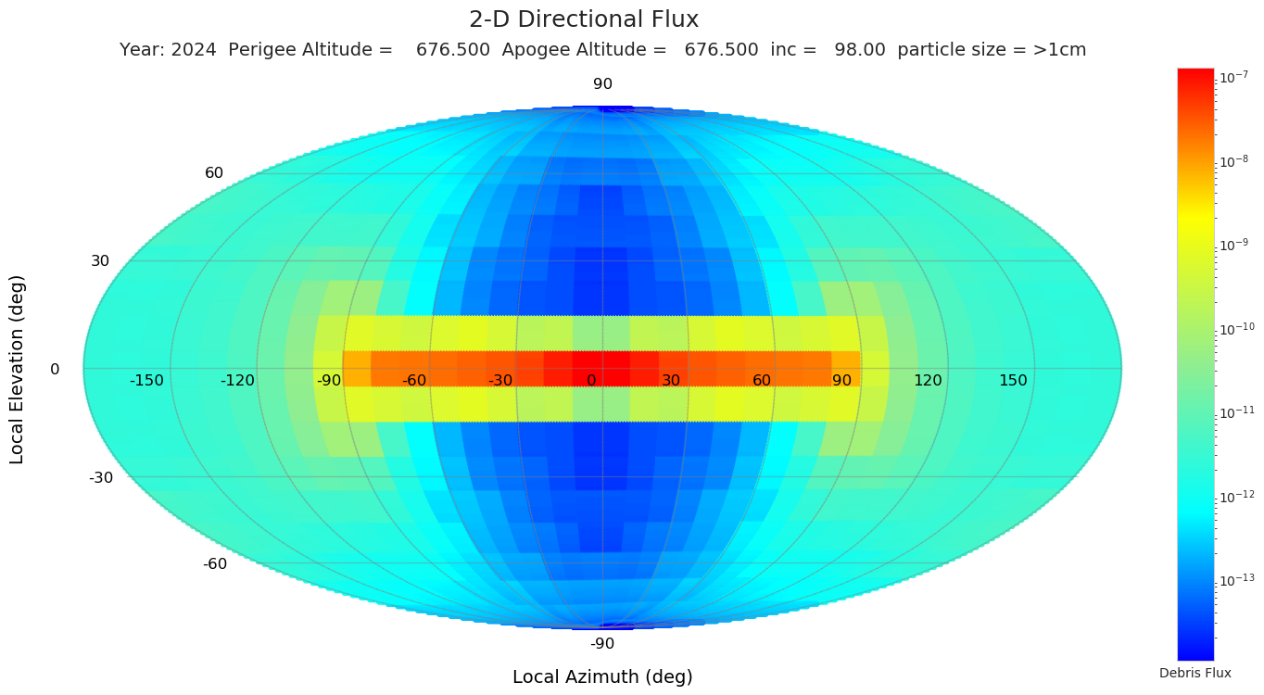
Figure 1. Plot of PACE operational orbit for 2024, from ORDEM 3.2.

The PACE Spacecraft
The PACE spacecraft nominal flight orientation is identified in Figure 2 (left). The original design (before the risk assessment) included a honeycomb panel over the propulsion tank in the ram direction as the only protection from the particle environment. The right side of the illustration shows the spacecraft ram face without the panel, to better observe the tank location. The machined panel is part of the Propulsion Module, and supports the frustum structure and the Launch Vehicle Interface Ring. The OCI instrument is in the anti-ram section of the spacecraft and is not visible in the illustration.

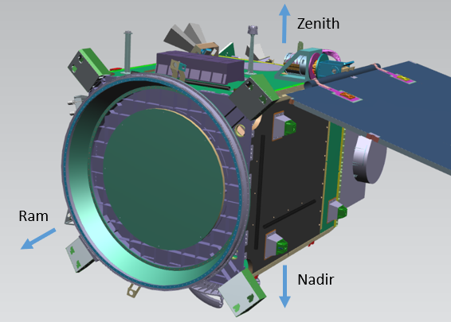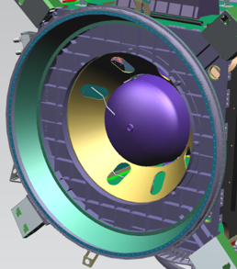
Figure 2. Deployed PACE spacecraft with marked orientation (left) and view of the Propulsion Tank inside the bus (right).

Initial MMOD Risk Assessment

Tools
The PACE spacecraft incorporates MMOD protection to several external and internal components, allowing the mission to mitigate the risk of hypervelocity impact (HVI) damage to reentry-critical components to less than 0.01. Those mitigation measures include the adoption of the Stuffed Whipple Shield in the ram direction that will be described in Section 4 below. The risk assessment and evaluation of shield alternatives were completed in 2019 using the Bumper3-Sat analysis software (version 3.8.0626.0), which is a limited version of the Bumper 3 hypervelocity impact simulation tool created by the Hypervelocity Impact Technology (HVIT) group at NASA Johnson Space Center (JSC). Bumper3-Sat is intended for analysis of robotic spacecraft. The particle environment models used in 2019 to model the PACE operational orbit during mission lifetime were ORDEM 3.0 (released in 2014 by the NASA Orbital Debris Program Office) and the Meteoroid Engineering Model version R2.05 (MEM R2, released in 2015 by the NASA Meteoroid Environment Office).
Since the original assessment, the Bumper3-Sat tool and the particle environment models have been updated and expanded. To validate the original analyses and ensure that compliance with the NASA requirement is not affected by advances in analysis tools, the original shielding scenarios were adapted and re-assessed in 2023 using the latest available tools and models: Bumper3-Sat (version 3.22.0.0504.0), ORDEM 3.2 (released in 2022) and MEM 3.0 (released in 2019). Ballistic Limit Equations (BLEs) are used to determine the characteristics of a particle capable of penetrating a given shield configuration. The original 2019 assessment applied the New Non-Optimum (NNO) BLE to analyze double walls (Whipple shield bumper and rear wall [2], valid when (bumper thickness)/(particle critical diameter) is more than 0.20 and less than 0.25), and Reimerdes’ modification to the NNO BLE for double walls where the shield is thin compared with the critical surface it protects [3]; in this paper, we will refer to this last BLE as “Reimerdes”, or R. The updated Bumper3-Sat version adds the SRL Equation [4], also known as the Triple Wall equation, to analyze cases where two shields protect a critical surface.

Tank Analysis Assumptions
Pressurized vessels present a challenge for HVI tests because of their potential to fail catastrophically and to damage adjacent components and structures. Since the Apollo era, pressurized tanks have been designed for a penetration depth that should not exceed 25% of the tank wall thickness [5]. Because the NNO BLE assumes that the surface fails by detached spall (with thickness reduction by spall equal to the impact crater depth) a pressurized vessel would fail with an impact that perforates half of its wall (two times 25% of the wall thickness). In Bumper, the analyst can represent this failure scenario by modelling the tank as a wall with half the thickness of the actual tank wall (0.5 t, where t is the minimum thickness of the wall). For conservatism, the PACE tank is modelled as having 0.4 times the minimum thickness reported by the tank vendor (0.4 t), equivalent to 20% of the tank wall thickness. The Joint Polar Satellite System (JPSS) Micrometeoroid and Orbital Debris (MMOD) Assessment provides more information on methods for modelling pressurized walls for analysis, with their history [6]. The reduction of wall thickness for analysis purposes makes pressure vessels to look particularly vulnerable to MMOD impact damage.

Initial Analyses
This paper focuses on the tank ram shield because its exposure to the highest particle flux and its thin wall presented a challenge. Since several components needed MMOD protection as well, the impact risk to the tank in ram direction had to be low enough to leave a reasonable margin for other components at risk without exceeding the overall spacecraft MMOD impact risk of 0.01. The risk to the tank sides was mitigated using a Kevlar blanket around them, and external components were reinforced with aluminum plates and Nextel blankets to mitigate their risk; however the risk was still dominated by the tank dome facing ram. Analysis of the other components is beyond the scope of this paper.
The 2023 assessment confirms the 2019 conclusion that traditional double walls are insufficient to keep the HVI risk in ram direction low enough for overall spacecraft compliance. Figure 3 illustrates some of the scenarios used in this demonstration using the updated tools: 1) Baseline case where only the honeycomb panel with 0.254 cm facesheets protects the tank; 2) same honeycomb panel and five layers of Kevlar in contact with the tank wall; 3) same honeycomb panel with a blanket of 10 layers of Kevlar on the tank wall (variation of 2019 case where the Kevlar was modelled as part of the shield); 4) 2-mm facesheets with 4 cm between them (This scenario was added for comparison with the Stuffed Whipple configuration). For completeness, the four cases were modelled using three BLEs: NNO, Reimerdes, and SRL.
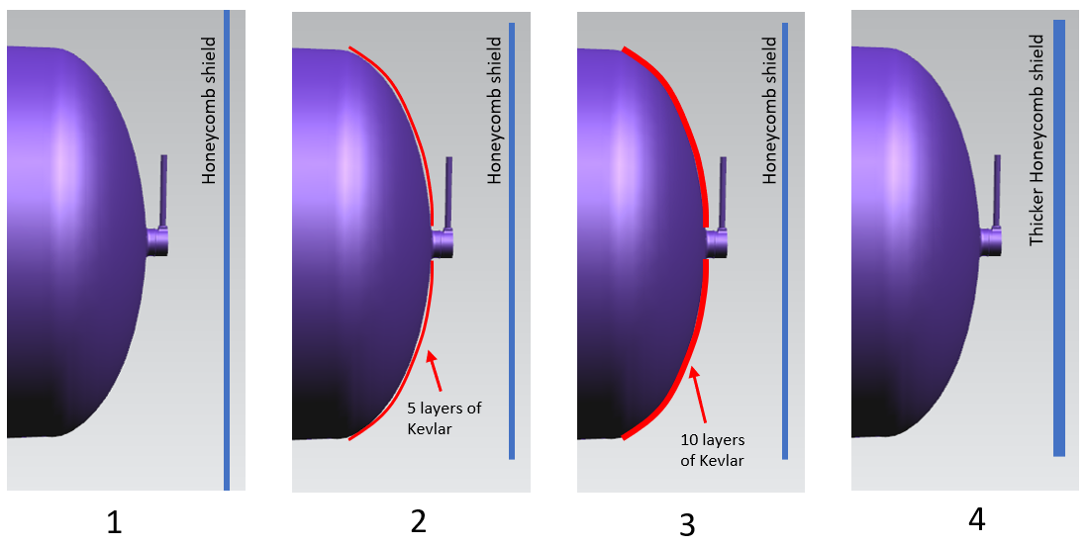
Figure 3. Four scenarios: tank with panel only (1) and three mitigation cases (2,3, and 4).

Table 1 shows a detailed description of the data and results of the new simulations using Bumper3-Sat version 3.22.0.0504.0 with ORDEM 3.2 and MEM 3 environment models (The earlier versions ORDEM 3.0 and MEM R2 produce a comparative increase of 11%-13% in the risk, making them more conservative, but the models are considered obsolete when compared to the newer ones). Where NNO and Reimerdes BLEs are used, the honeycomb facesheets are modelled as a single shield with a thickness equal to the sum of the two plates (0.508 mm, or two times the baseline thickness of 0.254 mm). Where SRL is used, the facesheets are modelled separately. Bumper3-Sat estimates the expected Number of Penetrations for the critical surface under analysis, represented by N. This N value is then converted to Probability of Failure (PF), where failure is defined as penetration of 20% of the tank wall (Section 3.2). The table shows the PF for the ram side of the tank. For perspective, the PF is converted to percent and also to the percent of 0.01, the minimum value that would result in non-compliance with the NASA requirement. This is important because other components needed for reentry also contribute to the total spacecraft PF, including the tank sides (inside the bus) and other subsystems and components located in the external bus walls, so the PF due to the ram section of the tank should be minimized. The asterisk at the side of the PF for cases 2A and 3A indicates that the configuration failed the criteria for using NNO, as described in Section 3.2 (was 0.096 for case 2A and 0.081 for case 3A, both less than 0.2), so the results are considered unconclusive and are shown here for completeness only.
Table 1. Data and results from analysis scenarios

Figure 4 summarizes the baseline case where only the “thin” honeycomb panel (0.0254 cm facesheets with 2.54 cm separation), or single simplified panel (0.0508 cm thick) protects the tank, without applying additional shielding. It can be observed that the risk to the tank dome alone violates the requirement of less than 0.01 for the combined risk of all reentry-critical components. Figure 5 shows different mitigation strategies.
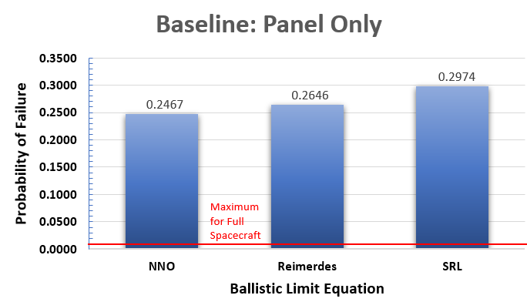
Figure 4. Baseline scenario with no propulsion tank protection other than a honeycomb panel

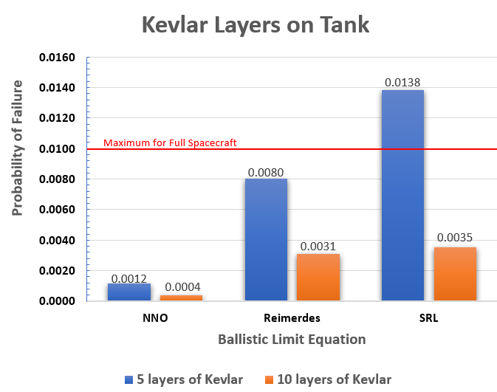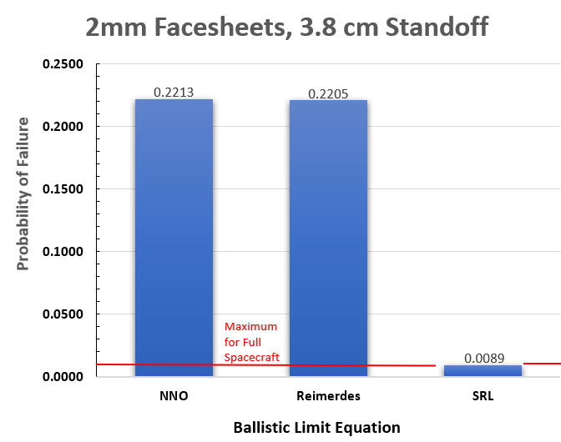
Figure 5. Mitigation scenarios: thin honeycomb panel with Kevlar on tank wall (left) and thicker panels but no Kevlar on tank (right)

The purpose of comparing the results of the three multiple-wall BLEs is not to evaluate the merit of each approach, but to perceive agreements and disagreements. The first observation is that the risk of tank failure, conservatively defined as penetration of 20% of the tank wall, is too high in the baseline case to be acceptable regardless of the BLE used; MMOD protection is required. The lower risk is given by the cases 2A and 3A, which use the NNO BLE, but shield specifications violate the condition for the use of NNO, so its application is not recommended. The difference between NNO and Reimerdes BLEs in those two cases also points to the possibility that the modelled shields are too thin for NNO to adequately predict the outcome. The blanket made of 10 layers of Kevlar, cases 3B and 3C, shows the next lowest risk using Reimerdes and SRL, respectively, but still represents more than 30% of the allocated spacecraft risk. Moreover, a blanket of 10 layers of Kevlar is hypothetical because it would have presented design challenges in the specific tank location. The alternate scenario (case 4) demonstrates that increasing the thickness of the facesheets and the standoff between them does not provide sufficient protection. In the listed cases, the configurations generally show a high risk of impact damage, while in some cases the apparent low risk is dubious.
As indicated before, the tank sides and other components needed MMOD protection as well, so the tank risk at the ram side had to be minimized to achieve a total MMOD impact risk of less than 0.01. Back in 2019, the MMOD impact risk was not allocated by component, but a value below 0.001 for the tank ram side was considered ideal. Traditional flexible and Whipple shields were not enough to achieve that ideal level of protection.

Stuffed Whipple Shield

Advanced Shield Designs
The Handbook for Designing MMOD Protection offers several advanced MMOD shield designs, like the Stuffed Whipple shield, Multi-shock shield, and Mesh double-bumper shield [2]. The Stuffed Whipple Shield (SWS) was selected for further analysis because of its relative simplicity and because the necessary materials were common to other shields used throughout the PACE spacecraft.
The SWS consists of two aluminum plates with several ceramic and aramid fibers (typically Nextel and Kevlar, respectively) between them. The basic configuration is illustrated in Figure 6. Although there is no gap between the Nextel and the Kevlar fibers, the combination of the two further breaks and stop most of the fragments and ejecta from the front wall penetration, reducing the damage to the rear wall. This configuration is well known because of its application in the International Space Station (ISS). Although the ISS applies different types of MMOD protections, the SWS is reserved for sections where the expected particle flux and the corresponding risk to the crew are significantly high [7]. The SWS has been validated to stop a particle up to 1.59 cm diameter [8].
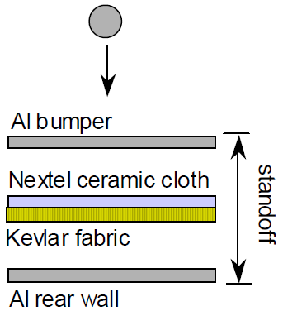
Figure 6. Basic Stuffed Whipple shield configuration, from [2]

MMOD Assessment using the Stuffed Whipple Shield Configuration
Besides the additional resistance against MMOD penetration, the advanced shield concepts have the benefit of using the rear wall as the critical surface. When applied as a tank shield, the BLE do not account for the tank behind the advanced shield’s rear wall; the 20% of tank wall penetration as failure mode is not applicable because the tank wall is not the critical surface. The actual risk to the tank cannot be computed, but is theoretically less than that of the shield’s rear wall, adding conservatism.
The 2023 assessments using the Stuffed Whipple BLE confirm the 2019 conclusion that this configuration can reduce the tank risk in ram direction to less than 0.001. Table 2 summarizes a sample of the representative cases analyzed, focusing on the use of 6 layers of Nextel and 6 layers of Kevlar between the two aluminum plates; other configurations were tested (less fabric layers), but preference was given to the use of 6 layers of each to follow the configuration of the ISS Stuffed Whipple shields (See next section).
The first observation from Table 2 is that, except for the Case 5, this shield configuration reduces the tank failure risk to less than 0.1%, a significant improvement in comparison with the cases considered valid in Table 1. It is also observed that increasing the standoff by one centimeter (from 3 cm to 4 cm) also improves the results, which is expected. Case 8 shows the lower PF compared with Case 6, but the configuration requires thicker plates, which increases the total mass (For comparison, mass is estimated as 15.42 kg when 0.20 cm thick aluminum panels are used, and 18.06 kg when 0.25 cm panels are used; mass difference due to standoff is considered negligible). Case 6 (0.20 cm aluminum plates with 6 layers of Nextel and 6 layers of Kevlar with a standoff of 4 cm) was selected as the ram shield configuration because it balances performance with total shield mass; the row is highlighted in color in Table 2 to indicate that it is final selection. Figure 7 is a diagram of the selected configuration.

Table 2. Stuffed Whipple shield simulations; the selected configuration is highlighted
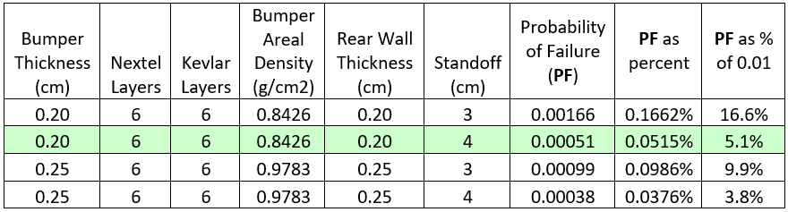
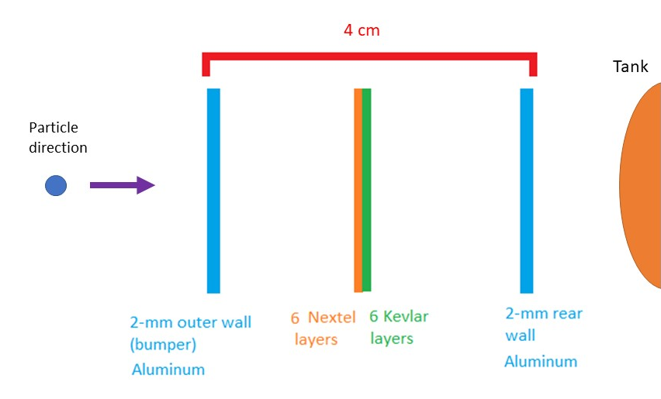
Figure 7. Final SWS configuration (Case 6)

In Table 1, Section 3.3, Cases 4A and 4B represented the selected configuration (2-mm aluminum panels, nearly 4 cm of standoff) without the Nextel and Kevlar fabrics between the panels, for comparison purposes. The PF of the two panels without the fabrics is about 431 times the PF of the same panels in the SWS configuration; this adds conservatism because the cases in Section 3.3 define the failure in terms of partial tank penetration and the SWS cases in Table 2 assume that the shield’s rear wall is the critical surface. As indicated before, damage to the tank itself is not factored in the risk when using the SWS BLE.

Comparison with ISS Stuffed Whipple Shield
The Stuffed Whipple shield was developed by the HVIT group at the Johnson Space Center to maximize the MMOD protection while limiting the necessary standoff. One example of its configuration in the ISS is a 2-mm aluminum bumper, an internal Multi-Layer Insulation (MLI) blanket close to the bumper, 6 Nextel layers and 6 Kevlar layers between plates, a 4.8-mm aluminum rear wall, and a standoff of 11 cm [7]. If the same specifications of the sample ISS shield without the internal MLI are applied to of the PACE scenario, the resulting PF is 0.00006. This greater performance is product of a thicker rear wall and a generous standoff, which would impose considerable weight and volume penalties in a typical robotic spacecraft. The PACE ram shield presents a lighter version of the human-rated ISS SWS, but is scaled down enough to limit the impact risk to the propulsion tank in the ram direction to about 5% of the total risk allowed by the NASA-STD-8719.14C Requirement 4.5-2. This reserves under 95% of the allocated risk for other critical surfaces in components needed for disposal maneuvers, including the tank sides.

Stuffed Whipple Shield Testing
In 2019, the Landsat 9 project funded hypervelocity impact tests for several spacecraft components. The tests were performed by the HVIT group at the Remote Hypervelocity Test Laboratory in New Mexico. As part of the test campaign, the PACE SWS configuration was tested twice using aluminum impactors with 0.419 cm and 0.459 cm at 7.0 km/s. The tests validated the design because the damage to the rear wall did not result in perforation or detached spall (See Figure 8). This shows reasonable agreement with the critical diameter of 0.447 cm predicted by the SWS BLE.
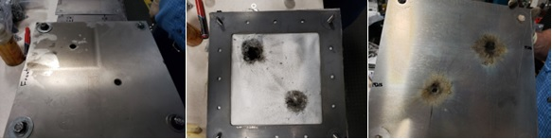
Figure 8: SWS configuration after HVI test: bumper (left), fabric layers with Nextel facing the bumper (center) and rear wall (right)

PACE MMOD Shield Final Configuration
The fully assembled Stuffed Whipple shield for PACE is shown in the Figure 9, left side. The 1.1-m circular shield serves as a cover for the circular aperture in the Propulsion Module while protecting the propulsion tank dome from MMOD. In the photo, the shield side facing up is the bumper, the outside plate facing away from the spacecraft. The lower plate is the rear wall designed to be in contact with the spacecraft. Between the two aluminum plates is a blanket assembly holding the 6 layers of Nextel AF10 (facing up) and 6 layers of Kevlar KM2+ (behind the Nextel), with Kapton tape covering the borders. The Nextel\Kevlar blanket is kept in the middle of the assembly by specially designed spacers that also hold the blanket in place in case of bumper penetration. The photo at the right of Figure 9 shows the PACE spacecraft lifted during integration and testing, with the OCI instrument at the top; facing down in the photo is the ram section with the launch vehicle adapter and the SWS at the center, covered by MLI.
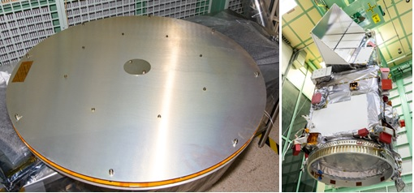
Figure 9. Assembled SW shield (left) and PACE spacecraft (right). Photos approved for public release.

Conclusion
This paper demonstrates that the Stuffed Whipple shield designed for the ISS can be scaled down for use in robotic spacecraft. In a typical robotic spacecraft, classical Whipple shields and soft shields (like Nextel) provide adequate protection to critical components from MMOD impacts. In extreme cases, the location of critical components and thin wall thickness can expose them to a predicted particle flux that may defeat bus panels and traditional MMOD shields. In those cases, the Stuffed Whipple is a viable alternative for robotic spacecraft, as the PACE tank shield design exemplifies.

References
- National Aeronautics and Space Administration, Process for Limiting Orbital Debris, NASA-STD-8719.14C, approved 5 November 2021.
- Christiansen, Eric L., et al, Handbook for Designing MMOD Protection, JSC-64399, 2009. Available at https://ntrs.nasa.gov/api/citations/20090010053/downloads/20090010053.pdf, accessed 31 August 2023.
- Reimerdes, H.-G., Nölke, D., Schäfer, F., Modified Cour-Palais/Christiansen Damage Equations for Double-Wall Structures, International Journal of Impact Engineering 33 (2006), 645-654. Available at https://doi.org/10.1016/j.ijimpeng.2006.09.036, accessed 11 October 2023.
- Schäfer, F.K., Ryan, S., and Lambert, M., Ballistic Limit Equation for Equipment Placed behind Satellite Structure Walls, International Journal of Impact Engineering 35 (2008), 1784-1791.
- National Aeronautics and Space Administration, Meteoroid Damage Assessment, NASA SP-8042. Available at https://ntrs.nasa.gov/api/citations/19710015594/downloads/19710015594.pdf , accessed 13 October 2023.
- Squire, Michael D., et al, Joint Polar Satellite System (JPSS) Micrometeoroid and Orbital Debris (MMOD) Assessment, NASA/TM-2015-218780, 2015.
- Christiansen, E. L., Nagy, K., Lear, D. M., Prior, T. G., Space Station MMOD Shielding, Acta Astronautica 65 (2009) 921-929. Available at https://www.sciencedirect.com/science/article‌/pii/S0094576509000319?via%3Dihub , accessed 25 September 2023.
- Ryan, S., Christiansen, E. L., Micrometeoroid and Orbital Debris (MMOD) Shield Ballistic Limit Analysis Program, NASA/TM-2009-214789, 2010.

