New Mie Scattering Diffuse Targets Development and Characterization

Georgi Georgiev, Joel McCorkel, Julia Barsi, Jessica Patel, Guangjun Gao, Elena Georgieva
NASA Goddard Space Flight Center, Greenbelt, MD 20771

Georgi.T.Georgiev@nasa.gov
Abstract. Earth science remote sensing observations require the detection and measurement of light originating from bright targets, such as clouds, and darker targets, such as an open ocean. This requirement drives the need to design, develop, and characterize improved calibration targets in support of current and future NASA instruments. New diffuse targets to be used as spectral albedo calibration standards were developed and characterized. The new targets based on fused silica or/and pressed and sintered Polytetrafluoroethylene (PTFE) were developed to be Earth scene specific. The various reflectance levels are achieved by modifying the material parameters, thickness, and surface finish. The new targets were characterized in laboratory and simulated space environments. We acquired high accuracy reflectance and transmittance data using a precision optical scatterometer and spectrophotometer located in the NASA Goddard Space Flight Center (GSFC) Diffuser Calibration Lab. The Total hemispherical reflectance (THR) and Bidirectional Reflectance Distribution Function (BRDF) were measured over the range of solar incident and scattered elevation and azimuthal angles typically realized on orbit by remote sensing instruments. We intend to space certify the new calibration targets after concluding on-orbit testing on the International Space Stations (ISS) scheduled for the second half of 2023.
- Introduction
Space instruments need on-board calibration systems to provide low uncertainty data to calibration teams. Spectralon and aluminum are the main materials used as space calibration diffuse targets on on-orbit calibration systems [1]. However, their reflectances of 99% for Spectralon and about 45% for aluminum do not address all calibration requirements when different Earth scenes are observed. Development and characterization of a set of diffuse calibration targets with Earth scene specific reflectance is needed to address the short comings of using one universal calibration target for the wide variety of Earth scenes [2]. The albedos of different Earth scenes are given in Figure 1. The newly developed calibration targets are sandwich type based on fused silica, Spectralon, and other materials. They are fine-tuned by modifying their thickness, materials and surface finish. The Total Hemispherical Reflectance (THR) and Bidirectional Reflectance Distribution Function (BRDF) were first modelled and then measured. The work was performed at NASA’s Goddard Space Flight Center (GSFC) Engineering and Technology Directorate (ETD) and Earth Sciences Division (ESD). The calibration targets were characterized in the UV-VIS-SWIR spectral range, from 200nm up to 2500nm.
Surface Typical Albedo
Open ocean 0.06 [3]
Conifer forest 0.08 to 0.09 [4]
Deciduous forest 0.15 to 0.18 [5]
Bare soil 0.17 [5]
Green grass 0.25 [5]
Desert sand 0.40 [5]
Ocean ice 0.5 to 0.7 [5]
Fresh snow 0.8 [5]

Figure 1. Sample image of Earth illustrating different Earth scenes, Left, with typical Albedo, Right
- New Calibration Targets Design
We designed a sandwich structure to develop calibration targets with specific reflectance referring to different Earth scenes as oceans, ice, deserts, vegetation, clouds, etc. The main component of the targets is UV grade fused silica substrate with millions of voids in the fused silica. The reflectance and transmittance of the fused silica substrate depends on number of voids per mm³, as they act as sources of scattered light for the next layer in the sandwich. The thickness and the surface finish contribute to reflectance and transmittance as well. The side finish/coating and the diameter of the fused silica substrate is another parameter being taken into account. Gray PTFE material with 20%, 40%, 60% and 99% THR was also tested and used to create sandwich type calibration targets with Earth scene specific reflectance. We tested diffusers with aluminum coated back side or backed with spectrally flat optical black light absorbing material. We experimented with the thickness and surface finish of the substrate material for fine tuning the reflectance properties. The instruments used in this study are regularly calibrated, and the results presented are traceable to those made at the National Institutes of Standards and Technology (NIST).
We pursued several design approaches simultaneously to optimize the process and to deliver calibration targets with flexible reflectance and transmittance characteristics. We focussed our efforts on three areas: 1) design and integration of the calibration targets; 2) measuring their Bidirectional reflectance and Directional Hemispherical Reflectance at discrete wavelengths utilizing the in-house test setups; and 3) analysing the results and proposing further work. A Mie Scattering Diffuser (MSD), fabricated from fused silica has a closed surface structure, which makes it less sensitive to contamination than PTFE diffusers, which have open structures. Our MSDs will use material fabricated from fused silica, which contains irregularly shaped closed voids of 20 μm across and make up approximately 2.3% of the volume of fused silica. These voids are randomly distributed to avoid coherence effects, which are known to produce spurious fine structure features. A similar material from a different vendor is specified by the number of encapsulated microscopic bubbles per cubic centimetre. For example, UV1000 means that there are 1,000 million microscopic bubbles /cm³. A significant advantage of an MSD is that it can be used in transmission and reflection modes. Laboratory measurements [2] have shown that the specular reflectance component is negligible and indicate that internal absorption by multiple scattering is small. The currently used diffusers incorporating Aluminum have spectral features around 850nm and 2150nm. The PTFE based diffusers’ spectral features begin at wavelengths longer than 2150nm. The Quasi Volume Diffuser (QVD), which is UV grade fused silica coated with Aluminum on one side, has both aluminum and fused silica spectral features. One of the new target advantages is that they can be manufactured in any shape. We intend to characterize MSDs with different thicknesses and numbers of voids (bubbles) to establish different level of reflectivity suitable for representative scenes and instruments.
We proceeded with varying the geometry parameters as diameter and thickness, surface roughness, number of voids, backing material and side finish that will provide information on how all parameters affects the reflectance and transmittance of calibration targets. The fused silica substrate is UV grade to allow for specifying the target in the UV spectral range, which is of primary importance for ozone monitoring instruments as OMPS. The fused silica substrate both surfaces are ground to increase the scatter. It is backed by aluminum coating with sufficient thickness to reflect 100% of incident light back into the fused silica substrate. A different fused silica sample was backed by metal velvet foil by Acktar, a spectrally flat material in UV-VIS-NIR with a very low reflectance ~2%. We used Spectralon as a backing media including grey Spectralon in a different design approach. The last Spectralon sandwich component was also backed by metal velvet by Acktar. Two different UV grade fused silica substrate was used. One with OH group resulting in spectral feature at 1.4 microns. The second one was without the OH group and without spectral feature at 1.4 microns. The aluminum backing will still introduce a spectral feature at 840nm. A special holder was designed to test different combinations of the sandwich calibration target different components before integrating in a final configuration, Figure 2. The design is very flexible to allow for fine adjustment of scattering properties of the calibration target depending on the specific project / instrument requirements. Well-known calibration targets as roughened aluminum, Spectralon, and QVD are used as reference during the development process. Their BRDF is shown on Figure 3.
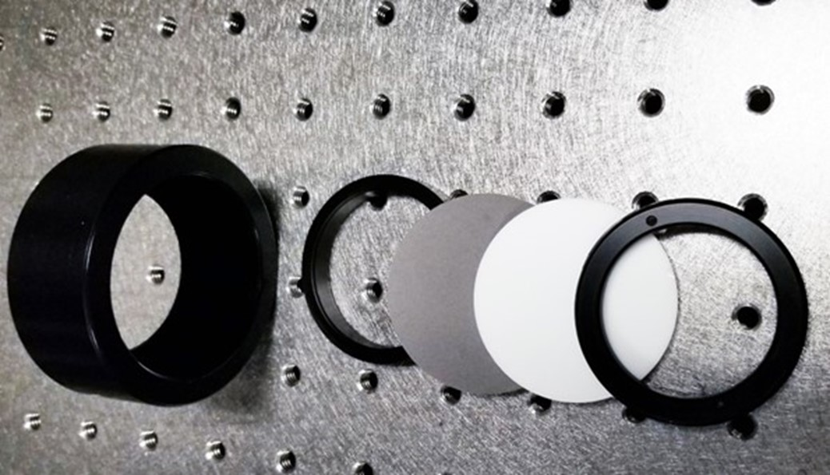
Figure 2. Sandwich target holder and optical components
The diffuser components were modelled in FRED to better describe their optical properties at different material, surface roughness, thickness and size. Example is provided in Figure 4.
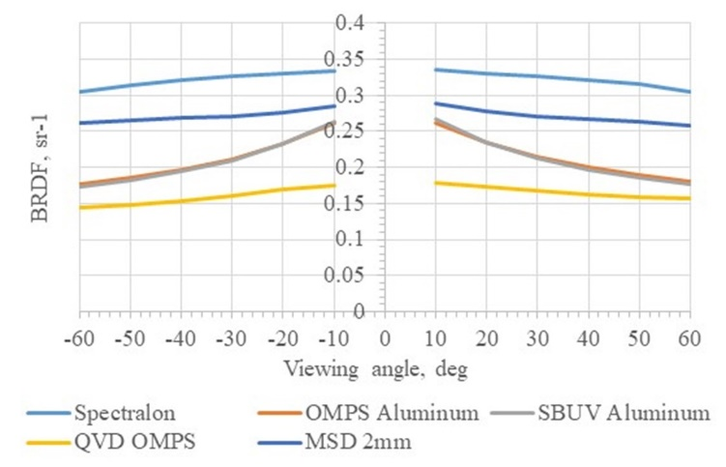
Figure 3. BRDF of most often used in-flight diffusers at 500nm, normal incidence
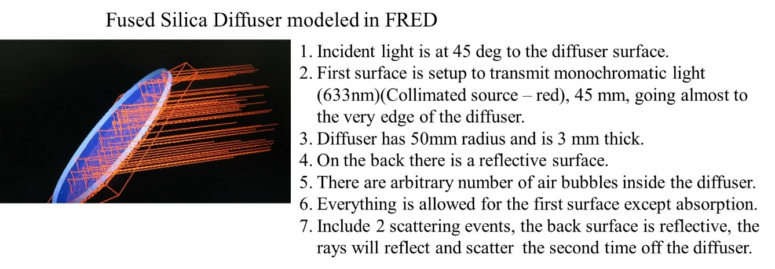
Figure 4. FRED modelled example of sandwich diffuse target component

Results and Discussion
8º directional/hemispherical reflectance and transmittance
The samples were evaluated through measurements of their 8º directional/hemispherical reflectance or transmittance from 250nm to 2500nm using Perkin Elmer 1050 spectrophotometer with a 150mm Spectralon integrating sphere with a 25mm sample port.
Bidirectional Scatter Distribution Function (BSDF). BSDF can quantify the specularity and/or diffuseness of the samples. The samples were measured at two orthogonal polarizations of the incident light, then averaged thus reporting the BSDF for unpolarized case of the incident light. The optical scatterometer facility at GSFC was used for components characterization.
The aging of the targets under cleanroom conditions was tested by measuring them in 2014 and in 2020. The samples were kept in a cleanroom condition between the two tests. The measured data is presented in Figure 5. The Diffusil UV2000, 50x3mm ground and HOD-500, 75x4mm polished samples show the smallest deviation of about 0.5%.

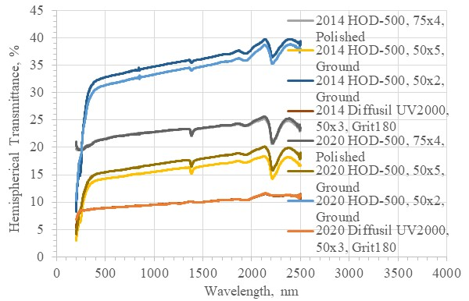
Figure 5 Mie diffusers components aging, measured in 2014 and 2020

The impact of the backing on BRDF of fused silica diffusers. One set of diffusers were measured at AOI=0deg, 500nm with Z306 backing first. Z306 was used as it is a widely used coating on space instruments. Different set of diffusers with the same parameters were coated with vacuum deposited aluminium and measured. The results are presented in Figure 6. The sandwich diffusers reflectance is combination of fused silica material, surface finish and back reflection by the backing media, Z306 or Aluminium. The Z306 coating absorbs the light whereas the aluminum coating reflects the light. There is a very small difference in the case of UV2000 Diffusil material of 0.004sr⁻¹. The backing media impact is higher with the polished HOD material, and it is the highest with Grit 180 HOD material. This experiment shows that the fused silica must be of high density backed by aluminium coating to achieve max reflectance. We can use lower density fused silica and Z306 coating, if we want to reduce the reflectance of such a sandwich diffuser.
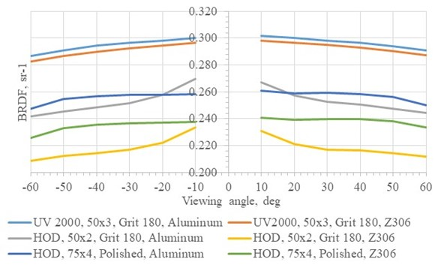
Figure 6. Fused silica diffusers backed by Aluminum and Z306 at AOI=0deg and 500nm

Conclusions and Future work
Earth scene specific albedo diffuse targets were developed and tested. Fused silica and sintered PTFE substrates were used to achieve different Hemispherical Reflectance and BRDF properties. The calibration targets degradation is a function of high energy vacuum UV radiation, temperature extremes, ionizing radiation, and the presence of atomic oxygen. Similarly, the optical, thermal, and tensile properties of the material are affected in the space environment. The extent of the reflectance changes depend on the following factors: (i) the irradiation geometry, (ii) the spectrum, intensity, and duration of the irradiation, (iii) the bidirectional reflectance geometry, and (iv) the spectral band being detected. The characterization was done using NIST traceable measurement equipment at the Diffuser Calibration Lab of GSFC. The calibration targets were characterized at cleanroom environment and are undergoing on-orbit environmental testing on board of International Space Station scheduled to end in early 2024.

References
- Datla, R.U., et al., “Best practice guidelines for pre-launch characterization and calibration of instruments for remote sensing,” Report to Global Space-based Inter-Calibration System (GSICS) NISTIR 7637, pp. 47, 2009
- D.F. Heath and G. Georgiev, “Characteristics of a New Type of Mie Scattering Volume Diffuser and Its Use as a Spectral Albedo Calibration Standard for the Solar Reflective Wavelength Region,” Proc. SPIE, 8153, 81530V-1-81530V-15 (2011)
- https://nsidc.org/cryosphere/seaice/processes/albedo.html
- Alan K. Betts; John H. Ball (1997). "Albedo over the boreal forest". Journal of Geophysical Research. 102 (D24): 28, 901–28, 910
- Tom Markvart; Luis CastaŁżer (2003). Practical Handbook of Photovoltaics: Fundamentals and Applications. Elsevier. ISBN 978-1-85617-390-2
- Georgiev G.T., Butler J.J.: “Long-term calibration monitoring of Spectralon diffusers BRDF in the air-ultraviolet”, Applied Optics, 2007, vol.46, No.32, pp.7892-7899

