Low-Earth Orbit Flight Test of an Inflatable Decelerator (LOFTID) Aeroshell Performance
Stephen J. Hughes, Dr. Neil Cheatwood, and John DiNonno
NASA Langley Research Center, Hampton, VA, 23681, USA
Gregory T. Swanson
NASA Ames Research Center, Moffett Field, California, 94035, USA
On November 10, 2022, NASA launched the Low-earth Orbit Flight Test of an Inflatable Decelerator (LOFTID) vehicle as a secondary payload mounted inside the launch vehicle adaptor on an Atlas V 401 out of the Vandenburg Space Force Base (VSFB). The primary payload, Joint Polar Satellite System-2 (JPSS-2), was delivered successfully to a sun synchronous trajectory shortly after launch, at which point the Centaur upper stage performed a burn to de-orbit the system. Once on the desired trajectory to enter the atmosphere the top of the payload adaptor was ejected to expose the LOFTID vehicle, then the LOFTID aeroshell, a Hypersonic Inflatable Aerodynamic Decelerator (HIAD), was deployed and inflated without issue. The Centaur pointed the LOFTID to the desired attitude to enter the atmosphere, spun the assembly to three rpm, separated the reentry vehicle, and finally performed a collision avoidance maneuver to prevent the Centaur from re-contacting the LOFTID after atmospheric entry. The LOFTID vehicle maintained the design attitude and spin rate from separation to atmospheric entry, roughly 30 minutes, demonstrating the aeroshell did not experience any energy damping from inflatable structure flexibility. The LOFTID vehicle entered the atmosphere over Alaska at >8km/sec and decelerated as designed demonstrating stable flight from hypersonic entry through subsonic parachute deployment. On-board visible light cameras captured the reactions of the heatshield through all phases of flight, and co-located infrared light cameras captured the temperature distribution of the aft side of the heat shield anchored to a distribution of thermocouples on the inflatable structure (IS) in the field of view. Thermocouples were also embedded in the forward side of the aeroshell both in the Flexible Thermal Protection System (FTPS) as well as the IS. This paper will discuss aeroshell response to the atmospheric entry. The visible light cameras captured mechanical response of the deployable aeroshell to the loads applied in the different phases of entry. Events seen on the visible light cameras correlate with the response of the load cell pins on webbing elements that attach the aeroshell to the centerbody structure. Thermocouple data captured verifies the aerothermal response of the aeroshell was in-kind with pre-flight analysis predictions although somewhat lower in most locations. This data will allow the improvement of the aeroshell modeling tools predictive capability. Post-flight inspection of the aeroshell after splash down and ocean recovery shows that all the aeroshell materials and manufacturing techniques developed over the past 15 years of HIAD technology development performed as designed at large scale, a scale which cannot be replicated in ground test facilities. The HIAD supported the LOFTID vehicle high in the water after touching down under parachute and maintained buoyancy and integrity for the hour it took to position the recovery vessel near the LOFTID after splash down. There was no indication the HIAD would have experienced an issue maintaining buoyancy for many more hours after water impact as the component maintained adequate inflation pressure more than 24 hours after water extraction with no additional inflation gas in tanks, as the inflation gas remaining in the tank was vented prior to impact.
- Nomenclature
- Introduction
For almost 20 years, NASA has been developing Hypersonic Inflatable Aerodynamic Decelerator (HIAD) technology. The reason for pursuing the technology originally was to develop a means of putting larger, higher mass payloads on the Martian surface. Studies [1,2] have concluded HIAD in combination with retro propulsion soft landing is an enabling technology for landing the tens of metric tons of logistics required to be delivered to the to the Martian surface for a manned mission. The use of a HIAD also allows the payload to fit in the currently envisioned launch vehicle shrouds, so that the payload and entry system is protected from the ascent environment.
Development successes [3, 4, 5, and 6] throughout the HIAD project have piqued the interest of commercial space companies in the application of HIAD technology. Reducing costs of access to space is key to remaining competitive in the commercial launch sector. One company, United Launch Alliance (ULA), has proposed a concept to reuse the first stage engine assembly on their new Vulcan launch vehicle, separating the engine assembly from the tanks and utilizing a HIAD to protect the assembly through atmospheric reentry (ULA Reuse paper References 7 and 8). The desire to prove out the HIAD technology at a larger scale led ULA to offer a rideshare opportunity to NASA’s Low-Earth Orbit Flight Test of an Inflatable Decelerator (LOFTID) flight test vehicle, providing an orbital velocity atmospheric entry opportunity for the largest HIAD aeroshell to date. LOFTID was in fact one of the largest secondary payloads ever flown on an Atlas 5. The opportunity was beneficial for both parties. The cost of access to an orbital velocity entry opportunity for a reasonable scale payload is typically more than a technology development project can bear, so the rideshare opportunity brought the cost of the flight experiment down to a level NASA could more easily fund, and the proposed LOFTID mission provided a demonstration, albeit at a significantly smaller scale, of all the phases of the proposed ULA engine recovery HIAD application.
Flying as a secondary payload constrained the payload maximum mass and volume. Working within those constraints, the LOFTID project was still able to flight test the largest blunt body aeroshell to enter Earth’s atmosphere and have enough mass to produce a challenging entry heating environment, in kind with a direct entry robotic Mars mission. The LOFTID aeroshell was a 6.0m diameter, 70degree half angle cone with a total entry mass of roughly 1100kg. The aeroshell packed into a roughly cylindrical volume 1.27m diameter by 0.46m thick. This small, stowed volume allowed the LOFTID Reentry Vehicle (RV) to package inside of the launch vehicle payload adaptor mounting the primary payload, the Joint Polar Satellite System 2 (JPSS-2), to the launch vehicle Centaur second stage. Riding on the capable Centaur second stage allowed further simplification of the LOFTID RV. The aeroshell could deploy while still attached to the Centaur, then, using the propulsion and guidance capabilities, the RV could be delivered to the desired entry trajectory, attitude, and spin rate. The LOFTID RV entered ballistically, spin-stabilized, to maintain the desired attitude until the aerodynamics of atmospheric entry took over. No attitude control, guidance, or navigation systems were required, significantly reducing cost and complexity of the vehicle. As a secondary payload the project did not have complete control of the entry conditions for the RV. The JPSS-2 required a delivery to ~800km sun-synchronous orbit and operational constraints of the Centaur limited the range of entry conditions. A compromise for the entry state was iterated with the launch vehicle services group to provide a peak heat rate, total integrated heat load, and peak drag combination that was within the capabilities of the HIAD and in kind with many potential entry applications. The aeroshell deployed nominally and separated from the Centaur roughly over the Sinai Peninsula. The RV, with the aeroshell deployed, coasted almost halfway around the planet to atmospheric interface roughly over Alaska.
Onboard instrumentation captured the response of the HIAD to the entry environment. Surface and in-depth temperature response of the FTPS was measured with an array of thermocouples distributed throughout the aeroshell. Strap load cell pins recorded the interface load of the aeroshell to the payload structure along the four cardinal directions. Total heat flux gages and a radiometer measured the entry environment, and co-located surface pressure taps created a Flush Air Data System (FADS), capturing dynamic pressure and vehicle attitude. Perhaps the most intriguing data sets of them all were the video data. Six camera pods were spaced equally about the aft end of the vehicle looking forward at the perimeter of the aeroshell. Each pod consisted of a visible light camera and two infra-red cameras that covered the same field of view as the visible light camera. Each visible light camera field of view slightly overlapped the adjacent camera pod fields of view to provide full coverage of the aeroshell through entry. There was also an additional visible light camera, the uplook camera, looking aft into the wake. This camera was intended to record the mid-air retrieval of the RV that was proposed as part of the original concept of operations. Eventually, the mid-air retrieval operation was cut due to cost and complexity but the camera, already included in the vehicle design, was retained. The visible light cameras captured a 360-degree field of view of atmospheric entry from the beginnings of ionized flow slipping around the perimeter of the heat shield, to the brilliant intensity of peak heating, and back down until the heat pulse concluded. The visible light cameras also captured structural deflection through the entry pressure pulse allowing the project to demonstrate that the load displacement behavior is consistent with that recorded during static load testing of both the Engineering Development Unit (EDU) and Flight Unit prior to the flight. After the entry pulse, the images of the aft side of the aeroshell look the same as prior to atmospheric entry. No charring or discoloration was evident. Interesting flow field phenomenon were observed in the “valleys” of the tori near the structural webbing. Glowing “balls” of what appear to be plasma were visible, biased on one side of the aeroshell. Thermocouple measurements and IR camera images verified the aft side temperatures were higher in regions where the plasma balls were observed. The aft looking camera captured a view of the wake closure. Streaks can be seen early in the entry pulse that align with the seams in the outer fabric surface. The streaks become obscured by the intensity of the flow field approaching peak heating, but near the end of the heat pulse they are again visible, though many more streaks are visible without the symmetry seen prior to peak heating. They appear to line up with discolorations observed on the aeroshell outer surface. The RV flew very close to the nominal predicted trajectory and was close enough to the predicted water impact location that the vehicle was captured with the IR cameras mounted to the bridge of the recovery vessel. The aeroshell appears in nominal condition in the captured IR images just prior to splashdown. Because the RV landed so close to the predicted landing point, the recovery vessel was able to get to the RV in roughly a half hour after water impact. The vehicle was found floating high in the water and appeared undamaged from the flight. Video observation of lifting the of the RV out of the water revealed the nose FTPS was no longer intact, but it is not clear when the damage occurred. Other than the nose, the aeroshell looked in very good condition once it was placed in the stand on the recovery vessel. Rain and sea spray gathered behind the FTPS on the trip back to port and a slit had to be cut to drain the gathering water. Once in port the RV was offloaded and reconfigured nose up so that a photographic survey of the aeroshell could be performed. The aeroshell was eventually deflated, loosely packed, and placed in a shipping container to be returned to NASA Langley Research Center (LaRC). Back at LaRC the aeroshell was reinflated and further inspections were performed.
- Pre-Flight Testing and Development
A long manufacturing and development phase preceded the successful flight test of the LOFTID aeroshell. An EDU was manufactured to refine the processes created during the HIAD technology development project. Manufacturing procedures were redlined to capture and incorporate lessons learned prior to releasing final versions to be utilized for the flight unit fabrication. Many material and process challenges were discovered and dispositioned during this phase for the FTPS and IS sub-assemblies, as well as the integration of the sub-assemblies to create the aeroshell. The completed EDU aeroshell was subjected to static load testing using a procedure developed during the HIAD ground development [9].
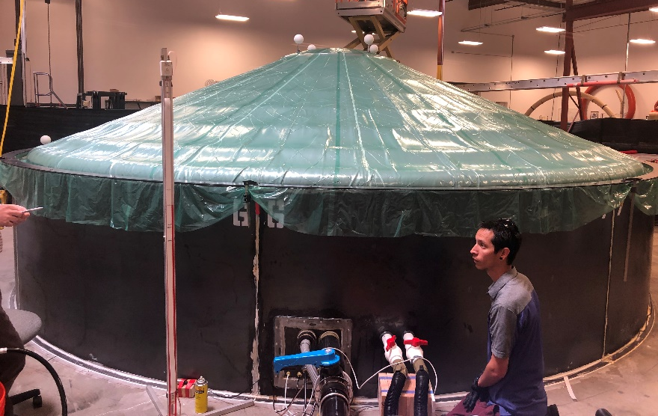
Fig. 1 LOFTID Static Load Testing.
Because the EDU was not going to fly and the aeroshell could be partially disassembled after the test, non-flight instrumentation could be utilized during the load test to verify the load distribution in the IS assembly with the FTPS integrated. The displacement of the aeroshell in response to the static load was captured with a laser scan and discrete displacement measurements. Load cases were run at a range of internal pressures and applied loads, and then used to correlate the structural modeling performance. Again, because this article was not going to fly, it could be tested to the limits of performance. Once the initial load testing was completed, the EDU was used to develop and refine the packing procedure. The article was hard packed multiple times to verify the packed aeroshell could fit into the allocated volume on the launch vehicle and was not damaged by the process. An additional load test series was performed to verify the structure retained adequate capacity after hard packing. All the EDU performance data was captured at nominal load as well as at margined capacity. A final hard pack of the EDU was performed, and a packed aeroshell assembly vibration test was performed to demonstrate the packing restraint could keep the packed aeroshell in the allocated launch vehicle volume when subjected to the launch environment. After vibration testing, the aeroshell was deployed at LaRC and inspected for signs of damage. The article showed no signs of degradation in observable material damage, leak performance, or deployed shape. Mass properties of the deployed aeroshell were measured for correlation of the solid model mass properties prediction. The EDU was eventually decompiled and dissected to extract test samples of the FTPS for arc jet testing to validate performance of the layup after being subjected to the rigors of packing and deployment. Material samples of the IS components were also extracted to verify the material retained adequate properties after being mechanically aged in the manufacturing, handling, packing, and deployment processes.
The flight unit was constructed using all the procedures developed with the EDU experience. For flight acceptance, it was only load tested to slightly beyond the flight conditions to prevent unnecessary damage to the assembly, while still having direct correlation performance data with the captured EDU performance data. The unit was hard packed only once at the manufacturer and delivered to LaRC for integration with the rest of the flight vehicle. Extensive vehicle functional testing was performed to ready the vehicle for the flight, after which the aeroshell was deployed in a Complete Systems Test (CST) of the RV in the 60ft sphere, Vacuum Space Environments Testing Facility at LaRC. The packing restraint released nominally and the aeroshell deployed, inflating as designed.

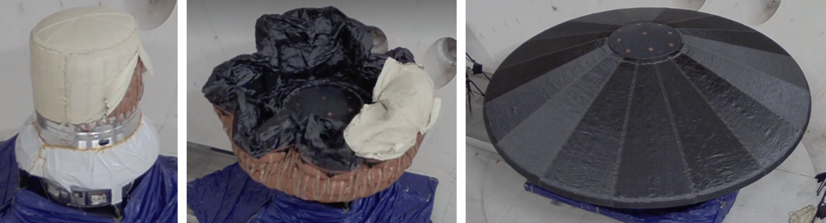
Fig. 2 LOFTID Complete System Test packing restraint release and aeroshell deployment.
After the CST, the RV was removed from the test facility and transported to the integration and test lab at LaRC. The aeroshell was re-inflated to verify the aeroshell instrumentation was functional, still located in the design positions, and reading on the correct channels in the data system. The vehicle was de-integrated, broken down into segment subsystems, partly to correct issues found during the CST, but also because the aeroshell packing procedure needed to be performed with only the aeroshell and the forward segment structure. The final hard pack was performed, and the vehicle was re-integrated for the flight operations.
- Flight Operations
The reintegrated RV was subjected to a final workmanship vibration test and then delivered to Vandenburg Space Force Base (VSFB) for integration to the Launch Vehicle (LV). After an initial launch scrub, required because of an LV anomaly, the LV lifted off from VSFB on November 10, 2022. JPSS-2 was successfully separated from the LV only 28 minutes after launch, but the Payload Launch Adaptor (PLA) was not jettisoned exposing the LOFTID RV for another 40 minutes, after the LV de-orbit burn.

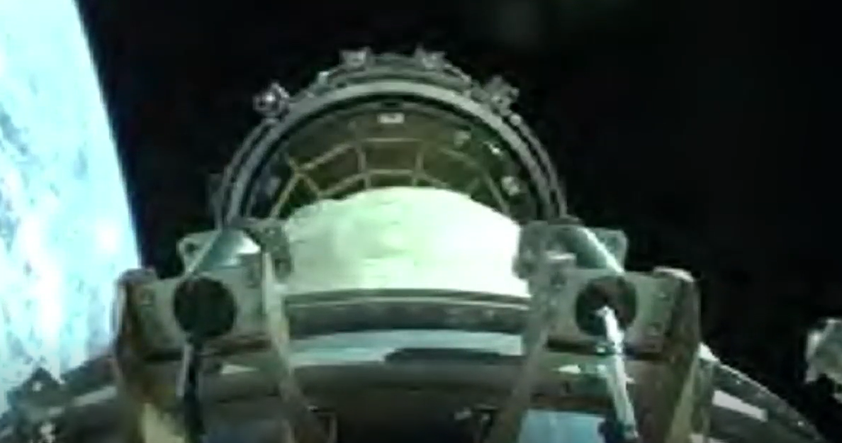
Fig. 3 LOFTID Payload Adaptor Separation System Jettison from Centaur.
About 45 seconds after the PLA was ejected, the packing restraint release cutters were fired, the packing restraint unzipped, and the aeroshell rapidly expanded to shape. The initial deployment was accomplished with only the packed strain energy and the gas entrained in the packed aeroshell and inflation system plumbing expanding in zero g and hard vacuum.
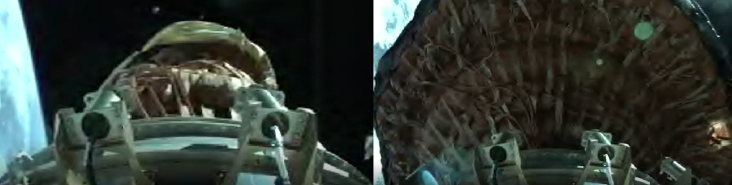
Fig. 4 LOFTID Packing Restraint Release and Auto-Inflation.

The inflation system pressurized the aeroshell to maneuvering pressure over the next two and a half minutes, at which point the Centaur began to orient the LOFTID RV attitude for release. Once properly oriented, the Centaur then spun the RV to ~three revolutions per minute (rpm). At that point the Centaur released the RV.

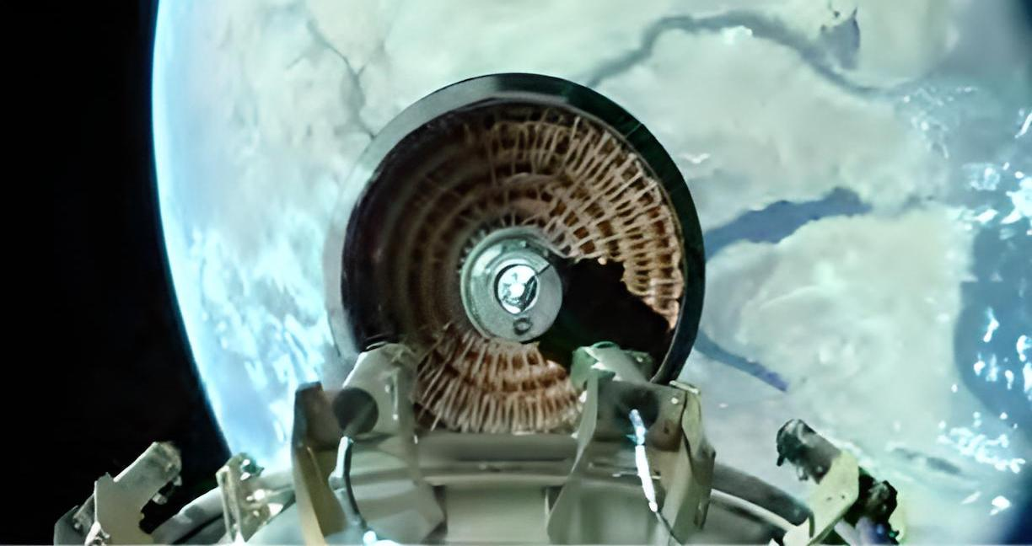
Fig. 5 LOFTID Separation from Centaur Over Sanai Peninsula.
The visible light cameras in the camera pods show the aeroshell is deployed nominally and remained stable from Centaur separation to atmospheric entry. One of the six visible light cameras had a known intermittent functionality issue prior to flight and did not capture video after the RV separation, while the other 17 of 18 cameras in the camera pods performed nominally throughout the mission.

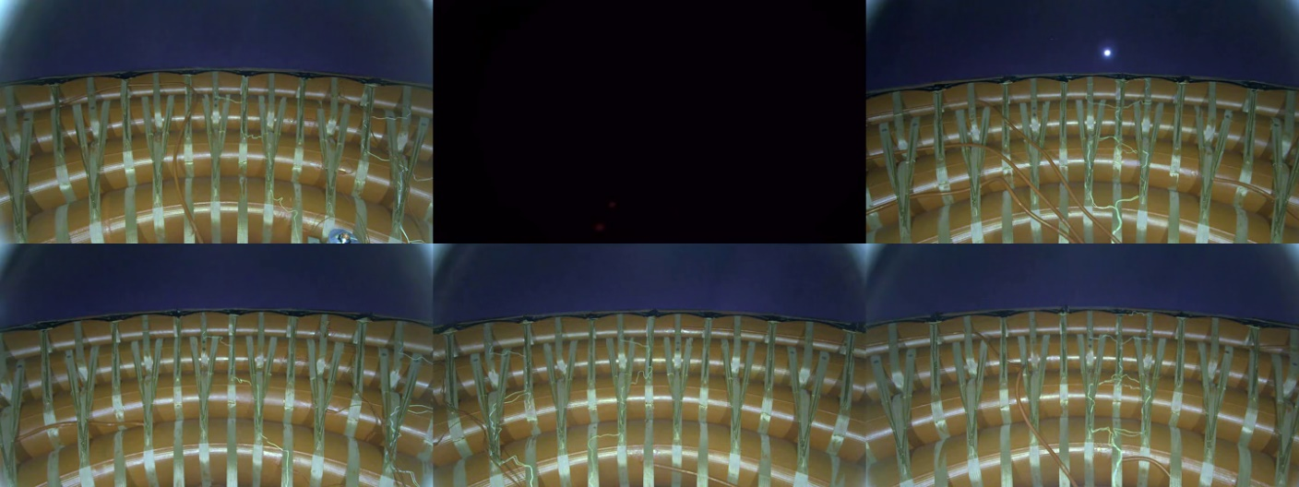Fig. 6 LOFTID Camera Pod Composite, Coasting Post Separation Prior to Atmospheric Entry.
The aeroshell, during static load testing, was seen to require roughly 1000lb to seat into the design position. This is an artifact of the configuration of the webbing interface of the aeroshell to the payload. In the free flight, zero-g environment, the initial state of the deployed aeroshell was free to tip a few degrees and translate an inch or so from the nominal design position prior to the beginning of the application of atmospheric drag. After experiencing only roughly 800lb drag load, the aeroshell was seen “seating” to the nominal design location in the visible light video images. Comparing the edge position in “frame grabs” from the video at different times, an approximation of the displacement can be made using a known component width for scale.

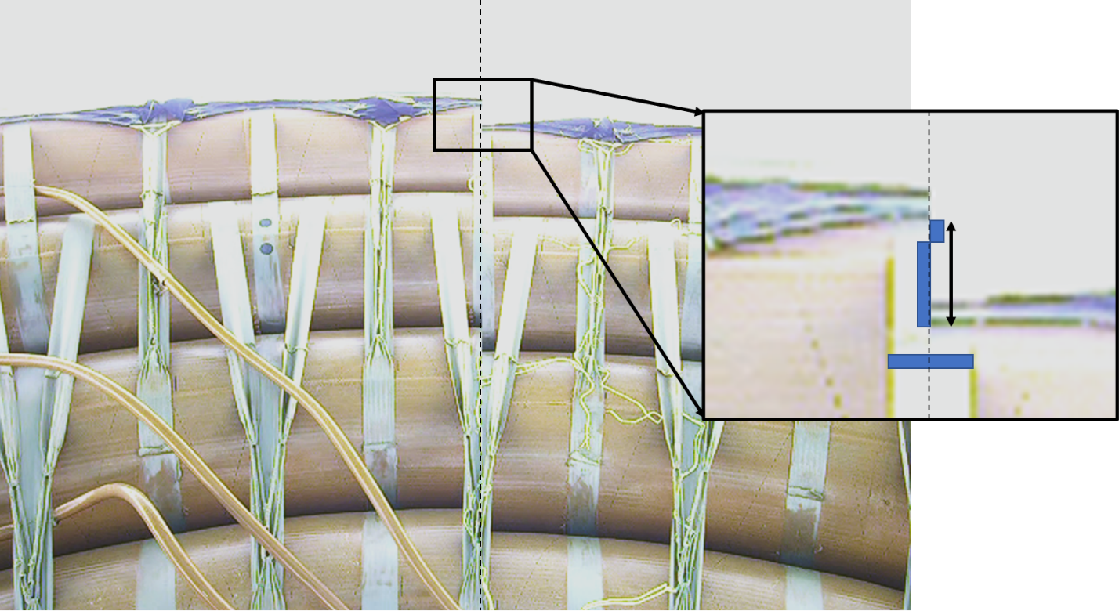
Fig. 7 Camera Pod 3 Visible Light Camera (11:35:45 UCT (Left) 11:35:43 (Right)) ~2.5in Shift.
Using a feature tracking technique, the aeroshell deflection, cone angle sharpening, and tilt relative to the payload were extracted from the video data [10 and 11]. The application of this technique verified the reaction of the aeroshell to the flight load is in kind with the deformation captured in the static load testing, roughly 1.5degrees cone sharpening at peak flight loading.
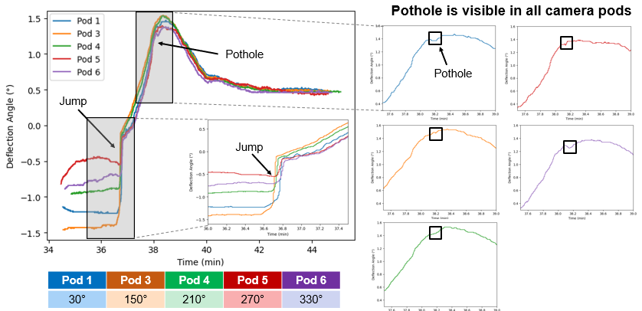
Fig. 8 Feature Tracking Method for Calculation of Aeroshell Angular Deflection in Flight.

Load cell pin data from the flight also correlated to the levels observed in static load testing. The blue curve in figure 9 is the average of the total webbing load at each of the four cardinal directions as measured by the load cell pins. The black curve is that same average webbing load at the cardinal directions from static load testing. The odd load behavior seen in the black curve is a result of stopping to dwell at a given load for a laser scan of the deformed shape. In general, the shape of the two curves is consistent and load in the interface webbing appears to be in kind for both load applications.
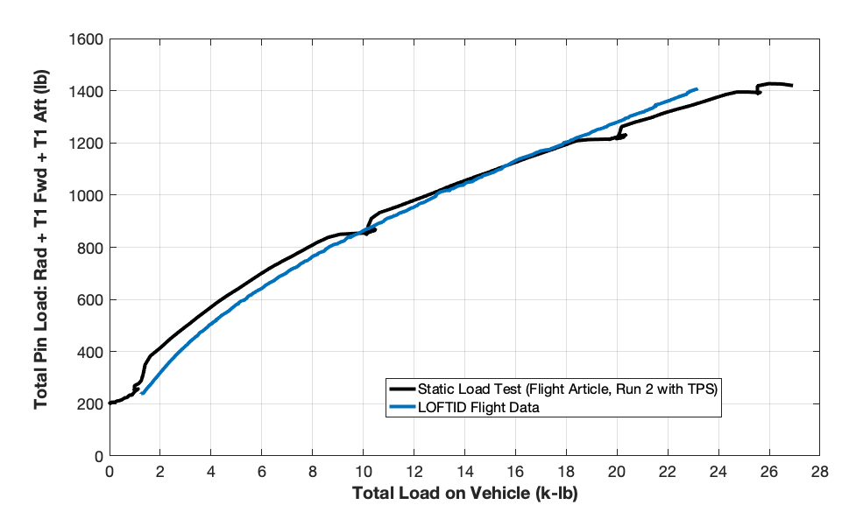
Fig. 9 Load Cell Pin Webbing Load Comparison Static Load Test Vs. Flight.
Thermocouple data from the aeroshell captured the surface and in-depth temperatures at a wide array of locations on the aeroshell. All data indicates there was considerable margin capacity of the aeroshell material set in response to the entry environment, but thermal analysis of the system for the as flown trajectory at the specific thermocouple locations is still in work, so the physics based thermal analysis methodology is still awaiting validation.
The FTPS covering the rigid nose was significantly damaged, missing many plies by the time the RV was lifted onto the recovery vessel. During the lift from the water onto the recover vessel, remnants of damaged plies could be seen hanging from the nose structure. The IR video images from the bridge of the recovery vessel do not seem to indicate failed material hanging off the vehicle descending under chute just prior to water impact, so it is expected that the damage was initiated on splashdown or the initial lift out of the water. Damage to the nose FTPS was not unexpected. The nose FTPS included a reduced number of plies above the gas barrier to intentionally stress the FTPS layup, knowing that the underlying metallic structure could withstand higher temperatures than the inflatable structure.

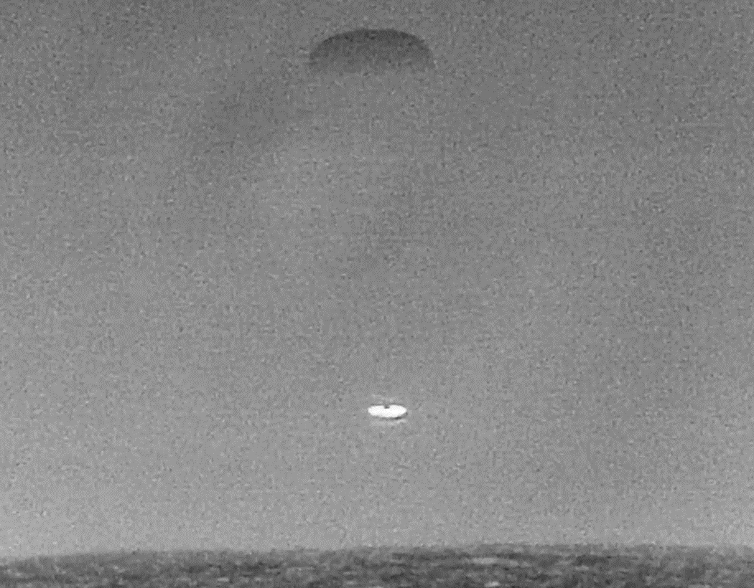
Fig. 10 Recovery Vessel Bridge Mounted Infrared Video Camera Image of LOFTID Under Chute.
Thermocouple traces from locations embedded in the Nose FTPS also indicate the layup was intact through entry until water impact, at which point the signals are no longer reliable due to electrical shorting. A change in the slope of the traces was observed at parachute deployment, but that is likely due to the hotter underlying plies of insulator compressing against the TC’s during the parachute inflation deceleration spike. If the material had ripped off the surface exposing the TC’s to the free stream temperature, the temperature traces would have dropped as opposed to increasing in temperature.
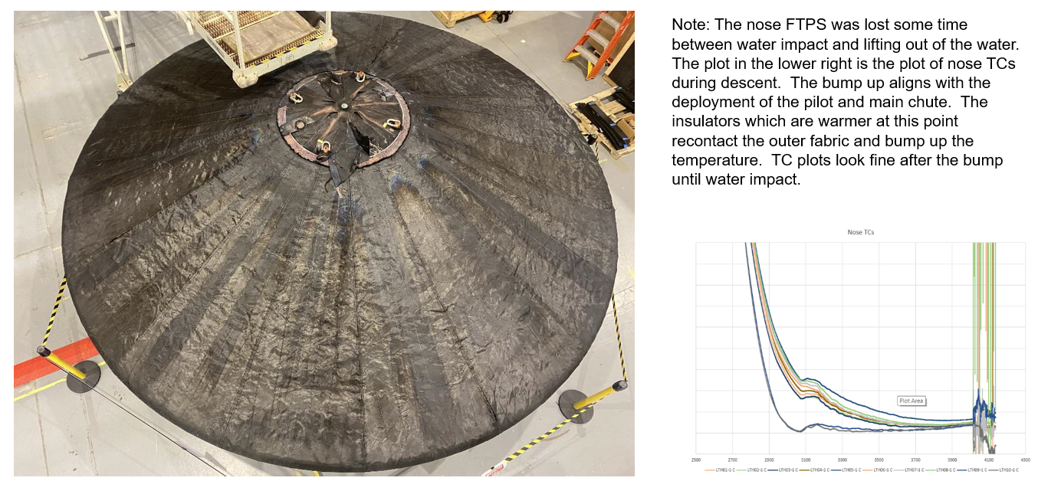
Fig. 11 Nose FTPS Damage Image with Nose FTPS TC Traces.
The aeroshell performance was very close to the design prediction as evidenced by the IR imagery recorded from the recovery vessel bridge. The parachute was observed to unload seconds after the RV disappeared below the horizon, indicating the vehicle touched down very close to the nominal prediction. Relative GPS locations of the LOFTID vehicle and the recovery vessel showed that touchdown was just over eight nautical miles from the vessel. The recovery team was able to intercept the LOFTID RV on the water in about a half hour. Upon first approach, the LOFTID RV was floating high in the water with no visible damage. It was hard to believe the vehicle had entered the atmosphere from orbital velocity. The RV was lifted from the water and placed onto a recovery stand on the deck of the recovery vessel and transported back to port.

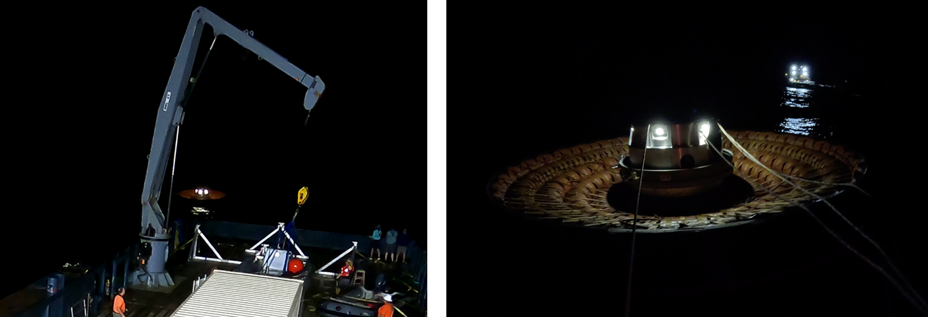
Fig. 12 LOFTID Floating in the Pacific at Recovery Vessel Intercept.

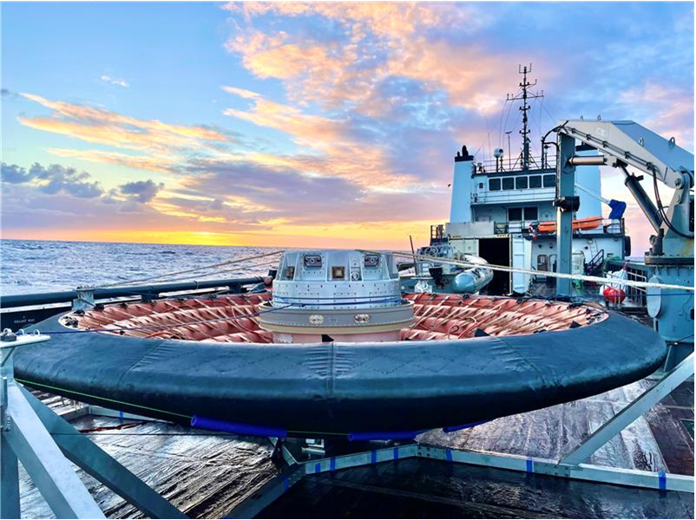
Fig. 13 LOFTID on the Stand on the Recovery Vessel on the Way Back to Port.
Other interesting phenomena were observed upon inspection of the aeroshell after the vehicle was recovered. In the beginning of the heat pulse, shortly after the aeroshell seated, the uplook camera captured what appears to be streaks of ionized gas that line up with the seams on the outer fabric of the aeroshell.

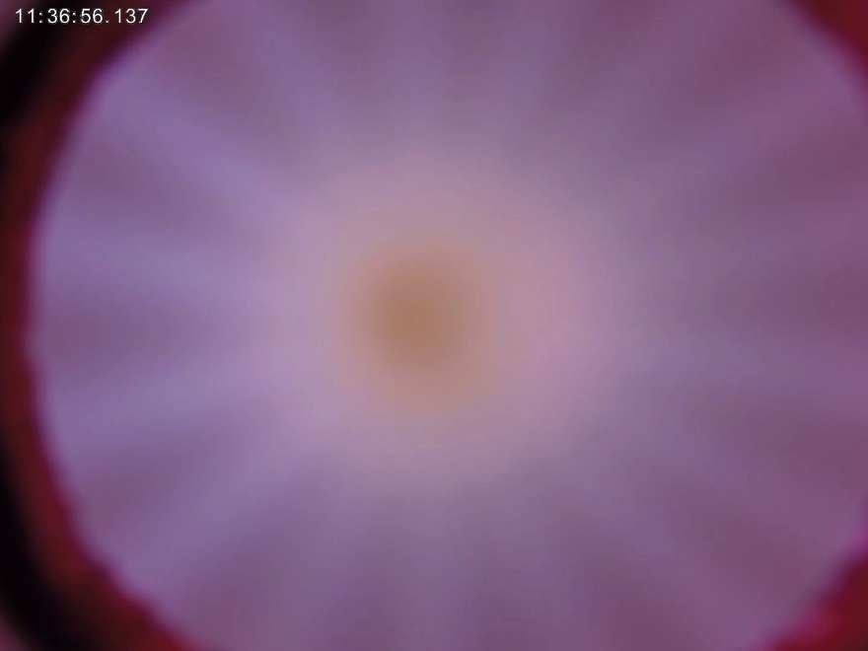
Fig. 14 Ionizing Flow Streaks Aligned with FTPS Outer Fabric Seams.
The image is saturated as the environment increases approaching peak heating and the streaking is obscured. As the heating reduces nearing the end of the heat pulse, the streaking becomes visible again, but this time there are many more streaks and the streaks are not evenly spaced. The streaks appear to align with lines of discoloration on the forward surface of the heat shield.
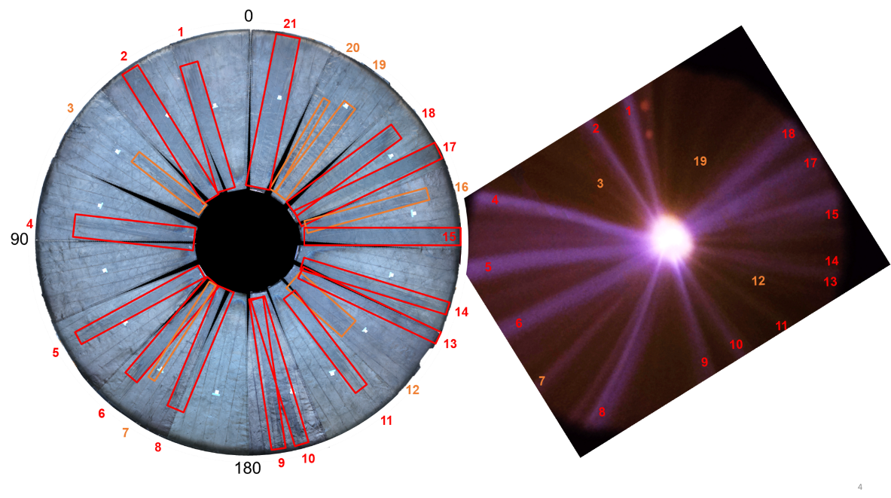
Fig. 15 Ionizing Flow Streaks Aligned with Discoloration Streaks on FTPS Outer Fabric Surface.
The surface was inspected with microscopy and spectroscopy to identify the reason for the streaks on the fabric, but the surface was far too contaminated from the water landing and subsequent handling in recovery and transportation back to LaRC (images from the spectroscopy report). Different material components in the FTPS have different decomposition temperatures, consequently there are visual indications on the aeroshell of relative heating/shear environments, particularly at the shoulder tangency where the environments differ greatly forward and aft of it.
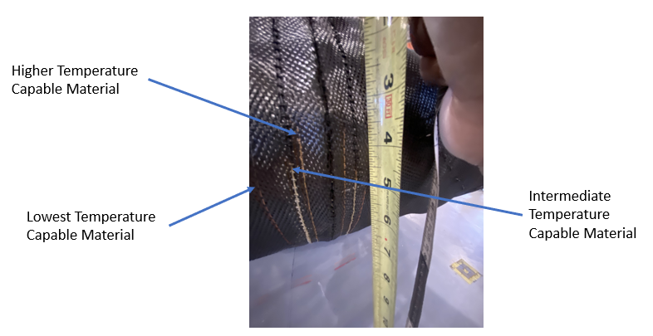
Fig. 16 Decomposed Surface Features Indicating Peak Surface Temperatures.

Finally, an interesting flow phenomenon was captured on the aft surface of the inflatable structure during the entry heat pulse. The vehicle trimmed at between four- and six and a half-degrees angle of attack as the RV approached peak heating. Roll angle for the trim angle is ~122 deg and flow on the leeward side at ~240 to 270deg shows the hottest region. As the environment approaches peak heating, the aft surface becomes uniformly saturated, but before and after the scene is obscured by saturation, “plasma balls” can be observed in the valley between T5 and T6 from azimuth angles between ~150deg and ~300deg. The balls also appear in the valley between T4 and T5 from azimuth angles between ~180deg and ~270deg. IR camera imagery correlates higher surface temperatures in the area where “plasma balls” are present, and TC readings in these locations are higher than those observed in regions where they are not present. This phenomenon was not captured in the CFD solutions for wake heating. This is not particularly surprising as wake flows are very chaotic and unsteady, and given the computational resources required, some of the features present on the aft side of the IS, the webbing components in particular, must be left out of the CFD modeling.
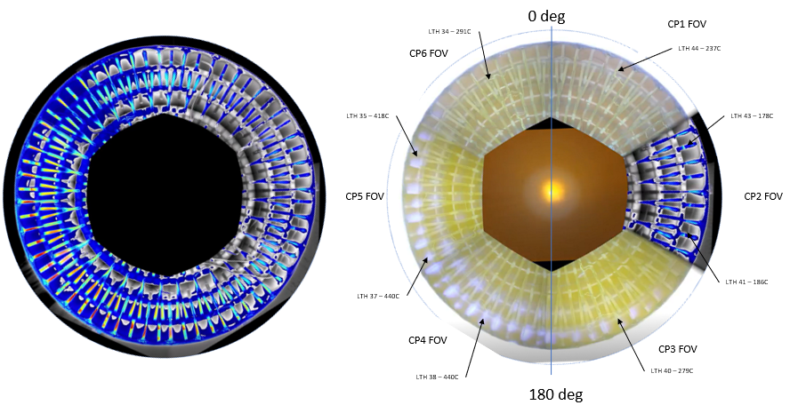
Fig. 17 Composite IR Camera at Peak Pressure (Left) Composite Visible Light Camera (Right).
- Conclusions and Future Opportunities
The LOFTID aeroshell was an absolute success. The aeroshell maintained the required stowed configuration through the launch environment, deployed to the designed shape, and maintained that shape from atmospheric entry through water impact. After water impact, the aeroshell maintained integrity while floating on the ocean surface, during lifting onto the recovery vessel, and through transportation back to LaRC. The RV entered the atmosphere from orbit surviving the atmospheric heating and flying stably through hypersonic, supersonic, transonic, subsonic flight regimes with no stability augmentation required before deployment of the subsonic parachute required to reduce water impact velocity.
As a result of the proven success of the system, multiple companies are pursuing development of HIAD systems for various applications. The largest of these commercial applications is a 10.4m diameter HIAD proposed for decelerating the Vulcan first stage engine assembly through atmospheric entry as a means of reuse to reduce cost of access to space. Multiple other potential commercial partners are proposing HIAD systems from the very small, ~2m diameter HIAD for satellite retrieval purposes to somewhere in between for smaller launch vehicle asset recovery.

Acknowledgments
The authors would like to thank the many dozens (possibly hundreds) of people that have been involved in the development of the HIAD technology, from the original proposal submissions to In-Space Propulsion in 2000, through the IRVE flights and HIAD Project technology ground development effort, culminating in the LOFTID flight experiment. There are too many to mention here, but many can be found as authors and co-authors in the extensive list of previous HIAD publications. Even that list doesn’t come close to capturing the many technologists who have participated in the design, manufacture, and the tests of test articles and flight vehicles over the years. Without all of their efforts, HIAD would not be the technology that is now ready to be used in space applications.

References
Referencess
[1] Cianciolo, Alicia D., Polsgrove, Tara T., “Human Mars Entry, Descent and Landing Architecture Study Phase 2 Summary,” AIAA 2018-5190, September 2018
[2] Cianciolo, Alicia D., Dillman, Robert A., Brune, Andrew J., Lugo, Rafael A., Polsgrove, Tara T., Percy, Thomas K., Sutherlin, Steve G., Cassell, Alan M., “Human Mars Entry, Descent and Landing Architecture Study: Deployable Decelerators,” AIAA 2018-5191, September 2018.
[3] Hughes, Stephen J., Dillman, Robert A., Starr, Brett R., Stephan, Ryan A., Lindell, Michael C., Player, Charles J., Dr. Cheatwood, F. McNeil., “Inflatable Re-entry Vehicle Experiment (IRVE) Design Overview,” AIAA 2005-0182124, September 2005.
[4] O‟Keefe, Stephen A., Bose, David M., “IRVE-II Post-Flight Trajectory Reconstruction,” AIAA Paper 2010 -0031103, August 2010.
[5] Olds, Aaron D., Beck, Roger, Bose, David, White, Joseph, Edquist, Karl, Hollis, Brian, Lindell, Michael, Cheatwood, F.N., Gsell, Valerie, Bowden, Ernest, “IRVE-3 Post Flight Reconstruction,” AIAA Paper 2013 -0013398, March 2013.
[6] Hughes, Stephen J., Dr. Cheatwood, F. McNeil, Dr. Calomino, Anthony M., Wright, Henry S., Wusk, Mary Elizabeth, Hughes, Monica F., “Hypersonic Inflatable Aerodynamic Decelerator (HIAD) Technology Development Overview,” IPPW 2013-0014935, June 2013.
[7] Reed, John G., Ragab, Mohamed M., Cheatwood, McNeil, Hughes, Stephen J., DiNonno, John M., Bodkin, R., Lowry, Allen, Brierly, Gregory T., Kelly, John W., “Performance Efficient Launch Vehicle Recovery and Reuse,” AIAA 2016-0012009, September 2016.
[8] Reed, John G., Holguin, Mike F., Cheatwood, McNeil, DiNonno, John M., “Vulcan Reuse,” AIAA 2020-5008263, October 2020.
[9] Swanson, G.T., Kazemba, C.D., Johnson, R.K., Hughes, S.J., Calomino, A.M., Cheatwood, F.M., Cassell, A.M., Gilles, B., Anderson, P., Lowery, A., “Overview of the 2ndGen 3.7m HIAD Static Load Test,” IPPW Poster 2016-00126, June 20216.
[10] Alpert, Hanna S., Kazemba, Cole D., and Swanson, Greg T., “Post-Flight Quantification of LOFTID Aeroshell Deflection Using Feature Tracking,” IPPW Poster 2023-0011256, August 2023.
[11] Swanson, G., Miller, R.A., Kazemba, C., Alpert, H., Williams, J., S., and Cheatwood, N., “Evaluation of the LOFTID Flight Thermocouple Measurements,” paper submitted to AIAA SciTech 2024, Orlando.

AST, Aerospace Flight Systems, D202, AIAA Senior Member.
Senior Engineer, Planetary Entry Descent and Landing, D205, AIAA Senior Member.
AST, Aerospace Flight Systems, D208
AST, Aerospace Flight Systems, ARC:TSS, AIAA Senior Member.

