Interactive Mars: A Direct-Experience Mission
Carolyn R. Mercer
NASA Headquarters, Washington, DC, 20546
Jeremy D. Frank
NASA Ames Research Center, Moffett Field, CA 94035
James M. Budinger
Cleveland State University, Cleveland, OH 44114
Steven R. Oleson, Geoffrey Landis, Norman F. Prokop
NASA Glenn Research Center, Cleveland, OH 44135
Martin Melicharek
Bohemia Interactive, Strakonická, Czechia, 38601
As NASA prepares to explore Mars, we describe an innovative architecture that could be based on public-private partnerships to offset the costs of such a mission, while demonstrating many of the key technologies—propulsion, communications, autonomy, and landing systems—that will be needed for future human exploration. We propose that NASA could use this capability to deliver dozens of small rovers to several sites on Mars to enable the creation of interactive games that would be operated commercially and sponsored privately. NASA would get a reduced cost to demonstrate a portion of the infrastructure needed for human exploration, and the private sector would get access to a new market and sponsorship opportunities for a broadly popular activity. In addition, our proposed architecture could enable a new, intuitive means for scientists to interpret data and conduct ground operations. This proposal is to broadly develop the overall concept, while focusing on the design of the novel communications system, developing requirements for the software architecture needed to control the rovers and implement gaming, and developing gaming concepts.
- Introduction
The number of space-based missions orbiting the Earth has grown significantly over the last decade and investments in the space economy have also greatly increased. These spacecraft are predominately for commercial communication relays and military applications, as well as science and weather observations. In-space servicing is emerging to extend the life of these missions, and in-space manufacturing demonstrations and sophisticated science experiments are conducted on the International Space Station and Tiangong space station. The number of commercial and governmental missions to cislunar space are also increasing, and deep space science missions, once the purview of only governments, are now being planned by private-sector organizations. What all these missions have in common is that only a relatively small number of people are engaged in mission development and operations even though there is clearly extraordinary interest in space by the general public as evidenced by the 14 million people who logged onto the NASA website to watch the Perseverance rover land on Mars in 2021.

In addition to the space-industry revolution, the number of people participating in interactive games has similarly surged globally to an estimated 3.4 billion players in 2023 with revenues projected at $188B. For comparison, from 2013 to 2022 global private equity investments totaled a comparable amount over a decade: about $272B. The gaming industry dwarfs commercial space and its profit margins are much higher since the cost of hardware is so much less.

To bridge these worlds and possibly tap into some of the resources available from the gaming sector, we describe
a concept to allow individuals to directly control rovers on Mars, using a gaming interface that would pipe data and imagery directly from the rovers into a game engine that would update the display as data arrives, accounting for the round-trip time lag caused by the round-trip distance between Earth and Mars. An example of a popular game that could be adapted to incorporate real-world play is Take on Mars, developed by Bohemia Interactive, a company that develops highly realistic training simulations for the U.S. Army. This game simulates driving on Mars using data from the Mars Reconnaissance Orbiter (MRO), and includes features that allow players to design their own virtual rovers.

There is an enormous, demonstrated market for games that are not fast-paced “shoot-em-ups.” Prime attributes that make gaming popular include the intrinsic satisfaction of solving puzzles, the urge to collect interesting objects, and the camaraderie of multi-player games. Examples of mobile games that generated over $1B in 2022 are Genshin Impact, a multi-player role-playing game with a huge open-world map to discover, and Candy Crush Saga, a puzzle solving game. Pokémon GO is based on collecting and collaborative play and remains among the leading free-to-play gaming titles worldwide having generated about $1B/year on average since its debut in 2016.

Gaming concepts on Mars could include searching for cached prizes, solving quests, and cooperative exploration. Excavation and building are possible, such as dragging a stylus to write or draw in the regolith, positioning corner cubes to construct laser mazes, or clearing roads and racetracks. These constructions could be observed by orbiting imagers such as MRO. Simply being the first to provide high-resolution imagery of a new patch of Mars’ surface, placing a virtual stake in an augmented reality landscape, would be tremendously compelling. Competing with Earth-based rovers for the opportunity to drive a Mars rover could also generate substantial interest. Outwitting or battling avatars for the right to command a rover on Mars could help select the most capable rover operators.

The number of people who could directly manipulate the rovers would be limited to several dozen at a time, but experience has shown that there is also tremendous interest in watching other players. In August 2017, the Seattle Key Arena was filled to capacity with fans who each paid $99 to watch 16 teams of 5 players compete for the world championship of the video game Defense of the Ancients. The prize purse was $24M, and over 5 million concurrent watchers tuned in online. Similarly, “Twitch plays Pokémon®” was an event that drew over 29 million spectators during the 15 days needed to win the game.

This type of broad engagement is needed to attract sponsors. A mission like this would likely cost upwards of $4B, which is out of the range of the private sector to develop the required infrastructure for the market. If a similar amount of money could be raised from corporations to sponsor this Mars game as was raised by the Olympic Committees ($2B) years in advance, then that would substantially offset the cost to NASA to demonstrate several of the key technologies needed for Mars exploration. NASA now has experience with several successful service contracts where the private sector contributes a substantial amount of their own capital to missions of interest to them and NASA. Under the commercial cargo, commercial crew, commercial lunar payload services programs companies provide spacecraft to deliver services for NASA, and a public-private partnership with Axiom allows them to use NASA spacecraft (the International Space Station) to conduct their business. Many well capitalized companies may want to be associated with a potentially very popular activity aligned with their core identities (such as computing, transportation, and communications). Companies such as Google and Microsoft earned $42B and $16B respectively on games in 2022, and General Motors and AT&T have significant advertising budgets ($2B to $3B annually ).,
- Mission Concept

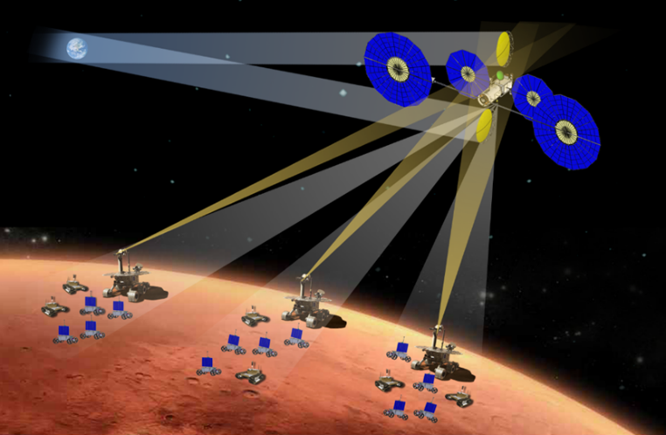
An interactive Mars mission concept would use existing technology and technology under development by NASA in innovative new ways and could serve to demonstrate the feasibility of the technology for future human missions to Mars. We would use a high-power (150 kW at Earth) solar electric propulsion (SEP) spacecraft to deliver dozens of small (<100 kg) rovers to Mars. To ensure a high level of interactivity from a nearly continuous view of a large portion of the Mars surface, we would position the spacecraft in areosynchronous or areostationary orbit 17,000 km above the Mars equatorial plane. The large solar arrays used to power the SEP spacecraft during the trip to Mars would then be used to power a high-capacity communications system to transmit data back to Earth, with data rates limited only by the allocated spectral bandwidth and the number and size of Earth-based receiving terminals.

Fig. 1 Interactive Mars Concept showing a high-power solar electric spacecraft used as an areostationary communications relay after having delivered three sets of rovers to be used for gaming.

The high-power SEP could be built by retrofitting the power and propulsion element of NASA’s Gateway Mission, with a second set of solar arrays, thrusters, and propellant tanks to boost the power level to 150 kW. This spacecraft would deliver 30 t to Mars and would fit within the mass and volume constraints of a Space Launch System (SLS) launch vehicle. Two designs exist for solar arrays large enough (50 kW each) to serve as the retrofit power source: Redwire’s ROSA and Northrop Grumman’s UltraFlex.⁹The number of electric thrusters (12.5 kW each) could be increased to 12 without requiring a technology change, and 8 additional tanks would bring the total amount of xenon propellant to 16 t. We would use two large (7-m) deployable mesh Ka-band antennas to relay data to and from Earth. These antennas would use novel RF power-combining techniques that draw on a small portion of the unprecedented 8 kW of power generated at Mars from the large solar arrays, power-combining the signals from 200-W amplifiers using opposite polarizations on two simultaneous links to return the most data possible to Earth. This would allow the transmission of over 60 Mbps of data for at least 8 continuous hours every day to each region on Earth as it rotates, except for 2 weeks each year when the sun encroaches the line of sight to Mars. Data rates as much as 25 times higher may be possible during Mars’ opposition when the red planet is 5 times closer to Earth. Even with this high return-link data rate, the game would still have to accommodate the round-trip time delay from forward links imposed by speed-of-light communications. These delays are 5 to 6 minutes at opposition and around 44 minutes near solar conjunction. Nonetheless, 10 to 80 interactions each day would be possible.

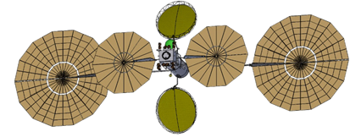

Fig. 2 Mars areosynchronous communications relay system with mesh Ka-band antennas (olive green) and flexible blanket solar arrays (tan). An X-band antenna (bright green) relays information to and from the surface rovers. 12 electric thrusters are shown on the SEP module (dark brown).

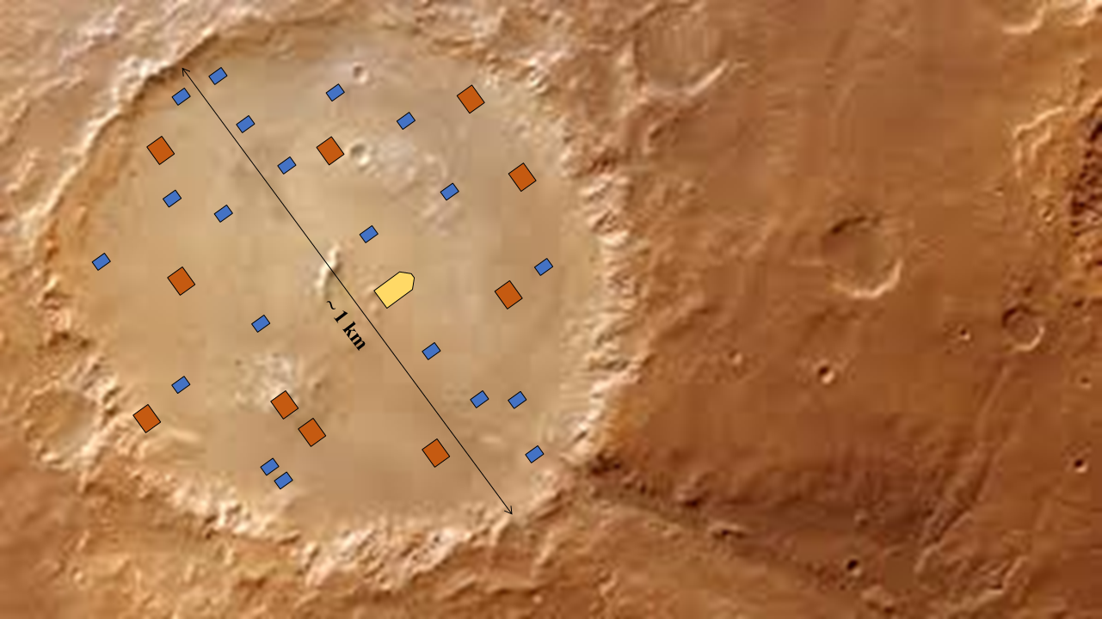
We would start with three types of rovers for this mission: one optimized for surface communications between the other rovers and the areosynchronous-relay satellite, one for surveying, and a third for excavating and building. Groups of these three types of rovers could be deployed to individual sites, such as 5-km craters, to both contain the play and provide interesting visuals on the horizon. A 50 kg rover based on a low-cost lunar prospecting concept would serve as the starting point for the surveyors, and for the builders we would start with a 95-kg excavator based on a previous lunar concept., The communications rover would have a mass of about 285 kg—similar to that of the Mars Exploration Rover (MER). Splitting the 30 t payload into three sites and using rough mass estimates of heat-shield
Fig. 3 Surface Concept of Operations (one site of three).

technology and lander concepts for large-scale operations to support Mars human exploration, we estimate that about 2.2 t of the three landed 10-t payloads could be allocated to rovers. This would allow 1 communications rover, 20 surveyors, and 10 builders at each site—93 rovers total in 1 launch—to start the game. Figure 3 depicts one possible site within a roughly 1 km diameter crater with the communications rover shown as the large yellow 5-sided figure, the “builders” or excavators shown as large red rectangles, and the surveyors or general “players” shown as small blue rectangles. Assumptions include rover velocities of nominally 0.3 cm/s (or 100 m/day) with 16 Gb of data returned per an eight-hour rover shift. A 1 cm data set would create a virtual model for following rovers to drive in near real-time. One year of operations would generate data to create 33 km² of high-resolution modeling of the site to further enhance the game.

Rover operations for the builders and surveyors would be public with all rovers potentially being driven simultaneously by different players. The game would both influence and be influenced by the rover designs. To maximize public participation and ensure basic operations skill, terrestrial competitions could be established to down select Mars rover operators. Even so, high-fidelity and multi-rover plan validation and tracking for fault management would need to be developed to allow a single nonexpert to accomplish what is currently done by a team of professionals and to prevent intentional or accidental rover failures. Simulations could be provided to help players visualize the plans they have built, and to provide engaging content while they are waiting for their next move.

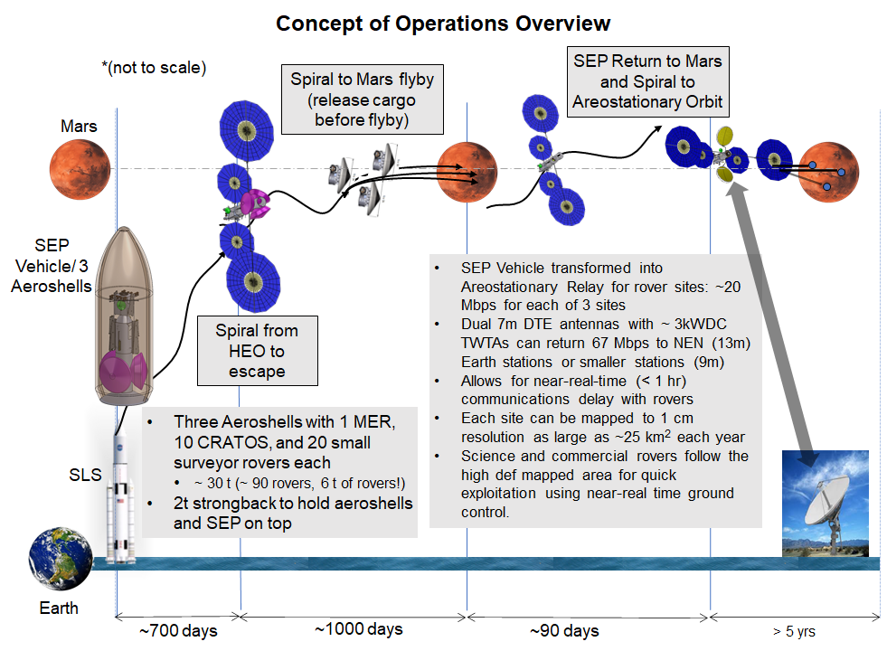
Fig. 4 Concept of operations.
The concept of operations for launch and deployment is shown in Figure 4. A single NASA SLS 2B rocket with a 10 m diameter payload fairing carries the spacecraft and all rovers to a 200 km x 20,000 km high Earth orbit. The spacecraft and rovers stowed for launch are shown in Figure 5. After deployment the low thrust electric propulsion system requires about 700 days to spiral to an escape trajectory and about another 1,000 days to transit to Mars. The total delta-V required is 8,000 km/s at a 3,000 s specific impulse. The SEP spacecraft flies by Mars at 250 km and releases the three entry vehicles carrying the rovers. It takes about 40 days to enter a high Mars orbit and another 50 days to spiral down to an areostationary orbit where it serves as the communications relay for each of the three rover sites.
- Impact to Technology Development Needed for Human Mars Exploration

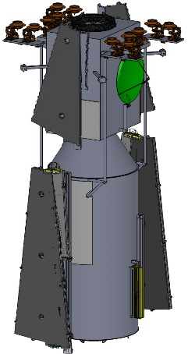
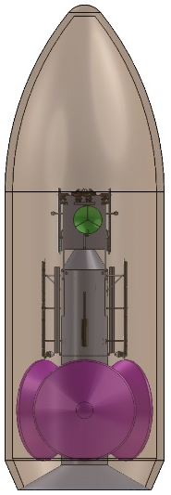
This interactive Mars mission would demonstrate capabilities needed for communications, cargo delivery, and autonomy for future human missions to Mars as identified by NASA’s Human Architecture Team. These include peak data rates up to 40 Mbps from Mars; at least 40 t payload delivery to the surface of Mars; and sensing, planning, and autonomous control for the robots. While NASA has identified notional solutions for each of these capability needs, these communications and in-space transportation concepts are still at low technology readiness levels for Mars. The state-of-the-art for SEP is nominally 20 kW beginning-of-life on Psyche. The state-of-the-art for communication at Mars is the MRO, which provides peak data downlink from 0.5 to 6.0 Mbps and uplink limited by MRO’s 3-m antenna. The state-of-the-art for a landed payload on Mars is 1 t for the Perseverance rover. The state-of-the-art in rover autonomy is the Perseverance rover, which has driven over 15 km since it arrived in Jezero Crater in 2021. Perception and autonomous (onboard) mobility planning have been demonstrated on Mars and autonomous robot arm planning and control for science operations are now underway albeit with a significant operations team for support.
Fig. 5 SEP spacecraft stowed for launch (left) and stacked within an SLS 2B fairing with aeroshells containing the with three sets of rover payloads (right).

The interfaces needed to display near real-time data in an intuitive and attractive manner may serve as a building block upon which the terabytes of data being generated by NASA’s science program could become accessible to scientists and citizens alike, greatly expanding the amount of citizen science that is already underway. Similarly, outfitting the rovers with simple instruments could attract citizen scientists. Take On Mars players have expressed interest in combining play with science, and an excellent interface could succeed in retaining the initial interest that citizen science projects attract. For example, small magnetometers mounted on groups of widely separated rovers could study local magnetic effects. Small imagers could be used to identify interesting minerals and geologic formations, serving as scouts for future large missions. Rovers equipped with small manipulators could collect and cache samples. In addition, while we are focused on Mars, the proposed mission could be conducted on the Moon. The software developed for this application could also be used for terrestrial Earth science campaigns (e.g., measuring ice sheet thickness or soil water content).

Conclusion
This interactive Mars mission concept was designed to address two fundamental objectives: the development of technology needed for future human Mars missions, notably the transportation system needed to deliver large payloads such as human habitats, and a new approach to tap into non-traditional funding sources, namely the gaming industry. The concept we describe could accomplish both objectives. A high-power solar electric propulsion vehicle (or a solar electric/chemical hybrid) can deliver large payloads to Mars, and once there, use the large available power to serve as a communications relay. By delivering rover payloads that can be operated by the general public on Earth, a means may be established to connect the burgeoning commercial space industry to the highly lucrative gaming industry. Terrestrial companies in the information systems, transportation, and communications industries may want to associate themselves with a mission like this, providing new funding streams for an ambitious space mission that can reduce risks for future human exploration. A direct, interactive experience with Mars would change space exploration—transforming it from a spectator sport into a personal activity available to anyone on Earth.

References

Chief Technologist, Science Mission Directorate
Group Lead, Autonomous Systems and Robotics
Senior Electronics Engineer, Green CLE Rising Collaborative
Lead, Concurrent Spacecraft Design Team
Scientist, Power and In-Space Propulsion Division
Electronics Engineer, Communications and Intelligent Systems Division
Indie Game Developer
S. Parvini, “3 Takeaways on the State of the Global Games Market (hint: it’s growing),” Los Angeles Times, August 21, 2023. https://www.latimes.com/entertainment-arts/business/story/2023-08-21/global-gaming-industry-report-2023-league-of-legends-activision-electronic-arts-nintendo-mobile-gaming-mario-bros accessed 11/5/2023.
J. Coykendall, K. Hardin, A. Brady, A. Hussain, “Riding the Exponential Growth in Space,” Deloitte Insights, March 22, 2023. https://www2.deloitte.com/us/en/insights/industry/aerospace-defense/future-of-space-economy.html accessed 11/5/203.
D. Curry, “Top Grossing Games 2023,” Business of Apps, May 2, 2023. https://www.businessofapps.com/data/top-grossing-games/ accessed 11/5/2023.
C. Chapple, “Pokemon GO Catches $6B in Lifetime Player Spending,” Sensor Tower: Store Intelligence, June 2022. https://sensortower.com/blog/pokemon-go-6-billion-revenue accessed 11/5/2023.
S. Larson, “Google Play Store Revenue, Ratings, and Subscription Stats 2023,” Priori Data, September 29, 2023. https://prioridata.com/data/google-play-revenue-statistics/#:~:text=Annual%20Google%20Play%20revenue%20(apps%20%26%20games)&text=The%20upward%20trajectory%20continued%2C%20reaching,2023%20to%20reach%20%2445.63%20billion. accessed 11/5/2023
J. Novet, “Microsoft Projects Two New Areas of Growth for Gaming, Leaked Document Says: Mobile and Ads,” CNBC, September 19, 2023 https://www.cnbc.com/2023/09/19/microsoft-projected-fast-gaming-growth-from-ads-mobile-transactions.html#:~:text=Actual%20fiscal%202022%20gaming%20revenue,X%2C%20formerly%20known%20as%20Twitter. accessed 11/5/2023
Unnamed, “Advertising Spending of Selected Automobile Manufacturers in the United States in 2022,” Statista 2023. Automobile manufacturers ad spend in the U.S. 2022 | Statista accessed 11/5/2023.
Abhijeet, “AT&T Advertising Expenses,” CH Blog, September 18, 2023 https://cheshnotes.com/att-advertising-expenses/#:~:text=The%20advertising%20expenses%20of%20AT%26T%20Inc%20declined%20to%20%242%2C462%20million,operating%20loss%20of%20%244%2C587%20million. accessed 11/5/2023
C.R.Mercer, M.L. McGuire, S.R. Oleson, M.J. Barrett, “Solar Electric Propulsion Concepts for Human Space Exploration,” AIAA SPACE 2015 Conference and Exposition, Pasadena, CA, AIAA 2015-4251, August 2015.
J. Caruso, L.C. Greer, W.T. John, D.C. Spina, M.J. Krasowski, P.B. Abel, N.F. Prokop, J.M. Flatico, K.R. Sacksteder, D. Sofranco, “Cratos: A Simple Low Power Excavation and Hauling System for Lunar Oxygen Production and General Excavation Tasks,” Planetary and Terrestrial Mining Sciences Symposium (PTMSS), Sudbury, Ontario, June 2007.
L.C. Greer, M.J. Krasowski, N.F. Prokop, D.C. Spina, “Cratos: The Evolution of a Robotic Vehicle,” NASA/TM—2013-216491, 2013.
C.R. Mercer, S.D. Vangen, J.A. Williams-Byrd, J.M. Stecklein, L. Alexander, S.A. Rahman, M.E. Rosenthal, D.S. Wiley, S.C. Davison, D.J. Korsmeyer, C.E. Kundrot, E.L. Tu, D.M. Hornyak, T.S. Balint, D.D. Alfano, “Critical Technology Determination for Future Human Spaceflight,” Global Space Exploration Conference, Washington DC, May (2012). Also NASA/TM—2012-217670 http://ntrs.nasa.gov/archive/nasa/casi.ntrs.nasa.gov/20120015918.pdf [accessed 25 Nov 2023]
V. Verma, M. Maimone, D. Gaines, R. Francis, T. Estlin, S. Kuhn, G. Rabideau, S. Chien, M. McHenry, E. Graser, A. Rankin, E. Thiel, “Autonomous robotics is driving Perseverance rovers progress on Mars,” Science Robotics, 8:80. July 2023.

