**Assessment of a Surface Water Transportation System Concept for ISRU Operations on Mars**

Jared F. Congiardo[1], Bradley C. Buckles[2], Amy M. Felt, James C. Lasater, Brian M. Nufer [3], Angela G. Krenn, Mark E. Lewis [4], Carey M. McCleskey[5], Jose M Perotti[6], Gabor Tamasy[7], Jennifer A. Thompson[8]  
*Kennedy Space Center, Merritt Island, Florida, 32899, USA*

Paul Bielski, Zu Qun Li, Paige A. Whittington [9], Collin W. Blake, Keaton C. Dodd[10], Stephen J. Hoffman, Taylor Phillips-Hungerford[11]  
*Johnson Space Center, Houston, Texas, 77058, USA*

Mike Baysinger, Joshua D. Rogan [12], Michael Chappell[13]  
*Marshall Space Flight Center, Huntsville, Alabama, 35812, USA*

**NASA is working to define the architecture needed for a Mars exploration campaign. Initial analysis assumptions allow for pre-deployment of essential cargo and equipment to support a crew landing, including the pre-positioning of a Mars Ascent Vehicle (MAV). This MAV is likely to represent the largest single payload that must be landed on the Mars surface. Its size would be influenced by the amount of mass that state-of-the-art Entry, Descent, and Landing (EDL) systems would be capable of placing on Mars. One possible method of increasing the usable size of the MAV without exceeding available EDL capabilities is to land the MAV without ascent propellant on board. Following such a method may necessitate a strategy to acquire sufficient ascent propellant to allow a crew to safely depart the Martian surface. This paper describes a conceptual return propellant strategy that uses a liquid transportation skid, or pallet, to be used in conjunction with a rover mobility system to transfer water across the Martian surface from a source point to an in-situ resource utilization (ISRU) plant that would use this water as a feedstock to generate oxygen and methane to enable launch of the MAV. Design considerations, concept of operations, and rover energetics will be discussed in this paper.**

1. **Nomenclature**

*MAV* = Mars Ascent Vehicle

*EDL =* Entry, Descent, and Landing

*ISRU* = In-situ Resource Utilization

*CO2* = Carbon Dioxide

*MALV* = Mars Ascent and Landing Vehicle

*HMA =* Hose Management Assembly

*FSP* = Fission Surface Power

*DTAU =* Dust Tolerant Automated Umbilical

*QD =* Quick Disconnect

*HSA =* Hose Subassembly

*RDSA =* Roller Drive Subassembly

*MLI =* Multi-Layer Insulation

*IPEx =* ISRU Pilot Excavator

*SBC =* Single Board Computer

*UHF =* Ultra High Frequency

*I/O =* Input/Output

*LED =* Light Emitting Diode

*TIR =* Total Internal Reflector

*EDS =* Electrostatic Dust Shield

*MT =* Mobility Transport

1. **Introduction**

NASA is working to define architecture areas that require development in order to facilitate decisions related to human deep-space exploration of and Mars. Initial analysis assumptions for the development of an architecture for a human Mars exploration campaign, as outlined in the Moon-to-Mars Architecture Definition Document released by NASA in April 2023[1], allow for the use of multiple landers to deliver and pre-deploy the cargo and equipment needed to support a crew landing. This may include pre-positioning a Mars Ascent Vehicle (MAV). This MAV would likely represent the largest indivisible payload that would need to be placed on the Martian surface. This makes the size of the MAV very closely coupled to the capability of Entry, Descent, and Landing systems developed for Mars landings. Due to this relationship, it may be advantageous for the MAV to be landed without the propellant it needs to return to orbit at the time of its arrival. Such a situation would likely create a need to develop a strategy to acquire sufficient ascent propellant to safely return a crew to orbit prior to that crew’s arrival on the surface of Mars.

The acquisition of this propellant may be accomplished in a number of ways depending on the characteristics of other architecture elements, particularly MAV engine design and the amount of surface power available. Previous studies have evaluated the surface transfer of liquid oxygen delivered from Earth for a LOX/methane MAV [2] and nitrogen tetroxide delivered from Earth for a storable propellant MAV [3]. In both cases, the MAV was landed with the fuel preloaded. With an increase in available surface power assumed, other studies have evaluated a partial in-situ resource utilization (ISRU) concept by generating oxygen from atmospheric CO2, then liquefying it using broad area cooling within the MAV propellant tank, which, again, was landed preloaded with methane. [3] Such ISRU oxygen generation was recently tested by the MOXIE payload on the Perseverance rover. [4] A MAV completely depleted of fuel and oxidizer necessitates an acquisition strategy that provides both propellants.

The surface return propellant strategy concept described in this paper represents one set of architecture permutations that are believed to represent a corner of the trade space: utilizing large, cryogenically propelled landers capable of landing up to 75 metric tons of payload; a MAV that uses one of these landers for both descent and ascent; and the availability of plentiful surface power. This provides a useful reference point for evaluation against other potential architecture permutations, such as smaller payload-to-surface capability or limited surface power capabilities.

1. **Major Elements**

The following section briefly describes major architectural elements that could be deployed to support Martian surface operations.

1. **Mars Ascent and Landing Vehicle**

This study makes use of several oxygen/methane-propelled Mars Ascent and Landing Vehicles (MALVs) capable of landing up to 75 metric tons of payload to the Martian surface, or approximately three times the landed payload capacity studied previously. [5][6] One of these MALVs would be equipped to serve as the Mars Ascent Vehicle in order to return the crew to orbit, and must be resupplied with an estimated 300 metric tons of combined propellant with the ISRU system. A rendering of a MALV is shown in Fig. 1a.

1. **ISRU Propellant Production Plant**

Propellant production via in-situ resource utilization is accomplished with a system that uses a combination of a Sabatier process reactor and solid oxide electrolysis to generate oxygen and methane from water and atmospheric carbon dioxide. For this study, these production units are containerized into three ISRU skids. [76] A rendering of an ISRU Propellant Production Plant skid is shown in Fig. 1b.

1. **Fission Surface Power System**

For the purposes of this study, power for surface elements is assumed to be provided by a number of 40 kWe fission surface power (FSP) systems. This is in keeping with a joint NASA/US Department of Energy Request for Proposals to develop preliminary designs for a 40 kWe FSP system[14].The Compass team at Glenn Research Center performed a notional design exercise for a 40 kWe FSP system that evaluated additional needs such as cabling, power conversion, and deployment methodology. [8] A rendering of an FSP system is shown in Fig. 1c.

1. **Liquefaction Pallet**

Gaseous oxygen and methane generated by the propellant production plant will be transferred to the MALV propellant tanks. Liquefaction pallets will supply 90K neon to broad area cooling systems integrated into the propellant tanks in order to liquefy the gaseous propellant. [76] A rendering of a liquefaction pallet is shown in Fig. 1d.

1. **Surface Water Transportation Pallet**

Feedstock water must be provided to the propellant production plant in order to generate oxygen and methane. A Water Transportation Pallet mounted aboard the Mobility Transport chassis will be used to transport this water from a supply point in five metric ton increments. The pallet may be dismounted from the Mobility Transport chassis in order to release the chassis for other tasks if needed. The design of this pallet is detailed in this paper. A rendering of a Water Transportation Pallet is shown in Fig. 1e.

1. **Mobility Transport Chassis**

The Mobility Transport chassis is used to transport surface system elements to their deployment location, and, using a manipulator arm, is capable of making electrical, fluid, and other connections as needed. It is also used to transport Water Transportation Pallets between the water supply point and the propellant production plant. For the purposes of this study, the chassis is derived from the Chariot mobility concept. [9] Other lunar rover vehicle concepts will be assessed for extensibility to this type of mobility application. The manipulator arm addition is detailed in this paper. A rendering of the Mobility Transport chassis and manipulator arm is shown in Fig. 1f.

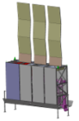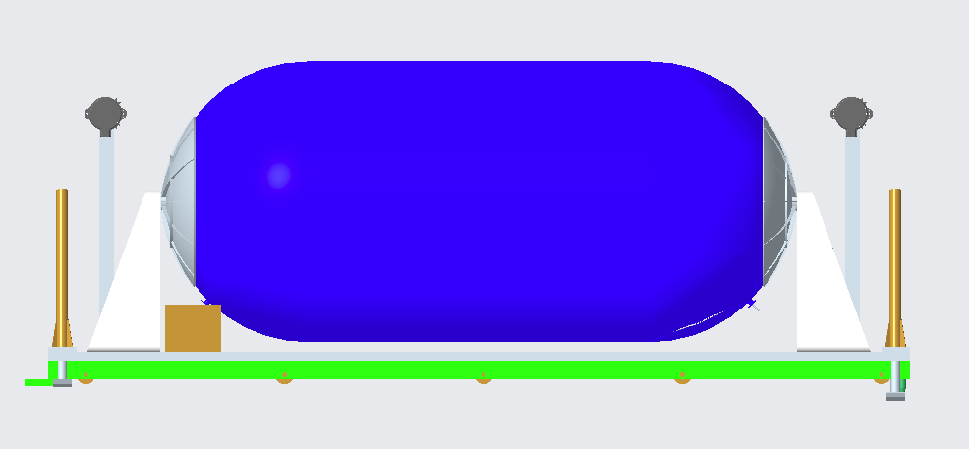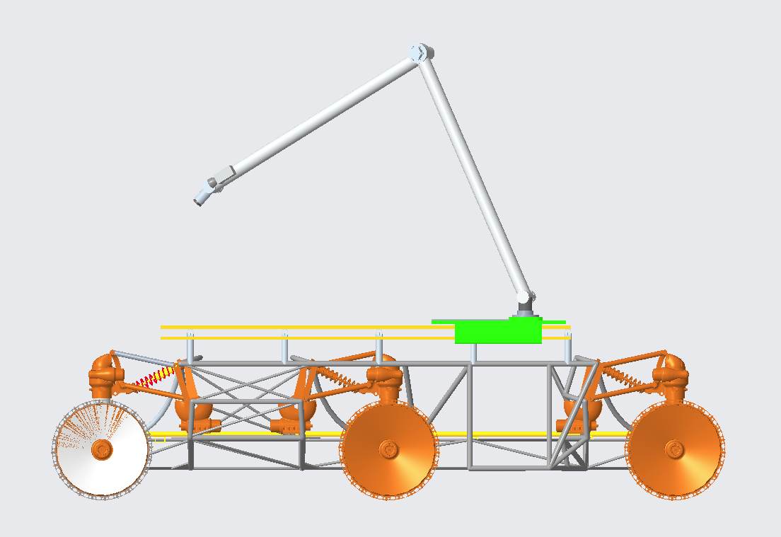

a)

b)

c)

d)

e)

f)

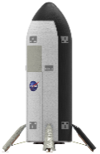

Fig. Major architecture elements; a) MALV; b) ISRU Propellant Production Plant; c) FSP; d) Liquefaction Pallet; e) Surface Water Transportation Pallet; f) Mobility Transport Chassis.

1. **Concept of Operations**

## ConOps Assumptions

No landing site selection for a human Mars landing has been made by NASA, nor does this study endorse a particular site. In keeping with the Compass team assumption of a generic mid-latitude site, Viking II landing site environmental data [14] is used for thermal assessments of the Water Transportation Pallet and Mobility Transport chassis. In order to characterize traverse energetics, Jezero Crater terrain data are used as notional representative conditions.

Local water production is beyond the scope of the overall study at this point in time. Therefore, the water source is assumed to be water delivered from Earth via dedicated MALV. Approximately 150t of water would need to be delivered to meet propellant production plant requirements, so the water delivery would need to be spread across two MALV landers.

The initial conditions of the water are assumed to be 1 bar and 20°C upon arrival to Mars. This assumes there is no temperature increase of the water due to entry aeroheating. This pressure is maintained for ease of handling and to meet ISRU propellant plant interface requirements.

One MALV is assumed to launch to Mars at each 26 month launch opportunity.

Landing sites of individual MALV landers should be at a minimum one-kilometer radius distance from previous landers to mitigate the risk of damage to critical surface hardware due to rocks or other debris liberated by the engine blast generated by the arriving lander.

It is assumed that no mission-specific design modifications to the cargo MALVs are made.

Because of the required timeframe to complete propellant production and the significant communications lag between Earth and Mars, it is assumed that the operations described are performed autonomously to the greatest degree possible.

## ConOps

A notional site plan layout is given in Fig. 2. One MALV would depart Earth during each 26 month launch opportunity, with the first landing approximately 104 months prior to the planned crew surface departure date. The first two landers in this concept are water delivery landers, for convenience designated Water-1 and Water-2, that land at -104 and -78 months, respectively. These delivery payloads remain largely quiescent. Some minimal amount of power to maintain liquid water in the delivery tank may be desirable, but it is also possible to design the tanks to allow the water to simply freeze until needed.

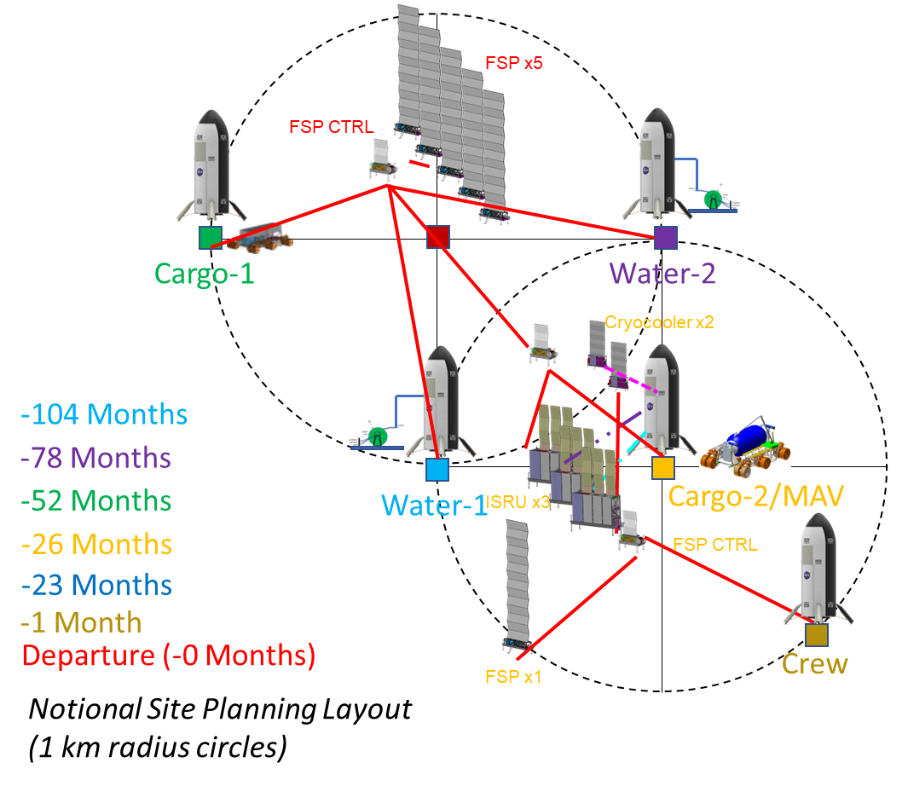

Fig. Notional Mars landing site layout plan.

At -52 months, the first cargo lander (designated Cargo-1) arrives. The notional manifest for Cargo-1 is a Mobility Transport chassis, five fission surface power units, and associated control and cabling pallets. One Water Transportation Pallet is delivered as well, but its deployment may be deferred until the arrival of the ISRU Propellant Plant. The Mobility Transport chassis would be used to deploy and activate the fission surface power units and connect cabling to provide power to the landed MALVs. This provides power to Water-1 and Water-2 to begin thawing their water payload if it was allowed to freeze, or otherwise relieves whatever keepalive system was maintaining liquid water.

At -26 months, the MALV designated as the Mars Ascent Vehicle arrives. This additionally functions as the second cargo lander, delivering a second Mobility Transport chassis, one FSP unit, the ISRU Propellant Plant units, the cryocooler units, and a second Water Transportation Pallet. The mobility chassis work to deploy and activate this equipment. As part of this activation period, Water-1 and Water-2 lower a hose reel and mating interface via the MALV cargo elevator in preparation for water transfer. By -23 months activation is complete and propellant production is able to begin. This marks the commencement of water transfer operations.

Nominally, water transfer operations would utilize two transportation pallets, with one active and one nominally in standby. Transfer operations are as follows:

1. Water Transportation Pallet mounted to Mobility Transport chassis approaches a water delivery lander.
2. One pallet Hose Management Assembly (HMA) is mated to the lander mating interface, using the Mobility Transport chassis manipulator arm. The HMA provides a connection for water, pressurant gas, and power.
3. Perform leak check.
4. Commence transfer of 5000 kg of water at approximately 4.5 kg/min using pallet-mounted pumps.
5. Evacuate transfer line.
6. Demate HMA from delivery lander using Mobility Transport chassis manipulator arm.
7. Mobility Transport chassis traverse to ISRU propellant plant.
8. Chassis approaches/conducts proximity operations at ISRU propellant plants.
9. Mobility Transport chassis manipulator arm mates water pallet HMAs to both ISRU skids.
10. Perform leak check.
11. Begin water transfer to ISRU plant at average 13 kg/hr consumption.
12. At end of transfer operation, evacuate transfer lines.
13. Demate HMAs from ISRU propellant plant.
14. Move away from ISRU propellant plant.
15. Traverse to standby location.

Approximately 72 hours prior to depletion of the water tanker supplying the ISRU plant, the second Water Transportation Pallet is activated from its standby location utilizing the second Mobility Transport chassis. Once activated, it conducts steps 1 through 5 above, remaining in a loaded standby mode while mated to the delivery lander. This standby mode allows for some contingency time in the operation. Once the pallet swap operation is commanded, the second pallet/chassis executes steps 6 and 7 above, waiting at a hold point until the first pallet/chassis completes steps 12 through 14. Once the first pallet/chassis is clear of the ISRU plant, the second pallet/chassis can execute its remaining transfer steps while the first tanker moves to its standby location. This process alternates until all required water is transferred.

Because the ISRU plant units have a small onboard supply tank, allowing 1 sol of continued operations without a connected water pallet, a contingency operation to allow transfer using a single tanker may be possible should one Water Transportation Pallet become nonoperational and unrecoverable.

Propellant production must be completed prior to a crew being given a GO to land on the surface. Once production is complete, the mobility chassis would move the ISRU units, cryocooler units, and water pallets to a safe distance from the MAV. The crew would then land and perform their surface activities. Approximately one month after landing, the crew would enter the MAV and depart the surface.

1. **Water Transportation Pallet Design Concept**

The Chariot-based Mobility Transport chassis was determined to have a payload capacity on Mars of approximately 7t. Given a ratio of dry mass to total mass from previous studies [2] of 29%, a target water payload mass of 5t was assumed. This left 2t available as allowance for dry mass for the Water Transportation Pallet. An isometric view of the Water Transportation Pallet is shown in Fig. 3.

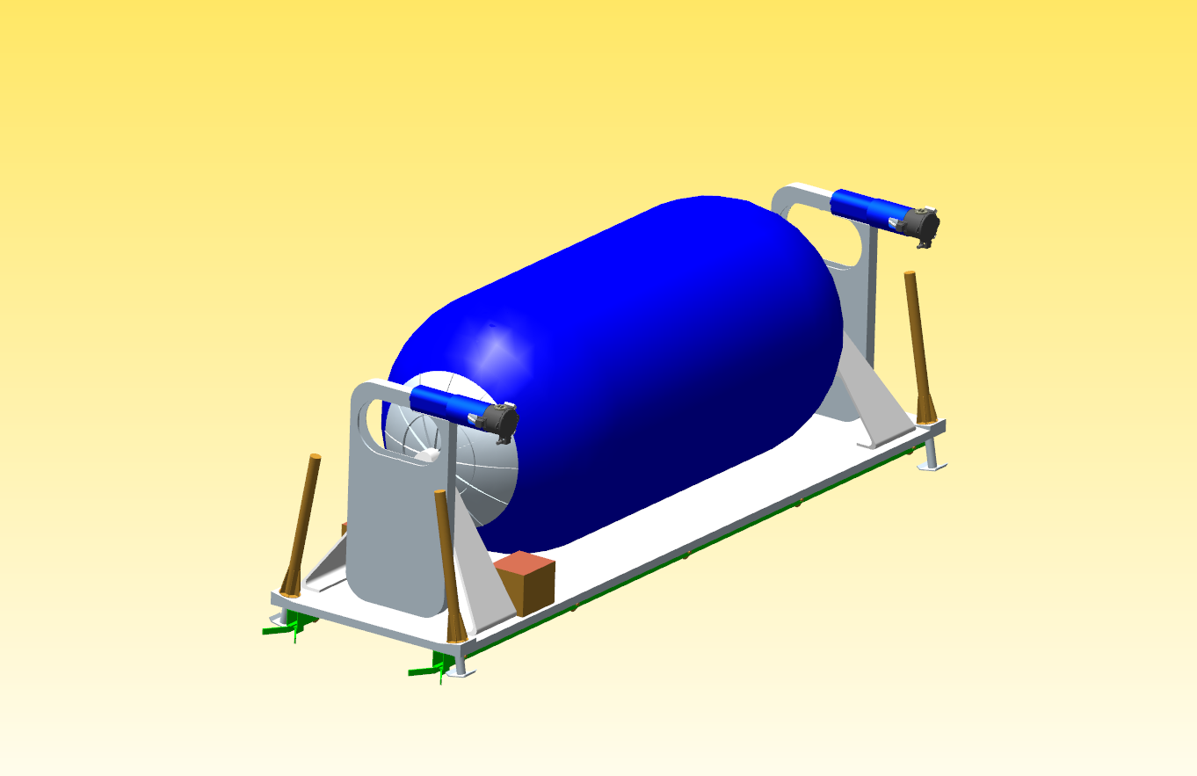

Tank

HMA (2x)

5m deployable flexible umbilical hose in protective box

Jack Stands (4x)

Avionics/Battery Enclosures (typical)

Primary Structural Base

DTAU (2x)

3 QDs (water, CO2, electrical) (dust cover closed)

Fig. Water Transportation Pallet isometric view.

## Major Structural Elements

The water tank is a 5000L cylindrical tank, 3.3m long and 1.5m in diameter, with hemispherical ends, and is structurally supported at either end. The tank is covered in 5.1cm of aerogel insulation. It is constructed of 6061 aluminum and is designed to operate at 1 bar internal pressure. The tank is supported at either end by bipod-shaped structural supports in order to withstand launch loads. These supports could be panel type, as depicted, or truss based. These supports are intended to provide support during the landing and surface ops phase. It is anticipated that they should be driven and sized by the Earth launch phase loads.

The structural base of the Water Transportation Pallet is an aluminum 6061 panel with a flat top and orthogrid bottom surface, with dimensions of 4.6m x 1.3m x 0.05m. It provides support for all components of the Water Transportation Pallet mounted to its top surface. On the bottom surface, it attaches to a mating interface rail system between the pallet and the Mobility Transport chassis. Using this universal mating interface rail system, the Water Transportation Pallet can be autonomously loaded/unloaded from the Mobility Transport chassis. The mating interface also has passive alignment and locking features to aid in the mating process and to secure the pallet during transport. At the four corners of the structural base it has electric linear actuator legs to support and level the pallet without the presence of the chassis. The legs are retracted during traverse and deployed while free standing or being loaded/offloaded from the chassis. This same structural base and mating interface could also be utilized for the other pallets (ISRU, FSP, Cryocooler, etc.) that need to be moved and deployed by the Mobility Transport chassis.

## Fluid Handling and Pressurization Elements

Aside from the water tank itself, fluid handling is accomplished via a network of tubing, assumed to be approximately 15.25m in length, of 0.375-inch (9.53mm) inner diameter 0.065-inch (1.65mm) wall stainless steel tubing. Pumps were sized from commercially available aerospace pumps to be able to transfer approximately 4.5 kg/min of water to allow water transfer onto the tanker to be accomplished in under 24 hours, with margin, to permit contingency operations in the event of the loss of a water tanker.

A small scroll pump, scaled from data from MOXIE [3], is implemented to acquire and compress local atmospheric CO2 for use as pressurant gas to maintain the 1 bar design pressure for the water tank. This eliminates the need to carry a consumable pressurant from Earth, reducing system mass and increasing the reusability potential of the pallet.

A number of latching and solenoid valves and filters, as well as pressure transducers, thermocouples, and a flow meter, are also specified for this system. A representative schematic of the Water Transportation Pallet fluid handling systems mated to the water delivery lander is shown in Fig. 4

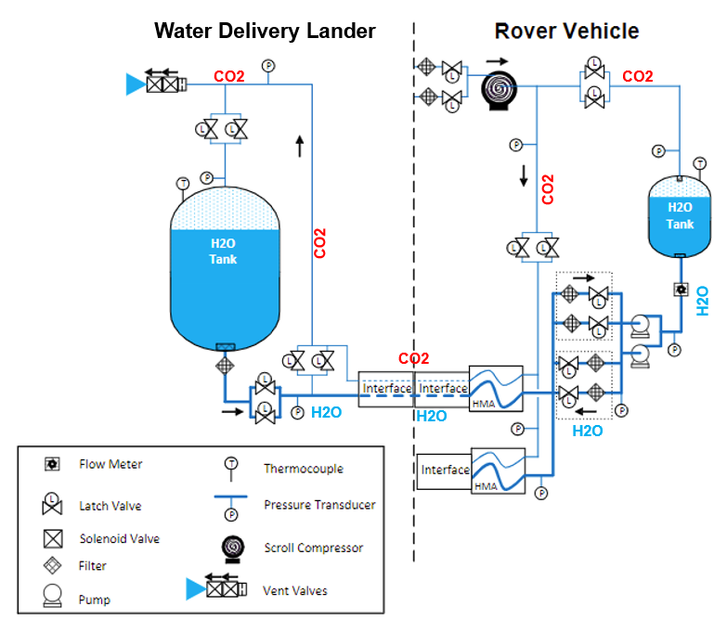

Fig. Fluid system schematic.

Connections between the Water Transportation Pallet, the MALV water delivery landers, and the ISRU propellant plants would be made via an umbilical system consisting of two HMAs, each with a Dust Tolerant Automated Umbilical (DTAU) connector. The HMAs are derived from the On-orbit Servicing, Assembly, and Manufacturing 1 (OSAM-1) project. [10] Each assembly has a flexible hose sub-assembly (HSA) consisting of a conduit, sleeve, Kapton sock, multi-layer insulation (MLI), modified flex hose ending, Kapton heaters, thermistors, wires, and hose clamps. A temperature controller monitors and maintains a nominal temperature of the flex hoses to prevent the water from freezing. The roller-drive sub-assembly (RDSA) is mounted on the opening of the box subassembly and has motor-driven pinch rollers to extend/retract the HSA. The DTAU is attached to the end of the HSA and consists of three Quick Disconnects (QDs) (water, pressurant CO2 gas, and electrical power) for battery charging. The DTAU also has mechanisms for alignment, latching, and QD mating/demating, and dust protection covers and seals to keep dust out of the interface during transfer operations and inactive periods. The umbilical HMA and DTAU components are shown in Fig. 3, and an example connection between the Water Transportation Pallet and the ISRU propellant production plant is shown in Fig. 5.

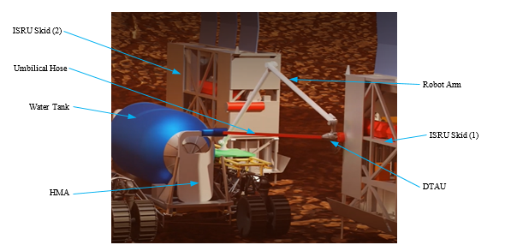

Fig. Umbilical connection to ISRU plant.

## Electrical and Communications Elements

A notional block diagram of the water pallet electrical system was developed for the study (see Fig. 6). It provides an initial design concept and identifies the major electrical subsystems and interfaces to estimate the size, mass, and power usage of the system.

The electrical power subsystem operates at a nominal input voltage of 120 VDC and provides power conditioning, storage, and distribution functions. Power conditioning includes filters that reduce noise and voltage ripple and provide surge protection. Circuit breakers provide over-current protection for the electrical system. The battery charging and discharging subsystem controls the charging rates and depth of discharge of the batteries to maintain optimal performance. Lithium-ion batteries, using LG Chem 18650 MJ1 cells, were selected for their high energy density and because of their intended use on future NASA exploration missions (e.g., Europa Clipper). The nominal battery voltage assumed was 122.4 VDC, and the battery capacity margins of 20% for aging [12] and 80% depth of discharge[15] were used to calculate a total battery energy storage need of 10 kWh. A conservative battery energy to mass ratio of 0.09 kWh/kg was assumed based on the ISRU Pilot Excavator (IPEx) Space Technology Mission Directorate (STMD) Game Changing Development (GCD) project [11] battery pack development. This ratio also includes the battery thermal management system. Multiple DC-DC converters distribute power from the batteries to the loads with varying regulated secondary power voltages. The tank heaters, scroll compressors and pumps, solenoid valves, and communications equipment use 28 VDC of electrical power, while the cameras use 24 VDC. Other equipment, such as the jack stands, motor controllers, and the digital and analog I/O boards, use 12 VDC, and the sensors and the single board computer (SBC) use 5 VDC and 3.3 VDC, respectively. Power and general-use cables use space-grade electrical connectors (e.g., MIL-DTL-38999), and Micro-D connectors (e.g., MIL-DTL-83513) are used for instrumentation and data. All the cable assemblies use Teflon insulated (Type PTFE) wire, and they were sized and derated per Table 4A of NASA EEE-INST-002: Instructions for EEE Parts Selection, Screening, Qualification, and Derating for bundled wires [13].



Fig. Notional water pallet electrical system block diagram.

The avionics subsystem consists of a space-grade radiation-hardened SBC (i.e., RAD750®) with memory, solid-state storage, external I/O (e.g., USB, Ethernet, etc.), and motor controller boards to control and monitor the electrical subsystems and acquire data from the various sensors on the water pallet.

Wireless communications for the pallet use UHF transceivers, antennas, and Wi-Fi systems. The UHF proximity communications are for command/telemetry links up to 300 km, while the Wi-Fi links (IEEE 802.11a/b/g/n) are for controlling the pallet up to 300m range. The data rate of the UHF transceivers is up to 10 Mbps (Rx) and 12 Mbps (Tx). Omnidirectional antennas with medium gain (15.5dB) were assumed.

Three camera subassemblies (Fig. **7**) are located on the pallet for optimal visual coverage. They are derived from IPEx cameras using an 8.8MP sensor and have integrated LEDs and TIR optics for supplemental lighting (3000 Lumens of white light), 15W survival heaters, and a low power integrated Electrostatic Dust Shield (EDS) for dust mitigation.

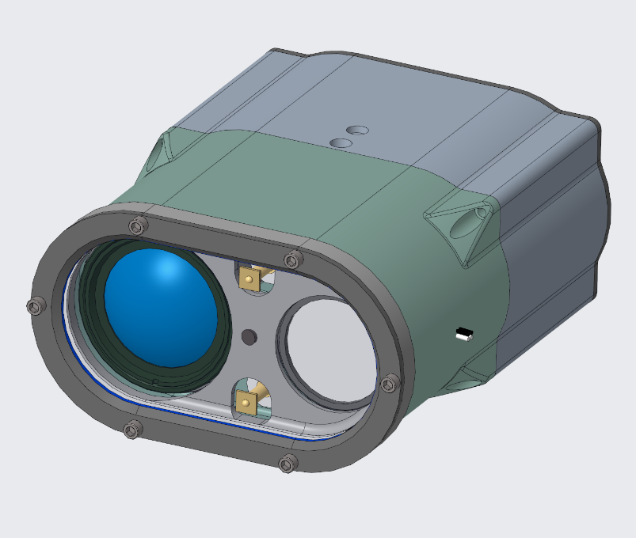

Fig. 7 Water pallet camera subassembly.

## Thermal Design

The tank is equipped with two 200W Kapton film heaters located laterally, and another 100W heater located ventrally. The heaters are bang-bang controlled to maintain a minimum temperature of 283K (ten degrees above freezing point). Preliminary Thermal Desktop analysis (Fig. 8) indicates that, with the water load starting at 300K, the heaters would not need to activate until approximately 9.5 days after arrival at the ISRU propellant plant. It is expected that some heaters would be required on the pallet tubing as well.

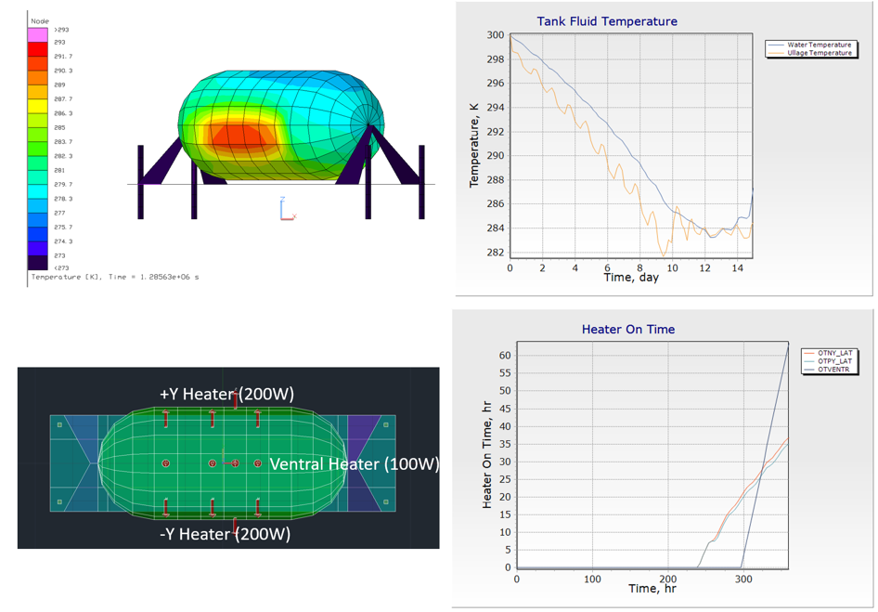

Fig. Water tank thermal analysis.

In lieu of radiators, component heat rejection would be to the water tank through direct mounting or thermal strapping whenever possible. This should serve to reduce the tank heater duty cycle.

## Mass Analysis

The mass estimate for the Surface Water Transportation Pallet, broken down by functional category, is given in Table 1. The gross mass (with margin) of 1153 kg is within the 2000 kg dry mass allowance.

Table Surface Water Transportation Pallet mass estimate.

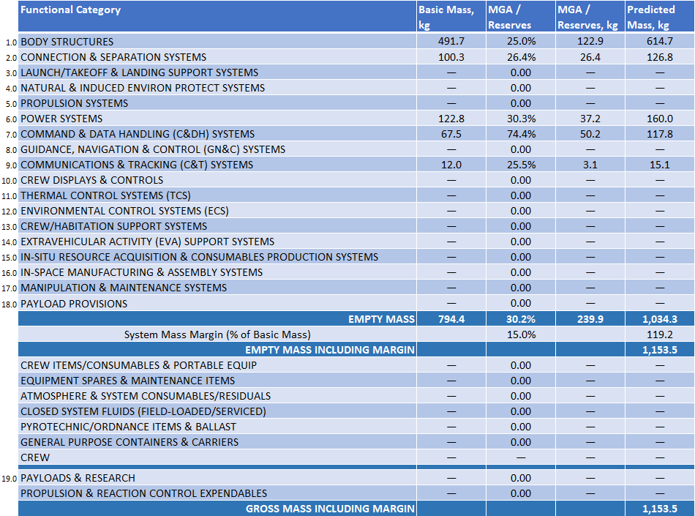

1. **Mobility Transport Chassis Design Concept**

An isometric view of the Mobility Transport chassis is shown in Fig. 9.

## Payload Capacity and Energetics

The Mobility Transport chassis (MT) is derived from the Chariot mobility system studied for lunar exploration. In Martian gravity, the payload capacity of the chassis is estimated to be 7100 kg, or 7.1 metric tons. The onboard batteries have 34.6 kWh of energy capacity. It is estimated that, in this configuration, the chassis would be able to operate for approximately 3.8 hours before requiring recharging. The MT is estimated to be able to traverse the surface autonomously at speeds up to 1.8 km/hr. IPEx-derived avionics and cameras were assumed to allow for this capability.

Speed and energy consumption are highly dependent on payload mass and the terrain traversed. The 1 km distance between landing sites would be the minimum distance traversed by the MT, due to the need to navigate around terrain features that cannot be negotiated by the MT. To that end, energetics analysis was conducted to evaluate the capability of the chassis to transport a water pallet across the surface and to estimate the actual distance traveled based on terrain data from a known location.

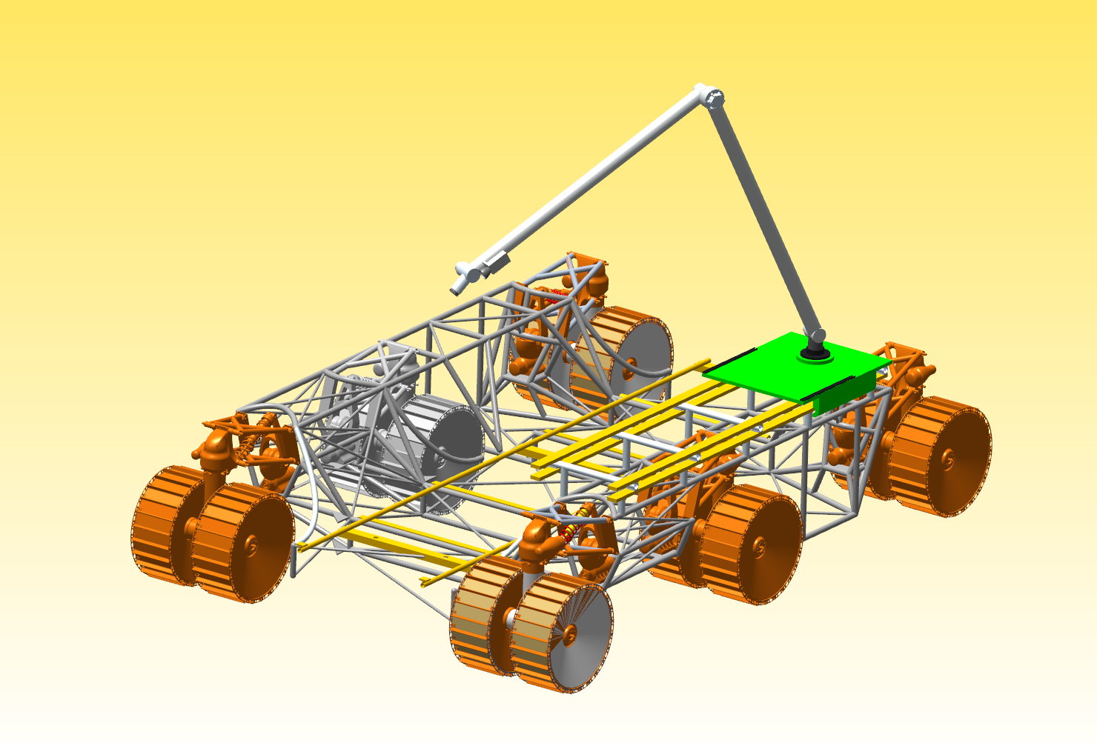

Chariot-derived Chassis

Skid Offload Rail System

Robot Arm (5m reach)

Robot Arm Translation Rail/Cart

Fig. Mobility Transport chassis isometric view.

An assessment of the MT was completed using a physics-based rover simulation built in the Trick Simulation Environment. [15] This simulation includes terramechanics modeling[16][17] with Martian soil characteristics. [16] Candidate traverse routes are integrated into the simulation framework and traversed in a loaded and unloaded tanker state. Unconstrained energy storage was allowed to determine traverse energy costs and to better assess the energy storage needs. The traverses were simulated end-to-end with no dwell times for charging or detanking.

The energetics simulation utilized Jezero Crater terrain data due to availability of high-resolution data and its use in previous human landing studies. A 1 meter per pixel High-Resolution Imaging Science Experiment (HiRISE) Digital Terrain Model (DTM) of Jezero Crater [17] was employed for terrain contact modeling and graphics in the rover simulation as well as traverse generation in the open-source QGIS software [18]. To enable traverse generation, two MALV landing sites were selected to be approximately 1 km from a common ISRU location. A slope raster was derived from the Jezero Crater DTM, shown in Fig. 10, and then a least cost path algorithm, which considers slope and distance, was used to calculate the two traverses shown in Fig. 11.

Preliminary results were gathered for the MT in multiple traverses in both a loaded and unloaded state. Housekeeping power loads of 2 kW were assumed along the traverses and added to the total power consumption at the end of the traverse. As shown in Fig. 12 and Fig. 13 below, the power consumption trend is similar for both traverses and when comparing loaded and unloaded Water Transportation Pallet states for each traverse. Power consumption is seen to increase on inclines and with higher payloads, as expected.

## Manipulator Arm

Fluid and electrical connections between multiple elements will need to be made and broken over the course of the uncrewed surface operations period. This includes electrical connections between FSPs and client elements, fluid connections between the ISRU propellant plant and the MAV, and working fluid connections between the liquefaction pallet and the MAV. The Water Transportation Pallet would need to make and break connections between itself and the ISRU propellant plant and the water delivery landers multiple times over the course of propellant production. In order to accomplish this, a chassis-mounted manipulator arm was developed. This arm is based on a robotic umbilical arm proposed for Artemis surface operations[18] and is mounted on a rail system to allow it to traverse from one end of the chassis to the other. A toolkit with various end effectors is included in the mass budget to allow the manipulator to accomplish a variety of tasks as needed. Fig. 14 shows the robot manipulator arm components layout.

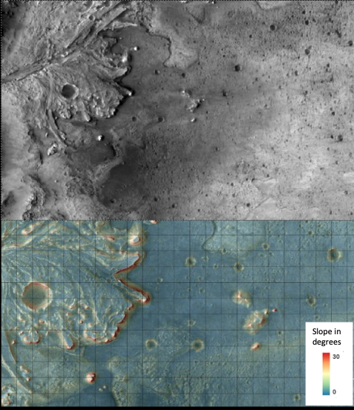

Fig. Jezero Crater terrain and corresponding slope raster used in traverse calculation for energetics simulations.

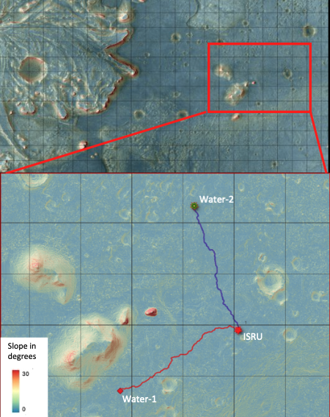

Fig. Represented sites and traverses calculated using a least cost path algorithm.

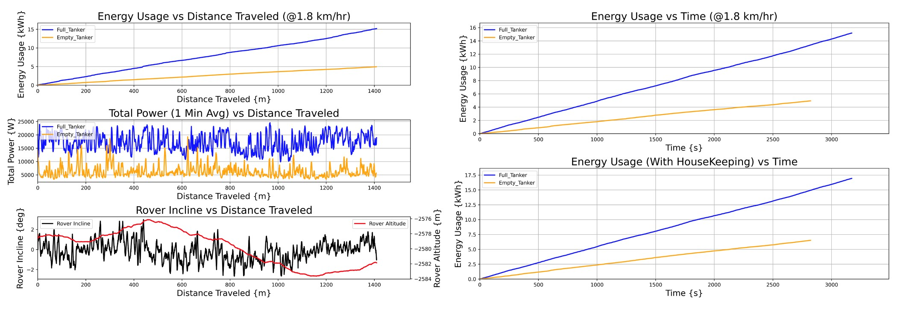

Fig. 12 Mobility Transport chassis energetics calculations for Water-1 traverse.

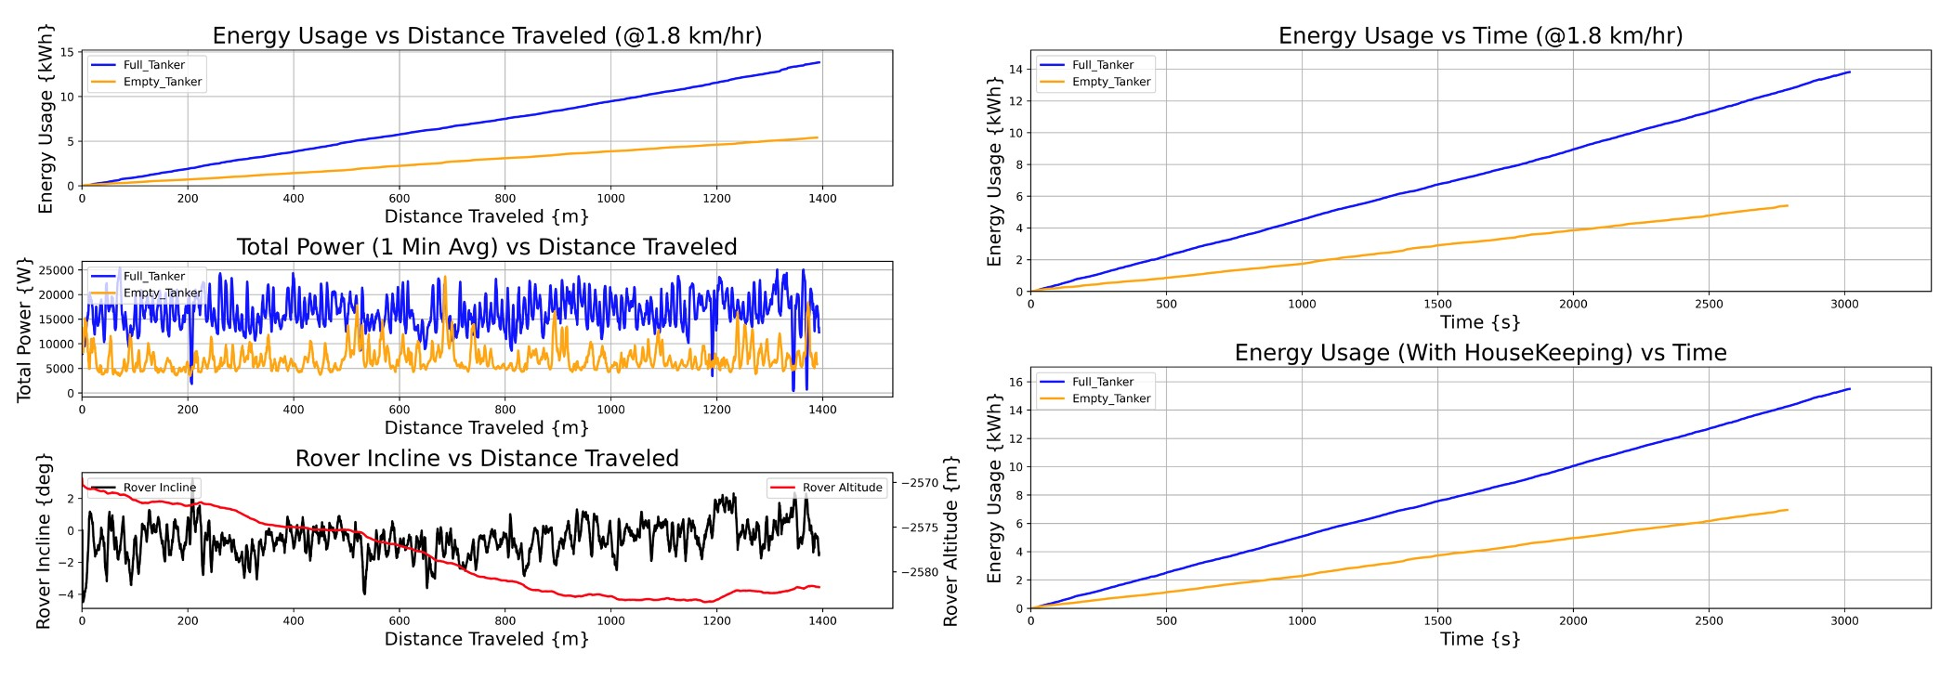

Fig. 13 Mobility Transport chassis energetics calculations for Water-2 traverse.

The manipulator arm and rail system would be permanently attached to one side of the MT. The base of the arm would be attached to a translating carriage/rail system. With the translating rail and 5m reach, the manipulator can reach all of the equipment on the MT and water pallet. The 5m reach was also selected so it could connect the umbilicals with sufficient standoff distance from adjacent elements. During transport, the arm is capable of folding into a low profile laid-down configuration (see Fig. 14) which would be held secure in a support bracket structure.

The manipulator end effector consists of a quick tool changer attachment so it can pick up multiple tools from a tool caddy located on the translating carriage at the base of the robot arm. The tool changer would have power and data connectors to power and control the various end effectors. It would grapple the DTAU during umbilical connection operations, and it could also pick up other tools such as a wrench, brush, cutter, gripper, etc. to perform contingency maintenance, cleaning, and troubleshooting operations on the mobility base and other surface elements.

The manipulator arm will also have an inspection/alignment camera with lighting located at the tip of the arm which would be used to track and align targets for umbilical mating, but could also be used for general inspection and troubleshooting.

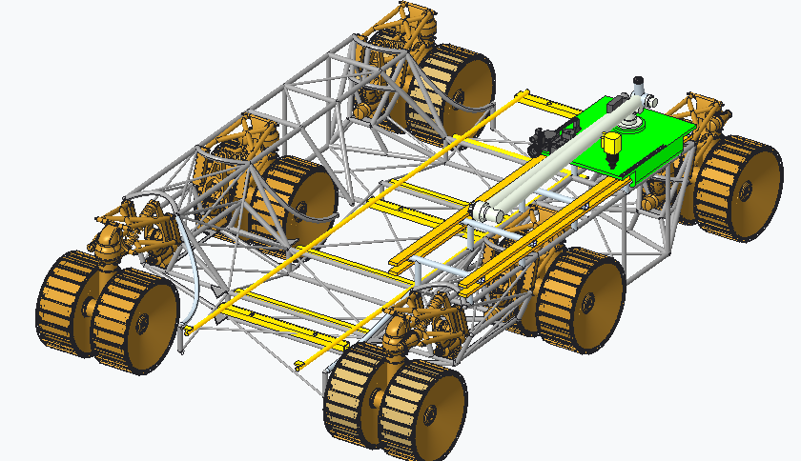

Load/Offload Rail System

Attached or built into mobility base chassis

Tool Caddy

On robot base plate

Robotic Arm

Folded in the transport position

Robotic Arm Linear Rails

Attached to Mobility Base

Fig. Robotic arm components.

## Load/Offload Rail System

The Mobility Transport chassis should be able to interface with the water transport pallet and be able to load/offload the pallet at various locations throughout the transport operations. It should also be able to load/offload other surface elements and move them from the MALVs to other locations on the Martian surface. For this reason, a concept was developed for a universal structural interface which can accommodate a common skid/pallet for transport. The basic elements of this structural interface were mentioned in Section V(A), but a more detailed concept is shown in Fig. 15 and Fig. 16, with explanatory notes showing the major components and features.

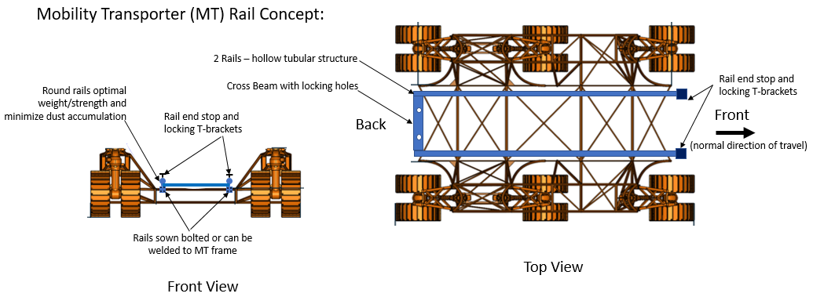

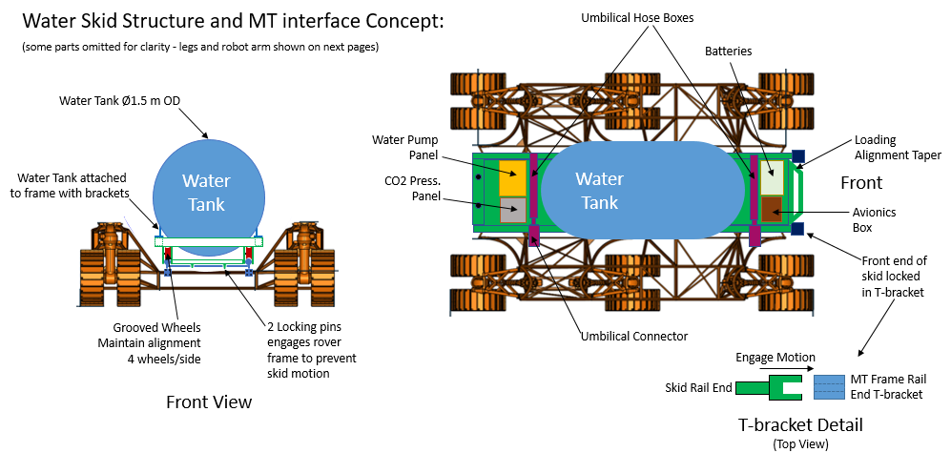

Fig. 15 Load/offload rail system concept.

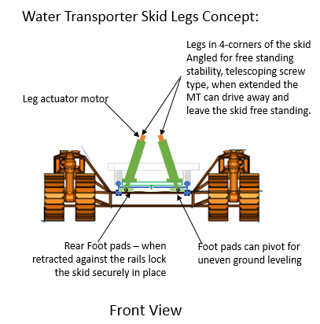

Fig. Water pallet legs concept.

The ConOps for loading/offloading the water pallet consist of the steps outlined in the following paragraph. The MT and pallet begin in the unloaded configuration after the pallet has been offloaded from the MALV. Fig. 15 shows the front/back direction notation for the MT.

Initially, the MT would drive up to the pallet to align the rails longitudinally with its back facing the interface. The MT would use visual targets to align the rails and adjust its height to match the elevation of the freestanding pallet’s interface height. It then drives under the pallet until its rails are engaged with the pallet rollers, aided by tapered alignment guides. Once the rails are engaged with the front set of rollers the front legs can be retracted, which allows the MT to continue driving under the pallet to engage the full length of rails/rollers. Once the MT is fully under the pallet the rear legs can be retracted, which fully lowers the pallet onto the MT.

There are passive locking features built into the rail system to secure the pallet during transport. In the front, there is a T-shaped bracket that receives the pallet fork bracket and should prevent forward and upward motion. In the back, the pallet has two locking pins that engage tapered holes in the MT frame as the pallet is lowered to prevent the pallet from rolling off. The foot pad of the retracted rear legs engages the bottom of the MT rail and prevents the pallet from raising and disengaging the locking pins, thereby fully securing the pallet for transport.

## Mass Analysis

The mass estimate for the Mobility Transport chassis, broken down by functional category, is given in Table 2.

Table Mobility Transport chassis mass estimate.

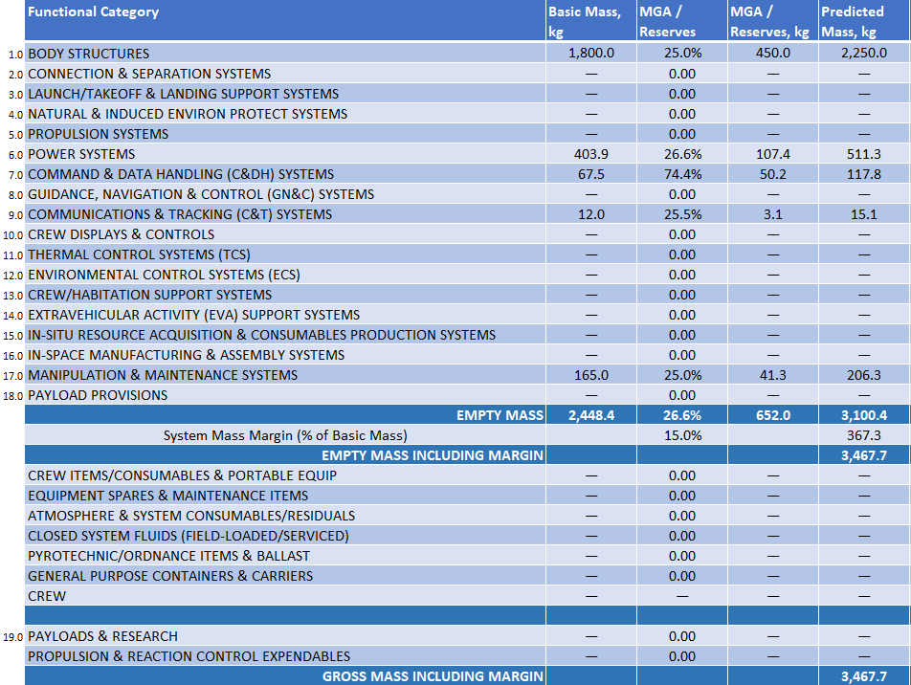

1. **Water Delivery Tanker Design Concept**

Water would be delivered from Earth in two tanks, each with a 75t (less dry mass) capacity, to meet payload capacity of the delivery MALV. Each tank is a 5.2m diameter 6061 aluminum sphere located in the MALV payload volume with a bottom elevation of 14.3m above ground level. The tank is insulated with 5.1cm of aerogel blanket.

A passive hose reel assembly mounted to the MALV payload elevator would be deployed when the ISRU Propellant Plant is activated. The hose would consist of water, CO2, and electrical lines. The reel would connect to a DTAU plate, permitting the water tanker to mate and take on water from the delivery lander. The hose deployment concept is shown in Fig. 17.

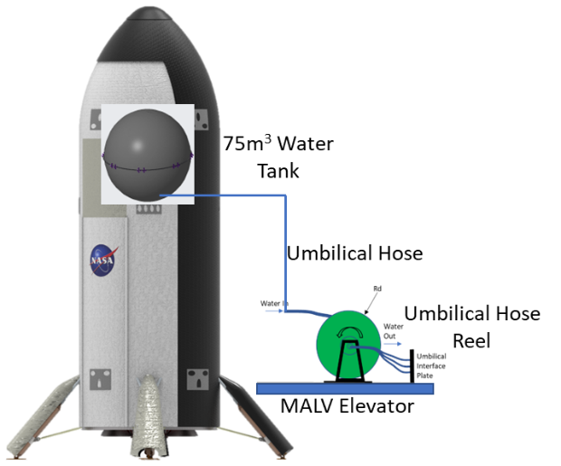

Fig. MALV water transfer hose deployment concept.

The tank would be heated with eight 300W Kapton strip heaters mounted in quadrants on the top and bottom hemispheres of the tank. The heaters are individually bang-bang controlled to maintain a minimum temperature of 283K during a two-year standby mode (Fig. 18). If the water in the tank is allowed to freeze, these heaters would be used to thaw the water. A calculation was performed to determine the minimum heater power required to thaw the payload from a 190K average atmospheric temperature to 300K in sufficient time to begin the water transfer procedure. This can be accomplished in 26 months with 664W. If all 2.4kW of available heaters are used, the thawing process can be completed in approximately 7 months (Fig. 19).

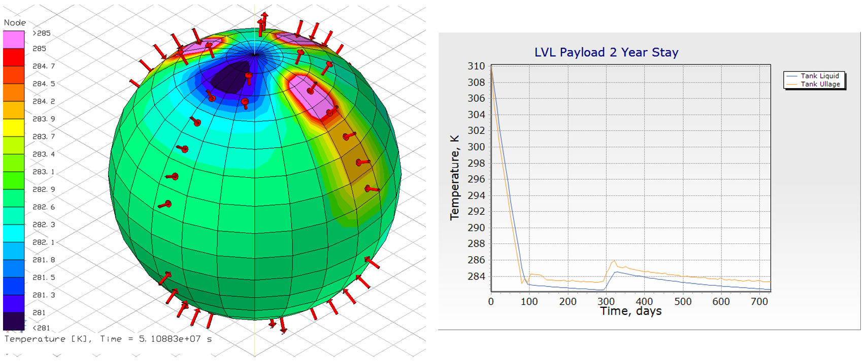

Fig. MALV water delivery tank thermal analysis.

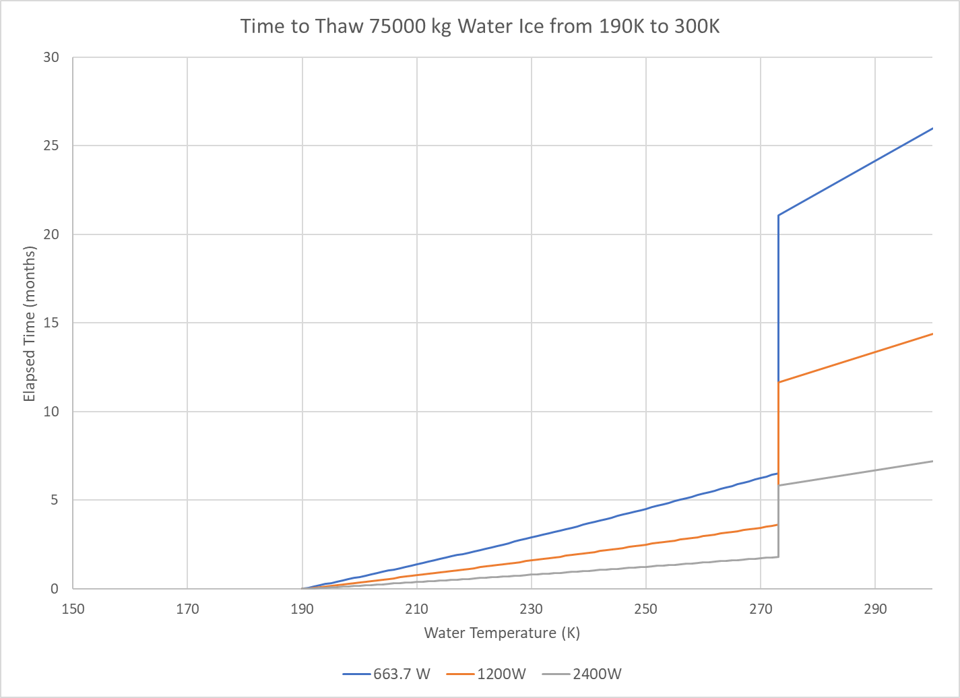

Fig. Time to thaw frozen MALV payload water from 190K to 300K.

The dry mass estimate for the storage tank is given in Table 3. The approximately 1.7t dry mass per delivery tanker system results in 146.6t of actual water delivery from Earth. Should this ISRU feedstock method be chosen, there may be opportunities to recover deliverable wet mass through greater integration of the water payload with the MALV.

Table Water payload tank mass estimate.

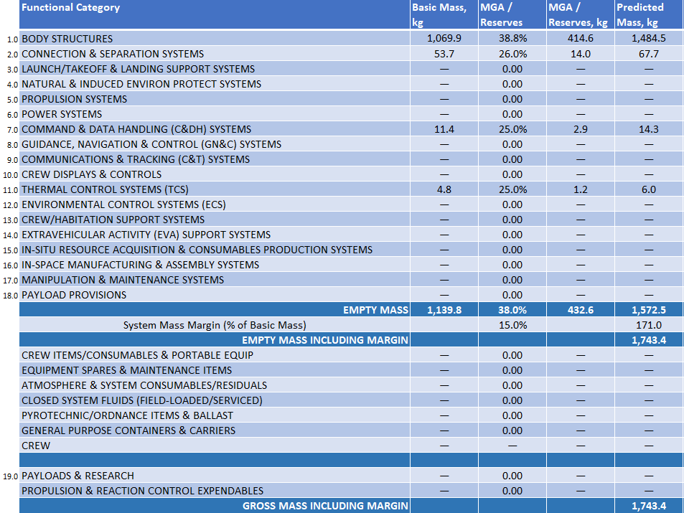

1. **Technological Needs**

Wherever possible, components for the Surface Water Transportation Pallet concept, the Mobility Transport Chassis concept, and the Water Delivery Tanker concept were derived from items that are either currently commercially available or in development for other flight projects, as noted above. Because these systems would be intended to operate in a Martian environment and would be critical for a successful crew return, the development of certain new technologies are required. In all cases, new technologies to enhance system reliability, and provide fault detection, isolation and recovery may be needed. For the Water Transportation Pallet, new technologies to enable autonomous fluid transfer operations, and enable repeated, reliable, high integrity umbilical mating/demating may be essential. For the Mobility Transport Chassis, technologies to enable autonomous robotic mobility may be needed. Of particular necessity may be developments in autonomous rover navigation and maneuvering capabilities, autonomous path planning, task processing, scheduling, and autonomous manipulator system operations. For the Water Delivery Tanker, technologies for autonomous operations, in particular, developments in autonomous task processing and scheduling, may be necessary.

1. **Conclusion**

The surface transportation of a bulk liquid commodity, whether a pre-delivered propellant or an ISRU feedstock such as the water presented here, from a source location to a utilization location has been featured as a component of several studies that encompass the strategy for propellant acquisition to fuel a MAV to return a crew to orbit from the surface of Mars. Repeated, reliable, and autonomous mating and demating of fluid and electrical connections and autonomous transfer of the commodity may be required to successfully perform this task, as may autonomous navigation. The ability to independently recover from off-nominal situations may also be vital. Many of the these concepts and technologies have broad applicability for space and surface systems. Indeed, many components of the Water Transportation Pallet and chassis are derived from concepts initially developed for other projects.

Variations to water sourcing on Mars may be considered for future study, including production of water from a subsurface source via Rodriguez Well and generation of water from soil mining and processing. As designed, the Mobility Transport chassis should be able to deploy the assets to support these production techniques and use the Water Transportation Pallet to deliver the produced water to the ISRU propellant plant with little to no modification.

**References**

[1] Goodliff, K., Merancy, N., Bhakta, S., Rucker, M., Chai, P., Ashurst, T., Troutman, P., and Stromgren, C., “Moon-to-Mars Architecture Definition Document,” NASA/TP-20230002706, 2023.

[2] Congiardo, J., Krenn, A., Martinez, J., Dupuis, M., and Swanger, A., “Development of a surface cryogenic propellant transfer concept for Martian operations,” *IOP Conference Series: Materials Science and Engineering*, Vol. 1240, 2022.

doi: 10.1088/1757-899X/1240/1/012011

[3] Krenn, A., Trent, D., Sanders, G., Hoffman, S., Chai, P., and Hinterman, E., “Architectural impacts of in-situ resource utilization production of oxygen for use as propellant in a Mars ascent vehicle,” *IOP Conference Series: Materials Science and Engineering*, Vol. 1240, 2022.

doi: 10.1088/1757-899X/1240/1/012010

[4] Carreau, M., “MOXIE Demo Extracts Oxygen from Mars Atmosphere, NASA Says,” *Aviation Week*, published online 11 September, 2023, URL: https://aviationweek.com/defense-space/space/moxie-demo-extracts-oxygen-mars-atmosphere-nasa-says [retrieved 19 October 2023].

[5] Trent, D., Edwards, S., Chappell, M., Lugo, R., and Andreini, M., “Design of a Family of Mars Chemical Transportation Elements,” *AIAA SciTech Forum*, Submitted for Publication, AIAA, Orlando, FL, 2024.

[6] Rucker, M., et. al., "NASA's Strategic Analysis Cycle 2021 (SAC21) Human Mars Architecture," *2022 IEEE Aerospace Conference (AERO)*, Big Sky, MT, USA, 2022, pp. 1-10.

doi: 10.1109/AERO53065.2022.9843237.

[7] Oleson, S., et. al., “Kiloton Class ISRU Systems for LOX/LCH4 Propellant Production on the Mars Surface,” *AIAA SciTech Forum*, Submitted for Publication, AIAA, Orlando, FL, 2024.

[8] Oleson, S., et. al., “A Deployable 40 kWe Lunar Fission Surface Power Concept,” *ANS Nuclear and Emerging Technologies for Space 2022*, American Nuclear Society, Downers Grove, IL, 2022, pp. 519-527

[9] Harrison, D. A., Ambrose, R., Bluethmann, B., and Junkin, L., "Next Generation Rover for Lunar Exploration," *2008 IEEE Aerospace Conference*, Big Sky, MT, USA, 2008, pp. 1-14.

doi: 10.1109/AERO.2008.4526234.

[10] Coll, G. T., et. al., "NASA’s Exploration and In-Space Services (NExIS) Division OSAM-1 Propellant Transfer Subsystem Progress 2020," *2020 AIAA Propulsion and Energy Forum*, USA, 2020.

doi: 10.2514/6.2020-3795.

[11] Schuler, J. Nick, A. Leucht, K., Langton, A., and Smith, D., "ISRU Pilot Excavator: Bucket drum scaling experimental results," *18th Biennial International Conference of the ASCE - Earth and Space 2022*, Denver, CO, 2022.

doi: 10.1061/9780784484470.037.

[12] Pesaran, A., Roman, L., and Kincaide, J., “Electric Vehicle Lithium-Ion Battery Life Cycle Management,” NREL/TP-5700-84520, 2023.

[13] Sahu, K., Leidecker, H., and Lakins, D., “EEE-INST-002: Instructions for EEE Parts Selection, Screening, Qualification, and Derating,” NASA/TP-2003-212242, 2008.

[14] Millour, E., et. al., “The Mars Climate Database (Version 5.3),” *Scientific Workshop: “From Mars Express to ExoMars”*, ESAC, Madrid, Spain, 2018.

[15] National Aeronautics and Space Administration, Johnson Space Center, Software, Robotics & Simulation Division, Simulation and Graphics Branch (ER7), “Trick simulation environment: Documentation,” URL: https://nasa.github.io/trick/documentation/ Documentation-Home, September 2023.

[16] Trease, B, Arvidson, R, Lindemann, R, Bennett, K, Zhou, F, Iagnemma, K, Senatore, C, and Van Dyke, L. "Dynamic Modeling and Soil Mechanics for Path Planning of the Mars Exploration Rovers." *Proceedings of the ASME 2011 International Design Engineering Technical Conferences and Computers and Information in Engineering Conference. Volume 6: 35th Mechanisms and Robotics Conference, Parts A and B*. Washington, DC, USA. August 28–31, 2011. pp. 755-765.

[doi: 10.1115/DETC2011-47896](https://doi.org/10.1115/DETC2011-47896)

[17] Fergason, R. L., Hare, T. M., Mayer, D. P., Galuszka, D. M., Redding, B. L., Smith, E. D., Shinaman, J. R., Cheng, Y., and Otero, R. E., “Mars 2020 Terrain Relative Navigation Flight Product Generation: Digital Terrain Model and Orthorectified Image Mosaics,” 51st Lunar and Planetary Science Conference, no. 2326, 2020.

doi: [10.5066/P9REJ9JN](https://doi.org/10.5066/P9REJ9JN)

[18] QGIS.org (2023). QGIS Geographic Information System. Open Source Geospatial Foundation Project. URL: http://qgis.org.

1. Lead Aerospace Technologist, Engineering Directorate, Kennedy Space Center
2. Research Aerospace Technologist, Automation and Robotics Systems, Exploration Research and Technology Programs Directorate, Kennedy Space Center
3. Aerospace Technologist, Fluid Systems Test, Engineering Directorate, Kennedy Space Center
4. Aerospace Technologist, Technical Management, Exploration Research and Technology Programs Directorate, Kennedy Space Center
5. Aerospace Technologist, Theoretical Simulation Techniques, Exploration Research and Technology Programs Directorate, Kennedy Space Center
6. Aerospace Technologist, Engineering Directorate, Kennedy Space Center
7. Aerospace Technologist, Gas and Fluid Systems, Engineering Directorate, Kennedy Space Center
8. Aerospace Technologist, Safety and Mission Assurance, Kennedy Space Center
9. Aerospace Technologist, Automation and Robotics Systems, Engineering Directorate, Johnson Space Center
10. Software Engineer, CACI
11. Aerospace Corporation
12. Aerospace Technologist, Aerospace Flight Systems, Engineering Directorate, Marshall Space Flight Center
13. Aerospace Technologist, Technical Management, Science and Technology Office, Marshall Space Flight Center
14. NASA, “NASA Announces Artemis Concept Awards for Nuclear Power on Moon”, URL: https://www.nasa.gov/news-release/nasa-announces-artemis-concept-awards-for-nuclear-power-on-moon/ [retrieved 9 November 2023]
15. RELiON Batteries, “Lithium Battery Depth of Discharge, State of Charge & Capacity”, URL: <https://www.relionbattery.com/blog/tech-tuesday-depth-of-discharge> [retrieved 8 November 2023]
16. Akin, D., “Planetary Surface Robotics: Terramechanics 1,” URL: https://spacecraft.ssl.umd.edu/academics/788XF20/788XF20L06.terramechanics1x.pdf, 2020, Accessed: 10/05/2020.
17. Akin, D., “Planetary Surface Robotics: Terramechanics 2,” URL: https://spacecraft.ssl.umd.edu/academics/788XF20/788XF20L07.terramechanics2x.pdf, 2020, Accessed: 10/05/2020.
18. Tamasy, G. et. al., ‘Robotic Fluid Servicing Transfer Study,” *Unpublished Internal White Paper,* NASA, 2022.