Artemis I Liftoff Measurements Issues and Corrections
Tomas E. Nesman, Darren K. Reed, and Thein H. Shi

NASA Marshall Space Flight Center, Huntsville, Alabama, 35812, United States of America
The SLS rocket was instrumented to collect liftoff environment data during Artemis I launch. The instruments were microphones and pressure transducers. Most data were acceptable for analysis, but required corrections for port resonance, mean signal drift, data system delays, and data spikes. The data were all transmitted via telemetry and in this process some of the measurements experienced unexpectedly long gaps in the data stream. A time validated reconstruction algorithm failed when encountering the long gaps and required use of data from a simpler reconstruction process, with manually inserted data delay corrections. This paper discusses the issues and the corrections that were necessary for the launch data to determine the true physics of the acoustics occurring during launch.
- Introduction
The first Space Launch System (SLS) rocket was launched on November 16, 2022, powering the Artemis I mission. Multiple measurements were made of the liftoff environments. Of these, 45 vehicle measurements (Fig. 1) were deemed ‘good’ for assessment of the liftoff environments. Despite the ‘good’ designation, most of the Booster (blue), interstage (red), and Core Stage (green) measurements showed significant issues that required corrective adjustments to the data. Some of the Multi-Purpose Crew Vehicle (MPCV) measurements (yellow) also required corrective adjustments. This presentation describes the data issue, correction method, and correction result for the liftoff environment measurements.
Liftoff environments include transient events and time averaged events. These events occur in the five seconds preceding liftoff and the first ten seconds of flight. Several measurement issues occurred during these times and required corrections to the data. The measurement corrections included port resonance removal, trend removal, time alignment, and data gap and spike zeroing. The port resonance removal is required to prevent erroneously high amplitude data. The trend removal eliminates a time changing bias in the data. The time correction synchronizes measurements to the correct flight time. Zeroing the data gaps removes the erroneous high-amplitude low-frequency spectral content introduced by a bias resulting from interpolation across the data gap. Zeroing the data spikes removes a high-amplitude transient that introduces a significant distortion to the spectral content. Each measurement correction method is described in this presentation.
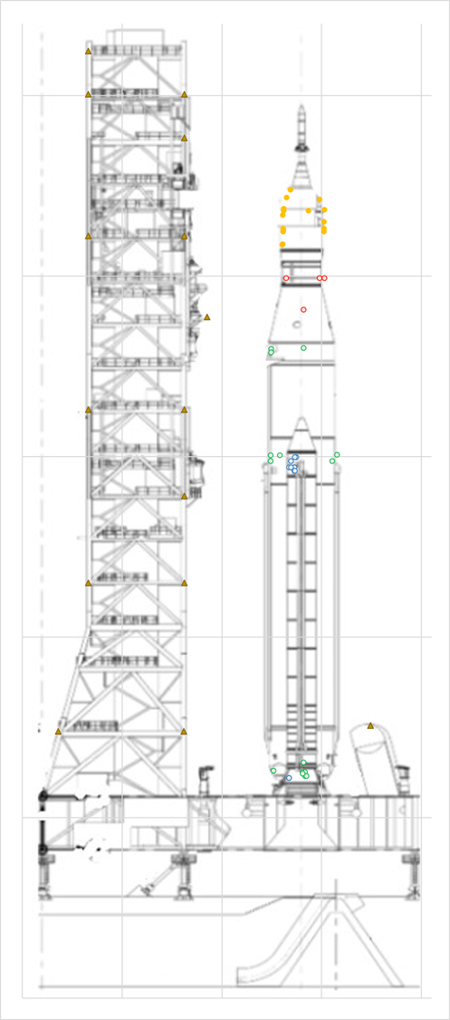
Fig. 1 Artemis I Liftoff Environment Measurements
- Port Resonance Removal
Some of the liftoff environment transducers were recessed in small cavities (ports) which experienced an acoustic resonance that erroneously amplified the data. A single-degree-of-freedom resonance model was created and used to remove the resonance effect from the data in those measurements. The resonance adds energy at the acoustic mode frequency of the port that is not part of the acoustic field on the vehicle. The port resonance effect and its removal are illustrated in the 1/3 Octave Band Spectra in Fig. 2. These spectra are computed for a 1 second time interval occurring a short time after liftoff.

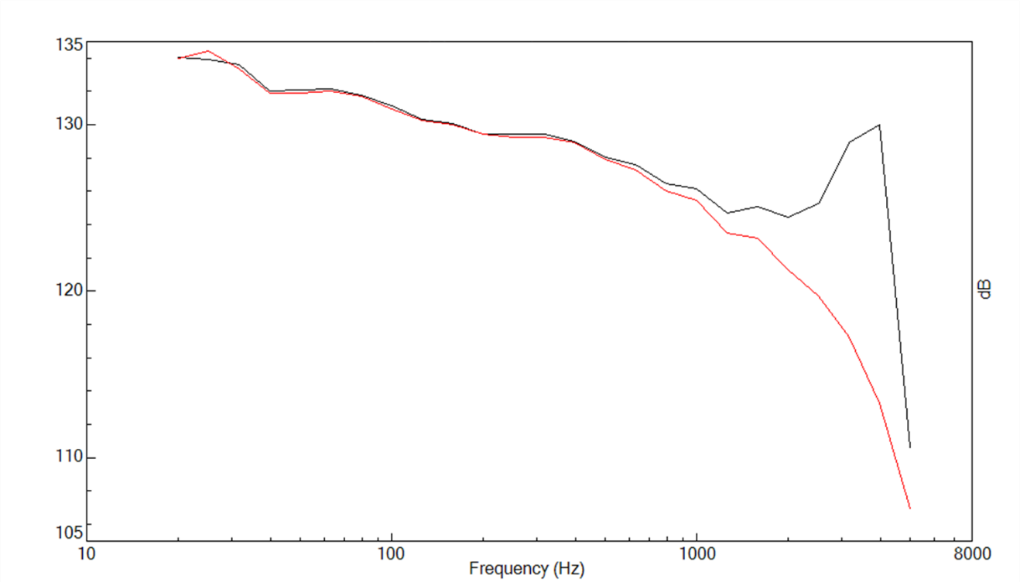
Fig. 2. 1/3 Octave Band Spectra of Raw Data (black) and Port Resonance Removed Data (red)
- Trend Removal
Some measurements showed a bias and slow drift in the mean pressure. This drift has been attributed to gradual changes in temperature or changes in mean pressure due to flight effects. For the acoustics environment, which is from 20 to 5000 Hz, the bias, slow trend, and very low frequencies can be removed from the data (Fig. 3) without affecting the 20 to 5000 Hz content of the signal. The de-trended data has an improved signal for frequency analysis.

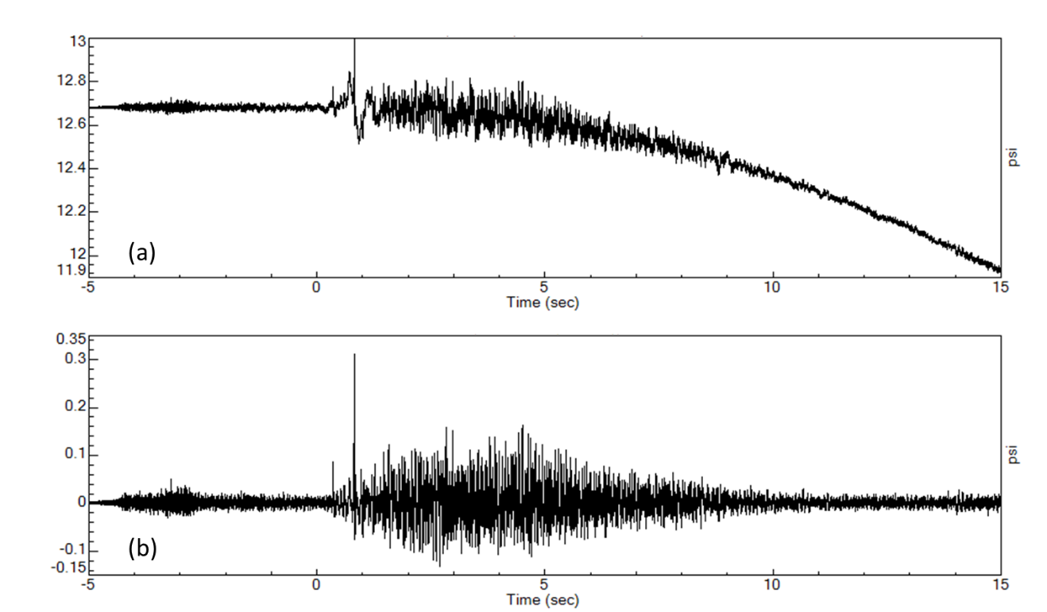
Fig. 3 Time History (a) without and (b) with Very Low Frequency and Trend Removal
- Time Alignment
Except for measurements on the crew vehicle and tower, each of these measurements was sampled, packeted, and telemetered to ground receiving stations. The data from the receiving stations was then reconstituted into its original form using software. Un-anticipated problems with this process led to issues with time alignment and data gaps. Two types of software algorithms were used to reconstitute the telemetered data into original measurement time signals. The simplest algorithm assigns time in sequence to all data points within a data packet. The sequentially assigned time references the beginning packet time which is included in the data stream. A more complex algorithm provides timestamp validation based on known clock drift and biases from the flight telemetry. This second algorithm provides time values that are more accurate than the simple algorithm.
Examination of all the data showed that there was an erroneous time delay (Fig. 4.a) for measurements from the sequential algorithm (red) to the timestamp validation algorithm (black). This delay occurred on most measurements, and it was different for different groups of measurements. By shifting the measurement start time, the simple algorithm data was aligned to the data that was reconstructed with the time validation algorithm (Fig. 4.b). This results in a close reconstruction from both sets of data.

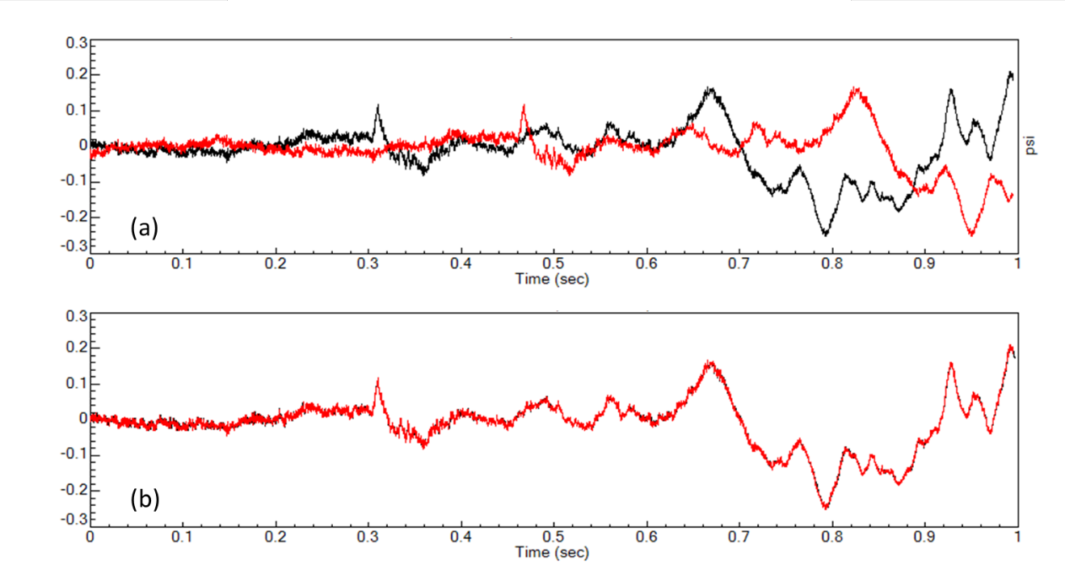
Fig. 4 (a) Original Sequential Data (red) and Timestamp Validation Data (black); (b) Sequential Data Shifted to Align with Timestamp Validation Data (red overlays black)
- Selecting Algorithm without Data Gap Write-over
Another problem with some of the data is that there were significant gaps in the data beginning a couple of seconds after liftoff (Fig. 5). The sequential reconstruction algorithm simply shows the data gaps in the sequence that they occur (Fig. 5.a and Fig. 6.a). The timestamp adjustment algorithm, while able to adjust for small data gaps, creates a period of erroneous data when it encounters larger data gaps. By careful examination of the data, it was determined that the data gaps trigger the timestamp algorithm to incorporates negative time markers, while reconstructing the data, which causes a re-write over existing data; and in this example also producing a lengthy data gap (Fig. 6.b). After a short time of erroneous data, the algorithm begins to provide accurate data again. The data re-write issue invalidates a crucial portion of the timestamp validation algorithm data and for that reason the sequential algorithm data was used to generate the liftoff environments for the ten seconds after liftoff. Note that the gaps are set to zero in the figures, but next we will show that the reconstructions use interpolation which creates other problems.

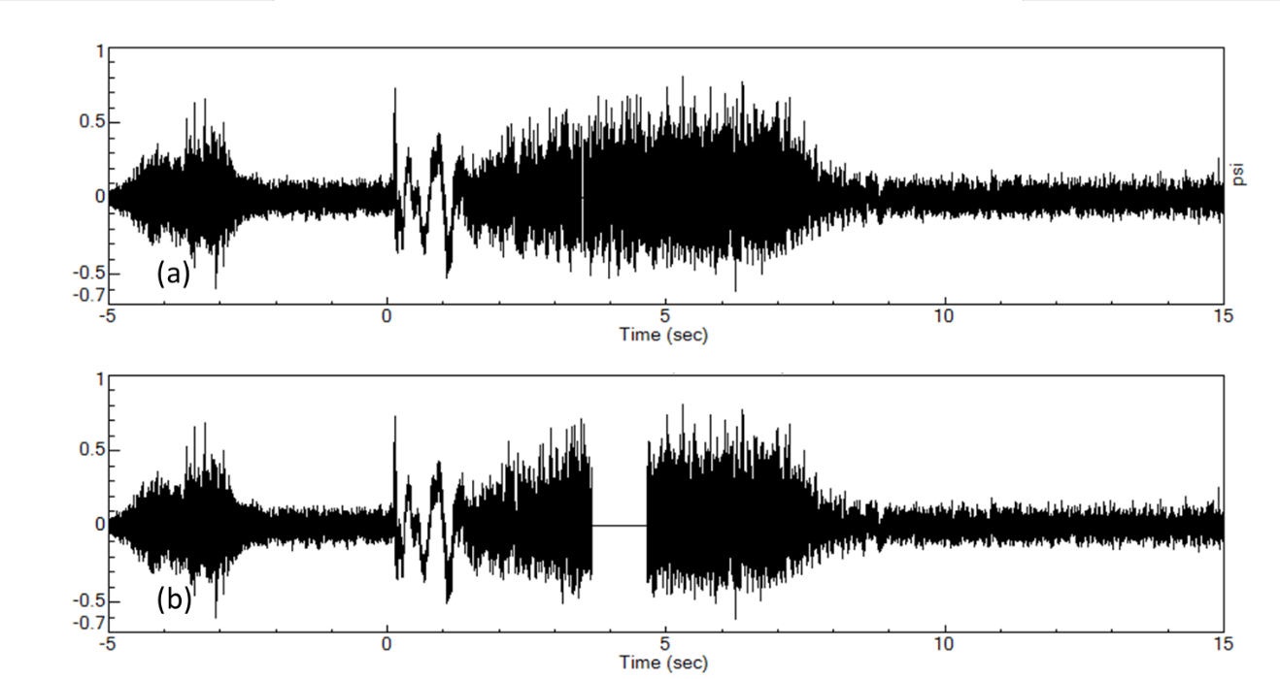
Fig. 5 Example of Data Gaps on Both (a) Sequential Time (b) Timestamp Validation Algorithms

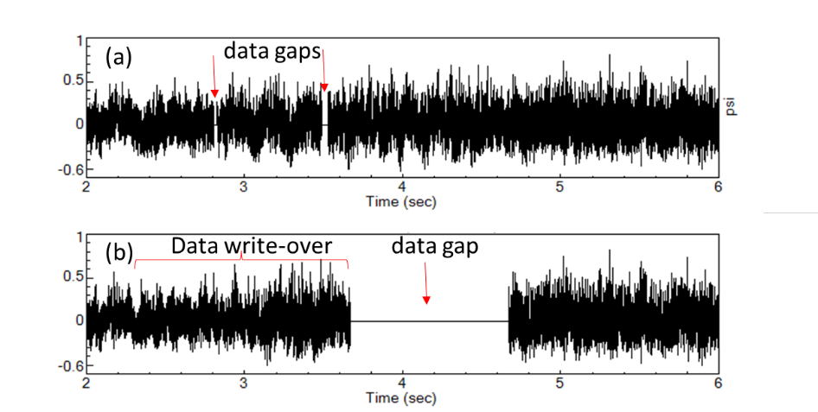
Fig. 6 (a) Sequential Time Gaps (b) Timestamp Validation Gap and Data Write-over

- Data Gap Zeroing
All the liftoff environment measurements were examined, and data gaps were identified in 22 of those measurements. A major problem with the data gaps is that the software tool used to reconstruct the acoustic measurements linearly interpolated across the data gap interval. This is sound practice for a data gap of one or two data points; however, much larger gaps were found in the liftoff environment measurements. This led to excessively biased ‘steps’ in the data which show up as erroneous high-amplitude low-frequency spectral values. By zeroing the gap data, this error is mitigated. It can be shown that the period of no-data is small compared to the block size, resulting in only a fraction of a dB drop in spectrum amplitude.

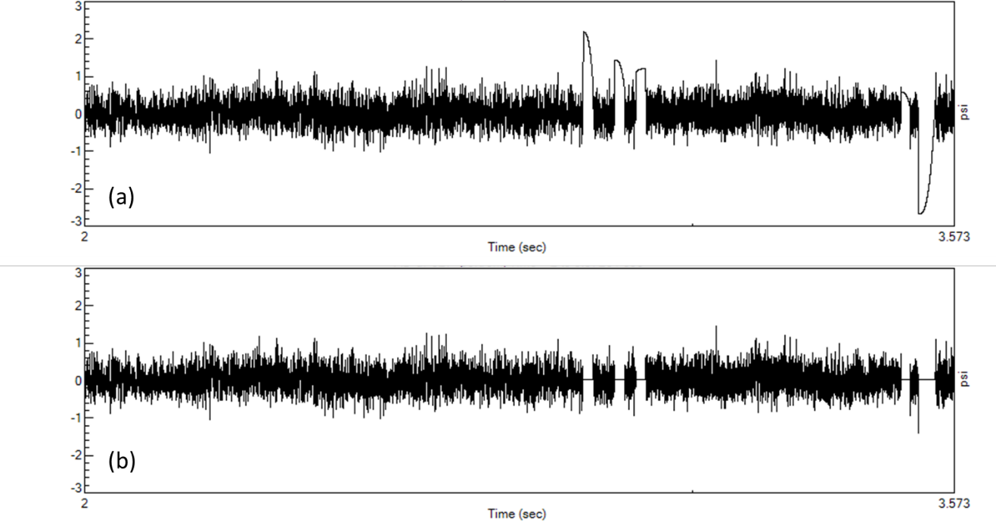
Fig. 7 Time Plots of Data Gaps as They Appear (a) When Interpolated (b) When set to Zero
Data gaps are interpolated by the reconstruction algorithm (Fig. 7.a). Spectra of the raw interpolated gap flight data shows erroneous amplitude at low frequencies due to the bias steps in the gaps (Fig. 8, black). The gap data can, however, easily be set to zero (Fig7.b). The zero-filled gaps data removes the erroneous amplitude at low frequencies due to the bias steps in the interpolated gaps (Fig. 8, red).

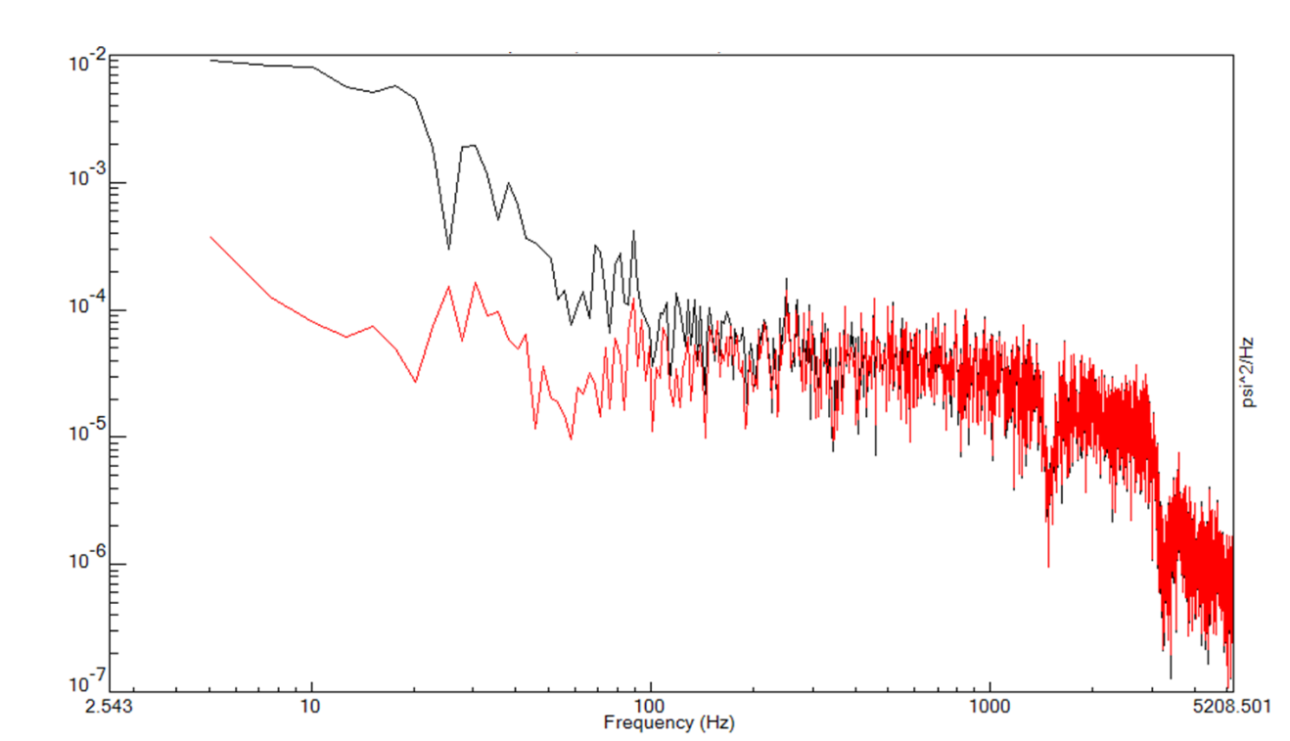
Fig. 8 Power Spectral Density Showing Gap Interpolation Low Frequency Distortion (black) Compared to Zeroed Gap (red)
- Data Spike Zeroing
All the liftoff environment measurements were examined, and data ‘spikes’ were identified in 3 of those measurements. These were large-amplitude, short-duration spikes. These large amplitude spikes in the data distort the spectra. Time history plots in Fig. 9.a show a typical signal with spikes and then with spikes set to zero in Fig.9.b. The effect of one of these spikes on the 1/3 Octave Spectrum is significant. Fig. 10 shows a 1/3 Octave Spectrum plot of a 5 to 6 second time window of data. In this figure, the 1/3 Octave Spectrum of data with a spike (black) is compared to the 1/3 Octave Spectrum of the same time window with the spike set to zero (red). Because of the short zeroed-spike duration, the amplitude due to time of no data is insignificant compared to the analysis window length.

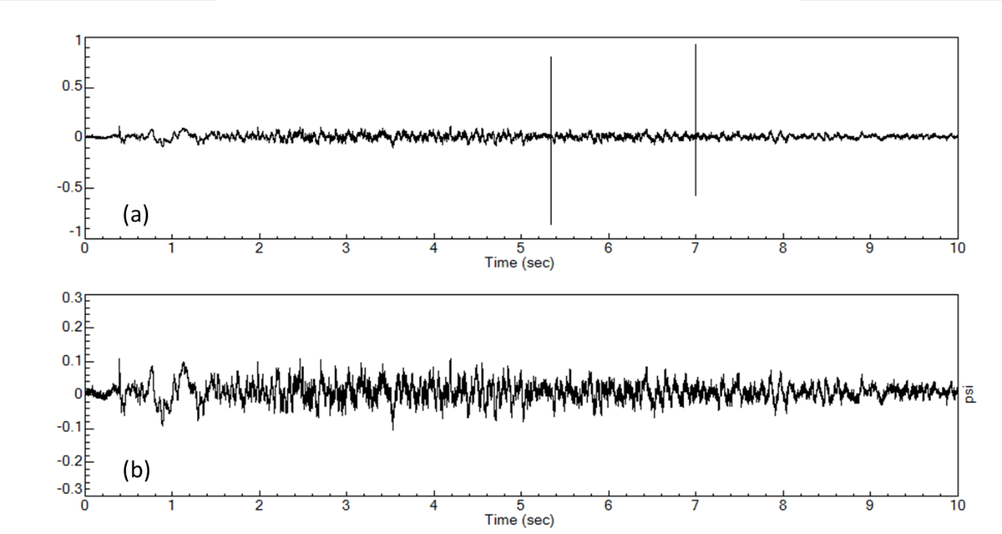
Fig. 9 Time Histories Showing (a) Spikes and (b) Spike Removal

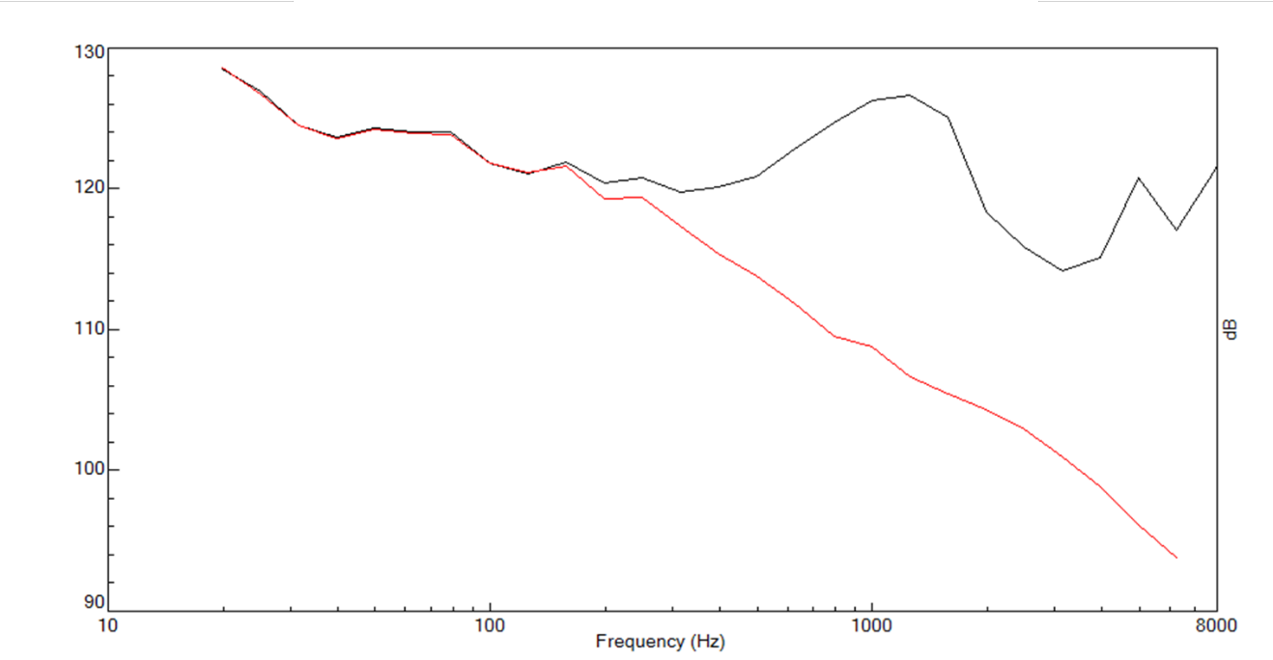
Fig. 10 1/3 Octave Band Spectra Showing Spike (black) and Spike Removal (red)
- Conclusion
In summary, 45 liftoff environment measurements were selected as ‘good’ and a series of corrections applied to provide time alignment, sense port resonance removal, trend removal, and gap and spike zeroing.

Subject Matter Expert, Fluid Dynamics Branch, Propulsion Systems Department
Engineering Consultant, Fluid Dynamics Branch, NASA Marshall Space Flight Center
Engineering Consultant, Fluid Dynamics Branch, NASA Marshall Space Flight Center
Casiano, M.J., and Fischbach, S.R., “Analytical and Numerical Modeling of Sensor Port Acoustics,” NASA TP-20210000024, January 2021

