Simulations of OSIRIS-REx Atmospheric Entry for Comparisons with Data from the Imaging Campaign
Dinesh K. Prabhu
AMA, Inc. at NASA Ames Research Center, Moffett Field, CA 94035, USA
Results from pre-flight flow and radiation simulations for the OSIRIS-REx Sample Return Capsule along a candidate entry trajectory are presented. These results are from pre-flight simulations in support of the observation campaign. Details of the methodology for computing temporal variation of spectral irradiance on an instrument onboard an aerial observation platform are presented along with a sampling of results. An attempt is made to use the methodology presented to assess the level of elemental sodium in the shock layer. The final paper will be based on the actual flight trajectory and will include comparisons of predictions with calibrated spectrometric data.

Introduction
S
pectrometric imaging, using an airborne platform, of a capsule entering Earth’s atmosphere at hyperbolic speeds has reached a certain level of maturity, having been applied to four missions now (see Table 1). The technique was first applied to NASA’s Stardust mission [1] and then refined for the two Hayabusa missions [2,3]. The latest application of this technique is NASA’s OSIRIS-REx (Origins, Spectral Interpretation, Resource Identification, Security, Regolith Explorer) mission. In this mission, the Sample Return Capsule (SRC), almost identical to the previously flown Stardust, entered Earth’s atmosphere on September 24, 2023 and landed safely in Utah Test and Training Range (UTTR), the same place where the Stardust SRC landed; the two Hayabusa capsules landed in the Woomera Test Range (WTR) in Australia.

Table 1. List of Earth-entry missions to date that have used spectrometric imaging.
Mission/Agency | Entry Date | Landing Site | SRC dia. (m) (Mass (kg)) | Entry speed (km/s) | Aerial Obs. Platforms
Stardust/NASA | 15 Jan. 2006 | UTTR, USA | 0.811 (46) | 12.9 (inertial) | NASA N817 (DC-8)
Hayabusa/JAXA | 13 Jun. 2010 | WTR, Aus. | 0.413 (16) | 12.2 (inertial) | NASA N817 (DC-8)
Hayabusa2/JAXA | 5 Dec. 2020 | WTR, Aus. | 0.413 (16) | 12.0 (inertial) | NASA N992 (GIII)  NASA N520 (GIII)
OSIRIS-REx/NASA | 24 Sep. 2023 | UTTR, USA | 0.811 (55) | 12.4 (est. relative) | NASA N522 (GIV)  NASA N992 (GIII)  NASA N927 (WB-57)  Falcon 990EX

One the one hand, in the absence of any instrumentation/sensors built into the thermal protection system around an entry capsule, an airborne spectrometric imaging campaign is a valuable alternative method to obtain data to verify the simulation tools used in aerothermal design of the thermal protection system. Irradiance measurements provide temporal and spectral resolution of two primary sources of radiance from the SRC: (i) a volumetric source representing the shock-heated gas mixture around the entry capsule, and (ii) an areal source representing the aerodynamically-heated surface of the capsule. Since the radiating object, i.e., the SRC, is imaged from a distance orders of magnitude larger than the geometric length scale (e.g., the base diameter) of the object, there is no spatial resolution of either the flow field or the capsule. Consequently, the radiance is homogenized or spatially averaged with subsequent transmission through the intervening atmosphere. Nevertheless, the relative magnitude of measured irradiance of the two sources allows one to discern certain characteristics of the radiance, e.g., the surface temperature that develops as a consequence of the imposed aerothermal environments. Post-flight analysis of measured irradiance allows one to assess the conservatism in the aerothermal design and thus lead to a more informed margins policy, which is usually driven by ground testing and/or limited flight data. On the other hand, if there are sensors built into the thermal protection system around the entry capsule, an airborne imaging campaign would obtain supplementary data and thus provide a self-consistent and more complete data set for better validation of simulation tools.
The present work is an application of tools and techniques developed initially for the Stardust entry imaging mission [4]. These tools and techniques, with refinements in the process and/or modeling, were used subsequent imaging campaigns – Hayabusa [5] and Hayabusa2 [6]. Given the as-flown or best-estimated trajectory (BET) for the entry capsule, the process consists of predicting the flowfield around the entry capsule at several points along the trajectory, computing the radiance on to an imaging plane, transmitting the integrated (in solid angle) radiance to the instrument, and finally scanning the predicted irradiance with the instrument function for each spectrometer used in the campaign. In the present work, the flowfields are computed using Dplr [7,8] and the radiance distributions are computed using Neqair [9,10]. Computation of the radiance distribution at each time point from the computed flowfield is accomplished using an in-house software utility, Stardust_Lines [11], which constructs lines of sight normal to an imaging plane for a specified combination of view angle and slant range determined the airborne platform. The wavelength range covered in the radiance computations is dictated by the instruments used in measurements. In the present work, a wavelength range of 300-2100 nm is considered, and the instrument function is that of CALSPEC [12] used in the Haybusa2 imaging campaign.
In what follows, details of the methodology for computing temporal variation of spectral irradiance on an instrument onboard an aerial observation platform are presented along with a sampling of results. An attempt is made to use the methodology presented to assess the level of elemental sodium in the shock layer.

Methodology
The methodology used in the present work, conceptualized in Fig. 1a, is essentially similar to that adopted for Hayabusa2 simulations [6]. Briefly, the source of radiation, i.e., the aerodynamically-heated capsule, surrounded by a shock-heated gas mixture, radiates (over all wavelengths) into the field of view of an instrument onboard the airborne platform (Fig. 1a). This spectral radiance (in units of W.cm⁻².µm⁻¹.sr⁻¹) of the source is first captured on an imaging plane (Fig. 1b). The imaging plane is discretized by a large number of lines of sight (normal to the plane), some of which intersect the capsule surface. A line-by-line radiative transfer code is used to compute spectral radiance along each line of sight with high resolution in wavelength. The individual spectral radiances, after attenuation by the intervening atmosphere, are summed, i.e., integrated over the solid angle (of the field of view) to obtain the spectral irradiance (in units of W.cm⁻².µm⁻¹) on the instrument. The high-resolution spectral irradiance is then convolved with the slit function of the instrument, which then allows one-to-one comparisons with measured data. Given that the distance of the airborne platform is orders of magnitude larger than the size of the SRC, the summation of radiance over the imaging plane is essentially homogenization to a point source, which is what the SRC appears to the observing aircraft. In other words, while the airborne instruments provide temporal and spectral resolution of the radiating source, they do not resolve the source spatially [3,12]. The current methodology does not consider background solar radiation for a daytime entry; OSIRIS-REx was a daytime entry, unlike the other three missions – Stardust, Hayabusa and Hayabusa2 (listed in Table 1) – which were nighttime entries. The assumption in the present work is that compensation for the solar background is handled at the instrument level and not in the simulations.

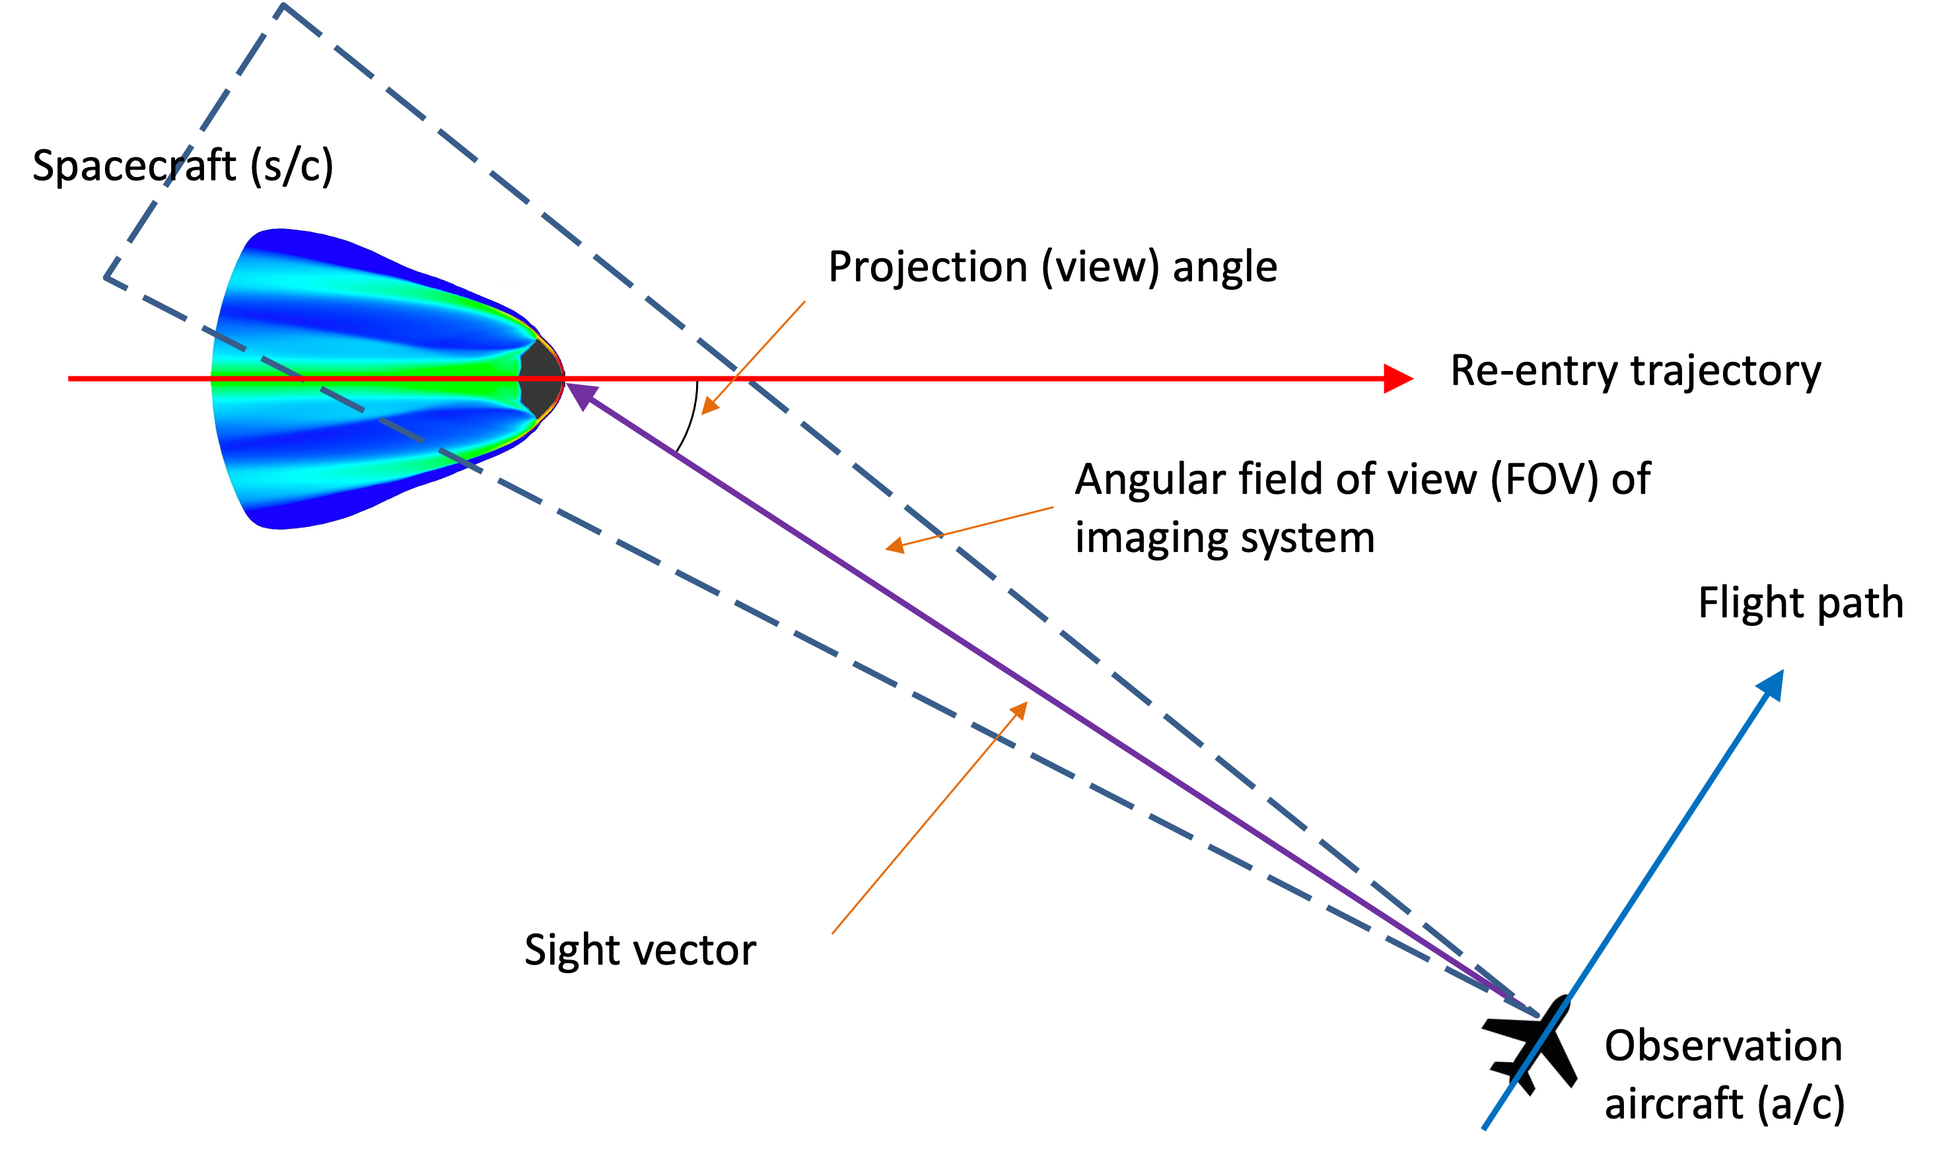 | 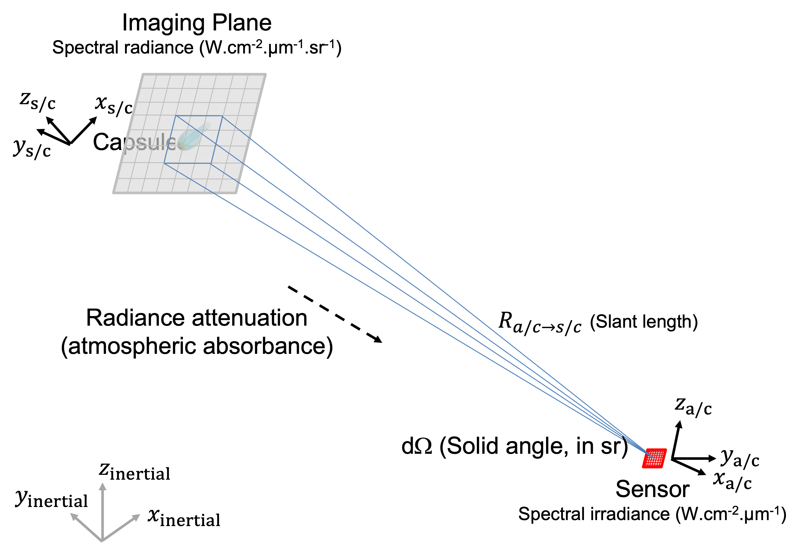
(a) Observation a/c and SRC | (b) Radiance and irradiance
Figure 1. (a) Schematic overview of the imaging process – exaggerated scale. Emission from the shock-heated gases and surface re-radiation within the field of view contribute to the radiance observed from the aircraft. (b) Radiance (units of W.cm⁻².µm⁻¹.sr⁻¹) from the object is captured on the imaging plane (surface of a sphere whose radius is the slant length of the sight vector) and the view angle is the angle the sight vector makes with the velocity vector of the spacecraft.

Preliminary Results
Each step of the methodology is described in what follows. At the time of writing the present extended abstract, a best estimated trajectory (BET) for the SRC was not available. Therefore, the focus of the present work is to catalog the results of pre-flight computations which helped in setting the ranges of various instruments onboard the airborne observation platforms.

- SRC Configuration and Flight Trajectory
The generatrix of the OSIRIS-REx SRC is shown in Fig.2a. The 0.8 m diameter, 60° blunted sphere-cone configuration is identical to the Stardust SRC. Since the SRC has rotational symmetry, its three-dimensional representation is constructed quite easily by rotating the generatrix about the roll axis.
A nominal flight trajectory of the SRC is constructed with Traj [13] using an entry state provided in the work of White et al. [14] and the US 1976 Standard Atmosphere [15]. This trajectory, shown in Fig. 2b as an altitude-velocity map, is compared with the BETs of Stardust and Hayabusa2. The differences between the Stardust and OSIRIS-REx trajectories, despite identical vehicle geometries, are due to differences in mass, velocity, and flight path angle at entry interface (EI) of the two SRCs.
Four regions of the atmosphere – the troposphere, stratosphere, mesosphere, and thermosphere – are called out in the altitude-velocity map, and the interfaces between these regions are shown as dotted lines (to denote them as being notional). Also shown in Fig. 2b are three shaded regions. The lowest of these is the region where the observation aircraft operated. Above this is the ozone layer, which being a strong absorber of radiation below 290 nm, precludes any irradiance measurement at wavelengths below this limit. Finally, the topmost shaded layer, denoted as a metal vapor layer, represents the region that is most likely to have metal content from the constant bombardment of Earth’s atmosphere by meteors and dust.

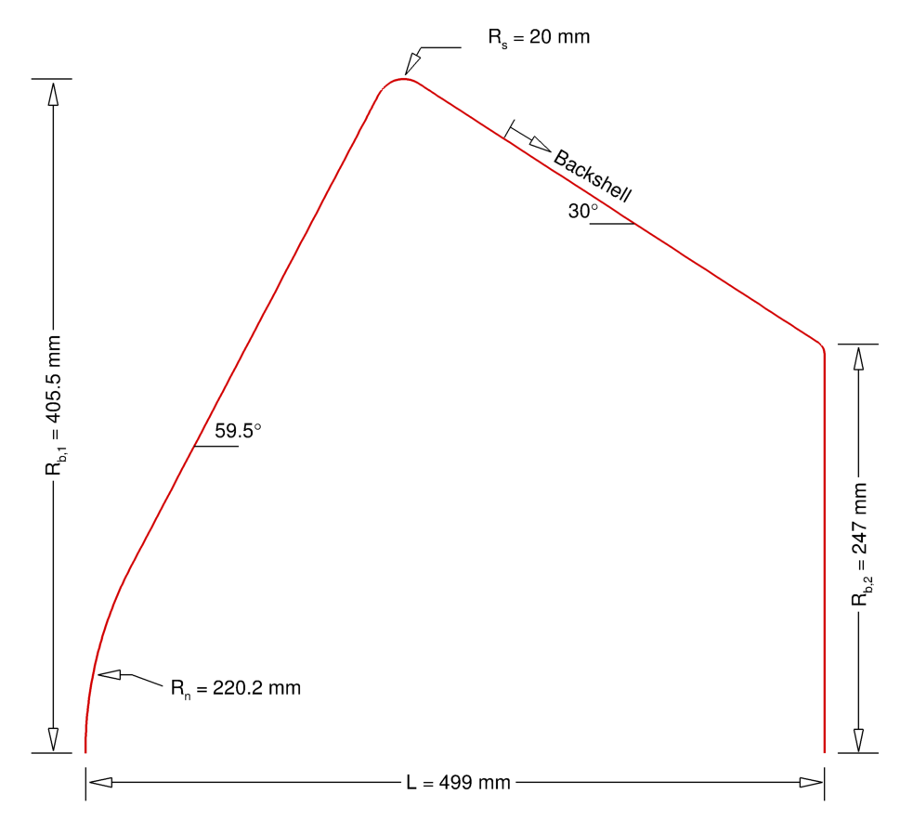 | 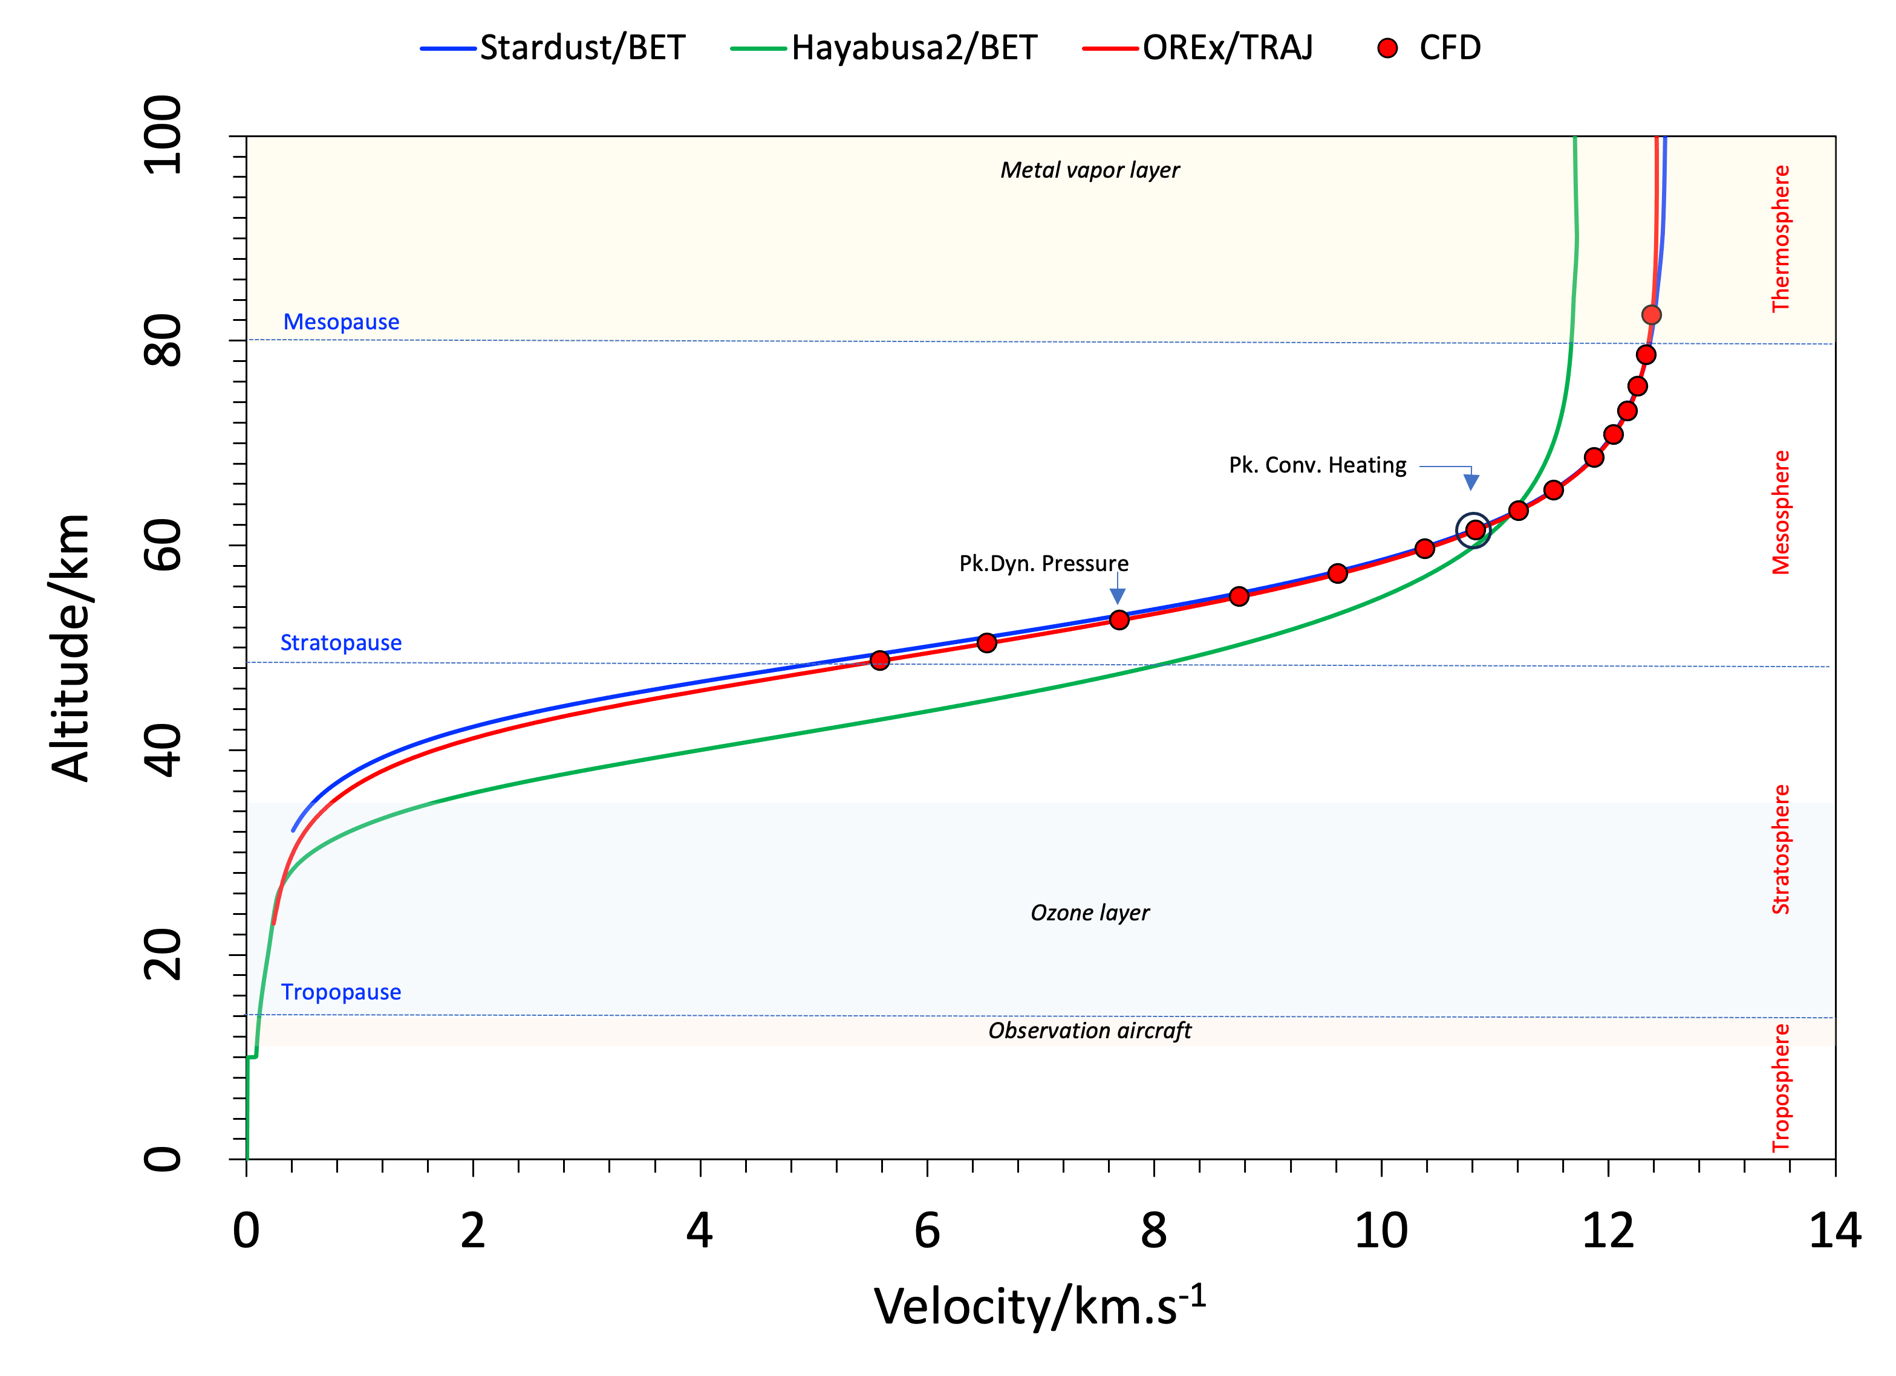
(a) SRC generatrix | (b) Altitude vs. Velocity map
Figure 2. (a) Generatrix of the SRC, and (b) Altitude-Velocity maps for Stardust and Hayabusa2 BETs and a nominal 3DOF trajectory (constructed using Traj) of the OSIRIS-REx SRC.

The symbols along the flight trajectory of the OSIRIS-REx SRC are the points selected for detailed flow computations and correspond to roughly 30 s (from t = 33 s to t = 63 s) of the spectrometric observation period. During most of the observation period, the flight of the SRC is in the mesosphere.

- Flowfield Computations
Detailed flow computations are performed using v4.05.1b2 of the flow solver Dplr [8] at points selected (symbols in Fig. 2a) along the flight trajectory. Since the flight of the SRC is ballistic (i.e., C_{L} = 0, ignoring small oscillations in angle of attack), axisymmetric computations are sufficient. The axisymmetric flow solutions are easily converted into equivalent 3D solutions using an in-house utility software called Revolve_Grid [11]; three-dimensional solutions are needed for radiance computations. While Dplr is used to determine convective heating, v15.2.2 of Neqair [10] is used at select spatial locations to determine radiative heating from the shock-heated gas mixture around the SRC to the surface of the SRC. Both convective and radiative heating distributions over the surface of the SRC are needed to compute the response of the materials (PICA and SLA-561V) that make up the thermal protection system.
At each point selected along the flight trajectory, the ambient density and temperature, and SRC velocity (relative to the atmosphere) are used in flow computations. The requisite gas composition, in terms of mole and mass fractions of constituent species, used in the present work is provided in Table 2. The trace species CO2 and H2O are included to see if the shock-layer radiation signature will show significant contributions from CN and/or H, which have been observed in entries of Stardust, Hayabusa, and Hayabusa2.

Table 2. Composition of the ambient atmosphere.
Species | Molar mass  (kg/kmol) | Mass fraction  (Y_{s}) | Mole fraction  (X_{s})
N₂ | 28.01348 | 0.755149 | 0.780813
O₂ | 31.9988 | 0.231431 | 0.209493
Ar | 39.948 | 0.012824 | 0.009298
CO₂ | 44.0095 | 0.000593 | 0.000390
H₂O | 18.01528 | 0.000003 | 0.000005

A 30-species (CH₄, CH₃, CH₂, H₂O, CO₂, CO, CO⁺, C₂, N₂, N₂⁺, O₂, O₂⁺, H₂, CH, OH, NO, NO⁺, CN, CN⁺, C, C⁺, N, N⁺, H, H⁺, O, O⁺, Ar, Ar⁺, e–) model is employed with a 2-temperature model and a chemical mechanism (kinetics) due to Cruden [16]. The number of species is expanded from the usual 11-species air model to accommodate CO₂, H₂O, and Ar as additional atmospheric constituents and also in anticipation of including ablation products from the PICA heatshield in the final simulations. For the present work, the surface is assumed to be one that allows atomic species O, N, and H to recombine to O₂, N₂, and H₂, respectively, and one that neutralizes cations. Furthermore, the surface is assumed to be in radiative equilibrium with a constant emissivity of 0.85. Since the flow solver does not consider conduction of heat through the thickness of material, the surface temperatures resulting from the re-radiation boundary condition will be higher than observed. A materials thermal response solver, such as Fiat [17], or Pato [18], is necessary to obtain more realistic values surface temperature.
The temporal variations of computed heat fluxes – convective, radiative, and total – at the apex of the heatshield (i.e., the stagnation point) are shown in Fig. 3a, and that of the pressure are shown in same figure. The peak values and the corresponding times (from EI) are called out in the figure. The peak radiative, total, and convective heat fluxes are spaced roughly 2 seconds apart with the peak radiative heating occurring at t = 47.5 s, peak total (radiative + convective) heating occurring at t = 49.5 s, and peak convective heating occurring at t = 51.5 s. Peak dynamic pressure occurs at t = 63 s.
In the present work, only laminar flow solutions have been computed at all time points except at t = 53.5 s, where an additional turbulent flow solution has been computed. Examination of laminar solutions with both momentum thickness Reynolds number (${Re}_{θ}$) and roughness Reynolds number (${Re}_{kk}$) criteria did not indicate the possibility of the flow transitioning from laminar to turbulent.

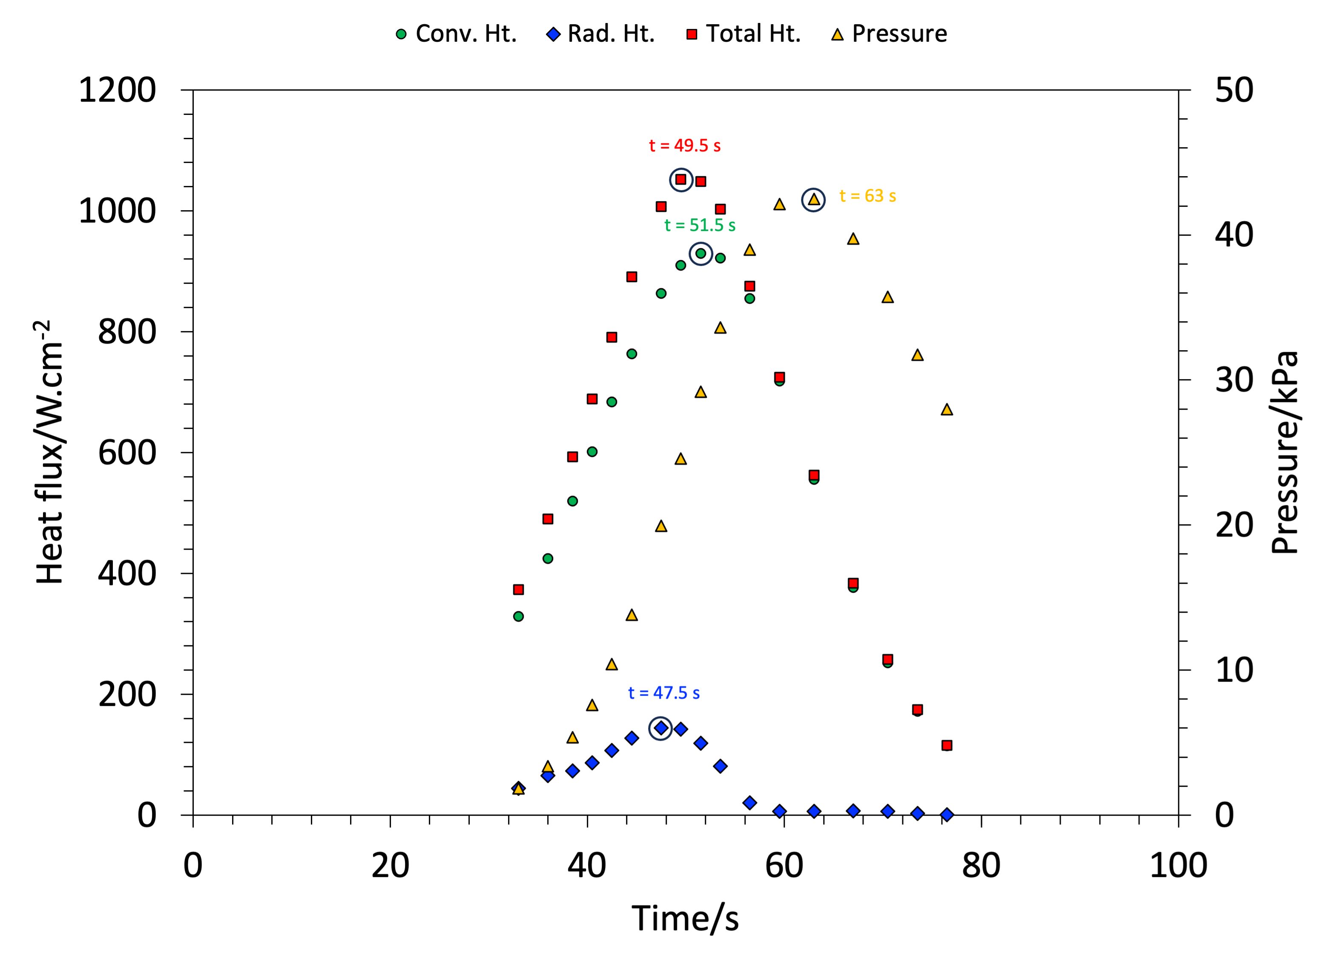 | 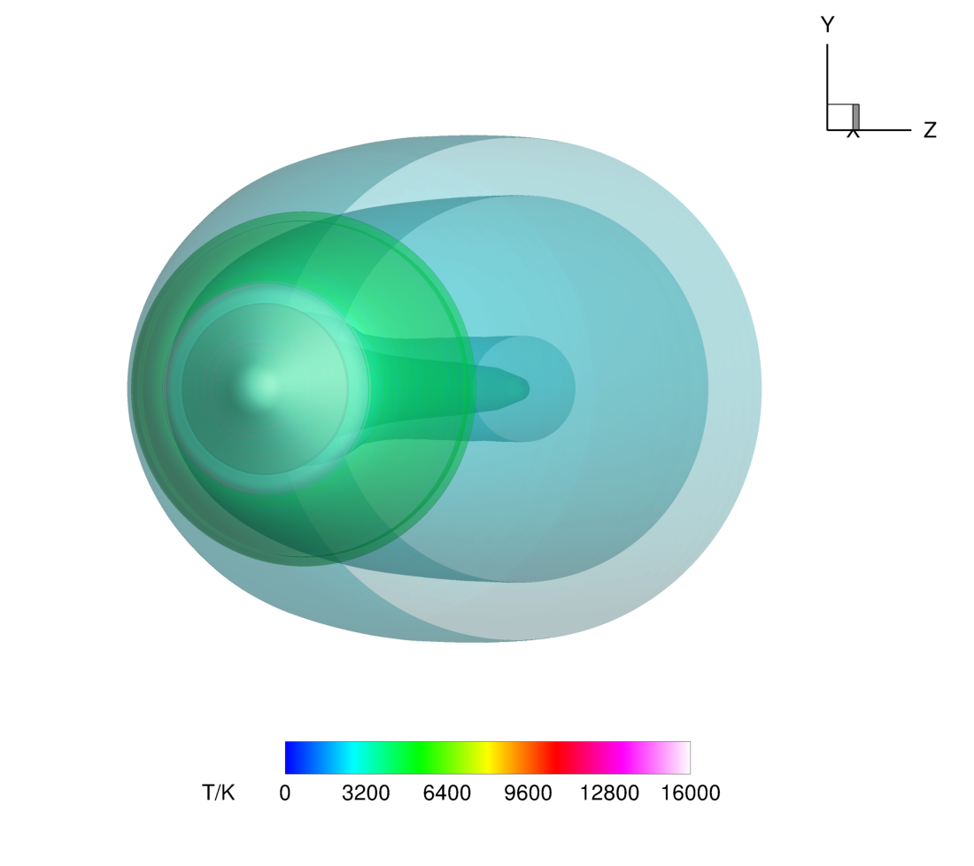
(a) Stagnation point environments | (b) Temperature isosurfaces
Figure 3. (a) Histories of heat flux – convective, radiative, and total – and pressure at the stagnation point of the SRC, and (b) isosurfaces (translucent) of temperature – 2500 K, 5000 K, and 15000 K – at t = 53.5 s (from EI).

A typical 3D flow field solution at t = 53.5 s (from EI) is shown in Fig. 3b. The three-dimensional volume is constructed from the computed axisymmetric solution using the software utility Revolve_Grid [11]. The translucent surfaces that envelop the SRC are isotherms corresponding to 2500 K, 5000 K, and 15000 K. The spectral radiance from this volume, including the aerodynamically-heated SRC, is computed at each time point.

- Spectral Radiance
Two parameters – the slant range and view angle – are needed to compute the spectral energy flux (or irradiance) on the instrument sensor. The slant range is the magnitude of the sight vector from the observation platform to a point on the SRC surface. The view angle is the angle included between the sight vector and the velocity vector of the SRC. In this convention, a view angle of 0° means that the SRC is viewed head on. The slant range and view angle depend on the flight path of the observation aircraft. Of the four aircraft deployed, three of them – N992, N522, and N927 – had all the NASA instruments on board. The fourth aircraft, Falcon 990EX, had instruments of international team members.
The slant range and view angle time histories for the aircraft N992 are shown in Fig. 4a, and for the aircraft N522 in Fig. 4b. These time histories are from the proposed flight paths and not as-flown data. The actual flight paths were not available at the time of writing this extended abstract. For N992, the view angle increases from 7.5° to 21° while the slant range decreases from roughly 400 km down to about 100 km. For angles less than 30° the backshell of the SRC does not come into view because the SRC is a 60° blunted sphere-cone. From the previous experience with Hayabusa2 [6], it is known that irradiance is not as sensitive to view angle as it is to slant range, and irradiance varies at the inverse square of the slant range. Therefore, the instruments on this aircraft would measure rapidly increasing irradiance, with levels decreasing past peak heating, even if the slant range is much smaller than at entry. This is because the SRC starts cooling (relatively speaking) past the peak heating point. For N522, the view angle increases from about 44° to abut 160° while the slant range decreases very slowly between 300 km and 200 km. The measured irradiance would be less sensitive to slant range and would be more sensitive to the backshell and wake environments.

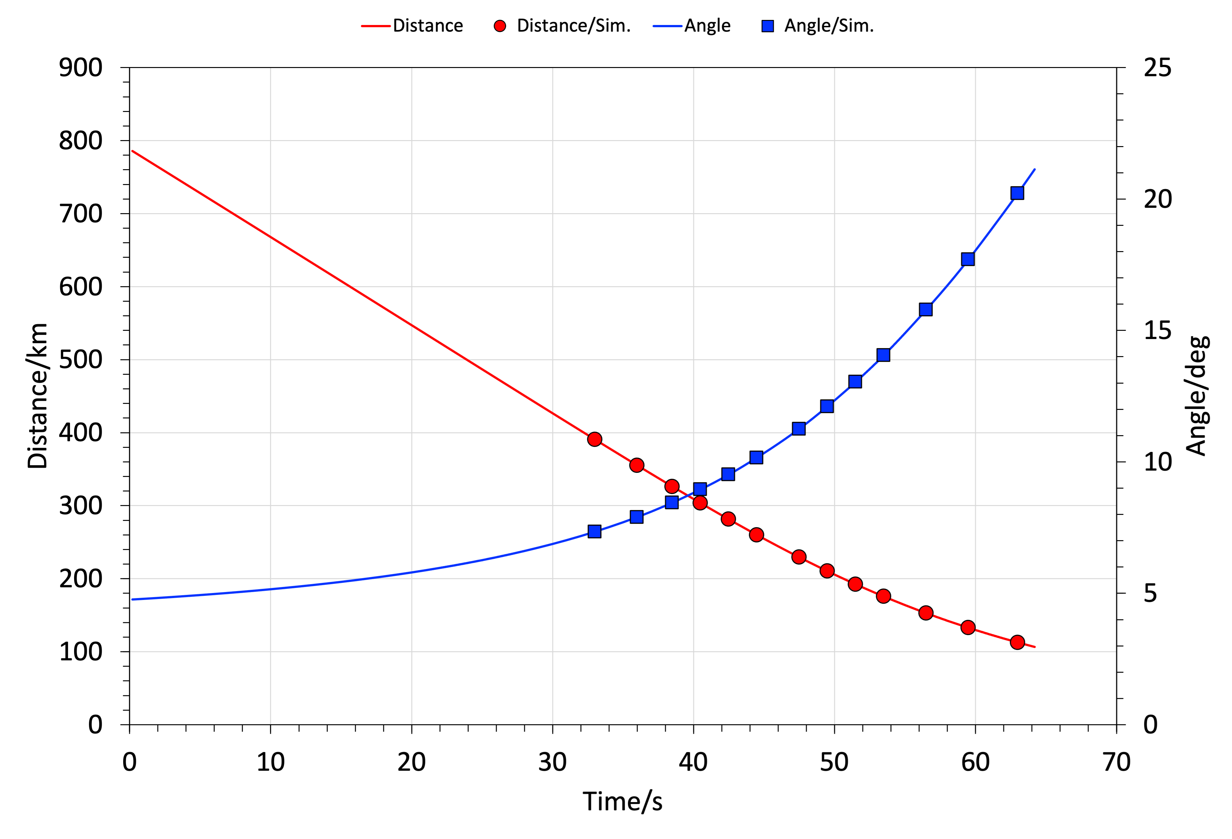 | 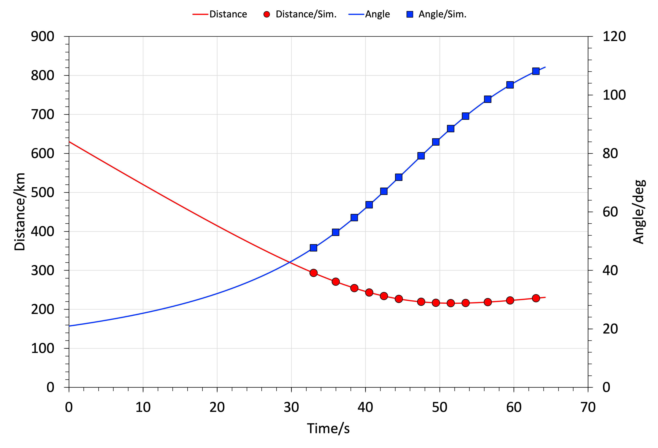
(a) N992 | (b) N522
Figure 4. Slant range and view angle time histories for: (a) N992 and (b) N522 aircraft. It is assumed that t = 0 for both aircraft coincides with t = 0 for the flight trajectory.

It is tacitly assumed here that the clocks of the observation aircraft (and the instruments onboard) are synchronized with that of the SRC. For the SRC, t = 0 is reckoned at EI. The consequence of unsynchronized clocks in examined later in the present paper.
Computation of radiance using Neqair [10] is straightforward. As shown in Fig. 1b, the radiance from flowfield (Fig. 3b) is captured on an imaging plane (a small rectangular patch on a sphere whose radius is the slant length from the observing aircraft and the SRC). The imaging plane is divided into small area elements, and lines of sight perpendicular to the imaging plane are constructed using an in-house software utility Stardust_Lines [11]. This plane is large enough to accommodate the entire 3D volume solution from flow computations. The lines of sight that intersect the body are terminated at the point of intersection, while the other lines of sight are terminated at the outer boundary of flow volume grid – the outer boundary is at ambient conditions). The initial value of radiance is either zero at the ambient condition termination point, or $B_{λ}(T_{w})$ (blackbody function evaluated at $T_{w}$) at surface termination point. Radiance transport from the initial point to the imaging plane is computed for each line of sight for wavelength ranges of 290–1000 nm, and 1000-2100 nm, all with high resolution. Lines and bands of all relevant species, and associated continua (bound-free or free-free) are included in the computations. The number of lines of sight (equivalently the number of area elements of the imaging plane) is based on prior experience with the Stardust and Hayabusa2 computations. One special feature of Neqair is its ability to move the lines of sight in an adaptive manner to increase the line density in regions of high radiance.
In an attempt to determine the relative contributions of volumetric and areal parts of the SRC flow field to radiance, two flow computations are performed at t = 53.5 s along the flight trajectory. In the first calculation, the baseline case, the surface of the SRC re-radiates (to a 0 K sink) incident heating with an emissivity of 0.85; there is no conduction of the incident heat flux through the thickness of the thermal protection material. The distribution of radiance on part of the imaging plane is shown in Fig. 5a for this case. In the second computation the surface of the entire SRC is assumed to be at a fixed temperature of 300 K, i.e., a cold wall. The distribution of radiance on part of the imaging plane is shown in Fig. 5b for this second case. The contour map shows the distribution of radiance from the shock layer alone since the radiance from the cold SRC surface is negligibly small. The radiance from the shock layer is about 50 times lower than the first case. In a third calculation, the entire shock layer around the SRC is replaced by the conditions of the ambient atmosphere, i.e., the aerodynamically-heated SRC is suspended in the ambient atmosphere. The resulting radiance distribution, shown in Fig. 5c, compares very well with distribution shown in Fig. 5a. The conclusion from these qualitative results is that the radiating surface of the SRC is the dominant contributor to total radiance, which points to the need for consideration of material thermal response to obtain better estimates of surface temperature. This observation could be useful in the interpretation of measured data (irradiance).

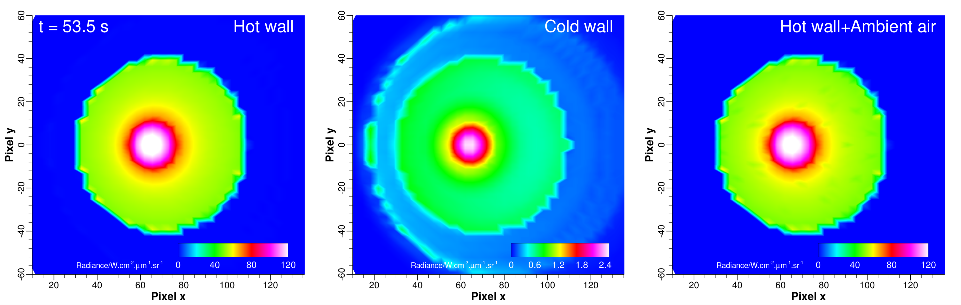
(a) Hot SRC + Shock Layer | (b) Cold SRC + Shock Layer | (c) Hot SRC + Ambient Atmosphere
Figure 5. Radiance contours on the imaging plane for: (a) entire shock layer, including the heated SRC, (b) entire shock layer, with the SRC at a temperature of 300 K, and (c) just the heated SRC imbedded in the ambient atmosphere. The slant range and view angle for these computations are 176 km and 14.1°, respectively.

The computed radiance on the imaging plane is converted to an irradiance by $\frac{1}{L^{2}}\int{I_{λ}dA}$, where $L$ is the slant length/range and $dA$ is the area element. However, before this conversion is made, radiance gathered at the imaging plane has to be transported through the intervening atmosphere between the source and instrument.

- Atmospheric Transmission
The penultimate step is to transmit the summed radiance on the imaging plane down to the instrument. Such a computation requires consideration of the intervening atmosphere. Usually, one would employ a code such as Modtran [19] to determine the transmission coefficient for the atmosphere. In the present work, however, the atmospheric spectral transmission coefficient is computed using Neqair itself as a separate step to the imaging computation. Atmospheric species and temperature profiles are obtained from Earth–GRAM 2016 [20] using the latitude, longitude and altitude of the spacecraft and observation aircraft, and converted to line-of-sight format by Neqair’s converter tool. Neqair is then run in transmission mode using the Hitran linelist [21] to compute absorption by O₃, H₂O, N₂O, CH₄, and CO, and the Leiden database [22] for photodissociation and photoionization of O₂ (Schumann-Runge continuum) and other air species. Absorption by other species, including atoms, CO₂ and bound O₂ Schumann-Runge, is computed by the existing Neqair databases. Rayleigh scattering is also computed in Neqair, but scattering by high altitude particles is neglected. Spectral transmission coefficient data are computed for each time point selected along the best-estimated trajectory. Atmospheric transmission as functions of wavelength predicted by Neqair (present work) and Modtran compare very well, ignoring the significant differences in the absorption peaks, as seen in Fig. 6. Although these absorption peaks differ, the impact of these in computed irradiance was not as much, at least not in the Hayabusa2 simulations [6].

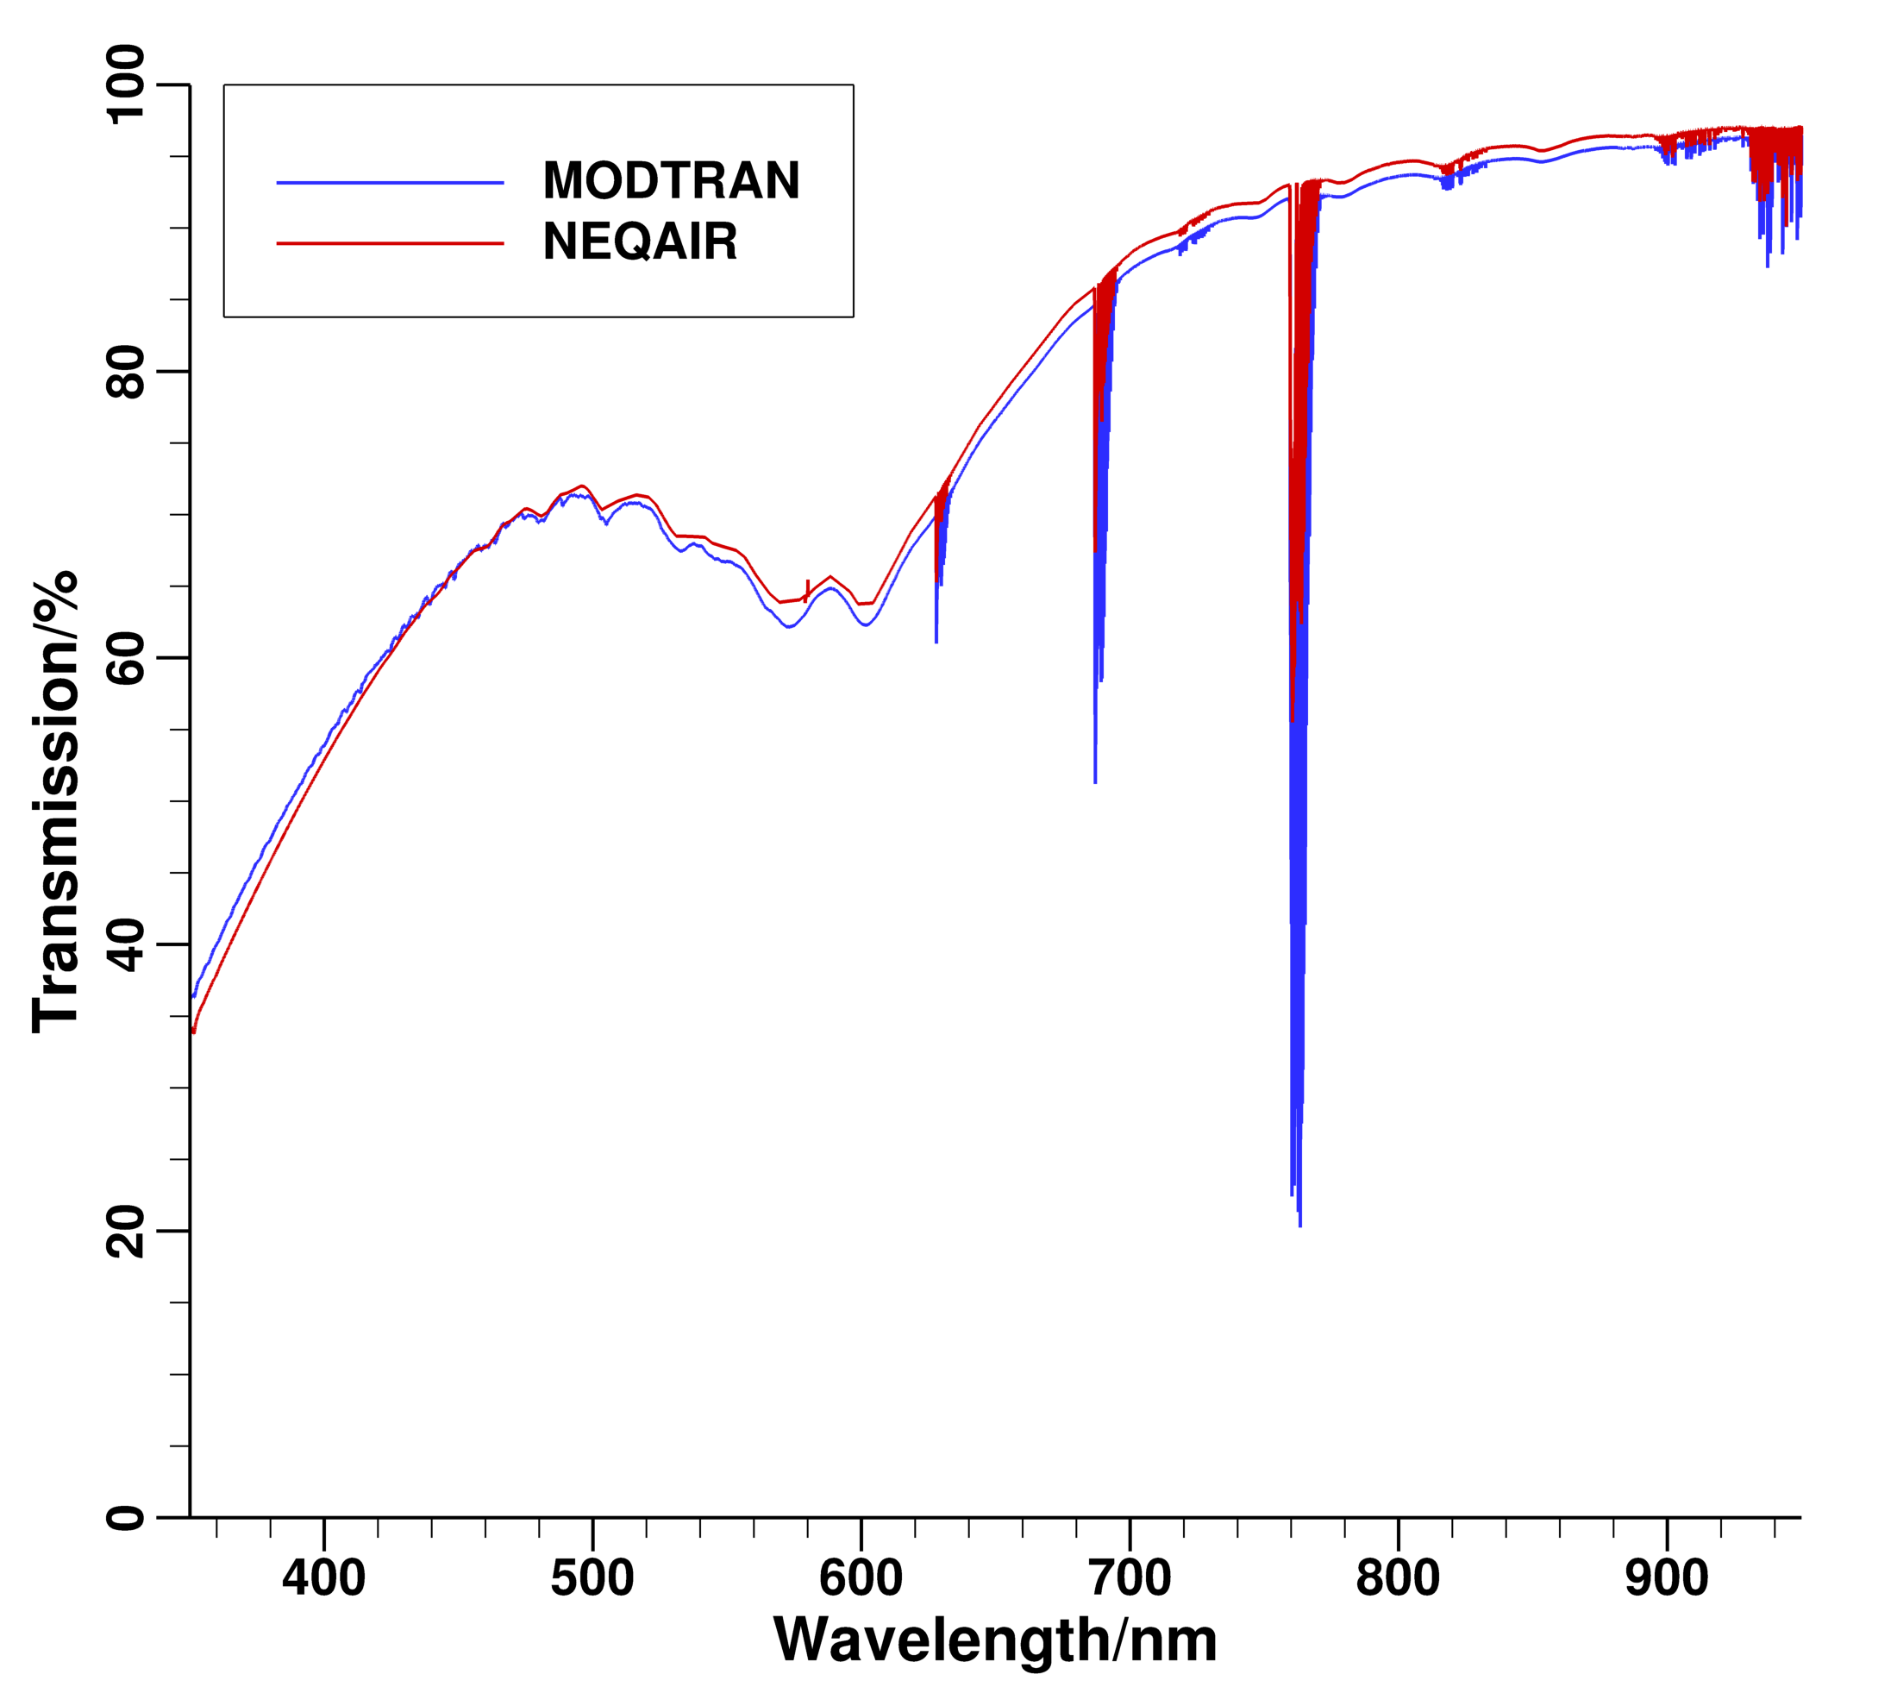
Figure 6. Comparison of transmission coefficients from Modtran and Neqair. The Neqair result does not include any particulate scattering, but does include Rayleigh scattering, photodissociation and line-by-line absorption coefficient.

- Spectral Irradiance
The final step is to convolve the high-resolution spectral irradiance with the instrument slit function. In the present work, it is assumed that the slit function is Gaussian. The full-width at half maximum (FWHM) depends on the instrument. Since these values were not available at the time of writing this paper, a value of 0.84 nm of the CALSPEC instrument (from the Hayabusa2 imaging campaign [12]) is used as a representative value of FWHM. The convolution is then performed by Neqair to obtain the scanned spectral irradiance, thus allowing direct comparison of predictions and measurements.

- Temporal Variation of Irradiance
Putting together all of the steps discussed so far results in the waterfall plots (Figs. 7a and 7b) of irradiance for the two NASA aircraft – N992 and N522. The differences in the predictions for the two aircraft are interesting in that N522, which is less influenced by the surface temperature of the SRC, shows stronger atomic line emission and increased emission signature at the low wavelength end towards the end of the measurement period. Some of these differences remain to be investigated.

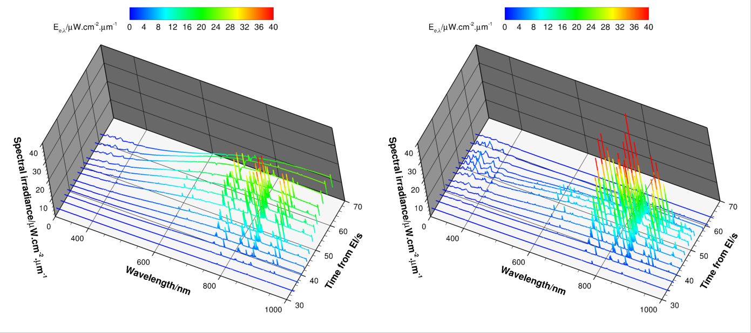
(a) N992 | (b) N522
Figure 7. Spectral irradiance (in units of μW.m⁻².μm⁻¹) as a function of time (in units of s) and wavelength (in units of nm) for: (a) spectrometer on N992, and (b) for a spectrometer on N522. The spectral irradiances are computed by scanning the corresponding high-resolution irradiance with a gaussian function (representing the instrument slit) with a FHWM of 0.84 nm.

For t = 53.5 s along the flight trajectory of the SRC, the computed spectral irradiances are shown in Figs. 8a and 8b for N992 and N522, respectively. These figures provide the quantitative information corresponding to the contour plots shown in Figs. 5a–5c. The green curves in the two plots are for the case of a cold wall ($T_{w}$ = 300 K) with the computed shock layer. Since the wall temperature is low, there is negligibly small radiance from the surface. The spectral features seen are the lines of the atomic species N and O, and the band structure close to 300 nm is the N₂⁺ 1st Negative system. The blue curve in each figure corresponds to the aerodynamically heated SRC imbedded in the ambient atmosphere, i.e., there is not shock layer around the SRC. The irradiance is then simply that of a blackbody at the area-averaged value of temperature on the visible portion of the SRC. The red curve is the combination of the two solutions. The figures show that it is the areal portion of radiance that dominates over the volumetric portion. Although the disparity between the areal and volumetric portions is marked for N922, it is relatively less so for N522. The interesting feature in Fig. 8b is the influence on wall temperature on the band structure between 300–460 nm, and the cause remains to be investigated.

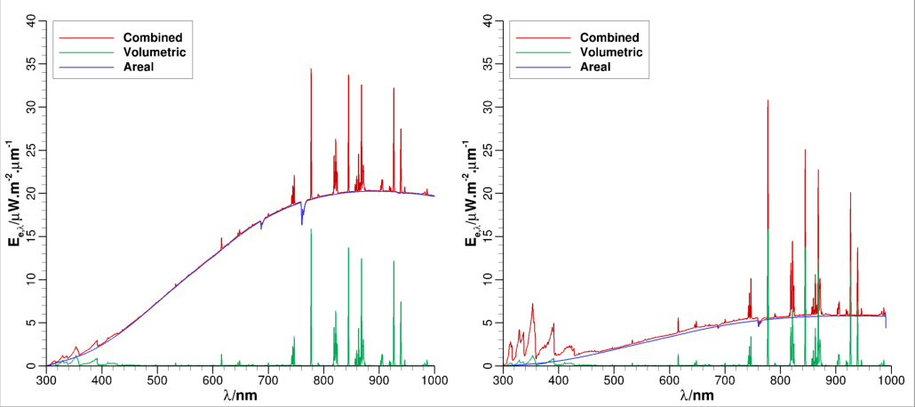
(a) N992 | (b) N522
Figure 8. Spectral irradiance at t = 53.5 s for: (a) N992 for three solutions – hot wall+shock layer (red line), cold wall+shock layer (green line), and hot wall+ambient atmosphere (blue line), and (b) N522 for three solutions – hot wall+shock layer (red line), cold wall+shock layer (green line), and hot wall+ambient atmosphere (blue line). The slant range and view angle for N992 are 176 km and 14.1°, respectively, and for N522 are 216.4 km and 92.8°, respectively.

Computed spectral irradiances over the extended wavelength range 1000-2100 nm are shown in Figs. 9a and 9b at t = 53.5 s along the flight trajectory of the SRC. The spectral features in the IR wavelength range are not as intense as the features in the visible region. The wavelength corresponding to the peak irradiance from the areal contribution perhaps corresponds to a temperature given by Wien’s displacement law – $λ_{peak}=b/T$, $b$ ≈ 2898 µm.K. Whether the inferred temperature corresponds to an area-averaged temperature remains to be investigated.

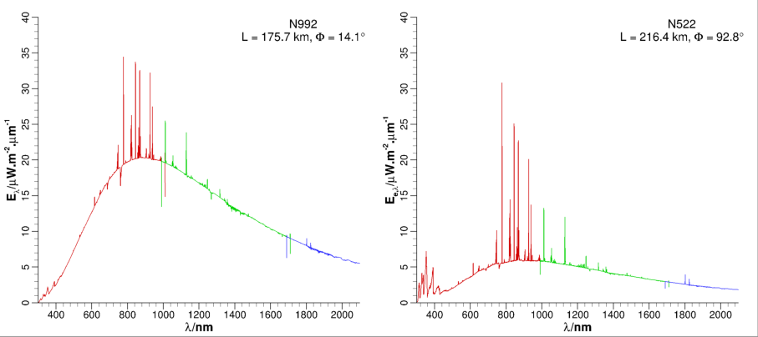
(a) N992 | (b) N522
Figure 9. Spectral irradiance at t = 53.5 s for: (a) N992 for three wavelength regions – 300-1000 nm (red line), 1000-1700 nm (green line), and 1700-2100 nm (blue line), and (b) N522 for three wavelength regions – 300-1000 nm (red line), 1000-1700 nm (green line), and 1700-2100 nm (blue line). The slant range and view angle for N992 are 176 km and 14.1°, respectively, and for N522 are 216.4 km and 92.8°, respectively.

At this point, all simulations needed for pre-flight predictions of irradiance levels to be expected for different instruments are complete. Since the simulations are based on somewhat conservative assumptions of a fully catalytic wall and a passive surface, i.e., the thermal protection material does not respond to the imposed aerothermal environments, the predicted spectral irradiances should be considered upper bounds. In reality, the material thermal response will decrease the surface temperature at every time point, thus reducing the areal contribution to radiance; the volumetric contribution from the shock layer depends only on the chemical kinetics and thermodynamic properties of the constituent species. Since spectral irradiance is dominated by the areal contribution of the SRC, comparison of baseline predictions (axisymmetric, laminar flow, and fully catalytic surface) with spectrometric measurements will allow exploration of the role of material response (including surface catalycity) and perhaps flow transition as well. Furthermore, computations of the 3D flow fields around the SRC will allow the exploration of the influence of angle of attack as well.
The methodology developed thus far is useful in verifying some aspects of shock-layer chemical kinetics and gas-surface interaction. Since the radiating SRC is essentially a point source to the instrument onboard the aircraft, spectrometric measurements are spatially averaged values of radiance, i.e., any spatial gradient information is lost. However, that does not preclude the use of the methodology to explore/explain spectral features seen in the measurements. For instance, irradiance measurements have always shown spectral lines corresponding to Na (sodium), Ca (calcium), K (potassium), and H (hydrogen), and band features corresponding to CN (see [12], [23], [24]). These features are commonly attributed to emissions from pyrolysis products from the thermal protection material [25]. This attribution is difficult to square away with the fact that spectra from meteors (e.g., see Refs. [26] and [27]) also show some of the same features. Some of the elements could be part of the materials that make up a meteor and emit due to vaporization of meteors. However, entry capsules rely on blowing of pyrolysis gases into the wall-bounded shear layer and it is unlikely that these gases get into the inviscid part of the shock layer where the temperatures are high – a requisite to see strong lines in emission. It is possible, however, there is spallation of particles from the thermal protection material and that these particles vaporize in the inviscid part of the shock layer. Regardless of the mechanism that leads to line emissions, the current methodology can be used to: (a) determine the number density of elements to match their line intensities, and (b) determine whether the boundary layer plays any significant role.

- Sodium D Line
The spectral line seen at 589 nm in the spectrometric data from Stardust, Hayabusa, and Hayabusa2 entries ([23], [24], [12]) is unambiguously due to elemental sodium (Na) and not due its cation, or even a sodium-bearing compound. Sodium, like all alkali metals (Li, K, Rb, …) is very reactive and does not occur in elemental form in nature. Instead of considering various compounds of Na and including chemical kinetics of these compounds in the shock layer, a simpler, but ad hoc, strategy is employed in the present work. In a first set of computations, a fixed number of Na atoms is added to every point in the flow field (including the surface of the SRC). The usual spectral radiance/irradiance computations (steps outlined in the preceding subsections) are performed to determine the number density at which there is noticeable emission of Na in the spectral irradiance. Next, for the number density at which the emission of Na is the strongest, that value is added only to the boundary-layer around the SRC and spectral radiance/irradiance computations performed again to see if there is any optical output from the boundary layer.
For illustrating the procedure, computations are performed at t = 53.5 s along the flight trajectory of the SRC. At this time point, the SRC is at an altitude of 59.7 km and has a velocity of 10.4 km/s. This altitude is well below the 80 km cut off of the metal vapor layer of the thermosphere around Earth. Three values of Na number density – 5×10⁷/cc, 5×10⁸/cc, and 5×10⁹/cc – are considered. In each radiance/irradiance computation, this amount of elemental sodium is added to every point in the computed flowfield to construct a new flowfield without any spatial gradients in the Na distribution. The resulting spectral irradiances in the wavelength region 300-900 nm are compared in Fig. 10a. The strongest emission from Na is for the case of 5×10⁹/cc, which is not surprising. The inset in Fig. 10a provides a magnified view of the D line of sodium (the doublet is not resolved). Next, confining the value of 5×10⁹/cc to just the boundary layer (determined using the software utility Blayer [11]) around the SRC, radiance/irradiance computations are repeated. The resulting spectral irradiance is compared with that from the case where sodium is added to the entire flowfield. Clearly, there is no emission from sodium in the boundary layer. Although not shown here, additional computations with sodium number density as high as 5×10¹⁵/cc yielded no noticeable signal.
The reason for these results is partially explained by the distributions of temperature and enthalpy, and species mole fractions and total number density along the stagnation line of SRC at this flight condition. The temperatures (translational and vibrational) profiles and total enthalpy profile are shown in Fig. 11a. Also shown in the figure is the approximate location of the boundary-layer edge. The boundary layer occupies only about a third of the shock layer thickness and has rapidly diminishing temperature from the edge to the wall. When sodium is added to the entire flowfield, the high temperatures (≈10000 K) in the inviscid portion of the shock layer are sufficient for strong emission when the number density reaches about 5×10⁹/cc. The temperatures within the boundary layer are not high enough for sodium emission.
Although the value of 5×10⁹/cc as sodium number density might appear to be large, it is very small in terms of mole fraction. In Fig. 11b, the mole fractions of neutral species and free electrons along the stagnation line are shown along with the total number density of the gas mixture. The value of total number density is approximately 5×10¹⁷/cc (black dashed line), which means that the mole fraction of elemental sodium is 2.5×10⁻⁸. However, a fixed value of number density would imply significant reduction in mole fraction in the coolest portion of the boundary layer, where the total number density reaches 10¹⁸/cc. In hindsight, it would have been better to specify a mole fraction of elemental sodium rather than a number density.

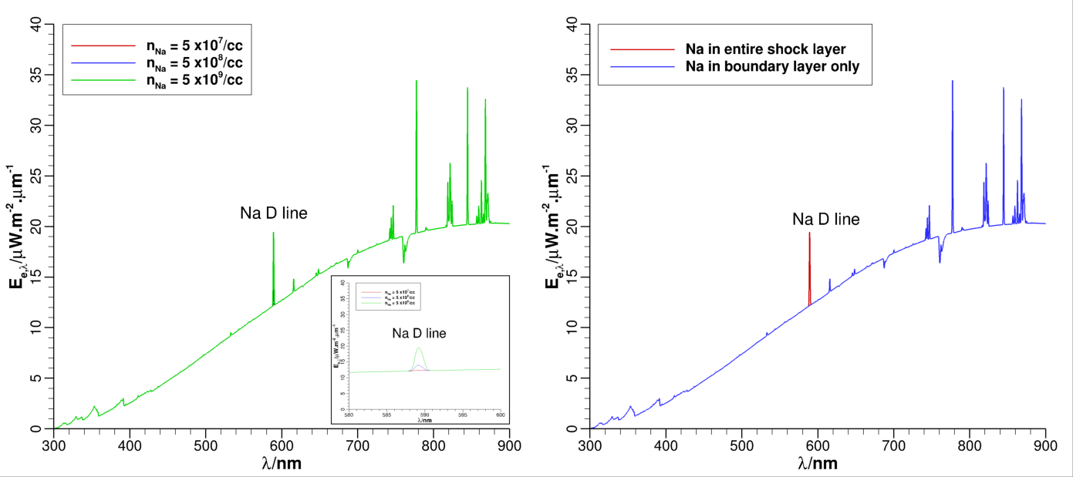
(a) Na added to all flowfield points | (b) Na added in the boundary layer only
Figure 10. Spectral irradiance at t = 53.5 s for: (a) three values of sodium number density – 5×10⁷/cc (red line), 5×10⁸/cc (blue line), and 5×10⁹/cc (green line), and (b) 5×10⁹/cc (blue line) added to just the boundary layer around the SRC.

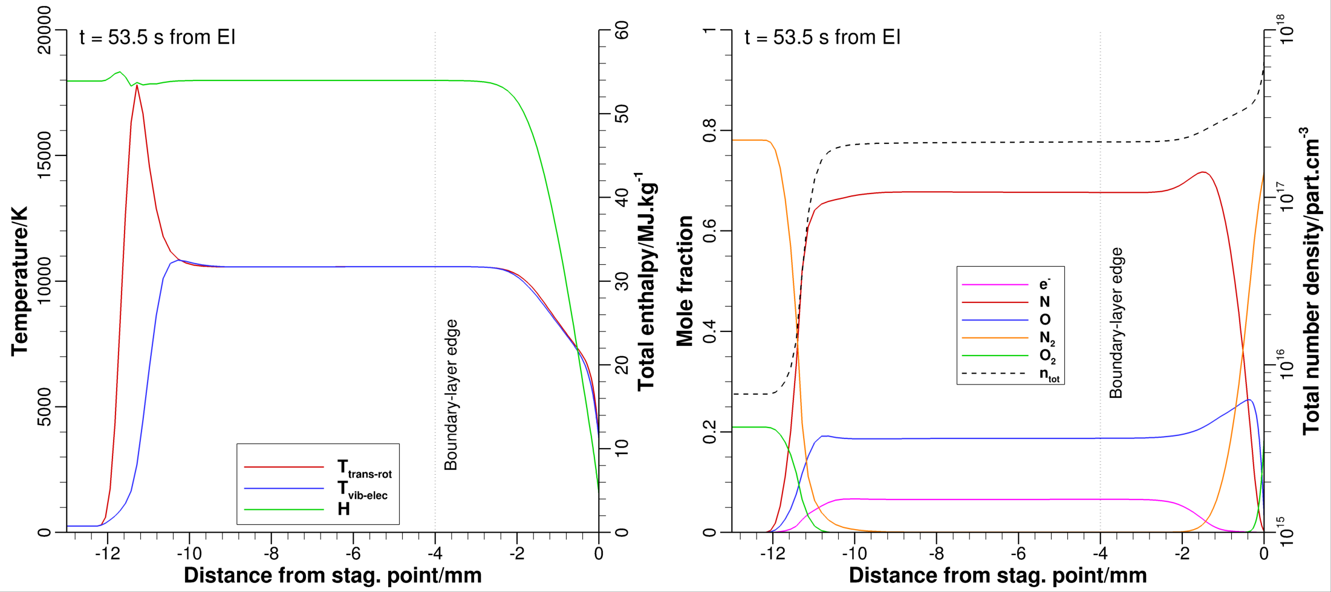
(a) Temperatures and total enthalpy | (b) Species mole fractions and total number density
Figure 11. Stagnation line profiles at t = 53.5 s for: (a) temperatures – translational (red line), vibrational (blue line), and specific total enthalpy (green line), and (b) mole fractions and total number density (dashed line). The grey dotted line denotes the boundary layer edge.

Although one can conclude that the emission of elemental sodium seen in the spectral irradiance is due its presence in the inviscid part of the shock layer, the analysis does not provide any information about the origin of this element. If, for the sake of argument, one assumes that elemental sodium appears in the shock layer due to the decomposition of a sodium-bearing compound across the bow shock, then there is still the issue of chemical kinetics involving this compound. If, for instance, the sodium-bearing compound is its oxide, Na2O, then the decomposition of this compound across the normal shock does not result in elemental sodium. It is more likely to obtain the cation, Na⁺, in the shock layer for the velocity considered in the example – a simple equilibrium normal shock calculation [28] yields this result. Spallation of microparticles from the heatshield material into the shock layer is another possibility. However, arcjet tests of PICA [29,30] do not show this emission. The spallation hypothesis is perhaps worth pursuing.

Conclusions and Proposed Paper
The present abstract presents the methodology for predicting the irradiance on a spectrometer onboard an airborne observation platform. The results presented are from pre-flight simulations because the best-estimated entry trajectory is yet to be provided and so are the calibrated data from the various instruments used in the imaging campaign. It is anticipated that all these data will be available early 2024, at least well ahead of the AIAA summer conferences. The final paper will include:
- Flow computations along several time points along the best-estimated trajectory (BET). These computations will be based on correcting some of the reaction rates in the 30-species model and a more relaxed surface catalysis model instead of a fully catalytic one, which is relevant for aerothermal design.
- Flow and material thermal response coupling to determine a better estimate of surface temperature – the surface temperature is key to determining the areal contribution to radiance/irradiance. Materials thermal response computations will require flow solutions for the entry capsule in the thermosphere (freestream density is too small for a continuum approximation to be valid) because the heat pulse needs to be closed at early entry time. To that end, the use of Sparta [31] will be explored.
- Sensitivity of predicted irradiance to mismatch in timing between trajectory and instruments will be established.
- Sensitivity of predicted irradiance to angle of attack changes at one or two time points along the BET will be explored.
- Estimates of elemental mole fractions of pertinent species that are not included in the shock-layer chemistry model but observed in flight.
- Correlation of data from two or more observation platforms so that the influence of view angle and slant range are consistent across all platforms.
- The concept of areal-average temperature to provide guidance on the choice of surface boundary condition.

Acknowledgments
The present work was supported by NASA Contract NNA15BB15C to AMA, Inc. The author thanks the entire HORIS team for all the illuminating discussions leading up the date of entry of SRC. Thanks are due to Rob Conn (AMA @ NASA Langley Research Center) for flight trajectories of both the SRC and observation aircraft, Brett Cruden (AMA @ NASA Ames Research Center) for constructing the 30-species chemistry model, the atmospheric transmittance data, and v15.2.2 of Neqair, and David Saunders (AMA @ NASA Ames Research Center) for enhancing the software tools to allow view angles greater than 90°.

References
¹“Stardust Airborne Observation Campaign Support,” NASA Engineering and Safety Center Report, RP-06-80, Aug, 2006.
²Cassell, A. M., Allen, G. A., Winter, M. W., Grinstead, J. H., Antimisaris, M. E., Albers, J, and Jenniskens, P. M., “Hayabusa Reentry: Trajectory Analysis and Observation Mission Design,” AIAA Paper 2011-3330, 42nd AIAA Thermophysics Conference, June 2011.
³Scott, C. F., Jr., Inman, J. A., et al., “SCIFLI Airborne Observation of the Hayabusa2 Sample Return Capsule Re-Entry,” AIAA Paper 2022-3798, AIAA AVIATION 2022 Forum, Chicago, IL, June 2022.
⁴Liu, Y., Prabhu, D., Trumble, K. A., Saunders, D., and Jenniskens, P., “Radiation Modeling for the Reentry of the Stardust Sample Return Capsule,” Journal of Spacecraft & Rockets, Vol. 47, No. 5, 2010, pp. 741–752.
⁵Winter, M., McDaniel, R., Chen, Y.-K., Liu, Y., Saunders, D., and Jenniskens, P. M., “Radiation Modeling for Reentry of Hayabusa Sample Return Capsule,” Journal of Spacecraft & Rockets, Vol. 56, No. 4, 2019, pp. 1152–1164.
⁶Prabhu, D. K., Saunders, D. A., Cruden , B. A., and Grinstead, J. H., “Simulations of Hayabusa2 Atmospheric Entry and Comparisons with Data from the Imaging Campaign,” AIAA Paper 2022-3800, AIAA AVIATION 2022 Forum, Chicago, IL, June 2022.
⁷Wright, M., Candler, G., and Bose, D., “Data-Parallel Line Relaxation Method for the Navier-Stokes Equations,” AIAA Journal, Vol. 36, No. 9, 1998, pp. 1603-1609.
⁸Wright, M. W., White, T., and Mangini, N., “Data Parallel Line Relaxation (DPLR) Code User Manual Acadia–Version 4.01.1,” NASA TM-2009-215388, Oct. 2009.
⁹Whiting, E., Park, C., Liu, Y., Arnold, J., and Paterson, J., “NEQAIR96, Nonequilibrium and Equilibrium Radiative Transport and Spectra Program: User's Manual,” NASA Reference Publication 1389, December 1996.
¹⁰Cruden , B. A., and Brandis, A. M., “Updates to the NEQAIR Radiation Solver,” Radiation in High Temperature Gases. St. Andrews, UK, 2014.
¹¹Saunders, D. A., and White, T. R., http://sourceforge.net/projects/cfdutilities/.
¹²Scriven, G. R., Scott, C. F., Inman, J. A., Tanno, H., Yamada, T., Johnston, C. O., Prabhu, D. K., Conn, R., “Hayabusa2 SHARC Spectro-Radiometric Calibration and Analysis,” AIAA AVIATION 2022, Chicago, IL.
¹³Allen, G. A., Jr., Wright, M. J., and Gage, P., “The Trajectory Program (Traj): Reference Manual and User’s Guide,” NASA TM-2005-212847, 2005.
¹⁴White, T., Maddock, R., Kazemba, C., Winski, R., and Adams, D., “Detailed Design of an Earth Entry Vehicle for Comet Surface Sample Return,” 14th International Planetary Probes Workshop, The Hague, Netherlands, June 2017.
¹⁵NOAA/NASA/USAF, “US Standard Atmosphere, 1976,” NOAA–S/T 76-1562, US Govt. Printing Office, 1975.
¹⁶Cruden , B. A., “On the Fluid Dynamics Boundary Condition in Ablating or Blowing Flows,” AIAA Paper 2023-3614, AIAA AVIATION 2023 Forum, San Diego, CA, 2023.
¹⁷Chen, Y.-K., and Milos, F. S., “Ablation and Thermal Analysis Program for Spacecraft Heatshield Analysis,” Journal of Spacecraft and Rockets, Vol. 36, No. 3, 1999, pp. 475–483.
¹⁸Lachaud, J., et al., “A Generic Local Thermal Equilibrium Model for Porous Reactive Materials Submitted to High Temperatures,” International Journal of Heat and Mass Transfer, Vol. 108, pp. 1406–1417, 2017.
¹⁹Anderson, G. P., Berk, A., Acharya, P. K., Matthew, M.W., Bernstein, L. S., Chetwynd, J. H., Dothe, H., Adler-Golden, S.M., Ratkowski, A. J., Felde, G. W., et al., “MODTRAN4: Radiative Transfer Modeling for Remote Sensing,” Proceedings of SPIE, Algorithms for Multispectral, Hyperspectral, and Ultraspectral Imagery VI, S. S. Chen, and M. R. Descour (Eds.), Vol. 4049, Aug. 2000, pp. 176–183.
²⁰White, P. W., Hoffman, J., “Earth Global Reference Atmospheric Model (Earth-GRAM): User Guide,” NASA/TM-20210022157, September 2021.
²¹L.S. Rothman, I.E. Gordon, Y. Babikov, A. Barbe, D. Chris Benner, P.F. Bernath, M. Birk, L. Bizzocchi, V. Boudon, L.R. Brown, A. Campargue, K. Chance, E.A. Cohen, L.H. Coudert, V.M. Devi, B.J. Drouin, A. Fayt, J.-M. Flaud, R.R. Gamache, J.J. Harrison, J.-M. Hartmann, C. Hill, J.T. Hodges, D. Jacquemart, A. Jolly, J. Lamouroux, R.J. Le Roy, G. Li, D.A. Long, O.M. Lyulin, C.J. Mackie, S.T. Massie, S. Mikhailenko, H.S.P. Müller, O.V. Naumenko, A.V. Nikitin, J. Orphal, V. Perevalov, A. Perrin, E.R. Polovtseva, C. Richard, M.A.H. Smith, E. Starikova, K. Sung, S. Tashkun, J. Tennyson, G.C. Toon, Vl.G. Tyuterev, G. Wagner, “The HITRAN2012 Molecular Spectroscopic Database,” J. Quant. Spectrosc. Radiat. Transfer, Vol. 130, 4-50 (2013).
²²Schöier, F. L. ; van der Tak, F. F. S. ; van Dishoeck, E. F. ; Black, J. H., “An atomic and molecular database for analysis of submillimetre line observations,” Astronomy and Astrophysics, Volume 432, Issue 1, March 11, 2005, pp. 369–379.
²³Jenniskens, P. M., “Observations of the Stardust Sample Return Capsule Entry with a Slitless Echelle Spectrograph,” Journal of Spacecraft & Rockets, Vol. 47, 2010, pp. 718–735.
²⁴Grinstead, J. H., Jenniskens, P. M., Cassell, A. M., Albers, J., Winter, M., “Airborne Observation of the Hayabusa Sample Return Capsule Re-entry,” 42nd AIAA Thermophysics Conference, Honolulu, HI, Jan. 2011.
²⁵Zhong, J., and Levin, D., “Modeling of Sodium Radiation from Reentry Flows at High Altitudes,” Journal of Spacecraft and Rockets, Vol. 47, No. 5, 2010, pp. 757–764.
²⁶Borovicka, J., Koten, P., Spurny, P. Bocek, J., and Stork, R.., “A survey of meteor spectra and orbits: evidence for three populations of Na-free meteoroids,” Icarus, Vol. 174, 2005, pp. 15–30.
²⁷Trigo-Rodriguez, J. M., and Llorca, J., “On the sodium overabundance in cometary meteoroids,” Advances in Space Research, Vol. 139, 2007, pp. 517–525.
²⁸Gordon, S., and McBride, B. J., “Computer program for calculations of complex chemical equilibrium compositions, rocket performance, incident and reflected shock, and Chapman-Jouguet detonations,” NASA/SP-273, 1976.
²⁹Raiche, G. A., and Driver, D. M., “Shock Layer Optical Attenuation and Emission Spectroscopy Measurements During Arc Jet Testing with Ablating Models,” AIAA Paper 2004-825, 42nd AIAA Aerospace Sciences Meeting, Reno, NV, Jan. 2004.
³⁰Park, C., Raiche, G. A., II, and Driver, D. M., “Radiation of Spalled Particles in Shock Layers,” AIAA Paper 2004-1349, 42nd AIAA Aerospace Sciences Meeting, Reno, NV, Jan. 2004.
³¹Plimpton, S. J., et al., “Direct Simulation Monte Carlo on petaflop supercomputers and beyond,” Phys. Fluids, 31(8), 2019.

Sr. Research Scientist, Aerothermodynamics Branch, M/S 230-1, Associate Fellow AIAA.

