Pre-Flight Hazardous Gas Assessment Methodology for the Space Launch System
Brian R. Richardson
NASA Marshall Space Flight Center, Huntsville, AL
Abstract:
The complexity of the Artemis I liquid rocket propulsion systems produces many sources of hazards during the operation of the vehicle. Pre-flight hazardous gas leakages pose fire and explosion risks to rocket that could potentially lead to loss of the vehicle, mission, and crew. The National Aeronautics and Space Administration (NASA) uses a probability risk assessment strategy to assess the likelihood of the hazard and the consequence should the hazardous situation occur. For high probability hazards that pose a potentially catastrophic consequence to the vehicle, the most effective strategy for reducing the risk is accomplished by engineering and implementing systems that actively mitigate the hazard. A hazards analysis is completed to determine the likelihood and severity of each hazard. These hazard analyses are informed using relevant empirical data and physics-based analytical models. Time-accurate Computational Fluid Dynamics models used to quantify and understand the risks posed to Artemis I due to expulsions of hazardous gas near the vehicle. Several sources of hazardous gas that posed a risk to Artemis I during nominal pre-flight operations are analyzed in this work. The results of the analyses were used to develop flight rationale and make risk acceptance decisions for the Artemis I launch.
- Frequently Used Acronyms
CAPU = Core Auxiliary Power Unit
CFD = Computational Fluid Dynamics
CS = Core Stage
ES = Engine Section
HBOI = Hydrogen Burn-Off Igniter
LEL = Lower Explosive Limit
LFL = Lower Flammability Limit
SLS = Space Launch System
VCE = Vapor Cloud Explosion

- Introduction
NASA recently successfully launched the Artemis I mission using the Space Launch System (SLS) rocket. In the days leading up to a launch, thousands of vehicle and ground systems must be checked for nominal operation by launch operators and support engineers to ensure a safe and successful mission. Even certain nominal pre-flight operations of the vehicle can produce potential hazards. One such example is the nominal venting and leakage of hazardous gases from the vehicle that occur during normal propellant tanking and engine start-up operations. For SLS, during all phases of propellant tanking and through flight, both hydrogen (H2) and oxygen (O2) gas is purposefully vented or leaking from multiple locations on the vehicle to the external ambient environment. Pre-flight fluid analyses are performed to describe the hazardous gas environments produced by these leakage sources and these analyses help inform vehicle risk assessments and mitigation strategies.

The SLS vehicle uses liquid hydrogen and oxygen propellants to provide propulsion for both the lower Core Stage (CS) and upper stage of the rocket. H2 and O2 leakages from the vehicle produce unique fire/deflagration/detonation hazards to the vehicle once mixed with the ambient atmosphere around the exterior of SLS. H2 is flammable over a wide range of concentrations when mixed with air and can produce a nearly invisible flame. Additionally, H2 can readily produce a detonable mixture with air. A relatively small mass of combusting premixed H2 and air can produce a significant overpressure wave depending on the flame speed and nature of the combustion event. Meanwhile O2 leakages from SLS can enrich the oxygen concentration of the air surrounding the vehicle. In the event of a fire or combustion event on the exterior of the vehicle, air with enriched O2 concentrations would support more vigorous and faster flame spread which increases the hazard consequence for the SLS vehicle, mission, and crew.

The various sources of hazardous gas leakages from the SLS vehicle are analyzed and mitigated by varying methods depending upon the assessed risk to the vehicle. Relatively small gaseous H2 and O2 leaks at the umbilical plate interfaces and inside the vehicle compartments are mitigated by diluting the leakages to a non-hazardous concentration with helium or nitrogen purge systems before exhausting to the atmosphere. Large, unconfined gaseous H2 expulsions such as the RS-25 H2 lead, H2 lag and Core Auxiliary Power Unit (CAPU) H2 exhaust gases are mitigated using an external ignition source that is designed to prevent the accumulation of unburned hydrogen gas near the vehicle. Other sources of hazardous gases, such as O2 venting from the propellant tanks and the Solid Rocket Booster (SRB) Auxiliary Power Unit (APU) exhaust gas do not require mitigation due to their assessed risk to the vehicle. Fluid dynamic analyses and assessments were conducted for all these sources of hazardous gases to inform the risk assessment for a nominal SLS launch sequence. In this work, we will focus on describing the analysis methodology and results applied to assess two of these hazardous gas sources: the CAPU exhaust gas, and H2 leakages at the CS Engine Section (ES) LH2 umbilical interfaces. The CAPU exhaust gas analysis can be qualitatively compared with publicly available visual flight data from the successful launch of Artemis I. The H2 leakages at the CS ES umbilical interface contributed to launch scrubs that preceded the successful Artemis I flight.
- SLS External Gas Hazards

The work presented in this paper focuses on analyzing three sources of externally vented hazardous gas that pose a risk to SLS vehicle during nominal preflight operations. Hazardous gas sources from the CAPU system, CS LH2 engine section umbilical plate purge system and umbilical plate external vent are described in this section. The general operation of each system is described below as it relates to the various sources of hazardous gas and the risk to the vehicle if the hazards are not mitigated.

Four CAPUs provide auxiliary electrical power to the SLS Core Stage during flight. Prior to main engine start-up, gaseous helium is used to power the CAPUs. Once the four SLS RS-25s begin running prior to lift-off, the CAPUs exhaust GH2 overboard through four exhaust ports located on the Core Stage base heat shield. Figure 1 shows a camera still from the Artemis I launch that captures one of the inert helium pulses as it is exhausted below the CS base heatshield.

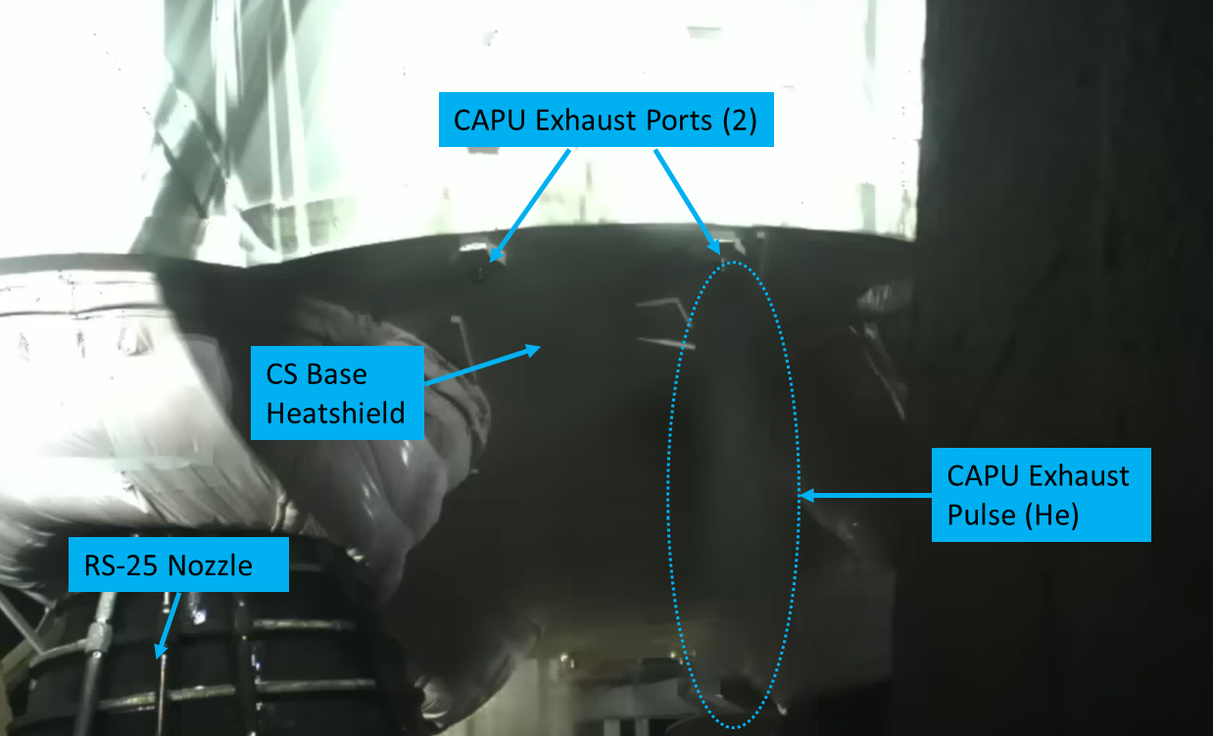
Figure 1: A still image from a camera on the Artemis I mobile launcher showing an inert gas pulse from a CAPU exhaust port at the base of the Core Stage.

Hydrogen Burn-off Igniters (HBOIs) direct burning zirconium particles at the CAPU exhaust ports to burn off the expelled GH2 exhaust. Figure 2 shows two still images from the Artemis I launch showing HBOI particles impacting the CS base heatshield near the CAPU exhaust ports. The image on the left shows the HBOI particles just prior to RS-25 start up. The faint orange region in the right image near the CS base heatshield is the H2 from CAPU exhaust gas combusting with air. During the Artemis I pre-launch sequence, the HBOIs were effective at burning away the H2 expelled from the CAPU exhaust ducts. Post-flight analysis of data showed that the HBOIs performed as intended.

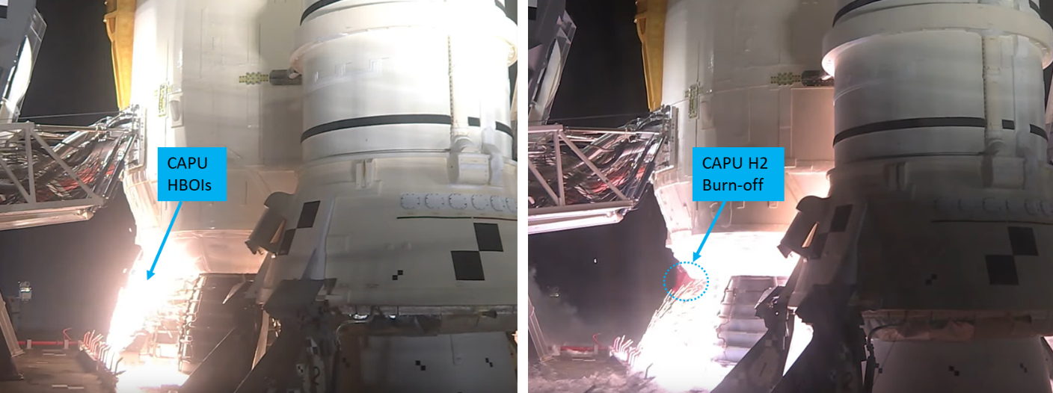
Figure 2: A still image from a camera during the Artemis I launch sequence showing HBOI particles directed at the CAPU exhaust ports (left) and burning CAPU exhaust during RS-25 start-up (right).

The pre-flight analysis shown herein was conducted to quantify the potential consequence to the SLS vehicle if the HBOIs did not function as intended. Should the HBOIs fail to ignite the CAPU GH2 exhaust as it exits the exhaust port, an accumulation of unburned hydrogen and air mixture could form under the base heat shield. An ignition of the accumulated hydrogen and air mixture could produce an overpressure load on the SLS base heat shield that could damage the vehicle, possibly leading to loss of mission or vehicle.

The Fill and Drain and Bleed umbilical interfaces inside the CS ES umbilical carrier plates are surrounded by a cavity where H2 leakages from the umbilical interfaces are purged with an inert gas, helium (He), to dilute the exhaust to a non-hazardous mixture before exiting the vehicle through an exhaust port. The analysis was conducted to investigate why the umbilical plate purge system was producing inconsistent gas mixtures at the Launch Equipment Test Facility (LETF) in the months leading up to the Artemis I launch. These internal umbilical plate cavity CFD simulations were conducted using nominal H2 leakage flow rates and He purge flow rates. The risk to the vehicle posed by the inconsistent gas mixture measurements is that the H2 leakage rate into the cavity could be much greater than the sensor reading producing an unmitigated hazard. Alternatively, erroneously high H2 concentration readings from the sensor could cause unnecessary aborts of launch and test attempts.

During several of the Artemis I launch attempts and wet dress rehearsals, the H2 leakage within the CS ES umbilical plate cavity exceeded the nominal flow rate. These off-nominal leakages exceeded the capacity of the He purge to dilute the H2 gas to a non-hazardous concentration before exiting the vehicle. Prior to the successful launch of Artemis I, CFD simulations of the umbilical cavity exhaust gas were conducted using off-nominal H2 leakage rates to quantify the size and shape of the combustible gas region that formed outside of the vehicle. This external, off-nominal H2 leakage CFD analyses helped to inform the SLS program of the potential risk created by these off nominal leakages and the results were used to develop Artemis I flight rationale. For Artemis I, the risk posed by off nominal H2 leakages into the CS ES umbilical plate cavity was that an unmitigated flammable mixture of air and H2 formed near the vehicle external surface.

- General Analysis Methodology

Detailed analysis methodology for the CAPU exhaust hazard, CS LH2 umbilical plate system and CS umbilical plate GH2 vent hazard analyses are described in the following section of the paper, in separate subsections, preceding the analysis results. The general analysis methodology for the time-accurate, three-dimensional (3-D) computational fluid dynamics (CFD) simulations conducted for the hazardous gas sources is described in this section.

The density-based Navier Stokes solver, Loci/CHEM was selected to simulate the CAPU exhaust venting pulses beneath the CS base heatshield [1]. Loci/CHEM was selected for this application because it can accurately model the RS-25 supersonic plume induced entrainment effect on the CAPU exhaust gas during a transient venting event. The pressure-based Navier-Stokes solver Loci-STREAM was selected to model the CS LH2 umbilical cavity purge and vent flow applications [2,3]. Loci-STREAM was selected for these applications because the pressure-based formulation was useful for these applications with large ranges of fluid velocity in the domain. A common methodology approach was used to discretize the computational domains and monitor solution convergence for all three analysis applications. These general modeling approaches are described here.

All three CFD analysis applications were discretized using a hybrid unstructured mesh approach. Solid surfaces were discretized using triangular elements using the BETA-CAE ANSA software [4]. AFLR3 was used to extrude prisms away from solid surfaces to resolve gradients in the fluid boundary layer [5]. The remainder of the computational domain volume was filled with unstructured tetrahedral volume elements. Cell spacing was varied throughout the computational domain to resolve geometric features and fluid flow gradients. In lieu of formal mesh dependency studies, engineering judgement and experience were used to determine reasonable mesh densities to resolve the quantities of interest in the flow field. Multiple mesh modifications were made for each application to improve the overall mesh quality and tailor mesh cell density in critical regions of the computational domain.

Similarly, experience-based solution verification metrics were monitored to reduce the numerical error in the solution for all three CFD analysis applications. For the Loci/CHEM solutions, the fully-implicit formulation enables temporal accuracy at moderately large time-steps with sufficient inner-iterations. For Loci/CHEM, the L2 norm of the residual is monitored to ensure sufficient residual drop for each time step as well as global mass flow rate convergence. Loci-STREAM solves each governing equation sequentially using a semi-implicit time discretization formulation. This semi-implicit formulation requires iterations on the global time step size to ensure that the solution is time-step size independent. Additionally, the residual drop for each governing equation was monitored to ensure sufficient temporal accuracy at the selected time-step size. Global mass flow rate convergence and conservation of species in the domain were also monitored as an additional solution convergence metric for the Loci-STREAM simulations.

- Detailed Analysis Methodology and Results

  - CAPU Exhaust Hazard Assessment Methodology

Figure 1 shows views of the computational domain used to conduct CFD simulations of the CAPU exhaust pulses exiting the CS base heatshield. The image on the left panel shows details of the CS base heatshield, RS-25 nozzles and the CAPU exhaust ports which protrude down several inches from the heatshield. The image on the right panel of Figure 1 shows the SLS vehicle, mobile launcher, and pad geometry that was included in the model as well. These large-scale launch facility features were included in the CFD domain to enable accurate modeling of wind blockage and RS-25 plume-induced entrainment velocity. The right panel image of Figure 1 shows an iso-surface of the RS-25 plume at 600 Kelvin to demonstrate the plume expansion environment at the time just prior to lift-off when the flammable CAPU exhaust gas is expelled below the vehicle.

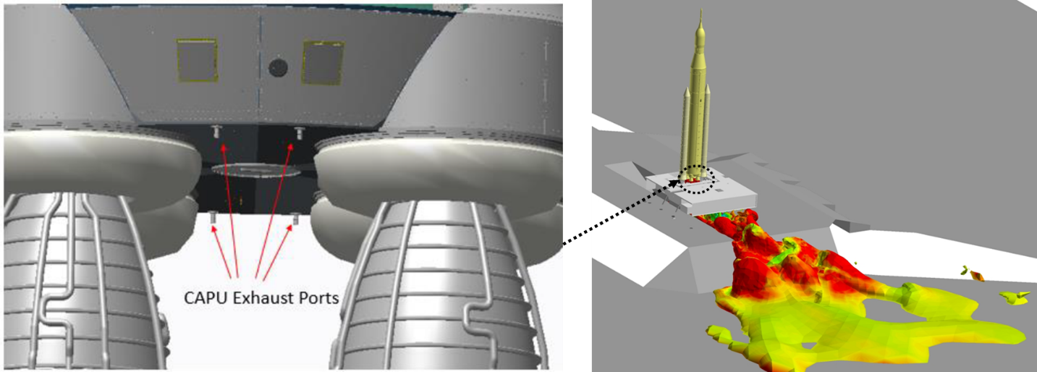
Figure 3: The location of the 4 CAPU exhaust ports on the SLS base heatshield (left) and a view of the ML, pad and trench features with an iso-surface showing the RS-25 exhaust plume at the time in the launch sequence when the CAPU expel hazardous gas.

Figure 2 shows a plot of the CAPU exhaust duty cycle versus time. CAPU exhaust pulses are expelled through a combination of short duration, high flow rate pulses, separated by relatively long periods of low flow rate exhaust. Each high flow pulse is separated by approximately one second and the high flow pulses from each of the four CAPU exhaust ports are staggered in time to eliminate the possibility of two simultaneous high flow exhaust pulses. Initially, the CAPU exhaust gas is composed of helium which transitions to mostly hydrogen as the RS-25 engines reach full power. The final few CAPU exhaust pulses just prior to lift-off contain the largest concentration of hydrogen and the expansion of the exhaust gas into the atmosphere is significantly affected by RS-25 plume induced entrainment effects. For the time-accurate CFD simulation of the CAPU exhaust pulse mixing with the air around the SLS vehicle, a transient boundary condition was used to enforce the time-varying mass flow rate shown in Figure 2 was used to model the exhaust pulses. The CFD analysis results were used to quantify the volume and location of the flammable hydrogen-air mixture and the maximum mass of the hydrogen contained in the detonable volume.

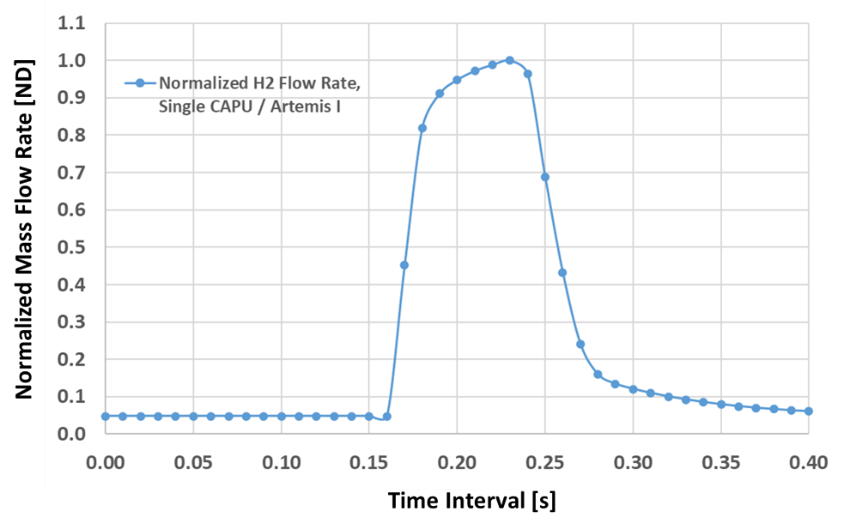
Figure 4: Diagram of a CAPU exhaust pulse duty cycle vs. time.

An analysis of the potential environment produced by overpressure from a hydrogen detonation of the CAPU exhaust was performed using the Baker-Strehlow-Tang modification to the widely used blast curves for Vapor Cloud Explosions (VCE), developed by The Netherlands Organisation (TNO) for Applied Scientific Research [6,7]. The BST model estimates the energy released, in the form of overpressure, by the ignition of a premixed vapor cloud of fuel in air. The BST Model requires three input values to parameterize the overpressure produced by a combustion event over a range of distances away from the event. For this application, the inputs are i) the fuel species, hydrogen, ii) the mass of hydrogen released, and iii) the combustion wave speed expressed in terms of a Mach number, Mf. This combustion wave speed can be either a subsonic deflagration (Mf<1) or a supersonic detonation (Mf>1). The appropriate physical value of the combustion event speed is dependent on parameters such as fuel to air mixture ratio, confinement of the combustion event and strength of the initial ignition source.

The CFD simulation results were analyzed to determine the maximum flammable and detonatable mixture volumes that occur during the transient CAPU exhaust pulse. CFD simulation results were used because it would be overly conservative to assume that all the expelled H2 would form a detonable mixture with air. Due to the diffusive nature of H2, only a small portion of the expelled H2 gas is at a detonable mixture condition at any snapshot in time. Figure 3 shows the flammable limits for hydrogen and air mixtures with various diluents [8]. While there is some amount of helium species in the expelled CAPU exhaust gas, in the CFD analysis the exhaust gas was modeled as 100% hydrogen to add additional conservatism to the calculation. The explosive or detonable limits of hydrogen-air mixtures are nominally accepted as a range of 18-59% hydrogen in air by volume [9].

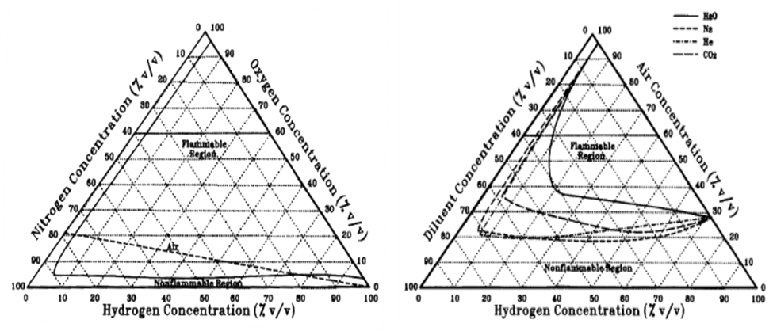
Figure 5: Ternary plots showing the flammable concentrations of Hydrogen and Air mixtures (Left) and for Hydrogen, Air and Inert diluent mixtures (Right).

The mass of detonable hydrogen was extracted from the time-accurate CFD simulations of the CAPU exhaust gas pulse at the time in the simulation when the maximum amount of hydrogen had collected beneath the CS base heatshield. This mass of detonable hydrogen along with the distance between the CS base heatshield and the center of mass of the detonable mixture were used as inputs into the VCE model. The VCE model was used to generate a series of overpressure magnitudes at the base heatshield produced by a combustion event of the detonable gas mixture over a range of possible flame speeds. Finally, these overpressure magnitudes were compared against other sources of overpressure waves such as the nominal RS-25 H2 lead-pop environment.

- CAPU Exhaust Hazard Analysis Results

Figure 8 shows a cross-section through the fluid volume around the SLS CS base heatshield. In Figure 8, the solid yellow surfaces are the SLS CS body, the gray features are the mobile launcher solid surfaces and two of the four the RS-25 nozzles are visible through the partially transparent velocity magnitude contour surface. Figure 8 shows contours of velocity magnitude in feet per second and streamlines that illustrate the downdraft velocity produced by RS-25 plume entrainment just prior to launch. The CAPU ports extend from the bottom of the base heatshield into the recirculation zone that forms beneath the blockage produced by the vehicle. The recirculation zone is asymmetric because of the tower and pad structure and blockages that surround the vehicle but are not shown in Figure 8. The recirculation zone is of concern because it provides a physical mechanism to support hydrogen exhaust gas accumulation near the outer surface of SLS.

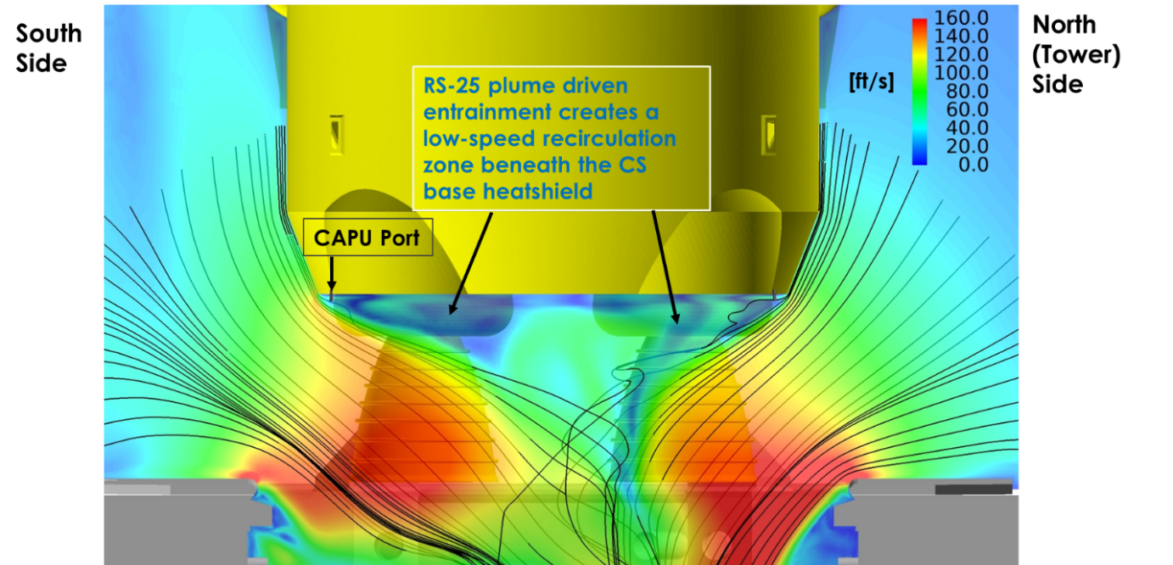
Figure 6: Cross-section showing the RS-25 plume induced entrainment velocity magnitude with streamlines just prior to SLS launch.

The hydrogen expelled during a CAPU exhaust pulse must mix with air in the ambient environment around the SLS vehicle to form flammable and detonable mixtures of gases. Figure 9 shows an iso-surface that encloses all of the flammable hydrogen and air gas mixture at a snapshot during a CAPU exhaust pulse. The iso-surface shows a gas mixture of 4% hydrogen in air which is the nominally accepted lower flammability limit (LFL) of hydrogen in air by volume.

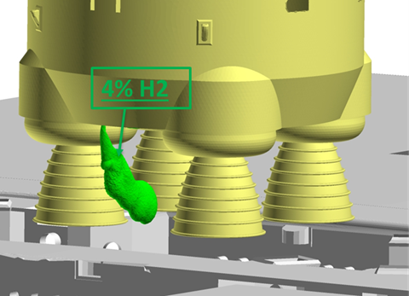
Figure 7: Iso-surface showing the Lower Flammability Limit of H2 and Air.

Within the LFL iso-surface shown in Figure 9, detonable mixtures of hydrogen and air exist. Figure 10 shows iso-surfaces that represent the lower detonable limit and upper detonable limit hydrogen concentrations respectively. The volume of detonable gas between these iso-surfaces contains the mass of detonable hydrogen the value of which is used as input into the VCE analysis to predict the overpressure environment on the SLS vehicle.

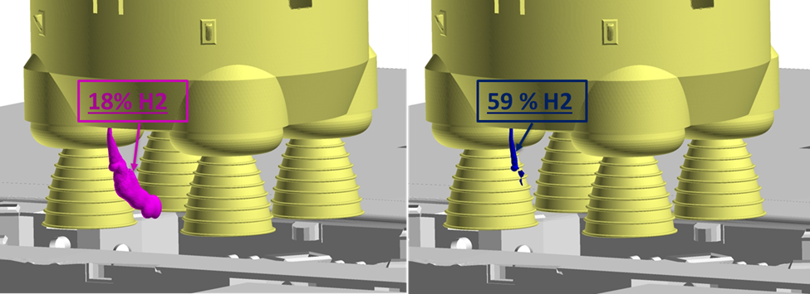
Figure 8: Iso-surface showing the Lower Detonation Limit of H2 and Air (Left) and the Upper Detonation Limit of H2 and Air (Right), the gas mixture in the volume between the Pink and Blue surfaces is detonable and also flammable.

Figure 11 shows a pair of cross-sections through the CAPU port exhaust plume during a high-flow pulse phase as described in Figure 2 on the South side of the vehicle. The contours in Figure 11 show the mass fraction of hydrogen at a snapshot in time when the maximum mass of hydrogen collects below the SLS CS base heatshield. In Figure 11, a threshold was applied to hide portions of the contour that were not at a detonable mixture of hydrogen and air. Figure 11 also identifies tendrils of hydrogen and air detonable mixtures near the base heatshield. These tendril features are considered flammable and not detonable because their thickness is smaller than the characteristic hydrogen and air detonation cell size for the mixture of gases [10]. The mass of the hydrogen in these tendril features is still included in the VCE calculation but is not included when calculating the center of mass of the detonable gas relative to the base heatshield location. The graph in the right image of Figure 11 shows the results of the VCE calculation using the mass of hydrogen and location of the detonable mixture extracted from the CFD simulation result. The solid lines plot the overpressure magnitude versus distance away from the combustion event for different flame propagation speeds. The VCE model contains decay correlations that range from a weak subsonic deflagration event propagating at Mach 0.2 up to a strong detonation event propagating at Mach 5.4. The actual propagation flame speed of real-world a vapor cloud combustion event is difficult to predict. Thus, the results of the VCE model are shown for the full range of potential flame speeds in Figure 11 The grey dashed vertical line shows the distance from the center of the combustible gas mixture to the CS base heatshield. Figure 11 shows that even assuming the worst possible flame propagation speed of Mach 5.4, the overpressure magnitude at the CS base heatshield is predicted to be approximately equivalent to the nominal H2 lead pop during engine start from STS launch data. This overpressure magnitude prediction is approximately the same magnitude as the nominal RS-25 H2 lead pop environment and less than the design environment for the heatshield. The combined CFD and VCE analysis predicts that an uncontrolled vapor cloud combustion event is unlikely to damage the base heatshield even when applying significant conservatism to the model.

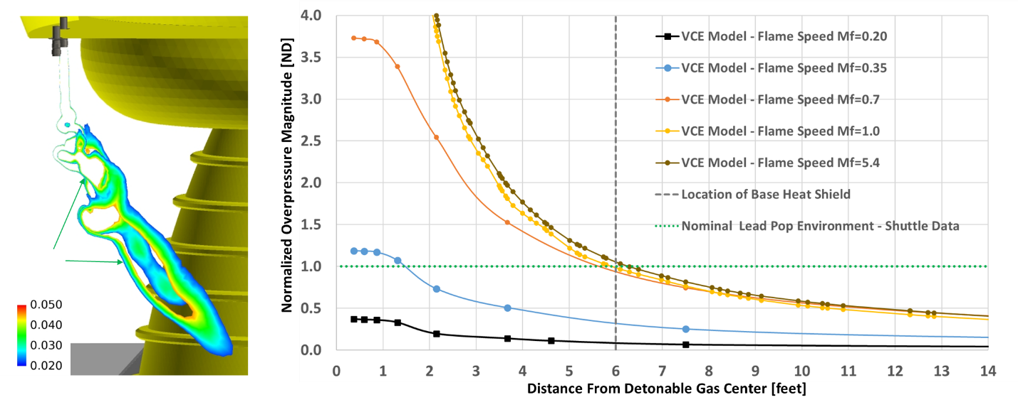
Figure 9: A snapshot showing detonable hydrogen and air mixture regions formed by a south side CAPU pulse (left) and results of the VCE analysis (right).

Figure 12 shows a pair of cross-sections through the CAPU port exhaust plume during a high-flow pulse phase on the north side of the vehicle. The shape of the exhaust plume differs from the exhaust pulses on the south side due to the asymmetry in the RS-25 downdraft induced entrainment previously shown in Figure 8. The graph in right image of Figure 12 shows the results of the VCE calculation using the mass of hydrogen and location of the detonable mixture extracted from the CFD simulation result. Figure 12 shows that even assuming the worst possible flame propagation speed of Mach 5.4, the overpressure magnitude at the CS base heatshield is predicted to be 92% of the nominal H2 lead pop during engine start from STS launch data. This overpressure magnitude prediction is approximately the same magnitude as the nominal RS-25 H2 lead pop environment and less than the design environment for the heatshield. The combined CFD and VCE analysis predicts that an uncontrolled vapor cloud combustion event is unlikely to damage the base heatshield even when applying significant conservatism to the model.

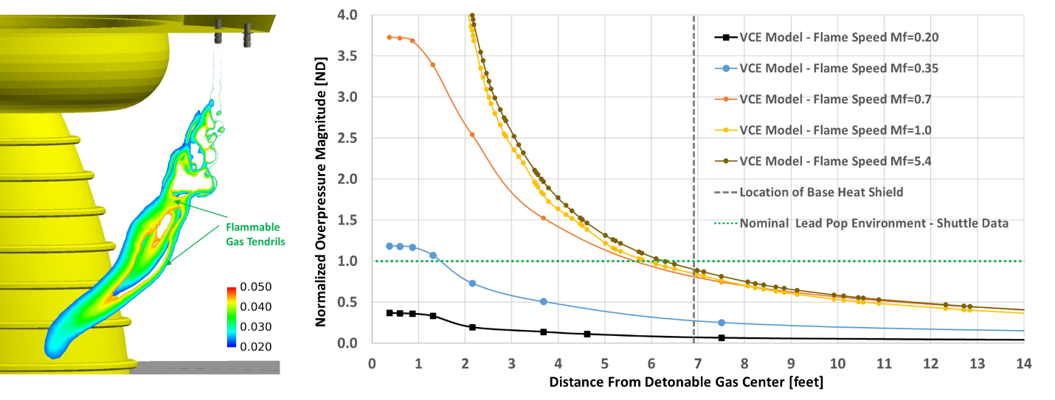
Figure 10: A snapshot showing detonable hydrogen and air mixture regions formed by a north side CAPU pulse (left) and results of the VCE analysis (right).

Both results shown were extracted from CFD simulations with no significant environmental wind. Universally, wind was found to slightly decrease the detonable mass of hydrogen in the hazardous gas mixture. Since the simulations without wind represent the worst-case environmental scenario for the hazard consequence, only the no-wind results where used quantify the potential consequence to the SLS vehicle.

- Core Stage Engine Section LH2 Umbilical Plate Cavity Purge Analysis Methodology

Figure 4 shows the computational domain used for the CFD analysis of the CS ES LH2 umbilical next to a detailed drawing of the umbilical carrier plate. The fluid volume that comprises the computational domain is the cavity between the umbilical carrier plate and the SLS vehicle. The volume is enclosed by a perimeter seal which isolates the cavity from the exterior environment and electrical connectors, giving the fluid volume its unique shape. Additionally, there are two, round, quick disconnect interfaces for LH2 tank fill and drain and bleed operations in the center the umbilical carrier plate. Hydrogen leakages into the umbilical plate cavity nominally occur along the outer perimeter of these quick disconnects. Figure 4 shows that there are 5 H2 inlet ports modeled around the perimeter of the quick disconnect region to simulate the H2 leakages into the umbilical cavity. The H2 leakages into the cavity are purged using helium which is directed into the volume through two purge ports. The purge gas mixture of H2 and helium exits the domain at the top of the cavity to the atmosphere. In the CFD model, this outlet is modeled as a fixed pressure outlet at 14.7 psia.
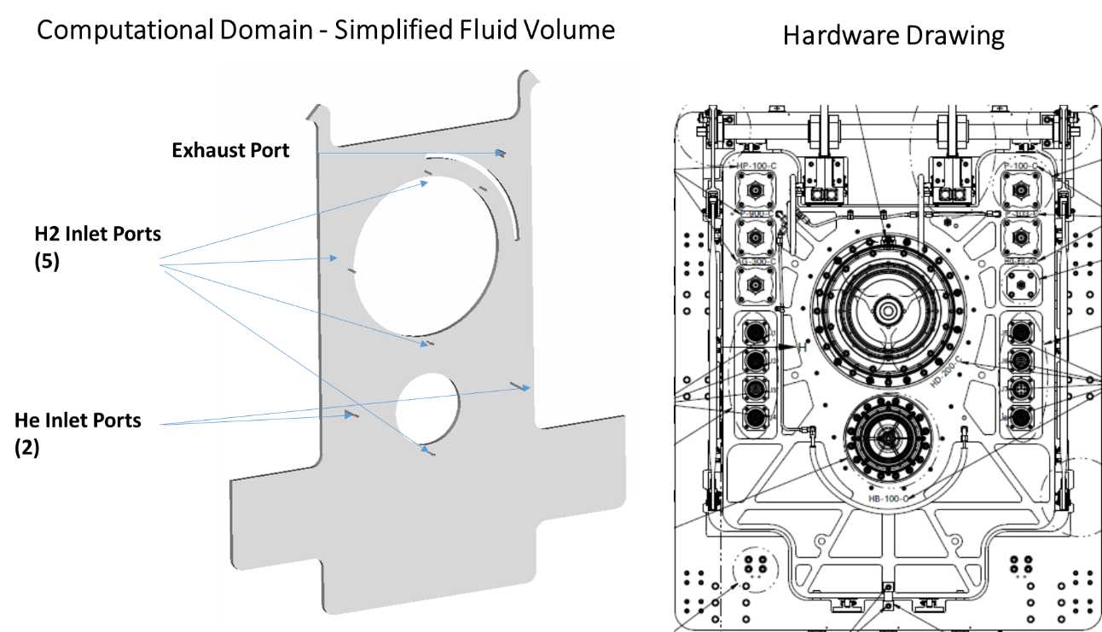
Figure 11: The computational domain used to model the umbilical plate cavity (left) and a hardware drawing of the exterior plate details (right).

CFD simulations of the umbilical cavity were initialized with ambient helium. H2 leakages were simulated by flowing a fixed mass flow rate through one or more of the H2 inlet ports in the domain. Time-accurate CFD simulations were conducted until the mass of the accumulated hydrogen inside the computational domain reached a stationary value. Buoyancy effects were included in the CFD model. Much of the purge and leakage gas mixing inside of the cavity occurred at relatively low velocity. Buoyancy and diffusion were significant drivers of hydrogen and helium transport and mixing throughout the domain. A delayed detached eddy simulation turbulence model was used. Both time-averaged and instantaneous CFD simulation results were interrogated to understand species distribution observations that could explain inconsistent H2 concentration data from experiments with known quantities of H2 leakage gas.

- Core Stage Engine Section LH2 Umbilical Plate Cavity Purge Analysis Results

CFD simulations of the Core Stage Engine Section LH2 umbilical plate cavity helium purge system were conducted to help explain the cause of inconsistent hydrogen concentration readings measured during tests of the system. Given that there was a known quantity of helium purge gas and a constant flow of hydrogen leakage into the volume, the final concentration of the homogeneous mixture can be easily calculated without the need for CFD. During the test series, test-to-test inconsistences were observed in the measured concentration of hydrogen near the outlet of the umbilical plate volume. In launch attempt scenario, these measurement inconsistencies could have caused an erroneous LCC violation leading to an unnecessary abort. Additional inconsistencies in measured test data occurred when the hydrogen leakage location was changed. CFD simulation results were focused on understanding the changes in gas mixture distribution inside the cavity as a result of changes in the hydrogen leakage location. Additionally, the possibility of sensor sampling location error was investigated using CFD simulation results.

Figure 13 shows a snapshot from a time-accurate CFD simulation of the umbilical plate purge system. In the image, streamlines are seeded at the inlets of the two helium purge ports. The contours in Figure 13 show the instantaneous mass fraction of hydrogen. Hydrogen gas is injected at the Target 4 location to simulate a hydrogen leak from LH2 fill and drain umbilical quick disconnect interface at a location that is the closest point to the purge vent outlet. Figure 13 shows that the purge gas flow and buoyancy effects advect the hydrogen gas toward the upper part of the cavity. The lower pressure at the purge gas exit creates a swirling flow pattern into the purge gas exit duct.

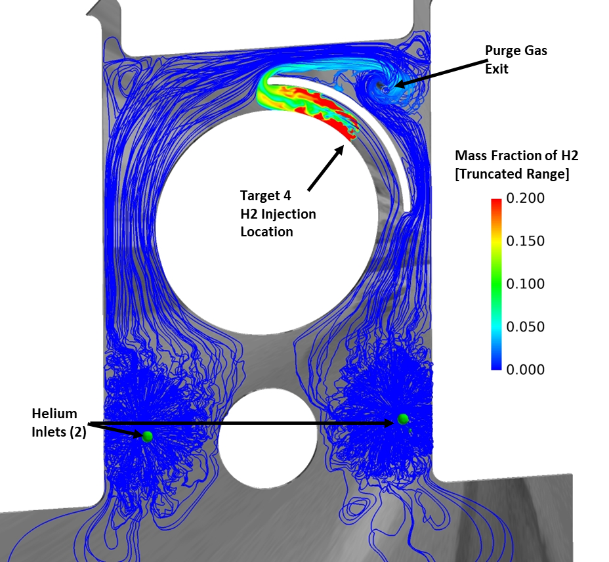
Figure 12: CFD simulation snapshot showing streamlines originating at the helium purge ports and mass fraction of hydrogen originating at the Target 4 location near the purge gas exit.

Figure 14 again shows the instantaneous hydrogen mass fraction contours shown in Figure 13 but enlarged to show the distribution of gas concentration around the purge gas exit duct. Figure 14 also indicates that the sampling location to measure hydrogen concentration during tests is located some distance away from the exit port. Contours shown in the image indicate that for the Target 4 leakage location, the hazardous gas monitoring system would likely report a hydrogen concentration that would not match the concentration at the actual purge gas exit due to incomplete mixing and sampling bias errors.
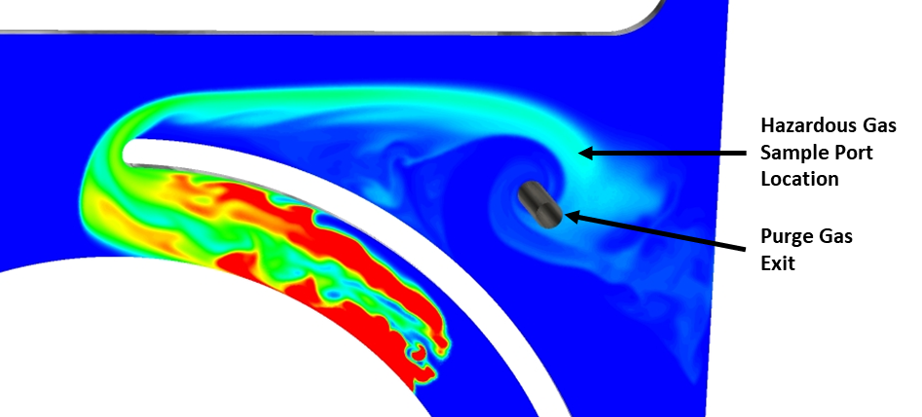
Figure 13: CFD simulation snapshot showing mass fraction of hydrogen dilution as swirling flow into the exit port forces mixing with the helium purge gas.
CFD simulations were conducted simulating hydrogen leakages at different locations to investigate if sampling location bias errors during testing were likely for other test hydrogen leakage configurations. Figure 15 shows instantaneous snapshots of hydrogen mass fraction results for simulated leakages at the Target 2 (9 o’clock position) and Target 3 (6 o’clock position) hydrogen leakage locations. Both snapshots shown in Figure 15 reveal that buoyancy effects drive some hydrogen gas to the upper regions of the cavity and a swirling flow pattern into the purge exit duct occurs. Mixing of the hydrogen leakage and helium purge gases occur throughout the swirling flow pattern with the inlet to the duct enforcing vigorous mixing of the two gas species. Like the previously shown Target 4 leakage location results, the CFD simulation results show the potential for sampling location bias errors at the Target 2 and 3 hydrogen leakage results.

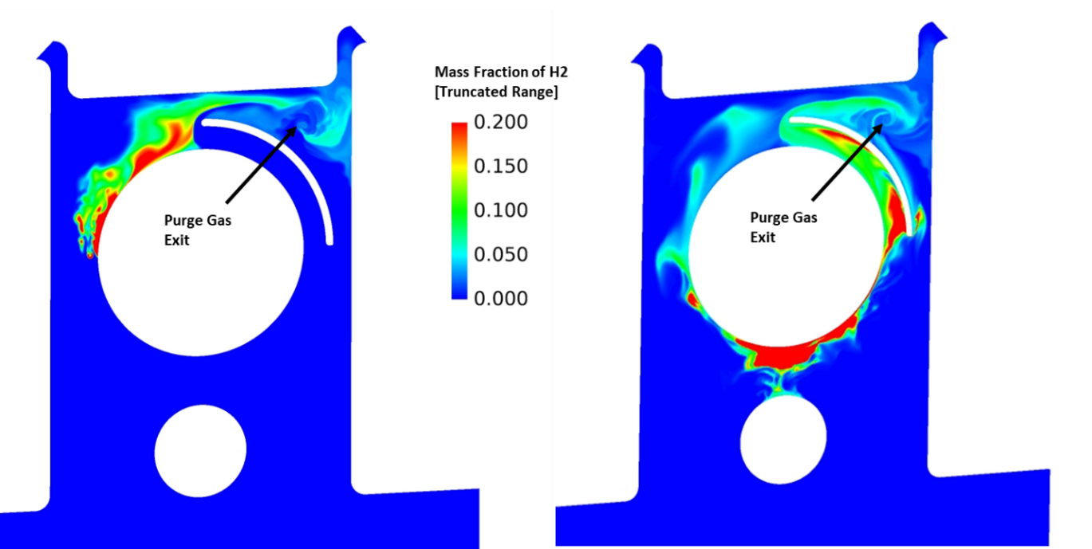
Figure 14: CFD simulation snapshots of hydrogen mass fraction showing different mixing patterns for to different hydrogen leakage locations, Target 2 (left) and Target 3 (right).

CFD simulation identified sampling location error as one potential cause of the inconsistent test data measured during the leakage tests at varied hydrogen leakage locations. In response to this finding, the test conductors physically moved the hazardous gas sampling port location to the purge exit duct to ensure that the gas concentration data was taken from a location where helium and hydrogen gases were uniformly mixed. However, the tests again produced inconsistent data at the new gas concentration sampling location. The CFD simulation results at the new hazardous gas sampling location were investigated to quantify any spatial non-uniformities over the test sampling period. Figure 16 shows time-averaged CFD simulation results at the new gas sampling location in the purge exit port. The contours in Figure 16 show hydrogen concentration by volume for three different hydrogen leakage locations. Figure 16 shows that there are some spatial variations in hydrogen concentrations that could lead to variations in the measured concentration during tests. The spatial variation was most noticeable at hydrogen leakage location Target 4 where the leakage location is closest to the exit duct. The variations in the concentration were estimated to be up to +/- 2% out of a mean value of 4% hydrogen. While the ~+/- 50% variation in measured hydrogen concentration predicted by the CFD analysis seems significant, the variation observed during testing was significantly larger than the CFD estimate and these large variations in the data occurred at all hydrogen leakage locations.

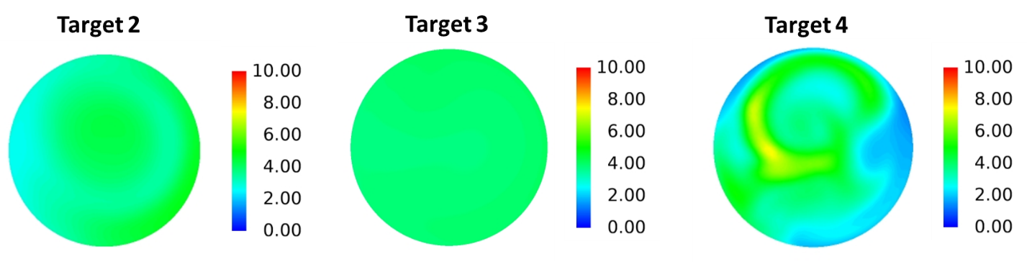
Figure 15: Time-averaged hydrogen concentration results in the purge exit port from CFD analyses modeling different hydrogen leakage locations.

After discussions with the test conductors and engineers, it was determined that the CFD simulation results had eliminated incomplete mixing and sampling location bias as the actual source of the inconsistent test measurements. Ultimately the team discovered that the umbilical plate outer perimeter seal was leaking to the atmosphere around the test article. This leak produced a second outlet path for gas to escape from the cavity and was responsible for the inconsistent and unrepeatable test results. After the seal leak issue was fixed, the gas concentration test data agreed with the CFD simulation results shown in Figure 16. Hydrogen leakages at the Target 2 and 3 leakage locations produced the nominal and expected measured value of 4% hydrogen by volume throughout the test. Leakages at the Target 4 location produced an approximately +/- 25% variation about the mean value of the measured hydrogen concentration which agreed with observations from the CFD simulation results.

- Core Stage Engine Section LH2 Umbilical Plate Exhaust Analysis Methodology

Figure 5 shows an external view of the CS LH2 engine section umbilical plate with a zoomed in view of the purge port protruding from the exterior of the plate. Nominally, hydrogen leakages occur between the umbilical plate shown in Figure 5 and the SLS vehicle. Helium purge gas is used to dilute the hydrogen leakage to a non-flammable concentration prior to exiting to the ambient environment around the vehicle through a purge port shown in Figure 5. However, during several of the Artemis I wet dress rehearsals and launch attempts, the hydrogen leakage rate exceeded the capacity of the purge system, and a potentially flammable mixture of hydrogen and helium were expelled outside of the vehicle. Fluid analysis, including CFD simulations using Loci-STREAM were conducted to quantify the volume of flammable gas around the purge port for a flight risk assessment.

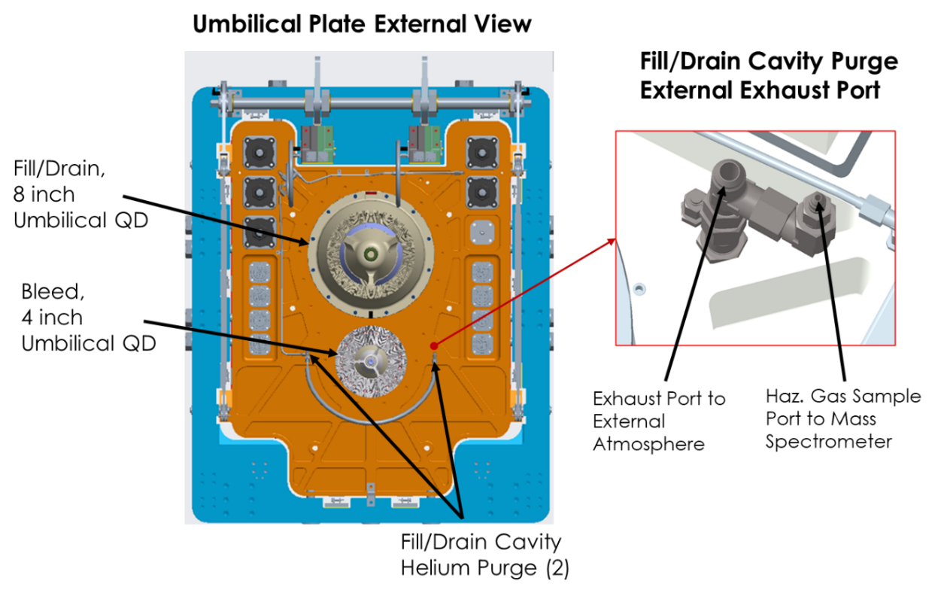
Figure 16: An external view of the CS Engine Section LH2 umbilical carrier plate with a detailed view of the plate cavity purge exhaust port.

Figure 6 shows the computational domain used to model the venting of the LH2 umbilical plate cavity purge gas to the external environment around the SLS vehicle. The white, simplified umbilical plate geometry represents the blockage of the actual, as-installed plate but does not include the complex surface features. The gold-colored cylindrical shapes represent the envelope and wind blockage of the LH2 fill/drain line and bleed lines. Dozens of smaller purge lines and electrical lines were not included in the model as their locations are not well defined by CAD and are expected to have a second-order effect on wind blockage. The purge port interior geometry closely matches the geometry of the as-installed port on the vehicle. The interior flow path includes multiple area changes due to the presence of fittings. These geometric features were found to produce a first-order effect on the shape of the purge gas jet exiting the port.

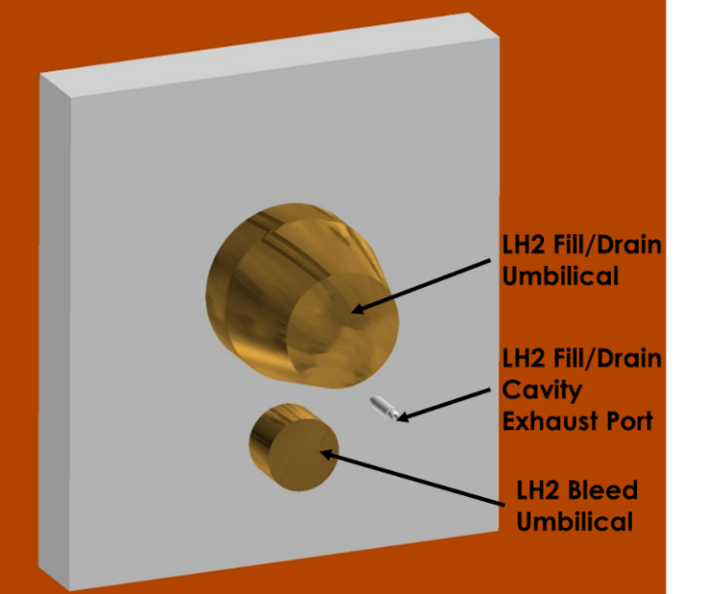
Figure 17: The computational domain used to simulate gas from the exhaust port mixing with the external environment around the SLS vehicle.

The SLS Flight Commit Criteria (FCC) states that the concentration of the hydrogen gas exiting the umbilical plate through the purge port cannot exceed 4% H2 by volume. The FCC was developed to ensure that the exiting hydrogen and helium purge gas mixture would not be flammable once mixed with air. Figure 7 shows the flammability diagram for hydrogen and air mixtures with various diluent species, including helium. The green, red and orange lines on the plot represent uniform mixing of a hydrogen-helium mixture with air starting at 4%, 8%, and 10% H2 concentrations respectively. Figure 7 shows that the 4% H2 and 96% helium mixture never reaches a flammable condition when uniformly mixed with air. The 8% H2 concentration mixture just reaches the edge of the flammable condition while 10% H2 can definitively produce a flammable mixture with air. Figure 7 shows that the original FCC to ensure non-flammability of the hydrogen-helium mixture may be conservative. CFD simulations of purge gas mixing with air were conducted at 8%, 10%, 20%, and 38% H2 concentrations.

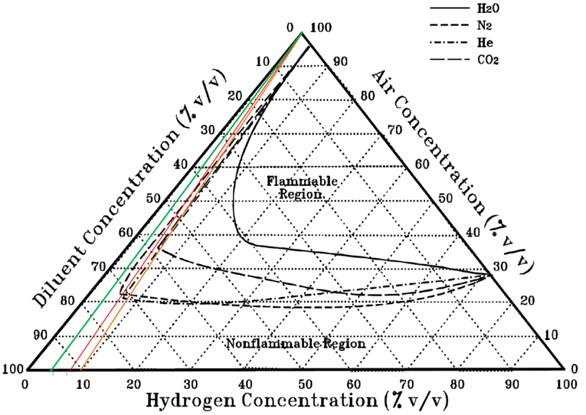
Figure 18: Ternary plot showing flammability limits of hydrogen, air and diluent mixtures with lines marking the 4%, 8% and 10% H2 mixture conditions.

CFD simulations were conducted time-accurate and with second-order spatial accuracy. While the quantity of interest from the simulation was the qualitative volume and location of the flammable gas mixture, several solution verification methods were applied to ensure numerical accuracy of the CFD result. Several successive mesh refinements were conducted to ensure that the results were not highly sensitive to spatial resolution. The time-step size was successively decreased until global mass flow rate convergence was satisfied to within 3% error or less and the L2 norm of the residual could be decreased by several orders of magnitude during each time-marching step.

- Core Stage Engine Section LH2 Umbilical Plate Exhaust Analysis Results

This section contains time-accurate, three-dimensional CFD analysis results for the SLS Core Stage Engine LH2 umbilical plate vent system using Loci-STREAM. The umbilical plates facilitate commodity transfers to and from the Core Stage prior to flight. The Fill and Drain and Bleed umbilical interfaces inside the umbilical plates are surrounded by a cavity where H2 leakages from the umbilical interfaces are purged with an inert gas, helium, to dilute the exhaust to a non-hazardous mixture before exiting the umbilical plate through an exhaust port. The Artemis I Launch Commit Criteria (LCC) states that the combined H2/GHe exhaust gas exiting the umbilical plate cannot exceed 4% H2 by volume. However, during the first and second Artemis I launch attempts, the concentration in the exhaust exceed that 4% limit. In response, an H2 limit deviation waiver was proposed for Artemis I. The CFD analysis results in this section describe the flammable volume of gas generated by expelling H2/GHe mixtures into the ambient air around the SLS vehicle for a range of H2 concentrations and wind conditions to understand the potential hazard that may be created by increasing the allowable H2 concentration in the exhaust gas. Since the expulsion of hazardous gas at this location was caused by an unplanned leakage anomaly at the umbilical interface, no planned mitigation system existed to reduce the potential risk posed to the vehicle. Using CFD to understand the potential risk posed to the vehicle and ground systems was critical in developing flight rationale for the Artemis I launch.

Figure 17 shows three iso-surface images at a single snapshot in time from the CFD simulation modeling the exhaust plume for a gas mixture of 8% H2 and 92% helium by volume. The green iso-surface in the far-left image shows the LFL of the hydrogen/helium/air mixture that forms as the exhaust gases are expelled out of the vent port. The middle image shows an iso-surface that visualizes the lower oxygen limit to support combustion as defined in the ternary plot shown in Figure 17. The image on the right shows a composite image of both the LFL and lower oxygen limit iso-surfaces. The volume inside the blue iso-surface does not contain a sufficient concentration of oxygen to enable combustion of the hydrogen in the minute. The region outside the green iso-surface does not contain enough hydrogen to produce a combustible mixture of gases. Only the small region between the blue and green iso-surfaces contains a combustible mixture of gases. The exhaust gas exits the port at a velocity magnitude that exceeds 400 feet/second. The volume and shape of the combustible gas region varied significantly due to unsteady fluid mixing. Engineering experience indicates that a combustion event is unlikely to produce a sustained flame at these conditions.

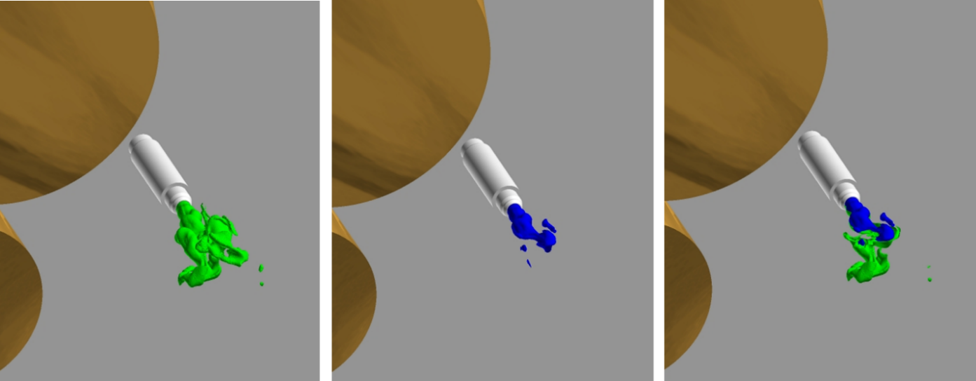
Figure 19: CFD result snapshots showing the LFL iso-surface (left), lower oxygen limit iso-surface (middle) and composite iso-surfaces (right) for exhaust containing 8% H2 with calm ambient wind.

Figure 18 shows three iso-surface images at snapshots in time from CFD simulations modeling the exhaust plume for a gas mixture of 10% H2 and 90% helium by volume with different wind conditions. The left image shows a composite image of both the LFL and lower oxygen limit iso-surfaces with a gentle 3knot crosswind. The middle image shows the LFL iso-surface under the influence of a 25 knot crosswind. The image on the right shows a composite image of both the LFL and lower oxygen limit iso-surfaces for the exhaust exiting into the 25 knot wind condition. Only the region between the blue and green iso-surfaces contains a combustible mixture of gases in Figure 18. Figure 18 shows that the wind shortens and bends the combustible volume downstream of the exhaust port and only slightly affects the overall volume of the combustible gas mixture compared to the results with calm winds.

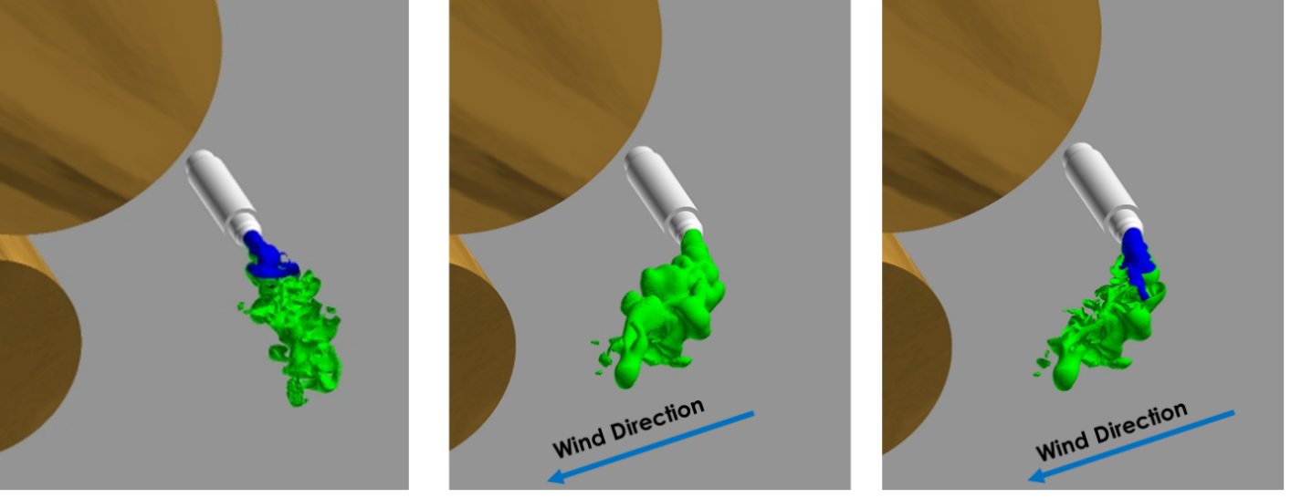
Figure 20: CFD result snapshots showing composite iso-surfaces for exhaust containing 10% H2 with calm ambient wind (left), LFL iso-surface (middle) and composite iso-surfaces (right) for exhaust containing 10% H2 with a 25 knot crosswind.

Figure 19 three iso-surface images at snapshots in time from CFD simulations modeling the exhaust plume for a helium and hydrogen gas mixture of 20% H2 and 38% H2 by volume respectively. The left and middle images show composite images of both the LFL (green) and lower oxygen limit (blue) iso-surfaces. The volume between the blue and green iso-surfaces contains a combustible mixture of gases. Figure 19 shows that the flammable volume of gas grows significantly as the concentration of hydrogen exiting the purge vent increases. The far-right snapshot shows a pink iso-surface which encloses the detonable mixture of gases that form as the 38% H2 exhaust mixes with air in the ambient environment. However, the volume of gas at this detonable mixture is significantly smaller than the detonation cell size corresponding to the lean equivalency ratio observed for this H2-air mixture [10]. Therefore, the gas mixture cannot support a detonation.
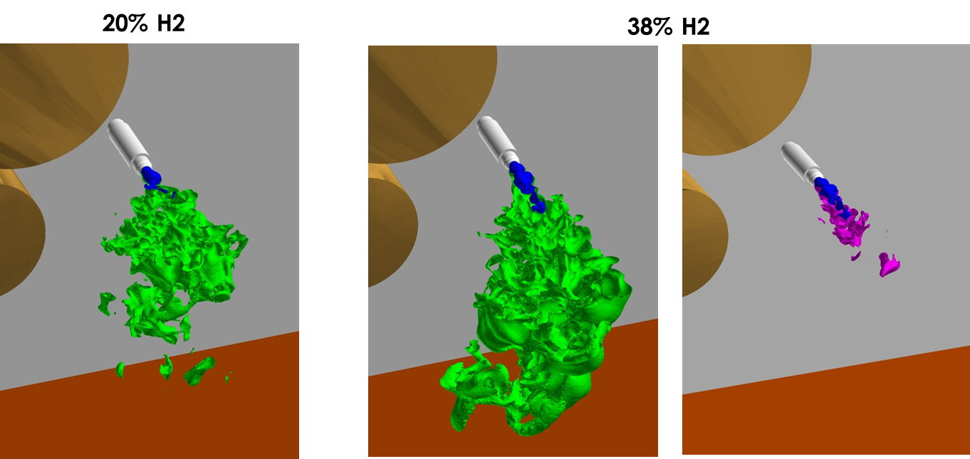
Figure 21: CFD result snapshots showing composite iso-surfaces for exhaust containing 20% H2 (left), composite iso-surfaces for exhaust containing 38% H2 (middle) and LEL iso-surface (right).

From the analysis, the primary hazard to the vehicle is assessed to be potential thermal damage to the vehicle produced by a sustained combustion event. Based on the analysis result, the likelihood of a sustained flame increases with an increased H2 concentration in the umbilical plate exhaust gas. For the 8% H2 result, the transient nature of the flammable volume could make sustaining a flame unlikely. Additionally, for all H2 concentrations modeled, the high shear along the edge of the exhaust gas jet does not support flame anchoring to the exhaust port and a stand-off flame would be expected if the gas ignited. Small weakly burning stand-off flames could potentially be extinguished by environmental factors such as wind. The initiation of a combustion event would require an ignition source within the volume that was identified as flammable in the CFD analysis. No ignition source in the region of the flammable gas mixture was identified. The combined CFD and hazard analysis were used to develop a flight rationale waiver that allowed the H2 concentration in the exhaust gas to exceed 4% without being considered an LCC violation for Artemis I. The updated flight waiver was used during the successful Artemis I flight.

- Summary and Conclusions

CFD simulations of the non-reacting hydrogen CAPU plume interacting with the environment around the SLS vehicle just prior launch were conducted using Loci/CHEM. The non-reacting CFD results were used to identify combustible and detonatable regions of the CAPU plume as it mixes with the air surrounding the vehicle. A vapor cloud explosion model was used to predict the consequence of a detonation of the CAPU exhaust gas at various combustion flame speeds and wind conditions. The results of the VCE model indicate that even a strong detonation of the CAPU exhaust would not generate an overpressure magnitude which exceeds the current design environment for the SLS base heatshield. This conclusion was reached even with significant conservatism built into the model. The conservatisms included the initial failure of the HBOIs to mitigate the accumulation of unburned hydrogen, the maximum accumulated mass of hydrogen was used in the VCE calculation, and the maximum combustion event flame speed of Mach 5.4 was assumed for the VCE calculation.

Loci-STREAM simulations of the Core Stage Engine Section LH2 umbilical plate cavity helium purge system were conducted to help explain the cause of inconsistent hydrogen concentration readings measured during tests of the system. CFD simulation results were focused on understanding the changes in gas mixture distribution inside the cavity as a result of changes in the hydrogen leakage location. Analysis results showed that incomplete mixing and sensor location bias were contributors to the inconsistencies in the test data but could not explain the full range of the inconsistent data. The test conductors discovered that the umbilical plate outer perimeter seal was leaking to the atmosphere around the test article. This leak produced a second outlet path for gas to escape from the cavity and was responsible for the inconsistent and unrepeatable test results. Once the leaks through the perimeter seal were stopped during testing, the H2 concentration data exiting the exhaust port showed test-to-test consistency and more closely matched the expected concentration based on the gross flow rates of the two gases. The data corroborated the CFD observations that H2 leakages close to the exhaust port produced sampling data that consistently varied from data collected from cases where leakages occurred far away from the port.

CFD simulation of external venting of the CS engine section LH2 umbilical plate cavity was conducted using Loci-STREAM. The analysis identified regions of flammable gas produced by venting exhaust from the plate cavity during off-nominal H2 leakages into the umbilical plate cavity. From the analysis, the primary hazard to the vehicle is assessed to be potential thermal damage to the vehicle produced by a sustained combustion event. Based on the analysis result, the likelihood of a sustained flame increases with an increased H2 concentration in the umbilical plate exhaust gas. The initiation of a combustion event would require an ignition source within the volume that was identified as flammable in the CFD analysis. No credible ignition source was identified and the CFD analysis results were used to develop a flight rationale waiver that allowed the H2 concentration in the exhaust gas to exceed 4% without being considered an LCC violation for Artemis I. The updated flight waiver was used during the successful Artemis I flight. A recommendation was made to consider an additional external purge stage for future Artemis missions if the root cause of the H2 leaks cannot be mitigated to avoid potential ignition from any unidentified source.
- References

[1] Luke, Ed, et. al, “CHEM 4.0 A Finite-Rate Viscous Chemistry Solver – The User Guide” April 11, 2018.
[2] Thakur, S., Wright, J., “Loci-STREAM: An All-Speed CFD Solver for Arbitrary Polygonal Meshes – Methodology,” Streamline Numerics, Inc. Report, Gainesville Florida, April 2009a.
[3] Thakur, S., Wright, J. and Shyy, W., “An Algorithm for Chemically Reacting Flows on Generalized Grids Using a Rule-Based Framework,” 43rd AIAA Conference, Paper No. 2005-0875, Reno, NV (Jan 2005).
[4] ANSA v13.2.3., May. 2012, User's Guide. BETA CAE Systems S.A.
[5] Marcum, D. L. AFLR3 Unstructured Grid Generator. (Simcenter) Retrieved from Solidmesh Web Site: http://www.simcenter.msstate.edu/docs/solidmesh/
[6] M.J. Tang and Q.A. Baker “A New Set of Blast Curves from Vapor Cloud Explosion” 33rd Loss Prevention Symposium held during the AIChE Spring National Meeting, Houston, Texas, March 14-18, 1999
[7] J. Lobato, P. Cañizares, et. al. “A comparison of hydrogen cloud explosion models and the study of the vulnerability of the damage caused by an explosion of H2,” University of Castilla- La Mancha, Spain. September 2006
[8] NASA Technical Report “Safety standard for hydrogen and hydrogen systems. Guidelines for hydrogen system design, materials selection, operations, storage, and transportation.” Technical report NSS 1740.16, Office of safety and mission assurance, Washington.
[9] ISO/TR 15916 (2004). Basic considerations for the safety of hydrogen systems. International Organization for Standardization. ISO Technical Committee 197 Hydrogen Technologies. International Organization for Standardization, Geneva.
[10] 22. Lee, J. H., Kynstantus, R., Guirao, C. M., Benedick W. A, and Shepherd, J. E., “Hydrogen Air Detonations.” Proceedings of the 2nd International Workshop on the Impact of Hydrogen on Water Reactor Safety. M. Berman Ed., SAND82-2456 Sandia National Laboratories, Albuquerque, NM, Oct. 1982.

Computational Fluid Dynamicist, Fluid Dynamics Branch (ER42), NASA MSFC.

