Conference: AIAA Aviation Forum
Date: 7/29/24 – 8/2/24
Title: A Green’s function sensor fusion approach for evaluating spacecraft entry heating from on-board thermal instrumentation.
Target Topic Areas:
Information Systems
- Sensor Systems and Information Fusion: Applications of sensor systems and distributed sensor networks to aviation, including detection, collection, fusion, processing, storage, retrieval, distribution, and reception of information at the local sensing node and at the distributed sensor network level.
Flight Testing
- Techniques, Measurement Technologies, and Approaches to Acquire Crucial Flight Data in Flight Test
Authors:
Kenneth McAfee, Presenting Author
- Department of Aerospace Engineering, University of Maryland
Hannah Alpert
- Entry Systems and Vehicle Development Branch, NASA Ames Research Center
Peter Sunderland
- Department of Fire Protection Engineering, University of Maryland
Oded Rabin, Corresponding Author
- Department of Materials Science and Engineering, University of Maryland
- Institute for Research in Electronics and Applied Physics, University of Maryland

All abstracts submitted to AIAA forums must meet the following minimum requirements in order to be considered for acceptance to the event:
- The abstract must be an extended abstract or draft manuscript with a minimum of 1,000 words.
- The submission must include sufficient detail to demonstrate the purpose of the paper, the technical foundation for the topics to be discussed, any preliminary results to date, and the expected results of the final paper, including key figures, equations, tables, and references, as appropriate. Sufficient information must be included in the submission to convince the forum organizers and reviewers that the author(s) will have a strong likelihood of completing the final manuscript by the final manuscript submission deadline.
- There is no required format, but many authors use the final manuscript template available on the Author Resources Page.

Abstract
Nomenclature
$$q$$ | = | Heat flux
$$T$$ | = | Temperature
$$k$$ | = | Thermal conductivity
$$α$$ | = | Thermal diffusivity
$$∇^{2}$$ | = | Laplacian
$$g$$ | = | Internal heat generation
$$G$$ | = | Green’s function
$$δ$$ | = | Dirac delta function
$$x$$ | = | 3-dimensional coordinate vector
$$x_{0}$$ | = | 3-dimensional coordinate vector (dummy variable)
$$t$$ | = | Time
$$τ$$ | = | Time (dummy variable)
$$T_{0}$$ | = | Initial temperature
$$\hat{n}$$ | = | Surface normal
$$S$$ | = | Surface
$$V$$ | = | Volume
$$ϕ_{n}$$ | = | Eigenfunction
$$ψ_{n}$$ | = | Eigenvector
$$Λ_{n,n}$$ | = | Eigenvalue
$$f_{j}$$ | = | Basis function
$$λ$$ | = | Regularization parameter
$$\left[L\right]$$ | = | Discrete 2nd derivative operator
$$L$$ | = | Length or thickness
$$r$$ | = | Radius
$$R_{1}$$ | = | Heat flux sensor radius
$$R_{2}$$ | = | Total radius of TPS-sensor system
Subscripts
CW | = | Cold wall
HW | = | Hot wall
TPS | = | Thermal protection system
HFS | = | Heat flux sensor

Background and Motivation
During atmospheric entry, distributed thermal measurements are critical to enable the evaluation of heat loads on spacecraft thermal protection systems (TPS). In recent space exploration missions, Schmidt-Boelter-type heat flux gauges have been integrated into the TPS alongside conventional temperature measurement instrumentation to measure total (convective and radiative) and radiative heat transfer rates^{1,2}. While direct heat flux sensors (HFS) are able to provide valuable information detailing the thermal loads experienced by spacecraft, the interpretation of these measurements in unsteady, convective environments requires a correction factor to account for local heating augmentations at the cold wall HFS surface^{2,3}. Current efforts to estimate cold wall correction factors, and thus recover the hot wall TPS heat flux, rely on time-marching computational fluid dynamics (CFD) simulations². Simulation-based methods are susceptible to large uncertainties, however, as they require estimations of vehicle trajectory, gas kinetics, wall catalysis models, and other flight conditions as input parameters^{2,4}. Furthermore, CFD simulations are computationally expensive and cannot efficiently survey all possible entry scenarios, exacerbating the uncertainty of reconstructed hot wall heat flux values. These drawbacks motivate the development of alternative hot wall heat flux reconstruction methods that are not reliant on CFD-based correction factors.
Technical Merit
We report on the development of a reconstruction framework to accurately recover hot wall TPS heat flux values during atmospheric entry solely utilizing on-board thermal instrumentation. A schematic of the HFS and surrounding TPS (referred to herein as the TPS-sensor system) is shown in Figure 1. The reconstruction framework aims to recover the hot wall heat flux absorbed into the TPS $q_{HW}$ using the time history of the cold wall heat flux measurement $q_{CW}$ and distributed temperature measurements embedded in the surrounding TPS. The approach consists of two main technical steps. First, the TPS-sensor system is represented using Green’s functions to establish a relationship between the hot and cold wall surface heat flux boundary conditions and the subsurface temperature distribution. Then, the unknown hot wall heat flux is recovered through regularized inversion of Green’s function using known cold wall heat flux $q_{CW}$ and temperature $T$ measurement values.
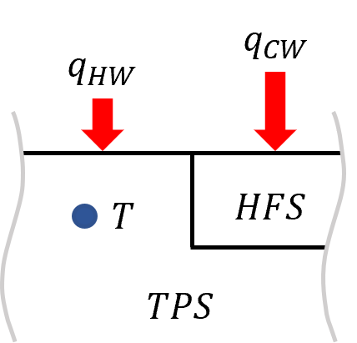
Figure 1. Schematic of the TPS-sensor system. Heat flux absorbed by the cold wall heat flux sensor (HFS) $q_{CW}$ is augmented compared to the heat flux absorbed by the hot wall TPS $q_{HW}$. Discrete temperature measurements are embedded within the TPS near the heat flux sensor.
Green’s Function Formulation
A Green’s function representation of the TPS-sensor system is used to encapsulate heat flux and embedded temperature measurements within a single equation formulation. Green’s function models the impulse response of a linear system to a Dirac delta forcing term and is applied to the heat conduction problem via an analogous auxiliary equation⁵.
 | $$\frac{1}{α}\frac{∂T}{∂t}-∇^{2}T=\frac{1}{k}g\left(x,t\right)$$ | (1)
 | $$\frac{1}{α}\frac{∂G}{∂t}-∇^{2}G=\frac{1}{α}δ\left(x-x_{0},t-τ\right)$$ | (2)
Equation 1 is the heat conduction equation with a heterogeneous internal heat generation term $g(x, t)$. In Equation 1, $T$ represents temperature, $∇^{2}$ is the Laplacian operator, and $k$ and $α$represent the thermal conductivity and thermal diffusivity of the medium of interest, respectively. Equation 2 is the auxiliary equation and models Green’s function $G(x, t, x_{0}, τ )$ as the impulse response to a heterogeneous Dirac delta heat pulse occurring at location $x_{0}$ and time $τ$. In Equations 1 and 2, $x$ represents general 3-dimensional coordinates. In this work, the TPS-sensor system is represented by cylindrical coordinates $x=\left\{r,θ,z\right\}$.
Following Cole and Beck⁵, manipulation of Equations 1 and 2 leads to an integral representation of the subsurface TPS temperature distribution due to heat flux boundary conditions imposed on the outer surfaces of the TPS-sensor system,
 | $$T\left(x,t\right)=T_{0}-\int_{0}^{t}{\int_{S_{TPS}}{\frac{α_{TPS}}{k_{TPS}}q_{HW}\left(x_{0},τ\right)G_{TPS,TPS}\left(x,t,x_{0},τ\right)}⋅\hat{n}dS_{0}dτ} -\int_{0}^{t}{\int_{S_{HFS}}{\frac{α_{TPS}}{k_{TPS}}q_{CW}\left(x_{0},τ\right)G_{TPS,HFS}\left(x,t,x_{0},τ\right)}⋅\hat{n}dS_{0}dτ}$$ | (3)
In Equation 3, $T_{0}$ represents the initial temperature of the system, which is assumed to be uniform. The surface integral terms on the right-hand-side of Equation 3 represent individual contributions of the hot wall TPS heat flux $q_{HW}$ and the cold wall HFS measurement $q_{CW}$ on the temperature rise within the TPS. The material properties $α_{TPS}$ and $k_{TPS}$ are the thermal diffusivity and thermal conductivity of the TPS, respectively and $G$ represents the TPS-specific Green’s function due to heat flux boundary conditions imposed on the TPS $G_{TPS,TPS}$ or HFS $G_{TPS,HFS}$.
In the reconstruction framework, Green’s functions are developed for the TPS-sensor system using a Galerkin formulation^{5–7}. In this method, Green’s functions are constructed using an approximation of the linear heat conduction eigenfunctions⁶ $ϕ_{n}$.
 | $$G_{l,m}\left(x,t,x_{0},τ\right)=\sum_{n=1}^{N}{ϕ_{n}^{\left(l\right)}\left(x\right)ϕ_{n}^{\left(m\right)}\left(x_{0}\right)e^{-Λ_{n,n }\left(t-τ\right)}} l,m=TPS or HFS$$ | (4)
where the eigenfunctions $ϕ_{n}$ are expressed as the sum of scaled basis functions $f_{j}$.
 | $$ϕ_{n}^{\left(l\right)}=\sum_{j=1}^{N}{ψ_{j,n }f_{j}^{\left(l\right)}} l=TPS or HFS$$ | (5)
In Equation 4, Green’s function is defined for a multi-domain system, where the temperature-of-interest is located in domain $l$ and the heat flux boundary condition is imposed on domain $m.$ The variable $Λ_{n,n}$ represents the eigenvalue accompanying each eigenfunction $ϕ_{n}$. In Equation 5, basis functions $f_{j}$ are required to satisfy the homogeneous boundary conditions imposed on the TPS-sensor system and are defined separately for each domain⁵. These basis functions are then scaled by the eigenvector $ψ_{n}$ accompanying the respective eigenfunction $ϕ_{n}$. Eigenvalues $Λ_{n,n}$ and eigenvectors $ψ_{n}$ are solutions to the generalized eigenvalue problem.
 | $$\left(A+Λ_{n,n}B\right)ψ_{n}=0$$ | (6)
Where matrices A and B define the interaction between elements of the basis function set $f$. Considering all domain volumes⁶,
 | $$A_{ij}=\int_{V_{HFS}}{k_{HFS}∇f_{i}^{\left(HFS\right)}∇f_{j}^{\left(HFS\right)}dV_{0,HFS}}+\int_{V_{TPS}}{k_{TPS}∇f_{i}^{\left(TPS\right)}∇f_{j}^{\left(TPS\right)}dV_{0,TPS}}$$ | (7)
 | $$B_{ij}=\int_{V_{HFS}}{\frac{k_{HFS}}{α_{HFS}}f_{i}^{\left(HFS\right)}f_{j}^{\left(HFS\right)}dV_{0,HFS}}+\int_{V_{TPS}}{\frac{k_{TPS}}{α_{TPS}}f_{i}^{\left(TPS\right)}f_{j}^{\left(TPS\right)}dV_{0,TPS}}$$ | (8)
To achieve appropriate scaling of the basis functions, eigenvectors are normalized with respect to $B$.
 | $$ψ_{n}^{T}Bψ_{n}=1$$ | (9)
The representation of the TPS-sensor system using a Green’s function formulation (Equation 3) is advantageous for three main reasons: (I) The effect of the heat flux sensor on the subsurface TPS temperature distribution is captured, which becomes especially important when investigating the nearfield effect of measurement systems in close proximity, (II) the temperature rise within the TPS is analytically accessible for any time $t$ within the entry heat pulse, eliminating the need for computationally expensive time-marching methods, and (III) the unknown hot wall heat flux $q_{HW}$ can be isolated from all measured quantities, as shown in Equation 10.
 | $$γ\left(x,t\right)=-\int_{0}^{t}{\int_{S_{TPS}}{\frac{α_{TPS}}{k_{TPS}}q_{HW}\left(x_{0},τ\right)G_{TPS,TPS}\left(x,t,x_{0},τ\right)}⋅\hat{n}dS_{0}dτ}$$ | (10)
where, $γ\left(x,t\right)$ combines all measured temperature and heat flux quantities into one term.
 | $$γ\left(x,t\right)=T\left(x,t\right)-T_{0}+\int_{0}^{t}{\int_{S_{HFS}}{\frac{α_{TPS}}{k_{TPS}}q_{CW}\left(x_{0},τ\right)G_{HFS,TPS}\left(x,t,x_{0},τ\right)}⋅\hat{n}dS_{0}dτ}$$ | (11)
Equation 10 explicitly defines the relationship between measured quantities (Equation 11) and the unknown hot wall heat flux, facilitating a direct inversion of the right-hand-side integral to recover hot wall heat flux values. Because heat flux and temperature measurements are sampled at a finite rate of $1/Δt$, Equation 10 is instead recast as a discrete linear system⁸.
 | $$\left\{γ\right\}=-\frac{α_{TPS}}{k_{TPS}}\left[G\right]\left\{q_{HW}\right\}$$ | (12)
In Equation 12, for $N$ measurement samples, $γ$ is now represented as a $N×1$ vector and Green’s function becomes an $N×N$ lower triangle matrix where each element represents an incremental integration of Green’s function.
 | $$G_{i,j}=\int_{\left(j-1\right)Δt}^{jΔt}{\int_{S_{TPS}}{G\left(x,iΔt,x_{0}, τ\right)⋅\hat{n}dS_{0}dτ}}$$ | (13)
Recovery of Hot Wall Heat Flux Values
In the second step of the reconstruction framework, the hot wall heat flux is recovered through inversion of Equation 12. To mitigate the amplification of measurement noise present in $\left\{γ\right\}$, inversion of Equation 12 requires solution regularization^{8–10}. Typically, regularization is implemented by penalizing the squared $L_{2}$ norm of $\left\{q_{HW}\right\}$. However, this method, referred to as Tikhonov regularization, requires optimization of regularization parameters for each application and unconditionally leads to a tradeoff between the sharpness of resolved transient heat flux features and solution stability⁹. In the hot wall heat flux reconstruction framework, the cold wall heat flux sensor is used instead to regularize the solution by enforcing smoothness between the cold wall and hot wall heat flux time histories. The relationship between $q_{CW}$ and $q_{HW}$ can be expressed as
 | $$q_{HW}=C\left(t\right)q_{CW}$$ | (14)
Where $C\left(t\right)$ is an unknown arbitrary, smooth, time-varying function with a continuous 2nd derivative in time. In discrete form, $C\left(t\right)$ becomes an $N×1$ vector to be determined.
 | $$\left\{q_{HW}\right\}=\left[diag\left\{q_{CW}\right\}\right]\left\{C\right\}$$ | (15)
Equation 12 is then recast as a function of $\left\{C\right\}$, yielding
 | $$\left\{γ\right\}=-\frac{α_{TPS}}{k_{TPS}}\left[G\right]\left[diag\left\{q_{HW}\right\}\right]\left\{C\right\}$$ | (16)
The solution of $\left\{C\right\}$ aims to simultaneously minimize the squared $L_{2}$ norms of the measurement residual and the 2nd derivative of $\left\{C\right\} ADDIN ZOTERO_ITEM CSL_CITATION \{"citationID":"a1uvlkvig9e","properties":\{"formattedCitation":"\backslash \backslash super 9,11\backslash \backslash nosupersub\{\}","plainCitation":"9,11","noteIndex":0\},"citationItems":[\{"id":629,"uris":["http://zotero.org/users/8559886/items/NQRDQKQ5"],"itemData":\{"id":629,"type":"article-journal","abstract":"By deconvolution we mean the solution of a linear first-kind integral equation with a convolution-type kernel, i.e., a kernel that depends only on the difference between the two independent variables. Deconvolution problems are special cases of linear first-kind Fredholm integral equations, whose treatment requires the use of regularization methods. The corresponding computational problem takes the form of structured matrix problem with a Toeplitz or block Toeplitz coefficient matrix. The aim of this paper is to present a tutorial survey of numerical algorithms for the practical treatment of these discretized deconvolution problems, with emphasis on methods that take the special structure of the matrix into account. Wherever possible, analogies to classical DFT-based deconvolution problems are drawn. Among other things, we present direct methods for regularization with Toeplitz matrices, and we show how Toeplitz matrix–vector products are computed by means of FFT, being useful in iterative methods. We also introduce the Kronecker product and show how it is used in the discretization and solution of 2-D deconvolution problems whose variables separate.","container-title":"Numerical Algorithms","DOI":"10.1023/A:1015222829062","ISSN":"1572-9265","issue":"4","journalAbbreviation":"Numerical Algorithms","language":"en","page":"323-378","source":"Springer Link","title":"Deconvolution and Regularization with Toeplitz Matrices","volume":"29","author":[\{"family":"Hansen","given":"Per Christian"\}],"issued":\{"date-parts":[["2002",4,1]]\},"citation-key":"hansenDeconvolutionRegularizationToeplitz2002"\}\},\{"id":626,"uris":["http://zotero.org/users/8559886/items/W3MXXAND"],"itemData":\{"id":626,"type":"article-journal","abstract":"This paper introduces a novel method to combine total variation and l2 regularizations to reconstruct piecewise smooth signals. The main idea is to consider the signal as a sum of two components: a piecewise constant component and a smooth component. For the solution of ill-posed problems, the Tikhonov method with a special stabilizer in the form of a sum of two different stabilizers is used: the total variation for the first component and the Sobolev norm for the second one. An iteratively re-weighted least squares technique is used as a fast and an efficient algorithm for minimization of the Tikhonov functional. A method is also presented for determining the regularization parameters. Numerical experiments, among the many performed, in denoising, deblurring, and compressed sensing demonstrate high performance of the new regularization for reconstruction of piecewise-smooth solutions with sharp discontinuities.","container-title":"Signal Processing","DOI":"10.1016/j.sigpro.2012.12.008","ISSN":"0165-1684","issue":"7","journalAbbreviation":"Signal Processing","page":"1945-1960","source":"ScienceDirect","title":"A balanced combination of Tikhonov and total variation regularizations for reconstruction of piecewise-smooth signals","volume":"93","author":[\{"family":"Gholami","given":"Ali"\},\{"family":"Hosseini","given":"S. Mohammad"\}],"issued":\{"date-parts":[["2013",7,1]]\},"citation-key":"gholamiBalancedCombinationTikhonov2013"\}\}],"schema":"https://github.com/citation-style-language/schema/raw/master/csl-citation.json"\}$^{9,11}, in effect penalizing solutions which exhibit non-smooth behavior in $\left\{C\right\}$. The minimization statement can be explicitly expressed as
 | $$\min\left\{{\left\|\left\{γ\right\}+\frac{α_{TPS}}{k_{TPS}}\left[G\right]\left[diag\left\{q_{HW}\right\}\right]\left\{C\right\}\right\|}_{2}^{2}+λ^{2}{\left\|\left[L\right]\left\{C\right\}\right\|}_{2}^{2}\right\}$$ | (17)
In Equation 17, $λ$ is introduced as a regularization parameter to tune the magnitude of the 2nd derivative penalty term, where $\left[L\right]$ is a discrete 2nd derivative operator given by
 | $$\left[L\right]=Δt^{-2}\left[\begin{matrix}\begin{matrix}1 & -2 & 1 \\ & ⋱ & ⋱ \\ & & 1\end{matrix} & \begin{matrix} & \\ ⋱ & \\ -2 & 1\end{matrix}\end{matrix}\right]$$ | (18)
Following the calculation of $\left\{C\right\}$, hot wall heat flux values may then be recovered using Equation 15.

Preliminary Results
1-Dimensional Test Case
The hot wall heat flux reconstruction framework was assessed using a theoretical 1-dimensional system subject to transient heat flux boundary conditions. Figure 2 shows a schematic of the test configuration. A rod of length $L=5×{10}^{-3} m$, thermal conductivity $k=10 W/m-K$, and thermal diffusivity $α=7.1×{10}^{-6} m^{2}/s$ is embedded into a perfectly insulating housing adjacent to, but insulated from, a heat flux sensor. The rod has an initial temperature of $T_{0}$ and is exposed to a step heat flux at $x=L$ and $t=t_{0}$. The rod is held at a constant temperature of $T_{0}$ at $x=0$. A discrete temperature measurement is sampled from the rod at $x=0.8L$ and at a rate of 10 Hz, simulated with a 100-term exact analytical solution to the transient heat conduction problem. The heat flux sensor is exposed to the same heat flux profile, but with a lesser amplitude. In the 1-dimensional rod, Green’s function is approximated as a 3-term set of monomial basis functions (Equations 4 and 5)⁶
 | $$f_{1}=x$$ | (19a)
 | $$f_{2}=x^{2}$$ | (19b)
 | $$f_{3}=x^{3}$$ | (19c)

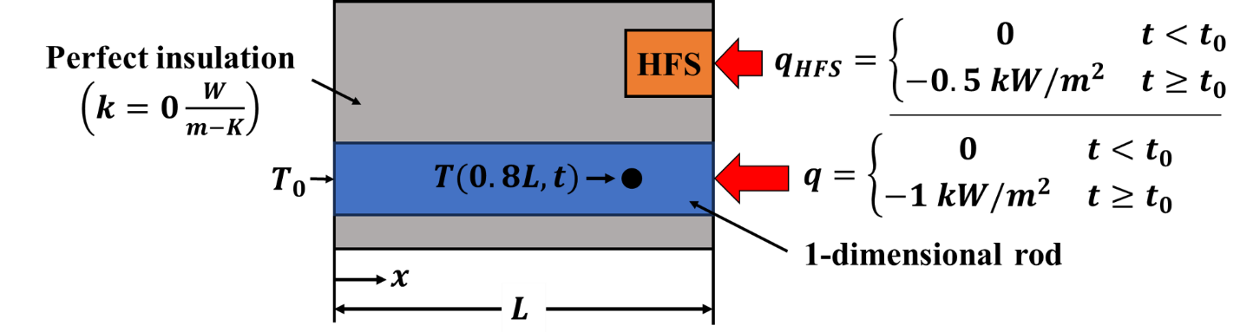
Figure 2. Sensor fusion reconstruction test configuration. A 1-dimensional rod is exposed to a step heat flux and the temperature response is measured at $x=0.8L$. The face at $x=0$ is held at a constant temperature $T_{0}$. A heat flux sensor in close proximity measures an attenuated heat flux step.
First the reconstruction framework is analyzed by considering a pristine temperature measurement without solution regularization, i.e., direct inversion of Equation 15. The simulated temperature measurement at $x=0.8L$ is shown in Figure 3a and the reconstructed heat flux profile is shown in Figure 3b, along with the exact solution. Data points are plotted every 0.25s in the vicinity of the step and every 0.5s elsewhere. With ideal measurement conditions, inversion of the Green’s function formulation can sufficiently reproduce the step heat flux, with only minor errors observed in the step vicinity, mainly attributed to numerical discretization errors.
In a more realistic scenario, noise will be present in the temperature measurement. In the next test case, Gaussian noise with a standard deviation of $σ={0.01}^{∘}C$ was added to the temperature measurement prior to reconstructing the heat flux profile (Figure 4a). Figure 4b shows the reconstruction results from direct inversion of Green’s function with noisy temperature measurements. This result illustrates how measurement noise may become amplified in inverse heat transfer problems and motivates the use of solution regularization¹⁰. Figure 4c shows the same scenario, but with regularization added to the hot wall heat flux reconstruction framework using the adjacent heat flux sensor measurement $q_{HFS}$. Gaussian noise with a standard deviation of $σ=25 W/m^{2}$ was also added to the auxiliary heat flux measurement. For comparison, an additional heat flux profile is shown where the inversion of Equation 12 was stabilized using Tikhonov regularization^{9,10,12}. Errors in the reconstructed heat flux profiles for both regularization techniques are shown in Figure 4d. For a similar level of noise reduction, the hot wall heat flux reconstruction framework is able to resolve the discontinuous step heat flux profile with a much higher accuracy, illustrating the advantages of regularizing solution features, rather than the solution itself.
Finally, in real measurement scenarios, the auxiliary heat flux sensor may exhibit a transient response time similar to, or larger than, the temperature measurement sampling interval. In the final test case, an auxiliary heat flux sensor with an exponential time constant of $τ=0.2s$ (63.2% of steady state signal) was used in the reconstruction approach. These results are shown in Figures 4e and 4f. The effect of a slow heat flux sensor response adds a slight overshoot to the reconstructed heat flux profile near the transient step, however the sharpness of the solution is not lost to regularization. After the initial overshoot, the solution converges towards the exact heat flux profile.
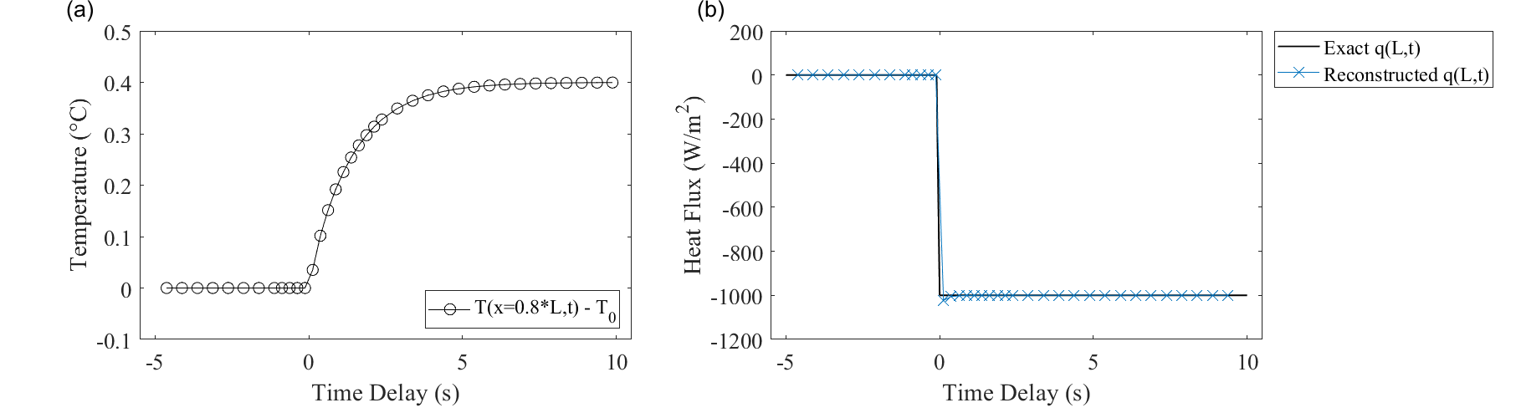
Figure 3. Ideal reconstruction framework test case. (a) Simulated transient temperature measurement at $x=0.8L$. (b) Reconstructed heat flux profile at $x=L$ using direct inversion of Green’s function. The solid black line shows the exact solution, and the blue series shows the reconstructed solution.
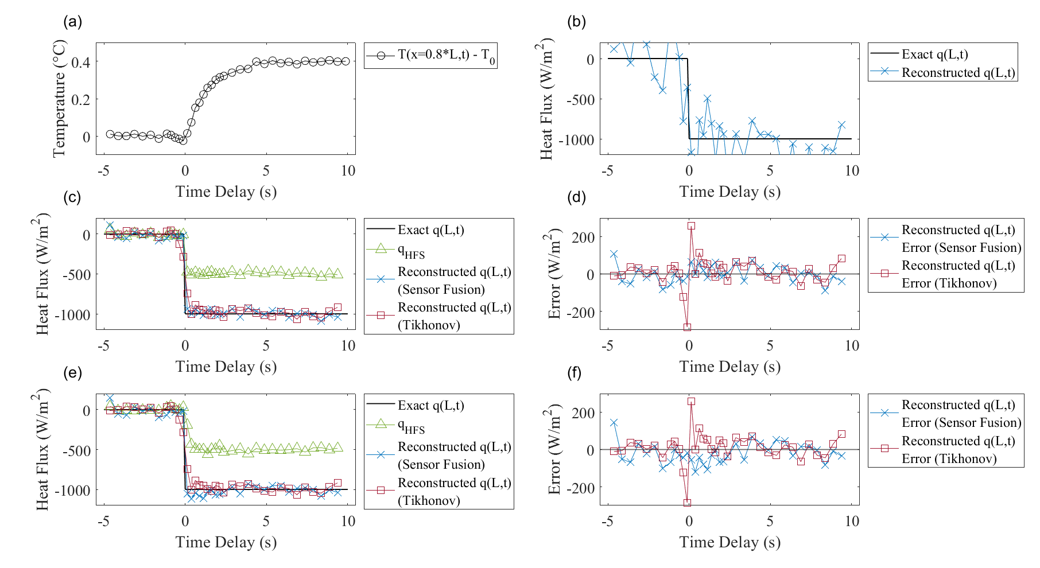
Figure 4. Non-ideal reconstruction framework test cases. (a) Simulated transient temperature measurement at $x=0.8L$ with additional gaussian noise. (b) Reconstructed heat flux profile at $x=L$ using direct inversion of Green’s function. The solid black line shows the exact solution, and the blue series shows the reconstructed solution. (c) Reconstructed heat flux profile at $x=L$ using solution regularization. The blue series shows the heat flux reconstructed using the sensor fusion framework and the red series shows the heat flux reconstructed using Tikhonov regularization. The green series shows the auxiliary heat flux sensor measurement. (d) Error in the reconstructed heat flux profiles in (c). (e) Reconstructed heat flux profile at $x=L$ using solution regularization with slow heat flux sensor response. (f) Error in the reconstructed heat flux profiles in (e).
3-Dimensional Galerkin Formulation for Theoretical TPS-Sensor System
Green’s functions were developed using a Galerkin formulation for a theoretical 3-dimensional axisymmetric TPS-sensor system, shown in Figure 5. The theoretical TPS-sensor system is comprised of an inner cylinder representing the HFS, domain 1, surrounded by TPS, domain 2. For each domain, the basis functions which comprise the eigenfunction approximation to Green’s function (Equations 4 and 5) are decomposed into radial and axial components.
 | $$f_{j}^{\left(1\right)}\left(r,z\right)=g_{j}^{\left(1\right)}\left(r\right)h_{j}^{\left(1\right)}\left(z\right)$$ | (20a)
 | $$f_{j}^{\left(2\right)}\left(r,z\right)=g_{j}^{\left(2\right)}\left(r\right)h_{j}^{\left(2\right)}\left(z\right)$$ | (20b)
In the theoretical TPS-sensor system, basis functions must conform to the following boundary and interface conditions:
 | $${\left.\frac{∂}{∂r}g_{j}^{\left(1\right)}\right|}_{r=0}=0$$ | (21a)
 | $${\left.\frac{∂}{∂r}g_{j}^{\left(2\right)}\right|}_{r=R_{2}}=0$$ | (21b)
 | $${\left.g_{j}^{\left(1\right)}\right|}_{r=R_{1}}={\left.g_{j}^{\left(2\right)}\right|}_{r=R_{1}}$$ | (21c)
 | $${k_{1}\frac{∂}{∂r}\left.g_{j}^{\left(1\right)}\right|}_{r=R_{1}}={k_{2}\left.{\frac{∂}{∂r}g}_{j}^{\left(2\right)}\right|}_{r=R_{1}}$$ | (21d)
 | $${\left.h_{j}^{\left(1\right)}\right|}_{z=0}={\left.h_{j}^{\left(2\right)}\right|}_{z=0}=0$$ | (21e)
Equation 21a enforces a smooth radial temperature distribution along the center axis within the HFS. Equation 21b enforces an adiabatic wall condition on the outer circumference of the TPS. This may be interpreted as enforcing 1-dimensional heat flow through the TPS when sufficiently far away from the TPS-sensor interface. Equations 21c and 21d enforce continuity of temperature and heat flux across the shared TPS-sensor interface, respectively. Equation 21e enforces a homogeneous temperature boundary condition at z = 0.
The interface continuity conditions represented by Equations 21c and 21d require special treatment of the radial basis function components $g_{j}^{(1)}$and $g_{j}^{(2)}$. Adopting the approach of Haji-Sheikh and Beck, $g_{j}^{(1)}$and $g_{j}^{(2)}$ are recast in terms of a global basis function $g_{j}$ and perturbation $g_{j}^{'} ADDIN ZOTERO_ITEM CSL_CITATION \{"citationID":"a16u7p6udiq","properties":\{"formattedCitation":"\backslash \backslash super 5,13\backslash \backslash nosupersub\{\}","plainCitation":"5,13","noteIndex":0\},"citationItems":[\{"id":591,"uris":["http://zotero.org/users/8559886/items/M84X8EHH"],"itemData":\{"id":591,"type":"article-journal","abstract":"A procedure to obtain accurate solutions for many transient conduction problems in complex geometries using a Galerkin-based integral (GBI) method is presented. The nonhomogeneous boundary conditions are accommodated by the Green’s function solution technique. A Green’s function obtained by the GBI method exhibits excellent large-time accuracy. It is shown that the time partitioning of the Green’s function yields accurate small-time and large-time solutions. In one example, a hollow cylinder with convective inner surface and prescribed heat flux at the outer surface is considered. Only a few terms for both large-time and small-time solutions are sufficient to produce results with excellent accuracy. The methodology used for homogeneous solids is modified for application to complex heterogeneous solids.","container-title":"Journal of Heat Transfer","DOI":"10.1115/1.2910360","ISSN":"0022-1481","issue":"1","journalAbbreviation":"Journal of Heat Transfer","page":"28-34","source":"Silverchair","title":"Green’s Function Partitioning in Galerkin-Based Integral Solution of the Diffusion Equation","volume":"112","author":[\{"family":"Haji-Sheikh","given":"A."\},\{"family":"Beck","given":"J. V."\}],"issued":\{"date-parts":[["1990",2,1]]\},"citation-key":"haji-sheikhGreenFunctionPartitioning1990b"\}\},\{"id":223,"uris":["http://zotero.org/users/8559886/items/RLQPFYMP"],"itemData":\{"id":223,"type":"book","edition":"2","language":"en","publisher":"CRC Press","source":"Zotero","title":"Heat Conduction Using Greens Functions","author":[\{"family":"Cole","given":"Kevin"\},\{"family":"Beck","given":"James"\},\{"family":"Haji-Sheikh","given":"A"\},\{"family":"Litkouhi","given":"Bahman"\}],"issued":\{"date-parts":[["2010"]]\},"citation-key":"coleHeatConductionUsing2010"\}\}],"schema":"https://github.com/citation-style-language/schema/raw/master/csl-citation.json"\}$^{5,13}
 | $$g_{j}^{\left(1\right)}=g_{j}$$ | (22a)
 | $$g_{j}^{\left(2\right)}=g_{j}+Γg_{j}^{'}$$ | (22b)
where $g_{j}^{'}$ is designed to vanish at the $r=R_{1}$ interface and $Γ$ is specified to satisfy Equation 21d. In this representation, the global basis function must satisfy the adiabatic constrains given by Equations 21a and 21b while the perturbation basis function must satisfy the adiabatic constraint given by Equation 21b. The global basis function is derived as a polynomial expression which exhibits even behavior about $r=R_{2}$ and contains additional derivatives which vanish at $r=0$ and $r=2R_{2}$.
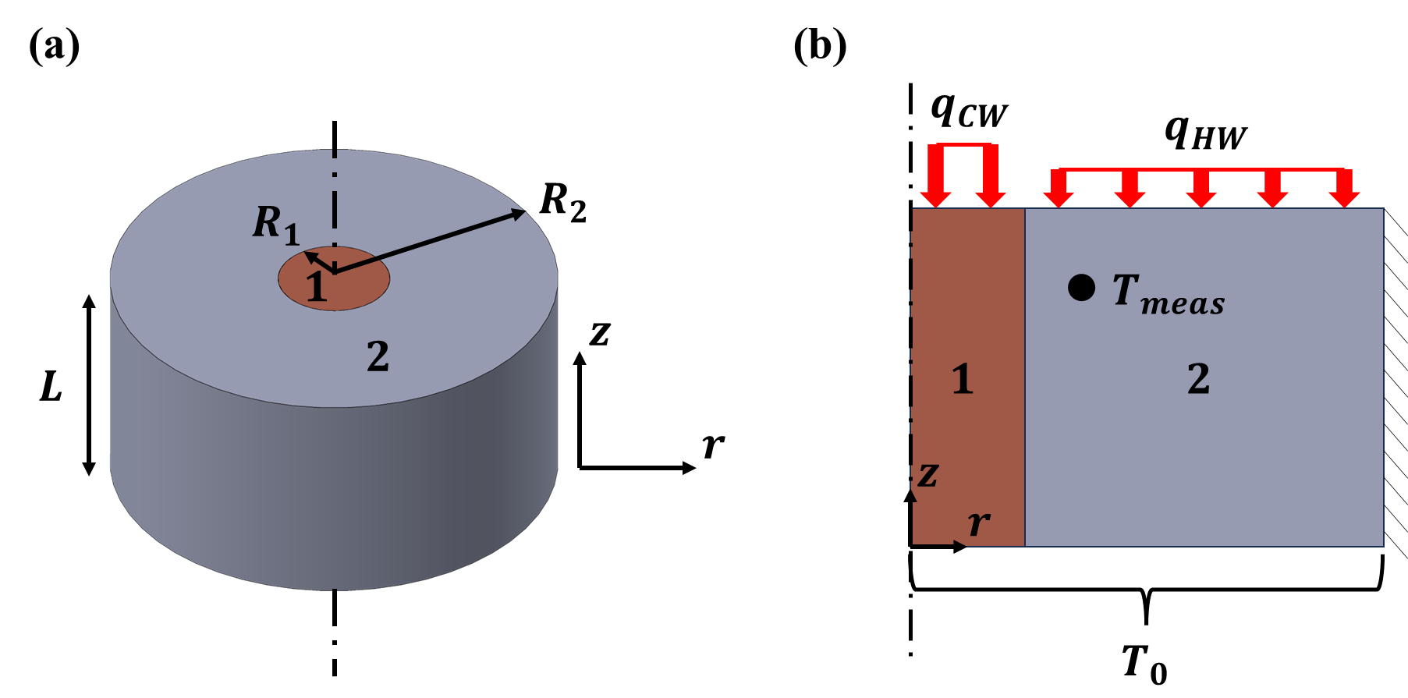
Figure 5. Schematic of the TPS-sensor system. (a) Isometric view. Domain 1 represents the heat flux sensor with a radius $R_{1}$ and domain 2 represents the surrounding TPS with an outer radius $R_{2}$. The system has a total thickness $L$. (b) Cross-section view. On the top surface ($z=L$), the heat flux absorbed by the cold wall heat flux sensor is augmented compared to the heat flux absorbed by the hot wall TPS. The bottom surface ($z=0)$ is maintained at a constant temperature. The outer surface at $r=R_{2}$ is modeled as insulating. Temperature measurements $T_{meas}$ are distributed within the TPS surrounding the heat flux sensor.
 | $$g_{j}=\left[{\left(2R_{2}-r\right)}^{2η_{j}-1}{\left(r\right)}^{2η_{j}-2}+{\left(r\right)}^{2η_{j}-1}{\left(2R_{2}-r\right)}^{2η_{j}-2}\right]$$ | (23)
In Equation 23, $η$ is a set of integers, e.g., $η=\left[1,2,3,1,2,3\right]$. The perturbation basis function $g_{j}^{'}$ must be designed to vanish at $r=R_{1}$, however its first derivatives must be non-zero for all terms at $r=R_{1}$ to maintain continuity of heat flux across the domain boundary (Equation 21d). Combining these constraints with the adiabatic conditions at $r=R_{2}$, $g_{j}^{'}$ was derived as the following polynomial.
 | $$g_{j}^{'}=R_{1}R_{2}η_{j}\left[1-{\left(\frac{r}{R_{1}}\right)}^{η_{j}+1}\right]-R_{2}^{2}\left(η_{j}+1\right)\left[1-{\left(\frac{r}{R_{1}}\right)}^{η_{j}}\right]$$ | (24)
The radial basis functions $g_{j}^{\left(1\right)}$ and $g_{j}^{\left(2\right)}$ can now be determined using Equations 22a and 22b and, from Equation 21d, $Γ$ becomes
 | $$Γ=\frac{\left(\frac{k_{1}}{k_{2}}-1\right)\left(2η_{j}-2\right)\left[{\left(2R_{2}-R_{1}\right)}^{2η_{j}-1}{\left(R_{1}\right)}^{2η_{j}-3}-{\left(R_{1}\right)}^{2η_{j}-1}{\left(2R_{2}-R_{1}\right)}^{2η_{j}-3}\right]}{-R_{2}η_{j}\left(η_{j}+1\right)+ R_{2}^{2}η_{j}\left(η_{j}+1\right)R_{1}^{-1}}$$ | (25)
The axial basis functions $h_{j}\left(z\right)$ were specified using the same set of monomial terms as described in the previous 1-dimensional test-case⁶,
 | $$h_{j}^{\left(1\right)}=h_{j}^{\left(2\right)}=z^{ξ_{j}}$$ | (26)
where $ξ$ is a set of integers specified to compliment $η$, such that all permutations of the elements of $η$ and $ξ$ are represented, e.g., $ξ=\left[1,1,1,2,2,2\right]$. Combining radial and axial basis function components for domains 1 and 2 yields the following 3-dimensional axisymmetric basis functions for the TPS-system geometry.
 | $$f_{j}^{\left(1\right)}\left(r,z\right)=\left[{\left(2R_{2}-r\right)}^{2η_{j}-1}{\left(r\right)}^{2η_{j}-2}+{\left(r\right)}^{2η_{j}-1}{\left(2R_{2}-r\right)}^{2η_{j}-2}\right]z^{ξ_{j}}$$ | (27)
 | $$f_{j}^{\left(2\right)}\left(r,z\right)=\left\{f_{j}^{\left(1\right)}\left(r,z\right)+Γ\left(R_{1}R_{2}η_{j}\left[1-{\left(\frac{r}{R_{1}}\right)}^{η_{j}+1}\right]- R_{2}^{2}\left(η_{j}+1\right)\left[1-{\left(\frac{r}{R_{1}}\right)}^{η_{j}}\right]\right)\right\}z^{ξ_{j}}$$ | (28)
Following the scaling of these basis functions via Equations 6-9, Green’s function is now fully defined for the theoretical TPS-sensor system shown in Figure 5 and can be implemented in the hot-wall heat flux reconstruction framework for further evaluation.

Expected Results and Future Work
Extending from the 1-dimensional test configuration described in the previous section, we aim to demonstrate the capabilities of the 3-dimensional hot wall heat flux reconstruction framework on the theoretical TPS-sensor system shown in Figure 5. Simulated temperature measurements will be generated with finite element analysis using both elementary step heat flux profiles and heat flux profiles representative of a spacecraft entry heat pulse. We will report on the accuracy of the hot wall heat flux reconstruction framework as a function of parameters such as simulated temperature measurement distribution, heat flux sensor response time, and measurement noise level. We will extend, and report on, the capabilities of the reconstruction framework to resolve spatially varying hot wall TPS heat flux values in the vicinity of the heat flux sensor. Finally, we aim to report on the application of the hot wall heat flux reconstruction framework to existing ground test or flight test data to evaluate its capabilities against the current state-of-the-art sensor diagnostics tools and CFD-based cold wall correction methods.
This work was supported by a NASA Space Technology Graduate Research Opportunity (grant 80NSSC23K1201).

References
1. Gülhan, A., Thiele, T., Siebe, F., Kronen, R. & Schleutker, T. Aerothermal measurements from the ExoMars Schiaparelli capsule entry. Journal of Spacecraft and Rockets 56, 68–81 (2019).
2. Miller, R. A., Tang, C. Y., Santos, J. A. B., White, T. R. & Cruden, B. A. Aftbody Heat Flux Measurements During Mars 2020 Entry. Journal of Spacecraft and Rockets 0, 1–14 (2023).
3. Karlgaard, C. D., Stoffel, T. D., White, T. & West, T. K. Data Fusion of In-Flight Aerothermodynamic Heating Measurements Using Kalman Filtering. in AIAA AVIATION 2022 Forum (American Institute of Aeronautics and Astronautics, 2022). doi:10.2514/6.2022-3794.
4. Dutta, S., Braun, R. D. & Karlgaard, C. D. Uncertainty Quantification for Mars Entry, Descent, and Landing Reconstruction Using Adaptive Filtering. Journal of Spacecraft and Rockets 51, 967–977 (2014).
5. Cole, K., Beck, J., Haji-Sheikh, A. & Litkouhi, B. Heat Conduction Using Greens Functions. (CRC Press, 2010).
6. Massa, L. & Schetz, J. A. Hypersonic Heat Flux Reconstruction with Distributed Temperature Sensors. Journal of Thermophysics and Heat Transfer 34, 331–346 (2020).
7. Nguyen, N. M., Ruda, M. L. & Massa, L. Effect of Insulations and Coatings on Hypersonic Heat Flux Reconstruction. Journal of Thermophysics and Heat Transfer 35, 63–79 (2021).
8. Whalen, T. J., Laurence, S. J., Marineau, E. C. & Ozawa, H. A Green’s function approach to heat-flux estimation from temperature-sensitive paint measurements. Meas. Sci. Technol. 32, 114011 (2021).
9. Hansen, P. C. Deconvolution and Regularization with Toeplitz Matrices. Numerical Algorithms 29, 323–378 (2002).
10. Beck, J. V., Blackwell, B. & Haji-Sheikh, A. Comparison of some inverse heat conduction methods using experimental data. International Journal of Heat and Mass Transfer 39, 3649–3657 (1996).
11. Gholami, A. & Hosseini, S. M. A balanced combination of Tikhonov and total variation regularizations for reconstruction of piecewise-smooth signals. Signal Processing 93, 1945–1960 (2013).
12. Golub, G. H., Hansen, P. C. & O’Leary, D. P. Tikhonov Regularization and Total Least Squares. SIAM J. Matrix Anal. Appl. 21, 185–194 (1999).
13. Haji-Sheikh, A. & Beck, J. V. Green’s Function Partitioning in Galerkin-Based Integral Solution of the Diffusion Equation. Journal of Heat Transfer 112, 28–34 (1990).

