Residual Thrust in a Solid Rocket Motor: A Model Applied to the Mars Ascent Vehicle
Timothy P. Kibbey
NASA George C. Marshall Space Flight Center, Huntsville, AL, 35812, USA
A model for solid rocket motor residual thrust is built from the concept that hot nozzle phenolic or carbon materials provide a radiating source of heat flux to the insulation, leading to continued off-gassing by pyrolysis. This model is 1. Fitted to flight datasets and scaled to the Mars Ascent Vehicle second stage motor (MAV SRM2), and 2. Derived with MAV SRM2 design and material estimates. The two methods show a potential range of modeling uncertainty for use by mission analysts. Further loss methods that could reduce the maximum residual impulse are identified but left to further work to evaluate.
- Nomenclature
A = surface area
b_{F} = thrust factor
C_{rad} = radiation constant
c = specific heat
F = thrust
f_{char} = char ratio, fraction of virgin material that remains as char when pyrolyzed
${δh}_{v}$ = insulation heat of pyrolysis (or vaporization)
${δh}_{indepth}$ = in-depth heat flow through insulation
k = thermal conductivity
I_{rem} = impulse remaining
I_{sp} = specific impulse
m = mass
$\dot{m}$ = mass flow rate
$\dot{Q}$ = heat transfer rate
T = temperature Subscripts
t = time abl = ablation
b = burn
ε = emissivity i = insulation
ρ = density init = initial
σ = Stefan-Bolzmann constant n = nozzle
Θ = temperature-related parameter p = propellant
θ = nondimensionalized temperature pyrol = pyrolysis
τ = nondimensionalized time r = radiation
- Introduction
When a solid rocket motor (SRM) has achieved “burnout,” that is, when all its propellant is gone or extinguished, it has finished its job, having delivered the impulse required of it. However, it may continue to flow mass, resulting in a residual thrust for minutes after burnout. In many missions, this small additional impulse is unimportant, as there is often a liquid propellant or electric propulsion engine onboard the spacecraft that can fine-tune the orbit and offset uncertainties. But this additional impulse and its uncertainty is important at for certain in-space motor applications, particularly for deciding when to separate the solid rocket motor from the spacecraft. Interest in this has been noted as far back as 1980 with the Inertial Upper Stage motors [1].
Sometimes the motor is the final impulse the spacecraft will receive, and it becomes important to estimate and bound the amount of remaining impulse. Such is the case with the Mars Ascent Vehicle (MAV) for the Mars Sample Return campaign. The 2nd stage will put the samples into orbit, and then needs to eject the payload before too long. (This is because the spinning rocket could build up too much nutation angle due to energy dissipation, thus adding too much uncertainty to the final orbit of the ejected payload.) After payload ejection, only a small amount of remaining delta-V is allowed of the motor. (This is because the rendezvous craft must make assumptions about the payload’s orbit based on the easier-to-locate stage’s orbit.)
Therefore, the thrust residual versus time of the MAV Stage 2 SRM must be modeled with a bounding estimate. When the impulse remaining falls below a required threshold, then it is ok to separate.
Panicker [2], et. al. show the residual of two flights of the Polar Satellite Launch Vehicle (PSLV) 3rd Stage. One of these data-streams shows almost 2 minutes of data past burnout. Though they propose a pair of exponential models, the behavior appears to decay more slowly than exponential, making such models unconservative. They do however provide a clue to a better model in describing the likely physical mechanism of the continued pyrolysis of the motor’s case insulation: “But attempts have been made in this direction considering the fact that the main source of heating of insulation is the submerged nozzle itself, which has a sufficiently large thermal mass and gets heated during the action time of the motor. Since the motor itself is an adiabatic system, the thermal mass of the submerged nozzle and the heat required for decomposition of the liner material determine the history of heat flux to the insulator surface.” In other words, the residual thrust comes from continued off-gassing of the case insulation as it pyrolyzes, and the heat required is radiated by the nozzle material. This seems reasonable: nozzle materials’ (phenolic and/or carbon) surface is around 5000°R at the start of the residual timeframe, and insulation ablation temperature is around 1460°R. The radiation will continue to contribute to pyrolysis until the nozzle loses enough heat for its surface to drop below the insulation pyrolysis temperature.
Herein, the author derives this phenomenological description into working equations, compares it semi-empirically to the PSLV 3rd stage, scales it to the MAV 2nd stage, compares to other reported data, and explores a design-based estimate and physical reasons for any further adjustments.
- Derivation of Radiative-Ablative Model
At first, assume all radiation is between the interior portion of the nozzle and insulation, and that the net heat flow is carried away by the ablating material (no view factor from the internal parts of the nozzle to space, no view factor from the insulation to space, no in-depth heating of the insulation or loss through the case to space, no heat loss along the nozzle from interior-facing regions to the exit cone):

${δh}_{v}\dot{m}={\dot{Q}}_{r,n}-{\dot{Q}}_{r,i}={\dot{Q}}_{r,net}$ (1)
Where $\dot{Q}$ are the heat flow rates radiating from the nozzle and insulation, $\dot{m}$ is the mass flow rate of insulation pyrolysis gases, and ${δh}_{v}$ the heat of pyrolysis. The insulation remains the same temperature T_{abl}, controlled by the pyrolysis temperature.
Assuming constant specific heat of the nozzle and that both nozzle and insulator have equal emissivity = absorptivity, ε, where T_{r} is the radiating temperature of the nozzle, the net heat flow at the nozzle can be written, which can solve for the nozzle’s temperature time history:

${\dot{Q}}_{r,net}=\frac{d(m_{n} c_{n} T_{r})}{dt}=-σϵA_{n}\left(T_{r}^{4}-T_{abl}^{4}\right)$ (2)
Define $θ=\frac{T_{r}}{T_{abl}}$, and the differential equation is more straight-forwardly solved non-dimensionalized:
$\frac{dθ}{dt}=-\frac{σϵA_{n}T_{abl}^{3}}{m_{n} c_{n}}\left(θ^{4}-1\right)$ (3)
This ordinary differential equation solves by separation of variables for T as a function of t. Including finding the integration constant by setting T_{r}(0) = T₀, so that $θ_{0}=\frac{T_{r}(0)}{T_{abl}}$,
$-\left(\ln\left(Θ\right)+2\left(\operatorname{atan}{θ_{0}}-\operatorname{atan}{θ}\right)\right)=-\frac{4T_{abl}^{3}σϵA_{n}}{m_{n} c_{n}}t=\hat{t}$ (4)
$Θ=\frac{\left(θ-1\right)\left(θ_{0}+1\right)}{(θ+1)(θ_{0}-1)}$ (5)
Thus time can be solved as an explicit function of the nozzle temperature. Though literally the product of nozzle mass and specific heat, the meaning of m_{n} · c_{n} is the overall heat capacity, equal to the total radiable heat when multiplied by initial temperature. For the purposes of a semi-empirical explanation, it may end up being sufficient to lump all the specific values, and state “for similar variable relationships, similar performance is expected.”
Having established relationships for energy flow, importantly linking time with temperature, Eqs. (1) - (3) rearrange for mass flow rate of the pyrolysis gases and consequent thrust:
${δh}_{v}\dot{m}=m_{n} c_{n} T_{abl}\frac{dθ}{dt}$ (6)
$\dot{m}=\frac{T_{abl}^{4}σϵA_{n}}{{δh}_{v}}(θ^{4}-1)$ (7)
So mass flow rate does not depend on insulation mass or geometric parameters: only on nozzle radiation and the heat of pyrolysis and ablation temperature of the insulation. This makes sense, because the nozzle-determined heat-delivery rate is spread out over whatever insulation surface is exposed. However, if in-depth heating were to be considered, the insulation geometry may start to be important.
Summarizing, define the following grouped parameter sets and outcomes:
Radiation constant $c_{rad}=σϵA_{n}T_{abl}^{4}$, in units of energy flow rate (8)
Thrust factor $b_{F}=\frac{I_{sp}c_{rad}}{{δh}_{v}}$, in units of thrust (9)
Time constant $τ=\frac{m_{n} c_{n} T_{abl}}{4c_{rad}}$, in units of time (10)
Non-dimensional time $\hat{t}=-\left(\ln\left(Θ\right)+2\left(\operatorname{atan}\left(θ_{0}\right)-\operatorname{atan}\left(θ\right)\right)\right)$ (11)
$t=τ\hat{t}$ (12)
$F=b_{F}\left(θ^{4}-1\right)$ (13)
$\dot{m}=\frac{F}{I_{sp}}$ (14)
While direct calculations based on the physical constants are available here, it may be more instructive to fit the two parameters thrust factor b_{F} and time constant τ to a set of data and assess what scaling can apply to a different solid rocket motor. This is attempted next.
- Radiative-Ablative Model Fitting and Scaling
Throughout the equations and plots, time is defined as “from the start of the residual thrust period.” Residual begins when thrust tailoff ends – when the pressure and thrust during tailoff drops below that of the residual model, that is the start of residual thrust. While this can vary from motor to motor and based on the inputs to the equations, it seems to be generally around 1 or 2 psia (7 to 14 kPa). All the propellant has burned (or possibly extinguished), and transient gas mass storage has mostly depleted by this point. Also note the change in timing importance: motor tailoff happens in seconds, residual over tens or hundreds of seconds.
- Model of the PSLV 3rd Stage Thrust Residual
Figure 1 shows the two PSLV 3rd Stage datasets as digitized from the Panicker paper [2]; the first flight has 20 seconds of data, and the second flight more than 110 seconds of data. Note the semilog-Y scale and the exponential shown as a straight line. An exponential curve can capture the initial steepness of the data but woefully underpredicts after only 10 seconds. It is apparent that all such “straight curves” can only locally approximate. The radiative-ablative model excels compared to the exponential model because it is anchored in physical phenomena which are scalable to other systems, provides a better fit while remaining conservative (as expected since loss mechanisms are ignored), and like the exponential has only two parameters, meaning it has no increase in complexity or risk of overfitting!

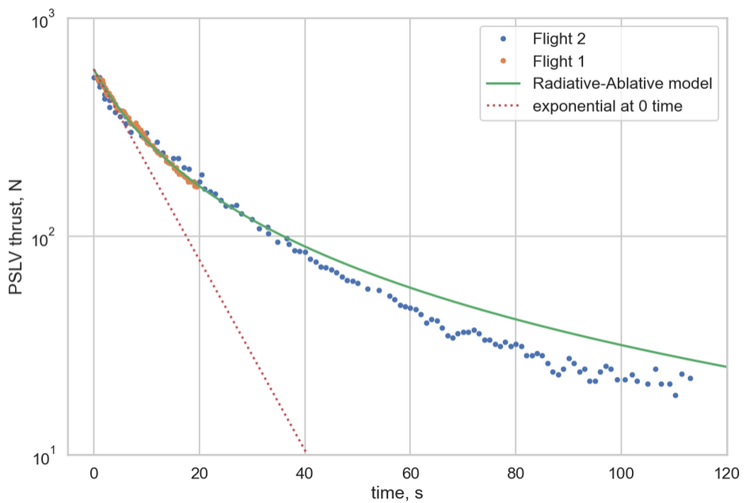
Figure 1: PSLV 3rd Stage data with fitted radiative-ablative model: τ = 401 s, b_{F} = 4.24 N
- Semi-empirical scaling between motor designs
From Eqs. (8)-(9) & (13), residual thrust will be proportional to the radiating surface area of the nozzle. If we assume a scaled-geometry version of the whole motor, then since mass scales with length cubed all areas would scale with propellant mass (m_{p}) to the 2/3^{rds} power. Therefore, if all we know is the propellant mass of the two motors,
$\frac{F_{2}}{F_{1}}=\frac{{\dot{m}}_{2}}{{\dot{m}}_{1}}={\left(\frac{m_{p2}}{m_{p1}}\right)}^{\frac{2}{3}}$ (15)
From Eqs. (8), (10) & (12), time will be proportional to nozzle thermal mass over radiating surface area. Analogous to the thrust argument above, this would scale time with propellant mass to the 1/3rd power. But consider, mass over surface area would be like a thickness times density. Call this “thermal thickness.” This is a measure of how much heat can be stored per unit area at burnout and the commencement of radiative ablation. Comparing motors over large mass differences could be unconservative using the propellant mass scaling. It is possible instead that the burntime of the motor drives the amount of heat that was able to soak into the nozzle. Even though ablation moves back the initial surface, there is also heat flowing deeper into the nozzle over time. Therefore, the leading model for scaling radiative-ablative time is simply with each motor’s burntime (t_{b}), Eq. (15). For these purposes, the values in Table 1 were used.
$\frac{t_{2}}{t_{1}}=\left(\frac{t_{b2}}{t_{b1}}\right)$ (15)
Table 1: Mass and Burntime for Reference Motors
 | Propellant mass | Burn time
PSLV 3rd stage | 7600 kg | 109 s
MAV SRM2 | 46.5 kg | 25 s

- MAV Stage 2 Residual Thrust Prediction

Figure 2 shows the MAV Stage 2 prediction as the solid line according to Eqs. (15)-(16), and the PSLV 3rd Stage as the dashed line. Note how the scaling reduces both the magnitude and the duration.

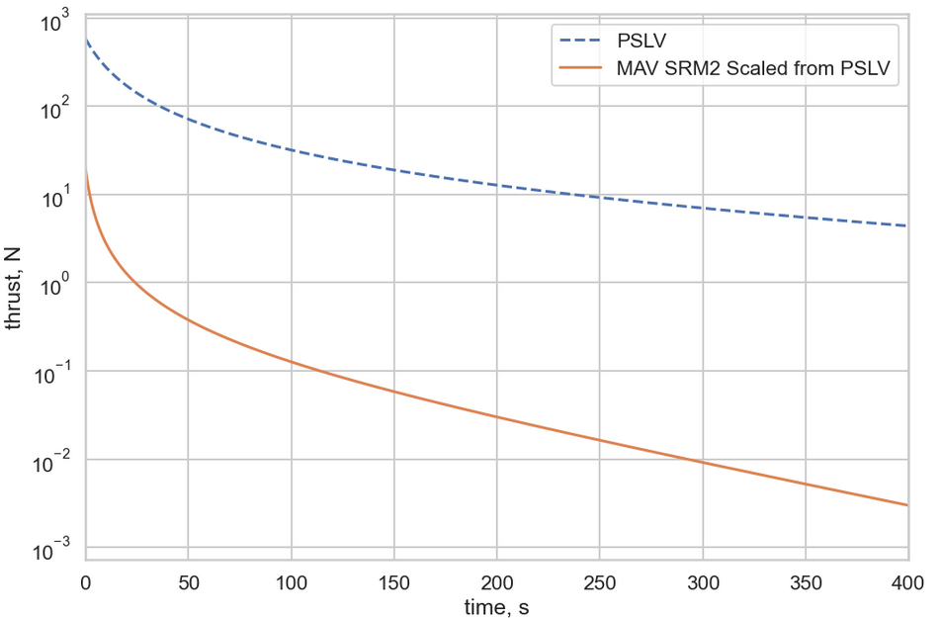
Figure 2: Residual thrust for MAV SRM2 as scaled

- Bulk Interpretation
Before comparing to other witnesses of the residual thrust phenomenon, consider the following equation for total energy (E_{tot}) available in the nozzle for radiation:
$E_{tot}=m_{n}c_{n}T_{abl}\left(θ_{0}-1\right)$ (17)
Combining Eqs. (2) & (17) and integrating, the totality of mass flowed during the residual is:
$m_{tot}=\frac{m_{n}c_{n}T_{abl}}{δh_{v}}\left(θ_{0}-1\right)$ (18)
And by integrating Eq. (13), or simply applying the definition of specific impulse (I_{sp}, in velocity units for consistency), impulse remaining (I_{rem}) can be found:
$I_{rem}\left(0\right)=I_{sp}\frac{m_{n}c_{n}T_{abl}}{δh_{v}}\left(θ_{0}-1\right)=4b_{F}τ\left(θ_{0}-1\right)$ (19)
These can all be generalized to the energy, mass, or impulse remaining after a certain time by replacing θ₀ with θ. This demonstrates what on physical grounds must be true, that a finite amount of energy, mass flow, and impulse is available to the residual thrust phenomenon, so even though the time domain for thrust and mass flow rate is infinite, the integrals converge. This approach sets up another straightforward way to evaluate and compare different witnesses to this phenomenon.
When first deriving this and only having the PSLV dataset, my inclination was to assign an uncertainty factor of 2 in both time and thrust, thus total mass and impulse would be bounded by a factor of 4 on the reference fit to the PSLV data. The “MAV SRM2 Scaled from PSLV” model along with dispersions of up to 2x in both time and thrust has been in use by mission analysts.
- Scaled versions of other motors
After deriving the model and applying it to the PSLV 3rd stage, a few other witnesses to this phenomenon were found. These are shown in Table 2 and Fig. 3. To best compare in the context of predicting MAV SRM2, the parameters and bulk results have been scaled by Eqs. (15)-(16).

Table 2: Residual Thrust Witnesses Scaled to MAV SRM2
 | b_{F}, N | τ, s | Mass to flow, kg | Impulse, N·s
PSLV Reference | 0.14 | 91.88 | 0.083 | 127
Motor A single flight | 0.23 | 238.10 | 0.353 | 536
Motor B family, nom | - | - | 0.082 | 124
Motor B family, dispersed | - | - | 0.183 | 278
Vega Zefiro 9 flight [3], fit 1 | 0.41 | 250.00 | 0.661 | 1,005
Vega Zefiro 9 flight, fit 2 | 0.32 | 383.96 | 0.783 | 1,191

The pedigree and method for each of these witnesses is as follows:
- PSLV Reference 110 sec of thrust vs time, digitized from published plot
- Motor A single flight an estimate from a reported bulk delta-V
- Motor B family, nom & dispersed interpreted bulk behavior based on motor specification
- Vega Z9 flight, fit 1 & 2 30 sec of thrust vs time, digitized from published plot
Note that PSLV Reference and Motor B family nominal are very similar in mass flowed and impulse. Motor B family gave an exponential function in their specification for both nominal and +3σ, but the motor manufacturer in a later conversation clarified that they were responding to the launch vehicle operator’s stated bulk delta-V experience during the residual timeframe.
Motor A single flight was a bulk delta-V observation stated by the launch vehicle operator from reconstructing a particular mission. This row presents one possible fit of b_{F} and τ for that observation. The mass and impulse of this are very similar to 4x the PSLV Reference, which was the initially used model uncertainty.
Note that Vega Zefiro 9 (Z9) flight estimates are more than double the max of the other observations. The paper by Mini, et. al., showed about 30 seconds of flight data and a finite-element thermal model. Because of the shape of the data and ambiguity about when the motor transitions from tailoff to residual, two different fits of the model are reported. The Z9 is 40% more propellant mass than the PSLV 3rd stage, yet its thrust factor is double, and its time constant is quadruple that of PSLV. Note the higher and shallower nature Figure 3.
Finally, Kavanaugh’s [1] Inertial Upper Stage paper showed a model only, and one which did not include any nozzle-to-insulation irradiation. As shown in Figure 3, it comes in very much lower than the other motors, even though IUS Stage 1 is between PSLV and Z9 in propellant mass (IUS Stage 2 is about 1/3rd that of PLSV). Without any link to flight data, it is unrealistically low for our purposes. Further, this supports the dominance of the nozzle as a heat source for this phenomenon, compared to their calculation based on heat soaking and reaction rates within the insulation alone. Those witnesses with defined radiative-ablative constants have been scaled for size and burntime to MAV SRM2 in Figure 4.

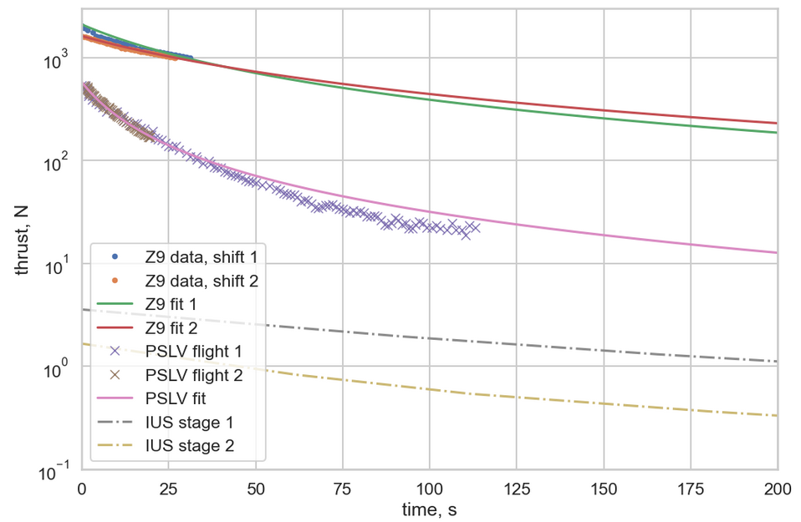
Figure 3: Raw data and radiative-ablative fitting of Z9 and PSLV thrust residuals
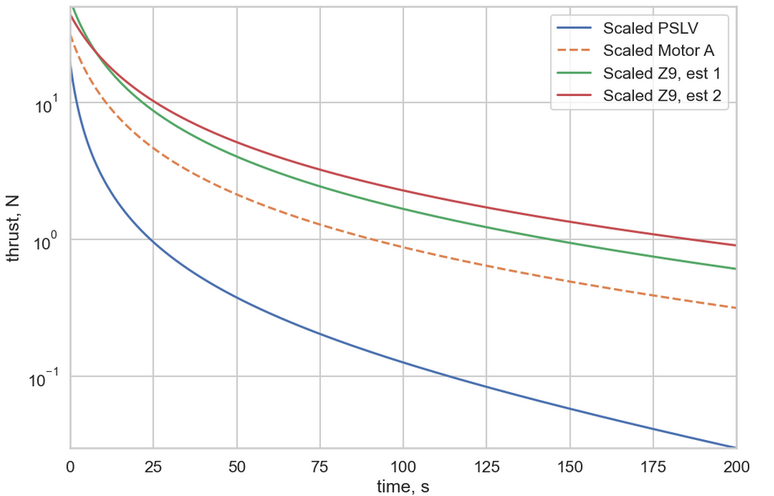
Figure 4: Radiative-Ablative fits to witnesses, scaled to MAV SRM2 size
When the Vega Z9 mass to flow at its own size was calculated, compared to reasonable estimates of Z9 insulation mass, this would mean 1/3rd of the insulation mass is required to flow during the residual thrust period. This sounds high, at the edge of believability, but not enough to rule it out. (A typical motor insulation design might expect to erode 1/3rd of the insulation during motor operation, and char another 1/3rd of it, leaving the last 1/3rd as an unaffected layer at burnout for case protection. That would mean Z9 might consume ALL of this remaining insulation during residual thrust.) The insulation mass consumed will be an important consideration in the next section.
- Analysis from motor and design parameters
Due to the risk of overly trusting an oversimple model, and of not knowing the sensitivity to errors in the constants, using the model semi-empirically with the above datasets was a prudent start. Filling in the constants with values from the design and the literature as appropriate will certainly add insight to the previous semi-empirical estimates.

Table 3: Parameter values for design-based assessment
Parameter | Value | Reason
A_{n}, mm^2 | 13,900 | Estimated from design
m_{n}, kg | 0.113 | Bulk effective from design
c_{n}, J/(kg K) | 2093 | Reasonable constant estimate from thermal analyst
δh_{v}, J/kg | -1.4e6 | Same value in Ponti, et. al. [3]
T_{abl}, K | 811.11 | 1000°F from thermal analyst practice
ε | 0.9 | Assume nearly black body
σ, J/(s m² K) | 5.67e-8 | Stefan-Bolzman constant

The nozzle participating area and mass were estimated from the design and from observations of the first development motor static test, and should be considered approximate. Consider area as known within about 10%, due to it being a simplification in lieu of calculating radiation view factors.
The choice of value for participating nozzle mass, m_{n}, will be set to drive the best estimate of total energy available. Note that this approximates the situation as an isothermal piece of nozzle material decreasing in its uniform temperature as it radiates. This may be very close to true for the 3D carbon-carbon (3D C-C) throat insert, but for the carbon cloth phenolic (CCP) nozzle inlet, this is a stand-in for an in-depth temperature gradient. The mass was chosen to be the 3D C-C portion up to the throat, plus the heat affected portion of CCP up to the throat, modified by 50% for the gradient (assumed nearly linear) and multiplied by 80% assuming the observed char depth bore witness to continued heat-soak after primary burn. An uncertainty of 20% on the total participating nozzle mass m_{n} value seems reasonable.
When these values were used in Eqs. (1) – (14) with an I_{sp} of 155 s (1520 m/s), the result is given as “SRM2 Design Estimate, naïve” in Table 5. This is an overprediction on physical grounds for the following reasons.

Derivation modifications for char ratio and in-depth heating
Recall that the initial model culminates in Eqs. (12) & (13), which allows a thrust, time dataset to be fitted by two parameters, τ and b_{F}. The level of complexity or interpretation of underlying components does not matter to the fitting. Therefore, some of the derivation may be rederived without doing injustice to the PSLV or other above fits and scalings if the general mathematical form is not displaced.
Consider the energy balance at the surface of the insulation. Equation (1) treats the insulation as if it is preheated to T_{abl}, and adiabatic below the surface – any mass that will participate is necessarily already at that temperature. Secondly, it treats the insulation as if all mass that pyrolyzes turns into gas, while in reality a portion is turned to char that tends to stay in place. The char ratio f_{char} is rate of char produced divided by the rate of pyrolyzing virgin material. So instead, derive:
${\dot{Q}}_{r,n}={\dot{Q}}_{r,i}+{\dot{Q}}_{pyrol}+{\dot{Q}}_{indepth}$ (20)
${\dot{Q}}_{r,n}=-σϵA_{s,n}T_{r}^{4}$ (21)
${\dot{Q}}_{r,i}=-σϵA_{s,n}T_{abl}^{4}$ (22)
The itemization of char and gas relates to heat flow of pyrolysis, ${\dot{Q}}_{pyrol}$:
${\dot{m}}_{gas}=\frac{{\dot{Q}}_{pyrol}\left(1-f_{char}\right)}{δh_{v}}$ (23)
Assume a steady-state eroding boundary where the thermal wave moves into the material at the same rate of the eroding mass. This is equivalent to pre-heating the eroding mass flow rate from initial temperature to ablation temperature, and acts to maintain the quasi-steady ablating boundary. This is how each differential length of depth gets heated to the pyrolysis temperature, ready to accept the bit of energy that is to pyrolyze it. This is a much more realistic assumption than the “preheated to a constant T_{abl}” assumption, and results in the following. Note this is still an “ideal” calculation; some loss mechanisms will be posited below that would further decrease the flow and thrust.
${\dot{Q}}_{indepth}=\frac{{\dot{m}}_{gas}}{1-f_{char}}\int_{T_{init}}^{T_{abl}}{c_{i}\left(T\right)dT }$ (24)
Combining these equations replaces Eq 0 with
${\dot{m}}_{gas}=\frac{\left(1-f_{char}\right)}{δh_{v}+\int_{T_{init}}^{T_{abl}}{c_{i}\left(T\right)dT }} m_{n} c_{n} T_{abl}\frac{dθ}{dt}$ (25)
Information for a common insulation shows the following values. So, how important were each of these assumptions? The char assumption reduces mass flowed by 27%, and comparing the in-depth heating per kg to the heat of pyrolysis, in-depth heating acts as 67% more heat sink.

Table 4: Additional parameters
$$f_{char}$$ | 27%
$δh_{indepth}=\int_{T_{init}}^{T_{abl}}{c_{i}\left(T\right)dT }$ | -0.94e6 J/kg
I_{sp} | 170 s = 1667 m/s

And none of this affects the mathematical form derived initially, nor even the time constant τ. It merely replaces Eq. (9) with:
$b_{F}=\frac{I_{sp}c_{rad}}{{δh}_{v}+δh_{indepth}}\left(1-f_{char}\right)$ (26)
$F=I_{sp} {\dot{m}}_{gas}$ (27)
Finally, it remains to decide I_{sp}. Initially, an I_{sp} of 155 s was assumed by taking the motor I_{sp} times the square root of T_{abl}/T_{flame}, after the definition of a motor’s characteristic velocity, or c-star. However, now that only gas is being considered, using an I_{sp} for a strongly two-phase solid rocket flow seems too low. Not having an exact insulation composition to model thermochemically, but considering a range of potential combustion products and all-gas analogs, the author selected 170 seconds (1667 m/s) as an expected value, which is possibly uncertain by 10%.
This corrected ideal SRM2 Design Estimate is listed in Table 5, note that this reduced by more than half the naïve estimate. Considering the total mass to flow, it is less than 8% of the motor’s total insulation design mass. Comparing to the PSLV Reference it is roughly double in mass flowed and impulse. But notice that the thrust factor, b_{F}, is similar, and the time factor τ is much larger than the PSLV-based scaling. (As discussed above, it is the time scaling which seems the most open to interpretation, as it entails the most opportunity for errors and omitted loss factors). Also, perhaps the PSLV radiative-ablative model fit includes some of the real losses to which the thrust curve is bearing witness.
The SRM2 Design Estimate at least rules out the Vega Z9 flight in this instance. Though these were best-estimated values, not maximums, uncertainty is probably only 25-40% (root-sum-squaring or summing), and the Vega estimate is much higher. Furthermore, loss mechanisms were not included, so very likely this represents something closer to a maximum, with the PSLV witness being closer to nominal.

Table 5: Radiative-Ablative modeling and scaling results
 | b_{F} | τ | mass to flow Impulse
SRM2 Design Estimate, naïve | 0.33 | 156. | 0.333 | 506
SRM2 Design Estimate, corrected ideal | 0.16 | 156. | 0.144 | 241
 | Values Scaled to MAV SRM2:
PSLV Reference | 0.14 | 92. | 0.083 | 127
Motor A single flight | 0.23 | 238. | 0.353 | 536
Motor B family, nom | - | - | 0.082 | 124
Motor B family, +3s | - | - | 0.183 | 278
Vega Z9 flight, fit 1 | 0.41 | 250. | 0.661 | 1,005
Vega Z9 flight, fit 2 | 0.32 | 384. | 0.783 | 1,191

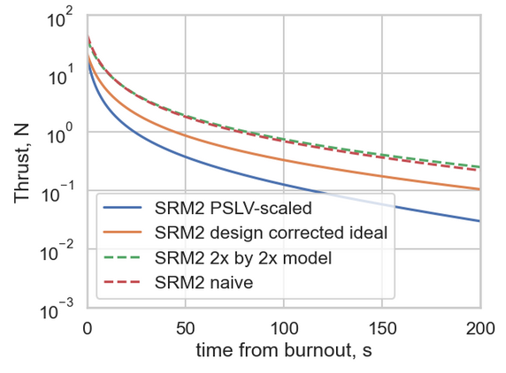
Figure 5: Thrust residual for two leading models and some alternates

Further in-depth heat loss
Recall, everything above still fit the ideal equation form, and still merely asymptotes toward 0 flow and thrust as time approaches infinity. Now, consider realistic loss possibilities that not only reduce the total mass flowed and impulse but can put a final time on the analysis. This would be very useful to the guidance, navigation and control analysts and mission timeline designers.
Generalize the energy balance further to the following:
${\dot{Q}}_{r,n}+{\dot{Q}}_{loss,n}={\dot{Q}}_{r,i}+{\dot{Q}}_{pyrol}{+\dot{Q}}_{loss,i}$ (28)
Now, once the insulation in-depth and loss heat flow exceeds the net nozzle radiation onto the insulation, the insulation surface temperature will begin to drop and pyrolysis will cease.
${\dot{Q}}_{loss,ins}$ represents in-depth heat flow, not linked just to what’s required to pre-heat the current mass flow rate. One simple way to estimate this heat flow is to model as a semi-infinite wall. Though it is likely thin enough insulation over the timeframe of interest that this is not a great model, it may show how important this term may be.
$\frac{{\dot{Q}}_{loss,ins}}{A_{ins}}=\sqrt{k ρ c_{i}}\frac{T_{abl}-T_{i}}{\sqrt{πt}}$ (28)
It is for the first time important to know something about the geometry of the insulation and the thermal conductivity and density. Initial estimates suggest that Eq 0 does provide the desired limiter in a mission-useful amount of time, as the heat loss rate level at reasonable times is significant, and the time^{-1/2} behavior drops off more slowly than the Eq 0 radiative-ablative behavior. However, the treatment of k and c as functions of temperature and the varied initial state of the insulation throughout the motor make it difficult to trust the bulk usage of Eq 0. This was not further investigated by the time of publication.
- Conclusion
The design-based assessment provides a lossless estimate of residual thrust, though with reasonably 25%-40% uncertainty due to inputs. Further, it suggests that the Z9-based estimate does not apply in this case, as it overpredicts the energy available. The PSLV radiative-ablative fit provides a motor system level estimate, including any losses that affect the curve parameters, and suggests that the curve fit is conservative for like-motors.
It is left to the SRM system analyst how much uncertainty to include in a dispersed model based on these witnesses. If the mission deems unacceptable the corrected ideal and flight-scaled results, then the loss mechanisms – in-depth heat loss through the insulation and nozzle, and view factors through the nozzle throat – should be more deeply investigated, to see if a different maximum curve can be more reliably identified.
The PSLV 3rd stage and Z9 are motors of a similar order of magnitude and construction (eg, both are submerged nozzle, motors have similar length to diameter ratio), yet have reported wildly different residual thrust levels and decay timings. The author would value any work that would further understand these differences.
The best way to further understand the residual thrust phenomenon is data, data, data. If launch vehicle and mission operators have more flight reconstructed thrust estimates for preferably 2 minutes or more after burnout that would really advance the understanding.

References

[1] Kavanaugh, D. J and C. C. Nichols, “A Post Burn Outgassing and Thrust Prediction for the IUS Solid Rocket Motors,” AIAA-80-1104, June 1980.
[2] Panicker, P.R. M., N. Ramachandran, K. P. Sreekumar and M. K. A. Majeed, “Pyrolysis Caused Tail-Off Thrust in a Solid Rocket Motor: A Semi-Empirical Model,” Defence Science Journal, Vol 48, January 1998, pp. 87-91.
[3] Mini, S., F. Ponti, A. Annovazzi and E. Gizzi, “Impact of Thermal Protections Insulation Layer on Solid Rocket Motor Performance,” AIAA 2020-3933, August 2020.

Motor Performance SME, Solid Propulsion and Pyro Devices Branch, and AIAA Member.

