P33B-06 Novel Mars In-situ Wind & Wind-Blown Particle Measurement Instruments

Wednesday, 13 December 2023

 15:00 - 15:10

* + *216 - South (Level 2, South, MC)*

Top of Form

Bottom of Form

**Abstract**

**Mars Sonic Anemometer**

We have developed the Mars Sonic Anemometer: an in-situ wind measuring instrument. It uses transducers to transmit ‘chirps’ through a volume of atmosphere and measures wind direction, speed, and temperature based on the chirp travel times when received by a paired transducer (fig 1). This method can rapidly take multiple samples of wind (~20 Hz) and can measure gentler wind speeds (~0.05 m/s) than current planetary weather stations (~1Hz and ~2m/s) and is more durable than recent Mars wind sensors. The Sonic Anemometer opens new avenues of research into Mars surface-to-atmosphere exchange (e.g., of heat, momentum or trace gases). It also can be recast as a hydrogen ortho-para sensor for a giant planet descent probe or as an infrasound detector for Earth or Venus. The performance of the sensor at Mars-like conditions of 6mbar of CO2 was validated at the Danish Mars Wind Tunnel.

**Saltation Sensor**

Saltation (the temporary lofting of grains by wind stress) is believed to be a dominant factor in dust lifting, which at Mars is key to understanding Mars’ climate, and both processes have significant impact on human exploration safety. Existing instrumentation to detect saltation yields incomplete information (e.g., impact timing only) and is not flight qualified. We are developing a Saltation Sensor (fig 2), as a variant of the Mars Sonic Anemometer that detects not only grain impacts, but also their speed, mass, and the height. This sensor uses the same instrument computer back-end to facilitate cross-comparison of their mutually supporting information (e.g., to determine the critical wind stress for grain motion). Basic instrument performance has been demonstrated in the lab for detecting grain impacts in typical Mars particle size range (100um-1mm), resolving impact size, speed, and height at impact rates up to ~1000/second. The plan is to mature these capabilities from a lab prototype to an Engineering Test Unit using similar architectures to the Mars Sonic Anemometer. The field prototype will be characterized in the lab with well-defined impacts before being tested in an active dune field, alongside state-of-the-art (but notably less capable) commercial instrumentation. Our MatISSE funded sensor will reach TRL 6 in 2025.  
[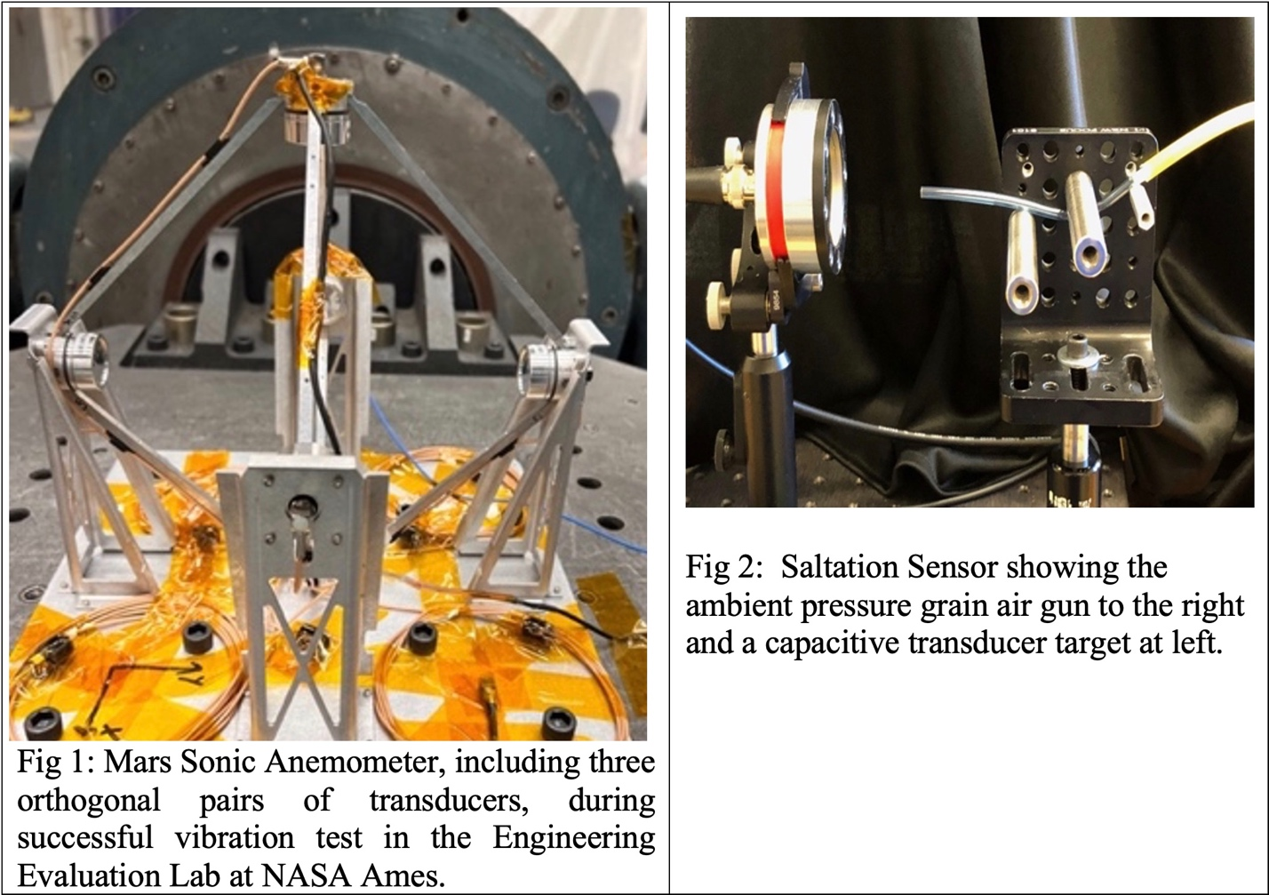](https://agu.confex.com/data/abstract/agu/fm23/5/7/Paper_1419075_abstract_1244683_0.jpg)

**First Author**

* + B[**Donald J Banfield**](https://agu.confex.com/agu/fm23/meetingapp.cgi/Home/Person/7483)
    - NASA Ames Research Center

**Authors**

* + C[Anthony Colaprete](https://agu.confex.com/agu/fm23/meetingapp.cgi/Home/Person/5305)
    - NASA Ames Research Center
  + D[Arwen Dave](https://agu.confex.com/agu/fm23/meetingapp.cgi/Home/Person/815592)
    - NASA Ames Research Center
  + C[Amanda Cook](https://agu.confex.com/agu/fm23/meetingapp.cgi/Home/Person/155800)
    - NASA Ames Research Center
  + J[Vandana Jha](https://agu.confex.com/agu/fm23/meetingapp.cgi/Home/Person/87009)
    - NASA Ames Research Center
  + W[Bruce White](https://agu.confex.com/agu/fm23/meetingapp.cgi/Home/Person/516739)
    - NASA Ames Research Center
  + R[Abraham Rademacher](https://agu.confex.com/agu/fm23/meetingapp.cgi/Home/Person/816201)
    - NASA Ames Research Center
  + S[Jared Shimada](https://agu.confex.com/agu/fm23/meetingapp.cgi/Home/Person/816216)
    - NASA Ames Research Center
  + N[Ian Neeson](https://agu.confex.com/agu/fm23/meetingapp.cgi/Home/Person/975375)
    - VN Instruments
  + S[Jacob Smith](https://agu.confex.com/agu/fm23/meetingapp.cgi/Home/Person/1442277)
    - VN Instruments
  + M[Lily Mueller](https://agu.confex.com/agu/fm23/meetingapp.cgi/Home/Person/1442371)
    - University of Waterloo
  + W[Robert White](https://agu.confex.com/agu/fm23/meetingapp.cgi/Home/Person/1442487)
    - Tufts University
  + C[Rishabh Chaudhary](https://agu.confex.com/agu/fm23/meetingapp.cgi/Home/Person/1442577)
    - Tufts University
  + C[Timothy Cheng](https://agu.confex.com/agu/fm23/meetingapp.cgi/Home/Person/1442669)
    - Tufts University
  + H[Julia Huckaby](https://agu.confex.com/agu/fm23/meetingapp.cgi/Home/Person/1442794)
    - Tufts University