Leveraging scientific community knowledge for air quality model chemistry parameterizations
Havala O. T. Pye, Rebecca H. Schwantes, Kelley C. Barsanti, V. Faye McNeill, and Glenn M. Wolfe

Overview sentence: An introduction to atmospheric chemical mechanisms: development, usage, and future needs.

Air pollution contributes to adverse health outcomes, and 121 million people in the U.S., one third of the population, live where National Ambient Air Quality Standards are violated.¹ In most cases, the criteria pollutants exceeding standards are ozone (O₃) and fine particles (PM_{2.5}). In addition, 188 substances known or suspected to cause cancer or other serious health effects are designated as hazardous air pollutants (HAPs).² Essentially all O₃ and significant portions of PM_{2.5} and HAPs are produced in the atmosphere through chemical and physical processes. In the case of PM_{2.5}, subcomponents formed primarily from precursor gases—sulfate, nitrate, ammonium, and secondary organic aerosol (SOA) —account for 60% of the U.S. county-level annual mean concentration.³ In addition, 47% of the cancer risk and 25% of the noncancer risk from HAPs have been attributed to atmospheric chemistry rather than direct emissions.⁴ In this article, we introduce the role of chemical mechanisms in air quality models, a new atmospheric science community effort, and needs for further mechanism development.

Chemical Mechanisms
Chemical mechanisms describe the interactions of reactive organic carbon (ROC) and nitrogen oxide (NO_{X}) emissions to form O₃ and secondary products.⁵ Chemical mechanisms used in air quality models like the Community Multiscale Air Quality (CMAQ) system are simplified representations of atmospheric chemistry with Carbon Bond,⁶ SAPRC,⁷ and the Regional Atmospheric Chemistry Mechanism (RACM)⁸ (Figure 1) taking different approaches to balance computational cost and chemical detail.^{9, 10} Carbon Bond reduces the number of species by tracking types of carbon bonds; SAPRC and RACM retain the carbon backbone of emissions and group by similar structure and reactivity. Historically, development of these mechanisms focused on the most volatile subset of ROC emissions responsible for O_{3,} which differs from the ROC most important for SOA (Figure 2). This approach leaves development of SOA algorithms largely independent of chemical mechanisms despite important linkages. Accordingly, models have struggled to consistently simulate O₃, HAPs, PM_{2.5}, SOA, and related quantities.¹¹⁻¹³

The Community Regional Atmospheric Chemistry Multiphase Mechanism (CRACMM)
CRACMM (https://www.epa.gov/cmaq/cracmm) is a new mechanism that integrates the representation of O₃, PM_{2.5}, and HAPs to best address current and future air quality modeling needs under regimes of lower NO_{X},¹⁴ increased wildfires,¹⁵ increasingly oxygenated ROC,^{16, 17} lower inorganic PM_{2.5} precursors,¹⁸ and higher temperatures.¹⁹ CRACMM will be used and developed by the atmospheric chemistry community to ensure the latest scientific updates are efficiently and accurately incorporated into air quality models. The “Community” aspect of CRACMM reflects the importance of incorporating advances from a multi-institution community of researchers now and in the future.

CRACMM version 1^{20, 21} was released in CMAQv5.4²² in 2022 and included developments from the Environmental Protection Agency (EPA), the National Oceanic and Atmospheric Administration (NOAA)’s Chemical Sciences Laboratory, the University of Colorado Boulder, the University of Texas El Paso, and Columbia University. CRACMM continues collaborative efforts between NOAA and the EPA on forecasting air quality²³ as well as NOAA and the National Center for Atmospheric Research (NCAR) on co-development of common modeling infrastructure.²⁴ NCAR leads development of the Model-Independent Chemistry Module (MICM) that will enable CRACMM implementation into NOAA’s Unified Forecast System (https://ufscommunity.org/) with chemistry (UFS-Chem). In addition, CRACMM is available in the Framework for 0-D Atmospheric Modeling (F0AM)¹¹ v4.3, a widely-used research community box model that supports analyses of laboratory and real-world chemical systems and facilitates rapid mechanism development and intercomparison.

Atmospheric Chemistry Community Needs
Simplified mechanisms like CRACMM rely on detailed chemistry information and measurements to robustly represent the fate of emitted compounds. To support continued development and application of mechanisms like CRACMM, we recommended the following:

1. Explicit mechanisms. Explicit mechanisms (Figure 3) are detailed representations of atmospheric chemistry and include information like isomer-specific pathways, which can influence later generation reactions and products.²⁵ Isoprene is one of the more studied systems, and a recent mechanism synthesized its chemistry with 385 species and 810 reactions.²⁶ For less-well characterized systems, generators such as the Generator for Explicit Chemistry and Kinetics of Organics in the Atmosphere (GECKO-A)²⁷ and SAPRC Mechanism Generation System (MechGen)^{28, 29} apply structure-activity relationships to estimate reaction rate coefficients and product yields. The benefit of these approaches is that they extend our current understanding of reaction pathways and yields based on studied compounds to a broader range of atmospherically relevant compounds. However, structure activity relationship predictions can produce errors if the underlying data provide poor constraints.¹⁰ The Master Chemical Mechanism (MCM) is another example of a semi-explicit mechanism.³⁰

Explicit or semi-explicit mechanisms can provide a complete picture of atmospheric chemistry upon which simplified mechanisms can be built. For CRACMM1, MCM provided a foundation for the chemistry of propylene glycol,³¹ and F0AM box model calculations were used to evaluate CRACMM against MCM.²² However, no current explicit mechanism is complete. For example, state-of-science experiments for benzene account for 80% of the carbon mass,³² and autoxidation—a critical process leading to SOA³³—is missing from MCM and GECKO-A. MCM also lacks detailed halogen treatment relevant to marine environments. Explicit mechanism generation and verification against laboratory and field observations is a continual need and critical step to inform mechanisms suitable for models like CMAQ.³⁴

2. Reduction methods. Explicit mechanisms are too computationally intensive for routine use in models like CMAQ which require judicious selection of species and reactions. Currently, CRACMM relies on manual curation because fully explicit, coupled representations of O₃ and SOA are not available. In addition, the community lacks broadly applicable automated techniques for simplifying explicit mechanisms. As part of a recent funding opportunity, EPA³⁵ called for development of algorithms to reduce detailed chemical mechanisms into simplified mechanisms resulting in more studies on the topic of reduction. Full machine learning replacements of chemical mechanisms within air quality models have not been sufficiently accurate.^{36, 37} However, using machine learning to identify a subset of reactions most relevant at certain times and locations has successfully reduced the time required to solve chemistry in a global model by 50% with less than 2% error.^{38, 39} Another avenue to reduce computational load is to simplify explicit mechanisms through the Automated Model Reduction (AMORE) technique. AMORE uses a directed-graph path-based reduction approach and has been used to reduce a fully explicit isoprene chemistry.²⁰ For SOA, the GENerator of reduced Organic Aerosol mechanism (GENOAv1.0) uses a series of predefined reduction strategies to reduce chemical mechanism size. GENOA has been used to reduce an MCM-based mechanism to 3% of its full size, while reproducing predicted SOA mass concentrations with an average error of < 3%.⁴⁰

3. Parameter measurement and curation. Chemical mechanisms require rate constants and branching ratios to describe the likelihood of atmospheric reactions and the products they produce. Two community efforts originating in the 1970s have synthesized kinetic and photochemical data: the NASA/JPL Data evaluation panel established by the NASA Upper Atmosphere Research Program Office⁴¹ and the Task Group on Atmospheric Chemical Kinetic Data Evaluation under the International Union of Pure and Applied Chemistry (IUPAC).⁴² Other work has synthesized information in a searchable database.⁴³ These efforts rely on experimental data and other sources of information and are regularly used to update models. Rate constants for some fundamental reactions remain significant sources of uncertainty in global models,⁴⁴ and CRACMM simulations for the Northeast U.S. identified updates in inorganic chemistry rate constants based on the JPL/IUPAC assessments as one of the top factors influencing O₃ predictions compared to RACM2.²² Continual investment in laboratory kinetic measurements and curation of fundamental rate constants and their dependence on temperature, product distributions, and structure-activity relationships are needed.

4. Property estimation methods. Chemical mechanisms require additional metadata to connect to endpoints beyond O₃. For example, deposition competes with chemical loss and influences the ability of emissions to form secondary pollutants. Deposition is also a critical input to sensitive ecosystems. To correctly estimate deposition as well as SOA, at minimum, properties such as solubility and vapor pressure are needed. For many secondary ROC species, these properties cannot be measured as authentic standards are not available. As a result, computational methods have been developed to predict these properties from structures. Recent work indicates that not only do existing methods of estimating vapor pressure, Henry’s Law coefficients, and hydroxyl radical rate constants vary by parametrization, but properties for individual isomers can vary by an order of magnitude.⁴⁵ As the community moves towards greater characterization of the full suite of airborne compounds through non-targeted analysis methods,⁴⁶ improved property estimation methods are needed for new compounds not previously included in mechanisms. In addition, improved toxicity estimation for individual compounds,⁴⁷ particularly secondary species more toxic than their parent chemical,⁴⁸ could better capture the full health burden of inhaled pollutants.

A Community Approach
Strategies to reduce health impacts of air pollution evolve over time as sources of exposure and knowledge of health risks change. Chemical mechanisms serve an important role as public health tools by representing the chemistry of specific sources, pollutants, and regimes within large-scale models. Because pollutants and their state-of-science evolve over time, mechanisms must be continuously updated. Advancing chemical mechanisms benefits from leveraging scientific community knowledge across measurements and models using approaches outlined here.

About the authors:

Havala O. T. Pye (corresponding author) is a research scientist as the U.S. EPA Office of Research and Development, member of the CMAQ development team, and lead of the CRACMM project. Email: pye.havala@epa.gov.

Rebecca H. Schwantes is a research scientist at NOAA Chemical Sciences Laboratory, developer of UFS-Chem, and NOAA lead for CRACMM development. Email: rebecca.schwantes@noaa.gov.

Kelley C. Barsanti is a research scientist at the National Center for Atmosphere Research (NCAR) and developer of detailed representations of coupled gas and SOA chemistry using GECKO-A and MechGen. Email: barsanti@ucar.edu.

V. Faye McNeill is a Professor at Columbia University, the developer of the AMORE technique, and contributor to IUPAC assessments. Email: vfm2103@columbia.edu.

Glenn M. Wolfe is a research scientist at NASA Goddard Space Flight Center and the principal developer of F0AM. Email: glenn.m.wolfe@nasa.gov.

Disclaimer: The views expressed in this article are those of the authors and do not necessarily reflect the views or polices of the U.S. EPA.

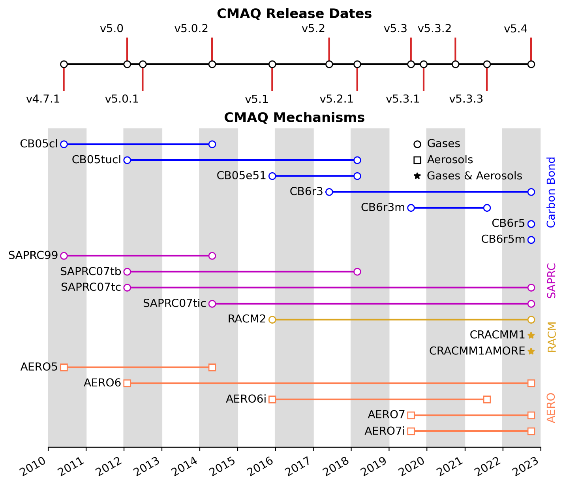

Figure 1: Gas-phase chemical mechanisms and aerosol (AERO) modules in CMAQ since 2010. Carbon Bond version 5 mechanisms⁴⁹ include implementations with chlorine chemistry (CB05Cl)⁵⁰, chlorine and toluene (CB05tucl),⁵¹ and EPA modifications for the treatment of organic nitrates in CMAQv5.1 (CB05e51).⁵² Carbon Bond version 6 mechanisms include revision 3 (CB6r3),⁶ revision 3 with marine chemistry (CB6r3m),^{53, 54} revision 5 (CB6r5),⁵⁵ and revision 5 with marine chemistry (CB6r5m). SAPRC implementations include versions initially from 1999 (SAPRC99)⁵⁶ and 2007 (SAPRC07)⁷ and one with expanded isoprene chemistry (SAPRC07tic).⁵⁷ The Regional Atmospheric Chemistry Mechanism (RACM) was implemented as version 2 (RACM2)^{8, 58} and built upon to develop CRACMM1^{21, 22} and CRACMM1 with AMORE isoprene (CRACMM1AMORE).²⁰ Aerosol modules start with version 5 (AERO5) which includes SOA pathways introduced in CMAQv4.7.⁵⁹ AERO6 includes updates to heterogeneous oxidation of primary organic aerosol (POA)⁶⁰ and the representation of trace metals⁶¹ (CMAQv5.0) as well as the introduction of isoprene epoxydiol,⁶² polycyclic aromatic,⁶³ and alkane⁶³ SOA (CMAQv5.1). In CMAQv5.2, SOA parameters were updated⁶⁴ and semivolatile POA and SOA from anthropogenic and biomass burning sources⁶⁵ were introduced (AERO6). Revisions to monoterpene⁶⁶ SOA and new pathways to glyoxal⁶⁶ SOA were introduced in CMAQv5.3 AERO7. Two AERO versions compatible with SAPRC07tic have expanded isoprene SOA species⁶² (AERO6i/AERO7i). CRACMM is an integrated representation of gas- and aerosol-phase chemistry, so the chemical mechanism completely specifies the aerosol configuration.

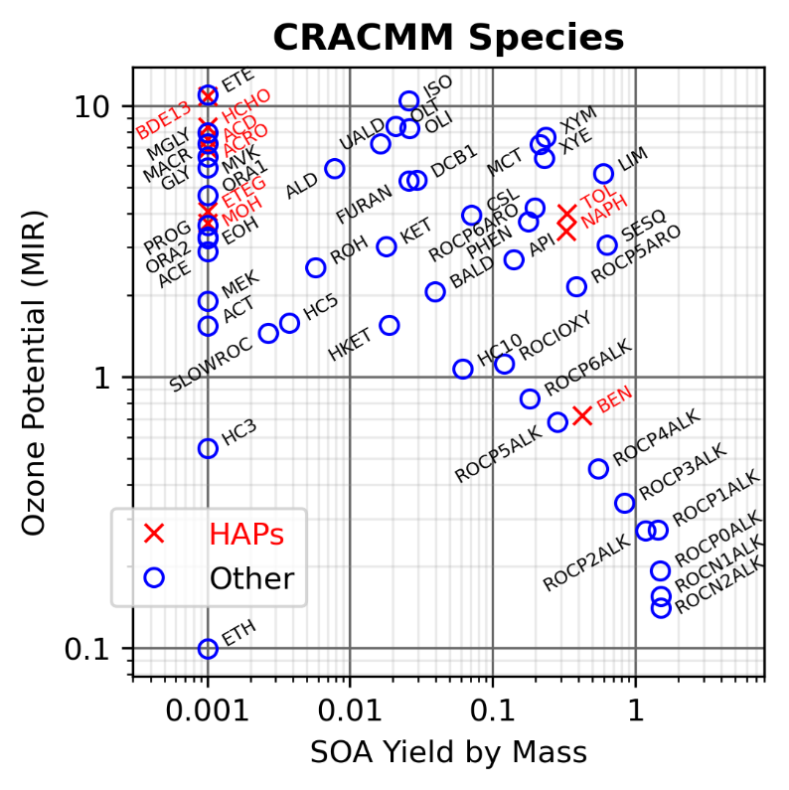
Figure 2: Potential ozone formation (indicated by emission-weighted maximum incremental reactivity, MIR, in g/g) vs secondary organic aerosol (SOA) yield (g/g) for reactive organic carbon emissions grouped by CRACMM1 species. CRACMM species composed entirely of HAPs are indicated in red. SOA yields lower than 0.001 are shown at 0.001. See the work of Pye et al.²¹ for the simple structure-activity relationships and 2017 U.S. emissions used to calculate these values. Species descriptions are available at https://github.com/USEPA/CMAQ and in the work of Pye et al.²¹

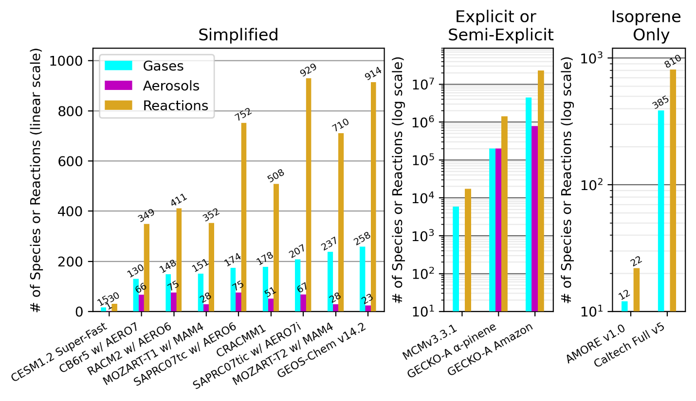
Figure 3: Number of reactions and gas vs particle species in selected chemical mechanisms used throughout the community to demonstrate breadth of complexity. The simplified mechanisms as well as MCMv3.3.1 represent a full suite of NO_{X}-ROC chemistry. Two versions of explicit GECKO-A mechanisms—one for only the oxidation of α-pinene⁶⁷ and another for the oxidation of many VOC precursors relevant for the Amazon rainforest⁶⁸—demonstrate how differences in assumptions for precursors and reduction changes the complexity of the chemistry. Two mechanisms illustrate the complexity of known gas-phase isoprene chemistry (Caltech Full mechanism²⁶) compared to the representation size needed for an air quality model (AMORE v1.0²⁰). Note the GEOS-Chem v14.2 mechanism⁶⁹ includes stratospheric chemistry unlike the others which focus on the troposphere. CB6r5 with AERO7, RACM2 with AERO6, SAPRC07tc with AERO6, CRACMM1, and SAPRC07tic with AERO7i values are from CMAQv5.4. MCMv3.3.1 values are from the F0AM¹¹ implementation. Super-Fast,^{70, 71} MOZART-T1 with MAM4,⁷² and MOZART-T2 with MAM-4⁷³ are implemented in the Community Earth System Model (CESM). In CESM, MOZART-T1 and MOZART-T2 are coupled with stratospheric chemistry, but the stratospheric chemistry is excluded in these calculations to better compare with CRACMM.

References

(1) U.S. Environmental Protection Agency. Summary Nonattainment Area Population Exposure Report; 2023. https://www3.epa.gov/airquality/greenbook/popexp.html.
(2) U.S. Environmental Protection Agency. Initial List of Hazardous Air Pollutants with Modifications. 2022. https://www.epa.gov/haps/initial-list-hazardous-air-pollutants-modifications (accessed 9 November 2023).
(3) Pye, H. O. T.; Ward-Caviness, C. K.; Murphy, B. N.; Appel, K. W.; Seltzer, K. M. Secondary organic aerosol association with cardiorespiratory disease mortality in the United States. Nat. Commun. 2021, 12 (1), 7215. DOI: 10.1038/s41467-021-27484-1.
(4) Scheffe, R. D.; Strum, M.; Phillips, S. B.; Thurman, J.; Eyth, A.; Fudge, S.; Morris, M.; Palma, T.; Cook, R. Hybrid modeling approach to estimate exposures of Hazardous Air Pollutants (HAPs) for the National Air Toxics Assessment (NATA). Environ. Sci. Technol. 2016, 50 (22), 12356-12364. DOI: 10.1021/acs.est.6b04752.
(5) Heald, C. L.; Kroll, J. H. The fuel of atmospheric chemistry: Toward a complete description of reactive organic carbon. Sci. Adv. 2020, 6 (6), eaay8967. DOI: 10.1126/sciadv.aay8967.
(6) Luecken, D. J.; Yarwood, G.; Hutzell, W. T. Multipollutant modeling of ozone, reactive nitrogen and HAPs across the continental US with CMAQ-CB6. Atmos. Environ. 2019, 201, 62-72. DOI: 10.1016/j.atmosenv.2018.11.060.
(7) Carter, W. P. L. Development of the SAPRC-07 chemical mechanism. Atmos. Environ. 2010, 44 (40), 5324-5335. DOI: 10.1016/j.atmosenv.2010.01.026.
(8) Goliff, W. S.; Stockwell, W. R.; Lawson, C. V. The regional atmospheric chemistry mechanism, version 2. Atmos. Environ. 2013, 68, 174-185. DOI: 10.1016/j.atmosenv.2012.11.038.
(9) Dodge, M. C. Chemical oxidant mechanisms for air quality modeling: critical review. Atmos. Environ. 2000, 34 (12-14), 2103-2130. DOI: 10.1016/S1352-2310(99)00461-6.
(10) Stockwell, W. R.; Saunders, E.; Goliff, W. S.; Fitzgerald, R. M. A perspective on the development of gas-phase chemical mechanisms for Eulerian air quality models. J. Air Waste Manage. Assoc. 2020, 70 (1), 44-70. DOI: 10.1080/10962247.2019.1694605.
(11) Wolfe, G. M.; Marvin, M. R.; Roberts, S. J.; Travis, K. R.; Liao, J. The Framework for 0-D Atmospheric Modeling (F0AM) v3.1. Geosci. Model Dev. 2016, 9 (9), 3309-3319. DOI: 10.5194/gmd-9-3309-2016.
(12) Knote, C.; Tuccella, P.; Curci, G.; Emmons, L.; Orlando, J. J.; Madronich, S.; Baró, R.; Jiménez-Guerrero, P.; Luecken, D.; Hogrefe, C.; et al. Influence of the choice of gas-phase mechanism on predictions of key gaseous pollutants during the AQMEII phase-2 intercomparison. Atmos. Environ. 2015, 115, 553-568. DOI: 10.1016/j.atmosenv.2014.11.066.
(13) Tsigaridis, K.; Daskalakis, N.; Kanakidou, M.; Adams, P. J.; Artaxo, P.; Bahadur, R.; Balkanski, Y.; Bauer, S. E.; Bellouin, N.; Benedetti, A.; et al. The AeroCom evaluation and intercomparison of organic aerosol in global models. Atmos. Chem. Phys. 2014, 14 (19), 10845-10895. DOI: 10.5194/acp-14-10845-2014.
(14) Foley, K. M.; Pouliot, G. A.; Eyth, A.; Aldridge, M. F.; Allen, C.; Appel, K. W.; Bash, J. O.; Beardsley, M.; Beidler, J.; Choi, D.; et al. 2002–2017 anthropogenic emissions data for air quality modeling over the United States. Data in Brief 2023, 47, 109022. DOI: 10.1016/j.dib.2023.109022.
(15) Westerling, A. L.; Hidalgo, H. G.; Cayan, D. R.; Swetnam, T. W. Warming and Earlier Spring Increase Western U.S. Forest Wildfire Activity. Science 2006, 313 (5789), 940-943. DOI: 10.1126/science.1128834 (acccessed 2023/10/13).
(16) Venecek, M. A.; Carter, W. P. L.; Kleeman, M. J. Updating the SAPRC Maximum Incremental Reactivity (MIR) scale for the United States from 1988 to 2010. J. Air Waste Manage. Assoc. 2018, 68 (12), 1301-1316. DOI: 10.1080/10962247.2018.1498410.
(17) McDonald, B. C.; de Gouw, J. A.; Gilman, J. B.; Jathar, S. H.; Akherati, A.; Cappa, C. D.; Jimenez, J. L.; Lee-Taylor, J.; Hayes, P. L.; McKeen, S. A.; et al. Volatile chemical products emerging as largest petrochemical source of urban organic emissions. Science 2018, 359 (6377), 760. DOI: 10.1126/science.aaq0524.
(18) Pye, H. O. T.; Appel, K. W.; Seltzer, K. M.; Ward-Caviness, C. K.; Murphy, B. N. Human-health impacts of controlling secondary air pollution precursors. Environ. Sci. Tech. Lett. 2022, 9 (2), 96-101. DOI: 10.1021/acs.estlett.1c00798.
(19) Fiore, A. M.; Naik, V.; Leibensperger, E. M. Air Quality and Climate Connections. J. Air Waste Manage. Assoc. 2015, 65 (6), 645-685. DOI: 10.1080/10962247.2015.1040526.
(20) Wiser, F.; Place, B. K.; Sen, S.; Pye, H. O. T.; Yang, B.; Westervelt, D. M.; Henze, D. K.; Fiore, A. M.; McNeill, V. F. AMORE-Isoprene v1.0: a new reduced mechanism for gas-phase isoprene oxidation. Geosci. Model Dev. 2023, 16 (6), 1801-1821. DOI: 10.5194/gmd-16-1801-2023.
(21) Pye, H. O. T.; Place, B. K.; Murphy, B. N.; Seltzer, K. M.; D'Ambro, E. L.; Allen, C.; Piletic, I. R.; Farrell, S.; Schwantes, R. H.; Coggon, M. M.; et al. Linking gas, particulate, and toxic endpoints to air emissions in the Community Regional Atmospheric Chemistry Multiphase Mechanism (CRACMM). Atmos. Chem. Phys. 2023, 23 (9), 5043-5099. DOI: 10.5194/acp-23-5043-2023.
(22) Place, B. K.; Hutzell, W. T.; Appel, K. W.; Farrell, S.; Valin, L.; Murphy, B. N.; Seltzer, K. M.; Sarwar, G.; Allen, C.; Piletic, I. R.; et al. Sensitivity of northeastern US surface ozone predictions to the representation of atmospheric chemistry in the Community Regional Atmospheric Chemistry Multiphase Mechanism (CRACMMv1.0). Atmos. Chem. Phys. 2023, 23 (16), 9173-9190. DOI: 10.5194/acp-23-9173-2023.
(23) U.S. Environmental Protection Agency and National Oceanic and Atmospheric Administration. Memorandum of Agreement on Cooperation in Forecasting Air Quality between U.S. Environmental Protection Agency and National Oceanic and Atmospheic Administration, U.S. Department of Commerce; 2021. https://www.weather.gov/media/sti/NOAA-EPA%20MOA%20signed_2021.pdf.
(24) National Center for Atmospheric Research and National Oceanic and Atmospheric Administration. NCAR-NOAA Memorandum of Agreement (MOA) for Co-development of a Common Modeling Infrastructure; 2018. https://www.weather.gov/media/sti/nggps/18-064553_SignedMOU.pdf.
(25) Vasquez, K. T.; Crounse, J. D.; Schulze, B. C.; Bates, K. H.; Teng, A. P.; Xu, L.; Allen, H. M.; Wennberg, P. O. Rapid hydrolysis of tertiary isoprene nitrate efficiently removes NO_{X} from the atmosphere. P. Natl. Acad. Sci. USA 2020, 117 (52), 33011-33016. DOI: 10.1073/pnas.2017442117.
(26) Wennberg, P. O.; Bates, K. H.; Crounse, J. D.; Dodson, L. G.; McVay, R. C.; Mertens, L. A.; Nguyen, T. B.; Praske, E.; Schwantes, R. H.; Smarte, M. D.; et al. Gas-Phase reactions of isoprene and its major oxidation products. Chem. Rev. 2018, 118 (7), 3337-3390. DOI: 10.1021/acs.chemrev.7b00439.
(27) Aumont, B.; Szopa, S.; Madronich, S. Modelling the evolution of organic carbon during its gas-phase tropospheric oxidation: development of an explicit model based on a self generating approach. Atmos. Chem. Phys. 2005, 5 (9), 2497-2517. DOI: 10.5194/acp-5-2497-2005.
(28) Carter, W. P. L. Documentation of the SAPRC-22 Mechanism; 2023. https://intra.engr.ucr.edu/~carter/SAPRC/22/S22doc.pdf.
(29) Carter, W. P. L.; Jiang, J.; Orlando, J. J.; Barsanti, K. C. Derivation of Atmospheric Reaction Mechanisms for Volatile Organic Compounds by the SAPRC Mechanism Generation System (MechGen). EGUsphere 2023, 2023, 1-65. DOI: 10.5194/egusphere-2023-2343.
(30) Jenkin, M. E.; Saunders, S. M.; Pilling, M. J. The tropospheric degradation of volatile organic compounds: a protocol for mechanism development. Atmos. Environ. 1997, 31 (1), 81-104. DOI: 10.1016/S1352-2310(96)00105-7.
(31) Coggon, M. M.; Gkatzelis, G. I.; McDonald, B. C.; Gilman, J. B.; Schwantes, R. H.; Abuhassan, N.; Aikin, K. C.; Arend, M. F.; Berkoff, T. A.; Brown, S. S.; et al. Volatile chemical product emissions enhance ozone and modulate urban chemistry. P. Natl. Acad. Sci. USA 2021, 118 (32), e2026653118. DOI: 10.1073/pnas.2026653118.
(32) Xu, L.; Møller, K. H.; Crounse, J. D.; Kjaergaard, H. G.; Wennberg, P. O. New Insights into the Radical Chemistry and Product Distribution in the OH-Initiated Oxidation of Benzene. Environ. Sci. Technol. 2020, 54 (21), 13467-13477. DOI: 10.1021/acs.est.0c04780.
(33) Pye, H. O. T.; D’Ambro, E. L.; Lee, B. H.; Schobesberger, S.; Takeuchi, M.; Zhao, Y.; Lopez-Hilfiker, F.; Liu, J.; Shilling, J. E.; Xing, J.; et al. Anthropogenic enhancements to production of highly oxygenated molecules from autoxidation. P. Natl. Acad. Sci. USA 2019, 116 (14), 6641. DOI: 10.1073/pnas.1810774116.
(34) Kaduwela, A.; Luecken, D.; Carter, W.; Derwent, R. New directions: Atmospheric chemical mechanisms for the future. Atmos. Environ. 2015, 122, 609-610. DOI: 10.1016/j.atmosenv.2015.10.031.
(35) U.S. Environmental Protection Agency. Overview Information: Chemical Mechanisms to Address New Challenges in Air Quality Modeling; 2019. https://www.epa.gov/sites/default/files/2019-05/documents/airenergyrfa_20190418_clean_4.pdf.
(36) Keller, C. A.; Evans, M. J. Application of random forest regression to the calculation of gas-phase chemistry within the GEOS-Chem chemistry model v10. Geosci. Model Dev. 2019, 12 (3), 1209-1225. DOI: 10.5194/gmd-12-1209-2019.
(37) Kelp, M. M.; Jacob, D. J.; Lin, H.; Sulprizio, M. P. An Online-Learned Neural Network Chemical Solver for Stable Long-Term Global Simulations of Atmospheric Chemistry. J. Adv. Model. Earth Syst. 2022, 14 (6), e2021MS002926. DOI: 10.1029/2021MS002926 (acccessed 2023/09/28).
(38) Shen, L.; Jacob, D. J.; Santillana, M.; Bates, K.; Zhuang, J.; Chen, W. A machine-learning-guided adaptive algorithm to reduce the computational cost of integrating kinetics in global atmospheric chemistry models: application to GEOS-Chem versions 12.0.0 and 12.9.1. Geosci. Model Dev. 2022, 15 (4), 1677-1687. DOI: 10.5194/gmd-15-1677-2022.
(39) Lin, H.; Long, M. S.; Sander, R.; Sandu, A.; Yantosca, R. M.; Estrada, L. A.; Shen, L.; Jacob, D. J. An Adaptive Auto-Reduction Solver for Speeding Up Integration of Chemical Kinetics in Atmospheric Chemistry Models: Implementation and Evaluation in the Kinetic Pre-Processor (KPP) Version 3.0.0. J. Adv. Model. Earth Syst. 2023, 15 (2), e2022MS003293, 10.1029/2022MS003293. DOI: 10.1029/2022MS003293 (acccessed 2023/07/25).
(40) Wang, Z.; Couvidat, F.; Sartelet, K. GENerator of reduced Organic Aerosol mechanism (GENOA v1.0): an automatic generation tool of semi-explicit mechanisms. Geosci. Model Dev. 2022, 15 (24), 8957-8982. DOI: 10.5194/gmd-15-8957-2022.
(41) Jet Propulsion Laboratory. Chemical Kinetics and Photochemical Data for Use in Atmospheric Studies. 2020. https://jpldataeval.jpl.nasa.gov/index.html (accessed 19 October 2023).
(42) IUPAC Task Group on Atmospheric Chemical Kinetic Data Evaluation. Evaluated kinetic data. 2023. https://iupac.aeris-data.fr/en/home-english/ (accessed 19 October 2023).
(43) McGillen, M. R.; Carter, W. P. L.; Mellouki, A.; Orlando, J. J.; Picquet-Varrault, B.; Wallington, T. J. Database for the kinetics of the gas-phase atmospheric reactions of organic compounds. Earth Syst. Sci. Data 2020, 12 (2), 1203-1216. DOI: 10.5194/essd-12-1203-2020.
(44) Newsome, B.; Evans, M. Impact of uncertainties in inorganic chemical rate constants on tropospheric composition and ozone radiative forcing. Atmos. Chem. Phys. 2017, 17 (23), 14333-14352. DOI: 10.5194/acp-17-14333-2017.
(45) Isaacman-VanWertz, G.; Aumont, B. Impact of organic molecular structure on the estimation of atmospherically relevant physicochemical parameters. Atmos. Chem. Phys. 2021, 21 (8), 6541-6563. DOI: 10.5194/acp-21-6541-2021.
(46) Escher, B. I.; Stapleton, H. M.; Schymanski, E. L. Tracking complex mixtures of chemicals in our changing environment. Science 2020, 367 (6476), 388-392. DOI: 10.1126/science.aay6636 (acccessed 2023/10/13).
(47) McKinney, J. D.; Richard, A.; Waller, C.; Newman, M. C.; Gerberick, F. The Practice of Structure Activity Relationships (SAR) in Toxicology. Toxicol. Sci. 2000, 56 (1), 8-17. DOI: 10.1093/toxsci/56.1.8 (acccessed 9/29/2023).
(48) Liu, Q.; Li, L.; Zhang, X.; Saini, A.; Li, W.; Hung, H.; Hao, C.; Li, K.; Lee, P.; Wentzell, J. J. B.; et al. Uncovering global-scale risks from commercial chemicals in air. Nature 2021, 600 (7889), 456-461. DOI: 10.1038/s41586-021-04134-6.
(49) Sarwar, G.; Luecken, D.; Yarwood, G.; Whitten, G. Z.; Carter, W. P. L. Impact of an updated carbon bond mechanism on predictions from the CMAQ modeling system: Preliminary assessment. J. Appl. Meteorol. Clim. 2008, 47 (1), 3-14. DOI: 10.1175/2007jamc1393.1.
(50) Sarwar, G.; Bhave, P. V. Modeling the Effect of Chlorine Emissions on Ozone Levels over the Eastern United States. J. Appl. Meteorol. Clim. 2007, 46 (7), 1009-1019. DOI: 10.1175/JAM2519.1.
(51) Sarwar, G.; Simon, H.; Bhave, P.; Yarwood, G. Examining the impact of heterogeneous nitryl chloride production on air quality across the United States. Atmos. Chem. Phys. 2012, 12 (14), 6455-6473. DOI: 10.5194/acp-12-6455-2012.
(52) Appel, K. W.; Napelenok, S. L.; Foley, K. M.; Pye, H. O. T.; Hogrefe, C.; Luecken, D. J.; Bash, J. O.; Roselle, S. J.; Pleim, J. E.; Foroutan, H.; et al. Description and evaluation of the Community Multiscale Air Quality (CMAQ) modeling system version 5.1. Geosci. Model Dev. 2017, 10 (4), 1703-1732. DOI: 10.5194/gmd-10-1703-2017.
(53) Sarwar, G.; Gantt, B.; Schwede, D.; Foley, K.; Mathur, R.; Saiz-Lopez, A. Impact of enhanced ozone deposition and halogen chemistry on tropospheric ozone over the Northern Hemisphere. Environ. Sci. Technol. 2015, 49 (15), 9203-9211. DOI: 10.1021/acs.est.5b01657.
(54) Sarwar, G.; Gantt, B.; Foley, K.; Fahey, K.; Spero, T. L.; Kang, D.; Mathur, R.; Foroutan, H.; Xing, J.; Sherwen, T.; et al. Influence of bromine and iodine chemistry on annual, seasonal, diurnal, and background ozone: CMAQ simulations over the Northern Hemisphere. Atmos. Environ. 2019, 213, 395-404. DOI: 10.1016/j.atmosenv.2019.06.020.
(55) Ramboll Environment and Health. User's Guide: Comprehensive Air Quality Model with Extensions (CAMx) Version 7.10; 2020. https://camx-wp.azurewebsites.net/Files/CAMxUsersGuide_v7.10.pdf.
(56) Carter, W. P. L. Implementation of the SAPRC-99 chemical mechanism into the models-3 framework; 2000. https://intra.engr.ucr.edu/~carter/pubs/s99mod3.pdf.
(57) Xie, Y.; Paulot, F.; Carter, W. P. L.; Nolte, C. G.; Luecken, D. J.; Hutzell, W. T.; Wennberg, P. O.; Cohen, R. C.; Pinder, R. W. Understanding the impact of recent advances in isoprene photooxidation on simulations of regional air quality. Atmos. Chem. Phys. 2013, 13 (16), 8439-8455. DOI: 10.5194/acp-13-8439-2013.
(58) Sarwar, G.; Godowitch, J.; Henderson, B. H.; Fahey, K.; Pouliot, G.; Hutzell, W. T.; Mathur, R.; Kang, D.; Goliff, W. S.; Stockwell, W. R. A comparison of atmospheric composition using the Carbon Bond and Regional Atmospheric Chemistry Mechanisms. Atmos. Chem. Phys. 2013, 13 (19), 9695-9712. DOI: 10.5194/acp-13-9695-2013.
(59) Carlton, A. G.; Bhave, P. V.; Napelenok, S. L.; Edney, E. O.; Sarwar, G.; Pinder, R. W.; Pouliot, G. A.; Houyoux, M. Model representation of secondary organic aerosol in CMAQv4.7. Environ. Sci. Technol. 2010, 44 (22), 8553-8560. DOI: 10.1021/es100636q.
(60) Simon, H.; Bhave, P. V. Simulating the Degree of Oxidation in Atmospheric Organic Particles. Environ. Sci. Technol. 2012, 46 (1), 331-339. DOI: 10.1021/es202361w.
(61) Appel, K. W.; Pouliot, G. A.; Simon, H.; Sarwar, G.; Pye, H. O. T.; Napelenok, S. L.; Akhtar, F.; Roselle, S. J. Evaluation of dust and trace metal estimates from the Community Multiscale Air Quality (CMAQ) model version 5.0. Geosci. Model Dev. 2013, 6 (4), 883-899. DOI: 10.5194/gmd-6-883-2013.
(62) Pye, H. O. T.; Pinder, R. W.; Piletic, I. R.; Xie, Y.; Capps, S. L.; Lin, Y.-H.; Surratt, J. D.; Zhang, Z.; Gold, A.; Luecken, D. J.; et al. Epoxide pathways improve model predictions of isoprene markers and reveal key role of acidity in aerosol formation. Environ. Sci. Technol. 2013, 47 (19), 11056-11064. DOI: 10.1021/es402106h.
(63) Pye, H. O. T.; Pouliot, G. A. Modeling the role of alkanes, polycyclic aromatic hydrocarbons, and their oligomers in secondary organic aerosol formation. Environ. Sci. Technol. 2012, 46 (11), 6041-6047. DOI: 10.1021/es300409w.
(64) Pye, H. O. T.; Murphy, B. N.; Xu, L.; Ng, N. L.; Carlton, A. G.; Guo, H.; Weber, R.; Vasilakos, P.; Appel, K. W.; Budisulistiorini, S. H.; et al. On the implications of aerosol liquid water and phase separation for organic aerosol mass. Atmos. Chem. Phys. 2017, 17 (1), 343-369. DOI: 10.5194/acp-17-343-2017.
(65) Murphy, B. N.; Woody, M. C.; Jimenez, J. L.; Carlton, A. M. G.; Hayes, P. L.; Liu, S.; Ng, N. L.; Russell, L. M.; Setyan, A.; Xu, L.; et al. Semivolatile POA and parameterized total combustion SOA in CMAQv5.2: impacts on source strength and partitioning. Atmos. Chem. Phys. 2017, 17 (18), 11107-11133. DOI: 10.5194/acp-17-11107-2017.
(66) Pye, H. O. T.; Luecken, D. J.; Xu, L.; Boyd, C. M.; Ng, N. L.; Baker, K. R.; Ayres, B. R.; Bash, J. O.; Baumann, K.; Carter, W. P. L.; et al. Modeling the current and future roles of particulate organic nitrates in the southeastern United States. Environ. Sci. Technol. 2015, 49 (24), 14195-14203. DOI: 10.1021/acs.est.5b03738.
(67) Afreh, I. K.; Aumont, B.; Camredon, M.; Barsanti, K. C. Using GECKO-A to derive mechanistic understanding of secondary organic aerosol formation from the ubiquitous but understudied camphene. Atmos. Chem. Phys. 2021, 21 (14), 11467-11487. DOI: 10.5194/acp-21-11467-2021.
(68) Mouchel-Vallon, C.; Lee-Taylor, J.; Hodzic, A.; Artaxo, P.; Aumont, B.; Camredon, M.; Gurarie, D.; Jimenez, J. L.; Lenschow, D. H.; Martin, S. T.; et al. Exploration of oxidative chemistry and secondary organic aerosol formation in the Amazon during the wet season: explicit modeling of the Manaus urban plume with GECKO-A. Atmos. Chem. Phys. 2020, 20 (10), 5995-6014. DOI: 10.5194/acp-20-5995-2020.
(69) Bates, K.; Evans, M.; Henderson, B.; Jacob, D. Impacts of updated reaction kinetics on the global GEOS-Chem simulation of atmospheric chemistry. EGUsphere 2023, 2023, 1-18. DOI: 10.5194/egusphere-2023-1374.
(70) Brown-Steiner, B.; Selin, N. E.; Prinn, R.; Tilmes, S.; Emmons, L.; Lamarque, J. F.; Cameron-Smith, P. Evaluating simplified chemical mechanisms within present-day simulations of the Community Earth System Model version 1.2 with CAM4 (CESM1.2 CAM-chem): MOZART-4 vs. Reduced Hydrocarbon vs. Super-Fast chemistry. Geosci. Model Dev. 2018, 11 (10), 4155-4174. DOI: 10.5194/gmd-11-4155-2018.
(71) Cameron-Smith, P.; Lamarque, J. F.; Connell, P.; Chuang, C.; Vitt, F. Toward an Earth system model: atmospheric chemistry, coupling, and petascale computing. Journal of Physics: Conference Series 2006, 46 (1), 343. DOI: 10.1088/1742-6596/46/1/048.
(72) Emmons, L. K.; Schwantes, R. H.; Orlando, J. J.; Tyndall, G.; Kinnison, D.; Lamarque, J.-F.; Marsh, D.; Mills, M. J.; Tilmes, S.; Bardeen, C.; et al. The Chemistry Mechanism in the Community Earth System Model Version 2 (CESM2). J. Adv. Model. Earth Syst. 2020, 12 (4), e2019MS001882. DOI: 10.1029/2019MS001882.
(73) Schwantes, R. H.; Emmons, L. K.; Orlando, J. J.; Barth, M. C.; Tyndall, G. S.; Hall, S. R.; Ullmann, K.; St. Clair, J. M.; Blake, D. R.; Wisthaler, A.; et al. Comprehensive isoprene and terpene gas-phase chemistry improves simulated surface ozone in the southeastern US. Atmos. Chem. Phys. 2020, 20 (6), 3739-3776. DOI: 10.5194/acp-20-3739-2020.

