Lessons From Pluto for Uranus Moons. J. M. Moore¹, P. M. Schenk², and J. R. Spencer³, ¹Space Sciences Division, NASA Ames Research Center, Moffett Field, CA (jeff.moore@nasa.gov), ²Lunar and Planetary Institute, Houston, TX, ³Southwest Research Institute, Boulder, CO.

Introduction: Small patches of starkly different albedo on both Oberon and Umbriel may be evidence for frost segregation and volatile migration. The high obliquity of the Uranian system makes it a good candidate for volatile transport activity. CO₂ and ammonium species have been detected on some Uranian satellites, and CH₄ is at least theoretically viable as a resident volatile. The OWL-recommended UOP Orbiter spacecraft should be equipped with instruments capable of evaluating the nature and extent of volatiles in the Uranian satellite system.
Voyager Observations: Umbriel: The nearly complete bright ring on the floor of 130-km crater Wunda (Fig. 1a) is superficially similar to the bright ring of N₂ and CH₄ ice on the floor of Pluto’s Elliott crater, with the ring surrounding central peaks in both cases. This similarity may support the idea that these bright deposits are due to volatile accumulation in topographic lows. On Umbriel the volatile would more likely be a bright CO₂, or as yet undetected CH₄ or ammonium ice. At least one other crater of similar size, Vuver, also occurs at these equatorial latitudes that exhibits a central bright patch. There are no other obviously analogous deposits on the Saturnian satellites (except perhaps Iapetus) or on the observed portions of the other Uranian moons.
Oberon exhibits some of the greatest apparent variability in albedo. Bright and dark crater deposits (Fig. 1b) at Hamlet, Otello (rim diameters 205 and 114 km) and elsewhere suggest either thermal segregation of initially intermixed material into its volatile components and its (dark) refractory components forming a floor lag, or else excavation of dark subsurface material and generation of bright impact related frosts or debris. These crater deposits resemble those now associated with NH₃ in similar bright and dark craters on Charon. To date, NH₃ has only been identified on Miranda and possibly Ariel, but as ammonia was only identified on Charon by spacecraft it could also occur undetected on other Uranian satellites, especially within preserved crater deposits.
Frost Segregation: Thermal segregation of H₂O ice was first proposed for Ganymede and especially Callisto. Sublimation is thought to be the most significant process for the redistribution of ice at sub-km to km scales there. As ices sublime, the low albedo component of the surface materials remains behind or moves down slope to form a refractory-rich sublimation lag deposit. The lag may eventually become thick enough to suppress any further sublimation from underneath. The volatile(s) create a bright ice that may precipitate on local cold-trap-forming topographic crests as seen on Callisto.
Volatile Migration: The notion of equatorial volatile precipitation during periods of high obliquity has been proposed in Martian studies. It has been long recognized that obliquities ~> 60° result in annually averaged net warmth of the poles relative to the low latitudes. High obliquity excursions have been used to explain the timing and duration of Martian equatorial and mid-latitude fluvial features and other sedimentary deposits, but until seen at Pluto, such an explanation had been purely hypothetical. Pluto exhibits strong latitudinal zoning of various volatiles, which are thought to represent both seasonal and long-term volatile migration under the influence of Pluto’s very high obliquity. Bladed Terrain deposits there are an excellent example of this process. Perhaps it’s not a coincidence that the frost deposits on Umbriel are near the equator.
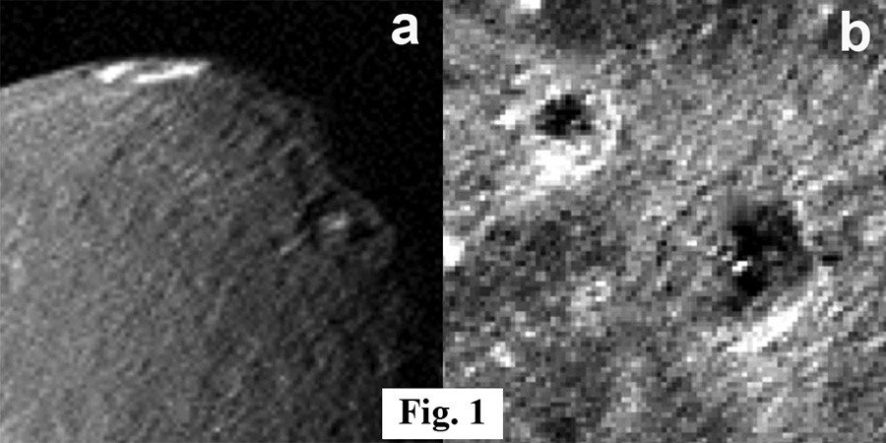
UOP Measurement Desirements: The Galileo, Cassini, and New Horizons experiences suggest that visible light imaging of surface features related to volatile erosion and deposition should be globally acquired at resolutions of ~250 m/pixel or better, ideally in stereo and in several colors. The pinnacles and mass movements related to frost segregation on Callisto were best characterized in images <50 m/pixel. Likewise compositional evaluation of this feature class on Pluto and Charon, for instance, were best done with imaging spectroscopy of at least ~1 km/pixel spatial resolution and ~6 nm spectral resolution across a range of at least 1.2 to 2.5 μm. UV and thermal IR measurements of this feature class would also be potentially useful. If at all possible UOP should arrive to collect data prior to the next equinox so that both poles of the satellites can be examined.

