**JPSS-3 VIIRS version 2 at-launch relative spectral response characterization**

Chris Moellera[1], Tom Schwartingb, David Moyerc, and Julia Barsib

a CIMSS, Univ. Wisconsin; 1225 West Dayton Street; Madison, WI

bScience Systems and Applications Inc., Lanham, MD

c Aerospace Corporation, El Segundo, CA

**ABSTRACT**

The JPSS-3 VIIRS sensor has completed its pre-launch test program including measurements for characterizing the VIIRS relative spectral response (RSR) in support of the Sensor and Environmental Data Records (SDR and EDR, resp.) that will be generated from VIIRS on-orbit observations. Government team subject matter experts of the VIIRS DAWG have analyzed the VIIRS spectral measurements and produced the VIIRS spectral characterization, in the form of band-average and supporting detector level RSR for each VIIRS band. The characterization is based upon the analysis of independent SpMA dual monochromator (all bands) and GSFC GLAMR laser system (reflectance bands only) spectral measurements. The SpMA and GLAMR measurements for reflectance bands (DNB LGS and MGS, I1-I3, M1-M11) were combined to produce a “fused” RSR. For emissive bands (I4, I5, M12-M16), the SpMA measurements provide the characterization. The effort has led to the VIIRS Version 2 RSR release, the official at-launch RSR characterization for the JPSS-3 VIIRS mission. The JPSS-3 RSR are a close match to those of JPSS-2. An assessment on compliance with spectral performance metrics finds that VIIRS band-average RSR are compliant on nearly all metrics, with only a single minor exception. The Version 2 RSR release is available under EAR99 restrictions to the science community on the restricted access NASA Sharepoint.

Keywords: JPSS-3, VIIRS, RSR, Spectral, GLAMR, SDR

**1. INTRODUCTION**

The Joint Polar Satellite System-3 (JPSS-3, henceforth referred to as “J3” in this paper) Visible Infrared Imaging Radiometer Suite (VIIRS) instrument[1] is the fourth VIIRS in the series (S-NPP VIIRS launched in 2011; NOAA-20 VIIRS launched in 2017; NOAA-21 VIIRS launched in 2022). VIIRS is a filter radiometer with 5 imager “I” bands at 375 km resolution and 16 moderate “M” bands at 750 km resolution (note: bands M16A and M16B are time delay integrated into a single M16 band) plus a multi-stage day-night band (DNB). VIIRS views an onboard solar illuminated diffuser panel and a high emissivity blackbody to calibrate the reflectance solar band (RSB) and thermal emissive band (TEB) observations, resp., into radiances. The radiometric calibration relies in part on a high quality spectral characterization of the VIIRS bands to produce climate quality radiances for the earth-atmosphere observations.

Table 1. J3 VIIRS specifications and measured spectral performance of the V2 band-average RSR. Red box indicates non-compliance with the specification.

Focal Plane Legend: - VisNIR; - S/MWIR; - LWIR

|  |  |  |  |  |  |  |  |  |  |  |
| --- | --- | --- | --- | --- | --- | --- | --- | --- | --- | --- |
| Band | Specified Center (nm) | Measured Center (nm) | Specified 50% Bandpass (nm) | Measured 50% Bandpass (nm) | Specified Lower 1% Limit (nm) | Measured Lower 1% Limit (nm) | Specified Upper 1% Limit (nm) | Measured Upper 1% Limit (nm) | Specified MIOOB (%) | Measured MIOOB (%) |
| I1 | 640 ±6 | 641.1 | 80 ±6 | 79.2 | ≥565 | 594.3 | ≤715 | 687.8 | 0.5 | 0.04 |
| I2 | 865 ±8 | 867.9 | 39 ±5 | 38.5 | ≥802 | 835.8 | ≤928 | 897.7 | 0.7 | 0.19 |
| I3 | 1610 ±14 | 1611.8 | 60 ±9 | 62.5 | ≥1509 | 1547.9 | ≤1709 | 1686.7 | 0.7 | 0.37 |
| I4 | 3740 ±40 | 3753.2 | 380 ±30 | 381.6 | ≥3340 | 3485.4 | ≤4140 | 4029.9 | 0.5 | 0.17 |
| I5 | 11450 ±125 | 11536.5 | 1900 ±100 | 1836.6 | ≥9900 | 10448.6 | ≤12900 | 12746.7 | 0.4 | 0.10 |
| M1 | 412 ±2 | 410.3 | 20 ±2 | 21.2 | ≥376 | 397.4 | ≤444 | 423.7 | 1.0 | 0.12 |
| M2 | 445 ±3 | 444.9 | 18 ±2 | 16.9 | ≥417 | 434.4 | ≤473 | 456.6 | 1.0 | 0.17 |
| M3 | 488 ±4 | 488.2 | 20 ±3 | 20.1 | ≥455 | 475.9 | ≤521 | 501.1 | 0.7 | 0.16 |
| M4 | 555 ±4 | 555.4 | 20 ±3 | 21.2 | ≥523 | 541.9 | ≤589 | 568.7 | 0.7 | 0.16 |
| M5 | 672 ±5 | 671.5 | 20 ±3 | 20.6 | ≥638 | 651.6 | ≤706 | 693.7 | 0.7 | 0.40 |
| M6 | 746 ±2 | 747.1 | 15 ±2 | 14.9 | ≥721 | 736.1 | ≤771 | 758.3 | 0.8 | 0.23 |
| M7 | 865 ±8 | 868.2 | 39 ±5 | 38.5 | ≥801 | 836.1 | ≤929 | 898.1 | 0.7 | 0.22 |
| M8 | 1240 ±5 | 1241.1 | 20 ±4 | 20.5 | ≥1205 | 1225.4 | ≤1275 | 1255.9 | 0.8 | 0.20 |
| M9 | 1378 ±4 | 1382.0 | 15 ±3 | 15.1 | ≥1351 | 1368.5 | ≤1405 | 1398.2 | 1.0 | 0.37 |
| M10 | 1610 ±14 | 1611.9 | 60 ±9 | 62.6 | ≥1509 | 1548.2 | ≤1709 | 1686.9 | 0.7 | 0.39 |
| M11 | 2250 ±13 | 2250.8 | 50 ±6 | 47.7 | ≥2167 | 2206.1 | ≤2333 | 2293.7 | 1.0 | 0.29 |
| M12 | 3700 ±32 | 3682.2 | 180 ±20 | 192.5 | ≥3410 | 3525.9 | ≤3990 | 3864.8 | 1.1 | 0.32 |
| M13 | 4050 ±34 | 4021.2 | 155 ±20 | 154.8 | ≥3790 | 3863.6 | ≤4310 | 4176.2 | 1.3 | 0.37 |
| M14 | 8550 ±70 | 8566.0 | 300 ±40 | 342.8 | ≥8050 | 8229.4 | ≤9050 | 8908.3 | 0.9 | 0.35 |
| M15 | 10763 ±113 | 10655.3 | 1000 ±100 | 932.6 | ≥9700 | 10019.1 | ≤11740 | 11321.2 | 0.4 | 0.19 |
| M16A | 12013 ±88 | 11938.9 | 950 ±50 | 913.1 | ≥11060 | 11299.9 | ≤13050 | 12647.1 | 0.4 | 0.20 |
| M16B | 12013 ±88 | 11942.2 | 950 ±50 | 913.5 | ≥11060 | 11302.2 | ≤13050 | 12651.6 | 0.4 | 0.20 |
| M161 | 12013 ±88 | 11940.6 | 950 ±50 | 913.6 | ≥11060 | 11301.0 | ≤13050 | 12650.1 | 0.4 | 0.20 |
| DNBMGS2 | 700 ±14 | 694.4 | 400 ±20 | 391.4 | ≥470 | 491.4 | ≤960 | 900.5 | 0.1 | 0.02 |
| DNBLGS | 700 ±14 | 695.4 | 400 ±20 | 391.6 | ≥470 | 491.7 | ≤960 | 901.0 | 0.1 | 0.02 |

1M16 is an average of M16A and M16B.

2DNBMGS spectral characterization also represents DNBHGS. DNBHGS not measured due to its high gain.



**Band Center Center**

**1%**

**1%**

Figure 1. Graphical representation of VIIRS spectral performance specification metrics.

The J3 VIIRS pre-launch performance test program took place at the Raytheon El Segundo facility beginning late in 2019 and extending into 2021. The pre-launch performance characterization included, among other elements, spectral measurements of all VIIRS bands including first-time special measurements of the DNB high gain stage (HGS) to verify that the DNB HGS and MGS spectral characterizations are a close match, as expected. Consistent with previous VIIRS builds (SNPP, JPSS-1, and JPSS-2) the J3 VIIRS spectral measurements consisted of dual monochromator measurements using the Spectral Measurement Assembly (SpMA)[2] for all bands except HGS plus complimentary laser-based measurements by the Goddard Laser for Absolute Measurement of Radiance (GLAMR)[3] for all RSB (M1-M10, I1-I3, DNB LGS and MGS and HGS). For RSB, the SpMA and GLAMR measurements are merged or “fused” for the final RSR characterization. An analysis of the pre-launch spectral measurements has been completed for J3 VIIRS, leading to the creation of “at-launch” relative spectral response (RSR) in the form of the Government Team’s VIIRS Data Analysis Working Group (DAWG) April 2023 Version 2 (V2) RSR release. The at-launch RSR support the development of Look-Up Tables (LUTs) used by the VIIRS sensor data record (SDR) and environmental data record (EDR) algorithms as well as the NASA L1B algorithm. Spectral performance compliance of VIIRS is assessed on four metrics: Band Center, Bandpass (at 50% response level), Extended Bandpass (at 1% response level), and Maximum Integrated Out-of-Band (MIOOB) contribution (as a percent of the total RSR). The spectral metrics for the measured VIIRS bands are given in Table 1 with their definitions shown graphically in Figure 1.

**2. MEASUREMENTS AND RSR ANALYSIS PROCEDURE**

The SpMA and GLAMR spectral measurements and subsequent data analysis methodology for J3 VIIRS closely followed that of JPSS-2[4,5] (henceforth “J2”) and will not be repeated here. The J3 VIIRS measurements yielded similar high quality output to that of J2 VIIRS for the development of the RSRs. A special measurement was added to the J3 VIIRS spectral test program to measure the spectral response of the DNB HGS using GLAMR. Due to its extreme gain sensitivity and the associated logistical challenges, the spectral response of the DNB HGS has not been measured in any previous VIIRS build; however, the bandpass filters/optics for DNB HGS closely match those of the DNB MGS, allowing for MGS to serve as a surrogate RSR for HGS. This surrogate strategy was assessed and confirmed in J3 through the special DNB HGS spectral measurement.

The SpMA and GLAMR-based spectral measurements of VIIRS are system measurements, i.e. full instrument optical path, bandpass filters, and detectors, and provide spectral coverage of the full in-band and out-of-band regions (see Figure 1). The SpMA measurements, known as “FP-15” (in-band) and “FP-16” (out-of-band), use monochromatic light with a slit over the source to constrain the illumination to a single VIIRS band for identifying the in-band spectral response plus any out-of-band filter leaks in that band. Each VIIRS band (DNB LGS and MGS, M1-M16A/B, I1-I5) was measured independently (See Table 2 for a summary of the in-band SpMA-based spectral measurements). The analysis process for each band is broadly described as follows:

1. Review and select FP-15 and FP-16 RSR measurements and relative spectral output (RSO) source characterization.
2. Average the VIIRS digital output and perform background subtraction for each wavelength.
3. Remove source spectral and temporal dependencies at each wavelength by dividing by the RSO characterization. Normalize the resulting FP-15 and FP-16 spectral responses to their respective peak response.
4. Insert the FP-15 RSR into the FP-16 RSR to create a full (in-band + out-of-band) RSR.
5. Determine a threshold based on a band-average signal-to-noise (SNR) statistic to stratify data into high
6. quality (light-driven) and low quality (noise-driven) response.
7. Average the high quality response over all detectors and assign a specified low response fill value (e.g. 1E-10) to the low quality wavelengths.
8. The end result of this process is a band-average (over all detectors) RSR for each VIIRS band (except HGS) based upon the SpMA spectral measurements.

Table 2. VIIRS in-band RSR data collected during pre-launch testing along with test configurations. Out-of-band data collection is not listed due to space considerations.

|  |  |  |  |  |  |  |  |  |  |
| --- | --- | --- | --- | --- | --- | --- | --- | --- | --- |
| Band | UAID | Detector Row | Wavelength Range (nm) | Delta Wavelength (nm) | Order Filter | SpMA Source | Source Name | Date | Test Phase |
| I1 | 7501237 | NA | 563-679 | 4 | 5 | Tungsten | K | 12/23/2020 | Pre-TV #2 |
| I1 | 7501238 | NA | 611-727 | 4 | 2 | Tungsten | K | 12/23/2020 | Pre-TV #2 |
| I2 | 7501227 | NA | 799-931 | 3 | 2 | Tungsten | K | 12/23/2020 | Pre-TV #2 |
| I3 | 7501814 | Odd | 1506-1718 | 1 | 7 | Tungsten | J | 2/1/2021 | Hot TV |
| I3 | 7501811 | Even | 1506-1718 | 1 | 7 | Tungsten | J | 2/4/2021 | Hot TV |
| I4 | 7501502 | Odd | 3326-4166 | 4 | 12 | Ceramic | B | 1/23/2021 | Hot TV |
| I4 | 7501602 | Even | 3326-4166 | 4 | 12 | Ceramic | C | 1/28/2021 | Hot TV |
| I5 | 7501186 | Odd | 9852-13292 | 80 | 16 | Ceramic | D | 12/19/2020 | Hot TV |
| I5 | 7501676 | Even | 9852-13292 | 80 | 16 | Ceramic | C | 1/31/2021 | Hot TV |
| M1 | 7501263 | N/A | 375-445 | 2 | 5 | Tungsten | K | 12/30/2020 | Pre-TV #2 |
| M2 | 7501451 | NA | 416-475.8 | 1.3 | 5 | Tungsten | D | 1/20/2021 | Hot TV |
| M3 | 7501439 | NA | 454-522.4 | 1.2 | 5 | Tungsten | D | 1/20/2021 | Hot TV |
| M4 | 7501829 | NA | 522-590.4 | 0.9 | 5 | Tungsten | J | 2/7/2021 | Hot TV |
| M5 | 7501406 | NA | 637-707.2 | 0.9 | 2 | Tungsten | K | 1/15/2021 | Hot TV |
| M6 | 7501463 | NA | 720-772 | 0.8 | 2 | Tungsten | D | 1/20/2021 | Hot TV |
| M7 | 7501817 | NA | 799-931.6 | 1.3 | 2 | Tungsten | J | 2/6/2021 | Hot TV |
| M8 | 7501759 | Odd | 1204-1276 | 0.7 | 7 | Tungsten | J | 2/4/2021 | Hot TV |
| M8 | 7501702 | Even | 1204-1276 | 0.7 | 7 | Tungsten | D | 2/1/2021 | Hot TV |
| M9 | 7501788 | Odd | 1350-1407.6 | 0.4 | 7 | 18A Tungsten | B | 2/5/2021 | Hot TV |
| M9 | 7501729 | Even | 1350-1407.6 | 0.4 | 7 | Tungsten | B | 2/2/2021 | Hot TV |
| M10 | 7501339 | Odd | 1506-1718 | 1 | 7 | Tungsten | K | 1/12/2021 | Hot TV |
| M10 | 7501473 | Even | 1506-1718 | 1 | 7 | Tungsten | D | 1/20/2021 | Hot TV |
| M11 | 7501516 | Odd | 2164-2339.5 | 1.3 | 8 | Tungsten | D | 1/23/2021 | Hot TV |
| M11 | 7501632 | Even | 2164-2339.5 | 1.3 | 8 | Tungsten | D | 1/29/2021 | Hot TV |
| M12 | 7501425 | Odd | 3401.1-4019 | 6 | 12 | Ceramic | B | 1/17/2021 | Hot TV |
| M12 | 7501588 | Even | 3401.1-4019 | 6 | 12 | Ceramic | C | 1/27/2021 | Hot TV |
| M13 | 7501646 | Odd | 3782.1-4315.1 | 6.5 | 12 | Ceramic | C | 1/30/2021 | Hot TV |
| M13 | 7501616 | Even | 3782.1 | 6.5 | 12 | Ceramic | C | 1/28/2021 | Hot TV |
| M14 | 7501198 | Odd | 8035.2-9095 | 20 | 11 | Ceramic | D | 12/19/2020 | Hot TV |
| M14 | 7501574 | Even | 8035.2-9095 | 20 | 11 | Ceramic | C | 1/27/2021 | Hot TV |
| M15 | 7501158 | Odd | 9667-11917 | 50 | 15 | Ceramic | D | 12/18/2020 | Hot TV |
| M15 | 7501279 | Even | 9667-11917 | 50 | 16 | Ceramic | D | 1/8/2021 | Hot TV |
| M16A | 7501212 | Odd | 11027-13107 | 65 | 16 | Ceramic | D | 12/20/2020 | Hot TV |
| M16A | 7501688 | Even | 11027-13107 | 65 | 16 | Ceramic | C | 1/31/2021 | Hot TV |
| M16B | 7501172 | Odd | 11027-13107 | 65 | 16 | Ceramic | D | 12/18/2020 | Hot TV |
| M16B | 7501662 | Even | 11027-13107 | 65 | 16 | Ceramic | C | 1/31/2021 | Hot TV |
| DNBLGS | 7501418 | NA | 432-702 | 15 | 5 | Tungsten | K | 1/16/2021 | Hot TV |
| DNBLGS | 7501419 | NA | 612-987 | 15 | 2 | Tungsten | K | 1/16/2021 | Hot TV |
| DNBMGS | 7501856 | NA | 432-702 | 15 | 5 | Tungsten | J | 2/11/2021 | Post TV |
| DNBMGS | 7501857 | NA | 612-987 | 15 | 2 | Tungsten | J | 2/11/2021 | Post TV |

As opposed to use of a slit during FP-15/-16 measurements, the GLAMR-based spectral measurements use monochromatic light filling the entire VIIRS aperture to illuminate the entire VIIRS focal plane (“flood” illumination) for each measured wavelength. Measuring with flood illumination yields an integrated response that includes in-band spectral response and out-of-band filter leaks plus any optical or electronic crosstalk that may be occurring on the focal plane in a “flight-like” measurement. For J3, the GLAMR lasers were tunable from about 360 nm out to about 2500 nm, providing spectral in-band + out-of-band coverage only for RSB (DNB LGS and MGS and HGS, M1-M11, I1-I3) to a maximum wavelength of 2500 nm (See Table 3 for a summary of the GLAMR-based spectral measurements). The analysis of GLAMR measurements is described as:

1. Average the VIIRS digital output and perform background subtraction for each wavelength.
2. Remove source dependence at each wavelength by dividing by the NIST-calibrated GLAMR monitor radiance. Normalize the resulting spectral response to its peak response.
3. Remove inconsistent/rogue response data in the GLAMR-based RSR. This removes out-of-family wavelengths and sweeps that have generally met baseline performance characteristics but remain out-of-family in their response.
4. Apply a SNR statistic threshold to the GLAMR-based RSR to distinguish high (light-driven) from low (noise-driven) quality response.
5. Average the high quality response over all detectors and remove all low quality response.
6. The end result of this process is a band-average (over all detectors) RSR for each VIIRS RSB to a maximum wavelength of 2500 nm based upon the GLAMR spectral measurements.

Two additional steps are required to fuse the GLAMR-based and SpMA-based measurements for RSB:

1. Merge high quality GLAMR-based RSR with SpMA-based RSR to form a fused RSR. The spectral gaps left by discarding the low quality response in the GLAMR-based RSR are filled with SpMA-based response. Any SpMA-based response outside the spectral boundaries of the GLAMR-based response is also added. Average the detector RSR to form a band-average RSR.
2. Shoulder response observed in the Step 7 result is suspected of being caused by fluorescence in the GLAMR Spherical Integrating Sphere (SIS). Fluorescence has been identified previously in PTFE-coated spheres[6] and in the GLAMR SIS during separate testing by the GLAMR Team[7]. The suspected fluorescence-driven response was removed and replaced with SpMA-based response to form the final band-average fused RSR.

**3. VERSION 2 RSR RESULTS AND DISCUSSION**

The J3 VIIRS V2 RSR release consists of band-averaged (over all detectors) fused GLAMR and SpMA RSR for Visible-Near Infrared (VisNIR) and Shortwave Infrared (SWIR) bands (M1-M11, I1-I3, DNB LGS and MGS), plus band-averaged RSR for Midwave Infrared (MWIR) and Longwave Infrared (LWIR) bands (M12-M16A/B, I4, I5) that are based upon SpMA spectral measurements alone. Note, as indicated in the description of fusing GLAMR and SpMA-based measurements in the previous section, that high quality (as identified by the SNR test) GLAMR-based measurements are retained in the V2 RSR wherever both SpMA-based and GLAMR-based high quality measurements overlap. This strategy was chosen for multiple reasons, among those being the real-time NIST-traceable absolute calibration capability of GLAMR measurements (SpMA uses an offline relative calibration) and the unpolarized nature of GLAMR light (SpMA light is known to be polarized). A noteworthy disadvantage of GLAMR-based measurements is that the GLAMR SIS used in the test setup contributes fluorescence to the light entering the VIIRS aperture. This is identifiable as a response “shoulder” in the GLAMR-based measurements. Wavelengths containing significant fluorescence were removed from the GLAMR-based measurements in the fusion process with the SpMA-based measurements.

Table 3. J3 VIIRS spectral test data collection characteristics using GLAMR.

|  |  |  |  |  |  |  |  |
| --- | --- | --- | --- | --- | --- | --- | --- |
| **Sweep** | **Target** | **Start Date**  **(Local)** | **Laser Mode** | **Nominal Laser Bandpass (nm)** | **Light Time (sec)** | **Dark Time (sec)** | **Description** |
| 1 | M9 | 12/3/2019 | OPO NIR Idler | 0.15 | 30 | 20 | 1369-1410 nm |
| 2 | M11, OOB | 12/4/2019 | ARGOS | 1.1 | 30 | 20 | 2187-2502 nm |
| 3 | M10/I3 | 12/4/2019 | OPO NIR Idler | 0.15 | 30 | 20 | 1605-1746 nm |
| 4 | M9, OOB | 12/4/2019 | OPO NIR Idler | 0.15 | 30 | 20 | 1337-1546 nm |
| 5 | M8, M10/I3 | 12/5/2019 | OPO NIR Idler | 0.15 | 30 | 20 | 1189-1611 nm |
| 6 | OOB | 12/5/2019 | OPO NIR | 0.1 | 30 | 20 | 1081-1124 nm |
| 7 | M10/I3 | 12/5/2019 | OPO NIR Idler | 0.15 | 30 | 20 | 1607-1960 nm |
| 8 | OOB | 12/5/2019 | OPO SWIR | 0.1 | 30 | 20 | 1119-1192 nm |
| 9 | M11, OOB | 12/5/2019 | IPG CLT | 0.15 | 30 | 20 | 1949-2498 nm |
| 10 | OOB | 12/6/2019 | OPO NIR | 0.1 | 30 | 20 | 910-1081 nm |
| 11 | M10/I3 | 12/6/2019 | OPO NIR Idler | 0.15 | 30 | 20 | 1611-1882 nm |
| 12 | M8, M9 | 12/6/2019 | OPO NIR Idler | 0.15 | 30 | 20 | 1192-1569 nm |
| 13 | M11 | 12/7/2019 | IPG CLT | 0.15 | 30 | 20 | 2023-2370 nm |
| 14 | M6, M7/I2, DNB | 12/7/2019 | OPO NIR | 0.1 | 30 | 20 | 699-912 nm |
| 15 | M4, M5, I1, DNB | 12/7/2019 | OPO SWIR SHG | 0.1 | 30 | 20 | 560-680 nm |
| 16 | M2, M3, M4, DNB | 12/9/2019 | OPO NIR SHG | 0.05 | 30 | 20 | 444-547 nm |
| 17 | M8, M9 | 12/9/2019 | OPO NIR Idler | 0.15 | 30 | 20 | 1249-1388 nm |
| 18 | I1, M5, DNB | 12/9/2019 | OPO NIR | 0.1 | 30 | 20 | 685-706 nm |
| 19 | M1, M2 | 12/10/2019 | OPO NIR SHG | 0.05 | 30 | 20 | 389-446 nm |
| 20 | M4, M5, I1, DNB | 12/10/2019 | OPO SWIR SHG | 0.1 | 30 | 20 | 575-677 nm |
| 21 | I1, M5, M6, M7/I2, DNB | 12/10/2019 | OPO NIR | 0.1 | 30 | 20 | 675-892 nm |
| 22 | I1, M5, DNB | 12/11/2019 | OPO SWIR SHG | 0.1 | 30 | 20 | 639-677 nm |
| 23 | OOB, M3, DNB | 12/11/2019 | OPO NIR SHG | 0.05 | 30 | 20 | 358-511 nm |
| 24 | I1, M5, M6, M7/I2, DNB | 12/12/2019 | OPO NIR | 0.1 | 30 | 20 | 675-919 nm |
| 25 | M1, M2 | 12/12/2019 | OPO NIR SHG | 0.05 | 30 | 20 | 389-445 nm |
| 26 | M4, M5, I1, DNB | 12/12/2019 | OPO NIR,  OPO SWIR SHG | 0.1 | 30 | 20 | 545-824 nm |
| 27 | M6, DNB | 12/13/2019 | OPO NIR | 0.1 | 30 | 20 | 704-796 nm |
| 28 | M2, M3 | 12/13/2019 | OPO NIR SHG | 0.05 | 30 | 20 | 443-480 nm |
| 29 | OOB, DNB | 12/11/2019 | OPO NIR SHG | 0.05 | 30 | 20 | 509-535 nm |
| 30 | M4, DNB | 12/13/2019 | OPO SWIR SHG | 0.1 | 30 | 20 | 558-591 nm |
| 31 | M3, M4, DNB | 12/13/2019 | OPO NIR SHG | 0.05 | 30 | 20 | 489-558 nm |
| 32 | I1, M5, M6, DNB | 12/14/2019 | OPO NIR | 0.1 | 30 | 20 | 675-781 nm |
| 33 | M4, I1, M5, DNB | 12/13/2019 | OPO SWIR SHG | 0.1 | 30 | 20 | 545-675 nm |
| 34 | M4, I1, M5, DNB | 12/10/2019 | OPO SWIR SHG | 0.1 | 30 | 20 | 576-639, 676 |
| 35 | M4, I1, DNB | 12/14/2019 | OPO SWIR SHG | 0.1 | 30 | 20 | 573-634 |

“OOB” = out-of-band

For the VisNIR and SWIR bands, GLAMR measurements provide the entire characterization for the in-band region and for portions of the out-of-band region while SpMA measurements fill in spectral gaps where GLAMR measurement quality was low, i.e. noise-driven response (Figure 2). For example, in band M1 GLAMR measurements dominate the response characterization around the M1 in-band region down to a response level of about 10-4 as well as much of the out-of-band response region from 0.7 µm to about 1.1 µm. SpMA measurements generally provide much of the response characterization at lower response levels including a filter leak from 0.55 – 0.70 µm that GLAMR was unable to resolve. This is typical for all VisNIR bands and largely so for all SWIR bands with the exception of an out-of-band filter leak in the 3.5 - 4.0 µm

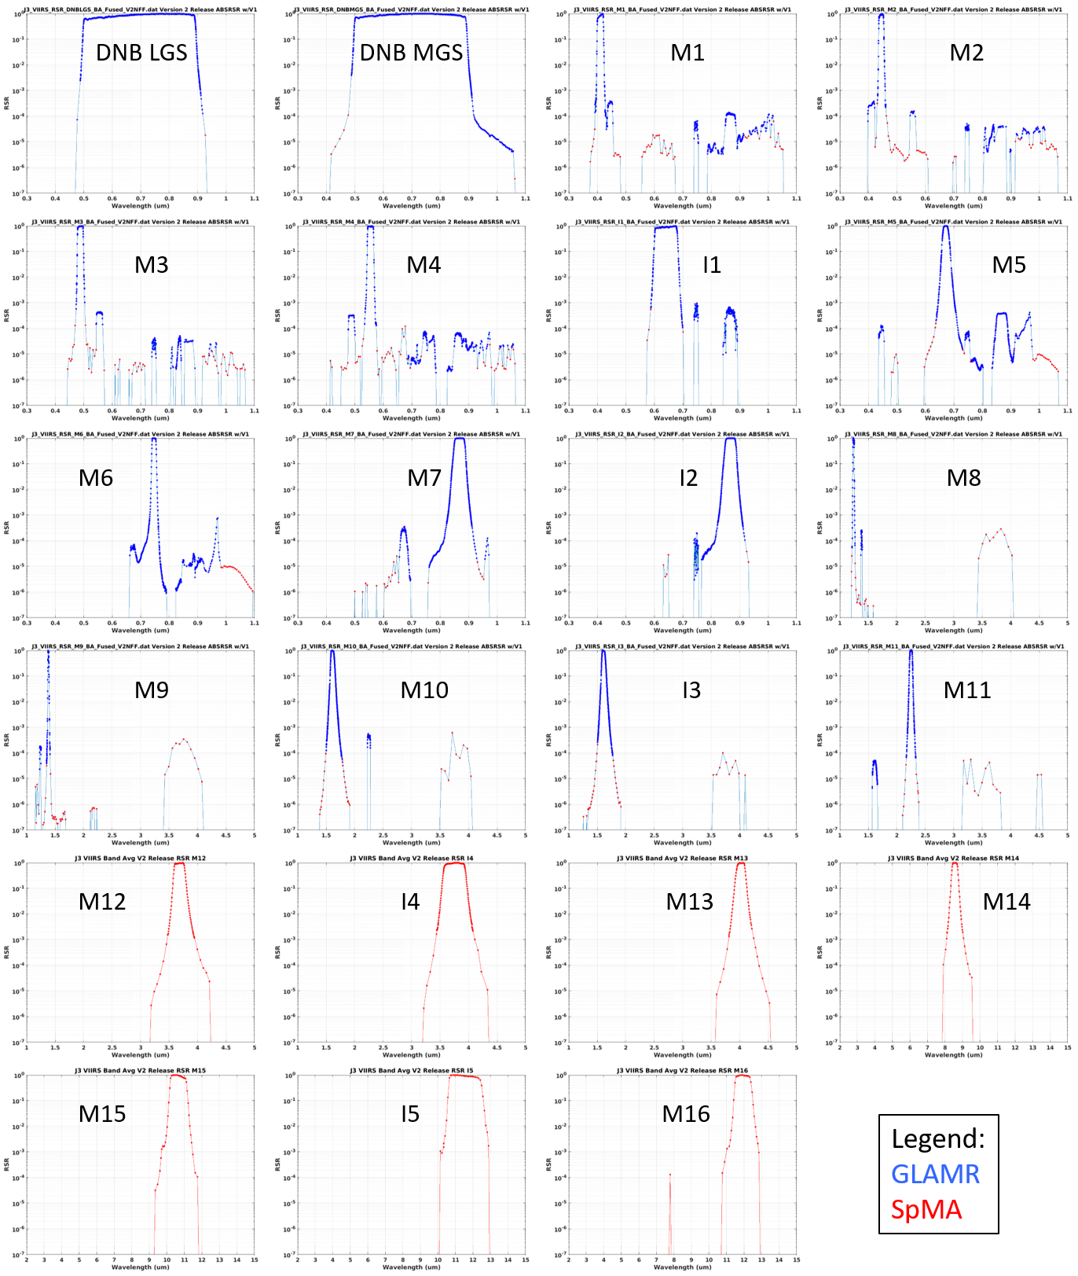

*Figure 2. J3 VIIRS V2 band-average RSR. Data separated into GLAMR-based (blue) and SpMA-based (red) contributions. For RSB (DNB, I1-I3, M1-M11), GLAMR-based response exclusively dominates the in-band high response zone and much of the out-of-band response zone while SpMA-based response supplements in low response zones. For TEB (I4, I5, M12-M16) only SpMA-based measurements were collected and thus the characterization is entirely provided by the SpMA.*

region that was beyond the 2.5µm limit of the GLAMR spectral coverage. For MWIR and LWIR bands, there is no GLAMR coverage and thus the entire spectral characterization for V2 is taken from SpMA measurements.

VIIRS out-of-band response includes optical filter leaks, electronic and optical crosstalk. Response that appears at the spectral position of another band on the same focal plane is often an electronic crosstalk response. For example, in Figure 2 band M1 shows an out-of-band response just to the right (~.43 - .46 µm) of the M1 in-band response. The spectral position (and shape) of this out-of-band response matches that of band M2. M1 also shows out-of-band response at the spectral positions of M6 and M7 as well. The band M2 plot in Figure 2 shows out-of-band electronic crosstalk response at the spectral positions of bands M1, M4, M6, and M7. Other VisNIR and SWIR bands show similar behavior. These electronic crosstalk responses can be either positive or negative domain responses, i.e. either contribute towards or detract from the measured on-orbit earth scene signal; however, for the purpose of Figure 2, negative electronic crosstalk is plotted as a positive value using an absolute value function. The official J3 VIIRS V2 RSR release files show negative electronic crosstalk response as a negative value.

A comparison of J3 and J2 VIIRS V2 RSR (Figure 3) shows generally close agreement between the sensors, not surprising since the design of the bandpass filters is the same for both sensors. In the in-band region (top panel) modest shape differences exist in bands M1, I1, M8, M16A/B and I5, largely due to a change in a single dichroic of the J3 optical system. In the out-of-band spectral region (bottom panel), most response features in J2 are replicated in J3 typically down to 10-4 and lower; however, in some cases, J3 appears to be able to resolve an out-of-band response that J2 could not, e.g. band M2 at 550 nm (M4 electronic crosstalk response) and band M5 at 450 nm (M2 electronic crosstalk response). It is highly likely that J2 VIIRS included these additional electronic crosstalk responses but they were unable to be resolved in the spectral measurements of the J2 test program. For the RSR of M16A and M16B, the J3 measurements did not capture the out-of-band filter leak that was found in J2 centered at about 8000 nm. Due to delays in the SpMA readiness, the M16A/B spectral measurements were collected during the Hot Plateau segment of the J3 VIIRS pre-launch test program, elevating the noise floor of the measurements to a point that the out-of-band feature near 8000 nm was masked by the noise. Some evidence of the leak is seen in J3 M16A and so it’s likely that this leak does in fact exist in J3; however, this leak in J2 did not cause a non-compliance on the MIOOB specification. Additionally, an elevated noise floor in band I5 may be masking out-of-band features below 10-3, though notably there were no out-of-band response features observed in J2 band I5. A significant increase (about an order of magnitude) in the response level of the 3500 - 4000 nm out-of-band feature of SWIR bands M8 – M11 and I3 is also evident in the J3 RSR of Figure 3. While noteworthy and of interest, the increase does not cause a non-compliance on the MIOOB specification (Table 1) of these bands and therefore is not expected to materially affect data quality.

While not presented in Figure 3, the J3 VIIRS V2 RSR also include an “M16” RSR, which is a linear average of the M16A and M16B RSR to represent response for the time delay integrated signal of M16A and M16B on-orbit. On-orbit nominal operations downlink the integrated M16 signal for inclusion in the SDR product.

Ambient atmospheric constituents attenuate the signal of band M9 (water vapor) and M13 (CO2) spectral measurements (Figure 4 left and right panels, resp.). This attenuation biases the response profile at absorbing wavelengths by depressing the signal at the VIIRS detector. For M9, a forward model (LBLRTM[8]) using real time (with the spectral measurements) atmospheric temperature and humidity measurements as input was used to estimate the transmittance at each wavelength. Attempts to use the model transmittance to correct the signal at all wavelengths resulted in over-correcting the water vapor influence at strong absorption wavelengths (blue in Figure 4 left panel). Instead, wavelengths where the transmittance exceeded 0.99 in the high response zone (response > 0.4), and 0.98 in the low response zone (response < 0.4) were corrected by the model and retained

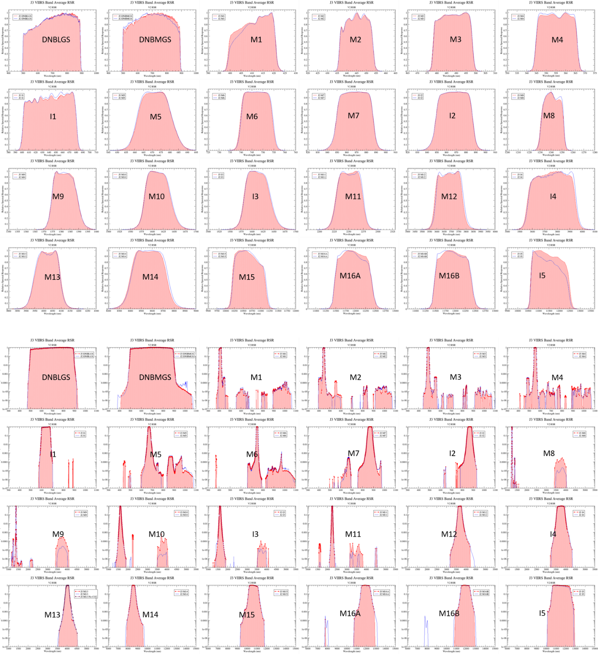

Figure 3. J3 VIIRS V2 RSR highlighting in-band (top section) and out-of-band region (lower section) for all bands measured during the pre-launch test program. Generally close spectral agreement is seen between the J3 (red shaded) and J2 RSR (blue) in the in-band region with only minor differences in shape (e.g. top section bands M1, I1, M8, M16A,B, I5) due to changes in an optical element for J3. Out-of-band response is also very similar in J2 and J3 with the exception of a significant increase in the feature centered near 4000 nm in J3 bands M8, M9, M10, I3, and M11.

for the M9 RSR. A similar strategy was used for processing the M9 spectral measurements for J2[5]. The resulting J3 RSR profile (red in Figure 4 left panel) is smooth and largely devoid of any water vapor influence and agrees closely with that of J2 M9 RSR (see M9 plot in Figure 3 top panel). For M13, no real time measurements of CO2 concentration were collected during VIIRS spectral measurements. A forward model transmittance estimate based upon a 700 ppm CO2 concentration was used to guide a minor correction of the CO2 influence in the 4200 – 4400 nm wing region. The resulting M13 RSR (blue in Figure 4 right panel) profile is largely devoid of any CO2 influence.

As mentioned previously, first time ever measurements of the DNB HGS spectral performance were collected for J3 VIIRS to confirm the expectation that the DNB MGS RSR is highly representative of the DNB HGS RSR. To accomplish this, special spectral measurements of the DNB HGA (DNB HGS consists of two redundant stages, HGA and HGB) were collected using GLAMR with finely tuned laser power to avoid saturation of the DNB HGA detectors. The resulting RSR (Figure 5) confirms that DNB MGS and DNB HGS RSR are a close match and thus it continues to be recommended that RSR from DNB MGS be used to represent DNB HGS for all VIIRS builds.

To evaluate the spectral impact on on-orbit observations, top-of-atmosphere (TOA) reflectances (for RSB) and brightness temperatures (for TEB) were simulated using forward model spectra for blue ocean, desert, grassland, and a tropical atmosphere. The simulated reflectances and brightness temperatures were compared to simulations using the J2 VIIRS V2 RSR (Figure 6). Differences in the J2 and J3 simulations are very small, less than 0.5% for all RSB and less than 0.10 K for all TEB except I5 which is slightly larger due the broader longwave shoulder of the J3 I5 RSR. These results are not surprising given the close agreement between J3 and J2 VIIRS RSR demonstrated in Figure 3.

**4. RSR UNCERTAINTY**

While an uncertainty analysis was not conducted expressly on the J3 RSR for this paper, previous evaluations of the J1 and J2 RSB RSR uncertainty have indicated typical GLAMR wavelength uncertainties of about 0.1 nm and response uncertainties at or below .001 response (at or below .0001 for VisNIR M bands)[5,9]. This translates to a relative uncertainty of about 0.1% or less for the in-band region of the RSR and about 10% in the lower response out-of-band region.

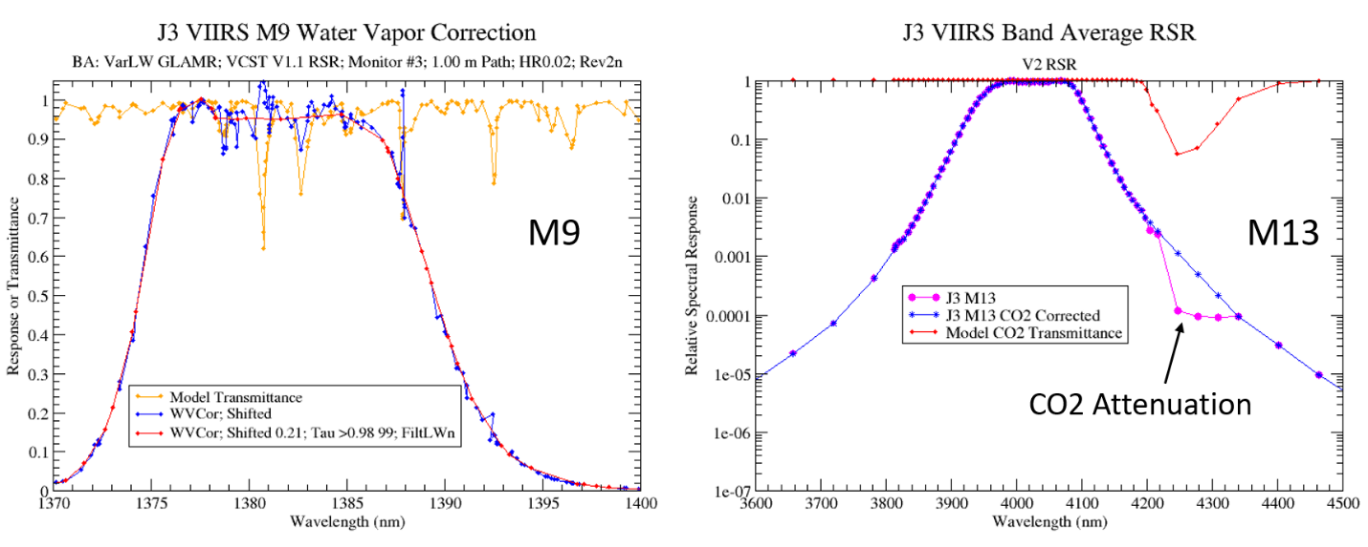

Figure 4. J3 VIIRS atmospheric correction of laboratory ambient water vapor influence on M9 (left) and CO2 influence on M13 (right) spectral measurements.

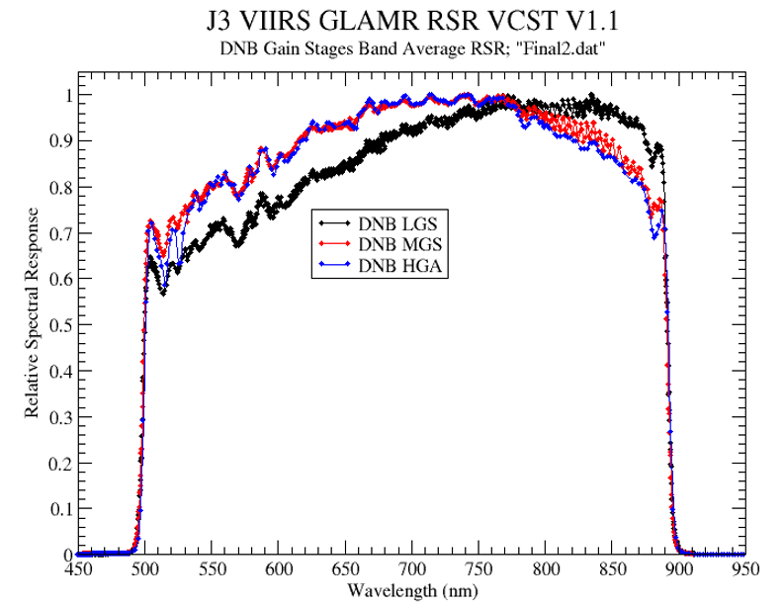

Figure 5. J3 VIIRS band-average RSR for DNB LGS (black), MGS (red), and HGA (blue) gain stages. The RSR profile of LGS, which uses an additional neutral density filter in the optical path, is set apart from MGS and HGA which are close matches to each other.

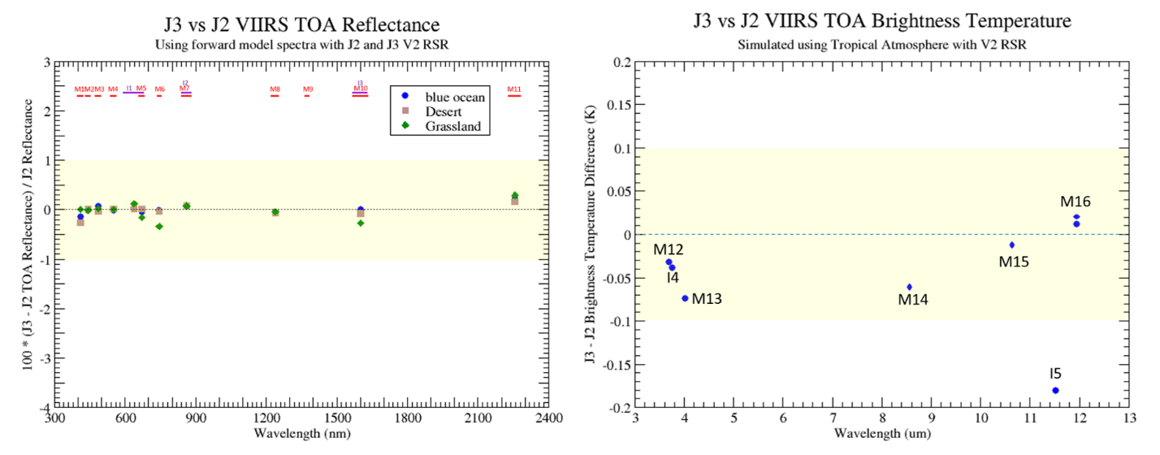

Figure 6. J3 and J2 top-of-atmosphere simulated reflectance (left) and brightness temperature (right) differences due to spectral differences between J3 and J2. J3 and J2 TOA reflectance differences are very small, within 0.5%. TOA brightness termperatures are also very close, within 0.1K for all bands except for band I5 which is slightly larger.

**5. SUMMARY**

This paper introduces the J3 VIIRS Version 2 “at-launch” RSR as retrieved by subject matter experts of the Government Team’s VIIRS DAWG. The characterization uses monochromator-based SpMA spectral measurements of all bands plus complimentary laser-based GLAMR spectral measurements for all RSB (out to 2500 nm) from the J3 VIIRS pre-launch test program. The analysis captures a high quality characterization in the high response in-band region plus response features typically down to 10-4 and lower (band I5 exception) caused by optical filter leaks or electronic/optical crosstalk in the out-of-band region. The J3 VIIRS spectral characterization is very similar to that of J2, not surprising since J2 and J3 used bandpass filters of the same design. A noteworthy difference is a significant increase of the out-of-band response at 3500 - 4000 nm in M8-M11 and I3. J3 VIIRS RSR are compliant on nearly all VIIRS spectral performance metrics with the exception of a minor non-compliance in band M14; note that all non-compliances have been allowed through waivers accepted by the Government Team. In addition to the baseline spectral measurements, the DNB HGS (represented by DNB HGA) stage spectral performance was also measured and found to agree closely with that of the DNB MGS spectral performance.

The J3 VIIRS V2 release package including the official band-average RSR used in the VIIRS SDR, EDR and L1B algorithms, supporting detector RSR, and documentation are available on the password-protected NASA Sharepoint. The V2 release will be undergoing review for public release before the launch of J3.

**6. ACKNOWLEDGEMENTS**

The authors wish to acknowledge the GSFC GLAMR team for their efforts to deploy GLAMR to the Raytheon El Segundo facility and make spectral measurements of VIIRS VisNIR and SWIR bands in December 2019. The authors specifically acknowledge the efforts of Brendan McAndrew for his role in the setup and measurement effort. The authors also acknowledge the VIIRS instrument team at Raytheon Space and Airborne Systems for their dedication to accomplishing a successful VIIRS pre-launch test program as well as their technical and logistical support of the GLAMR measurement effort. This work has been funded at the University of Wisconsin under NASA Grant 80NSSC19K1039.

**7. REFERENCES**

[1] Murphy, R. P., P. E. Ardanuy, F. De Luccia, J. E. Clement, and C. Schueler, “The visible infrared imaging radiometer suite”, in Earth Science Satellite Remote Sensing, Vol. 1, pp. 199-223, Springer-Verlag: New York, USA (2006).

[2] Xiong, X., N. Che, and W. Barnes, "Terra MODIS On-Orbit Spectral Characterization and Performance", IEEE Trans. Geosci. Remote Sens. 44 (8), pp. 2198-2206, (2006).

[3] McAndrew, B., McCorkel, J., Shuman, T., Zukowski, B., Traore, A., Rodriguez, M., Brown, S.W., Woodward, J., “Goddard Laser for Absolute Measurement of Radiance for Instrument Calibration in the Ultraviolet to Short Wave Infrared,” Conference on Lasers and Electro-Optics, OSA Technical Digest (online), paper AF3M.6, (2018).

[4] Schwarting, T., C. Moeller, D. Moyer, J. McIntire, H. Oudrari, and X. Xiong, "JPSS-2 VIIRS Version 1 spectral characterization and performance assessment", Proc. SPIE Vol. 11127, 111270C, doi:10.1117/12.2530097, (2019).

[5] Moeller, C., T. Schwarting, J. McCorkel, D. Moyer, and J. McIntire "The JPSS-2 VIIRS version 2 at-launch relative spectral response characterization", Proc. SPIE 11127, 111270D, doi:10.1117/12.2530022, (2019).

[6] Ping-Shine Shaw and Zhigang Li, "On the fluorescence from integrating spheres," Appl. Opt. **47**, 3962-3967 (2008).

[7] Barsi, J. A., J. T. McCorkel, B. McAndrew, T. Shuman, A. B. Sushkov, M. R. Rodriguez, N. G. Reed "Spectral and radiometric performance of the Goddard Laser for Absolute Measurement of Radiance". Accepted for presentation at the Earth Observing Systems XXVIII, conference No. 12685, (2023).

[8] Clough, S. A., M. W. Shephard, E. J. Mlawer, J. S. Delamere, M. J. Iacono, K. Cady-Pereira, S. Boukabara, and P. D. Brown, “Atmospheric radiative transfer modeling: a summary of the AER codes”, Short Communication: J. Quant. Spectrosc. Radiat. Transfer, 91, 233-244, (2005).

[9] Moeller, C., T. Schwarting, J. McIntire, D. Moyer, and J. Zheng “JPSS-1 VIIRS version 2 at-launch relative spectral response characterization and performance”, *Proc. SPIE*9972, Earth Observing Systems XXI, 997203 (September 19, 2016); doi: 10.1117/12.2238050, (2016).

1. 1[chris.moeller@ssec.wisc.edu](mailto:chris.moeller@ssec.wisc.edu), 608–263-7494, 608–262-5974 (FAX), [thomas.schwarting@ssaihq.com](mailto:thomas.schwarting@ssaihq.com), [david.i.moyer@aero.org](mailto:david.i.moyer@aero.org), julia.a.barsi@nasa.gov