NASA’s compact High-efficiency Rotating Detonation Rocket Engine for Mars Interplanetary Missions
(Preprint) AAS XX-XXX
Thomas Teasley, Dillon Petty, Shawn Skinner, and Joseph Hernandez-McCloskey
NASA Marshall Space Flight Center, Huntsville, AL, 35808, United States
NASA has successfully test fired a novel and compact liquid propulsion system known as a Rotating Detonation Rocket Engine. This is a specially designed ring-shaped thrust chamber that leverages additive manufacturing techniques and novel alloys such as GRCop-42 and GRX-810. The extreme combustion event, known as a detonation, reduces the combustion chamber length requirements down to a few inches while equivalent constant pressure rocket thrust chambers are on the order of feet. This is primarily due to rapid completion of combustion by the high-pressure detonation, an order of magnitude faster than deflagration combustion. In addition, the ring shape allows for rapid expansion of the combustion products. Depending on the thrust class and design supersonic area ratio, the full RDRE can be anywhere from 10% to 50% shorter than a traditional liquid rocket assuming the same exit diameter but is dependent on a number of design assumptions. This may enable substantial mass savings, cost savings, and broader design trade space for various mission architectures. Finally, the engine system has potential for higher Isp at identical average chamber pressure, which is currently being assessed by NASA. Experimental data obtained from testing in 2022 identified the feasibility of the novel propulsion system while multiple test series scheduled throughout 2023 and 2024 target closing the remaining critical technical gaps preventing widespread use of the technology amongst industry.
Introduction
NASA seeks to invest in critical technologies for space flight, exploration, habitation, and the growth of knowledge and understanding of the universe. One technology area specific to Marshall Space Flight Center’s heritage is the liquid rocket engine. NASA engineers have identified that future cislunar and Moon to Mars missions will require radical improvements in propulsive efficiency. As such, the rotating detonation rocket engine (RDRE) was identified as a near term propulsion platform for rapid advancement towards a practical technology readiness level (TRL) for use in space missions.
This manuscript gives an overview of NASA RDRE technology maturation projects, their near-term milestones, and future goals. Each of these projects have been or will be conducted with a qualified industry or academic partner to close critical technology gaps preventing the engine system from widespread use in the space economy. A first order analysis of length trades, considerations for integrating design for additive manufacturing techniques, and critical diagnostics development is also overviewed.
NASA Technology Development to Date and Applications
The following sub-sections give an overview of the RDRE development work conducted in collaboration with NASA MSFC and GRC. Future technology maturation projects are also discussed in addition to other planned but unfunded work needed to advance the TRL.
Feasibility of Integrating Additive GRCop-Alloys for Long Duration Hot Fire
NASA’s first dual-regeneratively cooled RDRE was fired during the summer of 2022 in two phases. Phase 1 utilized gaseous hydrogen and liquid oxygen, and phase 2 utilized regenerative methane and direct-injection liquid oxygen, as well as direct-injection liquid methane and liquid oxygen. All hardware was water cooled or methane regeneratively cooled and is outlined in greater detail in another manuscript. ¹ This work was primarily a feasibility study aiming to demonstrate the integration of additive manufacturing techniques and novel alloys such as GRCop-42, scaling up the engine system to high thrust class (5K-7K lbf), and demonstrating hardware survival at flight-realistic durations of 100 seconds or greater. NASA partnered with IN Space LLC and Purdue University, integrating their significant RDRE thrust chamber and injector design experience with NASA’s manufacturing and regenerative channel design experience. This work was funded by a Space Technology Mission Directorate (STMD) announcement for collaborative opportunity (ACO) award. Figure 1 is an image of a successful test firing using regenerative LCH₄ and direct injection LOx and 5 co-rotating waves observed during this test. However, modal transitions to 4 waves and clockwise to counterclockwise propagation were also observed.
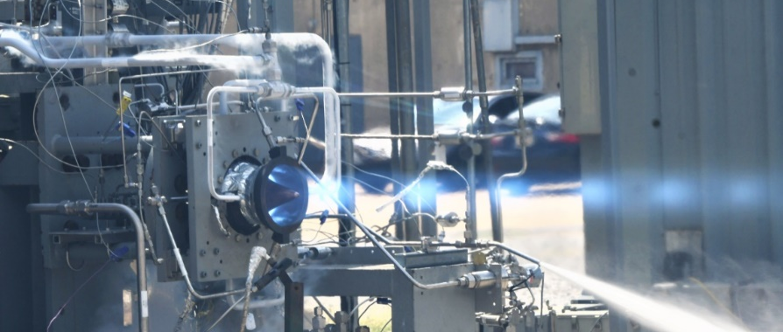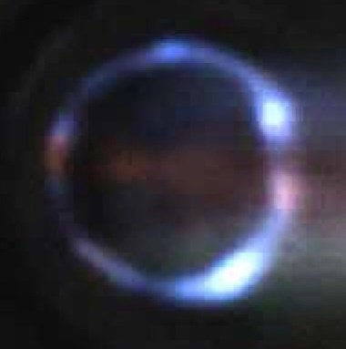
Figure 1. NASA / IN Space LLC 7K lbf regenerative RDRE test firing and clockwise 5-wave co-rotating mode.
These transitions appeared to have no impact on other performance metrics such as mean total pressure, thrust, and heat load which is consistent with some works in the open literature ^{2–4} and in contrast to others.⁵ Further work is needed to better understand the coupling of engine performances with operating wave mode. This is particularly the case with regenerative chamber configurations that have scarcely been explored.
Furthermore, the use of GH₂/LOx direct injection was investigated with a test firing shown in Figure 2. In all conditions tested, the combustion appeared to be only deflagrative in nature with what appeared to be predominantly acoustic modes and flame holding dominating the flow field. An example of this is shown in Figure 2.
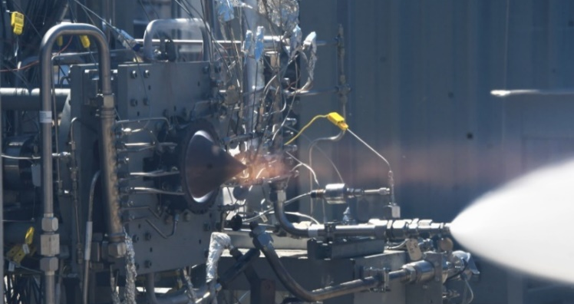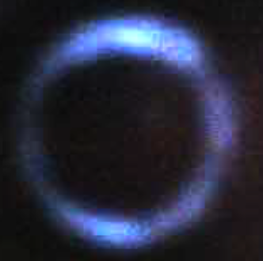
Figure 2. NASA / IN Space LLC 5K lbf actively cooled calorimetry RDRE test firing and counter-propagating acoustic modes and flame holding.
Even though deflagration dominated the flow field, an equivalent C* indicated near perfect completion of combustion in all cases. This is highly encouraging since the chamber L’ was only 2.74 inches. A comparable liquid rocket thrust chamber would have an L’ of about 12-16 inches. While it is not known or well understood how completion of combustion was so high without the presence of detonations, it does give high confidence in the use of hydrogen/oxygen propellant in an annular combustion chamber. The net benefits in reduced L' requirements are rather substantial and means the length advantages of the RDRE geometry will apply, even without detonations. Lastly, even though detonation was not observed the heat absorbed by the chamber walls was found to be substantially higher than what the predicted heat transfer⁶ would have been with deflagration combustion alone. This suggests that either non-observable detonations were present, or the annular combustion chamber is superior to the cylindrical chamber and De’Laval nozzle for heat release.
Closing of Major Technology Gaps
Follow-on work was sought to close the remaining critical technology gaps preventing the engine system from broad development within the US towards flight applications. This 2-year award from NASA STMD was selected in partnership with Venus Aerospace. Venus contributed their broad design experience for unique additive components, post processing of additive components, and requirements for future flight applications. The NASA team simultaneously incorporated major lessons learned from testing, employed regenerative channel design experience, and developed methods for use of liquid oxygen as a coolant.
Summer of 2023, NASA conducted hot fire testing of its 10,000 lbf (Vac) RDRE to assess engine performances. The remaining limiting technology gaps are identified in Table 1.
Table 1. Critical technology gaps requiring closure.
Parameter | Quantification
Reduced Injection Pressures | ΔP < 500 psid
Integrated Ignition | > 10 stable starts without hardware damage
Self-sustained cooling | No reliance on water coolant, only propellant
Hardware Duty Cycle | > 500 seconds cumulative duration
Thrust | > 5,000 lbf (SL) to assess dynamic stability
Figure 3 shows the 12th successful test of the V3 RDRE which achieved a 251 second burn with no hardware related issues. In total, the following critical technology gaps have been demonstrated.
- 14 stable starts were achieved.
- Only liquid methane and liquid oxygen were used as regenerative coolant.
- A total of 680 seconds cumulative duration was achieved.
- Thrust in excess of 5800 lbf was achieved in atmosphere.
The only remaining performance parameter left to close is demonstrating reduced injection pressure drop requirements.
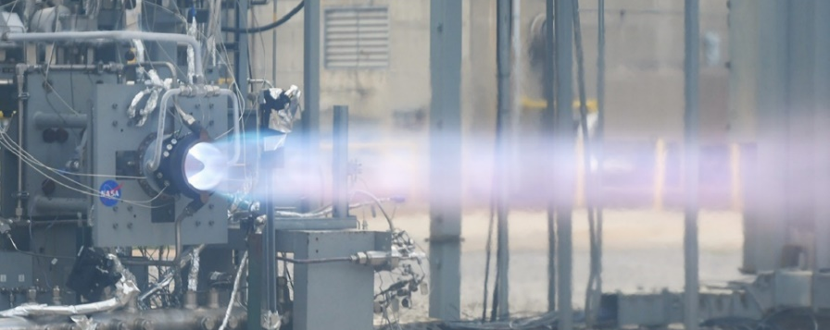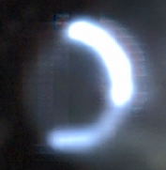
Figure 3. NASA 10K lbf dual regenerative RDRE 251 second test firing and clockwise single-wave mode.
Similar to the ACO work completed in 2022, the use of additive manufacturing and GRCop-42 were essential for survival of hardware in the extreme environment conditions. An example of laser powder bed fusion (L-PBF) GRCop-42 hardware is shown in Figure 4. Furthermore, other alloys under development have been found to be critical for meeting higher strength and reduced mass requirements of next-generation components. GRX-810, a Nickel-Cobalt-Chromium alloy, has proven to be incredibly resilient for use in extreme heat flux environments, particularly for use with injector and nozzle extension subcomponents.⁷ An example of a NASA RP/LOx RDRE injector produced using L-PBF GRX-810 is shown in Figure 4.
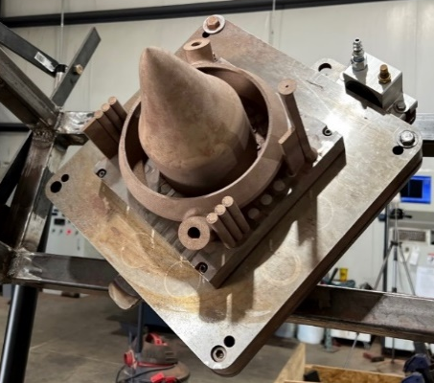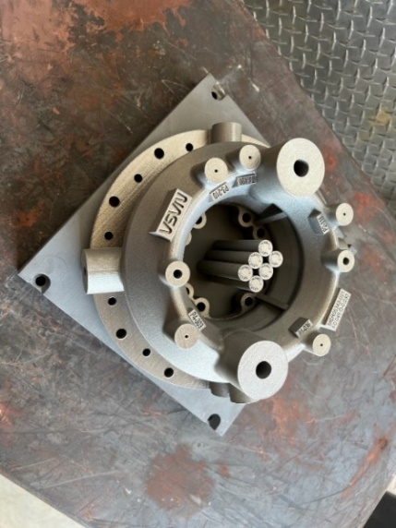
Figure 4. AM L-PBF GRCop-42 inner body and outer body manifold (left) and GRX-810 injector (right).
The use of GRX-810 was found to be necessary for nozzle extensions. The extreme dynamic environment and heat fluxes experienced at the nozzle extension required the use of a high strength alloy capable of both convective and radiative heat rejection at elevated wall temperature. In addition, the build angle limitations of GRCop-42 (typically < 35 degrees overhangs)^{8,9} are less than the nozzle expansion half angle limitation for vacuum nozzle extensions. This is typically closer to a 40-50 degree overhang. Similar to other super alloys like Inconel 625 and 718,¹⁰ GRX-810 can be built up to an overhang angle of about 45 degrees. This is a major advantage alone for the production of high area ratio nozzle extensions. Figure 5 shows a still image of an infrared video of the RDRE stub nozzle extension with an even more extreme expansion angle than the initial 35 degree shroud. This demonstrates the feasibility of attaching a truncated nozzle extension to high area ratio without flow separation on the wall, like the rendering shown in Figure 5.
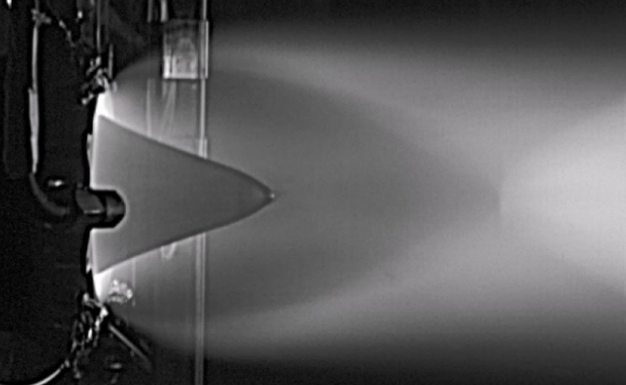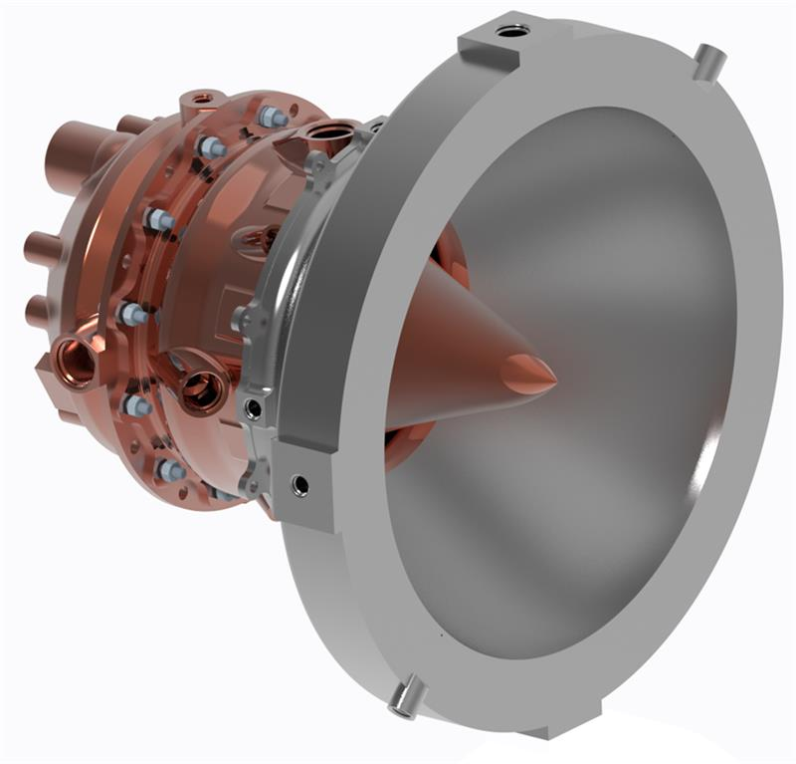
Figure 5. Infrared imaging of NASA 10K RDRE plume without outer shroud nozzle and candidate design with GRX-810 high area ratio nozzle extension.
Further hot fire testing is planned for early 2024 with LH₂/LOx and RP/LOx to evaluate scalability to different propellants and inherent performance advantages. In addition, novel modeling activities will be conducted to identify structural limitations in the hardware design and continue to develop thermal models for integrated coolant channels.
Demonstrating Staged Combustion Cycle Feasibility
Considerations for cycle trades have become a necessity as the engine system matures. The ability to integrate turbomachinery and operate in a steady state condition will be needed for space applications. One cycle of interest is the oxygen-rich staged combustion (ORSC) cycle. Put simply, oxygen and a small proportion of fuel is pre-burned to drive the main pump turbine. This cycle is only limited by the turbine and pre-burner material temperature limits and efficiencies. However, a major concern for this cycle is the injection temperature of pre-combusted gases. It is traditionally thought that if high temperature propellant was injected, flame holding would dominate due to a reduced ignition delay and all performance advantages of the RDRE would be lost. A significant amount of work has been conducted towards estimating the ignition delay of various propellants as a function of temperature in addition to determining its impact on RDRE performances.^{11–17}
For this reason, an experimental feasibility study assessing the viability of RP/GOx rich staged combustion was conducted in partnership with Purdue University. This work was sponsored by a Center Innovation Fund (CIF) grant where researchers at Purdue University in collaboration with NASA engineers successfully demonstrated wave activity, hardware survivability, and high-performance metrics using pre-burned oxygen-rich injection within an RDRE. Details of this work have been published ¹⁸. Figure 6 shows a single hot fire with a characteristic blue/purple plume.
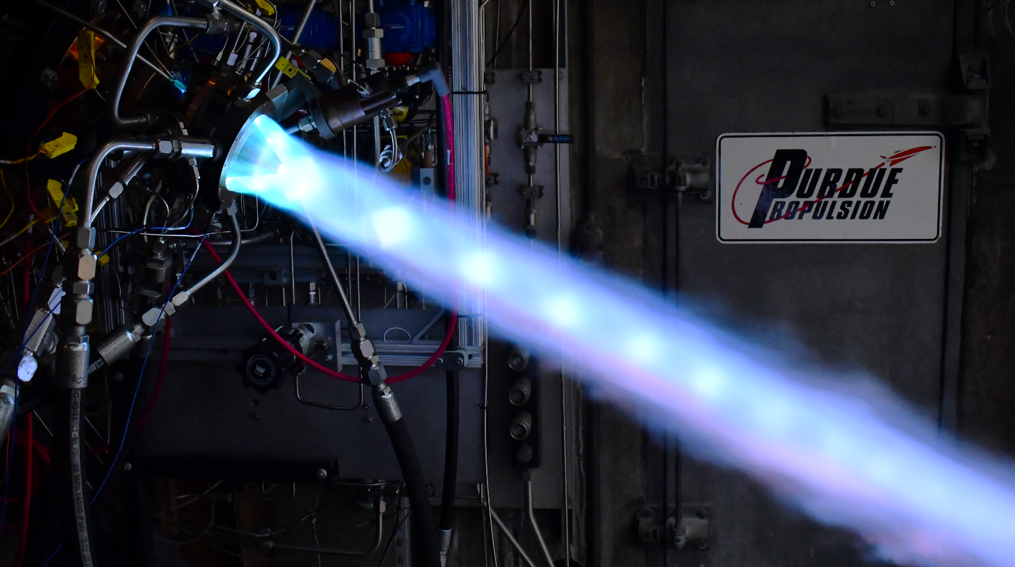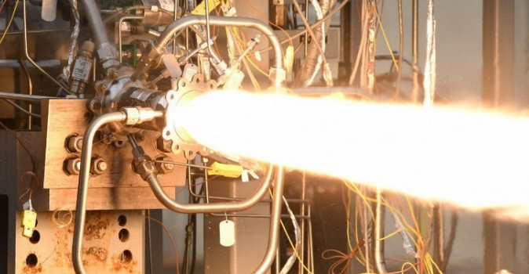
Figure 6. Purdue University / NASA RP/GOx rich staged combustion RDRE ¹⁸ test firing and test firing of NASA/Virgin Orbit constant pressure RP/LOx additively manufactured thrust chamber.¹⁹
Typically, RP/Ox plumes are characterized by bright yellow flames representative of carbon or soot formation in the exhaust. The deep blue/purple plume is caused by a reduction in combustion time scale which effectively prevents soot formation and thus produces emission of higher wavelengths associated primarily with flame chemiluminescence. It is thought that this is an indication of higher combustion efficiency and potentially heat release.
This work leveraged the findings of previous collaborations to design hardware using L-PBF GRCop-42, examples of hardware tested are shown in Figure 7. In addition, all hardware was water cooled to obtain critical heat transfer data for future NASA RP/LOx testing. Several major findings have been documented and will be published in future articles in detail. Some of those findings include:
- High completion of combustion > 80% constant pressure assumed characteristic exhaust velocity in a chamber with an L’ of only 1.75 inches.
- Wave activity at elevated injection temperatures and reduced combustion potential energy.
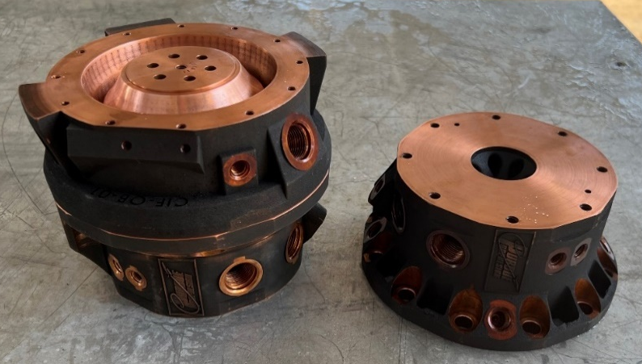
Figure 7. AM L-PBF GRCop-42 chambers and injectors.
Details of this test campaign will be documented and presented at appropriate forums. Two primary studies have been identified from this work that the broader community will need to investigate prior to elevation of RDRE staged combustion cycle TRL.
- The global impact on detonability for propellants with reduced and elevated temperature. Fuels and oxidizers of interest along with injection temperature and phase may include those listed in Table 2.
- The global impact of pre-burned (deflagrated) propellants and thus reduced percentage of chemical energy available for detonation.
Table 2. Propellant and injection temperature range of interest with phase and application.
Propellant | Injection Temperature Range (F) | Phase / Application
Oxygen | -275 to 1300 | Liquid to Pre-burned
Hydrogen | -300 to 1300 | Conditioned to Pre-burned
Methane | -100 to 1300 | Conditioned to Pre-burned
Kerosene | Ambient to 1300 | Liquid to Pre-burned
>90% H₂0₂ | Ambient to 500 | Liquid to Decomposed

These two studies imply the use of an experimental setup or CFD model capable of generating wave-based combustion in a broad operating range. Average chamber total pressure will need to exceed that of 100 psia to obtain meaningful data.
Scalability and Cost-Effective Parameterization
It has become apparent that rapid design iteration in a cost-effective platform is needed to better understand how to yield the highest possible performances. For this reason, a subscale 2” research RDRE was developed and tested. An image of a 3-second hot fire is shown in Figure 8.
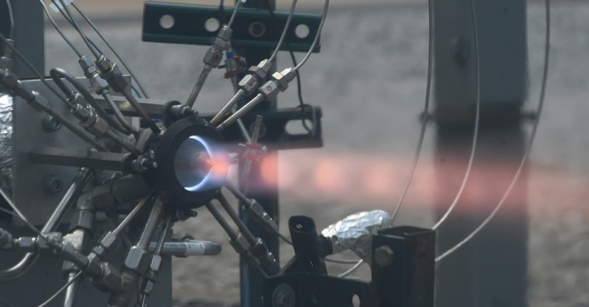
Figure 8. Test firing of NASA subscale 2” 1K lbf thruster RDRE with clockwise 2-wave co-rotating mode.
This design was water cooled and parametric where the injector, inner body/plug nozzle, outer body, and outer shroud nozzle were interchangeable to investigate design variable effects on performance. The combustor L’ was 1 inch and still showed detonation activity; up to 2 co-rotating waves were present. However, many cases with high contraction ratios yielded counter-propagating modes and performance was not consistent from test to test. This result is consistent with previous works. Conversely, the C* performance was computed to be as high as 85% of theoretical limits assuming constant pressure combustion. For a chamber only 1 inch in L’ and at average pressures below 200 psia, this is an extremely high relative percentage of complete combustion. It is likely that the annular chamber was too short relative to its gap width to obtain peak performance.
In addition to parametric interchangeability of parts, this platform can be used to assess material performances. An image of GRX-810 components during the depowdering process are shown in Figure 9.
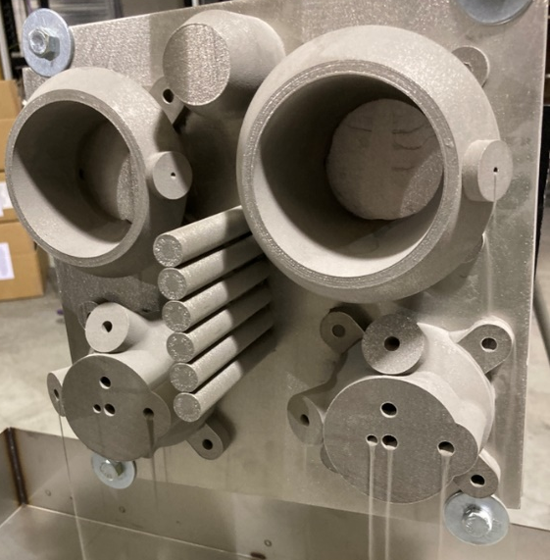
Figure 9. GRX-810 subscale RDRE components during depowdering.
Throughout all test conditions, the GRX-810 injectors and nozzles survived proving to be a viable material for RDRE component development.
Future Test Objectives and Technology Maturation
Several test campaigns are anticipated throughout 2024 with new and previously tested hardware. Each has a specific goal for technology maturation to provide critical data to industry. The first is phase 2 testing of the 2” NASA hardware. This campaign has several high priority goals using GCH4/GOx including:
- Identify the impact of injection stiffness magnitude at and below the choked criteria, at varying stiffness ratios, with varying impingement distance from the injector face, with different annulus L’, and with varying element density and total mass flux.
- Identify the impact of combustor L’ and L* on computed C* relative to constant pressure theory. In addition, obtain a better understanding of time-averaged total and static pressure losses and gains throughout the annular geometry.
- Assess nozzle extension design parameters and their impact on thrust chamber specific impulse including nozzle exit half angle and nozzle extension length.
- Assess trends in total heat load and heat flux as a function of operating conditions and hardware configuration.
These data will directly inform the scalability and optimal design practices for the engine system. A preliminary CAD mockup of anticipated V3 hardware is shown in Figure 10.
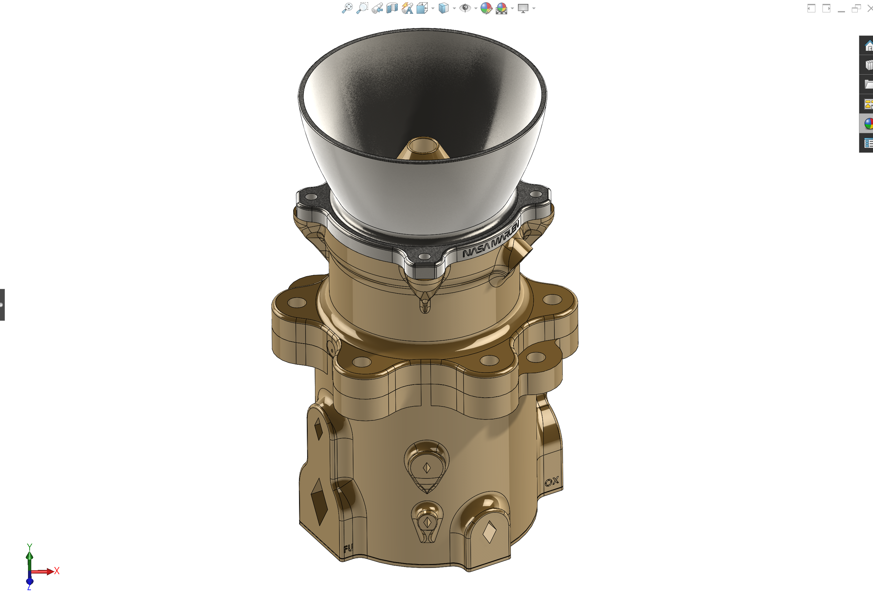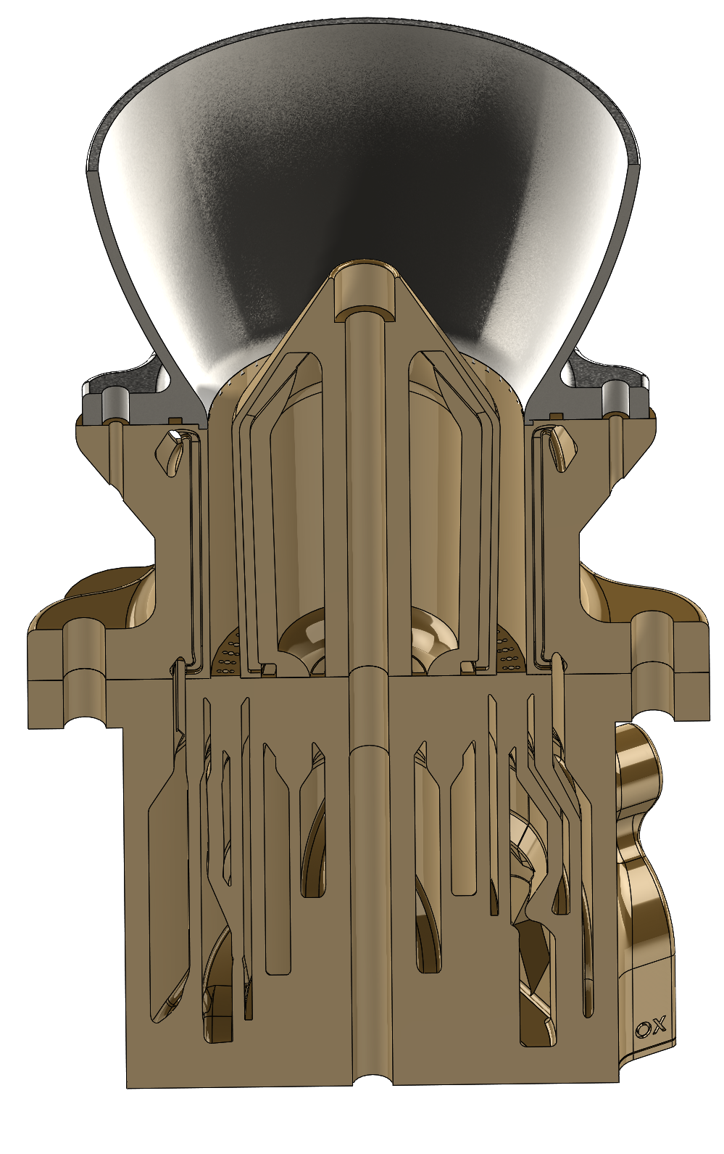
Figure 10. NASA V3 Subscale 2” water-cooled RDRE.
Further evaluation of the NASA 10K lbf hardware will be conducted with LH₂/LOx in a dual regenerative configuration. The primary objective of this test campaign is to assess the feasibility of hydrogen/oxygen detonability at low injection temperatures and with a more optimized injection scheme. H₂/Ox detonability has previously been shown to be feasible ¹³. However, the observation of detonations may require the use of a seed fuel to allow for emission in the visible light spectra since H₂ combustion primarily emits in the UV. This may be the reason no waves were observed under previous NASA hydrogen testing. In addition, further assessment of a more flight like regenerative configuration coupled with reduced ignition delay/injection temperatures will help to evaluate the feasibility of using hydrogen as a viable RDRE fuel.
Immediately following the hydrogen test phase, NASA will evaluate RP/LOx direct injection using previous calorimetry hardware and new hardware. These data will be used to establish a baseline of what to expect for heat flux trends with kerosene as a fuel. Those trends can then be correlated with existing scaling functions and channel design models for use by industry. Finally, a comparative study was conducted where an equivalent constant pressure thrust chamber was fired with a GRX-810 nozzle extension matching flow rates, mixture ratio, throat area, injection flow area, nozzle exit half angle, and nozzle exit area. An example test firing and GRX-810 nozzle extension are shown in Figure 11. The measured performances of the thrust chamber assembly (TCA) were comparable to previous hot fire test data at the same scale with typical efficiencies and loss terms. The second phase of methane RDRE testing will occur in mid-2024 for direct comparison to these thrust chamber performances and lend further credibility to the technology.
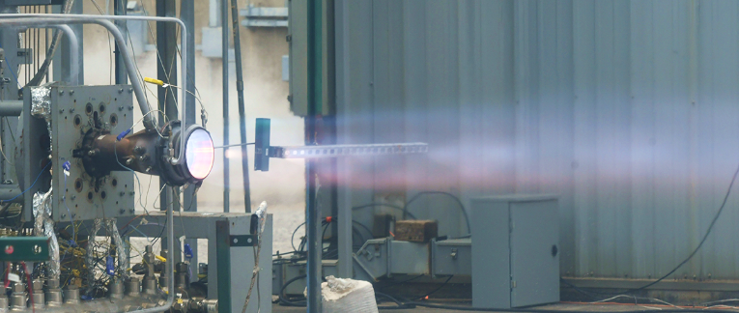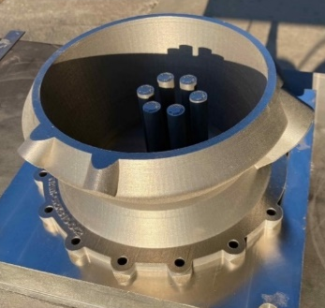
Figure 11. Hot fire demonstration of equivalent constant pressure TCA.
In addition to the comparative performance study, the GRX-810 nozzle was an early feasibility test to demonstrate the use of the new alloy in a relevant environment. This was mainly a risk reduction activity prior to investment and development for testing with an RDRE. It was initially planned that a high area ratio (supersonic area ratio of approximately 40) truncated ideal nozzle (TIC) would be manufactured using NASA HR-1 with the directed energy deposition (DED) process. However, due to future NASA power balance model requirements in addition to reduced length requirements of the nozzle extension, GRX-810 powder bed fusion has become a primary focus of demonstration with the technology. The survivability of GRX-810 proved to be superior to other super-alloys and is a high priority for the technology in the near term.
To further describe the length advantage of the RDRE annular geometry, Figure 12 gives a direct comparison of truncated ideal contours (TIC) for an equivalent thrust and exit area RDRE versus traditional liquid rocket.
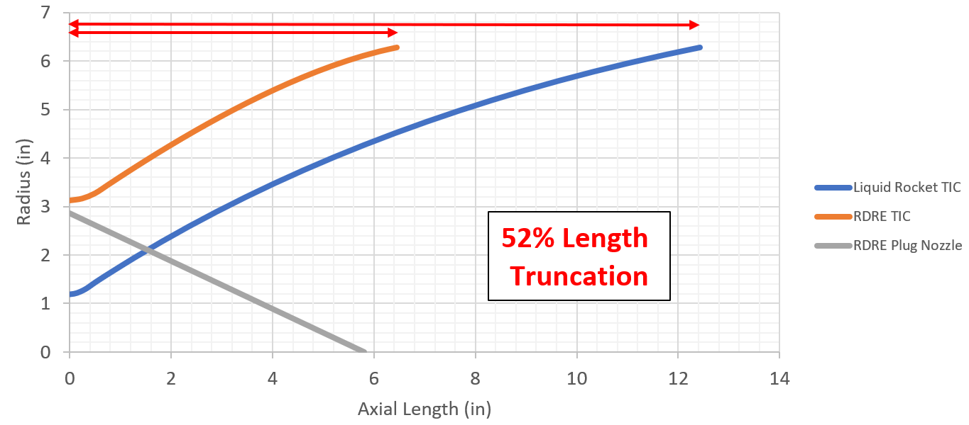
Figure 12. Truncated ideal nozzle contours for traditional liquid rocket engine and comparable RDRE.
It is apparent right away that the outer nozzle for the RDRE gives a 52% reduction in overall nozzle length at the same exit diameter and throat area. The RDRE outer nozzle contour is about 6.2 inches in length relative to the liquid rocket nozzle’s 12.2 inches in length. Including a main chamber stub nozzle extension, the RDRE nozzle would only be approximately 4-5 inches long. Thus, powder bed fusion would be a far more practical manufacturing process in terms of cost and schedule compared to DED at this scale.
Similar to nozzle length savings, the thrust chamber also demonstrates a significant length advantage. The RDRE fired in 2022¹ had an L’ of only 3 inches with computed scaled C* values in the 90-100% range of theoretical constant pressure combustion efficiency. A similar scale liquid rocket would have to have an L’ of 12-16 inches and a subsonic area ratio of 2.5 or greater to achieve the same combustion efficiency. This is a staggering improvement in combustion efficiency and represents a major step forward for rocket propulsion system technology. The following section will give a more in-depth analysis of thrust chamber scalability and nozzle length trades.
Thrust Chamber Scalability and Length Trades
The majority of the work conducted to date has focused on thruster and lander scales predominantly out of a need for cost effective parameterization of hardware and NASA test position availability. These scales are not driven by an immediate NASA mission need. Once desirable hardware design trades have been identified in the 100 lbf – 10,000 lbf range, then scaling relations and design rules of thumb can be derived for industry to utilize at any scale of interest. Ultimately design scalability is the goal for all of industry to employ at any thrust class and with any propellant. For NASA’s envisioned Moon to Mars mission architectures a wide range of thrust classes will be needed. Power balance trade studies have looked at engine scales from thrusters, 100 lbf, interplanetary scales up to 250,000 lbf. It is the intent of this work to give the reader a better idea of scale benefits for specific applications. It is also the goal of NASA to enable industry with the tools and data needed to assess which thrust class makes the most sense for a given business model, mission, or application.
Applications and Potential Performance Benefits
To visualize the length benefits of the RDRE, a first order analysis was conducted to approximate and compare the TCA contour with a constant pressure (CP) engine of the same thrust class. Three different thrust classes were selected for comparison including 10K, 25K, and 500K lbf. At each thrust class, the throat area and supersonic area ratio were held constant. High supersonic area ratio nozzles were included since in-space operation is a major environment of interest for NASA.
As mentioned above, the detonation event allows the combustion chamber to be far shorter relative to a constant pressure thrust chamber. However, differences in thrust classes may show differences in length gains. Furthermore, current knowledge of scaling requirements may be limited due to a dearth in knowledge of RDRE design requirements. The CP chamber and nozzle contours were calculated using standard L* recommendations ⁶. The converging part of the combustor was approximated assuming sharp corners and a constant converging angle of 35°. Table 1 and Table 3 below shows the resulting combustor lengths for each thrust class, and the resulting contours can be visualized in Figure 13.
Table 3. L' Calculation for RDRE combustors.
Thrust Class | 10K | 25K | 500K
Equivalent Throat Diameter (in) | 2.5 | 5.0 | 10.0
Gap/OD ratio | 0.0528 | 0.0528 | 0.0528
Annulus OD (in) | 5.55 | 11.10 | 22.36
Annulus ID (in) | 4.96 | 9.91 | 20.00
Gap (in) | 0.30 | 0.59 | 1.18
L' (in) | 2.97 | 5.95 | 11.81

Table 4. L' calculation for constant pressure combustors.
Thrust Class | 10K | 25K | 500K
Throat Diameter (in) | 2.5 | 5.0 | 10.0
L* (in) | 45 | 45 | 45
Ac/At | 4 | 4 | 4
Dc (in) | 3.95 | 7.85 | 15.81
Converging angle (deg) | 35 | 35 | 35
L' (in) | 16.9 | 15.9 | 13.7
For the RDRE gap width calculation, the gap width to outer diameter ratio was held constant at a value of 0.0528. This was taken from the RDRE geometry tested in 2022, which was notably high performing in C*. It is likely that this ratio does not completely reflect scalability in high-performance metrics, and that the actual ideal gap to outer diameter ratio is related to the resulting wave spacing. In a 2017 study on RDRE scalability, Bykovksii showed that for the same gap width and flow conditions, increasing the combustor’s circumference increased the number of waves, but the wave spacing remained the same ²⁰. However, this assumption is sufficient for a first order analysis of scaling with thrust class. Also, for the same injection conditions increasing the gap width will change the wave speed and impact the number of waves in the combustor. This has been observed in NASA RDRE hardware. More work is required to better understand these relationships, but future designs may target a specific wave spacing as opposed to a specific number of waves. An additional design parameter not covered in this study is varying the gap width of the combustor. Instead of using a straight annulus like the contours investigated below, the designer can apply a subsonic area ratio to change the throat hydraulic diameter.
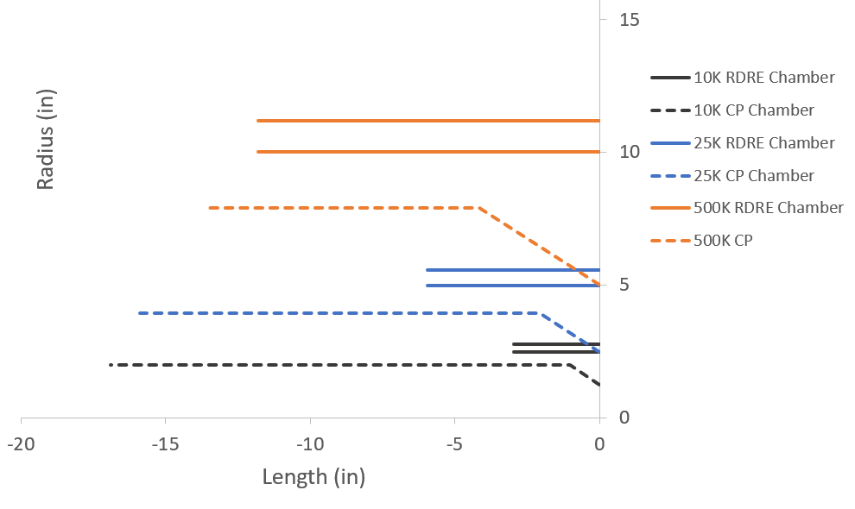
Figure 13. CP vs. RDRE thrust chamber contours for 10K, 25K, and 500K thrust class.
In Figure 13, the combustor length reduction is significant at the 10K and 25K lbf thrust classes but diminishes to a marginal improvement at the 500K lbf class. The reduced length is so drastic for the lower thrust class geometries that at the system-level it may become a design challenge to incorporate turbomachinery. For example, a turbopump is usually mounted parallel with the TCA axis of thrust and can be approximately the same length as the TCA. However, this may not be possible since the RDRE TCAs are now an order of magnitude shorter than the turbopump assemblies. A major technology application for the RDRE may be hypersonics, specifically the rocket based combined cycle (RBCC). This is an area of interest that will need further investigation.
In addition to the combustor length benefits resulting from the detonation cycle, the annular geometry shows additional benefits when a nozzle analysis is conducted. For all three thrust classes, a nozzle contour was developed using a modified Rao method to generate a parabolic contour. Both the RDRE and CP nozzles assumed an 80%-length truncated bell with a 35° initial angle and a 7° exit angle. The RDRE plug nozzle was approximated as a 30° cone. The RDRE reaches its desired expansion ratio at a reduced length compared to the CP nozzle. The RDRE outer body diameter is larger than the throat diameter of the CP combustor and thus has a "head start” for expansion. Figure 14, Figure 15, and Figure 16 show the resulting contours for the 10K, 25K and 500K thrust classes, respectively, with 0 indicating the combustor throat.
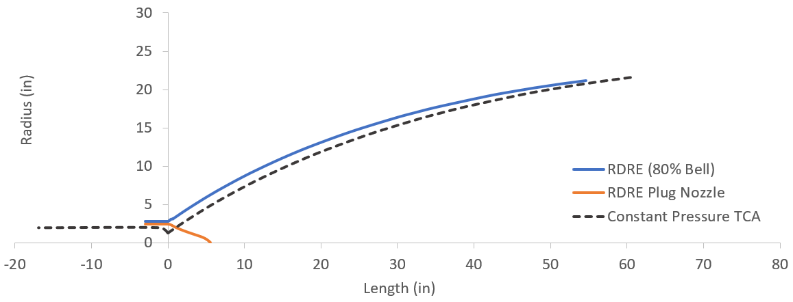
Figure 14. 10K lbf TCA contours with AR 300 nozzle.

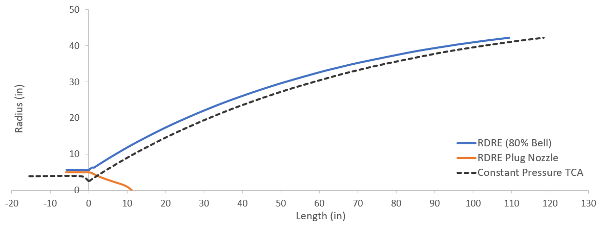
Figure 15. 25K lbf TCA contours with AR 285 nozzle.
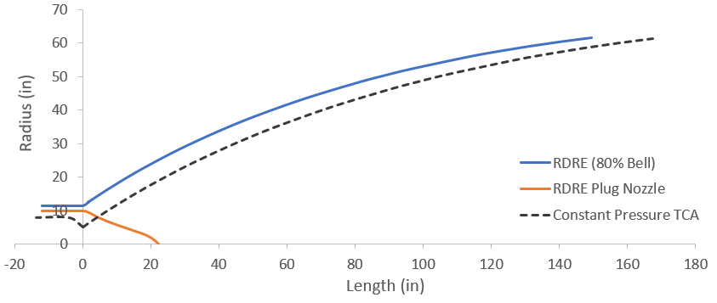
Figure 16. 500K lbf TCA contours with AR 150 nozzle.
The trade results are summarized in Table 5, and show that despite thrust class or area ratio the RDRE bell nozzle has about 90% the length of CP nozzle with identical design parameters. In reality, there is a lot more freedom when designing an RDRE. For example, by implementing a varied gap width and/or subsonic area ratio other than 1.0, the diameter of the chamber section can be increased significantly. For a set throat area and supersonic AR, the minimum length of the RDRE nozzle is inversely proportional to the diameter of the outer body. This flexibility is not possible in CP combustors because there is no inner body to decouple the throat area from the chamber’s diameter. However, there is still a complex trade study to be conducted because once the diameter increases, so does weight of both the outer body and inner body, as well as surface area to be cooled.
Manufacturability will also need to be considered when sizing the outer body, since larger diameters will be increasingly complex to manufacture and machine. With the use of additive manufacturing and novel alloy materials, higher performing and shorter nozzles may be achievable for both RDRE and CP thrust chambers. Nozzle expansion angles up to 45° are achievable with current L-PBF and blown powder DED technologies for materials such as NASA HR-1 or Inconel 625. Blown powder DED is the most feasible AM method compared to L-PBF because of build volume limitations. For in-space vacuum nozzles, more compact contours could be implemented without appreciable shock losses within the nozzle. Such a nozzle is shown below in Figure 17 and shows additional potential length savings when using AM for vacuum nozzles. The blue contour is a traditional 80% truncated bell with an AR of 150. The orange contour has a steeper expansion angle (45° instead of 35°) and has a higher length truncation (60% instead of 80%). With any vacuum nozzle, performing ground testing without forming shocks is a design consideration but can be achieved by using an ejector system or testing at higher chamber pressures, if the system allows it.
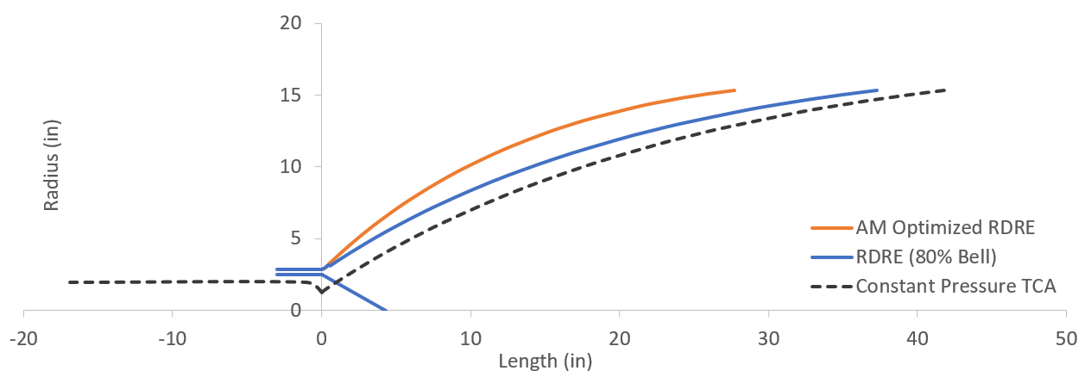
Figure 17. 10K lbf TCA contours with AR 150 nozzle and AM optimized contour.
Table 5. Nozzle and overall length comparison with straight annulus.
Thrust Class (Supersonic AR) | 10K (150) Optimized for AM | 10K (300) | 25K (285) | 500K (150)
RDRE Nozzle Length (in) | 27.72 | 54.63 | 109.41 | 149.35
CP Nozzle Length (in) | 41.82 | 60.75 | 118.39 | 167.31
Length Truncation of Chamber | 17.6% | 17.6% | 37.5% | 86.1%
Length Truncation of Nozzle | 66.3% | 89.9% | 92.4% | 89.3%
Total Length Truncation | 52.3% | 74.2% | 85.9% | 89.0%

Generally speaking, length advantages start to reduce for higher area ratio nozzles and for increasing thrust class. However, to demonstrate the advantages of implementing a varied gap width and larger outer body diameter, the 25K and 500K contours were produced while forcing outer body diameters of 20” and 40”. All contours shown below are an 80% bell curve using the same modified Rao method as above. Comparing a 20” TCA to 40” TCA, system length savings can be more than doubled for the same area ratio by using a 40” diameter. A more in-depth trade is necessary to determine if the additional mass of the chamber and plug nozzle are worth the decreased length. Also, the combustor’s length is not affected by the diameter since the chamber volume is balanced by the gap width and outer body circumference. To keep the same throat area at an increased diameter, the gap width has to shrink towards the throat. This creates another practical limitation of the maximum outer diameter where it can only be increased so far until the gap width becomes too small for wave propagation.
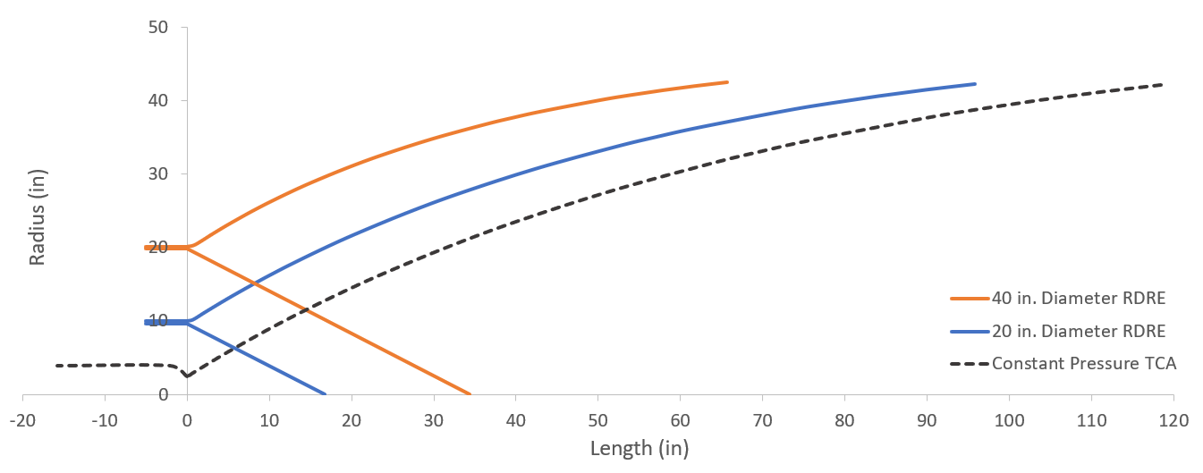
Figure 18. 25K lbf varied gap width with TCA contours and AR 285 nozzle.

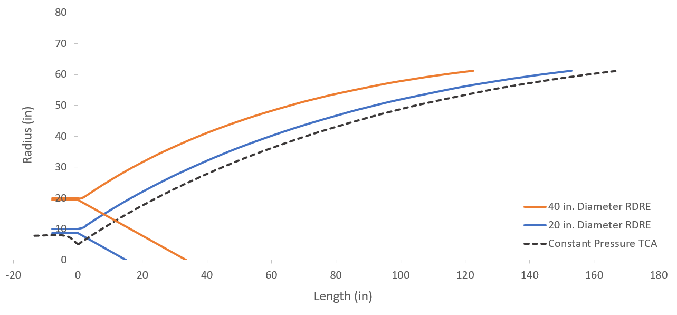
Figure 19. 500K lbf varied gap width with TCA contours with AR 150 nozzle.
Confidence in Scalability
A major component of the RDRE technology maturation plan includes a scalability assessment so that any engine thrust class can be developed. As such, all thrust class comparisons above need to be validated. It is expected that certain applications may not be validated in the lifespan of RDREs technology maturation within NASA. However, the trades should be well understood prior to substantial investment. Figure 20 shows a plot of the relative initial uncertainty in scaling to higher thrust classes with validated and unvalidated cases including confidence interval.

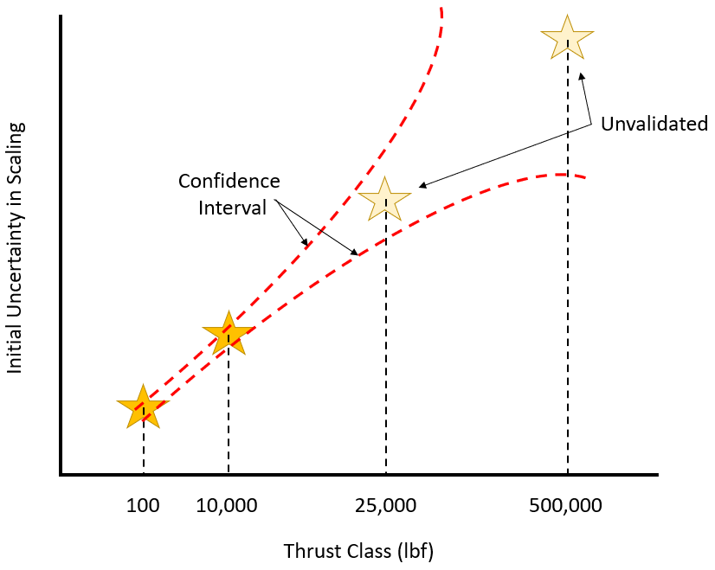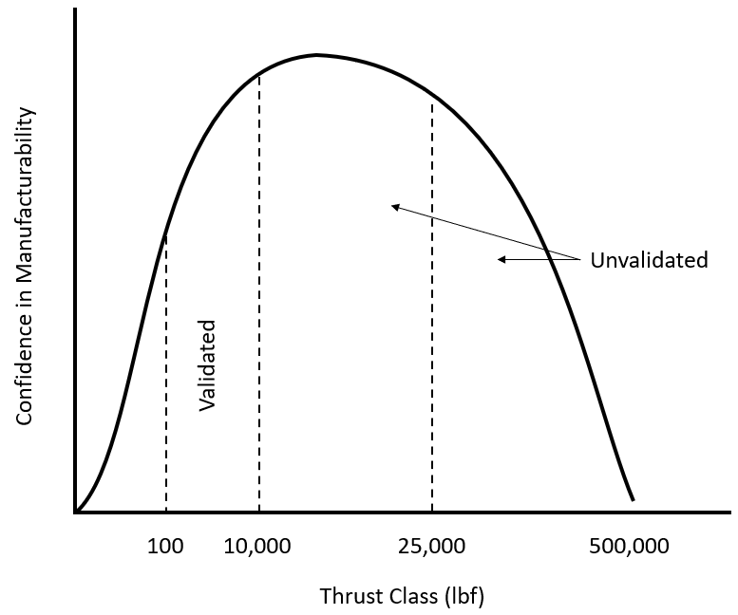
Figure 20. Representative plot of initial uncertainty in scaling with engine thrust class and confidence in manufacturability as a function of thrust class.
Should an additional thrust class be validated the confidence intervals will collapse and reduce the gap in confidence. Many researchers also anticipate that higher overall performance gains may be achieved at larger engine thrust classes due to the relative increase in cooling capability, reduction in relative manufacturing constraints, reduction in major loss mechanisms, and manufacturability of hardware. The confidence in relative manufacturability may become inverted as the thrust class becomes very large.
As shown in the previous section, once the thrust class becomes very large the confidence in manufacturability decreases. This is primarily a result of the reduction in available production methods. For example, a standard M400 build plate may accommodate a maximum cylindrical diameter of about 15.8 inches. The upper limit to manufacturability for an RDRE using widely available AM capabilities may reside around the 200,000 lbf class, but with diminished length gains. This thrust class and below encompasses approximately 90% plus of all chemical propulsion applications with the exception of heavy launch. However, large scale build plates such as the Sapphire XC 1MZ and ongoing NASA laser powder directed energy deposition (LP-DED) development are currently available or will be available for use in the near future with RDRE critical alloys such as GRCop-42. This would effectively eliminate manufacturing constraints due to scale if additive must be employed.
RDRE DESIGN CONSIDERATIONS
RDREs have a variety of design-related challenges. These include injector and inner body geometric fit, manifold geometry, aerospike or plug nozzle design, coolant channel design, and thrust chamber assembly considerations. Furthermore, the novelty of RDRE physics make design and analysis challenging. Not fully understanding design impacts on wave phenomena and acoustic coupling dynamics on hardware has led to overly conservative analysis and sizing. This conservatism can lead to oversized internal features that compound into geometry fit challenges, add mass to a component, and reduce global performance metrics. Even with the over-conservative manifold wall thickness, problems can still occur if off-nominal, high-energy dynamic modes propagate, potentially causing hardware damage. Figure 21 shows how a single wave mode can damage internal features even after conservative first-order design margins are applied. Further CFD efforts are being conducted to understand how detonation waves interact with hardware designs. Until analytical efforts (and comparative experimental efforts) are matured, there will continue to be challenges for the design of RDREs.
Figure 21. Internal damage to support features inside the NASA 10K inner body even with “conservative” wall thicknesses due to single wave propagation.
Critical technology elements of NASAs 10K RDRE are broken down as follows: injector, inner body, outer body, and nozzle extension as shown in Figure 22. The outer body and nozzle extension for RDREs are designed using similar methods to those of traditional, AM, thrust chamber assembly hardware. Design methods can be found in the literature. ²¹ The major design differentiator for RDREs comes from the injector and inner body designs. Whether separate hardware connected via a duct assembly or a conjoined single injector-aerospike geometry, the design for this hardware will differ the greatest from a traditional thrust chamber assembly due to the addition of an inner body and nature of an annular injector.
Major geometry fit concerns arise from the smaller working volume due to the annular shape. Further challenges arise in fitting propellant and oxidizer inlet ports, instrumentation, and igniter ducting into the smaller injection surface. Fitting instrumentation ports along the injector face, inner and outer body walls, and nozzle walls can be challenging depending on the additional material needed. This is particularly true for the inner body since the only feasible access point for these instrumentation ports is at the mating plane between the inner body and the injector. This is a relatively small surface area—unlike the full outer body exterior that is like traditional combustion device hardware where accessibility is not as limited.

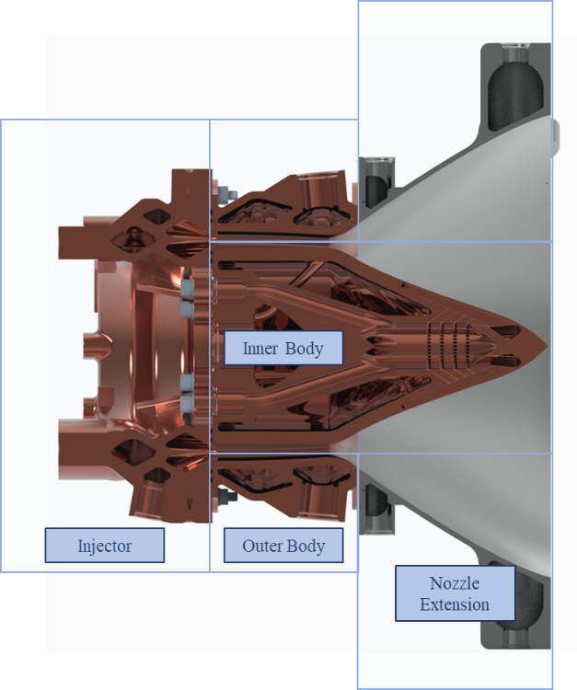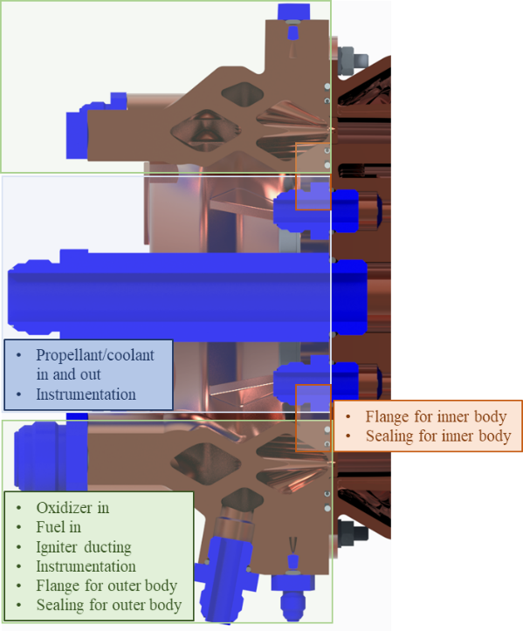
Figure 22. Anatomy of an annular RDRE and injector to inner body design considerations.
When comparing different thrust classes, fitment of internal ducts and manifolds alongside manufacturing features, orifices, and instrumentation must be considered prior to design. For smaller thrust classes, properly fitting the propellant manifolding can be a challenge for the injector and inner body. This is primarily due to design limitations for AM at smaller scales creating minimum wall and channel thicknesses. Furthermore, there is a limit to design fidelity at smaller dimensions that set a minimum wall thickness. ²¹ In addition, requirements for hydraulic flow area must be met or flow choking can occur.^{6,22} For annular injectors, at a minimum there is a fuel manifold, oxidizer manifold, and igniter manifold (if applicable). Often, additional ducts are needed to deliver the propellants from the regeneratively cooled inner and outer bodies to the injector manifolds. On smaller geometries, it can be a challenge to fit everything together without making the injector body excessively tall and losing out on the length benefits of the RDRE. For larger scales, manifolding and ducts also become larger; however, the design limitations become easier to work through with the added size. Design related challenges are often a balance between build plate size limitations and component requirements. Often, sizing the manifolds for the outer body and nozzle extensions can lead to challenges with fitting on a single L-PBF build plate and may require the use a different manufacturing technique altogether.
Similarities between the different sized RDREs include injector elements, coolant channels, general wall profile, and some manufacturing processing techniques. Larger RDREs may also include more channel bifurcation or other coolant channel designs available with a larger volume; however, the general design practices for the designer will remain consistent across scales. The annular shape of RDRE injectors allow for additional inlet and instrumentation configurations compared to deflagration AM injectors: instead of only being able to come from the back plate or outside perimeter of the injector, additional routing can be accomplished on the inner perimeter of the injector. However, the designer must be careful with this additional real estate, as the inner body also needs to be provided with its inlet and exit ports for the regenerative cooling channels. Because inner body design requirements are not encountered in typical deflagration-based chamber hardware, it is recommended to design around servicing the inner body first, before using any of the inner perimeter of the injector to service the injector. A general breakdown of the needs of the injector to inner body interface is shown in Figure 22. Fitment of different injector element schemes is highly dependent on the internal manifolds for delivering the fuel and oxidizer to the injector. Designing these features to fit properly—while maintaining proper element density—can be particularly challenging. Note that injector elements may not be fully printed to the required tolerance, so inclusion of additional post-machining or processing may be required during the design process.
Due to the uncertainty of wave phenomena for a particular design, higher-than-anticipated vibrations can impact the interfaces across the RDRE by loosening thread engagement on bolts or damaging seals. Metallic seals able to withstand the large pressure oscillations and temperatures of the engine are recommended. However, since the stronger seals are often less flexible, the interface design needs tighter tolerances to prevent potential gapping and seal failure. C-seals have demonstrated success, although E-seals’ additional flexibility have also been considered. Designing with a conservative number of fasteners maintains thread engagement in case of any threads loosening during operation is also recommended. Lock nuts, lock wire, or other retaining features can help mitigate threads from backing out. Increasing the overall number of threaded bolts also helps with maintaining the seal.
Threading into the inner body can be challenging just by nature of the RDRE geometry and may require direct threading. Instrumentation ports can also rely on directly threading into the body. It is recommended to use inserts when threading into a relatively soft material like GRCop-42. Due to the extreme vibrations created by the RDRE, smaller instrumentation ports have popped out during testing. Larger threaded ports such as main propellant lines have not had as many issues as smaller ports regarding threads backing out during operations.
Additional general design for additive manufacturing (DFAM) for propulsion applications can be found in Gradl et al., 2022²¹. When using DFAM for an RDRE application, it is helpful to design with flow passages in mind, especially for the injector and inner body. This includes everything from the regeneratively cooled channels to the oxidizer and fuel manifolds. It can be very helpful to model the empty space/fluid volumes of the flow passages in the manifolds and ducts and then work backwards to develop the body around it. This ensures flow and manufacturing objectives/constraints are met prior to overall solid geometry design, minimizing labor-intensive iteration. The nozzle extension and outer body can be designed using traditional design methods wherein the overall volume of the geometry is designed with the channel passages patterned and subtracted out of the volume.
RDRE DIAGNOSTICS
An additional technology gap remains in providing new methods of performance assessment of the detonative engine cycle. Experimental C* estimates for deflagration-based engines, used since the before the 1960s, use measured chamber throat pressure as a major input. Capillary tube attenuated pressure (CTAP) measurements are typically used in RDREs to represent time-averaged pressure, but difficulty in interpretation arises as measurements can largely be affected by tube length, angle, diameter, etc., causing uncertainty in recorded pressures and thus C* estimates. Therefore, sensor development is critical to compare RDRE performance more accurately to that of deflagration-based engines and to bolster technology transition.
In a collaboration with the University of Texas at San Antonio (UTSA) via a NASA Space Technology Graduate Research Opportunities (NSTGRO) fellowship, mid-wave infrared (mid-IR) laser absorption spectroscopy (LAS) measurements were conducted in September 2023. The goal was to determine the feasibility of obtaining quantitative thermochemical data from large-scale RDRE hot fire tests via portable, low-power semiconductor lasers. Anchoring RDRE (and LRE) performance data to chemistry and gas thermodynamic properties can shed light on theoretical performance gains and provide new data for future Moon to Mars propulsion system trades.
Thermochemical data obtained from hydrocarbon combustion products include CO, CO₂, and H₂O chemical species concentration, hot gas temperature, and local pressure. Measured values can be used to discern combustion completeness as well as modes of combustion at megahertz rates.²³ In general, the extreme vibration and acoustic environment caused by RDRE operation have dissuaded (quantitative) optically based measurement attempts in large-scale combustors; implementation is difficult outside of well-conditioned laboratory environments and/or laboratory-scale combustors with low vibration levels, as sensitive optics/photonics must be placed very close to the combustor.
After significant preparation for vibration isolation and test stand integration, the LAS setup shown in Figure 23 was successfully tested using mid-IR fiber optics with the 10,000 lbf thrust class RDRE at NASA Marshall Space Flight Center (MSFC). Figure 23 shows the ruggedized, N₂-purged photonics box, the single-mode fiber optic cables used to distance the photonics from the violent combustor assembly, and the setup for path-integrated exhaust measurements with free-space beam coupling into the catch-side fiber optic cable. The assembly is also seen in figure 5.
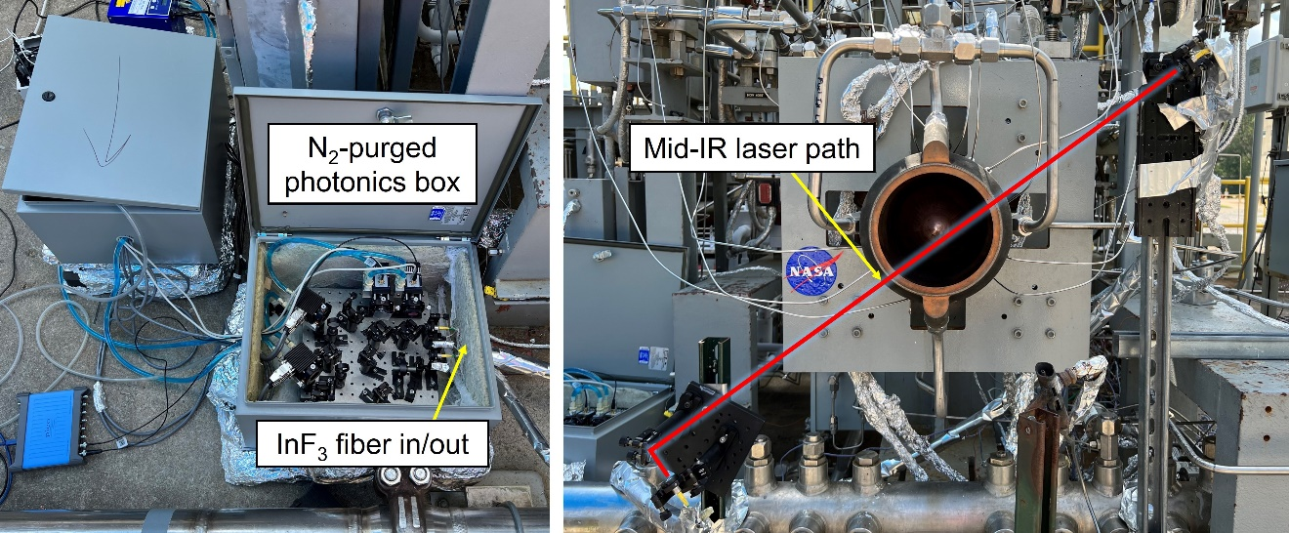
Figure 23. Laser absorption spectroscopy (LAS) setup with full scale NASA RDRE.
To the authors' knowledge, these are the first quantitative laser-based measurements recovered in an RDRE combustor of this scale. Though the recorded signals had lower intensity than desired in this initial campaign and experienced etaloning ²⁴, (undesirable reflections) due to the fixed focal length collimators used, this pathfinder-type campaign demonstrated mid-IR laser absorption spectroscopy as a viable technique to characterize combustor performance toward RDRE technology transition.
Additionally, to the authors' knowledge, these are also the first measurements recorded using catch-side mid-IR, single-mode fiber optics in a rocket engine architecture, enabling all photonics (including photovoltaic detector modules) to be distanced from the combustor. Measurements found in the literature using single-mode fiber optics to distance mid-IR lasers from combustors each used a PV detector directly mounted to the combustor or a PV detector placed very close to the combustor. For this 10,000 lbf thrust class combustor, it was desired to entirely remove photonics from engine proximity to mitigate potential for damage.
Future planned efforts include time-resolved measurements of individual detonation waves at the combustor exit as well as inside the combustor itself to provide further data for cycle performance analysis and scalability.
Conclusion
NASA has made significant progress in the development and maturation of RDRE technology and associated technologies. Recent testing demonstrated the viability of the GOx rich staged combustion cycle, dual regenerative cooling, over a dozen successful consecutive ignitions, and scalability of hardware. Future work will continue to assess power balance cycle feasibility, scalability of critical components to higher thrust classes, assess design rules of thumb for higher performance, and demonstrate reduced injection pressure losses.
This paper has documented some of the major 1st order considerations for length trades and quantified appreciable gains in combustor length with thrust class. Between 10K and 500K lbf, the length gains for high area ratio nozzles may reside between a 50% to 10% reduction in length. For hypersonic applications, that length trade will be even greater due to reduced nozzle length constraints. Looking towards the future, the space economy is continuously driving towards higher propulsive efficiency and will likely consider RDRE equally for its theoretical benefit in Isp gains which have not been considered in this study. Nonlinear dynamics of detonative combustion may also have a significant effect on nozzle design trades extending the length advantage further.
Significant design related challenges have been experienced in the development of RDRE components and assemblies. Strict consideration for manufacturing techniques, design and integration methodologies, instrumentation, feed system layout, and propellant delivery must be employed. Strategies for use of the DFAM process have been overviewed in the hopes that lessons learned by NASA may reduce development time for industry, government, and academia.
Future LAS diagnostic measurement attempts will be made to obtain high-frequency species concentration/temperature data, to gain further insight into modes of combustion present, and to ultimately achieve a better understanding of RDRE performance metrics. It is anticipated this effort will aid in system-level trade studies to assess RDRE application within NASA’s Moon to Mars architecture and further elucidate what advantages in Isp are realistically achievable.
Acknowledgments
The work presented in this manuscript was funded by the NASA Space Technology Mission Directorate. It has given nearly 3 dozen early career engineers a chance to develop and investigate promising technologies for a thriving space economy. This work would also not have been possible without the expertise of NASA design team in ER41, the MSFC test facility team / ET10, NASA Glenn collaborators, industry and academic collaborators, and the numerous student interns and fellows supported by this work.
References

1. Teasley, T. W., Fedotowsky, T. M., Gradl, P. R., Austin, B. L. & Heister, S. D. Current State of NASA Continuously Rotating Detonation Cycle Engine Development. in AIAA SCITECH 2023 Forum 1873 (2023).
2. Stechmann, D. P., Heister, S. D. & Sardeshmukh, S. V. High-pressure rotating detonation engine testing and flameholding analysis with hydrogen and natural gas. in 55th AIAA Aerospace Sciences Meeting 1931 (2017).
3. Fotia, M. L., Schauer, F., Kaemming, T. & Hoke, J. Experimental study of the performance of a rotating detonation engine with nozzle. J Propuls Power 32, 674–681 (2016).
4. Bennewitz, J. W., Bigler, B., Danczyk, S., Hargus, W. A. & Smith, R. D. Performance of a rotating detonation rocket engine with various convergent Nozzles. in AIAA Propulsion and Energy 2019 Forum 4299 (2019).
5. Bigler, B. R., Burr, J. R., Bennewitz, J. W., Danczyk, S. & Hargus, W. A. Performance effects of mode transitions in a rotating detonation rocket engine. in AIAA Propulsion and Energy 2020 Forum 3852 (2020).
6. Huang, D. H. & Huzel, D. K. Modern Engineering for Design of Liquid-Propellant Rocket Engines. (American Institute of Aeronautics and Astronautics, 1992).
7. Gradl, P. et al. Advancement of extreme environment additively manufactured alloys for next generation space propulsion applications. Acta Astronaut 211, 483–497 (2023).
8. Gradl, P. R. et al. GRCop-42 Development and Hot-fire Testing using Additive Manufacturing Powder Bed Fusion for Channel-Cooled Combustion Chambers. in AIAA Propulsion and Energy 2019 Forum 4228 (2019).
9. Gradl, P. R., Teasley, T. W., Protz, C. S., Garcia, C. P. & Greene, S. E. Hot-fire Performance of Additively Manufactured GRCop-42 and GRCop-84 Channel-Cooled Combustion Chambers. 1–36 (2019).
10. Gradl, P. R. et al. Geometric feature reproducibility for laser powder bed fusion (L-PBF) additive manufacturing with Inconel 718. Addit Manuf 47, 102305 (2021).
11. Stechmann, D. P., Sardeshmukh, S., Heister, S. D. & Mikoshiba, K. Role of ignition delay in rotating detonation engine performance and operability. J Propuls Power 35, 125–140 (2019).
12. Harroun, A. & Heister, S. D. Liquid Fuel Survey for Rotating Detonation Rocket Engines. in AIAA SCITECH 2022 Forum 0088 (2022).
13. Sosa, J. et al. Experimental evidence of H2/O2 propellants powered rotating detonation waves. Combust Flame 214, 136–138 (2020).
14. Schumaker, S. A., Knisely, A. M., Hoke, J. L. & Rein, K. D. Methane–oxygen detonation characteristics at elevated pre-detonation pressures. Proceedings of the Combustion Institute 38, 3623–3632 (2021).
15. Teasley, T. W., Protz, C. S., Larkey, A. P., Williams, B. B. & Gradl, P. R. A Review Towards the Design Optimization of High Performance Additively Manufactured Rotating Detonation Rocket Engine Injectors. in AIAA Propulsion and Energy 2021 Forum 3655 (2021).
16. Lietz, C., Mundis, N. L., Schumaker, S. A. & Sankaran, V. Numerical investigation of rotating detonation rocket engines. in 2018 AIAA aerospace sciences meeting 0882 (2018).
17. Wolański, P. Detonative propulsion. Proceedings of the combustion Institute 34, 125–158 (2013).
18. Martinez, A., Cabot, B., Blong, K., Teasley, T. W. & Heister, S. D. Experimental Study of a Watercooled GOX/RP-1 Rotating Detonation Rocket Combustor for Application to Ox-Rich Staged Combustion Engine Cycles. in AIAA SCITECH 2024 Forum 2791 (2024).
19. Gradl, P. R. Advancement of Metal Additive Manufacturing Techniques and Materials for Rocket Propulsion Applications Paul Gradl National Aeronautics and Space Administration (NASA). no. August (2020).
20. Bykovskii, F. A., Zhdan, S. A., Vedernikov, E. F. & Samsonov, A. N. Scaling factor in continuous spin detonation of syngas–air mixtures. Combust Explos Shock Waves 53, 187–198 (2017).
21. Gradl, P. Metal Additive Manufacturing for Propulsion Applications. in Danish AM Hub Roundtable (2023).
22. Anderson, J. D. Modern Compressible Flow. (Tata McGraw-Hill Education, 2003).
23. Nair, A. P. et al. MHz laser absorption spectroscopy via diplexed RF modulation for pressure, temperature, and species in rotating detonation rocket flows. Applied Physics B 126, 138 (2020).
24. Stiborek, J. W. et al. Four-color fiber-coupled mid-infrared laser-absorption sensor for temperature, CO, CO 2, and NO at 5 kHz in internal combustion engine vehicle exhaust. Appl Opt 62, 8517–8528 (2023).

Lead Combustion Device Engineer, Engine Components Development and Technology Branch, NASA Marshall Space Flight Center.
Combustion Device Engineer, Engine Components Development and Technology Branch, NASA Marshall Space Flight Center.
Propulsion Systems Design Engineer, Design and Structural Dynamics Branch, NASA Marshall Space Flight Center.
NSTGRO Fellow, Engine Components Development and Technology Branch, NASA Marshall Space Flight Center.

