Investigation of Hardware and Instrumentation to Measure Hand Grasp Activity with the Spacesuit Gloves

Rachel L. Thompson^{1*}, Kyoung J. Kim¹, William Green¹, Linh Q. Vu², Nathaniel J. Newby¹

¹KBR, 2400 Nasa Parkway, Houston, TX

² Aegis Aerospace Inc., 18050 Saturn Ln, Houston, TX

*Corresponding author’s email: rachel.l.thompson@nasa.gov

Introduction: During the 2022 suited injury summit, it was hypothesized that there will be concerns for hand and glove injuries for future exploration space missions, especially given the fact that the “total number of Extravehicular activity (EVA) hours and frequency” for lunar surface missions is expected to vastly increase [1]. It has been reported that the hands experienced the greatest “absolute number” of reported injuries and far exceeds other injuries during EVA [1, 2]. It was reported that the most fatiguing part of the surface EVA was the repetitive gripping tasks [3]. It was recommended that a “glove sub-team” be created to look at possible injury mechanism and mitigation strategies. Some of the recommendations that were suggested [1] are as follows: examine hand fatigue, utilize motion capture, examine the duration and frequency of hand movements, and identify frequent hand motions.
Fig. 1: Customized MoCap glove used.
We started assessing hardware and instrumentation to measure hand grasp activity in the pressurized glove environment. The purpose of this test was to perform a hardware evaluation for motion capture (MoCap) gloves obtained from StretchSense (Auckland, New Zealand). The specific gloves used were the Pro Fidelity and SuperSplay to determine the repeatability, reliability, feasibility, and useability inside of a pressurized gloved environment.
Fig. 2: Glove box used for testing.

Methods: The MoCap gloves were customized (e.g., battery/Bluetooth pack relocated to upper arm) to better suit the pressurized testing environment and protect the subject from unintentional injury (Fig. 1). Fourteen total subjects from different demographics (i.e., gender and pressurized glove experience level) participated in this test series. Testing included one session each of a baseline data collection (NASA Johnson Space Center (JSC) building 21) and a spacesuit glove box (Fig. 2 at JSC building 7 room 2027) data collection (under vacuum down to 4.3 psid), where each session lasted 3-5 hours. Controlled and reproducible tasks to systematically evaluate the repeatability and reliability of the hardware were performed during baseline data collection. Additionally, subjects performed simulated EVA-like tasks in a pressurized gloved environment. For all sessions, MoCap gloves were placed on each of the subjects’ hands and the signal from it, or the raw capacitance (Fig. 3), was analysed. The raw capacitance was used to estimate the open and closed hand states between the testing conditions and allow us to provide an offset caused by the pressurized environment.
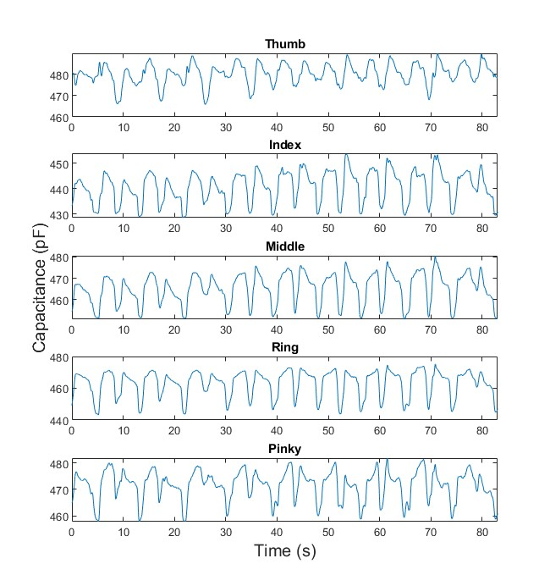
Fig. 3: Raw capacitance data for the object relocation task.

Results & Discussion: Initial observation with the bare hands (baseline) condition showed that the MoCap gloves appeared to track grasping and releasing of the fingers (opening and closing fist) with both high- and low-speed conditions, while adduction and abduction of the fingers were not relatively tracked. A hardware evaluation was done outside of the glove box to assess the reliability and repeatability of the MoCap glove. In one task, a point force was applied to various locations on the back of the hand. When the point force was applied to the space between the 1st digit and the pointer finger, there was a noticeable distortion to the MoCap data. Another task examining an increasing force from a 10 lb. sandbag applied to the back of the hand while lying flat on a table, showed a constant flat line with only a distortion when the weight was increased or added to the back of the hand. Fig. 3 shows an object relocation task where you can see when each individual finger “opened” and “closed” (changed position) when picking up and setting down the dumbbell. When the fingers were stationary, the signal remained relatively flat compared to the peaks and valleys that can be observed in Fig. 3.
This study showed promising results and imperative input into an attempt to discriminate between hand states across various functional tasks and should be evaluated with context to the repeatability and reliability outcomes. Depending on the task done inside of the pressurized glove box environment and outside, the results appear to be affected by many different factors (i.e., drift, pressure, hand size, etc.).

Significance: If this hardware proves to be reliable and repeatable in determining the open and closed hand states then this may provide critical insight into the characterization of the pressurized gloved environment and the effect on crew member exertion level. Ultimately, this tool will provide useful data for quantifying the repetitive nature of EVA training and tasks.

Acknowledgments: The authors would like to acknowledge the NASA Mars Campaign Office for providing funding for this research. Lastly, thanks to all the engineers and technicians at NASA JSC who helped with this data collection.

References: [1] Reiber, et al. (2022), NASA/TM-20220007605; [2] Scheuring, et al. (2009), Av., Sp., and Envir. Med. 80(2).
[3] Scheuring, et al. (2007), NASA/TM–2007–214755.

