Carbothermal Reduction Demonstration (CaRD) Gas Analysis Subsystem Development
Ryan P. Gott, Joel A. Olson, Nilab Azim, Roberto Aguilar Ayala, Janine E. Captain.
NASA, Kennedy Space Center, FL, 32899
and
Nathan P. Haggerty, Kevin Rogers, Thomas Davis, and Brant C. White
Sierra Space, Madison, WI, 53717
The Carbothermal Reduction Demonstration (CaRD) project is currently developing a subscale system to demonstrate the operation and performance of the carbothermal reduction process and quantify the production of molar equivalent oxygen via carbon monoxide (CO) and carbon dioxide (CO₂). Traditionally, gas chromatography (GC) systems are utilized to quantify gases due to their ability to separate volatile compounds within the gas mixture, followed by detection of the isolated component of interest. Despite their capabilities, GCs require carrier gas consumables for their operational mobile phase and consequently are not often considered a flight-forward option. An alternative analytical technique known as mass spectrometry measures the presence of gas phase molecules without the need of carrier gas. Residual gas analyzers (RGAs), which are smaller and rugged mass spectrometers, are not traditionally used to quantify analytes as they serve more as a monitoring tool. However, proper application and calibration can result in a flight-forward analytical instrument capable of direct quantification of volatile compounds of interest. Kennedy Space Center's role for the JSC led CaRD project is to design a gas analyzer system to detect and quantify the CO and CO₂ gases produced during the carbothermal reaction utilizing a commercial version of the Mass Spectrometer observing lunar operations (MSolo) instrument. MSolo is a modified commercial off-the-shelf RGA, which consists of quadrupole mass filter and space rated electronics. MSolo is currently a TRL 6 technology and manifested on the PRIME-1 and VIPER missions. This paper describes leveraging MSolo based instrumentation to develop a gas analysis system for the work outlined in the 2023 International Conference on Environmental Systems (ICES) paper number 313.

Nomenclature
CaRD = Carbothermal Reduction Demonstration
COPR = Carbothermal Oxygen Production Reactor
CO = Carbon Monoxide
CO₂ = Carbon Dioxide
GC = Gas Chromatography
JSC = Johnson Space Center
KPP = Key Performance Parameter
KSC = Kennedy Space Center
MSolo = Mass Spectrometer observing lunar operations
O₂ = Oxygen
RGA = Residual Gas Analyzer

Introduction
L
unar regolith contains ~45% oxygen (O₂) by mass, which can be extracted and utilized for long-term exploration. The carbothermal reduction process is one of the oxygen-from-regolith (O2FR) technologies currently under development. This process involves the reduction of molten regolith, composed of metal- and semi-metal oxides, in the presence of carbon to produce recoverable O₂ in the form of carbon monoxide (CO) and carbon dioxide (CO₂) gas. The recovered O₂ can then be used as propellant to reduce the required consumables to be delivered to lunar surface for future missions. This technology reduces risks to long-duration crewed surface missions as it can be available for breathing and fuel cells.¹⁻⁴
The Carbothermal Reduction Demonstration (CaRD) project led by Johnson Space Center (JSC) is currently developing a subscale system to demonstrate the operation and performance of the carbothermal reduction process and quantify the production of molar equivalent O₂ in the form of CO and CO₂. One of the goals is to design a gas analyzer system to detect and quantify the CO and CO₂ gas produced during the carbothermal reaction utilizing a commercial version of the Mass Spectrometer Observing Lunar Operations (MSolo) instrument.
A previous test successfully integrated a brassboard design of the gas analysis and manual carbothermal reactor subsystems, collected performance data of the reactor, and determined the gas analysis subsystem’s quantification accuracy compared to a gas chromatograph (GC). This test used the gas analysis subsystem to sample from the reactor fluid system developed by Sierra Space that recirculated argon (Ar) and carbothermal reduction product gases. The reaction was initiated by a 2kW laser to simulate concentrated solar energy for a total of 6-minutes. The design of the gas analyzer subsystem included the ability to sample in a delayed “real-time” configuration and surge tanks that captured the gases at specific time points to provide snapshots of the 6-minute reaction.
The brassboard test demonstrated up to 15.79 g/kWh utilizing thermal energy. This O₂ production was an order of magnitude higher than the key performance parameter (KPP) target of 1.25 g/kWh. MSolo’s CO quantification closely matched the GC’s and resulted in 8.71% ± 6.86% variance. Negligible quantities of CO₂ were observed across all tests, therefore, only the CO quantity was used to determine the O₂ production. This test was a success in not only demonstrating O₂ production by the CaRD brassboard system in a vacuum environment but demonstrating MSolo’s ability to derive performance data. Upon meeting the desired KPP and determining the subsystem’s accuracy, lessons learned were captured to be implemented to the next design phase.
The prototype design phase for the gas analysis subsystem aimed to achieve the analysis of the reaction products with hydrogen (H₂) as the working gas and to assist with the design of a flight-forward configuration. H₂ was used as the working gas for the prototype tests since it will be the gas utilized on the lunar surface due to its ability to be recycled in the larger scheme of ISRU implementation. Utilizing H₂ during the carbothermal reduction reaction could produce relevant gases including potential corrosive acids such as HCl, HF, and H₂S. The goal of the test was to identify if such gases are produced in quantities that would be harmful to the equipment and quantify the production of CO with H₂ as the working gas. Delays in real-time sampling that were observed in the brassboard testing were addressed in the gas analysis system design for prototype testing by significantly simplifying the hardware configuration. This new configuration is intended to be more representative of a flight-forward design.
The prototype testing integrated the Sierra Space Carbothermal Oxygen Production Reactor (COPR) reactor with the MSolo instrument attached to COPR’s valve panel. Additional information on the COPR system can be found in ICES-2023-313.⁵ Briefly, COPR is the prototype automatic reactor designed to operate in lunar relevant environment. The operation of COPR includes sample prep, reaction in reaction chamber, and melt removal. For the test described here, the reaction was performed with a simulated solar energy via a laser.

Materials and Methods

Gas Analysis Subsystem Design
All testing was conducted using an INFICON Transpector MPH Crossbeam RGA connected to a Pfeiffer HiCube 80 gas pumping system. As shown in Figure 1, gas was sampled into a ConFlat 6-way cube through a hydroguard fused silica capillary tube. The ion source region of the crossbeam sensor was carefully placed into the cube in a manner where it aligned directly to the path of the capillary. For preliminary calibration testing, a manifold was used at the other end of the capillary to set a pressure of gas mixtures. For the prototype testing at Sierra Space, this manifold was removed, and the capillary was directly attached to the COPR valve panel.

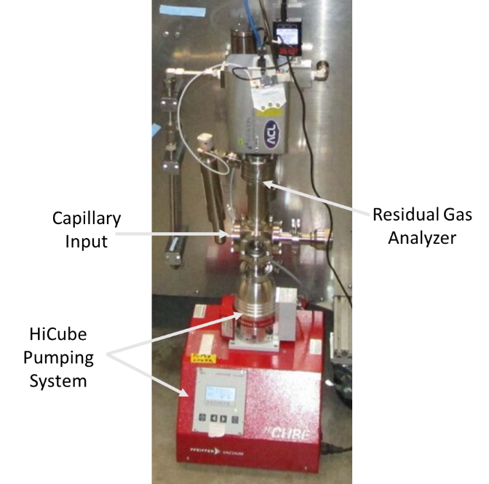
Figure 1. RGA and pumping Setup

Calibration Procedure
Preliminary testing was conducted at Johnson Space Center (JSC) to demonstrate the ability to calibrate the MSolo instrument in a H₂ environment. Gas standards were obtained with CO concentrations ranging from 1 to 10%. First, the chamber and manifold were evacuated and brought to background pressures. For the chamber, this was on the order of 10⁻⁶ Torr or below. For the manifold, this was on the order of 10⁻¹ Torr. The RGA recorded data at these pressures for five minutes to use as a background signal. Then, the full system was purged with the test gas, which meant pressurizing the manifold to ~700 Torr with the test gas. This cycled for two minutes, then the full system was evacuated back to background pressures. It’s important to note that for the H₂ tests, this meant waiting until a “ballast purge” occurred as a rapid decrease in the H₂ signal at mass-to-charge ratio (m/z) of 2 was observed, then letting the system pump down for five more minutes. A ballast purge is a mode of the HiCube system that pulled low levels of air into the roughing pump. This occurred every 15 minutes during operation of the pump and helped remove excess H₂ that would accumulate in the pumping system. Once the pressure maintained the background level for five minutes, the system would then be pressurized to a target manifold pressure step of 51.7 Torr (1 psi). The manifold pressure was achieved by carefully balancing the input and output needle valves. This pressure would be maintained for five minutes with continuous signal recording by the RGA. Then, the pressure would be increased to the next pressure step for five minutes.
The RGA measures both: a total pressure plate (TPP) value and a signal current response at different m/z also known as atomic mass units (amu); note that, for purposes of this report, m/z values will simply be reported as amu. For these tests, the RGA recorded 1 point per amu for a mass range of 1-85 amu, with a corresponding dwell time of 128 ms for each amu. The measured partial pressure for each gas was determined by multiplying the total pressure measured by the TPP by the known fraction of the measured gas standard. For example, for a gas mixture of 10% CO in H₂, the measured partial pressure of CO was calculated by multiplying the TPP by 0.10. Similarly, for the given example, the measured partial pressure of H₂ would then be the TPP pressure value by 0.90. A distinction is made here between the measured pressure and the actual pressure. Note that the TPP displays a known deviation from the actual pressure in the chamber. However, the deviation is proportional for all gases and pressures over the range of measurement. Thus, the deviation is eliminated when the ratio of response slopes is calculated (see below). Corrections must be made to the measured current signals based on the other potential gases that could be observed at the same amu. CO is measured at 28 amu, but nitrogen can also be seen at that same mass to charge ratio. Also, CO₂ could also have some contributions in the 28 amu signal due to fragmentation during its ionization process. To correct for this, other signals that measure nitrogen and CO₂ can be subtracted at known fragmentation factor ratios. In practice, this means subtracting (0.11/0.70) times the measured 44 amu signal and (0.88/0.12) times the 14 amu signal from the 28 amu signal to yield the current resulting from CO. Note that the potential formations of di-cations were neglected for these calibrations (that is, signal at 14 amu could potentially be the result of CO²⁺; however, this potential contribution was neglected). Additionally, all current signals were corrected for the background signal. The background signal was determined by averaging current values for each amu during the background measurement step described above. These average values were then subtracted from the current value for each amu. Equation 1 shows the calculation for the CO current response at 28 amu.

$I_{CO}=I_{28}-\frac{0.11}{0.70}{×(I}_{44}-I_{44BG})-\frac{0.88}{0.12}×I_{14}-I_{28BG}$ (1)

Here I_{CO} is the signal current at 28 amu resulting from CO, I₂₈ is the measured current at 28 amu, I₄₄ is the measured current at 44 amu, I_{44BG} is the average background current for 44 amu, I₁₄ is the measured current at 14 amu, and I_{28BG} is the average background current for 28 amu. These corrections were performed individually for each datum in the time-domain data. Note that interfering species don’t exist for H₂. Therefore, no corrections (other than the background correction) were applied to the 2 amu current.
Figure 2 provides a workflow of the calibration process that starts with the standard gas bottle as the source of the gas that fills the volume of the manifold, which then moves through the capillary into the RGA vacuum chamber to be analyzed.
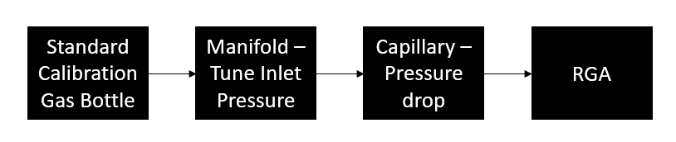
Figure 2. Workflow of the calibration process.

Testing Setup and Procedure
For the prototype testing, the RGA system was connected to the COPR reactor. An 85 cm capillary was connected to a sampling port that maintained a pressure between 3-4 psia during the reaction. This port captured real-time gases as they flowed out of the reactor and into a storage tank.
Initially, a series of scans were collected with all lines evacuated to establish a background level for the instrument. Then, H₂ gas was flowed into the reactor and through the system for around three minutes to establish a pre-test baseline. Once an equilibrium state was reached, the laser was powered on to start the carbothermal reaction. During the activation of the laser, gas was sampled through the short capillary. Following the reaction, H₂ gas was flowed into the system until the sampling was complete. This allowed the RGA signal to return to a baseline CO measurement.

Results and Discussion

Calibration Proof of Concept
Testing at JSC showed the feasibility of calibrating the MSolo system with a H₂-based test gas. For each gas mixture, the RGA current response was measured for H₂ and CO. These were plotted in reference to the changes in partial pressures for each gas. Examples of these plots are shown in Figure 2 and Figure 3. If the RGA is properly calibrated, the current signals should increase linearly with rising partial pressures.

Figure 3. The changes in RGA signal current are shown with reference to partial pressures of H₂.

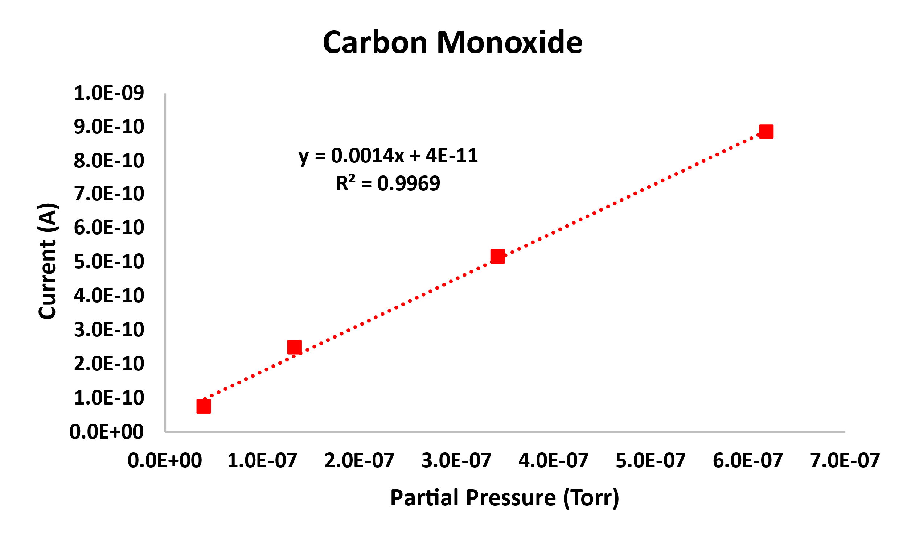
Figure 4. The changes in RGA signal current are shown with reference to partial pressures of CO.

Linear regression lines were calculated for each of the H₂ and the CO plots, with the equations shown in the figures. The CO/H₂ ratio of the slopes from these equations were then calculated and compared for each gas mixture. Three tests were conducted at each concentration and used to calculate the average ratio of CO/H₂ slopes.
For two of the gases (2% CO and 5% CO), the gas mixtures were tested an additional 3 times each. For these challenge sets, the calculations were done in reverse. Instead of being an input, the expected gas mixture was calculated to achieve the average CO/H₂ slope ratio from the calibration tests. The resulting values are presented in Table 1 along with their error percentages. Altogether, the average error for these challenge tests was 3.2%, and the worst case was an error of 6.4%. This was well within our target of less than 25% error.

Table 1. The error percentages for each of the challenge tests are shown.
Challenge Test | Actual  CO% | Calculated CO% | Error %
1 | 2.0 | 2.1 | 6.4
2 | 5.0 | 5.1 | 1.2
3 | 5.0 | 5.3 | 6.2
4 | 2.0 | 1.9 | 2.6
5 | 5.0 | 5.0 | 0.6
6 | 2.0 | 2.0 | 2.2
 |  | Avg | 3.2

It was noted during calibrations that pumping H₂ through vacuum pumps reduces the pumping rate, which inherently led to an increase in H₂ concentration during these purges. This is shown in Figure 4. Since CO is being pumped out at a consistent rate but H₂ is not, the calibration errors on the side of a lower concentration of CO. This means that calculated CO values would be higher than actual values in future tests. This was not seen fully in the challenge tests because those were conducted in the same pumping environment as the calibrations. It should also be noted that every 15 minutes, the HiCube system performs a ballast purge that flushes in a small volume of air to help the H₂ flow out of the pump. This reduces the pressure in the system during the purge event.

Figure 5. Calibration data showing accumulation of H₂ in pumping system.

Prototype Testing
Once the calibration was shown to work as a proof on concept, the gas analysis system was integrated into the COPR reactor at Sierra Space. Due to the behavior of the H₂ accumulation in previous tests, a new calibration was performed with a 3% CO mixture in H₂.
Using this calibration, the real-time percentage of CO being produced could be calculated. This method depends on the previous experimental determination of the ratio (R) of the slopes of current versus partial pressure for both H₂ (at m/z = 2) and CO (at m/z = 28).

$$R= \frac{m_{CO}}{m_{H_{2}}} [2]$$

Here the slopes are taken from:

$$m_{CO}= \frac{I_{28}(CO)}{P_{TPP}∙f_{CO}} [3]$$

And

$$m_{H_{2}}= \frac{I_{2}(H_{2})}{P_{TPP}∙{(1 - f}_{CO})} [4]$$

Where I_{X}(Y) is the corrected current for species Y at m/z = x, P_{TPP} is the pressure as measured by the total pressure plate (previously P_{INT}), and f_{CO} is the fraction of CO in the gas mixture. Here we assume that the gas mixture is binary (as will be shown below, the end result does not depend on a binary gas mixture), thus the (1 - f_{CO}) term in place of the fraction of H₂ in Equation [3].
The corrected currents are measured as follows:

$I_{2}\left(H_{2}\right)= I_{2}\left(TOT\right)- I_{2}\left(BG\right)$[5]

And

$$I_{28}\left(CO\right)= I_{28}\left(TOT\right)- I_{28}\left(BG\right)-\left(I_{44}\left(TOT\right)- I_{44}\left(BG\right)\right)∙ \frac{0.11}{0.70} - I_{14}\left(TOT\right)∙ \frac{0.93}{0.06} [6]$$

Here the notations are: TOT = total and BG = background. The numerical fractions are the ratios of the fragmentation factors with that for m/z = 44 representing the contribution of CO₂ to the m/z = 28 peak, and m/z = 14 representing the contribution of N₂ to the m/z = 28 peak. Note that the background value is not subtracted from I₁₄(TOT); experience has shown that this results in negative adjusted current values for I₂₈(CO) due to the large multiplier from the ratio of fragmentation factors.
Previously, the slopes (m) were determined from time averaging responses of constant experimental conditions (gas concentrations), and then taking a regression from the plot of adjusted current versus known partial pressure. However, this could just as easily be performed for single points (with potential loss in averaging - though averaging could be performed later providing a mathematically equivalent result).
If R is previously determined experimentally, then these equations could be reversed to find f_{CO} from measured currents (even single data points) as follows. First, we solve Equation [3] for f_{CO}:

$$f_{CO}= \frac{I_{28}(CO)}{P_{TPP}∙ m_{CO}} [7]$$

From the previously determined ratio R, we can substitute from Equations [1] and then [3] (and then cancelling P_{TPP}):

$$f_{CO}= \frac{I_{28}(CO)}{P_{TPP}∙ {R ∙ m}_{H_{2}}}= \frac{I_{28}\left(CO\right)∙P_{TPP} ∙(1- f_{CO})}{P_{TPP}∙ {R ∙I}_{2}(H_{2})} = \frac{I_{28}\left(CO\right)∙(1- f_{CO})}{{R ∙I}_{2}(H_{2})} [8]$$

The implications of the cancellation of P_{TPP} is such that it could have been defined as just the fraction of P_{TPP} that resulted from the sum of CO and H₂, thus these equations should also work if there are additional non-interfering gases present with unknown partial pressures.
Next, Equation [8] is solved for f_{CO}:

$$f_{CO}= \frac{Q}{Q+1} [9]$$

where

$$Q= \frac{I_{28}(CO)}{I_{2}(H_{2})∙R} [10]$$

For each individual collected data point, Equations [9] and [10] can be used in conjunction with Equations [5] and [6] to determine the fraction of CO.
These calculations resulted in the values shown in Figure 3.

Laser
Off
Ballast Purge
Figure 6. The real time CO concentration as measured during Test 2.

It can be seen that the reaction takes roughly 30 seconds after laser ignition for the first produced gases to reach the RGA. The production of CO continues to rise as the reactor warms the regolith and starts driving a carbothermal reaction. A steady state is achieved around five minutes into the test. Coincidentally, for Test 2, the five-minute mark is also when a ballast purge event occurred in the system. As noted above, the ballast purge dumps excess H₂ that had built up in the pump. This raises the calculated CO concentration because the H₂ concentration, which is in the denominator of Equation [2], decreases during the purge. It should be noted that the measured CO concentration before the ballast purge is likely artificially low due to the slow buildup of H₂. In the steady state after the purge, the reaction was producing CO at a concentration of 2.3%.
Given the flow rate of gas through the system, the measured concentration of CO can be integrated over time to give the overall amount of CO produced during the reaction. A constant flow of 35 SLM was used throughout the run, resulting in the calculated CO production shown and compared with Sierra Space gas chromatograph data in Table 2. For each test, the RGA integration showed good alignment with the Sierra Space data, with the exception of Test 4. During test 4, a valve issue caused the venting of a high percentage of the test gases. This caused pressure variations and gas mixing that led to unreliable measurements. This was an off-nominal case and will be prevented in the future via procedural corrections.

Table 2. Measured CO extraction comparing RGA and GC measurements.
Test name | SS Test name | mCO(g) RGA Integration | mCO(g) SS | Variance (%)
Test 1 | COPR - 7 | 5.112 | 4.840 | 5.5
Test 2 | COPR - 8 | 4.030 | 3.642 | 10.1
Test 3 | COPR - 9 | 3.827 | 3.965 | 3.5
Test 4 | COPR - 10 | 2.062 | 3.120 | 40.8
Test 5 | COPR - 11 | 3.393 | 3.846 | 12.5
AVG |  | 4.09 | 4.07 | 7.9
STD |  | 0.73 | 0.53 | 4.1

Notably, none of the potential corrosive acids such as HCl, HF, and H₂S were detected by the RGA. Although this could suggest that the corrosive acids were not produced, it cannot be concluded as such. For instance, H₂S may have been produced in quantities below the RGA’s limit of detection, which is calculated as 13 ppm H₂S, since no signal intensity was observed. Future testing can be performed to investigate the production and quantification of these corrosive gases by optimizing the RGA’s configuration if desired. Regardless, one of the goals of this test was to ensure that the RGA system in the current configuration would not be damaged during the testing and this was successfully demonstrated.

Conclusion
The CaRD brassboard test had demonstrated that the MSolo instrument could successfully quantify the production of CO and a negligible amount of CO₂ in real-time with Ar as the working gas. Due to the negligible production of CO₂, the instrument would only be calibrated to quantify CO hence forth and monitor for CO₂ and other potential products. In this paper, the KSC gas analysis team demonstrated the ability to calibrate the MSolo instrument to measure CO concentrations with H₂ as the working gas in real-time. This was shown in both a controlled and a use-case scenario. The controlled scenario was performed at JSC where the MSolo instrument was calibrated and determined an average error of 3.2% for the challenge tests and a worst-case error of 6.4%. Subsequently, the use-case scenario tested the MSolo instrument in a relevant environment by testing it with the prototype COPR reactor with H₂ as the working gas. The tests demonstrated that the MSolo instrument has an average relative accuracy to the GC of 7.9% ± 4.3%, which is well below our requirement accuracy of 25%. Measurements at Sierra Space showed that RGA measurements align well with GC measurements and can give real-time data during a reaction. These preliminary tests have built confidence for fully integrated testing later this year. Additionally, future tests will involve keeping our vacuum ballast valve continuously open to prevent H₂ build-up and subsequently help improve our quantification accuracy.

Acknowledgments
The team would like to thank Anastasia Ford, Aaron Paz, Jeffery Michel, Todd Peters, and John Lauterbach for their support during calibration testing at the Energy Systems Test Area in Johnson Space Center.

References
¹R. Wickes, "NASA Successfully Extracts Oxygen from Lunar Soil Simulant," NASA, 25th April 2023. [Online]. Available: https://www.nasa.gov/feature/nasa-successfully-extracts-oxygen-from-lunar-soil-simulant. [Accessed 22nd May 2023].
²A. Paz, "Carbothermal Reduction Demonstration (CaRD)," Lunar Surface Innovation Consortium, Laurel, MD, 2023.
³B. White, R. Gustafson and M. Fidler, "2010 Field Demonstration of the Solar Carbothermal Regolith Process to Produce Oxygen," in 49th AIAA Aerospace Sciences Meeting, Orlando, FL, 2011.
⁴T. Nakamura and B. Smith, "Solar Thermal Power System for Lunar ISRU Applications: Development and Field Operations at Mauna Kea, HI," in 49th AIAA Aerospace Science Meeting, Orlando, FL, 2011.
⁵B. White and N. Haggerty, "Carbothermal Reduction System Overview and Developments in Support of the Artemis Program and a Commercial Lunar Economy, ICES-2023-313," in 52nd International Conerence on Environmental Systems, Calgary, Canada, 2023.

NASA, Research Scientist, Exploration Systems and Development Office, Kennedy Space Center, FL 32899.
LASSO II, Chemist SME, Bennett Aerospace, Kennedy Space Center, FL 32899.
Project Manager, Exploration Systems and Development Office, Kennedy Space Center, FL 32899.
NASA, Research Scientist, Exploration Systems and Development Office, Kennedy Space Center, FL 32899.
NASA, Principal Investigator, Exploration Systems and Development Office, Kennedy Space Center, FL 32899.
Sierra Space, Lead Engineer, Environmental Systems, 1212 Fourier Drive, Madison, WI 53717.
Sierra Space, Mechanical Engineer, Environmental Systems, 1212 Fourier Drive, Madison, WI 53717.
Sierra Space, Mechanical Engineer, Environmental Systems, 1212 Fourier Drive, Madison, WI 53717.
Sierra Space, ISRU Program Manager, Environmental Systems, 1212 Fourier Drive, Madison, WI 53717.

