Spacecraft Window Design from a Thermal Perspective
Cheyn L. Worn, Sydney J. Taylor-Smith, Ph.D and Abigail A. Z. Howard
NASA Johnson Space Center, Houston, TX, 77058
This paper gives a rudimentary introduction to spacecraft window design from a thermal engineering perspective. Windows have always been integral parts of all of NASA’s flown, crewed spacecraft missions and will continue to be included on future crewed vehicles. They are part of the primary structure and require high structural reliability. Often neglected by non-thermal engineers, there are important thermal impacts to including windows on a spacecraft design. Thermal radiation from the sun, planetary bodies, or other vehicles can enter the vehicle and heat the interior. Windows can also be heat leaks to space during cold operations. Windows may also serve as part of the vehicle Thermal Protection System for entry vehicles. Like all other parts of the spacecraft, windows must be included in thermal models to predict temperatures; the transparency of pane materials and the addition of coatings increase modeling complexity. Testing of windows is also more complex than typical spacecraft structure due to the uniqueness of each pane (depending on material), transmittance, and the challenge of physically measuring window material temperature during testing.

Nomenclature
α = absorptivity of a surface, unitless
ρ = reflectivity of a surface, unitless
τ = transmissivity of a surface, unitless

Introduction
A
STRONAUTS need windows on spacecraft for piloting, different types of photography, crew viewing, module-to-module viewing, situational awareness, observation, and psychological support. Spacecraft windows are part of the primary structure and require high structural reliability.[3] From a design standpoint, a window is an assembly that provides through-the-wall viewing and consists of frames / retainers, seals, cushions, vents, bolts, and several panes. Figure 1 displays a cross-sectional view of the Apollo’s command module hatch window. While designs and components have evolved since, the components’ implementation and function have essentially remained the same.

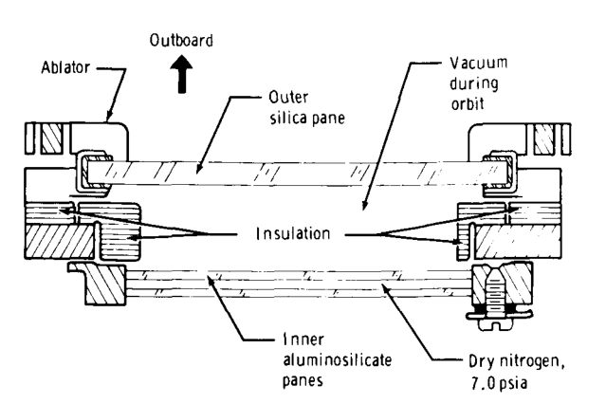
Figure 1. Cross-sectional drawing of Apollo’s command module hatch window. [1]

There are two sets of windows to a singular window structure – the outer, heat-shield window and the inner, pressure-vessel window. The outer window is usually one glass pane, the thickest singular pane, meant to withstand small impacts from debris and meteoroids and, as necessary, the extreme heating during entry. The cavity between the inner and outer windows is typically vacuum during orbit. The inner window is a boundary for the pressurized volume and is double paned (glass or plastic) for redundancy; the outermost pane here is sometimes referred to as the “redundant pane”, and the inner most the “pressure pane” as it is a boundary for the pressure vessel. The cavity between the inner window’s panes is usually evacuated and filled with a dry, inert gas.

Often forgotten by non-thermal engineers, there are important thermal impacts to including windows on a spacecraft design. In an uncovered window, additional heatload can enter from direct view to the sun, albedo from a planetary surface, or reflection off of parts of the vehicle in view of the window or from nearby vehicles. Windows can also lead to heat loss to space. For entry vehicles, windows may also serve as part of the vehicle Thermal Protection System. Therefore, windows must be included in thermal models to predict temperatures, and the optical properties of pane materials and the addition of coatings increase modeling complexity. Testing of windows is also extremely complex compared to typical spacecraft structure because each pane can be unique (depending on material), the materials are transmissive by nature and properties are hard to measure, and physically measuring window material temperature can be challenging due to the fact that temperature sensors can be difficult to adhere and they block some of the energy transfer through the window. This paper goes through some history of windows on spacecraft, introduces window material options, and finally goes into detail about thermal impacts of window and modeling and testing methods.

History
Windows have always been integral parts of all of NASA’s flown, crewed spacecraft missions and will continue to be included on future crewed vehicles. Historic vehicles window designs were primarily constructed of glass, but new window materials are being developed and used on Orion, Gateway, commercial space vehicles, and Pressurized Rover.

Apollo spacecraft had all glass panes, each window was comprised of three panes - two inner panes comprised of aluminosilicate panes with an inert gas in-between and one outer silica pane. The shuttle glass panes in front for GNC and one, with polycarbonate panes, in rear of crew area for viewing the payload bay. The windshields were made of glass and had three panes each, like Apollo. Figure 2 shows a cross-section of the windshields.[7]

ISS has all glass panes, similar in structure to Apollo and Shuttle.[6] Orion uses a hybrid mixture of glass and polymer panes. The outer thermal and redundant thermal panes are glass, but the inner pressure pane is acrylic.[2] Gateway windows will follow the Orion in using hybrid glass and polymer panes (e.g., glass debris pane, acrylic scratch pane, internal and external pressure panes). New technologies in this realm are ever evolving. Future prospects include laminated panes, curved windows, large-scale panes, and new materials.

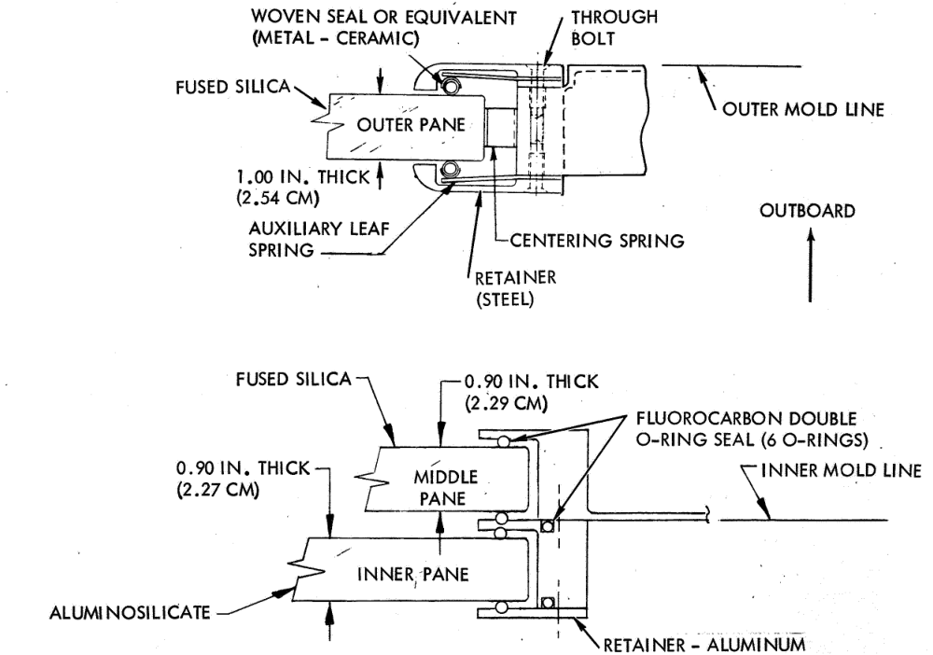
Figure 2. Cross-sectional drawing of the Shuttle windshield. [7]

Pane Materials
Windowpane materials can be divided into three categories – brittle/glass or ductile/plastic materials for the pane core, and then the surface coating. Glasses are the brittle materials for this purpose, and examples include fused silica, borosilicate, and aluminosilicate. Ductile materials include polycarbonates and acrylics both cast and stretched. Each set has its own advantages and disadvantages.

Glasses provide the best optics, compatibility, and thermal protection but they are heavy and brittle. Acrylic and polycarbonate materials can still provide adequate optics and are comparatively light weight and easier to fabricate but can have issues in compatibility and aging; and as of this writing, there is a lack of established industry material property data.[3]

Coatings are a strategy to overcome some pane material shortcomings and hone performance but may present a tradeoff themselves.

Brittle Materials (Glasses)
Overall glass provides the best optics, compatibility, and thermal protection. Certain types of glass are 100% transmissive in the visible range but may also be transmissive to a significant amount of UV and IR light, meaning it is valuable from a science perspective. Glasses provide excellent optics, thermal shock properties, and ballistic resistance to MMOD impacts. Fracture data and methodologies exist to manage the material risk. With glasses there are low -to no environmental issues (e.g., AO, flammability, radiation, etc.). It is impervious to atomic oxygen and UV, both of which may degrade plastics extremely quickly by attacking the surface and breaking down bonds causing embrittlement. Thermo-optical properties of glass windows are unlikely to change during the entire mission.

However, glass is brittle and provides little to no radiation shielding for crew and internal systems. Glass panes lose strength over time and have no tolerance to surface damages like scratches; even worse, there is no non-destructible means of determining actual strength of the component. To reduce risk, glass windows are usually supplemented with redundant panes, increasing mass of the system.[3]

Ductile Materials (Plastics)
Ductile materials include plastics such as acrylics and polycarbonates. As the name implies, these materials are more pliable and damage-resistant than glass; they are usually cheaper to manufacture but they have their own tradeoffs.

Acrylics (Cast and Stretched)
Acrylic glasses can be engineered to provide excellent optical properties; by nature, they are very lightweight and have excellent damage tolerance, good impact resistance, good hvi resistance, and are not brittle. There is also evidence that acrylic windows can provide some thermal protection capability. For example, space shuttle Columbia’s internal, payload-focused acrylic window survived the system’s disintegration upon re-entry.

Acrylic windows are relatively inexpensive to manufacture, easy to machine, polishable, and capable of shielding from some radiations. However, as of this writing, the drawbacks of acrylic window materials include a lack of established industry material property data, a possibility of brittle failure modes, material sensitivity to some environmental factors (including radiation, atomic oxygen, UV), flammability, and potential for creep over time.

Polycarbonates
Polycarbonates provide adequate optical properties for piloting and point-and-shoot imagery. The material is generally lightweight, not brittle, inexpensive, and easy to cut. Additionally, it has excellent damage tolerance, excellent impact resistance, some thermal protection capability, excellent reliability/low structural risk, and some radiation shielding capability.

Polycarbonate drawbacks are much like acrylics; firstly, there is no established industry material property data. Also, like acrylics, the material can be sensitive to environmental factors (radiation, atomic oxygen, UV), sometimes flammable, and have the potential for creep. Polycarbonate optical properties are insufficient for large aperture lens imagery and cannot be polished.

Coatings
Surface coatings are a good way to improve spacecraft windowpane performance in the areas of optics, durability, crew safety, and compatibility. For plastic panes, the coatings may be applied via vapor deposition, chemical coating, or other surface treatment processes, whereas for glass, usually a very thin sheet of plastic is vacuum sealed onto the pane material.

Examples of coatings in action include anti-reflective coatings, UV coatings, anti-scratch coatings, and even heater coatings. Heater coatings have been used on ISS glass; the coating is an indium tin oxide with embedded RTD’s. Figure 3 below shows a cross-section of the Apollo CM windows surface coatings.

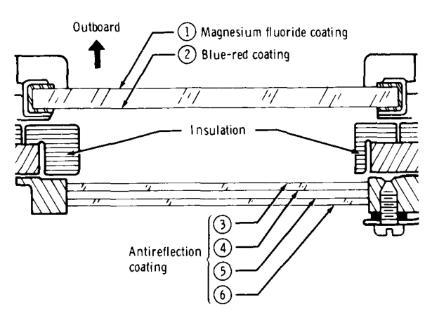
Figure 3. Apollo CM window surface notation.

Anti-reflective coatings reduce glare and filter undesired light. UV coatings may be added to a window to minimize UV light passing into the cabin. Low emissivity coatings are another common coating on both windows and astronaut helmets, as these reduce the heat flow between the pressurized volume and the space environment.

Yet another example are anti-scratch coatings; these are installed on the interior side of the inboard pane to prevent scratches and other damage from the crew. Most acrylic and polycarbonate vendors sell products with anti-scratch coatings. These are highly recommended to prolong component life. Anti-scratch coatings can also protect the pane from atomic oxygen attacks and larger physical impacts.

Coatings alter the pane’s optical properties (transmittance, absorptance, and reflectance), altering its thermal behavior. Always check for effects of unfamiliar coatings on pane materials as at times this may impact other areas. A case in point, the Orbiter had a red reflector (RR) coating found to detrimentally affect the strength of the glass, causing a late design change that placed it on the internal side of the cabin.

Thermal
Spacecraft windows represent a thermal liability due to heat leak to cold space, and their design, modeling, and analysis requires additional considerations due to the nature of their properties.

Heat Leak and Condensation Mitigation
Windows allow not just conduction of heat through the panes and frame, but the transmission of thermal radiation into and out of the vehicle. Windows leak heat from the cabin to the cold of space and may get very cold in the process; this can cause condensation as well. Any windowed spacecraft needs some method for controlling this heat leak. Heaters are a common solution to this problem, as are covers.

In years past, the Shuttle implemented a Window Cavity Conditioning System “WCCS”, to maintain clear windows and provide pressure control of window cavities.[6] The ISS uses a combination of external covers for the cupola and heater coatings not unlike those in terrestrial automobile back windshields.

Thermal Protection System
Windows on landing spacecraft, such as Orion’s or Apollo’s crew module, may experience aeroheating from atmospheric reentry and thus constitute a portion of the spacecraft’s thermal protection system (TPS). With extreme aeroheating, ablation can be a concern, whereby a solid material burns and sublimates (this typically starts at or around degradation temperature). Glass is typically the outermost pane for these designs due to its higher melting point and thermal tolerance. However, in the future, specifically engineered plastics could supersede glass for this purpose; Columbia’s acrylic payload-facing window survived the incident, not unscathed, but far better than previously predicted. Arc jet testing simulates heating and temperature conditions during atmospheric reentry; it is a form of destructive testing meant to characterize a material’s performance as a portion of the TPS. In arc jet testing, in near vacuum, a superheated plasma flows over a test sample for a short time; the sample is set up to guarantee a specific heat flux (usually in W/cm2; 20 W/cm2 is considered “high” for this portion of the TPS) for a period of time on the order of tens to hundreds of seconds depending on the case run (e.g. long, slow burn versus “worst case” high flux for a short time). A calibration run with calorimeters is performed before sample runs to ensure the chamber conditions produce the target heat flux. Temperature sensors within the sample record the internal temperatures the sample experiences; aimed IR cameras and pyrometers record the sample’s surface temperatures. This can be problematic for transparent samples as they may reflect and transmit thermal radiation more than they emit, causing the camera to read a temperature that does not reflect the actual sample surface temperature.

Modeling and Testing
The thermal modeling of transparent and semi-transparent materials involves many challenges absent in common aerospace materials. Care must be taken when modeling vehicles with windows. Windows are, by design, transparent in the visible and frequently near-infrared ranges, so there is some amount of light that enters through the window and is absorbed in interior surfaces that must be considered, making the typical modeling approach of internal and external radiation groups in more nuanced. Another consideration is that surfaces in thermal analysis are not always drawn true to CAD and there may be some geometry differences that allow light to leak to parts of the spacecraft in modeling that, in real life, would be blocked.

There is also the consideration of the window properties themselves. Regarding optics, unlike opaque surfaces, the thickness of the pane may make a difference to the absorptance and transmittance. The variety of different coatings and different manufacturing methods for windowpane materials also make it difficult to determine accurate optical properties, especially as modern window materials evolve beyond glass. If the refractive index, thickness, and extinction coefficient of the window material are known, the transmittance, reflectance, and absorptance of the windowpane may be computed as a slab with ray tracing methods. Similarly, the transmittance, reflectance, and absorptance of the windowpane with coatings may be calculated by considering it as a thick slab with thin film(s).[4] A final consideration is that many modeling tools are designed for opaque materials and may lack the ability to model the in-depth absorption of incident solar radiation.

Comparatively, typically thermal conductivity is mid for glass and low for plastic. Heat capacity tends to be high for glass but low for plastics. [5] These are usual trends; once again, one must seek the manufacturer’s properties.

When high level of fidelity is required, windows can be modeled in Thermal Desktop and other software by following the advice above. The lay-up geometry should be modeled with more accuracy than typical thermal models, making sure to keep layer thickness and gap distances correct. To increase accuracy due to reflections within the transparent materials, panes should be modeled as solids rather than surfaces and all surfaces (external spacecraft surfaces, inside, outside, and internal surfaces of solid windowpanes, and internal spacecraft surfaces) should be included in the same radiation analysis group. Structure should surround the edges of the window as it would in real life to avoid unintentional light leaks. Other structure, which may block light in real life but may not be modeled, should also be considered. Internal air or air in between panes can be modeled as boundary nodes with convective ties to the surfaces. High fidelity is not always required for windows, so this may be simplified in those cases.

Issues
Issues rooted in physics, hardware constraints, and material variability plague window thermal modeling, analysis, and temperature measurement. Historically thermal models have not been accurately corelated (±10% accuracy) for transparent materials. Correlating analysis of window thermal performance to tests can prove elusive.

Historically, measuring temperature on transparent material has been difficult or elusive due to the nature of the material. The reflective and transparent nature of the material makes measuring surface temperature with infrared photography difficult. A strategically placed piece of black electrical tape may help. Regarding measuring internal temperatures, since most windowpane materials have a low thermal conductivity, the method of placing sensors can have a significant impact on the temperature measured, and thermal resistance between the sensor and pane should be considered. Adhesion of sensors may be more difficult on window materials than other materials which impacts contact conductance. Sensor cable radiative insulation may also affect the sensor output.

Beyond measurement, the availability of material property information complicates model correlation. Window material properties, such as such as emittance, conductivity, and specific heat, are typically expressed as a function of temperature, and information for this is often missing or inaccurate due to many variables to simultaneously correlate. Thermal and optical properties vary significantly based on manufacturer, especially for ductile materials.

Due to these issues, overstated thermal predictions drive several design efforts for windowpanes that may not be necessary and can add weight and cost, such as unnecessary heaters. Consequently, accurate thermal modeling and correlation techniques of windowpane materials is needed. Material properties such as modulus, CTE, thermal conductivity, emissivity, and specific heat as a function of temperature are needed. Elevated temperature creep testing for polycarbonate and acrylic materials needs to be developed.

Acknowledgments
A special thanks to structural windows SME’s Hannah Bradley, Lynda Estes, and Mykale Holland of JSC ES2.

References
1. APOLLO EXPERIENCE REPORT - SPACECRAFT STRUCTURAL WINDOWS, O.E. Pigg & S.P. Weiss, NASA TN D-7439, 1973
2. Optical Property Requirements for Glasses, Ceramics and Plastics in Spacecraft Window Systems, NASA Document JSC 66320, Baseline December 2011
3. Engineering of Windows for the International Space Station, L.R. Estes & K.S. Edelstein
4. Radiative Heat Transfer 2nd Edition, Modest.
5. Introduction to Heat Transfer 5th edition, Incropera et al.
6. Analysis of the Purge, Vent, and Drain Subsystem, McDonnell Douglas Astronautics Co., NASA NTRS no. 19900001653, November 1987
7. Space Shuttle Orbiter Windshield System Design and Test Final Report, NASA NTRS 19730007152, November 1972

AST Heat Transfer, Passive Thermal Branch, 2101 E NASA Pkwy, MS ES3, Houston, TX 77058.

