NASA/TM-20240002945

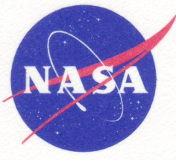

Stress Corrosion Evaluation of Inconel
X-750 for the International Space Station Environmental Control and Life Support System

Pablo D. Torres
Marshall Space Flight Center, Huntsville, Alabama

March 2024

ABSTRACT

Inconel X-750 alloy was evaluated for stress corrosion in support of the Environmental Control and Life Support System. Round tensile specimens that were obtained from 0.25 in thick material successfully completed 365 days of exposure to baseline pretreat, baseline brine, alternate pretreat, alternate brine, and 3.5% NaCl alternate immersion without any failures at stresses of up to 90% of the yield strength. Posttest evaluations consisting of metallography and tensile testing did not indicate stress corrosion susceptibility.

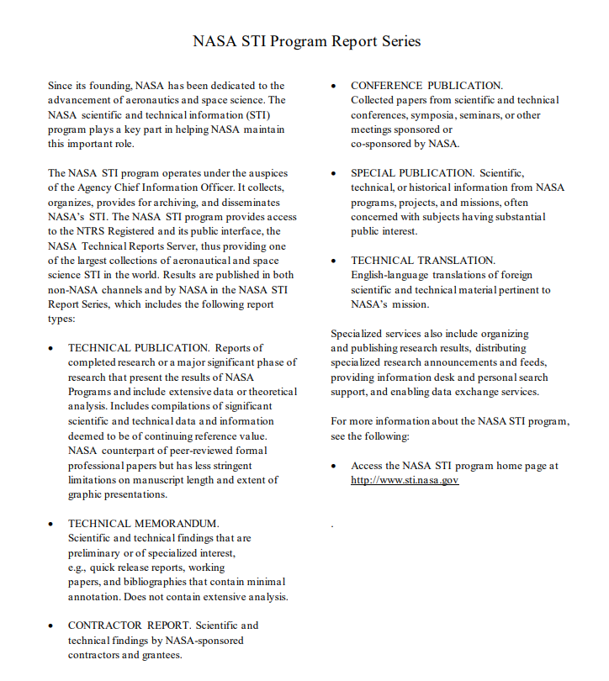

NASA/TM-20240002945

Stress Corrosion Evaluation of Inconel
X-750 for the International Space Station Environmental Control and Life Support System

Pablo D. Torres
Marshall Space Flight Center, Huntsville, Alabama

National Aeronautics and
Space Administration

Marshall Space Flight Center, Huntsville, Alabama 35812

March 2024

ACKNOWLEDGEMENTS

The author wishes to acknowledge the contributions of the following supporters from Marshall Space Flight Center: A. Richardson from the Transportation and Logistics Engineering Office; A. Girgis, L. Sharff, C. Harris, J. Faulk, C. Bosley, S. Bell, and R. Shelton from the Materials Test, Chemistry, and Contamination Control Branch; J. Hastings, J. Honeycutt, E. Rabenberg, K. Rodgers, and I. Hanson from the Materials Science and Metallurgy Branch; L. Foreman from the Materials and Processes Engineering Support Office; J. Hill from the Mechanical Design, Analysis and Fabrication Division; D. Carter, J. Williamson, and D. Long from the Environmental Control and Life Support System Development Branch; K. Presson from the International Space Station Projects Office; and S. Lecroix and P. White from the Mechanical Fabrication Branch.

The use of trademarks or names of manufacturers in this report is for accurate reporting and does not constitute an official endorsement, either expressed or implied, of such products or manufacturers by the National Aeronautics and Space Administration.

Available from:

NASA STI Program / Mail Stop 050
NASA Langley Research Center
Hampton, VA 23681-2199

This report is also available in electronic form at
http://www.sti.nasa.gov

LIST OF ABBREVIATIONS, ACRONYMS, AND SYMBOLS

AMS | Aerospace Material Specification
ASTM | American Society for Testing and Materials
AvUTSi | average ultimate tensile strength initially
E | modulus of elasticity (Also known as Young’s modulus), stress/strain
ECLSS | Environmental Control and Life Support System
EL | elongation
HCl | hydrochloric acid
ksi | kilopounds per square inch
Msi | Megapounds per square inch
NaCl | sodium chloride
NaOH | sodium hydroxide
RA | reduction in area
SCC | stress corrosion cracking
TIR | total indicator reading
UNC | Unified National Course
UNS | Unified Numbering System
UTS | ultimate tensile strength
UTSe | ultimate tensile strength after exposure
YS | yield strength (0.2% offset)

TECHNICAL MEMORANDUM

STRESS CORROSION EVALUATION OF INCONEL X-750 FOR THE INTERNATIONAL SPACE STATION ENVIRONMENTAL CONTROL AND LIFE SUPPORT SYSTEM

- INTRODUCTION

Inconel X-750 alloy, a nickel-chromium alloy (UNS Number N07750) was evaluated for stress corrosion cracking (SCC) resistance in support of the Environmental Control and Life Support System (ECLSS). The experimental work and preparation of the document were performed at the Marshall Space Flight Center Materials and Processes Laboratory. This evaluation was performed in environments that are representative of service conditions and also in a sodium chloride (NaCl) environment for comparison purpose. The purpose of this investigation is to determine if the material has adequate SCC resistance. For previous stress corrosion studies in support of ECLSS see references 1-4.

- EXPERIMENTAL PROCEDURE

Inconel X-750 material with a thickness of 0.25 in was obtained from Specialty Metals for this evaluation. The chemical composition limits per AMS 5542 (Reference 5) and the mill analysis are presented in Table 1.

Table 1. Chemical composition of Inconel X-750.
Element | Minimum  (Weight Percent  Per AMS 5542) | Maximum  (Weight Percent Per AMS 5542) | Mill Analysis  (Weight Percent in Material Certification (Heat Number HT4750XK1221))
Carbon | -- | 0.08 | 0.05
Manganese | -- | 1.00 | 0.07
Silicon | -- | 0.50 | 0.06
Sulfur | -- | 0.01 | 0.001
Chromium | 14.00 | 17.00 | 15.99
Columbium (Niobium) | 0.70 | 1.20 | 0.88
Titanium | 2.25 | 2.75 | 2.44
Aluminum | 0.40 | 1.00 | 0.71
Iron | 5.00 | 9.00 | 8.08
Cobalt | -- | 1.00 | 0.02
Tantalum | -- | 0.05 | 0.003
Copper | -- | 0.50 | 0.12
Nickel + Cobalt | 70.0 | -- | 71.41
Phosphorus | -- | -- | 0.003
Niobium + Tantalum | -- | -- | 0.89

The specimens for this evaluation were fabricated per drawing shown in Figure 1. A view of a representative fabricated sample is shown in Figure 2. Three specimens were tensile tested in air at room temperature (70°F) per The American Society for Testing and Materials (ASTM) Standard Test Method E8 (Reference 6) to obtain baseline tensile data and the results are presented in Table 2. Figure 3 shows the stress-strain curves and statistical data obtained from this testing.

The remaining of the specimens were loaded per ASTM Standard Practice G49 (Reference 7) to various percentages of the yield strength (YS) by using the constant strain method. The stress levels were 0%, 75%, and 90% of the YS. Most of the specimens in this test program were tested in triplicate. A modulus of elasticity of 27.7 Msi was used to calculate the strains corresponding to the desired stress levels.

Figures 4-7 show the schematic diagrams of the stressing fixtures used to load the specimens. The material used for the fixtures was PH 13-8 Mo H1000. Figure 8 shows the stressing device and the extensometer used to load the samples and Figure 9 shows representative stressing components, a fully assembled specimen, and a view of a sample with a strain gage extensometer attached.

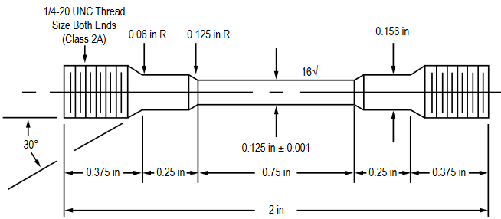

Notes:
- Tolerances: ± 0.005 inch, except otherwise specified.
- Surface finish (arithmetic average roughness value in microinches): 16√ for the reduced section, 32√ for the rest.
- Thread dimensions must be as specified. Measurement by fabricator is mandatory.
- No undercutting of radii permitted.
- Gage section to be concentric with axis within 0.002 inch TIR (gage section of the tensile specimen cannot have more than 0.002 in total run-out) and parallel.
- No file marks or nicks permitted within gage section.
- If center-drilling the ends, keep the hole as small as possible. Chamfer diameter not to exceed 0.100 in.
- Break sharp edges.
- The reduced section may have a gradual taper from the ends toward the center with the ends not more than 0.005 inch larger in diameter than the center.
- Drawing not to scale.
- Place each specimen in individual Ziplock bag and write on each bag the corresponding specimen ID.

Figure 1. Configuration used to fabricate the Inconel X-750 round tensile specimens.

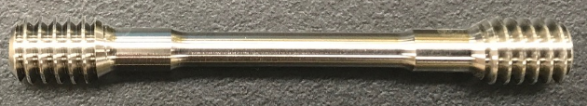
Figure 2. View of representative Inconel X-750 stress corrosion specimen as received.

Table 2. Baseline tensile data for Inconel X-750 alloy.

Specimen Number | UTS  ksi | YS  ksi | EL  % | RA  % | E  Msi
X-750-44 | 137.2 | 71.5 | 42.1 | 34.0 | 25.7
X-750-45 | 131.0 | 65.9 | 43.5 | 33.2 | 29.8
X-750-46 | 130.0 | 63.3 | 45.2 | 33.5 | 27.7
Averages | 132.7 | 66.9 | 43.6 | 33.6 | 27.7
UTS: ultimate tensile strength
YS: 0.2% offset yield strength
EL: fracture elongation
RA: reduction in area
E: modulus of elasticity (also known as Young’s modulus)

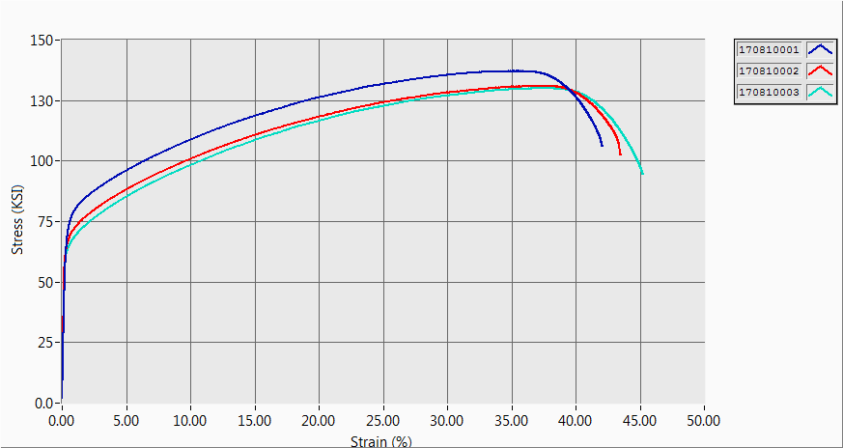
X-750-44
X-750-45
X-750-46
(a)-Stress-strain curves

(b)-Individual Tensile Data Results
Specimen Identification | Tensile Strength  (ksi) | Yield Strength  (ksi) | Inelastic Strain  (%) | Modulus of Elasticity  (Msi) | Fracture Elongation  (%) | Reduction of Area  (%)
X-750-44 | 137.16 | 71.51 | 41.58 | 25.67 | 42.05 | 34.04
X-750-45 | 130.97 | 65.89 | 43.06 | 29.76 | 43.48 | 33.21
X-750-46 | 130.04 | 63.29 | 44.77 | 27.74 | 45.19 | 33.50

(c)-Statistical Data
Test Results | Maximum | Minimum | Median | Mean | Standard Deviation | Coefficient of Variation
Tensile Strength (ksi) | 137.16 | 130.04 | 130.97 | 132.72 | 3.87 | 2.91
Yield Strength (ksi) | 71.51 | 63.29 | 65.89 | 66.90 | 4.20 | 6.27
Inelastic Strain (%) | 44.77 | 41.48 | 43.06 | 43.14 | 1.59 | 3.70
Modulus of Elasticity (Msi) | 29.76 | 25.67 | 27.74 | 27.73 | 2.04 | 7.36
Fracture Elongation (%) | 45.19 | 42.05 | 43.48 | 43.57 | 1.57 | 3.60
Reduction of Area (%) | 34.04 | 33.21 | 33.50 | 33.58 | 0.42 | 1.26

Figure 3. Stress-train curves (a), individual tensile data results (b), and statistical data (c) for Inconel X-750 non-exposed specimens.

After the samples were loaded, they were exposed to the ECLSS solutions (baseline pretreat, baseline brine, alternate pretreat, and alternate brine) by complete immersion (Figure 10) and to 3.5% NaCl alternate immersion (Figures 11 and 12) per ASTM G44 (reference 8) and regularly inspected. According to Reference 9, the alternate formulation (phosphoric acid based) was developed because the baseline formulation (sulfuric acid based) was causing precipitation of calcium sulfate dihydrate in the urine processor assembly distillation assembly, which resulted in problems in the system. For more information and to see how the problem was approached see Reference 9. The test solutions were supplied already prepared by the Environmental Control and Life Support System Development Branch at Marshall Space Flight Center (ES62). Appendix A shows details on how the ECLSS solutions were prepared and Appendix B describes the alternate immersion test procedure. The test duration was 365 days.

After completing all the exposures, part of the specimens were subjected to metallographic evaluations to determine if cracks were present. Others were tensile tested and the strength compared with the initial strength obtained with non-exposed specimens. These comparisons can determine if there is any reduction in load carrying ability of the specimens, and if so, to what extent. When there is a reduction in load carrying ability, these tests can determine if the stress and the environment, acting together, had a more detrimental effect on the strength than the environment alone, and when that is the case, to what extent.

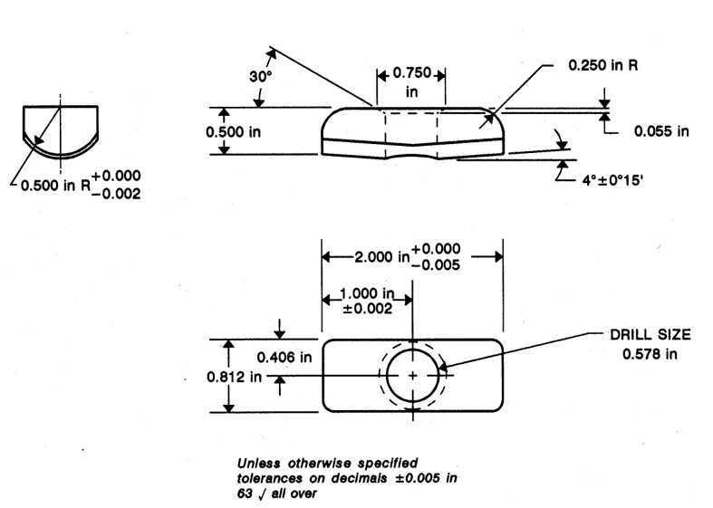
Figure 4. Stress corrosion frame crosshead.

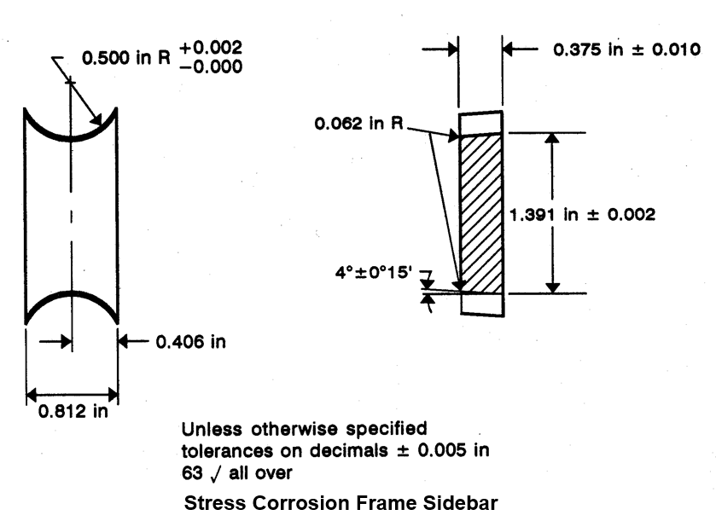

Figure 5. Stress corrosion frame sidebar.

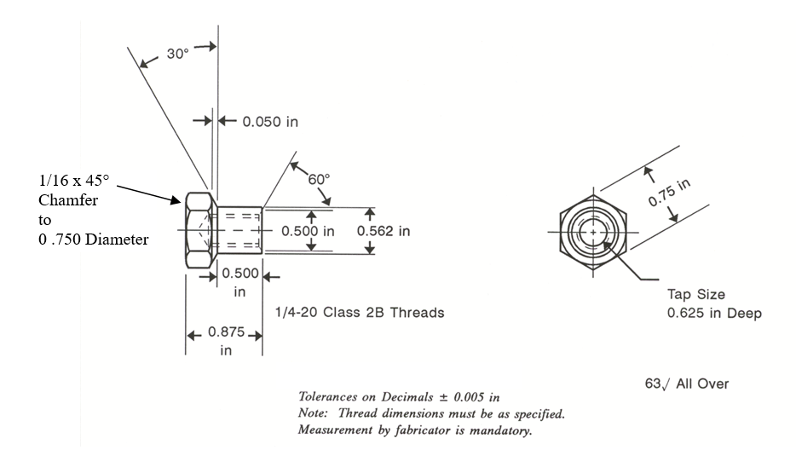
Figure 6. Stress corrosion frame nut with 1/4-20 threads.

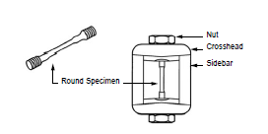

Figure 7. Schematic diagram of a fully assembled specimen (not to scale).

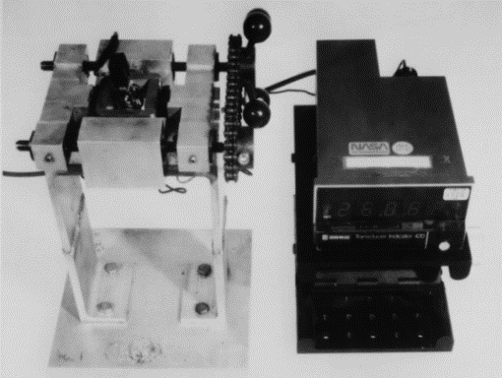

Figure 8. Stressing device and extensometer.

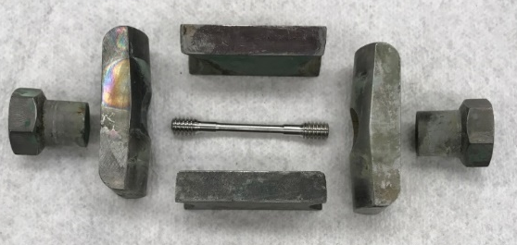
(a)-Exploded view of the stressing assembly

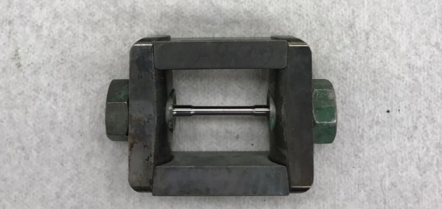
(b)-Assembled specimen

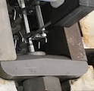
(c)-Specimen with the attached strain gage extensometer

Figure 9. Photographs of frames and assembled specimen.

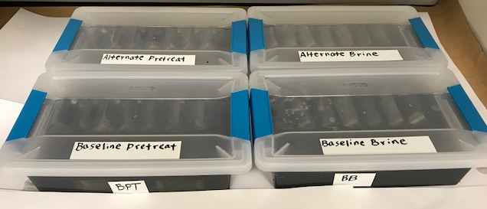
(a)-Specimens being immersed

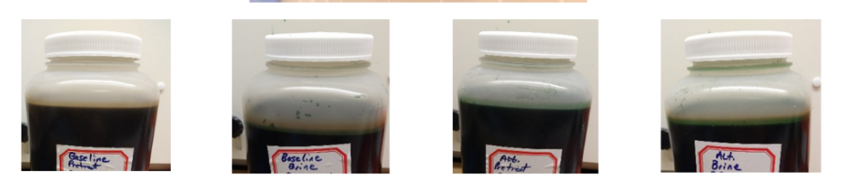
(b)-ECLSS solutions

Figure 10. Stress corrosion test setup for Inconel X-750 specimens tested by complete immersion.
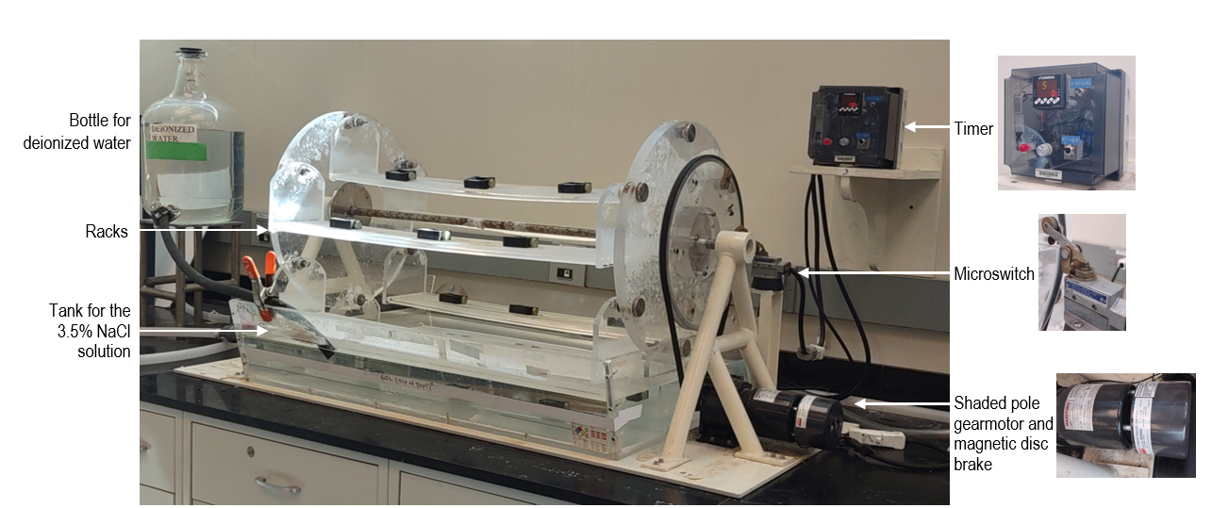

Figure 11. Photograph of a typical alternate immersion tester similar to the one used to test Inconel X-750.

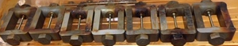

Figure 12. Photograph of Inconel X-750 samples on the plexiglass racks being exposed in the alternate immersion tester.

- RESULTS AND DISCUSSION

None of the specimens failed in this test after a yearlong exposure, as shown in table 3. Figure 13 shows the specimens after they were removed from the test environments and washed with water. The specimens were then removed from the stressing frames. Figure 14 shows close-up images of representative samples after they were disassembled.
Table 3. Stress corrosion test results of Inconel X-750 after
365 days of exposure to various environments.

Test Environment | Stress Level  (%YS) | Stress Level  (ksi) | Failure Ratio* | Remarks
Baseline Pretreat  (Sulfuric Acid Based)  Total Immersion | 0  75  90 | 0  50.2  60.2 | 0/3  0/3  0/3 | No failures after 365 days of exposure
Baseline Brine  (Sulfuric Acid Based)  Total Immersion | 0  75  90 | 0  50.2  60.2 | 0/3  0/3  0/3 | No failures after 365 days of exposure
Alternate Pretreat (Phosphoric Acid Based)  Total Immersion | 0  75  90 | 0  50.2  60.2 | 0/3  0/3  0/3 | No failures after 365 days of exposure
Alternate brine  (phosphoric acid based)  total immersion | 0  75  90 | 0  50.2  60.2 | 0/3  0/3  0/3 | No failures after 365 days of exposure
3.5% NaCl alternate immersion | 0  75  90 | 0  50.2  60.2 | 0/2  0/2  0/3 | No failures after 365 days of exposure
*Failure Ratio = (Number of failures) / (Number of specimens tested at the same condition)

For each set of three samples, one was examined with metallography and two were tensile tested. For the sets that had only two specimens, they were both subjected to tensile testing. A photograph showing representative samples after they were tensile tested is shown in Figure 15. The ultimate tensile strength values of the specimens that were exposed (UTSe) are presented in Table 4. These values ranged from 130.1 ksi to 144.7 ksi. Eleven of them were less that the average initial UTS value (AvUTSi) of 32.7 ksi, 18 were greater, and 1 was the same. The average UTS after exposure, counting all the samples, was 134.8 ksi, which is 1.6% higher than the average initial value of 132.7 ksi. The exposed-to-initial UTS ratios (UTSe/AvUTSi) ranged from 0.980 (UTSe was 2% less than AvUTSi) to 1.090 (UTSe was 9% higher than AvUTSi). The overall exposed-to-initial UTS value was 1.016 and the median value was 1.008. Figure 16 shows stress-strain curves for most of the specimens that were tensile tested after exposure and Figure 17 shows a graph contrasting the average UTS value after exposure for each environment against the average baseline initial value obtained from non-exposed specimens. The quantities in Figure 17 contain error bars denoting coefficient of variation. This coefficient of variation was obtained by taking the sample standard deviation and dividing it by the mean value. As seen in Table 4 and Figure 17, the strength values after exposure had a slight tendency to be higher than the initial values. This data suggest that the specimens did not lose ability to carry the load as a result of the exposure, regardless if they were exposed with an applied stress or unstressed.

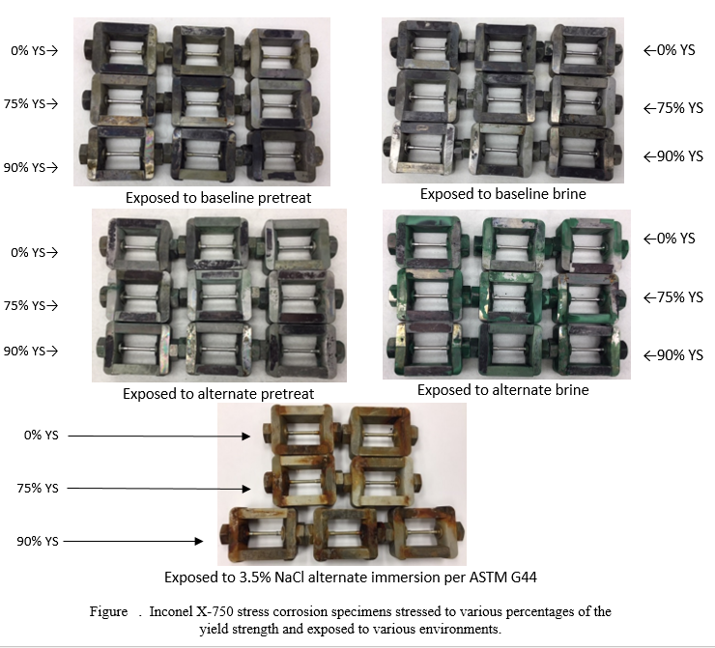
Figure 13. Inconel X-750 stress corrosion specimens stressed to various percentages of the yield strength and exposed to various environments for 365 days.

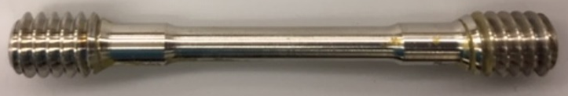  Sample X-750-BLPT-0-1, 0% YS, baseline pretreat | 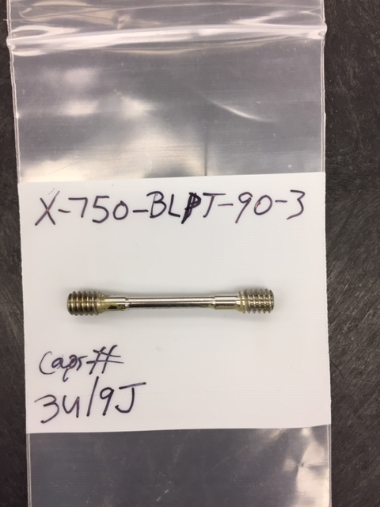  Sample X-750-BLPT-90-3, 90% YS, baseline pretreat
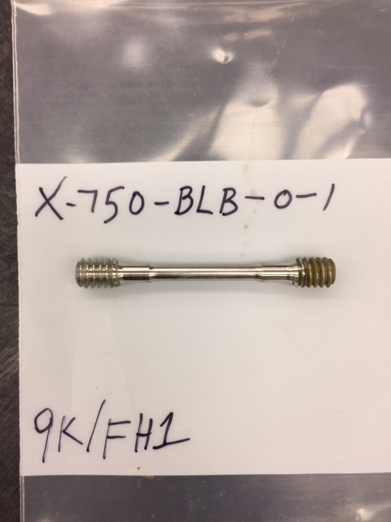  Sample X-750-BLB-0-1, 0% YS, baseline brine | 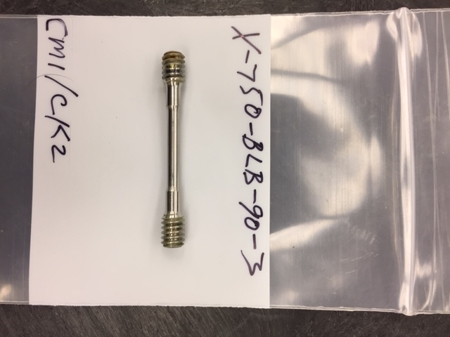  Sample X-750-BLB-90-3, 90% YS, baseline brine
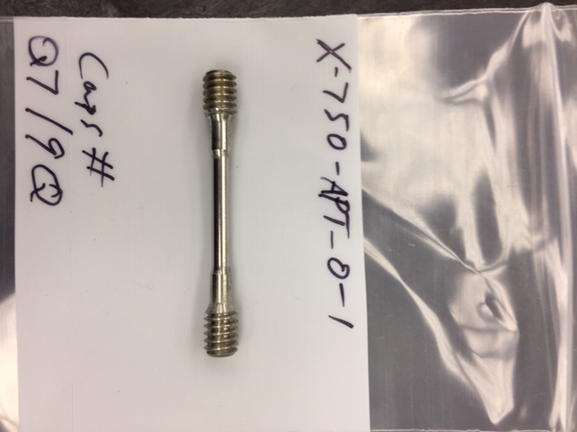  Sample X-750-APT-0-1, 0% YS, alternate pretreat | 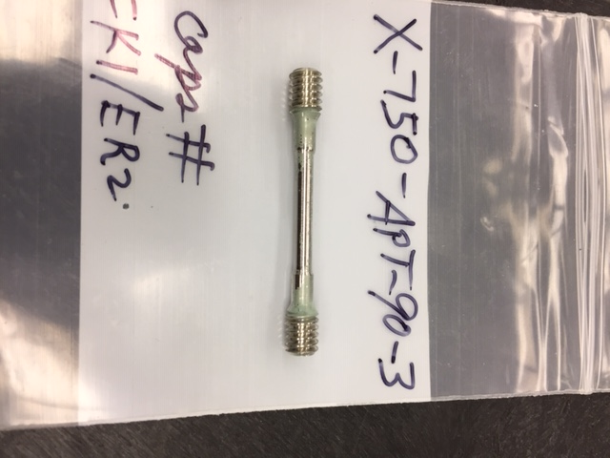  Sample X-750-APT-90-3, 90% YS, alternate pretreat
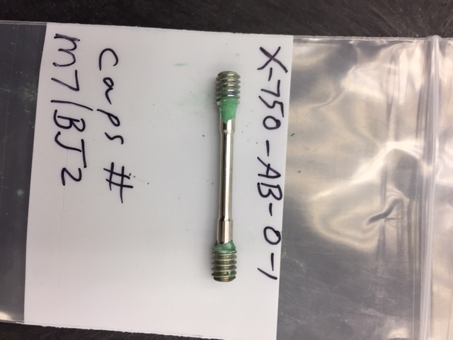  Sample X-750-AB-0-1, 0% YS, alternate brine | 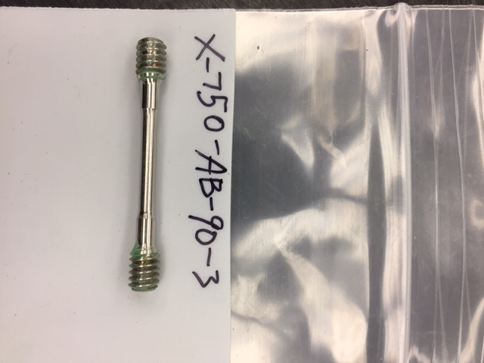  Sample X-750-AB-90-3, 90% YS, alternate brine
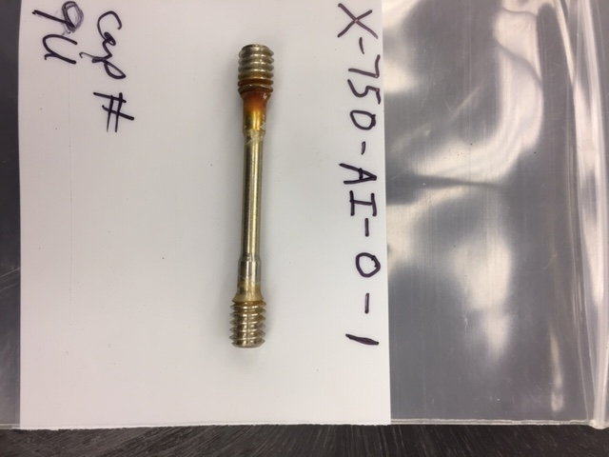  Sample X-750-AI-0-1, 0% YS, alternate immersion | 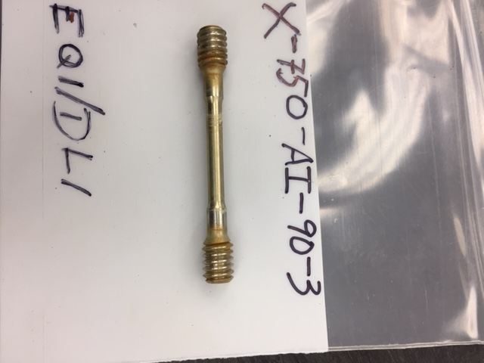  Sample X-750-AI-90-3, 90% YS, alternate immersion

Figure 14. Close-up images of representative Inconel X-750 stress corrosion specimens after exposure to various environments.

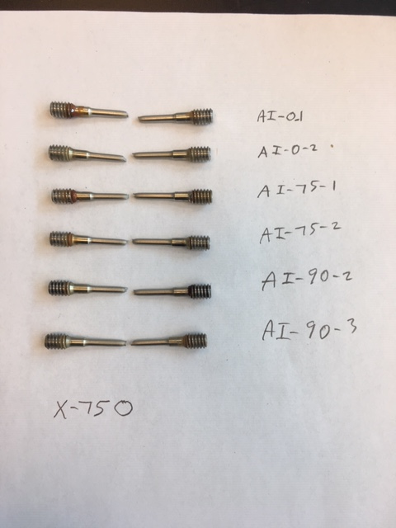

Figure 15. Photograph of representative exposed samples after they were tensile tested.
Table 4. Comparison of post-exposure UTS with initial UTS for Inconel X-750.

Test Environment | Specimen Number | Stress  Level  (% YS) | Stress  Level  (ksi) | UTSe  (UTS for exposed specimen)  (ksi) | Exposed-to-Initial UTS Ratio  (UTSe/AvUTSi  = UTSe/132.7)
Baseline Pretreat | X-750-BLPT-0-2 | 0 | 0 | 133.5 | 1.006
(Sulfuric Acid Based) | X-750-BLPT-0-3 | 0 | 0 | 130.4 | 0.983
(365 Days) | X-750-BLPT-75-2 | 75 | 50.2 | 134.3 | 1.012
 | X-750-BLPT-75-3 | 75 | 50.2 | 132.5 | 0.998
 | X-750-BLPT-90-2 | 90 | 60.2 | 132.0 | 0.995
 | X-750-BLPT-90-3 | 90 | 60.2 | 141.0 | 1.063
 |  |  |  | Avg=134.0 | Avg=1.010
Baseline Brine | X-750-BLB-0-2 | 0 | 0 | 144.7 | 1.090
(Sulfuric Acid Based) | X-750-BLB-0-3 | 0 | 0 | 139.0 | 1.047
(365 Days) | X-750-BLB-75-2 | 75 | 50.2 | 135.9 | 1.024
 | X-750-BLB-75-3 | 75 | 50.2 | 133.7 | 1.008
 | X-750-BLB-90-2 | 90 | 60.2 | 137.6 | 1.037
 | X-750-BLB-90-3 | 90 | 60.2 | 140.6 | 1.060
 |  |  |  | Avg=138.6 | Avg=1.044
Alternate Pretreat | X-750-APT-0-2 | 0 | 0 | 132.7 | 1.000
(Phosphoric Acid Based) | X-750-APT-0-3 | 0 | 0 | 130.7 | 0.985
(365 Days) | X-750-APT-75-2 | 75 | 50.2 | 139.6 | 1.052
 | X-750-APT-75-3 | 75 | 50.2 | 143.6 | 1.082
 | X-750-APT-90-2 | 90 | 60.2 | 130.8 | 0.986
 | X-750-APT-90-3 | 90 | 60.2 | 134.7 | 1.015
 |  |  |  | Avg=135.4 | Avg=1.020
Alternate Brine | X-750-AB-0-2 | 0 | 0 | 133.9 | 1.009
(Phosphoric Acid Based) | X-750-AB-0-3 | 0 | 0 | 133.8 | 1.008
(365 Days) | X-750-AB-75-2 | 75 | 50.2 | 130.6 | 0.984
 | X-750-AB-75-3 | 75 | 50.2 | 130.1 | 0.980
 | X-750-AB-90-2 | 90 | 60.2 | 131.1 | 0.988
 | X-750-AB-90-3 | 90 | 60.2 | 130.4 | 0.983
 |  |  |  | Avg=131.7 | Avg=0.992
Alternate | X-750-AI-0-1 | 0 | 0 | 140.7 | 1.060
Immersion in 3.5% NaCl | X-750-AI-0-2 | 0 | 0 | 130.6 | 0.984
(365 Days) | X-750-AI-75-1 | 75 | 50.2 | 134.5 | 1.014
 | X-750-AI-75-2 | 75 | 50.2 | 132.8 | 1.001
 | X-750-AI-90-2 | 90 | 60.2 | 132.0 | 0.995
 | X-750-AI-90-3 | 90 | 60.2 | 137.2 | 1.034
 |  |  |  | 134.6 | 1.015
 |  |  |  | Overall  Avg=134.8 | Overall  Avg=1.016

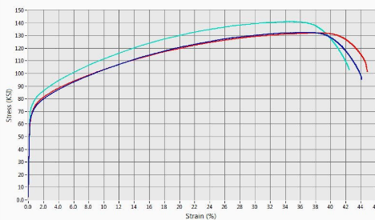 | 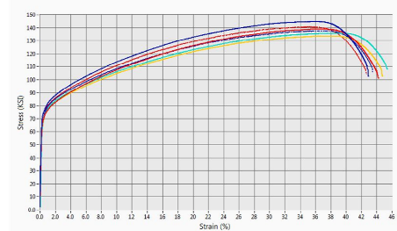
Baseline pretreat (Data shown for only 3 of 6 samples tested) | Baseline brine
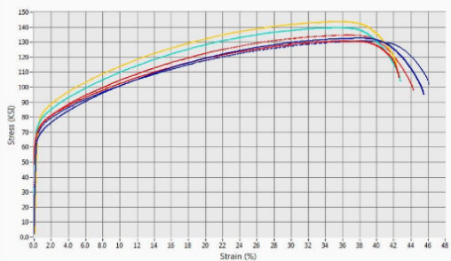 | 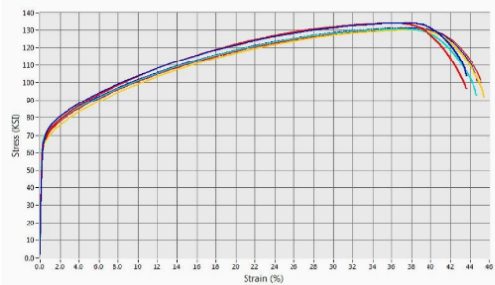
Alternate pretreat | Alternate brine
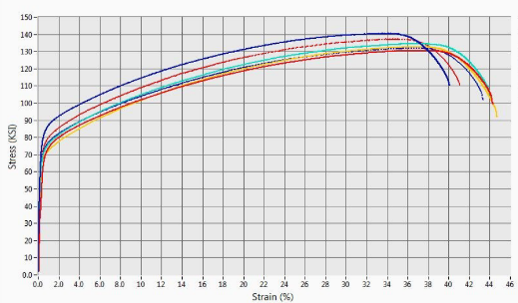
3.5% NaCl alternate immersion

Figure 16. Stress-strain curves for the majority of the Inconel X-750 specimens that were exposed for one year.

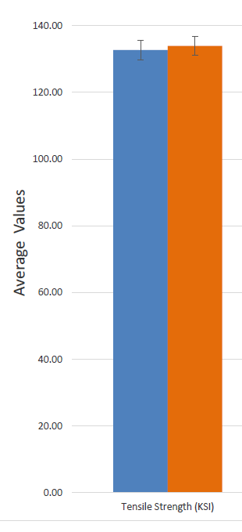 | 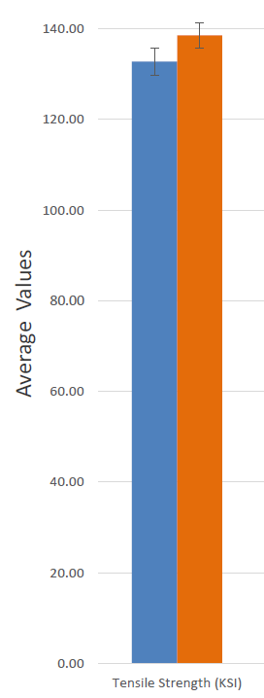 | 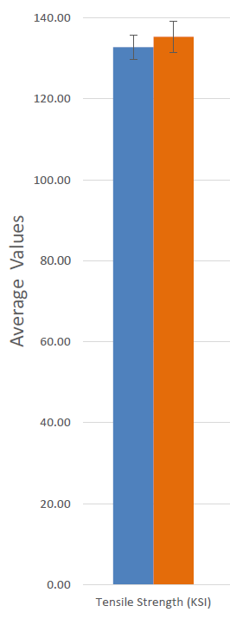 | 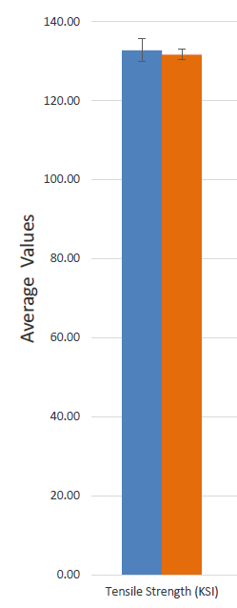 | 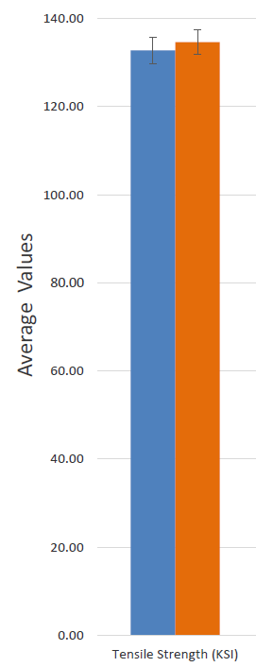
Baseline Pretreat | Baseline Brine | Alternate Pretreat | Alternate Brine | Alternate Immersion

Figure 17. Graph comparing average initial UTS values (left bar) with average post-exposure values (right bar) for Inconel X-750 exposed to various environments.

Information on the samples that were subjected to metallography is presented in table 5, and the metallographic views are shown in figures 18 to 30. No stress corrosion cracking features were observed on the specimens.

Table 5. Inconel X-750 specimens that were subjected to metallography after exposure.

Test Environment | Specimen Number | Stress Level  (% YS) | Stress Level  (ksi)
Baseline Pretreat (365 Days) | X-750-BLPT-0-1 | 0 | 0
 | X-750-BLPT-75-1 | 75 | 50.2
 | X-750-BLPT-90-1 | 90 | 60.2
Baseline Brine (365 Days) | X-750-BLB-0-1 | 0 | 0
 | X-750-BLB-75-1 | 75 | 50.2
 | X-750-BLB-90-1 | 90 | 60.2
Alternate Pretreat (365 Days) | X-750-APT-0-1 | 0 | 0
 | X-750-APT-75-1 | 75 | 50.2
 | X-750-APT-90-1 | 90 | 60.2
Alternate Brine (365 Days) | X-750-AB-0-1 | 0 | 0
 | X-750-AB-75-1 | 75 | 50.2
 | X-750-AB-90-1 | 90 | 60.2
Alternate Immersion (365 Days) | X-750-AI-90-1 | 90 | 60.2

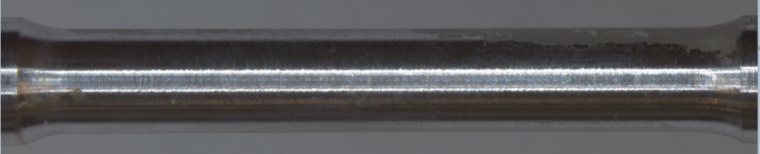
(a)-Overall view
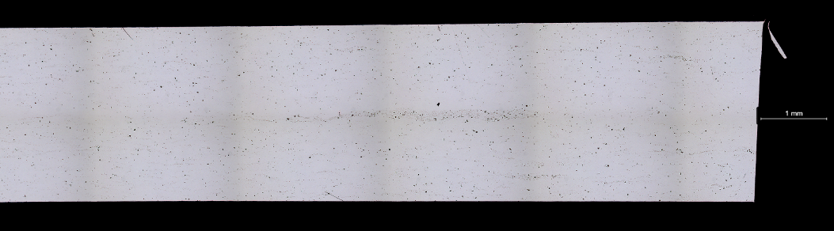
(b)-X50, unetched

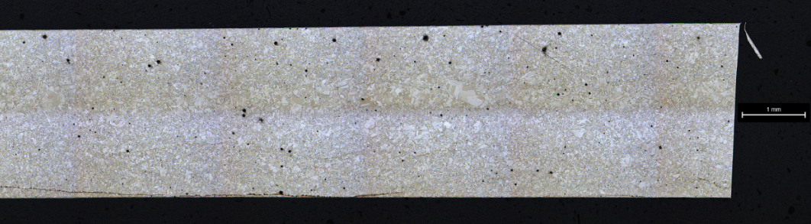
(c)-X50, etched

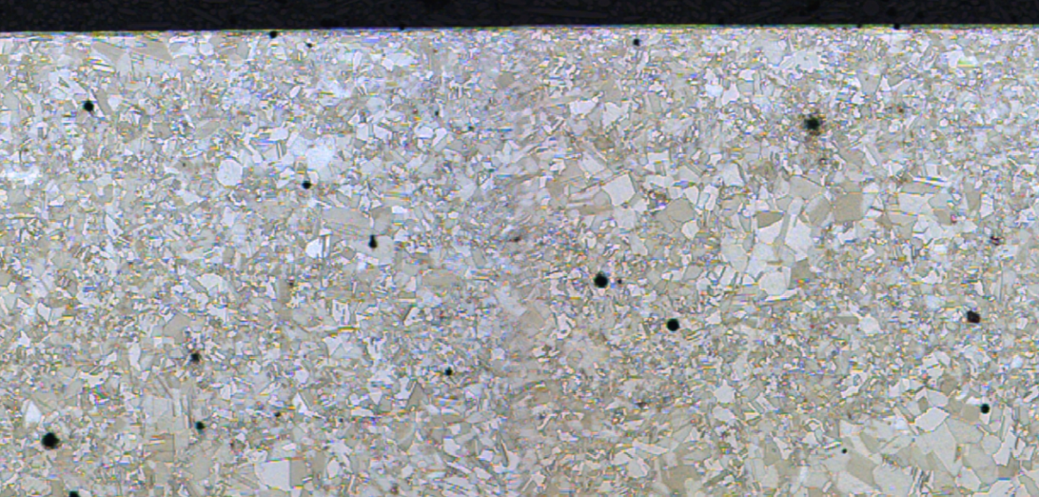
(d)-Magnified view, etched
Figure 18. Metallographic views of sample X-750-BLP-0-1, exposed unstressed to baseline pretreat for 365 days.

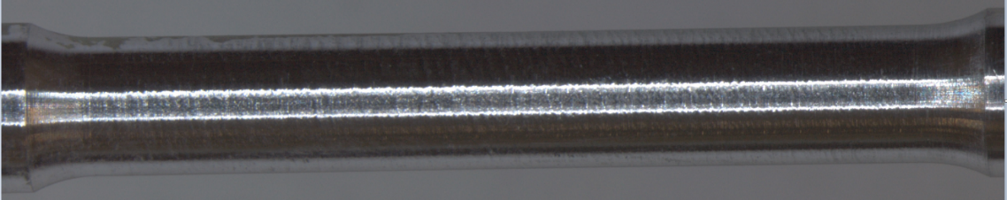
(a)-Overall view
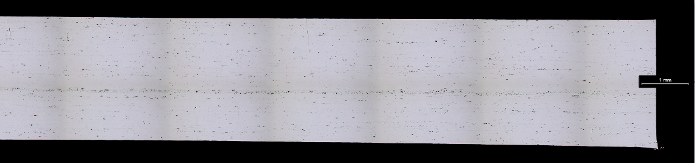
(b)-X50, unetched

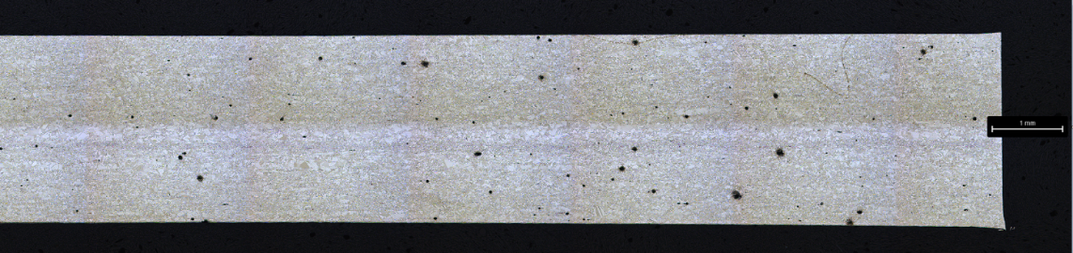
(c)-X50, etched
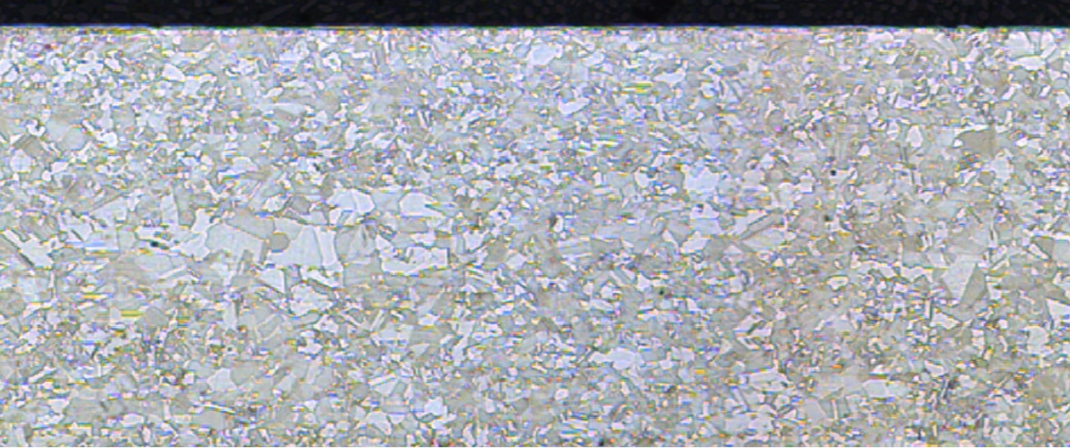
(d)-Magnified view, etched

Figure 19. Metallographic views of sample X-750-BLP-75-1, stressed to 75% YS (50.2 ksi) and exposed to baseline pretreat for 365 days.

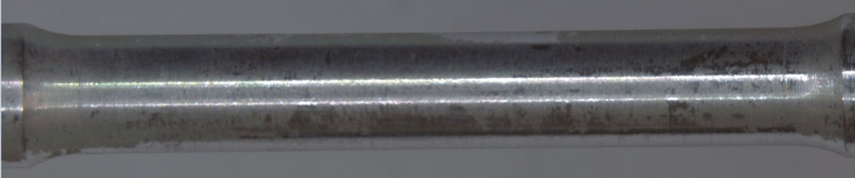
(a)-Overall view
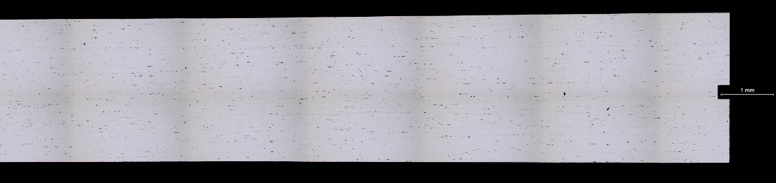
(b)-X50, unetched
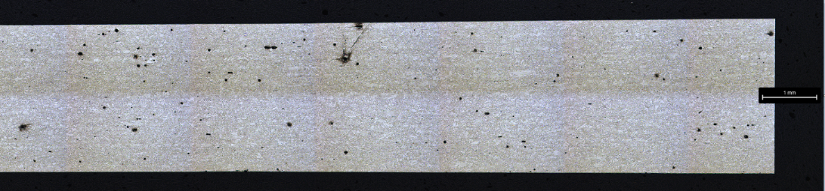
(c)-X50, etched
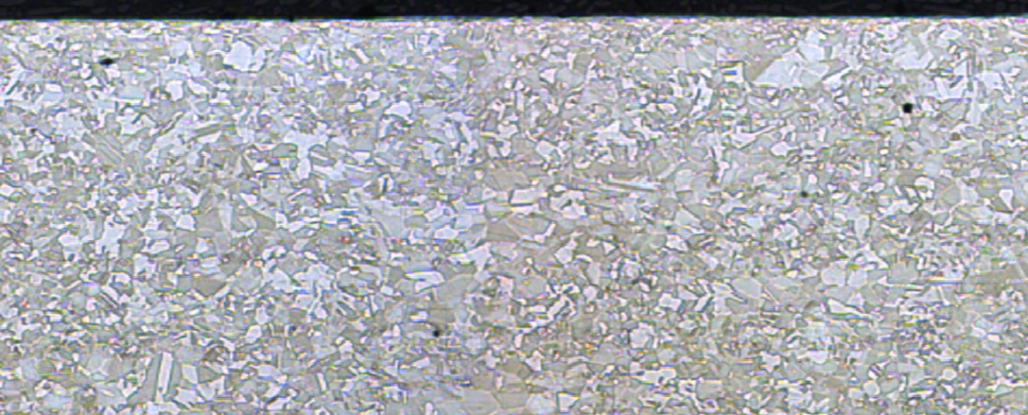
(d)-Magnified view, etched

Figure 20. Metallographic views of sample X-750-BLP-90-1, stressed to 90% YS (60.2 ksi) and exposed to baseline pretreat for 365 days.

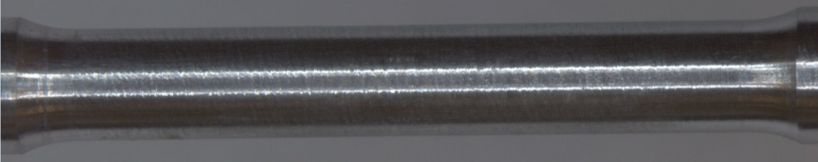
(a)-Overall view
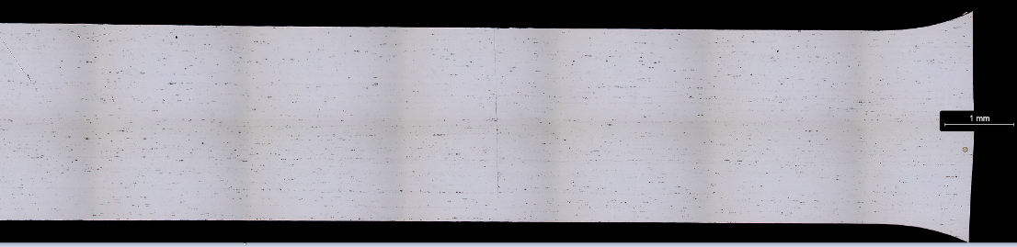
(b)-X50, unetched
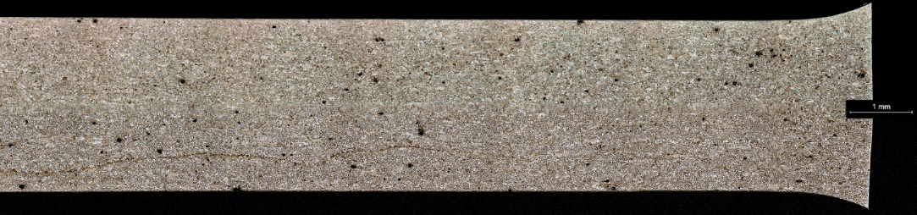
(c)-X50, etched
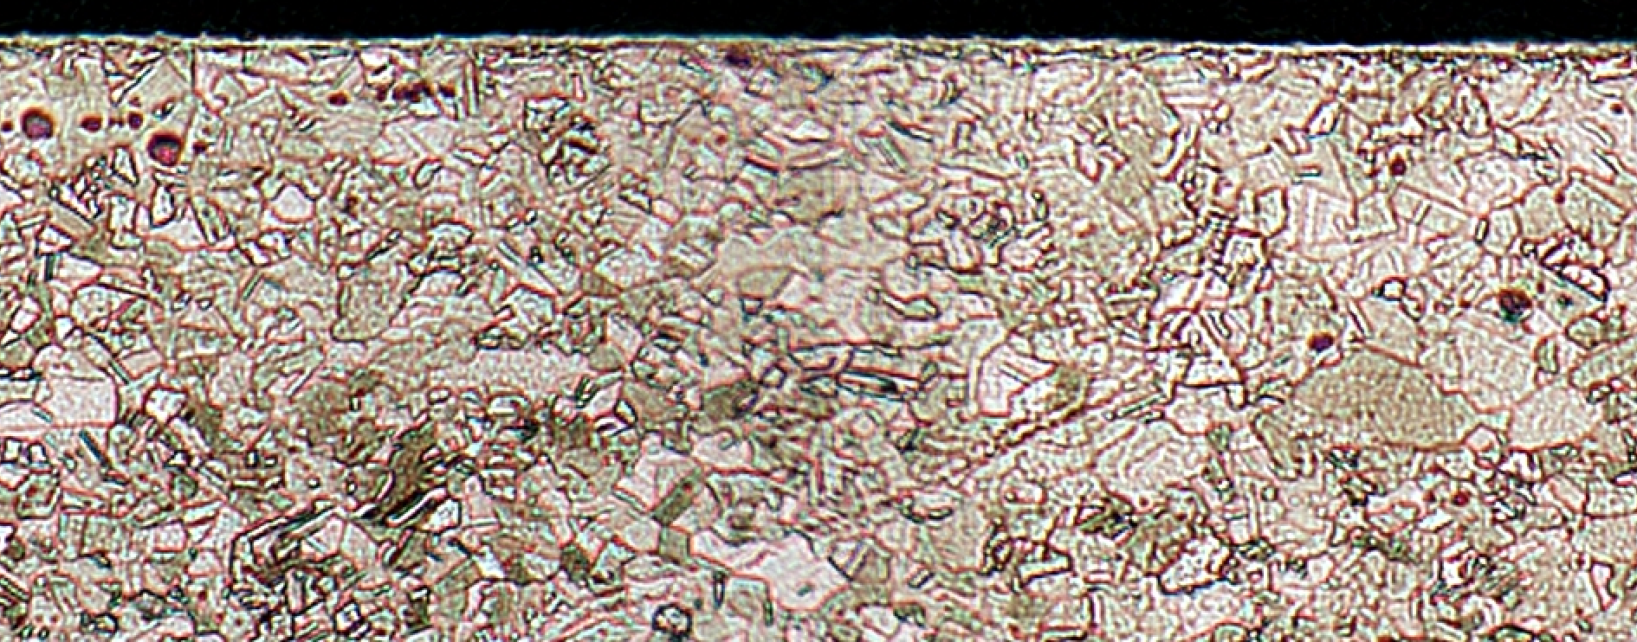
(d)-Magnified view

Figure 21. Metallographic views of sample X-750-BLB-0-1, exposed unstressed to baseline brine for 365 days.

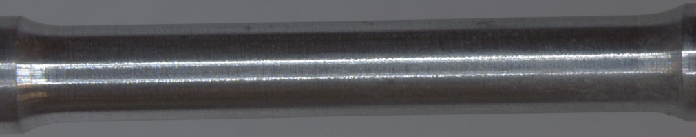
(a)-Overall view
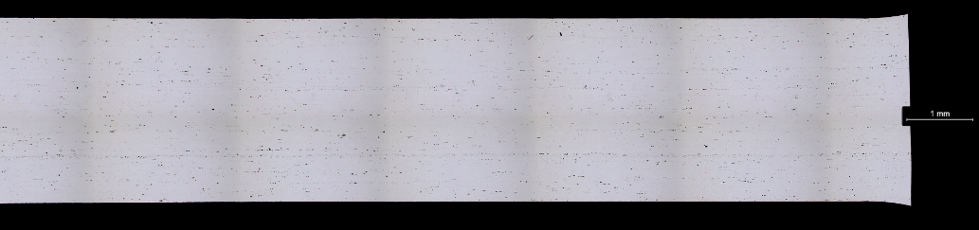
(b)-X50, unetched
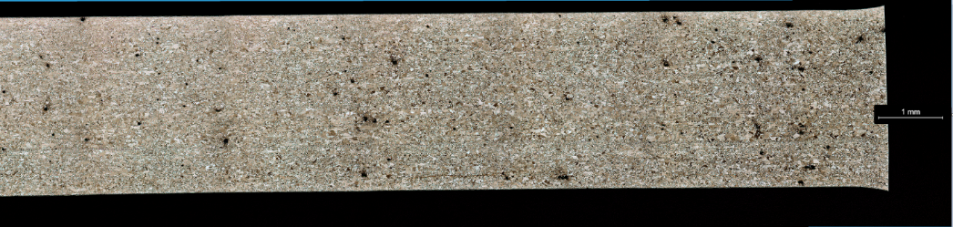
(c)-X50, etched
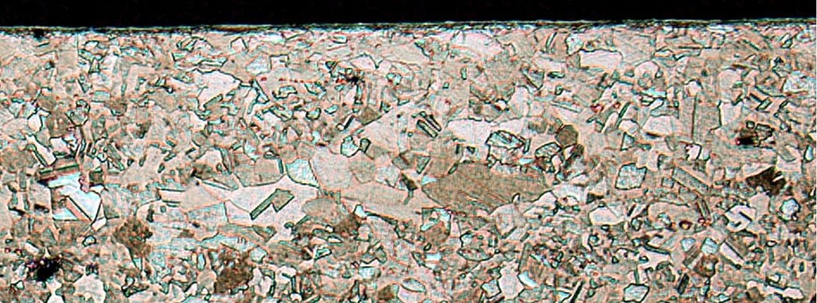
(d)-Magnified view

Figure 22. Metallographic views sample X-750-BLB-75-1, stressed to 75% YS (50.2 ksi) and exposed to baseline brine for 365 days.

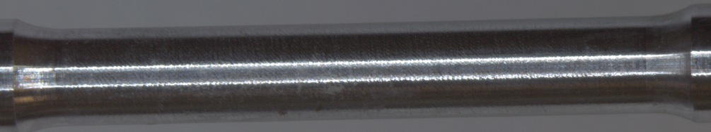
(a)-Overall view
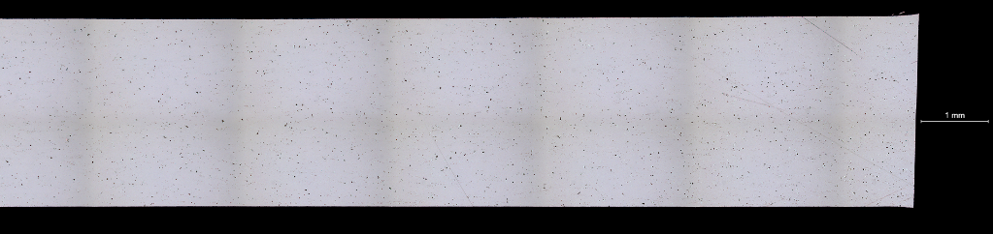
(b)-X50, unetched

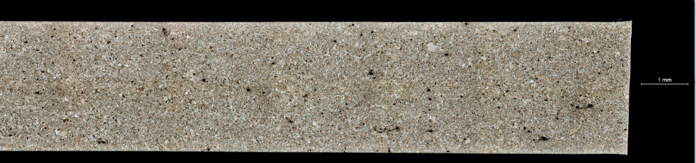
(c)-X50, etched
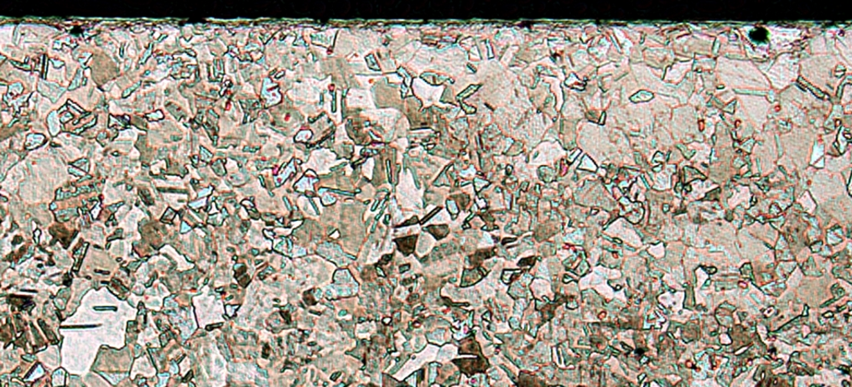
(d)-Magnified view

Figure 23. Metallographic views of sample X-750-BLB-90-1, stressed to 90% YS (60.2 ksi) and exposed to baseline brine for 365 days.

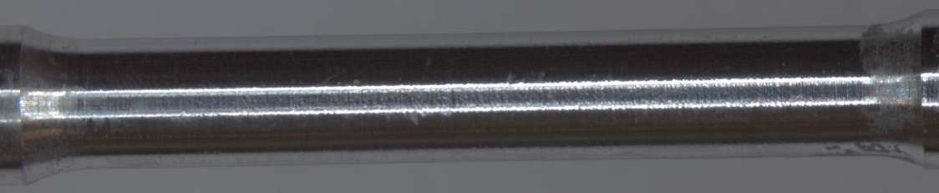
(a)-Overall view
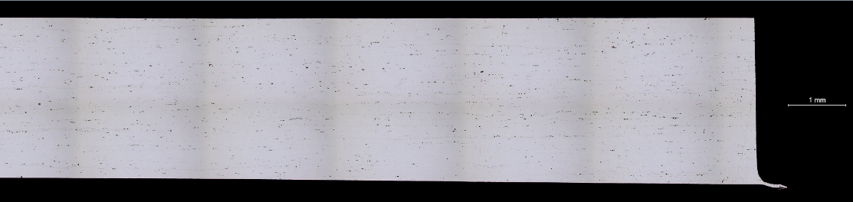
(b)-X50, unetched
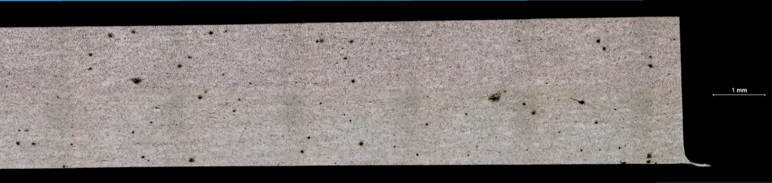
(c)-X50, etched
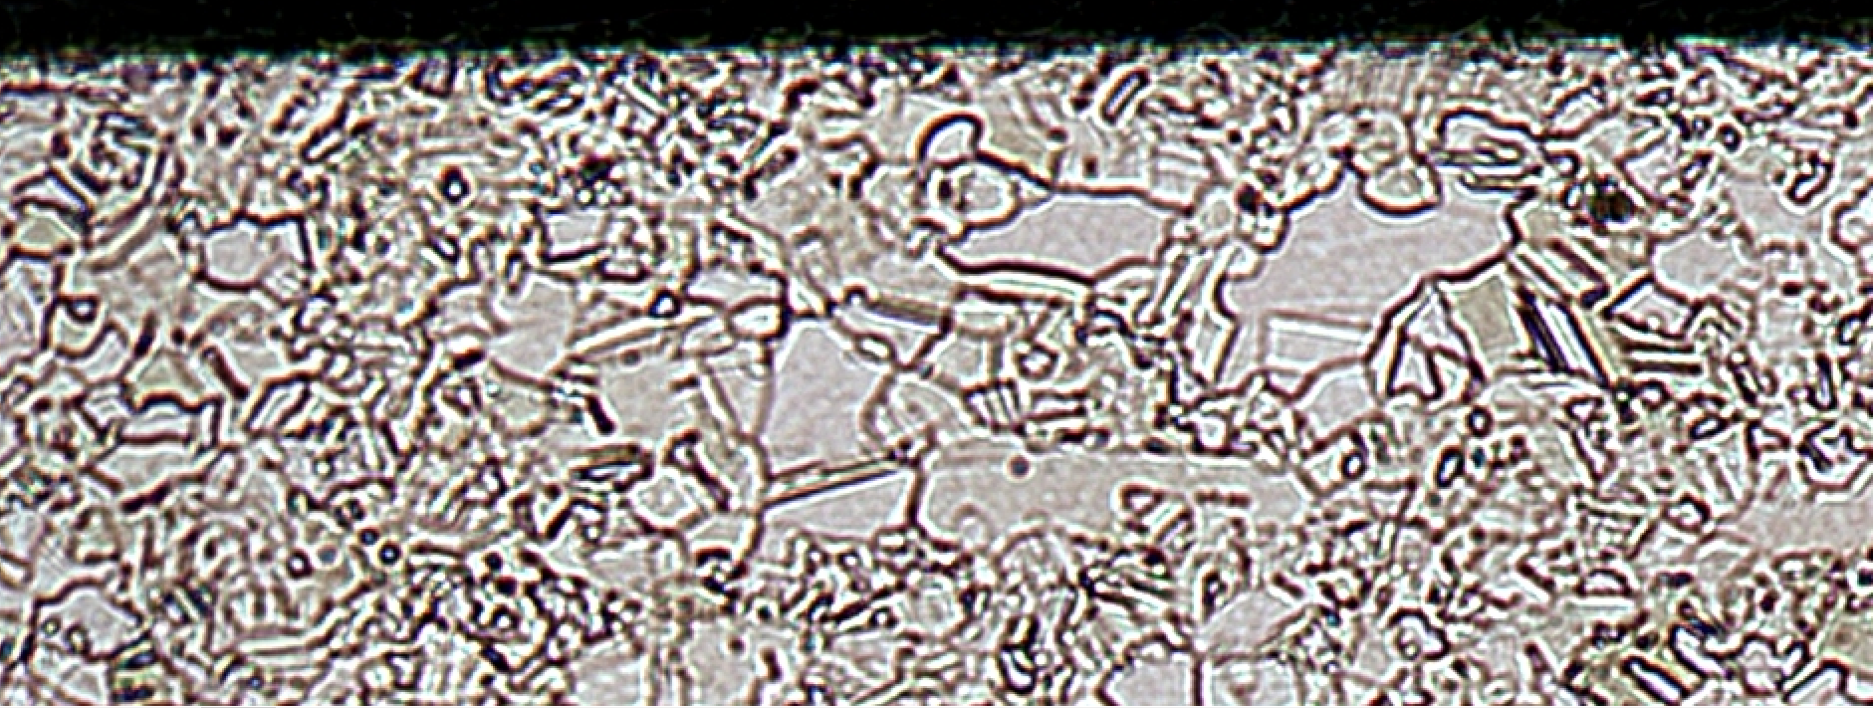
(d)-Magnified view

Figure 24. Metallographic views of sample X-750-APT-0-1, exposed unstressed to alternate pretreat for 365 days.

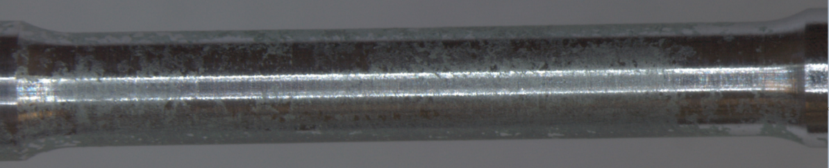
(a)-Overall view
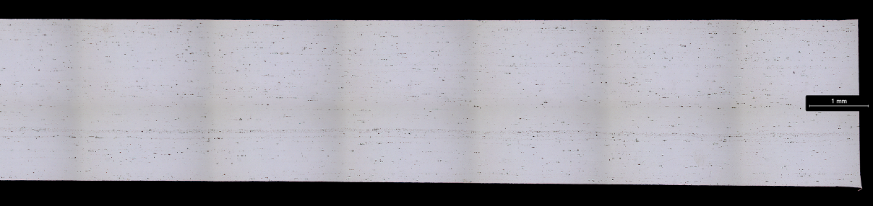
(b)-X50, unetched
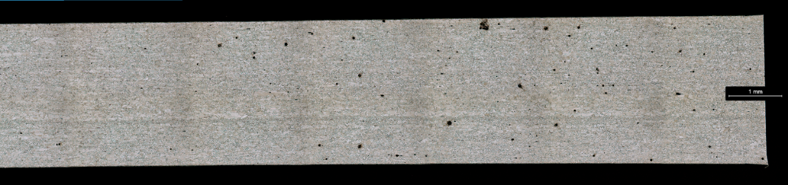
(c)-X50, etched
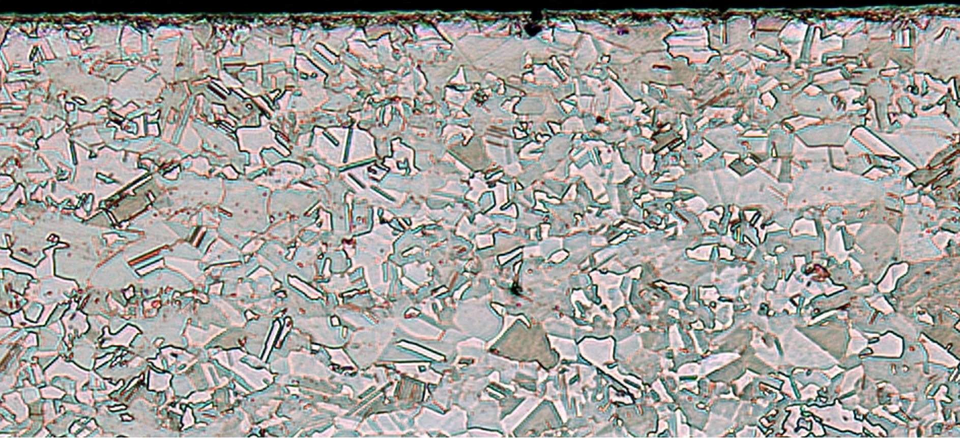
(d)-Magnified view
Figure 25. Metallographic views of sample X-750-APT-75-1, stressed to 75% YS (50.2 ksi) and exposed to alternate pretreat for 365 days.

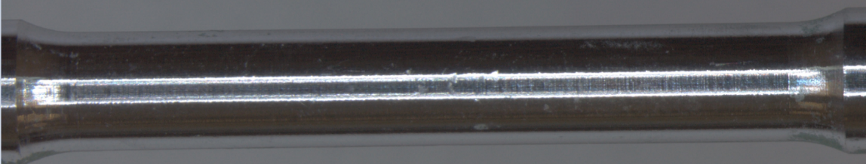
(a)-Overall view
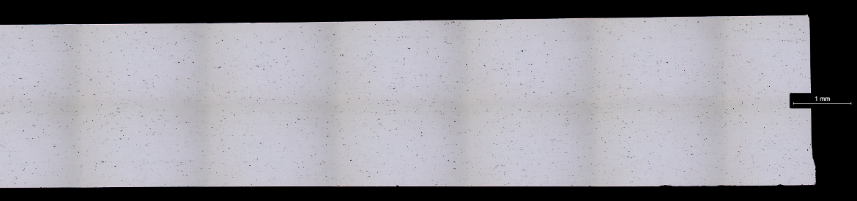
(b)-X50, unetched
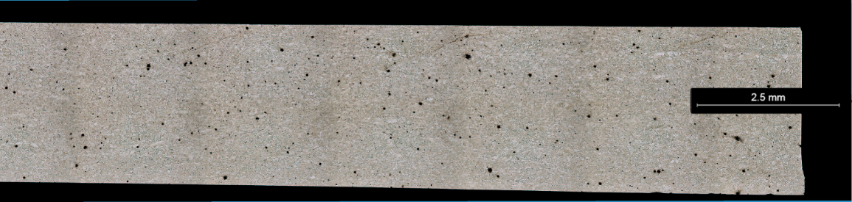
(c)-X50, etched
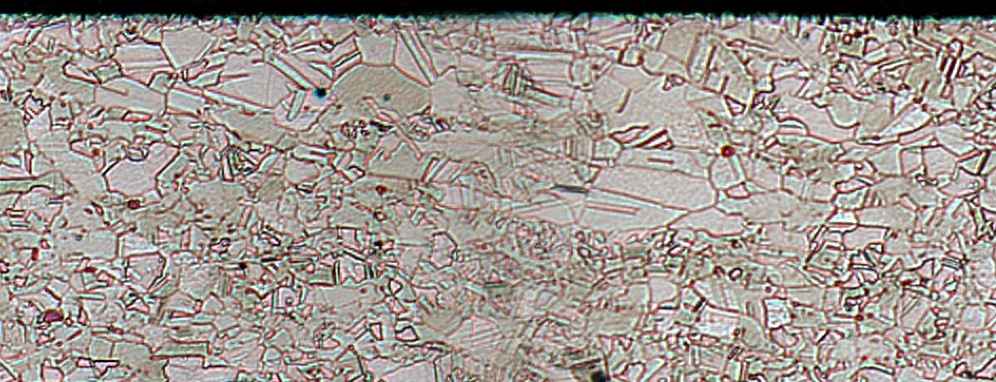
(d)-Magnified view
Figure 26. Metallographic views of sample X-750-APT-90-1, stressed to 90% YS (60.2 ksi) and exposed to alternate pretreat for 365 days.

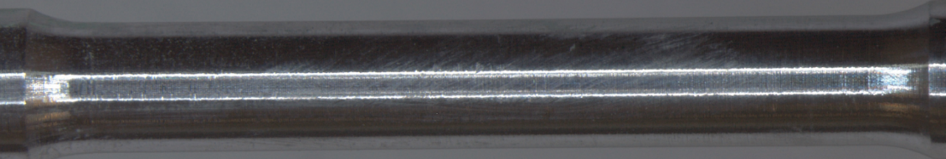
(a)-Overall view
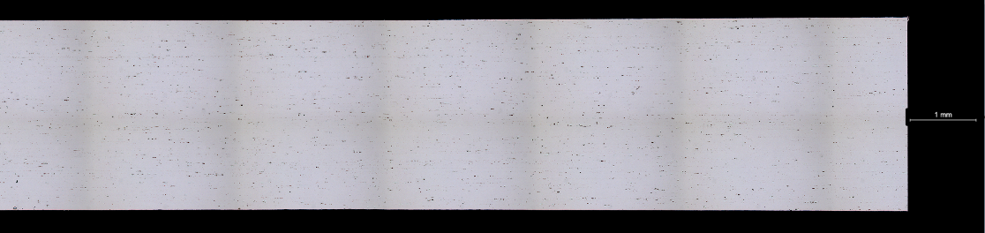
(b)-X50, unetched
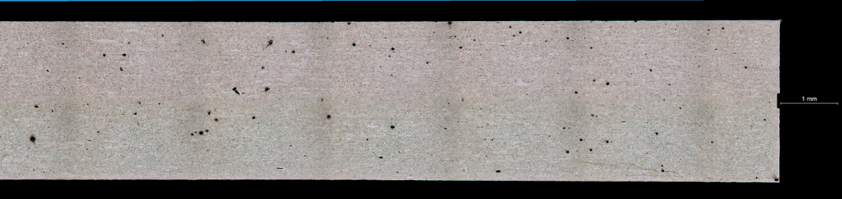
(c)-X50, etched
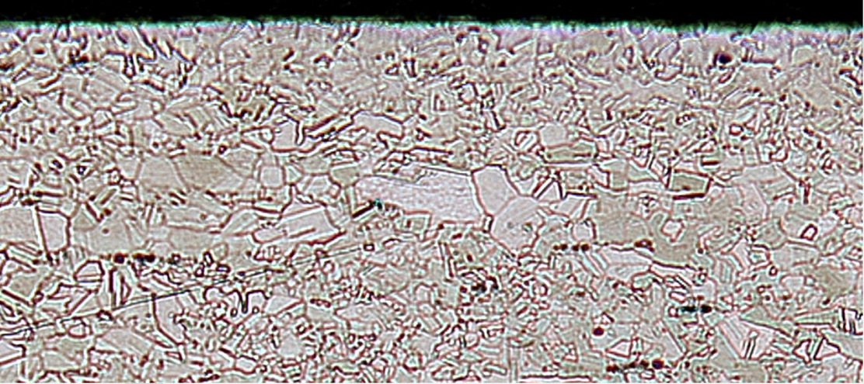
(d)-Magnified view
Figure 27. Metallographic views of sample X-750-AB-0-1, exposed unstressed to alternate brine for 365 days.

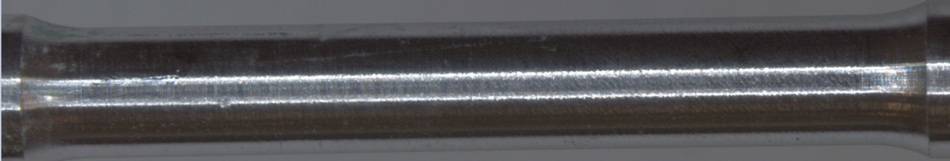
(a)-Overall view
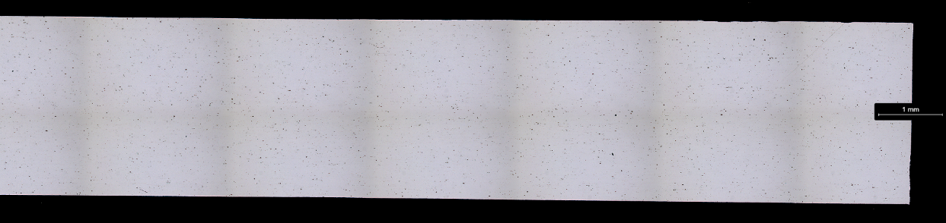
(b)-X50, unetched
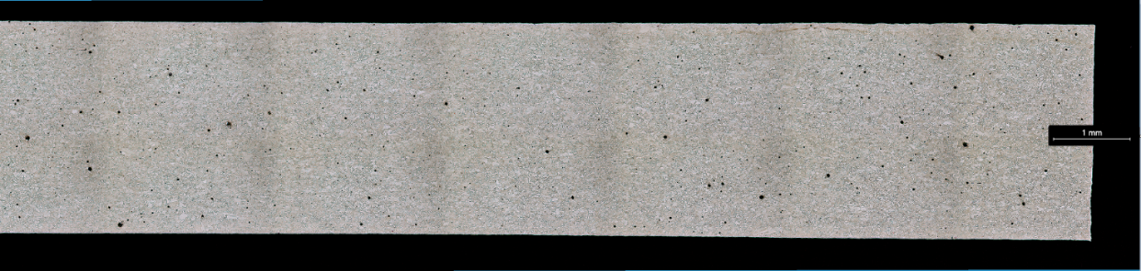
(c)-X50, etched
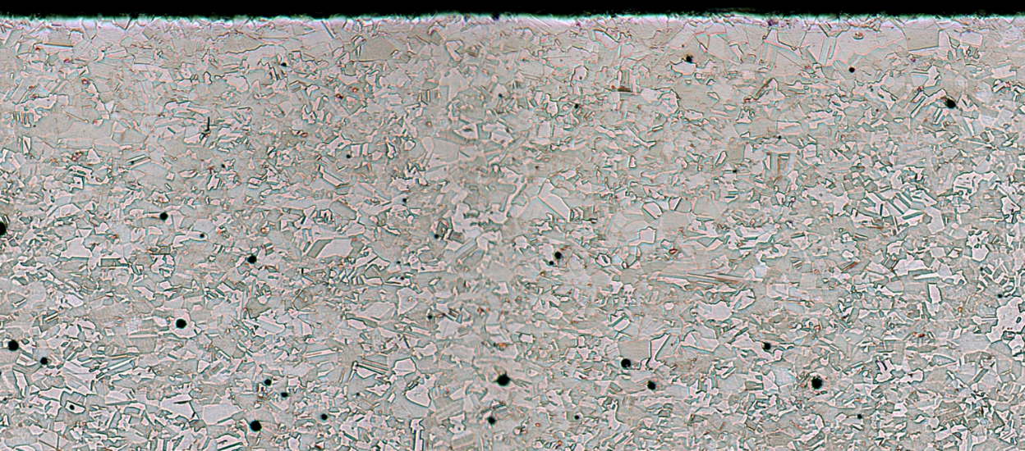
(d)-Magnified view
Figure 28. Metallographic views of sample X-750-AB-75-1, stressed to 75% YS (50.2 ksi) and exposed to alternate brine for 365 days.

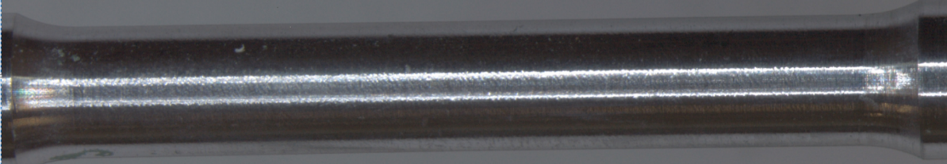
(a)-Overall view
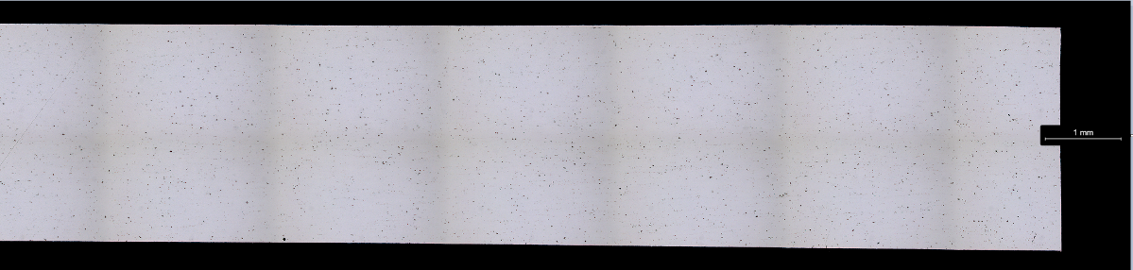
(b)-X50, unetched
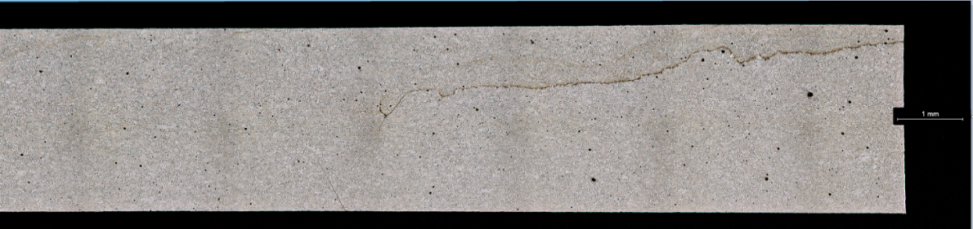
(c)-X50, etched
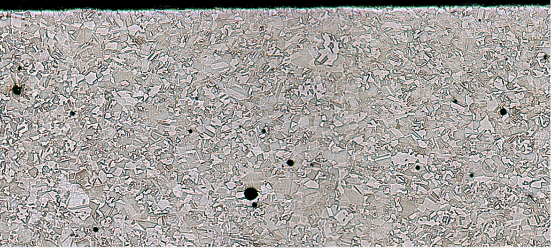
(d)-Magnified view
Figure 29. Metallographic views of sample X-750-AB-90-1, stressed to 90% YS (60.2 ksi) and exposed to alternate brine for 365 days.

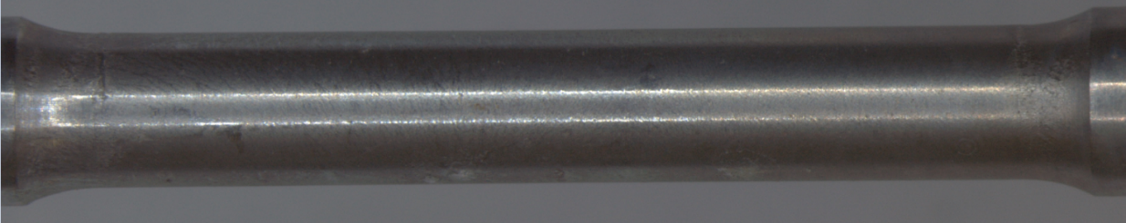
(a)-Overall view
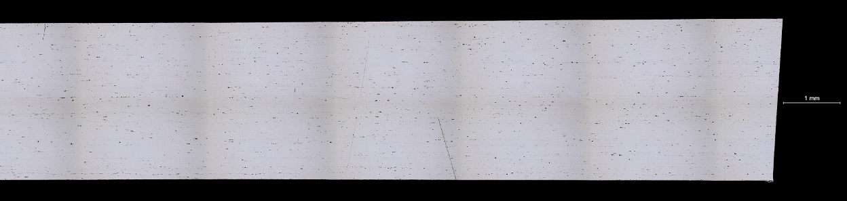
(b)-X50, unetched
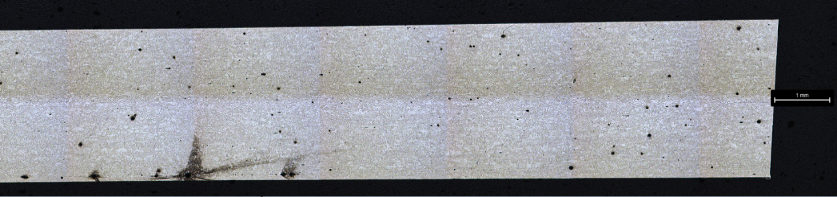
(c)-X50, etched

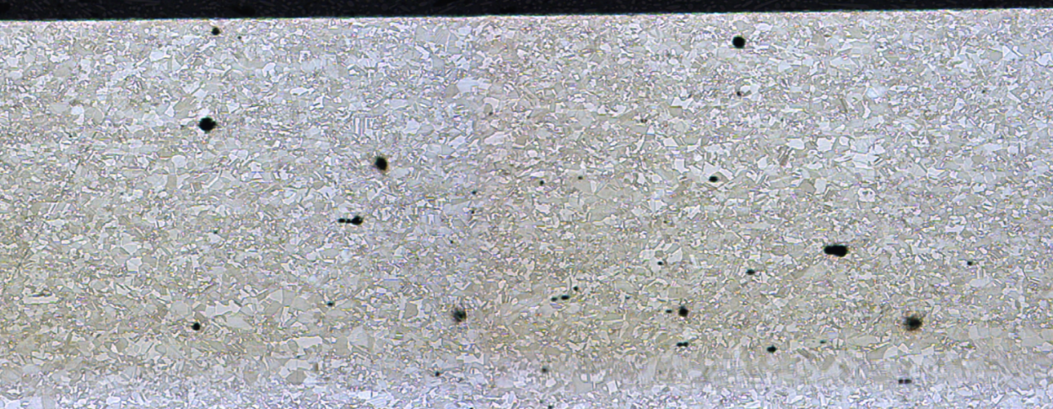
(d)-Magnified view
Figure 30. Metallographic views of sample X-750-AI-90-1, stressed to 90% YS (60.2 ksi) and exposed to 3.5% NaCl alternate immersion for 365 days.

CONCLUSIONS

Round tensile stress corrosion specimens of Inconel X-750 alloy survived a yearlong exposure to baseline pretreat, baseline brine, alternate pretreat, alternate brine, and 3.5% NaCl alternate immersion. No reduction in tensile strength resulted from exposure, and metallography did not show indications of stress corrosion on any of the specimens evaluated at stress levels of up to 90% of the yield strength. These results indicate that this material, at the strength level tested (132.7 ksi ultimate tensile strength), is resistant to stress corrosion cracking in the environments in which it was tested.

APPENDIX A - PROCEDURE FOLLOWED TO PREPARE THE ECLSS TEST SOLUTIONS

A.1 Baseline pretreat and brine

The baseline pretreatment solution was prepared by adding 15.9 ml of baseline pretreat stabilizer and 265 ml of deionized water to 1 liter of urine. The baseline pretreat stabilizer consists of 54.5% deionized water, 9% chromium trioxide (CrO3), and 36.5% sulfuric acid (H2SO4) by mass. The corresponding baseline brine solution is based on 85% water recovery of the pretreated urine.

A.2 Alternate pretreat and brine

The alternate pretreatment was prepared by adding 17.5 ml of alternate pretreat stabilizer and 265 ml of deionized water to 1 liter of urine. The alternate pretreat stabilizer contains 2.36 ml of 85% phosphoric acid (H3PO4) and 0.94 ml of 30% chromium trioxide (CrO3) oxidizer solution. The corresponding alternate brine solution is based on 85% water recovery of the pretreated urine.

Notes:
(1)-The ECLSS solutions were prepared at the MSFC Environmental Control and Life Support System Development Branch (ES62). All the solutions had a pH of about 2. The purpose of using the acids is to control the growth of microorganisms.
(2)-The brine solutions were obtained by distillation of the pretreat solutions.
(3)-The goal of processing urine in the International Space Station is to produce water for consumption of the astronauts. That is accomplished by using filtration and distillation processes.

APPENDIX B - DESCRIPTION OF THE ALTERNATE IMMERSION TEST PROCEDURE

Exposure to the salt solution was performed by alternate immersion by using a Ferris Wheel type apparatus (Figure 11). The main components of this apparatus are a tank for the 3.5% NaCl solution, a microswitch, a timer, an electric motor, a magnetic disc brake, 6 plexiglass racks, and a 5-gallon glass bottle containing deionized water to replenish the water lost by evaporation. Reagent grade sodium chloride and deionized water exceeding the purity requirements of ASTM Specification D1193 (Reference 10), Type IV reagent water, was used to prepare the solution. The concentration of the salt solution is verified with a salinometer. The pH of the salt solution when freshly prepared was within the range of 6.4 to 7.2. For those cases when the pH is not within that range, adjustments are made by using diluted, reagent grade hydrochloric acid (HCl) or reagent grade sodium hydroxide (NaOH). In the alternate immersion test, for each hour of exposure, the samples remain in the solution for 10 minutes and 50 minutes out of the solution (drying cycle in air). In order to do that the system rotates 60 degrees every 10 minutes. Those cycles are repeated for the entire length of the test. The relative humidity in the laboratory was 45 +/- 10% and the temperature 80 +/-2 °F.

LIST OF REFERENCES

- Torres, Pablo D.: “Stress Corrosion Evaluation of Various Metallic Materials for the International Space Station Water Recycling System”, NASA/TM—2015–218206, NASA Marshall Space Flight Center, Huntsville, AL, 66 pp., March 2015.

- Torres, Pablo D.: “Stress Corrosion Evaluation of Nitinol 60 for the International Space Station Water Recycling System,” NASA/TM—2016–218230, NASA Marshall Space Flight Center, Huntsville, Alabama, 38 pp., November 2016.

- Torres, Pablo D.: “Stress Corrosion Evaluation of Elgiloy Alloy for the ISS ECLSS — Universal Waste Management System”, NASA/TM—2019-220133, NASA Marshall Space Flight Center, Huntsville, Alabama, 54 pp., May 2019.

- Torres, Pablo D.: “Stress Corrosion Evaluation of NiTiHf Alloy for the International Space Station Environmental Control and Life Support System”, NASA/TM—20230010690, NASA Marshall Space Flight Center, Huntsville, Alabama, 54 pp, July 2023.

- AMS 5542, Revision N, Nickel Alloy, Corrosion and Heat-Resistant, Sheet, Strip, and Plate, 72Ni - 15.5Cr - 0.95Cb(Nb) - 2.5Ti - 0.70Al - 7.0Fe, Annealed, Reaffirmed in 2012.

- ASTM E8/E8M-16a, “Standard Test Methods for Tension Testing of Metallic Materials”, American Society for Testing and Materials, West Conshohocken, Pennsylvania, 2016.

- ASTM G49-85, “Standard Practice for Preparation and Use of Direct Tension Stress-Corrosion Test Specimens”, American Society for Testing and Materials, West Conshohocken, Pennsylvania, 2011.

- ASTM G 44-99: “Standard Practice for Exposure of Metals and Alloys by Alternate Immersion in Neutral 3.5 % Sodium Chloride Solution”, American Society for Testing and Materials, West Conshohocken, PA, 2013.

- Muirhead, D, Carter, L., and Williamson, J. “Preventing Precipitation in the ISS Urine Processor”, 48th International Conference on Environmental Systems ICES-2018-87, Albuquerque, New Mexico, July 8-12, 2018.

- ASTM D1193, “Standard Specification for Reagent Water”, American Society for Testing and Materials, West Conshohocken, Pennsylvania, 2018.

National Aeronautics and
Space Administration
George C. Marshall Space Flight Center
Huntsville, Alabama 35812

